Supporting Information for:
Non-targeted metabolomics-based molecular networking enables the chemical characterization of Rumex sanguineus
Valentina Ramundi^{1,2,3}, Mitja M. Zdouc⁴, Justin J.J. van der Hooft^{4,5}, Enrica Donati², Sara Cimini³, Laura Righetti^{1,6 *}
¹ Laboratory of Organic Chemistry, Wageningen University & Research, 6708 WE Wageningen, the Netherlands.
² Institute for Biological System (ISB), National Research Council of Italy (CNR), via Salaria km 29.300, 00015 Monterotondo Scalo (Rome), Italy
³ Department of Science and Technology for Humans and the Environment, Campus Bio-Medico University of Rome, Via Álvaro del Portillo, 21, Rome,00128, Italy.
⁴ Bioinformatics Group, Wageningen University & Research, Droevendaalsesteeg 1, 6708 PB, Wageningen, the Netherlands.
⁵ Department of Biochemistry, University of Johannesburg, 2006 Johannesburg, South Africa.
⁶ Wageningen Food Safety Research, Wageningen University & Research, 6700 AE, the Netherlands.

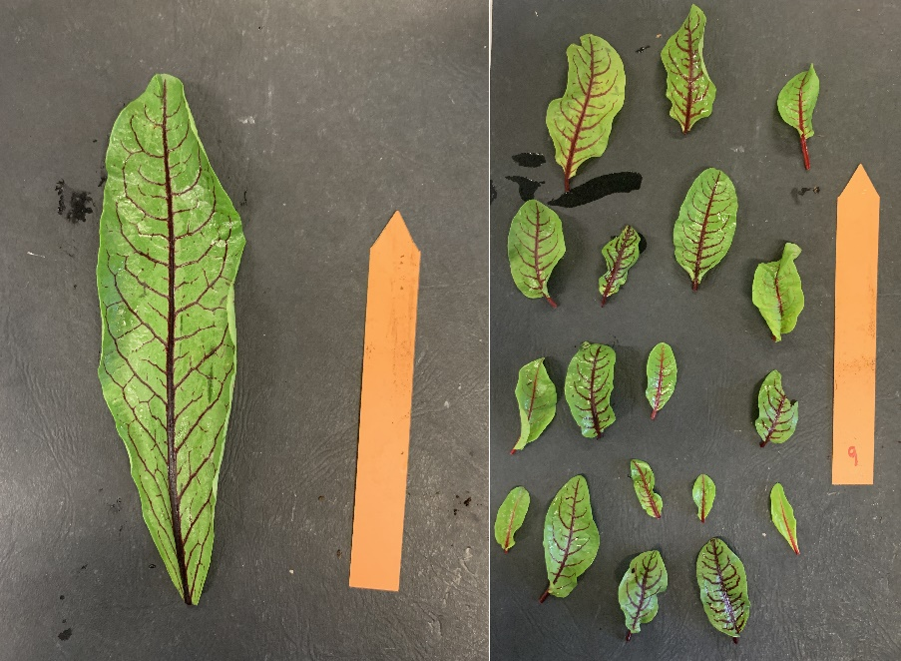
Figure S1. Adult and young leaves sampling. To ensure accurate measurements of leaf area and length during Fiji (ImageJ) analysis, we utilized an orange bookmark (1.8 cm by 14.3 cm) as a scale.

Figure S2. Principal component analysis (PCA) models of the first two principal components (PCs) built from (A) positive (R² = 0.74) and (B) negative (R² = 0.80) ionization data. Colour coding: roots (green), leaves (red) and stems (blue). In both positive and negative ionization mode, the first PC explains most of the variance (62% and 65%, respectively) and separates roots from stems and leaves, while the second PC discriminates the finer differences between leaves and stems.

Figure S3. FBMN built with ESI positive ionization mode data form Rumex sanguineus roots (yellow), leaves (orange) and stems (green). A total of 1118 features (nodes), interconnected by 2060 edges, were organized into 88 distinct clusters.
Figure S4. FBMN built with ESI negative ionization mode data form Rumex sanguineus roots (yellow), leaves (orange) and stems (green). A total of 1417 features (nodes), interconnected by 2527 edges, were organized into 128 distinct clusters.
Figure S5. Venn diagram displaying the distribution of 347 annotated compounds in roots, stems and leaves. As it can been seen from the figure, most compounds (90%) are common to the three plant organs, even though their accumulation can significantly change between roots, stems and leaves.

Figure S6. Accumulation of (A) kaempferol-3-glucoside, (B) aloin, (C) quercetin-3-glucoside and (D) proanthocyanidin B2 in leaves (red), roots (green) and stems (blue) groups.

Figure S7. Emodin content in leaves across two different growth stages (sampling August 2022); leaves were classified as adult and young based on their length and areas as indicated in Figure S1.

Fragmentation spectra
Table 1. This table includes all annotated compounds clustered into the five sub-networks, as thoroughly explained in the corresponding subsections of our analysis. Batch mode library creation supports and streamlines reference library formation, reducing errors, especially when handling a large number of spectra. All data are available on massIVE in mzXML format.
FILENAME | COMPOUND  NAME | MOLECULE  MASS | INSTRUMENT | ION  SOURCE | EXTRACT  SCAN | CHARGE | ION  MODE | ACQUISITION | EXACT  MASS | DATA  COLLECTOR | ADDUCT | LIB  QUALITY | PI
5L2_POS.mzXML | Emodin derivative | 271.0600 | Orbitrap | LC-ESI | 6662 | 1 | Positive | crude | 270.0523 | Valentina_Ramundi | M+H | 3 | Laura_Righetti
6S2_POS.mzXML | Emodin_anthrone derivative | 257.0811 | Orbitrap | LC-ESI | 7293 | 1 | Positive | crude | 256.0730 | Valentina_Ramundi | M+H | 3 | Laura_Righetti
8L2_POS.mzXML | Emodin-anthrone-hydrogen-sulfate | 337.0374 | Orbitrap | LC-ESI | 5623 | 1 | Positive | crude | 336.0298 | Valentina_Ramundi | M+H | 3 | Laura_Righetti
8S2_POS.mzXML | Emodin-hydrogen-sulfate | 351.0172 | Orbitrap | LC-ESI | 5708 | 1 | Positive | crude | 350.0090 | Valentina_Ramundi | M+H | 3 | Laura_Righetti
5R2_POS.mzXML | 3-Methyl-1,4,5,7-tetrahydroxy-anthraquinone | 285.0408 | Orbitrap | LC-ESI | 10585 | 1 | Negative | crude | 286.0483 | Valentina_Ramundi | M-H | 3 | Laura_Righetti
8L1_POS.mzXML | Dihydroxy-dimethylxanthone | 255.0664 | Orbitrap | LC-ESI | 8935 | 1 | Negative | crude | 256.0741 | Valentina_Ramundi | M-H | 3 | Laura_Righetti
7R1_POS.mzXML | 3,8-Dihydroxy-1-Methylanthraquinone-2-Carboxylic Acid | 297.0409 | Orbitrap | LC-ESI | 8702 | 1 | Negative | crude | 298.0483 | Valentina_Ramundi | M-H | 3 | Laura_Righetti
7R1_POS.mzXML | Endocrocin | 313.0359 | Orbitrap | LC-ESI | 7036 | 1 | Negative | crude | 314.0432 | Valentina_Ramundi | M-H | 3 | Laura_Righetti
8L2_POS.mzXML | Emodin-8-glucopyranosyl sulfate | 511.0552 | Orbitrap | LC-ESI | 5264 | 1 | Negative | crude | 512.0630 | Valentina_Ramundi | M-H | 3 | Laura_Righetti
8L2_POS.mzXML | Emodin 1-O-beta-D-glucoside | 431.0984 | Orbitrap | LC-ESI | 6115 | 1 | Negative | crude | 432.1062 | Valentina_Ramundi | M-H | 3 | Laura_Righetti
8L2_POS.mzXML | Dihydroxy-methyl-dioxoanthracen-yl)-oxy-trihydroxyoxan-yl-methyl acetate | 473.1087 | Orbitrap | LC-ESI | 6998 | 1 | Negative | crude | 474.1176 | Valentina_Ramundi | M-H | 3 | Laura_Righetti
8L2_POS.mzXML | Kwanzoquinone_D | 517.0988 | Orbitrap | LC-ESI | 7183 | 1 | Negative | crude | 518.1065 | Valentina_Ramundi | M-H | 3 | Laura_Righetti
8R2_POS.mzXML | Aloin_B | 419.1328 | Orbitrap | LC-ESI | 5188 | 1 | Positive | crude | 418.1269 | Valentina_Ramundi | M+H | 3 | Laura_Righetti
8R2_POS.mzXML | Aloin-A | 419.1328 | Orbitrap | LC-ESI | 5401 | 1 | Positive | crude | 418.1269 | Valentina_Ramundi | M+H | 3 | Laura_Righetti
5R2_POS.mzXML | Nodososide | 463.1238 | Orbitrap | LC-ESI | 4431 | 1 | Positive | crude | 462.1676 | Valentina_Ramundi | M+H | 3 | Laura_Righetti
5R2_POS.mzXML | Glocoobtusifolin | 447.1290 | Orbitrap | LC-ESI | 5247 | 1 | Positive | crude | 446.1218 | Valentina_Ramundi | M+H | 3 | Laura_Righetti
5L2_POS.mzXML | Kaempferol | 287.0550 | Orbitrap | LC-ESI | 6917 | 1 | Positive | crude | 286.0483 | Valentina_Ramundi | M+H | 3 | Laura_Righetti
5S1_POS.mzXML | Fisetin | 287.0552 | Orbitrap | LC-ESI | 3601 | 1 | Positive | crude | 286.0483 | Valentina_Ramundi | M+H | 3 | Laura_Righetti
8S1_POS.mzXML | Quercetin derivative | 303.0500 | Orbitrap | LC-ESI | 7757 | 1 | Positive | crude | 302.0432 | Valentina_Ramundi | M+H | 3 | Laura_Righetti
5L2_POS.mzXML | Kaempferol_3-[6''-(3-hydroxy-3-methylglutaryl) glucoside | 593.1498 | Orbitrap | LC-ESI | 5002 | 1 | Positive | crude | 592.1438 | Valentina_Ramundi | M+H | 3 | Laura_Righetti
5L2_POS.mzXML | Quercetin_3-glucuronide | 479.0821 | Orbitrap | LC-ESI | 4184 | 1 | Positive | crude | 478.0753 | Valentina_Ramundi | M+H | 3 | Laura_Righetti
5L2_POS.mzXML | Quercetin_3-glucoside | 465.1036 | Orbitrap | LC-ESI | 4143 | 1 | Positive | crude | 464.0960 | Valentina_Ramundi | M+H | 3 | Laura_Righetti
5L2_POS.mzXML | Quercetin_3-[6’’-(3-hydroxy-3-methylglutaryl) glucoside | 609.1449 | Orbitrap | LC-ESI | 4505 | 1 | Positive | crude | 608.1383 | Valentina_Ramundi | M+H | 3 | Laura_Righetti
5L2_POS.mzXML | Kaempferol_3-glucoside | 449.1079 | Orbitrap | LC-ESI | 4533 | 1 | Positive | crude | 448.1011 | Valentina_Ramundi | M+H | 3 | Laura_Righetti
5L2_POS.mzXML | Kaempferol_3-rutinoside | 595.1658 | Orbitrap | LC-ESI | 4513 | 1 | Positive | crude | 594.1590 | Valentina_Ramundi | M+H | 3 | Laura_Righetti
5L2_POS.mzXML | Kaempferol_3-glucuronide | 463.0874 | Orbitrap | LC-ESI | 4660 | 1 | Positive | crude | 462.0804 | Valentina_Ramundi | M+H | 3 | Laura_Righetti
5L2_POS.mzXML | Rutin | 611.1605 | Orbitrap | LC-ESI | 4039 | 1 | Positive | crude | 610.1539 | Valentina_Ramundi | M+H | 3 | Laura_Righetti
5S1_POS.mzXML | Cyanidin-3-glucoside | 449.1083 | Orbitrap | LC-ESI | 2095 | 1 | Positive | crude | 449.1083 | Valentina_Ramundi | M+ | 3 | Laura_Righetti
6R1_POS.mzXML | Cyanidin-catechin conjugate | 577.1337 | Orbitrap | LC-ESI | 4302 | 1 | Positive | crude | 576.1273 | Valentina_Ramundi | M+H | 3 | Laura_Righetti
8L2_POS.mzXML | Proathocyanidin_B2 | 579.1500 | Orbitrap | LC-ESI | 1695 | 1 | Positive | crude | 578.1423 | Valentina_Ramundi | M+H | 3 | Laura_Righetti
7L2_POS.mzXML | Proathocyanidin_B2-gallate | 731.1607 | Orbitrap | LC-ESI | 3328 | 1 | Positive | crude | 730.1539 | Valentina_Ramundi | M+H | 3 | Laura_Righetti

