Supplemental file

***In vitro* genotoxicity of dibutyl phthalate on A549 lung cells at air-liquid interface in exposure concentrations relevant at workplaces**

Stephanie Binder1,2, Xin Cao1,2, Stefanie Bauer1, Narges Rastak1, Evelyn Kuhn1, George C. Dragan3, Christian Monsé4, George Ferron1, Dietmar Breuer5, Sebastian Oeder1, Erwin Karg1, Martin Sklorz1, Sebastiano Di Bucchianico1,*, Ralf Zimmermann1,2

1 Joint Mass Spectrometry Center at Comprehensive Molecular Analytics, Helmholtz Zentrum München, Neuherberg, Germany

2 Joint Mass Spectrometry Center at Analytical Chemistry, Institute of Chemistry, University of Rostock, Rostock, Germany

3 Federal Institute for Occupational Safety and Health (BAuA) – Measurement of Hazardous Substances, Dortmund, Germany

4 Institute for Prevention and Occupational Medicine of the German Social Accident Insurance (IFA), Institute of the Ruhr-Universität Bochum (IPA), Bochum, Germany

5 Institute of Occupational Safety of the German Social Accident Insurance (IFA), Sankt Augustin, Germany

* Corresponding author E-mail address: dibucchianico@helmholtz-muenchen.de (Sebastiano Di Bucchianico)

Sebastiano Di Bucchianico: 1Comprehensive Molecular Analytics, Helmholtz Zentrum München, Gmunder Str. 37, 81379 Munich, Germany, [dibucchianico@helmholtz-muenchen.de](mailto:dibucchianico@helmholtz-muenchen.de)  
<https://orcid.org/0000-0002-6396-892X>  
* Corresponding author

**Detailed information on the calculation of DBP particle deposition in the alveoli of the human lung**

Both regional deposition and deposited mass are modeled for the human lung using the hygroscopic particle lung deposition (HPLD) model of (Ferron et al. 2013) in the “human-lung mode” and the deposited-mass-modeling equations of (Karg et al. 2020). The lung structure of Weibel (1963) is used to calculate the inner surface area of the airways in the lung. Table SI and SII list the surface area of the lung regions and the breathing conditions used for deposition modeling, respectively.

Figure S0 holds both the deposition probability as the output of the HPLD model, and the particle mass distribution for the three occupational exposure scenarios. It visualizes the convolution of deposition and size distribution which results in the mass deposited in the lung regions.

**Table SI.** Inner surface area of the model airways in the lung regions.

|  |  |  |  |
| --- | --- | --- | --- |
| ***Lung region*** | ***Surface area [m²]*** | ***Generation number*** | ***Meaning*** |
| et | 0.0118 | 1-2 | Extra thoracic (mouth and throat) |
| tb | 0.326 | 3-19 | Ducts of the tracheo-bronchial tree |
| al | 74.7 | 20-26 | Alveolar ducts and alveoli |
| tl | 75 | 1-26 | Total lung (ICRP, 1975) |

Table SII. Breathing conditions used in the model mimicking a person breathing orally at rest.

|  |  |  |
| --- | --- | --- |
| ***Meaning*** | ***Value*** | ***unit*** |
| Tidal volume | 750 | cm³ |
| Breathing frequency | 12 | breaths / min |
| Time for in- / exhalation | 2.5/2.5 | s |
| Breath holding between in- and exhalation | none | - |
| Respiratory minute volume | 9 000 | ml / min |
| Lung volume | 3 675 | cm³ |

**Detailed information on the LC-MS/MS settings and the parameters for DBP-d4 deposition measurements**

The amount of deposited DBP-d4 was measured in supernatant (stored at -80 °C) after one nebulization for 2 replicate inserts and analyzed with a capillary voltage of 5 kV, source temperature 350 °C, nebulizer gas 2.76 bar (40 psi), heater gas 3.48 bar (50 psi), curtain gas 1.38 bar (20 psi), and collision gas 0.76 bar (11 psi). A Kinetex C18 column (2.6 μm, 100×3 mm i.d., Phenomenex, UK) was used for separation and the column compartment was set at 20 °C. The autosampler injected a volume of 10 µL and was set at 20 °C. The measurement was performed in multiple reaction monitoring in positive ion mode using a gradient separation starting with 50% 0.1% acetic acid (mobile phase A) and 50% methanol (mobile phase B) with a constant flow of 300 µL/min going up to 100% methanol in 15 minutes. DBP-d4 m/z 283.3🡪153 transition was used for quantification and DBP-d4 m/z 283.3🡪209.2 transition ions served as qualifier ions. For quantification, an external calibration curve with DBP-d4 from 0.1 to 20 ng/mL was established and a blank (exposure to pure solvent without DBP-d4) was subtracted.

**Detailed information on the sample preparation process and the LC-MS/MS parameters for measurements of malondialdehyde (MDA) content in supernatant**

Sample medium was mixed with 25 µL of 33 ng/mL internal standard Malondialdehyde tetra butylammonium salt (d2-MDA), and a solution of 0.5 mM DNPH in 1% FA was added. The mixture was incubated at 37 oC under 300 rpm for 70 min in a Thermomixer C (Eppendorf, Germany) for derivatization. Afterwards, liquid-liquid extraction of MDA adduct (MDA-DNPH) was performed by addition of n-hexane, shaking for 30 sec, and subsequent centrifugation at 9390 x g for 5 min. The collected n-hexane supernatant was dried by nitrogen gas in a Vapotherm basis mobil I (Barkey, Germany) at room temperature. The dried residue was re-dissolved in mobile phase consisting of 80% methanol and 20 % ultrapure water with 0,1 % formic acid (methanol:0.1% formic acid, 80:20, v/v) and sonicated. The MDA adduct was analyzed by LC-MS/MS (capillary voltage 4.5 kV, source temperature 350 oC, column compartment set at 20 oC). The measurement was performed in multiple reaction monitoring in positive ion mode. MDA-DNPH m/z 235🡪159 and d2-MDA-DNPH m/z 237🡪161 transition ions were used for quantification and MDA-DNPH m/z 235🡪189 and d2-MDA-DNPH 237🡪191 transition ions were used as qualifier ions. Isocratic separation was conducted with a constant flow of 200 μL/min of mobile phase. Each sample was injected twice with 10 μL of injection volume for each measurement. The elution from 1.5 to 3.5 min was infused into the MS for measurement. A standard calibration curve with standard concentrations of MDA ranging from 0.5 to 20 ng/mL was set up for quantification.

**Detailed information on single-cell gel electrophoresis (comet assay) workflow and buffers**

The chemicals for conducting the Comet assay were purchased from Sigma-Aldrich (St. Louis, MO) if not stated otherwise. 20 µL of the cell suspension were added to 140 μl of 1% low-melting-point agarose, and 20 μl of this mixture were pipetted as drops onto a microscopy slide pre-coated with 0.5% normal-melting point agarose. The mini-gel containing slides were immersed in a cold freshly prepared 1 % Triton X-100 lysis buffer (2.5 M NaCl, 0.1 M EDTA, 10 mM Tris, pH 10) and the alkaline unwinding of the DNA was performed in pre-cooled alkaline solution (0.3 M NaOH, 1 mM EDTA, pH > 13) for 40 min. Both steps were conducted in the dark and on ice. Following an electrophoretic separation of 25 min (300 mA, 1.2 V/cm) in an electrophoretic chamber (BioRad, UK) surrounded by cooling pads in the dark, the slides were neutralized twice for 3 to 5 min with 0.4 M Tris, and afterwards washed twice with ultrapure water. Tris was purchased from Roth (Karlsruhe, Germany). 1x TE buffer solution (ChemCruz, Dallas, TX) containing SYBR GOLD consisted of 10 mM Tris-HCl and 1 mwM EDTA (pH 7.5).

**Detailed description of the experimental procedure of the cytokinesis-block micronucleus cytome assay (CBMN-Cyt assay)**

After harvesting, cells were subjected to hypotonic treatment (5 min, 0.075 M KCl), centrifuged at 146x g for 6 min, resuspended in ice cold methanol, and stored at -20 °C overnight. The next day, cells were suspended in 5:1 methanol:glacial acetic acid (fixing solution) and finally fixed on microscopy slides. The slides were stained with filtered 2% (v/v) Giemsa solution and air-dried at least overnight before scoring with a light microscope (400x magnification, Zeiss, Germany). Potassium chloride was purchased from Roth (Karlsruhe, Germany), methanol from Merck (Darmstadt, Germany), and glacial acetic acid and Giemsa solution were purchased from AppliChem (Darmstadt, Germany).

**Solvent treatment neither affected cell viability nor cytotoxicity**

Resazurin assay data showed that solvent treatment did not cause any loss of cell viability compared to the incubator control (100±0.3%, p=0.6253, 4 hours PE; 100±0.3%, p=0.5979, 24 hours PE). In accordance, solvent treatment did not increase cytotoxicity compared to the incubator control (3.9±0.7%, p=0.6852, 4 hours PE; 19.5±0.5%, p=0.9219, 24 hours PE) as measured by LDH release.

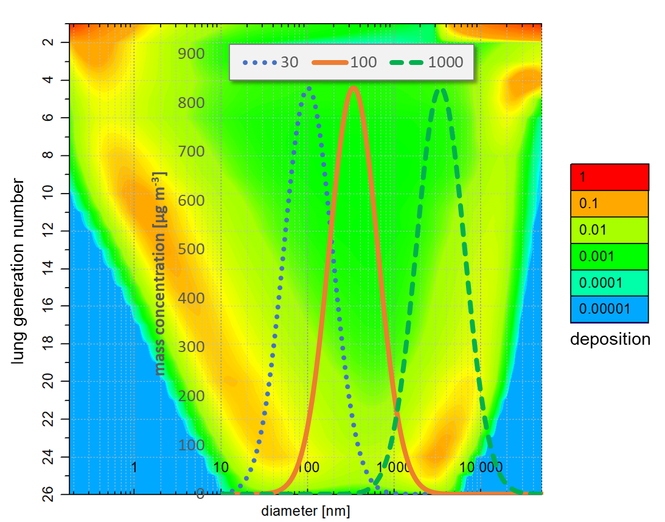

**Figure S0.** Composite graph showing lung deposition and particle mass distribution. Particle deposition is calculated by the HPLD computer model for a person breathing calmly via the mouth. Lung generation means the number of airway bifurcations from the mouth (generation 1) down to the terminal bronchi (generation 26). Deposition values are color coded from 0 to 1 and depend on both the lung generation and the aerodynamic particle diameter. Exposure particle mass concentration are calculated for the three exposure scenarios with a count median diameter of 30 nm (dotted), 100 nm (line) and 1000 nm (dashed). The modal diameters of the mass distributions are given in the main text (Table I). Total and modal mass concentrations are adjusted for the same SCOEL of 580 and 830 µg/m3, respectively, and a geometric standard deviation of 𝞼g=1.9. The corresponding mass deposited per lung tissue surface area is listed in Table I of the main text.



**Fig. S1.** % Cytotoxicity measured by LDH release upon 4 hours and 24 hours post exposure (PE) of A549 cells to DBP [ng/cm2]. Data shown as mean±SEM (n=4).

**

**Fig. S2.** CBMN-Cyt data of A549 cells depicting the comparison of the control groups in terms of cytokinesis-bock proliferation index (CBPI) (a), mitotic index (%) (b) and cytotoxicity measured in % necrosis (c) and % apoptosis (d) 48 hours PE. From left to righ in each graph: Incubator, Solvent and 0.15 µg/mL mitomycin C (MMC) positive control. Data shown as mean±SEM. Statistical analysis via Tukey one-way ANOVA, *p≤0.05.

**References**

Ferron GA, Upadhyay S, Zimmermann R, Karg E (2013) Model of the deposition of aerosol particles in the respiratory tract of the rat. II. Hygroscopic particle deposition. J Aerosol Med Pulm Drug Deliv 26(2):101-19 doi:10.1089/jamp.2011.0965

ICRP. 1975. Anatomical, Physiological and Metabolic Characteristics. Report of the Task Group on Reference Man. ICRP Publication 23. Oxford, UK: Pergamon Press.

Karg EW, Ferron GA, Bauer S, Di Bucchianico S, Zimmermann R (2020) Is the particle deposition in a cell exposure facility comparable to the lungs? A computer model approach. Aerosol Science and Technology 54(6):668-684 doi:10.1080/02786826.2020.1724868

Weibel, E. R. 1963. Morphometry of the Human Lung. Berlin: Springer Verlag