# Supplement

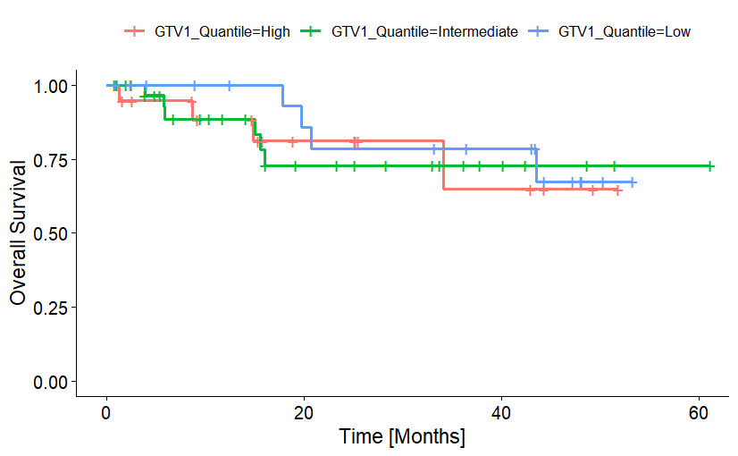

**Figure S1:** Kaplan–Meier plot of OS according to absolute GTV1 before radiotherapy. High, intermediate, and low GTV1 referring to the 25 and 75% quantiles.

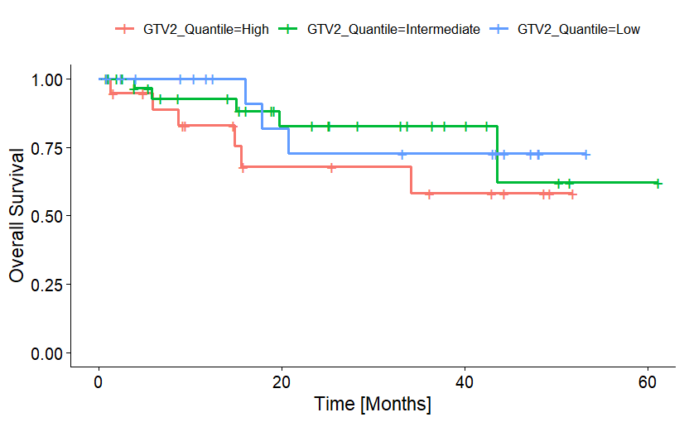

**Figure S2:** Kaplan–Meier plot of OS according to absolute GTV2 before radiotherapy boost. High, intermediate, and low GTV2 referring to the 25 and 75% quantiles.

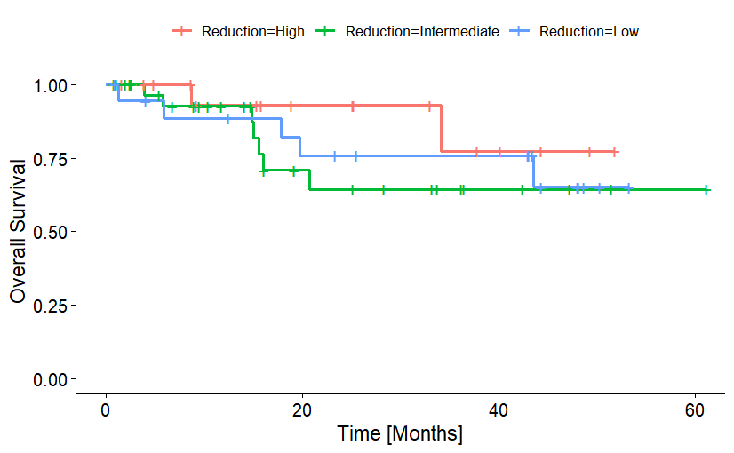

**S3:** Kaplan–Meier plot of OS according to relative GTV change during radiotherapy (from GTV1 to GTV2). Low, intermediate, and high GTV decrease referring to the 25 and 75% quantiles.

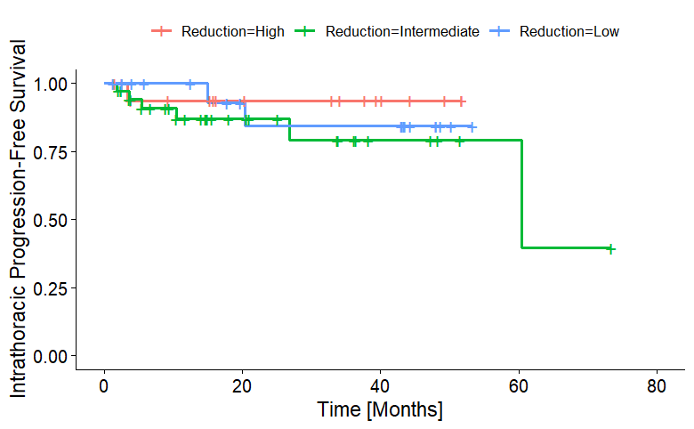

**S4:** Intrathoracic Progression-Free Survival of durvalumab treated patients, stratified according to absolute tumor volume reduction.

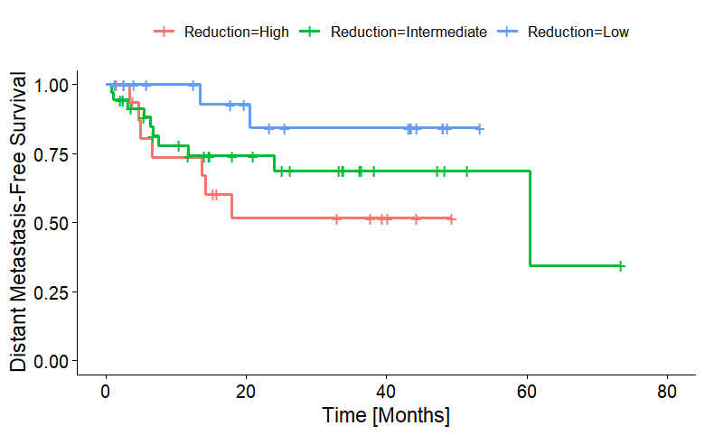

**S5:** Distant Metastasis-Free Survival for Patients treated with durvalumab, stratified according to absolute tumor volume reduction.