Supplemental Material

**Microbial diversity in homes and the risk of allergic rhinitis and inhalant atopy in two European birth cohorts**

Heidi Hyytiäinen, Pirkka V. Kirjavainen,Martin Täubel,Pauli Tuoresmäki, Lidia Casas, Joachim Heinrich, Gunda Herberth, Marie Standl, Harald Renz, Eija Piippo-Savolainen, Anne Hyvärinen, Juha Pekkanen, and Anne M. Karvonen

Contents

Figure S1. 2

Figure S2. 3

Figure S3. 4

Table S1. 5

Table S2. 6

Table S3. 7

Table S4. 8

Table S5. 9

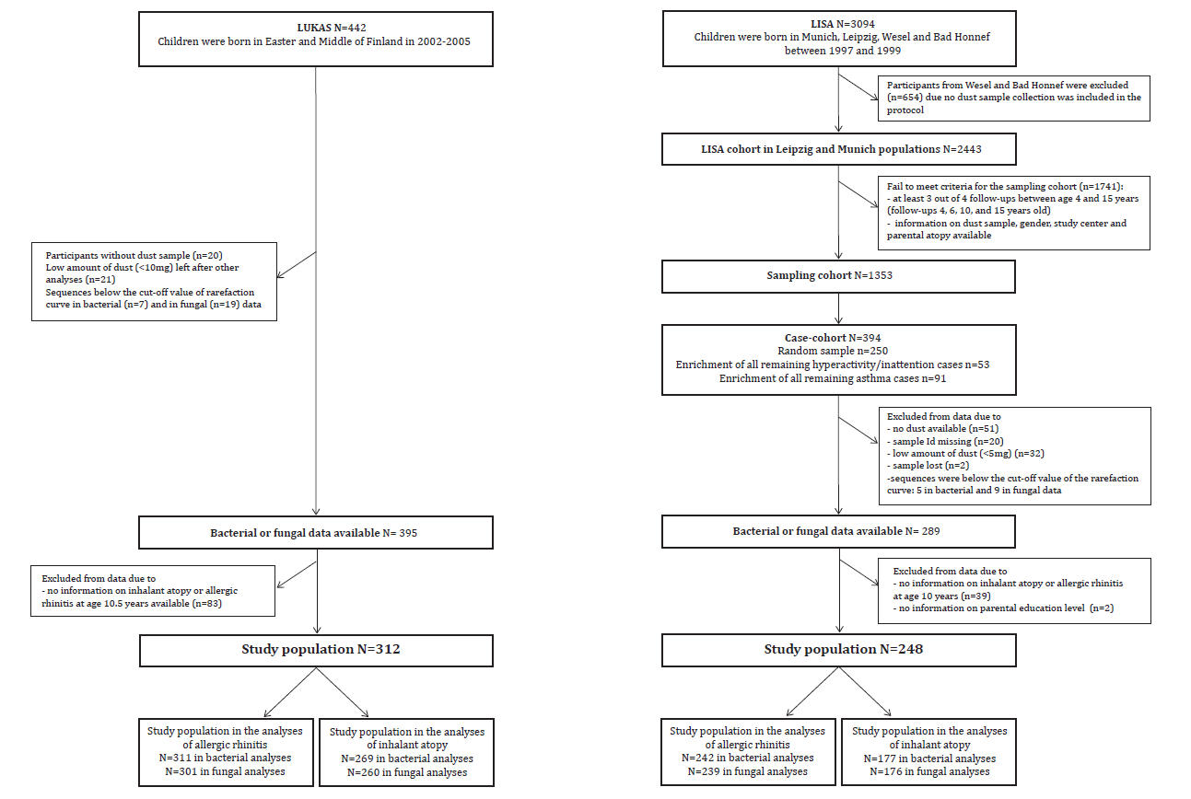

Figure S1. Flow charts of LUKAS and LISA cohorts.

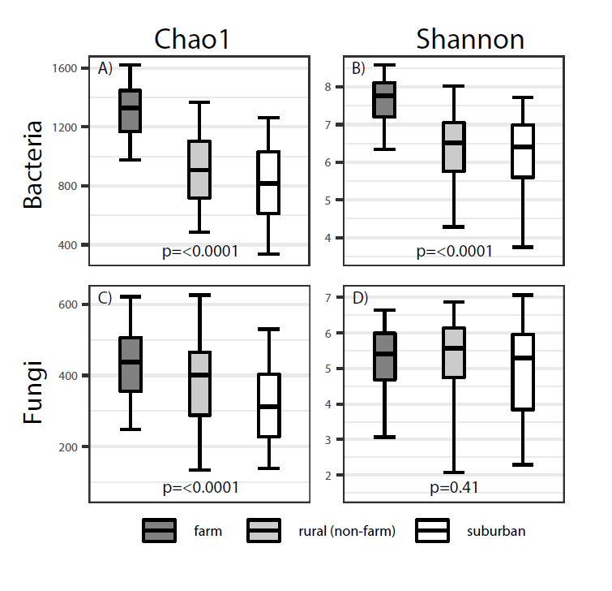

Figure S2. The levels of bacterial and fungal richness and Shannon entropy in three living environments.

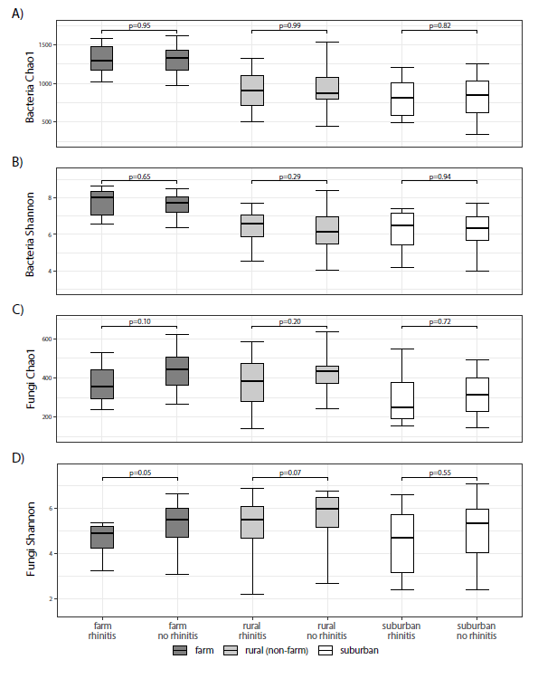

Figure S3. Comparison between bacterial and fungal richness and Shannon entropy in homes of allergic rhinitis and non-allergic rhinitis children in the LUKAS cohort.

Table S1. Prevalence of inhalant atopy and sensitization against specific allergens in two cohorts at the age of 10 years using different cut-offs.



The number of observations: 270 and 181 in LUKAS and LISA, respectively.

Table S2. Percentiles of the bacterial and fungal richness and Shannon entropy in all dust samples in LUKAS and LISA cohorts.



The number of observations in bacterial and fungal data in LUKAS were 395 and 382; and respectively in LISA 284 and 280.

Table S3. Comparison between richness and Shannon entropy in two locations of the home in LISA.



P-values are from paired T-test, and r defines the correlation coefficient from Spearman correlation. The numbers of observations were 120 in bacterial and 119 in fungal data sets.

Table S4. Comparisons between bacterial and fungal richness and Shannon entropy in homes of children with and without allergic rhinitis or the homes of children with or without inhalant atopy in the LUKAS and LISA cohorts.



p-values for comparisons between richness and Shannon entropy in house dust of allergic rhinitis and non-allergic rhinitis children or inhalant atopic and non-inhalant atopic children are from Mann-Whitney U and weighted Mann-Whitney-U-tests in LUKAS and LISA, respectively.

Table S5. Adjusted associations between bacterial and fungal diversity indices and rhinoconjunctivitis at the age of 10 years in LUKAS and LISA cohorts.



N numbers of observations in a class, and % percentage of observations of the outcome in a class. Weighted frequencies presented in LISA. aOR adjusted odds ratios, (95%CI) their 95% confidence intervals and p-values are from adjusted logistic and weighted logistic regression models in LUKAS and LISA, respectively. Models are adjusted for maternal education, cohort, living on a farm, gender, parental history of allergic diseases, older siblings, season for dust sampling and the number of different pet species at home in LUKAS; and for parental education, gender, the history of parental allergic diseases, center, older siblings, mother age at birth and season for dust sampling in LISA.