Appendix: *Exposure to surrounding greenness and natural-cause and cause-specific mortality in the ELAPSE Pooled Cohort*

**Table of contents**

Section 1: Characteristics of each of the eight cohorts and the study population

Section 2: Distribution and definition of physical activity across (sub)cohorts

Section 3: Evaluation of spatial stability of NDVI surfaces across years

Section 4: Supplementary tables

Table S1: AIC values for the non-linear and linear models for natural and cardiovascular mortality in the main model.

Table S2: Population weighted mean from all cohort-specific Spearman correlations between NDVI and the additional exposures.

Table S3: Spearman correlation matrices per (sub)cohort between NDVI and additional exposures.

Table S4: Main models with increasing level of adjustment.

Table S5: Multi-exposure analyses for natural and cause-specific mortality.

Table S6: Effect modification by age at baseline, smoking, air pollution, traffic-noise, neighborhood mean income, BMI, urbanicity and education level. Associations in cohorts with positive or negative correlations between NDVI exposures and area-level income.

Table S7: Sensitivity analyses for documentation potential selection bias.

Table S8: Sensitivity analyses including additional covariates with limited information.

Table S9: Checking for Proportional Hazard assumption for smoking status and marital status.

Table S10: Sensitivity analyses excluding specific cohorts.

Table S11: Sensitivity analyses with restricted follow-up period

Section 5: Supplementary figures

Figure S1: Natural spline models with 3df for NDVI and natural and cardiovascular mortality.

Figure S2: Box plots of NDVI exposure in the pooled cohort.

Figure S3: Distribution of NDVI across BMI categories in the pooled cohort.

Figure S4: Distribution of NDVI across BMI categories for each individual (sub) cohort.

Figure S5: Effect modification by BMI, education level, neighborhood mean income, traffic-noise and levels of NO2 and PM2.5 .

# Section 1: CHARACTERISTICS OF THE INCLUDED COHORTS

**CEANS** (Cardiovascular Effects of Air Pollution and Noise in Stockholm)

|  |  |  |  |  |  |  |  |  |  |  |  |  |  |
| --- | --- | --- | --- | --- | --- | --- | --- | --- | --- | --- | --- | --- | --- |
|  |  |  |  | **CEANS, sub-cohorts** | | | | | | | | | |
| Variable | | | | Total | | SALT | | SDPP | | SIXTY | | SNAC-K | |
|  |  |  |  |  |  |  |  |  |  |  |  |  |  |
| Baseline year, range | | | | 1992-2004 | | 1998-2003 | | 1992-1998 | | 1997-1999 | | 2001-2004 | |
| Total population, Na | | | | 21,987 | | 6,724 | | 7,835 | | 4,180 | | 3,248 | |
| Population with exposure information, N | | | | 21,986 | | 6,724 | | 7,835 | | 4,180 | | 3,247 | |
| Missing on covariatesb | | | | 978 | | 449 | | 85 | | 211 | | 233 | |
| Included, N | | | | 21,008 | | 6,275 | | 7,750 | | 3,969 | | 3,014 | |
| Age at baseline (years) (mean/SD) | | | | 57 (12) | | 58 (11) | | 47 (5) | | 60 (0) | | 74 (11) | |
| NDVI 300-m (mean/SD) | | | | 0.27 (0.11) | | 0.27 (0.09) | | 0.32 (0.07) | | 0.28 (0.09) | | 0.12 (0.1) | |
| NDVI 1-km (mean/SD) | | | | 0.28 (0.09) | | 0.28 (0.08) | | 0.33 (0.05) | | 0.28 (0.08) | | 0.13 (0.06) | |
| Women, N (%) | | | | 12,236 (58) | | 3,492(56) | | 4,742 (61) | | 2,068 (52) | | 1,934 (64) | |
| Unemployed, N (%) | | | | 6,613 (31) | | 2,260 (36) | | 714 (9) | | 1,283 (32) | | 2,256 (78) | |
| Marital status, N (%) | | | |  | |  | |  | |  | |  | |
| Single | | | | 2,838 (14) | | 885(14) | | 1,274 (16) | | 182 (5) | | 497 (16) | |
| Married | | | | 14,961 (71) | | 4,228 (67) | | 6,476 (84) | | 2,933 (74) | | 1,324 (44) | |
| Divorced | | | | 1,763 (8) | | 706 (11) | | - | | 650 (16) | | 407 (14) | |
| Widowed | | | | 1,446 (7) | | 456 (7) | | - | | 204 (5) | | 786 (26) | |
| Smoking status, N (%) | | | |  | |  | |  | |  | |  | |
| Never | | | | 8,837 (42) | | 2,861 (44) | | 1,607 (40) | | 1,628 (40) | | 1,484 (49) | |
| Former | | | | 7,532 (36) | | 2,353 (36) | | 1,523 (38) | | 1,565 (39) | | 1,113 (37) | |
| Current | | | | 4,639 (22) | | 1,340 (20) | | 839 (21) | | 863 (21) | | 417 (14) | |
| Smoking intensity, g/day mean (SD)c | | | | 13.1 (7.7) | | 12.7 (8) | | 13.5 (7.4) | | 13.4 (7.6) | | 11.6 (8.2) | |
| Smoking duration, years mean (SD)c | | | | 33.7 (11.1) | | 43.8 (13.8) | | 27.9 (8.6) | | 36.3 (9.9) | | 43.8 (13.8) | |
| Neighborhood incomed, mean (SD)d | | | | 25.3 (5.6) | | 25.3 (6.6) | | 24.3 (4.2) | | 24.7 (6.9) | | 28.6 (2.2) | |
| Abbreviations: NDVI, Normalized Difference Vegetation Index. | | | | | | | | | | | | | |
| aNumber of subjects for which information was transferred to Utrecht University for construction of the pooled cohort | | | | | | | | | | | | | |
| bMain model 3: age, sex, year of baseline visit, smoking status, duration, intensity, intensity2, marital status, employment status and 2001 mean income at neighborhood level. | | | | | | | | | | | | | |
| cAmong current smokers. | | | | | | | | | | | | | |
| dEUR per 1,000-year 2001. Neighborhood defined as municipality. | | | | | | | | | | | | | |

|  |  |  |  |  |  |  |  |  |  |  |  |
| --- | --- | --- | --- | --- | --- | --- | --- | --- | --- | --- | --- |
| **DCH** (Diet, Cancer and Health) | | | | | | | | | | | |
|  |  |  |  |  |  |  |  |  |  | **DCH** | |
| Variable | | | |  |  |  |  |  |  | Total | |
|  |  |  |  |  |  |  |  |  |  |  | |
| Baseline year, range | | | |  |  |  |  |  |  | 1993-1997 | |
| Total population, Na | | | |  |  |  |  |  |  | 56,308 | |
| Population with exposure information, N | | | |  |  |  |  |  |  | 56,308 | |
| Missing on covariatesb | | | |  |  |  |  |  |  | 2,623 | |
| Included, N | | | |  |  |  |  |  |  | 53,685 | |
| Age at baseline (years) (mean/SD) | | | |  |  |  |  |  |  | 57 (4) | |
| NDVI 300-m (mean/SD) | | | |  |  |  |  |  |  | 0.28 (0.07) | |
| NDVI 1-km (mean/SD) | | | |  |  |  |  |  |  | 0.28 (0.06) | |
| Women, N (%) | | | |  |  |  |  |  |  | 28,156 (52) | |
| Unemployed, N (%) | | | |  |  |  |  |  |  | 11,661 (22) | |
| Marital status, N (%) | | | |  |  |  |  |  |  |  |  |
| Single | | | |  |  |  |  |  |  | 3,247 (6) | |
| Married | | | |  |  |  |  |  |  | 38,407 (72) | |
| Divorced | | | |  |  |  |  |  |  | 9,062 (17) | |
| Widowed | | | |  |  |  |  |  |  | 2,969 (6) | |
| Smoking status, N (%) | | | |  |  |  |  |  |  |  | |
| Never | | | |  |  |  |  |  |  | 19,238 (36) | |
| Former | | | |  |  |  |  |  |  | 14,977 (28) | |
| Current | | | |  |  |  |  |  |  | 19,470 (36) | |
| Smoking intensity, g/day mean (SD)c | | | |  |  |  |  |  |  | 16.4 (9) | |
| Smoking duration, years mean (SD)c | | | |  |  |  |  |  |  | 36.3 (7.7) | |
| Neighborhood income, mean (SD)d | | | |  |  |  |  |  |  | 20.2 (3.4) | |
| Abbreviations: NDVI, Normalized Vegetation Index. | | | | | | | | | | | |
| aNumber of subjects for which information was transferred to Utrecht University for construction of the pooled cohort | | | | | | | | | | | |
| bMain model 3: age, sex, year of baseline visit, smoking status, duration, intensity, intensity2, marital status, employment status and 2001 mean income at neighborhood level. | | | | | | | | | | | |
| cAmong current smokers. | | | | | | | | | | | |
| dEUR per 1,000-year 2001. Neighborhood defined as municipality. | | | | | | | | | | | |

**DNC** (Danish Nurse Cohort)

|  |  |  |  |  |  |  |  |  |  |  |
| --- | --- | --- | --- | --- | --- | --- | --- | --- | --- | --- |
|  |  |  |  | **DNC, (sub) cohorts** | | | | | | |
| Variable | | | |  | Total | | 1993 | | 1999 | |
|  |  |  |  |  |  |  |  |  |  |  |
| Baseline year, range | | | |  | 1993-1999 | | 1993 | | 1999 | |
| Total population, Na | | | |  | 28,433 | | 19,664 | | 8,769 | |
| Population with exposure information, N | | | |  | 28,433 | | 19,664 | | 8,769 | |
| Missing on covariatesb | | | |  | 3,110 | | 2,503 | | 607 | |
| Included, N | | | |  | 25,323 | | 17,161 | | 8,162 | |
| Age at baseline (years) (mean/SD) | | | |  | 54 (8) | | 56 (8) | | 48 (4) | |
| NDVI 300-m (mean/SD) | | | |  | 0.29 (0.07) | | 0.29 (0.07) | | 0.30 (0.07) | |
| NDVI 1-km (mean/SD) | | | |  | 0.30 (0.06) | | 0.29 (0.06) | | 0.30 (0.06) | |
| Women, N (%) | | | |  | 25,323 (100) | | 17,161 (100) | | 8,162 (100) | |
| Unemployed, N (%) | | | |  | 5,608 (22) | | 5,171 (30) | | 437 (5) | |
| Marital status, N (%) | | | |  |  | |  | |  | |
| Single | | | |  | 2,587 (10) | | 1,825 (11) | | 762 (9) | |
| Married | | | |  | 17,785 (70) | | 11,601 (68) | | 6,184 (76) | |
| Divorced | | | |  | 3,169 (13) | | 2,118 (12) | | 1,051 (13) | |
| Widowed | | | |  | 1,782 (7) | | 1,617 (9) | | 165 (2) | |
| Smoking status, N (%) | | | |  |  | |  | |  | |
| Never | | | |  | 9,002 (36) | | 5,830 (34) | | 3,172 (39) | |
| Former | | | |  | 7,572 (30) | | 4,912 (29) | | 2,660 (33) | |
| Current | | | |  | 8,749 (34) | | 6,419 (37) | | 2,330 (29) | |
| Smoking intensity, g/day mean (SD)c | | | |  | 13.7 (8) | | 13.9 (8.2) | | 13.3 (7.3) | |
| Smoking duration, years mean (SD)c | | | |  | 30.4 (9.5) | | 31.6 (9.9) | | 27.1 (7.1) | |
| Neighborhood income, mean (SD)d | | | |  | 19.1 (2.5) | | 19.2 (2.6) | | 19.0 (2.4) | |
| Abbreviations: NDVI, Normalized Vegetation Index. | | | | | | | | | | |
| aNumber of subjects for which information was transferred to Utrecht University for construction of the pooled cohort | | | | | | | | | | |
| bMain model 3: age, sex, year of baseline visit, smoking status, duration, intensity, intensity2, marital status, employment status and 2001 mean income at neighborhood level. | | | | | | | | | | |
| cAmong current smokers. | | | | | | | | | | |
| dEUR per 1,000-year 2001. Neighborhood defined as municipality. | | | | | | | | | | |

**EPIC-NL** (European Prospective Investigation into Cancer and Nutrition, the Netherlands)

|  |  |  |  |  |  |  |  |  |  |  |  |  |  |
| --- | --- | --- | --- | --- | --- | --- | --- | --- | --- | --- | --- | --- | --- |
|  |  |  |  |  |  |  |  | **EPIC-NL, (sub) cohorts** | | | | | |
| Variable | | | |  | |  | | Total | | MORGEN | | PROSPECT | |
|  |  |  |  |  |  |  |  |  |  |  |  |  |  |
| Baseline year, range | | | |  | |  | | 1993-1997 | | 1993-1997 | | 1993-1997 | |
| Total population, Na | | | |  | |  | | 36,905 | | 20,711 | | 16,194 | |
| Population with exposure information, N | | | |  | |  | | 36,876 | | 20,683 | | 16,193 | |
| Missing on covariatesb | | | |  | |  | | 3,985 | | 2,376 | | 1,609 | |
| Included, N | | | |  | |  | | 32,891 | | 18,307 | | 14,584 | |
| Age at baseline (years) (mean/SD) | | | |  | |  | | 49 (12) | | 43 (11) | | 58 (6) | |
| NDVI 300-m (mean/SD) | | | |  | |  | | 0.35 (0.09) | | 0.34 (0.09) | | 0.35 (0.09) | |
| NDVI 1-km (mean/SD) | | | |  | |  | | 0.36 (0.08) | | 0.36 (0.09) | | 0.36 (0.08) | |
| Women, N (%) | | | |  | |  | | 24,647 (75) | | 10,063 (55) | | 14,584 (100) | |
| Unemployed, N (%) | | | |  | |  | | 12,900 (39) | | 5,725 (31) | | 7,175(49) | |
| Marital status, N (%) | | | |  | |  | |  | |  | |  | |
| Single | | | |  | |  | | 5,470 (17) | | 4,632 (25) | | 838 (6) | |
| Married | | | |  | |  | | 23,115 (70) | | 11,927 (65) | | 11,188 (77) | |
| Divorced | | | |  | |  | | 2,554 (8) | | 1,381 (8) | | 1,173 (8) | |
| Widowed | | | |  | |  | | 1,752 (5) | | 367 (2) | | 1,385 (9) | |
| Smoking status, N (%) | | | |  | |  | |  | |  | |  | |
| Never | | | |  | |  | | 13,234 (40) | | 6,790 (37) | | 6,444 (44) | |
| Former | | | |  | |  | | 9,959 (30) | | 5,157 (28) | | 4,802 (33) | |
| Current | | | |  | |  | | 9,698 (30) | | 6,360 (35) | | 3,338(23) | |
| Smoking intensity, g/day mean (SD)c | | | |  | |  | | 15 (8.7) | | 15.7 (8.6) | | 13.7 (8.7) | |
| Smoking duration, years mean (SD)c | | | |  | |  | | 28.9 (11.2) | | 28.9 (11.2) | | 36.8 (7.6) | |
| Neighborhood income, mean (SD)d | | | |  | |  | | 12.6 (1.6) | | 12.2 (1.6) | | 13.1 (1.4) | |
| Abbreviations: NDVI, Normalized Vegetation Index. | | | | | | | | | | | | | |
| aNumber of subjects for which information was transferred to Utrecht University for construction of the pooled cohort | | | | | | | | | | | | | |
| bMain model 3: age, sex, year of baseline visit, smoking status, duration, intensity, intensity2, marital status, employment status and 2001 mean income at neighborhood level. | | | | | | | | | | | | | |
| cAmong current smokers. | | | | | | | | | | | | | |
| dEUR per 1,000-year 2001. Neighborhood defined as a neighborhood of a larger city. | | | | | | | | | | | | | |

**HNR** (Heinz Nixdorf Recall study)

|  |  |  |  |  |  |  |  |  |  |  |  |
| --- | --- | --- | --- | --- | --- | --- | --- | --- | --- | --- | --- |
|  |  |  |  |  |  |  |  |  |  | **HNR** | |
| Variable | | | |  |  |  |  |  |  | Total | |
|  |  |  |  |  |  |  |  |  |  |  |  |
| Baseline year, range | | | |  |  |  |  |  |  | 2000-2003 | |
| Total population, Na | | | |  |  |  |  |  |  | 4,809 | |
| Population with exposure information, N | | | |  |  |  |  |  |  | 4,809 | |
| Missing on covariatesb | | | |  |  |  |  |  |  | 53 | |
| Included, N | | | |  |  |  |  |  |  | 4,756 | |
| Age at baseline (years) (mean/SD) | | | |  |  |  |  |  |  | 60 (8) | |
| NDVI 300-m (mean/SD) | | | |  |  |  |  |  |  | 0.30 (0.06) | |
| NDVI 1-km (mean/SD) | | | |  |  |  |  |  |  | 0.31 (0.04) | |
| Women, N (%) | | | |  |  |  |  |  |  | 2,394 (50) | |
| Unemployed, N (%) | | | |  |  |  |  |  |  | 2,852 (60) | |
| Marital status, N (%) | | | |  |  |  |  |  |  |  | |
| Single | | | |  |  |  |  |  |  | 277 (6) | |
| Married | | | |  |  |  |  |  |  | 3,553 (75) | |
| Divorced | | | |  |  |  |  |  |  | 474 (10) | |
| Widowed | | | |  |  |  |  |  |  | 452 (10) | |
| Smoking status, N (%) | | | |  |  |  |  |  |  |  | |
| Never | | | |  |  |  |  |  |  | 2,011 (42) | |
| Former | | | |  |  |  |  |  |  | 1,626 (34) | |
| Current | | | |  |  |  |  |  |  | 1,119 (24) | |
| Smoking intensity, g/day mean (SD)c | | | |  |  |  |  |  |  | 18.6 (12.1) | |
| Smoking duration, years mean (SD)c | | | |  |  |  |  |  |  | 34.5 (9.4) | |
| Neighborhood income, mean (SD)d | | | |  |  |  |  |  |  | 25.2 (8.2) | |
| Abbreviations: NDVI, Normalized Vegetation Index. | | | | | | | | | | | |
| aNumber of subjects for which information was transferred to Utrecht University for construction of the pooled cohort | | | | | | | | | | | |
| bMain model 3: age, sex, year of baseline visit, smoking status, duration, intensity, intensity2, marital status, employment status and 2001 mean income at neighborhood level. | | | | | | | | | | | |
| cAmong current smokers. | | | | | | | | | | | |
| dEUR PER 1,000-year 2001. Neighborhood defined as city district. | | | | | | | | | | | |

**E3N** (Etude Epidémiologique auprès de femmes de la Mutuelle Générale de l'Education Nationale)

|  |  |  |  |  |  |  |  |  |  |  |  |
| --- | --- | --- | --- | --- | --- | --- | --- | --- | --- | --- | --- |
|  |  |  |  |  |  |  |  |  |  | **E3N** | |
| Variable | | | |  |  |  |  |  |  | Total | |
|  |  |  |  |  |  |  |  |  |  |  |  |
| Baseline year, range | | | |  |  |  |  |  |  | 1989-1991 | |
| Total population, Na | | | |  |  |  |  |  |  | 53,521 | |
| Population with exposure information, N | | | |  |  |  |  |  |  | 52,917 | |
| Missing on covariatesb | | | |  |  |  |  |  |  | 12,307 | |
| Included, N | | | |  |  |  |  |  |  | 40,610 | |
| Age at baseline (years) (mean/SD) | | | |  |  |  |  |  |  | 53 (7) | |
| NDVI 300-m (mean/SD) | | | |  |  |  |  |  |  | 0.41 (0.12) | |
| NDVI 1-km (mean/SD) | | | |  |  |  |  |  |  | 0.40 (0.13) | |
| Women, N (%) | | | |  |  |  |  |  |  | 40,610 (100) | |
| Unemployed, N (%) | | | |  |  |  |  |  |  | 13,133 (32) | |
| Marital status, N (%) | | | |  |  |  |  |  |  |  | |
| Single | | | |  |  |  |  |  |  | 6,821 (17) | |
| Married | | | |  |  |  |  |  |  | 33,789 (83) | |
| Divorced | | | |  |  |  |  |  |  | - | |
| Widowed | | | |  |  |  |  |  |  | - | |
| Smoking status, N (%) | | | |  |  |  |  |  |  |  | |
| Never | | | |  |  |  |  |  |  | 27,587 (68) | |
| Former | | | |  |  |  |  |  |  | 7,764 (19) | |
| Current | | | |  |  |  |  |  |  | 5,259 (13) | |
| Smoking intensity, g/day mean (SD)c | | | |  |  |  |  |  |  | 11.4 (9.2) | |
| Smoking duration, years mean (SD)c | | | |  |  |  |  |  |  | 28.7 (7.6) | |
| Neighborhood income, mean (SD)d | | | |  |  |  |  |  |  | 11.2 (3.0) | |
| Abbreviations: NDVI, Normalized Vegetation Index. | | | | | | | | | | | |
| aNumber of subjects for which information was transferred to Utrecht University for construction of the pooled cohort | | | | | | | | | | | |
| bMain model 3: age, sex, year of baseline visit, smoking status, duration, intensity, intensity2, marital status, employment status and 2001 mean income at neighborhood level. | | | | | | | | | | | |
| cAmong current smokers. | | | | | | | | | | | |
| dEUR per 1,000-year 2001. Neighborhood defined as IRIS – a small administrative unit of a city. | | | | | | | | | | | |

**VHM&PP** (Vorarlberg Health Monitoring and Prevention Programme)

|  |  |  |  |  |  |  |  |  |  |  |  |
| --- | --- | --- | --- | --- | --- | --- | --- | --- | --- | --- | --- |
|  |  |  |  |  |  |  |  |  |  | **VHM&PP** | |
| Variable | | | |  |  |  |  |  |  | Total | |
|  |  |  |  |  |  |  |  |  |  |  |  |
| Baseline year, range | | | |  |  |  |  |  |  | 1985-2005 | |
| Total population, Na | | | |  |  |  |  |  |  | 170,250 | |
| Population with exposure information, N | | | |  |  |  |  |  |  | 169,854 | |
| Missing on covariatesb | | | |  |  |  |  |  |  | 25,645 | |
| Included, N | | | |  |  |  |  |  |  | 144,209 | |
| Age at baseline (years) (mean/SD) | | | |  |  |  |  |  |  | 42 (15) | |
| NDVI 300-m (mean/SD) | | | |  |  |  |  |  |  | 0.33 (0.06) | |
| NDVI 1-km (mean/SD) | | | |  |  |  |  |  |  | 0.35 (0.05) | |
| Women, N (%) | | | |  |  |  |  |  |  | 81,023 (56) | |
| Unemployed, N (%) | | | |  |  |  |  |  |  | 43,617 (30) | |
| Marital status, N (%) | | | |  |  |  |  |  |  |  | |
| Single | | | |  |  |  |  |  |  | 24,834 (17) | |
| Married | | | |  |  |  |  |  |  | 99,408 (69) | |
| Divorced | | | |  |  |  |  |  |  | 9,762 (7) | |
| Widowed | | | |  |  |  |  |  |  | 10,205 (7) | |
| Smoking status, N (%) | | | |  |  |  |  |  |  |  | |
| Never | | | |  |  |  |  |  |  | 106,343 (74) | |
| Former | | | |  |  |  |  |  |  | 8,995 (6) | |
| Current | | | |  |  |  |  |  |  | 28,871 (20) | |
| Smoking intensity, g/day mean (SD)c | | | |  |  |  |  |  |  | 15.6 (8.9) | |
| Smoking duration, years mean (SD)c | | | |  |  |  |  |  |  | 13.4 (8.3) | |
| Neighborhood income, mean (SD)d | | | |  |  |  |  |  |  | 22.9 (1.7) | |
| Abbreviations: NDVI, Normalized Vegetation Index. | | | | | | | | | | | |
| aNumber of subjects for which information was transferred to Utrecht University for construction of the pooled cohort | | | | | | | | | | | |
| bMain model 3: age, sex, year of baseline visit, smoking status, duration, intensity, intensity2, marital status, employment status and 2001 mean income at neighborhood level. | | | | | | | | | | | |
| cAmong current smokers. | | | | | | | | | | | |
| dEUR per 1,000-year 2001. Neighborhood defined as municipality. | | | | | | | | | | | |

**KORA** (Kooperative Gesundheitsforschung in der Region Augsburg)

|  |  |  |  |  |  |  |  |  |  |  |  |  |  |
| --- | --- | --- | --- | --- | --- | --- | --- | --- | --- | --- | --- | --- | --- |
|  |  |  |  |  |  |  |  | **KORA, (sub) cohorts** | | | | | |
| Variable | | | |  | |  | | Total | | S3 | | S4 | |
|  |  |  |  |  |  |  |  |  |  |  |  |  |  |
| Baseline year, range | | | |  | |  | | 1994-2001 | | 1994-1995 | | 1999-2001 | |
| Total population, Na | | | |  | |  | | 8,823 | | 4,566 | | 4,257 | |
| Population with exposure information, N | | | |  | |  | | 8,813 | | 4,556 | | 4,257 | |
| Missing on covariatesb | | | |  | |  | | 3,907 | | 1,953 | | 1,954 | |
| Included, N | | | |  | |  | | 4,906 | | 2,603 | | 2,303 | |
| Age at baseline (years) (mean/SD) | | | |  | |  | | 49(14) | | 50 (14) | | 49 (14) | |
| NDVI 300-m (mean/SD) | | | |  | |  | | 0.28 (0.06) | | 0.28 (0.05) | | 0.28 (0.06) | |
| NDVI 1-km (mean/SD) | | | |  | |  | | 0.30 (0.05) | | 0.30 (0.05) | | 0.30 (0.06) | |
| Women, N (%) | | | |  | |  | | 2,514 (51) | | 1,328 (51) | | 1,186 (51) | |
| Unemployed, N (%) | | | |  | |  | | 2,111 (43) | | 1,174 (45) | | 937 (41) | |
| Marital status, N (%) | | | |  | |  | |  | |  | |  | |
| Single | | | |  | |  | | 413 (8) | | 228 (9) | | 185 (8) | |
| Married | | | |  | |  | | 3,913 (80) | | 2,086 (80) | | 1,827 (79) | |
| Divorced | | | |  | |  | | 259 (5) | | 108 (4) | | 151 (7) | |
| Widowed | | | |  | |  | | 321 (7) | | 181 (7) | | 140 (6) | |
| Smoking status, N (%) | | | |  | |  | |  | |  | |  | |
| Never | | | |  | |  | | 2,381 (49) | | 1,334 (51) | | 1,037 (45) | |
| Former | | | |  | |  | | 1,474 (30) | | 748 (29) | | 726 (32) | |
| Current | | | |  | |  | | 1,051 (21) | | 521 (20) | | 530 (23) | |
| Smoking intensity, g/day mean (SD)c | | | |  | |  | | 16.1 (9.6) | | 16.5 (9.5) | | 15.8 (9.6) | |
| Smoking duration, years mean (SD)c | | | |  | |  | | 24.7 (11.8) | | 25.2 (12.1) | | 24.2 (11.5) | |
| Neighborhood income, mean(SD)d | | | |  | |  | | 37.3 (5.9) | | 36.7 (4.4) | | 38.0 (7.3) | |
| Abbreviations: NDVI, Normalized Vegetation Index. | | | | | | | | | | | | | |
| aNumber of subjects for which information was transferred to Utrecht University for construction of the pooled cohort | | | | | | | | | | | | | |
| bMain model 3: age, sex, year of baseline visit, smoking status, duration, intensity, intensity2, marital status, employment status and 2001 mean income at neighborhood level. | | | | | | | | | | | | | |
| cAmong current smokers. | | | | | | | | | | | | | |
| dEUR per 1,000-year 2001. Neighborhood defined as IRIS – a small administrative unit of a city. | | | | | | | | | | | | | |

# Section 2: DISTRIBUTION AND DEFINITION OF PHYSICAL ACTIVITY

In the ELAPSE pooled cohort, physical activity variable was based on monthly or weekly basis depending on the cohort and it was classified as low (once a month or less AND less than 1h/week), medium (about once a week AND around 1h/week) and high (3 times a week or more AND more than 2h/week). Information from DCH, HNR, CEANS, DNC, KORA and, E3N cohorts was available.

In this study, we additionally harmonized the physical activity data from the EPIC-NL cohort as this was not yet included in the ELAPSE pooled cohort dataset. The variable with most available information on the level of physical activity in the EPIC-NL cohort was named CPAIIMP and consisted of 4 categories: active, moderately active, moderately inactive, and inactive (Table A). To harmonize with the ELAPSE pooled cohort, we combined the “inactive” and “moderately inactive” categories, thus creating three categories as in the rest of the (sub) cohorts.

**Table A.** Distribution of the original CPAIIMP variable from the EPIC-NL cohort.

|  |  |  |
| --- | --- | --- |
| **CPAIIMP** | **Frequency** | **Percent** |
| Active | 16,542 | 41.34 |
| Moderately Active | 10,338 | 25.84 |
| Moderately inactive | 9,942 | 24.85 |
| Inactive | 3,189 | 7.97 |

**Figure A.** Distribution of physical activity across individual (sub)cohorts from the ELAPSE pooled cohort.

**Table B.** Definition and distribution of the physical activity across (sub) cohorts in the ELAPSE pooled cohort.

|  |  |  |  |  |
| --- | --- | --- | --- | --- |
| Study | Observations | Age (years) | Physical activity definition | Distribution |
| DCH | 55,765 | 57 ± 4 | Leisure time sports activities. Averaged over Winter and Summer/hours per week. | **1 (low) 45%**  2(medium) 25%  3 (high) 29% |
| HNR | 4,646 | 59 ± 8 | Frequency of units of sport in a typical week. Working in the garden and going for a walk were missing. | **1 (low) 52%**  2 (medium) 17%  3 (high) 28% |
| CEANS | 21,205 | 57 ± 12 | No definition available. | **1 (low) 61%**  2 (medium) 27%  3 (high) 8% |
| DNC | 28,366 | 54 ± 8 | - Low: sedentary activities.  - Medium: light exercise at least 4 hours per week (Sunday outings, light gardening  and cycling/walking to work).  - High: heavy exercise (train hard and participate in competitive sports regularly and heavy gardening at least 4 hours per week). | 1 (low) 7%  **2 (medium) 66%**  3 (high) 26% |
| KORA | 9,095 | 49 ± 14 | - Low: rarely or no physical activity  - Medium: regular or irregular, about 1 hour/week  - High: regular, more than 2 hours/week  Score of physical activity generated out of variables for summer and winter activity. | 1 (low) 38%  **2 (medium) 42%**  3 (high) 20% |
| E3N | 53,507 | 53 ± 7 | Classified according to MET-h/week.  - Low: METs<6  - Medium: 6<METs<12  - High: METs>12 | 1 (low) 9%  2 (medium) 19%  **3 (high) 72%** |
| EPIC-NL | 40,011 | 49 ± 12 | No definition available. Data from the original CPAIIMP variable was harmonized with the physical activity variable. | 1 (low) 33%  2 (medium) 26%  **3 (high) 41%** |

We further unsuccessfully attempted to harmonize the definitions of physical activity across (sub)cohorts, however, this was challenging as the metrics applied to define physical activity differed significantly across (sub) cohorts (Table B). Therefore, we followed an alternative approach and based on the distribution to check the consistency of the variable. Following this criterion, we evaluated whether the distribution of physical activity across (sub) cohorts was comparable or not. We considered that E3N, DNC (1993 and 1999) and EPIC-NL (Prospect and Morgen) cohorts had significantly different distribution compared to the others (Table B, Figure A). Consequently, we decided to conduct analyses of physical activity applying two different approaches:

(a) Including the complete data from all the (sub)cohorts.

(b) Including data from (sub)cohorts with comparable distribution (excluding E3N, DNC and EPIC-NL).

# Section 3: Evaluation of spatial stability of NDVI surfaces across years

We evaluated the spatial stability of NDVI surfaces over time by calculating correlations between NDVI estimates extracted from cohort areas in years 2005, 2010, 2015 and 2020. We used NDVI estimates extracted from the Terra Moderate Resolution Imaging Spectroradiometer (MODIS) Vegetation Indices (MOD13A3), which are provided monthly at 1×1 km spatial resolution. We selected the product with a spatial resolution in between the two spatial scales (300-m grid and 1-km buffer) we applied in the epidemiological analyses. Annual means were calculated as an average of all 12 monthly NDVI estimates in that particular year. Negative NDVI estimates were truncated to zero. The gridded NDVI values were extracted when the center of grids falls within the study areas of the cohorts. As this analysis was a post-hoc analysis, we could not assign these additional NDVI exposures to actual cohort addresses. Correlations of NDVI estimates between years 2005, 2010, 2015 and 2020 were calculated using Band Collection Statistics in ArcGIS at cohort level. Medians of cohort-specific correlations were all above 0.93 (Table C). For each cohort, correlations were high. The lowest correlations (0.70–0.74) were found in the CEANS cohort, based in Stockholm county. The results suggested that the spatial structure of NDVI surfaces is stable over time.

**Table C**. Correlations between NDVI exposures covering study areas in years 2005, 2010, 2015 and 2020

|  |  |  |  |  |
| --- | --- | --- | --- | --- |
| **Cohort** | 2005 | 2010 | 2015 | 2020 |
| ***MEDIAN*** |  |  |  |  |
| *2005* | *1* | *0.94* | *0.94* | *0.93* |
| *2010* | *0.94* | *1* | *0.94* | *0.93* |
| *2015* | *0.94* | *0.94* | *1* | *0.95* |
| *2020* | *0.93* | *0.93* | *0.95* | *1* |
| **CEANS** |  |  |  |  |
| 2005 | 1 | 0.70 | 0.74 | 0.72 |
| 2010 | 0.70 | 1 | 0.71 | 0.71 |
| 2015 | 0.74 | 0.71 | 1 | 0.71 |
| 2020 | 0.72 | 0.71 | 0.71 | 1 |
| **DCH** |  |  |  |  |
| 2005 | 1 | 0.87 | 0.89 | 0.91 |
| 2010 | 0.87 | 1 | 0.88 | 0.88 |
| 2015 | 0.89 | 0.88 | 1 | 0.88 |
| 2020 | 0.91 | 0.88 | 0.88 | 1 |
| **DNC** |  |  |  |  |
| 2005 | 1 | 0.78 | 0.84 | 0.84 |
| 2010 | 0.78 | 1 | 0.78 | 0.78 |
| 2015 | 0.84 | 0.78 | 1 | 0.85 |
| 2020 | 0.84 | 0.78 | 0.85 | 1 |
| **EPIC-NL** |  |  |  |  |
| 2005 | 1 | 0.94 | 0.94 | 0.94 |
| 2010 | 0.94 | 1 | 0.94 | 0.93 |
| 2015 | 0.94 | 0.94 | 1 | 0.96 |
| 2020 | 0.94 | 0.93 | 0.96 | 1 |
| **HNR** |  |  |  |  |
| 2005 | 1 | 0.98 | 0.99 | 0.98 |
| 2010 | 0.98 | 1 | 0.99 | 0.98 |
| 2015 | 0.99 | 0.99 | 1 | 0.98 |
| 2020 | 0.98 | 0.98 | 0.98 | 1 |
| **E3N** |  |  |  |  |
| 2005 | 1 | 0.93 | 0.94 | 0.91 |
| 2010 | 0.93 | 1 | 0.94 | 0.92 |
| 2015 | 0.94 | 0.94 | 1 | 0.95 |
| 2020 | 0.91 | 0.92 | 0.95 | 1 |
| **VHM&PP** |  |  |  |  |
| 2005 | 1 | 0.94 | 0.95 | 0.95 |
| 2010 | 0.94 | 1 | 0.95 | 0.94 |
| 2015 | 0.95 | 0.95 | 1 | 0.95 |
| 2020 | 0.95 | 0.94 | 0.95 | 1 |
| **KORA** |  |  |  |  |
| 2005 | 1 | 0.97 | 0.98 | 0.98 |
| 2010 | 0.97 | 1 | 0.97 | 0.97 |
| 2015 | 0.98 | 0.97 | 1 | 0.99 |
| 2020 | 0.98 | 0.97 | 0.99 | 1 |

# Section 4: Supplementary tables

|  |  |  |  |  |  |  |  |  |
| --- | --- | --- | --- | --- | --- | --- | --- | --- |
| **Table S1**. AIC values for the non-linear models (natural spline functions with three degrees of freedom) and linear models for natural and cardiovascular mortality in the pooled cohort applying the main model approach. | | | | | | | | |
|
|  |  |  |  |  | AIC values | | | |
|  |  |  |  |  | Lineara | Natural Splinesa | | |
| Study population | | Mortality | | Exposure | - | 3 df | | |
| All cohorts (N = 327,388) | | Natural | | NDVI 300m | 831,854 | 831,832 | | |
| NDVI 1km | 831,846 | 831,834 | | |
|  | |  |  |  |  |  |
| Cardiovascular | | NDVI 300m | 793,474 | 793,460 | | |
| NDVI 1km | 793,457 | 793,456 | | |
|  |  |  |  |  |  |  |  |  |
| Abbreviations: AIC, Akaike Information Criterion; df, degrees of freedom.  a Main model: adjusted for age, sex (strata), year of baseline visit, smoking status, duration, intensity, intensity², marital status, employment status, and 2001 mean income at the neighborhood level. | | | | | | | | |

|  |  |  |  |  |  |  |  |  |
| --- | --- | --- | --- | --- | --- | --- | --- | --- |
| **Table S2**. Population weighted mean from all cohort-specific Spearman correlations between the NDVI in the 300-m grid and 1-km buffer, PM2.5, NO2, BMI, Neighborhood Mean Income 2001, traffic-noise, and physical activity among all participants with full information in model 3 (N=327,388). | | | | | | | | |
|
| Exposures | NDVI 300m | NDVI 1km | PM2.5 | NO2 | BMI | Mean Incomea | Traffic- Noise | Physical Activity |
| NDVI 300-m | 1 | 0.73 | -0.29 | -0.48 | 0.00 | -0.07 | -0.31 | 0.02 |
| NDVI 1-km | - | 1 | -0.40 | -0.57 | 0.00 | -0.08 | -0.31 | 0.02 |
| PM2.5 | - | - | 1 | 0.62 | 0.00 | 0.09 | 0.35 | -0.02 |
| NO2 | - | - | - | 1 | -0.01 | 0.22 | 0.50 | 0.00 |
| BMI | - | - | - | - | 1 | -0.05 | 0.01 | -0.08 |
| Mean Incomeb | - | - | - | - | - | 1 | -0.03 | 0.06 |
| Traffic-noise | - | - | - | - | - | - | 1 | -0.05 |
| Physical Activity | - | - | - | - | - | - | - | 1 |
| Abbreviations: NDVI, Normalized Difference Vegetation Index; PM2.5, particulate matter <2.5um; NO2, nitrogen dioxide; BMI, Body Mass Index.  a Neighborhood Mean Income 2001. | | | | | | | | |

|  |  |  |  |  |  |  |  |  |  |  |  |  |  |  |  |  |  |  |
| --- | --- | --- | --- | --- | --- | --- | --- | --- | --- | --- | --- | --- | --- | --- | --- | --- | --- | --- |
| **Table S3**. Spearman correlations per (sub) cohort between the Normalized Difference Vegetation Index (NDVI) in the 300-m grid and 1-km buffer, NO2, PM2.5, BC, O3 (warm season), BMI, Neighborhood Mean Income 2001, traffic-noise, and Physical activity among participants with full information in the main model (N=327,388). | | | | | | | | | | | | | | | | | | |
| Exposure | NDVI 300m | NDVI 1km | PM2.5 | NO2 | BMI | Mean Incomea | Traffic-noise | Physical Activity | |  | NDVI 300m | NDVI 1km | PM2.5 | NO2 | BMI | Mean Incomea | Traffic-noise | Physical Activity |
| **CEANS-SALT** | | | | | | | | | | **DCH** | | | | | | | | |
| NDVI 300m | 1 | 0.78 | -0.34 | -0.58 | 0.03 | 0.09 | -0.52 | 0.02 | | NDVI 300m | 1 | 0.76 | -0.52 | -0.49 | -0.05 | 0.32 | -0.31 | 0.07 |
| NDVI 1km | - | 1 | -0.37 | -0.65 | 0.06 | 0.03 | -0.53 | 0.01 | | NDVI 1km | - | 1 | -0.6 | -0.54 | -0.04 | 0.38 | -0.30 | 0.08 |
| PM2.5 | - | - | 1 | 0.63 | -0.02 | 0.04 | 0.44 | -0.01 | | PM2.5 | - | - | 1 | 0.74 | 0.02 | -0.13 | 0.41 | -0.05 |
| NO2 | - | - | - | 1 | -0.06 | 0.06 | 0.70 | -0.04 | | NO2 | - | - | - | 1 | 0.01 | -0.04 | 0.54 | -0.03 |
| BMI | - | - | - | - | 1 | -0.08 | -0.03 | -0.12 | | BMI | - | - | - | - | 1 | -0.05 | 0.03 | -0.10 |
| Mean Incomea | - | - | - | - | - | 1 | -0.06 | 0.05 | | Mean Incomea | - | - | - | - | - | 1 | -0.06 | 0.12 |
| Traffic-noise | - | - | - | - | - | - | 1 | -0.04 | | Traffic-noise | - | - | - | - | - | - | 1 | -0.06 |
| **CEANS-SDPP** | | | | | | | | | **DNC-1993** | | | | | | | | | |
| NDVI 300m | 1 | 0.61 | -0.12 | -0.36 | -0.01 | 0.24 | -0.28 | 0.01 | | NDVI 300m | 1 | 0.71 | -0.24 | -0.21 | 0 | 0.08 | -0.26 | 0.09 |
| NDVI 1km | - | 1 | -0.08 | -0.37 | 0 | 0.19 | -0.27 | 0.02 | | NDVI 1km | - | 1 | -0.27 | -0.25 | 0.01 | 0.08 | -0.26 | 0.1 |
| PM2.5 | - | - | 1 | 0.6 | 0.01 | 0.06 | 0.22 | 0.01 | | PM2.5 | - | - | 1 | 0.58 | -0.04 | -0.06 | 0.27 | -0.06 |
| NO2 | - | - | - | 1 | -0.01 | 0.02 | 0.55 | 0.01 | | NO2 | - | - | - | 1 | -0.05 | 0.12 | 0.38 | -0.09 |
| BMI | - | - | - | - | 1 | -0.08 | -0.01 | -0.11 | | BMI | - | - | - | - | 1 | -0.02 | 0 | -0.07 |
| Mean Incomea | - | - | - | - | - | 1 | -0.06 | 0.1 | | Mean Incomea | - | - | - | - | - | 1 | 0.05 | 0.01 |
| Traffic-noise | - | - | - | - | - | - | 1 | -0.03 | | Traffic-noise | - | - | - | - | - | - | 1 | -0.08 |

|  |  |  |  |  |  |  |  |  |  |  |  |  |  |  |  |  |  |
| --- | --- | --- | --- | --- | --- | --- | --- | --- | --- | --- | --- | --- | --- | --- | --- | --- | --- |
| Exposure | NDVI 300m | NDVI 1km | PM2.5 | NO2 | BMI | Mean Incomea | Traffic-noise | Physical Activity |  | NDVI 300m | NDVI 1km | PM2.5 | NO2 | BMI | Mean Incomea | Traffic-noise | Physical Activity |
| **CEANS-SIXTY** | | | | | | | | | **DNC-1999** | | | | | | | | |
| NDVI 300m | 1 | 0.78 | -0.36 | -0.58 | 0.01 | 0.07 | -0.5 | 0.05 | NDVI 300m | 1 | 0.71 | -0.11 | -0.08 | -0.01 | 0.04 | -0.27 | 0.06 |
| NDVI 1km | - | 1 | -0.39 | -0.64 | 0.03 | 0.02 | -0.5 | 0.03 | NDVI 1km | - | 1 | -0.15 | -0.11 | 0.02 | 0.05 | -0.26 | 0.06 |
| PM2.5 | - | - | 1 | 0.63 | -0.04 | 0.05 | 0.41 | -0.02 | PM2.5 | - | - | 1 | 0.57 | -0.03 | -0.02 | 0.20 | -0.03 |
| NO2 | - | - | - | 1 | -0.05 | 0.1 | 0.68 | -0.03 | NO2 | - | - | - | 1 | -0.06 | 0.07 | 0.23 | -0.01 |
| BMI | - | - | - | - | 1 | -0.11 | -0.02 | -0.09 | BMI | - | - | - | - | 1 | -0.02 | -0.02 | -0.11 |
| Mean Incomea | - | - | - | - | - | 1 | -0.03 | 0.08 | Mean Incomea | - | - | - | - | - | 1 | 0.01 | -0.01 |
| Traffic-noise | - | - | - | - | - | - | 1 | -0.01 | Traffic-noise | - | - | - | - | - | - | 1 | -0.05 |
| **CEANS-SNACK** | | | | | | | | | **E3N** | | | | | | | | |
| NDVI 300m | 1 | 0.89 | -0.47 | -0.65 | 0 | -0.71 | -0.23 | -0.04 | NDVI 300m | 1 | 0.88 | -0.42 | -0.55 | 0.02 | -0.18 | - | -0.06 |
| NDVI 1km | - | 1 | -0.56 | -0.78 | -0.01 | -0.76 | -0.29 | -0.05 | NDVI 1km | - | 1 | -0.36 | -0.47 | 0.01 | -0.11 | - | -0.06 |
| PM2.5 | - | - | 1 | 0.76 | -0.03 | 0.49 | 0.28 | 0.05 | PM2.5 | - | - | 1 | 0.77 | -0.01 | 0.39 | - | 0.03 |
| NO2 | - | - | - | 1 | -0.01 | 0.55 | 0.43 | 0.05 | NO2 | - | - | - | 1 | -0.03 | 0.44 | - | 0.06 |
| BMI | - | - | - | - | 1 | 0.03 | -0.03 | -0.03 | BMI | - | - | - | - | 1 | -0.07 | - | -0.1 |
| Mean Incomea | - | - | - | - | - | 1 | 0.07 | 0.06 | Mean Incomea | - | - | - | - | - | 1 | - | 0.06 |
| Traffic-noise | - | - | - | - | - | - | 1 | 0.01 | Traffic-noise | - | - | - | - | - | - | - | - |

|  |  |  |  |  |  |  |  |  |  |  |  |  |  |  |  |  |  |  |  |  |  |  |  |  |
| --- | --- | --- | --- | --- | --- | --- | --- | --- | --- | --- | --- | --- | --- | --- | --- | --- | --- | --- | --- | --- | --- | --- | --- | --- |
| Exposure | NDVI 300m | NDVI 1km | | PM2.5 | | NO2 | | BMI | | Mean Incomea | | Traffic-noise | | Physical Activity | |  | NDVI 300m | NDVI 1km | PM2.5 | NO2 | BMI | Mean Incomea | Traffic -noise | Physical Activity |
| **HNR** | | | | | | | | | | | | | | | | **VHM&PP** | | | | | | | | |
| NDVI 300m | 1 | 0.62 | | -0.22 | | -0.25 | | -0.05 | | 0.06 | | -0.15 | | 0.04 | | NDVI 300m | 1 | 0.68 | -0.22 | -0.55 | 0 | -0.24 | - | - | |
| NDVI 1km | - | 1 | | -0.3 | | -0.39 | | -0.07 | | 0.19 | | -0.2 | | 0.05 | | NDVI 1km | - | 1 | -0.42 | -0.69 | 0 | -0.3 | - | - | |
| PM2.5 | - | - | | 1 | | 0.64 | | 0.03 | | 0.04 | | 0.37 | | -0.06 | | PM2.5 | - | - | 1 | 0.62 | 0.01 | 0.14 | - | - | |
| NO2 | - | - | | - | | 1 | | 0.04 | | -0.09 | | 0.47 | | -0.06 | | NO2 | - | - | - | 1 | 0.01 | 0.36 | - | - | |
| BMI | - | - | | - | | - | | 1 | | -0.07 | | 0.03 | | -0.11 | | BMI | - | - | - | - | 1 | -0.03 | - | - | |
| Mean Incomea | - | - | | - | | - | | - | | 1 | | -0.14 | | 0.07 | | Mean Incomea | - | - | - | - | - | 1 | - | - | |
| Traffic-noise | - | - | | - | | - | | - | | - | | 1 | | -0.05 | | Traffic-noise | - | - | - | - | - | - | - | - | |
| **EPIC-NL MORGEN** | | | | | | | | | | | | | | | | **KORA S3** | | | | | | | | |
| NDVI 300m | 1 | | 0.8 | | -0.07 | | -0.44 | | 0.06 | | -0.19 | | - | | -0.02 | NDVI 300m | 1 | 0.71 | -0.24 | -0.45 | -0.01 | -0.03 | -0.27 | -0.04 | |
| NDVI 1km | - | | 1 | | -0.09 | | -0.58 | | 0.07 | | -0.24 | | - | | -0.02 | NDVI 1km | - | 1 | -0.29 | -0.53 | -0.03 | -0.09 | -0.31 | -0.09 | |
| PM2.5 | - | | - | | 1 | | 0.2 | | -0.03 | | -0.09 | | - | | 0 | PM2.5 | - | - | 1 | 0.5 | 0.04 | 0.14 | 0.32 | -0.02 | |
| NO2 | - | | - | | - | | 1 | | -0.06 | | 0.13 | | - | | 0.03 | NO2 | - | - | - | 1 | 0.05 | 0.2 | 0.49 | 0.04 | |
| BMI | - | | - | | - | | - | | 1 | | -0.09 | | - | | 0.01 | BMI | - | - | - | - | 1 | -0.11 | 0.03 | -0.15 | |
| Mean Incomea | - | | - | | - | | - | | - | | 1 | | - | | 0.01 | Mean Incomea | - | - | - | - | - | 1 | 0.11 | 0.13 | |
| Traffic-noise | - | | - | | - | | - | | - | | - | | - | | - | Traffic-noise | - | - | - | - | - | - | 1 | -0.03 | |

|  |  |  |  |  |  |  |  |  |  |  |  |  |  |  |  |  |  |  |  |  |  |  |  |  |  |  |  |  |  |  |  |  |  |  |  |
| --- | --- | --- | --- | --- | --- | --- | --- | --- | --- | --- | --- | --- | --- | --- | --- | --- | --- | --- | --- | --- | --- | --- | --- | --- | --- | --- | --- | --- | --- | --- | --- | --- | --- | --- | --- |
| Exposure | | NDVI 300m | | NDVI 1km | | PM2.5 | | | NO2 | | BMI | | Mean Incomea | Traffic-noise | | Physical Activity | | Exposure | | NDVI 300m | | NDVI 1km | | | PM2.5 | | NO2 | | BMI | | Mean Incomea | Traffic-noise | | | Physical Activity |
| **EPIC-NL PROSPECT** | | | | | | | | | | | | | | | | | | **KORA S4** | | | | | | | | | | | | | | | | | |
| NDVI 300m | | 1 | | 0.74 | | -0.31 | | | -0.29 | | -0.02 | | 0.22 | - | | -0.01 | | NDVI 300m | | 1 | | 0.71 | | | -0.22 | | -0.45 | | -0.04 | | 0.02 | -0.28 | | | 0.02 |
| NDVI 1km | | - | | 1 | | -0.38 | | | -0.43 | | -0.01 | | 0.28 | - | | -0.01 | | NDVI 1km | | - | | 1 | | | -0.27 | | -0.53 | | -0.01 | | -0.08 | -0.34 | | | -0.03 |
| PM2.5 | | - | | - | | 1 | | | 0.42 | | -0.02 | | -0.07 | - | | -0.01 | | PM2.5 | | - | | - | | | 1 | | 0.58 | | -0.06 | | 0.47 | 0.39 | | | 0.05 |
| NO2 | | - | | - | | - | | | 1 | | 0.01 | | -0.18 | - | | 0 | | NO2 | | - | | - | | | - | | 1 | | -0.01 | | 0.2 | 0.53 | | | 0.05 |
| BMI | | - | | - | | - | | | - | | 1 | | -0.08 | - | | 0 | | BMI | | - | | - | | | - | | - | | 1 | | -0.1 | 0 | | | -0.18 |
| Mean Incomea | | - | | - | | - | | | - | | - | | 1 | - | | -0.02 | | Mean Incomea | | - | | - | | | - | | - | | - | | 1 | 0.24 | | | 0.08 |
| Traffic-noise | | - | | - | | - | | | - | | - | | - | - | | - | | Traffic-noise | | - | | - | | | - | | - | | - | | - | 1 | | | -0.01 |
|  |  |  |  | |  | |  |  | |  | |  |  | |  | |  |  |  |  |  | |  |  | |  | |  | |  |  | |  |  | |
| Abbreviations: NDVI, Normalized Difference Vegetation Index; PM2.5, particulate matter <2.5um; NO2, nitrogen dioxide; O3, ozone warm season; BC, Black carbon; BMI, Body Mass Index.  a Neighborhood Mean Income 2001. | | | | | | | | | | | | | | | | | | | | | | | | | | | | | | | | | | | |

|  |  |  |  |  |  |  |  |  |  |  |  |  |  |  |  |
| --- | --- | --- | --- | --- | --- | --- | --- | --- | --- | --- | --- | --- | --- | --- | --- |
| **Table S4.** Pooled analyses of Normalized Difference Vegetation Index (NDVI) exposure in the 300-m grid and 1-km buffer and risk of natural cause and cause-specific mortality, models with increasing level of adjustment. Hazard ratios and 95% confidence intervals were calculated for per 0.1-unit increase in NDVI exposures. | | | | | | | | | | | | | | | |
|
|  |  |  |  |  |  | | Model 1a  (N = 327,388) | | | Model 2b  (N = 327,388) | | | Model 3c (N = 327,388) | | | |
|  |  |  |  |  |  | |
| Outcome | | | | N | | Increment | HR (95% CI) | | | HR (95% CI) | | | HR (95% CI) | | | |
| Natural mortality | | | | 47,179 | |  |  |  |  |  |  |  |  |  |  | |
| NDVI 300m | | | |  | | 0.1 | 0.92 (0.91, 0.93) | | | 0.95 (0.94, 0.96) | | | 0.95 (0.94, 0.96) | | | |
| NDVI 1km | | | |  | | 0.1 | 0.90 (0.89, 0.92) | | | 0.94 (0.93, 0.95) | | | 0.94 (0.93, 0.95) | | | |
| Cardiovascular mortality | | | | 15,633 | |  |  |  |  |  |  |  |  |  |  | |
| NDVI 300m | | | |  | | 0.1 | 0.95 (0.93, 0.97) | | | 0.97 (0.95, 1.00) | | | 0.97 (0.95, 0.99) | | | |
| NDVI 1km | | | |  | | 0.1 | 0.93 (0.91, 0.96) | | | 0.96 (0.94, 0.99) | | | 0.96 (0.93, 0.98) | | | |
| Cerebrovascular mortality | | | | 3,774 | |  |  |  |  |  |  |  |  |  |  | |
| NDVI 300m | | | |  | | 0.1 | 0.95 (0.91, 1.00) | | | 0.97 (0.93, 1.02) | | | 0.97 (0.92, 1.01) | | | |
| NDVI 1km | | | |  | | 0.1 | 0.92 (0.87, 0.97) | | | 0.95 (0.90, 1.00) | | | 0.94 (0.89, 0.99) | | | |
| Ischemic heart disease mortality | | | | 7,294 | |  |  |  |  |  |  |  |  |  |  | |
| NDVI 300m | | | |  | | 0.1 | 0.94 (0.91, 0.98) | | | 0.97 (0.94, 1.00) | | | 0.97 (0.94, 1.00) | | | |
| NDVI 1km | | | |  | | 0.1 | 0.92 (0.88, 0.96) | | | 0.95 (0.91, 0.99) | | | 0.94 (0.91, 0.98) | | | |
| Diabetes mortality | | | | 1,042 | |  |  |  |  |  |  |  |  |  |  | |
| NDVI 300m | | | |  | | 0.1 | 0.83 (0.76, 0.91) | | | 0.87 (0.79, 0.95) | | | 0.86 (0.79, 0.94) | | | |
| NDVI 1km | | | |  | | 0.1 | 0.76 (0.69, 0.85) | | | 0.81 (0.72, 0.90) | | | 0.80 (0.72, 0.89) | | | |
| Respiratory mortality | | | | 2,885 | |  |  |  |  |  |  |  |  |  |  | |
| NDVI 300m | | | |  | | 0.1 | 0.88 (0.84, 0.93) | | | 0.95 (0.90, 1.00) | | | 0.95 (0.90, 1.00) | | | |
| NDVI 1km | | | |  | | 0.1 | 0.86 (0.81, 0.91) | | | 0.94 (0.88, 1.00) | | | 0.94 (0.89, 1.00) | | | |
| Lung cancer mortality | | | | 3,813 | |  |  |  |  |  |  |  |  |  |  | |
| NDVI 300m | | | |  | | 0.1 | 0.87 (0.84, 0.91) | | | 0.95 (0.91, 1.00) | | | 0.96 (0.92, 1.00) | | | |
| NDVI 1km | | | |  | | 0.1 | 0.85 (0.81, 0.89) | | | 0.94 (0.90, 0.99) | | | 0.95 (0.90, 1.00) | | | |
| COPD mortality | | | | 1,720 | |  |  |  |  |  |  |  |  |  |  | |
| NDVI 300m | | | |  | | 0.1 | 0.87 (0.81, 0.92) | | | 0.95 (0.89, 1.02) | | | 0.96 (0.90, 1.02) | | | |
| NDVI 1km | | | |  | | 0.1 | 0.83 (0.77, 0.90) | | | 0.93 (0.86, 1.01) | | | 0.94 (0.87, 1.02) | | | |
| Abbreviations: NDVI, Normalized Difference Vegetation Index; HR, hazard ratio; CI, confidence interval; COPD, Chronic Obstructive Pulmonary Disease. | | | | | | | | | | | | | | | |
| a Adjusted for study (strata), age, sex (strata), year of baseline visit. | | | | | | | | | | | | | | | |
| bFurther adjusted for smoking status, duration, intensity, intensity2, marital status and employment status. | | | | | | | | | | | | | | | |
| c Further adjusted for 2001 mean income at neighborhood level. | | | | | | | | | | | | | | | |

**Table S5**. Associations of Normalized Difference Vegetation Index in the 300-m grid and 1-km buffer with natural mortality and cause-specific mortality from single and multi-exposure models. Hazard ratios and 95% confidence intervals were calculated for per 0.1-unit increase in NDVI exposures. **(A)** Additional adjustment for noise, both air pollution and noise **(B)** Additional adjustment for BMI and physical activity respectively.

|  |  |  |  |  |  |  |  |  |
| --- | --- | --- | --- | --- | --- | --- | --- | --- |
| **(A)** | Complete case for traffic-noise (N = 109,593) | | | | | | | |
|  |
|  |  | Single exposurea | Adjusted for traffic-noise | Adjusted for PM2.5 | Adjusted for PM2.5 + traffic-noise | Adjusted for NO2 | Adjusted for NO2 + traffic-noise |
| Mortality Outcome | Cases | HR (95% CI) | HR(95% CI) | HR (95% CI) | HR(95% CI) | HR(95% CI) | HR(95% CI) |
| Natural | 19,273 |  |  |  |  |  |  |
| NDVI 300m |  | 0.95 (0.93, 0.97) | 0.96 (0.94, 0.98) | 0.97 (0.95, 0.99) | 0.97 (0.95, 0.99) | 0.97 (0.95, 0.99) | 0.97 (0.95, 0.99) |
| NDVI 1km |  | 0.95 (0.92, 0.97) | 0.96 (0.93, 0.98) | 0.97 (0.95, 1.00) | 0.98 (0.95, 1.00) | 0.98 (0.95, 1.00) | 0.98 (0.95, 1.00) |
| Cardiovascular | 4,647 |  |  |  |  |  |  |
| NDVI 300m |  | 0.99 (0.95, 1.03) | 1.00 (0.96, 1.04) | 1.00 (0.96, 1.05) | 1.01  (0.96, 1.05) | 1.01 (0.96, 1.05) | 1.01 (0.97, 1.05) |
| NDVI 1km |  | 0.99 (0.95, 1.04) | 1.01 (0.96, 1.06) | 1.02 (0.96, 1.08) | 1.03 (0.97, 1.09) | 1.03 (0.97, 1.09) | 1.03 (0.97, 1.09) |
| Cerebrovascular | 1,249 |  |  |  |  |  |  |
| NDVI 300m |  | 0.95 (0.88, 1.02) | 0.95 (0.88, 1.03) | 0.96 (0.89, 1.04) | 0.96 (0.88, 1.04) | 0.95 (0.88, 1.03) | 0.95 (0.88, 1.03) |
| NDVI 1km |  | 0.95 (0.86, 1.04) | 0.95 (0.86, 1.05) | 0.97 (0.87, 1.07) | 0.97 (0.87, 1.08) | 0.95 (0.86, 1.06) | 0.95 (0.86, 1.06) |
| Ischemic heart disease | 1,936 |  |  |  |  |  |  |
| NDVI 300m |  | 1.03 (0.97, 1.10) | 1.03 (0.97, 1.10) | 1.03 (0.96, 1.10) | 1.03 (0.96, 1.10) | 1.04 (0.97, 1.11) | 1.04 (0.97, 1.11) |
| NDVI 1km |  | 1.04 (0.96, 1.12) | 1.04 (0.96, 1.13) | 1.04 (0.95, 1.13) | 1.04 (0.95, 1.13) | 1.06 (0.97, 1.15) | 1.05 (0.96, 1.15) |
| Diabetes | 303 |  |  |  |  |  |  |
| NDVI 300m |  | 0.84 (0.72, 0.98) | 0.85 (0.72, 1.00) | 0.84 (0.71, 0.99) | 0.85 (0.72, 1.01) | 0.87 (0.73, 1.03) | 0.87 (0.73, 1.03) |
| NDVI 1km |  | 0.85 (0.70, 1.04) | 0.87 (0.71, 1.07) | 0.86 (0.68, 1.08) | 0.87 (0.69, 1.09) | 0.90 (0.72, 1.12) | 0.90 (0.72, 1.13) |
| Respiratory | 1,531 |  |  |  |  |  |  |
| NDVI 300m |  | 0.93 (0.87, 1.00) | 0.95 (0.88, 1.02) | 0.96 (0.89, 1.04) | 0.97 (0.90, 1.05) | 0.97 (0.90, 1.04) | 0.97 (0.90, 1.05) |
| NDVI 1km |  | 0.92 (0.85, 1.01) | 0.94 (0.86, 1.03) | 0.97 (0.88, 1.07) | 0.98 (0.89, 1.09) | 0.98 (0.89, 1.08) | 0.99 (0.89, 1.09) |
| Lung cancer | 1,964 |  |  |  |  |  |  |
| NDVI 300m |  | 0.92 (0.86, 0.98) | 0.92 (0.86, 0.98) | 0.93 (0.87, 1.00) | 0.93 (0.87, 0.99) | 0.93 (0.87, 1.00) | 0.93 (0.87, 0.99) |
| NDVI 1km |  | 0.90 (0.84, 0.98) | 0.90 (0.83, 0.98) | 0.93 (0.85, 1.01) | 0.92 (0.84, 1.00) | 0.93 (0.85, 1.01) | 0.92 (0.84, 1.01) |
| COPD | 955 |  |  |  |  |  |  |
| NDVI 300m |  | 0.94 (0.86,1.02) | 0.96 (0.87, 1.05) | 0.97 (0.88, 1.07) | 0.98 (0.89, 1.08) | 0.98 (0.89, 1.09) | 0.99 (0.89, 1.09) |
| NDVI 1km |  | 0.92 (0.82, 1.03) | 0.94 (0.84, 1.06) | 0.97 (0.86, 1.10) | 0.98 (0.87, 1.12) | 0.99 (0.87, 1.12) | 0.99 (0.87, 1.12) |

|  |  |  |  |  |  |  |  |  |  |
| --- | --- | --- | --- | --- | --- | --- | --- | --- | --- |
|  | Complete case for BMI | | | Physical Activity (complete data) | | | Physical Activity (E3N, DNC and EPIC-NL excluded) | | |
| **(B)** | (N = 324,739) | | | (N = 181,692) | | | (N = 83,121) | | |
|  |  | Single exposure | Adjusted for BMI |  | Single exposure | Adjusted for Physical activity |  | Single exposure | Adjusted for Physical activity |
| Mortality Outcome | Cases | HRa (95% CI) | HRa (95% CI) | Cases | HRa (95% CI) | HRa (95% CI) | Cases | HRa (95% CI) | HRa (95% CI) |
| Natural | 46,806 |  |  | 23,974 |  |  | 14,470 |  |  |
| NDVI 300m |  | 0.95 (0.94, 0.96) | 0.95 (0.94, 0.97) |  | 0.97 (0.96, 0.99) | 0.97 (0.96, 0.99) |  | 0.95 (0.92, 0.97) | 0.95 (0.93, 0.97) |
| NDVI 1km |  | 0.94 (0.93, 0.95) | 0.94 (0.93, 0.95) |  | 0.97 (0.95, 0.99) | 0.97 (0.95, 0.99) |  | 0.94 (0.91, 0.96) | 0.94 (0.91, 0.97) |
| Cardiovascular | 15,515 |  |  | 5,459 |  |  | 3,493 |  |  |
| NDVI 300m |  | 0.97 (0.94, 0.99) | 0.97 (0.95, 0.99) |  | 1.01 (0.98, 1.05) | 1.01 (0.98, 1.05) |  | 0.98 (0.94, 1.03) | 0.99 (0.94, 1.03) |
| NDVI 1km |  | 0.95 (0.93, 0.98) | 0.95 (0.93,0.98) |  | 1.02 (0.98, 1.06) | 1.02 (0.98, 1.06) |  | 0.98 (0.93, 1.04) | 0.99 (0.93, 1.04) |
| Cerebrovascular | 3,729 |  |  | 1,497 |  |  | 889 |  |  |
| NDVI 300m |  | 0.96 (0.92, 1.01) | 0.96 (0.92, 1.01) |  | 1.00 (0.93, 1.06) | 1.00 (0.94, 1.06) |  | 0.97 (0.88, 1.06) | 0.97 (0.88, 1.06) |
| NDVI 1km |  | 0.93 (0.88, 0.98) | 0.93 (0.88, 0.99) |  | 1.01 (0.94, 1.09) | 1.01 (0.94, 1.09) |  | 0.96 (0.86, 1.08) | 0.97 (0.86, 1.08) |
| Ischemic heart disease | 7,262 |  |  | 2,179 |  |  | 1,513 |  |  |
| NDVI 300m |  | 0.97 (0.94, 1.00) | 0.97 (0.94, 1.01) |  | 1.06 (1.00, 1.12) | 1.06 (1.01, 1.12) |  | 1.05 (0.98, 1.12) | 1.05 (0.98, 1.13) |
| NDVI 1km |  | 0.94 (0.91, 0.98) | 0.95 (0.91, 0.99) |  | 1.06 (1.00, 1.14) | 1.07 (1.00, 1.14) |  | 1.06 (0.97, 1.16) | 1.07 (0.98, 1.17) |
| Diabetes | 1,032 |  |  | 362 |  |  | 252 |  |  |
| NDVI 300m |  | 0.87 (0.80, 0.95) | 0.88 (0.81, 0.97) |  | 0.82 (0.72, 0.94) | 0.83 (0.72, 0.94) |  | 0.81 (0.68, 0.96) | 0.81 (0.69, 0.97) |
| NDVI 1km |  | 0.81 (0.72, 0.90) | 0.81 (0.73, 0.91) |  | 0.81 (0.69, 0.95) | 0.81 (0.69, 0.95) |  | 0.81 (0.65, 1.00) | 0.81 (0.65, 1.01) |
| Respiratory | 2,860 |  |  | 1,730 |  |  | 1,110 |  |  |
| NDVI 300m |  | 0.96 (0.91, 1.01) | 0.95 (0.91, 1.00) |  | 0.97 (0.91, 1.03) | 0.97 (0.91, 1.03) |  | 0.95 (0.87, 1.03) | 0.95 (0.87, 1.03) |
| NDVI 1km |  | 0.95 (0.89, 1.01) | 0.95 (0.89, 1.01) |  | 0.96 (0.89, 1.04) | 0.96 (0.90, 1.04) |  | 0.94 (0.84, 1.04) | 0.94 (0.84, 1.04) |
| Lung cancer | 3,798 |  |  | 2,406 |  |  | 1,555 |  |  |
| NDVI 300m |  | 0.95 (0.91, 1.00) | 0.95 (0.91, 1.00) |  | 0.98 (0.93, 1.03) | 0.98 (0.93, 1.03) |  | 0.95 (0.88, 1.02) | 0.95 (0.88, 1.02) |
| NDVI 1km |  | 0.94 (0.90, 0.99) | 0.94 (0.89, 0.99) |  | 0.99 (0.93, 1.05) | 0.99 (0.93, 1.05) |  | 0.97 (0.88, 1.06) | 0.96 (0.88, 1.06) |
| COPD | 1,711 |  |  | 1,037 |  |  | 710 |  |  |
| NDVI 300m |  | 0.96 (0.90, 1.03) | 0.96 (0.90, 1.02) |  | 0.96 (0.89, 1.04) | 0.97 (0.89, 1.05) |  | 0.94 (0.85, 1.05) | 0.95 (0.85, 1.05) |
| NDVI 1km |  | 0.95 (0.87, 1.03) | 0.94 (0.87, 1.02) |  | 0.95 (0.86, 1.04) | 0.95 (0.86, 1.05) |  | 0.92 (0.81, 1.05) | 0.92 (0.80, 1.05) |

Abbreviations: CI, confidence interval; HR, hazard ratio; BMI, Body Mass Index; COPD, Chronic Obstructive Pulmonary Disease

a Model adjusted for study (strata), age, sex (strata), year of baseline visit, smoking status, duration, intensity, intensity2, marital status, employment status, and 2001 mean income at neighborhood level.

|  |  |  |  |  |  |  |  |  |  |  |  |  |  |  |
| --- | --- | --- | --- | --- | --- | --- | --- | --- | --- | --- | --- | --- | --- | --- |
| **Table S6.** Hazard ratios and 95% confidence intervals for a 0.1-unit increase in Normalized Difference Vegetation Index in the 300-m grid and 1-km buffer and natural mortality stratified by levels of age at baseline, smoking, air pollution, traffic noise, Neighborhood Mean Income 2001, BMI, urbanicity, and education level. Associations in cohorts with positive or negative correlations between NDVI and area-level income. | | | | | | | | | | | | | | |
|  |  |  |  | Linear exposure variable | | | | | | | | | |  |
|  | |  |  | NDVI 300m | | | |  | NDVI 1km | | | | | |
|  |  |
| Stratified exposure variable | | No Obs |  | HRa (95% CI) | | | p.intb |  | HRa (95% CI) | | | | | p.intb |
| Age at baseline |  | 327,388 |  | - | - | - | 0.05 |  | - | | - | | - | 0.01 |
| Age <65 | | 300,075 |  | 0.95 (0.93, 0.96) | | |  |  | 0.93 (0.92, 0.95) | | | | |  |
| Age ≥65 | | 27,313 |  | 0.97 (0.95, 0.99) | | |  |  | 0.97 (0.95, 1.00) | | | | |  |
| Sex |  | 327,388 |  | - | - | - | 0.77 |  | - | | - | | - | 0.79 |
| Male |  | 111,312 |  | 0.95 (0.93, 0.97) | | |  |  | 0.94 (0.92, 0.96) | | | | |  |
| Female |  | 216,076 |  | 0.95 (0.94, 0.97) | | |  |  | 0.94 (0.92, 0.96) | | | | |  |
| NO2 (ug/m3) |  | 327,388 |  | - | - | - | 0.34 |  | - | | - | | - | 0.55 |
| Q1 (≤19.53) | | 81,736 |  | 0.99 (0.97, 1.02) | | |  |  | 0.98 (0.95, 1.00) | | | | |  |
| Q2 (≤24.15) | | 81,808 |  | 0.98 (0.95, 1.01) | | |  |  | 0.99 (0.96, 1.03) | | | | |  |
| Q3 (≤29.7) | | 81,983 |  | 0.97 (0.94, 0.99) | | |  |  | 0.97 (0.94, 0.99) | | | | |  |
| Q4 (>29.7) | | 81,861 |  | 0.97 (0.95, 0.99) | | |  |  | 0.97 (0.94, 0.99) | | | | |  |
| PM2.5 (ug/m3) |  | 327,388 |  | - | - | - | 0.11 |  | - | | - | | - | 0.08 |
| Q1 (≤12.84) | | 81,851 |  | 0.95 (0.93, 0.98) | | |  |  | 0.94 (0.91, 0.96) | | | | |  |
| Q2 (≤15.5) | | 81,900 |  | 0.95 (0.93, 0.98) | | |  |  | 0.96 (0.93, 0.98) | | | | |  |
| Q3 (≤17.32) | | 81,690 |  | 0.98 (0.96, 1.00) | | |  |  | 0.97 (0.95, 1.00) | | | | |  |
| Q4 (>17.32) | | 81,947 |  | 0.98 (0.96, 1.01) | | |  |  | 0.99 (0.96, 1.02) | | | | |  |
| Traffic-noise (dB) |  | 109,593 |  | - | - | - | 0.63 |  | - | | - | | - | 0.06 |
| Q1 (≤49) | | 27,526 |  | 0.99 (0.94, 1.03) | | |  |  | 1.03 (0.97, 1.08) | | | | |  |
| Q2 (≤53.94) | | 27,242 |  | 0.95 (0.92, 0.99) | | |  |  | 0.93 (0.88, 0.97) | | | | |  |
| Q3 (≤60) | | 27,441 |  | 0.97 (0.93, 1.01) | | |  |  | 0.96 (0.92, 1.00) | | | | |  |
| Q4 (>60) | | 27,384 |  | 0.96 (0.93, 0.99) | | |  |  | 0.95 (0.92, 0.99) | | | | |  |
| BMI |  | 324,739 |  | - | - | - | 0.28 |  | - | | - | | - | 0.37 |
| Underweight | | 7,466 |  | 0.99 (0.93, 1.06) | | |  |  | 0.98 (0.91, 1.05) | | | | |  |
| Normal weight | | 176,638 |  | 0.95 (0.94, 0.97) | | |  |  | 0.94 (0.92, 0.96) | | | | |  |
| Overweight | | 105,138 |  | 0.95 (0.93, 0.97) | | |  |  | 0.93 (0.91, 0.95) | | | | |  |
| Obese | | 35,497 |  | 0.97 (0.94, 1.00) | | |  |  | 0.96 (0.92, 0.99) | | | | |  |
| Urbanicity |  | 326,661 |  | - | - | - | 0.31 |  | - | | - | | - | 0.83 |
| Cities | | 113,855 |  | 0.95 (0.93, 0.96) | | |  |  | 0.94 (0.92, 0.96) | | | | |  |
| Towns and suburbs | | 161,664 |  | 0.96 (0.94, 0.98) | | |  |  | 0.95 (0.93, 0.97) | | | | |  |
| Rural | | 51,142 |  | 0.97 (0.94, 1.00) | | |  |  | 0.95 (0.92, 0.99) | | | | |  |
| Education level |  | 181,941 |  | - | - | - | 0.28 |  | - | | - | | - | 0.27 |
| Low | | 22,575 |  | 0.99 (0.96, 1.02) | | |  |  | 0.99 (0.95, 1.02) | | | | |  |
| Medium | | 76,289 |  | 0.96 (0.94, 0.99) | | |  |  | 0.95 (0.93, 0.98) | | | | |  |
| High | | 83,077 |  | 0.97 (0.95, 0.99) | | |  |  | 0.97 (0.95, 0.99) | | | | |  |
| Correlations between NDVI exposures and area-level income | | 327,388 |  |  |  |  | - |  |  |  | |  | | - |
| Negativec | | 211,046 |  | 0.97 (0.96, 0.99) | | |  |  | 0.96 (0.94, 0.98) | | | | |  |
| Positived | | 116,342 |  | 0.96 (0.94, 0.98) | | |  |  | 0.95 (0.93, 0.98) | | | | |  |
| Abbreviations: CI, confidence interval; HR, hazard ratio; BMI, body mass index; PM2.5, particulate matter <2.5um in aerodynamic diameter.  a Hazard ratios are adjusted for study (strata), age, sex (strata), year of baseline visit, smoking status, duration, intensity, intensity2, marital and employment status, and 2001 mean income at neighborhood level, except when stratifying variable.  b P.int shows the p-value for the overall interaction.  cCohorts in which correlations between NDVI exposures and area-level income were negative (i.e., CEANS-SNACK, E3N, EPIC_NL-Morgen, VHM_PP, KORA)  dCohorts in which correlations between NDVI exposures and area-level income were positive (i.e., CEANS-SALT, CEANS-SDPP, CEANS-SIXTY, DCH, DNC, EPIC_NL-Prospect, HNR) | | | | | | | | | | | | | | |

|  |  |  |  |  |  |
| --- | --- | --- | --- | --- | --- |
| **Table S7**. Sensitivity analyses for documentation potential selection bias of Normalized Difference Vegetation Index (NDVI) in the 300-m grid and 1-km buffer and natural mortality. Model 1 estimates for all subjects and for the complete cases on individual and area-level variables. Hazard ratios and 95% confidence intervals were calculated for per 0.1-unit increase in NDVI exposures. | | | | | |
|  |  |  | Linear exposure variable per 0.1-unit increase | | |
| Model 1a |  |  | NDVI 300m |  | NDVI 1km |
| No Obs |  | HR (95% CI) |  | HR (95% CI) |
| All subjects | 379,996 |  | 0.92 (0.91, 0.93) |  | 0.90 (0.89, 0.92) |
|  |  |  |  |  |  |
| Complete casesb | 327,388 |  | 0.92 (0.91, 0.93) |  | 0.90 (0.89, 0.92) |
| Abbreviations: HR, hazard ratio; CI, confidence interval.  a Adjusted for study (strata), age, sex (strata), and year of baseline visit.  b Complete cases on individual and area-level variables: smoking status, duration, intensity, intensity², marital status, employment status, and 2001 mean income at the neighborhood level. | | | | | |

|  |  |  |  |  |  |  |
| --- | --- | --- | --- | --- | --- | --- |
| **Table S8**. Sensitivity analyses of Normalized Difference Vegetation Index (NDVI) in the 300-m grid and 1-km buffer and natural mortality including additional confounders in the subset of the pooled cohort with the available information. Hazard ratios and 95% confidence intervals were calculated for per 0.1-unit increase in NDVI exposures. | | | | | | |
|  |  |  | Model 3a |  | Model 3a + additional covariate adjustment |
|  | No Obs | Exposure | HR (95% CI) |  | HR (95% CI) |
| Educational levelb | 187,448 | NDVI 300m | 0.97 (0.96, 0.99) |  | 0.97 (0.96, 0.99) |
| NDVI 1km | 0.97 (0.95, 0.98) |  | 0.97 (0.95, 0.98) |
|  |  |  |  |  |  |
| Neighborhood unemployment ratec | 306,247 | NDVI 300m | 0.95 (0.94, 0.96) |  | 0.95 (0.94, 0.96) |
| NDVI 1km | 0.94 (0.92, 0.95) |  | 0.94 (0.92, 0.95) |
|  |  |  |  |  |  |
| Smoking duration and intensity restored for former smokersb | 183,179 | NDVI 300m | 0.97 (0.95, 0.98) |  | 0.97 (0.96, 0.99) |
| NDVI 1km | 0.97 (0.95, 0.99) |  | 0.97 (0.95, 0.99) |
|  |  |  |  |  |  |
| Occupational statusd | 279,813 | NDVI 300m | 0.97 (0.96, 0.99) |  | 0.97 (0.96, 0.99) |
| NDVI 1km | 0.97 (0.95, 0.98) |  | 0.97 (0.95, 0.98) |
|  |  |  |  |  |  |
| Occupational classe | 186,423 | NDVI 300m | 0.95 (0.94, 0.97) |  | 0.95 (0.93, 0.97) |
| NDVI 1km | 0.94 (0.92, 0.96) |  | 0.93(0.91, 0.95) |
| Abbreviations: HR, hazard ratio; CI, confidence interval.  a Adjusted for study (strata), age, sex (strata), year of baseline visit, smoking status, duration, intensity, intensity², marital status, employment status, and 2001 mean income at the neighborhood level.  b Excluding the VHM&PP cohort. Education level: Primary school or less, up to Secondary school or equivalent, University degree and more  c Excluding the CEANS cohort. Neighborhood unemployment rate: unemployment rate at neighborhood level, year 1991  d Excluding the DCH cohort. Occupational status: employed/ self-employed, unemployed, homemaker/ housewife, retired  e Excluding the DCH, EPIC-NL, HNR and E3N cohorts. Occupational class: “white collar” occupation, "blue collar" occupation | | | | | | |

|  |  |  |  |  |  |  |  |  |  |  |  |  |  |
| --- | --- | --- | --- | --- | --- | --- | --- | --- | --- | --- | --- | --- | --- |
| **Table S9.** Pooled analyses of Normalized Difference Vegetation Index (NDVI) exposure in the 300-m grid and 1-km buffer and risk of natural cause mortality, checking for Proportional Hazard assumption for smoking status and marital status. | | | | | | | | | | | | | |
|  |  |  |  | Linear exposure variable per 0.1-unit increase | | | | | | | | | |
| **All natural death (N = 47,179)** | | |  | NDVI 300m | | | | |  | NDVI 1km | | | |
|  |
| No Obs | HRa (95% CI) | | | AIC | |  | HRa (95% CI) | | | AIC |
| Model 3.3a | | | 327,388 | 0.95 (0.94, 0.96) | | | 831854.3 | |  | 0.94 (0.93, 0.95) | | | 831845.9 |
|  |
|  |  |  |  |  |  |  |  | |  |  |  |  |  |
| Model 3.3a + Smoking status as stratab | | | 327,388 | 0.95 (0.94, 0.96) | | | 753850.2 | |  | 0.94 (0.93, 0.96) | | | 753843.5 |
|  |
|  | | | | | | | | | | | | | |
| Model 3.3a + Marital status as stratac | | | 327,388 | 0.95 (0.94, 0.96) | | | 746955.1 | |  | 0.94 (0.93, 0.96) | | | 746947.1 |
|  |
| aAdjusted for study (strata), age, sex (strata), year of baseline visit, smoking status, duration, intensity, intensity2, marital status, employment status and 2001 mean income at neighborhood level. | | | | | | | | | | | | | |
|
| bThe same as Model 3.3a but with smoking status as strata. | | | | | | | |
| cThe same as Model 3.3a but with marital status as strata. | | | | | | | | | | | | | |

|  |  |  |  |  |
| --- | --- | --- | --- | --- |
| **Table S10.** Sensitivity analyses of Normalized Difference Vegetation Index (NDVI) in the 300-m grid and 1-km buffer and natural mortality excluding specific cohorts. | | | | |
|  |  | Linear exposure variable per 0.1-unit increase | | |
| Model 3a | No Obs | NDVI 300m |  | NDVI 1km |
| HR (95% CI) |  | HR (95% CI) |
|  |  |  |  |  |
| All cohorts | 327,388 | 0.95 (0.94, 0.96) |  | 0.94 (0.93, 0.95) |
|  |  |  |  |  |
| Excluding CEANS | 306,380 | 0.95 (0.94, 0.96) |  | 0.94 (0.92, 0.95) |
|  |  |  |  |  |
| Excluding DCH | 273,703 | 0.97 (0.96, 0.98) |  | 0.96 (0.94, 0.98) |
|  |  |  |  |  |
| Excluding DNC | 302,065 | 0.95 (0.94, 0.96) |  | 0.94 (0.92, 0.95) |
|  |  |  |  |  |
| Excluding E3N | 286,778 | 0.94 (0.93, 0.96) |  | 0.92 (0.91, 0.94) |
|  |  |  |  |  |
| Excluding EPIC-NL | 294,497 | 0.95 (0.93, 0.96) |  | 0.93 (0.92, 0.95) |
|  |  |  |  |  |
| Excluding HNR | 322,632 | 0.95 (0.94, 0.96) |  | 0.94 0.93, 0.95) |
|  |  |  |  |  |
| Excluding KORA | 322,482 | 0.95 (0.94, 0.96) |  | 0.94 (0.92, 0.95) |
|  |  |  |  |  |
| Excluding VHM&PP | 183,179 | 0.97 (0.95, 0.98) |  | 0.97 (0.95, 0.99) |
| Abbreviations: HR, hazard ratio; CI, confidence interval a Adjusted for study (strata), age, sex (strata), year of baseline visit, smoking status, duration, intensity, intensity², marital status, employment status, and 2001 mean income at the neighborhood level. | | | | |

**Table S11**. Sensitivity analysis: Associations of NDVI exposures with natural mortality with restricted follow-up period

|  |  |  |  |  |  |
| --- | --- | --- | --- | --- | --- |
| Exposure | Hazard Ratio (95% confidence interval) per 0.1-unit increase | | | | |
| Full follow-upa | After 2000b | After 2005c | After 2008d | After 2010e |
| NDVI 300-m | 0.95 (0.94, 0.96) | 0.96 (0.95, 0.97) | 0.96 (0.95, 0.98) | 0.96 (0.94, 0.98) | 0.96 (0.94, 0.99) |
| NDVI 1-km | 0.94 (0.93, 0.95) | 0.95 (0.93, 0.96) | 0.95 (0.94, 0.97) | 0.95 (0.93, 0.98) | 0.96 (0.94, 0.99) |

aTotal number of observations = 327,388; person-years at risk = 6,374,370; number of deaths from natural mortality = 47,179.

bFollow-up period restricted to year 2000 and after, number of observations = 318,717 (97%); person-years at risk = 4,421,357 (69%); number of deaths from natural mortality = 39,819 (84%)

cFollow-up period restricted to year 2005 and after, number of observations = 306,289 (94%); person-years at risk = 2,929,822 (46%); number of deaths from natural mortality = 29,997 (64%)

dFollow-up period restricted to year 2008 and after, number of observations = 296,777 (91%); person-years at risk = 2,026,203 (32%); number of deaths from natural mortality = 22,024 (47%)

eFollow-up period restricted to year 2010 and after, number of observations = 287,140 (88%); person-years at risk = 1,442,875 (23%); number of deaths from natural mortality = 15,764 (33%)

# Section 5: supplemental figures

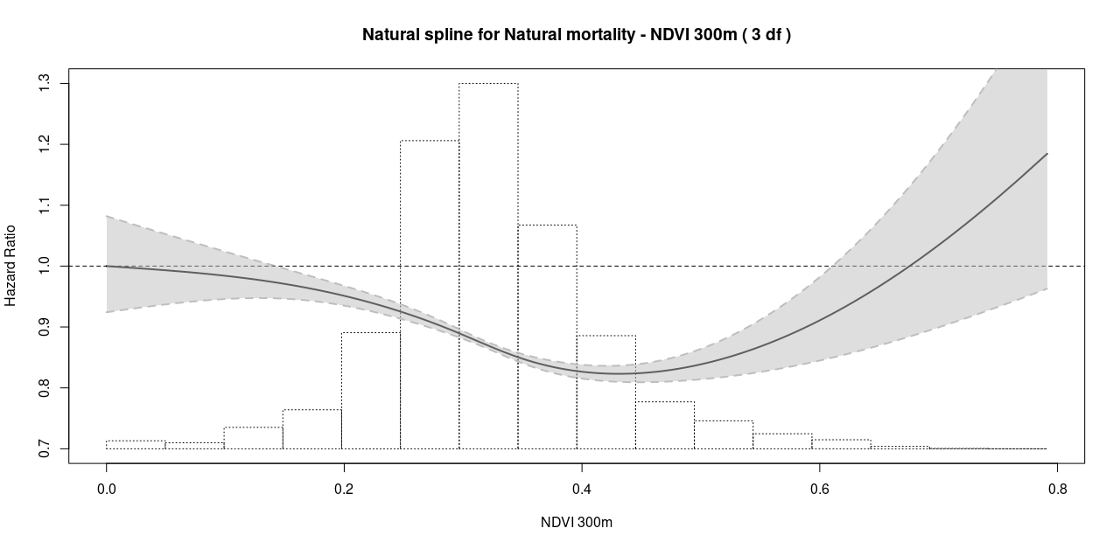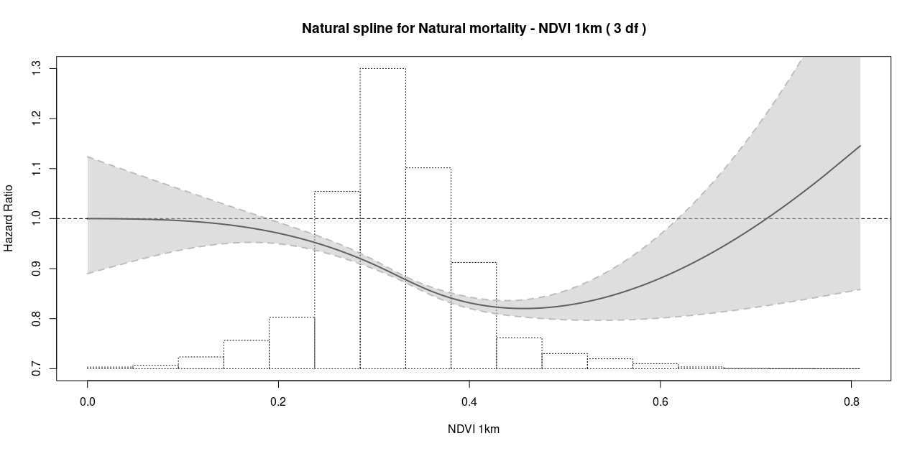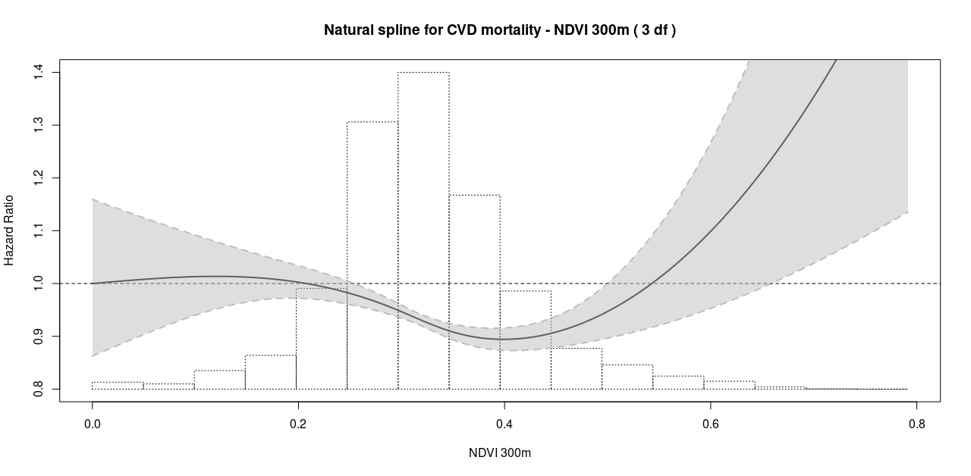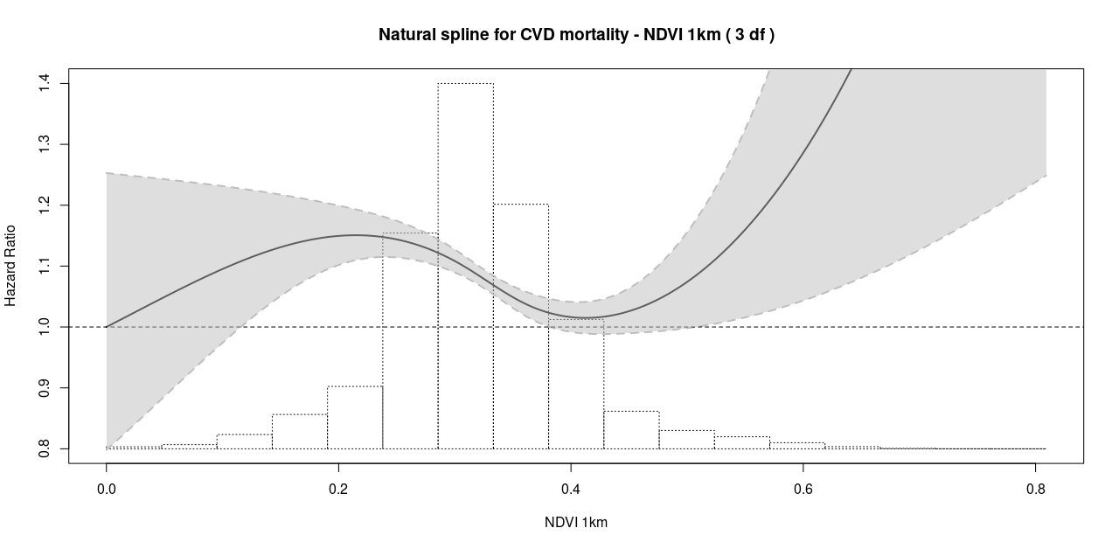

**Figure S1.** Hazard ratios and 95% confidence intervals (CI) for natural spline models of Normalized Vegetation Index (NDVI) in the 300-m grid and 1-km buffer and natural and cardiovascular (CVD) mortality with 3 degrees of freedom (df) in model 3 population from the ELAPSE pooled cohort (N = 327,388).

**Figure S2**. Distribution of the Normalized Difference Vegetation Index (NDVI) inside radii of 300-m and 1-km from participant’s residential addresses in model 3 population from the ELAPSE pooled cohort (N = 327,388), with negative NDVI values recoded to zero.

**Figure S3.** Distribution of the Normalized Difference Vegetation Index (NDVI) inside radii of 300-m **(A)** and 1-km **(B)** from participant’s residential addresses across Body Mass Index (BMI) categories in model 3 population from the ELAPSE pooled cohort (N = 327,388), with negative NDVI values recoded to zero.

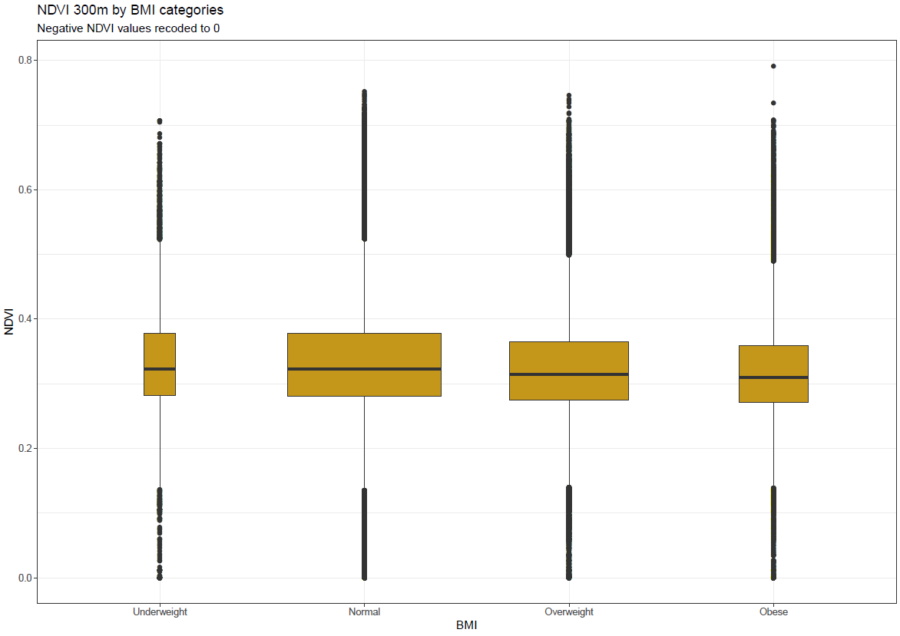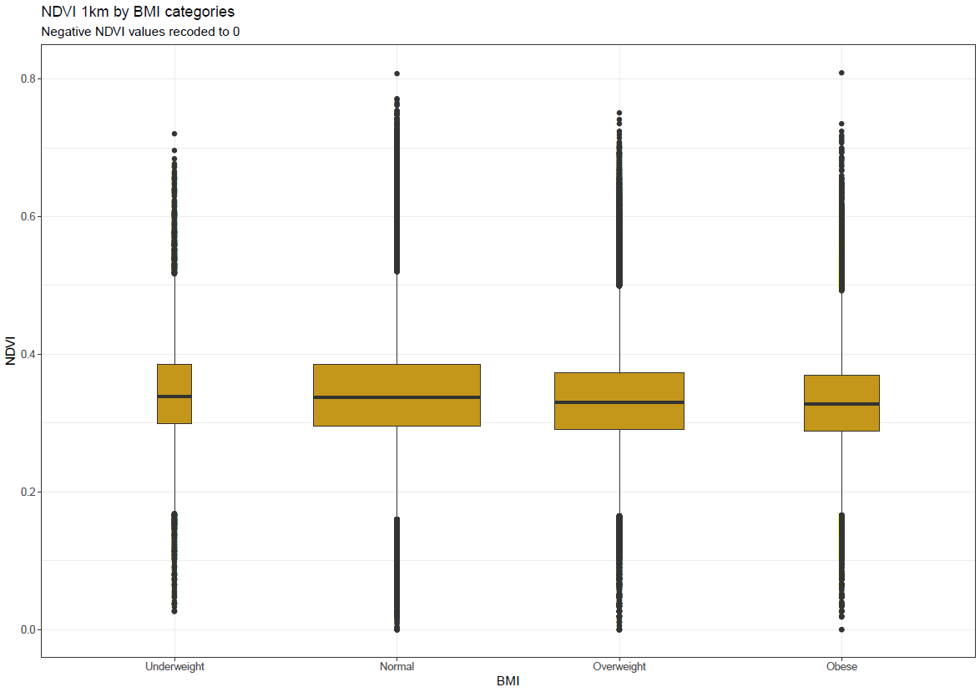

**A**

**B**

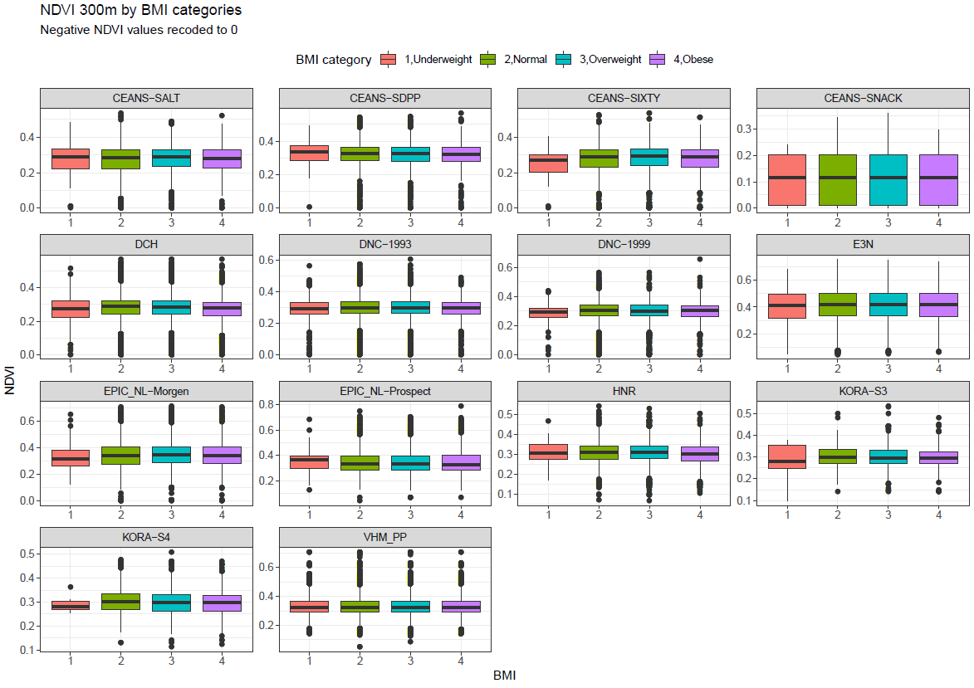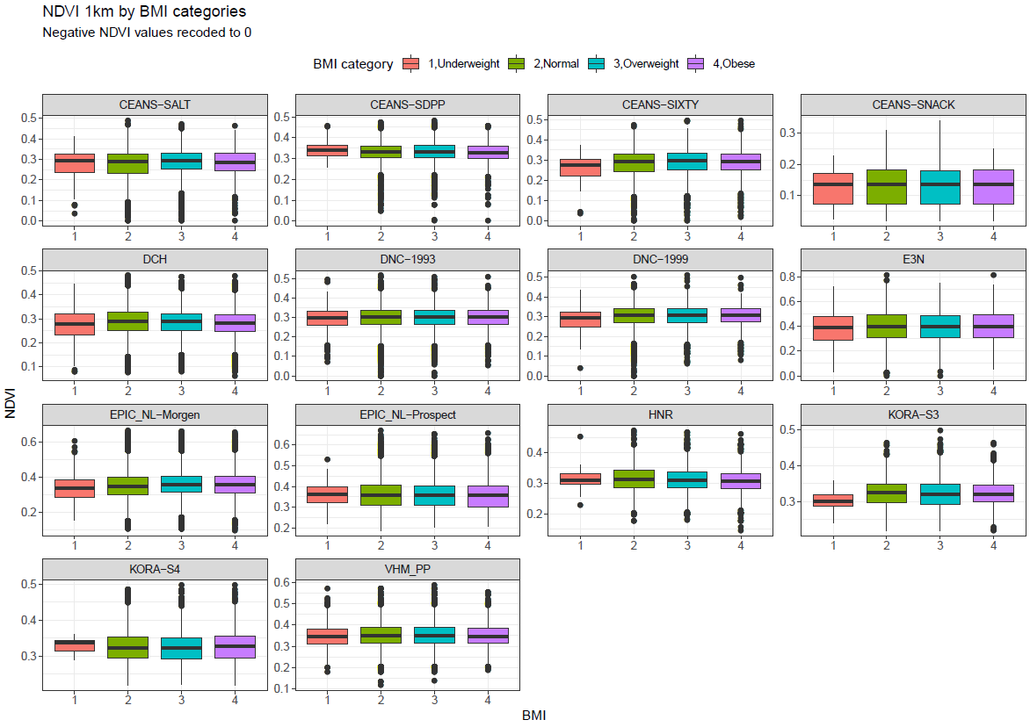

**A**

**B**

**Figure S4.** Distribution of the Normalized Difference Vegetation Index (NDVI) inside radii of 300-m **(A)** and 1-km **(B)** from participant’s residential addresses across Body Mass Index (BMI) categories in model 3 population for each individual (sub) cohort included in the ELAPSE pooled cohort (N = 327,388), with negative NDVI values recoded to zero.

**B**

**A**

**Figure S5.** Hazard ratios and 95% confidence intervals (CI) for a 0.1 unit increase in Normalized Vegetation Index (NDVI) in the 300-m grid and 1-km buffer and natural mortality in the ELAPSE pooled cohort stratified by **(A)** Body Mass Index (BMI) categories (N = 324,739), **(B)** education level (N = 181,941), **(C)** levels of Neighborhood Mean Income (N = 327,388), **(D)** levels of traffic-noise (N = 109,593), **(E)** levels of NO2 ( N = 327,388) and **(F)** levels of PM2.5 (N = 327,388). Hazard ratios are adjusted for study (strata), age, sex (strata), year of baseline visit, smoking status, duration, intensity, intensity2, marital status, employment status, and 2001 mean income at neighborhood level, except when stratifying variable.

**C**

**D**

**F**

**E**