Field CalibRation of a TLD albedo DosEmeter in the high-energy neutron Field of CERF

T. Haninger 1,*, P. Kleinau1 and S. Haninger1

1Helmholtz Zentrum München, German Research Center for Environmental Health, Individual Monitoring Service, Otto-Hahn-Ring 6, D-81739 München, Germany

Received month date year, amended month date year, accepted month date year

The new albedo dosemeter type AWST-TL-GD 04 has been calibrated in the CERF neutron field (Cern–EU high-energy Reference Field). This type of albedo dosemeter is based on thermoluminescence detectors (TLD) and used by the individual monitoring service of the Helmholtz Zentrum München (AWST) since 2015 for monitoring persons, who are exposed occupationally against photon and neutron radiation. The motivation for this experiment was to gain a field specific neutron correction factor *N*n for workplaces at high-energy particle accelerators. *Nn* is a dimensionless factor relative to a basic detector calibration with 137Cs and is used to calculate the personal neutron dose in terms of *H*p(10) from the neutron albedo signal. The results show that the sensitivity of the albedo dosemeter for this specific neutron field is not significantly lower as for fast neutrons of a radionuclide source like 252Cf. The neutron correction factor varies between 0.73 and 1.16 with a midrange value of 0.94. The albedo dosemeter is therefore appropriate to monitor persons, which are exposed at high- energy particle accelerators.

Introduction

With the beginning of 2015, a new albedo neutron dosemeter based on TLD (thermoluminescence detectors) has been introduced by the individual monitoring service (AWST) of the Helmholtz Zentrum München. This albedo dosemeter has the official designation "AWST-TL-GD 04" and the type approval 23.52/14.01 for photon radiation allocated by the Physikalisch-Technische Bundesanstalt (PTB). Approx. 5000 persons are monitored currently with this type of dosemeter. It mainly consists of a four-element detector card type Harshaw and a new designed card holder which has been developed by the working group Radiation Physics of the Technical University in Dresden. Its properties are described in detail in Reference 1.

The AWST is also monitoring occupationally exposed persons at workplaces at high-energy accelerators which are used for medical or research purposes.

The albedo dosemeter has a significant energy dependence and therefore field specific neutron correction factors are defined for different categories of workplaces. The correction factor for workplaces at high-energy accelerators has been deduced from irradiations with fast neutrons produced by a 252Cf source, and it was the motivation of this experiment to verify this calibration method.

Dosimetric properties of albedo dosemeters

Figure 1 shows the fluence to dose conversion coefficient for neutrons and for the operational quantity *H*p(10;0°). The conversion coefficient begins to increase rapidly for neutron energies above 10 keV. In the same figure the response of a TLD albedo dosemeter to *H*p(10; 0°) is presented. The albedo dosemeter has a nearly constant fluence response up to 10 MeV, and therefore the response in terms of *H*p(10) decreases significantly for energies above 10 keV. This can be gathered from Figure 1: both graphs begin to diverge at the intersection, which is located at 10 keV.

Figure 1. *H*p(10) response of an albedo dosemeter (arbitrary units) and fluence to personal dose equivalent conversion coefficient for neutrons and *H*p(10;0°) (pSv · cm2). Data are taken from Reference 2 (table 3.XXV, column 2 and table 2. III, column 3).

The energy spectra of the neutrons fields at high-energy accelerators typically show two pronounced peaks around 1 and 100 MeV.

This can be taken from Figure 2, where the energy spectra at CERF and of a bare 252Cf source are presented. The albedo dosemeter is nearly “blind” for neutrons in this energy region, but the CERF spectra also show that a significant part of the spectra consists of neutrons with thermal and intermediate energies. A calibration measurement of albedo dosemeters in the field of a 252Cf source can be performed at the Physikalisch-Technische Bundesanstalt (PTB), but it is not clear whether this calibration is also valid for workplaces at high-energy accelerators, because a 252Cf source does not deliver neutrons with energies above 10 MeV. This was the motivation for a field calibration at CERF (CERN–EU high-energy Reference Field)(3). This field is primarily used for the calibration of neutron monitors which are used in flight dosimetry. The CERF field can be regarded as typical for other high-energy accelerators, e.g. the GSI heavy ion accelerator in Darmstadt(4) or medical acceleratorslike proton therapy centers.

Figure 2. Energy spectra of neutron fields at CERF and of a bare 252Cf source (at a distance of 170 cm). Data are taken from Reference 2 (table 4.XXIII, columns 2 and 3 and table 4. VI, column 2).

Measurement Principle of albedo dosemeters

The measurement principle of a TLD albedo dosemeter is well established in neutron dosimetry since many years(5). Therefore only a short description of the main principle to determine the personal neutron dose is given here.

The Harshaw TLD card 6776 contains four square detector elements *E1*to *E4* (size: 3.2 x 3.2 x 0.38 mm3) made of LiF(Mg,Ti). *E1* and *E4* are enriched with the isotope 6Li and therefore sensitive for thermal neutrons and photon radiation. *E2* and *E3* contain the isotope 7Li and are sensitive for photon radiation only. The card reader and all four elements are calibrated with a 137Cs source to determine their individual sensitivity. The calibrated measurements signals are denoted as *M1* to *M4*. *M*2 delivers directly the personal dose for photon radiation in terms of *H*p(10) without a further correction factor.

By the calculating the difference of the signals *M1* and *M2* and the difference of *M4* and *M3* two neutron measurement signals can be determined. *M1 – M2* is denoted as albedo signal *Mn(albedo),* because these detector are shielded with boron loaded aluminum filters against the incoming neutron radiation and unshielded against neutrons, which are backscattered by the human body. *M4**– M3*is denoted as *Mn(field),* because the shielding is in opposite direction, so that only neutron radiation incident from the front can be detected.

The personal neutron dose *H*n in terms of *H*p(10) is calculated by multiplying the albedo signal with a field specific correction factor *Nn*, which can be described as a function of the ratio *X = Mn(field) / Mn(albedo).*

*Hn = Nn(X) · Mn(albedo)* (1)

*Nn* and *X* show high variations for different neutron fields. The functional dependency of *Nn*with *X* can be used to reduce a multiplicity of neutron fields to a few categories, which can be regarded as typical for certain workplaces(6).

Field calibration method

*Corresponding author: Haninger@helmholtz-muenchen.de

One commonly used method to determine the correction factor *Nn(X)* in an unknown neutron field is the single sphere approach, which was developed by Burgkhardt and Piesch(7).

A polyethylene sphere (PE ball) with a diameter of 30 cm is used as phantom for two albedo dosemeters, which are fixed on opposite sides of the sphere. A TLD card in the center of the sphere is used to determine the ambient dose equivalent *H*\*(10) for neutron radiation. The neutron measurement signal of this detector card is denoted as *Mn(center)* whichis determined by calculating the difference of the mean values of the two 6Li detectors and the two 7Li detectors. The neutron calibration factor *Nc* of the central detector card is determined by a measurement in the neutron field of a reference source like 252Cf.

|  |  |
| --- | --- |
|  | (2) |

The field specific correction factor *Nn(X)* for the albedo dosemeteris calculated by using the sum of the albedo signals of both dosemeters:

|  |  |
| --- | --- |
|  | (3) |

|  |  |
| --- | --- |
|  | (4) |

The sum of both dosemeters is used, because an albedo dosemeter fixed on one side of the sphere is shielded against neutron radiation coming from the rear side, whereas the measurement of *H\**(10) is defined as isotropic and the TLD card inside the sphere detects neutron radiation coming from all directions.

Luszik-Bhadra has evaluated the single sphere approach by measurements which have been performed in the framework of the EVIDOS project(8). The results show that the sum *H*p,sum(10) of the personal dose values measured at two opposite positions on a sphere is always lower than *H*\*(10). The main reason for this observation is, that the operational quantity *H*p(10) depends on the angle of incidence  with approx. cos() and the albedo dosemeter has a similar angular dependency(8). The ratios *H*p,sum(10) / *H*\*(10) determined by Luszik-Bhadra vary between 0.33 and 0.94. The neutron correction factor *Nn(X)* is the reciprocal of this ratio and therefore the single sphere approach delivers conservative correction coefficients which tend to overestimate personal neutron dose. In view of radiation protection purposes this is a desirable behavior because it prevents an underestimation of dose. It should be noted however, that all measurements of the EVIDOS project have been performed at workplaces of the nuclear industry and therefore the results can be transferred to workplaces at high-energy accelerators only with care, because it may be that high-energy neutrons can completely penetrate the sphere and therefore the second albedo on the back side of the sphere is no longer shielded against neutrons coming from the other side. It should be noted here, that no electronic personal dosemeter is commercially available, which can deliver a reference value for *H*p(10) with sufficient accuracy. For these reasons a modified single sphere approach has been chosen to determine field specific neutron correction factors for the albedo dosemeter.

MODIFIED FIELD CALIBRATION AT CERF

The original single sphere approach was modified for the measurements at CERF.

Two TLD cards in the center of the sphere were used to determine *H*\*(10). The detector cards were fixed mirrored, so that one 6Li detector was covered by a 7Li element of the other card to prevent shielding effects, because neutrons are absorbed in the surface layer of the 6Li detectors. *Mn(center)* was determined by calculating the difference of the two mean values of the four 6Li detectors and of the four 7Li detectors.

For the determination of *H*\*(10) at CERF, a special neutron ball for TLD cards was used(9), which mainly consist of polyethylene, but contains an additional lead layer to improve the response to high-energy neutrons. This special neutron ball has been developed at the Gesellschaft for Schwerionen (GSI) in Darmstadt, and therefore it is denoted as GSI ball, whereas a normal PE sphere without lead layer is denoted as PE ball.

Ultra-relativistic neutrons with energies higher than 10 MeV produce additional neutrons by spallation in the lead. Because this process is absent in the human body, the GSI ball was used as reference instrument for *H*\*(10), but not as a phantom for albedo dosemeters. For this purpose only normal PE spheres without lead were used.

Experimental Setup

The measurements took place during two different beam time runs (Run 1 and 2). The balls were set up on the roof and in a small corridor at the side of the CERF facility. These positions are denoted by Mitaroff and Silari(3) as Top Concrete and Side Concrete. The CERN staff provides PIC counts of a beam monitor for every beam time and with the conversion factors, given in table 2 of Reference 3, the ambient dose equivalent *H*\*(10) can be calculated. This is possible only for positions within defined grids on the roof (Top Concrete) and the conversion factors refer only to *H*\*(10) and not to *H*p(10). For the location at the side no conversion factors are available.

During the first run one GSI ball (GSI1) was located on the roof in the center of the grid fields 06, 07, 10 and 11. The GSI ball was surrounded by 4 PE balls (PE1 to PE4) which were positioned in the center of one these fields. To fix the balls basic holders of tripods without bars were used, so that the height of a ball center amounted 20 cm above the cover plate of the roof.

At the side position one GSI ball was set up on a complete tripod, so that the center of the ball was located at a height of 85 cm above ground. The PE balls PE5 and PE6 were located close to the GSI ball on the left and right.

During the second beam time the two balls PE1 and PE2 were located in the grid fields 08 and 12 on the roof. GSI ball GSI1 could not be used for this beam time, because of a mechanical problem, which occurred during card change.

At the side the ball GSI 2 was located at a height of 126 cm above ground and the ball PE3 close to it, whereas the balls PE4 and PE5 were set up on tripods at a height of 85 cm. PE6 was positioned in the labyrinth of the entrance in a greater distance.

It should be noted that during Run 1 the exposition periods at the locations Top and Side Concrete were equivalent (8 hours), but for Run 2 the exposure lasted 16 hours for the balls at the side and 20.5 hours for the balls on the roof. The position of the albedo dosemeters on the PE balls which were faced directly to the target is denoted as Front. For the measurement on the roof, this position denotes the dosemeters, which were orientated downwards to the ground. The dosemeters on the opposite side of the ball are denoted as Back and the other 2 dosemeters as Left and Right.

Determination of *H*\*(10)

Different methods were combined to determine the neutron ambient dose equivalent *H*\*(10). The results of all *H*\*(10) measurements are listed in table 1.

The first step was to calibrate the GSI ball and the PE sphere in the reference field of a 252Cf source in the neutron calibration laboratory of the Physikalisch-Technische Bundesanstalt (PTB). The distance between the source and the center of the ball was 170 cm. The irradiation was performed at a height of 3.25 m above ground.

The calibration factors *Nc,* which were determined at the PTB amount 0.480 for the GSI ball and 0.416 for the PE sphere.

In a second step the results of the balls, which were gained during the CERF experiment, are compared with the reference values calculated from the PIC counts. By using the PTB calibration factor of 0.480 for the GSI ball, the measured dose value for *H*\*(10) for Run 1 amounts 651 µSv and is therefore 20% higher than the value calculated from the PIC counts (541 µSv, see Table 1). The normal PE ball without lead inlay underestimates ambient dose by using the PTB calibration factor, because its sensitivity decreases substantially for neutron energies above 10 MeV. The mean value for *H*\*(10) of four PE balls amounts 426 µSv, which results in an underestimation of dose.

The results of Run 1 at Top concrete have been used to determine new calibrations factors of *Nc* = 0.53 for the PE balls and *Nc* = 0.40 for the GSI balls.

For the measurements at the side, the balls PE5 and PE6 were located close to the ball GSI2 during Run1, and PE3 during Run 2. The dose values of these PE balls are up to 30% higher than the corresponding dose value of GSI2 (see Table 1). Therefore it can be concluded, that by using a calibration factor *Nc* of 0.53, the PE balls tend to overestimate ambient dose, so that neutron correction factors for the albedo dosemeters calculated with formulas (2) and (3) are conservative.

RESULTS

Table 2 shows the results of all balls which were used for the field calibration. (PE6 was located in the labyrinth during Run 2 and the dose there was quite low, so that no albedo correction factors were determined).

The values of *Xsum* range from 1.00 to 1.32 and the field specific correction factors *Nn(X)* from 0.73 to 1.17. This variation is not so large as expected and extreme outliers are not present. The midrange values (arithmetic mean between minimum and maximum value) amount:

*sum* = 1.16 and *n(X)* = 0.94

A notable detail is the ratio of the albedo signals of two opposite dosemeters. These ratios can be deduced from the results in Table 2a und 2b. The ratio for the Front and Back position of the balls on the roof varies between 6.0 and 10.2, whereas all other ratios are between 1.0 and 2.3. A ratio of 10.2 (PE1, Run 1) indicates that the correction factor *Nn(X)* = 0.89 for this dosemeter pair is caused mainly by the frontal dosemeter, which is faced downwards and to the target. The back dosemeter does not contribute much to the sum of the albedo signals. This exposure situation is very different from the situation at the side, where a substantial fraction of neutrons is backscattered by the second wall of the narrow floor and contributes a substantial part to the sum of the albedo signals of two opposite dosemeters. The variation of all field correction factors amounts only 30% (2) and this implies that *Nn(X)* shows only a weak dependence of the individual exposure situation.

Field Calibration with a radionuclide source

The field calibration measurement has been repeated at PTB with a bare 252Cf source. This source is used routinely by PTB for the annual intercomparison measurements of the albedo dosemeters, which are used by the official German dosimetry services. The motivation of this experiment was to compare the neutron correction factor gained at CERF with a correction factor which can be determined much easier with a standard neutron calibration source.

At first a calibration has been performed with four albedo dosemeters, which were fixed at the surface of a slab phantom (30 x 30 x 15 cm3). The distance between source and phantom amounted 170 cm. The PTB delivered a reference value of *H*p(10), which was used for the calculation of the exact field specific correction factor: *Nn(X)* = 1.07 ± 0.03 (arithmetic mean ± standard deviation), with *X* = 0.35 ± 0.02.

In a second step, a PE ball equipped with 4 albedo dosemeters was located with its center in a distance of 185 cm from the source, so that the position of the albedo dosemeter at the front side of the sphere was the same as in the measurement with the cuboid phantom. For the albedo dosemeter at the front side, a correction factor *Nn(X)* = 1.18 was determined by using the reference value of *Hp*(10). By using the field calibration method the following parameters were determined (see Table 3): *Xsum* = 0.52 and *Nn(X)* = 0.87 (albedo dosemeters at the front and back positions) and *Xsum* = 0.59 and *Nn(X) =* 1.12 (side positions). The PTB reference value of *H*(10)* for this measurement is 6.00 mSv, and the dose measured with the ball amounts 6.16 mSv. The agreement between the field specific correction factors calculated with the exact value of *H*p(10) and the factors determined with single sphere method is within 20%. This test has shown, that the single sphere method works properly.

The field specific correction factors *Nn(X)* in the neutron fields of a bare 252Cf source and at CERF are comparable.

It should be noted here, that the fluence to dose coefficients for high-energy neutrons vary only within a factor 2 in the energy region from 1 to 1000 MeV and for 100 MeV neutrons it is even lower than for 1 MeV neutrons(10). The albedo signal depends mainly on neutrons with energies below 100 keV, and therefore a radionuclide source can be used for the calibration of albedo dosemeters in the high-energy region although neutrons with energies above 10 MeV are missing in the spectrum.

Therefore other measurement services can calibrate their albedo dosemeters with an unmoderated radionuclide source, if the personal staff of a high-energy particle accelerator has to be monitored. The energy dependence of different albedo dosemeters based on TL detectors should be similar.

This statement is only valid for the amount of the field correction factor *Nn(X)*, but not for its dependence on the ratio *X*. The ratio *X* between the field detector and the albedo detector differ substantially between both irradiation conditions. The *X* factor determined at CERF with a value of 1.16 is twice as the *X* factor in the field of a 252Cf source. If *X* is used for the correction of *Nn(X)* and if it decreases with increasing *X*, the correction factor will be too low for the fields at high-energy accelerators, if the dosemeter is based on the calibration with a radionuclide source only.

Figure 3 shows the dependence of the neutron correction factor *Nn(X)* on the ratio *X* of *Mn(field)* to *Mn(albedo).* Figure 3 comprises data of calibration measurements at PTB with different unmoderated radionuclide sources (252Cf, 241Am(Be)) and the CERF data. The CERF data points are clearly located in a region with higher X-values.

The reason for this observation is that during all irradiations at PTB the neutron source is located in the center of the room to reduce the fraction of scattered neutrons in the spectrum. This does not reflect the situation at CERF where the fractions of moderated neutrons in the spectra are higher (see Figure 2). Additional experiments would be required to find an irradiation condition with a radionuclide source where the resulting field contains a higher fraction of moderated neutrons with intermediate energies, which is more similar to the fields of CERF. As a final conclusion it can be stated, that a calibration with an unmoderated radionuclide source delivers a good estimate for *Nn(X)* for workplaces at high-energy accelerators, but the correction with *X* should be performed with care.

Fig. 3: Functional dependence of the neutron correction factor *Nn(X)* on the ratio *X* of *Mn(field)* to *Mn(albedo)* for fast neutron fields.

Conclusion

The field calibration of the TLD albedo dosemeter AWST-TL GD 04 in the high-energy neutrons fields at CERF has revealed that this kind of dosemeter can also be used for personal monitoring at workplaces of high-energy accelerators, because its sensitivity is high enough to detect even a low neutron personal dose of 0,1 mSv. This is very important, because the number of workplaces at medical accelerators like proton therapy centers will increase.

acknowledgments

The authors are grateful to the following persons for their assistance in performing field calibration measurements with albedo dosemeters at different workplaces: G. Fehrenbacher and E. Kozlova from GSI in Darmstadt, E. Kudejova from Technical University of Munich, M. Silari and his colleagues from CERN, M. Luszik-Bhadra from PTB in Braunschweig and W. Rabauer and W. Behmer from EON GmbH in Essenbach.

References

1. Haninger, T. and Henniger J. *Dosimetric properties of* *the new TLD albedo neutron dosemeter type AWST-TL-GD 04.* Radiat. Prot. Dosimetry(2015) doi: 10.1093/ pd/ncv406
2. International Atomic Energy Agency. *Compendium of neutron spectra and detector responses for radiation protection purposes: supplement to Technical Report Series No. 318.* Technical Report Series No. 403. IAEA. (2001).
3. Mitaroff, A. and Silari, M. *The CERN–EU High-Energy Reference Field (CERF) Facility for Dosimetry at Commercial Flight Altitudes and in Space.*Radiat. Prot. Dosim. **102**, 7–22 (2002).
4. Iwase H., Wiegel, B., Fehrenbacher G., Schardt D., Nakamura, T., Niita, K. and T. Radon *Comparison between calculation and measured data on secondary neutron spectra by heavy ion reactions from different thick targets.* Prot. Dosim. **116**, 640–646 (2005).
5. Piesch, E. and Burgkhardt, B. *Albedo Neutron Dosimetry.* Radiat. Prot. Dosim. **10.** 175–188 (1985).
6. Luszik-Bhadra, M., Zimbal, A., Busch, F., Eichelberger, A., Engelhardt, J., Figel, M., Frasch, G., Günther, K., Jordan, M., Martini, E., Haninger, T., Rimpler, A., and Seifert, R. *Albedo neutron dosimetry in Germany: regulations and performance.* Radiat. Prot. Dosim. 162, 649–656 (2014).
7. Burgkhardt, B. and Piesch, E. *Field calibration technique for albedo neutron dosemeters.* Radiat. Prot. Dosim. **23**, 121–126 (1988).
8. Luszik-Bhadra, M. *Field correction factors for personal* *neutron dosemeters.* Radiat. Prot. Dosim. (2015).doi: 10.1093/rpd/ncv444
9. Fehrenbacher G., Kozlova E., Gutermuth F., Radon T., Schütz R., Nolte R. and Böttger R. *Measurement of the fluence response of the GSI neutron ball dosemeter in the energy range fron thermal to 19 MeV.* Radiat. Prot. Dosim. **126**, 546–548 (2007).
10. Ferrari A. and Pelliccioni M. *Fluence to dose equivalent conversion data and effective quality factors for high-energy neutrons.* Radiation Protection Dosimetry **76**, 215–224 (1998).

Tables

Table 1: Results of the *H*\*(10) measurements at CERF (Location Top* denotes the center of the grids 06, 07, 10 and 11).

|  |  |  |  |  |  |
| --- | --- | --- | --- | --- | --- |
| **Ball - run** | **Location** | ***Mn*(center)  (µSv)** | ***Nc*** | **Ball dose (µSv)** | **PIC dose (µSv)** |
| GSI1 - 1 | Top* | 1356 | 0.400 | 543 | 541 |
| PE1 - 1 | Top 07 | 1002 | 0.530 | 531 | 539 |
| PE2 - 1 | Top 06 | 987 | 0.530 | 523 | 546 |
| PE3 - 1 | Top 10 | 1079 | 0.530 | 572 | 546 |
| PE4 - 1 | Top 11 | 1029 | 0.530 | 545 | 535 |
| GSI2 - 1 | Side | 1414 | 0.400 | 566 |  |
| PE5 - 1 | Side | 1287 | 0.530 | 682 |  |
| PE6 - 1 | Side | 1361 | 0.530 | 721 |  |
| PE1 - 2 | Top 08 | 5063 | 0.530 | 2683 | 2599 |
| PE2 - 2 | Top 12 | 5296 | 0.530 | 2807 | 2576 |
| GSI2 - 2 | Side | 6114 | 0.400 | 2446 |  |
| PE3 - 2 | Side | 5288 | 0.530 | 2803 |  |
| PE4 - 2 | Side | 4151 | 0.530 | 2200 |  |
| PE5 - 2 | Side | 4366 | 0.530 | 2314 |  |
| PE6 - 2 | Labyrinth | 94 | 0.530 | 50 |  |

Table 2a. Results of the field calibration measurements at CERF, first beam time (Run 1).

|  |  |  |  |  |  |  |  |
| --- | --- | --- | --- | --- | --- | --- | --- |
| **Ball - run** | **Position** | ***Mfield*** | ***Malbedo*** | ***X*** | **Ball dose (µSv)** | ***Xsum*** | ***Nn(X)*** |
| PE1 - 1 | Front | 759 | 546 | 1,39 | 531 | 1,32 | 0.89 |
| PE1 - 1 | Back | 30 | 53 | 0.56 | 531 |  |  |
| PE1 - 1 | Left | 192 | 223 | 0.86 | 531 | 1,10 | 1,16 |
| PE1 - 1 | Right | 309 | 233 | 1,32 | 531 |  |  |
| PE2 - 1 | Front | 671 | 506 | 1,32 | 523 | 1,26 | 0.92 |
| PE2 - 1 | Back | 45 | 60 | 0.74 | 523 |  |  |
| PE2 - 1 | Left | 281 | 296 | 0.95 | 523 | 1,04 | 1,08 |
| PE2 - 1 | Right | 221 | 187 | 1,18 | 523 |  |  |
| PE3 - 1 | Front | 659 | 499 | 1,32 | 572 | 1,23 | 0.98 |
| PE3 - 1 | Back | 57 | 83 | 0.69 | 572 |  |  |
| PE3 - 1 | Left | 304 | 293 | 1,04 | 572 | 1,06 | 1,16 |
| PE3 - 1 | Right | 217 | 199 | 1,09 | 572 |  |  |
| PE4 - 1 | Front | 784 | 578 | 1,35 | 545 | 1,29 | 0.85 |
| PE4 - 1 | Back | 37 | 60 | 0.63 | 545 |  |  |
| PE4 - 1 | Left | 263 | 262 | 1,00 | 545 | 1,00 | 1,05 |
| PE4 - 1 | Right | 260 | 260 | 1,00 | 545 |  |  |
| PE5 - 1 | Front | 667 | 530 | 1,26 | 682 | 1,21 | 0.81 |
| PE5 - 1 | Back | 351 | 310 | 1,13 | 682 |  |  |
| PE5 - 1 | Left | 694 | 592 | 1,17 | 682 | 1,15 | 0.78 |
| PE5 - 1 | Right | 307 | 279 | 1,10 | 682 |  |  |
| PE6 - 1 | Front | 680 | 527 | 1,29 | 721 | 1,20 | 0.83 |
| PE6 - 1 | Back | 358 | 338 | 1,06 | 721 |  |  |
| PE6 - 1 | Left | 621 | 559 | 1,11 | 721 | 1,13 | 0.83 |
| PE6 - 1 | Right | 363 | 311 | 1,17 | 721 |  |  |

Table 2b. Results of the field calibration measurements at CERF, second beam time (Run 2).

|  |  |  |  |  |  |  |  |
| --- | --- | --- | --- | --- | --- | --- | --- |
| **Ball - run** | **Position** | ***Mfield*** | ***Malbedo*** | ***X*** | **Ball dose (µSv)** | ***Xsum*** | ***Nn(X)*** |
| PE1 - 2 | Front | 3388 | 2514 | 1,35 | 2683 | 1,27 | 0.96 |
| PE1 - 2 | Back | 183 | 292 | 0.63 | 2683 |  |  |
| PE1 - 2 | Left | 2060 | 1789 | 1,15 | 2683 | 1,12 | 1,03 |
| PE1 - 2 | Right | 850 | 818 | 1,04 | 2683 |  |  |
| PE2 - 2 | Front | 3430 | 2449 | 1,40 | 2807 | 1,29 | 1,00 |
| PE2 - 2 | Back | 210 | 364 | 0.58 | 2807 |  |  |
| PE2 - 2 | Left | 1597 | 1413 | 1,13 | 2807 | 1,19 | 1,01 |
| PE2 - 2 | Right | 1715 | 1379 | 1,24 | 2807 |  |  |
| PE3 - 2 | Front | 3152 | 2462 | 1,28 | 2803 | 1,25 | 0.77 |
| PE3 - 2 | Back | 1410 | 1178 | 1,20 | 2803 |  |  |
| PE3 - 2 | Left | 2460 | 1792 | 1,37 | 2803 | 1,30 | 1,02 |
| PE3 - 2 | Right | 1116 | 968 | 1,15 | 2803 |  |  |
| PE4 - 2 | Front | 1723 | 1365 | 1,26 | 2200 | 1,24 | 0.80 |
| PE4 - 2 | Back | 1664 | 1373 | 1,21 | 2200 |  |  |
| PE4 - 2 | Left | 2477 | 1927 | 1,29 | 2200 | 1,27 | 0.73 |
| PE4 - 2 | Right | 1374 | 1107 | 1,24 | 2200 |  |  |
| PE5 - 2 | Front | 2490 | 1921 | 1,30 | 2314 | 1,28 | 0.73 |
| PE5 - 2 | Back | 1583 | 1270 | 1,25 | 2314 |  |  |
| PE5 - 2 | Left | 2120 | 1850 | 1,15 | 2314 | 1,24 | 0.78 |
| PE5 - 2 | Right | 1533 | 1102 | 1,39 | 2314 |  |  |

Table 3. Results of field calibration measurements at PTB with a bare 252Cf source (distance source – ball center: 185 cm).

|  |  |  |  |  |  |  |  |
| --- | --- | --- | --- | --- | --- | --- | --- |
| **Ball** | **Position** | ***Mfield*** | ***Malbedo*** | ***X*** | **Ball dose (µSv)** | ***Xsum*** | ***Nn(X)*** |
| PE | Front | 1983 | 4970 | 0.40 | 6157 | 0.52 | 0.87 |
| PE | Back | 1675 | 2125 | 0.79 | 6157 |  |  |
| PE | Left | 1596 | 2771 | 0.58 | 6157 | 0.59 | 1,12 |
| PE | Right | 1641 | 2714 | 0.60 | 6157 |  |  |

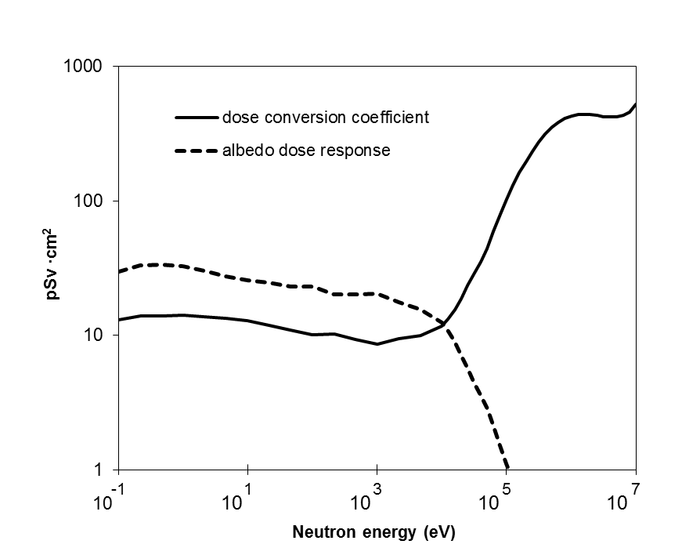

Figure 1. *H*p(10) response of an albedo dosemeter (arbitrary units) and fluence to personal dose equivalent conversion coefficient for neutrons and *H*p(10;0°) (pSv · cm2). Data are taken from Reference 2 (table 3.XXV, column 2 and table 2.III, column 3).

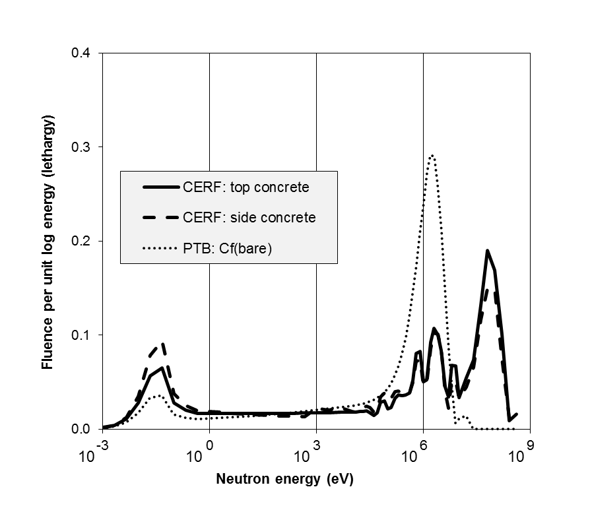

Figure 2. Energy spectra of neutron fields at CERF and of a bare 252Cf source (at a distance of 170 cm).   
Data are taken from Reference 2 (table 4.XXIII, columns 2 and 3 and table 4.VI, column 2).

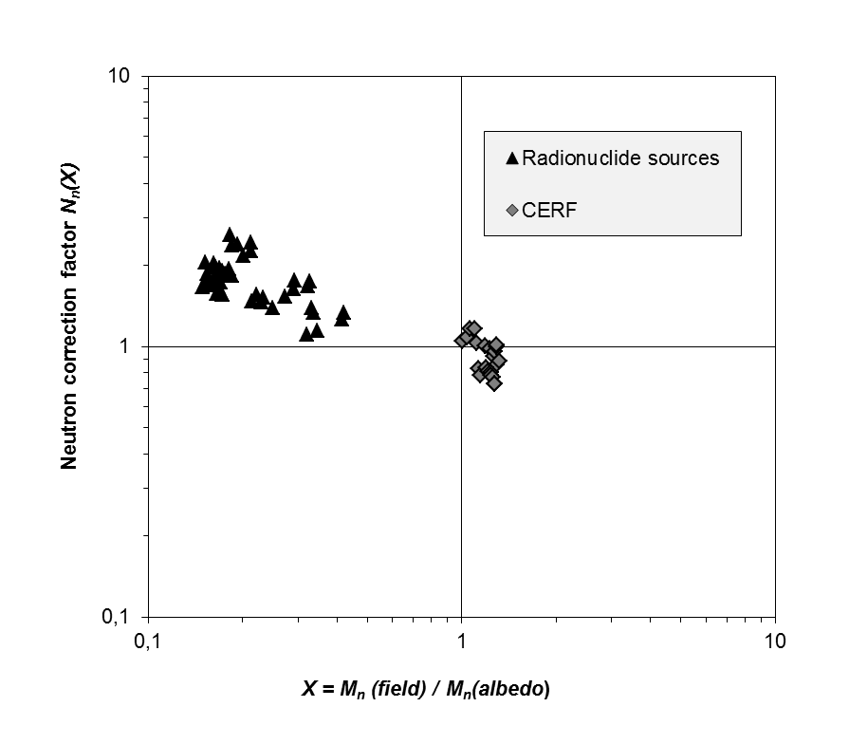

Fig. 3: Functional dependence of the neutron correction factor *Nn(X)* on the ratio *X* of *Mn(field)* to *Mn(albedo)* for fast neutron fields.