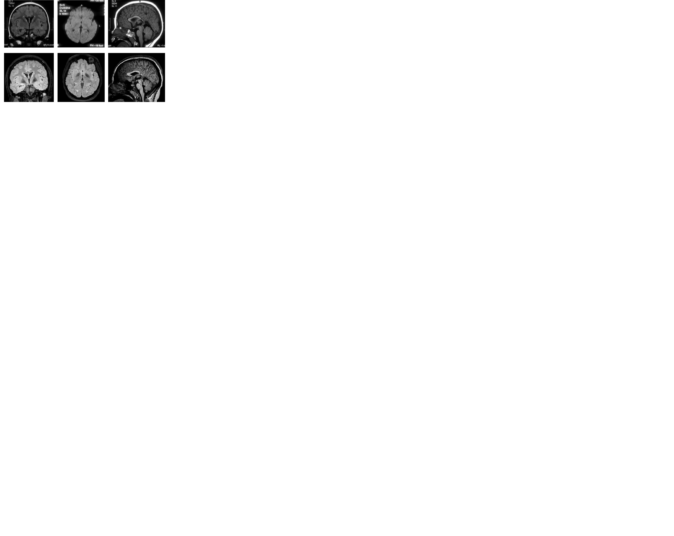

f

e

d

c

b

a

**Figure 1:** MRI scans age 2.3 years (a: T2 Flair; b: DW/SSH; c: T1) and age 13 years: (d: T2 Flair; e: T2 Flair; f: T1).

Thin corpus callosum in the splenium from the age of 3 years on (c;f); bilateral hypointense singal alterations in T2-weighted sequences in the globus pallidus at the age of 13 years (d;e) which was not present in comparable sequences at the age of 3 years (a;b). No relevant atrophy, no ventriculomegaly.