Type of contribution
Supplementary Information - Biology and Fertility of Soils

Title
Spring barley performance benefits from simultaneous shallow straw incorporation and top dressing as revealed by rhizotrons with resealable sampling ports

Authors
Rüdiger Reichel¹, Catherine Wambui Kamau², Amit Kumar³, Zhijie Li¹, Viviane Radl², Vicky M. Temperton³, Michael Schloter², Nicolas Brüggemann¹

¹Forschungszentrum Jülich GmbH, Institute of Bio- and Geosciences, Agrosphere (IBG-3), 52425 Jülich, Germany

²Helmholtz Zentrum München GmbH, Research Unit for Comparative Microbiome Analysis, Ingolstädter Landstraße 1, 85764 Neuherberg, Germany

³Chair of Ecosystem Functioning and Services, Institute of Ecology, Leuphana University of Lüneburg, Universitätsallee 1, 21335 Lüneburg, Germany

Corresponding author
*Rüdiger Reichel, Tel.: + 49 2461 61 6721, e-mail: ru.reichel@fz-juelich.de

Supplementary Tables

Table S1 Physicochemical soil and substrate properties: cation exchange capacity (CEC), water holding capacity (WHC), bulk density (BD), pH in 0.01M CaCl₂ solution, organic carbon (C_{org}) and total N (N_{t}) in soil dry matter (dm), ammonium (NH₄⁺), nitrate (NO₃⁻), mineral S (S_{min}), plant accessible potassium (K_{CAL}) and phosphorus (P_{CAL}), magnesium (Mg) and phosphorus (P) extracted with 0.01M CaCl₂, microbial carbon (C_{mic}) and nitrogen (N_{mic}), and the ratio of both (C_{mic}:N_{mic}) for the soil substrates. S1: loamy sand soil, used to fill the upper 28 cm of the rhizotron. S2: substrate 1, quartz powder (Ø particle size 90 µm, unsterilized), and quartz sand (Ø particle size 370 µm, unsterilized), mixed at a volumetric ratio of 1:1:6 to form the depth of 28 to 85 cm. S3 contained only quartz sand with an average grain size of 370 µm, forming the C horizon at a depth of 85 to 100 cm. Parameters below the limit of quantification are marked (<LOQ)
Table S2 Temporal wheat straw effects on physicochemical soil parameter mean values (± standard deviation) of the NP (control) and the WSNP (wheat straw) treatment in the soil layer 3-5 cm (below the treatment application zone) zero days after straw amendment and fertilization (0 DAF), 6, 20 (transplanting of barley), 40, 49, 84 DAF. ANOVA results are displayed below each parameter. Statistical tests at p ≤ 0.05 revealed significant differences between treatments (grey marked fields) and significant differences between incubation times (deviating capital case letters). No mark or letter indicates insignificance. Parameters below the limit of quantification are marked (<LOQ: 0.8 mg kg⁻¹ for NH₄⁺)

Table S3 Wheat straw effects at different soil depth on soil parameter mean values (± standard deviation) of the NP (control) and the WSNP (wheat straw) treatment in the soil layers 3-5 cm, 5-10 cm, 10-20 cm, and 20-30 cm 20 days after straw amendment and fertilization (20 DAF), 40, and 84 DAF in bulk soil. ANOVA results are displayed below. Statistical tests at p ≤ 0.05 revealed significant differences between treatments (grey marked fields), between soil depths (deviating lower case letters), and significant differences between incubation times (deviating capital case letters). No mark or letter indicates insignificance
Table S4 Wheat straw effects in bulk and root-affected soil on physicochemical soil parameter mean values (± standard deviation) of the NP (control) and the WSNP (wheat straw) treatment in the soil layer 3-5 cm (below the treatment application zone) 33 days after straw amendment and fertilization (DAF; 13 day old barley), and 49 DAF (29 day old barley). ANOVA results are displayed below. Statistical tests at p ≤ 0.05 revealed significant differences between bulk and root-affected soil (grey marked fields), significant differences between treatments (deviating lower case letters), and significant differences between incubation times (deviating capital letters). No mark or letter indicates insignificance

Table S5 Wheat straw effects on microbial biomass N (N_{mic}), and microbial C:N ratio (mean ± standard deviation) of the NP (control) and the WSNP (wheat straw) treatment 90 days after wheat straw amendment and fertilization (90 DAF) at the displayed soil depths in cm. Significant differences (p ≤ 0.05) between the treatments at the indicated incubation time are marked in grey

Table S6 Plant parameter mean values (± standard deviation) of the NP (control) and the WSNP (wheat straw) treatment. Units are displayed next to the parameter (in brackets). Root-to-shoot ratio, shoot and root C, N, P content (left panel) 90 days wheat straw amendment and fertilization (90 DAF). Relative leaf greenness (SPAD as proxy for chlorophyll content), shoot height, and leaves (count) 51, 56, 68, 77, and 90 DAF (right panel). Significant differences (p ≤ 0.05) between the treatments at the indicated incubation time are highlighted in grey. Statistical differences between incubation times are marked by deviating capital letters

Supplementary Figures
Rhizotron design and technical aspects
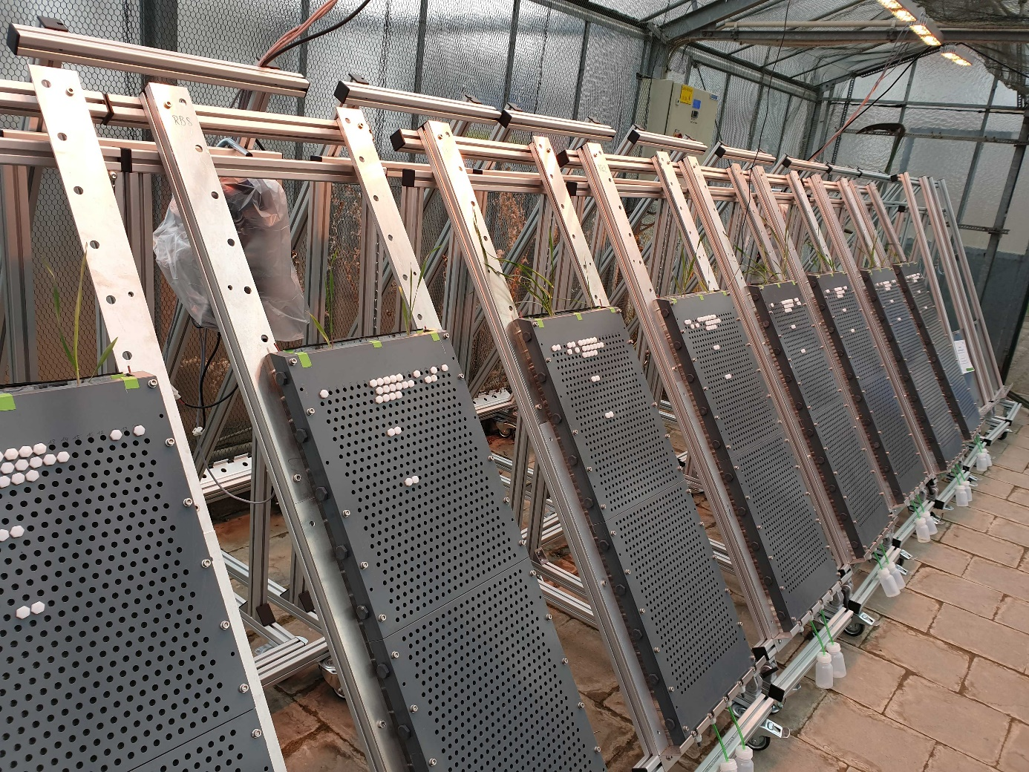
Fig. S1a Rhizotrons with spring barley plants (49 DAF), comprising a rack and two modules, each 35 cm in length, 50 cm in height, and 2.5 cm inner width. Front and back plates with 520 holes (8 mm diameter and 8 mm hole-to-hole distance), arranged in a 20 x 26 grid. White plastic screws sealed with an O-ring in order to close the soil sampling ports watertight. The three threaded holes at the bottom strut were used to collect seepage water

Rhizotron system
The rhizotron system comprised a rack and a rhizotron unit (Fig. 1). Aluminum strut profiles, connections, joints, and wheel elements (Bosch Rexroth AG, Lohr am Main, Germany) were used to build a rack for carrying a maximum weight of 100 kg at a rhizotron angle between 40° to 70°. The rhizotron unit was based on three modules, each 35 cm in length, 50 cm in height, and 2.5 cm inner width (4.4 L volume), to allow rooting depths of 50 cm, 100 cm, or 150 cm. Each module had an opaque PVC plate at the front and a transparent Perspex window at the back. Front and back plates were 12 mm thick to avoid deformation by the weight of the filled rhizotron, and contained 520 holes (8 mm diameter and 8 mm hole-to-hole distance), arranged in a 20 x 26 grid. PVC struts were glued to the opaque PVC plate to form the side boundaries of each rhizotron module. Another PVC strut was glued to the PVC plate of the bottom module, forming the lower boundary. A rubber seal was embedded in the cut groove of the PVC strut frame to allow waterproof sealing of the rhizotron. Modules contained five threaded holes at each side, which were sealed with plastic screws, but which could be used to insert measuring tools via a plastic cable fitting (M16, RAL 7035, WISKA Hoppmann GmbH, Germany). The three threaded holes at the bottom strut were used to collect seepage water. To retain the soil, the bottom strut was covered with 30 µm nylon filter fabric (PAS5, Hartenstein GmbH, Würzburg, Germany). For our greenhouse experiment, the upper and bottom rhizotron were mounted together by the help of guiding pins in joint ends of the PVC struts. Before final assembly, the inner surface of both (PVC and Perspex) plates were covered with a highly transparent, adhesive PET film of 210 µm thickness (Global Marketing Consult Vertriebs- und Beratungsgesellschaft mbH, Eschweiler, Germany). Both plates were screwed together, forming the final, U-shaped rhizotron unit. Additionally, the unit was screwed via a flat aluminum plate to the pivoting rack frame (with the transparent Perspex window facing down). Thin PVC shading panels were inserted into guiding grooves of the frame to reduce light transmission through the transparent Perspex window to avoid adverse influences of light on root growth.
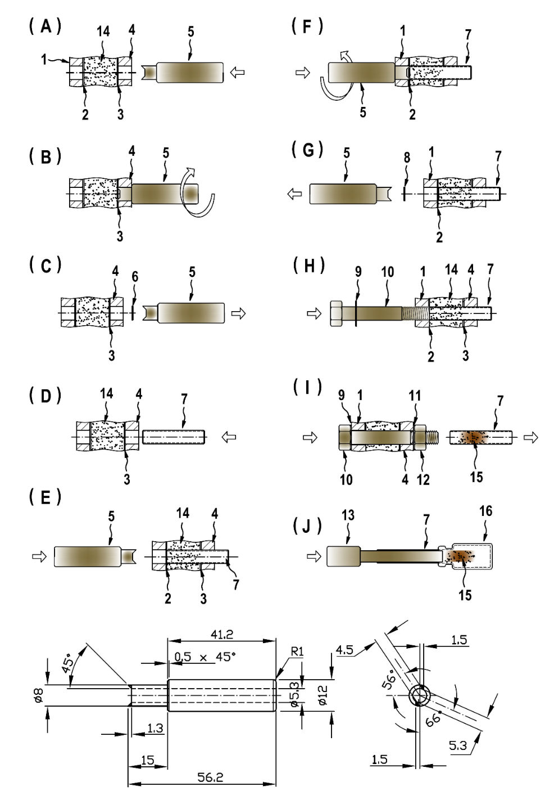
Fig. S1b Soil sampling procedure: (A) section of the rhizotron, with the opaque PVC plate and sampling openings 1 covered with adhesive film 2, and sampling opening 4 with adhesive film 3 at the transparent window. Custom-made cutting tool 5 and soil substrate 14 (cutting tool details in Fig. S1). (B) cutting tool 5 is inserted into plate 4, penetrates and cuts a hole into film 3 by a clockwise rotation. (C) cutting tool 5 is pulled out of plate 4, before removing cut-out film 6. (D) sampling cylinder 7 is ready for insertion into sampling opening of plate 4. (E) sampling cylinder 7 is pushed forward to the adhesive film. (F) cutting tool 5 is pushed into plate 1, cutting a hole in film 2, while pushing sampling cylinder 7 forward. (G) Cutting tool 5 is pulled out of plate 1 and the film 8 is removed. (H) Sampling cylinder 7 and soil substrate 15 are released by using a plastic screw 10 with O-ring seal 9. (I) Seal 11 and nut 12 close the sampling opening after removing sampling cylinder 7 with soil substrate 15. (J) Soil 15 is released into a sample vial 16 by using a plunger 13

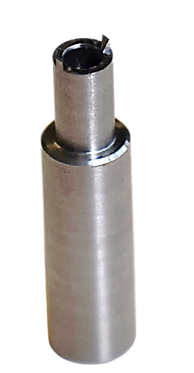
Fig. S1c Technical drawing (side and top view) of the custom-made film-cutting tool with all measures in millimeter at the left and a picture at the right. Invented by Klaus Jürgen Reichel (retired patent drafter)

Soil sampling via re-sealable openings
A custom-made, stainless steel cutting tool (Fig. S1b; Fig. S1c) was used to open the soil sampling ports by penetrating the 210 µm PET film with minimal disturbance of the soil habitat. It turned out advantageous to first penetrate the PET film at the up-facing rhizotron side (opaque PVC plate). A bumper edge at the cutting tool shaft helped to avoid a too deep insertion and disturbance of the soil behind the PET film. After several turns with the cutting tool, the cut out PET film disc was removed with tweezers. A thin-walled, stainless steel sampling cylinder (metal thickness 0.25 mm) was inserted in a rotating manner to cut out the soil core. The opposing sampling port was opened at an up-right rhizotron position before pushing through the cylinder. A plastic screw sealed with an O-ring was attached to the sampling cylinder before pushing it back with the screw to the other rhizotron side. After releasing the sampling cylinder, the sampling port was closed watertight using another O-ring seal and a screw nut. A plunger with a diameter slightly smaller than the sampling cylinder was used to transfer the soil core of about 1.5 g into storage vials. In total, 156 different soil samples were taken by this procedure.
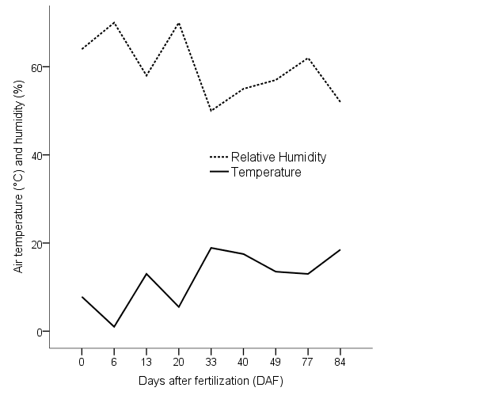
Fig. S2 Average air temperature (°C) and relative humidity (% at 12 a.m.) for different days after wheat straw amendment and fertilization (DAF). Zero (0 DAF) marks the time before treatment application
Fig. S3 Wheat straw effects on (A) overall bacterial abundance (16S rRNA gene copies), (B) abundance of ammonia-oxidizing archaea (AOA), (C) abundance of ammonia-oxidizing bacteria (AOB), (D) abundance of nitrite reducers (nirS), (E) abundance of nitrite reducers (nirK), and (F) abundance of nitrous oxide reducers (nosZ) in bulk and root-affected soil of the NP (control) and the WSNP (wheat straw) treatment zero days after amendment and fertilization (0 DAF) and 49 DAF (29 days after barley transplanting) in soil dry matter (dm). Significances between the treatments are illustrated with: ns (p > 0.05), * (p < 0.05), ** (p < 0.01) and *** (p < 0.001)

Fig. S4 Barley root from the WSNP treatment 90 days after wheat straw amendment and fertilization (scale in centimeters), after stringent washing with tab water. Wheat straw leaves remained attached to the root surface, which might likely be microbe-assisted

