Supplementary information for:

Road-Traffic Emissions of Ultrafine Particles and Elemental Black Carbon in Six Northern European Cities

Simonas Kecorius^{a,b,c*}, Leizel Madueño^{d}, Kristina Plauškaitėª, Steigvilė Byčenkienėª, Mario Lovrić^{e,f}, Valentino Petrić^{f,g}, Manuel Carranza-García^{h}, Manuel J. Jiménez-Navarro^{h}, María del Mar Martínez-Ballesteros^{h}, and Gaudentas Kecorius^{i}

ªCenter for Physical Sciences and Technology, Vilnius, Lithuania
^{b}Institute of Epidemiology, Helmholtz Zentrum München, Neuherberg, Germany
^{c}Augsburg University, Augsburg, Germany
^{d}Leibniz-Institute for Tropospheric Research, Leipzig, Germany
^{e}Institute for Anthropological Research, Zagreb, Croatia
^{f}Lisbon Council, Brussels, Belgium
^{g}Ascalia d.o.o., Čakovec, Croatia
^{h}University of Seville, Seville, Spain
^{i}Private Researcher, Kupiškis, Lithuania

* Correspondence to: Simonas Kecorius
Email: simonas.kecorius@helmholtz-munich.de

This PDF file includes:

Supplementary text
Figures S1 to S6
Table T1
References
Legends for Movies 0
Legends for Datasets 0

Other supplementary materials for this manuscript include the following:

Movies 0
Datasets 0

Supplementary Information Text
Supplementary Information Figures
Supplementary Information Tables

Supplementary Information Text
Custom algorithm for pollutant concentration peak detection

The algorithm first approximates the first derivative of the smoothed time series, $f\left(t\right)$, by computing finite differences between consecutive observations. A local maximum is identified when this derivative changes sign from positive to negative, which in discrete terms corresponds to finding an index iii at which the difference in the signs of the derivatives (i.e., $sign\left(f\left(i+1\right)−f\left(i\right)\right)$) equals −2. In other words, a candidate peak is located at i if $sign\left(f\left(i\right)−f\left(i−1\right)\right)=+1$ and $sign\left(f\left(i+1\right)−f\left(i\right)\right)=−1$. Only candidate peaks with values exceeding a predefined threshold are retained. Next, the algorithm performs a sequential temporal filtering to ensure that peaks are sufficiently separated. For each candidate peak, the time difference from the most recently accepted peak is calculated. If the gap is less than a minimum required duration, the algorithm compares the peak values and retains only the higher of the two. This ensures that closely spaced fluctuations—likely due to noise—do not produce redundant peak detection. For each accepted peak, the algorithm then delineates the "plateau" surrounding it by examining the local behavior of $f\left(t\right)$ within specified intervals extending backward and forward in time. Mathematically, starting from the peak at index i, the algorithm searches backward until it finds an index j where the condition $f\left(j\right)<f\left(j−1\right)$ holds, marking the beginning of the plateau. Similarly, it searches forward until it encounters an index k such that $f\left(k\right)<f\left(k+1\right)$, defining the end of the plateau. These indices j and k represent the temporal boundaries over which the peak remains elevated. Finally, the method extracts the profile of each peak by collecting the values from the plateau start to the plateau end and compiles key information such as the peak time, peak value, plateau boundaries, and duration (the time interval between the boundaries). This extraction yields detailed descriptions of the identified peaks, which are then used for further statistical analysis.

Absorption Ångström exponent (AAE)

The absorption Angstrom exponent (AAE) is a measure used in atmospheric science to show how much light aerosols absorb at different wavelengths. It helps to understand how the absorption changes as the wavelength of light varies, which is key for identifying what kind of aerosols are present (Saarikoski et al., 2021). The calculation of AAE involves measuring the absorption coefficients at two different wavelengths and applying the formula (Vijay et al., 2024):

$AAE=−\frac{ln\left(\frac{b_{ab,λ_{1}}}{b_{ab,λ_{2}}}\right)}{ln\left(\frac{λ_{1}}{λ_{2}}\right)}$, (1)
where b_{ab,λ1} and b_{ab,λ2} are light absorption coefficients at two respective wavelengths λ₁ and λ₂ (in this study it is 470 and 880 nm). The light absorption coefficients were calculated as:

$b_{ab,λ_{1}}=LAC\left(λ_{1}\right)×{MAC}_{λ_{1}}$, (2)
$b_{ab,λ_{1}}=LAC\left(λ_{1}\right)×{MAC}_{λ_{1}}$, (3)

where LAC(λ₁) and MAC_{λ1}, as well as LAC(λ₂) and MAC_{λ2} are light absorbing carbonaceous (LAC) aerosol mass concentrations and mass absorption coefficients (MAC) at corresponding wavelengths (MAC_{470nm} = 14.69 and MAC_{880nm} = 7.78 m²g⁻¹). The eBC mass concentration attributable to traffic-related emissions (eBC_{FF}) were calculated using:

$b_{abFF}=\frac{b_{ab}\left(λ_{1}\right)−b_{ab}\left(λ_{1}\right)×{\left(\frac{λ_{1}}{λ_{2}}\right)}^{−{AAE}_{BB}}}{{\left(\frac{λ_{1}}{λ_{2}}\right)}^{−{AAE}_{FF}}−{\left(\frac{λ_{1}}{λ_{2}}\right)}^{−{AAE}_{BB}}}$, (4)
where AAE_{FF} and AAE_{BB} were chose as 1 and 2, based on Saarikoski et al. (2021) and Minderytė et al. (2023). The median AAE values and fossil fuel-related eBC mass fractions (eBC_{FF}) for each city are as follows:

City | AAE (λ = 470 - 880), background aerosol | eBC_{FF} (%), background aerosol | AAE (λ = 470 - 880), tailpipe emission | eBC_{FF} (%), tailpipe emission
Panevėžys | 1.5 | 65 | 0.9 | 78
Alytus | 1.6 | 65 | 0.8 | 76
Šiauliai | 1.6 | 64 | 0.8 | 79
Klaipėda | 1.5 | 66 | 0.8 | 78
Kaunas | 1.4 | 70 | 0.8 | 77
Vilnius | 1.2 | 79 | 0.7 | 79

In Lithuania, the AAE values for background aerosol range from 1.2 to 1.6, while vehicle-following (tailpipe) samples showed values between 0.7 and 0.9. These values are consistent with literature reports and suggest a mix of fresh and aged combustion particles. AAE values below 1 can arise from several factors. As noted by Schuster et al. (2006), AAE values less than one indicate the presence of large particles such as dust or sea salt. Similarly, Yu et al. (2016) observed that AAE values below unity may be attributed to coarse-mode particles, including resuspended dust or sea salt. Moreover, aging and coating of soot particles can reduce AAE. Gyawali et al. (2012) reported that coated black carbon particles can result in AAEs ranging from 0.7 to 1.0, underscoring the role of atmospheric processing in altering spectral absorption properties. In this context, the observed AAE values below 1 in urban environments can be interpreted as a combination of aged/coated fossil-fuel-derived BC and contributions from non-exhaust sources such as resuspended dust. Background AAE values of 1.2–1.6, together with eBC_{FF} mass fractions of 64–79%, indicate a dominant contribution from fossil-fuel combustion, with some influence from particle aging and urban aerosol mixing.
Supplementary Information Figures

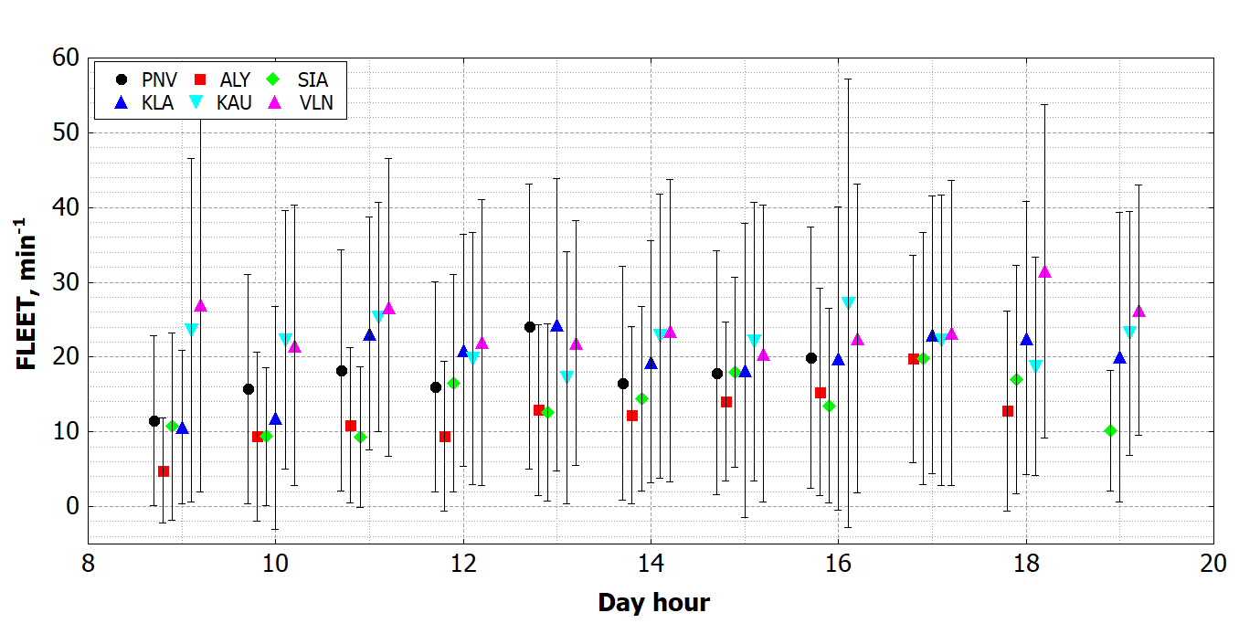
Fig. S1. Average vehicular fleet flow per minute across six Lithuanian cities, derived from video footage recorded by the onboard camera during mobile measurement campaigns. Calculations are based on the specific hours of the day when measurements were performed. Error bars indicate one standard deviation.

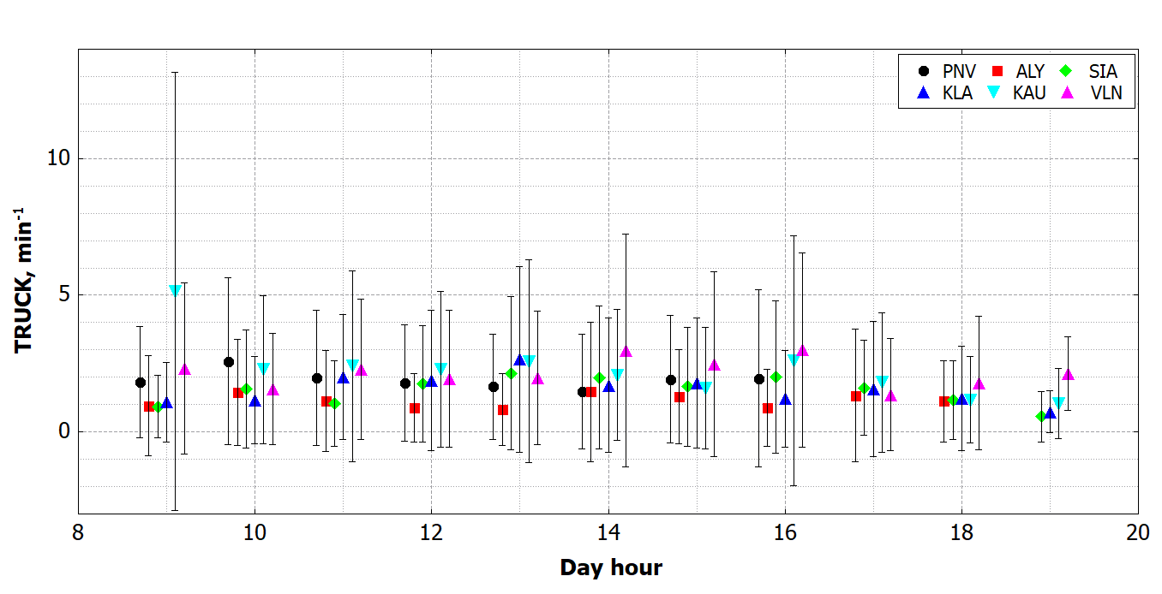
Fig. S2. Average truck fleet flow per minute across six Lithuanian cities, derived from video footage recorded by the onboard camera during mobile measurement campaigns. Calculations are based on the specific hours of the day when measurements were performed. Error bars indicate one standard deviation.
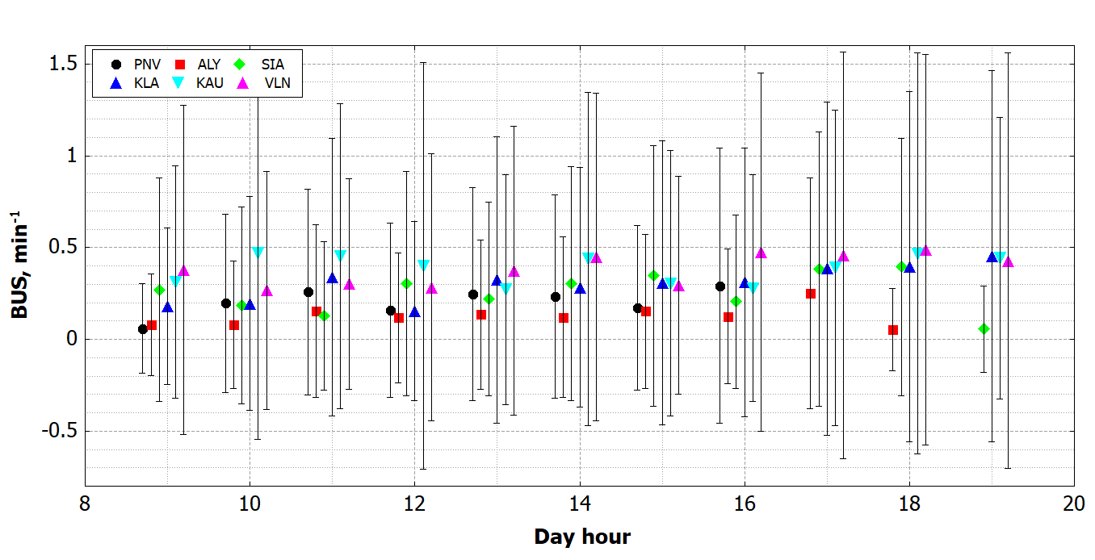
Fig. S3. Average bus fleet flow per minute across six Lithuanian cities, derived from video footage recorded by the onboard camera during mobile measurement campaigns. Calculations are based on the specific hours of the day when measurements were performed. Error bars indicate one standard deviation.
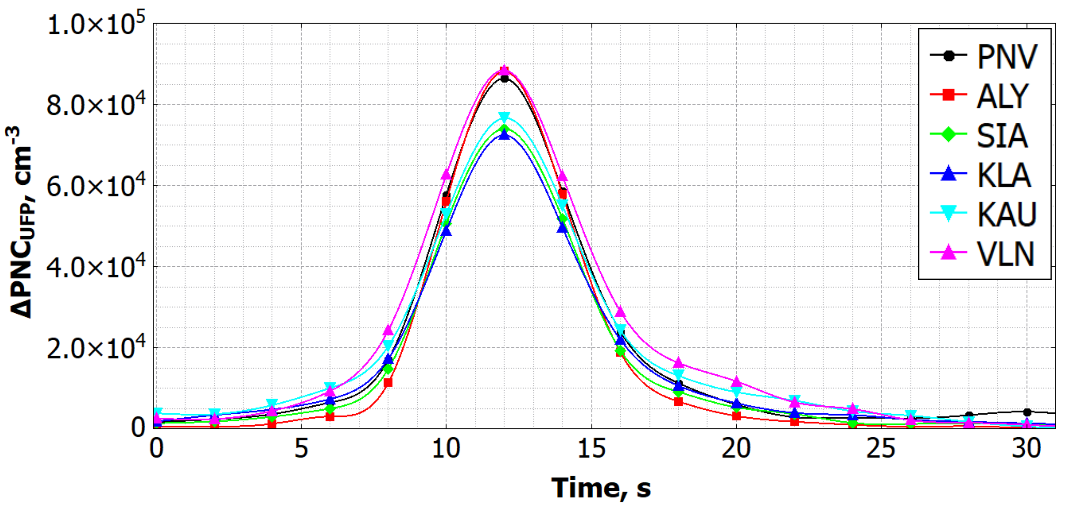
Fig. S4. Median pollutant plume profiles showing increases in ultrafine particle number concentration derived from the difference between total and background pollutant concentrations across six Lithuanian cities.
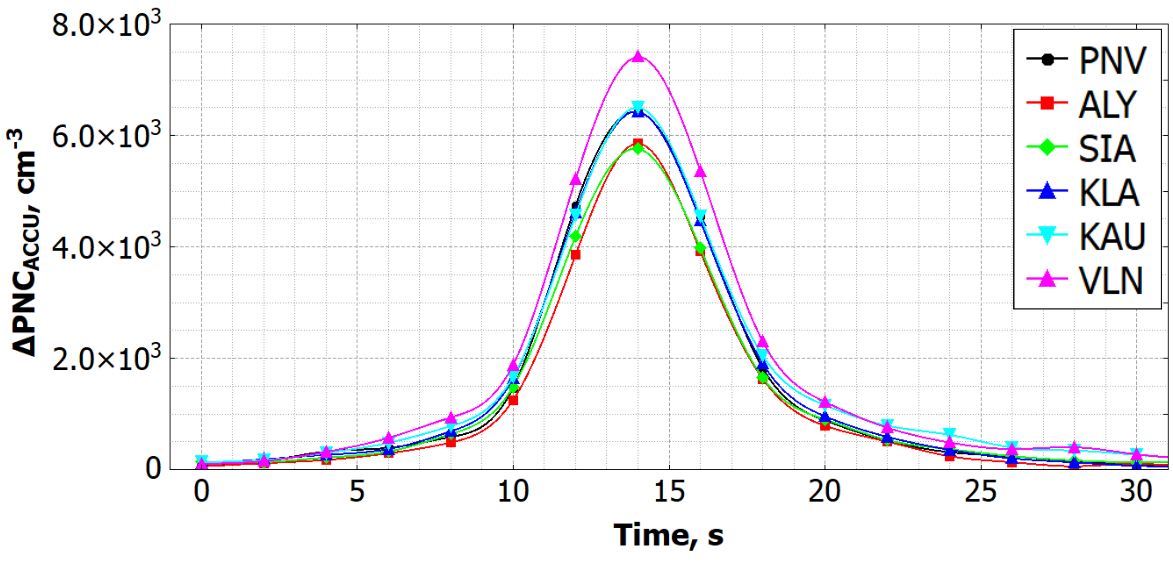
Fig. S5. Median pollutant plume profiles showing increases in accumulation mode particle number concentration derived from the difference between total and background pollutant concentrations across six Lithuanian cities.
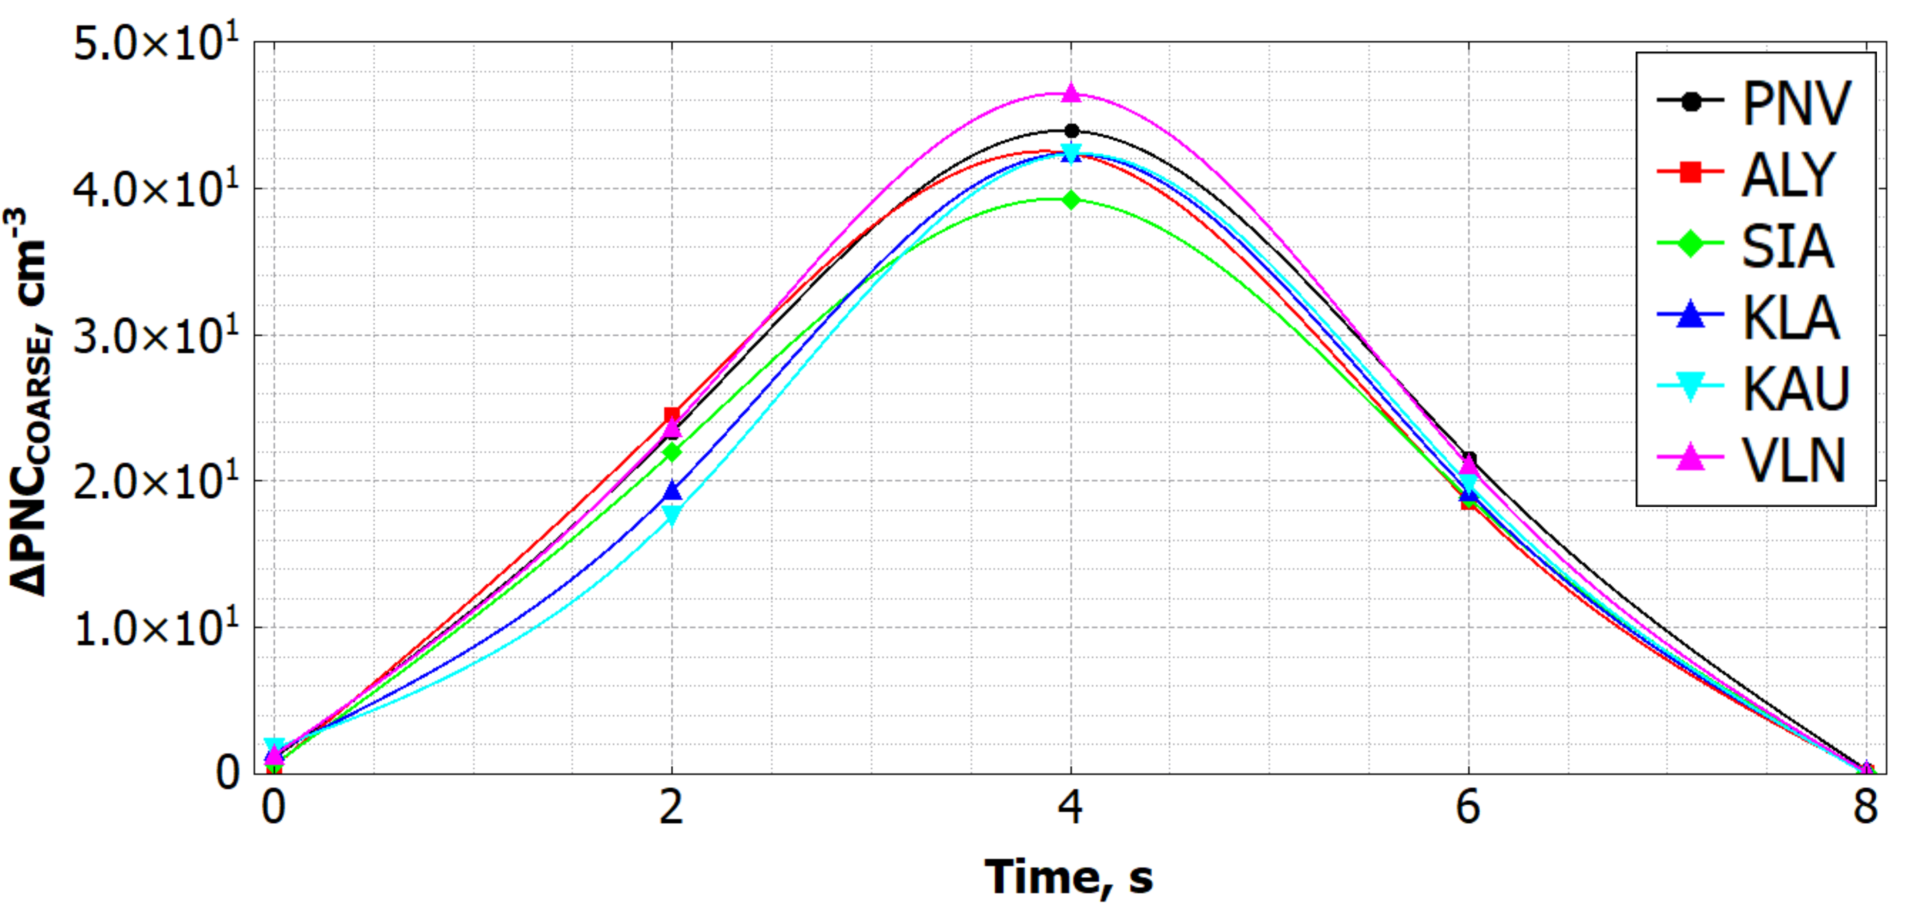
Fig. S6. Median pollutant plume profiles showing increases in coarse mode particle number concentration derived from the difference between total and background pollutant concentrations across six Lithuanian cities.
Supplementary Information Tables

Table T1. Exponentially modified Gaussian fit parameters (amplitude A, location μ, Gaussian width σ, and exponential decay λ) for total (PNC), ultrafine (UFP), accumulation (ACCU) and coarse (COARSE) mode particle number concentration, as well as equivalent black carbon (eBC) across six Lithuanian cities.
City | Pollutant | Fit parameters
 |  | A | μ | σ | λ
Panevėžys | PNC | 532242 | 10.5 | 1.83 | 0.49
 | UFP | 528412 | 10.46 | 1.86 | 0.47
 | ACCU | 41780 | 12.33 | 1.96 | 0.46
 | COARSE | 186 | 3.89 | 1.67 | 21.14
 | eBC | 164408 | 15.33 | 3.63 | 0.11
Alytus | PNC | 466228 | 10.8 | 1.79 | 0.63
 | UFP | 485400 | 10.79 | 1.77 | 0.64
 | ACCU | 35962 | 12.43 | 1.88 | 0.46
 | COARSE | 178 | 3.45 | 1.6 | 2.74
 | eBC | 130856 | 14.96 | 3.52 | 0.1
Šiauliai | PNC | 441648 | 10.64 | 1.94 | 0.53
 | UFP | 454221 | 10.52 | 1.91 | 0.51
 | ACCU | 38102 | 12.2 | 1.99 | 0.42
 | COARSE | 167 | 3.75 | 1.66 | 7.16
 | eBC | 144583 | 15 | 3.56 | 0.1
Klaipėda | PNC | 485426 | 10.38 | 1.94 | 0.45
 | UFP | 464873 | 10.34 | 1.97 | 0.44
 | ACCU | 42276 | 12.27 | 2.02 | 0.44
 | COARSE | 168 | 3.94 | 1.58 | 22.22
 | eBC | 145600 | 15.12 | 3.71 | 0.1
Kaunas | PNC | 534428 | 10.12 | 2.03 | 0.36
 | UFP | 524129 | 10.19 | 2.05 | 0.38
 | ACCU | 44632 | 12.06 | 1.94 | 0.35
 | COARSE | 165 | 4.02 | 1.55 | 22.55
 | eBC | 161992 | 14.73 | 4.22 | 0.1
Vilnius | PNC | 606305 | 10.06 | 2.02 | 0.35
 | UFP | 613444 | 10.07 | 1.99 | 0.36
 | ACCU | 49983 | 12.27 | 2.05 | 0.41
 | COARSE | 190 | 3.87 | 1.61 | 20.92
 | eBC | 185527 | 14.5 | 3.56 | 0.09

References

Gyawali, M., Arnott, W.P., Zaveri, R.A., Song, C., Moosmüller, H., Liu, L., Mishchenko, M.I., Chen, L.W., Green, M.C., Watson, J.G. and Chow, J.C., 2012. Photoacoustic optical properties at UV, VIS, and near IR wavelengths for laboratory generated and winter time ambient urban aerosols. Atmospheric Chemistry and Physics, 12(5), pp.2587-2601.
Minderytė, A., Ugboma, E.A., Montoro, F.F.M., Stachlewska, I.S. and Byčenkienė, S., 2023. Impact of long-range transport on black carbon source contribution and optical aerosol properties in two urban environments. Heliyon, 9(9).
Saarikoski, S., Niemi, J.V., Aurela, M., Pirjola, L., Kousa, A., Rönkkö, T. and Timonen, H., 2021. Sources of black carbon at residential and traffic environments obtained by two source apportionment methods. Atmospheric chemistry and physics, 21(19), pp.14851-14869.
Schuster, G.L., Dubovik, O. and Holben, B.N., 2006. Angstrom exponent and bimodal aerosol size distributions. Journal of Geophysical Research: Atmospheres, 111(D7).
Vijay, S., Schöbitz, L., Chilunga, H.K. and Tilley, E., 2024. Absorption Ångström exponent values to identify light-absorbing carbonaceous aerosol sources in Blantyre, Malawi. Aerosol and Air Quality Research, 24(11), pp.1-16.
Yu, X., Wang, T., Liu, C. and Pu, L., 2016. Numerical studies on a severe dust storm in East Asia using WRF-Chem. Atmospheric and Climate Sciences, 7(1), pp.92-116.

