**Supplemental Figure 1** Clinical overview of the 209 index patients and molecular diagnostic rates in the validation cohort

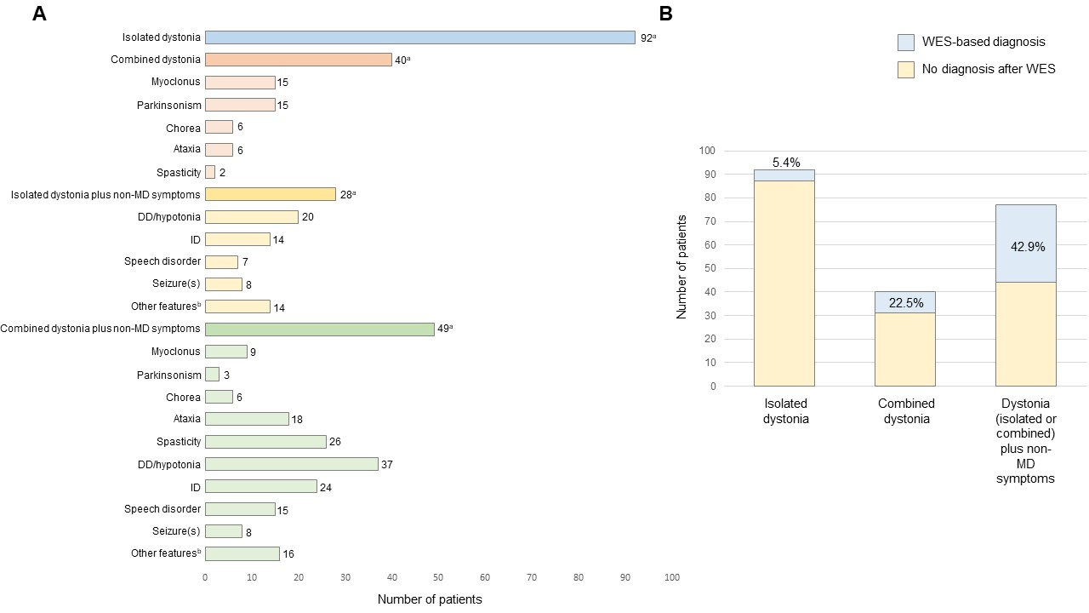

aTremor present in 20% of the entire cohort: isolated dystonia – 28%; combined dystonia – 8%; isolated dystonia with coexisting non-movement disorder-related neurological symptoms – 14%; combined dystonia with coexisting non-movement disorder-related neurological symptoms – 18%.

bOther features included: oculomotor abnormalities, visual impairment, hearing impairment, dysphagia, neurogenic bladder/bowel dysfunction, sleep disturbances, behavioral disorders, psychiatric problems (anxiety, depression), dementia, neuropathic symptoms, episodic headache, stereotypies.

(A) Number of index cases per dystonia subtype and presenting comorbidity. DD, developmental delay; ID, intellectual disability. (B) Percentages of index patients with genetic diagnoses per dystonia subtype. Non-MD symptoms, non-movement disorder-related neurological symptoms; WES, whole-exome sequencing.

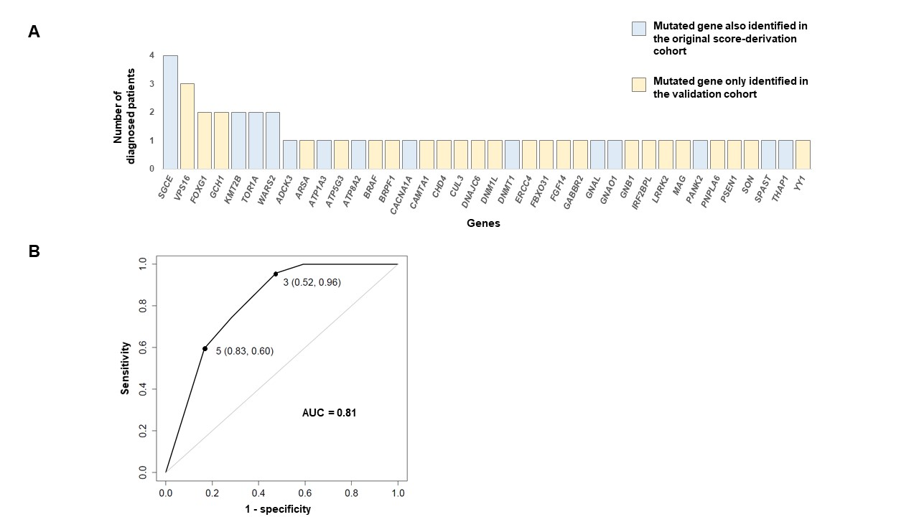**Supplemental Figure 2** Spectrum of disease-associated genes in the validation cohort and predictive power of the scoring algorithm

(A) Number of index patients with pathogenic or likely pathogenic variants, subdivided by gene. Of the 38 variant-harboring genes, 14 (37%) have also been identified in the original score-derivation cohort1. (B) Receiver operating characteristic (ROC) curve in the validation cohort. AUC, area under the curve.

1. Zech M, Jech R, Boesch S, et al. Monogenic variants in dystonia: an exome-wide sequencing study. Lancet Neurol 2020;19(11):908-918.

**Supplemental Table 1** Clinical and sequencing characteristics of the 209 index patients in the validation cohort

|  |  |
| --- | --- |
| **Characteristics** | **No (%)** |
| Gender | |
| Female | 92 (44.0) |
| Male | 117 (56.0) |
| Ancestrya | |
| European | 198 (94.7) |
| Asian | 2 (1.0) |
| Middle Eastern | 9 (4.3) |
| Age at testing |  |
| Infancy (0-2 years) | 10 (4.8) |
| Childhood (3-12 years) | 37 (17.7) |
| Adolescence (13-20 years) | 20 (9.6) |
| Adulthood (≥21 years) | 142 (67.9) |
| Age at dystonia onset | |
| Infancy (0-2 years) | 43 (20.6) |
| Childhood (3-12 years) | 41 (19.6) |
| Adolescence (13-20 years) | 30 (14.4) |
| Adulthood (≥21 years) | 95 (45.5) |
| Body distribution | |
| Generalized dystonia | 82 (39.2) |
| Segmental dystonia | 62 (29.7) |
| Focal dystonia | 65 (31.1) |
| Coexisting symptoms | |
| Combined dystonia plus non-MD symptoms | 49 (23.4) |
| Isolated dystonia plus non-MD symptoms | 28 (13.4) |
| Combined dystonia | 40 (19.1) |
| Isolated dystonia | 92 (44.0) |
| Family historyb |  |
| Positive | 35 (16.7) |
| Negative | 174 (83.3) |
| Sequencing modec | |
| Singleton | 146 (69.9) |
| Duo | 11 (5.3) |
| Trio | 52 (24.9) |

aAccording to families’ self-report.

bReported to have first/second degree relatives with dystonia and/or tremor and/or a complex neurological condition related to the phenotype of the index patient in the cohort.

cSingleton, exome analysis of the index patient only; duo, exome analysis of the index patient and 1 affected family member (affected parent or affected sibling); trio, exome analysis of the index patient and the unaffected parents.

Non-MD symptoms, non-movement disorder-related neurological symptoms.

**Supplemental Table 2** Pathogenic and likely pathogenic variants detected in the validation cohort and the associated genetic diagnoses

|  |  |  |  |  |  |  |  |  |  |
| --- | --- | --- | --- | --- | --- | --- | --- | --- | --- |
| Index patient IDa | Summary score according to the predictive algorithm (Zech et al.)1 | Gene | Transcript | cDNA variant(s) | Protein variant(s) | Variant inheritanceb | Zygosityb | Known pathogenic variantc (ACMG rule activated to classify novel pathogenic or likely pathogenic variants)d | Corresponding diagnosis (OMIM number)a |
| Patient 7 | 2 | *ADCK3* | NM_020247.4 | c.638G>A; c.911C>T | p.Arg213Gln; p.Ala304Val | AR | compound heterozygous | yes; yes | Coenzyme Q10 deficiency, primary, 4 (612016) |
| Patient 77 | 2 | *LRKK2* | NM_198578.3 | c.6055G>A | p.Gly2019Ser | AD (NK) | heterozygous | yes | Parkinson disease 8 (607060) |
| Patient 191 | 3 | *BRPF1* | NM_004634.2 | CNV (chr3:9593958-9788137, deletion) | CNV (chr3:9593958-9788137, deletion) | AD (NK) | heterozygous | no (PVS1, PM2) | Intellectual developmental disorder with dysmorphic facies and ptosis (617333) |
| Patient 201 | 3 | *CUL3* | NM_003590.4 | c.664C>T | p.Gln222* | AD (I-SP) | heterozygous | no (PVS1, PM2, PP1) | N/Ae |
| Patient 56 | 3 | *ERCC4* | NM_005236.2 | c.2026G>T; c.2395C>T | p.Glu676*; p.Arg799Trp | AR | compound heterozygous | no (PVS1, PM2, PM3); yes | Xeroderma pigmentosum, type F/Cockayne syndrome (278760) |
| Patient 101 | 3 | *GNAL* | NM_001142339.2 | c.478G>A | p.Asp160Asn | AD (NK) | heterozygous | no (PM1, PM2, PP2, PP3) | Dystonia 25 (615073) |
| Patient 187 | 3 | *PSEN1* | NM_000021.3 | c.697A>G | p.Met233Val | AD (I-SP) | heterozygous | yes | Alzheimer disease, type 3 (607822) |
| Patient 49 | 3 | *THAP1* | NM_018105.2 | c.11C>T | p.Ser4Phe | AD (NK) | heterozygous | yes | Dystonia 6, torsion (602629) |
| Patient 72 | 3 | *TOR1A* | NM_000113.2 | c.907_909delGAG | p.Glu303del | AD (I-AP) | heterozygous | yes | Dystonia-1, torsion (128100) |
| Patient 129 | 3 | *TOR1A* | NM_000113.2 | c.907_909delGAG | p.Glu303del | AD (I-AP) | heterozygous | yes | Dystonia-1, torsion (128100) |
| Patient 87 | 3 | *VPS16* | NM_022575.2 | c.559C>T | p.Arg187* | AD (NK) | heterozygous | no (PVS1, PM2) | N/Ae |
| Patient 128 | 3 | *VPS16* | NM_022575.2 | c.559C>T | p.Arg187* | AD (NK) | heterozygous | no (PVS1, PM2) | N/Ae |
| Patient 119 | 4 | *ATP5G3* | NM_001689.4 | c.318C>G | p.Asn106Lys | AD (DN) | heterozygous | yes | N/Ae |
| Patient 204 | 4 | *FGF14* | NM_004115.3 | CNV (chr13:102521075-102568994, deletion) | CNV (chr13:102521075-102568994, deletion) | AD (DN) | heterozygous | no (PVS1, PS2, PM2) | Spinocerebellar ataxia 27 (609307) |
| Patient 110 | 4 | *GCH1* | NM_000161.2 | c.287G>A | p.Trp96* | AD (I-AP) | heterozygous | yes | Dystonia, DOPA-responsive, with or without hyperphenylalaninemia (128230) |
| Patient 126 | 4 | *GCH1* | NM_000161.2 | c.281C>T | p.Thr94Met | AD (I-AP) | heterozygous | yes | Dystonia, DOPA-responsive, with or without hyperphenylalaninemia (128230) |
| Patient 51 | 4 | *SGCE* | NM_003919.2 | c.170T>G | p.Leu57Arg | AD (I-AP) | heterozygous | no (PM1, PM2, PP1, PP3, PP4) | Dystonia-11, myoclonic (159900) |
| Patient 69 | 4 | *SGCE* | NM_003919.2 | c.314A>G | p.Gln105Arg | AD (I-AP) | heterozygous | yes | Dystonia-11, myoclonic (159900) |
| Patient 193 | 4 | *SGCE* | NM_003919.2 | c.786delT | p.Arg263Valfs*26 | AD (NK) | heterozygous | no (PVS1, PM2, PP4) | Dystonia-11, myoclonic (159900) |
| Patient 165 | 5 | *ARSA* | NM_000487.5 | c.1276G>A | p.Glu426Lys | AR | homozygous | no (PM1, PM2, PP1, PP3) | Metachromatic leukodystrophy (250100) |
| Patient 60 | 5 | *ATP1A3* | NM_152296.4 | c.2332A>C | p.Thr778Pro | AD (NK) | heterozygous | no (PM1, PM2, PP2, PP3) | Dystonia-12/Alternating hemiplegia of childhood 2/CAPOS syndrome (128235/614820/601338) |
| Patient 159 | 5 | *ATP8A2* | NM_016529.4 | c.691_701del | p.Leu231Ilefs*7 | AR | homozygous | no (PVS1, PM2) | Cerebellar ataxia, mental retardation, and dysequilibrium syndrome 4 (615268) |
| Patient 207 | 5 | *BRAF* | NM_004333.4 | c.1574T>A | p.Leu525Gln | AD (DN) | heterozygous | yes | Cardiofaciocutaneous syndrome (115150) |
| Patient 203 | 5 | *CACNA1A* | NM_000068.3 | c.3536delC | p.Pro1179Hisfs*11 | AD (NK) | heterozygous | no (PVS1, PM2) | Spinocerebellar ataxia 6/Migraine, familial hemiplegic, 1/Epileptic encephalopathy, early infantile, 42 (183086/141500/617106) |
| Patient 155 | 5 | *CAMTA1* | NM_015215.2 | c.3585_3592del | p.Trp1197Argfs*28 | AD (I-AP) | heterozygous | no (PVS1, PM2, PP1) | Cerebellar ataxia, nonprogressive, with mental retardation (614756) |
| Patient 42 | 5 | *CHD4* | NM_001273.2 | c.637A>G | p.Ser213Gly | AD (DN) | heterozygous | no (PS2, PM2, PP2, PP3) | Sifrim-Hitz-Weiss syndrome (617159) |
| Patient 139 | 5 | *DNAJC6* | NM_014787.3 | c.817C>T | p.Arg273* | AR | homozygous | no (PVS1, PM2) | Parkinson disease 19b, early-onset (615528) |
| Patient 9 | 5 | *DNM1L* | NM_005690.4 | c.428C>G | p.Thr143Arg | AD (DN) | heterozygous | no (PS2, PM2, PP2, PP3) | Encephalopathy, lethal, due to defective mitochondrial peroxisomal fission 1 (614388) |
| Patient 89 | 5 | *DNMT1* | NM_001379.2 | c.1775T>G | p.Leu592Arg | AD (DN) | heterozygous | no (PS2, PM1, PM2, PP2, PP3, PP4) | Cerebellar ataxia, deafness, and narcolepsy, autosomal dominant (604121) |
| Patient 153 | 5 | *FBXO31* | NM_024735.3 | c.1000G>A | p.Asp334Asn | AD (DN) | heterozygous | yes | N/Ae |
| Patient 92 | 5 | *FOXG1* | NM_005249.4 | c.703C>T | p.Leu235Phe | AD (NK) | heterozygous | yes | Rett syndrome, congenital variant (613454) |
| Patient 130 | 5 | *FOXG1* | NM_005249.4 | c.406G>T | p.Glu136* | AD (NK) | heterozygous | yes | Rett syndrome, congenital variant (613454) |
| Patient 20 | 5 | *GABBR2* | NM_005458.7 | c.1699G>A | p.Ala567Thr | AD (DN) | heterozygous | yes | Neurodevelopmental disorder with poor language and loss of hand skills (617903) |
| Patient 154 | 5 | *GNAO1* | NM_138736.2 | c.625C>T | p.Arg209Cys | AD (DN) | heterozygous | yes | Neurodevelopmental disorder with involuntary movements (617493) |
| Patient 173 | 5 | *GNB1* | NM_002074.3 | c.226G>A | p.Asp76Asn | AD (NK) | heterozygous | no (PM1, PM2, PM5, PP2, PP3) | Mental retardation, autosomal dominant 42 (616973) |
| Patient 203 | 5 | *IRF2BPL* | NM_024496.3 | c.2135delCinsGGT | p.Pro712Argfs*56 | AD (NK) | heterozygous | no (PVS1, PM2) | Neurodevelopmental disorder with regression, abnormal movements, loss of speech, and seizures (618088) |
| Patient 46 | 5 | *KMT2B* | NM_014727.1 | c.17_23dup | p.Ser9Argfs*109 | AD (NK) | heterozygous | no (PVS1, PM2) | Dystonia 28, childhood-onset (617284) |
| Patient 88 | 5 | *KMT2B* | NM_014727.1 | c.3335-9_3363del | p.? | AD (NK) | heterozygous | no (PVS1, PM2) | Dystonia 28, childhood-onset (617284) |
| Patient 186 | 5 | *MAG* | NM_002361.3 | c.1126C>T | p.Gln376* | AR | homozygous | no (PVS1, PM2) | Spastic paraplegia 75, autosomal recessive (616680) |
| Patient 170 | 5 | *PANK2* | NM_153638.2 | c.735dupT | p.Lys246* | AR | homozygous | no (PVS1, PM2) | Neurodegeneration with brain iron accumulation 1 (234200) |
| Patient 112 | 5 | *PNPLA6* | NM_006702.4 | c.2944_2947dupAGCC; c.3931C>T | p.Arg983Glnfs*38; p.Arg1311Trp | AR | compound heterozygous | yes; yes | Boucher-Neuhauser syndrome (215470) |
| Patient 149 | 5 | *SGCE* | NM_003919.2 | CNV (chr7:93516132-95668732, deletion) | CNV (chr7:93516132-95668732, deletion) | AD (NK) | heterozygous | no (PVS1, PM2, PP4) | Dystonia-11, myoclonic (159900) |
| Patient 189 | 3 | *SON* | NM_032195.2 | c.5753_5756delTTAG | p.Val1918Glufs*87 | AD (DN) | heterozygous | yes | ZTTK syndrome (617140) |
| Patient 90 | 5 | *SPAST* | NM_014946.3 | c.1496G>A | p.Arg499His | AD (DN) | heterozygous | yes | Spastic paraplegia 4, autosomal dominant (182601) |
| Patient 103 | 5 | *VPS16* | NM_022575.2 | c.559C>T | p.Arg187* | AD (I-AP) | heterozygous | no (PVS1, PM2) | N/Ae |
| Patient 29 | 5 | *WARS2* | NM_015836.3 | c.37T>G; c.298_300delCTT | p.Trp13Gly; p.Leu100del | AR | compound heterozygous | yes; yes | Neurodevelopmental disorder, mitochondrial, with abnormal movements and lactic acidosis, with or without seizures (617710) |
| Patient 196 | 5 | *WARS2* | NM_015836.3 | c.37T>G; CNV (chr1:119618973-119619229, deletion) | p.Trp13Gly; CNV (chr1:119618973-119619229, deletion) | AR | compound heterozygous | yes; yes | Neurodevelopmental disorder, mitochondrial, with abnormal movements and lactic acidosis, with or without seizures (617710) |
| Patient 39 | 5 | *YY1* | NM_003403.4 | c.1118A>G | p.His373Arg | AD (NK) | heterozygous | no (PM1, PM2, PP2, PP3) | Gabriele-de Vries syndrome (617557) |

aTwo patients and their corresponding genetic diagnoses have been previously reported by our group – patient 186 (*MAG* variant)2 and patient 103 (*VPS16* variant)3.

bBased on whole-exome sequencing data and Sanger evaluation of all available family members.

cVariant(s) previously reported as pathogenic alleles in the ClinVar database and/or the published literature.

dAccording to Richards et al.4

eAssociated genetic disorder not (yet) listed in the Online Mendelian Inheritance in Man database – *ATP5G3*, manuscript in preparation by collaborators*; CUL3*, manuscript in preparation by collaborators; *FBXO31*, Jin et al.5; *VPS16*, Steel at al.3

Abbreviations: ACMG, American College of Medical Genetics and Genomics; AD, autosomal-dominant; AR, autosomal-recessive; DN, *de novo*; I-AP, inherited from asymptomatic parent; I-SP, inherited from symptomatic parent; N/A, not available; NK, not known; OMIM; Online Mendelian Inheritance in Man database.

1. Zech M, Jech R, Boesch S, et al. Monogenic variants in dystonia: an exome-wide sequencing study. Lancet Neurol 2020;19(11):908-918.

2. Zech M, Brunet T, Skorvanek M, et al. Recessive null-allele variants in MAG associated with spastic ataxia, nystagmus, neuropathy, and dystonia. Parkinsonism Relat Disord 2020;77:70-75.

3. Steel D, Zech M, Zhao C, et al. Loss-of-Function Variants in HOPS Complex Genes VPS16 and VPS41 Cause Early Onset Dystonia Associated with Lysosomal Abnormalities. Ann Neurol 2020.

4. Richards S, Aziz N, Bale S, et al. Standards and guidelines for the interpretation of sequence variants: a joint consensus recommendation of the American College of Medical Genetics and Genomics and the Association for Molecular Pathology. Genet Med 2015;17(5):405-424.

5. Jin SC, Lewis SA, Bakhtiari S, et al. Mutations disrupting neuritogenesis genes confer risk for cerebral palsy. Nat Genet 2020;52(10):1046-1056.