This supplementary file includes:
Supplementary subjects and methods
Figure S1-6
Table S1-2
Reference
A full list of German Mouse Clinic Consortium members

Supplementary Subjects and Methods
Clinical presentation
Patient 1 is a 4-year-old female born at 36 weeks and 6 days of gestational age. She was noted to be growth restricted prenatally. At the age of 3 months, she was noted to have severe microcephaly, and MRI showed undersulcation and gyration. She had swallowing dysfunction with micro aspiration on nasogastric feeding. Her dysmorphic features included bitemporal narrowing, small and deep-seated eyes, retro-micrognathia, short forehead, prominent midface, upward slanting of palpebral fissures, large dysplastic ears, wide spaced nipples, ulnar deviation of hands with camptodactyly, and talipes with overlapping toes. Consanguinity was reported between parents and no similar condition was reported in the family.
The patient has history of seizure and was on Keppra medication, however, she is seizure-free for almost 2 years without medication. The patient has global developmental delay as well as fine and gross motor delay. The patient is not able to sit without support, does not walk, and is non-verbal. Echocardiogram was performed at the age of 1 week and was normal for her age.
Patient 2 was the first live born child to a known consanguineous couple. She was born at 36 weeks and 6 days via induced vaginal delivery due non-reassuring fetal status to a then G2P1 mother. Pregnancy was complicated by IUGR noted at 30 weeks. Prenatal anatomy scan at 20 weeks was normal. Birth measurements were weight- 2.09kg (3.1%ile), length 41cm (<1%ile) and OFC- 29.5cm (<1%ile). Apgars were 7/9. At 33 hours of life, she was taken to NICU due to apnea and lethargy. In NICU she was noted to have ventricular septal defect (VSD) on echocardiogram and presented with anisocoria with right>left.
She was noted to have developmental delays around 6 months of age in addition to persistent microcephaly. There was also concern for vision impairment as the patient was not reaching for toys. Ophthalmology diagnosed her with Aides Pupil via pilocarpine testing. Brain MRI at 12 months revealed microcephaly, callosal hypogenesis, pachygyria and white matter hypomyelination, small olfactory bulbs, optic nerves, and hippocampi, tectal dysplasia, severe cerebellar hypoplasia and atrophy. Repeat MRI at 22 months of age showed stable cerebellar/vermian hypoplasia with supratentorial brain volume loss, colpocephaly and hypoplastic optic nerves. She was later diagnosed with cortical visual impairment.
At 2 years and 10 months of age, she was g-tube dependent but still several standard deviations below curve on all growth parameters (weight -3SD, height -2SD and head circumference is -6SD). She was receiving speech, physical, occupational and vision therapy for global developmental delays. She was able to roll over independently. She could sit and stand with support only. She had no words but a generally happy demeanor. Family history is notable for three maternal aunts with primary ciliary dyskinesia, a maternal male cousin that died at 33 weeks due to anencephaly and heart defects, and a paternal cousin that was still born at 26 weeks for unknown causes. Parents are double first cousins from Amish/Mennonite ancestry.
Patient 3 was a 13-year-old boy born to consanguineous parents of Ashkenazi Jewish origin. Pregnancy and delivery were uneventful; he was born at 39+2 weeks, at a birthweight of 3000 grams and head circumference 33 cm, with no neonatal complications. The infantile period was complicated by hypotonia and delayed developmental milestones. He walked independently at 24 months, had delayed speech development and poor eye contact, and was diagnosed with autism spectrum disorder. Intelligence quotient (IQ) was evaluated as 46. He had two MRI scans – the first reported normal at age 6.5 years, and the second showed hypoplasia of the vermis and possible heterotopia in the left frontal region at age 11 years. Electromyography (EMG) at age 8 years indicated congenital neuron motor dysfunction, with chronic and diffuse neurogenic changes and normal nerve conduction. Seizures started at age 10 years and responded to treatment. He had congenital ptosis. Hearing was normal. Orthopedic issues included high-arched feet and an upwards position of the first toes. Physical exam revealed mild hypertelorism, ptosis, a high-arched palate and large ears, significant joint laxity and hypermobility, hypotonia, abnormal gait, pes cavus with deformity of the metatarsal region and valgus, and upturned toes.
The younger affected sibling (Patient 4) was a 9-year-old female, born at 39+5 weeks at a birthweight of 2926 grams, and a head circumference of 33 cm. She walked at 16 months and had speech delay, autism spectrum disorder and attention deficit and hyperactivity disorder, yet did not have seizures. She did not have a formal IQ evaluation. Brain MRI at age 3 years was within normal limits. Renal ultrasound demonstrated a double collecting duct. Hearing and vision exams were normal. On physical exam, she had mild dysmorphism, with an elongated face, deep set eyes, high-arched palate, and large ears, as well as joint laxity. Her feet were similar to her brother, with a high arch and deformity of the metatarsal region with valgus.
Patient 5 is a female only child born full-term to healthy consanguineous parents of Emirati ancestry. At birth her hands were noted to extended and her feet flexed. From infancy she was noted to have failure to thrive, microcephaly, global developmental delay, and hypotonia. At last evaluation she was 8 years old and was non-verbal and severely delayed. She is able to maintain some head control, but unable to sit independently. She has a history or seizures that developed at 6 years of age, controlled with keppra and lamotrigine. She has feeding issues and is primarily fed by NG tube. On physical exam she is noted to have microcephaly, prominent eyes, bilaterally simplified everted upper helices and prominent ear lobes. There is intermittent esotropia and nystagmus and sleep apnea s/p tonsillectomy and adenoidectomy. She has subluxation of the left hip and significant bilateral pes planus. MRI shows cerebellar hypoplasia, thin corpus callosum, and anterior horn cell disease. EMG is also suggestive of anterior horn cell disease. She has a movement disorder with near constant choreiform movements. Cardiology exam is significant for Wenckebach second-degree heart block.
Mouse strain. The Wsb2-knockout (KO) (C57BL/6N-Wsb2^{tm1b(EUCOMM)Hmgu}/Ieg; EM:08073) mice were constructed using the IMPC ‘knockout first’ targeting strategy at Helmholtz Zentrum München, Germany as follows. Wsb2-KO mice were generated by allele conversion of C57BL/6N Crl (C57BL/6N-Charles River)- Wsb2^{Tm1a (EUCOMM) Hmgu} mouse line originating from EUCOMM ES clone Monterotondo-HEPD0508_2_A11-2 (clone construction overview here: (https://escell-data.s3.eu-west-2.amazonaws.com/targ_rep_allele/12314/targeting-vector-genbank-file). The tm1b allele was produced by deletion of exon 3 and 4 of Wsb2 and the neomycin cassette using a cell-permeable Cre recombinase. The allele is a knockout as skipping over of the LacZ cassette does not produce a functional protein. The cassette expresses LacZ under the control of the Wsb2 promoter as fusion protein with exon three. The mice were genotyped to verify the mutation. Genomic DNA was extracted from tissue samples collected from mice during ear labelling at weaning (ABI DNA Extract All Reagents Kit (Life technologies;4402599)) and PCR reaction was performed with Wsb2 -specific primers (Wsb2 5' arm neu: TCCCAAGCTAGATGTCCCATC; Wsb2 3' arm neu: ACGTGTGTCACGCACAGTGTA; LAR3: CAACGGGTTCTTCTGTTAGTCC). DNA was amplified by PCR using AllTaq PCR Core Kit (Qiagen; 203127). Wsb2-KO mice can be ordered through the IMPC website (https://www.mousephenotype.org/data/genes/MGI:2144041#order).
Heterozygous mice were intercrossed to generate -/- mice with +/+ controls for experimental analysis. Mice from two cohorts were used in the analysis to have the following number of mutant mice per group: n = 7 male mutants, n = 7 female mutants.
Open field
The Open Field (OF) was assessed at 8 weeks of age and carried out as described previously (1). The arena was made of transparent and infra-red light-permeable acrylic with a smooth floor (internal measurements: 45.5 x 45.5 x 39.5 cm). Illumination levels for the measurement were set at approx. 150 lux in the corners and 200 lux in the middle of the test arena. Data were recorded and analysed using the ActiMot system (TSE, Germany) over a 20 minute period.
SHIRPA
SHIRPA test was used for the evaluation of pronounced physical characteristics, behaviours and morphological aberrations at 9 weeks of age. For neurobehavioral assessment, a series of parameters reflecting abnormal locomotion, appearance, behaviour and reflex reactions were chosen including contact righting, vocalization, aggression, head bobbing, startle response, unexpected behaviours, trunk curl, limb grasp, gait, locomotor activity, activity (body position), head morphology, and tremor. Defined rating scales (as expected/not as expected, present/absent, reduced/normal/increased) were used to categorise alterations. The number of squares crossed in the viewing arena (3 x 5 squares of 10 cm²) during the first 30 seconds after transfer indexed locomotor activity.
Prepulse inhibition of acoustic startle
Sensorimotor gating and recruitment was measured via assessment of the acoustic startle reflex (ASR) and its prepulse inhibition (PPI) at 10 weeks of age with modification to the previously described protocol (2) and further details can be found here (https://www.mousephenotype.org/impress/ProcedureInfo?action=list&procID=746&pipeID=14). Briefly, the Med Associates Inc. (St. Albans, USA) startle equipment was used with background noise [no stimulus (NS)] set to 65 dB. Basal startle response (S, startle pulse of 110 dB/40 ms white noise) and % PPI (to four different pre-pulse (PP) intensities (67, 69, 73, 81 dB [2, 4, 8 and 16 dB above background respectively]), 50-ms interval between S and PP) were determined.
Echocardiography (ECHO)
At 12 weeks of age, left ventricular function of the mice were evaluated with transthoracic echocardiography using a Vevo 2100 Imaging System (Visual Sonics) with a 30 MHz probe. To avoid anesthetic related impairment of cardiac function during echocardiography (3), they were performed on conscious animals. Left ventricular parasternal short and long-axis views were obtained in B-mode imaging and left ventricular parasternal short-axis views were obtained in M-mode imaging at the papillary muscle level. The short axis M-mode images were used to measure left ventricular end-diastolic internal diameter (LVEDD), left ventricular end-systolic internal diameter (LVESD), diastolic and systolic septal wall thickness (IVS) and diastolic and systolic posterior wall thickness (LVPW) in three consecutive beats according to the American Society of Echocardiography leading edge method (Sahn et al., 1978). Fractional shortening (FS) was calculated as FS%=[(LVEDD-LVESD)/LVEDD]x100. Ejection fraction (EF) was calculated as EF%=100*((LVvolD-LVvolS)LVvolD) with LVvol=((7.0/(2.4+LVID)*LVID3). The corrected left ventricular mass (LV MassCor) was calculated as LV MassCor=0.8 ( 1.053 * ((LVIDD + LVPWD + IVSD)3 - LVIDD3)). The Stroke volume of the left ventricle was obtained by substracting end-systolic volume (ESV) from end-diastolic volume (EDV).
Body composition (DEXA lean/fat)
After anesthesia, the weight and length of the mouse were recorded, and the mouse was placed in the analyzer (pDEXA Sabre X-ray Bone Densitometer, Norland Medical Systems Inc., Basingstoke, Hampshire, UK;). Whole body analysis excluding the skull was performed (Scan speed 20 mm/s, Resolution 0.5 mm x 1.0 mm, HAW 0.020).
Indirect calorimetry in metabolic cages
At the age of 11 weeks, homecage locomotor activity (distance travelled) and exploration (rearing), gas exchange (oxygen consumption and carbon dioxide production, VCO2/VO2), energy expenditure (heat production, kJ/h/animal), food intake and substrate utilization of single-caged mice was measured by indirect calorimetry in metabolic homecages (TSE, detailed protocol: https://www.mousephenotype.org/impress/ProcedureInfo?action=list&procID=855&pipeID=14). The measurement commenced five hours before lights off and finished four hours after lights-on the next morning (21 hours in total). Energy expenditure and respiratory quotient were calculated, as well as distance travelled, food intake and substrate utilization profiles.
Optical Coherence Tomography (OCT)
At 15 weeks of age, the mice’s eye fundus and retina are analyzed with a Spectralis OCT (Heidelberg Engineering, Heidelberg, Germany) which is modified with a 78-diopter double aspheric lens (Volk Optical, Inc., Mentor, OH, USA) fixed directly to the outlet of the device. To the dilated (Atropin 0,5%, Ursapharm, Saarbruecken, Germany) eye of the mouse, a contact lens with a 10 mm focal length (Roland Consult, Brandenburg, Germany) is applied using a drop of hypromellose (Methocel 2%, OmniVision, Puchheim, Germany). The mice, anesthetized with ketamine/xylazine, are placed on a platform positioned in front of the Spectralis OCT camera, with the eye directly facing the recording unit. Images are captured as previously described (4), and retinal thickness is measured using the thickness profile tool provided by the Spectralis software.
Pathology
For LacZ staining mice, under deep terminal anaesthesia, were perfused with phosphate buffer saline (PBS) and then cold 4% paraformaldehyde (PFA) prior to tissue collection. Tissues were further fixed by immersion in 4% PFA for extra 30 minutes and then washed in PBS. Tissues were incubated in X-Gal (5-bromo-4-chloro-3-indolyl-beta-D-galacto-pyranoside) solution at 4°C for 48 h followed by a post-fixation with 4% PFA overnight at 4°C. Tissues were washed in 50% glycerol and LacZ reporter gene expression was photographed where staining was observed using a Leica M165C microscope and LAS V3.8 software.
For histopathological analyses, Hematoxylin and Eosin (H&E) staining was performed on formalin-fixed paraffin-embedded sections (3 µm) from 30 tissue. The slides were microscopically analyzed by two independent pathologists. The Pathology screening was performed at 16 weeks of age according to standardized protocols as previously described (5, 6). Immunohistochemical staining was performed using an automated BOND RX^{m} (Leica, Germany) stainer as recommended by the manufacturer. Sections were deparaffinized, antigens were retrieved with citrate buffer for 30 minutes and blocked for 30 minutes with blocking agent. Sections were then incubated with anti-cytochrome P450 (CYP17A1) (Abcam 134910) at a dilution of 1:400. The detection was performed with BOND Polymer Refine Detection DAB (3, 3'-diaminobenzidine). Slides were counterstained with hematoxylin, imaged with a NanoZoomer S60 scanner (Hamamatsu, Japan) and examined with NDP.View2 Plus Software. In negative-control sections, the primary antibodies were omitted, and antibody diluent was used.
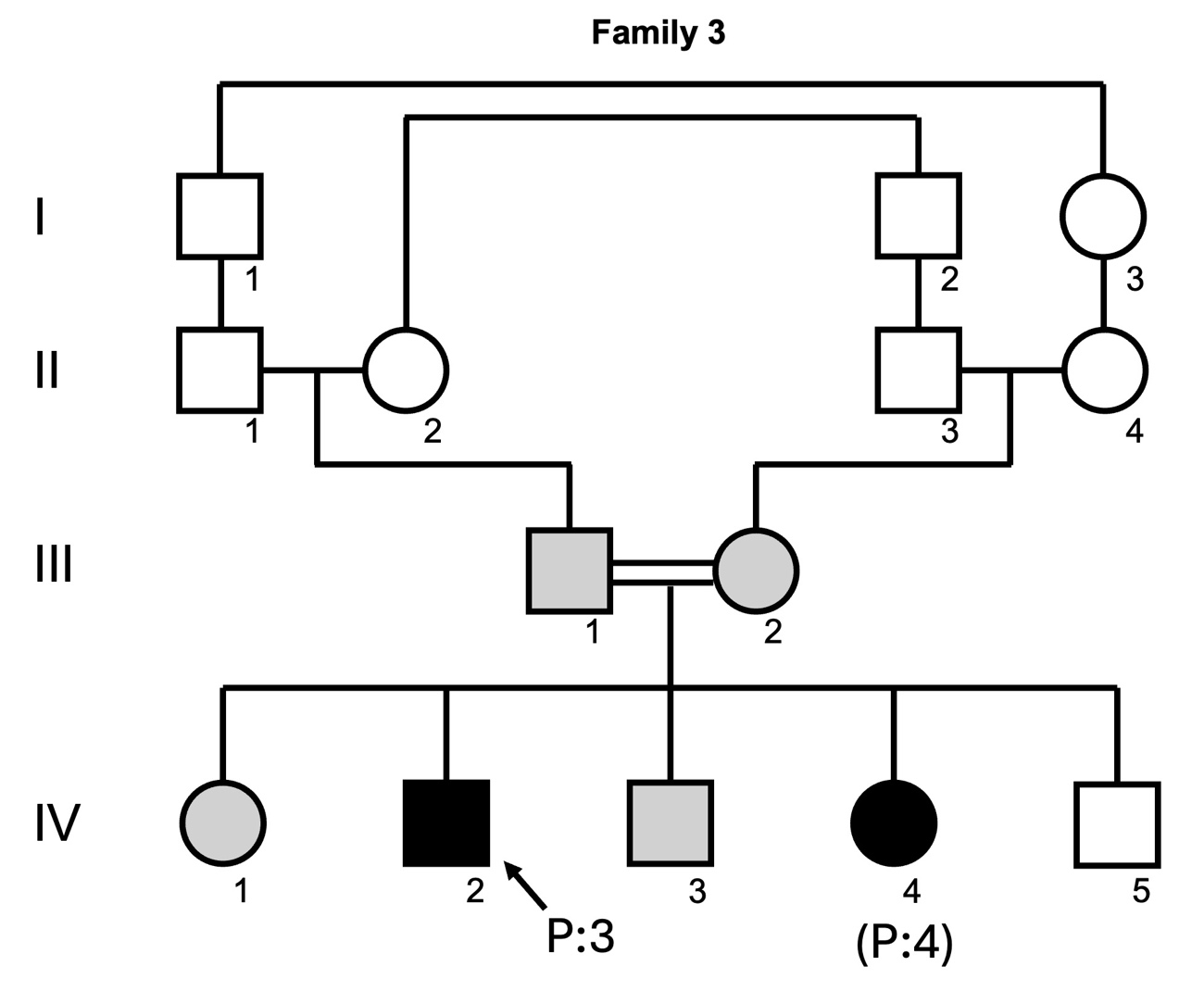
Figure S1. Pedigree of Family 3 with two patients (P:3 and P:4) carrying the same homozygous missense variant in the WSB2 gene (NM_018639.5: c.1121G>A, p.Arg374Gln). P:3 (IV:2) and P:4 (IV:4) are denoted in dark color. They have three unaffected siblings, two of them (IV:1 and IV:3, denoted in grey color) are heterozygous carriers and the other one (IV:5) doesn’t carry this variant.

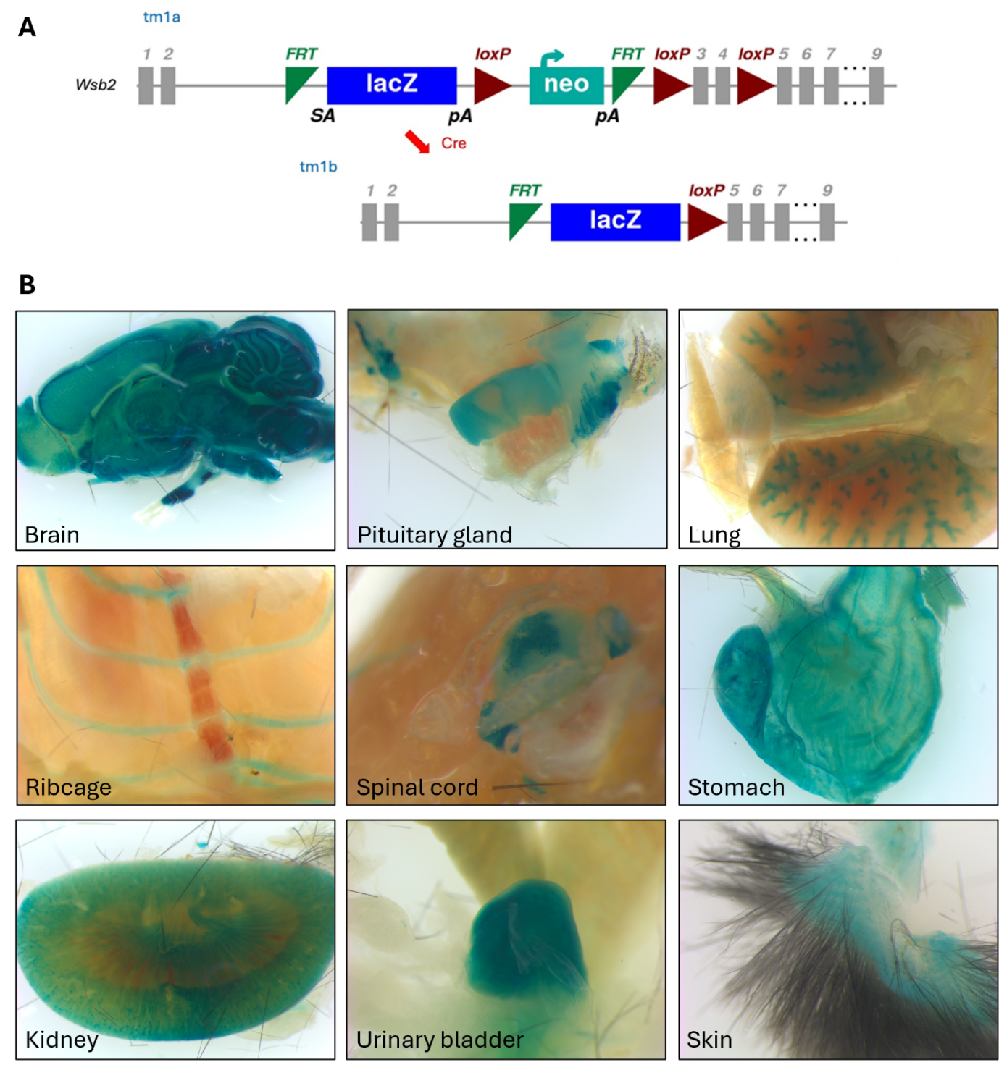
Figure S2. Characterization of the Wsb2-mut mouse model. (A) Targeting vector design for Wsb2-mut mouse model. This vector contained an IRES:LacZ trapping cassette and a floxed promoter-driven Neo-cassette, which was inserted into introns 2–4 of the murine Wsb2 gene. FRT sites flanked the LacZ and Neo cassettes and LoxP sites flanked critical exons 3-4. The vector is used for the generation of a ‘knockout-first’ allele (tm1a) in C57BL/6N embryonic stem cells (7). Cre deletes the promoter-driven selection cassette and floxed exon of the tm1a allele to generate a lacZ– tagged allele (tm1b). Image retrieved from: https://www.mousephenotype.org/data/genes/MGI:2144041. (B) Wholemount images of LacZ reporter gene expression in various tissues of Wsb2^{tm1b} mice, including brain, pituitary gland, lung, ribcage, spinal cord, stomach, kidney, urinary bladder, and skin.
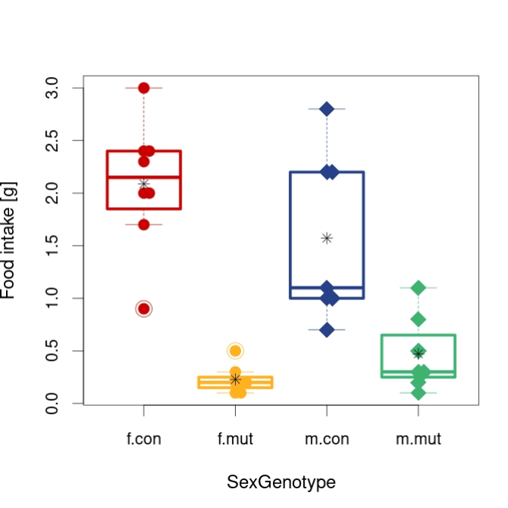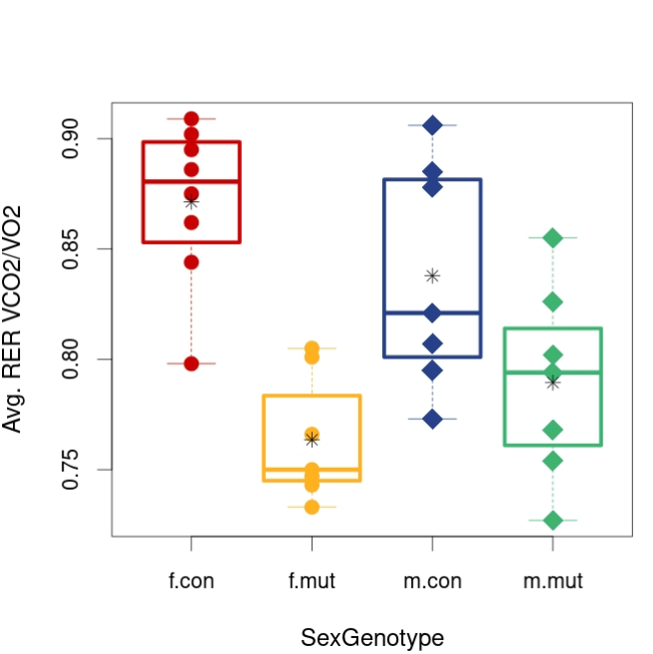
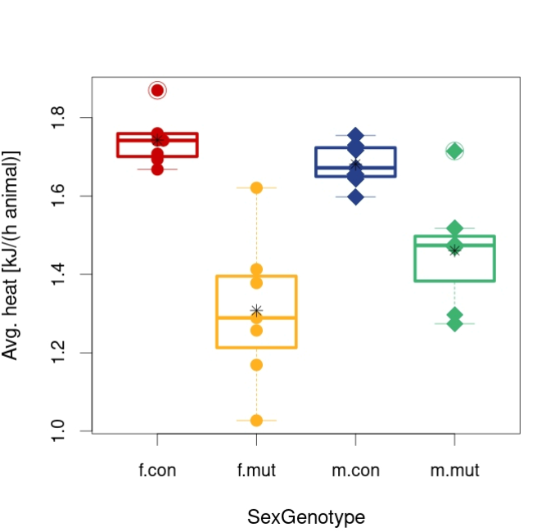
Figure S3. Food consumption, respiratory exchange ratio and heat production using indirect calorimetry in Wsb2-mut mice. Mutant mice of both sexes had a pronounced reduction in food intake (control vs mutant, p<0.001), decrease in respiratory exchange ratio (control vs mutant, p<0.001) and decrease in metabolic rate (control vs mutant, p<0.001). Control group: 8 female (f.con) and 7 male (m.con); mutant group: 7 female (f.mut) and 7 male (m.mut); ANCOVA.

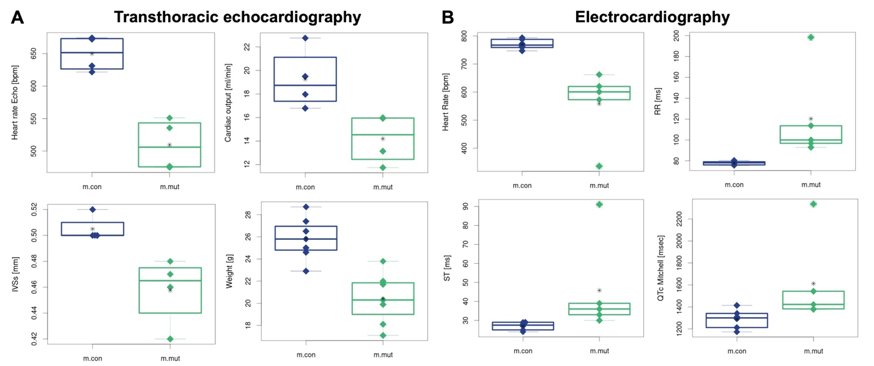
Figure S4. Transthoracic echocardiography and electrocardiography measured in Wsb2-mut mice. Wsb2-mut mice had a reduced heart rate and cardiac output. Significance level: p<0.05, Wilcoxon rank-sum test. m.con: control male, m.mut: mutant male.

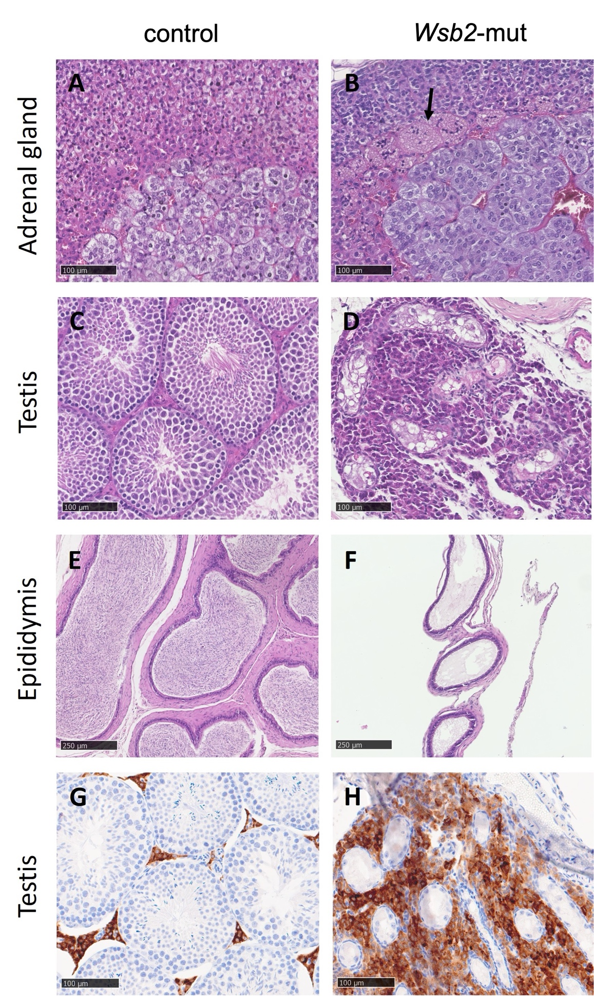
Figure S5. Histopathological findings in the mouse adrenal gland, testis and epididymis at 16 weeks of age. Representative cross-sections stained with H&E (A-F) and immunostained with Cytochrome P450 antibody (G, H) from a control male mouse (A, C, E, G) and from a Wsb2-mut (B, D, F, H) male mouse (scale bar=100 and 250 µm). A shows the absence of X-zone in the peri-medullary area. B illustrates, by comparison, the accumulation of pigment laden cells (arrow) formerly occupied by the X-zone. C shows the normal testicular architecture and cell composition in seminiferous tubules separated by Leydig cells. D indicates severe testicular atrophy. E shows mature sperm in the cauda of the epididymis. F indicates total absence of sperm (aspermia). G reveals normal composition of Leydig cells expressing Cytochrome P450 (CYP17A1) between the seminiferous tubules. H Immunohistochemical staining for Cytochrome P450 (CYP17A1) demonstrating Leydig cell hyperplasia. (n=2 per genotype per sex)

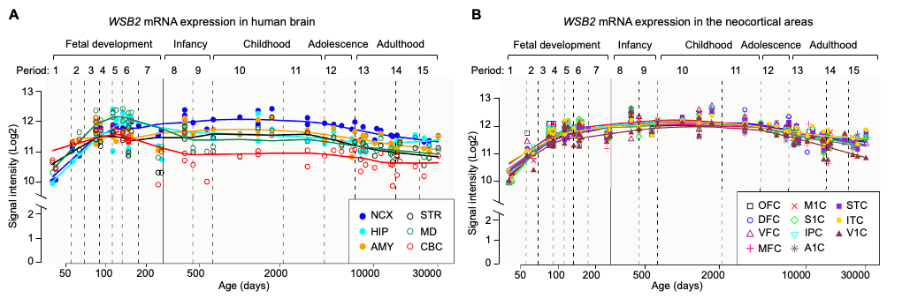
Figure S6. Human WSB2 mRNA expression during brain development. (A) Plots depicting WSB2 expression in different regions of the human brain during fetal development (period 1–7), early (period 8–9), young adulthood (period 10–11), adolescence (period 12), and adulthood (period 13–15). Regions include neocortex (NCX), hippocampus (HIP), amygdala (AMY), striatum (STR), medial dorsal thalamus (MD), and cerebellar cortex (CBC). (B) WSB2 expression in the neocortical areas. Regions include orbital frontal cortex (OFC), dorsolateral prefrontal cortex (DFC), ventrolateral prefrontal cortex (VFC), medial prefrontal cortex (MFC), primary motor cortex (M1C), primary somatosensory cortex (S1C), posterior inferior parietal cortex (IPC), primary auditory cortex (A1C), superior temporal cortex (STC), inferior temporal cortex (ITC), and primary visual cortex (V1C). Data obtained from the human brain transcriptome dataset (https://hbatlas.org/, search gene WSB2).
Patient # | 1 | 2 | 3 | 4 | 5
Sex | Female | Female | Male | Female | Female
Failure to thrive | + | + | - | - | +
Feeding issues | Swallowing dysfunction, nasogastric feeding tube | G-tube dependent | not available | not available | G-tube dependent
Dysmotility | Dysphagia | Constipation | - | - | -
Hypoventilation | TTN | Neonatal apnea | - | - | Obstructive sleep apnea
Delayed speech development | +, nonverbal | +, nonverbal | + | + | +, nonverbal
Delayed gross motor development | +, severe | +, brisk reflexes | + | -, walking at 16 months | +
Delayed fine  motor skills | +, severe | + | + | + | +
Vision/Eye abnormalities | Hyperopia | Bilateral abnormal pupil morphology, hypoplastic optic nerves, cortical visual impairment | Ptosis | - | Intermittent esotropia and hyperopic error
Dysmorphic features | Severe microcephaly, bitemporal narrowing, small and deep-seated eyes, retro-micrognathia, short forehead, prominent midface, upward slanting of palpebral fissures, large dysplastic ears, wide spaced nipples, ulnar deviation of hands with camptodactyly, and talipes with overlapping toes. | Microcephaly, micrognathia, low anterior hairline, overlapping toes, clinodactyly of the 5th finger | Mild hypertelorism, ptosis, high-arched palate and large ears, foot deformity with high arch and upturned toes | Mild - long face, deep set eyes, high-arched palate and large ears, foot deformity with high arch | Microcephaly, prominent eyes, bilaterally simplified everted upper helices and prominent ear lobes, significant bilateral pes planus
Congenital anomalies | - | VSD, spontaneously closed | - | Double collecting duct | -
Muscle Findings (Biopsy results if applicable) | - | - | ND | ND | Skeletal muscle with slight predominance of type 1 fibers and fiber type grouping
Table S1. Other clinical findings of patients carrying variants in the WSB2 gene
Abbreviations: G-tube, gastrostomy tube; ND, not done; TTN, transient tachypnea of newborn; VSD, ventricular septal defect.

Table S2. Identified substrates of WSB2.
Substrates | Biomedical/biological consequences upon substrate degradation | Ref
granulocyte colony-stimulating factor (G-CSF) receptor | Negatively regulates G-CSF-R and G-CSF-controlled proliferation and differentiation signaling | (8)
Interleukin-21 (IL-21) receptor | Negatively regulates IL-21 receptor expression and its signal transduction | (9)
Cyclin D1 | Regulates cyclin D1 ubiquitination and proteasome degradation in a phosphorylation-dependent manner | (10)
p53 | Regulates p53 ubiquitination and proteasome degradation and activates the IGFBP3-AKT-mTOR-dependent pathway in hepatocellular carcinoma | (11)
RelA | Recognizes chromatin-bound methylated RelA for ubiquitination and proteasomal degradation and prevents sustained NF-κB activation | (12)
NOXA | Targets NOXA, a pro-apoptotic BCL-2 family protein, for ubiquitination and proteasome degradation  - https://doi.org/10.7554/eLife.98372.1 | eLife preprint

Reference:
1. Garrett L, Lie DC, Hrabe de Angelis M, Wurst W, Holter SM. Voluntary wheel running in mice increases the rate of neurogenesis without affecting anxiety-related behaviour in single tests. BMC Neurosci. 2012;13:61.
2. Heermann T, Garrett L, Wurst W, Fuchs H, Gailus-Durner V, Hrabe de Angelis M, et al. Crybb2 Mutations Consistently Affect Schizophrenia Endophenotypes in Mice. Molecular neurobiology. 2019;56(6):4215-30.
3. Roth DM, Swaney JS, Dalton ND, Gilpin EA, Ross J, Jr. Impact of anesthesia on cardiac function during echocardiography in mice. Am J Physiol Heart Circ Physiol. 2002;282(6):H2134-40.
4. Pawliczek D, Dalke C, Fuchs H, Gailus-Durner V, Hrabe de Angelis M, Graw J, et al. Spectral domain - Optical coherence tomography (SD-OCT) as a monitoring tool for alterations in mouse lenses. Exp Eye Res. 2020;190:107871.
5. Fuchs H, Aguilar-Pimentel JA, Amarie OV, Becker L, Calzada-Wack J, Cho YL, et al. Understanding gene functions and disease mechanisms: Phenotyping pipelines in the German Mouse Clinic. Behav Brain Res. 2018;352:187-96.
6. Fuchs H, Gailus-Durner V, Adler T, Aguilar-Pimentel JA, Becker L, Calzada-Wack J, et al. Mouse phenotyping. Methods. 2011;53(2):120-35.
7. Pettitt SJ, Liang Q, Rairdan XY, Moran JL, Prosser HM, Beier DR, et al. Agouti C57BL/6N embryonic stem cells for mouse genetic resources. Nat Methods. 2009;6(7):493-5.
8. Erkeland SJ, Aarts LH, Irandoust M, Roovers O, Klomp A, Valkhof M, et al. Novel role of WD40 and SOCS box protein-2 in steady-state distribution of granulocyte colony-stimulating factor receptor and G-CSF-controlled proliferation and differentiation signaling. Oncogene. 2007;26(14):1985-94.
9. Nara H, Onoda T, Rahman M, Araki A, Juliana FM, Tanaka N, et al. Regulation of interleukin-21 receptor expression and its signal transduction by WSB-2. Biochem Biophys Res Commun. 2010;392(2):171-7.
10. Lu K, Zhang M, Wei G, Xiao G, Tong L, Chen D. Multiple cullin-associated E3 ligases regulate cyclin D1 protein stability. Elife. 2023;12.
11. Li X, Zhang CC, Lin XT, Zhang J, Zhang YJ, Yu HQ, et al. Elevated expression of WSB2 degrades p53 and activates the IGFBP3-AKT-mTOR-dependent pathway to drive hepatocellular carcinoma. Exp Mol Med. 2024;56(1):177-91.
12. Zhang J, Yu Y, Zou X, Du Y, Liang Q, Gong M, et al. WSB1/2 target chromatin-bound lysine-methylated RelA for proteasomal degradation and NF-kappaB termination. Nucleic Acids Res. 2024;52(9):4969-84.

§German Mouse Clinic Consortium
Valérie Gailus-Durner (valerie.gailusdurner@helmholtz-munich.de),⁴
Helmut Fuchs (helmut.fuchs@helmholtz-munich.de),⁴
Martin Hrabě de Angelis (martin.hrabedeangelis@helmholtz-munich.de),^{4,14,15}
Lillian Garrett⁴ (lillian.garrett@helmholtz-munich.de),
Oana Veronica Amarie⁴ (oanaveronica.amarie@helmholtz-munich.de)
Nadine Spielmann⁴ (nadine.spielmann@helmholtz-munich.de)
Adrián Sanz-Moreno⁴ (adrian.sanzmoreno@helmholtz-munich.de)
Patricia da Silva-Buttkus⁴ (patricia.dasilvabuttkus@helmholtz-munich.de)
Nathalia RV Dragano⁴ (nathalia.dragano@helmholtz-munich.de)
Lore Becker⁴ (lore.becker@helmholtz-munich.de),
Sabine M Hölter^{4,16,17} (sabine.hoelter-koch@helmholtz-munich.de)
Wolfgang Wurst^{16,17,18} (wolfgang.wurst@helmholtz-munich.de)
Claudia Seisenberger⁴ (claudia.seisenberger@helmholtz-munich.de)
Susan Marschall⁴ (susan.marschall@helmholtz-munich.de),
Juan Antonio Aguilar-Pimentel⁴ (juanantonio.aguilarpimentel@helmholtz-munich.de)
Julia Calzada-Wack⁴ (julia.calzadawack@helmholtz-munich.de)
Filip Dámek⁴ (filip.damek@helmholtz-munich.de)
Markus Kraiger⁴ (markusjosef.kraiger@helmholtz-munich.de)
Stefanie Leuchtenberger⁴ (stefanie.leuchtenberger@helmholtz-munich.de)
Manuela A Östereicher⁴ (manuela.oestereicher@helmholtz-munich.de)
Birgit Rathkolb^{4,15} (birgit.rathkolb@helmholtz-munich.de)
Claudia Stöger¹ (claudia.stoeger@helmholtz-munich.de)

⁴Institute of Experimental Genetics and German Mouse Clinic, Helmholtz Zentrum München, German Research Center for Environmental Health, Neuherberg, Germany
¹⁵German Center for Diabetes Research (DZD), Ingolstädter Landstr. 1, 85764 Neuherberg, Germany
¹⁶Institute of Developmental Genetics, Helmholtz Zentrum München, German Research Center for Environmental Health, Neuherberg, Germany
¹⁷Technische Universität München, Freising-Weihenstephan, Germany
¹⁸Deutsches Institut für Neurodegenerative Erkrankungen (DZNE) Site Munich, Feodor-Lynen-Str. 17, Munich, Germany

