**REAL TIME MONITORING OF SLOW PYROLYSIS OF POLYETHYLENE TEREPHTHALATE (PET) BY DIFFERENT MASS SPECTROMETRIC TECHNIQUES**

Asma DHAHAK†, Christoph GRIMMER‡, Anika NEUMANN‡, Christopher RÜGER‡, Martin SKLORZ‡♣, Thorsten STREIBEL‡♣, Ralf ZIMMERMANN‡♣, Guillain MAUVIEL†, Valérie BURKLE-VITZTHUM†*

† Laboratory of Reactions and Process Engineering (LRGP), National Centre for Scientific Research (CNRS), University of Lorraine, National School of Chemical Industries (ENSIC), 1 Rue Grandville, 54000 Nancy, France

‡Joint Mass Spectrometry Centre, Chair of Analytical Chemistry, Institute of Chemistry, University of Rostock, 18059 Rostock, Germany

♣ Joint Mass Spectrometry Centre, Cooperation Group Comprehensive Molecular Analytics, Helmholtz Zentrum München-German Research Center of Environmental Health (GmbH), Ingolstädter Landstrasse 1, 85764 Neuherberg, Germany

* Corresponding author: valerie.vitzthum@univ-lorraine.fr

**Abstract**

In the context of waste upgrading of polyethylene terephthalate (PET) by pyrolysis, this study presents three on-line monitoring mass spectrometric techniques with soft ionization for monitoring the emitted decomposition products and their thermal dependent evolution profiles. Pyrolysis experiments were performed using a thermogravimetric analyzer (TGA) under nitrogen atmosphere with a heating rate of 5 °C/min from 30 °C to 600 °C. Single-photon ionization (SPI at 118 nm/10.5 eV) and resonance enhanced multiple photon ionization (REMPI at 266 nm) time-of-flight mass spectrometry (TOF-MS) were used with for evolved gas analysis (TGA-SPI/REMPI-TOFMS) featuring soft an selective ionization. Additionally, the chemical signature of the pyrolysis was investigated by atmospheric pressure chemical ionization (APCI) ultra high resolution Fourier Transform ion cyclotron resonance mass spectrometry (FT-ICR MS) which enables assignment of molecular sum formulas (TGA-APCI FT-ICR MS). Despite the soft ionization by SPI, the fragmentation of some compounds with the loss of the [O-CH=CH2] fragment is observed. The major compounds were acetaldehyde (m/z= 44), benzoic acid (m/z= 122) and a fragment of m/z= 149. Using REMPI, aromatic species were selectively detected. Several series of pyrolysis products were observed in different temperature intervals, showing the presence of polycyclic aromatic hydrocarbons (PAHs), especially at high temperatures. FT-ICR MS data showed, that the CHO4 class was the most abundant compound class with a relative abundance of 45.5%. The major compounds detected with this technique corresponded to m/z 193.0495 (C10H9O4+) and 149.0233 (C8H5O3+). Based on detailed chemical information, bulk reaction pathways are proposed, showing the formation of both cyclic monomer/dimer and linear structures.

**Key words: pyrolysis, polyethylene terephthalate, REMPI, SPI, FT-ICR MS, APCI, TOF-MS**

**Highlights:**

* Online mass spectrometric monitoring of volatile species of PET pyrolysis using thermal analysis with soft ionization techniques was investigated for the first time.
* The mass spectra for each technique and temperature resolved profiles of major species during the pyrolysis were monitored.
* The major compounds detected by SPI were acetaldehyde (m/z = 44), benzoic acid (m/z = 122) and a fragment of m/z =149.
* The evolved gas analysis signal retrieved by REMPI exhibited a bimodal behaviour.
* Using FT-ICR-MS exact mass, both cyclic monomer/dimer and linear structures were observed and reaction pathways are proposed.

**Graphical abstract:**

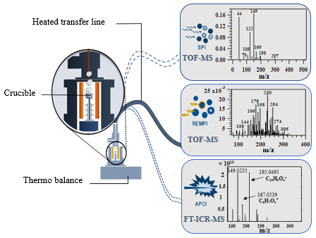

1. **Introduction**

Pyrolysis is a versatile thermochemical technique that converts a solid material into useful gaseous, liquid, and solid products in absence of oxygen. This technique can be used to valorize various products, such as polymers, biomass, and tires. The material chosen in this study is polyethylene terephthalate (PET). PET is the third frequently consumed polymer in Europe after polypropylene and low density polyethylene.1 It is frequently used to make a variety of consumer goods, such as synthetic polyester fibers, bottles and films.1,2

The pyrolysis of PET yields a complex mixture of products which consists of aldehydes (e.g., acetaldehyde, benzaldehyde), carbon oxides (CO2 and CO), aliphatic hydrocarbons C1-C4 (e.g., CH4, C2H4), aromatic species (e.g., benzene, toluene, styrene), carboxylic acids such as benzoic acid and its derivatives (e.g., acetylbenzoic acid, methylbenzoic acid, ethylbenzoic acid), terephthalic acid and vinyl terephthalate as well as esters (e.g., di-vinyl terephthalate, vinyl benzoate), ketones (e.g., acetophenone, benzophenone, fluorenone) and other compounds.3–8

Various analytical techniques based on mass spectrometry were used in literature for the characterization of the pyrolysis products. In the last decades, time of flight mass spectrometry (TOF-MS) has been widely applied9–11. It provides high sensitivity and high acquisition speed12,13. The identification of complex mixtures however often requires high resolution mass spectrometry which allows resolving multiple peaks with the same nominal m/z.14 Fourier transform ion cyclotron resonance mass spectrometry (FT-ICR MS) has proven high potential for detecting and identifying compounds without pre-separation by chromatography.15,16 Molecular formula can be assigned to the resolved signals, typically within ppm mass accuracy.17

Different ionization methods are available for mass spectrometry, all exhibiting different advantages and drawbacks. In fact, electron ionization (EI) in vacuum is the method commonly used for the evolved gas analysis of pyrolysis gases. It is a “hard” and universal ionization mode.18,19 It leads to strong fragmentation of the molecule because of the high ionization energy generally deployed (70 eV).20 Consequently, the EI mass spectrum is complicated to interpret because of the absence of the molecular ions and strong overlapping signals of complex mixtures impeding data interpretation. In contrast, soft ionization techniques such as chemical ionization (CI), atmospheric pressure chemical ionization (APCI), electrospray ionization (ESI) or vaccum photo ionization (PI), a molecular ion (radical cation and/or protonated ion species) can be preserved and fragmentation is greatly diminished21, athough all to the latter methods are less universal than EI.

Photo ionization (PI) coupled to mass spectrometry has been widely used for the characterization of complex mixtures. PI can be divided in single-photon ionization (SPI) and resonance-enhanced multiphoton ionization (REMPI). SPI commonly involves a single-photon in the vacuum ultraviolet range (VUV) to ionize the molecule in one step, inducing little or no fragmentation.20,22 The photon energy commonly used is between 7.5 - 11.8 eV, corresponding to a wavelength of 165 - 105 nm.22 In other words, only organic molecules with ionization energy lower than the photon energy can be ionized. Many types of lasers can be used to generate VUV light with different wavelengths such as Nd:YAG (118 nm; 10.48 eV23), F2 (157 nm; 7.9 eV24), H2 (160 nm; 7.75 eV25). Figure 1 represents the ionization energies (IE) of compounds identified during PET pyrolysis.26 IE are available from the National Institute of Standards and Technology (NIST).27 IE of most compounds are below the photon energy, except certain small molecules, such as CO, CO2, H2O, H2, and CH4. Carbon oxides might represent a major proportion of PET pyrolysis gases, but cannot be ionized with common setups.

Unlike SPI, REMPI uses ultraviolet (UV) light, requiring at minimum two photons in which a single-photon or multiple photons absorbed excites an intermediate state and a second photon ionizes the atom or molecule.19 The soft ionization pathway, due to the low photon energies, leads to few fragmentation which facilitates the interpretation of the mass spectra. In addition, REMPI allows the selective detection of vibronic structure species such as mono- or polycyclic aromatic compounds and their derivatives.28,29

Another soft ionization technique commonly used, especially for FT-ICR MS, is atmospheric pressure chemical ionization (APCI).30 Corona discharge induced ion- molecule reactions in gas phase, generating radical cations or protonated molecule ions with little fragmentation.31,32 This technique allows the detection of polar and medium polar compounds, preferably oxygenated species.23,33 Du to instrumental limits of the FT– ICR MS, the mass range is between 100 - 1000. More details on the APCI process are given elsewhere.32

Numerous studies on pyrolysis have been performed by coupling thermogravimetry or pyrolysis experiments with the analytical techniques described above.9,10,34,35 These techniques provide not only the chemical formula of the analytes but also their evolution profile in real time. Consequently, temperature dependent pyrolysis products can be analyzed. So far, numerous studies focused on polymers such as polyethylene, polypropylene, polystyrene and polyvinyl chloride9,21,35–38. However, limited studies have been conducted on oxygenated macromolecules such as polyethylene terephthalate (PET). Some PET pyrolysis experiments have been conducted online by using conventional analytical tools such as thermogravimetry (TGA) coupled to mass spectrometry39, and TGA coupled to Fourier transform infrared spectroscopy (FTIR).40–43

In this study, three different analytical techniques were coupled to thermogravimetry for online monitoring of volatile compounds emitted by the slow pyrolysis of PET. Single-photon ionization (SPI) at 118 nm (10.5 eV) and resonance enhanced multi photon ionization (REMPI) at 266 nm were coupled to a time of flight mass spectrometer (TOF-MS). SPI is aiming for detection of organic species whose ionization energy are lower than 10.5 eV, whereas REMPI is suitable for the sensitive detection of aromatic and polyaromatic constituents. Another thermogravimetry analyzer was coupled to a Fourier transform ion cyclotron resonance mass spectrometer (FT-ICR MS) using atmospheric pressure chemical ionization (APCI). APCI FT-ICR MS is suitable to ionize medium-polar and polar species with a mass range [100 - 1000] mass range. Using the FT-ICR MS exact mass data, detailed chemical information was gained and combined with the results obtained with SPI and REMPI. This procedure allowed for the detailed description of the pyrolysis process.

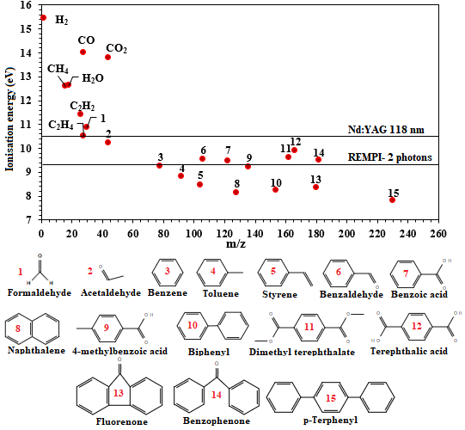

Figure 1: Ionization energies of selected molecules identified in PET pyrolysis (adapted from refs19,44).

1. **Materials and methods**

**2.1. Materials**

PET was purchased from Goodfellow SARL (Lille, France) in a powder form (particle size of 300 microns). This polymer is amorphous with a crystallinity of 16%. The elemental analysis of carbon, hydrogen and oxygen content in PET was determined using a Flash Smart CHNS/O Analyser by Thermo Fisher Instrument. The oxygen content was calculated by difference. The results showed that PET contains about 45.5% carbon by mass, 36.4% hydrogen and 18.2% oxygen.

**2.2. Instrumentation**

**2.2.1. Thermogravimetry coupled to SPI/REMPI-TOF-MS**

A schematic overview of TG-REMPI/SPI-TOF-MS is presented in Figure 2.a.23 The thermobalance (STA 409, Netzsch Gerätebau, Selb, Germany) was on-line coupled to the ionization source of the mass spectrometer using a heated transfer line (280°C, ID 280 μm × 2.25 m length). 8 - 10 mg of PET was filled in an aluminum oxide crucible and heated up to 550°C with a constant heating rate of 5 °C/min. The nitrogen flow rate around the sample was fixed to 50 mL/min for reactive gas and 50 mL/min for protective gas.

The ionization source was operated under vacuum conditions (around 10−4 mbar) which allows transferring a small aliquot of evolved gas out of the thermobalance inside the mass spectrometer based on the pressure gradient. A Nd:YAG laser (Surelite III, Continuum, Inc., Santa Clara, CA, U.S.A; wavelength: 1064 nm45) was used in this experiment. A beam at 355 nm was produced by frequency tripling conversion. It operated with pulse energies of 25 mJ, pulse width of 5 ns, and repetition rate of 10 Hz. For SPI, the wavelength was again tripled, generating a vacuum ultraviolet light (118 nm, 10.5 eV), by using a xenon-filled gas cell (Xe 4.0, 12 mbar). For REMPI, a wavelength of 266 nm (4.66 eV) was obtained by frequency-quadrupling of the Nd:YAG laser 1064 nm. Consequently, the energy ionization with REMPI using two photons is 9.32 eV. Further details are available elsewhere.45,46

Once the ions are generated, they are m/z-separated using a reflectron TOF analyzer (Kaesdorf Instrumente für Forschung and Industrie, Munich, Germany) and detected by a microchannel plate (MCP, Chevron Plate, Burle Electro-Optics Inc.).23,45 The ions were recorded up to m/z 500. A custom LabView-software was used for data processing.45

**2.2.2. Thermogravimetry coupled to APCI/FT-ICR-MS**

A thermobalance (STA 209, Netzsch Gerätebau GmbH, Germany) was used for pyrolysis experiments (Figure 2.b). A mass of 1-1.5 mg sample was loaded in an aluminum crucible and heated under a constant nitrogen flow of 200 mL/min from 20 °C to 600 °C with a heating rate of 5 °C/min. Approximately 2 mL/min of the evolved gas mixture was transferred to the ionization chamber via a slight overpressure of 5 mbar by a heated transfer line (deactivated fused silica capillary, 2 m, 0.53 mm ID, 300 °C). The chemical ionization was carried out by a modified Bruker GC-APCI II source, operating at atmospheric pressure in positive ion mode. For ionization, a stainless-steel needle was used, generating a corona discharge with a current of 2.5 µA. More details have been given elsewhere.47 The ions produced were detected by a Bruker Apex II ultra FT−MS equipped with a 7 T magnet (InfinityCell, Bruker Daltonics, Bremen, Germany). A mass range of 100-1000 was recorded with five microscans per spectrum. A 4 Megaword transient of approximately 2 s length was applied, offering an ultrahigh resolution of 260,000 at m/z 400 was obtained.

Processing data was carried out using Bruker DataAnalysis for m/z-calibration of the spectra and a self-written tool CERES based on Matlab scripting for further processing and sum formula calculation. Every measurement was internal linearly calibrated in DataAnalysis and again every single spectrum during processing in CERES. For sum formula assignment, the following restrictions were applied: C4‑100H4‑200N0O15S0, H/C ratio of 0-3 and double bond equivalent (DBE) of 0-40.

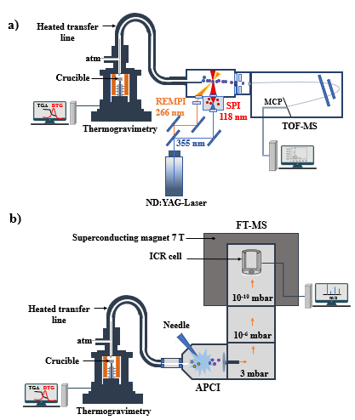

Figure 2: Schematic of the instrumental setup of: a) TGA-REMPI/SPI-TOF-MS; b) TGA-APCI FT-ICR MS (adapted from refs23,47).

1. **Results and discussion**

**3.1. Evolved gas analysis by Single-photon ionization (SPI) mass spectrometry**

Figure 3.a) shows the total ion current (TIC) and the derivative of the mass loss signal (DTG) as a function of temperature. Over the whole pyrolysis time, the TIC is obtained by adding all ions of the spectra obtained at a defined time resp. temperature. Visibly, the evolution of TIC coincides with the DTG curve. This indicates that SPI detected some of the major volatile degradation products of the PET pyrolysis, excluding CO2 and CO. The decomposition starts at roughly 350 °C and lasts approximately till 500 °C. The maximum of TIC and DTG corresponds to 435 ± 1 °C.

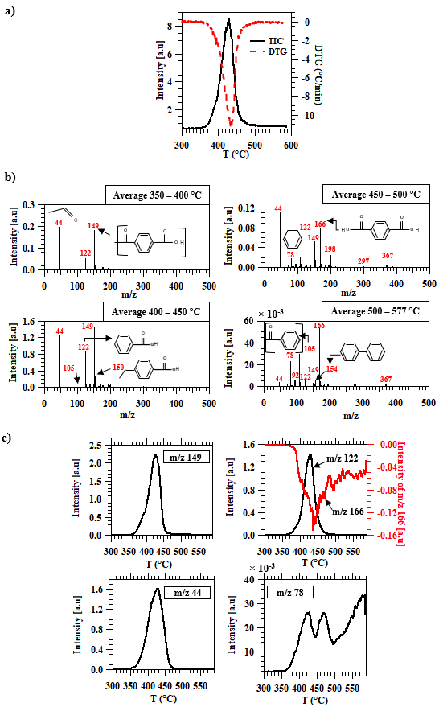

Figure 3: TGA-SPI TOF-MS results: a) DTG, TIC curves, b) Average mass spectra of the products at various temperatures, c) thermal evolution profiles of major m/z.

Figure 3.b) displays the average mass spectra for selected temperature ranges of the emitted compounds. It should be noted that the temperature indicates the transformation of molecules into the gas phase and they can be generated before in the condensed phase. Signal intensities increase steadily up to a temperature of 450 °C. In the 350-400°C temperature range, major degradation products appear, and their intensities increase as the pyrolysis temperature increases. Signals at m/z= 44, 122, and 166 are most likely correspond to acetaldehyde, benzoic acid, and terephthalic acid, respectively. Based on the literature, the peak corresponding to m/z =149 is a characteristic fragment of vinyl terephthalate (Mw=192 g/mol) which reported to be one of the primary compounds of PET degradation. Thus, a mass loss of m/z 43 occurs, which can be attributed to a [O-CH=CH2] fragment.48,49 Despite soft ionization, the carbon - carbon double bond (C=C) orbital is destabilized followed by the oxygen ester, undergoing photo-fragmentation under these conditions.50 An example in the literature of photoionization of vinyl butyrate which has the same fragment in its structure proved that the fragmentation occurs from 9.5 eV by losing m/z 43.51 Losing the same group, the peaks at m/z= 105 and 175 may be also the results of fragmentation of vinyl benzoate (Mw=148 g/mol) and di-vinyl terephthalate (Mw=218 g/mol), respectively. On the other hand, the intensities of major products reach a maximum between 400 °C and 450 °C and decrease there after which shows either the end of the pyrolysis or the presence of secondary reactions causing their intensities diminution. The intensity of terephthalic acid (m/z=166) decreases slightly between 450 - 500 °C, even so it becomes the compound with the highest intensity at high temperatures, as shown in Figure 3.b).

Possible peak assignments of major compounds are summarized in Table S. 1. The mixture mostly contains acids and vinyl end groups. The same observation was made by Garozzo et al.48 using electron ionization at low electron energy (18 eV) for copolyesters containing ethylene terephthalate and p-oxybenzoate units. They studied the on-line pyrolysis coupled to mass spectrometry with a heating rate of 10 °C/min. Garozzo et al.48 observed the loss of 43 [O-CH=CH2] and 17 [OH] mass units, confirming the metastable transitions of fragments and indicating the presence of open chain structures with carboxyl and vinyl end groups. Each compound corresponding to a specific m/z can be easily real-time-monitored. The thermal evolution profiles of major m/z are plotted in Figure 3.c). Acetaldehyde (m/z= 44) is the first compound detected by TOF-MS, at about 315 °C, followed by benzoic acid (m/z= 122) at 350 °C. The terephthalic acid (m/z= 166) is detected at 371 °C, 21 °C after the detection of benzoic acid and 7°C after benzene (m/z= 78). The maximum productions of major compounds are observed at 431°C, except for terephthalic acid (m/z= 166) which is observed at 440 °C. Interestingly, the benzene curve shows a bi-modal emission behaviour in which the maximum of the first peak is detected at 427 °C and the second maximum at 470 °C. Benzene goes through a minimum at 447 °C. The first and the second peak may be due to the decarboxylation of benzoic acid and terephthalic acid, respectively. The production of benzene is accelerated at higher temperature, as shown in Figure 3.c).

**3.2. Evolved gas analysis by Resonance-enhanced multiphoton ionization (REMPI) mass spectrometry**

Using REMPI, only aromatic species can be detected. However, aromatic carboxylic acids such as terephthalic acid and benzoic acid can not be ionized because of their high ionization energy (see Figure 1). Benzene which has a ionization energy of 9.24 eV also requires a little more energy to be ionized ( ≥ 9.5 eV)52. Figure 4.a) shows the TIC and DTG curves. Contrary to the SPI-TIC, REMPI-TIC exhibits a bi-modal behavior as the temperature increases. The first peak coincides with the DTG curve, whereas the second peak appears in a region where the mass loss is almost done, indicating the presence of secondary reactions with a small mass loss. The maximum peaks correspond to 435 °C and 473 °C, respectively. The profile of benzene measured with SPI has the same trend as REMPI-TIC, as observed in Figure 3.c). This may be due to the reactivity of benzene for producing other aromatics such as polycyclic aromatic hydrocarbons (PAHs). Hujuri et al.53 reported that the production of PAHs occurs only at high temperatures (> 400°C) by radical reactions and benzene is involved in their pyrolytic formation. REMPI mass spectra are shown in Figure S. 1. For both peaks observed in the REMPI-TIC curve, an average mass spectrum is presented in Figure S. 2. The mass spectrometric pattern is significantly different when comparing the two stages, and they depend mainly on temperature. The effect of temperature on the pyrolysis product intensities is depicted in Figure 4.b). As can be seen, a higher variety of compounds is detected in REMPI than in SPI. Different series of pyrolysis products are observed at different temperature intervals. This evolved gas complexity confirms the presence of different and various reactions involved in the pyrolysis of PET. In fact, between 300 °C and 350 °C, m/z of 274, 298, 264, and 288 are detected with low average intensities. With the increase of temperature, the mass spectrum shows other peaks such as m/z of 192, 188, 148, 144, 94, and 162. The m/z of 148, 94, and 162 presumably belong to vinyl terephthalate, vinyl benzoate, phenol, and vinyl 4-methylbenzoate, respectively. Using REMPI, compounds with [O-CH=CH2] do not undergo a photo-fragmentation, because of the low energy. However, their sensitivity of detection by REMPI is much lower than by SPI.

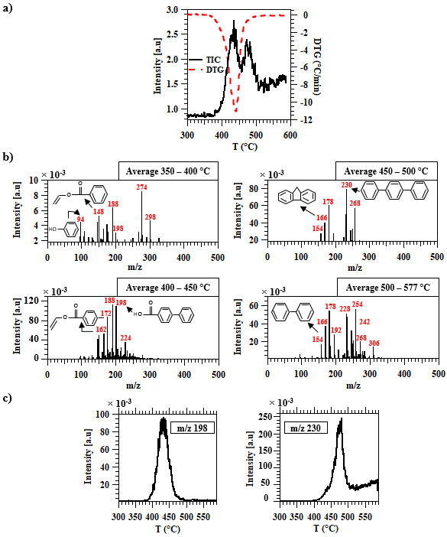

Figure 4: TGA-REMPI TOF-MS results: a) DTG, TIC curves, b) Average mass spectra of the products at various temperatures, c) thermal evolution profiles of major m/z.

The signal intensities of aromatic products increase at higher temperatures. The highest intensities are observed between 400 °C and 450 °C, which corresponds to the maximum decomposition rate of PET. In this phase, the major compounds correspond to m/z of 188, 198, 172, and 162. At higher temperature (450- 577 °C), other compounds appear such as m/z= 254, 178, 228, 230, 166, and 154. Based on literature26,53, those peaks may be attributed to 1,​2'-​binaphthalene, benzo[a]anthracene, anthracene or/and phenanthrene, terphenyl, 9H-fluorene and biphenyl or/and acenaphthene, respectively (Table S. 1). The presence of PAHs is mainly detected between 450- 500 °C, confirming the presence of secondary reactions and most likely causing the second peak in REMPI-TIC.

The evolution profile of major peaks is shown in Figure 4.c). The maximum productions of the different aromatics do not occur at the same time. Terphenyl, which corresponds to m/z= 230, approximately appears at 415 °C and reaches a maximum at 477 °C. The peak at m/z= 198, which may probably correspond to biphenyl-4-carboxylic acid (C13H10O2)26,54,55, evolves starting from 389 °C to 492 °C. Its maximum production occurs at 439 °C. The evolution profile of m/z= 198 detected by REMPI resembles to the SPI signals (Figure S. 3).

**3.3. Evolved gas analysis by TGA-APCI FT-ICR MS**

The DTG, TIC, and temperature curves revealed by thermogravimetric coupling to APCI FT-ICR MS are shown in Figure S. 4. The temporal evolution of the decomposition rate (DTG) is consistent with the TIC curve, showing a single peak. A similar trend was observed by SPI-TOF-MS (see Section 3.1). The maximum decomposition rate is found at about 417°C. Typical diagrams are constructed to facilitate the visualization and interpretation of high-resolution mass spectrometric data, such as double bond equivalence (DBE) against carbon number and Van-Kreleven plot. DBE is a measure of unsaturation (double bonds and rings) in a molecule and contributes to the prediction of the chemical structure from a given elemental formula. Besides, Van-Krevelen diagram is a graphical distribution of H/C ratio versus O/C, providing an overall view on compound categories56,57. The evolution of double bond equivalence (DBE) versus carbon number is shown in Figure 5.a). It indicates that there are compounds with DBE values ranging from 2 to 15 and carbon numbers ranging from C6 to C20. The high DBE values confirm the presence of polycyclic aromatic hydrocarbons. Most of the detected compounds have a relatively low abundance (in blue color). The highest abundances (red color) correspond to species with a carbon number C8-C10 and a DBE of 6-7. The core structure of these compounds is probably based on one benzene ring (DBE of 4) or two aromatic rings (DBE of 7). Figure 5.b) represents the Van-Krevelen plot, highlighting different compound classes. For instance, a complex mixture of aromatic compounds with expanded oxygen content is mainly distributed within a H/C range of 0.7-1 and O/C values in the range of 0.1-0.5, as well as highly unsaturated compounds (H/C 1.5) and little aliphatic compounds (1.5 H/C 2)58.

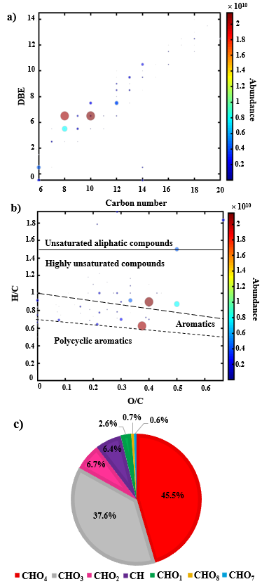

Figure 5: TGA-APCI FT-ICR MS results: a) Double bond equivalent (DBE) vs carbon number plot, b) Van Krevelen plot (H/C vs O/C), c) Pie chart representing the compound class distribution. In a) and b), the size of the dots is proportional to the abundance.

Furthermore, polycyclic and aromatic compounds without oxygen are also present with H/C ≈ 0.5-1 and account for roughly 6.4% of the overall signal. The class distribution of detected species is shown in Figure 5.c). Seven classes are observed in APCI FT-ICR MS in which the oxygenated category CHOx is the prevailing class. The most abundant CHOx compounds are those containing 4 and 3 oxygen atoms with a percentage of 45.5% and 37.6% respectively. Very low abundances of highly oxygenated compounds (7 and 8) (<1%) are also detected.

An APCI FT-ICR mass spectrum is shown in Figure 6. A unique molecular formula is attributed to each peak detected using the accurate mass measurement.

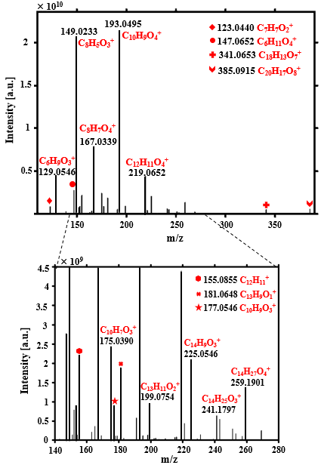

Figure 6: Average APCI FT-ICR MS spectrum of pyrolysis products of PET.

The species are detected mainly as protonated molecule [M+H]+ and to a part as molecular cation [M]+, where M refers to the molecule. Seventy-seven peaks are assigned unambiguously in the mass from m/z= 100 to 400. Possible peak assignments of major compounds are summarized in Table S. 1. The highest intensities are observed at m/z= 193.0495 and 149.0233, corresponding to C10H9O4+ and C8H5O3+ respectively. The peak at m/z= 385.0915 (C20H17O8+) is the highest mass obtained by FT-ICR-MS and may be attributed to cyclic or/and linear dimer59. Ubeda et al 60 reported similar results. In their study, they analyzed the oligomer of PET by using ultra-high-performance liquid chromatography-quadrupole time-of-flight mass spectrometry (UPLC-MS-QTOF). They found that the cyclic monomer and dimer are characterized by an exact m/z of 193.0498 and 385.0915, respectively. Possible structure assignments of major compounds detected by FT-ICR MS are given in Table S. 1. Signals corresponding to m/z= 219.0652 (C12H11O4+) and m/z= 167.0339 (C8H7O4+) can be attributed to di-vinyl terephthalate and terephthalic acid, respectively. The temporal evolution profiles of the compounds with the highest intensities are shown in Figure S. 5. Peaks at m/z= 193.0495 (C10H9O4+) and 149.0233 (C8H5O3+) are detected by FT-ICR MS at the same temperature, about 346 °C. Terephthalic acid (m/z= 167.0339 (C8H7O4+)) is detected at 361 °C. A cyclic dimer (m/z= 385.0915 (C20H17O8+)) and an anhydride compound at m/z= 341.0653 (C18H13O7+) appear later at 381 °C (Figure S. 6). These compounds are among the primary products of the degradation of PET, and their delayed detection may indicate that they are generated in condensed phase (solid or liquid) and transferred into the gas phase at higher temperatures.

Different reaction pathways for PET degradation can be proposed, involving most likely two back-biting possibilities through a concerted mechanism (Figure 7). Reaction in Figure 7.a) is more energetically favorable than the reaction in Figure 7.b), involving the six-membered cyclic transition state, as reported in previous studies.49,53,61 The transition state energy of dissociation is about 50 kcal/mol.62 It leads to the formation of carboxyl and vinyl end groups. In the second possibility, PET may undergo a decarboxylation reaction, producing benzene and vinyl end groups.

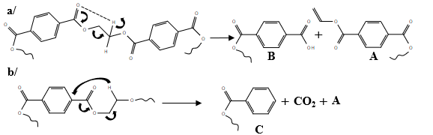

Figure 7: Intramolecular possibilities in PET degradation.

Vinyl decompose via six-membered cyclic transition state, as shown in Figure 8.a), producing di-vinyl terephthalate (m/z 218), vinyl terephthalate (m/z 192), as expected53, and other carboxyl and vinyl end groups, having lower molecular weights. Carboxyl end groups may undergo two different reactions (Figure 8.b). In fact, a six-membered cyclic transition state which generates terephthalic acid (m/z 166), vinyl terephthalate (m/z 192), and carboxyl and vinyl end groups, according to two different branches in the same molecule.

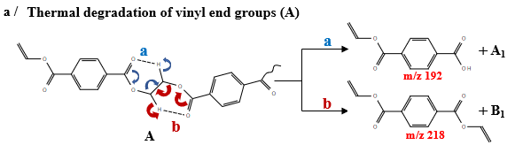

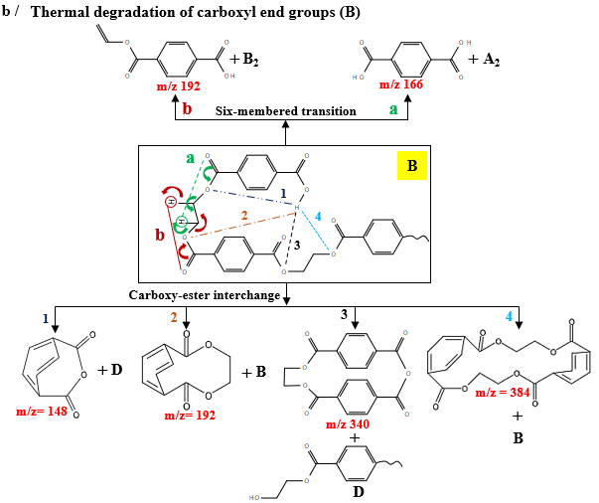

Figure 8: Proposed reaction pathways for the degradation of: a/ vinyl end groups, b/ carboxyl end groups.

Additionally, an intramolecular carboxy-ester interchange may take place, leading to the formation of cyclic products, such as cyclic dimer (m/z 385.0915) and cyclic monomer (m/z 193.0495), and hydroxy end groups. Mantaudo et al.61 investigated the direct pyrolysis of PET using negative chemical ionization. They found that cyclic oligomers are the primary products at about 300 °C that decompose further by β-H transfer reactions at 400 °C generating open-chain oligomers with olefin and carboxylic end groups. Samperi et al.63 also studied the isothermal degradation of PET in the temperature range of 270–370 °C using matrix-assisted laser desorption ionization–time of flight (MALDI-TOF) mass spectrometry and NMR analysis. They indicated the formation of cyclic oligomers, and proposed their structural characterization. Anhydrides containing oligomer may also be generated at m/z= 341.0653, which is in agreement with literature.63

Possible reaction pathways for the degradation of cyclic dimer and anhydrides are shown in Figure 9.

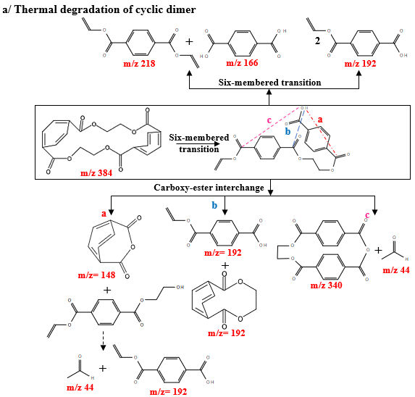

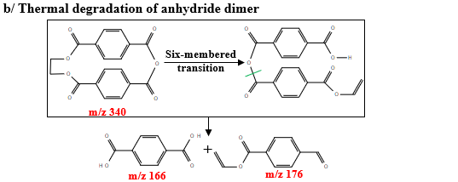

Figure 9: Proposed reaction pathways for the degradation of: a/cyclic dimer, b/ cyclic anhydride.

Six-membered transition state occurs to generate linear dimer and anhydride. These linear dimers may undergo carboxy-ester interchange in different positions producing principally a variety of cyclic anhydrides, vinyl terephthalate (m/z 192), and acetaldehyde. Figure 10.a) shows that benzoic acid (m/z 122), vinyl benzoate (m/z 148) and carboxyl and vinyl end groups can be generated via the six-membered transition in benzene end groups (**C**).

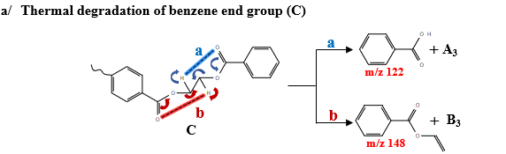

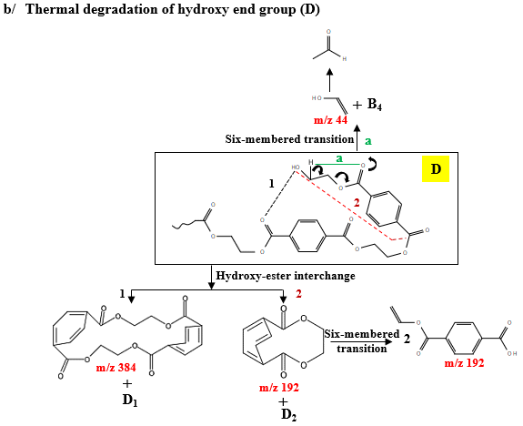

Figure 10: Proposed reaction pathways for the degradation of: a/benzene end groups, b/ hydroxyl end groups.

In the case of hydroxy end groups, an intramolecular hydroxy-ester interchange, as shown in Figure 10.b), may occur and produces cyclic dimer and monomer.64 In literature, the presence of hydroxy end in the structure accelerates the interchange reaction and favored the formation of cyclic products.65,66 Vinyl alcohol (m/z 44) is also generated via six-membered transition, however, it transforms to acetaldehyde, which is one of primary volatile products in PET degradation (Figure 10.b). Among the volatile PET degradation species are ethylene (C2H4), which is formed with a smaller extent. An intermolecular reaction through an eight-membered transition between PET and vinyl end groups is proposed for its formation (Figure 11).67

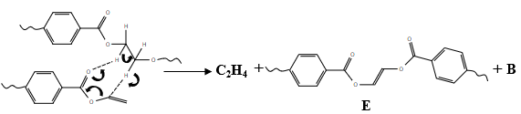

Figure 11: Formation of ethylene.

In addition, tentative degradation pathways of major products are illustrated in Figure 12. The routes proposed here are consistent with the main products identified by three techniques. The starting point is the di-vinyl terephthalate (m/z 218). In literature, Taylor reported various reactions occurred in vinyl acetate decomposition between 363- 448 °C.68 By analogy, every compounds with a [(C=O)O(CH=CH2)] segment undergoes the same routes.

Traces of acetylene (C2H2) also exists in PET degradation26,69. Unfortunately, it cannot be detected with the three techniques because of its high ionization energy and lower molecular weight. The formation of acetylene may be the by-product of vinyl end groups degradation. Polycyclic aromatic hydrocarbons (PAHs), such as biphenyl (m/z 154) and terphenyl (m/z 230), are also presented. They are most likely produced via benzene.

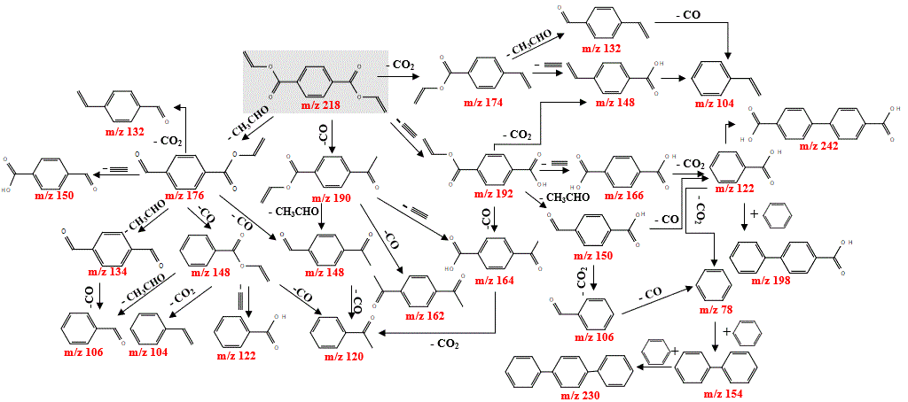

Figure 12: Proposed reaction pathways for the degradation of major products.

1. **Conclusion**

In this study, three different soft ionization mass spectrometric approaches have been applied, allowing a comprehensive overview and understanding of the slow pyrolysis of PET in real time. The originality of this paper firstly lies in online monitoring of the emitted decomposition products and their thermal dependent evolution profiles. Secondly, the combination of these techniques allows the almost complete identification of volatile species and therefore, the typical reactions that can occur. TG-SPI-TOF-MS was used for the desciption of organic species with ionization energies below 10.5 eV. This technique showed that the main major peaks were acetaldehyde (m/z= 44), benzoic acid (m/z= 122) and a peak at m/z= 149 which is a fragment of the monomer of PET (m/z= 192). Despite the use of soft ionization, some compounds fragmented with the loss of a [O-CH=CH2] fragment. Aromatic compounds, such as benzene and toluene, exhibited a bi-modal behavior in their profiles showing the existence of two different reactions involved in their formation. The second soft ionization technique used was REMPI-TOF-MS, selective for aromatic species. REMPI-TIC has the same trend as the benzene profile, confirming its reactivity in the production of other aromatics, such as polycyclic aromatic hydrocarbons (PAHs). Different series of pyrolysis products are observed in different temperature intervals. The main products correspond to m/z= 230, 178, and 254. Possible structures were proposed in SPI and REMPI techniques. Additionally, FT-ICR MS was applied, detecting medium-polar and polar species in a mass range from 100 - 400 Da. Compounds with DBE values ranging from 2 to 15 and carbon numbers ranging from C6 to C20 weredetected. Seven classes were observed in which the most abundant was CHO4, with a percentage of 45.5%. Detailed chemical information was gained using FT-ICR exact mass data. The signals with the highest intensities found in mass spectrum are m/z= 193.0495 and 149.0233, corresponding to C10H9O4+ and C8H5O3+ respectively. Possible structures for some peaks were suggested, helping the construction of reaction pathways that showed the formation of both cyclic monomer and dimer and linear compounds. Typical reactions have been proposed which may explain the majority of products emitted: “intramolecular exchange”, via hydroxy-ester and carboxy-ester interchange and six-membered transition state, and “intermolecular exchange”.

**Acknowledgements**

“Access to a EU_FT-ICR_MS network installation funded by the EU Horizon 2020 grant 731077 and support for conducting research is gratefully acknowledged”. This work has been funded additionally by LRGP-CNRS, from University of Lorraine. The authors thank Lukas Friederici for his help in SPI and REMPI measurements and Professor René Fournet who provided his expertise on chemical reactions.

**References**

1. Kawecki D, Scheeder PRW, Nowack B. Probabilistic Material Flow Analysis of Seven Commodity Plastics in Europe. *Environ Sci Technol*. 2018;52:9874-9888. doi:10.1021/acs.est.8b01513

2. Zander NE, Gillan M, Lambeth RH. Recycled polyethylene terephthalate as a new FFF feedstock material. *Addit Manuf*. 2018;21:174-182. doi:10.1016/j.addma.2018.03.007

3. Yoshioka T, Grause G, Eger C, Kaminsky W, Okuwaki A. Pyrolysis of poly(ethylene terephthalate) in a fluidised bed plant. *Polym Degrad Stab*. 2004;86(3):499-504. doi:10.1016/j.polymdegradstab.2004.06.001

4. Sophonrat N, Sandström L, Johansson AC, Yang W. Co-pyrolysis of Mixed Plastics and Cellulose: An Interaction Study by Py-GC×GC/MS. *Energy Fuels*. 2017;31(10):11078-11090. doi:10.1021/acs.energyfuels.7b01887

5. Kumagai S, Yamasaki R, Kameda T, et al. Tandem μ-reactor-GC/MS for online monitoring of aromatic hydrocarbon production via CaO- catalysed PET pyrolysis. *React Chem Eng*. 2017;2:776-784. doi:10.1039/C7RE00097A

6. Artetxe M, Lopez G, Amutio M, Elordi G, Olazar M, Bilbao J. Operating conditions for the pyrolysis of poly-(ethylene terephthalate) in a conical spouted-bed reactor. *Ind Eng Chem Res*. 2010;49(5):2064-2069. doi:10.1021/ie900557c

7. Dzięcioł M, Trzeszczyński J. Volatile products of poly(ethylene terephthalate) thermal degradation in nitrogen atmosphere. *Appl Polym Sci*. 2000;77(9):1894-1901.

8. Dziȩcioł M, Trzeszczyński J. Temperature and Atmosphere Influences on Smoke Composition during Thermal Degradation of Poly(ethylene terephthalate). *J Appl Polym Sci*. 2001;81(12):3064-3068. doi:10.1002/app.1757

9. Wu Q, Hua L, Hou K, et al. Vacuum ultraviolet lamp based magnetic field enhanced photoelectron ionization and single photon ionization source for online time-of-flight mass spectrometry. *Anal Chem*. 2011;83(23):8992-8998. doi:10.1021/ac201791n

10. Shi Z, Jin L, Zhou Y, Li H, Li Y, Hu H. In-situ analysis of catalytic pyrolysis of Baiyinhua coal with pyrolysis time-of-flight mass spectrometry. *Fuel*. 2018;227:386-393. doi:10.1016/j.fuel.2018.04.109

11. Lee J, Lee T, Tsang YF, Oh JI, Kwon EE. Enhanced energy recovery from polyethylene terephthalate via pyrolysis in CO2 atmosphere while suppressing acidic chemical species. *Energy Convers Manag*. 2017;148:456-460. doi:10.1016/j.enconman.2017.06.026

12. Green CS, Martin H. Fragment‐free accurate mass measurement of complex mixture components by gas chromatography/field ionization‐orthogonal acceleration time‐of‐flight mass spectrometry: an unprecedented capability for mixture analysis. *Rapid Commun Mass Spectrom*. 2006;15(3):236-239. doi:10.1002/1097-0231(20010215)15:3<236::AID-RCM197>3.0.CO;2-B

13. Qian K, Dechert GJ. Recent advances in petroleum characterization by GC field ionization time-of-flight high-resolution mass spectrometry. *Anal Chem*. 2002;74(16):3977-3983. doi:10.1021/ac020166d

14. Barrow MP, Peru KM, Headley J V. An added dimension: GC atmospheric pressure chemical ionization FTICR MS and the athabasca oil sands. *Anal Chem*. 2014;86(16):8281-8288. doi:10.1021/ac501710y

15. Bae E, Na JG, Chung SH, Kim HS, Kim S. Identification of about 30 000 chemical components in shale oils by electrospray ionization (ESI) and atmospheric pressure photoionization (APPI) coupled with 15 T fourier transform ion cyclotron resonance mass spectrometry (FT-ICR MS) and a comparison to. *Energy Fuels*. 2010;24(4):2563-2569. doi:10.1021/ef100060b

16. Kekäläinen T, Venäläinen T, Jänis J. Characterization of birch wood pyrolysis oils by ultrahigh-resolution fourier transform ion cyclotron resonance mass spectrometry: Insights into thermochemical conversion. *Energy Fuels*. 2014;28(7):4596-4602. doi:10.1021/ef500849z

17. Huba AK, Huba K, Gardinali PR. Understanding the atmospheric pressure ionization of petroleum components: The effects of size, structure, and presence of heteroatoms. *Sci Total Environ*. 2016;568:1018-1025. doi:10.1016/j.scitotenv.2016.06.044

18. Yuzawa T, Watanabe C, Nemoto N, Ohtani H. Rapid evaluation of photo, thermal and oxidative degradation of high impact polystyrene by a xenon lamp-based online ultraviolet irradiation-pyrolysis-GC/MS system. *Polym Degrad Stab*. 2013;98(2):671-676. doi:10.1016/j.polymdegradstab.2012.11.005

19. Jia L, Brech Y Le, Mauviel G, et al. Online Analysis of Biomass Pyrolysis Tar by Photoionization Mass Spectrometry. *Energy Fuels*. 2016;30(3):1555-1563. doi:10.1021/acs.energyfuels.5b02274

20. Hsu H, Ni C-K. Vacuum Ultraviolet Single-Photon Postionization of Amino Acids. *Appl Sci*. 2018;8(5):1-14. doi:10.3390/app8050699

21. Wang Y, Huang Q, Zhou Z, Yang J, Qi F, Pan Y. Online study on the pyrolysis of polypropylene over the HZSM‑5 zeolite with photoionization time-of-flight mass spectrometry. *Energy Fuels*. 2015;29(2):1090–1098.

22. Giri A, Coutriade M, Racaud A, et al. Molecular characterization of volatiles and petrochemical base oils by photo-ionization GC×GC-TOF-MS. *Anal Chem*. 2017;89(10):5395-5403. doi:10.1021/acs.analchem.7b00124

23. Rüger CP, Grimmer C, Sklorz M, Neumann A, Streibel T, Zimmermann R. Combination of different thermal analysis methods coupled to mass spectrometry for the analysis of asphaltenes and their parent crude oils: comprehensive characterization of the molecular pyrolysis pattern. *Energy Fuels*. 2018;32(3):2699-2711. doi:10.1021/acs.energyfuels.7b02762

24. Trukhin AN, Golant KM. Peculiarities of photoluminescence excited by 157 nm wavelength F2 excimer laser in fused and unfused silicon dioxide. *J Non Cryst Solids*. 2009;355(34-36):1719-1725. doi:10.1016/j.jnoncrysol.2009.06.020

25. T.Fukuzawa, S.Tanimizu. Flourescence decay characteristics of Tb3+-activated phosphates under H2-VUV laser excitation. *J Lumin*. 1978;16(4):447-456.

26. Sovová K, Ferus M, Matulková I, et al. A study of thermal decomposition and combustion products of disposable polyethylene terephthalate (PET) plastic using high resolution fourier transform infrared spectroscopy, selected ion flow tube mass spectrometry and gas chromatography mass spectrometr. *Mol Phys*. 2008;106(9-10):1205-1214. doi:10.1080/00268970802077876

27. NIST Chemistry webbook [Gas phase ion energetics data] Available online : https://webbook.nist.gov/chemistry/ (last accessed Mai 2019).

28. Zimmermann R, Heger HJ, Kettrup A. On-line monitoring of traces of aromatic-, phenolic- and chlorinated components in flue gases of industrial scale incinerators and cigarette smoke by direct-inlet laser ionization-mass spectrometry (REMPI-TOFMS). *Fresenius J Anal Chem*. 1999;363(8):720-730. doi:10.1007/s002160051281

29. Dorfner R, Ferge T, Yeretzian C, Kettrup A, Zimmermann R. Laser Mass Spectrometry as On-Line Sensor for Industrial Process Analysis: Process Control of Coffee Roasting. *Anal Chem*. 2004;76(5):1386-1402. doi:10.1063/1.1405610

30. Crepier J, Le Masle A, Charon N, Albrieux F, Duchene P, Heinisch S. Ultra-high performance supercritical fluid chromatography hyphenated to atmospheric pressure chemical ionization high resolution mass spectrometry for the characterization of fast pyrolysis bio-oils. *J Chromatogr B*. 2018;1086:38-46. doi:10.1016/j.jchromb.2018.04.005

31. Tose L V., Cardoso FMR, Fleming FP, et al. Analyzes of hydrocarbons by atmosphere pressure chemical ionization FT-ICR mass spectrometry using isooctane as ionizing reagent. *Fuel*. 2015;153:346-354. doi:10.1016/j.fuel.2015.03.004

32. Li DX, Gan L, Bronja A, Schmitz OJ. Gas chromatography coupled to atmospheric pressure ionization mass spectrometry (GC-API-MS): Review. *Anal Chim Acta*. 2015;891:43-61. doi:10.1016/j.aca.2015.08.002

33. Parr MK, Wüst B, Teubel J, Joseph JF. Splitless hyphenation of SFC with MS by APCI, APPI, and ESI exemplified by steroids as model compounds. *J Chromatogr B*. 2018;1091:67-78. doi:10.1016/j.jchromb.2018.05.017

34. Xu J, Zhuo J, Zhu Y, Pan Y, Yao Q. Analysis of volatile organic pyrolysis products of bituminous and anthracite coals with single-photon ionization time-of-flight mass spectrometry and gas chromatography/mass spectrometry. *Energy Fuels*. 2017;31(1):730-737. doi:10.1021/acs.energyfuels.6b02335

35. Huang Q, Liu C, Wei R, Wang J. Experimental study of polyethylene pyrolysis and combustion over HZSM-5, HUSY, and MCM-41. *J Hazard Mater*. 2017;333:10-22. doi:10.1016/j.jhazmat.2017.03.029

36. Zhou Z, Chen X, Wang Y, Liu C, Ma H, Zhou C. Bioresource Technology Online photoionization mass spectrometric evaluation of catalytic co- pyrolysis of cellulose and polyethylene over HZSM-5. *Bioresour Technol*. 2019;275:130-137. doi:10.1016/j.biortech.2018.12.045

37. Kai X, Yang T, Shen S, Li R. TG-FTIR-MS study of synergistic effects during co-pyrolysis of corn stalk and high-density polyethylene (HDPE). *Energy Convers Manag*. 2019;181:202-213. doi:10.1016/j.enconman.2018.11.065

38. Saraji-Bozorgzad M, Geissler R, Streibel T, et al. Thermogravimetry coupled to single photon ionization quadrupole mass spectrometry: A tool to investigate the chemical signature of thermal decomposition of polymeric materials. *Anal Chem*. 2008;80(9):3393-3403. doi:10.1021/ac702599y

39. Gupta YN, Chakraborty A, Pandey GD, Setua DK. Thermal and thermooxidative degradation of engineering thermoplastics and life estimation. *Appl Polym Sci*. 2004;92(3):1737-1748. doi:10.1002/app.20134

40. Pan Y, Wang W, Pan H, Zhan J, Hu Y. Fabrication of montmorillonite and titanate nanotube based coatings: Via layer-by-layer self-assembly method to enhance the thermal stability, flame retardancy and ultraviolet protection of polyethylene terephthalate (PET) fabric. *RSC Adv*. 2016;6:53625-53634. doi:10.1039/c6ra05213d

41. Kinoshita R, Teramoto Y, Yoshida H. TG-DTA/FT-IR method for analyzing thermal decomposition mechanism of polyesters. *J Therm Anal*. 1993;40(2):605-611. doi:10.1007/BF02546630

42. Czégény Z, Jakab E, Blazsó M, Bhaskar T, Sakata Y. Thermal decomposition of polymer mixtures of PVC, PET and ABS containing brominated flame retardant: Formation of chlorinated and brominated organic compounds. *J Anal Appl Pyrolysis*. 2012;96:69-77. doi:10.1016/j.jaap.2012.03.006

43. Badia JD, Martinez-Felipe A, Santonja-Blasco L, Ribes-Greus A. Thermal and thermo-oxidative stability of reprocessed poly(ethylene terephthalate). *J Anal Appl Pyrolysis*. 2013;99:191-202. doi:10.1016/j.jaap.2012.09.003

44. Hanley L, Zimmermann R. Light and molecular ions: The emergence of vacuum UV single-photon ionization in MS. *Anal Chem*. 2009;81(11):4174-4182. doi:10.1021/ac8013675

45. Czech H, Schepler C, Klingbeil S, Ehlert S, Howell J, Zimmermann R. Resolving coffee roasting-degree phases based on the analysis of volatile compounds in the roasting off-gas by Photoionization Time-of-Flight Mass Spectrometry (PI-TOFMS) and statistical data analysis: Toward a PI-TOFMS roasting model. *Agric food Chem*. 2016;64(25):5223-5231. doi:10.1021/acs.jafc.6b01683

46. Fendt A, Geissler R, Streibel T, Sklorz M, Zimmermann R. Hyphenation of two simultaneously employed soft photo ionization mass spectrometers with thermal analysis of biomass and biochar. *Thermochim Acta*. 2013;551:155-163. doi:10.1016/j.tca.2012.10.002

47. Rüger CP, Miersch T, Schwemer T, Sklorz M, Zimmermann R. Hyphenation of thermal analysis to ultrahigh-resolution mass spectrometry (fourier transform ion cyclotron resonance mass spectrometry) using atmospheric pressure chemical ionization for studying composition and thermal degradation of complex materials. *Anal Chem*. 2015;87(13):6493-6499. doi:10.1021/acs.analchem.5b00785

48. Garozzo D, Giuffrida M, Montaudo G, Lenz RW. Mass spectrometric characterization of Poly( ethylene Terephthalate-co-p-Oxybenzoate). *J Polym Sci Part A Polym Chem*. 1987;25(1):271-284.

49. Plage B, Schulten HR. Thermal degradation and mass spectrometric fragmentation processes of polyesters studied by time-/temperature-resolved pyrolysis-field ionization mass spectrometry. *Macromolecules*. 1990;23(10):2642-2648. doi:10.1021/ma00212a008

50. Van Dam H, A. Oskam. He(I) and He(II) photoelectron spectra of some substituted ethylenes. *J Electron Spectros Relat Phenomena*. 1978;13(3):273-290.

51. Czekner J, Taatjes CA, Osbornb DL, Meloni G. Study of low temperature chlorine atom initiated oxidation of methyl and ethyl butyrate using synchrotron photoionization TOF-mass spectrometry. *Phys Chem Chem Phys*. 2018;20(8):5785-5794. doi:10.1039/c7cp08221e

52. Boesl U, Neusser HJ, Schlag EW. Two-photon ionization of polyatomic molecules in a mass spectrometer. *Zeitschrift für Naturforsch A*. 1978;33(12):1546–1548. doi:10.1002/chin.197913069

53. Hujuri U, Ghoshal AK, Gumma S. Temperature-dependent pyrolytic product evolution profile for polyethylene terephthalate. *J Appl Polym Sci*. 2013;130(6):3993-4000. doi:10.1002/app.39681

54. Deng Y, Wang YZ, Ban DM, Liu XH, Zhou Q. Burning behavior and pyrolysis products of flame-retardant PET containing sulfur-containing aryl polyphosphonate. *J Anal Appl Pyrolysis*. 2006;76(1-2):198-202. doi:10.1016/j.jaap.2005.11.002

55. Guo DM, Fu T, Ruan C, Wang XL, Chen L, Wang YZ. A new approach to improving flame retardancy, smoke suppression and anti-dripping of PET: Via arylene-ether units rearrangement reactions at high temperature. *Polym (United Kingdom)*. 2015;77:21-31. doi:10.1016/j.polymer.2015.09.016

56. Miettinen I, Kuittinen S, Paasikallio V, Mäkinen M, Pappinen A, Jänis J. Characterization of fast pyrolysis oil from short-rotation willow by high- resolution Fourier transform ion cyclotron resonance mass spectrometry. *Fuel*. 2017;207:189-197. doi:10.1016/j.fuel.2017.06.053

57. Oni O, Schmidt F, Miyatake T, Kasten S, Friedrich MW. Microbial communities and organic matter composition in surface and subsurface sediments of the helgoland mud area, North Sea. *Front Microbiol*. 2015;6:1290. doi:10.3389/fmicb.2015.01290

58. Li X, Sun G, Chen S, et al. Molecular Chemodiversity of Dissolved Organic Matter in Paddy Soils. *Environ Sci Technol*. 2018;52(3):963-971. doi:10.1021/acs.est.7b00377

59. Nasser ALM, Lopes LMX, Eberlin MN, Monteiro M. Identification of oligomers in polyethyleneterephthalate bottles for mineral water and fruit juice Development and validation of a high-performance liquid chromatographic method for the determination of first series cyclic trimer. *J Chromatogr A*. 2005;1097(1-2):130-137. doi:10.1016/j.chroma.2005.08.023

60. Ubeda S, Aznar M, Nerín C. Determination of oligomers in virgin and recycled polyethylene terephthalate (PET) samples by UPLC-MS-QTOF. *Anal Bioanal Chem*. 2018;410(9):2377-2384. doi:10.1007/s00216-018-0902-4

61. Montaudo G, Puglisi C, Samperi F. Primary thermal degradation mechanisms of PET and PBT. *Polym Degrad Stab*. 1993;42(1):13-28. doi:10.1016/0141-3910(93)90021-A

62. Dayma G, Thion S, Lailliau M, et al. Kinetics of propyl acetate oxidation: Experiments in a jet-stirred reactor, ab initio calculations, and rate constant determination. *Proc Combust Inst*. 2019;37(1):429-436. doi:10.1016/j.proci.2018.05.178

63. Samperi F, Puglisi C, Alicata R, Montaudo G. Thermal degradation of poly(ethylene terephthalate) at the processing temperature. *Polym Degrad Stab*. 2004;83:3-10. doi:10.1016/S0141-3910(03)00166-6

64. Murillo EA, Vallejo PP, López BL. Characterization of hydroxylated hyperbranched polyesters of fourth and fifth generation. *E-Polymers*. 2010;10(1):1347-1358. doi:10.1515/epoly.2010.10.1.1347

65. Kamoun W, Salhi S, Rousseau B, El Gharbi R, Fradet A. Furanic-aromatic copolyesters by interchange reactions between poly(ethylene terephthalate) and poly[ethylene 5,5′-isopropylidene-bis(2- furoate)]. *Macromol Chem Phys*. 2006;207(22):2042-2049. doi:10.1002/macp.200600390

66. Chikh L, Arnaud X, Guillermain C, Tessier M, Fradet A. Cyclizations in hyperbranched aliphatic polyesters and polyamides. *Macromol Symp*. 2003;199(1):209-221. doi:10.1002/masy.200350918

67. Levchik S V., Weil ED. A review on thermal decomposition and combustion of thermoplastic polyesters. *Polym Adv Technol*. 2004;15(12):691-700. doi:10.1002/pat.526

68. Taylor R. The mechanism of thermal elimination. Part 17. Rate data for Pyrolysis of vinyl acetate and 1,2-Diacetoxyethane. *J Chem Soc Perkin Trans 2*. 1983;0(8):1157-1160.

69. Turnbull L, Liggat JJ, Macdonald WA. Thermal degradation chemistry of poly(ethylene naphthalate) - A study by thermal volatilisation analysis. *Polym Degrad Stab*. 2013;98(11):2244-2258. doi:10.1016/j.polymdegradstab.2013.08.018

**Supporting information**

Table S. 1: Compounds at m/z detected by SPI/REMPI-TOF-MS and APCI FT-ICR MS and possible structures.

|  |  |  |  |  |
| --- | --- | --- | --- | --- |
| **m/z** | **TGA-SPI-TOFMS** | **TGA-REMPI-TOFMS** | **TGA-APCI FT-ICR MS** | **Noun/ Possible structure** |
| **44** | - SI= 934 (rel= 93%)  - Tmax= 431°C |  |  | Acetaldehyde |
| **78** | - SI= 55.8 (rel= 5.5%)  - Tmax-1= 427°C  - Tmax-2= 470°C |  |  | Benzene |
| **92** | - SI= 23.6 (rel= 2.3%)  - Tmax-1= 432°C  - Tmax-2= 473°C | - SI= 24 (rel= 17.4%)  - Tmax= 476°C |  | Toluene |
| **94** | - SI= 13.3 (rel=1.3 %)  - Tmax= 426°C | - SI= 21.4 (rel= 15.5%)  - Tmax= 424°C |  | Phenol |
| **104** | - SI= 12.8 (rel= 1.3%)  - Tmax= 429.7°C | - SI= 16.5 (rel= 11.9%)  - Tmax= 427°C |  | Styrene |
| **106** | - SI= 26 (rel= 2.6%)  - Tmax= 431.5°C | - SI= 23 (rel= 16.9%)  - Tmax= 430°C |  | Benzaldehyde    Or/and  Ethylbenzene    Or/and  p-Xylene |
| **120** | - SI= 15.3 (rel= 1.5%)  - Tmax= 434°C |  |  | Acetophenone |
| **122** | - SI= 595.9 (rel= 59.1%)  - Tmax= 431°C |  | **C7H6O2 + H+:**  - SI= 882354852 (rel = 4.1%)  - Tmax= 417°C | Benzoic acid |
| **128** | - SI= 9.2 (rel= 0.9%)  - Tmax= 430°C | - SI= 21.9 (rel= 15.9 %)  - Tmax= 428°C | **C6H8O3 + H+:**  - SI= 4513194219 (rel= 21.1%) | Hexanedioic anhydride |
| **132** | - SI= 12.1 (rel= 1.2%)  - Tmax= 430°C | - SI= 13.4 (rel= 9.7 %)  - Tmax= 431°C | **C9H8O1 + H+:**  - SI= 19887890 (rel=0.1 %) | Benzaldehyde, 4-​ethenyl- |
| **134** | - SI: 9.5 (rel=0.9 %)  - Tmax= 440°C |  | **C8H6O2 + H+:**   * SI=13523356 (rel=0.06%) | Terephthalaldehyde |
| **136** | - SI= 64.4 (rel= 6.4%)  - Tmax= 431.6°C |  | **C8H8O2 + H+:**  - SI= 107295477 (rel= 0.5%)  - Tmax= 416°C | 4-methylbenzoic acid |
| **146** | - SI= 8.8 (rel= 0.9%)  - Tmax= 429.5°C | - SI=11.7 (rel= 8.5%)  - Tmax= 423°C | **C6H10O4 + H+:**  - SI= 2772694791 (rel= 12.9%) | Ethanedioic acid, diethyl ester |
| **C9H6O2 + H+:**  - SI= 1095320931 (rel=5.1%)  - Tmax= 413°C |  |
| **148** | **\*With fragmentation “m/z= 105”:**  - SI: 93.7 (rel= 9.3%)  - Tmax= 424.6°C  **\*Without fragmentation**  - SI: 71.9 (rel=7.1%)  - Tmax= 431°C | -SI= 42 (rel= 30.4%)  -Tmax-2 = 431.5°C | **C9H8O2 + H+:**  - SI= 1’619’763'136 (rel= 7.5 %)  - Tmax= 414°C | 4-vinylbenzoic acid    Or /and  4-acetylbenzaldehyde    Or/and  Vinyl benzoate (fragmented with SPI) |
| **C8H4O3 + H+**:  -SI= 20’704’930’442 (Relatif= 96.6%)  -Tmax= 413°C | Terephthalic acid anhydride |
| **150** | - SI= 199.7 (rel= 19.8%)  - Tmax= 434°C | - SI= 10.8 (rel= 7.9 %)  - Tmax= 419°C | **C9H10O2 + H+**:  - SI= 144’363’321 (rel= 0.67%)  - Tmax= 414°C | 4-ethylbenzoic acid |
| **C8H6O3 + H+**:  - SI= 86898944 (rel= 0.4%)  - Tmax= 420°C | Terephthalaldehydic acid |
| * **C12H6 + H+**:  - SI= 51035238 (Relatif= 0.24%)  * **C12H6+**:  SI= 24640706 (rel= 0.11 %) | Acenaphthyne |
| **152** | - SI= 9.7 (rel= 1%)  - Tmax= 433°C | - SI= 10.9 (rel= 7.9%)  - Tmax= 440°C | * **C12H8 + H+**:  - SI= 910502632 (rel= 4.2%)  - Tmax-1= 416°C  - Tmax-2= 426°C  * **C12H8+**:  - SI= 786244657 (rel= 3.67%)  - Tmax-1= 418°C  - Tmax-2= 428.4°C | Acenaphthylene |
| **154** | - SI= 19.9 (rel= 2%)  -Tmax-1= 432°C  -Tmax-2= 472°C | - SI= 57.4 (rel= 41.6%)  -Tmax-1= 431°C  -Tmax-2= 472°C | * **C12H10 + H+**:  - SI= 2’216’673'089 (rel= 10.3%)  - Tmax-1= 420.8°C  - Tmax-2= 425.7°C  * **C12H10+**:  - SI= 143’658’274 (rel= 0.67%) | Biphenyl    Or/and  Acenaphthene |
| **162** | \***With fragmentation** “m/z=119”  - SI= 12 (rel= 1.2%)  - Tmax= 431°C  **\*Without fragmentation**  - SI= 27.7 (rel=2.7%)  - Tmax= 429°C | - SI= 43 (rel= 31.3%)  - Tmax= 429.8°C | **C10H10O2 + H+**:  - SI= 216899146 (rel= 1%)  - Tmax= 415°C | 4-acetylacetophenone    Or/and  p-Toluic acid, vinyl ester (fragmented with SPI) |
| **164** | - SI= 27.8 (rel= 2.8%)  - Tmax= 433°C |  | **C9H8O3 + H+**:  - SI= 368492822 (rel=1.72 %)  - Tmax= 417°C | 4-acetylbenzoic acid |
| **C13H8 + H+** (protonated) :  - SI= 353154444 (rel=1.64 %) |  |
| **166** | - SI= 171.7 (rel=17%)  - Tmax= 440°C |  | **C8H6O4+ H+:**  - SI= 7’901’451’455 (rel=36.87%)  - Tmax= 417°C | Terephthalic acid |
| - SI= 72 (Relatif= 52.5%)  - Tmax= 473°C | **C13H10+**  - SI= 23597933 (rel=0.11%)  -Tmax= 438°C  **C13H10 + H+:**  - SI= 179722275 (rel=0.84%)  -Tmax= 438°C | 9H-​Fluorene |
| **168** | -SI= 11.8 (rel=1.2%)  - Tmax= 473°C | - SI= 41 (rel=29.7%)  - Tmax= 477°C | **C13H12 + H+**  - SI= 124325594 (rel=0.6%)  - Tmax= 430.6°C | 1,1-Diphenylmethane |
| **174** | \***With fragmentation** “m/z= 131”:  - SI= 16 (rel= 1.6%)  - Tmax= 430°C  **\*Without fragmentation**  - SI= 10.5 (rel= 1%)  - Tmax= 429°C | - SI= 22 (rel=16.1%)  - Tmax= 426°C | **C11H10O2 + H+:**  - SI= 130231187 (Relatif= 0.6%)  - Tmax= 414°C | Benzoic acid, p-vinyl-, vinyl ester (fragmented with SPI) |
| **C10H6O3 + H+:**  - SI= 2442268654 (rel=11.39%)  - Tmax= 412°C |  |
| **176** | **\*With fragmentation** “m/z= 133”:  - SI= 15.3 (rel=1.5%)  - Tmax= 431°C  **\*Without fragmentation**  - SI= 18.61 (rel=1.8%)  - Tmax= 429°C | - SI= 16.3 (rel=11.8%)  - Tmax= 429.7°C | **C10H8O3 + H+:**  - SI= 907155013 (rel=4.23%)  -Tmax= 416°C | Benzoic acid, 4- formyl ethenyl ester (fragmented with SPI) |
| **C11H12O2 + H+:**  - SI= 153516847 (rel=0.72%)  -Tmax= 414°C | 1-​Propanone, 1-​(4-​acetylphenyl)​-    And/or  Ethyl 4-vinyl benzoate    And/or  Benzoic acid, 4-​ethyl-​, ethenyl ester (fragmented with SPI) |
| **178** | - SI= 11 (rel= 1.1%)  -Tmax-1= 429°C  -Tmax-2= 471°C | - SI= 106 (rel=77.2%)  -Tmax-1= 430°C  -Tmax-2= 472°C | \***C14H10 + H+:**  - SI= 111’388’785 (rel=0.52%)  - Tmax= 428°C  * **C14H10+:**  - SI= 118’829’499 (rel= 0.55 %)  - Tmax-1= 428 °C  - Tmax-2= 440 °C | Anthracene    Or/and  Phenanthrene |
| **180** | - SI= 14.8 (rel=1.5%)  - Tmax= 437°C | - SI= 42 (rel=30.6%)  -Tmax-1= 438°C  -Tmax-2= 477 °C | **C13H8O1 + H+:**  - SI= 1’889’102’809 (rel= 8.81%)  - Tmax-1= 418°C  - Tmax-2= 428 °C | 9H-​Fluoren-​9-​one |
| **C9H8O4+ H+:**  SI= 58537490 (rel=2.72%) | Terephthalic acid, monomethyl ester |
| **C14H12 + H+:**  SI= 19007595 (rel=0.09%) |  |
| **182** | - SI= 9.8 (rel= 1%)  -Tmax= 444°C | - SI= 18.4 (rel= 13.4%)  -Tmax= 437°C | **C13H10O1+ H+:**  - SI= 53922277 (rel=0.25%)  - Tmax= 442°C | Benzophenone    And/Or  [1,​1'-​Biphenyl]​-​4-​carboxaldehyde |
| **190** | * **With fragmentation** **“m/z=147”:**  - SI= 10.8(rel=1.1%)  - Tmax= 424°C  **\* Without fragmentation :**  - SI= 15.2 (rel=1.5%)  - Tmax= 440°C | - SI= 11.8 (rel= 8.5%)  -Tmax= 429°C | **C11H10O3+ H+:**  - SI= 201504627 (rel=0.94%)  - Tmax= 415°C | Benzoic acid, p-acetyl-, vinyl ester (fragmented with SPI) |
| **C10H6O4+ H+:**  - SI= 584164222 (rel=2.7%)  - Tmax= 416°C |  |
| **192** | * **With fragmentation** **“m/z=149”:**  - SI= 1008.9 (rel=100%)  - Tmax= 431°C  **\* Without fragmentation :**  - SI= 65.8 (rel=6.5%)  - Tmax= 430.6°C | - SI= 53.5 (rel= 38.8%)  -Tmax= 482°C | **C10H8O4+ H+:**  - SI= 21432606852 (rel= 100%)  - Tmax= 417°C | Vinyl terephthalate (fragmented with SPI)    or/and  Terephthalic acid,cyclic ethylene ester |
| **194** | - SI= 40 (rel= 4%)  -Tmax= 431.5°C | - SI= 23 (rel=16.7%)  -Tmax= 432°C | **C10H10O4+ H+:**  - SI= 69616059 (rel=0.32%)  - Tmax= 413°C | Terephthalic acid, monoethyl ester    And/ or  Dimethyl terephthalate |
| **C14H10O1+ H+:**  - SI= 123994162 (rel=0.58%)  - Tmax= 425°C |  |
| **198** | - SI= 70.5 (rel= 7%)  - Tmax= 440°C | - SI= 95 (rel=68.9%)  - Tmax= 437°C | * **C13H10O2+ H+:**  - SI= 949’502’264 (rel= 4.43%)  - Tmax= 417°C  * **C13H10O2+**  - SI= 138493179 (rel= 0.65%) | Biphenyl-4-carboxylic acid    Or/and  Benzoic acid, phenyl ester |
| **202** | - SI= 9 (rel= 0.9%)  - Tmax= 432°C | - SI= 25 (rel=18.1%)  - Tmax= 437°C | \***C16H10+ H+:**  - SI= 60710265 (rel=0.28%)  - Tmax= 443.65°C  **\* C16H10+**  - SI= 48062015 (rel=0.22%)  - Tmax= 440°C | Pyrene |
| **218** | * **With fragmentation “m/z=175”:**  - SI= 44.5 (rel=4.4%)  - Tmax= 425°C  **\* Without fragmentation:**  - SI= 8.27 (rel=0.8%)  - Tmax= 424°C | - SI= 18 (rel=13.1%)  - Tmax-1= 434°C  - Tmax-2= 483°C | **C12H10O4+ H+:**  - SI= 4403359432 (rel=20.54%)  - Tmax= 417°C | Di-vinyl terephthalate |
| **220** | **\*With fragmentation “m/z=177”:**  - SI= 12.6 (rel=1.2%)  - Tmax= 427°C  **\*Without fragmentation :**  - SI= 6.9 (Relatif= 0.7%)  - Tmax= 427°C | - SI= 18.6 (rel= 13.5%)  - Tmax= 436°C | **C12H12O4+ H+:**  - SI= 442’163’133 (rel= 2.06%)  - Tmax= 421°C | Terephthalic acid, ethyl vinyl ester |
| **224** | **\*Fragmentation “m/z=181”**  - SI= 10.4 (rel= 1%)  - Tmax= 437.4 °C  **\*Without fragmentation**  - SI= 19.8 (rel= 2%)  - Tmax= 453°C | - SI= 49.6 (rel= 36%)  - Tmax= 445°C | **C14H8O3+ H+:**  - SI= 2087076024 (rel=9.74 %)  - Tmax= 421°C | Or   * 4-Phenylphthalic anhydride |
| **C15H12O2+ H+:**  - SI= 41034683 (rel=0.19%)  - Tmax= 420.8°C | Vinyl p-phenylbenzoate |
| **226** | - SI= 17.6 (rel=1.7%)  -Tmax= 440°C | - SI= 20 (rel=14.7%)  -Tmax= 437°C | **C14H10O3+ H+:**  - SI= 19634956 (rel=0.09 %) | Benzoic acid, 4-​formyl-​, phenyl ester    And/or  4'-Formylbiphenyl-4-carboxylic acid    And/or  Benzoic acid, anhydride |
| **C18H10+:**  SI= 18043930 (rel=0.08%) |  |
| **228** | - SI= 7 (rel= 0.7%)  -Tmax-1= 423°C  -Tmax-2= 483°C | - SI= 85 (rel=61.9%)  -Tmax= 481.6°C | \***C18H12+ H+:**  - SI= 37’404’783 (rel=0.17%)  - Tmax= 443°C  * **C18H12+**  - SI= 26’151’451 (rel=0.12%) | Benzo [a] anthracene |
| **230** | - SI= 9 (rel= 0.9%)  -Tmax-1= 427°C  -Tmax-2= 474°C | - SI= 138 (rel=100%)  -Tmax= 479°C | \***C18H14+ H+:**  - SI= 152’436’018 (rel= 0.71%)  - Tmax-1= 425°C  - Tmax-2= 442°C  \***C18H14+**:  - SI= 18’837’033 (rel=0.09%) | Terphenyl |
| **240** | - SI= 7.4(rel= 0.7%)  -Tmax= 435°C | - SI= 12.2(rel=8.9%)  -Tmax= 437°C | **C14H24O3+ H+:**  - SI= 641561436 (rel=3%) | Dodecanedicarboxylic anhydride |
| **242** | - SI= 7.8 (rel=0.8%)  -Tmax= 434°C | - SI= 59 (rel=42.8%)  -Tmax= 479.7°C | **C14H10O4+ H+:**  - SI= 544407515 (rel=2.54%)  - Tmax= 420.8°C | Terephthalic acid, phenyl ester    And/or  4,4'-Biphenyldicarboxylic acid |
| **268** | * **Fragmentation “m/z= 226”:**  - SI= 17 (rel=1.7%)  - Tmax= 440 °C  * **Without fragmentation:**  - SI= 7 (rel=0.7%)  - Tmax= 465°C | - SI= 38 (rel=27.5%)  - Tmax= 494 °C | **C16H12O4+ H+:**  - SI= 255375076 (rel=1.19 %)  - Tmax= 420.8 °C | Terephthalic acid, phenyl vinyl ester |
| **340** | * **Fragmentation “m/z= 297”:**  - SI= 28 (rel=2.8%)  - Tmax= 431 °C  * **Without fragmentation:**  - SI= 5 (rel=0.5%) |  | **C18H12O7+ H+:**  - SI= 533593513 (rel=2.49%)  - Tmax= 413 °C | Or  (fragmented with SPI) |
| **384** | - SI= 7 (rel=0.7%)  -Tmax= 449°C |  | **C20H16O8+ H+:**  - SI= 581359430 (rel=2.71%)  - Tmax= 415 °C | Terephthalic acid, bimol. cyclic ethylene ester    And/or |

SI= Summed intensity

Reli (relative intensity) =

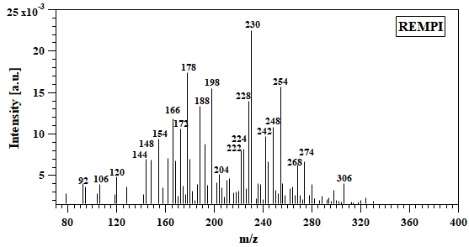

Figure S. 1: Average TG REMPI-TOF mass spectra of PET pyrolysis.

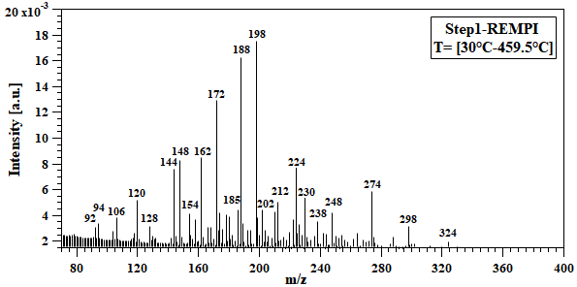

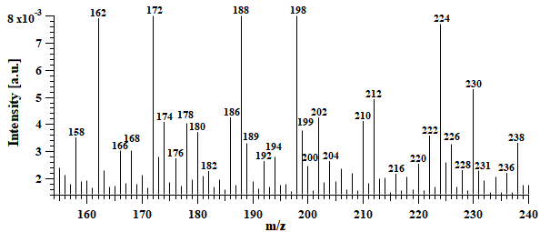

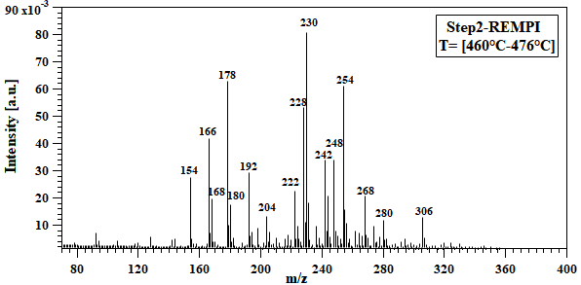

Figure S. 2: Selected time-ranges of TG REMPI-TOF mass spectra of PET pyrolysis.

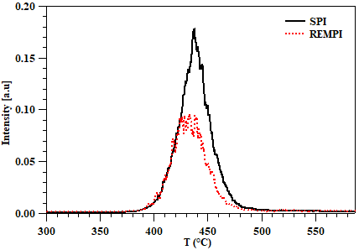

Figure S. 3: Temporal profile of m/z= 198 by REMPI and SPI.

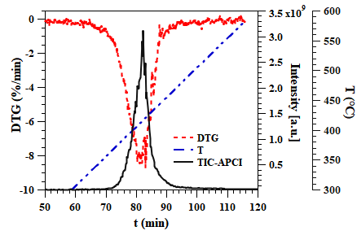

Figure S. 4: DTG, TIC and temperature curves for APCI FT-ICR MS.

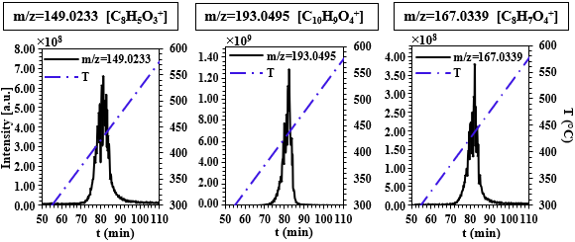

Figure S. 5: Temporal evolutions of major m/z detected by APCI FT-ICR MS.

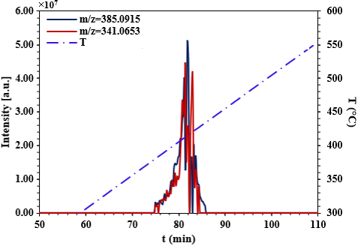

Figure S. 6: Temporal evolutions of m/z 385.0915 and 341.0653 by APCI FT-ICR MS.