Robust overlay schemes for the fusion of fluorescence and color channels in biological imaging

Jürgen Glatza, Panagiotis Symvoulidisb, P. Beatriz Garcia-Allendea, Vasilis Ntziachristosa,b

*a Chair for Biological Imaging, Technische Universität München, Munich, Germany  
b Institute for Biological and Medical Imaging, Helmholtz Zentrum München, Neuherberg, Germany*

**Abstract**

Molecular fluorescence imaging is a commonly used method in various biomedical fields and undergoing rapid translation towards clinical applications. Color images are commonly superimposed with fluorescence measurements to provide orientation, anatomical information and molecular tissue properties in a single image. New adaptive methods that produce a more robust composite image than conventional lime green alpha blending are presented and demonstrated herein. Moreover, visualization through temporal changes is showcased as an alternative for real-time imaging systems.

**1. Introduction**

Tissue interrogation by means of optical fluorescence imaging is one of most widespread methods in medicine and biology [1]. Recently molecular fluorescent agents have emerged as a means to enhance human vision by targeting disease biomarkers [2,3]. Fluorescence imaging with molecular specificity has been successfully translated into clinical applications to enable accurate cancer identification and demarcation [4,5] as well as sentinel lymph node localization [6,7].

Intra-operative imaging systems such as the ones presented in [8] or [9] typically capture the fluorescence emission waveband as well as an additional color image. In order to provide the surgeon with easy and intuitive orientation that matches his field of view, the detected fluorescence signal is superimposed on the color image.

Typically a pseudo-color image is generated by superimposing the fluorescence image over the color image in lime green using alpha-blending [10]. A transparent overlay can be used to maintain the structural information present in the color image while adding the molecular information of the fluorescence distribution.

Biological data visualization requires standardization and robustness, to be intuitively interpretable and easily transferable. However, a transparent green overlay is not robust, since it is based on the presence of a predominantly redish tissue background. Thus, in cases where this assumption is violated, it will produce low contrast and an inappropriate visualization. In this work we propose alternative schemes to select the superimposed color in an adaptive way that does not make a priori assumptions on the sample’s color appearance. Furthermore, we showcase a novel visualization method for video-rate surgical fluorescence imaging that modulates transparency and color over time.

**2. Materials and Methods**

2.1 Pre-processing

Before the two acquisition channels can be merged into a composite image, a number of pre-processing steps are required. Depending on the system setup, re-sizing of the fluorescence channel and co-registration with the color image, e.g. by an affine transformation, might be necessary. In order to restrict the superimposed fluorescence signal to physiologically relevant information, de-noising and thresholding can be applied to remove auto-fluorescence, filter cross-talk and other parasitic signals. An appropriate threshold can be determined either manually, or by an automatic thresholding or segmentation algorithm [11,12]. Herein we used Otsu’s method [13] to determine the threshold T, for which the pre-processed fluorescence image **F’** is then calculated from the measured intensity image **F** as:

2.2 Alpha Blending

Alpha-blending of the fluorescence image **F’** over the color image with RGB channels is given as:

Thereby ***P*** is the composite image, is the transparency and is the pseudo-color of the overlay. As the default color, we selected lime green, i.e. , for the superimposition on biological tissue. Additionally, we applied a pixel-wise variable map for the transparency to obtain smoother transitions between areas above and below the fluorescence threshold. For a maximum transparency this can be written as:

2.3 HSV-based color selection

An adaptive approach to select a pseudo-color that yields a strong contrast is based on picking a color that is underrepresented in the ROI. The color image was transformed into HSV representation and the average hue was calculated in the region of interest (ROI) where the fluorescence lies above the threshold. The hue of the overlay color was chosen to lie on the opposite side of the HSV cone, while both saturation and value were set to 1.

The obtained color was transformed back into the RGB space and utilized for alpha-blending as described in section 2.2.

2.4 PCA-based color selection

Alternatively, robust overlay was done by principal component analysis (PCA) of the color image. Thereby the ROI was vectorized and PCA was performed to yield the principal component loadings **U**. The transformation of the color image into the coordinate system spanned by the principal component eigenvectors is given by:

As the principal components are ordered by their statistical contribution to the original image, we superimposed the pre-processed fluorescence image on the third, least significant component in order to achieve the highest contrast to the main image features.

The composite image was then transformed back into the original RGB color space.

Since the eigenvector matrix is orthonormal this equation simplifies to:

Thus blending the fluorescence over the least significant principal component is equivalent to selecting the eigenvector with the smallest eigenvalue as the overlay “color” for alpha blending in RGB space.

2.5 Animated Overlay

The methods discussed so far aim to integrate the fluorescence information into the spectral components of the color image, generating the contrast by selecting a color that is underrepresented in the image. Alternatively, especially in the case of continuously acquired clinical images, the signal can also be visualized along the temporal dimension. It was assumed that the image changes slowly compared to the acquisition frame rate, hence changes occurring with a higher temporal frequency are easily identifiable in the overlay. The temporal alpha blending can then be written as:

A sinusoidal curve oscillating at 2 Hz was used to vary transparency and the overlay color hue.

2.7 Biological Samples

Color and epi-fluorescence images from a variety of biological studies as shown in Fig.1 were choosen to test and validate the proposed algorithms. Image set A stems from a study of leaves transpiration and vasculature network, where the leaf absorbed Alexa Fluor 750 through its petiolule. The images of sets B and C were acquired using a prototype cryoslicer-based imaging system [14]. Set B shows an axial section of a mouse bearing a tumor targeted by a virus that expressed green fluorescent protein (GFP) and melanin [15]. In image set C, we depict two zebrafish with pan-neuronal expression of GFP embedded in the same block. In D we imaged a NIR probe (cetuximab-CW800) targeting intra-peritoneal tumors (HT29luc2) through the intact skin of a nude mouse. In dataset E we simulated an intraoperative scenario using a subcutaneous 4T1 tumor targeted with bevacizumab-CW800 [REF Koch et al. JBO 2014].

**3. Results**

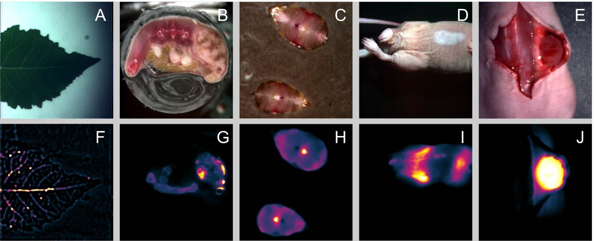

*Figure 1: Color images of the leaf, melanin and GFP expressing mouse, GFP expressing zebrafish, transcutaneous imaging of an intraperitoneal tumor in a mouse and intraoperative imaging of a subcutaneous tumor (A-E) as well as corresponding fluorescence images (F-J).*

Color images acquired from the five biological samples are displayed in Figure 1A-E), while the corresponding fluorescence channel is shown in Figure 1F-J). The mouse images contain parasitic signals from intestinal autofluorescence (Fig. 1G), skin autofluorescence (Fig. 1I and 1J) and contrast agent accumulation in the liver (Fig. 1I). The images were co-registered and automatic segmentation of the fluorescence signal was performed using Otsu’s method. The region of interest was defined for each image as the area containing fluorescence signal above the threshold.

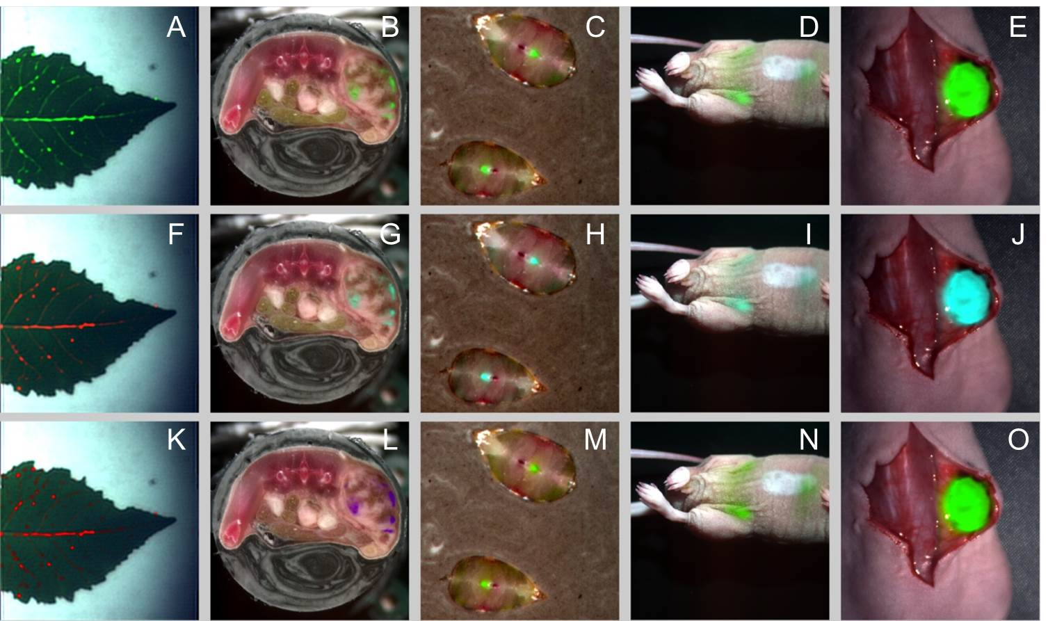

*Figure 2: Overlay images generated from the color and fluorescence data shown in Figure 1. A-E) Pseudo-green alpha blending. F-J) Robust overlay color selection in HSV space. K-O) Robust overlay color selection from principal component analysis. A supplementary video of the intraoperative mouse data using the animated overlay is available.*

Overlay images were calculated for all data sets using the pseudo-green alpha blending, color picking in HSV space and the PCA-based alpha blending. Figure 2A-E) shows the overlay in lime green, which produces reduced contrast when the assumption of a predominantly red background is violated, as is the case for the leaf and the mouse skin. The color selection in HSV space is plotted in Figure 2F-J). The algorithm picks various shades of cyan for the animal tissue and an orange color for overlay on the leaf. Color-selection using PCA is shown in Figure 2K-O) and yields a wider range of colors for the different samples. The time-modulated overlay is shown in Supplementary Video 1.

**4. Discussion**

The ongoing translation of fluorescence molecular imaging into clinical and surgical practice calls for standardized and robust ways to represent multispectral data. Fluorescence emission wavebands contain molecular information on tissue that is invisible to the human eye, while additional color images provide anatomical information and easy orientation. In this work we investigated methods for the fusion of multispectral fluorescence data into a composite RGB image.

Schemes for the generation of a pseudo-color fluorescence overlay were discussed. Among those, the overlay in lime green is widely used for biological tissue, but it is based on a priori assumptions about the spectral characteristics of the imaged sample. Therefore we proposed more robust alternatives that utilize hue or principal component analysis to adaptively select a color for the overlay, based on the tissue characteristics. Additionally, visualization along the temporal dimension of color and fluorescence data acquired in real-time was proposed and demonstrated.

The problem can be generalized to the representation of an n-dimensional dataset in the RGB color space. Herein we assumed a single fluorescence measurement that is superimposed on a corresponding color image. Such a projection onto a lower dimensional space is inherently lossy, however, the proposed robust methods enable a minimization of information loss and an optimal and intuitive visualization.

As an extension to the presented cases, measurements might be taken with multiple fluorochromes or with just a single visible wavelength for orientation. Modified version of the current algorithms for novel schemes need to be developed to provide even more flexibility under such a wider range of conditions.

**Acknowledgments**  
We would like to thank Mrs. Zhen Bi and Prof. Dr. J.P. Schnitzler for the leaf samples, Prof. G.G. Westmeyer for the zebrafish sample, Dr. Strizker and Prof. Dr. Szalay for the melanin and GFP expressing tumor samples, Dr. Vladimir Ermolayev for the 4T1 mouse, Dr. Wouter Nagengast for proving the intraperitoneal tumor mice and the cetuximab-CW800 contrast agent and Prof. Dr. Gooitzen van Dam and Prof. Dr. E.G. Elisabeth de Vries for the bevacizumab-cw800 agent.

# Bibliography

x

|  |  |
| --- | --- |
| 1 | Ntziachristos V. Going deeper than microscopy: the optical imaging frontier in biology. Nature methods. 2010; 7(8): p. 603-614. |
| 2 | Weissleder R, Pittet MJ. Imaging in the era of molecular oncology. Nature. 2008; 452(7187): p. 580-589. |
| 3 | Hilderbrand SA, Weissleder R. Near-infrared fluorescence: application to in vivo molecular imaging. Current Opinion in Chemical Biology. 2010; 14(1): p. 71-79. |
| 4 | Stummer W, Pichlmeier U, Meinel T, et al. Fluorescence-guided surgery with 5-aminolevulinic acid for resection of malignant glioma: a randomised controlled multicentre phase III trial. The lancet oncology. 2006; 7(5): p. 392-401. |
| 5 | van Dam GM, Themelis G, Crane LMA, et al. Intraoperative tumor-specific fluorescence imaging in ovarian cancer by folate receptor-[alpha] targeting: first in-human results. Nature Medicine. 2011; 17(10): p. 1315-1319. |
| 6 | Troyan SL, Kianzad V, Gibbs-Strauss SL, et al. The FLARE™ intraoperative near-infrared fluorescence imaging system: a first-in-human clinical trial in breast cancer sentinel lymph node mapping. Annals of surgical oncology. 2009; 16(10): p. 2943-2952. |
| 7 | Crane L, Themelis G, Arts H, et al. Intraoperative near-infrared fluorescence imaging for sentinel lymph node detection in vulvar cancer: first clinical results. Gynecologic Oncology. 2011; 120(2): p. 291-296. |
| 8 | Mieog JSD, Troyan SL, Hutteman M, et al. Toward Optimization of Imaging System and Lymphatic Tracer for Near-Infrared Fluorescent Sentinel Lymph Node Mapping in Breast Cancer. Annals of Surgical Oncology. 2011; 18(9). |
| 9 | Glatz J, Varga J, Garcia-Allende PB, et al. Concurrent video-rate color and near-infrared fluorescence laparoscopy. Journal of Biomedical Optics. 2013; 18(10): p. In Press. |
| 10 | Porter T, Duff T. Compositing digital images. ACM Siggraph Computer Graphics. ; 18(3): p. 253-259. |
| 11 | Sezgin M, Sankur B. Survey over image thresholding techniques and quantitative performance evaluation. Journal of Electronic Imaging. 2004; 13(1): p. 146-168. |
| 12 | Ghaye J, Kamat MA, Corbino-Giunta L, et al. Image thresholding techniques for localization of sub-resolution fluorescent biomarkers. Cytometry Part A. 2013; 83(11): p. 1001-1016. |
| 13 | Otsu N. A threshold selection method from gray-level histograms. Automatica. 1975; 11: p. 285-296. |
| 14 | Sarantopoulos A, Themelis G, Ntziachristos V. Imaging the bio-distribution of fluorescent probes using multispectral epi-illumination cryoslicing imaging. Molecular Imaging and Biology. 2011; 13(5): p. 874-885. |
| 15 | Stritzker J, Kirscher L, Scadeng M, et al. Vaccinia virus-mediated melanin production allows MR and optoacoustic deep tissue imaging and laser-induced thermotherapy of cancer. Proceedings of the National Academy of Sciences. 2013; 110(9): p. 3316-3320. |

x