**Supplementary Figures and Tables**

**Fig S1** Excitation-emission spectra of FITC solution (0.002 nM in distilled water), CHT-FITC suspension (0.002 nM in distilled water) and GSNO-CHT-FITC suspension (0.002 nM in distilled water). Excitation (exc.) maxima was recorded at ~488 nm and maximum emission (em.) was recorded at ~515 nm.

**Fig S2** Representative confocal microscopic images showing primary root tips of *Brassica napus* seedlings treated with distilled water (DW, control), 500 µM GSNO, 0.000241 mg/ml FITC, 500 µM GSNO-CHT, 500 µM GSNO-CHT-FITC, 500 µM CHT-FITC for 2 hours via the root system. Scale bars= 100 µm.

**Fig S3** Time course of *in planta* nitric oxide level changes. Values of pixel intensities in the maturation zone (A) and meristematic zone (B) of the primary root of control, 250 µM GSNO or GSNO-CHT treated *Brassica napus* seedlings. Different letters indicate statistically significant differences according to Duncan’s test (n=10, p<0.05). (C) Representative fluorescent microscopic images of DAF-FM DA labelled roots in case of 2h treatment. Scale bars= 100 µm.

**Fig S4** Pixel density values measured on western blot membranes showing 3-nitrotyrosine levels in protein extracts from *Brassica napus* seedlings treated with distilled water (control), GSNO, GSNO-CHT or CHT at concentrations of 250 or 500 µM for 2 hours *via* the root system. Protein extracts were prepared from whole seedlings. MM= molecular marker. The representative protein bands were numbered and the pixel densities were measured using GelQuant software (biochemsolutions.com). Asterisks indicate significant differences according to Student’s t-test (*≤0.05, ­­**≤0.01, ***≤0.001, n.s.=non-significant).

**Table S1** Primers used in this study.

**Fig S1**

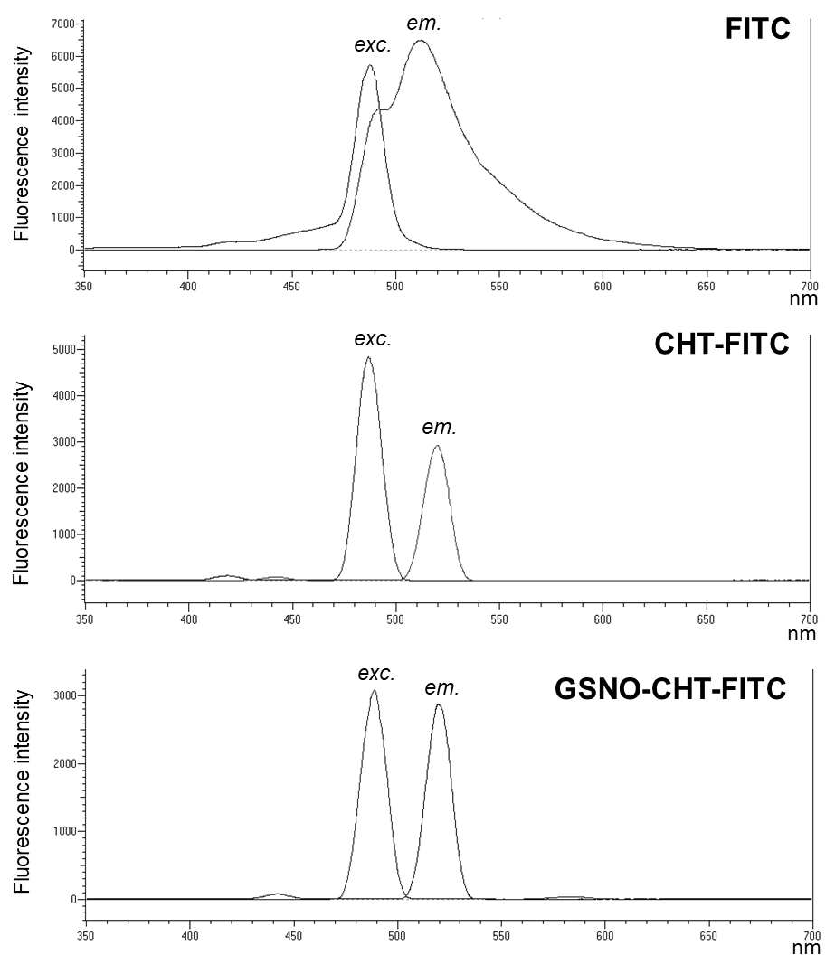

**Fig S2**

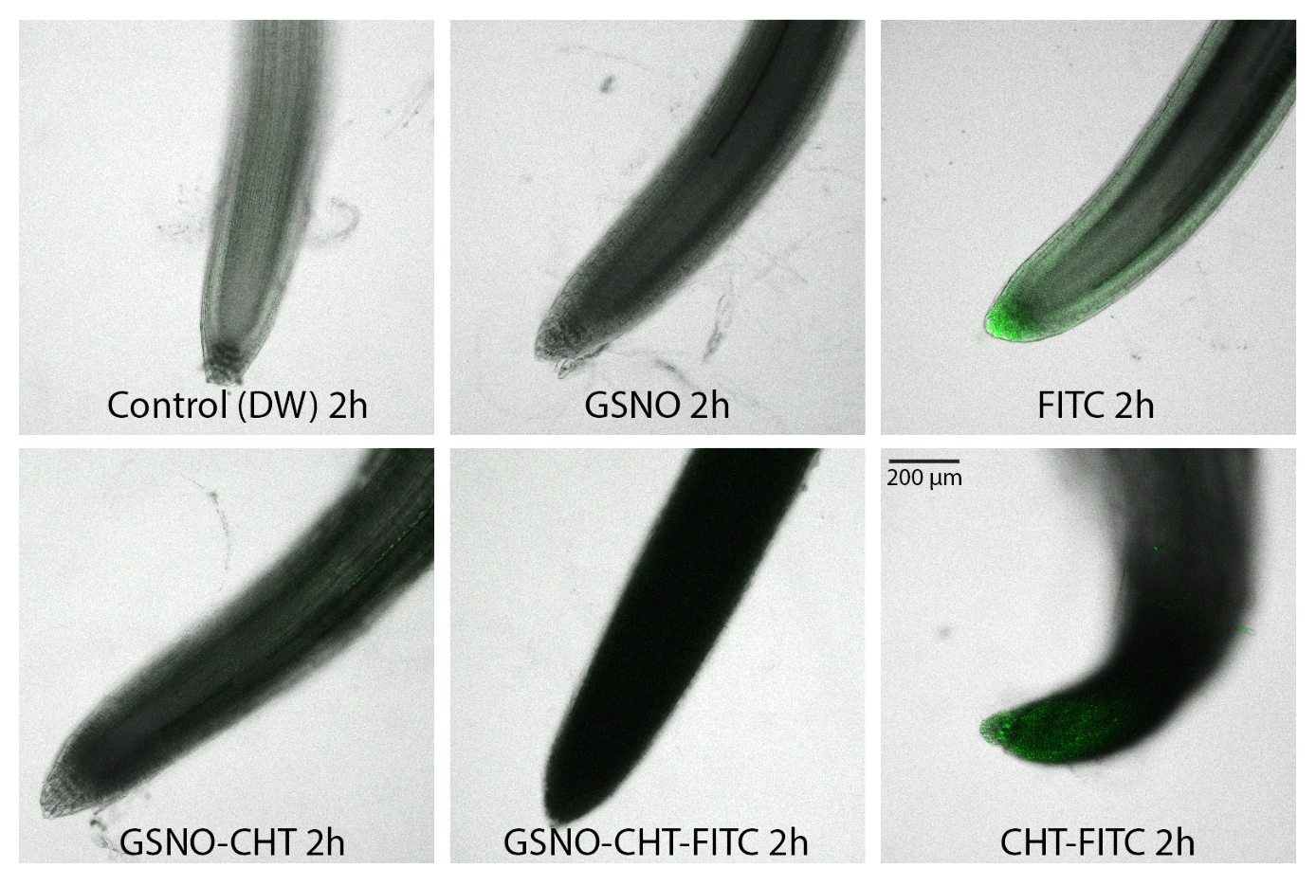

**Fig S3**

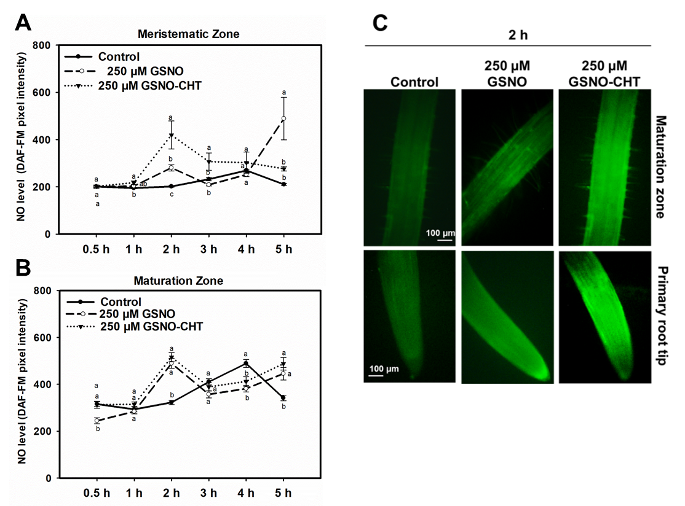

**Fig S4**



**Table S1**

|  |  |  |  |
| --- | --- | --- | --- |
| **Gene** | **Accession** | **Forward primer (5' ==> 3')** | **Reverse primer (5' ==> 3')** |
| *BnNIA1* | PBNBR1405 | CTTCAAACCTCCTCTCGTCCC | GGTCTTCTTTGGTGGTTTTGTCG |
| *BnGSNOR1* | JX104828 | CCCTTGTATCCTCGGTCACG | CATTCACGGCACTCAGCTTG |
| *BnGLB1* | LOC106449340 | TGTTGTGAGTCAGCAGCACA | CTGGCACCGCCTCCTTTATT |
| *BnGLB2* | LOC106346174 | ATTCGAGCGAATGTAGTGAAAGTT | CCAAAGCTTCTTGCTTCTCCG |
| *BnActin7* | Bra028615 | GCTGACCGTATGAGCAAAG | AAGATGGATGGACCCGAC |