**SUPPLEMENTAL MATERIAL**

Dew point temperature (dp) was calculated as follows:

|  |  |
| --- | --- |
|  | (1) |

with temp= air temperature and rh=relative humidity.

Supplemental Table 1. Description of (cause-specific) mortality outcomes per   
100,000 inhabitants.

|  |  |  |  |  |  |  |
| --- | --- | --- | --- | --- | --- | --- |
| **City** | **Year** | **Population** | **Daily mean (SD)/100,000 inhabitants** | | |  |
| **Natural death counts** | **Cardiovascular death counts** | **Respiratory death counts** |  |
|
| **Augsburg** | 2011 | 266,647 | 2.6 (0.9) | 1.2 (0.6) | 0.2 (0.3) |  |
|  | 2012 | 272,699 | 2.6 (1.0) | 1.1 (0.6) | 0.1 (0.2) |  |
| **Chernivtsi** | 2013 | 258,371 | 2.4 (1.0) | 1.7 (0.8) | 0.04 (0.2) |  |
| **Dresden** | 2011 | 517,765 | 2.2 (0.7) | 1.0 (0.4) | 0.1 (0.2) |  |
|  | 2012 | 525,105 | 2.3 (0.7) | 1.0 (0.5) | 0.1 (0.2) |  |
| **Ljubljana** | 2012 | 280,607 | 2.1 (0.9) | 0.8 (0.5) | 0.1 (0.2) |  |
|  | 2013 | 282,994 | 2.0 (0.8) | 0.8 (0.5) | 0.1 (0.2) |  |
| **Prague** | 2012 | 1,246,780 | 2.2 (0.5) | 1.1 (0.3) | 0.1 (0.1) |  |
|  | 2013 | 1,243,201 | 2.1 (0.5) | 1.0 (0.3) | 0.1 (0.1) |  |
| outcome definitions: | |  |  |  |  |  |
| natural causes ICD-10 A00-R99, cardiovascular diseases ICD-10 I00-I99, respiratory diseases ICD-10 J00-J99 | | | | | | |

Supplemental Table 2. Spearman's rank correlation coefficients for meteorological and air pollution parameters.

|  |  |  |  |  |  |  |  |  |
| --- | --- | --- | --- | --- | --- | --- | --- | --- |
| **Augsburg (2011-2012)** | Air temperature (°C) | Relative humidity (%) | PM10† (μg/m³) | PM2.5‡ (μg/m³) | PM2.5-10 (μg/m³) | UFP§ (n/cm³) | PNC# (n/cm3) | NO2& (μg/m³) |
| Air temperature (°C) | 1.00 | -0.57 | -0.19 | -0.33 | 0.17 | 0.06 | 0.01 | -0.53 |
| Relative humidity (%) | -0.57 | 1.00 | -0.03 | 0.11 | -0.30 | -0.37 | -0.33 | 0.19 |
| PM10† (μg/m³) | -0.19 | -0.03 | 1.00 | 0.93 | 0.78 | 0.43 | 0.54 | 0.70 |
| PM2.5‡ (μg/m³) | -0.33 | 0.11 | 0.93 | 1.00 | 0.53 | 0.37 | 0.49 | 0.73 |
| PM2.5-10" (μg/m³) | 0.17 | -0.30 | 0.78 | 0.53 | 1.00 | 0.45 | 0.50 | 0.44 |
| UFP§ (n/cm³) | 0.06 | -0.37 | 0.43 | 0.37 | 0.45 | 1.00 | 0.99 | 0.51 |
| PNC# (n/cm3) | 0.01 | -0.33 | 0.54 | 0.49 | 0.50 | 0.99 | 1.00 | 0.58 |
| NO2& (μg/m³) | -0.53 | 0.19 | 0.70 | 0.73 | 0.44 | 0.51 | 0.58 | 1.00 |
| **Chernivtsi (2013)** | Air temperature (°C) | Relative humidity (%) | PM10† (μg/m³) | PM2.5‡ (μg/m³) | PM2.5-10 (μg/m³) | UFP§ (n/cm³) | PNC# (n/cm3) | NO2& (μg/m³) |
| Air temperature (°C) | 1.00 | -0.55 | . | . | . | 0.08 | 0.01 | . |
| Relative humidity (%) | -0.55 | 1.00 | . | . | . | -0.29 | -0.19 | . |
| PM10† (μg/m³) | . | . | . | . | . | . | . | . |
| PM2.5‡ (μg/m³) | . | . | . | . | . | . | . | . |
| PM2.5-10" (μg/m³) | . | . | . | . | . | . | . | . |
| UFP§ (n/cm³) | 0.08 | -0.29 | . | . | . | 1.00 | 0.97 | . |
| PNC# (n/cm3) | 0.01 | -0.19 | . | . | . | 0.97 | 1.00 | . |
| NO2& (μg/m³) | . | . | . | . | . | . | . | . |
| **Dresden (2011-2012)** | Air temperature (°C) | Relative humidity (%) | PM10† (μg/m³) | PM2.5‡ (μg/m³) | PM2.5-10 (μg/m³) | UFP§ (n/cm³) | PNC# (n/cm3) | NO2& (μg/m³) |
| Air temperature (°C) | 1.00 | -0.50 | -0.28 | -0.37 | 0.17 | 0.29 | 0.19 | -0.42 |
| Relative humidity (%) | -0.50 | 1.00 | 0.06 | 0.14 | -0.28 | -0.42 | -0.35 | 0.28 |
| PM10† (μg/m³) | -0.28 | 0.06 | 1.00 | 0.97 | 0.58 | 0.37 | 0.56 | 0.68 |
| PM2.5‡ (μg/m³) | -0.37 | 0.14 | 0.97 | 1.00 | 0.40 | 0.30 | 0.50 | 0.68 |
| PM2.5-10" (μg/m³) | 0.17 | -0.28 | 0.58 | 0.40 | 1.00 | 0.51 | 0.58 | 0.37 |
| UFP§ (n/cm³) | 0.29 | -0.42 | 0.37 | 0.30 | 0.51 | 1.00 | 0.96 | 0.33 |
| PNC# (n/cm3) | 0.19 | -0.35 | 0.56 | 0.50 | 0.58 | 0.96 | 1.00 | 0.45 |
| NO2& (μg/m³) | -0.42 | 0.28 | 0.68 | 0.68 | 0.37 | 0.33 | 0.45 | 1.00 |
| **Ljubljana (2012-2013)** | Air temperature (°C) | Relative humidity (%) | PM10† (μg/m³) | PM2.5‡ (μg/m³) | PM2.5-10 (μg/m³) | UFP§ (n/cm³) | PNC# (n/cm3) | NO2& (μg/m³) |
| Air temperature (°C) | 1.00 | -0.45 | -0.44 | -0.53 | -0.06 | -0.17 | -0.22 | -0.54 |
| Relative humidity (%) | -0.45 | 1.00 | 0.06 | 0.16 | -0.14 | 0.08 | 0.13 | 0.38 |
| PM10† (μg/m³) | -0.44 | 0.06 | 1.00 | 0.95 | 0.67 | 0.36 | 0.59 | 0.57 |
| PM2.5‡ (μg/m³) | -0.53 | 0.16 | 0.95 | 1.00 | 0.43 | 0.27 | 0.50 | 0.55 |
| PM2.5-10" (μg/m³) | -0.06 | -0.14 | 0.67 | 0.43 | 1.00 | 0.46 | 0.55 | 0.40 |
| UFP§ (n/cm³) | -0.17 | 0.08 | 0.36 | 0.27 | 0.46 | 1.00 | 0.95 | 0.54 |
| PNC# (n/cm3) | -0.22 | 0.13 | 0.59 | 0.50 | 0.55 | 0.95 | 1.00 | 0.62 |
| NO2& (μg/m³) | -0.54 | 0.38 | 0.57 | 0.55 | 0.40 | 0.54 | 0.62 | 1.00 |
| **Prague (2012-2013)** | Air temperature (°C) | Relative humidity (%) | PM10† (μg/m³) | PM2.5‡ (μg/m³) | PM2.5-10 (μg/m³) | UFP§ (n/cm³) | PNC$ (n/cm3) | NO2& (μg/m³) |
| Air temperature (°C) | 1.00 | -0.52 | -0.19 | -0.25 | 0.14 | 0.31 | 0.15 | -0.46 |
| Relative humidity (%) | -0.52 | 1.00 | 0.00 | 0.12 | -0.16 | -0.31 | -0.18 | 0.35 |
| PM10† (μg/m³) | -0.19 | 0.00 | 1.00 | 0.96 | 0.77 | 0.29 | 0.54 | 0.68 |
| PM2.5‡ (μg/m³) | -0.25 | 0.12 | 0.96 | 1.00 | 0.61 | 0.25 | 0.50 | 0.66 |
| PM2.5-10" (μg/m³) | 0.14 | -0.16 | 0.77 | 0.61 | 1.00 | 0.40 | 0.56 | 0.43 |
| UFP§ (n/cm³) | 0.31 | -0.31 | 0.29 | 0.25 | 0.40 | 1.00 | 0.94 | 0.26 |
| PNC$ (n/cm3) | 0.15 | -0.18 | 0.54 | 0.50 | 0.56 | 0.94 | 1.00 | 0.46 |
| NO2& (μg/m³) | -0.46 | 0.35 | 0.68 | 0.66 | 0.43 | 0.26 | 0.46 | 1.00 |
| †particulate matter with a size range of <10 μm in aerodynamic diameter | | | | | |  |  |  |
| ‡particulate matter with a size range of <2.5 μm in aerodynamic diameter | | | | | |  |  |  |
| "coarse particles with a size range of 2.5-10 μm in aerodynamic diameter | | | | | |  |  |  |
| §ultrafine particles with a size range of 0.02 to 0.1μm in aerodynamic diameter (20-100 nm) | | | | | |  |  |  |
| #particle number concentration with a size range of 0.02 to 0.8μm in aerodynamic diameter (20-800 nm) | | | | | | |  |  |
| $particle number concentration with a size range of 0.02 to 0.5μm in aerodynamic diameter (20-500 nm) | | | | | | |  |  |
| &nitrogen dioxide |  |  |  |  |  |  |  |  |

Supplemental Table 3. Percent changes in the pooled relative risk (95%-CI) of (cause-specific) mortality with each average IQR increase in air pollutants, single lags.

|  |  |  |  |  |  |  |  |
| --- | --- | --- | --- | --- | --- | --- | --- |
| **Association under investigation** | **IQR†** | **lag 0** | **lag 1** | **lag 2** | **lag 3** | **lag 4** | **lag 5** |
| **Natural mortality** |  |  |  |  |  |  |  |
| UFP (n/cm3) | 2,750 | -0.8 (-2.6; 0.9) | 0.9 (-0.8; 2.7) | -0.3 (-2.0; 1.4) | -0.6 (-2.9; 1.8) | -0.1 (-1.7; 1.6) | -0.4 (-2.0; 1.3) |
| PNC (n/cm3) | 3,675 | -0.9 (-2.8; 0.9) | 0.6 (-1.2; 2.5) | -0.4 (-2.1; 1.4) | -0.5 (-2.8; 1.8) | 0.0 (-1.7; 1.8) | -0.4 (-2.1; 1.3) |
| PM2.5 (μg/m³) | 12.4 | -0.4 (-1.9; 1.2) | -0.3 (-1.9; 1.4) | 0.3 (-2.1; 2.7)* | 0.5 (-2.3; 3.4)* | 0.1 (-2.3; 2.6)* | 0.1 (-2.7; 3.0)* |
| PM10 (μg/m³) | 16.0 | 0.1 (-1.6; 1.8) | -0.4 (-1.9; 1.2) | 0.0 (-2.1; 2.1) | 0.6 (-2.1; 3.4)* | 0.0 (-2.1; 2.1) | 0.4 (-2.7; 3.5)* |
| PM2.5-10 (μg/m³) | 4.7 | 1.2 (-0.4; 2.8) | 0.3 (-1.3, 2.0) | 0.7 (-0.9; 2.2) | 0.2 (-1.4; 1.9) | 0.7 (-1.1; 2.4) | 1.1 (-1.4; 3.8)* |
| NO2 (μg/m³) | 15.4 | 0.6 (-1.3; 2.6) | 0.5 (-1.4; 2.5) | -0.2 (-2.1; 1.7) | 0.7 (-1.9; 3.4) | -0.8 (-2.9; 1.4) | 0.0 (-2.2; 2.3) |
| **Cardiovascular mortality** |  |  |  |  |  |  |  |
| UFP (n/cm3) | 2,750 | -0.8 (-3.3; 1.7) | 0.2 (-2.3; 2.9) | -0.2 (-2.7; 2.3) | 0.3 (-2.4; 3.1) | 0.2 (-2.2; 2.7) | 0.1 (-3.2; 3.6) |
| PNC (n/cm3) | 3,675 | -1.1 (-3.7; 1.6) | 0.0 (-2.6; 2.8) | -0.1 (-2.6; 2.5) | 0.4 (-2.7; 3.7) | 0.6 (-1.9; 3.2) | 0.2 (-3.6; 4.1)* |
| PM2.5 (μg/m³) | 12.4 | -0.7 (-2.9; 1.6) | 0.2 (-2.0; 2.5) | 1.3 (-1.2; 3.9) | 1.7 (-1.0; 4.4) | 1.5 (-2.2; 5.4)* | 1.2 (-3.8; 6.4)* |
| PM10 (μg/m³) | 16.0 | -0.5 (-2.7; 1.7) | -0.2 (-2.2; 2.0) | 0.5 (-1.5; 2.6) | 2.2 (-0.9; 5.3) | 1.4 (-1.8; 4.8) | 1.5 (-3.3; 6.5)* |
| PM2.5-10 (μg/m³) | 4.7 | 0.3 (-2.0; 2.7) | 0.8 (-2.1; 3.7) | 0.9 (-1.4; 3.2) | 2.3 (0.1; 4.6) | 2.1 (-0.1; 4.4) | 3.1 (-0.4; 6.7)* |
| NO2 (μg/m³) | 15.4 | -0.7 (-3.5; 2.2) | -0.4 (-4.0; 3.4) | -0.0 (-2.8; 2.9) | 1.9 (-1.3; 5.1) | 0.1 (-4.0; 4.5) | 1.3 (-2.9; 5.7) |
| **Respiratory mortality** |  |  |  |  |  |  |  |
| UFP (n/cm3) | 2,750 | 0.2 (-7.3; 8.2) | 4.5 (-4.1; 13.8) | -2.2 (-13.4; 10.4)* | 3.3 (-4.3; 11.6) | 5.5 (-1.7; 13.2) | 5.5 (-1.6; 13.2) |
| PNC (n/cm3) | 3,675 | -0.4 (-8.0; 7.9) | 2.5 (-5.9; 11.6) | -2.5 (-10.8; 6.5) | 2.7 (-5.6; 11.7) | 4.5 (-3.0; 12.6) | 5.3 (-2.2; 13.4) |
| PM2.5 (μg/m³) | 12.4 | -1.9 (-7.8; 4.3) | -3.1 (-9.0; 3.2) | -1.1 (-6.8; 5.0) | 1.0 (-4.7; 7.1) | -3.1 (-8.6; 2.8) | 0.9 (-4.9; 6.9) |
| PM10 (μg/m³) | 16.0 | -2.3 (-8.2; 3.9) | -4.2 (-9.7; 1.7) | -2.2 (-7.7; 3.6) | -0.9 (-6.5; 5.1) | -4.4 (-9.8; 1.2) | -1.3 (-6.8; 4.6) |
| PM2.5-10 (μg/m³) | 4.7 | 0.0 (-5.9; 6.2) | -2.5 (-8.4; 3.7) | -0.8 (-6.6; 5.4) | 0.0 (-6.4; 6.8) | -0.8 (-6.6; 5.3) | -2.8 (-8.6; 3.5) |
| NO2 (μg/m³) | 15.4 | 2.3 (-5.4; 10.6) | 2.2 (-5.7; 10.8) | -4.4 (-11.9; 3.6) | 2.6 (-6.3; 12.4) | -1.8 (-11.0; 8.4) | -2.4 (-9.7; 5.4) |
| †average interquartile range across all cities | | |  |  |  |  |  |
| *heterogeneity p-value<0.1 and I2>50% | |  |  |  |  |  |  |

Supplemental Table 4. Percent change in the pooled relative risk (95%-CI) of respiratory mortality per IQR increase in UFP and percent change in the pooled relative risk of cardiovascular mortality per IQR increase in PM2.5, effect modification by age, sex and season.

|  |  |  |
| --- | --- | --- |
|  | **UFP** and respiratory mortality (6-day average)** | **PM2.5† and cardiovascular mortality (average of lag2-5)** |
| Main effect | 9.9 (-6.3; 28.8) | 3.0 (-2.7; 9.1) |
| Age |  |  |
| <75 years | insufficient cases | 0.2 (-5.8; 6.6) |
| ≥75 years | 8.3 (-11.6; 32.8) | 3.1 (-2.5; 9.1)* |
| Sex |  |  |
| females | 8.8 (-28.1; 64.9)* | 3.5 (-3.5; 11.0)* |
| males | 1.9 (-14.9; 22.1) | 0.3 (-3.9; 4.7) |
| Season |  |  |
| October-March | 5.2 (-9.2; 21.9) | 2.8 (-2.9; 8.8)* |
| April-September | 3.7 (-27.6; 48.7)* | 3.2 (-4.0; 11.0) |
| Average interquartile range for UFP: 2,750 particles/cm3 | |  |
| Average interquartile range for PM2.5: 12.4 µg/m3 | |  |
| *heterogeneity p-value<0.1 and I2>50% | |  |
| **ultrafine particles with a size range of 0.02 to 0.1μm in aerodynamic diameter (20-100 nm) | | |
| †particulate matter with a size range of <2.5 μm in aerodynamic diameter | | |

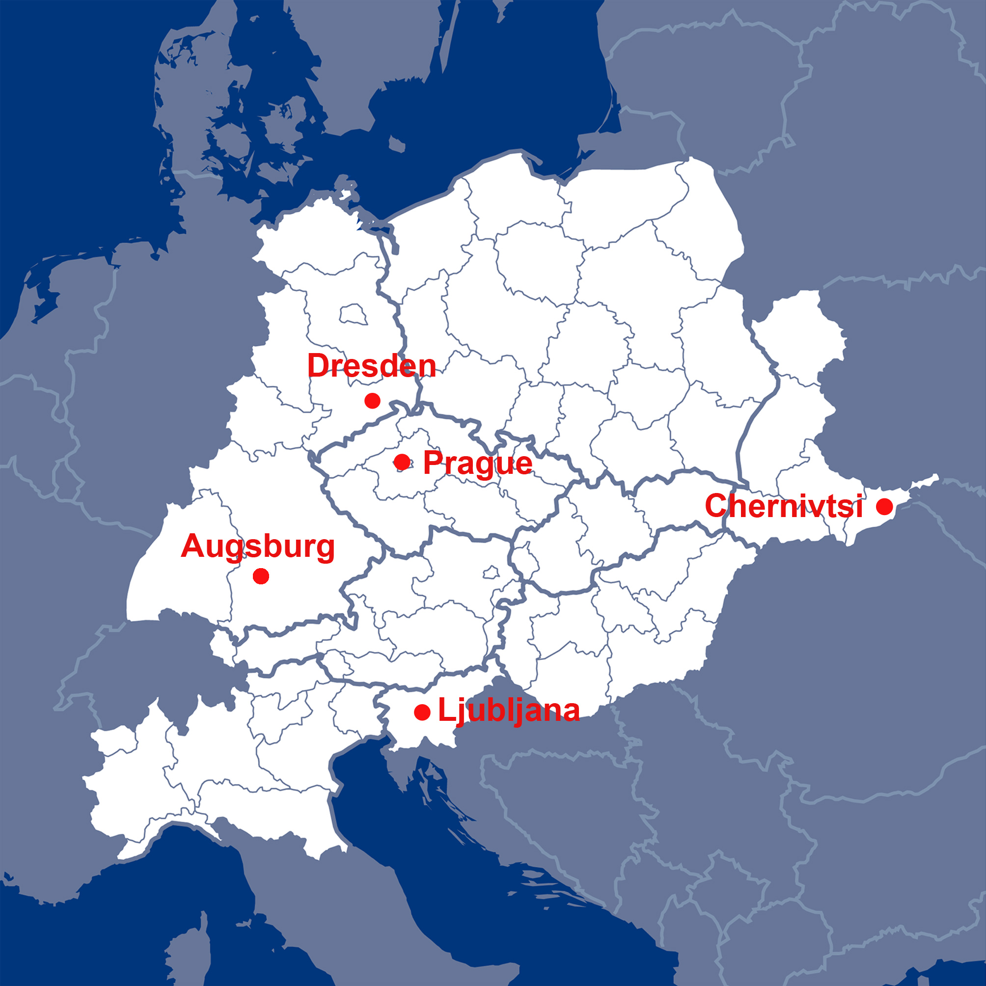

Supplemental Figure 1. Location of the five cities in Central and Eastern Europe.

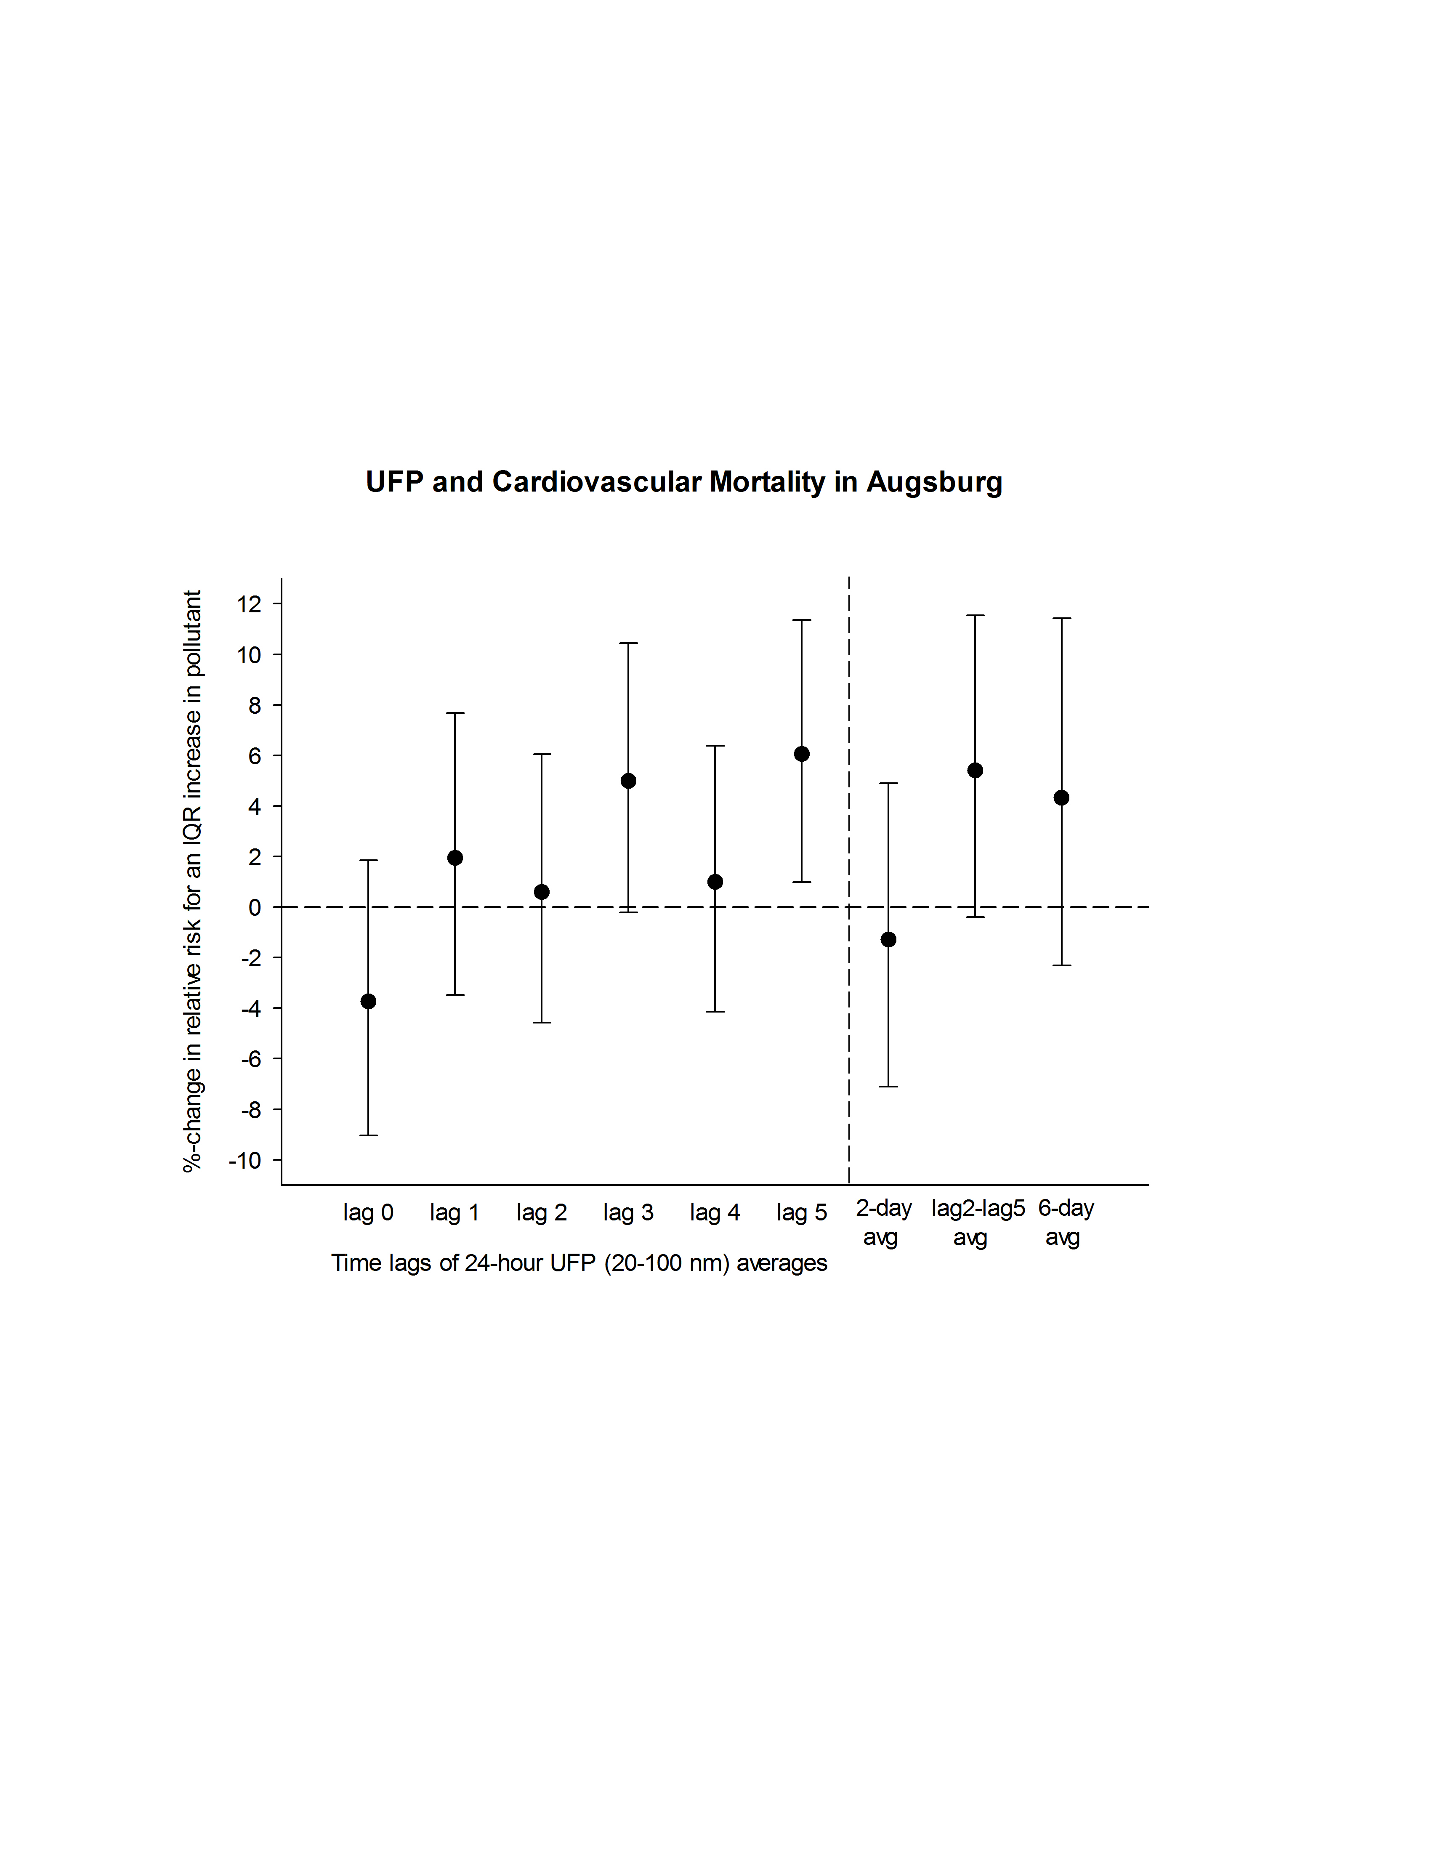

Supplemental Figure 2. Percent change in the relative risk of cardiovascular mortality per IQR increase in UFP in Augsburg.   
IQRs: 3,332 particles/cm3 for single lags, 2,915 particles/cm3 for 2-day average, 2,328 particles/cm3 for avg of lag 2-5, 2,162 for 6-day average.

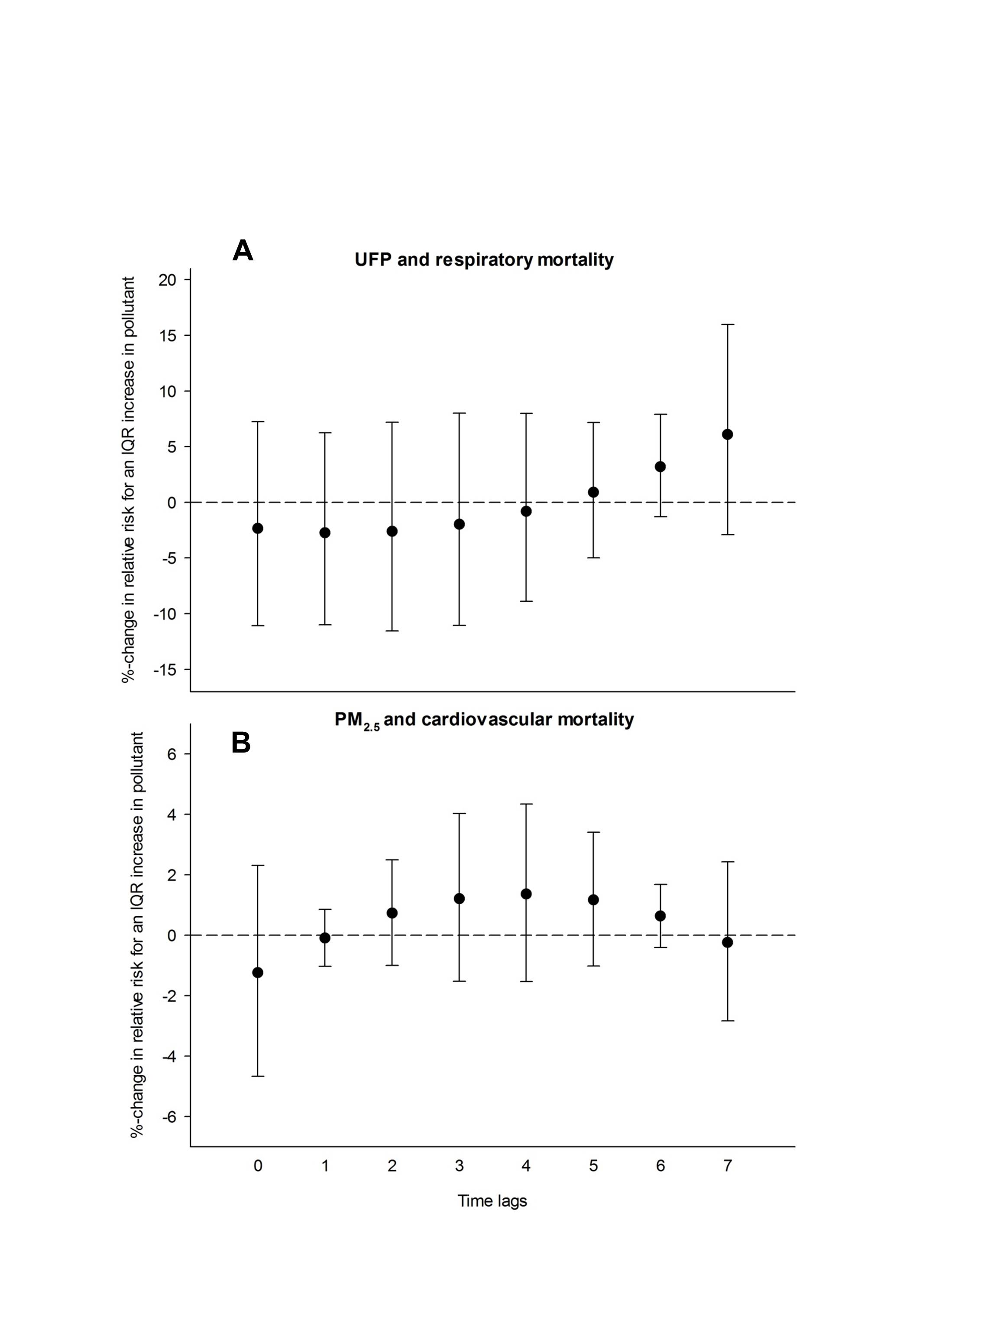

Supplemental Figure 3. Results of second degree polynomial distributed lag models presented as percent changes in the pooled relative risks of A) respiratory mortality per IQR increase in UFP and B) cardiovascular mortality per IQR increase in PM2.5, lag 0 to 7.

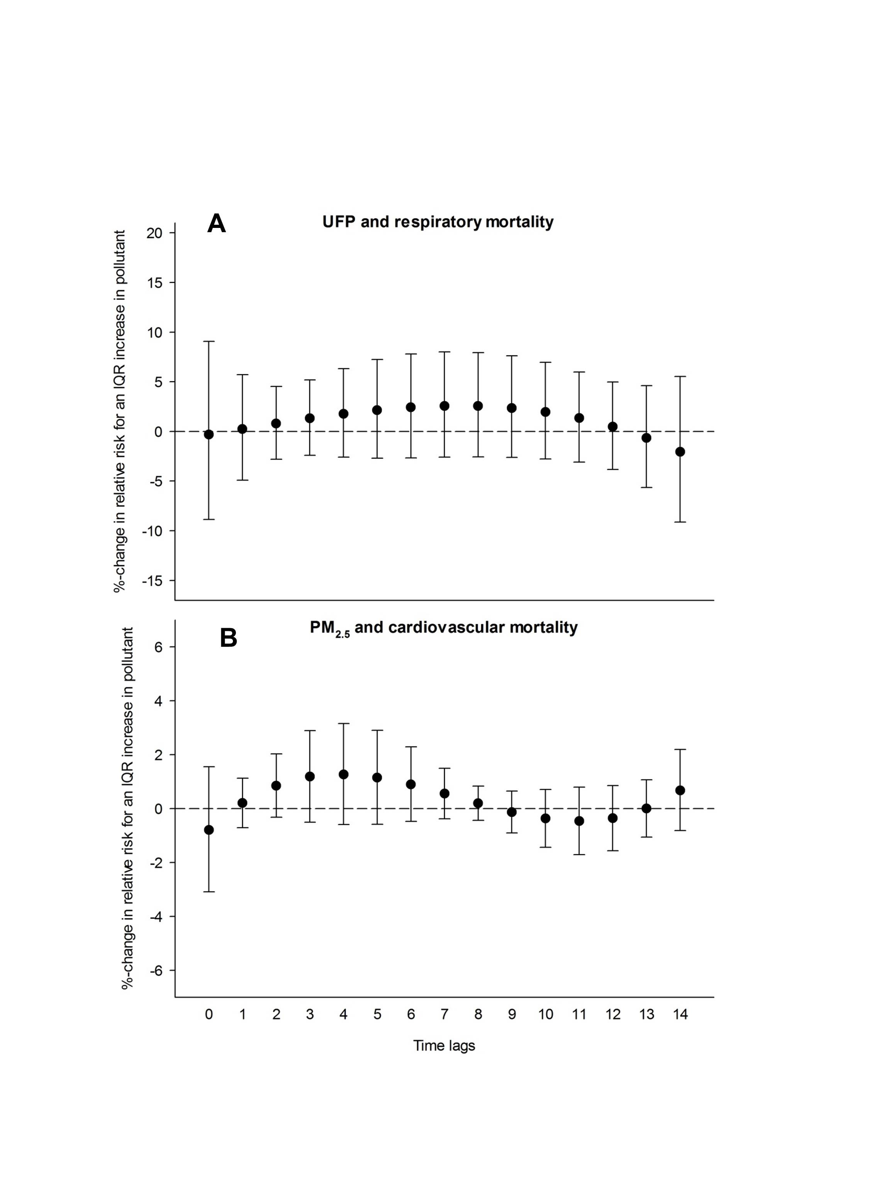

Supplemental Figure 4. Results of third degree polynomial distributed lag models presented as percent changes in the pooled relative risks of A) respiratory mortality per IQR increase in UFP and B) cardiovascular mortality per IQR increase in PM2.5, lag 0 to 14.