Supplementary Materials for

**Metabolic dependency mapping identifies Peroxiredoxin 1 as a driver of resistance to ATM inhibition**

Haojian Li1,2#, Takashi Furusawa1#, Renzo Cavero1, Yunjie Xiao1, Raj Chari3, Xiaolin Wu4, David Sun4, Oliver Hartmann5, Anjali Dhall1, Ronald Holewinski8, Thorkell Andresson8, Baktiar Karim9, Marina Villamor-Payà6, Devorah Gallardo10, Chi-Ping Day7, Lipika R. Pal7, Nishanth Ulhas Nair7, Eytan Ruppin7, Mirit I. Aladjem1, Yves Pommier1, Markus E. Diefenbacher5, Jung Mi Lim11, Rodney L. Levine11, Travis H. Stracker6, and Urbain Weyemi1 *.

1. Developmental Therapeutics Branch, Center for Cancer Research, National Cancer Institute/National Institutes of Health, 37 Convent Drive, Bethesda, MD 20892, USA. 2. Department of Molecular Biosciences, The University of Texas at Austin, Austin, Texas 78712, USA. 3. 3. Genome Modification Core, Laboratory Animal Sciences Program, Frederick, Maryland, USA. 4. NCI Genomics Technology Laboratory, Cancer Research Technology Program, Frederick National Laboratory for Cancer Research/ Frederick, Maryland, USA.5. Comprehensive Pneumology Center (CPC)/Institute of Lung Health and Immunity (LHI), Helmholtz Munich, Member of the German Center for Lung Research (DZL/CPC-M), Munich, Germany. 6. Radiation Oncology Branch/CCR/NCI. 7. Cancer Data Science Lab/ Center for Cancer Research/National Cancer Institute/National Institutes of Health, Bethesda, MD 20892, USA. 8. Protein Characterization Laboratory/Cancer Research Technology Program/Frederick National Laboratory for Cancer Research, Frederick, Maryland, USA. 9. Molecular Histopathology Laboratory/ Cancer Research Technology Program/Frederick National Laboratory for Cancer Research/ Frederick, Maryland, USA. 10, Laboratory Animal Sciences Program, Leidos Biomedical Research, National Cancer Institute, National Institutes of Health, Bethesda, MD, USA, Laboratory of Biochemistry, National Heart, Lung, and Blood Institute, Bethesda, MD, USA.

**This PDF file includes:**

**Materials and Methods**

**Figs. S1 to S7**

**Tables S1 and S2**

**EXPERIMENTAL MODEL AND SUBJECT DETAILS**

**Cell culture**

Human and mouse cell lines used in this study are reported in the Key Resources Table. Cells were grown in a humidified incubator at 37°C under 5% CO2 in air. A549-Cas9 cells were established in DeNicola’s group and kindly shared with our group (*43*). These cells were grown in Dulbecco's Modified Eagle Medium (DMEM) (Fisher Scientific) supplemented with 10% Fetal Bovine Serum (Thermo Scientific) and 2 μg/mL blasticidin to maintain Cas9 expression. NCI-H1299 cells were grown in RPMI 1640 medium (Fisher Scientific) supplemented with 10% Fetal Bovine Serum (Thermo Scientific) and 1 mM sodium pyruvate (Gibco). KP5 cells were grown in DMEM supplemented with 5% Fetal Bovine Serum (Thermo Scientific). All media were supplemented with penicillin and streptomycin (Gibco). A549-Cas9 PRDX1 knockout cells were generated using CRISPR/Cas9 genome editing. Guide RNA oligos targeting human PRDX1, sgPRDX1-1 (5'-GCGCTTCGGGTCTGATACCAA-3'), and sgPRDX1-3 (5'-TGAAAGCAATGATCTCCGTG-3'), were cloned into the lentiviral plasmid, lentiGuide-Puro (Addgene, #52963) after digestion with BsmBI-v2 (NEB). Lentiviral particles were produced using sgPRDX1-1 and sgPRDX1-3 plasmids co-transfected with lentiviral packaging plasmids psPAX2 and pCMV-VSVG into HEK-293 FT cells using Lipofectamine® 3000 (Thermo Scientific). At 48 hours post-transfection, the culture medium was collected and filtered through a 0.45 μM filter to be incubated with A549-Cas9 cells in the presence of polybrene (8 μg/ml). At 72 hours post-infection, infected cells were selected with 1 μg/mL puromycin for 7 days. Single-cell clones were expanded and screened by Western Blot for protein levels of PRDX1. NCI-H1299 PRDX1 knockdown cells were generated by infection with lentiviral particles produced using shRNA expressing plasmids (pLKO.1) targeting human PRDX1 (TRCN0000029513). Cells were selected with 0.5 μg/mL puromycin for 7 days and then maintained in the medium with 0.25 μg/mL puromycin. KP5 PRDX1 knockdown cells were generated by infection with lentiviral particles produced using shRNA expressing plasmids (pLKO.1) targeting mouse PRDX1 (TRCN0000120690). Cells were selected with 2.5 μg/mL puromycin for 7 days and then maintained in the medium with 2.5 μg/mL puromycin.

**Animals**

Six- to eight-week-old NOD SCID gamma mice and C57BL/6J mice were received from the NCI-Frederick facility. All animals were treated according to the recommendations of the NIH Animal Care and Use Committee. All animal procedures were performed according to protocols approved by the NCI Laboratory Animal Sciences Program.

**METHOD DETAILS**

***In vitro* Drug treatments**

All *in vitro* experiments were conducted using AZD1390 (Cat. S8680), AZD0156 (Cat. S8375), MK-1775 (Cat. S1525), VE-821 (Cat. S8007), and NU7441 (KU-57788, Cat. S2638), Z-VAD-FMK (Cat. S7023), Fer-1 (Ferrostatin-1, Cat. S7243) from Selleckchem. TCEP hydrochloride (Cat. C4706-10G) was purchased from Sigma-Aldrich.

**Transfection**

For siRNA transfection, 0.3 million cells were harvested and reverse transfected with a specific siRNA duplex at 25 nM using Lipofectamine RNAiMAX Reagent (Invitrogen, Cat. No.13778075) according to the manufacturer’s instructions for 48 hr. The siTP53 (AM51331; siRNA ID: 106141), siRPL32 (4392420; siRNA ID: s227220), and negative control siRNA (4390843) were obtained from AmbionTM. For plasmid transfection in U2OS, 0.2 million cells were seeded the day before transfection. Next day, 1 μg of DNA was transfected to the cells using jetOPTIMUS® DNA transfection Reagent (VWR, Cat. 76299-634) following the manufacturer’s protocol.

**Library design**

The screen library of focused metabolic genes was defined based on correlation analysis using data from the Broad Institute *DepMap* project to identify potential synthetic lethality pairs between metabolic genes and DDR kinases. In this study, a potential synthetic lethality gene pair A-B is defined as a gene A whose essentiality is correlated with the expression level of gene B. To establish the correlation between essentiality and expression, CCLE expression data and CRISPR gene effect data of cell lines are downloaded from the *DepMap* Public 22Q2 release. In this study, 2,981 metabolic genes are chosen from the human CRISPR metabolic gene knockout library (Birsoy et al., 2015). DDR kinases ATM, ATR, DNA-PK, and WEE1 were selected for this study. To avoid the lineage effect, only non-small cell lung cancer cell lines are selected for conducting correlation analysis. Specifically, the correlation analysis was conducted in *R (v. 4.1.3)* by comparing metabolic gene expression and DDR kinase gene effect and by comparing the gene effect of metabolic gene and DDR kinase expression. Altogether, 407 metabolic genes showed a significant positive correlation with at least one of the four DDR kinases in correlation analysis (Pearson R > 0 and *P*-value < 0.05). To generate the targeted CRISPR library, guide RNAs were selected for high specificity (*44*) and activity (*45*) and were also sourced from previously published libraries (*17*). In total, we designed a library with 2,175 sgRNAs, including 5 sgRNAs/gene for 405 metabolic genes except for DHRSX and ASMTL which lacked specific sgRNA, 50 nontarget sgRNAs and 100 sgRNAs targeting “safe harbor” regions.

**CRISPR/Cas9 KO library screen**

The focused metabolic gene library was used to validate synthetic lethality pairs between metabolic genes and DDR kinases in a non-small cell lung cancer cell line, A549. The CRISPR KO library screen was performed as described previously (*9*). Briefly, we transduced the library which contains 2,175 gRNAs targeting 405 human metabolic genes at a low MOI (~0.3) to ensure effective barcoding of individual cells. Then, the transduced cells were selected with 1 μg/mL of puromycin for 7 days to generate a mutant cells pool, which were then split into six groups (three replicates per group), one group was then frozen and designated as Day 0 sample, the other five groups were treated with vehicle (DMSO), ATM inhibitor AZD1390 (1 μM), ATR inhibitor VE821 (1 μM), DNAPK inhibitor NU7441 (1 μM), and WEE1 inhibitor (100 nM) for 7 days and 14 days, respectively. After treatment, at least 1.5 million cells per replicate were collected for genomic DNA extraction to ensure over 500X coverage of the human CRISPR metabolic gene library. The genomic DNA samples were subjected to PCR amplification and Next Generation Sequencing by the Genomics Technology Laboratory in NCI at Frederick. The sgRNA read count and hits calling were analyzed by MAGeCKFlute.

**RNA-seq**

After 6-day DMSO or AZD1390 (1 μM) treatment, A549-Cas9, and NCI-H1299 cells were harvested for RNA using RNeasy Mini Plus RNA extraction kit (Qiagen) after the indicated treatment. Samples with five biological replicates were processed using NextSeq 2000 PE 100 sequencing after polyA selection. Transcript abundance normalized to transcript per million expression was determined by pseudo alignment with human transcriptome (Ensembl Transcriptome v96) using Kallisto (v 0.48.0, Bray et al., 2016). Gene differential expression was performed using DESeq2 package (Love et al., 2014). Differential expression genes (DEGs) were defined as those showing at least 1.5-fold change and *p*-value < 0.05. DEG volcano plot was generated using EnhancedVolcano R package. GSEA analysis was performed using GSEA R package and H (hallmark gene sets) collections from MSigDB (https://www.gsea-msigdb.org/gsea/msigdb/collections.jsp). Heatmap was generated using p-heatmap R package.

**General Protocol for Global proteomic analysis**

***Lysis and Double Alkylation Cysteine Labeling:*** Cell pellets were resuspended in 500 µL of lysis buffer (100 mM HEPES pH 7, 0.1% SDS), treated with 1 µL of Universal Nuclease (Thermo 88700), and protein concentration was determined by BCA. For each sample, 100 µg of each sample was placed in a clean tube and treated with lysis buffer to a final volume of 100 µL and then with 100 µL of 92.4 mM Biotin-PEG2-Maleimide (Biotin-PEG2-MAL, BroadPharma BP-22147) in 100 mM HEPES pH 7. Samples were incubated at room temperature for 3 hrs to alkylate free cysteine residues, then subjected to ice-cold acetone (1 mL) and incubated at -20°C overnight. The samples were centrifuged at 14,000 g for 5 min. The supernatant was removed and washed with 300 µL of ice-cold acetone, followed by repeated centrifugation. The protein pellet was resuspended in 100 µL of 100 mM HEPES pH 7, 10 mM TCEP, 0.1% SDS, and sonicated briefly to assist with pellet solubilization. Samples were subsequently treated with 130 µL of 70 mM Biotin-PEG3-Maleimide (Biotin-PEG3-MAL, BroadPharma BP-22148) in 76 mM HEPEs pH 7, 24% DMSO and incubated at room temperature for 3hrs to alkylate reversibly oxidize cysteine residues. Samples were then subjected to 1mL of ice-cold acetone and incubated at -20°C overnight. Samples were centrifuged at 14,000 g for 5 min, followed by supernatant removal. Samples were washed with 300 µL of ice-cold acetone, followed by repeated centrifugation, and supernatant disposal.

***Digestion and TMTpro labeling:*** Each sample was treated with 300 µL of digestion buffer containing EasyPep Lysis buffer with 16.7 ng/µL trypsin/Lys-C and incubated at 37°C for ~18 hrs, after which point each sample was treated with 50 µL of 5 µg/µL TMTpro label and incubated at 25°C for 1 hr. Excess TMTpro was quenched with 50 µL of 5% hydroxylamine, 20% FA and incubated for 10 min before samples were combined. The mixed TMTpro sample was desalted using the column provided with the EasyPep Maxi kit (2mg capacity) according to the protocol and eluted in 3 mL of elution buffer provided with the kit. The eluted sample was aliquoted into 50 µL for global protein analysis and 4 x 725 µL for biotin-PEG-maleimide labeled peptide enrichment.

***Enrichment of Biotin-PEG-Maleimide peptides:*** High-Capacity Streptavidin Agarose (HCSA, Thermo 20359) was used for the enrichment of PEG2/3-MAL peptides. In a clean 1.5mL tube, 400μL of HCSA slurry was added (50% slurry, 200μg of settled beads) and centrifuged on a benchtop centrifuge. The liquid was removed, and the beads were washed three times with 400μL of 1X PBS, pH 7.4. The 4 x 725µL dried peptide aliquots were resuspended in 1mL 1X PBS, pH 7.4 total, added to the beads, and mixed with end-over-end rotation for 2 hours at room temperature. The slurry was transferred to a micro spin column (Thermo 69705) and centrifuged on a benchtop to remove the supernatant. The beads were then washed four times with 500μL of each of the following: 0.1% NP-40 in 1X PBS, pH 7.4; 1X PBS, pH 7.4; and LC/MS water. Bound peptides were eluted twice with 300 μL of 50% ACN, 0.5% TFA and then both elution fractions were combined and dried.

***LC/MS analysis:*** TMTpro labeled Global and enriched peptides were both analyzed in duplicate on an Dionex U3000 RSLC in front of an Orbitrap Eclipse (Thermo) equipped with an EasySpray ion source with FAIMSTM interface. Solvent A consisted of 0.1% FA in water and Solvent B consisted of 0.1% FA in 80% ACN. Samples were loaded onto the trap column (Acclaim™ PepMap™ 100 C18 HPLC Column, 3 μm, 75 μm I.D., 2 cm, PN 164535) and separated on the analytical column (EasySpray C18 HPLC Column, 2 μm, 75 μm I.D., 25 cm, Thermo PN ES902). The gradient pump was operated at a flow rate of 300 nL/min and each run used a linear LC gradient of 5–7% B for 1min, 7–30% B for 133min, 30–50% B for 35 min, 50–95% B for 4 min, holding at 95% B for 7 min, then re-equilibration of the analytical column at 5% B for 17 min. All MS injections employed the TopSpeed method with four FAIMS compensation voltages (CVs) and a 0.75 second cycle time for each CV (3-second cycle time total) that consisted of the following: Spray voltage was 2200 V and ion transfer temperature of 300⁰C. MS1 scans were acquired in the Orbitrap with resolution of 120,000, AGC of 4e5 ions, and max injection time of 50ms, mass range of 350–2000 m/z; MS2 scans were acquired in the Orbitrap using TurboTMT method with resolution of 15,000, AGC of 1.25e5, max injection time of 22 ms, HCD energy of 38%, isolation width of 0.4 Da, intensity threshold of 2.5e4 and charges 2–6 for MS2 selection. Advanced Peak Determination, Monoisotopic Precursor selection (MIPS), and EASY-IC for internal calibration were enabled and dynamic exclusion was set to a count of 1 for 15 sec. The only difference in the methods was the CVs used, one method used CVs of -45, -55, -65, and -75; and the second used CVs of -50, -60, -70, and -80.

***Database search and post-processing analysis:*** The four MS files were searched together with Proteome Discoverer 2.4 using the Sequest node. Data was searched against the Uniprot Human database from Aug 2023 using a full tryptic digest, two max missed cleavages, minimum peptide length of six amino acids and maximum peptide length of 40 amino acids, an MS1 mass tolerance of 10 ppm, MS2 mass tolerance of 0.02 Da, fixed modifications for TMTpro (+304.207) on lysine and peptide N-terminus, variable oxidation on methionine (+15.995 Da), and variable Biotin-PEG2-MAL (525.226) and Biotin-PEG3-MAL (569.252) on cysteine. Percolator was used for FDR analysis and IMP-ptmRS for site localization. TMTpro reporter ions were quantified using the Reporter Ion Quantifier node and normalized on the total peptide amount. TMTpro reporter channels were assigned to the following groups: 1) WT-DMSO: 126, 127N, 127C; 2) WT-ATMi: 128N, 128C, 129N; 3) KO-DMSO: 129C, 130N, 130C; and 4) KO-ATMi: 131N, 131C, 132N. For the analysis, only proteins and peptides that had reporter ion values in six or more channels, or in at least two channels of one group and none of the other in any individual comparison, were included in the final analysis. Proteins and PEG-MAL peptides were considered differentially expressed if they had a Log2FC of greater than or equal to 0.4 (upregulated) or less than or equal to -0.4 (downregulated) with a *p*-value of less than 0.05. For proteins and PEG-MAL peptides that were observed in one condition of a comparison and not the other, an arbitrary Log2FC of +/- 0.2 the highest/lowest Log2FC value in the comparison and a *p*-value slightly below the lowest in the comparison. This was done to allow for visualization in the volcano plots.

**PEG24 alkylation assay**

The PEG24 alkylation assay was conducted as described by Pant et al., 2021 (*42*). Briefly, oxidized and reduced controls were prepared by the lysis of 2 M cells in 200 μL lysis buffer (50 mM Tris-HCl pH 7.5, 150 mM NaCl, 10 mM MgCl2, 10% glycerol, 0.1% NP40, 1 mM EDTA) with 1 x protease (Roche) and phosphatase inhibitors (Sigma-Aldrich). The lysate was centrifuged at 14,000 rpm for 15 min and the 100 μL of supernatant was transferred to a new tube for each control. For oxidized control, CuCl2 was added at a final concentration of 30 μΜ and then the sample was incubated for 30 min at 37 °C. For reduced control, DDT was added at a final concentration of 40 mM and then the sample was incubated for 75 min at 37°C. After incubation, 1 mL trichloroacetic acid (TCA) was added to each control or 5 M cell pellet after the indicated treatment and then incubated on ice for 30 min. The protein was further spined down by centrifugation at 16,000 g for 10 min at 4 °C. Pellets were resuspended in resuspension buffer (50 mM Tris-HCl pH 7.5, 4 M urea, 2.5% glycerol, 2% SDS, 0.005% bromophenol blue) with methyl-maleimide polyethylene glycol (MM(PEG)24) (Thermo Scientific, Cat 22713) to a final concentration of 1 mM. Samples were incubated at 65°C for 5 min, and then at 24°C for 1 hr. Twenty microliters of each sample were loaded into an SDS-PAGE gel for Western blot analysis.

**Survival assays**

Cells were seeded in triplicates at a concentration of 500 cells per well into 6-well plates. After 24 hr, cells were continuously treated with indicated compounds for about 10 days. Colonies were fixed with fixation solution (five parts methanol and one part of acetic acid) at room temperature for 20 min and then stained with a solution of 0.4% (w/v) Coomassie Brilliant Blue G (B0770-25G) in H2O for 2 hours. Quantification of clone number was performed using ImageJ. For proliferation assay, cells were seeded into 96-well plates at a density of 1,000 cells per well, incubated overnight, and treated with indicated compounds. Cell viability measurement was carried out after the indicated treatment period using CellTiter-Glo kit (Promega, Cat. G7571) according to the manufacturer’s protocol.

**Flow cytometry**

For cell cycle analysis, cells were trypsinized, PBS-washed, and fixed with 70% ethanol overnight and then stained with FxCyleTMPI/RNase staining solution (Invitrogen) for 15 min at RT before acquisition. For reactive oxygen species measurement, cells were incubated with the HBSS buffer (Gibco) with 5 μM CellRox Green (Invitrogen) for 30 min at 37°C after indicated drug treatment. After incubation, cells were PBS-washed three times and trypsinized. The data was acquired by a BD FACSCantoII and analyzed with FlowJo.

**Comet assay**

Comet assays were performed using the CometAssay® Silver Kit (R&D Systems). Briefly, 25,000 cells in 50 μL PBS were mixed with 500 μL LMAgarose at 37°C and then 50 μL of mixture was pipetted onto the sample area of the comet slide. Cells were lysed with pre-chilled lysis buffer at RT for 30 min, incubated with pre-chilled alkaline unwinding solution at RT for 40 min in the dark, and then analyzed by electrophoresis under alkaline conditions. Cells were washed with pre-chilled water, fixed with 70% ethanol for 5 min, stained with SYBR Gold for 30 min, and visualized and captured by Zeiss Axio Observer 7 inverted microscope. The comet tail was measured by *OpenComet* (Gyori et al., 2014).

***In vivo studies***

All animals were treated according to the recommendations of the NIH Animal Care and Use Committee. All animal procedures were performed according to protocols approved by the NCI Laboratory Animal Sciences Program. To establish a model of lung cancer xenograft using A549-Cas9 cells, 6- to 8-week-old female and female immunocompromised NOD SCID gamma mice were injected subcutaneously on the right flank with A549 cells (5 × 106 cells in 200 μL of DMEM with 50% Matrigel). To establish a model of lung cancer xenograft using KP5 cells, 6- to 8-week-old female and male C57BL/6J mice were injected subcutaneously on the right flank with KP5 cells (3.5 × 105 cells in 200 μL of DMEM with 50% Matrigel). KP5 cells were initially established in Diefenbacher’s group and kindly shared with our laboratory (*40*). Tumor volumes were calculated using the following formula: (length × width2)/2. After tumor volume reached 50–100 mm3, mice were randomized and (10 per group) administrated with the following agents by oral gavage as specified by the experimental protocols: vehicle (0.5% w/v HPMC, 0.1% w/v Tween 80) or ATM inhibitor (AZD1390) at 10–20 mg/kg, daily for 5 days a week. Animals were observed daily, and tumor volume and body weight were measured twice per week. When tumor volume reached 2000 mm3, mice were euthanized by CO2 asphyxiation at humane endpoints per institutional ACUC guidelines (20 mm maximum dimension) for tumor collection and biochemical analysis. Upon collection, tumor tissues were fixed in 10% normal buffered formalin and weighed followed by sections for immunostaining.

**Immunohistochemistry**

IHC staining on LeicaBiosystems’ BondRX autostainer was performed with the following conditions: Epitope Retrieval 2 (EDTA) 20’ for mouse-specific p21, p21 (Abcam #ab188224, 1:1000 30’), and the Bond Polymer Refine Detection Kit (LeicaBiosystems #DS9800). Isotype control reagents were used in place of primary antibodies for the negative controls. Slides were removed from the Bond autostainer, dehydrated through ethanol, cleared with xylenes, and coverslipped. Human-specific p21 required manual staining with the following conditions: antigen retrieval with citrate buffer (Vector Labs), p21 (Cell Signaling Technology #2947, 1:50 overnight @ 4C), biotinylated secondary antibody goat anti-rabbit IgG (Vector Labs), ABC Elite (Vector Labs), and DAB. Sections were counterstained with hematoxylin, dehydrated through ethanols, cleared with xylenes, and coverslipped. Slides were digitally scanned at 20X using an Aperio AT2 Scanner (Leica Biosystems) into whole-slide digital images. All image analysis was performed using HALO imaging analysis software (v3.6.41314.362; Indica Labs, Corrales, NM), and image annotations were performed by one pathologist (BK). The analysis was performed using cytonuclear v2.0.9 algorithm in HALO to determine the percentage of positive cells. Areas of artifacts such as folds and tears were excluded from analysis.

**Analysis of TCGA pan-cancer datasets**

The datasets of the cancer patients used in this study were collected from cBioPortal (<https://www.cbioportal.org/>) or the TCGA repository. About 9994 cancer patients with 31 different cancer types, including ACC, BLCA, BRCA, CESC, CHOL, COADREAD, DLBC, ESCA, GBM, HNSC, KICH, KIRC, KIRP, LAML, LGG, LIHC, LUAD, LUSC, MESO, OV, PAAD, PCPG, SARC, SKCM, STAD, TGCT, THCA, THYM, UCEC, UCS, and UVM, were obtained with their gene expression (ATM and PRDX1 genes), mutation (p53 WT/Mut), and clinical data. The vital status and overall survival time of these cancer patients are included in the survival data. Cox proportional hazard (Cox-PH) regression model was implemented using “survival” package in R (v 4.2.3). The univariate survival analysis was performed for all cancer types by combining the expression of (ATM and PRDX1) genes and mutation status (p53 WT/Mut). The cancer patients were stratified into two categories based on median expression cut-off for ATM and PRDX1 genes. The survival analysis was performed by taking two major groups (i) low expression of (ATM + PRDX1) genes and mutation status (p53 WT/Mut), and (ii) high expression of (ATM + PRDX1) genes and mutation status (p53 WT/Mut). The significant survival distributions between the high-risk and low-risk groups were estimated using the log-rank test in terms of the *p*-value and Hazard Ratio (HR). HR > 1 shows a negative impact on the survival of patients, while HR < 1, shows improved survival of patients, and HR = 1 has no effect on survival. High-risk and low-risk groups were graphically represented using Kaplan-Meier survival curves. Additionally, we performed the correlation analysis using the expression data of ATM and PRDX1 for each cancer type. The correlation coefficient and *p*-value are computed using the Pearson correlation test.

**Data reproducibility and statistical analysis**

The statistical significance of experiments was determined with the tests stated in the figure legends using Prism 10 (GraphPad Software Inc.). Specific biological replicate numbers (n) for each experiment can be found in the corresponding figure legends. Statistical analysis of TCGA datasets is described in detail in the corresponding methods section. Statistically significant differences are labeled with one, two, three, or four asterisks if *p* < 0.05, *p* < 0.01, *p* < 0.001, or *p* < 0.0001, respectively.

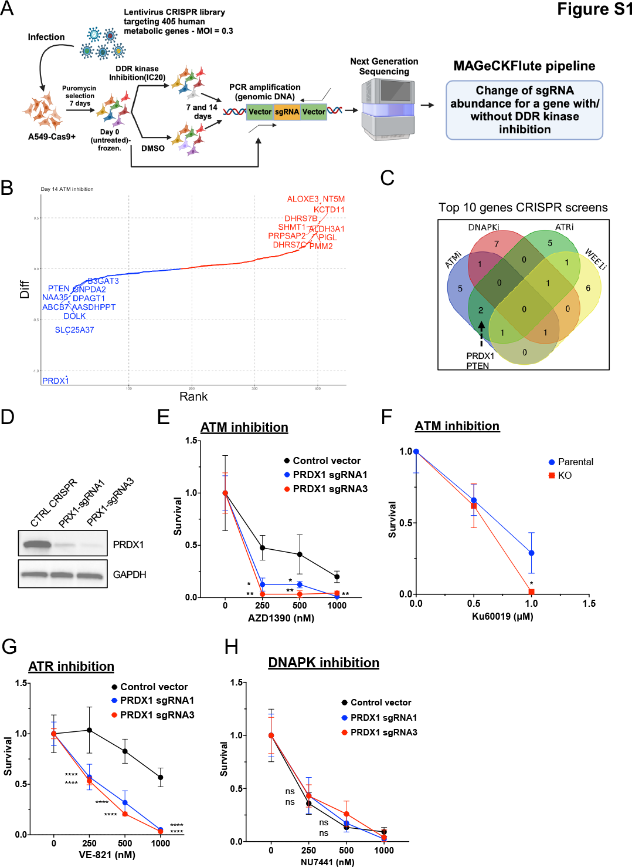

**Figure S1. Metabolism-focused CRISPR screen revealed PRDX1 loss in NSCLC as synthetically lethal with ATM and ATR inhibitors.**

(A) Diagram illustrating the workflow of metabolism-centered CRISPR/Cas9 knockout (KO) screen. This screen enables the utilization of ~407 metabolic genes positively correlated with DDR genes across non-small cell lung cancer cells (NSCLC) to identify vulnerabilities to DDR drugs targeting ATM (AZD1390), ATR (VE-821), WEE1 (MK-1775), and DNA-PK (NU7441). (B) Rank plot of genes after day 14 treatment with ATM inhibitor (AZD1390). (C) Venn Diagram of the Top 10 hits with ATM inhibitor (AZD1390), ATR inhibitor (VE821), WEE1 inhibitor (MK1775) and DNAPK inhibitor (NU7441), ranked by the *MAGeCK-Flute-MLE* pipeline. This rank is based on the differential beta score by subtracting the DMSO beta score from the beta score of the drug treatment group. (D) Western blot of parental and sgRNAs infected-A549-Cas9 cells. (E) Survival of parental and sgRNAs infected-A549-Cas9 cells following treatment with AZD1390 for 6 days. Control and PRDX1-targeting sgRNAs were used. Data are represented as mean SD; *n* = 4. (F) Cells were treated for 12 days with the ATM inhibitor KU60019 as indicated (500, or 1000 nM), and stained for colonies count. Data are represented as mean SD; n = 3. (G, H) Cells were treated for 6 days with ATR inhibitor (VE821) as indicated (250, 500, 1000 nM) or with DNAPK inhibitor (NU7441) as indicated (250, 500, 1000 nM) and analyzed for survival. Data are represented as mean SD; n = 3.

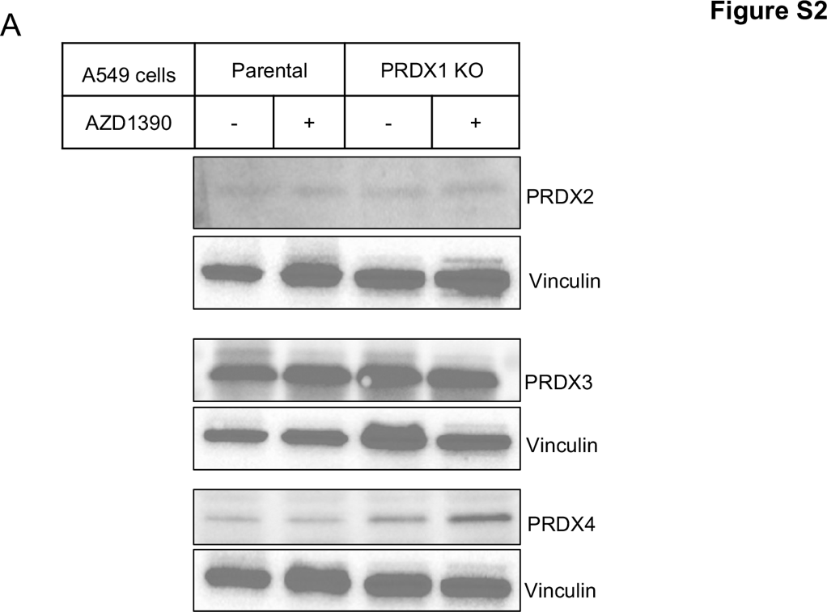

**Figure S2. Regulation of PRDX2, PRDX3, and PRDX4 upon PRDX1 loss and ATM inhibition**

(A) Western blot analysis of A549-Cas9 parental and PRDX1 KO cells after 6-day ATM inhibition using AZD1390 at 1 µM.

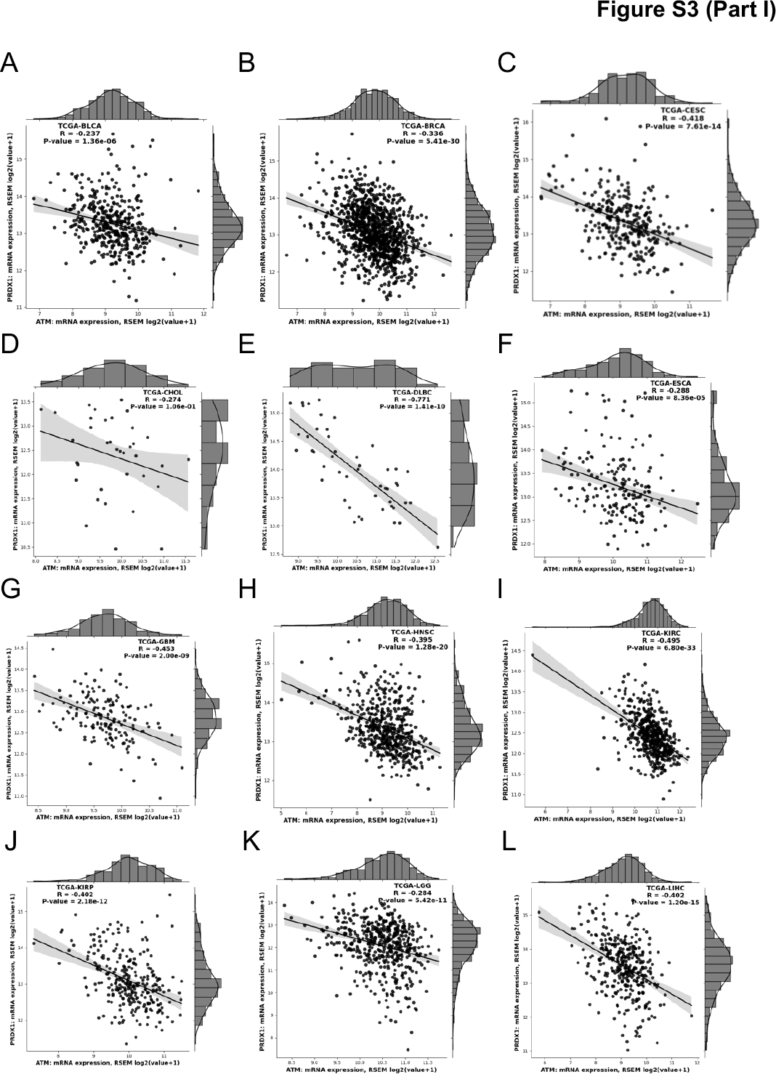

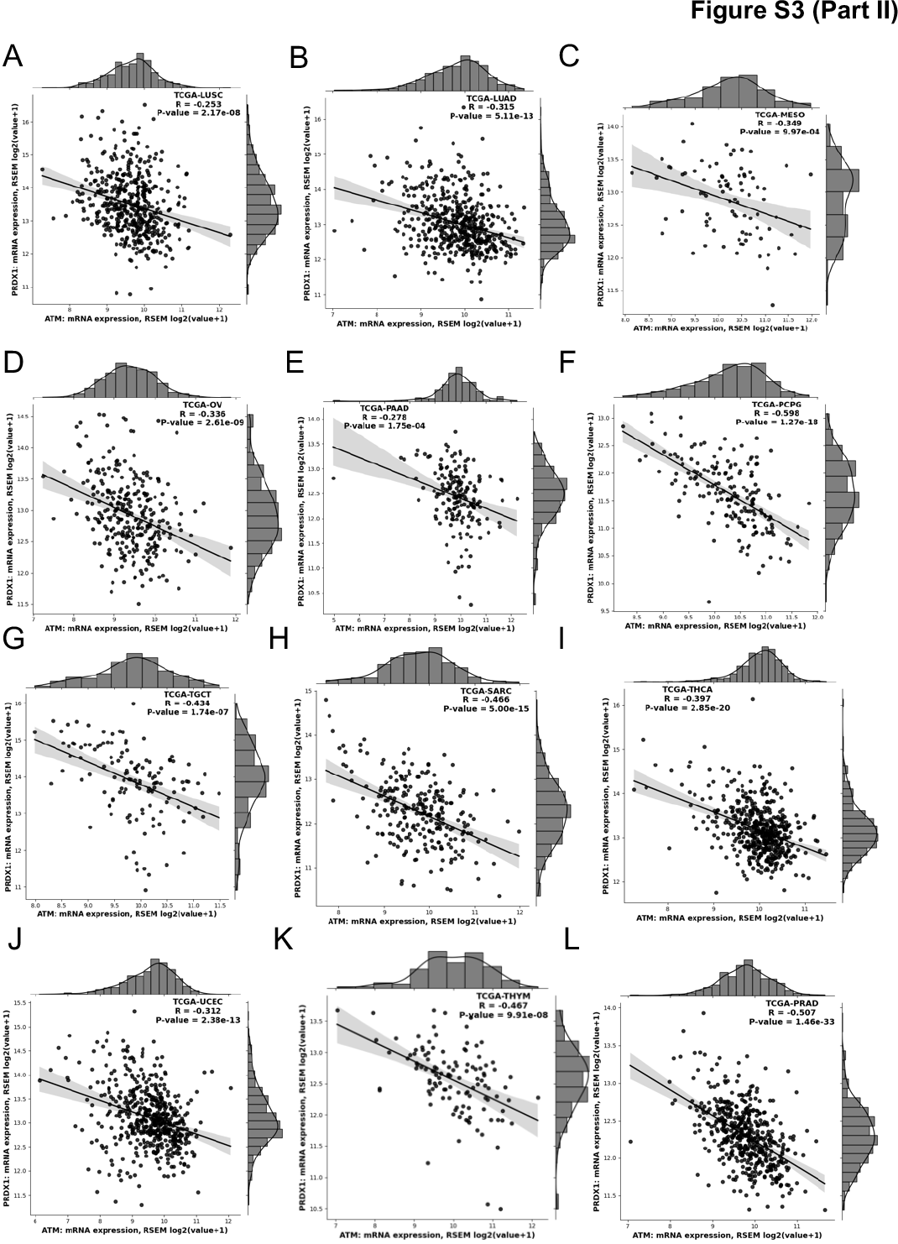

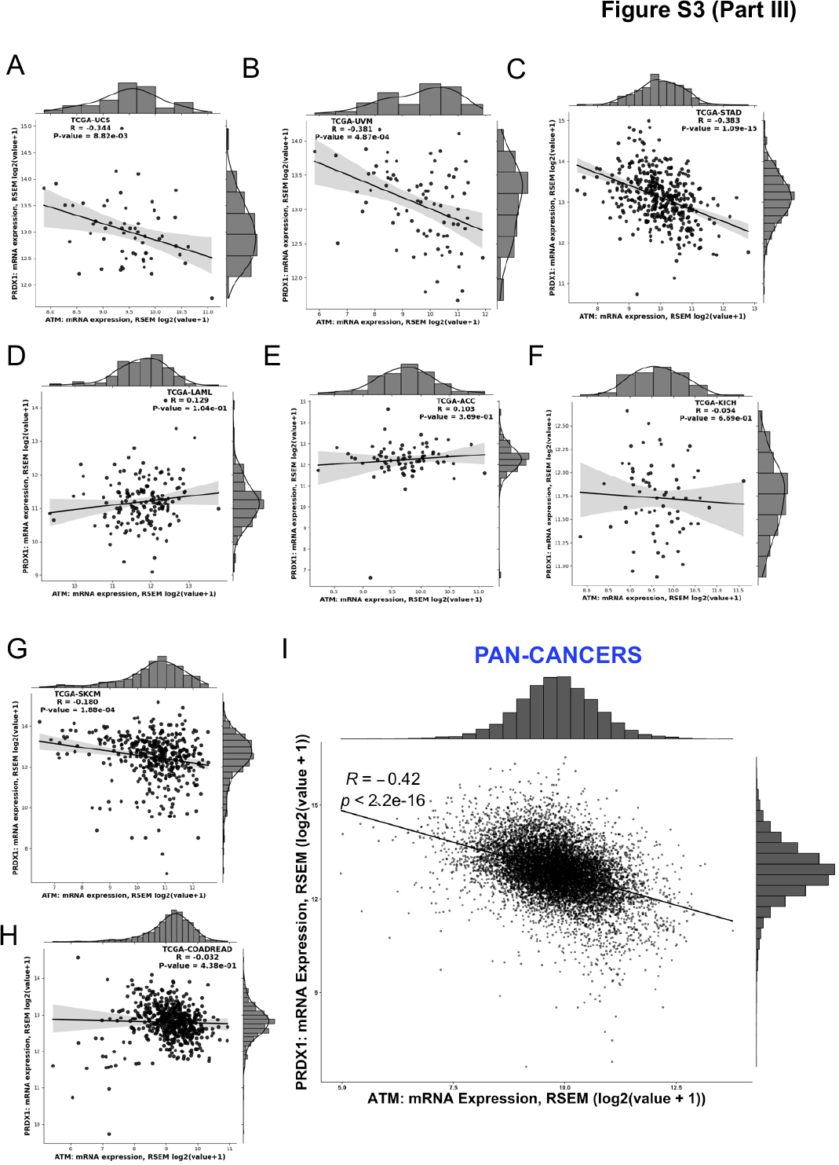

**Figure S3 (Part I, II & III). Correlation of ATM and PRDX1 expression in 32 TCGA pan-cancer datasets.**

(Part I, A-L) Correlation in TCGA BLCA, BRCA, CESC, CHOL, DLBC, ESCA, GBM, HNSC, KIRC, KIRP, LGG and LIHC cancer patient datasets. (Part II, A-L) Correlation in TCGA LUSC, LUAD, MESO, OV, PAAD, PCPG, TGCT, SARC, THCA, UCEC, THYM and PRAD cancer patient datasets. (Part III, A-H) Correlation in TCGA UCS, UVM, STAD, LAML, ACC, KICH, SKCM and COADREAD cancer patient datasets. (Part III, I) Correlation between transcript levels of ATM and PRDX1 across 10,967 pan-cancer samples (*TCGA* datasets).

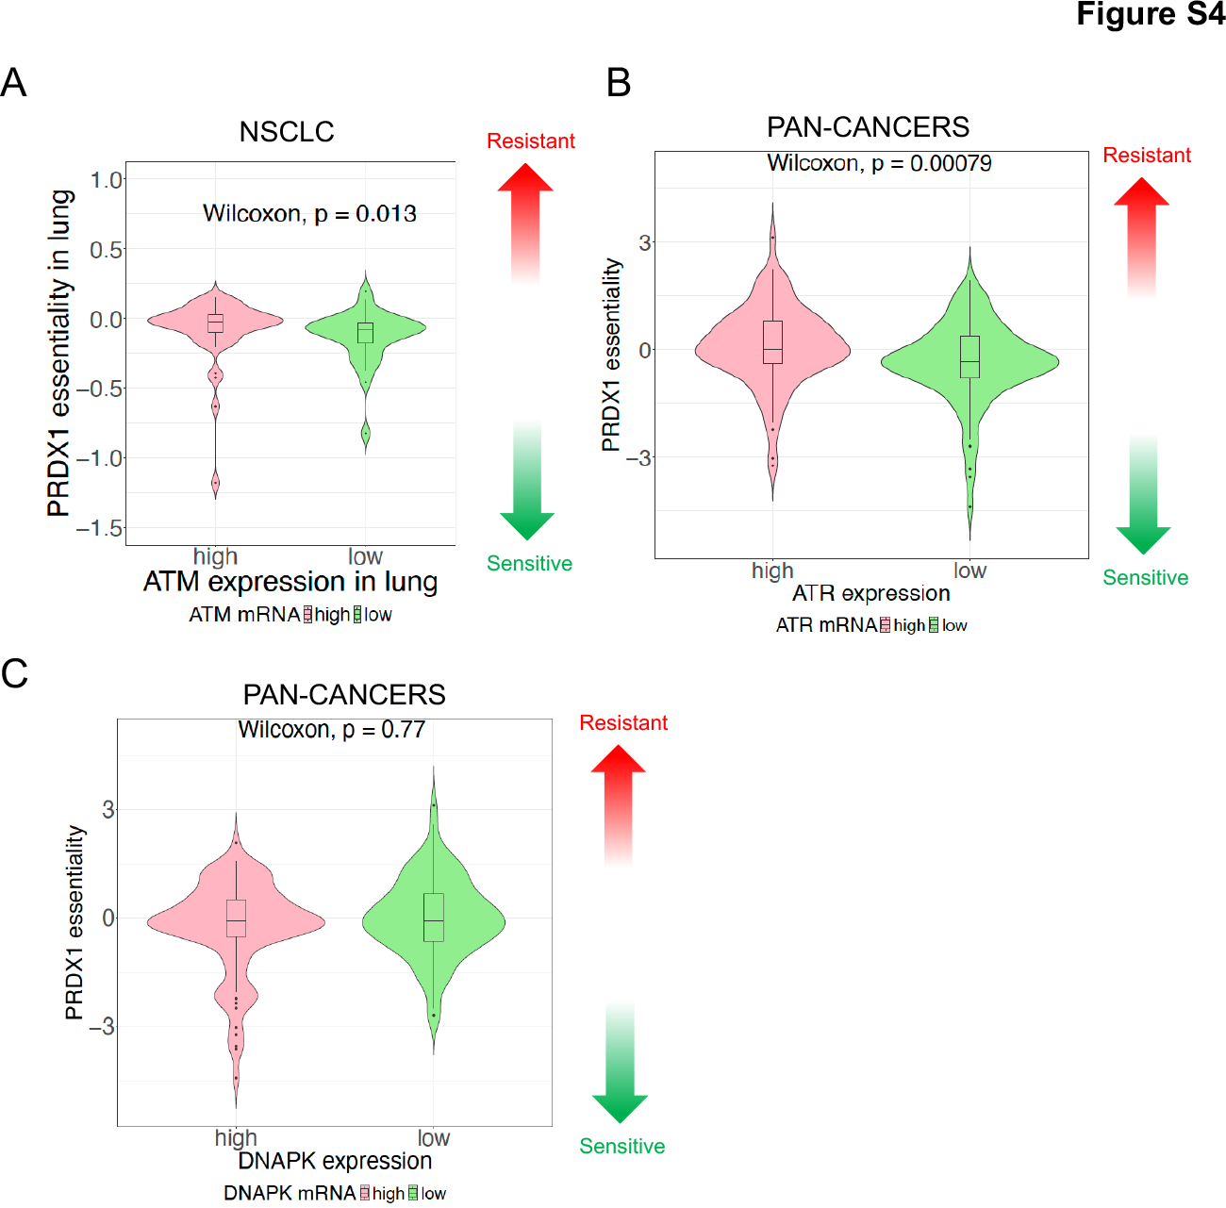

**Figure S4. PRDX1 essentiality of cell lines with high or low expression levels of ATM, ATR, and DNAPK.**

(A) Relationship between *PRDX1* gene essentiality and ATM expression levels across NSCLC lines. From the pan-cancer datasets, NSCLC cell lines were divided into two groups based on ATM expression levels: high ATM expression group (ATM mRNA high, represented by pink column on the left) and low ATM expression group (ATM mRNA low, represented by green column on the right). The y-axis represents the essentiality of PRDX1, which is the normalized growth reduction resulting from gene inactivation. Note that the essentiality of PRDX1 is significantly higher in high ATM-expressing cancer cells (pink) compared to low ATM-expressing cancer cells (green). (B) PRDX1 essentiality of cell lines with high or low expression levels of ATR across pan-cancer cell lines.(C) PRDX1 essentiality of cell lines with high or low expression levels of DNAPK across pan-cancer cell lines.

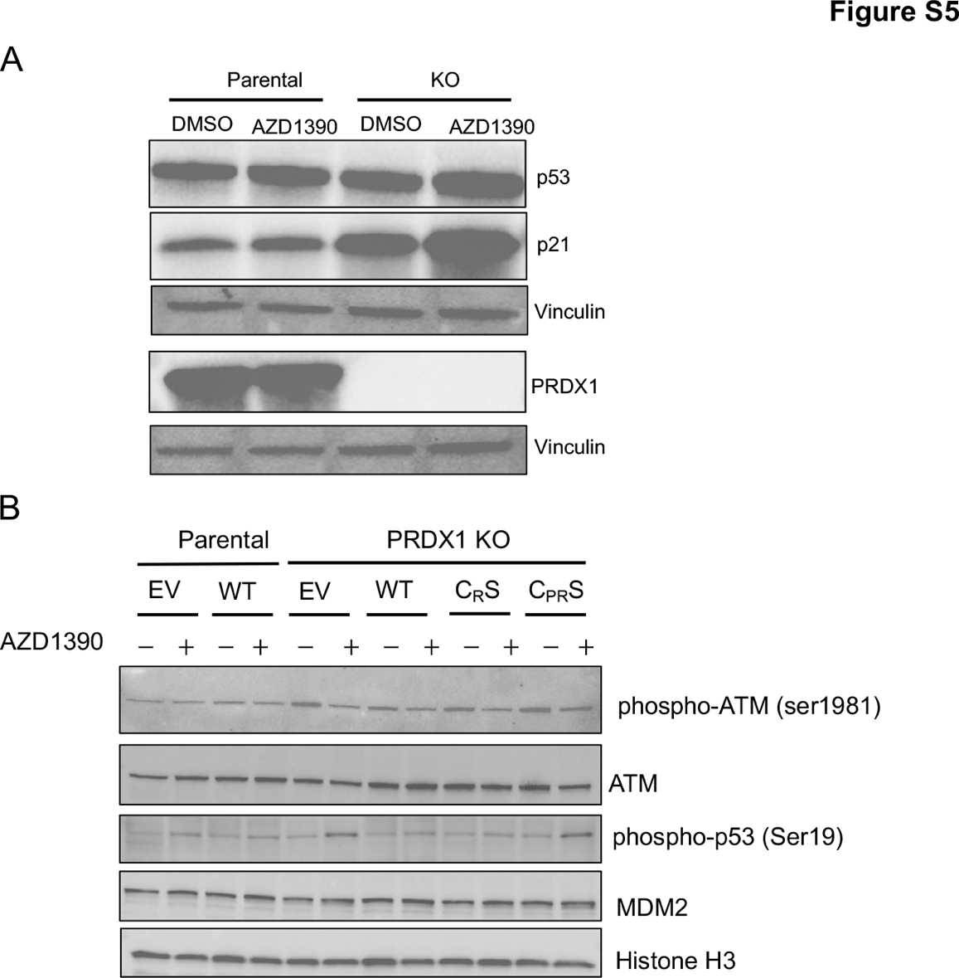

**Figure S5. ATM inhibition induces activation of p53 in PRDX1 knockout cells.**

(A) Western blot analysis of A549-Cas9 parental and PRDX1 KO cells after 6-day ATM inhibition using AZD1390 at 100 nM. **(**B) Western blot analysis of A549-Cas9 parental and PRDX1 KO cells infected with empty vector (EV), PRDX1 WT (WT), PRDX1-CRS (CRS) or PRDX1-CPRS (CPRS) after 6-day treatment with ATM inhibitor (AZD1390 - 1 μM).

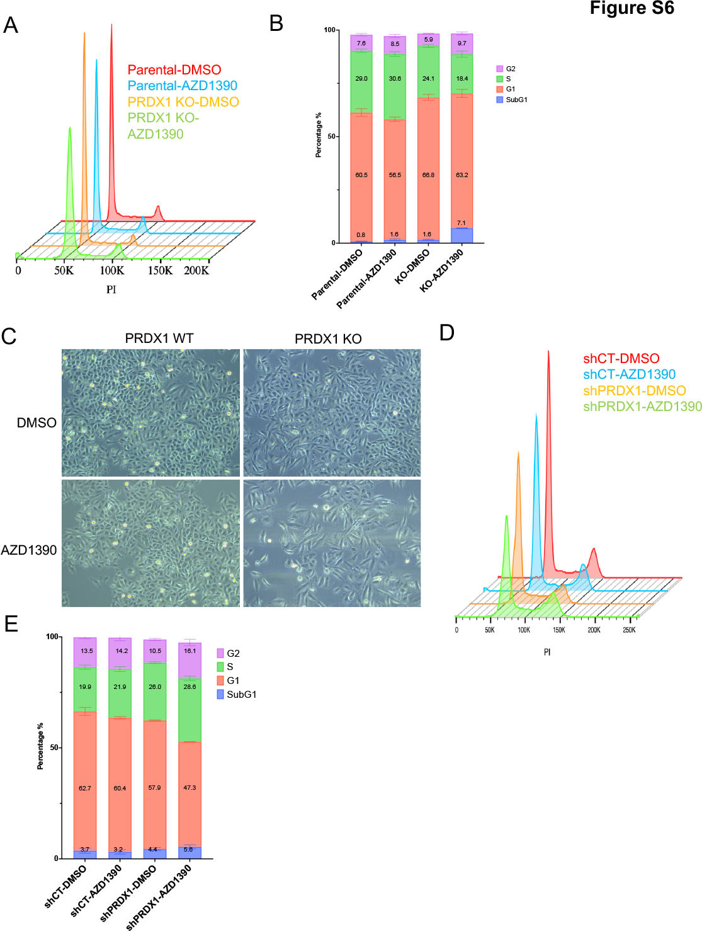

**Figure S6. ATM inhibition leads to cell cycle arrest in PRDX1-deficient A549-Cas9 cells.**

(A) A549-Cas9 parental and KO cells were treated with DMSO or AZD1390 at 1 μM for 6 days before PI staining and cell cycle analysis by flow cytometry. (B) Quantification of cell cycle distribution in panel A. (C) Morphology of A549-Cas9 parental and KO cells treated with DMSO or AZD1390 (1 μM) for 6 days. (D) NCI-H1299 shControl and shPRDX1 cells were treated with DMSO or AZD1390 (1 μM) for 6 days before PI staining and cell cycle analysis by flow cytometry. (E) Quantification of cell cycle distribution in panel D.

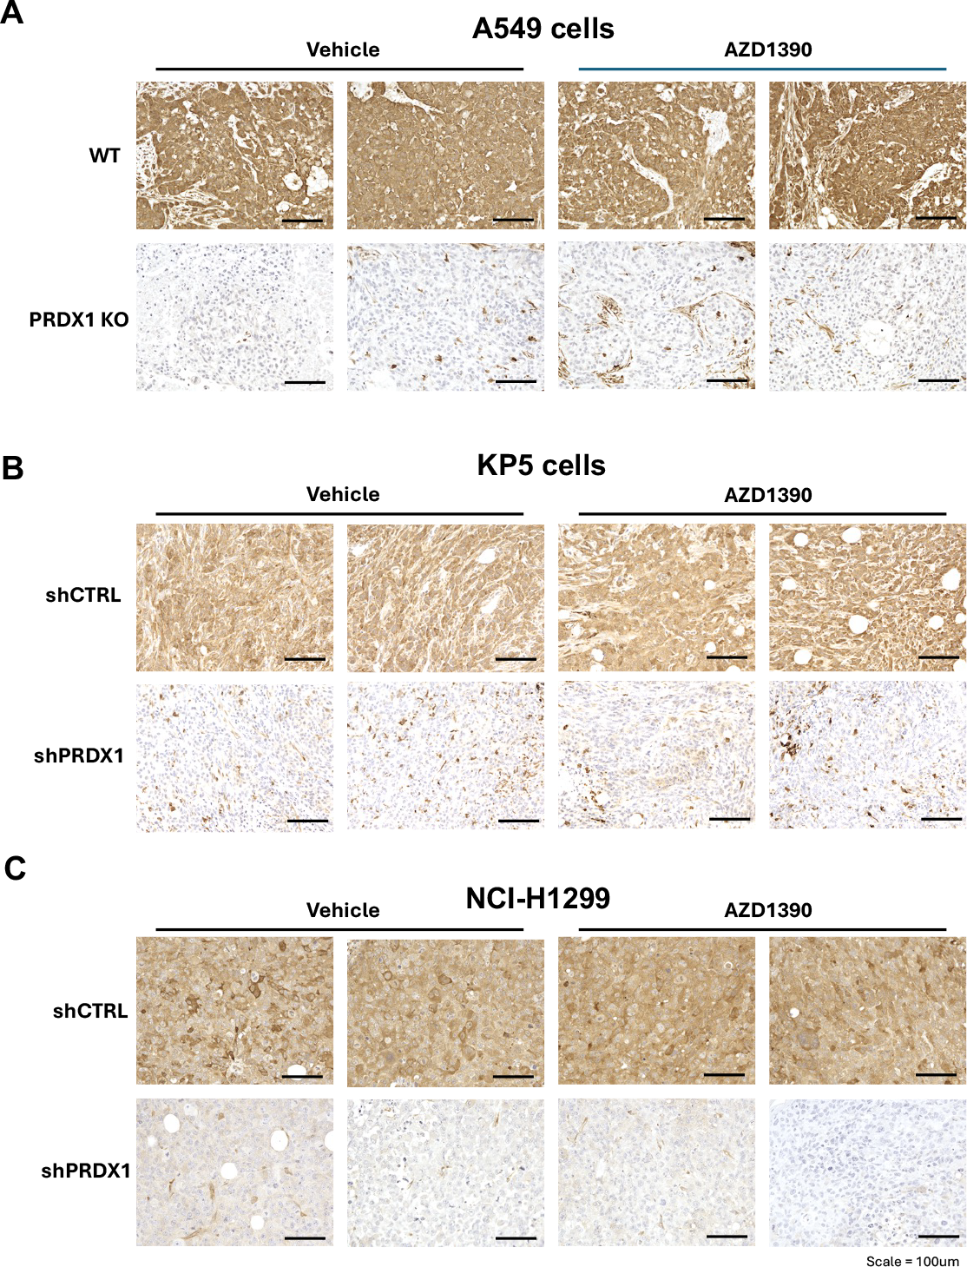

**Figure S7. PRDX1 expression in tumor tissues at the experiment’s endpoint.**

(A) Immunohistochemistry staining of PRDX1-positive tumor cells (brown staining) comparing A549 parental and PRDX1-knockout cells treated with AZD1390 at the endpoint. (B) Immunohistochemistry staining of PRDX1-positive tumor cells (brown staining) comparing KP5 parental and PRDX1-knockdown cells treated with AZD1390 at the endpoint. (C) Immunohistochemistry staining of PRDX1-positive tumor cells (brown staining) comparing NCI-H1299 parental and PRDX1-knockdown cells treated with AZD1390 at the endpoint.