**Supplementary information**

Table S1: Morphological data for different shaped particles calculated via the BioVoxxel plugin in the ImageJ software

|  |  |  |  |  |  |
| --- | --- | --- | --- | --- | --- |
| **particle shape** |  |  |  |  |  |
| **aspect ratio** | 1.00 | 0.70 | 0.91 | 0.50 | 0.50 |
| **extent bulkiness** | 0.79 | 0.71 | 0.69 | 0.80 | 0.74 |
| **compactness** | 1.00 | 0.8 | 0.90 | 0.71 | 0.69 |
| **circularity** | 1.00 | 0.89 | 0.89 | 0.88 | 0.73 |
| **roundness** | 1.00 | 0.64 | 0.80 | 0.51 | 0.47 |
| **solidity** | 1.00 | 1.00 | 1.00 | 1.00 | 0.86 |
| **convexity** | 1.00 | 1.00 | 1.00 | 1.00 | 0.90 |
| **ellipticity** | 1.00 | 1.00 | 1.05 | 2.00 | 1.91 |
| **elongation** | 0.00 | 0.00 | 0.07 | 1.00 | 0.93 |

Table S2: Number of particles found per sample measured via AZtec Features (Oxford)

|  |  |  |  |
| --- | --- | --- | --- |
|  | **Particles found per sample** | | |
| **Date** | **W15** | **F15** | **F5** |
| **17/5/2022** | 21622 | 31895 | 5426 |
| **19/7/2022** | 7765 | 31400 | 10194 |
| **28/8/2022** | 17789 | 61544 | 11121 |

**Ein Bild, das Text, Screenshot, Diagramm, Reihe enthält.
**

Figure S1: Energy-by-position distribution of a 5 kV electron beam in a Fe2O3 substrate, simulated via the trajectories of 2500 electrons in the Monte Carlo Software.

**Ein Bild, das Diagramm enthält.
**

Figure S2: X-ray intensity of Fe and O as a function of the penetration depth of a 5 kV electron beam in a Fe2O3 substrate, simulated via the trajectories of 2500 electrons in the Monte Carlo Software.

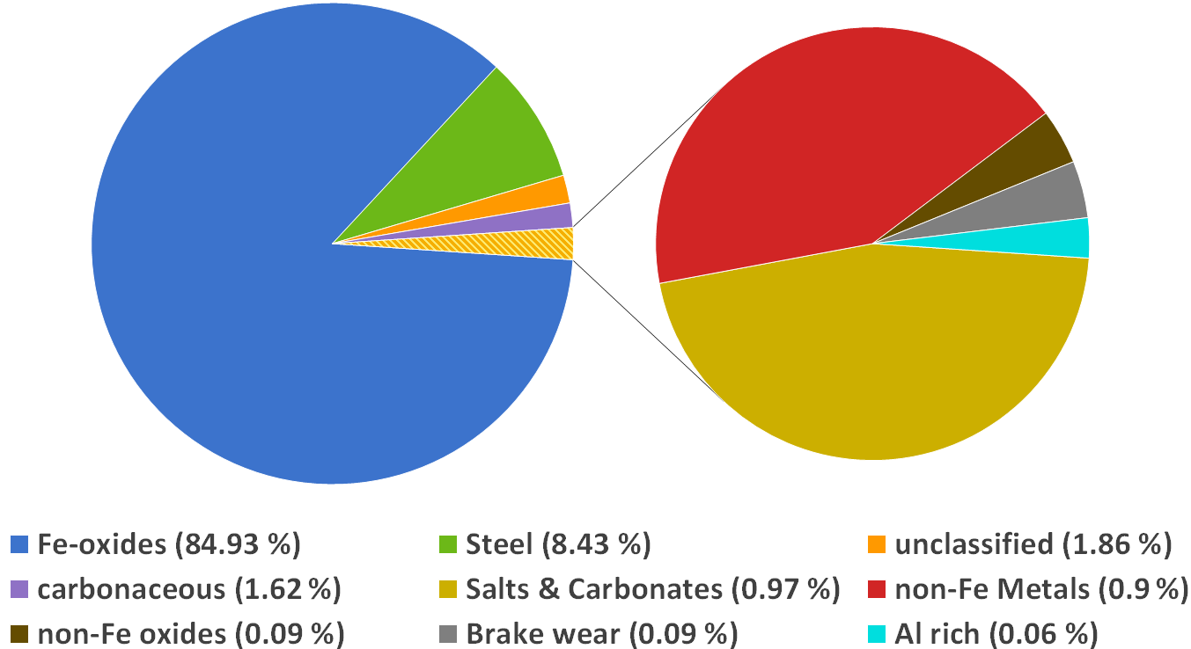

Figure S3: Average classification values for W15 samples

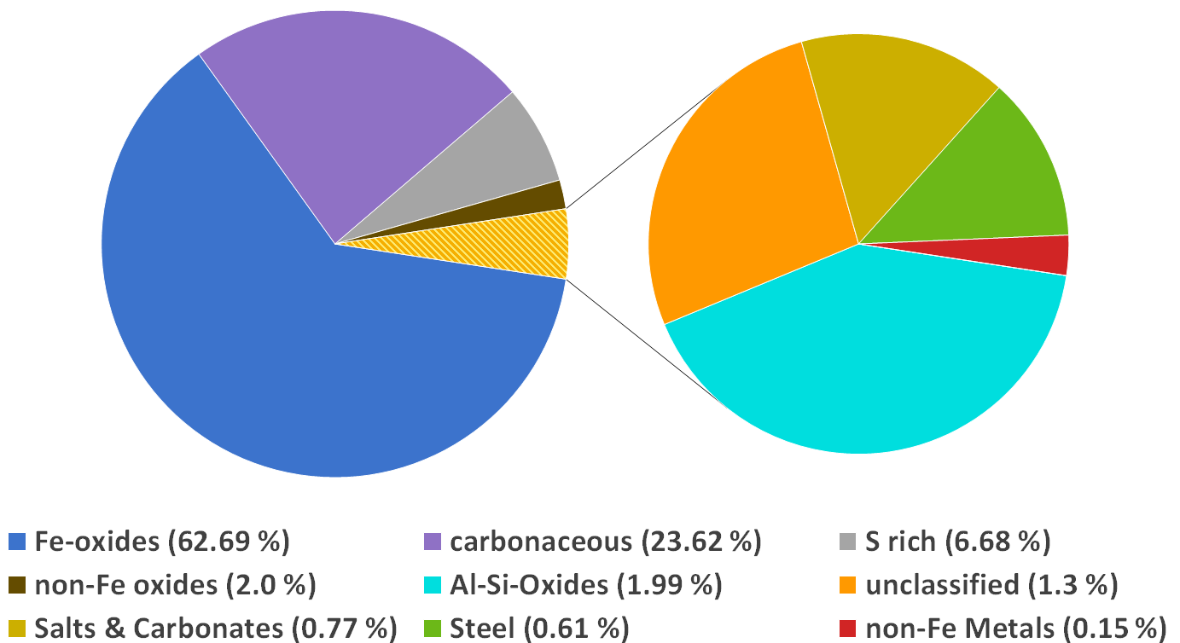

Figure S4: Average classification results of particles smaller than 1 µm for filter samples measured at 5 kV

Table S3: Classification scheme for particles on PC filters measured at 5 kV and 15 kV

| Class | Subclass | Criteria | Min | Max | Special rule |
| --- | --- | --- | --- | --- | --- |
| Oversized (F5 only) |  | DA (µm) | 1 | 100 | Reject if matched (F5 samples only) |
| Non-ferrous metals | Class rule | Oxygen | 20 | 100 | Exclude if matched |
| Cu | Copper | 5 | 100 | Must be detected |
| W | Tungsten | 2 | 100 | Must be detected |
| Ti | Titanium | 5 | 100 | Must be detected |
| Sn | Tin | 5 | 100 | Must be detected |
| Copper | 5 | 100 | Exclude if matched |
| Pb | Lead | 5 | 100 | Must be detected |
| Copper | 5 | 100 | Exclude if matched |
| Cd | Cadmium | 1 | 100 | Must be detected |
| Brake wear | Class rule | Sulphur | 1 | 100 | Must be detected |
| SbS3 | Antimony | 1 | 100 | Must be detected |
| BaSO4 | Barium | 1 | 100 | Must be detected |
| Ferrous metals | Class rule | Oxygen | 20 | 100 | Exclude if matched |
| Iron | 5 | 100 | Must be detected |
| Steel - Low alloy | Nickel | 2 | 100 | Exclude if matched |
| Manganese | 0 | 4 |  |
| Chromium | 0 | 1.5 |  |
| Steel - Cr | Manganese | 1 | 100 | Exclude if matched |
| Chromium | 1 | 20 | Must be detected |
| Nickel | 2 | 100 | Exclude if matched |
| Steel - High alloy | Nickel | 2 | 100 | Must be detected |
| Chromium | 2 | 100 | Must be detected |
| Al Alloys | Class rule | Aluminium | 75 | 100 | Must be detected |
| Oxygen | 10 | 100 | Exclude if matched |
| Manganese | 0 | 5 |  |
| Al | Magnesium | 0 | 0.5 |  |
| Aluminium | 75 | 100 | Must be detected |
| Silicon | 0 | 0.5 |  |
| Al (Mg) | Magnesium | 0.5 | 5 | Must be detected |
| Silicon | 0 | 1 |  |
| Al (Mg,Si) | Magnesium | 0.5 | 10 | Must be detected |
| Silicon | 0.5 | 10 | Must be detected |
| Non-ferrous oxides | Class rule | Oxygen | 20 | 100 | Must be detected |
| Iron | 30 | 100 | Exclude if matched |
| Ba-oxide | Barium | 1 | 100 | Must be detected |
| Titanium | 1 | 100 | Exclude if matched |
| Sulfur | 1 | 100 | Exclude if matched |
| Ti-oxide | Titanium | 5 | 75 | Must be detected |
| Zr-oxide | Zirconium | 10 | 75 | Must be detected |
| Silicon | 5 | 100 | Exclude if matched |
| Zn-oxide | Zinc | 15 | 50 | Must be detected |
| Cu-oxide | Cu | 5 | 100 | Must be detected |

Table S3: Classification scheme for particles on PC filters measured at 5 kV and 15 kV (continued)

|  |  |  |  |  |  |
| --- | --- | --- | --- | --- | --- |
| Class | Subclass | Criteria | Min | Max | Special rule |
| Iron oxide |  | Iron | 18 | 100 | Must be detected |
| Oxygen | 20 | 100 | Must be detected |
| Al-Si-Oxides | Class rule | Oxygen | 20 | 100 | Must be detected |
| Al-Oxide | Aluminium | 15 | 100 | Must be detected |
| Silicon | 5 | 100 | Exclude if matched |
| Iron | 5 | 100 | Exclude if matched |
| Copper | 5 | 100 | Exclude if matched |
| Tungsten | 2 | 100 | Exclude if matched |
| Si-Oxide | Silicon | 15 | 100 | Must be detected |
| Aluminium | 1 | 50 | Exclude if matched |
| Iron | 20 | 100 | Exclude if matched |
| Silicates | Aluminium | 5 | 100 | Must be detected |
| Silicon | 5 | 100 | Must be detected |
| Copper | 5 | 100 | Exclude if matched |
| Tungsten | 2 | 100 | Exclude if matched |
| Zircon | Zirconium | 5 | 100 | Must be detected |
| Silicon | 5 | 100 | Must be detected |
| Iron | 30 | 100 | Exclude if matched |
| Salts & carbonates | Class rule | Silicon | 10 | 100 | Exclude if matched |
| Salt | Chlorine | 5 | 100 | Must be detected |
| Aluminium | 5 | 100 | Exclude if matched |
| Copper | 5 | 100 | Exclude if matched |
| Zinc | 5 | 100 | Exclude if matched |
| Cadmium | 1 | 100 | Exclude if matched |
| Iron | 5 | 100 | Exclude if matched |
| CaSO4 | Calcium | 5 | 100 | Must be detected |
| Sulfur | 5 | 100 | Must be detected |
| Oxygen | 20 | 100 | Must be detected |
| Silicon | 5 | 100 | Exclude if matched |
| Chlorine | 10 | 100 | Exclude if matched |
| CaCO3 & CaO | Oxygen | 20 | 100 | Must be detected |
| Sodium | 0 | 15 |  |
| Sulfur | 0 | 2 |  |
| Calcium | 10 | 60 | Must be detected |
| Silicon | 10 | 100 | Exclude if matched |
| Al-chloride | Silicon | 10 | 100 | Exclude if matched |
| Chlorine | 10 | 100 | Must be detected |
| Aluminium | 10 | 100 | Must be detected |
| Nitrates | Oxygen | 60 | 100 | Must be detected |
| Nitrogen | 15 | 50 | Must be detected |
| Critical fibers |  | Aspect ratio | 3 | 250 | Must be detected |
| Lenght (µm) | 5 | 100 | Must be detected |
| Carbonaceous |  | Oxygen | 75 | 100 | Must be detected |

Table S4: Classification scheme for particles found on Si wafers measured at 15 kV

| Class | Subclass | Criteria | Min | Max | Special rule |
| --- | --- | --- | --- | --- | --- |
| Wafer |  | Oxygen | 95 | 100 | reject if matched |
| Ag-paint |  | Silver | 10 | 100 | reject if matched |
| Non-ferrous metals | Class rule | Oxygen | 20 | 100 | Exclude if matched |
| Cu | Copper | 5 | 100 | Must be detected |
| W | Tungsten | 2 | 100 | Must be detected |
| Ti | Titanium | 5 | 100 | Must be detected |
| Sn | Tin | 5 | 100 | Must be detected |
| Copper | 5 | 100 | Exclude if matched |
| Pb | Lead | 5 | 100 | Must be detected |
| Copper | 5 | 100 | Exclude if matched |
| Cd | Cadmium | 1 | 100 | Must be detected |
| Brake wear | Class rule | Sulfur | 1 | 100 | Must be detected |
| SbS3 | Antimony | 1 | 100 | Must be detected |
| BaSO4 | Barium | 1 | 100 | Must be detected |
| Ferrous metals | Class rule | Oxygen | 20 | 100 | Exclude if matched |
| Iron | 5 | 100 | Must be detected |
| Steel - Low alloy | Nickel | 2 | 100 | Exclude if matched |
| Manganese | 0 | 4 |  |
| Chromium | 0 | 1.5 |  |
| Steel - Cr | Manganese | 1 | 100 | Exclude if matched |
| Chromium | 1 | 20 | Must be detected |
| Nickel | 2 | 100 | Exclude if matched |
| Steel - High alloy | Nickel | 2 | 100 | Must be detected |
| Chromium | 2 | 100 | Must be detected |
| Al Alloys | Class rule | Aluminium | 75 | 100 | Must be detected |
| Oxygen | 10 | 100 | Exclude if matched |
| Manganese | 0 | 5 |  |
| Al | Magnesium | 0 | 0.5 |  |
| Al (Mg) | Magnesium | 0.5 | 5 | Must be detected |
| Non-ferrous oxides | Class rule | Oxygen | 20 | 100 | Must be detected |
| Iron | 30 | 100 | Exclude if matched |
| Ba-oxide | Barium | 1 | 100 | Must be detected |
| Titanium | 1 | 100 | Exclude if matched |
| Sulfur | 1 | 100 | Exclude if matched |
| Ti-oxide | Titanium | 5 | 75 | Must be detected |
| Zr-oxide | Zirconium | 10 | 75 | Must be detected |
| Zn-oxide | Zinc | 15 | 50 | Must be detected |
| Cu-oxide | Cu | 5 | 100 | Must be detected |
| Iron oxide |  | Iron | 18 | 100 | Must be detected |
| Oxygen | 20 | 100 | Must be detected |

Table S4: Classification scheme for particles found on Si wafers measured at 15 kV (continued)

|  |  |  |  |  |  |
| --- | --- | --- | --- | --- | --- |
| Al-Oxides |  | Oxygen | 20 | 100 | Must be detected |
| Aluminium | 15 | 100 | Must be detected |
| Iron | 5 | 100 | Exclude if matched |
| Copper | 5 | 100 | Exclude if matched |
| Class | Subclass | Criteria | Min | Max | Special rule |
| Salts & carbonates | Salt | Chlorine | 5 | 100 | Must be detected |
| Aluminium | 5 | 100 | Exclude if matched |
| Copper | 5 | 100 | Exclude if matched |
| Zinc | 5 | 100 | Exclude if matched |
| Cadmium | 1 | 100 | Exclude if matched |
| Iron | 5 | 100 | Exclude if matched |
| CaSO4 | Calcium | 5 | 100 | Must be detected |
| Sulfur | 5 | 100 | Must be detected |
| Oxygen | 20 | 100 | Must be detected |
| Chlorine | 10 | 100 | Exclude if matched |
| CaCO3 & CaO | Oxygen | 20 | 100 | Must be detected |
| Sodium | 0 | 15 |  |
| Sulfur | 0 | 2 |  |
| Calcium | 10 | 60 | Must be detected |
| Al-chloride | Chlorine | 10 | 100 | Must be detected |
| Aluminium | 10 | 100 | Must be detected |
| Nitrates | Oxygen | 60 | 100 | Must be detected |
| Nitrogen | 15 | 50 | Must be detected |
| Critical fibers |  | Aspect ratio | 3 | 250 | Must be detected |
| Length (µm) | 5 | 100 | Must be detected |
| Carbonaceous | Organic carbon | Oxygen | 10 | 60 | Must be detected |
| Carbon | 40 | 90 | Must be detected |
| Oxygen + Carbon | 90 | 100 | Must be detected |
| Elemental carbon | Oxygen | 99 | 100 | Must be detected |

Table S5: Elemental composition of Cu rich particles found in the Munich subway

|  |  |  |  |  |  |  |  |  |  |
| --- | --- | --- | --- | --- | --- | --- | --- | --- | --- |
| **Concentration in wt. %** | **Filter 15 kV** | | | **Wafer 15 kV** | | | **Filter 5 kV** | | |
| **Cu** | 30.38 | ± | 28.02 | 36.83 | ± | 23.36 | 22.12 | ± | 17.84 |
| **O** | 29.05 | ± | 9.87 | 12.78 | ± | 9.25 | 51.78 | ± | 16.39 |
| **Fe** | 37.90 | ± | 23.79 | 14.92 | ± | 19.93 | 10.86 | ± | 13.23 |
| **C** | ND | | | 29.15 | ± | 13.3 | ND | | |
| **Si** | 1.12 | ± | 1.99 | ND | | | 14.39 | ± | 8.15 |
| **other Elements** | 2.68 | ± | 6.50 | 6.32 | ± | 16.34 | 0.85 | ± | 3.29 |