Supplementary material
- Chemicals
 | Grade, assay | CAS Number | Supplier
Antipyrine | analytical standard | 60-80-0 | Sigma Aldrich
Atenolol | ≥98% (TLC) | 29122-68-7 | Sigma Aldrich
Caffeine | ≥98 %, ReagentPlus®, for HPLC | 58-08-2 | Sigma Aldrich
Carbamazepine | ≥98 % | 298-46-4 | Sigma Aldrich
Ciprofloxacin | ≥98.0% (HPLC) | 85721-33-1 | Sigma Aldrich
Diclofenac |  | 15307-79-6 | Sigma Aldrich
Ketoprofen | ≥98% (TLC) | 22071-15-4 | Sigma Aldrich
Ofloxacin |  | 82419-36-1 | Sigma Aldrich
Sulfamethoxazole | analytical standard | 723-46-6 | Sigma Aldrich
Methanol | ≥99.9%, CHROMASOLV(R) | 67-56-1 | Sigma Aldrich
Acetonitrile | ≥99.9%, LC-MS CHROMASOLV® | 75-05-8 | Sigma Aldrich
Ammonium acetate | ≥99.0%, for HPLC | 631-61-8 | Sigma Aldrich
Ammonium hydroxide solution | ≥25% in H₂O, eluent additive for LC-MS | 1336-21-6 | Sigma Aldrich
Formic acid | ~98% | 64-18-6 | Sigma Aldrich
Ammonium formate | ≥99.0% | 540-69-2 | Sigma Aldrich
Milli-Q water was generated by Milli-Q Advantage A10 Water Purification System (Millipore, Schwalbach, Germany).
- Quantification with LC-MS/MS – Positive mode
Column: Kinetex 2.6 µm C18 100 $Å$, 150 x 3 mm, Phenomenex, Aschaffenburg, Germany
Flow rate: 250 µl/min
Injection volume: 25 µl
Solvents: (A) methanol, (B) 10 mM formic acid / ammonium formate (pH 3.2)
Gradient: 0-1 min A:B = 10:90; 1-28 min A:B = 100:0; 28-29 min A:B = 100:0; 29-31 min A:B = 10:90; 31-34 = 10:90

Compound | MW | DP | EP | CEP | Q1 | Q3 | CE | CXP
Antipirine | 188.20 | 41 | 11.5 | 14.5 | 189.2 | 104.2 | 31 | 4
Atenolol | 266.34 | 36 | 12 | 20 | 267.2 | 145.0 | 39 | 4
Caffeine | 194.19 | 81 | 12 | 16 | 194.1 | 179.1 | 33 | 4
Carbamazepine | 236.27 | 36 | 6 | 16 | 237.2 | 194.2 | 27 | 4
Ciprofloxacin | 331.35 | 46 | 12 | 22 | 332.2 | 231.0 | 43 | 4
Clofibrate | 242.70 | 26 | 12 | 14 | 243.1 | 115.1 | 13 | 4
Ofloxacin | 361.37 | 36 | 12 | 20 | 362.2 | 261.1 | 31 | 4
Sulfamethaxazole | 253.30 | 31 | 4.5 | 16 | 254.1 | 156.2 | 19 | 4

Source/Gas Parameters

Parameter | TEM | CUR | IS | GS1 | GS2 | CAD
Value | 350 | 25 | 1500 | 40 | 40 | 5

- Quantification with LC-MS/MS – Negative mode
Column: Kinetex 2.6 µm C18 100 $Å$, 150 x 3 mm, Phenomenex, Aschaffenburg, Germany
Flow rate: 250 µl/min
Injection volume: 25 µl
Solvents: (A) acetonitrile, (B) 5 mM ammonium acetate / ammonim hydroxide (pH 8)
Gradient: 0-15 min A:B = 0:100; 15-20 min A:B = 60:40; 20-25 min A:B = 100:0; 25-28 min A:B = 0:100
Compound | MW | DP | EP | CEP | Q1 | Q3 | CE | CXP
Clofibric acid | 214.65 | -21 | -11.5 |  | 127 | 150 | -20 | -2
Diclofnac | 296.15 | -16 | -8 |  | 293.9 | 250.1 | -12 | -4
Ketoprofen | 257.31 | -31 | -9.5 |  | 252.9 | 209.2 | -8 | -4

Source/Gas Parameters

Parameter | TEM | CUR | IS | GS1 | GS2 | CAD
Value | 350 | 40 | -4500 | 40 | 40 | 3

- Limits of qualification of pharmaceuticals
Compound | Limit of qualification [µg/L]
Antipirine | 1
Atenolol | 1
Caffeine | 2
Carbamazepine | 1
Ciprofloxacin | 1
Diclofnac | 2
Ketoprofen | 2
Ofloxacin | 1
Sulfamethaxazole | 2

- Water properties
Sediment |  | G | V | E
Sampling location |  | Neuherberg | Caissargues | Montiró (Ventalló)
X |  | 692507 | 596897 | 505706
Y |  | 5344268 | 4840217 | 4666972
Conductivity* | µS/cm | NA | 747 | 1337
Temperature* | °C | NA | 15.2 | 16.6
pH* | - | 7.5 | 6.9 | 7.3
HCO₃⁻ | mg/L | 335.0 | 302.6 | 264.0
Alk T | mg/L | NA | NA | 220
SO₄²⁻ | mg/L | 7.35 | 77.26 | 269
Cl⁻ | mg/L | 33.47 | 30.89 | 55
NO₃⁻ | mg/L | 6.12 | 35.52 | 37
NO₂⁻ | mg/L | Nd | Nd | Nd
NH₄⁺ | mg/L | Nd | Nd | Nd
Ca²⁺ | mg/L | 86.46 | 122.98 | 175
Mg²⁺ | mg/L | 17.46 | 6.80 | 23
Na⁺ | mg/L | 19.97 | 17.38 | 33
K⁺ | mg/L | 1.07 | 1.86 | 3.13
F⁻ | mg/L | NA | NA | 0.09
PO₄³⁻ | mg/L | Nd | NA | 0.01
Br⁻ | mg/L | Nd | 0.238 | 0.13
SiO₂ | mg/L | NA | NA | 10
TOC | mg/L | 0.7 | NA | 0.37
TN | mg/L | NA | NA | 9.01
Notation: * – parameters measured in field, Nd – not detected, NA – not analysed

- Sorption isotherms
Horizontal error bars indicate the standard deviation of the triplicates. Vertical error bars represent errors calculated basing on the error propagation methodology, as S was calculated from other measurements, which all have their uncertainty (JCGM 100:2008). When error bars are not visible, they are smaller than the symbol size.
  - Sediment G (technical coarse sand)
Antipyrine Atenolol Caffeine
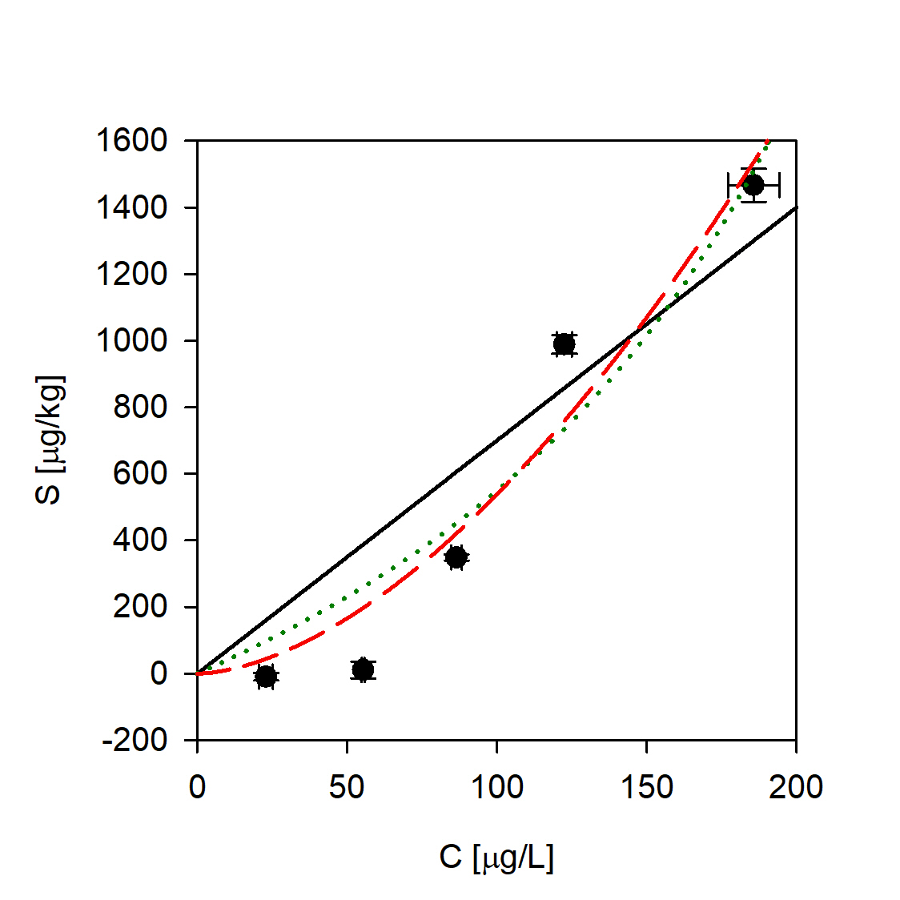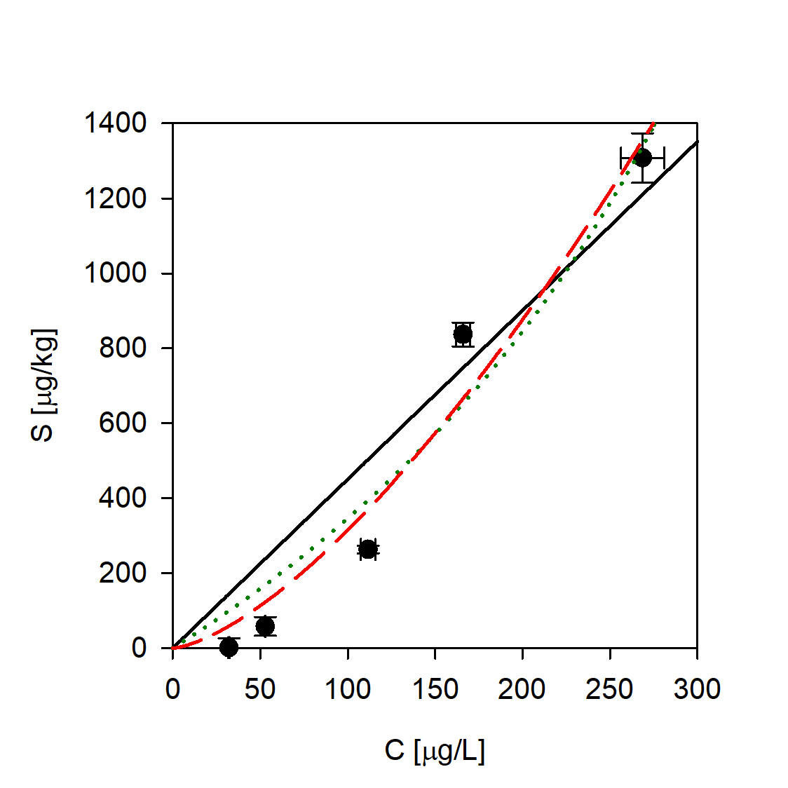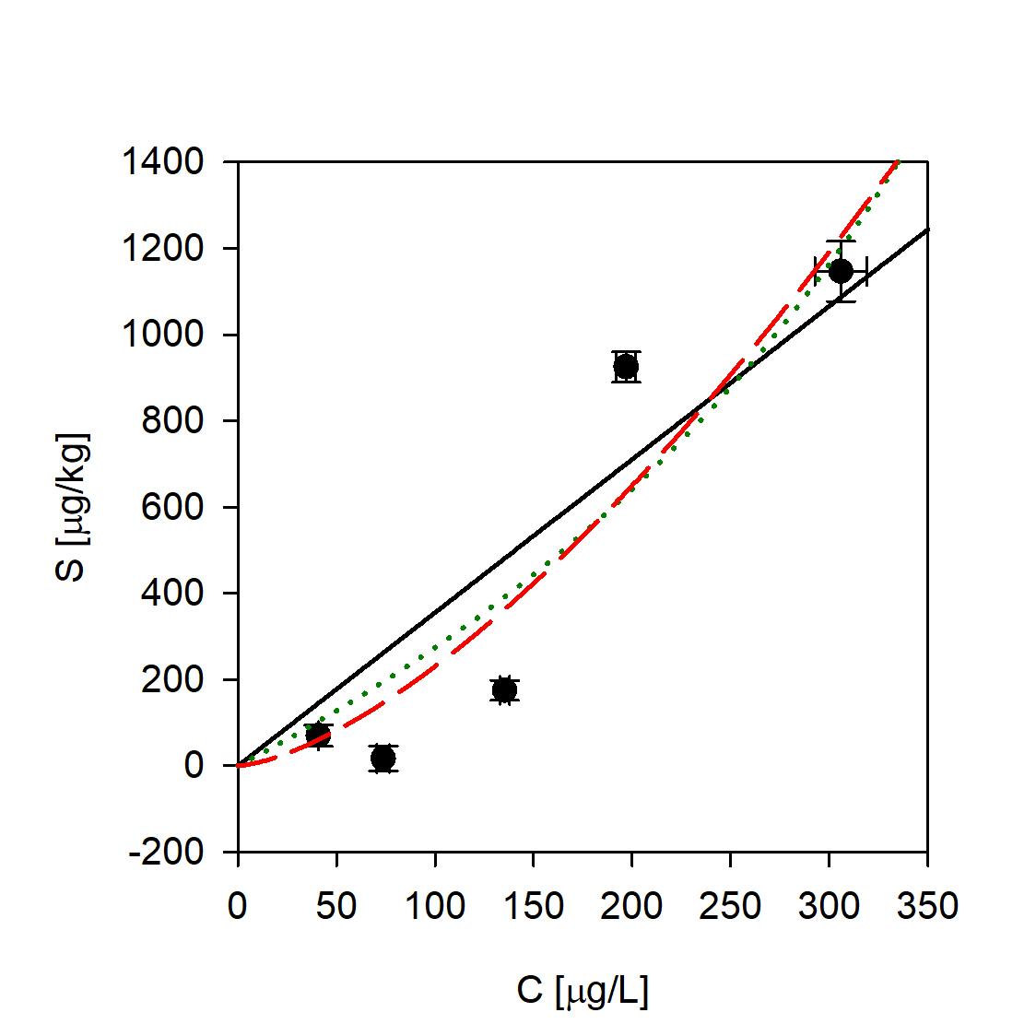
Carbamazepine Ciprofloxacin Diclofenac
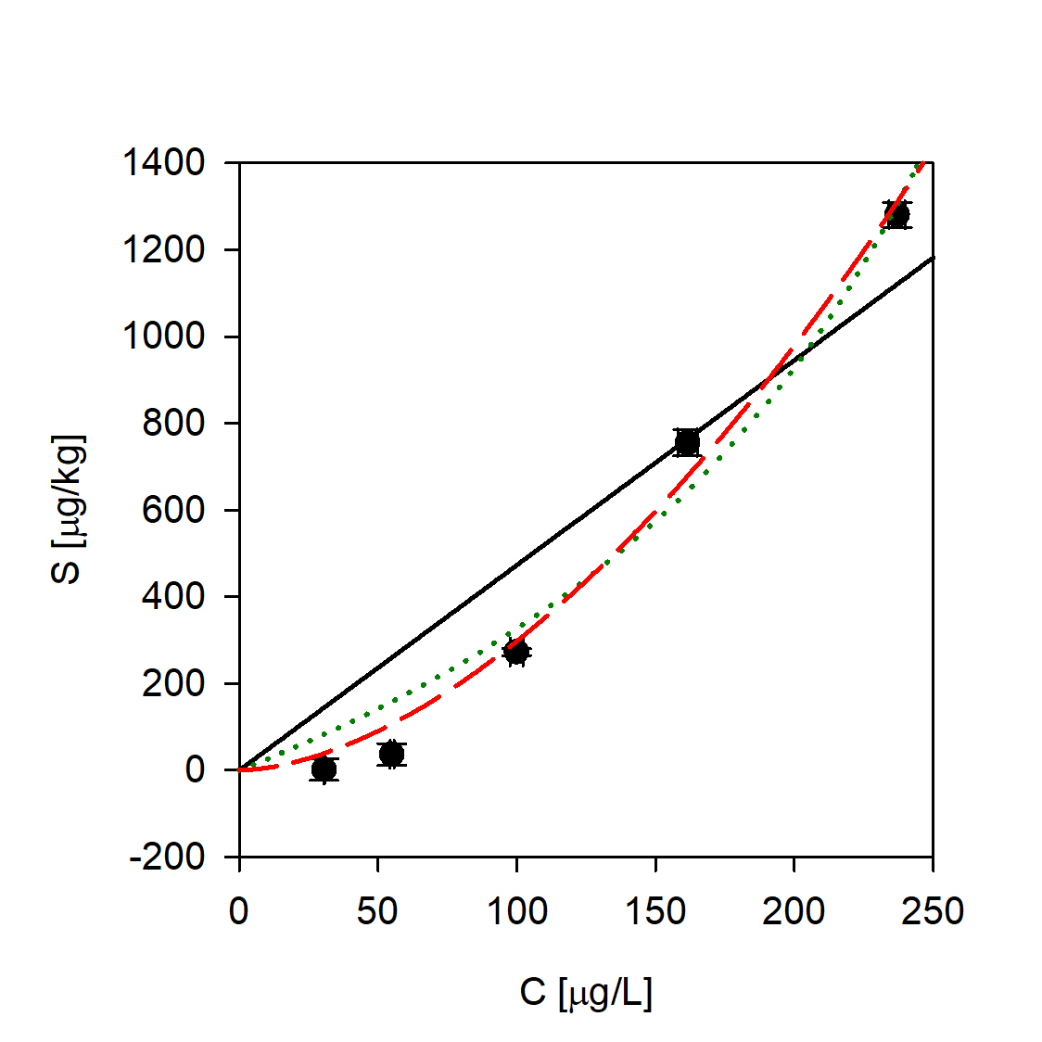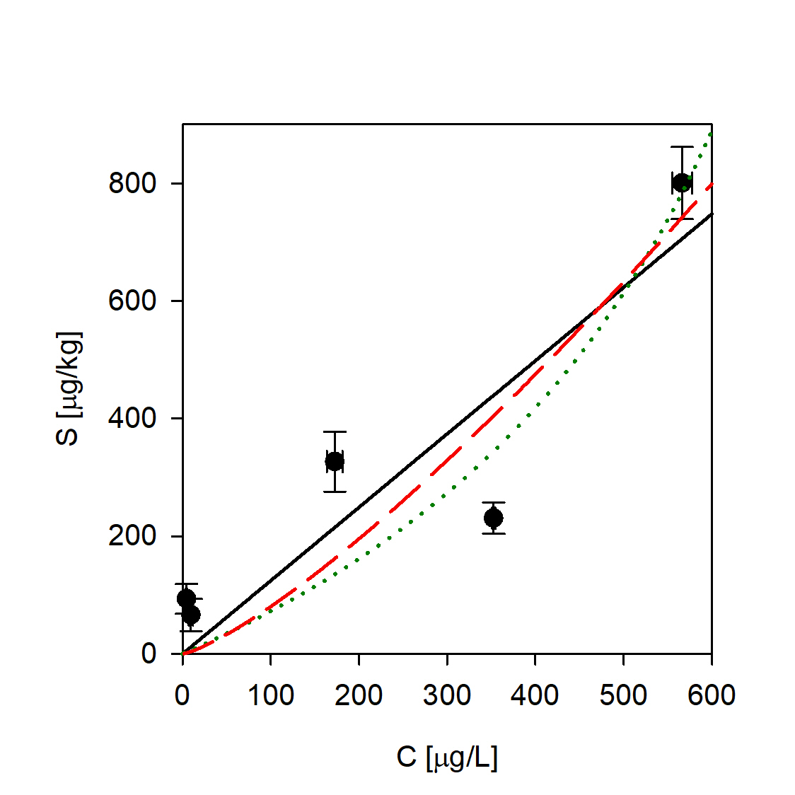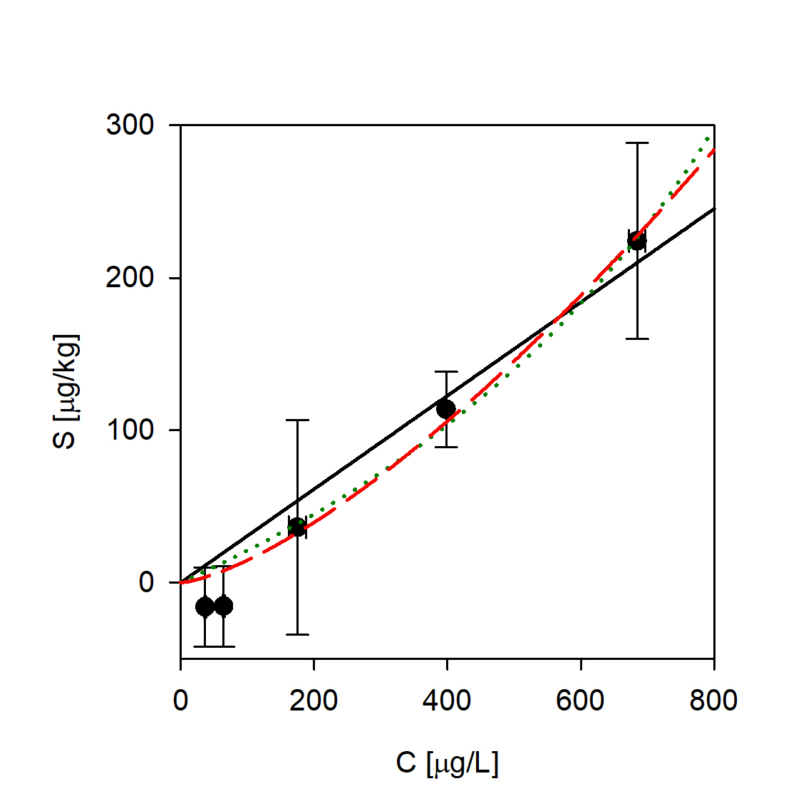
Ketoprofen Ofloxacin Sulfamethoxazole
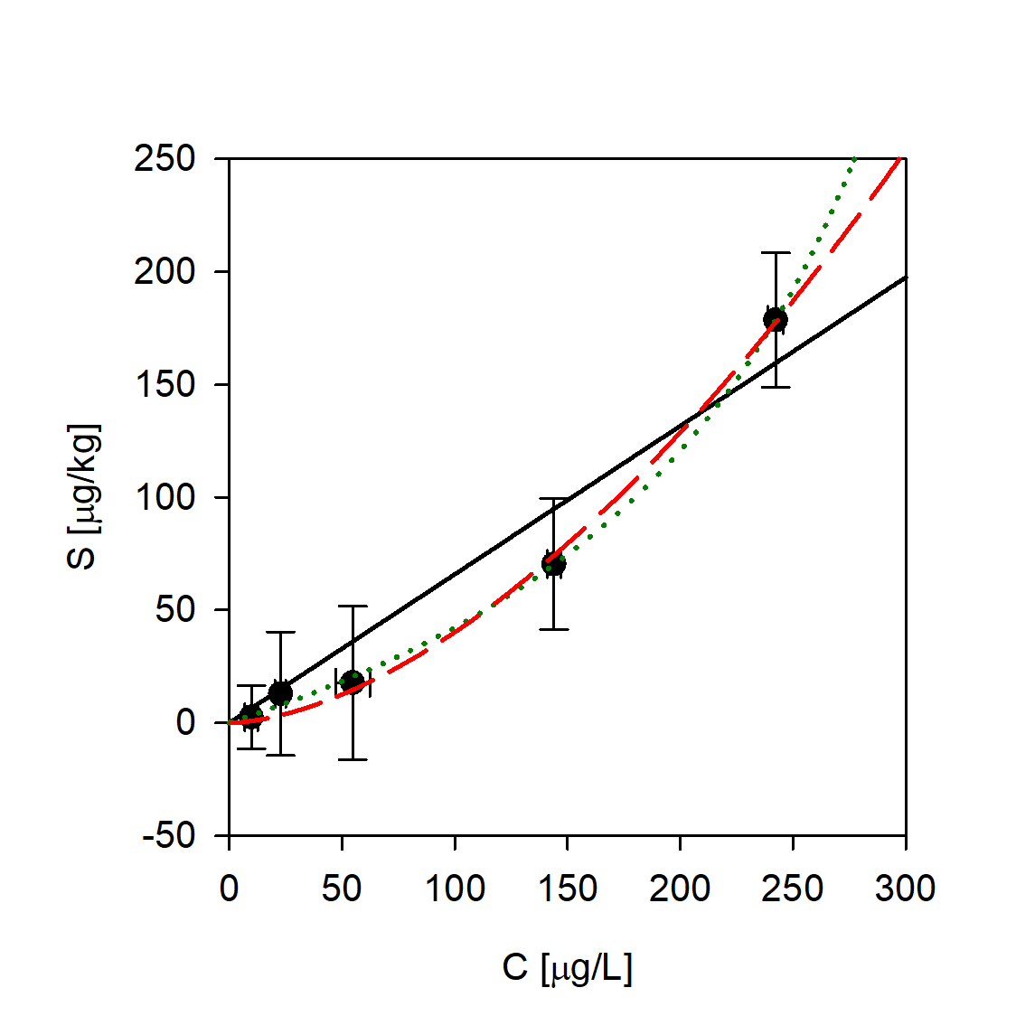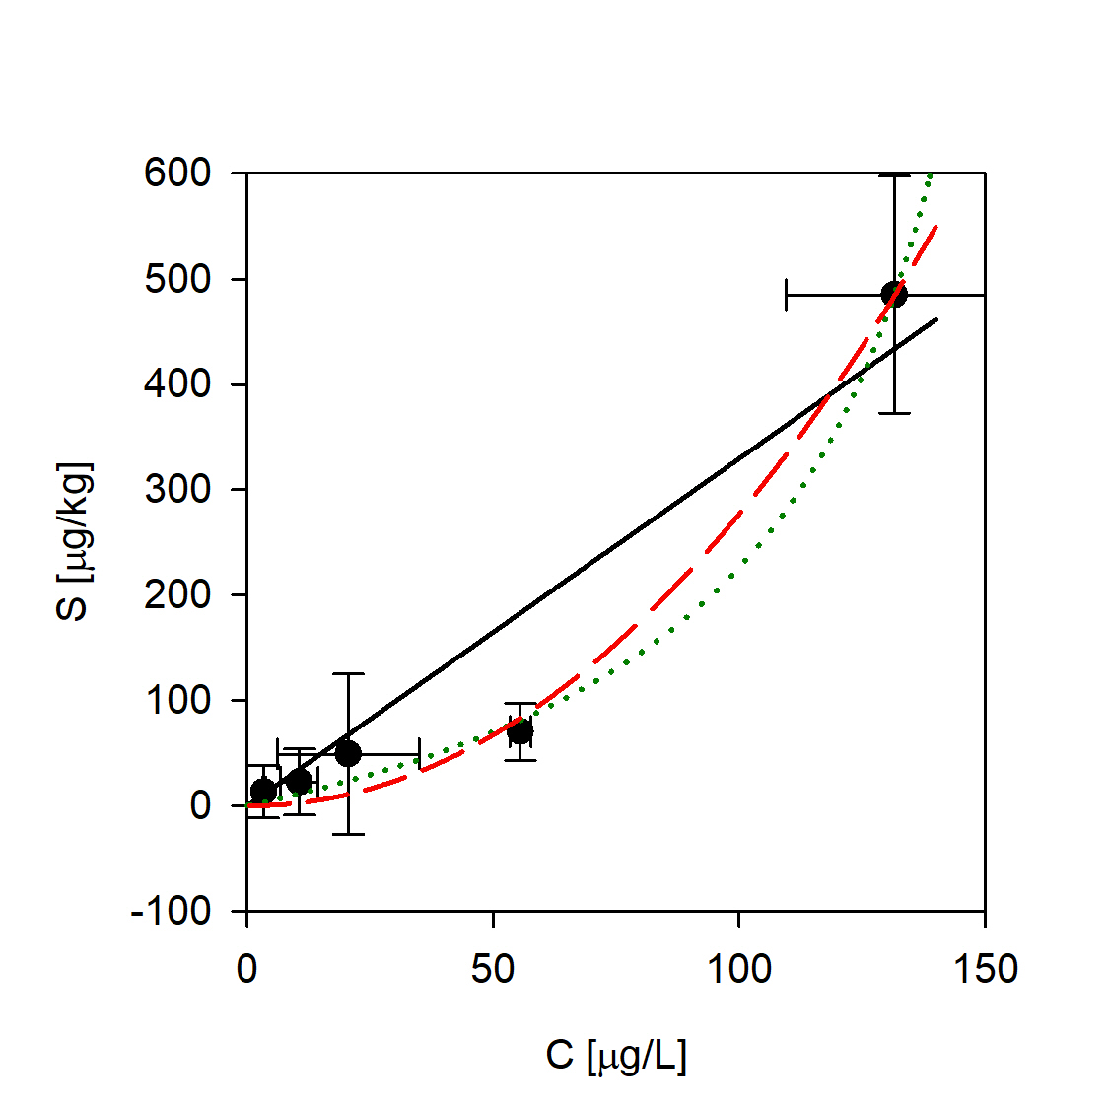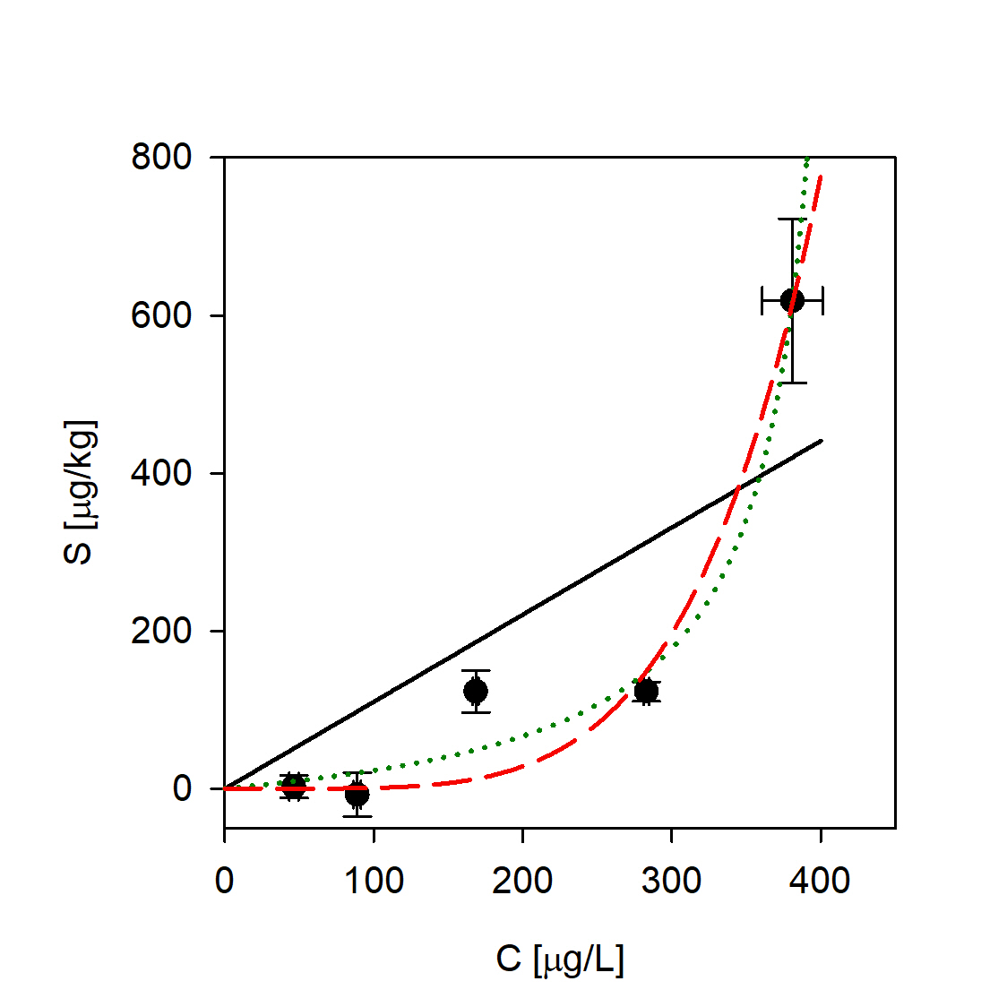

  - Sediment V (sandy loam)
Antipyrine Atenolol Caffeine
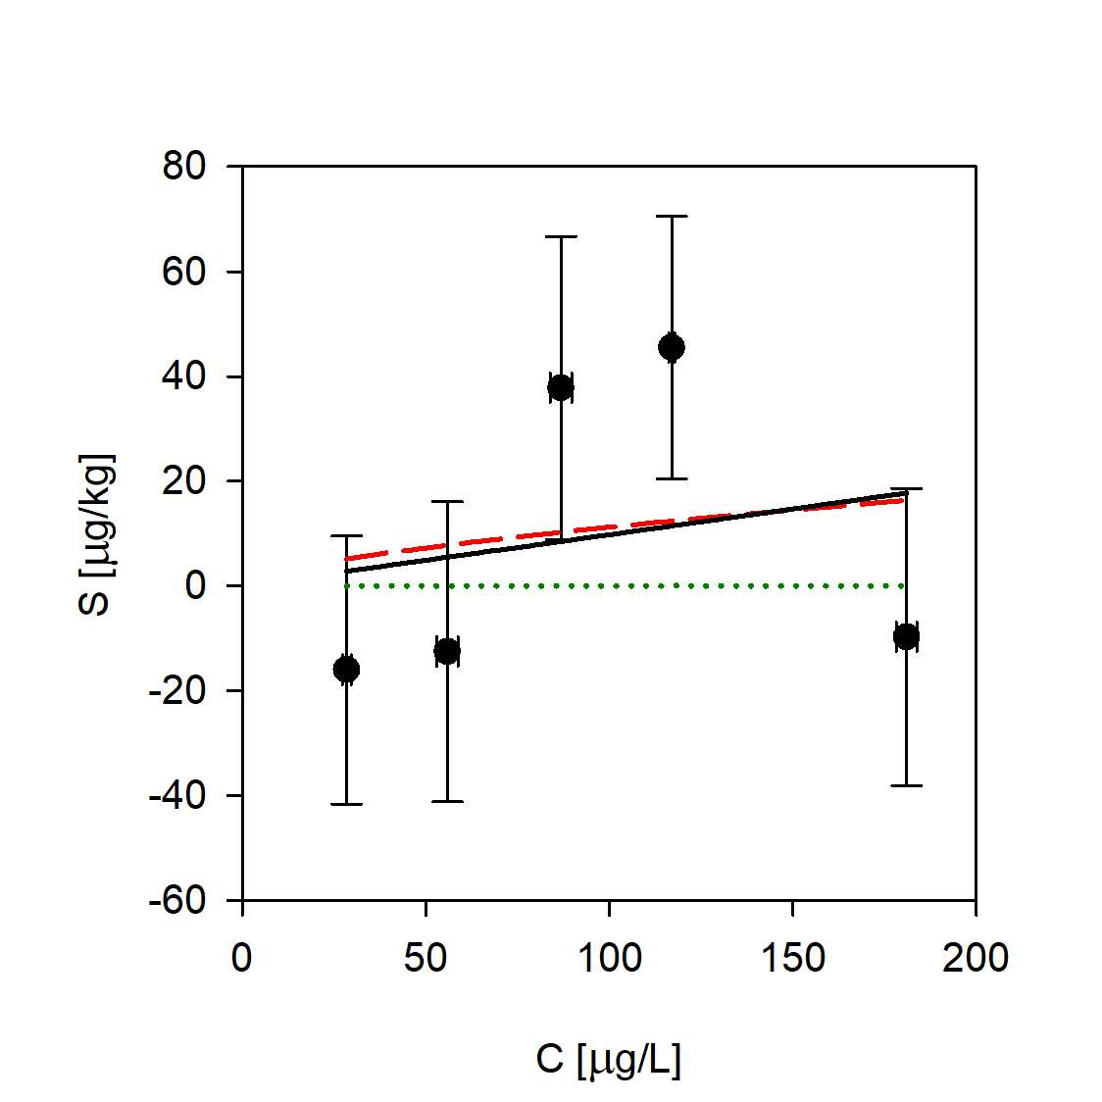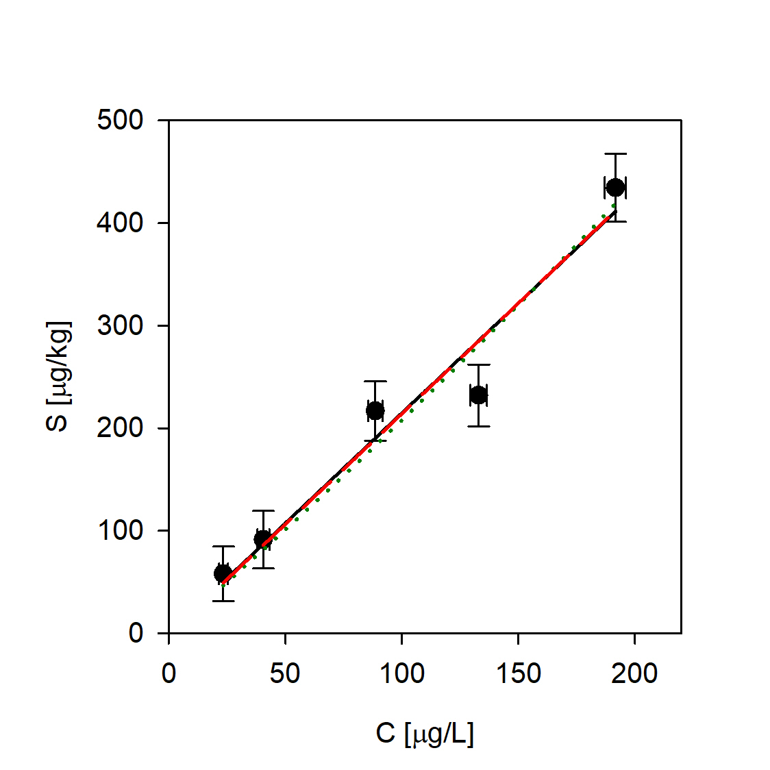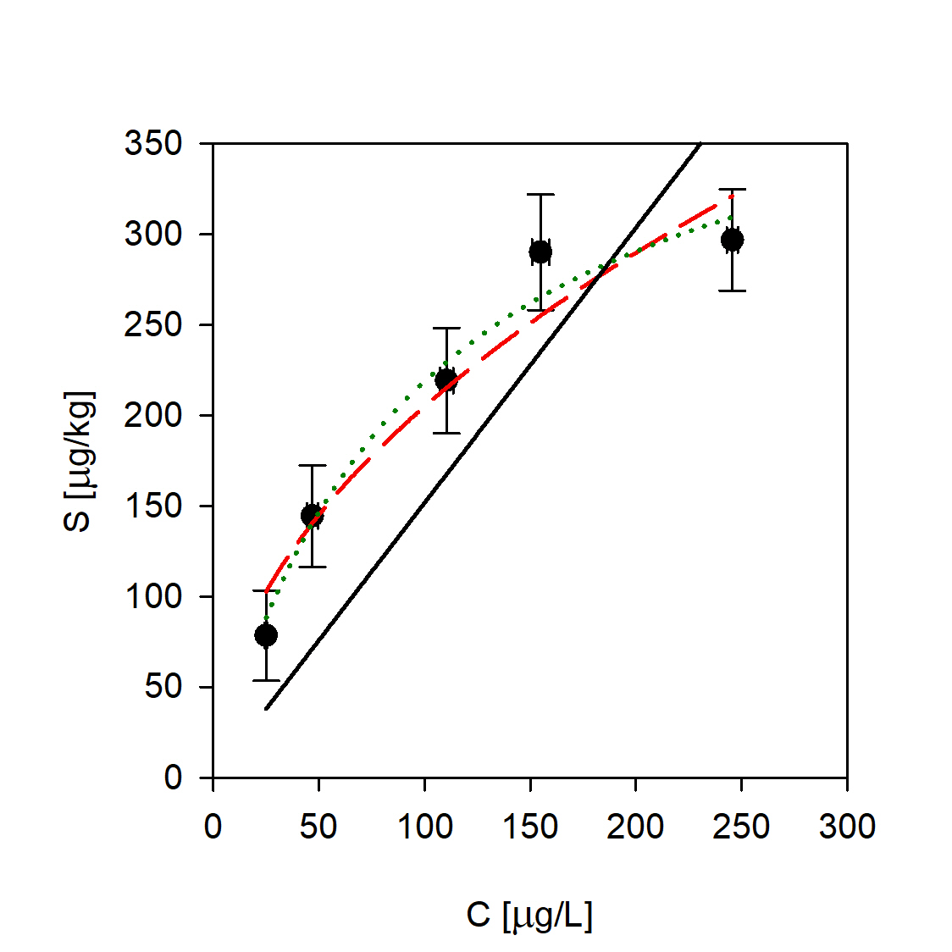
Carbamazepine Ciprofloxacin Diclofenac
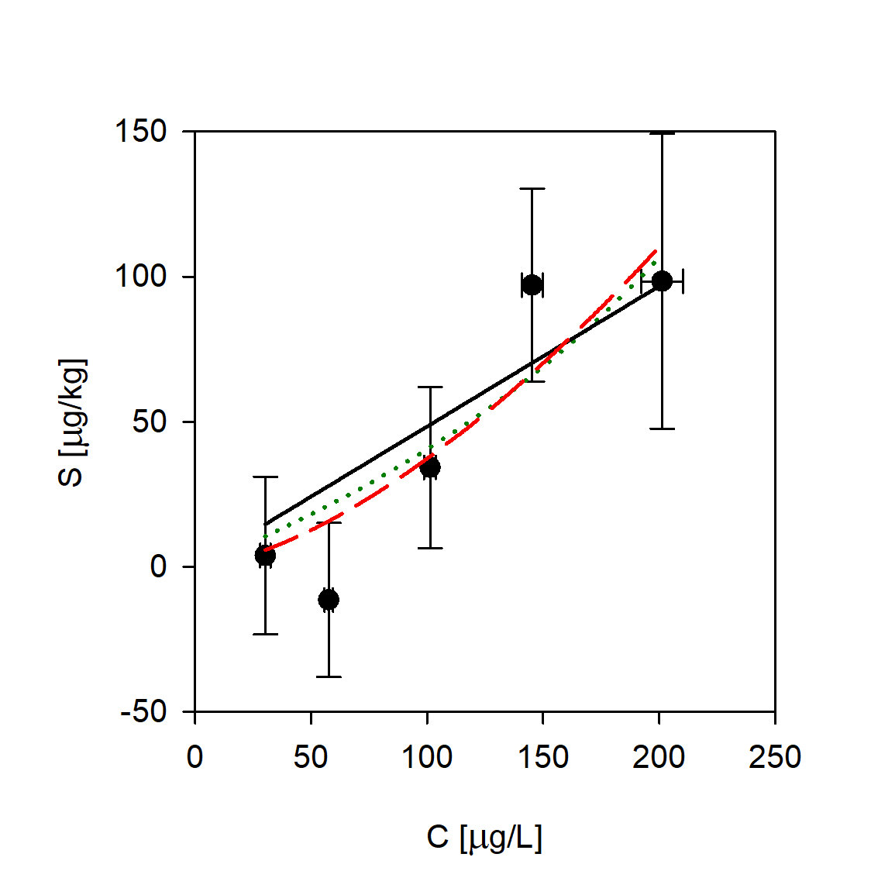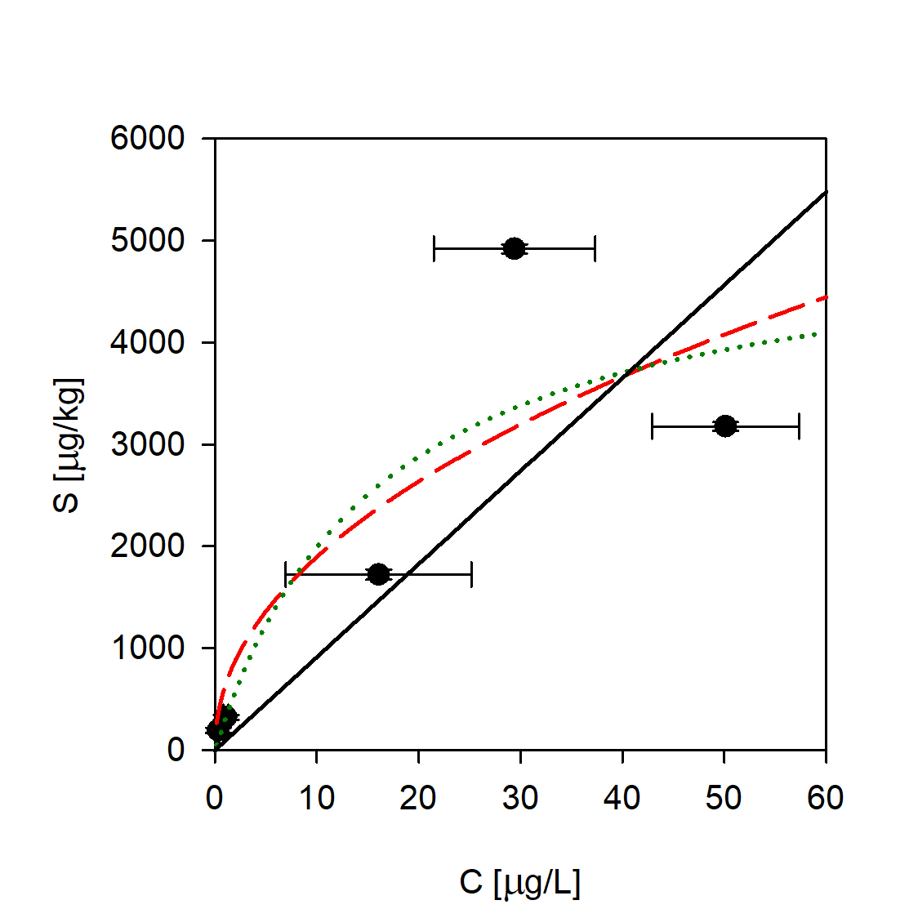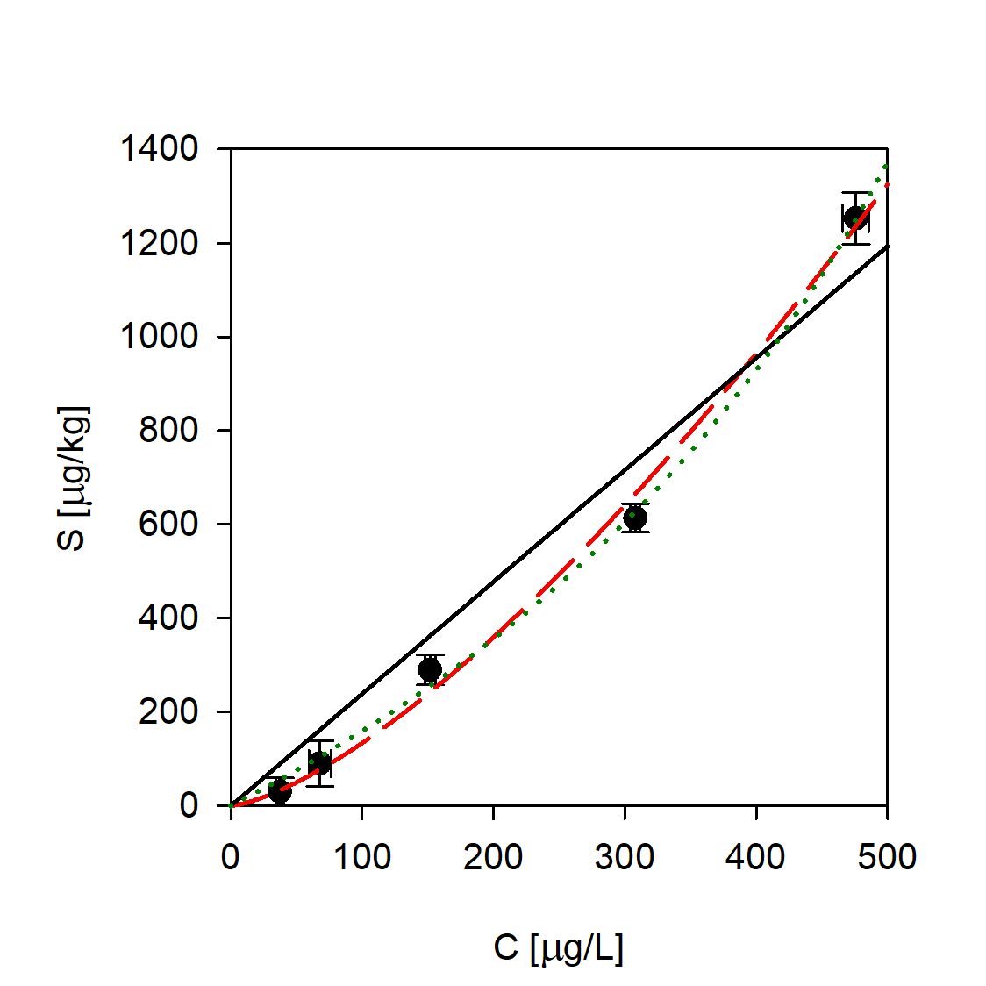
Ketoprofen Ofloxacin Sulfamethoxazole

  - Sediment E1 (sandy clay loam)
Antipyrine Atenolol Caffeine
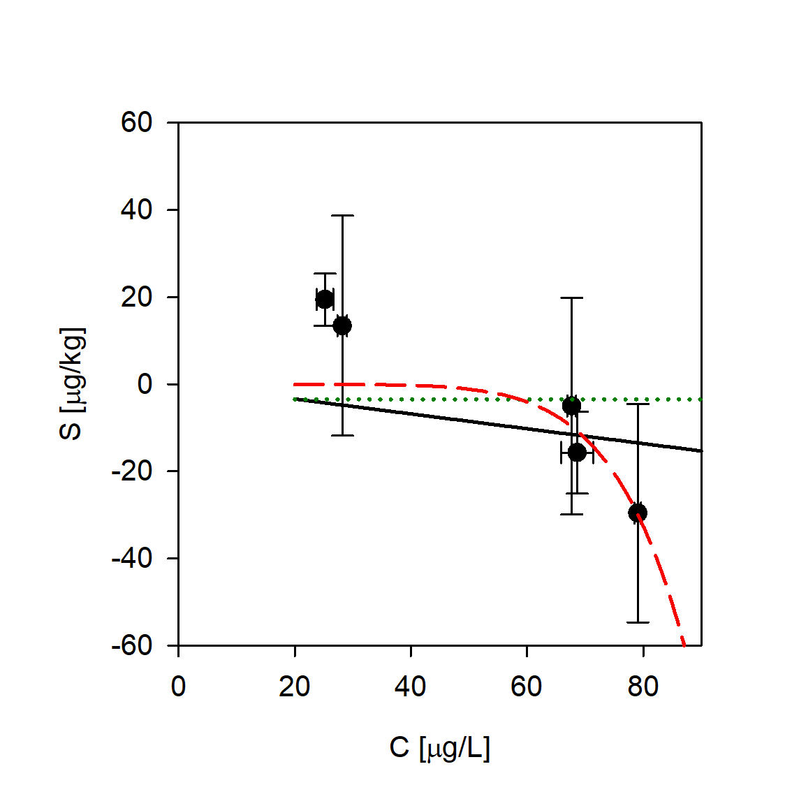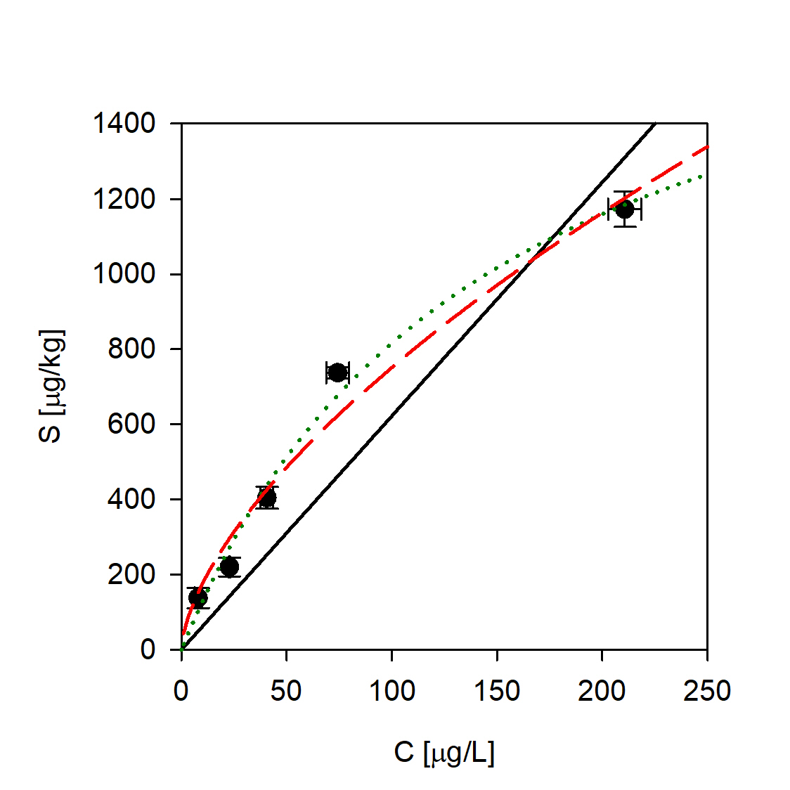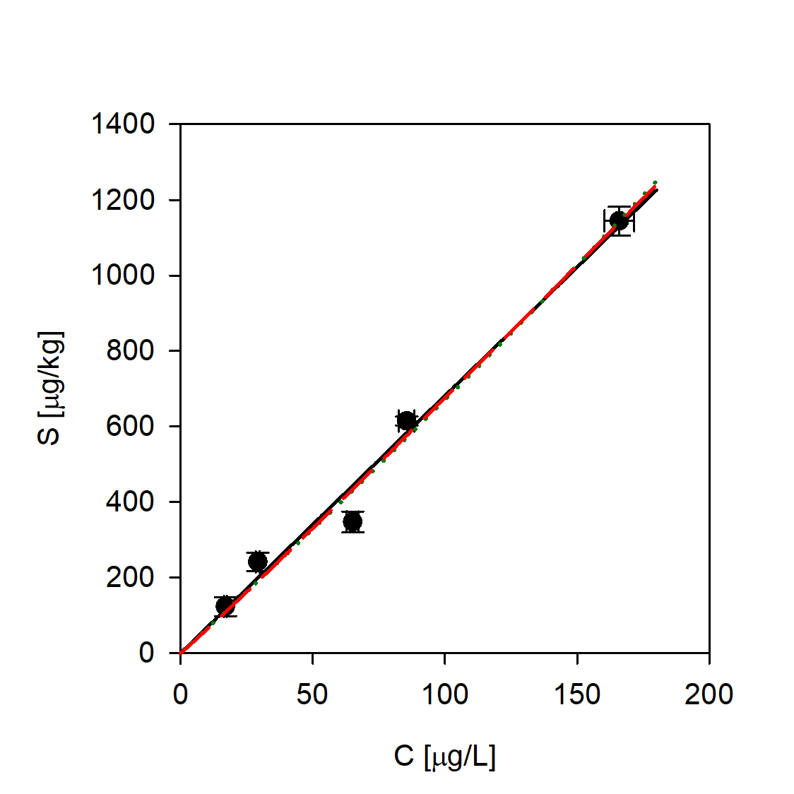
Carbamazepine Ciprofloxacin Diclofenac
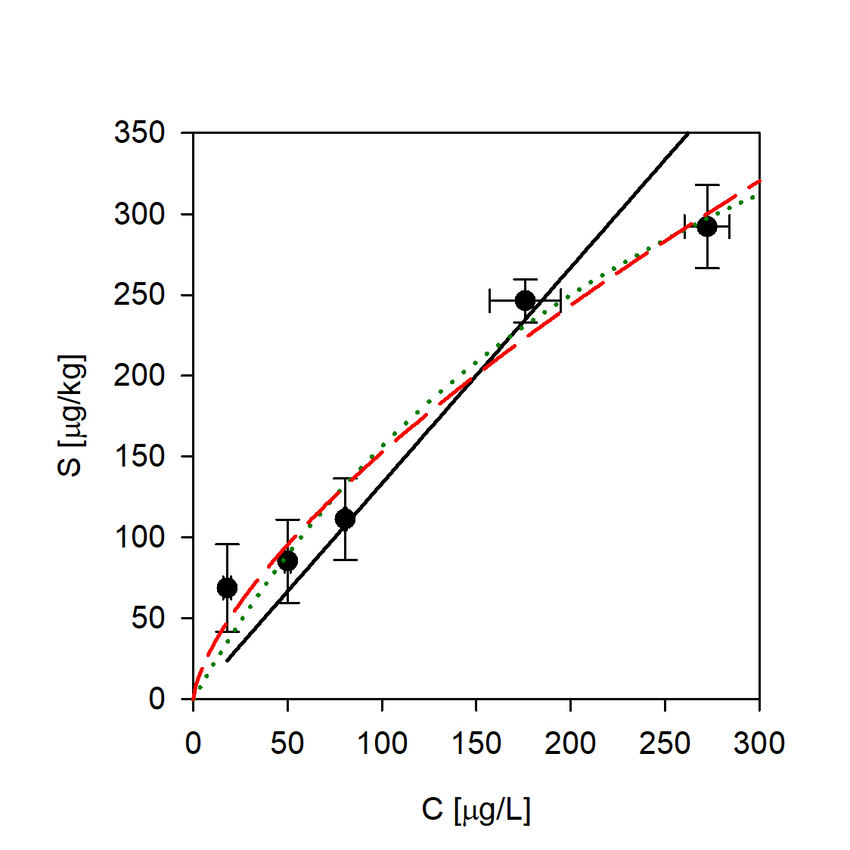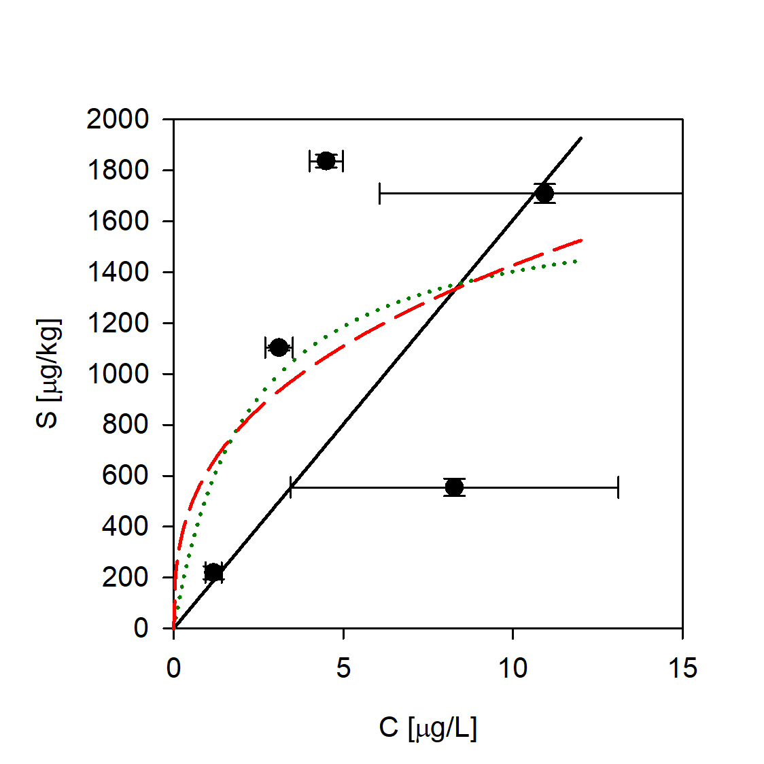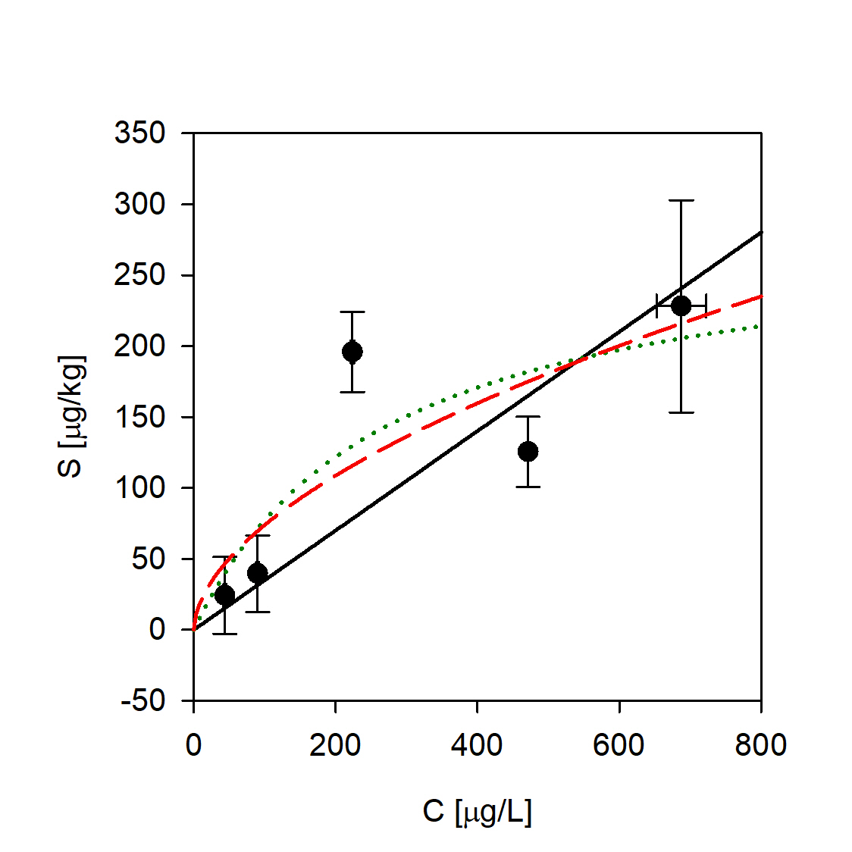
Ketoprofen Ofloxacin Sulfamethoxazole
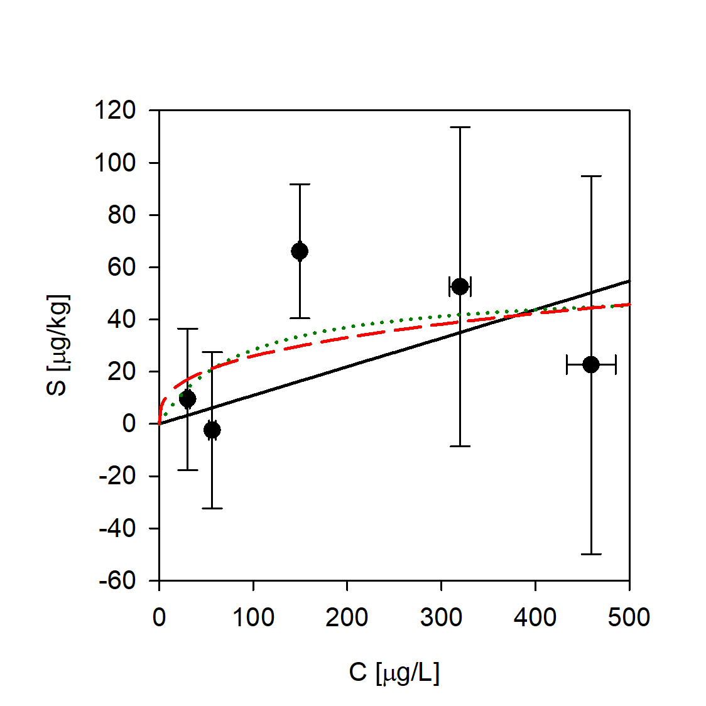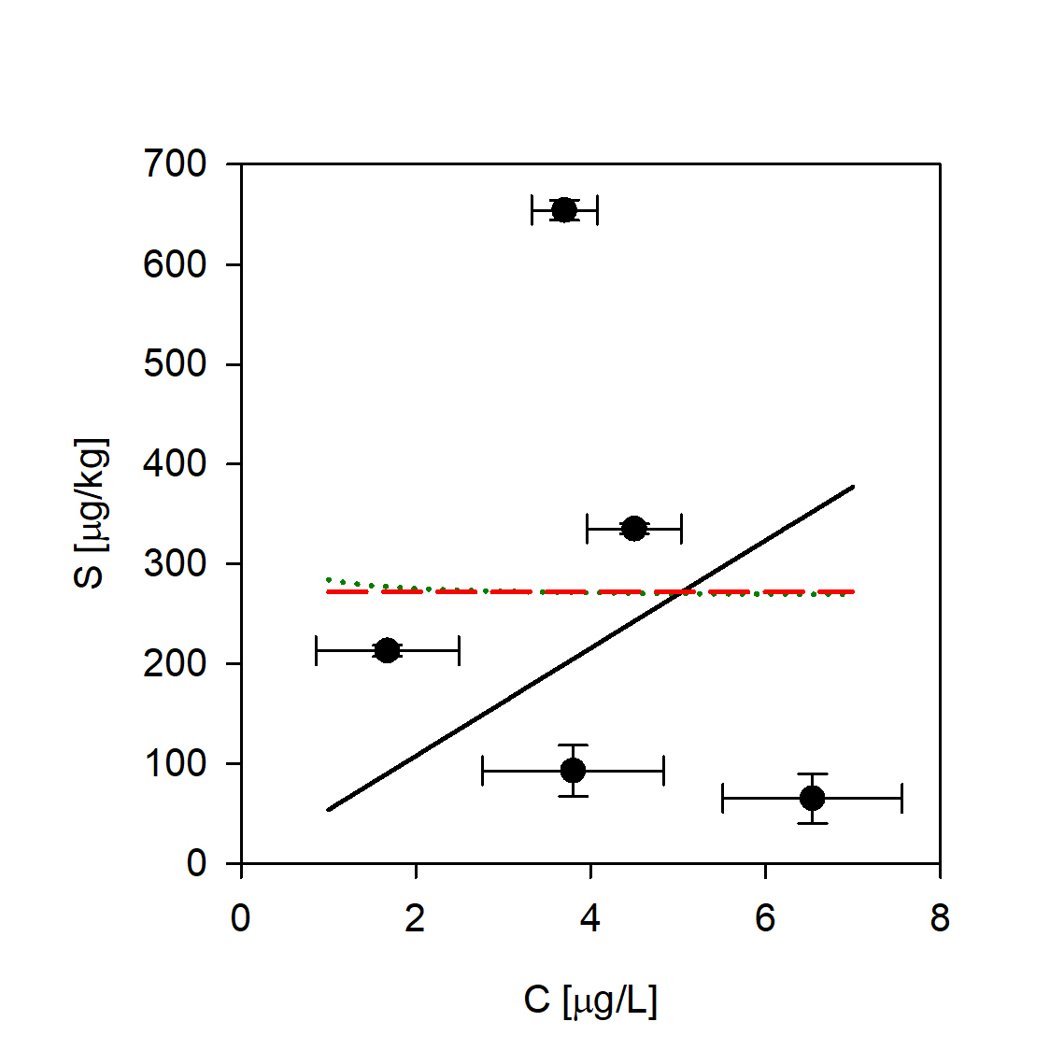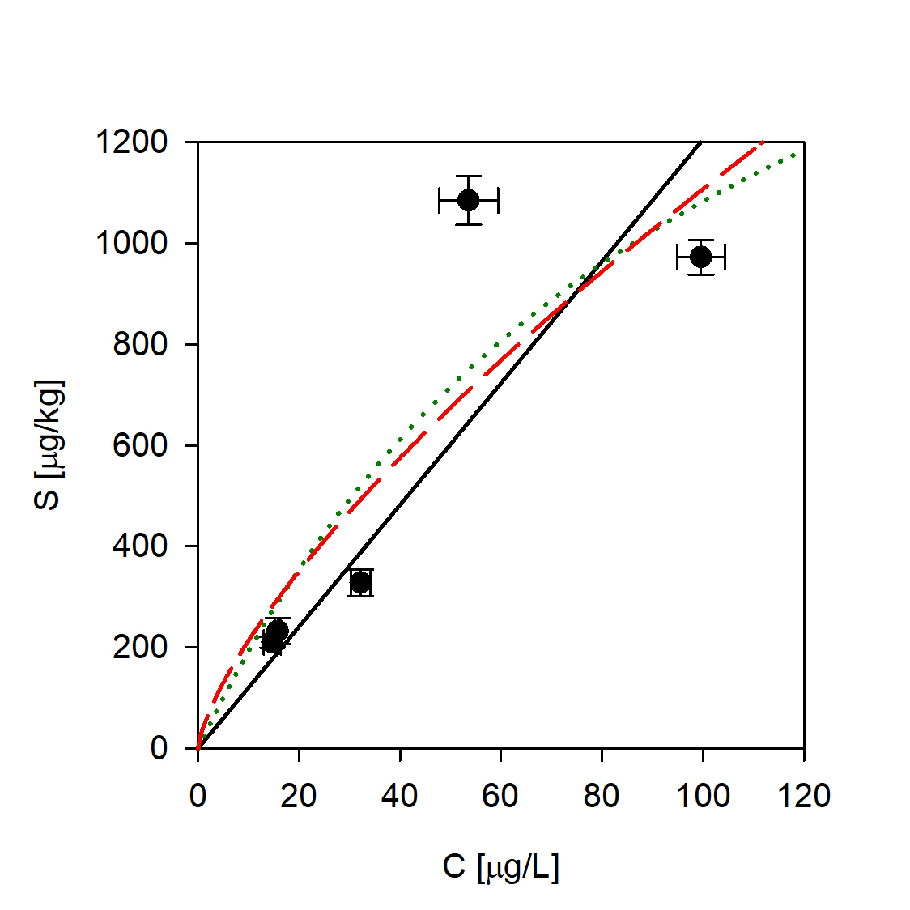

  - Sediment E2 (clay)
Antipyrine Atenolol Caffeine
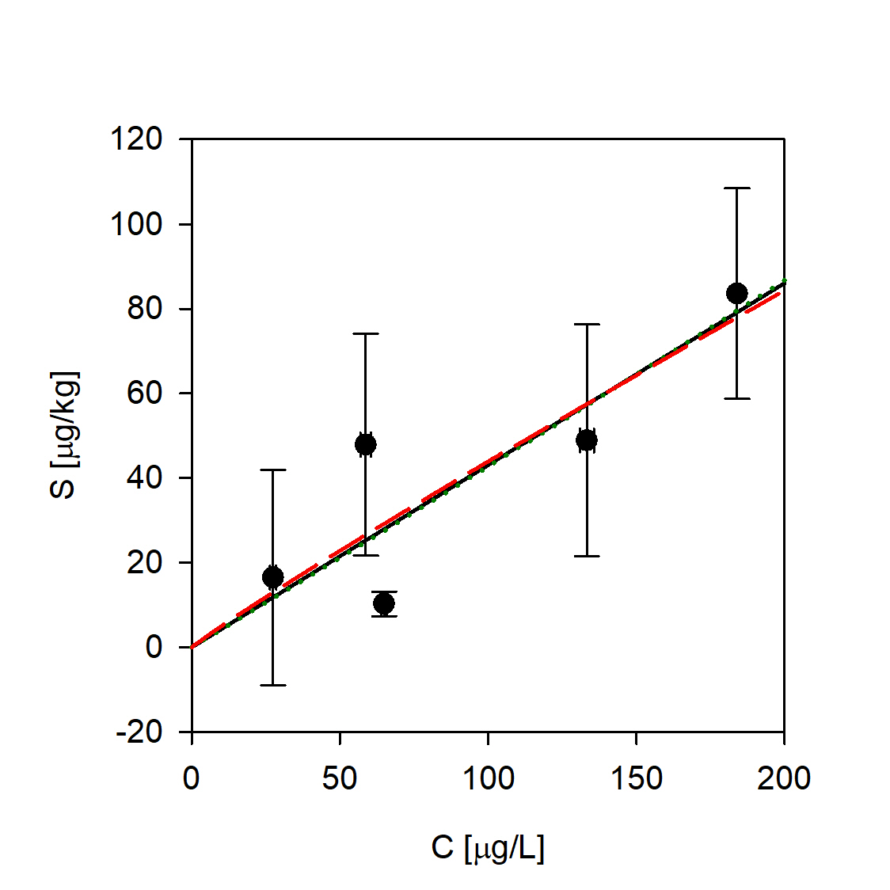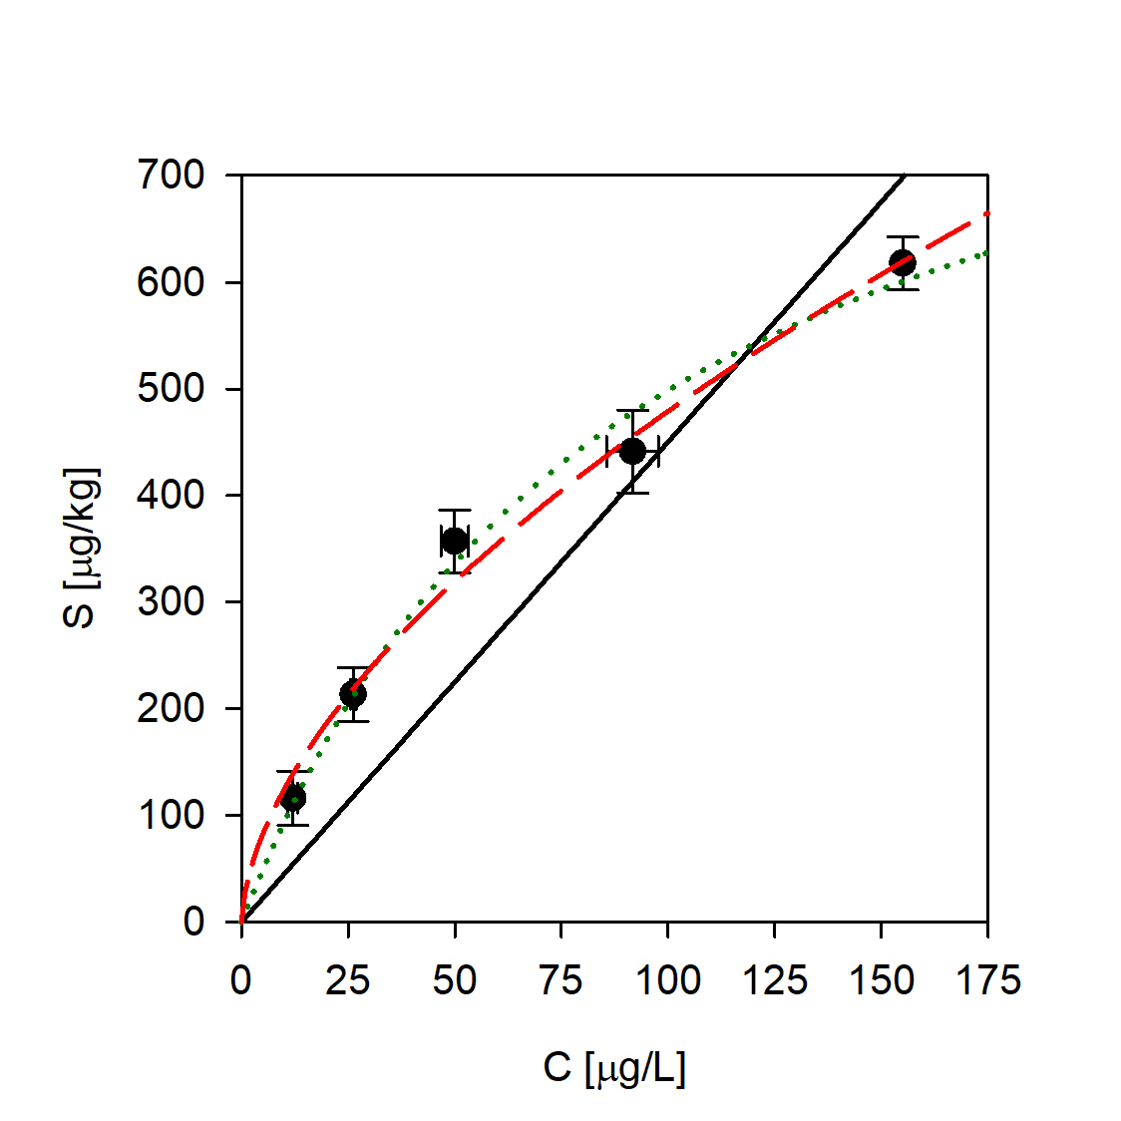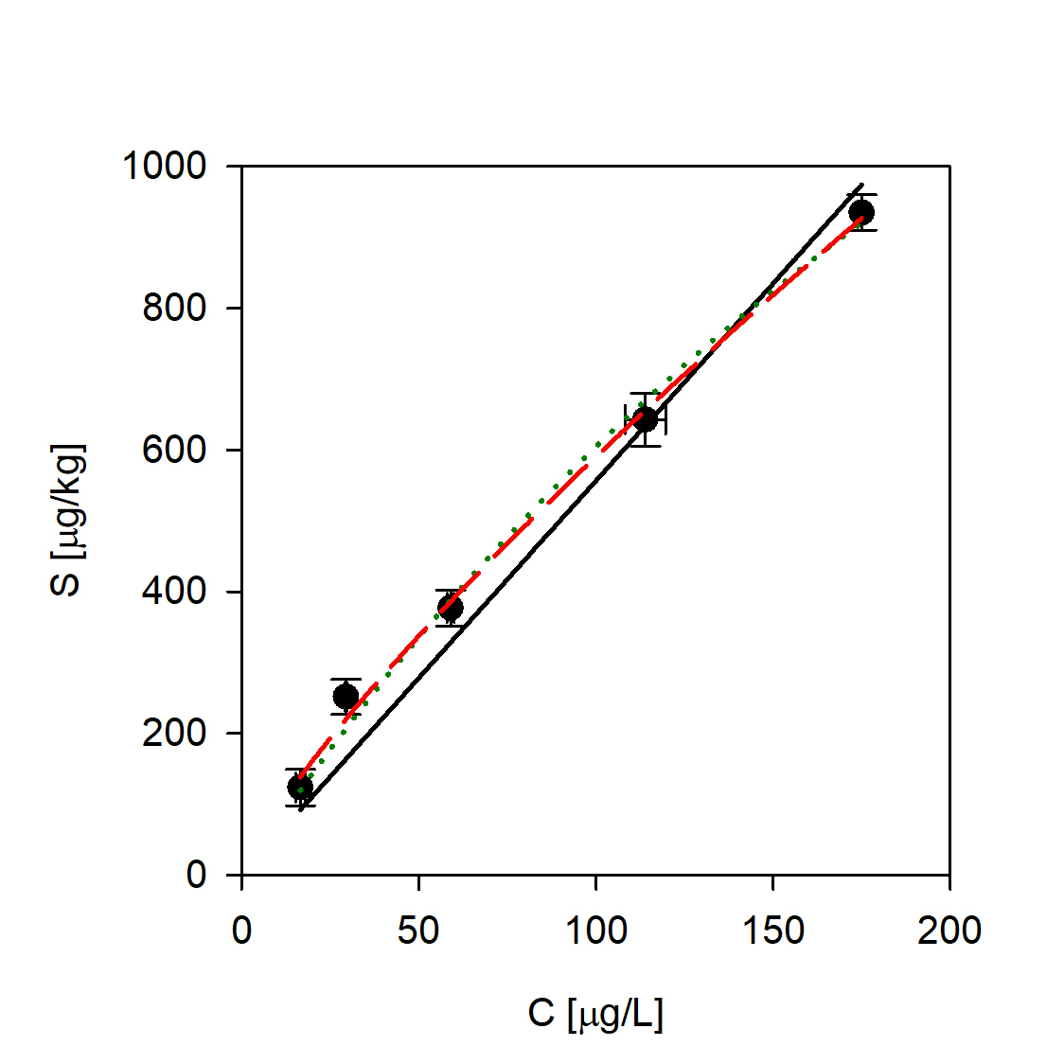
Carbamazepine Ciprofloxacin Diclofenac
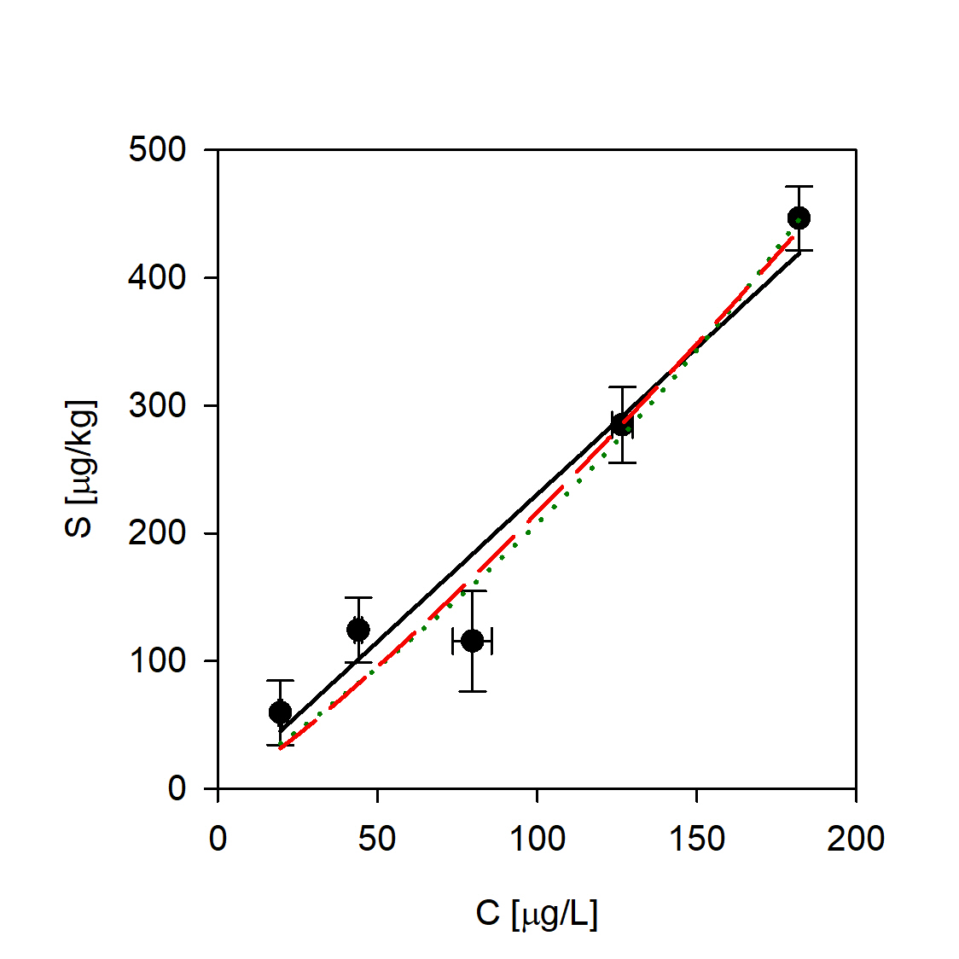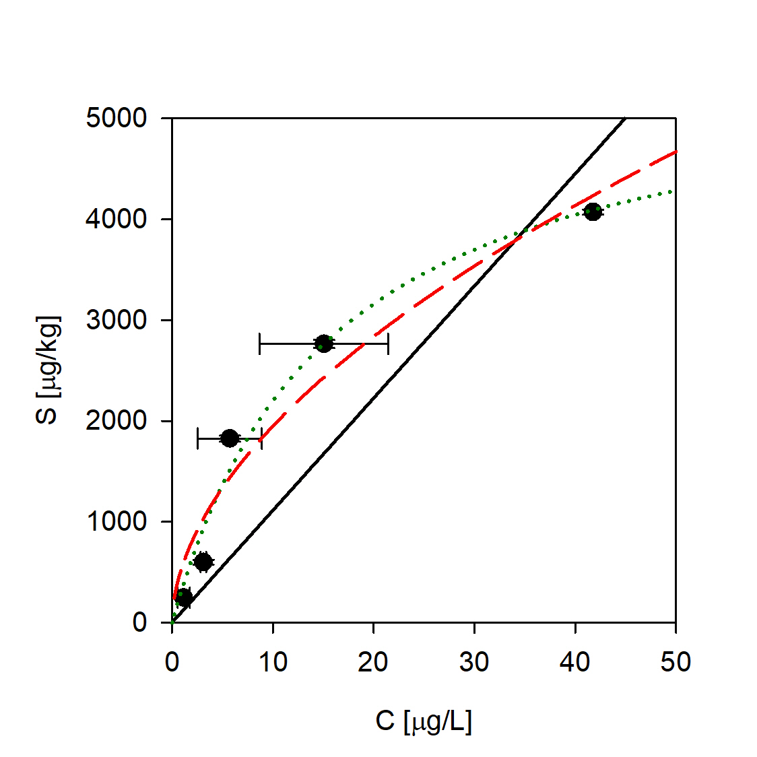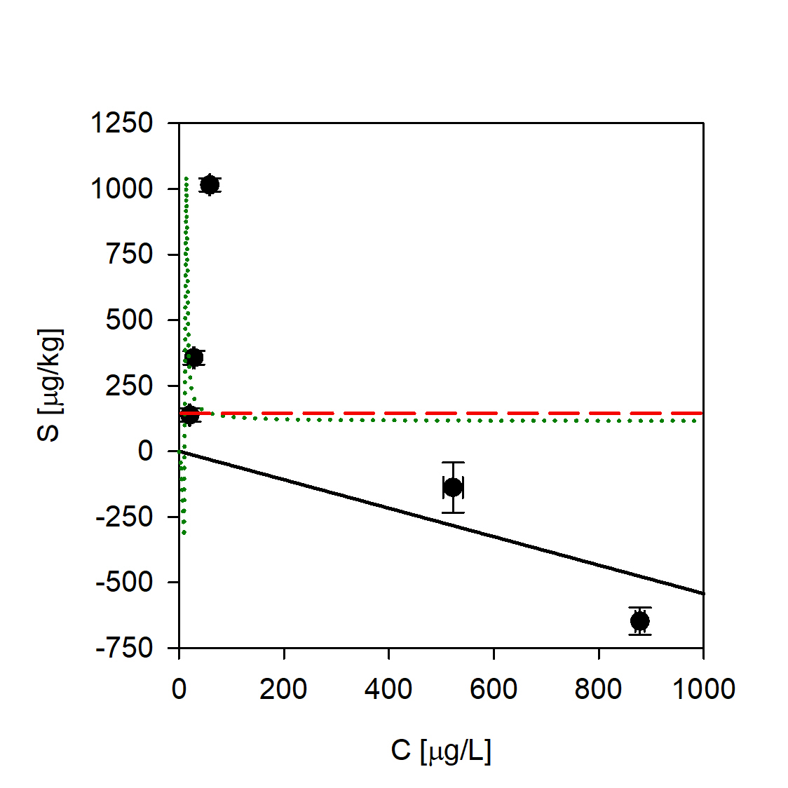
Ketoprofen Ofloxacin Sulfamethoxazole
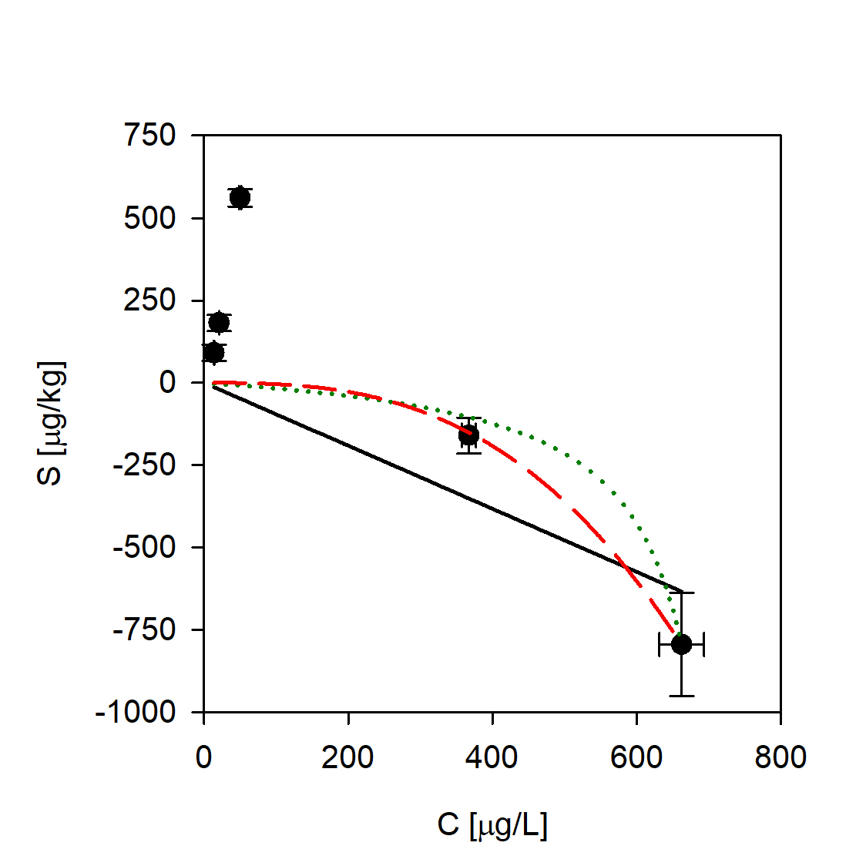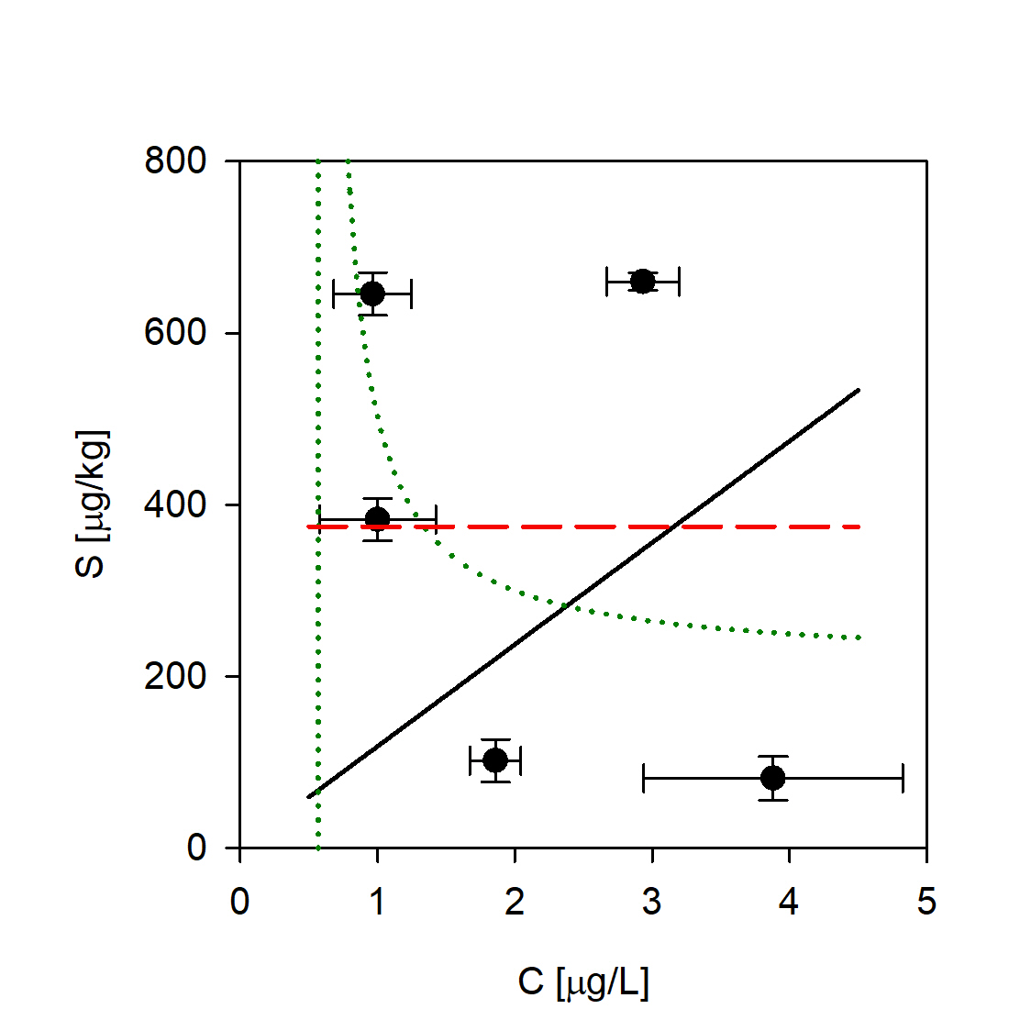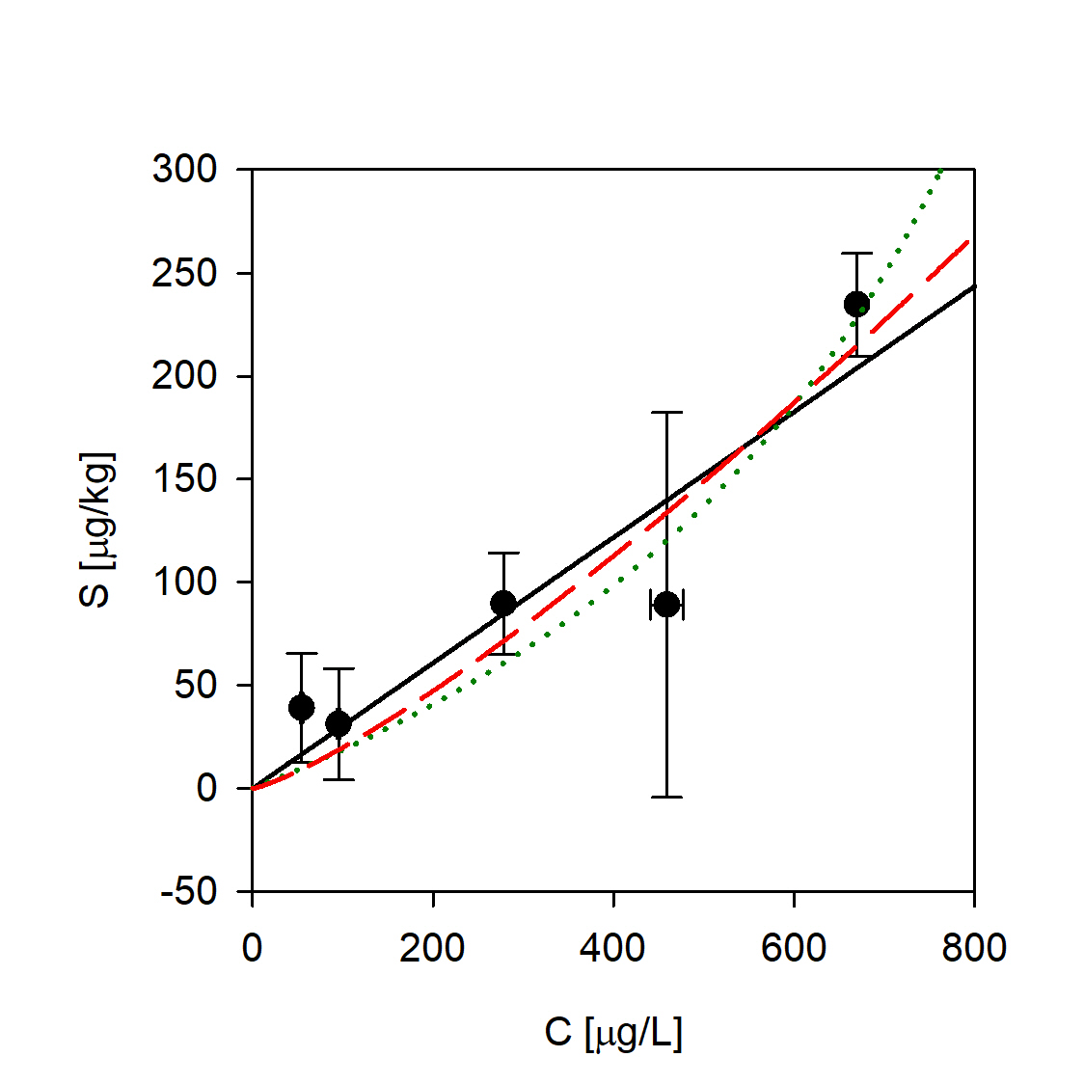

  - Sediment E3 (medium sand)
Antipyrine Atenolol Caffeine
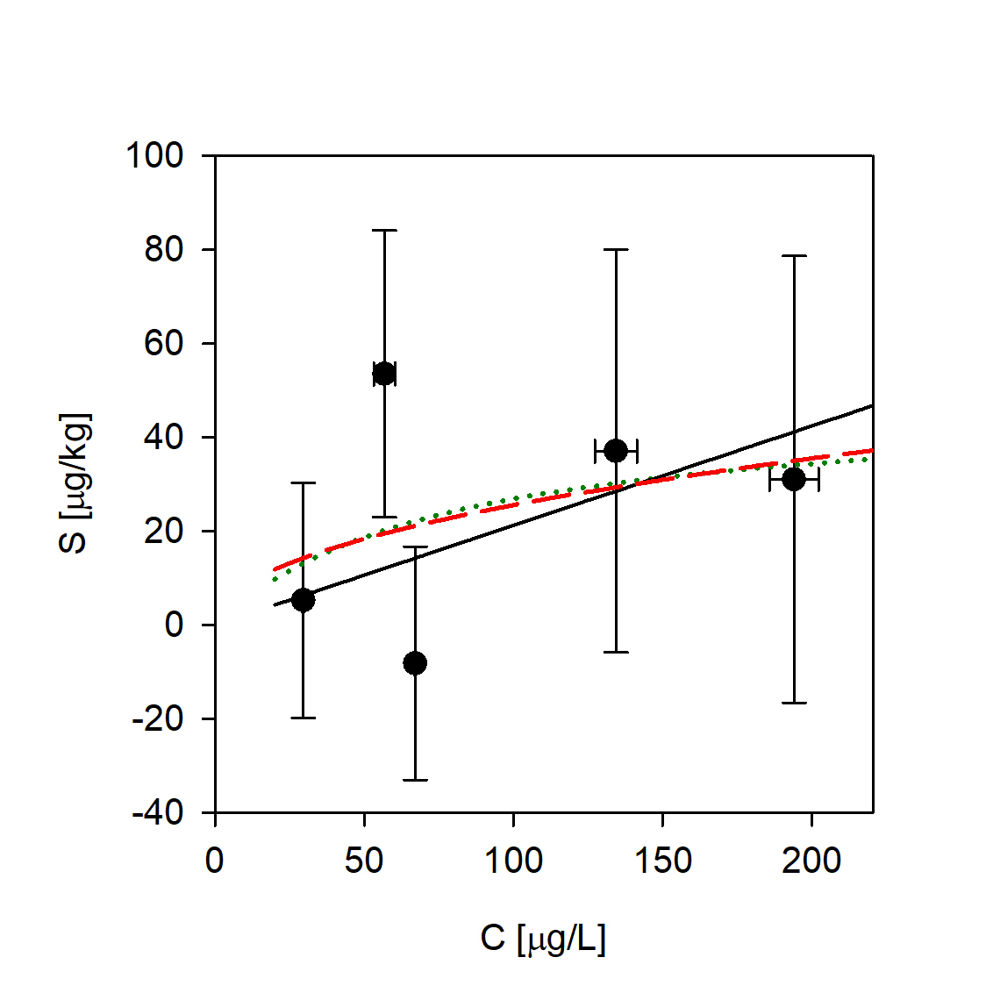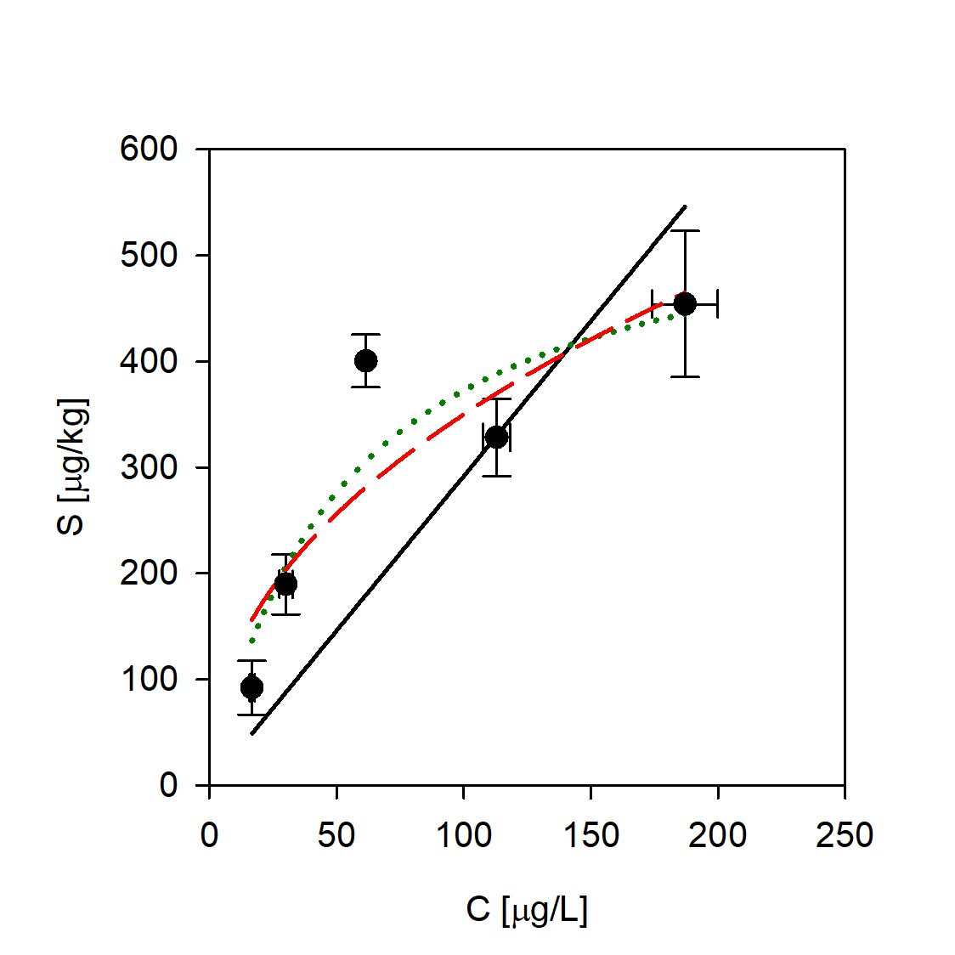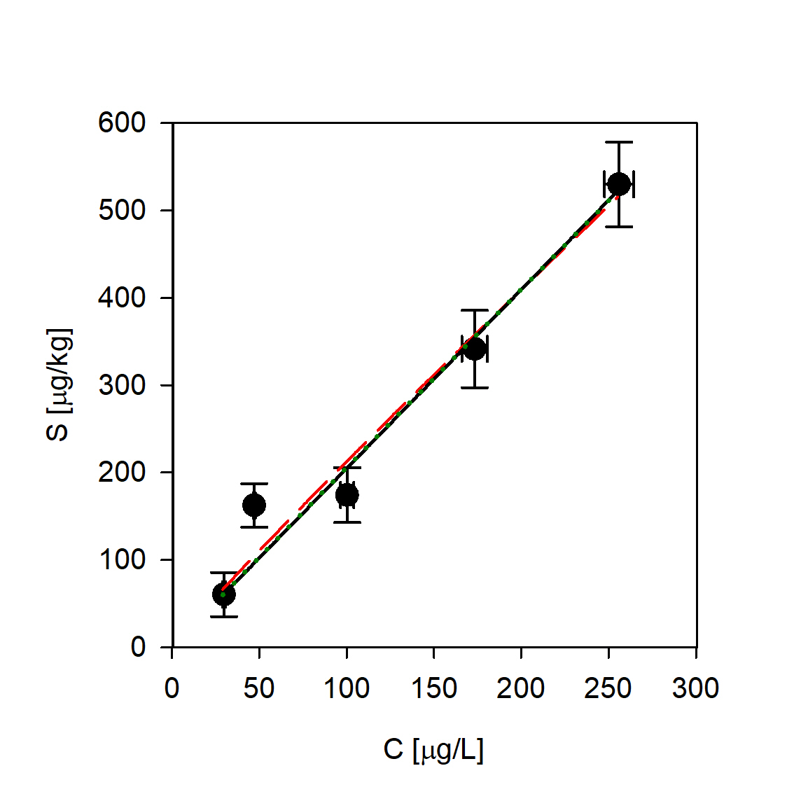
Carbamazepine Ciprofloxacin Diclofenac
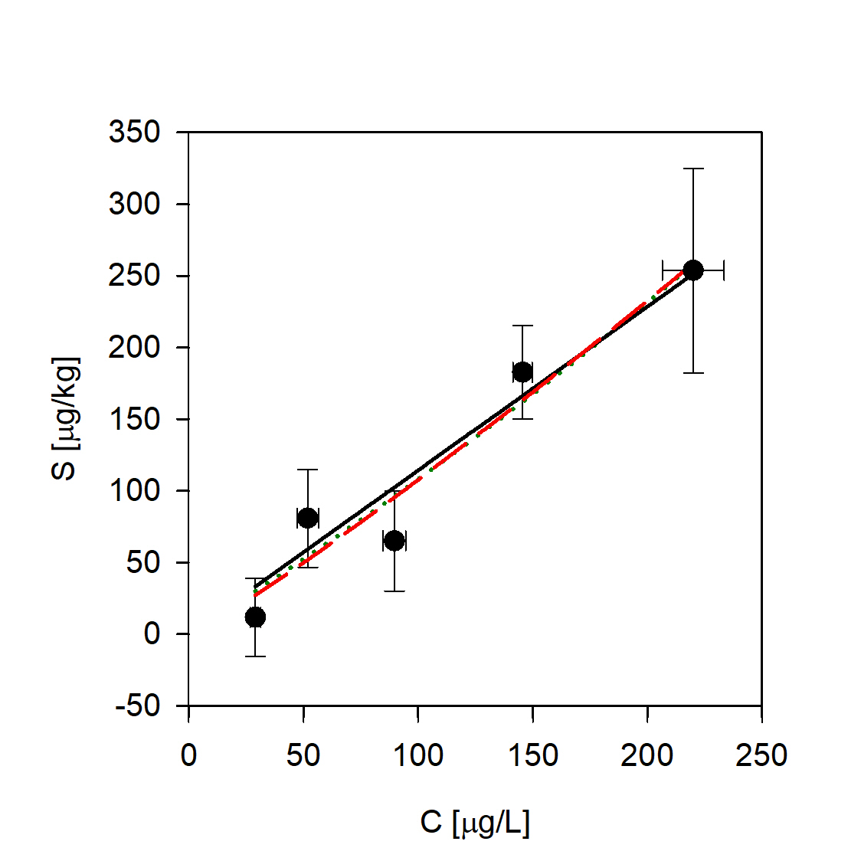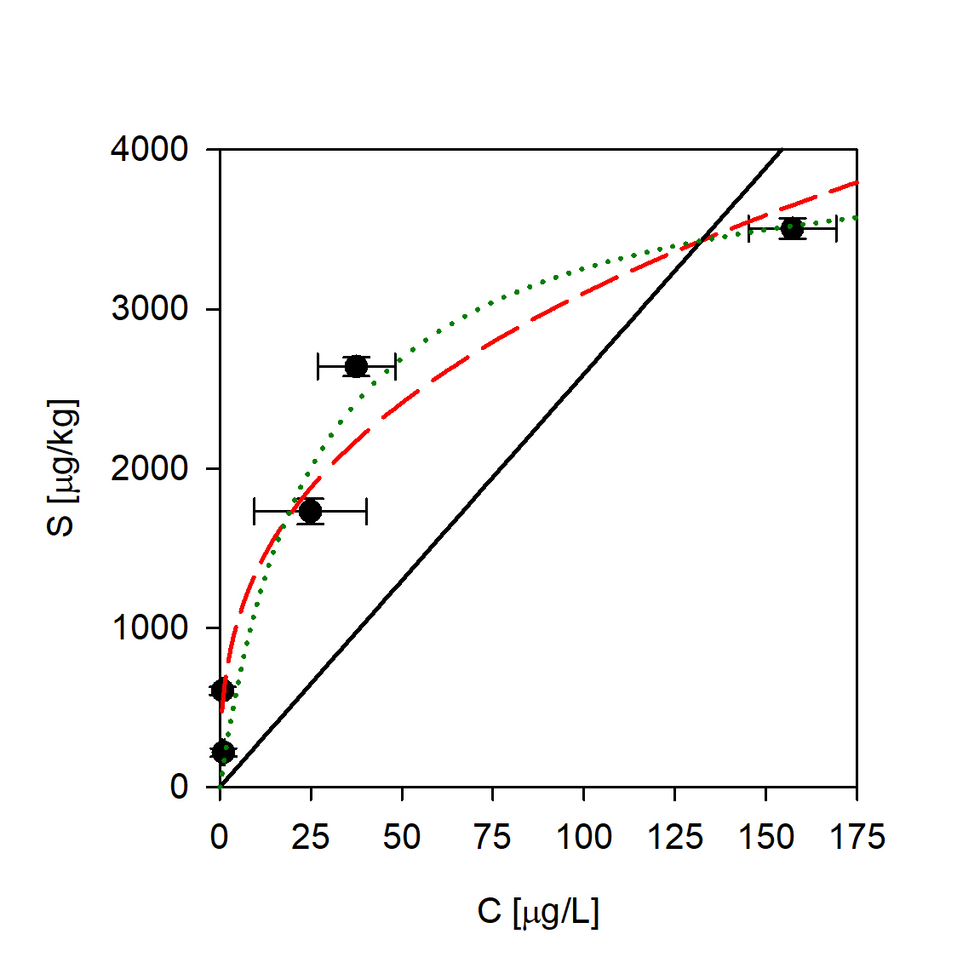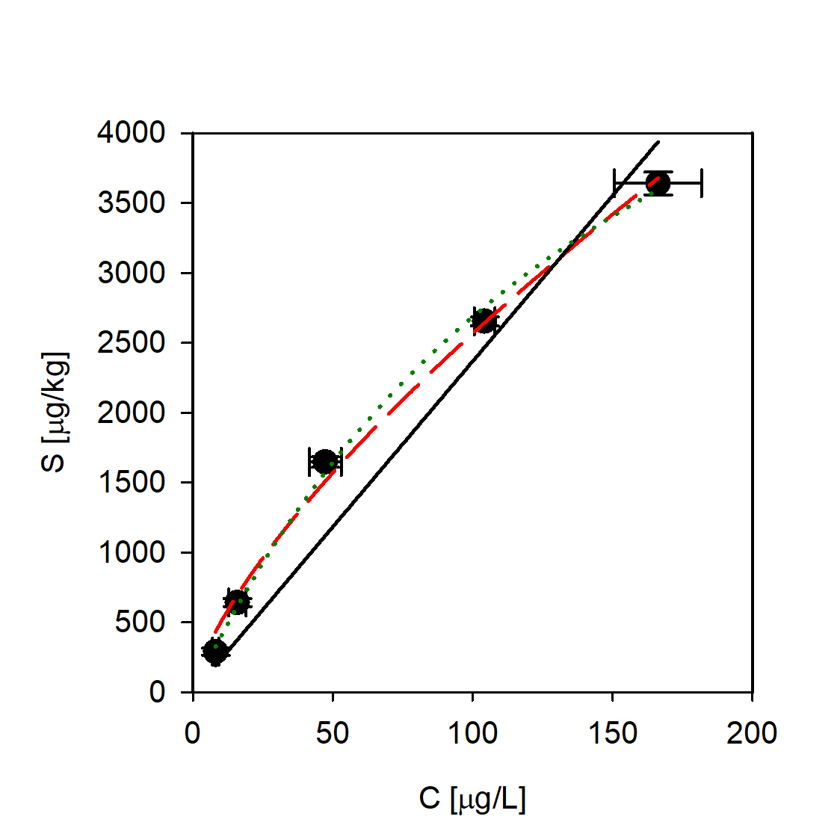
Ketoprofen Ofloxacin Sulfamethoxazole
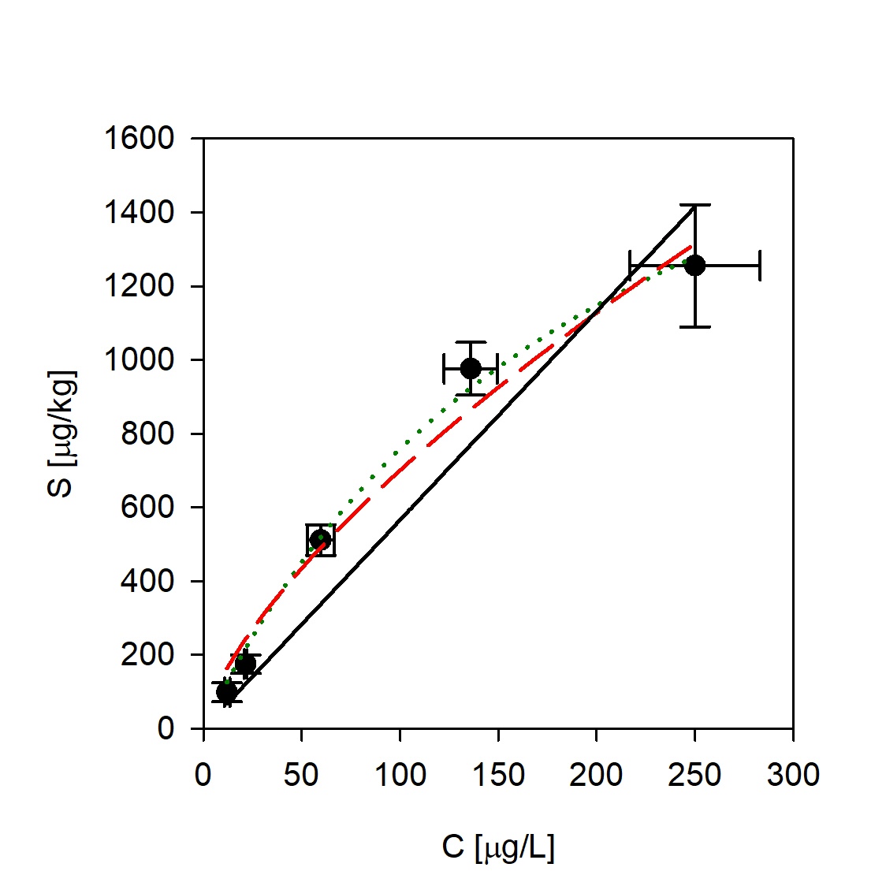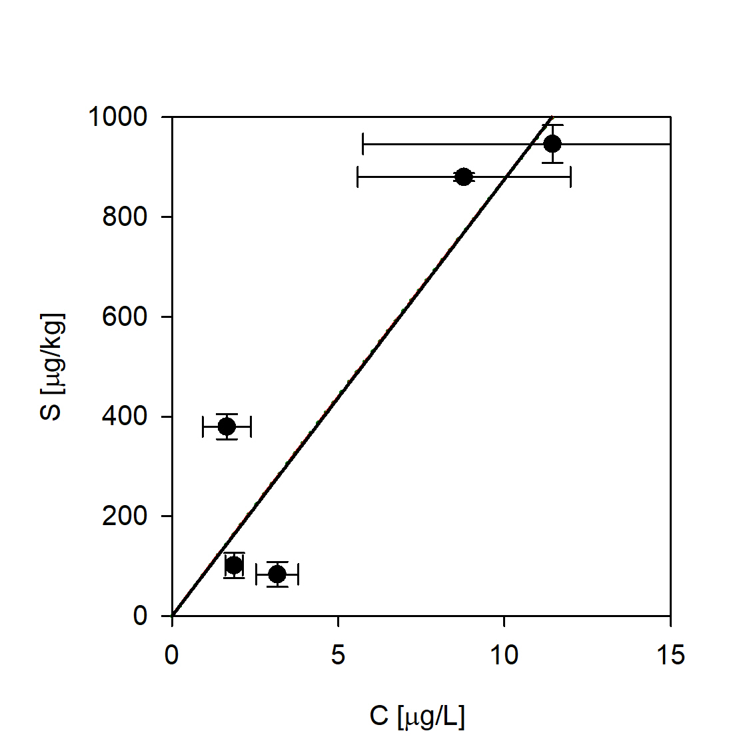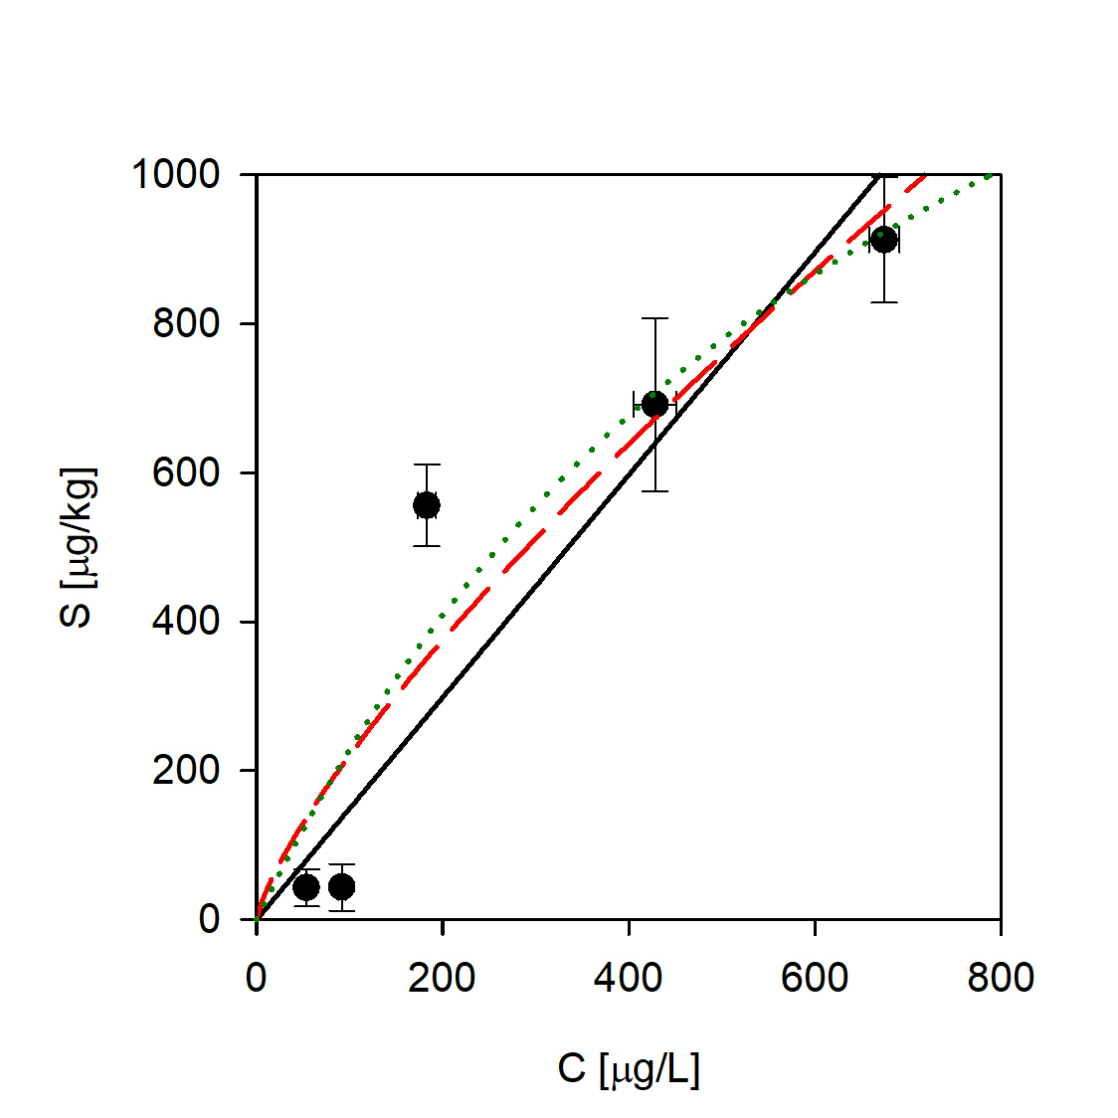

- Correlation graphs between Freundlich sorption coefficient KF and logK_{OW} of selected compounds
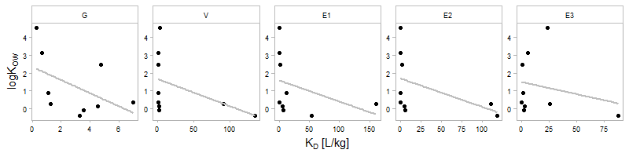
- Sorption partition coefficients K_{d} and K_{F}
Compound | Sediment | K_{d}  [L/kg] | K_{F}  [(L/kg)^{η}] | η | Solution type | Experim. type | Reference
Atenolol | coarse sand |  |  |  | groundwater | batch | this study
Antipyrine | coarse sand |  |  |  | groundwater | batch | this study
Carbamazepine | coarse sand |  |  |  | groundwater | batch | this study
Caffeine | coarse sand |  |  |  | groundwater | batch | this study
Ciprofloxacin | coarse sand |  |  |  | groundwater | batch | this study
Diclofenac | coarse sand |  |  |  | groundwater | batch | this study
Ketoprofen | coarse sand |  |  |  | groundwater | batch | this study
Ofloxacin | coarse sand |  |  |  | groundwater | batch | this study
Sulfamethoxazole | coarse sand |  |  |  | groundwater | batch | this study
Atenolol | sandy loam |  |  |  | groundwater | batch | this study
Antipyrine | sandy loam |  |  |  | groundwater | batch | this study
Carbamazepine | sandy loam |  |  |  | groundwater | batch | this study
Caffeine | sandy loam |  |  |  | groundwater | batch | this study
Ciprofloxacin | sandy loam |  |  |  | groundwater | batch | this study
Diclofenac | sandy loam |  |  |  | groundwater | batch | this study
Ketoprofen | sandy loam |  |  |  | groundwater | batch | this study
Ofloxacin | sandy loam |  |  |  | groundwater | batch | this study
Sulfamethoxazole | sandy loam |  |  |  | groundwater | batch | this study
Atenolol | sandy clay loam |  |  |  | groundwater | batch | this study
Antipyrine | sandy clay loam |  |  |  | groundwater | batch | this study
Carbamazepine | sandy clay loam |  |  |  | groundwater | batch | this study
Caffeine | sandy clay loam |  |  |  | groundwater | batch | this study
Ciprofloxacin | sandy clay loam |  |  |  | groundwater | batch | this study
Diclofenac | sandy clay loam |  |  |  | groundwater | batch | this study
Ketoprofen | sandy clay loam |  |  |  | groundwater | batch | this study
Ofloxacin | sandy clay loam |  |  |  | groundwater | batch | this study
Sulfamethoxazole | sandy clay loam |  |  |  | groundwater | batch | this study
Atenolol | clay |  |  |  | groundwater | batch | this study
Antipyrine | clay |  |  |  | groundwater | batch | this study
Carbamazepine | clay |  |  |  | groundwater | batch | this study
Caffeine | clay |  |  |  | groundwater | batch | this study
Ciprofloxacin | clay |  |  |  | groundwater | batch | this study
Diclofenac | clay |  |  |  | groundwater | batch | this study
Ketoprofen | clay |  |  |  | groundwater | batch | this study
Ofloxacin | clay |  |  |  | groundwater | batch | this study
Sulfamethoxazole | clay |  |  |  | groundwater | batch | this study
Atenolol | medium sand |  |  |  | groundwater | batch | this study
Antipyrine | medium sand |  |  |  | groundwater | batch | this study
Carbamazepine | medium sand |  |  |  | groundwater | batch | this study
Caffeine | medium sand |  |  |  | groundwater | batch | this study
Ciprofloxacin | medium sand |  |  |  | groundwater | batch | this study
Diclofenac | medium sand |  |  |  | groundwater | batch | this study
Ketoprofen | medium sand |  |  |  | groundwater | batch | this study
Ofloxacin | medium sand |  |  |  | groundwater | batch | this study
Sulfamethoxazole | medium sand |  |  |  | groundwater | batch | this study
Atenolol | sand | 1.54 |  |  | tap water | column | 1
Antipyrine | sand | 0.00 |  |  | tap water | column | 1
Carbamazepine | agricultural soil | 1.79 | 3.35 | 4.80 | 0.01 M CaCl₂ | batch | 2
Carbamazepine | loamy fine sand |  | 12.63 | 0.87 | secondary-treated wastewater | batch | 3
Carbamazepine | loamy fine sand |  | 11.46 | 1.21 | freshwater | batch | 3
Diclofenac | loamy fine sand |  | 11.90 | 0.27 | secondary-treated wastewater | batch | 3
Diclofenac | loamy fine sand |  | 8.81 | 0.49 | freshwater | batch | 3
Carbamazepine | sandy loam |  | 0.87 | 0.91 | secondary-treated wastewater | batch | 3
Carbamazepine | sandy loam |  | 1.21 | 0.73 | freshwater | batch | 3
Diclofenac | sandy loam |  | 0.27 | 1.13 | secondary-treated wastewater | batch | 3
Diclofenac | sandy loam |  | 0.49 | 0.92 | freshwater | batch | 3
Carbamazepine | clay (low TOC) | 0.49 | 0.51 | 0.95 | 0.01 M CaCl₂ | batch | 4
Carbamazepine | sandy loam (high TOC) | 37.00 | 57.00 | 0.67 | 0.01 M CaCl₂ | batch | 4
Sulfamethoxazole | clay (low TOC) | 0.23 | 0.28 | 0.66 | 0.01 M CaCl₂ | batch | 4
Sulfamethoxazole | sandy loam (high TOC) | 37.60 | 36.20 | 0.94 | 0.01 M CaCl₂ | batch | 4
Ofloxacin | clay (low TOC) | 1192.00 | 832.00 | 0.61 | 0.01 M CaCl₂ | batch | 4
Ofloxacin | sandy loam (high TOC) | 3554.00 | 3224.00 | 0.94 | 0.01 M CaCl₂ | batch | 4
Diclofenac | clay (low TOC) | 0.45 | 0.44 | 1.00 | 0.01 M CaCl₂ | batch | 4
Diclofenac | sandy loam (high TOC) | 164.50 | 172.00 | 0.92 | 0.01 M CaCl₂ | batch | 4
carbamazepine | silty clay | 5.81 |  |  | 0.01 M CaCl₂ | batch | 5
carbamazepine | silty clay | 9.11 |  |  | untreated wastewater | batch | 5
carbamazepine | clay | 11.40 |  |  | 0.01 M CaCl₂ | batch | 5
Carbamazepine | clay | 9.19 |  |  | untreated wastewater | batch | 5
Carbamazepine | topsoil/loam | 4.61 | 12.40 | 0.87 | 0.01 M CaCl₂ | batch | 6
Carbamazepine | agricultural soil/sand | 1.72 | 3.80 | 0.89 | 0.01 M CaCl₂ | batch | 6
Atenolol | sand |  | 0.67 | 0.85 | 0.01 M CaCl₂ | batch | 7
Carbamazepine | sand |  | 0.26 | 0.88 | 0.01 M CaCl₂ | batch | 7
Sulfamethoxazole | sand |  | 0.11 | 0.61 | 0.01 M CaCl₂ | batch | 7
Atenolol | loess |  | 5.08 | 0.85 | 0.01 M CaCl₂ | batch | 7
Carbamazepine | loess |  | 0.67 | 0.88 | 0.01 M CaCl₂ | batch | 7
Sulfamethoxazole | loess |  | 0.07 | 0.61 | 0.01 M CaCl₂ | batch | 7
ciprofloxacin | soil (loamy sand) | 427.00 |  |  | 0.01 M CaCl₂ | batch | 8
Ofloxacin | soil (loamy sand) | 309.00 |  |  | 0.01 M CaCl₂ | batch | 8
Carbamazepine | medium sand | 5.30 | 5.34 | 0.99 | artificially synthetised groundwater | batch | 9
Carbamazepine | fine sand | 0.21 | 0.13 | 1.08 | artificially synthetised groundwater | batch | 9
Diclofenac | medium sand | 4.66 | 0.57 | 1.43 | artificially synthetised groundwater | batch | 9
Carbamazepine | medium sand | 1.43 | 3.89 | 0.78 | artificially synthetised groundwater | batch | 9
Diclofenac | medium sand | 1.87 | 0.81 | 1.18 | artificially synthetised groundwater | batch | 9
Diclofenac | fine sand | 0.55 | 7.31 | 0.57 | artificially synthetised groundwater | batch | 9
Carbamazepine | sand | 0.13 |  |  | synthesized treated sewage water | column | 10
Diclofenac | sand | 0.57 |  |  | synthesized treated sewage water | column | 10
Sulfamethoxazole | silt loam | 3.28 | 3.26 | 0.96 | 0.005 M CaCl₂ | batch | 11
Sulfamethoxazole | silt loam | 3.36 | 6.10 | 0.79 | 0.005 M CaCl₂ | batch | 11
Sulfamethoxazole | sit loam | 1.31 | 2.28 | 0.82 | 0.005 M CaCl₂ | batch | 11
Carbamazepine | river sediment | 1.70 | 2.00 | 0.90 | 0.01 M CaCl₂ | batch | 12
Carbamazepine | river sediment | 12.30 | 14.10 | 0.82 | 0.01 M CaCl₂ | batch | 12
Ciprofloxacin |  | 150-45000 |  |  |  |  | 13
Atnolol | river sediment | 1.30 |  |  | 0.01 M CaCl₂ | batch | 14
Atnolol | river sediment | 8.10 |  |  | 0.01 M CaCl₂ | batch | 14
Atnolol | river sediment | 5.30 |  |  | 0.01 M CaCl₂ | batch | 14
Atnolol | loam silt | 1.10 |  |  | 0.01 M CaCl₂ | batch | 14
Carbamazepine | river sediment | 8.50 |  |  | 0.01 M CaCl₂ | batch | 14
Carbamazepine | river sediment | 1.40 |  |  | 0.01 M CaCl₂ | batch | 14
Carbamazepine | river sediment | 1.80 |  |  | 0.01 M CaCl₂ | batch | 14
Carbamazepine | loam silt | 1.20 |  |  | 0.01 M CaCl₂ | batch | 14
Ofloxacin | natural soil | 75.80 | 1778.28 | 0.46 | CaCl₂ soultion | batch | 15
Ofloxacin | soil (paddy field) | 46.60 | 1380.38 | 0.42 | CaCl₂ soultion | batch | 15
Ofloxacin | soil (dry farmland) | 67.80 | 1698.24 | 0.45 | CaCl₂ soultion | batch | 15
Ofloxacin | soil (pseudo-ginseng) | 250.00 | 3981.07 | 0.52 | CaCl₂ soultion | batch | 15
Ofloxacin | soil (pseudo-ginseng) | 158.00 | 3630.78 | 0.46 | CaCl₂ soultion | batch | 15
Ofloxacin | natural soil | 234.00 | 2041.74 | 0.63 | CaCl₂ soultion | batch | 15
Ofloxacin | natural soil | 239.00 | 3715.35 | 0.53 | CaCl₂ soultion | batch | 15
Ofloxacin | natural soil | 409.00 | 257.04 | 1.08 | CaCl₂ soultion | batch | 15
Ofloxacin | soil (paddy field) | 264.00 | 1621.81 | 0.69 | CaCl₂ soultion | batch | 15
Ofloxacin | agricultural soil | 156.00 | 467.74 | 0.81 | CaCl₂ soultion | batch | 15
Ofloxacin | peat soil | 530.00 | 9332.54 | 0.51 | CaCl₂ soultion | batch | 15
Ofloxacin | natural soil | 384.00 | 18620.87 | 0.34 | CaCl₂ soultion | batch | 15
Ofloxacin | quartz | 1.30 | 26.30 | 0.48 | CaCl₂ soultion | batch | 15
Ofloxacin | muscovite | 2.20 | 70.79 | 0.40 | CaCl₂ soultion | batch | 15
Ofloxacin | kaolinite | 60.50 | 2238.72 | 0.38 | CaCl₂ soultion | batch | 15
Ofloxacin | montmorillonite | 1510.00 | 95499.26 | 0.29 | CaCl₂ soultion | batch | 15

References
1. Burke, V., Treumann, S., Duennbier, U., Greskowiak, J., Massmann, G., 2013. Sorption behavior of 20 wastewater originated micropollutants in groundwater - Column experiments with pharmaceutical residues and industrial agents. J. Contam. Hydrol. 154, 29–41. doi:10.1016/j.jconhyd.2013.08.001
2. Calisto, V., Esteves, V.I., 2012. Adsorption of the antiepileptic carbamazepine onto agricultural soils. J. Environ. Monit. 14, 1597–1603. doi:10.1039/c2em10895j
3. Chefetz, B., Mualem, T., Ben-Ari, J., 2008. Sorption and mobility of pharmaceutical compounds in soil irrigated with reclaimed wastewater. Chemosphere 73, 1335–1343. doi:10.1016/j.chemosphere.2008.06.070
4. Durán-Álvarez, J.C., Prado-Pano, B., Jiménez-Cisneros, B., 2012. Sorption and desorption of carbamazepine, naproxen and triclosan in a soil irrigated with raw wastewater: Estimation of the sorption parameters by considering the initial mass of the compounds in the soil. Chemosphere 88, 84–90. doi:10.1016/j.chemosphere.2012.02.067
5. Fenet, H., Mathieu, O., Mahjoub, O., Li, Z., Hillaire-Buys, D., Casellas, C., Gomez, E., 2012. Carbamazepine, carbamazepine epoxide and dihydroxycarbamazepine sorption to soil and occurrence in a wastewater reuse site in Tunisia. Chemosphere 88, 49–54. doi:10.1016/j.chemosphere.2012.02.050
6. JCGM 100:2008, 2008. Evaluation of measurement data – Guide to the expression of uncertainty in measurement. Joint Committee for Guides in Metrology.
7. Kodešová, R., Grabic, R., Kočárek, M., Klement, A., Golovko, O., Fér, M., Nikodem, A., Jakšík, O., 2015. Pharmaceuticals’ sorptions relative to properties of thirteen different soils. Sci. Total Environ. 511, 435–443. doi:10.1016/j.scitotenv.2014.12.088
8. Nowara, A., Spiteller, M., 1997. Binding of Fluoroquinolone Carboxylic Acid Derivatives to Clay Minerals. J. Agric. Food Chem. 45, 1459–1463. doi:10.1021/jf960215l
9. Scheytt, T., Mersmann, P., Lindstädt, R., Heberer, T., 2005. Determination of sorption coefficients of pharmaceutically active substances carbamazepine, diclofenac, and ibuprofen, in sandy sediments. Chemosphere 60, 245–253. doi:10.1016/j.chemosphere.2004.12.042
10. Scheytt, T.J., Mersmann, P., Heberer, T., 2006. Mobility of pharmaceuticals carbamazepine, diclofenac, ibuprofen, and propyphenazone in miscible-displacement experiments. J. Contam. Hydrol. 83, 53–69. doi:10.1016/j.jconhyd.2005.11.002
11. Srinivasan, P., Sarmah, A.K., Manley-Harris, M., 2013. Co-contaminants and factors affecting the sorption behaviour of two sulfonamides in pasture soils. Environ. Pollut. 180, 165–172. doi:10.1016/j.envpol.2013.05.022
12. Stein, K., Ramil, M., Fink, G., Sander, M., 2008. Analysis and Sorption of Psychoactive Drugs onto Sediment. Environ. Sci. Technol. 42, 6415–6423. doi:10.1021/es702959a
13. Vasudevan, D., Bruland, G.L., Torrance, B.S., Upchurch, V.G., MacKay, A. a., 2009. pH-dependent ciprofloxacin sorption to soils: Interaction mechanisms and soil factors influencing sorption. Geoderma 151, 68–76. doi:10.1016/j.geoderma.2009.03.007
14. Yamamoto, H., Nakamura, Y., Moriguchi, S., Nakamura, Y., Honda, Y., Tamura, I., Hirata, Y., Hayashi, A., Sekizawa, J., 2009. Persistence and partitioning of eight selected pharmaceuticals in the aquatic environment: Laboratory photolysis, biodegradation, and sorption experiments. Water Res. 43, 351–362. doi:10.1016/j.watres.2008.10.039
15. Zhou, D., Chen, B., Wu, M., Liang, N., Zhang, D., Li, H., Pan, B., 2014. Ofloxacin sorption in soils after long-term tillage: The contribution of organic and mineral compositions. Sci. Total Environ. 497–498, 665–670. doi:10.1016/j.scitotenv.2014.07.130

