Defining diagnostic cutoffs in neurological patients for serum very long chain fatty acids (VLCFA) in genetically confirmed X-Adrenoleukodystrophy
Tim W. Rattay, MD^{1,2}; Maren Rautenberg, PhD³; Anne S. Söhn, PhD³; Holger Hengel, MD^{1,2}; Andreas Traschütz, MD, PhD^{1,2}; Benjamin Röben, MD^{1,2}; Stefanie N. Hayer, MD, PhD^{1,2}; Rebecca Schüle, MD^{1,2}; Sarah Wiethoff, MD, PhD^{1,2}; Lena Zeltner, MD^{1,4;}; Tobias B. Haack, MD^{3,4}; Alexander Cegan, PhD⁵; Ludger Schöls, MD^{1,2,4}; Erwin Schleicher, PhD^{6,7,8#}, Andreas Peter, MD^{6,7,8}
# Corresponding author

Author affiliations:
- Department of Neurology and Hertie-Institute for Clinical Brain Research, University of Tübingen, Tübingen, Germany
- German Center of Neurodegenerative Diseases (DZNE), Tübingen, Germany
- Institute of Medical Genetics and Applied Genomics, University of Tübingen, Tübingen, Germany
- Center of rare diseases (ZSE), University of Tübingen, Tübingen, Germany
- Department of Biological and Biochemical Sciences, Faculty of Chemical Technology, University of Pardubice, Pardubice, Czech Republic
- Institute for Clinical Chemistry and Pathobiochemistry/Central Laboratory, University of Tübingen, Tübingen, Germany
- German Center for Diabetes Research (DZD), Tübingen, Germany
- Institute for Diabetes Research and Metabolic Diseases (IDM) of the Helmholtz Centre Munich at the University of Tübingen, Tübingen, Germany

#Correspondence to:
Prof. Dr. Erwin Schleicher
Institute for Clinical Chemistry and Pathobiochemistry / Central Laboratory, University of Tübingen, Hoppe-Seyler-Str. 3, 72076 Tübingen, Germany
Email: erwin.schleicher@uni-tuebingen.de

Tel.: +49 7071 29 80602

Running title: Defining diagnostic cutoffs for very long chain fatty acids

SUPPLEMENTARY MATERIAL

Supplementary Table 1: All genetic mutations of the 34 X-ALD cases
Patient ID | Mutation |  | Patient ID | Mutation
1 | p.G51Afs*142 |  | 18 | c.1252C>T, p.R418W
2 | c.1534G>A, p.G512S |  | 19 | c.887A>G, p.Tyr296C
3 | c.889G>T, p.G279W |  | 20 | c.851C>T, p.S284L
4 | c.1816T>C, p.S606P |  | 21 | c.421G>A, p.A141T
5 | c.1816T>C, p.S606P |  | 22 | c.1772G>A, p. R519Q
6 | c.234_242del, p.L79_81del |  | 23 | c.1252C>T, p.R418W
7 | c.851C>T, p.S284L |  | 24 | c.1670T>G, p.V557G
8 | c.1415delAG |  | 25 | c.1992G>A, p.W664*
9 | c.1165C>T, p.R389C |  | 26 | c.1534G>A, p.G512S
10 | c.593C>T, p.T198M |  | 27 | c.623_624del, p.V208Gfs*
11 | c.2030C>A, p.G677D |  | 28 | c.119_147del, p.L49Rfs*145
12 | c.1849C>T, p.R617C |  | 29 | c.1661G>A, p.R554H
13 | c.1667A>T, p.Q556L |  | 30 | c.1817C>T; p.S606L
14 | c.411G>T, p.W137C |  | 31 | c.1233G>C, p.E411D
15 | c.-40_483del (Ex1) |  | 32 | p.R153C
16 | c.30G>A, p.W10* |  | 33 | c.421G>A, p.A141T
17 | c.1165C>T, p.R389C |  | 34 | c.1992G>A; p.W664*
20 | c.385dupG, p.Al129Gfs*66
For ID1 and ID32, the coding DNA sequence was not known due to an external laboratory DNA analysis and could not be specified.

Supplementary Table 2: All VLCFA and plasma cholesterol levels including consecutive visits
group |  | gender |  | behenic acid (C22:0) [µmol/l] | lignoceric acid (C24:0) [µmol/l] | cerotic acid (C26:0) [µmol/l] | ratio  C24:0 / C22:0 | ratio  C26:0 / C22:0 | total cholesterol [mg/dl] | total triglyc. [mg/dl] | HDL [mg/dl] | LDL [mg/dl]
 |  | ♀ | ♂
X-ALD cases (v=71) |  | 21 | 50 | 59.07 ± 14.69 (36.0-96.3) | 86.13 ± 23.96 (45.67-138.50) | 2.72 ± 1.67 (0.25-12.31) | 1.47 ± 0.27 (0.95-2.04) | 0.046 ± 0.026 (0.005-0.185) | 208 ± 41.9 (94-281) | 126.9 ± 74.19 (43.0-468.0) | 53.1 ± 13.5 (28-90) | 144.6 ± 41.4 (40-213)
increased VLCFA cases without ABCD1 mutation (v=18) |  | 9 | 9 | 97.61 ± 25.48 (33.4-140.6) | 91.75 ± 14.46 (48.23-116.93) | 1.03 ± 0.53 (0.33-2.65) | 0.99 ± 0.21 (0.66-1.42) | 0.012 ± 0.006 (0.003-0.024) | 276 ± 83.0 (198-514) | 347.3 ± 412.30 (60.0-1501.0) | 56.5 ± 16.5 (31-86) | 152.2 ± 30.9 (102-215)
Phenotypic controls (n/v=107) |  | 55 | 52 | 66.81 ± 14.54 (33.2-109.5) | 55.21 ± 13.01 (23.07-90.45) | 0.57 ± 0.23 (0.17-1.36) | 0.83 ± 0.08 (0.56-1.06) | 0.009 ± 0.004 (0.002-0.024) | 193 ± 41.9 (115-295) | 138.6 ± 107.41 (40.0-738.0) | 52.6 ± 15.6 (31-88) | 125.5 ± 37.1 (58-219)
a) HSP phenotype (n/v =66) |  | 32 | 34 | 66.45 ± 14.76 (41.7-107.5) | 55.37 ± 13.42 (30.62-90.45) | 0.52 ± 0.21 (0.17-1.35) | 0.83 ± 0.08 (0.60-0.98) | 0.008 ± 0.003 (0.002-0.018) | 191 ± 41.1 (115-295) | 126.9 ± 66.17 (40.0-271.0) | 52.7 ± 15.4 (32-88) | 125.1 ± 37.7 (58-219)
genetically solved (n/v =51) |  | 25 | 26 | 64.17 ± 14.41 (41.7-96.7) | 53.85 ± 13.18 (30.62-83.88) | 0.48 ± 0.22 (0.17-1.35) | 0.84 ± 0.07 (0.67-0.98) | 0.008 ± 0.003 (0.002-0.018) | 188 ± 38.8 (115-295) | 126.5 ± 67.29 (40.0-271.0) | 51.7 ± 14.7 (32-88) | 122.7 ± 36.2 (58-219)
genetically unsolved (n/v =15) |  | 7 | 8 | 74.18 ± 13.65 (50.9-107.5) | 60.53 ± 13.34 (39.72-90.45) | 0.63 ± 0.16 (0.40-0.89) | 0.82 ± 0.10 (0.60-0.97) | 0.009 ± 0.002 (0.006-0.013) | 265 ± 26.9 (246-284) | 136.0 ± 41.01 (107.0-165.0) | 77.0 ± 14.1 (67-87) | 180.5 ± 36.1 (155-206)
b) neurodegenerative (n/v =41) |  | 23 | 18 | 67.40 ± 14.35 (33.2-109.5) | 54.96 ± 12.48 (23.07-83.68) | 0.67 ± 0.23 (0.36-1.36) | 0.81 ± 0.09 (0.56-1.06) | 0.010 ± 0.005 (0.005-0.024) | 239 ± 46.7 (206-272) | 424.5 ± 443.36 (111.0-738.0) | 51.5 ± 29.0 (31-72) | 135.5 ± 21.9 (120-151)
cerebellar ataxia (n/v =18) |  | 13 | 5 | 70.07 ± 15.21 (51.5-109.5) | 57.56 ± 12.25 (41.41-83.68) | 0.60 ± 0.13 (0.36-0.87) | 0.82 ± 0.07 (0.67-0.93) | 0.009 ± 0.002 (0.005-0.014) | n/a | n/a | n/a | n/a
complex neurodegenerative (n/v =23) |  | 10 | 13 | 65.31 ± 13.61 (33.2-92.0) | 52.93 ± 12.55 (23.07-74.16) | 0.72 ± 0.28 (0.45-1.36) | 0.81 ± 0.11 (0.56-1.06) | 0.012 ± 0.005 (0.005-0.024) | 239 ± 46.7 (206-272) | 424.5 ± 443.36 (111.0-738.0) | 51.5 ± 29.0 (31-72) | 135.5 ± 21.9 (120-151)
gaussian variable |  | no |  | no | no | no | no | no | yes | no | no | yes
p-value | X-ALD vs. phenotypic cont. |  |  | < 0.001 | < 0.001 | < 0.001 | < 0.001 | < 0.001 | 0.040 | 0.864 | 0.604 | 0.027
 | X-ALD vs. incr. VLCFA |  |  | < 0.001 | 0.242 | < 0.001 | < 0.001 | < 0.001 | 0.001 | 0.015 | 0.317 | 0.504
 | incr. VLCFA vs. phen. cont. |  |  | < 0.001 | < 0.001 | < 0.001 | 0.002 | 0.007 | < 0.001 | 0.021 | 0.467 | 0.018
all cases (v=196) |  | 85 | 111 | 66.88 ± 18.94 (33.2-140.6) | 69.68 ± 23.94 (23.07-138.50) | 1.38 ± 1.43 (0.17-12.31) | 1.07 ± 0.35 (0.56-2.04) | 0.023 ± 0.024 (0.002-0.185) | 209 ± 54.8 (94-514) | 158.7 ± 176.41 (40.0-1501.0) | 53.3 ± 14.8 (28-90) | 135.8 ± 39.3 (40-219)
In contrast to table 3, v represents the number of visits tested per group, whereas n represents the number of participants per group. Data are presented as mean ± standard deviation (range (maximum – minimum value)). The Shapiro-Wilk Test tested Gaussian distribution due to 3<n<3000. The two-sided t-test analyzed all Gaussian variables and the Mann-Whitney-U-test tested non-Gaussian variables. Bonferroni correction for all tested parameters considered all p-values below an alpha of 0.5% (10 items) to be statistically significant, showing in bold the significant findings.
Abbreviation: cont.: controls pheno.; phenotypic; v: visits

Supplementary Table 3: Cutoff values tested with all X-ALD values (including the consecutive values)
 | cutoff | sensitivity | specificity
C220:0 | <105 µmol/l | 0.0% | 92.0%
C24:0 | <92 µmol/l | 38.6% | 92.0%
C26:0 | <1.2 µmol/l | 85.7% | 92.3%
ratio C24:0/C22:0 | <1.0 | 97.1% | 93.6%
ratio C26:0/C22:0 | <0.02 | 90.0% | 95.2%

All values equal or above the mentioned values are considered to be abnormal.

Supplementary Figure 1: ROC-curve analysis of VLCFA values (including the consecutive ones)

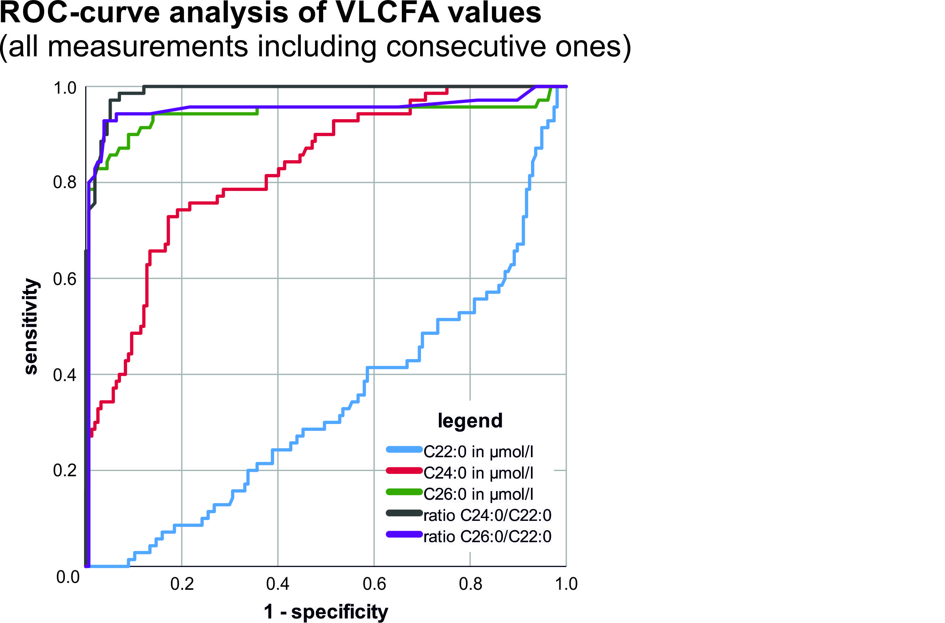

A ROC analysis of X-ALD (all 71 visits) vs. non-X-ALD cases (153 phenotypically similar cases) was performed using all five VLCFA measures (color coding see legend within the figure). Sensitivity and specificity were highest for the C24:0/C22:0 ratio followed by the C26:0/C22:0 ratio and the C26:0 absolute value.

Supplementary Figure 2: Correlation of total cholesterol serum levels and VLCFA values

Total cholesterol levels in mg/dl are shown in scatter blots with the VLCFA values C22:0 (A), C24:0 (B), C26:0 (C) and the ratios C24:0/C22:0 (D) and C26:0/C22:0 (E). The phenotypical control cases are shown by white circles, the X-ALD cases by filled black circles with each circle representing a single patient. Spearman’s rank correlation coefficient indicated a significant correlation for total cholesterol with C22:0 (r_{s} = 0.638; n=92; p<0.001), C24:0 (r_{s} = 0.521; n=92; p<0.001), and C26:0 (r_{s} = 0.365; n=92; p<0.001), but not for the ratios C24:0/C22:0 (r_{s} = 0.237; n=92; p=0.023), and C26:0/C22:0 (r_{s} = 0.192; n=92; p=0.067). A 2-tailed significance level of p < 0.002 was considered to be statistically significant (Bonferroni correction – see methods section for details). Further correlations can be found in table 4 together with the related p-values.

