**Table S1** ICD-8/101 codes and ATC to identify outcomes in the Danish registers

|  |  |  |
| --- | --- | --- |
| **Outcome** | **ICD-8/10** | **ATC** |
| **Asthma** | ICD-8: 493 (asthma)  ICD-10: J45 (asthma); J46 (status asthmaticus) | R03AC02, R03AC03, R03AC04, R03AC12 and R03AC13 (inhaled β2-agonists); R03BA01, R03BA02, and R03BA05 (inhaled glucocorticoids); R03AK06 and R03AK07 (fixed-dose combination of inhaled β2-agonists and glucocorticoids); R03DC03 (leukotriene receptor antagonists); R03DX05 (anti-IgE treatment) |
| **Allergic rhinitis** | CRITERIA 1: ≥1 hospital contact:  ICD-8: 507 (hay fever)  ICD-10: J30 (hay fever and allergic rhinitis); J30.1 (allergic rhinitis due to pollen); J30.2 (other seasonal allergic rhinitis); J30.3 (other allergic rhinitis); J30.4 (allergic rhinitis, unspecified) | CRITERIA 2 (based on ATC and ICD-10):  ≥ 2 filled prescriptions of: R01AD01 – R01AD60 (inhaled corticosteroids for rhinitis) and no hospital contact (ICD-10) for (exclusions criteria): J33 (nasal polyps), J330 (polyps in nasal cavity), J331 (polyp related sinus degeneration) J331A (woakes' ethmoiditis), J338 (nasal polyps, other), J338A (polypus sinus sphenoidalis), J339 (nasal polyps, unspecified), J010- J019 (acute sinusitis), J320 –J329 (chronic sinusitis)  CRITERIA 3 (based on ICD-10 and ATC)  ≥2 filled prescriptions of: R06A (antihistamines for systemic use) and no hospital contact (ICD-10) for: L29 (pruritus) or L50 (allergic urticaria)  CRITERIA 4 (based on ATC) ≥ 1 filled prescriptions of S01GX (medication for allergic conjunctivitis) |
| **Atopic eczema** | ICD-8: 691 (infantile eczema and related conditions)  ICD-10: L20 (atopic dermatitis); L308C (winter feet) |  |
| **Respiratory infections** | ICD-8: 032 (diphtheria); 075 (infectious mononucleosis); 381-383 (otitis media with and without mastoiditis, mastoiditis without otitis media); 460-465 (acute nasopharyngitis, sinusitis, pharyngitis, tonsillitis, laryngitis and tracheitis, upper respiratory infection of multiple or unspecified sites); 500-501 (hypertrophy of tonsils and adenoids, peritonsillar abscess); 503 (chronic sinusitis); 033 (whooping cough); 466 (acute bronchitis and bronchiolitis);  470-491 (influenza, pneumonia, bronchitis, unqualified, chronic bronchitis); 493 (asthma); 510 (empyema); 513 (abscess of lung)  ICD-10: A36 (diphtheria); B27 (infectious mononucleosis); H65–H72 (nonsuppurative otitis media, suppurative and unspecified otitis media, otitis media in diseases classified elsewhere, eustachian salpingitis and obstruction, other and unspecified disorders of eustachian tube, mastoiditis and related conditions, cholesteatoma of middle ear, perforation of tympanic membrane); J00–J06 (acute nasopharyngitis, sinusitis, pharyngitis, tonsillitis, laryngitis and tracheitis, obstructive laryngitis [croup] and epiglottitis, upper respiratory infections of multiple and unspecified sites); J32 (chronic sinusitis); J35–J36 (chronic diseases of tonsils and adenoids, peritonsillar abscess); A37 (whooping cough); J10–18 (influenza, pneumonia);  J20-21 (acute bronchitis, bronchiolitis); J22 (unspecified acute lower respiratory infection);  J45.9 (other and unspecified asthma); J85–J86 (abscess of lung and mediastinum, pyothorax) |  |
| Abbreviations: ICD, International Classification of Disease; ATC, Anatomical Therapeutic Chemical Classification  1ICd-8 available from 1977; ICD-10 available from 1994 | | |

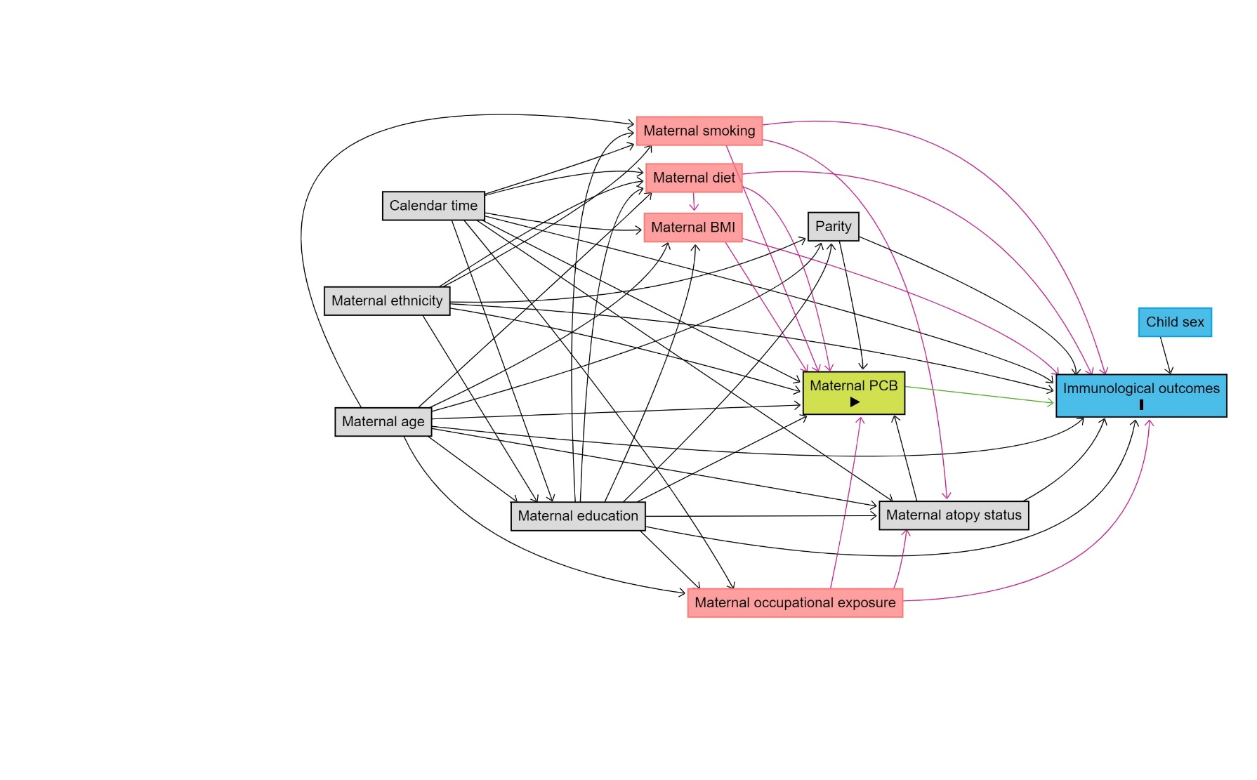**Figure S1** Directed Acyclic Graph. Red (unadjusted) and grey (adjusted) denote potential confounders, green denotes exposure, and blue outcome

**Table S2** Maternal exposure to PCB year1 in indoor air and hazard ratio of developing childhood asthma, allergic rhinitis, atopic eczema, and respiratory infections among 4314 children with information on maternal smoking

|  |  |  |  |  |
| --- | --- | --- | --- | --- |
|  | **Cases, n (%)** | **Adjusted3**  **HR2 (95% CI)** | **Cases4, n (%)** | **Adjusted4**  **HR5 (95% CI) + education** |
| **Asthma** | 722 (17) | 1.00 (1.00-1.01) | 693 (17) | 1.00 (0.99-1.01) |
| **Allergic rhinitis** | 752 (17) | 1.00 (1.00-1.01) | 698 (17) | 1.00 (1.00-1.01) |
| **Atopic eczema** | 46 (1) | 0.99 (0.97-1.01) | 46 (1) | 0.99 (0.96-1.01) |
| **Respiratory infections** | 1495 (35) | 1.00 (0.99-1.00) | 1419 (35) | 1.00 (0.99-1.01) |
| Abbreviations: PCB, Polychlorinated Biphenyls; HR, Hazard Ratios; CI, Confidence Intervals  1PCByear=PCBtotal ng/m3×year (PCBtotal = 5 × (PCB28, 52, 101, 118, 138, 153, 180)); 2HR and 95% CI per interquartile range increase (237 PCBtotal ng/m3×year) in PCByear; 3Adjusted for child age (timescale), maternal age at birth, ethnicity, atopy status, parity, calendar period, and maternal smoking; 4Additional adjusted for maternal education only available from 1981 (N=4065); 5HR and 95% CI per interquartile range increase (246 PCBtotal ng/m3×year) in PCByear. | | | | |

**Table S3** Maternal exposure to PCB year1 in indoor air and hazard ratio of developing childhood asthma, allergic rhinitis, atopic eczema, and respiratory infections among 1868 children with information on maternal Body Mass Index

|  |  |  |  |  |
| --- | --- | --- | --- | --- |
|  | **Cases, n (%)** | **Adjusted3**  **HR2 (95% CI)** | **Cases4, n (%)** | **Adjusted4**  **HR5 (95% CI) + education** |
| **Asthma** | 270 (14) | 1.00 (1.00-1.01) | 260 (15) | 1.00 (1.00-1.01) |
| **Allergic rhinitis** | 180 (10) | 1.01 (1.00-1.01) | 171 (10) | 1.01 (1.00-1.02) |
| **Atopic eczema** | 23 (1) | 0.98 (0.95-1.01) | 23 (1) | 0.98 (0.95-1.01) |
| **Respiratory infections** | 718 (38) | 1.00 (0.99-1.01) | 691 (39) | 1.00 (0.99-1.01) |
| Abbreviations: PCB, Polychlorinated Biphenyls; HR, Hazard Ratios; CI, Confidence Intervals  1PCByear=PCBtotal ng/m3×year (PCBtotal = 5 × (PCB28, 52, 101, 118, 138, 153, 180)); 2HR and 95% CI per interquartile range increase (219PCBtotal ng/m3×year) in PCByear; 3Adjusted for child age (timescale), maternal age at birth, ethnicity, atopy status, parity, calendar period, and maternal Body Mass Index; 4Additional adjusted for maternal education only available from 1981 (N=1782); 5HR and 95% CI per interquartile range increase (231 PCBtotal ng/m3×year) in PCByear. | | | | |

**Table S4** Maternal exposure to PCB year1 in indoor air and hazard ratio of developing childhood asthma, allergic rhinitis, atopic eczema, and respiratory infections among 7982 children stratified by sex of the child

|  |  |  |  |  |  |
| --- | --- | --- | --- | --- | --- |
|  | **Cases, n (%)** | **Crude**  **HR2 (95% CI)** | **Adjusted3**  **HR2 (95% CI)** | **Cases4, n (%)** | **Adjusted4**  **HR5 (95% CI) + education** |
| **Asthma** | | | | | |
| Girls | 517 (13) | 1.00 (1.00-1.01) | 1.00 (1.00-1.01) | 453 (14) | 1.00 (1.00-1.01) |
| Boys | 575 (14) | 1.00 (1.00-1.01) | 1.00 (0.99-1.01) | 521 (16) | 1.00 (0.99-1.01) |
| **Allergic rhinitis** | | | | | |
| Girls | 644 (16) | 1.00 (1.00-1.01) | 1.00 (1.00-1.01) | 539 (17) | 1.00 (0.99-1.01) |
| Boys | 666 (16) | 1.00 (1.00-1.01) | 1.00 (1.00-1.01) | 578 (18) | 1.00 (1.00-1.01) |
| **Atopic eczema** | | | | | |
| Girls | 31 (1) | 1.01 (0.99-1.02) | 1.01 (0.99-1.02) | 29 (1) | 1.01 (0.99-1.03) |
| Boys | 38 (1) | 0.93 (0.88-0.99) | 0.94 (0.88-1.00) | 30 (1) | 0.95 (0.90-1.00) |
| **Respiratory infections** | | | | | |
| Girls | 1167 (30) | 1.00 (0.99-1.00) | 1.00 (0.99-1.00) | 979 (31) | 1.00 (0.99-1.00) |
| Boys | 1380 (34) | 1.00 (1.00-1.01) | 1.00 (1.00-1.01) | 1147 (35) | 1.00 (1.00-1.01) |
| Abbreviations: PCB, Polychlorinated Biphenyls; HR, Hazard Ratios; CI, Confidence Intervals; IQR, Interquartile range  1PCByear=PCBtotal ng/m3×year (PCBtotal = 5 × (PCB28, 52, 101, 118, 138, 153, 180)); 2HR and 95% CI per interquartile range increase (214 for girls and 203 for boys PCBtotal ng/m3×year) in PCByear; 3Adjusted for child age (timescale), maternal age at birth, ethnicity, atopy status, parity, and calendar period; 4Additional adjusted for maternal education only available from 1981 (N=6453); 5HR and 95% CI per interquartile range increase (222 for girls and 217 for boys PCBtotal ng/m3×year) in PCByear. | | | | | |

**Table S5** Maternal exposure to PCB year1 in indoor air and hazard ratio of developing childhood asthma among 7284 children 3-20 years of age

|  |  |  |  |  |  |
| --- | --- | --- | --- | --- | --- |
|  | **Cases, n (%)** | **Crude**  **HR**2 **(95% CI)** | **Adjusted3**  **HR**2 **(95% CI)** | **Cases4, n (%)** | **Adjusted4**  **HR5 (95% CI) + education** |
| **Asthma** | 821 (11) | 1.01 (1.00-1.01) | 1.00 (1.00-1.01) | 716 (12) | 1.00 (1.00-1.01) |
| Abbreviations: PCB, Polychlorinated Biphenyls; HR, Hazard Ratios; CI, Confidence Intervals  1PCByear=PCBtotal ng/m3×year (PCBtotal = 5 × (PCB28, 52, 101, 118, 138, 153, 180)); 2HR and 95% CI per interquartile range increase (215 PCBtotal ng/m3×year) in PCByear; 3Adjusted for child age (timescale), maternal age at birth, ethnicity, atopy status, parity, and calendar period; 4Additional adjusted for maternal education only available from 1981 (N=5891); 5HR and 95% CI per interquartile range increase (227 PCBtotal ng/m3×year) in PCByear. | | | | | |

**Table S6** Maternal exposure to PCB year1 in indoor air and hazard ratio of developing childhood asthma, allergic rhinitis, atopic eczema, and respiratory infections among 7354 children2 with no stay in contaminated apartments in the first five years of life

|  |  |  |  |  |  |
| --- | --- | --- | --- | --- | --- |
|  | **Cases, n (%)** | **Crude**  **HR3 (95% CI)** | **Adjusted4**  **HR3 (95% CI)** | **Cases5, n (%)** | **Adjusted5**  **HR6 (95% CI) + education** |
| **Asthma** | 1014 (14) | 1.00 (1.00-1.01) | 1.00 (1.00-1.00) | 908 (15) | 1.00 (0.99-1.00) |
| **Allergic rhinitis** | 1200 (16) | 1.00 (1.00-1.01) | 1.00 (1.00-1.01) | 1033 (17) | 1.00 (1.00-1.01) |
| **Atopic eczema** | 61 (1) | 0.99 (0.97-1.01) | 0.99 (0.97-1.01) | 51 (1) | 0.99 (0.97-1.01) |
| **Respiratory infections** | 2356 (32) | 1.00 (1.00-1.00) | 1.00 (1.00-1.00) | 1983 (33) | 1.00 (1.00-1.00) |
| Abbreviations: PCB, Polychlorinated Biphenyls; HR, Hazard Ratios; CI, Confidence Intervals  1PCByear=PCBtotal ng/m3×year (PCBtotal = 5 × (PCB28, 52, 101, 118, 138, 153, 180)); 2628 children with postnatal exposure excluded; 3HR and 95% CI per interquartile range increase (132 PCBtotal ng/m3×year) in PCByear; 4Adjusted for child age (timescale), maternal age at birth, ethnicity, atopy status, parity, and calendar period; 5Additional adjusted for maternal education only available from 1981 (N=6001); 6HR and 95% CI per interquartile range increase (146 PCBtotal ng/m3×year) in PCByear. | | | | | |

**Table S7** Maternal exposure to PCB year1 in indoor air and hazard ratio of developing childhood asthma and allergic rhinitis among 3804 children born from 1995

|  |  |  |  |  |  |
| --- | --- | --- | --- | --- | --- |
|  | **Cases, n (%)** | **Crude**  **HR**2 **(95% CI)** | **Adjusted3**  **HR**2 **(95% CI)** | **Cases4, n (%)** | **Adjusted4**  **HR5 (95% CI) + education** |
| **Asthma** | 624 (16) | 1.00 (0.99-1.01) | 1.00 (1.00-1.01) | 594 (17) | 1.00 (0.99-1.01) |
| **Allergic rhinitis** | 623 (16) | 1.00 (1.00-1.01) | 1.00 (1.00-1.01) | 577 (16) | 1.00 (1.00-1.01) |
| Abbreviations: PCB, Polychlorinated Biphenyls; HR, Hazard Ratios; CI, Confidence Intervals  1PCByear=PCBtotal ng/m3×year (PCBtotal = 5 × (PCB28, 52, 101, 118, 138, 153, 180)); 2HR and 95% CI per interquartile range increase (241 PCBtotal ng/m3×year) in PCByear; 3Adjusted for child age (timescale), maternal age at birth, ethnicity, atopy status, parity, and calendar period; 4Additional adjusted for maternal education (N=3584); 5HR and 95% CI per interquartile range increase (247 PCBtotal ng/m3×year) in PCByear. | | | | | |