**Supplementary material**

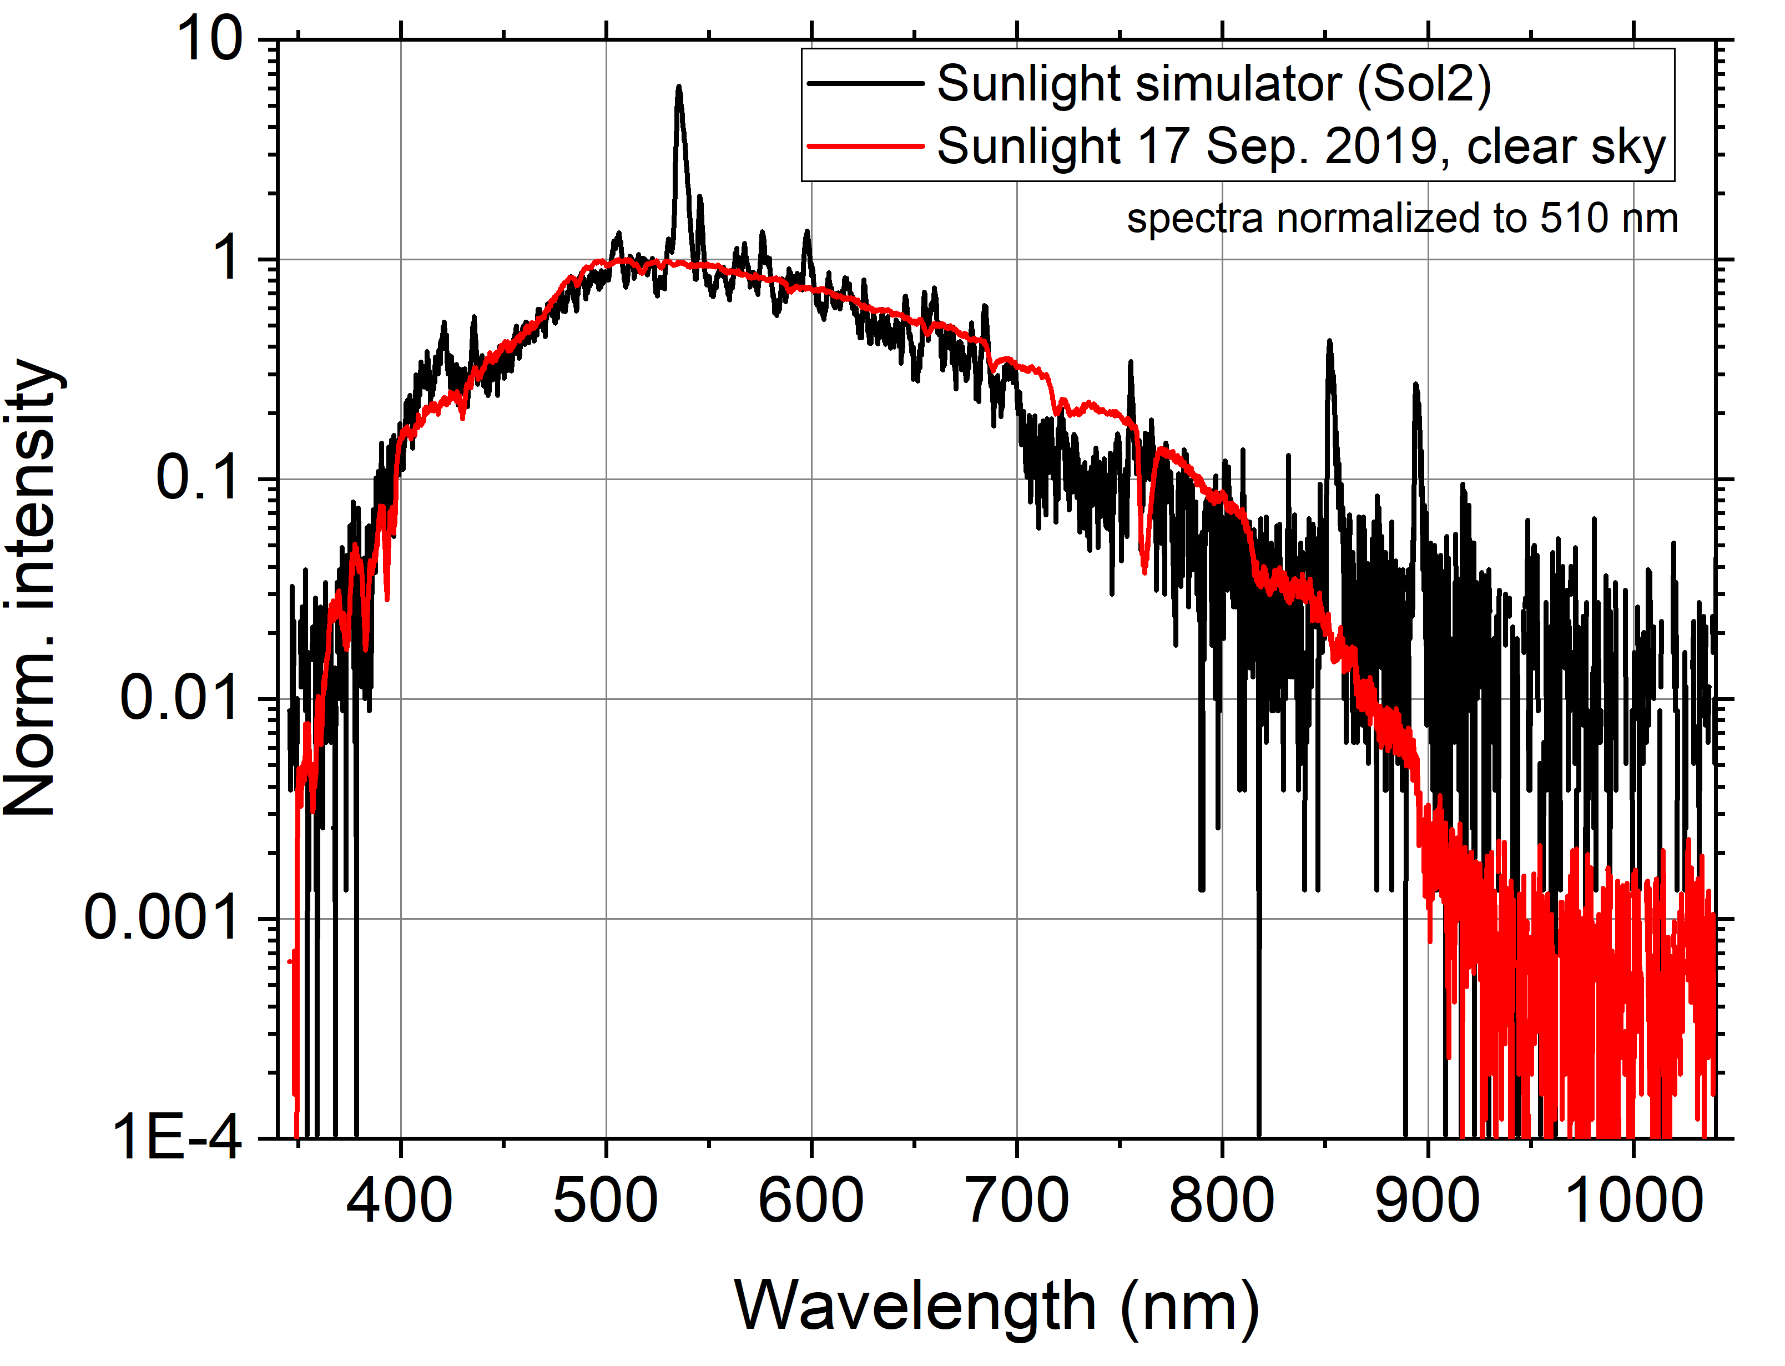

Fig. A1. Measured spectrum of sunlight (cloudless day at noon in Salzburg, Austria) and the emission spectrum of the SOL2 solar simulator including a glass filter. The spectral intensities are normalized to the wavelength of 510 nm for comparison. The SOL2 solar simulator is used for laboratory bleaching, and its filtered emission spectrum lies very close to the measured sunlight spectrum.



Fig. A2. Thermally assisted optically stimulated luminescence (TA-OSL) decay curves of display glasses depending on the elevated temperature of (a) 150 °C, (b) 250 °C, and (c) 350 °C. The first measurement is a native signal of the fresh sample without irradiation and the second to seventh measurements are signals after 1 Gy irradiation for repeated TA-OSL measurements.