Supplementary material

Trajectories of Body Mass Index before the Diagnosis of Type 2 Diabetes: The Rotterdam Study

Table S1. Characteristics of study participants by subgroup at their first clinical examination.
Figure S1. Trajectories of body mass index and waist circumference.
Figure S2. Trajectories of fasting plasma glucose, insulin, homeostatic model assessment –insulin resistance (HOMA-IR) and homeostatic model assessment –beta cell function (HOMA-%B)
Figure S3. Trajectories of total cholesterol, high density lipoprotein (HDL) cholesterol, low density lipoprotein (LDL) cholesterol, triglycerides, systolic blood pressure and diastolic blood pressure.
Figure S4. Trajectories of 8-year diabetes risk (ACC/AHA, American College of Cardiology/American Heart Association) for a man (Figure S4A) and a woman (Figure S4B) of 65 years of age.

Table S1: Characteristics of study participants at their first clinical examination
 | Individuals developing diabetes during follow-up (n = 565) |  |  | Individuals free of diabetes during follow-up (n = 5658)
 | Progressive Weight loss | Progressive weight gainers | Persistently high BMI | Diabetes-free | Non-diabetes mortality
 | n = 59 | n = 481 | n = 25 | n = 1891 | n = 3767
Time before diagnosis/last visit, years | 12.3 (5.4) | 9.9 (5.1) | 11.9 (4.9) | 20.0 (1.9) | 11.1 (6.0)
Age, years | 67.2 (7.2) | 66.4 (7.0) | 64.5 (5.2) | 62.2 (5.0) | 72.4 (8.5)
Women (%) | 30 (50.8) | 282 (58.6) | 20 (80.0) | 1230 (65.0) | 2119 (56.3)
Body mass index, kg/m² | 26.6 (3.1) | 28.0 (3.2) | 35.4 (5.8) | 25.9 (3.3) | 26.1 (3.7)
Waist circumference, cm | 92.7 (10.0) | 94.1 (10.0) | 103.61(13.3) | 87.3 (10.5) | 91.0 (11.1)
Systolic blood pressure, mmHg | 142.0 (25.2) | 141.3 (20.1) | 143.0 (22.3) | 131.4 (19.8) | 141.7 (22.3)
Diastolic blood pressure, mmHg | 72.2 (11.4) | 75.3 (11.1) | 77.1 (9.9) | 73.6 (10.4) | 73.7 (11.9)
Antihypertensive treatment† (%) | 11 (21.2) | 107 (26.6) | 7 (38.9) | 171 (10.8) | 598 (18.8)
Lipid lowering medication (%) | 5 (10.6) | 55 (21.2) | 4 (21.1) | 231 (14.6) | 179 (11.3)
Current smoker (%) | 17 (28.8) | 109 (23.2) | 4 (16.0) | 345 (18.5) | 918 (25.4)
Total cholesterol (mmol/L) | 5.7 (1.0) | 5.7 (0.9) | 5.6 (0.8) | 5.9 (0.9) | 5.7 (1.0)
Glucose† (mmol/L) | 7.5 (3.2) | 6.7 (1.3) | 6.7 (1.4) | 5.5 (0.6) | 5.6 (0.7)
Insulin† (pmol/L) | 87.5 (68.5) | 115.5 (117.0) | 167.0 (98.6) | 73.9 (57.6) | 76.5 (47.8)
HDL cholesterol† (mmol/L) | 1.2 (0.3) | 1.2 (0.3) | 1.1 (0.2) | 1.4 (0.3) | 1.4 (0.4)
LDL cholesterol† (mmol/L) | 3.8 (0.9) | 3.6 (0.8) | 3.5 (0.9) | 3.8 (0.8) | 3.7 (0.9)
Triglycerides† (mmol/L) | 1.7 (1.0) | 1.8 (0.9) | 2.0 (0.6) | 1.4 (0.6) | 1.4 (0.6)
HOMA-IR† (units) | 183.9 (153.2) | 216.1 (255.7) | 297.5 (187.4) | 112.2 (106.0) | 117.0 (83.8)
HOMA-%B† (units) | 1453.2 (1129.4) | 2033.0 (1784.0) | 3096.9 (1989.8) | 1584.7 (1068.1) | 1629.9 (976.8)
Values are mean ± SD, numbers (percentages)
Abbreviations
HDL, high density lipoprotein; HOMA-IR: homeostatic model assessment –insulin resistance; HOMA-%B: homeostatic model assessment –beta cell function; LDL, low density lipoprotein.
† Fasting measurements of lipids and glucose and treatment were available in the third, fourth and fifth visits of the original Rotterdam Study cohort.
The mean values of the characteristics of study participants in Table S1 are based on single measures at the baseline/first visit in the Rotterdam Study. This could explain the occasional observed differences with the predicted mean values in the figures for the latent class trajectory analyses.

Figure S1. Trajectories of body mass index and waist circumference during 22 years of follow-up until diagnosis of type 2 diabetes, death or censoring from the study. The figures represent a hypothetical woman of 65 years on glucose-lowering treatment. Light blue “progressive overweight” (including 85.1% of diabetes patients); red “persistently high BMI” (n= 6.4%); dark blue “progressive weight loss” (n= 25, 5.8%); grey “diabetes-free”; black “non-diabetes mortality”.

Figure S2. Trajectories of fasting plasma glucose, insulin, homeostatic model assessment –insulin resistance (HOMA-IR), homeostatic model assessment –beta cell function (HOMA-%B) during 14 years of follow-up until diagnosis of type 2 diabetes, death or censoring from the study. The figures represent a hypothetical woman of 65 years on glucose-lowering treatment. Light blue “progressive overweight” (including 85.1% of diabetes patients); red “persistently high BMI” (n= 6.4%); dark blue “progressive weight loss” (n= 25, 5.8%); grey “diabetes-free”; black “non-diabetes mortality”.

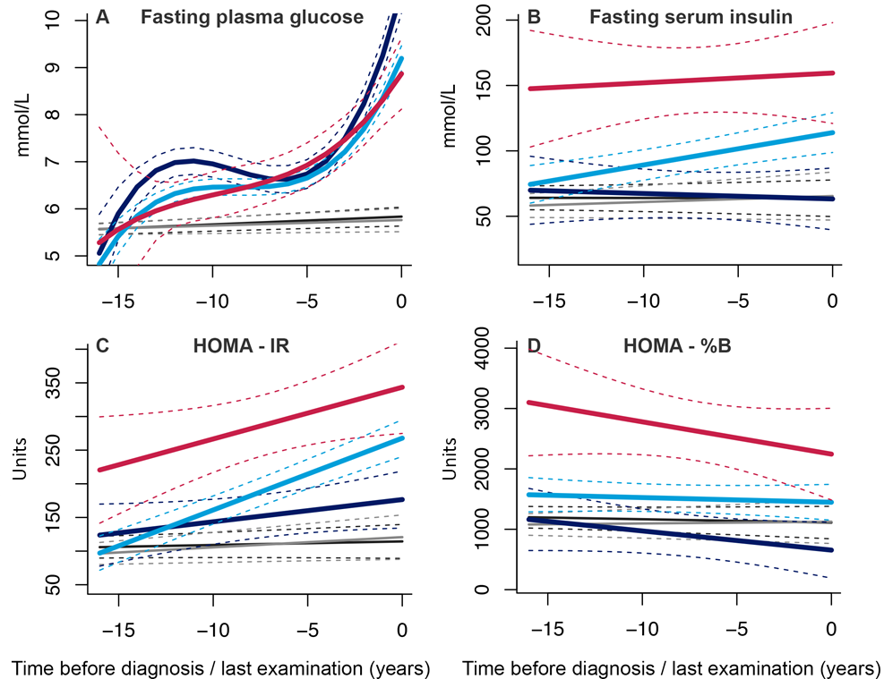

Figure S3. Trajectories of total cholesterol, high density lipoprotein (HDL) cholesterol, low density lipoprotein (LDL) cholesterol, triglycerides, systolic blood pressure and diastolic blood pressure. The figures represent a hypothetical woman of 65 years on glucose-lowering treatment. Light blue “progressive overweight” (including 85.1% of diabetes patients); red “persistently high BMI” (n= 6.4%); dark blue “progressive weight loss” (n= 25, 5.8%); grey “diabetes-free”; black “non-diabetes mortality”.

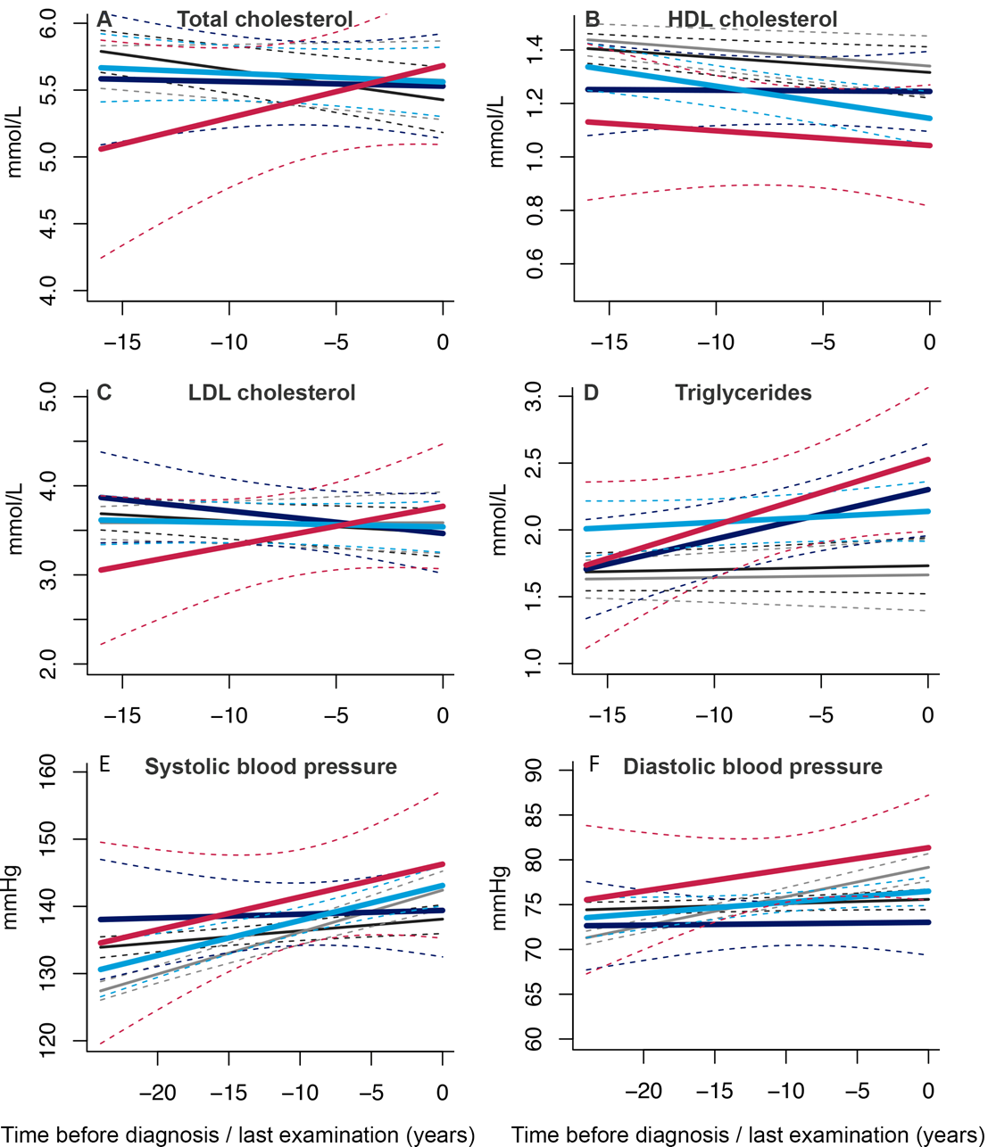

Figure S4. Trajectories of 8-year diabetes risk (ACC/AHA, American College of Cardiology/American Heart Association) during 22 years of follow-up until diagnosis of type 2 diabetes, death or censoring from the study. The figures represent a hypothetical man (Figure S4A)/woman (Figure S4B) of 65 years on glucose-lowering treatment. Light blue “progressive overweight” (including 85.1% of diabetes patients); red “persistently high BMI” (n= 6.4%); dark blue “progressive weight loss” (n= 25, 5.8%); grey “diabetes-free”; black “non-diabetes mortality”.

A
B

