Supplementary materials: Sex hormone-binding globulin may explain sex differences for glucose homeostasis and incidence of type 2 diabetes: The KORA study

Results-sensitivity analysis- Supplementary information 1

We additionally adjusted the association between sex (women vs men) and SHBG and between sex and glucose- and insulin-related traits for other cardiovascular risk factors as model 3. Similar to previous models, women had lower fasting glucose levels and higher SHBG levels than men (Supplementary Table 4). We also found an inverse association between SHBG and fasting glucose levels in this model (Supplementary Table 5). No association was observed between sex (women vs men) and SHBG with incidence of T2D in the third model (Supplementary Table 6). Also, we observed the mediatory role of SHBG on glucose levels while adjusting for further cardiovascular risk factors as well (PM 30%, CI: 22-39%, Supplementary Table 7).
We also performed another sensitivity analysis by adding testosterone to model 1 and 2 (Supplementary Table 8). PM of SHBG for fasting glucose levels was estimated up to 52% in model 1 and 53% in model 2. Also, PM of SHBG for T2D was up to 36% in model 1 and 31% in model 2.
Moreover, we observed the potential mediatory role of SHBG on the sex differences in fasting glucose levels in both age categories based on median of age (Supplementary Table 9). For individuals younger than 53 years old, the PM was 29% (CI:17-40%) in model 1 and the PM 30% (CI:19-43%) in model 2, whereas for those aged 53 and older, the PM was lower (PM 22%, CI:12-36% in model 1 and PM 19%, CI:10-34% in model 2).
Additionally, findings of mediation analysis of SHBG on the association between sex (women vs men) and fasting glucose levels in different categories of BMI showed a PM of 28% (CI:12-49%) in model 1 and PM 29% (CI:12-55%) in model 2 in normal weight individuals while the PM by SHBG for fasting glucose levels were 17% (CI:09-28%) in model 1 and 18% (CI:10-31%) in model 2 in overweight and obese individuals (Supplementary Table 10).

Supplementary Table 1. Association of sex (women vs men [Reference]) with SHBG and glucose- and insulin-related traits among participants of KORA F4.
Variable | ß (95 % CI) Model 1 |  | ß (95 % CI) Model 2
SHBG (nmol/l) | 0.47 (0.43, 0.52) |  | 0.47 (0.42, 0.51)
Glucose- and insulin-related traits
Fasting glucose levels (mg/dl) | -5.24 (-6.01, -4.47) |  | -4.94 (-5.77, -4.11)
Fasting insulin levels (µU/ml) | -0.10 (-0.15, -0.06) |  | -0.13 (-0.18, -0.08)
2h-glucose levels (mg/dl) | -2.13 (-4.66, 0.39) |  | -2.50 (-5.21, 0.19)
HOMA-IR | -0.16 (-0.21, -0.11) |  | -0.18 (-0.23, -0.13)
Model 1: Age.
Model 2: Model 1 + smoking + alcohol consumption + physical activity.
Fasting insulin levels, SHBG and HOMA-IR are log-transformed.
Abbreviations: SHBG, sex hormone-binding globulin; HOMA-IR, homeostatic model assessment for insulin resistance.

Supplementary Table 2. Association of SHBG with glucose- and insulin-related traits among participants of KORA F4.
Variable | ß (95 % CI) model 1 | ß (95 % CI) model 2
Fasting glucose levels (mg/dl) | -3.25 (-4.08, -2.42) | -3.22 (-4.05, -2.38)
Fasting insulin levels (µU/ml) | -0.36 (-0.40, -0.31) | -0.35 (-0.40, -0.31)
2h-glucose levels (mg/dl) | -11.39 (-14.09, -8.69) | -11.04 (-13.75, -8.33)
HOMA-IR | -0.39 (-0.44, -0.34) | -0.39 (-0.44, -0.34)
Model 1: Age.
Model 2: Model 1+ smoking+ alcohol consumption+ physical activity.
Fasting insulin levels, SHBG and HOMA-IR are log-transformed.
Abbreviations: SHBG, sex hormone-binding globulin; HOMA-IR, homeostatic model assessment for insulin resistance.

Supplementary Table 3. Association of sex (women vs men [Reference]) and SHBG with
incidence of T2D between KORA F4 and FF4.
Variable | OR (95% CI) model 1 | OR (95% CI) model 2
Sex (women vs men [Reference]) | 0.67 (0.42, 1.05) | 0.56 (0.34, 0.92)
SHBG (nmol/l) | 0.38 (0.23, 0.62) | 0.37 (0.22, 0.60)
Model 1: Age.
Model 2: Model 1+ smoking+ alcohol consumption+ physical activity.
SHBG is log-transformed.
Abbreviations: OR, odds ratio; T2D; type 2 diabetes; SHBG, sex hormone-binding globulin.

Supplementary Table 4. Association of sex (women vs men [Reference])
with SHBG and glucose- and insulin-related traits among participants of KORA F4 (model 3).
Variable | ß (95 % CI) model 3
SHBG (nmol/l) | 0.31 (0.27, 0.36)
Glucose- and insulin-related traits
Fasting glucose levels (mg/dl) | -1.68 (-2.62, -0.73)
Fasting insulin levels (µU/ml) | 0.14 (0.10, 0.19)
2h-glucose levels (mg/dl) | 7.05 (3.94, 10.15)
HOMA-IR | 0.12 (0.07, 0.17)

Model 3: Model 2 + waist circumference + SBP + antihypertensive
medications + lipid lowering medications + total cholesterol + CRP + TSH.
SHBG, fasting insulin and HOMA-IR are log-transformed.
Abbreviations: SHBG, sex hormone-binding globulin; HOMA-IR,
homeostatic model assessment for insulin resistance.

Supplementary Table 5. Association of SHBG with
glucose- and insulin-related traits among participants of KORA F4 (model 3).

Variable | ß (95 % CI) model 3
Fasting glucose levels (mg/dl) | -1.46 (-2.34, -0.59)
Fasting insulin levels (µU/ml) | -0.14 (-1.91, -0.10)
2h-glucose levels (mg/dl) | -5.98 (-8.85, -3.12)
HOMA-IR | -0.16 (-0.21, -0.11)

Model 3: Model 2+ waist circumference + SBP + antihypertensive
Medications + lipid lowering medications + total cholesterol + CRP + TSH.
SHBG, fasting insulin levels, and HOMA-IR are log-transformed.
Abbreviations: SHBG, sex hormone-binding globulin; HOMA-IR,
homeostatic model assessment for insulin resistance.

Supplementary Table 6. Association of sex (women vs men [Reference])
and SHBG with incidence of T2D between KORA F4 and FF4. (model 3).

Variable | OR (95% CI) model 3
Sex (women vs men [Reference]) | 0.92 (0.51, 1.63)
SHBG (nmol/l) | 0.61 (0.35, 1.04)
Model 3: Model 2+waist circumference+ SBP+ antihypertensive
medications+ lipid lowering medications+ total cholesterol + CRP+ TSH.
SHBG is log-transformed.
Abbreviations: OR, odds ratio; T2D; type 2 diabetes; SHBG, sex hormone-binding globulin;
SBP, systolic blood pressure; TSH, thyroid stimulating hormone.

Supplementary Table 7. Mediation analysis of SHBG on
the association between (women vs men [Reference]) and
glucose- and insulin-related traits (model 3).
Effects | ß (95% CI) model 3 | p-value
Fasting glucose levels
DE | -3.68 (-4.53, -2.86) | <0.001
IE | -1.56 (-1.99, -1.18) | <0.001
TE | -5.24 (-6.02, -4.52) | <0.001
PM | 0.30 (0.22-0.39) | <0.001
Fasting insulin levels
DE | 0.06 (0.01, 0.12) | 0.01
IE | -0.17 (-0.20, -0.14) | <0.001
TE | -0.10 (-0.15, -0.06) | <0.001
PM | 1.6 (1.12, 2.98) | <0.001
2h-glucose levels
DE | 3.33 (0.50, 6.34) | 0.05
IE | -5.47 (-6.71, -4.18) | <0.001
TE | -2.13 (-4.36, 0.59) | 0.08
PM | 2.56 (-4.66, 29.69) | 0.08
HOMA-IR
DE | 0.02 (-0.02, 0.07) | 0.35
IE | -0.18 (-0.22, -0.16) | <0.001
TE | -0.16 (-0.21, -0.11) | <0.001
PM | 1.16 (0.86-1.59) | <0.001

Model 3: Model 2+ waist circumference + SBP + antihypertensive
medications + lipid lowering medications + total cholesterol + CRP + TSH.
SHBG, fasting insulin levels and HOMA-IR are log-transformed.
Abbreviations:DE, direct effect; IE, indirect effect; TE, total effect; PM, proportion mediated.

Supplementary Table 8. Mediation analysis of SHBG on the association between (women vs men [Reference]) and fasting glucose levels and T2D with adding testosterone in the main models.

Mediation analysis of SHBG and fasting glucose levels
Effects | ß (95% CI) model 1 | p-value | ß (95% CI) model 2 | p-value
DE | -2.85 ( -5.42, -0.48) | 0.02 | -2.60 (-4.88, -0.45) | 0.03
IE | -3.1 (-4.26, -2.15) | <0.001 | -3.00 (-4.20, -2.12) | <0.001
TE | -5.96 (-8.47, -3.79) | <0.001 | -5.6 (-7.9, -3.78) | <0.001
PM | 0.52 (0.32, 0.88) | <0.001 | 0.53 (0.32, 0.89) | <0.001
Mediation analysis of SHBG and T2D
Effects | OR (95% CI) model 1 | p-value | OR (95% CI) model 2 | p-value
DE | 0.49 (0.18, 1.2) | 0.15 | 0.43 (0.16, 0.99) | 0.04
IE | 0.45 (0.28, 0.65) | <0.001 | 0.43 (0.27, 0.68) | <0.001
TE | 0.22 (0.08, 0.51) | 0.01 | 0.19 (0.08, 0.48) | 0.01
PM | 0.36 (0.10, 1.17) | 0.01 | 0.31 (0.08, 0.84) | 0.01
Model 1: Age + testosterone.
Model 2: Model 1+ smoking + alcohol consumption + physical activity + testosterone.
SHBG is log-trasnformed.
Abbreviations: OR, odds ratio; SHBG, sex hormone-binding globulin; T2D, type 2 diabetes; DE, direct effect; IE, indirect effect; TE, total effect; PM, proportion mediated.

Supplementary Table 9. Mediation analysis of SHBG on the association between (women vs men [Reference]) and fasting glucose levels stratified by median age (53 years).
Mediation analysis for individuals < 53 years
Effects | ß (95% CI) model 1 | p-value | ß (95% CI) model 2 | p-value
DE | -4.44 (-5.46, -3.30) | <0.001 | -4.18 (-5.33, -2.99) | <0.001
IE | -1.82 (2.40, -1.13) | <0.001 | -1.79 (-2.52, -1.10) | <0.001
TE | -6.27 (-7.06, -5.25) | <0.001 | -5.97 (-6.90, -5.01) | <0.001
PM | 0.29 (0.17-0.40) | <0.001 | 0.30 (0.19-0.43) | <0.001
Mediation analysis for individuals >= 53 years
Effects | ß (95% CI) model 1 | p-value | ß (95% CI) model 2 | p-value
DE | -3.28 (-4.45, -1.99) | <0.001 | -3.33 (-4.71, -2.21) | <0.001
IE | -0.93 (-1.31, -0.51) | <0.001 | -0.82 (-1.28, -0.43) | <0.001
TE | -4.22 (-5.40, -3.03) | <0.001 | -4.16 (-5.47, -3.07) | <0.001
PM | 0.22 (0.12-0.36) | <0.001 | 0.19 (0.10-0.34) | <0.001
Model 1: Age.
Model 2: Model 1+ smoking + alcohol consumption + physical activity.
SHBG is log-transformed.
Abbreviations: SHBG, sex hormone-binding globulin; DE, direct effect; IE, indirect effect; TE, total effect; PM, proportion mediated.

Supplementary Table 10. Mediation analysis of SHBG on the association between (women vs men [Reference]) and fasting glucose levels stratified by BMI.
Mediation analysis for individuals with normal body weight (BMI < 25 kg/m²)
Effects | ß (95% CI) model 1 | p-value | ß (95% CI) model 2 | p-value
DE | -3.28 (-4.72, -1.94) | <0.001 | -3.13 (-4.61, -1.55) | <0.001
IE | -1.33 (-2.06, -0.62) | <0.001 | -1.30 (-2.14, -0.50) | <0.001
TE | -4.61 (-5.73, -3.54) | <0.001 | -4.43 (-5.75, -3.28) | <0.001
PM | 0.28 (0.12, 0.49) | <0.001 | 0.29 (0.12, 0.55) | <0.001
Mediation analysis for overweight and obese individuals (BMI >= 25 kg/m²)
Effects | ß (95% CI) model 1 | p-value | ß (95% CI) model 2 | p-value
DE | -3.85 (-4.65, -2.81) | <0.001 | -3.48 (-4.51, -2.40) | <0.001
IE | -0.82 (-1.30, -0.43) | <0.001 | -0.81 (-1.17, -0.44) | <0.001
TE | -4.68 (-5.51, -3.60) | <0.001 | -4.29 (-5.27, -3.22) | <0.001
PM | 0.17 (0.09, 0.28) | <0.001 | 0.18 (0.10, 0.31) | <0.001
Model 1: adjusted for age.
Model 2: Model 1+ smoking + alcohol consumption + physical activity.
SHBG is log-transformed.
Abbreviations: SHBG, sex hormone-binding globulin; DE, direct effect; IE, indirect effect; TE, total effect; PM, proportion mediated.

Supplementary Table 11. Mediation analysis of SHBG on the association between (women vs men [Reference]) and incidence of T2D (model 3).
Effects | OR (95% CI) model 3 | P value
NDE | 1.02 (0.59, 1.60) | 0.91
NIE | 0.87 (0.73, 1.05) | 0.15
TE | 0.89 (0.51, 1.50) | 0.69
PM | 1.27 (-8.4, 10.9) | 0.73

Model 3: Model 2 + waist circumference + SBP + antihypertensive
medications + lipid lowering medications + total cholesterol + CRP + TSH.
SHBG is log-transformed.
Abbreviations: OR, odds ratio; T2D, type 2 diabetes; SHBG, sex hormone-binding globulin;
DE, direct effect; IE, indirect effect; TE, total effect; PM, proportion mediated.

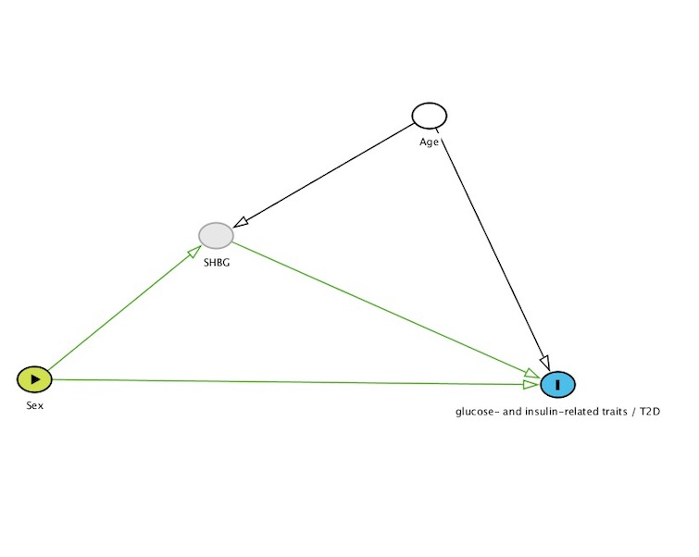

Supplementary Figure 1. Directed acyclic graph (DAG) for the association of sex through, sex hormone binding globulin (SHBG), on glucose- and insulin-related traits / type 2 diabetes (T2D). Study DAG for model 1, exposure = Sex, mediator = SHBG, outcome = glucose- and insulin-related traits / T2D. for model 1, adjustment = age.

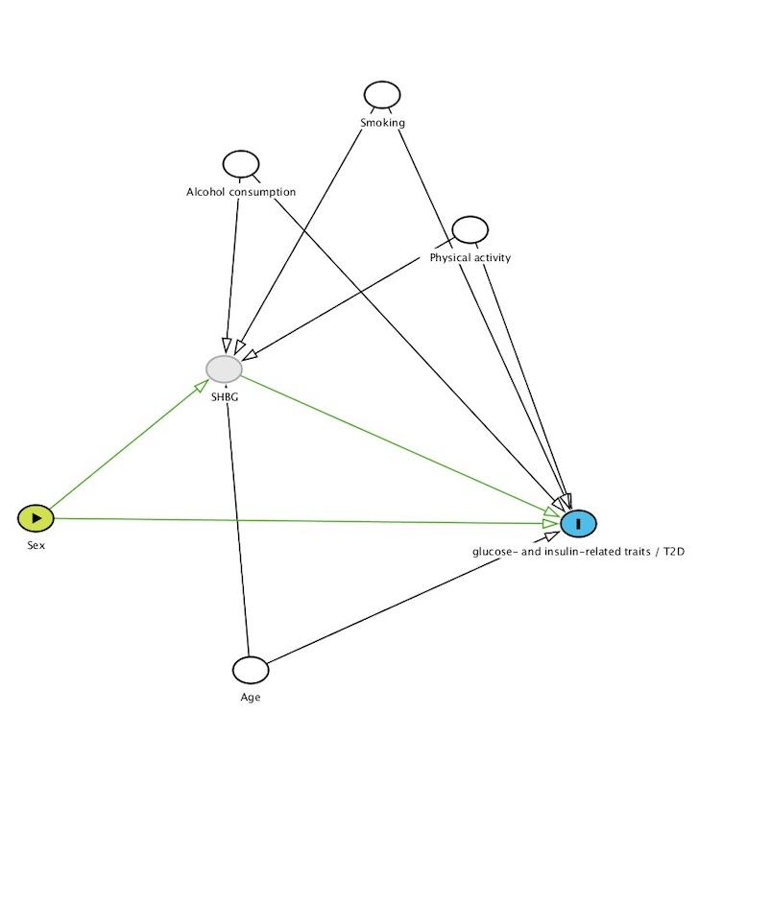
Supplementary Figure 2. Directed acyclic graph (DAG) for the association of sex, through sex hormone binding globulin (SHBG), on glucose- and insulin-related traits / type 2 diabetes (T2D). Study DAG for model 2, exposure = sex, mediator = SHBG, outcome= glucose- and insulin-related traits / T2D, adjustment variables = age + alcohol consumption + smoking + physical activity.

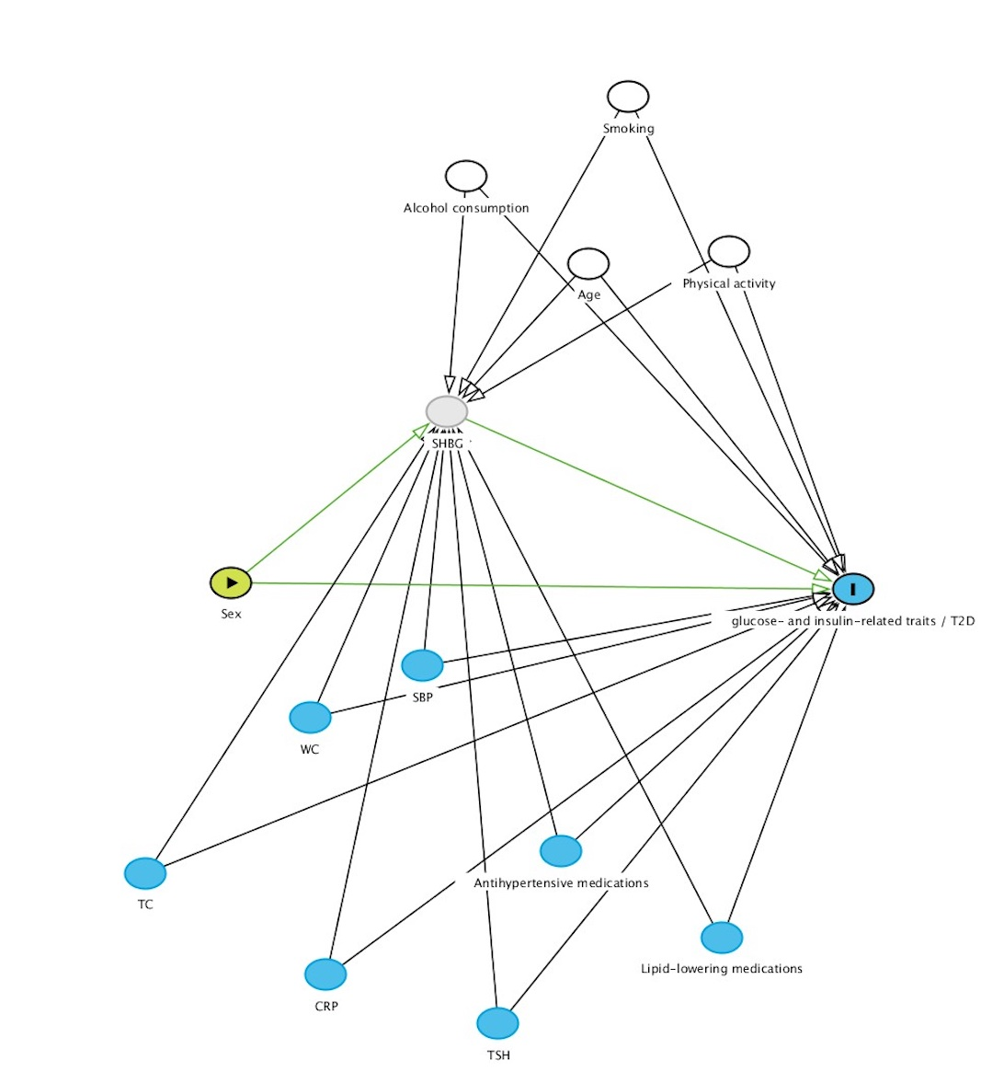

Supplementary Figure 3. Directed acyclic graph (DAG) for the association of sex, through sex hormone binding globulin (SHBG), on glucose- and insulin-related traits / type 2 diabetes (T2D). Study DAG for model 3, further adjustments for possible mediators (variables in blue). Exposure = Sex, mediator = SHBG, outcome = glucose- and insulin-related traits / T2D, adjustment variables = age + alcohol consumption + smoking, physical activity + waist circumference + SBP + antihypertensive medications+ lipid lowering medications + total cholesterol + CRP+ TSH.

