Running Title Page
Running Title:
Growth patterns associated with islet autoimmunity
Author:
Christina Yassouridis
University of Natural Resources and Life Sciences
Institute for Applied Statistics and Computing
Peter-Jordan-Strasse 82
A-1190 Vienna
Tel: +43-1/47654 5071
Email: christina.yassouridis@boku.ac.at

Title Page
Title:
Associations of growth patterns and islet autoimmunity in children with increased risk for type 1 diabetes: a functional analysis approach
Authors:
Christina Yassouridis1, Friedrich Leisch1, Christiane Winkler2, Anette-Gabriele Ziegler2, Andreas Beyerlein2
Affiliations:
1Department of Applied Statistics and Computing, University of Natural Resources and Life Sciences, Vienna, Austria
2Institute for Diabetes Research, Helmholtz Zentrum München, and Forschergruppe Diabetes, Klinikum rechts der Isar, Technische Universität München, Neuherberg, Germany

Word Count:
2113

Funding
The work was supported by grants from the Kompetenznetz Diabetes mellitus (Competence Network for Diabetes mellitus), funding by the Federal Ministry of Education and Research (FKZ 01GI0805-07, FKZ 01GI0805) and the Deutsche Forschungsgemeinschaft (DFG ZI-310/14-1 to -4), the JDRF (JDRF-No 17-2012-16), funding from the German Federal Ministry of Education and Research (BMBF) to the German Center for Diabetes Research (DZD e.V.), by iMed–the Helmholtz Initiative on Personalized Medicine, and by grants from the Helmholtz International Research Group (HIRG-0018).
Conflict of interests: None

Abstract and Keywords Page
Abstract:
Background: Several studies indicate associations between early growth and type 1 diabetes (T1D). However, it remains an open question whether these findings can be translated to typical growth patterns associated with increased risk for T1D-associated islet autoimmunity.
Methods: We analysed pooled data from 2,236 children followed up in two large prospective German birth cohorts with a genetically increased risk for T1D including 18,564 measurements of height and weight, which were transformed to sex- and age specific standard deviation scores (SDS). 191 children developed any islet autoantibodies, 101 multiple islet autoantibodies. We applied a model based clustering technique to derive typical height and body mass index (BMI) growth patterns, stratified for maternal T1D status. These patterns were used to predict islet autoimmunity in logistic regression models, adjusted for potential confounders.
Results: Growth patterns were not associated with islet autoimmunity in the whole dataset and in children of diabetic mothers, respectively. In children of non-diabetic mothers however, islet autoimmunity was associated with rapidly increasing BMI SDS values until age 3 years (adjusted odds ratio [95% confidence interval]: 2.02 [1.03, 3.73] for development of any islet autoantibodies), and with consistently above average height SDS values (odds ratio: 2.21 [1.15, 4.17]). In contrast, a pattern of high height SDS values at birth followed by a decrease to average values after 3 years was associated with a reduced rate of islet autoimmunity (odds ratio: 0.16 [0.01, 0.62]).
Conclusion: Early growth patterns may be associated with T1D-related islet autoimmunity risk in children of non-diabetic mothers.

Keywords:
Type 1 Diabetes, Growth, Autoimmunity, Children, Statistics

Introduction
Type 1 diabetes (T1D) is one of the most common chronic diseases in childhood, and its incidence is increasing worldwide (1). Before the first symptoms occur, patients go through a preclinical period of islet autoimmunity, which often develops already in infancy (2, 3). Besides a strong genetic component (4, 5), also environmental factors seem to play an important role in the pathogenesis of T1D (6).
Early growth has been suspected to be one of those factors according to the so-called ‘accelerator hypothesis’ (7), which is supported by evidence from several studies measuring growth up to or at a certain age (8-15). A previous analysis from our study group indicated that the association between early growth and T1D risk might be even more subtle, with an early age at an individual’s infant body mass index (BMI) peak being a potential predictor of islet autoimmunity development (16). However, it remains an open question whether these findings can be translated to typical growth patterns which are associated with increased risk for T1D-associated islet autoimmunity. Therefore we re-analysed our data using a functional clustering technique to identify distinct growth patterns from birth to age 18 years and investigated associations with islet autoimmunity.

Methods
Study population
Data from two ongoing German birth cohorts of healthy neonates with a familial increased risk for T1D, the BABYDIAB study and the BABYDIET natural follow-up study (17-19), were combined for this analysis. Between 1989 and 2000, a total of 1,650 offspring of patients with T1D were recruited for the BABYDIAB study and were followed for a median of 15.7 years. Between 2000 and 2006, 791 additional offspring or siblings of patients with T1D were screened in the context of the BABYDIET study and were followed by using the BABYDIAB protocol for a median of 8.7 years. Of those 150 participated in the BABYDIET dietary intervention study, the intervention had no effect on islet autoimmunity development or on growth parameters (18, 20).
The studies were approved by the ethical committee of Bavaria, Germany (Bayerische Landesärztekammer No. 95357 and Ludwig-Maximilians University No. 329/00 respectively). All families gave written informed consent to participate in the study. Investigations were carried out in accordance with the principles of the Declaration of Helsinki, as revised in 2000.

Growth measurements
Length or height and weight measurements during infancy were obtained by pediatricians or general practitioners performing the examinations of the well-baby preventive health program offered to all children in Germany (‘U-Untersuchungen’). These are regularly conducted at birth and at the age of 3-10 days, 4-6 weeks and 3-4, 6-7, 10-12, 21-24, 46-48 and 60-64 months. Thereafter, data on height and weight was assessed during study visits in three year intervals in the BABYDIAB study and yearly in the BABYDIET study. Length of children below the age of 2 years was measured with an infantometer with a precision of ± 1 mm and height of children older than 2 years with a stadiometer with a precision of ± 1 mm. Weight was measured digitally or beam using a scale with a precision of ± 100 g. Height, weight and BMI values were transformed to sex and age specific standard deviation scores (SDS, “z-scores”) based on German reference values for growth (21). In total, we had 20,275 measurements of either height or weight in 2,430 individuals (1,639 from BABYDIAB, 791 from BABYDIET) available.

Outcome variables
Islet autoantibodies were measured in venous blood samples from scheduled visits. Children in the BABYDIAB study had scheduled visits at birth, and at age 9 months, and at 2, 5, 8, 11, 14, 17 and 20 years of age, whereas children in the BABYDIET study had 3-monthly visits from birth until the age of 3 years, and yearly until the age of 12 years. Measurement of islet autoantibodies has been described elsewhere (19, 22). Islet autoimmunity was defined by the development of persistent autoantibodies to one or more of the antigens insulin, GAD65, IA-2 or Zn-T8. Samples with values above the 99th percentile of control children were defined as positive. Persistence was defined as positive in at least two consecutive samples and in the last available sample. Islet autoantibody assays were evaluated by the Diabetes Autoantibody Standardization Program (23).

Data preparation
In a preprocessing step, we excluded 670 outliers of growth measurements (defined as lying outside of the median +/-1.5 times the interquartile range). An additional 868 growth measurements after seroconversion to islet autoimmunity were excluded to avoid reverse causation issues. Further, we used only data from individuals with at least 2 growth measurements (excluding outliers and measurements after seroconversion), reducing the dataset to a total of 18,564 growth measurements from 2,236 individuals.

Statistical analysis
We applied a functional clustering technique on the growth measurements in order to assign the individuals to groups (clusters), so that growth patterns of the same group are more similar to each other than those of different groups. χ2Each cluster is represented by a center curve. We used a model-based method, where each curve is projected onto a spline basis with random coefficients plus a measurement error (24). The coefficients are assumed to follow a Gaussian distribution with a cluster specific mean and covariance matrix. Therefore a mixture likelihood with unknown distribution parameters and cluster affiliation can be defined and is maximized by the EM-algorithm. One advantage of this model is that sparse measurements are allowed, so that the number and location of measurements can differ between individuals.
As the number of clusters has to be predefined beforehand, we applied the algorithm for five up to eight clusters. The cluster centers stayed robust with an increasing number of clusters, i.e. the patterns of the curves in the five-class solution appeared in the eight-class solution as well. We therefore decided to use the eight-class solution, because the eight center curves distinguished well and each group contained a considerable number of individuals.
Once the clusters were found, a χ2- respectively Fisher’s exact test (for expected cell values smaller 5) was used to determine whether any of them was associated with islet autoimmunity (any or multiple islet autoantibodies), maternal T1D, the HLA-DR3/4 genotype, maternal smoking during pregnancy, preterm delivery (<37 weeks of gestation), delivery mode (C-section yes/no) and breastfeeding (ever vs. never). Significant associations with single clusters were assessed using Pearson residuals (defined as absolute residuals >2, corresponding with p<0.05).
All analyses were performed on the whole dataset and separately for children with and without a mother with T1D (1,294 and 942 individuals, respectively) to account for potential confounding by maternal T1D status. In children of non-diabetic mothers, we additionally estimated odds ratios (ORs) for development of any or multiple islet autoantibodies by each growth cluster within a logistic regression model with Firth’s correction method (25) if necessary. We used the cluster with the biggest sample size as reference (based on sum contrasts), and adjusted for the HLA-DR3/4 genotype, maternal smoking during pregnancy, preterm delivery, delivery mode and breastfeeding duration.
As the main incidence peak of islet autoimmunity is known to occur during the first 2-3 years of life (2, 26), we additionally investigated these associations in a reduced dataset, containing only growth measurements up to age 3 years.
All statistical tests were performed at the two-sided 0.05 significance level, and were conducted in R version 3.1.1 (http://cran.r-project.org/), using the vcd package.

Results
The data contained 191 (8.5 %) children who developed islet autoimmunity (101 (4.5%) having multiple islet autoantibodies) at a median age of 4 years, 85 (44.5 %) of them until age 3 years. On average, every child had 8.30 plausible growth measurements (either height or BMI SDS) recorded in the dataset (Table 1).
The center curves of the clusters for the complete dataset are shown in Figure 1.χ2 None of the eight estimated growth curves for either height or BMI, respectively, was significantly associated with islet autoimmunity in the whole dataset (supplementary table 1). Similarly, in children of mothers with T1D, no significant associations were observed between any growth patterns (figure 2) and an increased risk of islet autoimmunity (supplementary table 2).
However, in children of non-diabetic mothers (Figure 3), islet autoimmunity was associated with specific patterns of BMI SDS (p=0.045 for development of any islet autoantibodies, supplementary table 3) and height SDS (p<0.001 for development of any islet autoantibodies). In particular, these growth patterns reflected average values of BMI SDS at birth and rapidly increasing SDS values until age 3 years (cluster 7), and slightly decreasing, but consistently above average height SDS values (cluster 8). In contrast, a pattern of very high height SDS values at birth followed by a decrease to average values after 3 years was associated with a reduced rate of islet autoimmunity (cluster 2). In adjusted analyses, these patterns were still found to be associated with development of any islet autoantibodies, with ORs [95% confidence intervals] of 2.02 [1.03, 3.73] for BMI growth cluster 7 (table 2), as well as 0.16 [0.01, 0.62] and 2.21 [1.15, 4.17] for height growth clusters 2 and 8, respectively (table 3). Additionally, BMI growth cluster 3 – representing a contrasting pattern to that of BMI cluster 7 – was found to be associated with reduced risk of islet autoantibody development (OR 0.38 [0.13, 0.86]), and height growth cluster 5 – having a similar pattern to height cluster 8 – with increased risk (OR 2.51 [1.37, 4.61]) in adjusted analyses. The results for outcome multiple islet autoantibodies were very similar.
We did not observe significant associations of growth and islet autoimmunity when we restricted the dataset to growth measurements up to age 3 years (data not shown).

Discussion

These analyses indicate that early growth patterns may be associated with islet autoimmunity in T1D high-risk children whose mothers are non-diabetic. According to our results, a pattern of rapid BMI (i.e. weight) gain during the first three years of life seemed predictive of a higher risk of islet autoimmunity. On the other hand, while a consistently above average height SDS was associated with increased islet autoimmunity risk, a rapid decrease from very high to average height SDS values seemed rather protective.
Our results are in line with several previous studies which indicated that a high early weight gain is associated with development of early autoimmunity / T1D (9-12). However, it seems that our finding that a fast normalization in height of children who were large at birth may be associated with reduced islet autoimmunity risk is novel, but not contradictive to previous findings indicating a positive association between growth in height and T1D risk (8, 12). We can only speculate why these associations were apparently restricted to children of non-diabetic mothers. Possibly, the well-known impact of maternal diabetes on offspring’s growth (27) is so strong that it simply ‘overrides’ the more subtle associations we found in children of non-diabetic mothers.
In general, our other findings are also consistent with the literature. Children born preterm often have a low birth weight and length (if gestational age is not taken into account), and low birth weight infants are likely to show catch-up growth leading to an increased BMI in childhood (28-30). In our full dataset, these growth patterns were also associated with cesarean section, which may simply be due to the fact that preterm children are less likely to be born by vaginal delivery (31).
We used an established approach to analyse functional data which has already been applied for other research questions such as clustering electricity power demand curves (32), finding gender differences in growth curves (33) or investigating gene expression trajectories (34). A major advantage of this approach is that it allows finding temporal structures in longitudinal data without any a priori knowledge. Further, the data can be irregular or sparse, meaning that different individuals do not need to have the same number of measurements or measurements at the same time points. A potential limitation of this approach is that it does not account for uncertainty with respect to the cluster centers.
To account for potential confounding factors we stratified for maternal T1D status, as this factor is associated with increased risk of macrosomia (35, 36), but also with a lower risk for T1D compared to paternal T1D status (37). We attempted to avoid reverse causation issues as far as possible by excluding all growth measurements after detection of islet autoimmunity. However, the BABYDIAB children did not follow a yearly schedule of blood sampling after age 2 years, so that we may have treated some growth measurements as pre-autoimmune which were taken after the exact time point of seroconversion to islet autoimmunity.
In summary, early growth patterns may be associated with T1D-related islet autoimmunity risk in children of non-diabetic mothers only. While a rapid increase in BMI seemed to increase the risk of islet autoimmunity, a fast decrease in height from very high to normal values was associated with reduced risk.

Acknowledgments
We thank Maren Pflüger, Annette Knopff, Marlon Scholz, Anita Gavrisan for data collection and expert technical assistance, Peter Achenbach and Ezio Bonifacio for overseeing antibody measurement, Ramona Puff for laboratory management, and Sibille Jergens for data management. We also thank all pediatricians and family doctors in Germany for participating in the BABYDIAB Study.

Author contributions
CY reviewed data, undertook statistical analysis, interpreted the results and drafted the manuscript together with AB. CW assisted in obtaining data and critically reviewed the manuscript for intellectual content. FL contributed to statistical analyses, interpreted the results, and critically reviewed the manuscript for intellectual content. A-GZ is the principal investigator of the BABYDIAB and BABYDIET studies, designed the studies and concept, interpreted the results, and critically reviewed the manuscript for intellectual content.

References
1. Patterson CC, Dahlquist GG, Gyurus E, Green A, Soltesz G, Eurodiab Study Group. Incidence trends for childhood type 1 diabetes in Europe during 1989-2003 and predicted new cases 2005-20: a multicentre prospective registration study. Lancet. 2009; 373:2027-33.
2. Ziegler AG, Bonifacio E, Babydiab-Babydiet Study Group. Age-related islet autoantibody incidence in offspring of patients with type 1 diabetes. Diabetologia. 2012; 55:1937-43.
3. Ziegler AG, Rewers M, Simell O, Simell T, Lempainen J, Steck A, et al. Seroconversion to multiple islet autoantibodies and risk of progression to diabetes in children. JAMA : the journal of the American Medical Association. 2013; 309:2473-9.
4. Barrett JC, Clayton DG, Concannon P, Akolkar B, Cooper JD, Erlich HA, et al. Genome-wide association study and meta-analysis find that over 40 loci affect risk of type 1 diabetes. Nature genetics. 2009; 41:703-7.
5. Michels A, Zhang L, Khadra A, Kushner JA, Redondo MJ, Pietropaolo M. Prediction and prevention of type 1 diabetes: update on success of prediction and struggles at prevention. Pediatric diabetes. 2015; 16:465-84.
6. Akerblom HK, Vaarala O, Hyoty H, Ilonen J, Knip M. Environmental factors in the etiology of type 1 diabetes. American journal of medical genetics. 2002; 115:18-29.
7. Wilkin TJ. The accelerator hypothesis: weight gain as the missing link between Type I and Type II diabetes. Diabetologia. 2001; 44:914-22.
8. Larsson HE, Hansson G, Carlsson A, Cederwall E, Jonsson B, Jonsson B, et al. Children developing type 1 diabetes before 6 years of age have increased linear growth independent of HLA genotypes. Diabetologia. 2008; 51:1623-30.
9. Dabelea D, D'Agostino RB, Jr., Mayer-Davis EJ, Pettitt DJ, Imperatore G, Dolan LM, et al. Testing the accelerator hypothesis: body size, beta-cell function, and age at onset of type 1 (autoimmune) diabetes. Diabetes care. 2006; 29:290-4.
10. Knerr I, Wolf J, Reinehr T, Stachow R, Grabert M, Schober E, et al. The 'accelerator hypothesis': relationship between weight, height, body mass index and age at diagnosis in a large cohort of 9,248 German and Austrian children with type 1 diabetes mellitus. Diabetologia. 2005; 48:2501-4.
11. Johansson C, Samuelsson U, Ludvigsson J. A high weight gain early in life is associated with an increased risk of type 1 (insulin-dependent) diabetes mellitus. Diabetologia. 1994; 37:91-4.
12. Eurodiab Substudy 2 Study Group. Rapid early growth is associated with increased risk of childhood type 1 diabetes in various European populations. Diabetes care. 2002; 25:1755-60.
13. Winkler C, Marienfeld S, Zwilling M, Bonifacio E, Ziegler AG. Is islet autoimmunity related to insulin sensitivity or body weight in children of parents with type 1 diabetes? Diabetologia. 2009; 52:2072-8.
14. Hypponen E, Kenward MG, Virtanen SM, Piitulainen A, Virta-Autio P, Tuomilehto J, et al. Infant feeding, early weight gain, and risk of type 1 diabetes. Childhood Diabetes in Finland (DiMe) Study Group. Diabetes care. 1999; 22:1961-5.
15. Hypponen E, Virtanen SM, Kenward MG, Knip M, Akerblom HK, Childhood Diabetes in Finland Study G. Obesity, increased linear growth, and risk of type 1 diabetes in children. Diabetes care. 2000; 23:1755-60.
16. Beyerlein A, Thiering E, Pflueger M, Bidlingmaier M, Stock J, Knopff A, et al. Early infant growth is associated with the risk of islet autoimmunity in genetically susceptible children. Pediatric diabetes. 2014; 15:534-42.
17. Hummel M, Bonifacio E, Schmid S, Walter M, Knopff A, Ziegler AG. Brief communication: early appearance of islet autoantibodies predicts childhood type 1 diabetes in offspring of diabetic parents. Annals of internal medicine. 2004; 140:882-6.
18. Hummel S, Pflüger M, Hummel M, Bonifacio E, Ziegler AG. Primary dietary intervention study to reduce the risk of islet autoimmunity in children at increased risk for type 1 diabetes: the BABYDIET study. Diabetes care. 2011; 34:1301-5.
19. Ziegler AG, Hummel M, Schenker M, Bonifacio E. Autoantibody appearance and risk for development of childhood diabetes in offspring of parents with type 1 diabetes: the 2-year analysis of the German BABYDIAB Study. Diabetes. 1999; 48:460-8.
20. Beyerlein A, Chmiel R, Hummel S, Winkler C, Bonifacio E, Ziegler AG. Timing of gluten introduction and islet autoimmunity in young children: updated results from the BABYDIET study. Diabetes care. 2014; 37:e194-5.
21. Kromeyer-Hauschild K, Wabitsch M, Kunze D, Geller F, Geiß HC, Hesse V, et al. Perzentile für den Body-mass-Index für das Kindes- und Jugendalter unter Heranziehung verschiedener deutscher Stichproben. Monatsschrift Kinderheilkunde. 2001; 149:807-18.
22. Achenbach P, Lampasona V, Landherr U, Koczwara K, Krause S, Grallert H, et al. Autoantibodies to zinc transporter 8 and SLC30A8 genotype stratify type 1 diabetes risk. Diabetologia. 2009; 52:1881-8.
23. Schlosser M, Mueller PW, Torn C, Bonifacio E, Bingley PJ, Participating L. Diabetes Antibody Standardization Program: evaluation of assays for insulin autoantibodies. Diabetologia. 2010; 53:2611-20.
24. James GM, Sugar CA. Clustering for sparsely sampled functional data. Journal of the American Statistical Assocation. 2003; 98:397–408.
25. Firth D. Bias reduction of maximum likelihood estimates. Biometrika. 1993; 80:27-38.
26. Parikka V, Nanto-Salonen K, Saarinen M, Simell T, Ilonen J, Hyoty H, et al. Early seroconversion and rapidly increasing autoantibody concentrations predict prepubertal manifestation of type 1 diabetes in children at genetic risk. Diabetologia. 2012; 55:1926-36.
27. Mughal MZ, Eelloo J, Roberts SA, Maresh M, Ward KA, Ashby R, et al. Body composition and bone status of children born to mothers with type 1 diabetes mellitus. Archives of disease in childhood. 2010; 95:281-5.
28. Ong KK, Ahmed ML, Emmett PM, Preece MA, Dunger DB. Association between postnatal catch-up growth and obesity in childhood: prospective cohort study. Bmj. 2000; 320:967-71.
29. Oken E, Gillman MW. Fetal origins of obesity. Obes Res. 2003; 11:496-506.
30. Farooqi A, Hagglof B, Sedin G, Gothefors L, Serenius F. Growth in 10- to 12-year-old children born at 23 to 25 weeks' gestation in the 1990s: a Swedish national prospective follow-up study. Pediatrics. 2006; 118:e1452-65.
31. Delnord M, Blondel B, Drewniak N, Klungsoyr K, Bolumar F, Mohangoo A, et al. Varying gestational age patterns in cesarean delivery: an international comparison. BMC pregnancy and childbirth. 2014; 14:321.
32. Antoniadis A, X. B, Cugliari J, Poggi J. Clustering functional data using wavelets. International Journal of Wavelets, Multiresolution and Information Processing. 2013; 11:1350003.
33. Chiou J, Li P. Functional clustering and identifying substructures of longitudinal data. . Journal of the Royal Statistical Society B. 2007; 69:679-99.
34. Tang R, Muller HG. Time-synchronized clustering of gene expression trajectories. Biostatistics. 2009; 10:32-45.
35. Evers IM, de Valk HW, Mol BW, ter Braak EW, Visser GH. Macrosomia despite good glycaemic control in Type I diabetic pregnancy; results of a nationwide study in The Netherlands. Diabetologia. 2002; 45:1484-9.
36. Evers IM, de Valk HW, Visser GH. Risk of complications of pregnancy in women with type 1 diabetes: nationwide prospective study in the Netherlands. Bmj. 2004; 328:915.
37. Bonifacio E, Pflueger M, Marienfeld S, Winkler C, Hummel M, Ziegler AG. Maternal type 1 diabetes reduces the risk of islet autoantibodies: relationships with birthweight and maternal HbA(1c). Diabetologia. 2008; 51:1245-52.

Table 1. Characteristics of the 2,236 study subjects with at least two plausible height / and or body mass index (BMI) standard deviation scores (SDS). Proportions refer to number of available cases.
 | Mean (SD) or n (%)
Any islet autoantibodies | 191 (8.5%)
Multiple islet antibodies | 101 (4.5%)
Type 1 diabetes | 73 (3.2%)
Maternal type 1 diabetes | 1,294 (57.8%)
Male gender | 1,146 (51.3%)
HLA-DR3/4 genotype | 176 (8.2%)
Maternal smoking during pregnancy | 217 (9.9%)
Preterm delivery | 260 (11.8%)
Delivery by cesarean section | 796 (37.0%)
Child was breastfed | 1,663 (83.7%)
Number of growth measurements | 8.30 (3.56)
Height SDS at age 2 years | 0.20 (0.96)
Height SDS at age 4 years | 0.21 (0.93)
Height SDS at age 8 years | 0.31 (0.92)
BMI SDS at age 2 years | 0.12 (0.95)
BMI SDS at age 4 years | 0.04 (0.86)
BMI SDS at age 8 years | 0.19 (0.96)
Table 2. Odds ratios [95% confidence intervals] for development of any and multiple islet autoantibodies, by body mass index (BMI) growth clusters in children of non-diabetic mothers as defined in Figure 3 (reference: cluster 5), adjusted for the HLA-DR3/4 genotype, maternal smoking during pregnancy, preterm delivery, delivery mode and breastfeeding duration (in months). Significant associations are shown in bold face.
 | Any autoantibodies | Multiple autoantibodies
BMI growth cluster 1 | 1.50 [0.71, 2.91] | 1.36 [0.50, 3.15]
BMI growth cluster 2 | 1.01 [0.47, 1.95] | 1.36 [0.55, 2.95]
BMI growth cluster 3 | 0.38 [0.13, 0.86] | 0.35 [0.07, 1.03]
BMI growth cluster 4 | 1.01 [0.42, 2.09] | 0.59 [0.12, 1.77]
BMI growth cluster 6 | 0.93 [0.41, 1.85] | 0.66 [0.18, 1.74]
BMI growth cluster 7 | 2.02 [1.03, 3.73] | 2.45 [1.09, 5.08]
BMI growth cluster 8 | 0.82 [0.37, 1.61] | 1.28 [0.52, 2.76]
HLA-DR3/4 genotype | 4.01 [1.91, 8.05] | 4.28 [1.76, 9.68]
Maternal smoking during pregnancy | 0.64 [0.20, 1.66] | 0.82 [0.22, 2.42]
Preterm delivery | 0.71 [0.23, 1.81] | 0.74 [0.16, 2.34]
Delivery by cesarean section | 1.00 [0.50, 1.88] | 1.23 [0.53, 2.60]
Breastfeeding duration | 0.97 [0.91, 1.03] | 0.97 [0.90, 1.05]

Table 3. Odds ratios [95% confidence intervals] for development of any and multiple islet autoantibodies, by height growth clusters in children of non-diabetic mothers as defined in Figure 3 (reference: cluster 3), adjusted for the HLA-DR3/4 genotype, maternal smoking during pregnancy, preterm delivery , delivery mode and breastfeeding duration (in months). Significant associations are shown in bold face.
 | Any autoantibodies | Multiple autoantibodies
Height growth cluster 1 | 0.63 [0.18, 1.67] | 0.70 [0.59, 0.83]
Height growth cluster 2 | 0.16 [0.01, 0.62] | 0.62 [0.53, 0.72]
Height growth cluster 4 | 1.38 [0.65, 2.78] | 1.09 [0.92, 1.31]
Height growth cluster 5 | 2.51 [1.37, 4.61] | 1.48 [1.24, 1.82]
Height growth cluster 6 | 1.10 [0.48, 2.33] | 0.99 [0.84, 1.17]
Height growth cluster 7 | 0.90 [0.30, 2.17] | 0.91 [0.76, 1.11]
Height growth cluster 8 | 2.21 [1.15, 4.17] | 1.28 [1.08, 1.54]
HLA-DR3/4 genotype | 4.49 [2.12, 9.12] | 91.64 [0.06, 286288.66]
Maternal smoking during pregnancy | 0.68 [0.21, 1.78] | 1.04 [0.81, 1.35]
Preterm delivery | 0.93 [0.29, 2.49] | 0.90 [0.71, 1.17]
Delivery by cesarean section | 1.07 [0.53, 2.02] | 1.15 [0.98, 1.38]
Breastfeeding duration | 0.96 [0.90, 1.02] | 0.98 [0.97, 1.00]

Figure 1: Center curves of body mass index (BMI) and height standard deviation scores (SDS) over time for the whole dataset
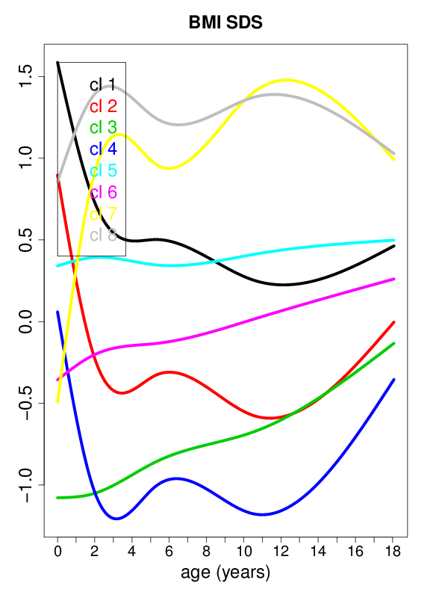 | 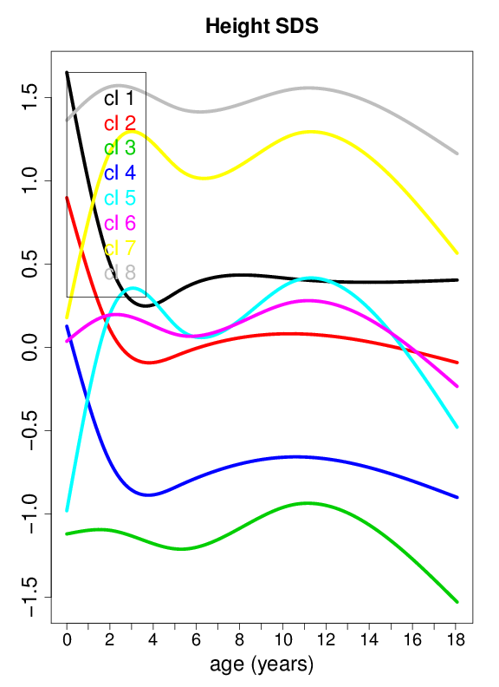

Figure 2: Center curves of body mass index (BMI) and height standard deviation scores (SDS) in children of mothers with type 1 diabetes
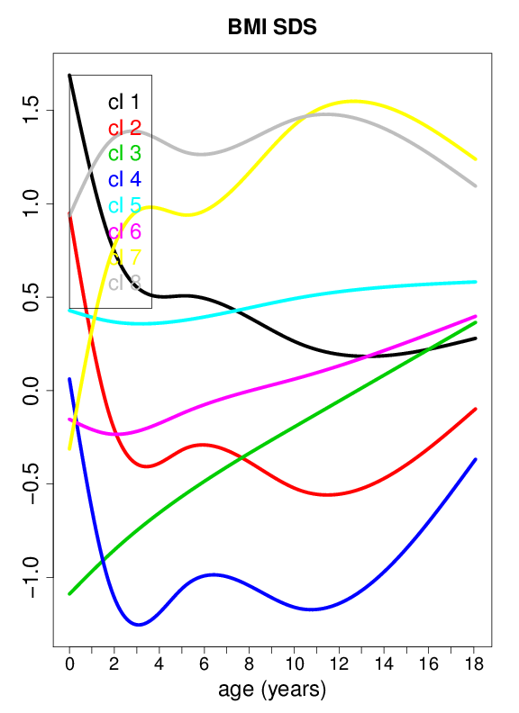 | 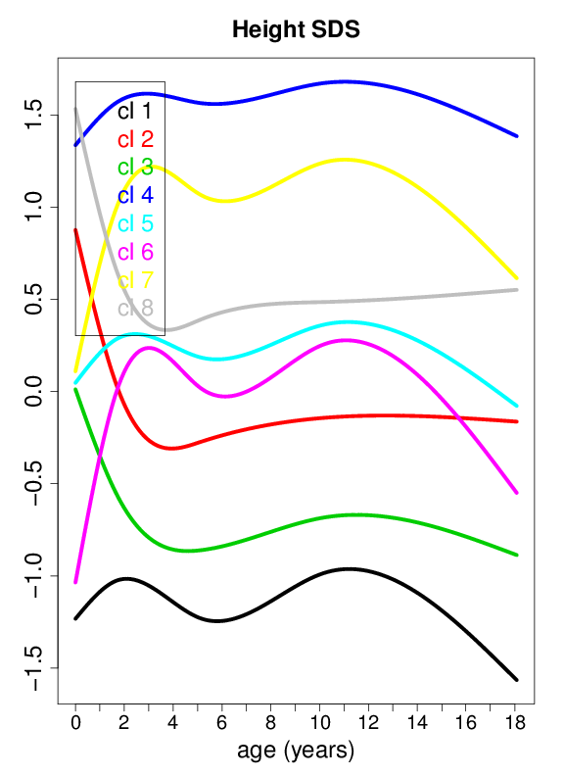

Figure 3: Center curves of body mass index (BMI) and height standard deviation scores (SDS) in children of mothers without type 1 diabetes
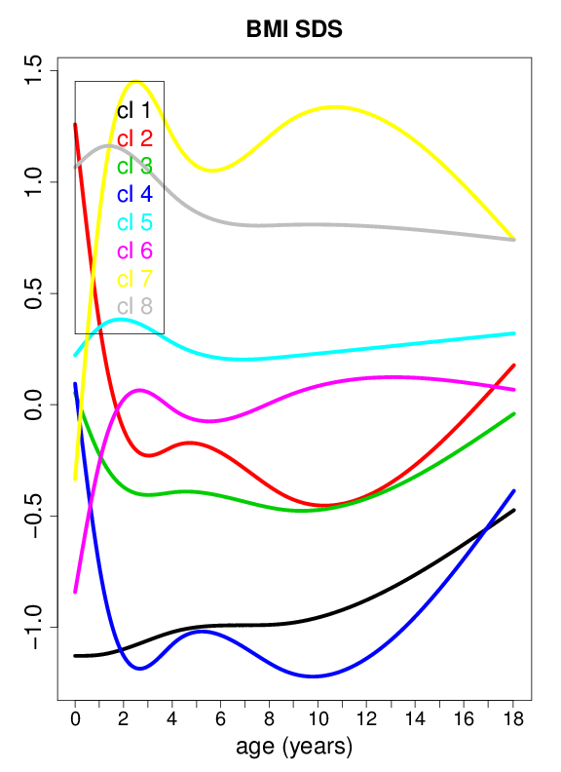 | 