*Review*

**Importance of tree height and social position for drought stress and induced mortality**

**Rüdiger Grote 1,*, Arthur Gessler 2,3, Robert Hommel 3, Werner Poschenrieder 4 and Eckart Priesack 5**

1 Institute for Meteorology and Climate Research (IMK-IFU), Karlsruhe Institute of Technology, Kreuzeckbahnstr. 19, 82467 Garmisch-Partenkirchen; E-Mails: Ruediger.Grote@kit.edu

2 Swiss Federal Institute for Forest, Snow and Landscape Research (WSL), Zürcherstrasse 111,  
8903 Birmensdorf; E-Mails: arthur.gessler@wsl.ch; gessler@zalf.de

3 Leibniz Centre for Agricultural Landscape Research (ZALF), Eberswalder Straße 84,  
15374 Müncheberg; E-Mail: Robert.Hommel@zalf.de

4 Chair of Forest Yield Research, Technische Universität München, Hans-Carl-v.-Carlowitz-Platz 2,  
85354 Freising; E-Mail: Werner.Poschenrieder@lrz.tu-muenchen.de

5 Institute of Biochemical Plant Pathology, Helmholtz Zentrum München, Ingolstädter Landstr. 1, 85764 Neuherberg; E-Mail: priesack@helmholtz-muenchen.de

**\*** Author to whom correspondence should be addressed; E-Mail: Ruediger.Grote@kit.edu;  
Tel.: +49-8821-183-124; Fax: +49-8821-183-247.

Academic Editor(s): EiC, EBM and GE

*Received: / Accepted: / Published:*

**Abstract:** Drought stress can trigger tree mortality but the impact depends on stress intensity (water demand and availability) and on the vulnerability of the individual. Most research concentrates on the species-specific properties that determine vulnerability such as water use efficiency or hydraulic conductivity and the loss thereof. At ecosystem scale, however, tree properties that have been found important for drought sensitivity or resistance vary not only among species but also with individual size and position within a given species. Moreover, the environmental conditions as such are different for each tree position. Stand scale responses might thus be considerably different from individual responses. Indeed, empirical evidence exists that drought stress impact depends on tree social position. In this review, we collect such evidence and discus the role of microclimate and soil water distribution as well as anatomical and physiological adjustments, which might be the cause for differentiated mortality impacts. Finally, we define model requirements aiming to capture stand-scale drought responses or management impacts related to drought stress mitigation.

**Keywords:** social class; tree height; drought stress; tree mortality; micro-environment; adaptation; modelling

**1. Introduction**

Future climate conditions are likely to be considerable warmer and drought periods are predicted to increase in intensity and frequency all over the globe [1]. This development particularly concerns forest managers which have to make decisions for decades ahead because drought is supposed to decrease forest growth, increase tree mortality, and impact the sustainable provision of ecosystem services [2-10]. Investigations of drought stress have focused on the mechanisms of direct and immediate impacts, which are stomata closure, reduced nutrient uptake [11] and consequently a reduction in photosynthesis and a decline in growth [12]. Individual mortality caused by drought, however, is less well understood because it originates not only from immediate impacts but also from long-term cumulative stress exposition and the occurrence of multiple stressors [13-16].

A number of recent reviews have summarized the current knowledge about the mechanisms of how drought stress influences or triggers tree mortality and have highlighted the need to consider carbon reserve state (carbon starvation) and direct drought stress (hydraulic failure) in combination [16-19]. However, the role of forest structure in mitigating or enhancing drought stress susceptibility has not been given much attention. This is to some degree surprising, because it is known that trees of different sizes and relative position within a forest vary in biochemical, physiological, and morphological properties that in turn affect the efficiency of carbon assimilation and the susceptibility to hydraulic failure [20, 21]. Accordingly, drought stress susceptibility should be differentiated by tree position within a forest. For management decisions aiming to mitigate drought stress, it is moreover important to know if such differences are dominantly caused by specific environmental conditions, such as protection from high light and temperature, or by biochemical, physiological, or morphological adjustment – or both.

In models describing forest development in dependence on environmental conditions, tree growth in structured forests is described either using a predefined growth rate which is modified by individual as well as general site conditions [22, 23], or by explicit description of the micro-environment [24, 25]. In the first case, there is no differentiation of competition between light and other limiting resources, in the second case, environmental impacts are seen as the sole influencing factor assuming biochemical and physiological properties usually as species-specific parameters. Drought stress in this context is mostly represented as a relation between evaporative demand and water availability, where foliage area and fine root abundance might be dynamically considered but hydraulic properties are not. The impact on mortality in structural forest growth models is either neglected, empirically determined with arbitrarily set threshold values, or indirectly calculated from net carbon assimilation [26]. Long-term adaptation, hydraulic differentiation with tree size, cavitation effects, or carry-over effects that might mitigate or enhance stress and mortality are generally not considered [27].

We will review the conditions that control the individual stress level under dry conditions within a forest, and define causes for the susceptibility of trees to succumb to drought stress. We will further try to evaluate the sensitivity of the processes that depend on these conditions with a conceptual model in order to provide decision support for further model developments and experimental studies.

**2. Environmental conditions for growth and mortality of tree cohorts**

*2.1. Canopy effects on carbon assimilation*

Photosynthesis is driven by light, temperature, and CO2 concentration. All three influences are differently affected by canopy structure and exhibit different profiles as presented in Fig. 1. In particularly: 1) Light availability decreases exponentially with canopy depth [28]. 2) Temperature development during the day is buffered leading to higher temperatures during the night, in the morning and evening hours while midday temperatures are decreased with canopy depth [29]. In addition, temperature is increased at the canopy surface due to absorption of direct radiation [30]. 3) CO2 concentration is also variable throughout the day, with respiration leading to accumulation during the night and assimilation to depletion within the canopy [31, 32]. Duration of differences depends on turbulence conditions, and is generally short-lived – despite of the fact that turbulence decreases with larger canopy volume and higher leaf area index (LAI).

Fig. 1 also shows that the changes of environmental factors with leaf area depend on the distribution of leaves and are considerable different for homogeneous and structured canopies. For example, temperature increases due to radiation absorption as well as the fraction of affected canopy is larger in a (deciduous) homogeneous than a structured canopy. Understory trees are partly shaded and thus slightly cooler while receiving relatively more radiation, which is favorable particularly in hot periods with clear skies. Deeply structured canopies have less leaf area exposed to intensive radiation and high temperatures and also have a better ventilation [31, 33] causing smaller vapor pressure deficits [32]. This results in generally less stressful conditions for understory compared to dominant trees, particularly in warm and bright environments where shade is less limiting [34].

Two additional aspects have to be mentioned in this context: First, lower canopy layers experience warmer conditions during the night and in spring when the upper canopy is still leafless. Thus leaf development starts earlier, is less susceptible to frost damage [35], and the vegetation period is eventually prolonged [36-38]. Independent of physiological acclimation (see below) the understory is thus able to draw from soil water reservoirs before larger trees can claim their share. If the soil water is not replenished by rainfalls, this temporal niche separation represents a competition advantage for understory trees. Second, it should be noted that these findings refer to similar total leaf areas while a mere reduction of dominant tree number results in less LAI, higher overall temperatures and a greater variation during the day [39]. Species-specific differences in light absorbance and foliage clumping modify microclimatic gradients that are thus specific to a particular forest composition [33].

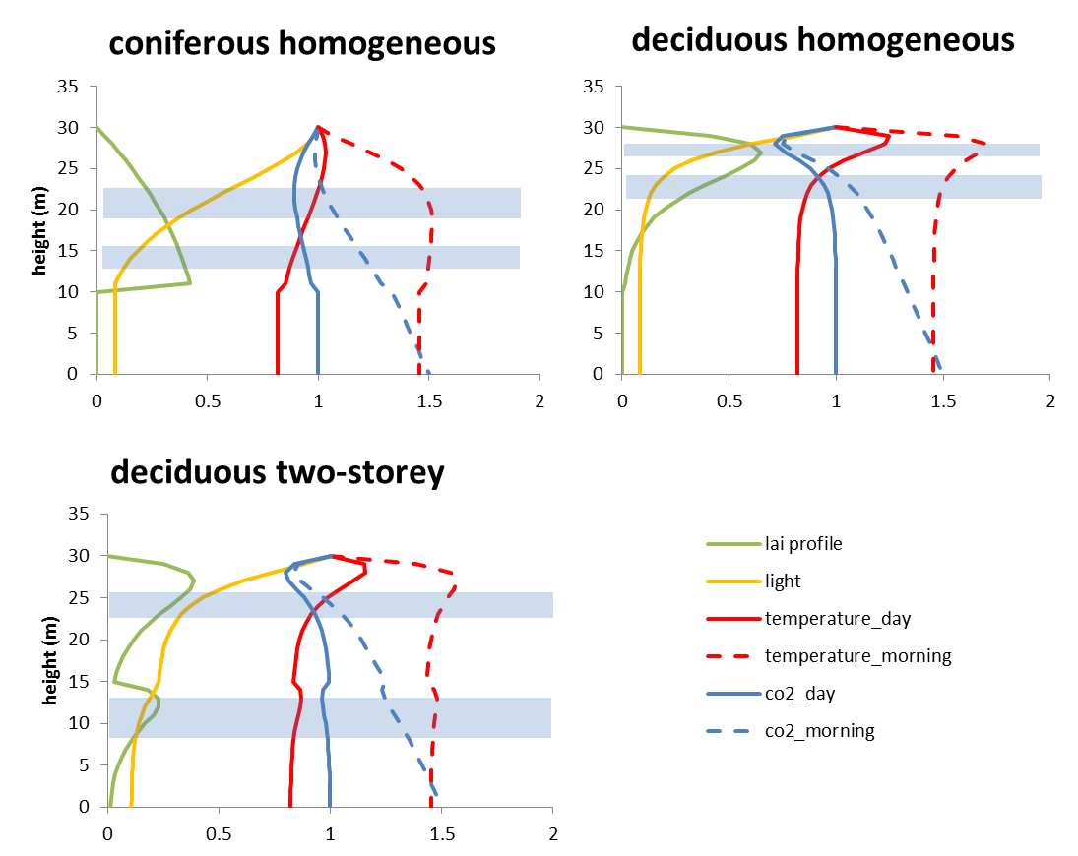

**Figure 1.** Simulated canopy profiles of radiation, light, and CO2 concentration based on different canopy structure (modelling assumptions: 1) Total leaf area is 5 in all cases (two story: 3+2), blue bars indicate the location of the 2/5 and the 4/5th of the total LAI. 2) Leaf area distribution is derived from Grote et al. [40] for Picea abies (coniferous) and Fagus sylvatica (deciduous). 3) Light extinction is calculated according to Beer-Lambert with extinction coefficient of 0.5 in all cases. 4) Temperature development is composed of a LAI-weighted transition between temperature below and above the canopy and is increased by a radiation absorption term. 5) CO2 development is calculated as a composite of a linear transition between concentrations below and above the canopy and the uptake by leaves which depends on light absorption (similar to photosynthesis response)). X-axis is given in absolute LAI per m canopy height; all other variables are expressed as relative terms in relation to above-canopy conditions.

*2.2. Soil water distribution and water uptake*

Generally, a more intensive rooting in structured forests due to niche separation has been found by several authors [41-43]. This is assumed to result in a faster exploitation of soil water reserves compared to homogeneous forests. If rainfall is not sufficient to supply the evaporation demand, the onset of drought stress is thus earlier and of longer duration in structured forests [44]. However, mitigation of a potentially increased drought might occur due to the phenomenon of hydraulic lift. This means that trees with deep roots are able to supply not only themselves but also smaller individuals. Since dryer conditions in upper soil layers increase outflow from lateral roots as well as uptake from deeper layers [45], the increased soil water exploitation may thus be compensated – partly or fully – by an increased water supply. It has been already shown for mixed forests that this facilitation effect results in a considerable stress release [46, 47] and that tree diversity decreases water stress levels in beech dominated temperate forests [48]. It can be assumed, however, that it is a general process in structured forests and can be applied to different social classes or trees in different canopy stories as well.

**3. Anatomical and physiological differentiation of tree cohorts**

*3.1. Tree height and hydraulic constraints*

The hydraulic limitation hypothesis (HLH) stated about 20 years ago, that maximum tree height is restricted by the ability to transport water against the gravimetric potential [49], with effects on stomatal conductance and assimilation in dependence on tree height. The underlying mechanism is that with increasing tree height and branch length the xylem path length and thus the hydraulic resistance increases. This theory assumes that the increase in resistance is larger than the increase in xylem vessel permeability with tree height that has also been observed [50] and that has formerly argued to be in balance with sapwood area and potential transpiration [51]. The hypothesis has been used to formulate the so called ‘West, Brown, Enquist’ (WBE) model approach [52], which calculates the resistance to water transport based on the total path length and the individual conductivity of tree segments that changes with height. It is, however, important to note that the concept should include belowground water transport and calculate a “whole plant conductance” rather than considering stemwood only [53].

Not all data support the HLH which may be due the dependency of conductance to nutrient supply and other environmental influences, as well as the acclimation of foliage and other tissues to long-term environmental conditions [54]. For example, increases in the soil-to-leaf water potential differential (ΔΨ) and decreases in the leaf area/sapwood area ratio can buffer hydraulic limitations in old and tall trees [55-57]. However, compensation mechanisms are likely to come with a price [58, 59] such as a decreased water use efficiency (WUE) with height [60]. More important, the increase in ΔΨ is associated with smaller vessel diameters and thus increased cavitation risks [61]. As a consequence, the vulnerability to cavitation is in general higher in old, tall trees as compared to young, small trees [62] pointing to a major disadvantage for tall trees under drought stress. Overall, the HLH can be regarded as valid and that taller trees differ physiologically from shorter ones. However, this is not sufficient to explain all observed declines in wood production and increases in mortality with height since numerous other – species specific - adaptations occur simultaneously [63].

*3.2. Stomatal control depends on tree height*

Stomatal regulation in vascular plants is an efficient means for adjusting water use to changes in plant water supply and demand. This fine-tuned mechanism allows a rapid reaction to altered water availability, while attempting to maximize carbon uptake, thus optimizing WUE [64]. In most cases stomatal conductance (gs) seem to decrease with tree height [55, 65], even though the negative impact of increasing flow-pathlength might be partially compensated by mechanisms described above. Overcompensation, and thus an increased gs with height has been shown for European beech [66] while Black locust (*Robinia pseudoacacia*) showed increased gs but decreased stomata abundance at the same time [67].

It is not only maximum conductivity but also stomatal sensitivity to environmental conditions, which depends on tree size and age, although it is generally regarded as species dependent only (isohydric vs. anisohydric species). For example, *Picea mariana* trees younger than approx. 70 years showed a strict stomatal control of water loss with increasing vapour pressure deficit (VPD), whereas older trees showed a linear increase of daily transpiration with VPD indicating no or only slight stomatal limitation of water loss [56]. The finding is corroborated by measurements along crowns of European beech (*Fagus sylvatica*) demonstrating that stomata from leaves in mid canopy showed less sensitivity to drought than those from the top of the trees [68]. Similar observations were made in Douglas fir (*Pseudotsuga menziesii*) trees [57]: Whereas stomatal closure was initiated at a leaf water potential of -1.21 MPa at 20 m height it occurred at -1.86 MPa at 55 m. In a comparable way, loss of leaf conductance occurred at a less negative leaf water potential (-1.34) at 20 m compared to 55 m (-1.92 MPa). The authors concluded that higher carbon gain during periods of greater drought stress is possible if the foliage at the top of tall trees is capable of maintaining stomatal conductance at more negative leaf water potential. However, information on how stomatal control changes with tree height, age or social class is still insufficient. In particular the question if increased stomata opening increases the risk of hydraulic failure in large trees is not yet answered [56, 57].

*3.3. Mesophyll conductance and tree height*

There is now an increasing awareness that mesophyll conductance (gm), which varies in a range comparable to gs, might be strongly involved in adjusting and optimizing the loss of water and the gain of CO2 [69]. Closing the stomata and thus reducing gs in response to drought increases WUE but also decreases net photosynthesis. In theory, the decrease in photosynthesis by decreased gs could be compensated by means of increasing gm with the result of increasing or stabilizing WUE [70]. However, Niinemets [71] observed that foliar photosynthesis rates decreased even stronger with tree age and height as could be explained by decreased stomatal conductance both in crowns of *Picea abies* and *Pinus sylvestris*. The author concluded that the response results from decreased mesophyll conductance with height, which might be the inevitable consequence of morphological adaptation to drought stress in needles/leaves of larger trees. This has been confirmed for *Pinus densiflora* trees [72]. However, deciduous leaves of beeches and oaks in higher canopy layers have been found to show higher gm than those at the canopy bottom while mid canopy beech leaves had highest mesophyll conductance [68]. Therefore, it is not clear yet if a decrease in mesophyll conductance with height is a general phenomenon or might be restricted to some tree species or coniferous trees only.

*3.4. Carbon relations and tree height*

The main processes currently discussed to explain increased mortality by drought stress is either hydraulic failure (see above), or carbon starvation, assuming that stomatal closure prevents carbon uptake while respiration is exploiting the carbon reserves and resulting in a negative whole tree carbon balance [73, 74]. Since high carbon reserves have been found in extremely stressed trees, starvation is supposedly a contributor of reduced tree performance and increased mortality under long lasting but relatively mild drought periods, whereas hydraulic failure most probably plays an important role under extreme drought [75]. The decreased assimilation rate with increasing tree height might thus lead to the assumption that taller trees are more prone to drought-induced C-starvation, which could not be confirmed, however, in various investigations [76-78]. Nevertheless, significant increases of non-structural carbohydrate and lipid concentrations were observed in *Pinus ponderosa* trees that suffered height-related growth reductions [76], leading to the hypothesis that mobilisation of photosynthates might be constrained in taller trees by the reduction of turgor-driven cell expansion or the impairment of phloem transport [77]. Restricted remobilisation and transport of carbohydrates to the sites of carbon and energy demand might be able to induce C-starvation even though sufficient amounts of stored carbohydrates would in principle be available on the whole tree level [75].

*3.5. Root biomass and depth distribution with tree height*

Relative little is known about below-ground distribution of roots in relation to tree height. In general the estimation of root biomass is derived from aboveground tree measures but show only a weak correlation to tree height and are mostly assumed to be independent of the position within a stand [79, 80]. However, tree height is closely related to root depth - which is important to exploit water reserves in deeper soil layers - at least in juvenile stages while later on height increases while roots are exploiting the most suitable soil volume. This development is depicted in Fig. 2, redrawn from a report investigating three species on three different soils [81], showing also the almost linear lateral root extension with time. With respect to social tree classes, dominant trees were actually found to produce proportional more coarse roots than suppressed ones in a study that investigated four different crown classes of *Fagus sylvatica* [82], as well as in others concentrating on *Picea abies*, *Quercus robur*, and *Pinus sylvestris* [83]. These findings may imply that dominant trees are less susceptible to drought since a relatively larger root system should be associated with deeper rooting and larger total exploration volume [84].

While coarse roots are mainly affecting the extension of the exploration, fine roots are responsible for the actual uptake of and thus fine root abundance reflects the potential intensity of water uptake. Fine root biomasses per individual are even more difficult to determine than coarse roots because the parent tree cannot be easily defined and the spatial as well as seasonal dynamic of fine root abundance may vary considerably [82, 85]. Biomass of fine roots (< 2mm) is assumed proportional to leaf biomass but also differs with stand age and soil fertility [86]. For example fine root biomass in a low-productivity stand of *Pseudotsuga menziesii* was found to peak at about 45 years [87]. While high fertility generally tends to increase foliage (and thus fine root) biomass, tree roots at poor sites show higher mycorrhizal infection rates [87].

Overall, the coarse root data indicate a relatively smaller exploration volume for smaller and younger trees; if it is assumed that the data from different stand ages can be transferred to heterogeneous stands with different age classes, however, the reduced exploration volume of younger trees can be partially compensated by higher exploration intensity. Given these trait differences, the direct belowground competition between smaller and larger trees seems to depend on the precipitation patterns and soil water storage of a specific site. While smaller trees are able to shield water from deeper roots with their intensive fine root net when precipitation events are small, larger trees will benefit from water storage in deeper soil layers.

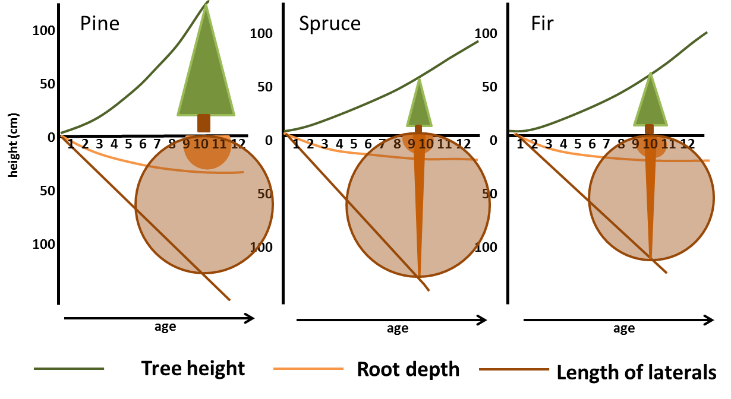

**Figure 2.** Tree height, root depth and the development of lateral roots during the first decade of development for *Pinus contorta* (left), *Picea glauca* (middle), and *Abies lasiocarpa* (right). The figure is redrawn from [81].

**4. New ways of modelling water uptake and transport**

For plant modelling of drought stress impacts, it is not only important to represent direct water movements but also to link these fluxes to tree carbon cycle and the feedback on tissue functionality. For long-term estimates of climate change responses, it is additionally required to accurately simulate growth and stand structural development in dependence on environment – a particularly difficult task in highly structured forests. It should also be considered that the representation of ecosystem water balance also feeds back to the climate and thus is not only import for ecosystem processes but also for regional and global climate simulations – however, we will concentrate here on the state-of-the art of simulating water uptake and transport and how this might be linked to impacts on plant physiology.

In view of expected changes in precipitation patterns, root water uptake is of particular importance, because decreasing soil water availability will increasingly limit individual tree evapotranspiration. The way it is considered within a model thus exerts a major influence on simulation results concerning competition strength of a species, stress exposure and long-term water availability. Despite this important role, root water uptake and transpiration are described by most models that consider forest structures in a rather simple way [88]. Yet, also the more complex uptake functions have to be seen as rather simple empirical approaches to describe root water and nutrient uptake, since they have only a limited biophysical basis [89]. Therefore, during the last years more mechanistic water uptake models have been developed, which consider root architecture as well as the water flow from the soil into the root system and further into the plant explicitly [89-92]. These models are able to differentiate between both plant species and individuals of a particular species but require explicit three-dimensional root architectural models [93, 94].

The mechanistic approach to model root water uptake and transport is based on two main concepts: The cohesion-tension theory [95] and the electrical circuit analogy [96]. The latter approach was further improved by substituting the electrical circuit analogy by a porous media description for xylem sap flow. This description is based on Darcy’s law to better account for the dynamic behaviour of the hydraulic capacities in a way that mass conservation can be directly calculated [97-102]. Janott et al. [103] obtained one of the first complete soil-plant water flow models based on this approach by combining models of aboveground and belowground sap flow with models of soil water flow. The one-dimensional flow representation within a three-dimensional plant architecture representation allows simulating transpiration for longer time-scales and groups of several plants which has been demonstrated for small tree groups [104, 105] as well as for forest stands [106]. By extending the tree hydrodynamic model by a photosynthesis model based on the Ball-Berry-Leuning approach also the impact of different light regimes on transpiration and water uptake could be of a group of different trees could be modelled (Figure 3).

Up to now the two conduit pathways, the xylem and phloem have mainly been studied as separate systems. Hölttä et al. [107] developed a mathematically simple conceptual model to simultaneously treat flow and transport in both systems including the exchange of water and solutes between xylem and phloem. In this way, the model represents the first approach to simulate the full “Münch circulation” [108]. However, the model assumes a representation of the plant architecture by a simple cylinder and does not include roots yet. The importance of describing plant internal transport processes in dynamic global vegetation models was recently emphasized [109] to better recognize the “direct environmental controls such as temperature, water and nutrient availability on tissue expansion and meristematic activity”. As this is not accounted for in any widely available physiological model, tree mortality based on starvation or hydraulic failure cannot yet be mechanistically described.



**Figure 3.** Simulated xylem water potential of three trees of different species: *Fraxinus excelsior* (left), *Tilia cordata* (middle) and *Fagus sylvatica* (right). Figure from Bittner et al. [104].

**5. Discussion and Conclusions**

Based on literature findings it is safe to say that understory trees experience less drought stress than dominant trees of forest stand within a structured forest. Field observations show that drought stress is actually smaller in suppressed or understory trees [110] and that this can result in decreased tree mortality of smaller trees [111]. It is obviously a composite of several impacts that are summarized in Figure 4 - with less evaporation demand being probably most important for the observed findings. While this is neglected in models that do not differentiate between different trees or tree classes, canopy climate is generally considered in layers that are able to reflect this issue. Similarly, only a detailed soil-water distribution model that accounts or a differentiated rooting depth is able to represent differences in water availability of different tree classes. A phenomenon that is generally neglected in forest water balance is the transport of water from deeper soil layers into the upper root horizon. Although ground water contact increases the competitive advantage of larger trees which are supposed to have deeper reaching roots, it seems that hydraulic lift enables smaller trees to profit from these additional water sources without the necessary investments in deep roots. Evidence suggests that this is not only important for dry ecosystems but is also a common issue in temperate regions and is supposed to get more important under a climate of longer drought periods.

What is less obvious than differences in micro-environmental conditions is that individual trees change their properties with size as well as with the environmental conditions they experience. Height alone is supposed to make water transport to the leaves more difficult, resulting in less conductivity of large trees, compared with smaller ones. The resulting decline in carbon gain is supposed to be the main reason for decreased stand productivity with age but may also result in less carbon reserves necessary to survive long or frequently repeated drought periods. Decreased vessel size and thus increased xylem conductivity with height can partly compensate for the decline in potential carbon gain, but such adjustments inevitably increase the risk of cavitation. Cavitation results either in immediate death or at least raises the necessity of investments into repair or rebuild of water transport structures. In any case, higher trees tend to be more susceptible to drought stress, which is well reflected in the global correlation of stand height and water supply.

Whereas the necessity of differentiating micro-environmental conditions as well as considering anatomical changes regarding hydraulic conductance is generally acknowledged, we state that this is not sufficient to describe drought stress in structured forests. In these cases, the social position, or more specifically the morphological and physiological adaptations that occur primarily due development under different degrees of shade, have also to be taken into account in order to determine the susceptibility to drought stress. Individual environmental conditions influence the specific leaf area, stomatal and mesophyll conductance, as well as photosynthetic capacities. These properties are influencing evaporation demand and WUE and are thus important to consider for drought stress estimation. Their representation requires a similar differentiation within the canopy as the environmental condition that drive them and they need to be calculated on an individual tree- or tree class basis.

While dominant trees are supposed to assimilate more carbon per unit living tissue under well-watered conditions than suppressed or understory trees, dominant trees also tend to be more susceptible to drought stress. Due to this compensatory behavior of smaller trees, a structured forest is supposed to be more resilient and better suited to provide important ecosystem services than homogeneous stands under stressful conditions. On the other hand, the long-term forest structure – or species composition in case of mixed forests – very much depends on the interplay between stressed and unstressed periods. Forest management can influence this development by selecting or favoring specific tree species, maintaining an understory of healthy trees, or provide temporary drought stress release by removing trees thus concentrating resources on the remaining ones. However, in order to evaluate long-term forest developments in response to expected climate changes, not only the specifics of different tree species but also those of different social classes needs to be adequately represented in models. We are confident that considering all three discussed aspects (microenvironment, anatomical changes with height, and adaptations with social positions) will serve this task and provide enough information to decide upon the necessary or beneficial degree of intervention.

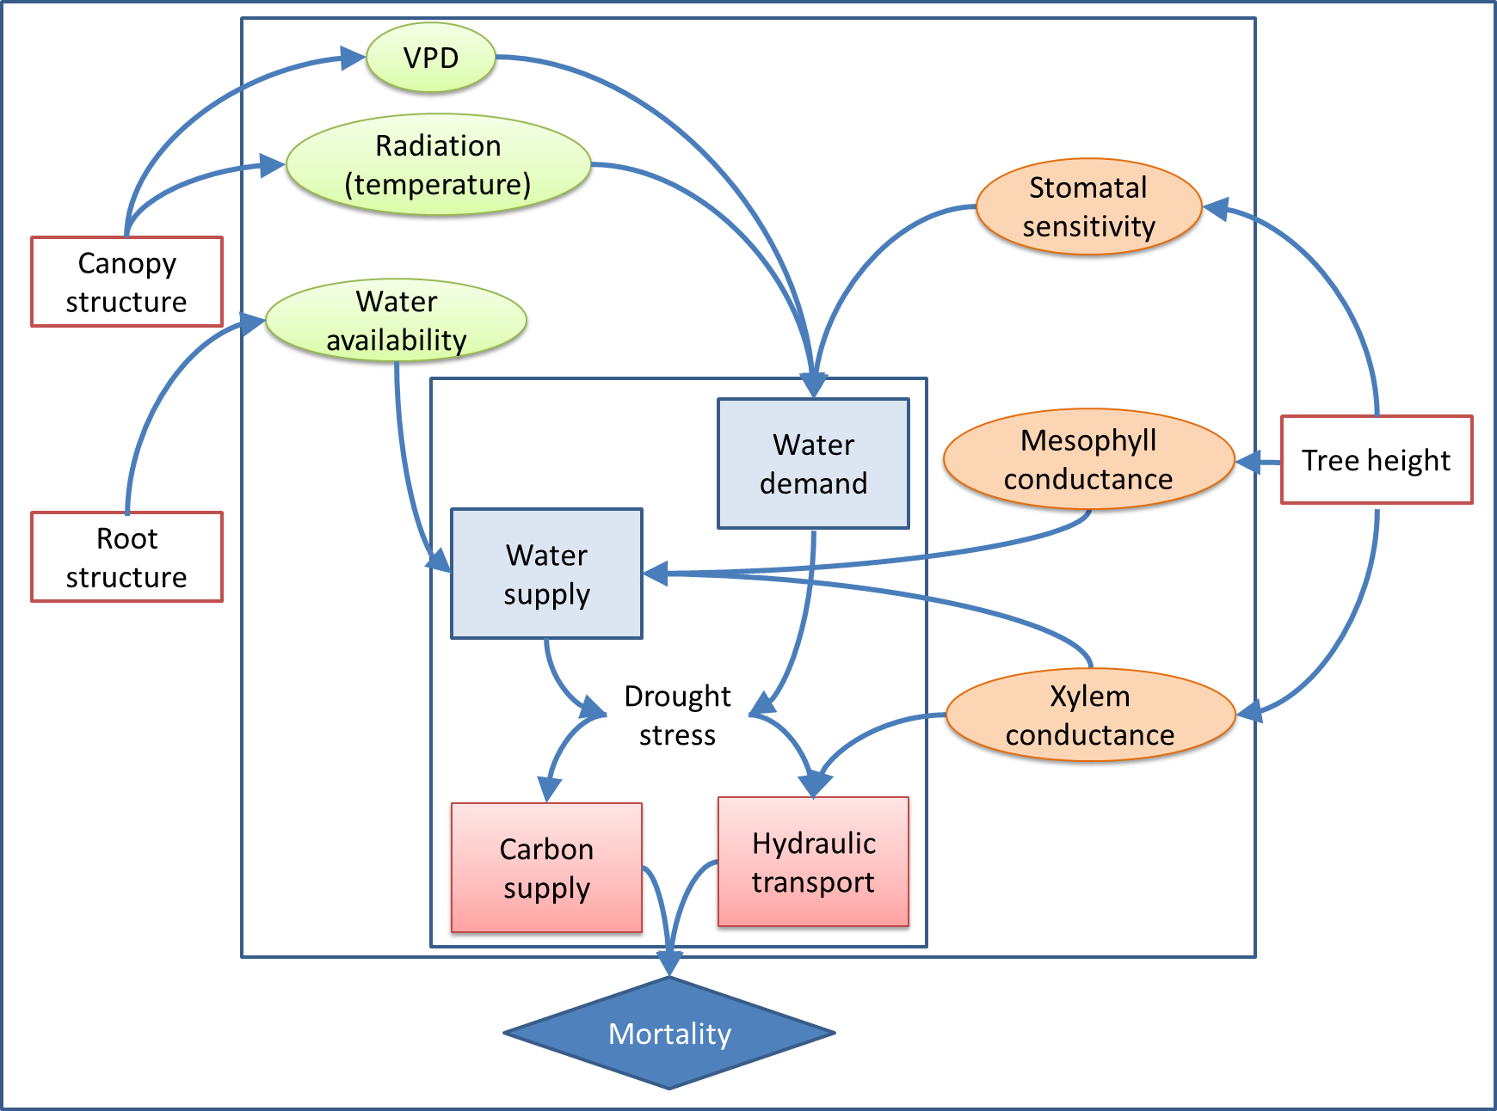

**Figure 4.** Tree height and structural indices that are influenced by position within a forest influence tree mortality indirectly by either changing the micro-environment (green ovals) or physiological traits (orange ovals). Both are defining water demand and supply (blue rectangles) that inflict either slow carbon depletion or quick hydraulic failure.

**Acknowledgments**

We acknowledge support by Deutsche Forschungsgemeinschaft and Open Access Publishing Fund of Karlsruhe Institute of Technology.

Author Contributions

Werner Poschenrieder prepared the outline of this review, wrote a first version of the introduction and collected most of the references. Rüdiger Grote elaborated on the ‘Environmental conditions’ chapter, wrote most of the discussion part, and finalized the manuscript for submission. Arthur Gessler and Robert Hommel were responsible for the ‘Anatomical and physiological differentiations’ chapter and Eckart Priesack wrote the ‘Modelling’ chapter. All authors contributed to the discussion of the topic and the final shape of the document.

**Conflicts of Interest**

The authors declare no conflict of interest.

**References and Notes**

1. IPCC, Climate Change 2013: The physical science basis. Contribution of working group I to the Fifth Assessment Report of the Intergovernmental Panel on Climate Change. In Stocker, T. F.; Qin, D.; Plattner, G.-K.; Tignor, M. M. B.; Allen, S. K.; Boshung, J.; Nauels, A.; Xia, Y.; Bex, V.; Midgley, P. M., Eds. Cambridge Univ. Press: 2013; p 1535.

2. Bigler, C.; Bräker, O. U.; Bugmann, H.; Dobbertin, M.; Rigling, A., Drought as an inciting mortality factor in Scots pne stands of the Valais, Switzerland. *Ecosystems* **2006,** *9*, 330-343.

3. van Mantgem, P. J.; Stephenson, N. L., Apparent climatically induced increase of tree mortality rates in a temperate forest. *Ecol. Lett.* **2007,** *10*, 909-916.

4. Adams, H. D.; Guardiola-Claramonte, M.; Barron-Gafford, G. A.; Villegas, J. C.; Breshears, D. D.; Zou, C. B.; Troch, P. A.; Huxman, T. E., Temperature sensitivity of drought-induced tree mortality portends increased regional die-off under global-change-type drought. *Proc. Nat. Acad. Sci.* **2009,** *106*, 7063-7066.

5. Adams, H. D.; Macalady, A. K.; Breshears, D. D.; Allen, C. D.; Stephenson, N. L.; Saleska, S. R.; Huxman, T. E.; McDowell, N. G., Climate-induced tree mortality: Earth system consequences. *Eos, Transactions American Geophysical Union* **2010,** *91*, 153-154.

6. Allen, C. D.; Macalady, A. K.; Chenchouni, H.; Bachelet, D.; McDowell, N.; Vennetier, M.; Kitzberger, T.; Rigling, A.; Breshears, D. D.; Hogg, E. H.; Gonzalez, P.; Fensham, R.; Zhang, Z.; Castro, J.; Demidova, N.; Lim, J. H.; Allard, G.; Running, S. W.; Semerci, A.; Cobb, N., A global overview of drought and heat-induced tree mortality reveals emerging climate change risks for forests. *For. Ecol. Manage.* **2010,** *259*, 660-684.

7. Anderegg, W. R. L.; Kane, J. M.; Anderegg, L. D. L., Consequences of widespread tree mortality triggered by drought and temperature stress. *Nature Clim. Change* **2013,** *3*, 30-36.

8. Engelbrecht, B. M. J., Plant ecology: Forests on the brink. *Nature* **2012,** *491*, 675-677.

9. Gustafson, E. J.; Sturtevant, B. R., Modeling forest mortality caused by drought stress: Implications for climate Change. *Ecosystems* **2013,** *16*, 60-74.

10. Rigling, A.; Bigler, C.; Eilmann, B.; Feldmeyer-Christe, E.; Gimmi, U.; Ginzler, C.; Graf, U.; Mayer, P.; Vacchiano, G.; Weber, P.; Wohlgemuth, T.; Zweifel, R.; Dobbertin, M., Driving factors of a vegetation shift from Scots pine to pubescent oak in dry Alpine forests. *Global Change Biol.* **2013,** *19*, 229-240.

11. Kreuzwieser, J.; Gessler, A., Global climate change and tree nutrition: influence of water availability. *Tree Phys.* **2010,** *30*, 1221-1234.

12. Flexas, J.; Medrano, H., Drought-inhibition of photosynthesis in C3 plants: stomatal and non-stomatal limitations revisited. *Ann. Bot.* **2002,** *89*, 183-189.

13. Franklin, J. F.; Shugart, H. H.; Harmon, M. E., Tree death as an ecological process. *BioScience* **1987,** *37*, 550-556.

14. Güneralp, B.; Gertner, G., Feedback loop dominance analysis of two tree mortality models: relationship between structure and behavior. *Tree Phys.* **2007,** *27*, 269-280.

15. Manion, P. D., *Tree disease concepts*. Prentice-Hall, Englewood Cliffs, NJ, 1981.

16. Zeppel, M. J. B.; Anderegg, W. R. L.; Adams, H. D., Forest mortality due to drought: latest insights, evidence and unresolved questions on physiological pathways and consequences of tree death. *New. Phytol.* **2013,** *197*, 372-374.

17. O'Grady, A. P.; Mitchell, P. J. M.; Pinkard, E. A.; Tissue, D. T., Thirsty roots and hungry leaves: unravelling the roles of carbon and water dynamics in tree mortality. *New. Phytol.* **2013,** *200*, 294-297.

18. McDowell, N. G.; Fisher, R. A.; Xu, C.; Domec, J. C.; Hölttä, T.; Mackay, D. S.; Sperry, J. S.; Boutz, A.; Dickman, L.; Gehres, N.; Limousin, J. M.; Macalady, A.; Martínez-Vilalta, J.; Mencuccini, M.; Plaut, J. A.; Ogée, J.; Pangle, R. E.; Rasse, D. P.; Ryan, M. G.; Sevanto, S.; Waring, R. H.; Williams, A. P.; Yepez, E. A.; Pockman, W. T., Evaluating theories of drought-induced vegetation mortality using a multimodel–experiment framework. *New. Phytol.* **2013,** *200*, 304-321.

19. Wang, W.; Peng, C.; Kneeshaw, D. D.; Larocque, G. R.; Luo, Z., Drought-induced tree mortality: ecological consequences, causes, and modeling. *Env. Rev.* **2012,** *20*, 109-121.

20. Binkley, D.; Campoe, O. C.; Gspaltl, M.; Forrester, D. I., Light absorption and use efficiency in forests: Why patterns differ for trees and stands. *For. Ecol. Manage.* **2013,** *288*, 5-13.

21. Lindroth, A.; Cienciala, E., Water use efficiency of short-rotation *Salix viminalis* at leaf, tree and stand scales. *Tree Phys.* **1996,** *16*, 257-262.

22. Pretzsch, H.; Biber, P.; Dursky, J., The single tree-based stand simulator SILVA: construction, application and evaluation. *For. Ecol. Manage.* **2002,** *162*, 3-21.

23. Schröder, J.; Röhle, H.; Gerold, D.; Münder, K., Modeling individual-tree growth in stands under forest conversion in East Germany. *Europ. J. For. Res.* **2007,** *126*, 459-472.

24. Collalti, A.; Perugini, L.; Santini, M.; Chiti, T.; Nolè, A.; Matteucci, G.; Valentini, R., A process-based model to simulate growth in forests with complex structure: Evaluation and use of 3D-CMCC Forest Ecosystem Model in a deciduous forest in Central Italy. *Ecol. Mod.* **2014,** *272*, 362-378.

25. Grote, R.; Korhonen, J.; Mammarella, I., Challenges for evaluating process-based models of gas exchange at forest sites with fetches of various species. *For. Syst.* **2011,** *20*, 389-406.

26. Adams, H. D.; Williams, A. P.; Xu, C.; Rauscher, S. A.; Jiang, X.; McDowell, N. G., Empirical and process-based approaches to climate-induced forest mortality models. *Front. Plant Sci.* **2013,** *4*.

27. van der Molen, M. K.; Dolman, A. J.; Ciais, P.; Eglin, T.; Gobron, N.; Law, B. E.; Meir, P.; Peters, W.; Phillips, O. L.; Reichstein, M.; Chen, T.; Dekker, S. C.; Doubkova, M.; Friedl, M. A.; Jung, M.; van den Hurk, B. J. J. M.; de Jeu, R. A. M.; Kruijt, B.; Ohta, T.; Rebel, K. T.; Plummer, S.; Seneviratne, S. I.; Sitch, S.; Teuling, A. J.; van der Werf, G. R.; Wang, G., Drought and ecosystem carbon cycling. *Agr. For. Met.* **2011,** *151*, 765-773.

28. Mayer, H.; Holst, T.; Schindler, D., Microclimate within beech stands - part I: photosynthetically active radiation. *Forstw. Cbl.* **2002,** *121*, 301-321.

29. Holst, T.; Mayer, H.; Schindler, D., Microclimate within beech stands—part II: thermal conditions. *Europ. J. For. Res.* **2004,** *123*, 13-28.

30. Wu, J.; Liu, Y.; Jelinski, D. E., Effects of leaf area profiles and canopy stratification on simulated energy fluxes: the problem of vertical spatial scale. *Ecol. Mod.* **2000,** *134*, 283-297.

31. Elias, P.; Kratochvilova, I.; Janous, D.; Marek, M.; Masarovicova, E., Stand microclimate and physiological activity of tree leaves in an oak-hornbeam forest I. Stand microclimate. *Biomedical and Life Science* **1989,** *3*, 227-233.

32. Oliet, J. A.; Jacobs, D. F., Microclimatic conditions and plant morpho-physiological development within a tree shelter environment during establishment of *Quercus ilex* seedlings. *Agr. For. Met.* **2007,** *144*, 58-72.

33. von Arx, G.; Dobbertin, M.; Rebetez, M., Spatio-temporal effects of forest canopy on understory microclimate in a long-term experiment in Switzerland. *Agr. For. Met.* **2012,** *166-167*, 144-155.

34. Thompson, D. R.; Hinckley, T. M., Effect of vertical and temporal variations in stand microclimate and soil moisture on water status of several species in an Oak-Hickory forest. *Am. Midl. Nat.* **1977,** *97*, 373-380.

35. Aussenac, G., Interactions between forest stands and microclimate: Ecophysiological aspects and consequences for silviculture. *Ann. For. Sci.* **2000,** *57*, 287-301.

36. Gressler, E.; Jochner, S.; Capdevielle-Vargas, R. M.; Morellato, L. P. C.; Menzel, A., Vertical variation in autumn leaf phenology of *Fagus sylvatica* L. in southern Germany. *Agr. For. Met.* **2015,** *201*, 176-186.

37. Richardson, A. D.; O'Keefe, J., Phenological differences between understory and overstory: A case study using the long-term Harvard Forest records. In *Phenology of Ecosystem Processes*, Noormets, A., Ed. Springer Science and Business Media: LLC, 2010; pp 87-117.

38. Seiwa, K., Changes in leaf phenology are dependent on tree height in *Acer mono*, a deciduous broad-leaved tree. *Ann. Bot.* **1999,** *85*, 355-361.

39. Rambo, T. R.; North, M. P., Canopy microclimate response to pattern and density of thinning in a Sierra Nevada forest. *For. Ecol. Manage.* **2009,** *257*, 435-442.

40. Grote, R. In *Simulating natural and management imposed changes of species composition in forests with a physiological-based model*, Helsinki, Finland, 9/29/3 AD, 2003; Arneth, A.; Korhonen, H.; Kulmala, M.; Raivonen, M.; Ruuskanen, T.; Suni, T., Eds. Yliopistopaino: Helsinki, Finland, 2003; pp 116-119.

41. Schmid, I.; Kazda, M., Clustered root distribution in mature stands of *Fagus sylvatica* and *Picea abies*. *Ecophysiology* **2005,** *144*, 25-31.

42. Bolte, A.; Kampf, F.; Hilbrig, L., Space sequestration below ground in old-growth spruce-beech forests – signs for facilitation? *Front. Plant Sci.* **2013,** *4*.

43. Jensen, A.; Löf, M.; Witzell, J., Effects of competition and indirect facilitation by shrubs on *Quercus robur* saplings. *Plant Ecol.* **2012,** *213*, 535-543.

44. Valladares, F.; Zaragoza-Castells, J.; Sanchez-Gomez, D.; Matesanz, S.; Alonso, B.; Portsmuth, A.; Delgado, A.; Atkin, O. K., Is shade beneficial for Mediterranean shrubs experiencing periods of extreme drought and late-winter frosts? *Ann. Bot.* **2008,** *102*, 923-933.

45. Caldwell, M. M.; Richards, J. H., Hydraulic lift: water efflux from upper roots improves effectiveness of water uptake by deep roots. *Oecologia* **1989,** *79*, 1-5.

46. Pretzsch, H.; Schütze, G.; Uhl, E., Resistance of European tree species to drought stress in mixed versus pure forests: evidence of stress release by inter-specific facilitation. *Plant Biol. (Stuttg)* **2013** *15*, 483-495.

47. Zapater, M.; Hossann, C.; Bréda, N.; Bréchet, C.; Bonal, D.; Granier, A., Evidence of hydraulic lift in a young beech and oak mixed forest using 18O soil water labelling. *Trees* **2011,** *25*, 885-894.

48. Grossiord, C.; Granier, A.; Ratcliffe, S.; Bouriaud, O.; Bruelheide, H.; Chećko, E.; Forrester, D. I.; Dawud, S. M.; Finér, L.; Pollastrini, M.; Scherer-Lorenzen, M.; Valladares, F.; Bonal, D.; Gessler, A., Tree diversity does not always improve resistance of forest ecosystems to drought. *Proc. Nat. Acad. Sci.* **2014,** *111*, 14812-14815.

49. Ryan, M. G.; Yoder, B. J., Hydraulic limits to tree height and tree growth. *BioScience* **1997,** *47*, 235-242.

50. Pothier, D.; Margolis, H. A.; Waring, R. H., Patterns of change of saturated sapwood permeability and sapwood conductance with stand development. *Can. J. For. Res.* **1989,** *19*, 432-439.

51. Edwards, W. R. N.; Jarvis, P. G., Relations between water content, potential and permeability in stems of conifers. *Plant, Cell, Environ.* **1982,** *5*, 271-277.

52. West, G. B.; Brown, J. H.; Enquist, B. J., A general model for the structure and allometry of plant vascular systems. *Nature* **1999,** *400*, 664-667.

53. Hubbard, R. M.; Bond, B. J.; Ryan, M. G., Evidence that hydraulic conductance limits photosynthesis in old *Pinus ponderosa* trees. *Tree Phys.* **1999,** *19*, 165-172.

54. Becker, P.; Meinzer, F. C.; Wullschleger, S. D., Hydraulic limitation of tree height: a critique. *Funct. Ecol.* **2000,** *14*, 4-11.

55. Schäfer, K. V. R.; Oren, R.; Tenhunen, J. D., The effect of tree height on crown level stomatal conductance. *Plant, Cell, Environ.* **2000,** *23*, 365-375.

56. Ewers, B. E.; Gower, S. T.; Bond-Lamberty, B.; Wang, C. K., Effects of stand age and tree species on canopy transpiration and average stomatal conductance of boreal forests. *Plant, Cell, Environ.* **2005,** *28*, 660-678.

57. Woodruff, D. R.; McCulloh, K. A.; Warren, J. M.; Meinzer, F. C.; Lachenbruch, B., Impacts of tree height on leaf hydraulic architecture and stomatal control in Douglas-fir. *Plant, Cell, Environ.* **2007,** *30*, 559-569.

58. Midgley, J. J., Is bigger better in plants? The hydraulic costs of increasing size in trees. *Trends Ecol. Evol.* **2003,** *18*, 5-6.

59. Sperry, J. S.; Meinzer, F. C.; McCulloh, K. A., Safety and efficiency conflicts in hydraulic architecture: scaling from tissues to trees. *Plant, Cell, Environ.* **2008,** *31*, 632-645.

60. Magnani, F.; Bensada, A.; Cinnirella, S.; Ripullone, F.; Borghetti, M., Hydraulic limitations and water-use efficiency in *Pinus pinaster* along a chronosequence. *Can. J. For. Res.* **2008,** *38*, 73-81.

61. Hoffmann, W. A.; Marchin, R.; Abit, P.; Lau, O. L., Hydraulic failure and tree dieback are associated with high wood density in a temperate forest under extreme drought. *Global Change Biol.* **2011,** *17*, 2731-2742.

62. Domec, J.-C.; Gartner, B. L., Cavitaton and water storage capacity in bole xylem segments of mature and young Douglas-fir trees. *Trees* **2001,** *15*, 204-214.

63. Ryan, M. G.; Phillips, N.; Bond, B. J., The hydraulic limitation hypothesis revisited. *Plant, Cell, Environ.* **2006,** *29*, 367-383.

64. Farquhar, G. D.; Wong, S. C., An empirical model of stomatal conductance. *Funct. Plant Biol.* **1984,** *11*, 191-210.

65. Ambrose, A. R.; Sillett, S. C.; Koch, G. W.; Van Pelt, R.; Antoine, M. E.; Dawson, T. E., Effects of height on treetop transpiration and stomatal conductance in coast redwood (*Sequoia sempervirens*). *Tree Phys.* **2010,** *30*, 1260-1272.

66. Van Wittenberghe, S.; Adriaenssens, S.; Staelens, J.; Verheyen, K.; Samson, R., Variability of stomatal conductance, leaf anatomy, and seasonal leaf wettability of young and adult European beech leaves along a vertical canopy gradient. *Trees* **2012,** *26*, 1427-1438.

67. Zhang, Y.; Zheng, Q.; Tyree, M., Factors controlling plasticity of leaf morphology in *Robinia pseudoacacia* I: height-associated variation in leaf structure. *Ann. For. Sci.* **2012,** *69*, 29-37.

68. Cano, F. J.; Sanchez-Gomez, D.; Rodriguez-Calcerrada, J.; Warren, C. R.; Gil, L.; Aranda, I., Effects of drought on mesophyll conductance and photosynthetic limitations at different tree canopy layers. *Plant, Cell, Environ.* **2013,** *36*, 1961-1980.

69. Hommel, R.; Siegwolf, R.; Saurer, M.; Farquhar, G. D.; Kayler, Z.; Ferrio, J. P.; Gessler, A., Drought response of mesophyll conductance in forest understory species – Impacts on water-use efficiency and interactions with leaf water movement. *Phys. Plant.* **2014,** *152*, 98-114.

70. Aranda, I.; Pardos, M.; Puertolas, J.; Jimenez, M. D.; Pardos, J. A., Water-use efficiency in cork oak (*Quercus suber*) is modified by the interaction of water and light availabilities. *Tree Phys.* **2007,** *27*, 671-677.

71. Niinemets, Ü., Stomatal conductance alone does not explain the decline in foliar photosynthetic rates with increasing tree age and size in *Picea abies* and *Pinus sylvestris*. *Tree Phys.* **2002,** *22*, 515-535.

72. Han, Q., Height-related decreases in mesophyll conductance, leaf photosynthesis and compensating adjustments associated with leaf nitrogen concentrations in *Pinus densiflora*. *Tree Phys.* **2011,** *31*, 976-984.

73. Galiano, L.; Martínez-Vilalta, J.; Lloret, F., Carbon reserves and canopy defoliation determine the recovery of Scots pine 4 yr after a drought episode. *New. Phytol.* **2011,** *190*, 750-759.

74. Sevanto, S.; McDowell, N. G.; Dickman, L. T.; Pangle, R.; Pockman, W. T., How do trees die? A test of the hydraulic failure and carbon starvation hypotheses. *Plant, Cell, Environ.* **2014,** *37*, 153-161.

75. Sala, A.; Piper, F.; Hoch, G., Physiological mechanisms of drought-induced tree mortality are far from being resolved. *New. Phytol.* **2010,** *186*, 274-281.

76. Sala, A.; Hoch, G., Height-related growth declines in ponderosa pine are not due to carbon limitation. *Plant, Cell, Environ.* **2009,** *32*, 22-30.

77. Woodruff, D. R.; Meinzer, F. C., Water stress, shoot growth and storage of non-structural carbohydrates along a tree height gradient in a tall conifer. *Plant, Cell, Environ.* **2011,** *34*, 1920-1930.

78. Piper, F. I.; Fajardo, A., No evidence of carbon limitation with tree age and height in *Nothofagus pumilio* under Mediterranean and temperate climate conditions. *Ann. Bot.* **2011**.

79. Wirth, C.; Schumacher, J.; Schulze, E. D., Generic biomass functions for Norway spruce in Central Europe - a meta-analysis approach toward prediction and uncertainty estimation. *Tree Phys.* **2004,** *24*, 121-139.

80. Wutzler, T.; Wirth, C.; Schumacher, J., Generic biomass functions for Common beech (*Fagus sylvatica*) in Central Europe: predictions and components of uncertainty. *Can. J. For. Res.* **2008,** *38*, 1661-1678.

81. Eis, S. *Root-growth relationship of juvenile White spruce, Alpine fir, and Lodgepole pine on three soils in the interior of British Columbia*; Department of Fisheries and Forestry, Canadian Forestry Service: Ottawa, Catalogue No. Fo. 47-1276, 1970; p 14.

82. Le Goff, N.; Ottorini, J.-M., Root biomass and biomass increment in a beech (*Fagus sylvatica* L.) stand in North-East France. *Ann. For. Sci.* **2001,** *58*, 1-13.

83. Kuhr, M. Grobwurzelarchitektur in Abhängigkeit von Baumart, Alter, Standort und sozialer Stellung. Dissertation, Georg-August-Universität, Göttingen, 2000

84. Neubauer, M.; Demant, B.; Bolte, A., Tree-based estimator for below-ground biomass of *Pinus sylvestris* L. (Einzelbaumbezogene Schätzfunktionen zur unterirdischen Biomasse der Wald-Kiefer). *Forstarchiv* **2015,** *86*, 42-47.

85. Epron, D.; Farque, L.; Lucot, E.; Badot, P.-M., Soil CO2 efflux in a beech forest: the contribution of root respiration. *Ann. For. Sci.* **1999,** *56*, 289-295.

86. Vanninen, P.; Mäkelä, A., Fine root biomass of Scots pine stands differing in age and soil fertility in southern Finland. *Tree Phys.* **1999,** *19*, 823-830.

87. Vogt, K. A.; Moore, E. E.; Vogt, D. J.; Redlin, M. J.; Edmonds, R. L., Conifer fine root and mycorrhizal root biomass within the forest floors of Douglas-fir stands of different ages and site productivities. *Can. J. For. Res.* **1983,** *13*, 429-437.

88. Pretzsch, H., Growing space and competitive situation of individual trees. In *Forest Dynamics, Growth and Yield*, Springer Berlin Heidelberg: 2009; pp 291-336.

89. Javaux, M.; Schroder, T.; Vanderborght, J.; Vereecken, H., Use of a three-dimensional detailed modeling approach for predicting root water uptake. *Vadose Zone* **2008,** *7*, 1079-1088.

90. Doussan, C.; Pierret, A.; Garrigues, E.; Pagès, L., Water uptake by plant roots: II – Modelling of water transfer in the soil root-system with explicit account of flow within the root system – Comparison with experiments. *Plant Soil* **2006,** *283*, 99-117.

91. Schneider, C. L.; Attinger, S.; Delfs, J. O.; Hildebrandt, A., Implementing small scale processes at the soil-plant interface - the role of root architectures for calculating root water uptake profiles. *Hydrol. Earth Syst. Sci.* **2010,** *14*, 279-289.

92. Schröder, T.; Javaux, M.; Vanderborght, J.; Körfgen, B.; Vereecken, H., Implementation of a microscopic soil–root hydraulic conductivity drop function in a three-dimensional soil–root architecture water transfer model. *Vadose Zone* **2009,** *8*, 783-792.

93. Dunbabin, V.; Postma, J.; Schnepf, A.; Pagès, L.; Javaux, M.; Wu, L.; Leitner, D.; Chen, Y.; Rengel, Z.; Diggle, A., Modelling root–soil interactions using three–dimensional models of root growth, architecture and function. *Plant Soil* **2013,** *372*, 93-124.

94. Li, S.; Gao, J.; Zhu, Q.; Zeng, L.; Liu, J., A dynamic root simulation model in response to soil moisture heterogeneity. *Math. Comput. Simulat.* **2015,** *113*, 40-50.

95. Tyree, M. T.; Zimmermann, M. H., *Xylem structure and the ascent of sap*. 2nd ed.; Springer: Berlin, 2002.

96. Cruiziat, P.; Cochard, H.; Ameglio, T., Hydraulic architecture of trees: main concepts and results. *Ann. For. Sci.* **2002,** *59*, 723-752.

97. Arbogast, T.; Obeyesekere, M.; Wheeler, M. F., Numerical methods for the simulation of flow in root-soil systems. *SIAM J. Numer. Anal.* **1993,** *30*, 1677-1702.

98. Aumann, C. A.; David Ford, E., Modeling tree water flow as an unsaturated flow through a porous medium. *J. theor. Biol.* **2002,** *219*, 415-429.

99. Bohrer, G.; Mourad, H.; Laursen, T. A.; Drewry, D.; Avissar, R.; Poggi, D.; Oren, R.; Katul, G. G., Finite element tree crown hydrodynamics model (FETCH) using porous media flow within branching elements: A new representation of tree hydrodynamics. *Water Resour. Res.* **2005,** *41*, n/a-n/a.

100. Chuang, Y.-L.; Oren, R.; Bertozzi, A. L.; Phillips, N.; Katul, G. G., The porous media model for the hydraulic system of a conifer tree: Linking sap flux data to transpiration rate. *Ecol. Mod.* **2006,** *191*, 447-468.

101. Früh, T.; Kurth, W., The hydraulic system of trees: Theoretical framework and numerical simulation. *J. theor. Biol.* **1999,** *201*, 251-270.

102. Kumagai, T. o., Modeling water transportation and storage in sapwood - model development and validation. *Agr. For. Met.* **2001,** *109*, 105-115.

103. Janott, M.; Gayler, S.; Gessler, A.; Javaux, M.; Klier, C.; Priesack, E., A one-dimensional model of water flow in soil-plant systems based on plant architecture. *Plant Soil* **2011,** *341*, 233-256.

104. Bittner, S.; Janott, M.; Ritter, D.; Köcher, P.; Beese, F.; Priesack, E., Functional–structural water flow model reveals differences between diffuse- and ring-porous tree species. *Agr. For. Met.* **2012,** *158–159*, 80-89.

105. Bittner, S.; Legner, N.; Beese, F.; Priesack, E., Individual tree branch-level simulation of light attenuation and water flow of threeF. sylvatica L. trees. *J. Geophys. Res.* **2012,** *117*, G01037 doi 01010.01029/02011JG001780.

106. Hentschel, R.; Bittner, S.; Janott, M.; Biernath, C.; Holst, J.; Ferrio, J. P.; Gessler, A.; Priesack, E., Simulation of stand transpiration based on a xylem water flow model for individual trees. *Agr. For. Met.* **2013,** *182–183*, 31-42.

107. Hölttä, T.; Vesala, T.; Sevanto, S.; Perämäki, M.; Nikinmaa, E., Modeling xylem and phloem water flows in trees according to cohesion theory and Münch hypothesis. *Trees* **2006,** *20*, 67-78.

108. Münch, E., *Die Stoffbewegungen in der Pflanzen*. Gustav Fischer: Jena, 1930; p 234.

109. Fatichi, S.; Leuzinger, S.; Körner, C., Moving beyond photosynthesis: from carbon source to sink-driven vegetation modeling. *New. Phytol.* **2014,** *201*, 1086-1095.

110. Zang, C.; Pretzsch, H.; Rothe, A., Size-dependent responses to summer drought in Scots pine, Norway spruce and common oak. *Trees* **2012,** *26*, 557-569.

111. Mueller, R. C.; Scudder, C. M.; Porter, M. E.; Talbot Trotter, R.; Gehring, C. A.; Whitham, T. G., Differential tree mortality in response to severe drought: evidence for long-term vegetation shifts. *J. Ecol.* **2005,** *93*, 1085-1093.