**Incidental Findings in Whole-Body MR Imaging of a Population-based Cohort Study: Frequency, Management and** **Psychosocial Consequences**

Christopher L. Schlett1, Susanne Rospleszcz2,6, Dorina Korbmacher1, Roberto Lorbeer3, Sigrid Auweter3, Holger Hetterich3, Sonja Selder3, Margit Heier2, Birgit Linkohr2,   
Sabine Weckbach4, Birgit Ertl-Wagner3,5, Annette Peters2,6, Fabian Bamberg1

1 Department of Diagnostic and Interventional Radiology, Medical Center - University of Freiburg, Faculty of Medicine, University of Freiburg, Freiburg, Germany

2 Institute of Epidemiology, Helmholtz Center Munich - German Research Center for Environmental Health, Neuherberg, Germany

3 Department of Radiology, Ludwig-Maximilians-University Hospital, Munich, Germany

4 Department of Diagnostic and Interventional Radiology, University Hospital Heidelberg, Heidelberg, Germany

5 Department of Medical Imaging, Hospital for Sick Children, University of Toronto, Toronto, Canada

6 Chair of Epidemiology, Institute for Medical Information Processing, Biometry and Epidemiology, Medical Faculty, Ludwig-Maximilians-University Munich, Munich, Germany

**Address for Correspondence:**

Christopher L. Schlett, MD MPH

Department of Diagnostic and Interventional Radiology

Medical Center - University of Freiburg

Hugstetter Straße 55, 79106 Freiburg, Germany

Telefon: +49 761 270 38190

Telefax: +49 761 270 39500

eMail: [christopher.schlett@post.harvard.edu](mailto:christopher.schlett@post.harvard.edu)

**Running title:**

Incidental Findings in Whole-Body MR Imaging

**Word count:**

2,980

**Disclosures:**

The study was funded by the German Research Foundation (DFG, Bonn, Germany; ID 245222810). Further, the KORA study was initiated and financed by the Helmholtz Zentrum München - German Research Center for Environmental Health, which is funded by the German Federal Ministry of Education and Research (BMBF) and by the State of Bavaria.

**Key words (MESH):**

incidental finding, whole body imaging, patient care management, psychosocial aspects, epidemiologic study

**ABSTRACT**

*Background:* Management of incidental findings (IF) in imaging remains controversial but highly relevant in the clinical and research setting. Our aim was to assess the frequency, management and psychosocial consequences of IF reporting in a population-based cohort study undergoing whole-body MR imaging.

*Methods:* The study was designed as a case-control (diabetes, prediabetes and controls) study nested in a prospective cohort from a longitudinal, population-based cohort (KORA) in southern Germany. All whole-body MR images obtained on a 3T magnet were reviewed by board-certified radiologists regarding the presence of clinically relevant IF. A baseline self-answered questionnairewas completed prior to the MRI examination. A follow-up questionnairewas conducted six months after baseline imaging, including the PHQ-9 score to analyze short-term consequences.

*Results:* Of 400 participants undergoing whole-body MRI, IF were found in 22% of participants (n=89, 22%, 95%-CI: 18-27%); most frequently located in the abdominal MR sequences. Strongest predictor for presence of IF was age (p<0.001). Most participants stated in the pre-scan survey that they wanted to “contribute to a scientific purpose” (91%), while “knowing whether I’m healthy” was the most frequent motivation reported 6 months post-scan (88%). 56.8% of the participants noted in the pre-scan survey that generally reporting of IF would be “very important” to them, which even increased 6 months post-scan (72% vs. 84%, p=0.001). Regarding psychosocial impact, a small portion (3.4%) reported that awaiting the IF report added “Definitely” or “Very Probably” additional stress burden. Of participants with reported IF, 56.8% classified the results as “very helpful”. In the post-scan survey moderate depression was observed in 3.3% and severe depression in 1.2%. This did not differ between participants with and without reported IF.

*Conclusion:* In this cohort using whole-body MR imaging, the prevalence of IF was high. To the participants, reporting of IF was deemed highly important and added only minor psychological burden. Thus, a stringent and transparent strategy of disclosing IFs as well as structured reporting may prove beneficial in a research setting.

**INTRODUCTION**

Management of incidental findings (IF) in imaging remains controversial but highly relevant for both – clinical care and research. The detection of IF poses various ethical and practical issues, particularly when the participants are “healthy” volunteers as it is often the case in population-based cohort studies (1). The definition of being “healthy” may vary strongly by the perspective of the volunteers, their caregivers or the research investigators, which makes the interpretation of IF even more complex.

A wide range of IF prevalence has been reported as low as 1% and up to 47% (16, 21). The prevalence depended on the anatomic coverage with the highest numbers for whole-body imaging, but also based on the clinical specificity of the performed imaging protocol. Thus, a significant number of the reported IF did not show clinical impact when they were investigated further (12, 21). However, there are also prominent case series which benefited from reporting IF because e.g. cancer was detected at an early, curable stage (6, 22).

Little is known about the volunteers’ perspective of reporting IF and their psychosocial impact. In a study of 394 participants from the SHIP (Study of Health in Pomerania) cohort (2), where participants underwent whole-body MR imaging and IF were reported, the investigators found that disclosed IF resulted in substantial psychosocial distress (9.9% had strong distress while waiting for a potential notification of an IF). However, disclosing IF is strongly endorsed by the participants although the interpretation of the clinical severity of the reported IF differed strongly between participants and caregivers (kappa = 0.02). Together with false expectations about potential benefits from MR imaging, this may lead to frustration and disappointment of the participants, which may alter the success of longitudinal, population-based cohort studies.

Thus, our aim was to assess the frequency, management and psychosocial consequences of IF reporting in all participants from the KORA (Cooperative Health Research in the Augsburg Region) study - a longitudinal, population-based cohort in Germany, which underwent whole-body MR imaging for research purposes.

**METHODS**

*Study Design and Population*

The study was designed as a case-control study nested in a prospective cohort from the “Cooperative Health Research in the Region of Augsburg” (KORA) in which participants with diabetes, with prediabetes and normoglycemic controls recruited from the FF4 follow-up of the KORA S4 study underwent whole-body MR imaging. The study design, sampling method and data collection are described in detail elsewhere (3). Briefly, subjects were excluded with history of cardiocerebrovascular disease defined as validated/self-reported stroke, myocardial infarction or revascularization. In addition, subjects with non-MRI safe devices including e.g. cardiac pacemaker or implantable defibrillator, report of cerebral aneurysm clip or serum creatinine ≥1.3 mg/dL were excluded.

The study was approved by the institutional review board of the medical faculty of Ludwig-Maximilian University Munich, Germany and all participants provided written informed consent.

*Magnetic Resonance Imaging*

MR images were acquired using a 3 Tesla Magnetom Skyra (Siemens AG, Healthcare Sector, Erlangen Germany) equipped with a whole-body coiling system. All participants underwent the imaging protocol within three months after the visit at the study center. The comprehensive whole-body protocol is detailed elsewhere (3). Briefly, it included cranial (FLAIR, T1, SWI, TOF), thoracoabdominal (T1 DIXON of the entire torso, multi-echo of the liver) and cardiovascular (LV and RV cine imaging, T1 mapping, LGE) sequences.

*Incidental Finding Reporting*

All images were reviewed by board-certified radiologists regarding the presence of clinically significant IF based on prospectively developed recommendations. These recommendations were based on current literature and consisted of a positive and a negative list of potential IF including size cut-offs below reporting was not recommended. However, these recommendations were not formally binding. In case the local radiologists felt unsure about reporting or not reporting a MR finding, they were able to refer the case for adjudication to an interdisciplinary panel including expert radiologists, epidemiologists and clinicians. The participants received a standardized letter including both, the information about the detected IF and what kind of further work-up was recommended for a final diagnosis. If no IF was detected, the participants received also a letter indicating that no IF was found.

*Endpoint Assessment and Follow-Up*

A baseline self-answered questionnairewas obtained directly prior to the MRI examination (“pre-scan survey”). The questionnaire included several questions regarding the motivation for participation and expected stress induced by waiting for the IF report, and assessed quality of the informed consent form. A follow-up questionnairewas conducted six months after baseline (“post-scan survey”) to analyze short-term consequences of population-based MRI study examinations and IF reporting on participants’ physical and mental well-being. Health status was assessed by self-rated health and depression was measured by standardized instruments (PHQ-9) (4).

*Quality Assurance*

All reported IF, which were part of the recommendation list and included a size cut-off, were re-evaluated by an independent investigator for the size of the lesion. This re-evaluation was performed only for quality assurance and did not affect the reporting of the IF.

*Statistical Analysis*

Demographics of participants, categories of IF, and psychosocial evaluations are reported as arithmetic mean and standard deviation or median and interquartile range for continuous variables and counts and/or percentages for categorical variables. Psychosocial evaluations were only assessed in participants with available data for the pre-scan and post-scan survey. Depression burden was determined by the Brief Patient Health Questionnaire (PHQ-9) in a standardized fashion. Differences between participants with and without IF and differences between participants with and without psychosocial evaluations were examined by unpaired t-test or χ2 -test, where appropriate. Changes in psychosocial evaluations pre-scan and post-scan were analyzed by paired t-test or χ2 -test, where appropriate. A p-value < 0.04 was considered to indicate statistical significance. R Version 3.5.2 was used for all analyses.

**RESULT**

Mean age of the participants was 56.3±9.2 years, 57.8% were male and mean BMI was 28.1±4.9 kg/m2. Of the 400 participants, 60.8% were normoglycemic (control), 25.8% had prediabetes and 13.5% had diabetes. Further demographics of the study population are provided in **Table 1**.

*Reporting and Management of Incidental Findings*

Based on the reading of the local radiologists, 116 IF in 89 participants (prevalence: 22.3%, 95%CI: 18-27%) were reported. Of those, three reported IF were excluded from analysis as the radiologists stated that no follow-up or work-up was necessary. Of cases with reported IF, 27 cases were reviewed by the investigators panel before they were reported. Additionally, 22 cases (5.5%) were referred to the panel but classified as not relevant for reporting. The study flow diagram is provided in **Figure 1**. All participants with clinically relevant IF were informed by mail which included a recommendation regarding the potential work-up. This comprised visiting the primary care physician or taking past medical history in 51% and seeing direct a specialist in 27%. Recommended work-up included additional imaging in 74% (n=84) of all participants, of those ultrasound correlations in 46% and/or dedicated MR exam in 41% (**Table 2**). In contrast, CT as a follow-up modality was recommended in 13% of cases. Mammography was recommended in all cases with reported breast lesions.

*Frequency of Incidental Findings and Associated Risk Factors*

Among 113 clinically relevant IF in 89 participants, multiple IF within one participant occurred in a total of 21 participants, of them 18 participants had 2 distinguished IF, and 3 participants had 3 distinguished IF. Most frequently reported were IF belonging to the abdomen (41%), followed by IF belonging to the neurocerebral system (17%) or to the cardiovascular system (17%). Of single findings, “Unclear Liver Lesion” (n=13), “Silent Myocardial Infarction” (n=12) and “Complex Renal Cyst” (n=9) were most common. The full list of IF is given in the **Appendix E1**.

Considering the nested case-control study design, no significant differences in IF frequency was observed between participants with diabetes, prediabetes and normal glucose tolerance (22% vs. 29% vs. 19%, p=0.14). However, 21 participants had reported IF belonging to categories, which are potentially related to diabetes (e.g. “Silent Myocardial Infarction”); there was a significant, stepwise trend of having diabetes-related IF between participants with normal glucose tolerance, with prediabetes and with diabetes (p=0.002 for the trend). Also, participants with IF were significantly older compared to those without IF (mean difference of 4.2 years, p<0.001) while there was no difference between the other characteristics (**Table 1**).

*Motivation, Expectations and Psychosocial Consequences*

Pre-/post-scan survey data were available in 243 participants. Participants with available pre- and post-scan survey data did not differ with respect to age and gender to those with missing survey data (p=0.06 and 0.70, respectively). However, participants with available survey data had a lower BMI (27.6±4.7 vs 29.0±5.1, p=0.006), had less frequent a pre-/diabetic glycemic status (p<0.001) and a slightly lower creatinine level (p=0.04; **Appendix E2**).

Regarding motivation of volunteers participating in whole-body MR imaging for research, most participants stated before the scan that they wanted to “contribute to a scientific purpose” (91%), which decreased to 82% in the follow-up questionnaire (p=0.01); while “knowing whether I’m healthy” became the most prominent motivation during follow-up (88%). Less than one quarter stated that “I have health complains and would like to figure out the reason” (**Table 3**). More than half of the participants (56.8%) noted in the pre-scan survey that reporting IF in general would be “very important” for them, which decreased to 42.0% after the scan (p<0.001); this decrease did not differ whether the participant had an IF reported or not (p=0.75). Only half of the volunteers would also have participated if absolutely no IF would have been disclosed (**Table 3**), this portion did not change significantly over time. However, the desire of reporting increased over time (pre- vs. 6-month-post-scan), also for clinically less important IF (72% vs. 84%, p=0.001 for IF that not life threating and treatment is not necessary, but possible; **Table 3**).

Regarding psychosocial impact, a small portion (3.4%) reported that waiting for the IF reporting added “Definitely” or “Very Probably” additional stress burden. Overall, the level of added stress burden of waiting for the IF report was not significantly different between the expected value (pre-scan) and the experienced value (post-scan; 4.1±1.3 vs 4.1±1.0, p=0.96; respectively; **Figure 2**). Of participants with reported IF, 9.1% felt that the results were “very burdening” while in contrast 56.8% classified the results as “very helpful”. In the post-scan survey and based on the PHQ-9 score, moderate depression (10-14 points) was observed in 3.3% and (moderately) severe depression (≥15 points) 1.2%, this did not differ between participants with and without reported IF (**Figure 3**).

*Quality Assurance*

Of IF in categories with recommendation regarding the minimal size to report a finding (n=59), in 20 cases (34%) the IF was reported although the recommended cutoff was not reached. Affected IF categories were e.g. “pancreas cyst (report if >20mm)”, “intraabdominal lymphadenopathy (report if short axis diameter >15mm) or “brain aneurysm (report if >5mm)”. The mean absolute and relative difference between the actual size of the IF and the recommended size cutoff was 6.3±3.8mm (range: 1.2-14.0mm) and 36±22% (range: 6-70%), respectively; e.g. a cyst lesion of 8mm in the pancreatic head was reported although the recommended size cutoff was 20mm (12mm absolute and 60% relative difference).

There was an observation that the recommended size cutoff was violated more frequently in some IF categories (e.g. in all 5 out 5 cases with pancreas cysts) than in others (e.g. in only 1 out 5 cases with solid cerebral mass), but this observation did not reach statistical significance (p=0.06).

**DISCUSSION**

In this nested case-controlled, whole-body MR imaging study of 400 asymptomatic, middle-aged individuals enrolled from a general population cohort without clinically known cardio-cerebrovascular disease we found 113 clinically relevant IF in 89 participants leading to a prevalence of 22% with “Unclear Liver Lesion”, “Silent Myocardial Infarction” and “Complex Renal Cyst” being the most common single lesions. Among the reported IF, IF detected on abdominal sequences were most frequent (41%).

The prevalence of IF in our cohort is interestingly high, which may in part be contributed to the a-priori design of the study. We included participants with prediabetes and diabetes and images were systematically reviewed by radiologists, which generated 13 times more potentially serious incidental findings in comparison to radiographer flagging in other studies (6). Also, in 20 cases (34%) the IF was reported, although the recommended cutoff was not reached. However, the prevalence of clinically relevant IFs in our study is consistent with the frequencies of potentially serious IFs previously published in other whole-body MR cohort studies. For example, a proportion of 12.8% in healthy control research subjects (5) and 17.9% (6) up to 31.5% in the general adult population has previously been reported (7). We also confirm prior research by demonstrating no significant differences in IF between participants with diabetes, prediabetes and normal glucose tolerance, while there was a significant, stepwise trend of having diabetes-related IF between participants with normal glucose tolerance, prediabetes and diabetes. Consistently, participants with IF were on average 4.2 years older than participants without IF (p<0.001). In a prospective cohort study within the UK Biobank Imaging Study designed to determine factors associated with potentially serious incidental findings on multi-modal imaging there also was no significant association between potentially serious incidental findings and body mass index or morbidity, but with age (6). Many other studies underline the increase of IFs with age (5, 14, 16, 19).

In addition to prior research, we investigated the motivation and psychosocial consequence of IF reporting on study participants. Contributing to a scientific purpose was the main motivation of subjects regarding the participation in whole-body MR imaging for research (91%), however, “knowing whether I’m healthy” became the most prominent motivation during follow-up (88%). More than half of the participants noted in the pre-scan survey that reporting IF in general would be “very important” for them and the wish for reporting also increased over time up to 84%, even for clinically less important IF, which is in agreement to the results of Kirschen et al., who stated that almost all subjects (>90%) wanted IFs to be communicated to them (10). Most of the participants with reported IF classified the results as “very helpful” (56.8%). Regarding psychosocial impact, only a small portion (3.4%) reported that waiting for the IF disclosure added “Definitely” or “Very Probably” additional stress burden, which is even less than the 9.9% of participants noticing strong distress while waiting for the IF report found by Schmidt et al. in the Study of Health in Pomerania (SHIP) (2). Our results were further supported be findings of Hegedüs et al., who found not only that 95% of participants considered the report of IFs as very important and 55% as beneficial to health status, but also that waiting for the IF report caused minimal stress levels, whereas high stress levels were reported when participants received an IF letter (8). However, in our cohort only 9.1% of participants with reported IF considered the results as “very burdening” and, furthermore, there was no increased rate of moderate or severe depression in the post-scan survey based on the PHQ-9 in participants with reported IF compared to participants without IF. Taken together, this emphasizes the need of structured reporting of IF, if participant motivation and adherence is of relevance.

Our results were supported by previously published studies regarding IFs in whole-body MR imaging (2, 5-9), underlining the importance of providing sufficient information to participants to minimize false expectations. While reported IF might turn out to be without direct clinical consequences, it may affect emotional wellbeing, finances and social life (2, 12, 13, 15). To attenuate the effect, a well understandable wording in IF reports is required, which also comprises contact points and potentially medical specialists for subsequent work-up.

Presently, the inconsistent management of IFs in imaging studies (11, 14, 18) can certainly be attributed to the different expectations of stakeholders involved in balancing disclosure and associated ethical problems and withholding information from participants because of potential harm caused by IFs (17, 18, 20). As a consequence, and consistent with Bunnik et al., a stringent strategy of reviewing study scans and disclosing IFs should be established taking into account seven steps, which include a reasonable cost management, researchers` moral obligations and the principle of reciprocity to address the participants` wish for reporting IFs (9). Furthermore, it can be anticipated that workflow-oriented tools such as structured reporting or deep learning algorithms may prove beneficial for standardization in this setting.

Our results need to be evaluated in the context of their limitations. First, this is a relatively small sample drawn from a population-based cohort. However, the study was particularly designed to investigate the degree of subclinical disease burden in a metabolically relevant group of participants in a well-monitored Western European setting. Thus, the results are of particular relevance in this target population while generalizability is certainly limited and further confirmatory research is warranted. Second, the MR imaging protocol is not fully comparable with previous research, which may also impact on the accuracy for the detection of IF. However, given technical advances and the specific research questions mandate targeted imaging protocols with varying image quality for the detection of IF. Third, the reading for the presence of IF depends on radiological expertise and degree of experience in this setting. In our study, all MR exams were read by board-certified radiologists with experience in reporting whole-body MRI. Thus, further research is warranted to determine the degree of experience necessary to perform whole-body MRI readings in a standardized fashion.

**CONCLUSION**

In this cohort, the prevalence of IF was high, and many findings were adjudicated by an interdisciplinary panel and quality assurance showed some level of disparity. For participants, reporting of potential IF was highly important and added only minor psychological burden. Given the substantial resources of the investigators for reporting IF, a stringent strategy of reviewing study scans and disclosing IFs as well as optimized, workflow-oriented tools such as structured reporting or deep learning algorithms may prove beneficial in this setting. Further research especially focusing on psychosocial and medical consequences of IFs in imaging studies should be conducted.

**IMAGES AND TABLES**

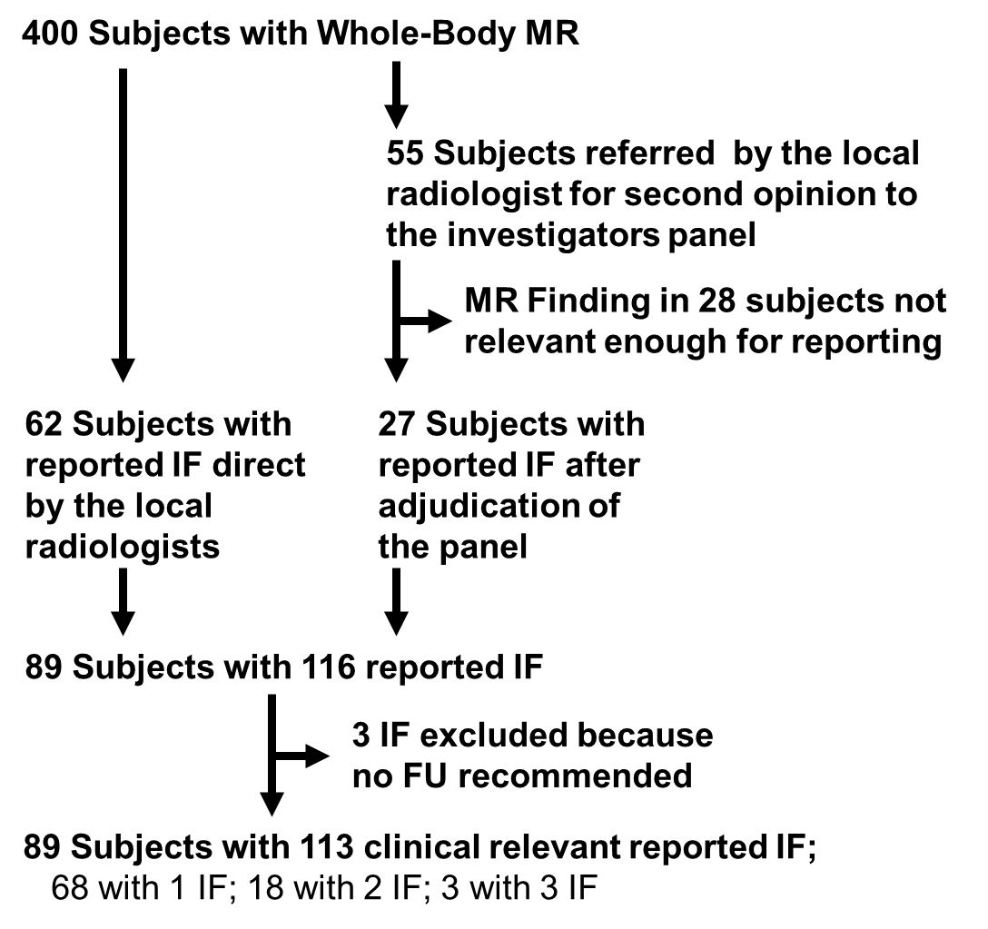

**Figure 1: Subjects Flow-Chart within the MR Whole-Body KORA Study.**

|  |  |  |  |  |
| --- | --- | --- | --- | --- |
|  | All | No IF | With IF* | p-value |
|  | N = 400 | N = 311 | N = 89 |  |
| Age (years) | 56.3 ± 9.2 | 55.4 ± 9.1 | 59.6 ± 8.9 | <0.001 |
| Sex (men) | 231 (57.8%) | 183 (58.8%) | 48 (53.9%) | 0.48 |
| BMI (kg/m2) | 28.1 ± 4.9 | 28.1 ± 5.1 | 28.3 ± 4.1 | 0.66 |
| Glycemic Status |  |  |  | 0.14 |
| Control | 243 (60.8%) | 196 (63.0%) | 47 (52.8%) |  |
| Prediabetes | 103 (25.8%) | 73 (23.5%) | 30 (33.7%) |  |
| Diabetes | 54 (13.5%) | 42 (13.5%) | 12 (13.5%) |  |
| Duration of Diabetes  (years, median) | 7.0 [5.0, 11.8] | 7.0 [4.5, 11.5] | 7.0 [5.5, 10.0] | 0.59 |
| HbA1c, % | 5.6 ± 0.7 | 5.6 ± 0.8 | 5.6 ± 0.6 | 0.61 |
| Hypertension | 136 (34.0%) | 101 (32.5%) | 35 (39.3%) | 0.28 |
| Systolic BP (mmHg) | 120.6 ± 16.7 | 120.4 ± 16.7 | 121.3 ± 16.8 | 0.65 |
| Diastolic BP (mmHg) | 75.3 ± 10.0 | 75.3 ± 10.1 | 75.0 ± 9.7 | 0.76 |
| Antihypertensive medication | 102 (25.5%) | 76 (24.4%) | 26 (29.2%) | 0.44 |
| Total cholesterol (mg/dL) | 217.8 ± 36.3 | 217.0 ± 36.2 | 220.6 ± 36.7 | 0.41 |
| HDL (mg/dL) | 61.9 ± 17.7 | 61.6 ± 18.0 | 63.0 ± 16.4 | 0.52 |
| LDL (mg/dL) | 139.5 ± 32.9 | 139.1 ± 32.9 | 141.1 ± 32.9 | 0.61 |
| Triglyceride levels (mg/dL) | 131.5 ± 84.8 | 132.3 ± 85.0 | 128.8 ± 84.4 | 0.74 |
| Lipid lowering medication | 43 (10.8%) | 31 (10.0%) | 12 (13.5%) | 0.45 |
| Smoking status |  |  |  | 0.42 |
| Never-smoker | 146 (36.5%) | 116 (37.3%) | 30 (33.7%) |  |
| Ex-smoker | 174 (43.5%) | 130 (41.8%) | 44 (49.4%) |  |
| Smoker | 80 (20.0%) | 65 (20.9%) | 15 (16.9%) |  |
| Creatinine (mg/dL) | 0.9 ± 0.2 | 0.9 ± 0.2 | 0.9 ± 0.1 | 0.12 |

**Table 1: Characteristics of the study sample according to Presence of Incidental Findings (IF).** * denotes at least 1 reported IF.

|  |  |  |
| --- | --- | --- |
| **Recommended Work-Up** | **All subjects with IF (N=113)** | |
|  | Frequency | Percentage |
| Seeing a PCP | 52 | 46% |
| Seeing a Specialist | 30 | 27% |
| Taking PMH | 9 | 8% |
| ECG | 3 | 3% |
| Lab | 1 | 1% |
| Additional Imaging | 84 | 74% |
| US | 39 | 46%* |
| MRI | 35 | 42%* |
| CT | 15 | 18%* |
| Mammography | 6 | 7%* |
| Xray | 2 | 2%* |
| Scintigraphy | 1 | 1%* |

**Table 2: Recommended Work-Up of Reported Incidental Findings.** PCP denotes primary care physician; PMH, past medical history; ECG, electrocardiogram; LAB, laboratory test; US, ultrasonography; MRI, dedicated magnetic resonance imaging; CT, computed tomography. * Percentage with respect of subjects with recommended, additional imaging (N=84).

|  |  |  |  |  |
| --- | --- | --- | --- | --- |
|  | **pre-scan survey** | **6 months post-scan survey** | **p-value** (pre vs post) | **p-value** |
| (No IF vs IF) |
| I participated in the whole-body research MR exam because … |  |  |  |  |
| …I wanted to contribute to a scientific purpose | 91.4% | 81.5% | 0.01 | 1.00 |
| …I would like to know whether I’m healthy | 86.0% | 88.1% | 0.31 | 0.55 |
| …I have health complains and would like to figure out the reason | 21.4% | 17.7% | 0.51 | 1.00 |
| Importance of reporting IF based on the MR exam (continuous) | 4.4 ± 0.8 | 4.1 ± 1.0 | <0.001 | 0.21 |
| Importance of reporting IF based on the MR exam |  |  | --- | --- |
| Very Important | 56.8% | 42.0% |  |  |
| Important | 28.4% | 32.9% |  |  |
| Moderately Important | 11.9% | 16.0% |  |  |
| Slightly Important | 2.1% | 6.2% |  |  |
| Not Important | 0.4% | 0.8% |  |  |
| Would you have participated if absolutely no IF had been disclosed? | 53.1% | 49.8% | 0.30 | 0.43 |
| How should be the IF communicated | --- |  | --- | 0.16 |
| by letter | 76.5% |  |
| by phone | 1.2% |  |
| by a personal appointment | 11.9% |  |
| others | 9.9% |  |
| IF will be (pre)/should be (post) reported in case of… |  |  |  |  |
| …life threating and immediate action is required | 91.4% | 97.5% | 0.002 | 0.75 |
| …not direct life threating, but treatment is necessary | 93.8% | 97.1% | 0.06 | 0.48 |
| …not life threating, treatment is not necessary, but possible | 72.0% | 83.5% | 0.001 | 0.07 |

**Table 3: Motivation and Expectations of Participants in a Population-based Cohort Study Undergoing Whole-Body MR Imaging.**

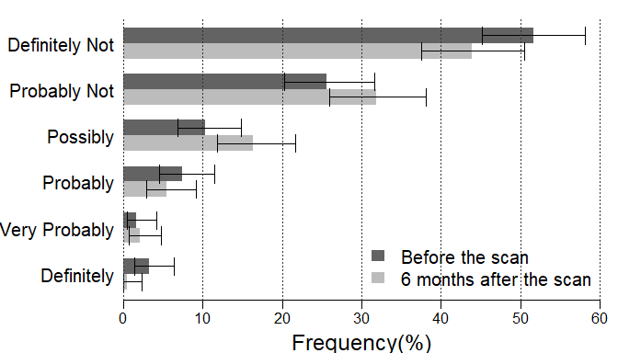

**Figure 2: Stress Burden of Waiting for IF Report.** The subjects were asked to rate their expected (pre-scan survey) and experienced (post-scan survey) stress burden on a 6-point-likert scale. On the x-axis: frequency of reported stress burden. On the y-axis: 6 categories of stress burden. Error bars denote 95% confidence intervals. Overall, no significant difference was observed between the two time points (4.1±1.3 vs 4.1±1.0, p=0.96 for pre- vs. post-scan).

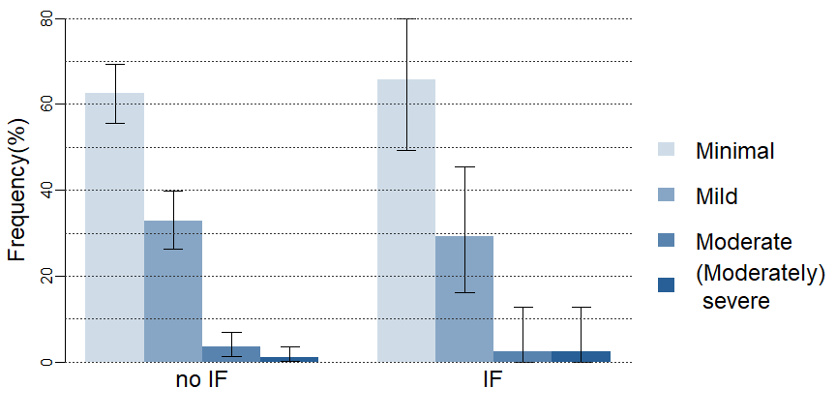

**Figure 3: Depression as measured by PHQ-9 score between participants with and without reported IF.** On the x-axis: categories of PHQ-9 score, stratified by reporting of IF. On the y-axis: frequencies of reported categories. Error bars denote 95% confidence intervals.No significant differences were observed (p=0.74).

**APPENDIX**

|  |  |  |  |
| --- | --- | --- | --- |
| **Body Location** | **IF Category** | **Recommended Definition/Cut-Offs** | **N (% of 113)** |
| **Abdomen** | Unclear Liver Lesion, further work-up recommended |  | 13 (11.5%) |
|  | Complex renal cyst | ≥ Bosniak 2F | 10 (8.9%) |
|  | Cystic Pancreatic Lesion | Size >2cm | 5 (4.4%) |
|  | Solid liver lesions | Size >2 cm | 4 (3.5%) |
|  | Intra or extrahepatic cholestasis with | DHC >15 mm (after cholecystectomy DHC >20 mm) | ≤3 |
|  | Urinary obstruction | Grade II, III or IV | ≤3 |
|  | Intraabdominal lymphadenopathy | Short diameter >15 mm and >3 lymphnodes grouped in a circumscribed region | ≤3 |
|  | Adrenal lesion | Size >2 cm | ≤3 |
|  | Chronic inflammatory bowel disease |  | ≤3 |
|  | Dilatation of pancreatic duct | Diameter >5 mm | ≤3 |
|  | Solid and semisolid renal tumors | Size >2 cm | ≤3 |
|  | Multiple non-cystic, non-hemangioma like liver lesions | Multiple >3, size >2 cm | ≤3 |
|  | Solid gall bladder lesion | Size >2 cm | ≤3 |
| **Cardio-vascular** | Myocardial infarction |  | 12 (10.6%) |
| Cardiomyopathy |  | ≤3 |
| Cardiac mass (including cardiac thrombus) |  | ≤3 |
|  | Severe Arterial Stenosis or Occlusion (of a relevant vessel) |  | ≤3 |
|  | Severely reduced LV function | EF <30% | ≤3 |
|  | Thoracic aortic aneurysm | Diameter >5 cm | ≤3 |
|  | Vasculitis |  | ≤3 |
| **ENT** | Cystic mass | Size >2 cm | ≤3 |
|  | Thyroid mass | Size >3 cm | ≤3 |
|  | Intraoral dental/bone/soft tissue infection |  | ≤3 |
| **Genital system** | Cystic ovarian tumor | Size >2 cm | ≤3 |
| **MSK** | Bone tumors and tumor like bone lesions | Size >2 cm | ≤3 |
|  | Soft tissue tumor | If size >5 cm or infiltrative growth pattern | ≤3 |
|  | Compression of myelon |  | ≤3 |
|  | Intraspinal tumor | Size >1 cm | ≤3 |
|  | Suspecion of rheumatic disease |  | ≤3 |
| **Neuro** | Solid cerebral mass supratentorial | Size >2 cm | 5 (4.4%) |
|  | Vascular malformations excluding DVA |  | 4 (3.5%) |
|  | Aneurysm of intracranial arteries | Diameter >5mm | ≤3 |
|  | Territorial brain infarction |  | ≤3 |
|  | Solid cerebral mass infratentorial | Size >1 cm | ≤3 |
|  | Cystic cerebral mass infratentorial | Size >1 cm | ≤3 |
|  | Cystic cerebral mass supratentorial | Size >2 cm | ≤3 |
| **Thorax** | Breast lesion | Size >2 cm | 6 (5.3%) |
|  | Pulmonary mass | Size >2 cm | 6 (5.3%) |
|  | Mediastinal lymphadenopathy | Short diameter >15 mm and >3 lymphnodes | ≤3 |

**Appendix E1:** Reported Incidental Findings by Categories and sorted by Body Location. Numbers of IF reported for 3 individuals or less are aggregated (for reasons of data and privacy protection as required by the local IRB). ENT denotes ear nose throat; MSK, musculoskeletal.

|  |  |  |  |  |
| --- | --- | --- | --- | --- |
|  | All | Excluded | Included | p-value |
|  | N = 400 | N = 157 | N = 243 |  |
| Age (years) | 56.3 ± 9.2 | 57.4 ± 9.4 | 55.6 ± 9.0 | 0.06 |
| Sex (men) | 231 (57.8%) | 93 (59.2%) | 138 (56.8%) | 0.70 |
| BMI (kg/m2) | 28.1 ± 4.9 | 29.0 ± 5.1 | 27.6 ± 4.7 | **0.006** |
| Glycemic Status |  |  |  | **<0.001** |
| Control | 243 (60.8%) | 64 (40.8%) | 179 (73.7%) |  |
| Prediabetes | 103 (25.8%) | 68 (43.3%) | 35 (14.4%) |  |
| Diabetes | 54 (13.5%) | 25 (15.9%) | 29 (11.9%) |  |
| Duration of Diabetes (years, median) | 7.0 [5.0, 11.8] | 6.5 [5.0, 11.0] | 7.5 [4.5, 13.5] | 0.59 |
| HbA1c, % | 5.6 ± 0.7 | 5.6 ± 0.7 | 5.5 ± 0.8 | 0.16 |
| Hypertension | 136 (34.0%) | 58 (36.9%) | 78 (32.1%) | 0.37 |
| Systolic BP (mmHg) | 120.6 ± 16.7 | 121.2 ± 16.6 | 120.2 ± 16.9 | 0.55 |
| Diastolic BP (mmHg) | 75.3 ± 10.0 | 75.6 ± 9.1 | 75.0 ± 10.6 | 0.56 |
| Antihypertensive medication | 102 (25.5%) | 45 (28.7%) | 57 (23.5%) | 0.29 |
| Total cholesterol (mg/dL) | 217.8 ± 36.3 | 220.3 ± 35.4 | 216.2 ± 36.8 | 0.26 |
| HDL (mg/dL) | 61.9 ± 17.7 | 62.7 ± 17.1 | 61.4 ± 18.0 | 0.47 |
| LDL (mg/dL) | 139.5 ± 32.9 | 139.1 ± 33.6 | 139.8 ± 32.5 | 0.82 |
| Triglyceride levels (mg/dL) | 131.5 ± 84.8 | 134.2 ± 88.9 | 129.8 ± 82.2 | 0.61 |
| Lipid lowering medication | 43 (10.8%) | 19 (12.1%) | 24 (9.9%) | 0.59 |
| Smoking status |  |  |  | 0.68 |
| Never-smoker | 146 (36.5%) | 59 (37.6%) | 87 (35.8%) |  |
| Ex-smoker | 174 (43.5%) | 70 (44.6%) | 104 (42.8%) |  |
| Smoker | 80 (20.0%) | 28 (17.8%) | 52 (21.4%) |  |
| Creatinine (mg/dL) | 0.9 ± 0.2 | 0.9 ± 0.2 | 0.9 ± 0.1 | **0.04** |

**Appendix E2:** Comparing subjects, of which the pre-/post-survey was included in the analysis as to those not-included

**REFERENCES**

1. Vernooij MW, Ikram MA, Tanghe HL, Vincent AJ, Hofman A, Krestin GP, et al. Incidental findings on brain MRI in the general population. The New England journal of medicine. 2007;357(18):1821-8.

2. Schmidt CO, Hegenscheid K, Erdmann P, Kohlmann T, Langanke M, Volzke H, et al. Psychosocial consequences and severity of disclosed incidental findings from whole-body MRI in a general population study. European radiology. 2013;23(5):1343-51.

3. Bamberg F, Hetterich H, Rospleszcz S, Lorbeer R, Auweter SD, Schlett CL, et al. Subclinical Disease Burden as Assessed by Whole-Body MRI in Subjects With Prediabetes, Subjects With Diabetes, and Normal Control Subjects From the General Population: The KORA-MRI Study. Diabetes. 2017;66(1):158-69.

4. Lowe B, Unutzer J, Callahan CM, Perkins AJ, Kroenke K. Monitoring depression treatment outcomes with the patient health questionnaire-9. Med Care. 2004;42(12):1194-201.

5. Morin, S. H. X., J. F. L. Cobbold, A. K. P. Lim, J. Eliahoo, E. L. Thomas, S. R. Mehta, G. Durighel, J. Fitzpatrick, J. D. Bell, und S. D. Taylor-Robinson. „Incidental Findings in Healthy Control Research Subjects Using Whole-Body MRI“. *European Journal of Radiology* 72, Nr. 3 (Dezember 2009): 529–33.

6. Gibson, Lorna M., John Nolan, Thomas J. Littlejohns, Edouard Mathieu, Steve Garratt, Nicola Doherty, Steffen Petersen, u. a. „Factors Associated with Potentially Serious Incidental Findings and with Serious Final Diagnoses on Multi-Modal Imaging in the UK Biobank Imaging Study: A Prospective Cohort Study“. *PloS One* 14, Nr. 6 (2019): e0218267.

7. Hegenscheid, Katrin, Rebecca Seipel, Carsten O. Schmidt, Henry Völzke, Jens-Peter Kühn, Reiner Biffar, Heyo K. Kroemer, Norbert Hosten, und Ralf Puls. „Potentially Relevant Incidental Findings on Research Whole-Body MRI in the General Adult Population: Frequencies and Management“. *European Radiology* 23, Nr. 3 (März 2013): 816–26.

8. Hegedüs, Peter, Oyunbileg von Stackelberg, Christoph Neumann, Sonja Selder, Nicole Werner, Pia Erdmann, Anja Granitza, u. a. „How to Report Incidental Findings from Population Whole-Body MRI: View of Participants of the German National Cohort“. *European Radiology* 29, Nr. 11 (November 2019): 5873–78.

9. Bunnik, Eline M., Lisa van Bodegom, Wim Pinxten, Inez D. de Beaufort, und Meike W. Vernooij. „Ethical Framework for the Detection, Management and Communication of Incidental Findings in Imaging Studies, Building on an Interview Study of Researchers’ Practices and Perspectives“. *BMC Medical Ethics* 18, Nr. 1 (6. Februar 2017): 10.

10. Kirschen, Matthew P., Agnieszka Jaworska, und Judy Illes. „Subjects’ Expectations in Neuroimaging Research“. *Journal of Magnetic Resonance Imaging: JMRI* 23, Nr. 2 (Februar 2006): 205–9.

11. Booth, T. C., A. D. Waldman, J. M. Wardlaw, S. A. Taylor, und A. Jackson. „Management of Incidental Findings during Imaging Research in ‚Healthy‘ Volunteers: Current UK Practice“. *The British Journal of Radiology* 85, Nr. 1009 (Januar 2012): 11–21.

12. Gibson, Lorna M., Thomas J. Littlejohns, Ligia Adamska, Steve Garratt, Nicola Doherty, UK Biobank Imaging Working Group, Joanna M. Wardlaw, u. a. „Impact of Detecting Potentially Serious Incidental Findings during Multi-Modal Imaging“. *Wellcome Open Research* 2 (2017): 114.

13. Håberg, Asta Kristine, Tommy Arild Hammer, Kjell Arne Kvistad, Jana Rydland, Tomm B. Müller, Live Eikenes, Mari Gårseth, und Lars Jacob Stovner. „Incidental Intracranial Findings and Their Clinical Impact; The HUNT MRI Study in a General Population of 1006 Participants between 50-66 Years“. *PloS One* 11, Nr. 3 (2016): e0151080.

14. Takashima, Kyoko, Yoshiyuki Takimoto, Eisuke Nakazawa, Yoshinori Hayashi, Atsushi Tsuchiya, Misao Fujita, und Akira Akabayashi. „Discovery and Informing Research Participants of Incidental Findings Detected in Brain Magnetic Resonance Imaging Studies: Review and Multi-Institutional Study“. *Brain and Behavior* 7, Nr. 5 (2017): e00676.

15. Bos, Daniel, Marielle M. F. Poels, Hieab H. H. Adams, Saloua Akoudad, Lotte G. M. Cremers, Hazel I. Zonneveld, Yoo Y. Hoogendam, u. a. „Prevalence, Clinical Management, and Natural Course of Incidental Findings on Brain MR Images: The Population-Based Rotterdam Scan Study“. *Radiology* 281, Nr. 2 (November 2016): 507–15.

16. Illes, J., A. C. Rosen, L. Huang, R. A. Goldstein, T. A. Raffin, G. Swan, und S. W. Atlas. „Ethical Consideration of Incidental Findings on Adult Brain MRI in Research“. *Neurology* 62, Nr. 6 (23. März 2004): 888–90.

17. Cole, Caitlin, Linda E. Petree, John P. Phillips, Jody M. Shoemaker, Mark Holdsworth, und Deborah L. Helitzer. „‚Ethical Responsibility‘ or ‚a Whole Can of Worms‘: Differences in Opinion on Incidental Finding Review and Disclosure in Neuroimaging Research from Focus Group Discussions with Participants, Parents, IRB Members, Investigators, Physicians and Community Members“. *Journal of Medical Ethics* 41, Nr. 10 (Oktober 2015): 841–47.

18. Booth, T. C., A. Jackson, J. M. Wardlaw, S. A. Taylor, und A. D. Waldman. „Incidental Findings Found in ‚Healthy‘ Volunteers during Imaging Performed for Research: Current Legal and Ethical Implications“. *The British Journal of Radiology* 83, Nr. 990 (Juni 2010): 456–65.

19. Orme, Nicholas M., Joel G. Fletcher, Hassan A. Siddiki, W. Scott Harmsen, Megan M. O’Byrne, John D. Port, William J. Tremaine, u. a. „Incidental Findings in Imaging Research: Evaluating Incidence, Benefit, and Burden“. *Archives of Internal Medicine* 170, Nr. 17 (27. September 2010): 1525–32.

20. Epstein, Ronald M., David N. Korones, und Timothy E. Quill. „Withholding Information from Patients — When Less Is More“. *New England Journal of Medicine* 362, Nr. 5 (4. Februar 2010): 380–81.

21. Gibson, Lorna M., Laura Paul, Francesca M. Chappell, Malcolm Macleod, William N. Whiteley, Rustam Al-Shahi Salman, Joanna M. Wardlaw, und Cathie L. M. Sudlow. „Potentially Serious Incidental Findings on Brain and Body Magnetic Resonance Imaging of Apparently Asymptomatic Adults: Systematic Review and Meta-Analysis“. *BMJ (Clinical Research Ed.)* 363 (22 2018): k4577.

22. Tarnoki, David Laszlo, Adam Domonkos Tarnoki, Antje Richter, Kinga Karlinger, Viktor Berczi, und Dirk Pickuth. „Clinical Value of Whole-Body Magnetic Resonance Imaging in Health Screening of General Adult Population“. *Radiology and Oncology* 49, Nr. 1 (März 2015): 10–16.