**Table of contents**

|  |  |
| --- | --- |
| **Single Nucleotide Polymorphisms (SNPs)** | |
| Table A.1 | Genetic instruments for body mass index |
| Table A.2 | Genetic instruments for waist circumference |
| Table A.3 | Genetic instruments for trunk fat ratio |
| **Univariable Mendelian randomization** | |
| Table A.4 | Power analysis |
| Table A.5 | Tests for detecting horizontal and directional pleiotropy |
| Table A.6 | Heterogeneity statistics |
| Table A.7 | Excluded SNPs based on Qj-statistics |
| **Multivariable Mendelian randomization** | |
| Table A.8 | Tests for detecting directional pleiotropy |
| Table A.9 | Heterogeneity statistics |
| **Multivariable Mendelian randomization mediation analyses** | |
| Table A.10 | Tests for detecting directional pleiotropy |
| Table A.11 | Heterogeneity statistics |
| **Sensitivity analyses** | |
| Fig. A.12 | Pairwise multivariable Mendelian randomization approach |
| Fig. A.13 | Mediation effects of type 2 diabetes |
| Fig. A.14 | Mediation effects of cardiovascular diseases |
| Fig. A.15 | Mediation effects of both, type 2 diabetes and cardiovascular diseases |
| **Additional analysis** | |
| Fig. A.16 | Effects of distinct BMI categories on COVID-19 susceptibility and severity |

**Table A.1** Associations of genome-wide significant SNPs used as instruments for body mass index and the susceptibility as well as hospitalization due to COVID-19

|  |  |  |  |  |  |  |  |  |  |  |
| --- | --- | --- | --- | --- | --- | --- | --- | --- | --- | --- |
|  |  |  | **COVID-19 susceptibility (n= 1079768)** | | | | **COVID-19 hospitalization (n=900687)** | | | |
| **SNP** | **EA** | **OA** | **EAF** |  | **SE** | **P** | **EAF** |  | **SE** | **P** |
| rs10002111 | A | G | 0.217 | 0.014 | 0.027 | 0.604 | 0.248 | 0.068 | 0.040 | 0.087 |
| rs10033843 | A | G | 0.300 | 0.004 | 0.026 | 0.891 | 0.285 | 0.024 | 0.039 | 0.530 |
| rs10050620 | T | C | 0.361 | -0.008 | 0.024 | 0.724 | 0.369 | -0.005 | 0.035 | 0.880 |
| rs1006317 | T | G | 0.157 | -0.039 | 0.032 | 0.217 | 0.186 | -0.101 | 0.049 | 0.040 |
| rs10099330 | A | G | 0.520 | 0.001 | 0.023 | 0.960 | 0.537 | -0.038 | 0.033 | 0.252 |
| rs10101364 | T | C | 0.692 | 0.006 | 0.024 | 0.806 | 0.674 | 0.036 | 0.036 | 0.320 |
| rs10110189 | T | C | 0.177 | -0.017 | 0.036 | 0.632 | 0.186 | -0.015 | 0.052 | 0.780 |
| rs10132280 | A | C | 0.334 | 0.016 | 0.024 | 0.490 | 0.332 | 0.047 | 0.035 | 0.181 |
| rs10145749 | T | C | 0.209 | 0.018 | 0.031 | 0.559 | 0.217 | 0.123 | 0.047 | 0.009 |
| rs10168563 | A | G | 0.670 | -0.030 | 0.025 | 0.216 | 0.641 | -0.003 | 0.037 | 0.935 |
| rs10169594 | T | C | 0.651 | 0.026 | 0.023 | 0.268 | 0.630 | 0.024 | 0.034 | 0.481 |
| rs10182181 | A | G | 0.505 | 0.010 | 0.022 | 0.662 | 0.524 | 0.012 | 0.033 | 0.715 |
| rs10185199 | A | G | 0.322 | -0.013 | 0.026 | 0.625 | 0.341 | 0.035 | 0.038 | 0.357 |
| rs10261050 | T | C | 0.452 | 0.035 | 0.022 | 0.121 | 0.450 | 0.021 | 0.033 | 0.531 |
| rs1048637 | T | G | 0.544 | 0.020 | 0.025 | 0.436 | 0.528 | 0.006 | 0.034 | 0.857 |
| rs10499694 | A | G | 0.527 | -0.022 | 0.022 | 0.321 | 0.522 | -0.012 | 0.033 | 0.714 |
| rs10506971 | A | G | 0.512 | -0.003 | 0.022 | 0.893 | 0.523 | -0.016 | 0.033 | 0.635 |
| rs10518694 | A | C | 0.161 | 0.007 | 0.032 | 0.838 | 0.181 | -0.010 | 0.048 | 0.840 |
| rs10733051 | A | G | 0.534 | -0.018 | 0.022 | 0.414 | 0.516 | -0.062 | 0.034 | 0.067 |
| rs10733682 | A | G | 0.483 | 0.001 | 0.026 | 0.974 | 0.509 | 0.009 | 0.034 | 0.790 |
| rs10741329 | A | G | 0.647 | 0.037 | 0.024 | 0.119 | 0.643 | 0.035 | 0.035 | 0.320 |
| rs10742752 | T | C | 0.371 | -0.006 | 0.023 | 0.797 | 0.387 | -0.044 | 0.034 | 0.195 |
| rs1075901 | T | C | 0.443 | -0.015 | 0.022 | 0.513 | 0.456 | -0.030 | 0.033 | 0.368 |
| rs10761785 | T | G | 0.510 | 0.028 | 0.022 | 0.203 | 0.519 | 0.025 | 0.033 | 0.451 |
| rs10772983 | T | C | 0.510 | 0.011 | 0.022 | 0.616 | 0.514 | 0.032 | 0.033 | 0.328 |
| rs10779751 | A | G | 0.302 | 0.039 | 0.024 | 0.106 | 0.300 | 0.062 | 0.037 | 0.092 |
| rs10811868 | A | G | 0.331 | -0.013 | 0.024 | 0.584 | 0.348 | -0.006 | 0.035 | 0.869 |
| rs10829164 | T | C | 0.202 | 0.029 | 0.031 | 0.350 | 0.230 | 0.065 | 0.046 | 0.158 |
| rs10842240 | C | G | 0.181 | 0.075 | 0.033 | 0.022 | 0.196 | 0.058 | 0.048 | 0.229 |
| rs10858334 | C | G | 0.850 | -0.001 | 0.034 | 0.984 | 0.825 | -0.060 | 0.048 | 0.216 |
| rs10864728 | A | G | 0.449 | 0.010 | 0.022 | 0.661 | 0.439 | -0.021 | 0.033 | 0.523 |
| rs10909880 | T | C | 0.416 | -0.001 | 0.022 | 0.976 | 0.432 | 0.055 | 0.033 | 0.096 |
| rs10920336 | A | G | 0.550 | -0.024 | 0.022 | 0.273 | 0.548 | 0.007 | 0.033 | 0.842 |
| rs10920678 | A | G | 0.426 | -0.037 | 0.022 | 0.094 | 0.436 | -0.040 | 0.033 | 0.229 |
| rs10929925 | A | C | 0.490 | -0.037 | 0.023 | 0.099 | 0.472 | -0.048 | 0.033 | 0.151 |
| rs10938397 | A | G | 0.592 | 0.007 | 0.022 | 0.749 | 0.570 | 0.015 | 0.033 | 0.661 |
| rs10942267 | A | G | 0.679 | 0.018 | 0.024 | 0.461 | 0.689 | 0.025 | 0.036 | 0.476 |
| rs10961649 | T | C | 0.322 | 0.018 | 0.024 | 0.454 | 0.339 | -0.004 | 0.035 | 0.897 |
| rs10962550 | C | G | 0.205 | 0.025 | 0.029 | 0.393 | 0.224 | 0.007 | 0.042 | 0.875 |
| rs10968114 | A | C | 0.547 | -0.013 | 0.022 | 0.564 | 0.535 | 0.034 | 0.034 | 0.318 |
| rs10975933 | C | G | 0.655 | 0.021 | 0.024 | 0.388 | 0.633 | 0.030 | 0.035 | 0.398 |
| rs10992867 | A | G | 0.322 | 0.021 | 0.025 | 0.405 | 0.344 | 0.023 | 0.037 | 0.532 |
| rs11001259 | A | T | 0.169 | 0.014 | 0.031 | 0.660 | 0.218 | 0.033 | 0.046 | 0.483 |
| rs11030618 | T | C | 0.584 | 0.018 | 0.022 | 0.428 | 0.565 | 0.017 | 0.033 | 0.618 |
| rs11044430 | A | T | 0.741 | 0.040 | 0.034 | 0.238 | 0.733 | 0.070 | 0.046 | 0.125 |
| rs11046972 | T | C | 0.105 | 0.037 | 0.041 | 0.360 | 0.140 | 0.050 | 0.058 | 0.390 |
| rs11060853 | A | G | 0.599 | 0.044 | 0.023 | 0.051 | 0.579 | 0.018 | 0.034 | 0.587 |
| rs11066188 | A | G | 0.328 | 0.006 | 0.023 | 0.795 | 0.367 | 0.005 | 0.034 | 0.893 |
| rs11078883 | C | G | 0.627 | -0.025 | 0.023 | 0.284 | 0.626 | 0.018 | 0.035 | 0.610 |
| rs11105839 | A | T | 0.401 | -0.036 | 0.023 | 0.116 | 0.396 | -0.071 | 0.034 | 0.038 |
| rs11115176 | T | C | 0.772 | 0.014 | 0.026 | 0.607 | 0.742 | -0.009 | 0.039 | 0.810 |
| rs11121210 | T | C | 0.408 | -0.029 | 0.022 | 0.192 | 0.419 | -0.072 | 0.034 | 0.033 |
| rs11128021 | A | G | 0.160 | 0.053 | 0.031 | 0.088 | 0.184 | 0.069 | 0.047 | 0.142 |
| rs11150911 | A | C | 0.357 | 0.016 | 0.025 | 0.533 | 0.353 | -0.022 | 0.038 | 0.557 |
| rs11165643 | T | C | 0.527 | 0.013 | 0.022 | 0.546 | 0.552 | 0.012 | 0.033 | 0.716 |
| rs11170468 | A | C | 0.777 | -0.005 | 0.027 | 0.865 | 0.760 | -0.005 | 0.039 | 0.905 |
| rs11218510 | A | G | 0.354 | 0.021 | 0.023 | 0.358 | 0.377 | 0.033 | 0.034 | 0.336 |
| rs11246136 | A | C | 0.119 | -0.060 | 0.039 | 0.127 | 0.153 | -0.094 | 0.058 | 0.103 |
| rs112646560 | T | C | 0.219 | 0.003 | 0.027 | 0.906 | 0.254 | 0.087 | 0.042 | 0.036 |
| rs1126930 | C | G | 0.058 | 0.080 | 0.066 | 0.225 | 0.094 | 0.121 | 0.105 | 0.245 |
| rs11525873 | T | C | 0.876 | 0.073 | 0.039 | 0.060 | 0.850 | 0.062 | 0.057 | 0.280 |
| rs11538 | A | G | 0.845 | -0.019 | 0.031 | 0.533 | 0.814 | 0.029 | 0.047 | 0.531 |
| rs11577094 | T | C | 0.088 | 0.051 | 0.042 | 0.230 | 0.118 | 0.096 | 0.068 | 0.159 |
| rs11594179 | T | C | 0.215 | -0.017 | 0.027 | 0.537 | 0.232 | -0.001 | 0.039 | 0.988 |
| rs1159692 | A | C | 0.495 | -0.040 | 0.023 | 0.085 | 0.496 | -0.051 | 0.034 | 0.134 |
| rs11614340 | T | C | 0.746 | 0.013 | 0.026 | 0.600 | 0.715 | -0.023 | 0.037 | 0.530 |
| rs11615578 | T | C | 0.232 | -0.005 | 0.027 | 0.841 | 0.252 | -0.011 | 0.040 | 0.786 |
| rs11633626 | A | C | 0.627 | -0.022 | 0.023 | 0.336 | 0.620 | 0.017 | 0.035 | 0.628 |
| rs11636611 | T | C | 0.478 | 0.046 | 0.022 | 0.040 | 0.490 | 0.053 | 0.033 | 0.108 |
| rs116374395 | A | G | 0.065 | 0.042 | 0.056 | 0.449 | 0.097 | 0.019 | 0.085 | 0.821 |
| rs11649864 | A | G | 0.108 | 0.025 | 0.040 | 0.536 | 0.134 | -0.011 | 0.059 | 0.853 |
| rs11655587 | T | C | 0.340 | 0.005 | 0.023 | 0.822 | 0.348 | 0.031 | 0.035 | 0.370 |
| rs11672660 | T | C | 0.207 | -0.008 | 0.028 | 0.778 | 0.233 | -0.070 | 0.042 | 0.093 |
| rs11692326 | T | C | 0.220 | -0.029 | 0.027 | 0.285 | 0.246 | 0.009 | 0.041 | 0.829 |
| rs11695013 | T | C | 0.596 | -0.044 | 0.023 | 0.057 | 0.618 | -0.062 | 0.034 | 0.071 |
| rs11713193 | A | G | 0.450 | 0.016 | 0.022 | 0.462 | 0.437 | 0.042 | 0.033 | 0.201 |
| rs11739877 | T | C | 0.622 | -0.008 | 0.023 | 0.720 | 0.603 | -0.056 | 0.034 | 0.102 |
| rs11757278 | T | C | 0.705 | 0.050 | 0.025 | 0.042 | 0.682 | 0.069 | 0.037 | 0.059 |
| rs11772246 | T | C | 0.803 | 0.031 | 0.029 | 0.280 | 0.767 | 0.039 | 0.042 | 0.355 |
| rs11773362 | T | C | 0.326 | 0.016 | 0.024 | 0.500 | 0.355 | -0.014 | 0.035 | 0.701 |
| rs11782074 | T | G | 0.327 | 0.010 | 0.024 | 0.665 | 0.357 | 0.009 | 0.035 | 0.807 |
| rs118081010 | T | C | 0.056 | -0.045 | 0.079 | 0.570 | 0.083 | -0.201 | 0.117 | 0.086 |
| rs11882409 | A | C | 0.277 | 0.029 | 0.025 | 0.253 | 0.287 | 0.034 | 0.037 | 0.357 |
| rs11902450 | T | C | 0.142 | 0.024 | 0.037 | 0.504 | 0.152 | 0.026 | 0.054 | 0.622 |
| rs11915371 | A | C | 0.774 | -0.042 | 0.027 | 0.120 | 0.763 | -0.066 | 0.041 | 0.106 |
| rs11919665 | A | T | 0.373 | -0.036 | 0.028 | 0.192 | 0.388 | -0.012 | 0.036 | 0.748 |
| rs11921432 | T | C | 0.881 | 0.015 | 0.037 | 0.677 | 0.851 | -0.001 | 0.054 | 0.981 |
| rs12072739 | A | G | 0.752 | -0.037 | 0.025 | 0.141 | 0.732 | -0.011 | 0.040 | 0.782 |
| rs12098284 | T | C | 0.157 | -0.004 | 0.033 | 0.896 | 0.171 | -0.048 | 0.049 | 0.329 |
| rs12140153 | T | G | 0.103 | -0.051 | 0.040 | 0.205 | 0.133 | 0.002 | 0.066 | 0.981 |
| rs12150665 | T | C | 0.625 | 0.001 | 0.023 | 0.973 | 0.592 | 0.015 | 0.033 | 0.645 |
| rs12259464 | A | G | 0.428 | 0.006 | 0.023 | 0.777 | 0.443 | 0.027 | 0.033 | 0.419 |
| rs12282785 | A | C | 0.259 | -0.006 | 0.027 | 0.829 | 0.264 | 0.028 | 0.039 | 0.480 |
| rs12286929 | A | G | 0.490 | -0.049 | 0.025 | 0.045 | 0.501 | -0.065 | 0.033 | 0.053 |
| rs12334877 | A | G | 0.235 | 0.019 | 0.028 | 0.496 | 0.251 | 0.053 | 0.041 | 0.196 |
| rs12364470 | T | G | 0.829 | 0.025 | 0.032 | 0.435 | 0.795 | 0.007 | 0.048 | 0.889 |
| rs12369179 | T | C | 0.085 | -0.008 | 0.046 | 0.870 | 0.122 | 0.034 | 0.069 | 0.623 |
| rs12386885 | T | C | 0.144 | 0.009 | 0.036 | 0.802 | 0.178 | -0.015 | 0.048 | 0.756 |
| rs12421848 | A | G | 0.429 | 0.014 | 0.025 | 0.587 | 0.434 | 0.023 | 0.034 | 0.512 |
| rs12429545 | A | G | 0.158 | 0.046 | 0.033 | 0.162 | 0.182 | 0.025 | 0.049 | 0.611 |
| rs12439632 | C | G | 0.195 | 0.017 | 0.031 | 0.579 | 0.218 | 0.034 | 0.049 | 0.478 |
| rs12448257 | A | G | 0.228 | -0.022 | 0.027 | 0.416 | 0.239 | 0.009 | 0.040 | 0.824 |
| rs12462975 | A | G | 0.298 | -0.017 | 0.024 | 0.490 | 0.321 | -0.009 | 0.036 | 0.798 |
| rs12527426 | A | G | 0.364 | 0.037 | 0.025 | 0.140 | 0.361 | 0.041 | 0.036 | 0.264 |
| rs12591120 | T | C | 0.732 | -0.014 | 0.026 | 0.587 | 0.725 | 0.006 | 0.038 | 0.874 |
| rs12602912 | T | C | 0.218 | -0.005 | 0.028 | 0.862 | 0.249 | -0.009 | 0.041 | 0.820 |
| rs12611148 | A | C | 0.167 | -0.012 | 0.031 | 0.701 | 0.189 | 0.019 | 0.046 | 0.680 |
| rs12628051 | T | C | 0.646 | 0.001 | 0.024 | 0.953 | 0.623 | -0.022 | 0.035 | 0.519 |
| rs12628891 | T | C | 0.287 | 0.021 | 0.025 | 0.402 | 0.306 | 0.068 | 0.038 | 0.069 |
| rs12636480 | T | G | 0.338 | 0.011 | 0.023 | 0.626 | 0.354 | 0.049 | 0.034 | 0.157 |
| rs12652212 | A | G | 0.576 | 0.014 | 0.022 | 0.534 | 0.577 | -0.023 | 0.033 | 0.478 |
| rs1268065 | A | G | 0.534 | 0.012 | 0.023 | 0.585 | 0.508 | -0.037 | 0.033 | 0.262 |
| rs12680842 | A | G | 0.668 | 0.024 | 0.024 | 0.312 | 0.639 | 0.040 | 0.035 | 0.253 |
| rs12681792a | A | C | 0.225 | -0.019 | 0.028 | 0.494 |  |  |  |  |
| rs12692596 | T | C | 0.363 | 0.009 | 0.023 | 0.687 | 0.378 | -0.009 | 0.034 | 0.799 |
| rs12714199 | T | C | 0.593 | 0.002 | 0.023 | 0.918 | 0.579 | 0.007 | 0.033 | 0.834 |
| rs12765914 | T | C | 0.107 | -0.023 | 0.039 | 0.566 | 0.142 | -0.029 | 0.058 | 0.612 |
| rs12868881 | A | T | 0.390 | -0.010 | 0.023 | 0.657 | 0.416 | -0.020 | 0.034 | 0.549 |
| rs12888545 | A | G | 0.780 | -0.013 | 0.026 | 0.614 | 0.753 | -0.036 | 0.039 | 0.359 |
| rs12912198 | T | C | 0.262 | -0.062 | 0.026 | 0.016 | 0.279 | -0.087 | 0.038 | 0.022 |
| rs12914623 | C | G | 0.284 | 0.011 | 0.025 | 0.675 | 0.286 | -0.023 | 0.038 | 0.546 |
| rs12922346 | C | G | 0.267 | 0.014 | 0.026 | 0.594 | 0.275 | -0.008 | 0.039 | 0.840 |
| rs12926250 | T | G | 0.107 | 0.059 | 0.038 | 0.122 | 0.134 | -0.015 | 0.055 | 0.781 |
| rs1293037 | T | C | 0.743 | -0.012 | 0.027 | 0.664 | 0.728 | -0.004 | 0.039 | 0.913 |
| rs12939549 | A | G | 0.585 | -0.015 | 0.022 | 0.512 | 0.586 | 0.013 | 0.033 | 0.697 |
| rs1296328 | A | C | 0.518 | -0.039 | 0.023 | 0.092 | 0.503 | -0.026 | 0.033 | 0.443 |
| rs12981256 | A | G | 0.477 | 0.015 | 0.023 | 0.506 | 0.499 | 0.005 | 0.035 | 0.883 |
| rs12987009 | A | T | 0.605 | -0.012 | 0.023 | 0.610 | 0.588 | -0.002 | 0.034 | 0.960 |
| rs13021737 | A | G | 0.186 | -0.027 | 0.030 | 0.370 | 0.220 | 0.014 | 0.043 | 0.752 |
| rs13033310 | A | G | 0.264 | -0.016 | 0.026 | 0.530 | 0.279 | -0.004 | 0.038 | 0.907 |
| rs1304549 | A | G | 0.269 | -0.053 | 0.027 | 0.053 | 0.259 | -0.022 | 0.040 | 0.580 |
| rs13107325 | T | C | 0.079 | 0.068 | 0.049 | 0.164 | 0.119 | 0.061 | 0.062 | 0.328 |
| rs13110266 | A | G | 0.410 | -0.033 | 0.023 | 0.141 | 0.422 | -0.043 | 0.034 | 0.201 |
| rs13174863 | A | G | 0.844 | -0.049 | 0.031 | 0.119 | 0.810 | -0.031 | 0.045 | 0.490 |
| rs13186194 | T | C | 0.615 | 0.019 | 0.023 | 0.416 | 0.613 | -0.006 | 0.035 | 0.856 |
| rs13191362 | A | G | 0.868 | 0.019 | 0.034 | 0.581 | 0.844 | 0.079 | 0.050 | 0.114 |
| rs13240600 | A | G | 0.729 | -0.031 | 0.031 | 0.322 | 0.739 | -0.060 | 0.045 | 0.179 |
| rs13245051 | A | G | 0.516 | 0.030 | 0.023 | 0.183 | 0.509 | 0.056 | 0.034 | 0.096 |
| rs13263601 | A | C | 0.689 | -0.047 | 0.024 | 0.047 | 0.679 | 0.007 | 0.035 | 0.849 |
| rs1327259 | A | G | 0.583 | 0.027 | 0.023 | 0.234 | 0.565 | 0.006 | 0.034 | 0.855 |
| rs13296413 | T | C | 0.371 | -0.014 | 0.023 | 0.531 | 0.377 | 0.000 | 0.034 | 0.995 |
| rs13298487 | T | C | 0.606 | -0.020 | 0.024 | 0.392 | 0.616 | -0.037 | 0.036 | 0.304 |
| rs1346841 | A | G | 0.444 | 0.018 | 0.023 | 0.423 | 0.431 | -0.032 | 0.034 | 0.351 |
| rs1350430 | T | C | 0.528 | -0.017 | 0.022 | 0.437 | 0.539 | -0.045 | 0.033 | 0.176 |
| rs1356506 | T | C | 0.650 | -0.022 | 0.023 | 0.352 | 0.627 | 0.003 | 0.035 | 0.931 |
| rs1358980 | T | C | 0.478 | -0.010 | 0.023 | 0.669 | 0.498 | -0.011 | 0.033 | 0.734 |
| rs1383592 | A | G | 0.254 | -0.013 | 0.026 | 0.611 | 0.273 | -0.035 | 0.039 | 0.371 |
| rs1409818 | T | C | 0.149 | -0.006 | 0.035 | 0.861 | 0.166 | -0.057 | 0.052 | 0.268 |
| rs1412235 | C | G | 0.282 | -0.001 | 0.025 | 0.954 | 0.304 | 0.034 | 0.037 | 0.361 |
| rs1421334 | A | C | 0.504 | -0.013 | 0.023 | 0.576 | 0.484 | -0.037 | 0.033 | 0.274 |
| rs1437842 | A | G | 0.499 | 0.030 | 0.022 | 0.174 | 0.474 | 0.010 | 0.033 | 0.765 |
| rs1441264 | A | G | 0.631 | 0.005 | 0.023 | 0.819 | 0.612 | -0.029 | 0.034 | 0.399 |
| rs1451077 | A | G | 0.539 | -0.047 | 0.023 | 0.038 | 0.542 | -0.068 | 0.034 | 0.043 |
| rs147568678 | T | C | 0.781 | 0.005 | 0.028 | 0.868 | 0.743 | -0.020 | 0.041 | 0.631 |
| rs1477199 | A | G | 0.830 | -0.041 | 0.032 | 0.194 | 0.813 | -0.046 | 0.046 | 0.324 |
| rs1492014 | T | C | 0.570 | -0.001 | 0.023 | 0.963 | 0.586 | -0.040 | 0.034 | 0.239 |
| rs1492767 | T | C | 0.432 | 0.020 | 0.022 | 0.381 | 0.453 | 0.033 | 0.033 | 0.321 |
| rs1501673 | A | G | 0.170 | 0.021 | 0.033 | 0.522 | 0.190 | 0.015 | 0.047 | 0.754 |
| rs150215901 | A | T | 0.068 | 0.093 | 0.057 | 0.103 | 0.119 | 0.012 | 0.082 | 0.882 |
| rs1522569 | T | G | 0.803 | -0.010 | 0.029 | 0.723 | 0.791 | 0.044 | 0.042 | 0.295 |
| rs1559673 | A | C | 0.932 | -0.036 | 0.070 | 0.610 | 0.895 | -0.146 | 0.109 | 0.179 |
| rs156201 | C | G | 0.683 | 0.006 | 0.029 | 0.831 | 0.681 | 0.008 | 0.039 | 0.834 |
| rs16851483 | T | G | 0.097 | -0.054 | 0.044 | 0.224 | 0.125 | 0.000 | 0.066 | 1.000 |
| rs16906838 | T | C | 0.091 | -0.023 | 0.048 | 0.634 | 0.114 | -0.057 | 0.071 | 0.427 |
| rs1700082 | C | G | 0.591 | 0.047 | 0.024 | 0.053 | 0.610 | 0.026 | 0.035 | 0.462 |
| rs17020497 | A | G | 0.158 | -0.005 | 0.033 | 0.887 | 0.168 | -0.023 | 0.047 | 0.624 |
| rs17024393 | T | C | 0.943 | -0.120 | 0.065 | 0.066 | 0.914 | -0.174 | 0.108 | 0.109 |
| rs17066856 | T | C | 0.836 | 0.028 | 0.038 | 0.456 | 0.828 | 0.045 | 0.055 | 0.418 |
| rs17094222 | T | C | 0.797 | -0.014 | 0.028 | 0.621 | 0.762 | -0.036 | 0.040 | 0.370 |
| rs17182027 | A | G | 0.498 | 0.041 | 0.022 | 0.068 | 0.506 | 0.059 | 0.034 | 0.078 |
| rs17207196 | T | C | 0.388 | -0.005 | 0.023 | 0.821 | 0.411 | -0.009 | 0.035 | 0.790 |
| rs1721447 | T | G | 0.503 | -0.034 | 0.022 | 0.132 | 0.507 | -0.034 | 0.033 | 0.313 |
| rs17367750 | T | C | 0.322 | 0.028 | 0.024 | 0.241 | 0.339 | 0.075 | 0.036 | 0.034 |
| rs17405603 | A | T | 0.736 | -0.001 | 0.025 | 0.963 | 0.711 | 0.007 | 0.038 | 0.861 |
| rs17405819 | T | C | 0.709 | -0.016 | 0.024 | 0.518 | 0.682 | -0.059 | 0.036 | 0.102 |
| rs1750307 | A | T | 0.385 | -0.003 | 0.025 | 0.915 | 0.394 | -0.010 | 0.035 | 0.764 |
| rs17544384 | T | C | 0.801 | 0.001 | 0.027 | 0.968 | 0.774 | -0.014 | 0.040 | 0.722 |
| rs17636031 | T | C | 0.728 | -0.018 | 0.026 | 0.501 | 0.698 | -0.033 | 0.037 | 0.384 |
| rs17681451 | A | G | 0.102 | 0.070 | 0.041 | 0.084 | 0.131 | 0.104 | 0.061 | 0.086 |
| rs17724992 | A | G | 0.715 | -0.021 | 0.025 | 0.401 | 0.693 | -0.006 | 0.037 | 0.870 |
| rs17783165 | T | C | 0.623 | -0.020 | 0.024 | 0.407 | 0.616 | -0.028 | 0.035 | 0.422 |
| rs17806224 | A | G | 0.180 | -0.021 | 0.029 | 0.466 | 0.213 | 0.013 | 0.043 | 0.756 |
| rs17814208 | A | G | 0.755 | -0.007 | 0.026 | 0.787 | 0.731 | -0.024 | 0.039 | 0.529 |
| rs1799923 | A | G | 0.170 | -0.037 | 0.035 | 0.282 | 0.177 | -0.053 | 0.053 | 0.315 |
| rs1808629 | A | G | 0.612 | 0.011 | 0.024 | 0.652 | 0.631 | 0.027 | 0.035 | 0.441 |
| rs185350 | T | C | 0.471 | -0.001 | 0.022 | 0.966 | 0.486 | 0.022 | 0.033 | 0.501 |
| rs1860561 | A | G | 0.210 | -0.002 | 0.028 | 0.947 | 0.237 | -0.025 | 0.041 | 0.546 |
| rs1877875 | T | C | 0.413 | -0.018 | 0.022 | 0.428 | 0.410 | -0.019 | 0.033 | 0.576 |
| rs1884389 | T | C | 0.429 | -0.033 | 0.022 | 0.147 | 0.433 | -0.046 | 0.033 | 0.168 |
| rs1884897 | A | G | 0.390 | -0.019 | 0.023 | 0.414 | 0.382 | -0.022 | 0.034 | 0.517 |
| rs1927790 | T | C | 0.562 | -0.019 | 0.022 | 0.405 | 0.560 | -0.021 | 0.033 | 0.532 |
| rs1928295 | T | C | 0.557 | -0.020 | 0.022 | 0.369 | 0.549 | -0.034 | 0.033 | 0.306 |
| rs1941213 | A | C | 0.706 | 0.023 | 0.025 | 0.369 | 0.690 | 0.051 | 0.038 | 0.175 |
| rs1941696 | A | G | 0.511 | 0.010 | 0.022 | 0.645 | 0.518 | -0.009 | 0.033 | 0.782 |
| rs1945160 | A | G | 0.354 | -0.031 | 0.023 | 0.183 | 0.367 | -0.047 | 0.034 | 0.168 |
| rs1948080 | T | G | 0.648 | -0.044 | 0.023 | 0.060 | 0.630 | -0.053 | 0.035 | 0.126 |
| rs194809 | A | G | 0.212 | -0.028 | 0.028 | 0.323 | 0.234 | -0.045 | 0.042 | 0.277 |
| rs1951455 | T | C | 0.289 | -0.002 | 0.025 | 0.941 | 0.305 | 0.000 | 0.036 | 0.993 |
| rs1958898 | C | G | 0.204 | -0.063 | 0.029 | 0.028 | 0.239 | -0.040 | 0.043 | 0.350 |
| rs1965529 | A | G | 0.752 | -0.033 | 0.027 | 0.219 | 0.732 | -0.045 | 0.040 | 0.263 |
| rs197374 | T | C | 0.413 | -0.012 | 0.022 | 0.597 | 0.405 | -0.024 | 0.034 | 0.478 |
| rs1999433 | T | C | 0.442 | 0.002 | 0.023 | 0.944 | 0.446 | 0.038 | 0.034 | 0.258 |
| rs2007518 | A | G | 0.605 | -0.016 | 0.022 | 0.471 | 0.600 | -0.024 | 0.033 | 0.473 |
| rs2047648 | A | T | 0.755 | 0.020 | 0.026 | 0.438 | 0.725 | -0.018 | 0.037 | 0.632 |
| rs2051559 | T | C | 0.845 | -0.016 | 0.033 | 0.618 | 0.824 | -0.047 | 0.051 | 0.352 |
| rs2053682 | A | C | 0.688 | 0.007 | 0.024 | 0.781 | 0.665 | 0.015 | 0.035 | 0.671 |
| rs2058527 | T | G | 0.269 | -0.032 | 0.025 | 0.202 | 0.292 | -0.038 | 0.038 | 0.306 |
| rs2064044 | A | C | 0.777 | 0.005 | 0.027 | 0.843 | 0.747 | -0.032 | 0.042 | 0.446 |
| rs2065418 | T | G | 0.661 | 0.051 | 0.023 | 0.028 | 0.642 | 0.020 | 0.034 | 0.550 |
| rs2066295 | A | G | 0.771 | 0.033 | 0.026 | 0.213 | 0.752 | 0.045 | 0.039 | 0.253 |
| rs2074314 | T | C | 0.656 | -0.013 | 0.023 | 0.577 | 0.614 | -0.025 | 0.034 | 0.465 |
| rs2108719 | A | G | 0.706 | -0.022 | 0.026 | 0.397 | 0.697 | 0.014 | 0.038 | 0.713 |
| rs2112347 | T | G | 0.588 | -0.040 | 0.023 | 0.079 | 0.589 | -0.062 | 0.034 | 0.068 |
| rs2119753 | A | G | 0.639 | -0.006 | 0.023 | 0.796 | 0.622 | -0.013 | 0.035 | 0.697 |
| rs2120710 | A | G | 0.655 | -0.024 | 0.024 | 0.314 | 0.628 | -0.002 | 0.035 | 0.962 |
| rs2134858 | T | C | 0.506 | 0.021 | 0.022 | 0.341 | 0.504 | -0.029 | 0.033 | 0.369 |
| rs213518 | T | C | 0.840 | -0.044 | 0.032 | 0.175 | 0.825 | 0.000 | 0.048 | 0.994 |
| rs214249 | T | G | 0.616 | 0.009 | 0.023 | 0.695 | 0.615 | 0.025 | 0.034 | 0.466 |
| rs215669 | A | G | 0.541 | -0.026 | 0.023 | 0.266 | 0.568 | -0.016 | 0.034 | 0.640 |
| rs217433 | T | C | 0.793 | 0.004 | 0.028 | 0.900 | 0.774 | -0.006 | 0.043 | 0.883 |
| rs217669 | T | C | 0.697 | 0.020 | 0.026 | 0.435 | 0.706 | -0.007 | 0.038 | 0.843 |
| rs2192158 | A | G | 0.480 | -0.011 | 0.022 | 0.621 | 0.482 | 0.036 | 0.033 | 0.278 |
| rs2196618 | A | G | 0.306 | 0.025 | 0.026 | 0.338 | 0.303 | 0.007 | 0.038 | 0.847 |
| rs2206277 | T | C | 0.202 | 0.016 | 0.029 | 0.578 | 0.229 | 0.011 | 0.042 | 0.789 |
| rs2228213 | A | G | 0.317 | -0.025 | 0.024 | 0.281 | 0.350 | -0.032 | 0.034 | 0.352 |
| rs2228552 | T | G | 0.594 | -0.051 | 0.022 | 0.022 | 0.608 | -0.070 | 0.034 | 0.041 |
| rs2238799 | A | G | 0.589 | 0.051 | 0.023 | 0.027 | 0.567 | 0.076 | 0.034 | 0.025 |
| rs2241423 | A | G | 0.284 | 0.020 | 0.026 | 0.444 | 0.278 | -0.017 | 0.038 | 0.657 |
| rs2246012 | T | C | 0.812 | 0.020 | 0.030 | 0.505 | 0.783 | -0.001 | 0.046 | 0.981 |
| rs2257791 | A | G | 0.720 | 0.027 | 0.026 | 0.291 | 0.715 | 0.064 | 0.038 | 0.093 |
| rs225882 | T | C | 0.693 | -0.007 | 0.025 | 0.783 | 0.672 | 0.027 | 0.037 | 0.462 |
| rs2267958 | A | G | 0.469 | -0.019 | 0.023 | 0.408 | 0.488 | -0.031 | 0.035 | 0.374 |
| rs2271046 | A | T | 0.649 | -0.012 | 0.025 | 0.619 | 0.665 | -0.025 | 0.037 | 0.506 |
| rs2271189 | A | G | 0.348 | -0.029 | 0.023 | 0.206 | 0.369 | -0.028 | 0.034 | 0.421 |
| rs2273175 | T | C | 0.703 | -0.023 | 0.025 | 0.359 | 0.673 | -0.089 | 0.036 | 0.014 |
| rs2275003 | A | G | 0.498 | 0.012 | 0.022 | 0.585 | 0.500 | -0.017 | 0.033 | 0.603 |
| rs2281819 | A | T | 0.244 | 0.009 | 0.026 | 0.723 | 0.268 | 0.064 | 0.039 | 0.105 |
| rs2283006 | A | G | 0.540 | -0.005 | 0.023 | 0.840 | 0.508 | -0.031 | 0.034 | 0.362 |
| rs2283093 | T | C | 0.212 | -0.006 | 0.028 | 0.821 | 0.236 | -0.004 | 0.041 | 0.929 |
| rs2289379 | T | C | 0.368 | -0.015 | 0.023 | 0.508 | 0.398 | -0.008 | 0.035 | 0.817 |
| rs2342892 | T | G | 0.444 | -0.012 | 0.023 | 0.601 | 0.464 | -0.002 | 0.033 | 0.962 |
| rs2357760 | A | G | 0.658 | -0.015 | 0.024 | 0.532 | 0.632 | -0.054 | 0.035 | 0.117 |
| rs2365389 | T | C | 0.485 | -0.031 | 0.022 | 0.174 | 0.472 | -0.039 | 0.033 | 0.249 |
| rs2396625 | A | T | 0.382 | 0.020 | 0.023 | 0.382 | 0.399 | -0.013 | 0.034 | 0.706 |
| rs2400414 | T | C | 0.367 | -0.008 | 0.022 | 0.719 | 0.365 | -0.009 | 0.034 | 0.782 |
| rs2423668 | T | C | 0.466 | 0.011 | 0.023 | 0.636 | 0.458 | 0.015 | 0.034 | 0.658 |
| rs2436728 | A | G | 0.378 | -0.022 | 0.023 | 0.343 | 0.407 | 0.019 | 0.033 | 0.568 |
| rs2439823 | A | G | 0.462 | 0.016 | 0.022 | 0.481 | 0.490 | -0.001 | 0.033 | 0.978 |
| rs2466103 | T | G | 0.718 | 0.034 | 0.024 | 0.164 | 0.702 | 0.008 | 0.036 | 0.815 |
| rs2470893 | T | C | 0.245 | 0.010 | 0.025 | 0.684 | 0.268 | 0.072 | 0.038 | 0.057 |
| rs2503185 | A | G | 0.474 | -0.013 | 0.022 | 0.546 | 0.484 | 0.005 | 0.033 | 0.878 |
| rs2513999 | A | G | 0.205 | 0.022 | 0.031 | 0.487 | 0.201 | 0.026 | 0.046 | 0.575 |
| rs2600226 | T | C | 0.617 | 0.000 | 0.024 | 0.988 | 0.609 | 0.009 | 0.035 | 0.790 |
| rs2605603 | A | G | 0.513 | -0.036 | 0.022 | 0.102 | 0.516 | -0.069 | 0.033 | 0.035 |
| rs2612576 | A | T | 0.334 | -0.054 | 0.025 | 0.032 | 0.321 | -0.093 | 0.037 | 0.012 |
| rs2622274 | T | G | 0.453 | -0.017 | 0.023 | 0.458 | 0.438 | -0.019 | 0.034 | 0.574 |
| rs264941 | A | C | 0.467 | 0.036 | 0.022 | 0.108 | 0.472 | 0.015 | 0.033 | 0.641 |
| rs2707183 | T | G | 0.528 | -0.018 | 0.023 | 0.426 | 0.532 | -0.007 | 0.033 | 0.838 |
| rs2712665 | T | C | 0.726 | -0.010 | 0.024 | 0.691 | 0.698 | -0.027 | 0.036 | 0.446 |
| rs2715423 | A | G | 0.250 | -0.049 | 0.025 | 0.054 | 0.274 | -0.034 | 0.038 | 0.371 |
| rs273512 | T | C | 0.410 | -0.014 | 0.023 | 0.524 | 0.416 | -0.002 | 0.034 | 0.945 |
| rs2744974 | T | C | 0.369 | 0.009 | 0.024 | 0.714 | 0.356 | -0.035 | 0.035 | 0.316 |
| rs274628 | A | C | 0.325 | -0.015 | 0.023 | 0.514 | 0.345 | 0.001 | 0.035 | 0.970 |
| rs2777768 | A | G | 0.747 | 0.036 | 0.026 | 0.162 | 0.735 | 0.056 | 0.037 | 0.137 |
| rs2820295 | A | G | 0.317 | 0.000 | 0.023 | 0.996 | 0.327 | -0.014 | 0.035 | 0.691 |
| rs2832283 | A | G | 0.217 | 0.012 | 0.027 | 0.655 | 0.246 | 0.029 | 0.041 | 0.476 |
| rs28350 | A | G | 0.193 | 0.026 | 0.029 | 0.371 | 0.228 | 0.071 | 0.042 | 0.091 |
| rs28489620 | A | G | 0.263 | 0.035 | 0.025 | 0.159 | 0.285 | 0.034 | 0.038 | 0.362 |
| rs2861089 | A | T | 0.380 | 0.003 | 0.023 | 0.899 | 0.392 | 0.058 | 0.034 | 0.086 |
| rs2861685 | T | C | 0.585 | -0.034 | 0.023 | 0.128 | 0.578 | -0.069 | 0.033 | 0.038 |
| rs2862996 | T | G | 0.672 | 0.023 | 0.024 | 0.351 | 0.657 | 0.015 | 0.035 | 0.672 |
| rs2875762 | C | G | 0.280 | -0.006 | 0.026 | 0.820 | 0.278 | 0.069 | 0.038 | 0.069 |
| rs2907948 | A | G | 0.231 | -0.010 | 0.026 | 0.700 | 0.257 | -0.015 | 0.038 | 0.692 |
| rs2910026 | T | C | 0.719 | 0.010 | 0.025 | 0.705 | 0.717 | -0.007 | 0.037 | 0.847 |
| rs2962334 | T | G | 0.054 | 0.135 | 0.079 | 0.086 | 0.079 | 0.055 | 0.115 | 0.632 |
| rs2984618 | T | G | 0.445 | -0.007 | 0.022 | 0.745 | 0.438 | 0.007 | 0.034 | 0.841 |
| rs3019466 | T | C | 0.170 | 0.000 | 0.031 | 0.992 | 0.188 | -0.026 | 0.046 | 0.564 |
| rs305256 | T | C | 0.234 | 0.043 | 0.028 | 0.118 | 0.273 | -0.032 | 0.042 | 0.447 |
| rs3101336 | T | C | 0.387 | 0.010 | 0.025 | 0.696 | 0.375 | 0.024 | 0.035 | 0.487 |
| rs3115667 | T | C | 0.257 | 0.007 | 0.029 | 0.805 | 0.255 | -0.033 | 0.040 | 0.408 |
| rs312750 | A | G | 0.536 | -0.030 | 0.023 | 0.180 | 0.505 | -0.050 | 0.033 | 0.132 |
| rs321237 | A | G | 0.741 | 0.014 | 0.025 | 0.576 | 0.718 | -0.016 | 0.037 | 0.677 |
| rs326893 | T | C | 0.546 | 0.015 | 0.023 | 0.518 | 0.566 | 0.055 | 0.034 | 0.109 |
| rs329651 | T | G | 0.825 | -0.040 | 0.028 | 0.156 | 0.793 | 0.020 | 0.041 | 0.621 |
| rs337637 | A | G | 0.323 | -0.021 | 0.024 | 0.372 | 0.349 | -0.051 | 0.035 | 0.147 |
| rs339991 | A | G | 0.435 | -0.038 | 0.023 | 0.091 | 0.444 | -0.019 | 0.033 | 0.570 |
| rs34184235 | T | C | 0.388 | -0.003 | 0.023 | 0.888 | 0.420 | -0.004 | 0.033 | 0.910 |
| rs34234296 | A | G | 0.364 | -0.039 | 0.023 | 0.092 | 0.373 | -0.076 | 0.034 | 0.026 |
| rs34517439 | A | C | 0.108 | 0.044 | 0.036 | 0.226 | 0.134 | 0.084 | 0.058 | 0.146 |
| rs34811474 | A | G | 0.211 | -0.034 | 0.028 | 0.222 | 0.253 | -0.059 | 0.042 | 0.168 |
| rs349088 | A | C | 0.502 | -0.003 | 0.022 | 0.886 | 0.521 | -0.034 | 0.033 | 0.297 |
| rs35408866 | A | G | 0.144 | 0.034 | 0.034 | 0.320 | 0.172 | 0.052 | 0.048 | 0.282 |
| rs35483388 | T | C | 0.389 | -0.019 | 0.024 | 0.429 | 0.393 | -0.034 | 0.035 | 0.322 |
| rs355777 | C | G | 0.410 | 0.018 | 0.023 | 0.428 |  |  |  |  |
| rs35867081 | A | G | 0.485 | 0.000 | 0.022 | 0.988 | 0.481 | -0.008 | 0.033 | 0.805 |
| rs35949039 | T | G | 0.126 | -0.055 | 0.037 | 0.136 | 0.157 | 0.008 | 0.056 | 0.885 |
| rs3764625 | T | G | 0.400 | 0.003 | 0.023 | 0.878 | 0.426 | -0.050 | 0.034 | 0.134 |
| rs3764835 | A | G | 0.155 | 0.005 | 0.031 | 0.871 | 0.185 | 0.096 | 0.046 | 0.039 |
| rs3770890 | T | G | 0.942 | 0.028 | 0.087 | 0.749 | 0.862 | -0.097 | 0.133 | 0.464 |
| rs3796432 | T | G | 0.353 | -0.018 | 0.023 | 0.444 | 0.366 | -0.001 | 0.034 | 0.967 |
| rs3806114 | A | G | 0.714 | -0.008 | 0.025 | 0.743 | 0.689 | -0.040 | 0.037 | 0.277 |
| rs3808477 | T | C | 0.253 | -0.024 | 0.026 | 0.359 | 0.280 | -0.016 | 0.039 | 0.677 |
| rs3814883 | T | C | 0.430 | 0.009 | 0.023 | 0.700 | 0.440 | -0.043 | 0.034 | 0.199 |
| rs3825061 | T | C | 0.373 | -0.021 | 0.023 | 0.350 | 0.375 | -0.014 | 0.034 | 0.688 |
| rs3902951 | T | G | 0.739 | -0.015 | 0.028 | 0.592 | 0.721 | -0.005 | 0.041 | 0.904 |
| rs3914628 | T | C | 0.827 | -0.009 | 0.031 | 0.784 | 0.805 | 0.024 | 0.046 | 0.604 |
| rs3923783 | A | C | 0.183 | 0.018 | 0.029 | 0.543 | 0.207 | -0.003 | 0.045 | 0.952 |
| rs39654 | A | G | 0.437 | 0.043 | 0.023 | 0.057 | 0.444 | 0.038 | 0.034 | 0.256 |
| rs40067 | A | G | 0.218 | -0.023 | 0.029 | 0.441 | 0.243 | -0.027 | 0.043 | 0.532 |
| rs4017425 | T | C | 0.480 | -0.002 | 0.022 | 0.942 | 0.462 | -0.003 | 0.033 | 0.927 |
| rs4097319 | T | G | 0.591 | 0.016 | 0.023 | 0.493 | 0.566 | 0.012 | 0.034 | 0.715 |
| rs4148155 | A | G | 0.883 | 0.000 | 0.037 | 0.996 | 0.857 | 0.001 | 0.056 | 0.990 |
| rs4240673 | T | C | 0.468 | 0.041 | 0.023 | 0.078 | 0.487 | 0.036 | 0.033 | 0.275 |
| rs4256980 | C | G | 0.400 | 0.006 | 0.023 | 0.795 | 0.404 | 0.020 | 0.034 | 0.553 |
| rs427943 | A | C | 0.438 | 0.013 | 0.023 | 0.562 | 0.452 | -0.030 | 0.033 | 0.371 |
| rs4286488 | A | G | 0.763 | 0.012 | 0.027 | 0.656 | 0.736 | -0.001 | 0.039 | 0.988 |
| rs4303732 | T | C | 0.653 | 0.048 | 0.023 | 0.039 | 0.634 | 0.052 | 0.034 | 0.131 |
| rs4307239 | A | G | 0.508 | -0.001 | 0.023 | 0.959 | 0.518 | -0.025 | 0.033 | 0.452 |
| rs4390583 | A | C | 0.591 | 0.004 | 0.023 | 0.868 | 0.588 | 0.030 | 0.034 | 0.372 |
| rs4430672 | T | C | 0.225 | -0.015 | 0.028 | 0.595 | 0.237 | -0.011 | 0.041 | 0.795 |
| rs4482463 | A | C | 0.860 | -0.049 | 0.040 | 0.224 | 0.843 | -0.126 | 0.059 | 0.033 |
| rs4517716 | C | G | 0.724 | 0.021 | 0.027 | 0.434 | 0.722 | -0.018 | 0.040 | 0.649 |
| rs45486197 | A | G | 0.081 | -0.055 | 0.049 | 0.260 | 0.118 | -0.012 | 0.074 | 0.873 |
| rs459552 | A | T | 0.769 | 0.045 | 0.027 | 0.096 | 0.736 | 0.025 | 0.040 | 0.526 |
| rs4653017 | T | C | 0.670 | 0.018 | 0.023 | 0.434 | 0.648 | 0.038 | 0.035 | 0.282 |
| rs4655141a | T | C | 0.757 | 0.032 | 0.028 | 0.257 |  |  |  |  |
| rs4671328 | T | G | 0.443 | -0.043 | 0.032 | 0.182 | 0.442 | -0.021 | 0.048 | 0.667 |
| rs4700608 | T | C | 0.511 | 0.030 | 0.023 | 0.189 | 0.489 | 0.030 | 0.033 | 0.357 |
| rs4721089 | T | C | 0.742 | 0.009 | 0.026 | 0.734 | 0.712 | 0.027 | 0.038 | 0.490 |
| rs4740383 | A | G | 0.454 | -0.011 | 0.026 | 0.676 | 0.435 | -0.009 | 0.035 | 0.797 |
| rs4740619 | T | C | 0.525 | 0.015 | 0.022 | 0.504 | 0.509 | 0.032 | 0.033 | 0.324 |
| rs474605 | A | G | 0.424 | 0.024 | 0.023 | 0.296 | 0.454 | 0.044 | 0.033 | 0.178 |
| rs4771218 | A | G | 0.573 | 0.002 | 0.023 | 0.921 | 0.591 | -0.011 | 0.033 | 0.750 |
| rs478707 | T | C | 0.275 | 0.059 | 0.027 | 0.030 | 0.281 | 0.046 | 0.040 | 0.246 |
| rs4812405 | A | C | 0.083 | 0.031 | 0.051 | 0.539 | 0.123 | 0.035 | 0.075 | 0.642 |
| rs4813619 | T | G | 0.555 | -0.031 | 0.023 | 0.171 | 0.529 | -0.036 | 0.034 | 0.296 |
| rs4858193 | T | C | 0.759 | 0.022 | 0.026 | 0.401 | 0.733 | 0.011 | 0.039 | 0.770 |
| rs4864201 | T | C | 0.433 | 0.013 | 0.024 | 0.578 | 0.411 | -0.001 | 0.035 | 0.987 |
| rs4865796 | A | G | 0.692 | -0.038 | 0.024 | 0.114 | 0.671 | -0.056 | 0.036 | 0.121 |
| rs4880341 | T | C | 0.553 | 0.003 | 0.022 | 0.904 | 0.548 | -0.026 | 0.033 | 0.427 |
| rs4900714 | T | G | 0.548 | -0.015 | 0.024 | 0.532 | 0.530 | 0.021 | 0.034 | 0.541 |
| rs4906263 | C | G | 0.657 | -0.023 | 0.024 | 0.340 | 0.637 | -0.028 | 0.035 | 0.419 |
| rs4921301 | T | C | 0.238 | -0.032 | 0.027 | 0.247 | 0.264 | -0.002 | 0.040 | 0.955 |
| rs4970991 | T | C | 0.263 | 0.008 | 0.026 | 0.753 | 0.270 | -0.014 | 0.041 | 0.722 |
| rs4973618 | A | G | 0.652 | -0.024 | 0.023 | 0.299 | 0.637 | 0.010 | 0.035 | 0.779 |
| rs4981693 | A | G | 0.735 | -0.007 | 0.026 | 0.800 | 0.719 | 0.026 | 0.040 | 0.515 |
| rs4986044 | T | C | 0.514 | -0.002 | 0.022 | 0.914 | 0.498 | -0.055 | 0.034 | 0.100 |
| rs4988235a | A | G | 0.487 | -0.048 | 0.028 | 0.085 |  |  |  |  |
| rs543874 | A | G | 0.794 | -0.004 | 0.028 | 0.893 | 0.782 | -0.063 | 0.043 | 0.146 |
| rs56133507 | T | G | 0.800 | -0.013 | 0.033 | 0.691 | 0.777 | -0.043 | 0.043 | 0.324 |
| rs56151256 | A | C | 0.765 | 0.048 | 0.027 | 0.072 | 0.749 | 0.050 | 0.039 | 0.208 |
| rs56161855 | A | T | 0.839 | -0.043 | 0.038 | 0.256 | 0.800 | -0.032 | 0.049 | 0.518 |
| rs56211164 | A | G | 0.250 | 0.010 | 0.026 | 0.697 | 0.270 | -0.009 | 0.039 | 0.814 |
| rs562664 | T | C | 0.180 | -0.008 | 0.033 | 0.799 | 0.216 | -0.007 | 0.044 | 0.866 |
| rs570463 | A | C | 0.330 | 0.035 | 0.024 | 0.142 | 0.336 | -0.023 | 0.035 | 0.525 |
| rs587271 | T | C | 0.702 | -0.004 | 0.024 | 0.875 | 0.665 | -0.030 | 0.037 | 0.416 |
| rs592483 | T | C | 0.595 | -0.006 | 0.023 | 0.794 | 0.566 | -0.001 | 0.034 | 0.988 |
| rs59302296 | A | T | 0.108 | 0.006 | 0.039 | 0.881 | 0.135 | -0.044 | 0.057 | 0.435 |
| rs6010784 | T | C | 0.430 | 0.007 | 0.023 | 0.744 | 0.475 | 0.002 | 0.033 | 0.958 |
| rs61740466 | A | G | 0.249 | 0.015 | 0.025 | 0.544 | 0.274 | 0.005 | 0.038 | 0.900 |
| rs61813324 | T | C | 0.136 | 0.027 | 0.034 | 0.439 | 0.180 | 0.065 | 0.052 | 0.214 |
| rs61828641 | A | G | 0.134 | 0.033 | 0.035 | 0.352 | 0.162 | 0.122 | 0.053 | 0.022 |
| rs61983990 | A | G | 0.098 | -0.041 | 0.046 | 0.368 | 0.139 | 0.085 | 0.066 | 0.196 |
| rs62176243 | A | T | 0.759 | 0.066 | 0.026 | 0.012 | 0.733 | 0.055 | 0.039 | 0.161 |
| rs6265 | T | C | 0.192 | -0.027 | 0.029 | 0.353 | 0.223 | -0.053 | 0.041 | 0.199 |
| rs6443750 | T | C | 0.180 | -0.028 | 0.030 | 0.360 | 0.232 | -0.030 | 0.046 | 0.514 |
| rs6445258 | T | C | 0.218 | -0.026 | 0.028 | 0.366 | 0.248 | 0.001 | 0.043 | 0.988 |
| rs6463489 | T | C | 0.120 | -0.021 | 0.037 | 0.563 | 0.150 | 0.039 | 0.057 | 0.488 |
| rs6470144 | T | G | 0.627 | -0.004 | 0.023 | 0.865 | 0.627 | -0.006 | 0.035 | 0.857 |
| rs6493498 | T | C | 0.460 | 0.031 | 0.025 | 0.210 | 0.469 | 0.043 | 0.034 | 0.199 |
| rs6496248 | A | T | 0.645 | -0.026 | 0.026 | 0.308 | 0.631 | -0.054 | 0.035 | 0.125 |
| rs6500208 | A | G | 0.243 | -0.022 | 0.028 | 0.422 | 0.253 | -0.008 | 0.042 | 0.839 |
| rs650198 | T | C | 0.707 | -0.022 | 0.025 | 0.382 | 0.678 | 0.009 | 0.036 | 0.813 |
| rs6512302 | C | G | 0.720 | -0.020 | 0.026 | 0.437 | 0.707 | 0.020 | 0.039 | 0.618 |
| rs6539064 | C | G | 0.691 | -0.016 | 0.025 | 0.535 | 0.679 | -0.031 | 0.037 | 0.396 |
| rs6545714 | A | G | 0.622 | -0.020 | 0.023 | 0.373 | 0.615 | -0.035 | 0.034 | 0.301 |
| rs6556301 | T | G | 0.355 | -0.008 | 0.024 | 0.725 | 0.375 | 0.012 | 0.035 | 0.734 |
| rs6567160 | T | C | 0.735 | -0.015 | 0.029 | 0.593 | 0.725 | 0.004 | 0.039 | 0.924 |
| rs657452 | A | G | 0.432 | 0.035 | 0.022 | 0.108 | 0.431 | 0.038 | 0.034 | 0.255 |
| rs6591407 | A | C | 0.183 | 0.066 | 0.029 | 0.026 | 0.209 | 0.031 | 0.043 | 0.466 |
| rs6607337 | T | C | 0.328 | 0.031 | 0.024 | 0.199 | 0.322 | 0.031 | 0.036 | 0.383 |
| rs6656785 | A | G | 0.607 | -0.048 | 0.022 | 0.030 | 0.589 | -0.050 | 0.034 | 0.136 |
| rs66595146 | A | C | 0.612 | 0.020 | 0.023 | 0.390 | 0.595 | 0.080 | 0.034 | 0.020 |
| rs6661316 | T | C | 0.562 | -0.002 | 0.022 | 0.939 | 0.549 | -0.040 | 0.033 | 0.224 |
| rs6696828 | C | G | 0.327 | 0.001 | 0.024 | 0.980 | 0.309 | -0.022 | 0.037 | 0.549 |
| rs6710091 | C | G | 0.678 | 0.010 | 0.024 | 0.664 | 0.661 | -0.048 | 0.035 | 0.174 |
| rs6716898 | A | G | 0.521 | 0.021 | 0.023 | 0.351 | 0.490 | 0.042 | 0.034 | 0.211 |
| rs6720868 | T | C | 0.353 | -0.013 | 0.024 | 0.584 | 0.361 | -0.024 | 0.035 | 0.497 |
| rs6725931 | T | C | 0.796 | -0.010 | 0.030 | 0.735 | 0.793 | -0.020 | 0.043 | 0.641 |
| rs6783054 | A | C | 0.522 | 0.009 | 0.022 | 0.701 | 0.523 | -0.042 | 0.033 | 0.204 |
| rs6803161 | T | C | 0.434 | 0.011 | 0.023 | 0.615 | 0.434 | 0.077 | 0.033 | 0.021 |
| rs6804842 | A | G | 0.463 | -0.011 | 0.022 | 0.626 | 0.463 | 0.008 | 0.033 | 0.804 |
| rs6808814 | T | C | 0.737 | 0.004 | 0.026 | 0.890 | 0.717 | -0.008 | 0.039 | 0.837 |
| rs6850421 | A | G | 0.491 | 0.056 | 0.023 | 0.014 | 0.499 | 0.072 | 0.033 | 0.032 |
| rs6864049 | A | G | 0.427 | 0.030 | 0.023 | 0.189 | 0.442 | 0.017 | 0.033 | 0.603 |
| rs687339 | T | C | 0.752 | 0.019 | 0.026 | 0.467 | 0.740 | 0.014 | 0.039 | 0.727 |
| rs6882366 | T | C | 0.403 | 0.019 | 0.023 | 0.398 | 0.400 | 0.040 | 0.034 | 0.243 |
| rs6886072 | T | C | 0.438 | -0.008 | 0.022 | 0.725 | 0.458 | -0.041 | 0.033 | 0.210 |
| rs6888194 | T | C | 0.804 | -0.005 | 0.031 | 0.877 | 0.808 | 0.018 | 0.047 | 0.694 |
| rs6890310 | A | G | 0.288 | -0.015 | 0.025 | 0.557 | 0.296 | -0.041 | 0.037 | 0.258 |
| rs6893539 | A | C | 0.686 | -0.029 | 0.024 | 0.240 | 0.677 | -0.040 | 0.037 | 0.281 |
| rs6909685 | T | C | 0.377 | 0.010 | 0.023 | 0.660 | 0.390 | 0.002 | 0.035 | 0.951 |
| rs6915002 | T | C | 0.446 | -0.004 | 0.023 | 0.861 | 0.434 | -0.028 | 0.034 | 0.410 |
| rs6921533 | T | C | 0.358 | 0.001 | 0.024 | 0.952 | 0.351 | 0.015 | 0.036 | 0.683 |
| rs6922607 | A | G | 0.783 | 0.007 | 0.028 | 0.793 | 0.764 | 0.069 | 0.041 | 0.089 |
| rs6950388 | A | G | 0.672 | 0.036 | 0.028 | 0.187 | 0.701 | 0.061 | 0.041 | 0.134 |
| rs6973656 | A | G | 0.605 | -0.020 | 0.023 | 0.389 | 0.602 | 0.017 | 0.033 | 0.605 |
| rs698147 | A | G | 0.441 | -0.034 | 0.023 | 0.139 | 0.466 | -0.060 | 0.033 | 0.071 |
| rs7024334 | T | G | 0.229 | -0.037 | 0.027 | 0.161 | 0.257 | -0.076 | 0.039 | 0.049 |
| rs7070670 | T | C | 0.306 | -0.014 | 0.024 | 0.579 | 0.321 | -0.025 | 0.036 | 0.489 |
| rs7084454 | A | G | 0.342 | -0.014 | 0.024 | 0.555 | 0.343 | 0.006 | 0.035 | 0.852 |
| rs7102454 | T | C | 0.701 | -0.032 | 0.024 | 0.181 | 0.679 | -0.039 | 0.035 | 0.270 |
| rs7124681 | A | C | 0.389 | 0.033 | 0.023 | 0.141 | 0.405 | 0.010 | 0.033 | 0.768 |
| rs7138803 | A | G | 0.364 | 0.015 | 0.023 | 0.512 | 0.376 | 0.028 | 0.034 | 0.414 |
| rs7144011 | T | G | 0.212 | 0.003 | 0.028 | 0.915 | 0.230 | 0.015 | 0.041 | 0.711 |
| rs7161194 | A | G | 0.369 | -0.021 | 0.025 | 0.396 | 0.371 | -0.026 | 0.036 | 0.465 |
| rs7171864 | A | G | 0.668 | -0.038 | 0.024 | 0.116 | 0.658 | -0.035 | 0.036 | 0.320 |
| rs7172627 | A | G | 0.495 | 0.023 | 0.022 | 0.297 | 0.509 | 0.035 | 0.033 | 0.293 |
| rs7206608 | C | G | 0.674 | -0.048 | 0.024 | 0.046 | 0.665 | -0.029 | 0.036 | 0.415 |
| rs7245985 | T | G | 0.770 | -0.047 | 0.027 | 0.088 | 0.754 | -0.044 | 0.039 | 0.265 |
| rs72649373 | T | C | 0.863 | 0.038 | 0.033 | 0.242 | 0.830 | 0.061 | 0.049 | 0.210 |
| rs72673947 | A | G | 0.859 | -0.022 | 0.040 | 0.582 | 0.873 | 0.021 | 0.070 | 0.763 |
| rs72757415 | T | G | 0.210 | 0.037 | 0.028 | 0.180 | 0.221 | -0.018 | 0.043 | 0.676 |
| rs73213484 | A | T | 0.815 | -0.012 | 0.031 | 0.706 | 0.788 | -0.004 | 0.045 | 0.921 |
| rs73225274 | A | G | 0.830 | -0.020 | 0.033 | 0.542 | 0.808 | -0.049 | 0.048 | 0.302 |
| rs7323 | C | G | 0.250 | -0.014 | 0.025 | 0.590 | 0.273 | -0.006 | 0.038 | 0.879 |
| rs7357754 | A | G | 0.495 | -0.025 | 0.022 | 0.265 | 0.511 | 0.005 | 0.033 | 0.877 |
| rs73985439 | A | C | 0.668 | -0.033 | 0.024 | 0.173 | 0.656 | -0.045 | 0.036 | 0.203 |
| rs742748 | T | C | 0.564 | -0.007 | 0.023 | 0.748 | 0.576 | -0.032 | 0.033 | 0.334 |
| rs74887628 | A | G | 0.067 | 0.133 | 0.075 | 0.076 | 0.143 | 0.098 | 0.119 | 0.410 |
| rs7498665 | A | G | 0.652 | 0.003 | 0.023 | 0.913 | 0.636 | -0.013 | 0.035 | 0.700 |
| rs750090 | T | C | 0.605 | -0.042 | 0.023 | 0.072 | 0.608 | -0.009 | 0.035 | 0.803 |
| rs7512146 | T | G | 0.485 | 0.007 | 0.022 | 0.748 | 0.504 | 0.002 | 0.033 | 0.954 |
| rs7534091 | A | G | 0.735 | -0.010 | 0.025 | 0.697 | 0.711 | 0.016 | 0.038 | 0.675 |
| rs7561278 | T | C | 0.765 | -0.022 | 0.027 | 0.430 | 0.740 | 0.000 | 0.041 | 0.993 |
| rs756717 | A | G | 0.366 | 0.002 | 0.023 | 0.937 | 0.385 | -0.015 | 0.035 | 0.668 |
| rs7588437 | A | G | 0.343 | -0.010 | 0.023 | 0.669 | 0.356 | 0.021 | 0.034 | 0.538 |
| rs7593917 | A | G | 0.474 | -0.002 | 0.022 | 0.946 | 0.466 | -0.079 | 0.033 | 0.018 |
| rs7599312 | A | G | 0.277 | -0.020 | 0.025 | 0.422 | 0.282 | -0.035 | 0.038 | 0.363 |
| rs7616009 | A | G | 0.170 | -0.016 | 0.032 | 0.615 | 0.196 | -0.076 | 0.046 | 0.101 |
| rs7631156 | A | G | 0.303 | 0.011 | 0.024 | 0.633 | 0.322 | -0.008 | 0.035 | 0.826 |
| rs7640424 | T | C | 0.275 | -0.013 | 0.025 | 0.601 | 0.301 | -0.016 | 0.036 | 0.656 |
| rs765125 | T | C | 0.526 | -0.037 | 0.023 | 0.101 | 0.536 | -0.038 | 0.033 | 0.246 |
| rs765875 | T | C | 0.473 | -0.009 | 0.022 | 0.678 | 0.491 | 0.005 | 0.033 | 0.870 |
| rs76638898 | A | G | 0.058 | 0.041 | 0.077 | 0.598 | 0.106 | 0.101 | 0.114 | 0.378 |
| rs7678054 | A | G | 0.466 | 0.014 | 0.022 | 0.532 | 0.465 | 0.007 | 0.033 | 0.831 |
| rs768023 | A | G | 0.546 | 0.017 | 0.023 | 0.453 | 0.553 | 0.020 | 0.034 | 0.551 |
| rs76942203 | A | G | 0.100 | -0.019 | 0.044 | 0.666 | 0.124 | -0.022 | 0.067 | 0.739 |
| rs7696649 | A | G | 0.272 | 0.014 | 0.025 | 0.577 | 0.293 | -0.003 | 0.037 | 0.944 |
| rs7713317 | A | G | 0.703 | 0.015 | 0.024 | 0.533 | 0.679 | 0.043 | 0.036 | 0.235 |
| rs7715256 | T | G | 0.566 | 0.003 | 0.022 | 0.892 | 0.554 | -0.044 | 0.033 | 0.185 |
| rs77165542 | T | C | 0.059 | 0.023 | 0.065 | 0.722 | 0.109 | -0.114 | 0.092 | 0.216 |
| rs7727781 | T | C | 0.482 | 0.021 | 0.022 | 0.345 | 0.502 | 0.030 | 0.033 | 0.366 |
| rs7730004 | T | C | 0.651 | 0.024 | 0.024 | 0.306 | 0.643 | 0.043 | 0.036 | 0.227 |
| rs7734385 | A | G | 0.392 | 0.028 | 0.023 | 0.227 | 0.419 | 0.019 | 0.034 | 0.576 |
| rs77432547 | A | G | 0.735 | -0.005 | 0.028 | 0.859 | 0.707 | 0.034 | 0.039 | 0.382 |
| rs7760482 | A | G | 0.612 | 0.022 | 0.023 | 0.340 | 0.598 | 0.034 | 0.034 | 0.318 |
| rs7774 | A | C | 0.397 | 0.010 | 0.027 | 0.717 | 0.400 | 0.009 | 0.046 | 0.851 |
| rs7802342 | T | G | 0.689 | 0.027 | 0.024 | 0.271 | 0.684 | 0.054 | 0.036 | 0.134 |
| rs7842934 | T | C | 0.861 | 0.012 | 0.041 | 0.768 | 0.854 | 0.012 | 0.063 | 0.845 |
| rs7861160 | T | C | 0.551 | 0.050 | 0.023 | 0.028 | 0.553 | 0.073 | 0.034 | 0.029 |
| rs7893571 | T | G | 0.696 | 0.036 | 0.025 | 0.150 | 0.668 | 0.024 | 0.035 | 0.493 |
| rs7899106 | A | G | 0.920 | -0.080 | 0.049 | 0.104 | 0.895 | -0.053 | 0.076 | 0.487 |
| rs7903146 | T | C | 0.312 | 0.023 | 0.024 | 0.332 | 0.325 | 0.043 | 0.035 | 0.226 |
| rs7907470 | A | G | 0.854 | -0.045 | 0.038 | 0.235 | 0.834 | 0.000 | 0.060 | 0.997 |
| rs79113395 | A | G | 0.273 | 0.018 | 0.036 | 0.613 | 0.262 | 0.041 | 0.054 | 0.446 |
| rs79186842 | A | G | 0.874 | 0.030 | 0.035 | 0.384 | 0.845 | 0.003 | 0.053 | 0.958 |
| rs7944782 | T | G | 0.482 | -0.026 | 0.023 | 0.250 | 0.488 | -0.050 | 0.034 | 0.136 |
| rs7975187 | A | G | 0.744 | -0.023 | 0.027 | 0.397 | 0.736 | -0.063 | 0.039 | 0.110 |
| rs79780963 | T | C | 0.191 | -0.014 | 0.039 | 0.728 | 0.155 | -0.045 | 0.056 | 0.428 |
| rs79906980 | T | C | 0.156 | -0.046 | 0.031 | 0.144 | 0.178 | -0.013 | 0.047 | 0.774 |
| rs805412 | A | G | 0.461 | 0.013 | 0.023 | 0.565 | 0.457 | 0.014 | 0.033 | 0.666 |
| rs8057911 | T | C | 0.257 | 0.005 | 0.027 | 0.847 | 0.269 | 0.036 | 0.040 | 0.364 |
| rs8065172 | A | G | 0.264 | 0.027 | 0.026 | 0.287 | 0.285 | 0.071 | 0.038 | 0.062 |
| rs8097672 | A | T | 0.817 | -0.037 | 0.032 | 0.246 | 0.806 | -0.124 | 0.047 | 0.008 |
| rs8122855 | A | G | 0.317 | 0.042 | 0.024 | 0.076 | 0.338 | 0.039 | 0.035 | 0.269 |
| rs8126575 | T | G | 0.825 | 0.049 | 0.033 | 0.137 | 0.796 | 0.028 | 0.048 | 0.553 |
| rs8134638 | T | C | 0.618 | 0.004 | 0.023 | 0.855 | 0.591 | -0.014 | 0.035 | 0.693 |
| rs8181823 | A | C | 0.260 | -0.034 | 0.026 | 0.202 | 0.276 | -0.082 | 0.039 | 0.036 |
| rs845084 | A | G | 0.292 | -0.002 | 0.025 | 0.929 | 0.311 | 0.007 | 0.037 | 0.849 |
| rs852056 | T | C | 0.317 | -0.038 | 0.026 | 0.139 | 0.323 | -0.011 | 0.038 | 0.771 |
| rs865809 | A | G | 0.244 | -0.001 | 0.027 | 0.976 | 0.277 | 0.032 | 0.040 | 0.428 |
| rs879620 | T | C | 0.528 | 0.011 | 0.023 | 0.632 | 0.549 | -0.009 | 0.034 | 0.780 |
| rs889398 | T | C | 0.388 | -0.017 | 0.023 | 0.458 | 0.402 | -0.012 | 0.034 | 0.726 |
| rs891387 | T | C | 0.500 | 0.033 | 0.022 | 0.136 | 0.502 | 0.030 | 0.033 | 0.362 |
| rs895330 | C | G | 0.745 | 0.012 | 0.028 | 0.679 | 0.759 | 0.085 | 0.042 | 0.040 |
| rs900144 | T | C | 0.490 | -0.019 | 0.023 | 0.394 | 0.511 | -0.041 | 0.033 | 0.223 |
| rs9168 | A | C | 0.280 | -0.022 | 0.028 | 0.424 | 0.292 | -0.031 | 0.038 | 0.417 |
| rs925018 | C | G | 0.637 | -0.011 | 0.024 | 0.646 | 0.650 | -0.050 | 0.035 | 0.155 |
| rs9294260 | A | G | 0.500 | 0.020 | 0.022 | 0.382 | 0.472 | 0.060 | 0.033 | 0.071 |
| rs9299 | T | C | 0.586 | -0.006 | 0.023 | 0.781 | 0.604 | 0.027 | 0.034 | 0.430 |
| rs930295 | A | C | 0.172 | -0.012 | 0.030 | 0.690 | 0.199 | -0.003 | 0.045 | 0.951 |
| rs9304665 | A | T | 0.688 | -0.027 | 0.026 | 0.307 | 0.673 | -0.030 | 0.040 | 0.450 |
| rs9320823 | T | C | 0.359 | 0.005 | 0.023 | 0.827 | 0.379 | -0.014 | 0.034 | 0.683 |
| rs935166 | A | G | 0.446 | 0.005 | 0.023 | 0.836 | 0.463 | -0.009 | 0.034 | 0.784 |
| rs9370410a | A | G | 0.724 | 0.053 | 0.025 | 0.030 |  |  |  |  |
| rs9375702 | T | C | 0.632 | -0.001 | 0.025 | 0.978 | 0.641 | -0.007 | 0.036 | 0.841 |
| rs942066 | A | G | 0.397 | 0.006 | 0.023 | 0.792 | 0.407 | 0.024 | 0.034 | 0.476 |
| rs9458814 | T | C | 0.737 | 0.022 | 0.026 | 0.402 | 0.720 | 0.011 | 0.039 | 0.778 |
| rs946824 | T | C | 0.173 | -0.049 | 0.032 | 0.128 | 0.196 | -0.078 | 0.048 | 0.107 |
| rs9478496 | T | C | 0.834 | 0.018 | 0.031 | 0.553 | 0.805 | -0.036 | 0.045 | 0.421 |
| rs9512648 | A | G | 0.456 | -0.009 | 0.023 | 0.704 | 0.466 | -0.019 | 0.033 | 0.565 |
| rs9522183 | T | G | 0.502 | -0.006 | 0.022 | 0.791 | 0.507 | -0.017 | 0.033 | 0.614 |
| rs9527895 | T | C | 0.830 | -0.027 | 0.030 | 0.362 | 0.801 | -0.072 | 0.044 | 0.098 |
| rs9531786 | C | G | 0.404 | -0.014 | 0.023 | 0.542 | 0.403 | -0.018 | 0.034 | 0.597 |
| rs9569777 | T | G | 0.210 | -0.007 | 0.029 | 0.802 | 0.234 | 0.015 | 0.045 | 0.734 |
| rs9595908 | T | C | 0.645 | -0.037 | 0.023 | 0.107 | 0.625 | -0.073 | 0.034 | 0.033 |
| rs9599161 | T | C | 0.569 | 0.032 | 0.023 | 0.164 | 0.582 | 0.042 | 0.034 | 0.217 |
| rs9603697 | T | C | 0.331 | 0.021 | 0.024 | 0.368 | 0.363 | -0.016 | 0.035 | 0.642 |
| rs962796 | T | C | 0.242 | 0.020 | 0.027 | 0.453 | 0.246 | 0.056 | 0.040 | 0.165 |
| rs9816226 | A | T | 0.207 | -0.030 | 0.028 | 0.295 | 0.225 | 0.005 | 0.042 | 0.907 |
| rs9818122 | T | C | 0.782 | -0.034 | 0.027 | 0.213 | 0.770 | -0.031 | 0.040 | 0.437 |
| rs9826775 | A | G | 0.827 | -0.032 | 0.031 | 0.304 | 0.807 | -0.046 | 0.046 | 0.322 |
| rs9827823 | T | C | 0.799 | 0.036 | 0.032 | 0.255 | 0.801 | 0.084 | 0.046 | 0.065 |
| rs9888533 | T | C | 0.508 | -0.028 | 0.023 | 0.220 | 0.529 | -0.041 | 0.034 | 0.233 |
| rs9926784 | T | C | 0.759 | -0.006 | 0.029 | 0.830 | 0.764 | -0.048 | 0.042 | 0.256 |
| rs9944219 | A | G | 0.611 | 0.002 | 0.023 | 0.934 | 0.607 | 0.019 | 0.034 | 0.564 |
| rs994596a | T | C | 0.325 | -0.053 | 0.024 | 0.026 |  |  |  |  |
| rs9951619 | T | G | 0.277 | -0.037 | 0.026 | 0.152 | 0.299 | -0.085 | 0.039 | 0.027 |
| rs10197031b | T | C |  |  |  |  | 0.677 | 0.075 | 0.037 | 0.043 |
| rs10510419b | T | G |  |  |  |  | 0.192 | -0.083 | 0.046 | 0.071 |
| rs11611246 b | T | G |  |  |  |  | 0.229 | 0.084 | 0.042 | 0.048 |
| rs429358 b | T | C |  |  |  |  | 0.817 | -0.057 | 0.050 | 0.254 |
| rs57989773 b | T | C |  |  |  |  | 0.742 | 0.085 | 0.040 | 0.031 |

Abbrevations: SNP, Single Nucleotide Polymorphism; EA, effect allele; OA, other allele; EAF, effect allele frequency; SE, standard error.

a Heterogeneous SNP identified as outliers by the radial regression in case of COVID-19 hospitalization.

b Heterogeneous SNP identified as outliers by the radial regression in case of COVID-19 susceptibility.

**Table A.2** Associations of genome-wide significant SNPs used as instruments for waist circumference and the susceptibility as well as hospitalization due to COVID-19

|  |  |  |  |  |  |  |  |  |  |  |
| --- | --- | --- | --- | --- | --- | --- | --- | --- | --- | --- |
|  |  |  | **COVID-19 susceptibility (n= 1079768)** | | | | **COVID-19 hospitalization (n=900687)** | | | |
| **SNP** | **EA** | **OA** | **EAF** |  | **SE** | **P** | **EAF** |  | **SE** | **P** |
| rs10132280 | A | C | 0.334 | 0.016 | 0.024 | 0.490 | 0.332 | 0.047 | 0.035 | 0.181 |
| rs10767658 | G | C | 0.693 | -0.032 | 0.024 | 0.186 | 0.678 | -0.007 | 0.037 | 0.850 |
| rs10840100 | G | A | 0.599 | 0.001 | 0.023 | 0.949 | 0.597 | -0.020 | 0.034 | 0.562 |
| rs10938397 | G | A | 0.408 | -0.007 | 0.022 | 0.749 | 0.430 | -0.015 | 0.033 | 0.661 |
| rs10968576 | G | A | 0.281 | -0.003 | 0.025 | 0.910 | 0.305 | 0.028 | 0.037 | 0.446 |
| rs11165623 | A | G | 0.448 | 0.006 | 0.022 | 0.782 | 0.464 | 0.020 | 0.033 | 0.534 |
| rs12429545 | A | G | 0.158 | 0.046 | 0.033 | 0.162 | 0.182 | 0.025 | 0.049 | 0.611 |
| rs1516725 | C | T | 0.836 | 0.013 | 0.032 | 0.685 | 0.817 | -0.010 | 0.047 | 0.837 |
| rs1558902 | A | T | 0.386 | 0.012 | 0.023 | 0.591 | 0.407 | 0.055 | 0.033 | 0.097 |
| rs16894959 | C | T | 0.164 | 0.032 | 0.032 | 0.325 | 0.179 | 0.052 | 0.048 | 0.276 |
| rs16996700 | C | T | 0.279 | 0.001 | 0.025 | 0.971 | 0.297 | 0.018 | 0.036 | 0.617 |
| rs17066856 | C | T | 0.164 | -0.028 | 0.038 | 0.456 | 0.172 | -0.045 | 0.055 | 0.418 |
| rs17381664 | C | T | 0.335 | 0.053 | 0.024 | 0.027 | 0.362 | 0.073 | 0.036 | 0.043 |
| rs2033529 | G | A | 0.269 | 0.020 | 0.029 | 0.498 | 0.312 | 0.041 | 0.038 | 0.287 |
| rs2112347 | G | T | 0.412 | 0.040 | 0.023 | 0.079 | 0.411 | 0.062 | 0.034 | 0.068 |
| rs2287019 | T | C | 0.199 | -0.001 | 0.028 | 0.980 | 0.223 | -0.073 | 0.043 | 0.088 |
| rs2293576 | A | G | 0.329 | -0.027 | 0.024 | 0.248 | 0.356 | -0.013 | 0.035 | 0.712 |
| rs2325036 | C | A | 0.403 | -0.005 | 0.023 | 0.831 | 0.416 | 0.001 | 0.034 | 0.965 |
| rs2489623 | C | A | 0.529 | -0.033 | 0.022 | 0.137 | 0.524 | -0.011 | 0.033 | 0.734 |
| rs2531992 | G | A | 0.774 | 0.020 | 0.031 | 0.521 | 0.766 | -0.018 | 0.046 | 0.688 |
| rs2820292 | C | A | 0.526 | 0.032 | 0.022 | 0.144 | 0.534 | 0.037 | 0.033 | 0.260 |
| rs3127553 | A | G | 0.615 | -0.021 | 0.023 | 0.352 | 0.600 | -0.017 | 0.034 | 0.619 |
| rs3849570 | A | C | 0.367 | 0.004 | 0.023 | 0.852 | 0.373 | 0.043 | 0.035 | 0.220 |
| rs4776970 | T | A | 0.417 | -0.010 | 0.023 | 0.666 | 0.403 | -0.040 | 0.034 | 0.241 |
| rs6163 | A | C | 0.396 | 0.045 | 0.023 | 0.056 | 0.411 | 0.048 | 0.034 | 0.164 |
| rs633715 | C | T | 0.198 | 0.003 | 0.028 | 0.920 | 0.222 | 0.054 | 0.043 | 0.207 |
| rs6440003 | A | G | 0.453 | 0.006 | 0.023 | 0.805 | 0.426 | -0.059 | 0.034 | 0.080 |
| rs6545714 | A | G | 0.622 | -0.020 | 0.023 | 0.373 | 0.615 | -0.035 | 0.034 | 0.301 |
| rs6567160 | C | T | 0.265 | 0.015 | 0.029 | 0.593 | 0.275 | -0.004 | 0.039 | 0.924 |
| rs6755502 | C | T | 0.815 | 0.034 | 0.030 | 0.260 | 0.789 | -0.006 | 0.043 | 0.896 |
| rs7138803 | A | G | 0.364 | 0.015 | 0.023 | 0.512 | 0.376 | 0.028 | 0.034 | 0.414 |
| rs7144011 | T | G | 0.212 | 0.003 | 0.028 | 0.915 | 0.230 | 0.015 | 0.041 | 0.711 |
| rs7239883 | A | G | 0.612 | 0.005 | 0.023 | 0.815 | 0.610 | -0.003 | 0.034 | 0.928 |
| rs749671 | A | G | 0.349 | 0.016 | 0.023 | 0.480 | 0.380 | 0.028 | 0.033 | 0.406 |
| rs7498665 | G | A | 0.348 | -0.003 | 0.023 | 0.913 | 0.364 | 0.013 | 0.035 | 0.700 |
| rs7531118 | C | T | 0.484 | -0.026 | 0.022 | 0.247 | 0.532 | -0.038 | 0.034 | 0.259 |
| rs7550711 | T | C | 0.052 | 0.124 | 0.067 | 0.063 | 0.085 | 0.189 | 0.111 | 0.088 |
| rs7903146 | T | C | 0.312 | 0.023 | 0.024 | 0.332 | 0.325 | 0.043 | 0.035 | 0.226 |
| rs806794 | G | A | 0.338 | 0.013 | 0.024 | 0.588 | 0.364 | 0.006 | 0.036 | 0.864 |
| rs929641 | G | A | 0.429 | -0.008 | 0.022 | 0.717 | 0.433 | -0.037 | 0.033 | 0.267 |
| rs9400239 | C | T | 0.615 | 0.030 | 0.024 | 0.204 | 0.619 | 0.065 | 0.035 | 0.062 |
| rs943005 | T | C | 0.189 | 0.022 | 0.029 | 0.446 | 0.218 | 0.020 | 0.044 | 0.657 |

Abbrevations: SNP, Single Nucleotide Polymorphism; EA, effect allele; OA, other allele; EAF, effect allele frequency; SE, standard error.

**Table A.3** Associations of genome-wide significant SNPs used as instruments for trunk fat ratio and the susceptibility as well as hospitalization due to COVID-19

|  |  |  |  |  |  |  |  |  |  |  |
| --- | --- | --- | --- | --- | --- | --- | --- | --- | --- | --- |
| **SNP** | **EA** | **OA** | **EAF** |  | **SE** | **P** | **EAF** |  | **SE** | **P** |
| rs10402308 | A | G | 0.248 | -0.047 | 0.028 | 0.096 | 0.253 | -0.065 | 0.043 | 0.133 |
| rs10962638 | A | G | 0.152 | -0.044 | 0.032 | 0.166 | 0.172 | -0.030 | 0.048 | 0.532 |
| rs11049533 | G | A | 0.244 | -0.024 | 0.025 | 0.337 | 0.271 | -0.037 | 0.037 | 0.325 |
| rs11205303 | C | T | 0.372 | 0.015 | 0.022 | 0.500 | 0.386 | 0.006 | 0.033 | 0.850 |
| rs115912456 | G | A | 0.072 | -0.123 | 0.056 | 0.027 | 0.107 | -0.174 | 0.083 | 0.037 |
| rs12790261 | A | C | 0.091 | -0.046 | 0.047 | 0.323 | 0.142 | -0.070 | 0.069 | 0.312 |
| rs12905253 | A | G | 0.428 | -0.014 | 0.022 | 0.528 | 0.442 | -0.025 | 0.033 | 0.445 |
| rs143384 | G | A | 0.497 | 0.016 | 0.023 | 0.472 | 0.463 | 0.017 | 0.033 | 0.612 |
| rs17511102 | T | A | 0.104 | 0.010 | 0.041 | 0.814 | 0.152 | 0.057 | 0.064 | 0.375 |
| rs1986599 | G | T | 0.113 | 0.027 | 0.037 | 0.465 | 0.142 | 0.051 | 0.052 | 0.324 |
| rs2071167 | T | C | 0.295 | 0.026 | 0.026 | 0.319 | 0.296 | 0.006 | 0.038 | 0.875 |
| rs2274432 | A | G | 0.338 | 0.027 | 0.023 | 0.240 | 0.356 | 0.037 | 0.035 | 0.296 |
| rs314263 | C | T | 0.322 | 0.012 | 0.024 | 0.614 | 0.328 | 0.054 | 0.036 | 0.131 |
| rs35650604 | G | A | 0.142 | 0.020 | 0.034 | 0.551 | 0.188 | -0.003 | 0.048 | 0.954 |
| rs3791679 | G | A | 0.245 | -0.030 | 0.026 | 0.254 | 0.267 | -0.025 | 0.038 | 0.514 |
| rs3817428 | G | C | 0.235 | 0.045 | 0.026 | 0.083 | 0.265 | 0.045 | 0.039 | 0.251 |
| rs41271299 | T | C | 0.072 | 0.047 | 0.057 | 0.408 | 0.121 | 0.066 | 0.082 | 0.417 |
| rs4483821 | G | A | 0.531 | 0.008 | 0.025 | 0.763 | 0.511 | 0.026 | 0.033 | 0.433 |
| rs459193 | A | G | 0.316 | 0.019 | 0.025 | 0.446 | 0.320 | -0.015 | 0.037 | 0.689 |
| rs4694510 | A | C | 0.095 | 0.038 | 0.046 | 0.406 | 0.120 | 0.156 | 0.070 | 0.025 |
| rs4846204 | T | C | 0.148 | 0.007 | 0.032 | 0.830 | 0.171 | 0.051 | 0.049 | 0.303 |
| rs6785012 | T | C | 0.448 | 0.005 | 0.023 | 0.814 | 0.420 | -0.059 | 0.034 | 0.084 |
| rs7236575 | A | G | 0.189 | 0.013 | 0.031 | 0.672 | 0.205 | -0.008 | 0.046 | 0.866 |
| rs72708236 | G | T | 0.055 | -0.067 | 0.064 | 0.296 | 0.094 | -0.140 | 0.101 | 0.167 |
| rs72755233 | A | G | 0.116 | 0.021 | 0.038 | 0.582 | 0.175 | 0.035 | 0.061 | 0.564 |
| rs7680661 | G | A | 0.199 | 0.013 | 0.029 | 0.648 | 0.219 | 0.005 | 0.042 | 0.913 |
| rs77485628 | T | C | 0.131 | 0.010 | 0.035 | 0.768 | 0.159 | -0.057 | 0.051 | 0.267 |
| rs7763064 | A | G | 0.338 | -0.015 | 0.024 | 0.532 | 0.335 | -0.059 | 0.035 | 0.092 |
| rs79112217 | C | T | 0.106 | 0.017 | 0.037 | 0.653 | 0.132 | -0.047 | 0.055 | 0.393 |
| rs798491 | G | A | 0.263 | -0.004 | 0.025 | 0.860 | 0.302 | -0.022 | 0.036 | 0.543 |
| rs888762 | C | A | 0.293 | -0.004 | 0.024 | 0.881 | 0.320 | 0.014 | 0.036 | 0.707 |
| rs9393688 | T | A | 0.302 | 0.014 | 0.025 | 0.578 | 0.355 | 0.006 | 0.038 | 0.881 |
| rs75848127a | A | G |  |  |  |  | 0.207 | -0.087 | 0.047 | 0.066 |

Abbrevations: SNP, Single Nucleotide Polymorphism; EA, effect allele; OA, other allele; EAF, effect allele frequency; SE, standard error.

a Heterogeneous SNP identified as outliers by the radial regression in case of COVID-19 susceptibility.

**Table A.4** Power analysis for the associations between genetically predicted BMI, WC and TFR (continuous) and COVID-19 susceptibility as well as hospitalization (binary)

|  |  |  |  |  |  |  |  |  |  |  |  |
| --- | --- | --- | --- | --- | --- | --- | --- | --- | --- | --- | --- |
| **Exposure** | **Outcome** | **N cases** | **N controls** | **OR=1.1** | **OR=1.2** | **OR=1.3** | **OR=1.4** | **OR=1.5** | **OR=1.6** | **OR=1.7** | **OR=1.8** |
| BMI | Suscept. | 6696 | 1073072 | 0.477 | 0.967 | 1.000 | 1.000 | 1.000 | 1.000 | 1.000 | 1.000 |
| WC | Suscept. | 6696 | 1073072 | 0.136 | 0.397 | 0.721 | 0.924 | 0.989 | 0.999 | 1.000 | 1.000 |
| TFR | Suscept. | 6696 | 1073072 | 0.147 | 0.437 | 0.771 | 0.950 | 0.994 | 1.000 | 1.000 | 1.000 |
| BMI | Hosp. | 3199 | 897488 | 0.262 | 0.752 | 0.977 | 1.000 | 1.000 | 1.000 | 1.000 | 1.000 |
| WC | Hosp. | 3199 | 897488 | 0.090 | 0.217 | 0.422 | 0.652 | 0.836 | 0.941 | 0.984 | 0.997 |
| TFR | Hosp. | 3199 | 897488 | 0.097 | 0.243 | 0.473 | 0.713 | 0.883 | 0.966 | 0.993 | 0.999 |

Abbrevations: OR, odds ratio; BMI, body mass index; WC, waist circumference; TFR, trunk fat ratio.

**Table A.5** Results of the MR-PRESSO global and MR-Egger-intercept tests for detecting horizontal and directional pleiotropy in the univariable Mendelian randomization setting

|  |  |  |  |  |  |  |
| --- | --- | --- | --- | --- | --- | --- |
| **Exposure** | **Outcome** | **MR-PRESSO RSSobs** | **PRSS** | **Egger-intercept** | **SE** | **PEgger** |
| BMI | susceptibility | 499.022 | 0.726 | 0.087 | 0.123 | 0.480 |
| WC | susceptibility | 33.796 | 0.840 | 0.377 | 0.391 | 0.340 |
| TFR | susceptibility | 21.365 | 0.937 | 0.516 | 0.776 | 0.511 |
| BMI | hospitalization | 522.938 | 0.459 | 0.084 | 0.125 | 0.504 |
| WC | hospitalization | 40.897 | 0.556 | 0.036 | 0.427 | 0.934 |
| TFR | hospitalization | 35.942 | 0.368 | 0.304 | 1.014 | 0.766 |

Abbrevations: MR-PRESSO, Mendelian Randomization Pleiotropy RESidual Sum and Outlier; RSSobs, observed residual sum of squares; SE, standard error; BMI, body mass index; WC, waist circumference; TFR, trunk fat ratio.

**Table A.6** Between SNP-heterogeneity based on the radial regression framework in the univariable Mendelian randomization setting

|  |  |  |  |  |  |  |  |  |  |
| --- | --- | --- | --- | --- | --- | --- | --- | --- | --- |
| **Exposure** | **Outcome** | **Cochran‘s Q** | **df** | **PQ** | **Rueckers Q'** | **PQ'** | **Q-Q'** | **PQ-Q'** | **Q'/Q** |
| BMI | susceptibility | 508.480 | 535 | 0.789 | 508.147 | 0.792 | 0.333 | 0.564 | 0.999 |
| WC | susceptibility | 32.492 | 41 | 0.826 | 31.815 | 0.848 | 0.677 | 0.411 | 0.979 |
| TFR | susceptibility | 19.907 | 32 | 0.953 | 19.706 | 0.956 | 0.201 | 0.654 | 0.990 |
| BMI | hospitalization | 532.830 | 535 | 0.518 | 532.583 | 0.521 | 0.247 | 0.619 | 1.000 |
| WC | hospitalization | 39.176 | 41 | 0.552 | 39.184 | 0.552 | -0.008 | 1.000 | 1.000 |
| TFR | hospitalization | 34.261 | 33 | 0.407 | 34.258 | 0.407 | 0.003 | 0.956 | 1.000 |

Abbrevations: BMI, body mass index; WC, waist circumference; TFR, trunk fat ratio; df, degrees of freedom.

**Table A.7** Influential Single Nucleotide Polymorphisms (SNPs) identified and excluded by an iterative approach calculating SNP-specific Qj-statistics in the radial inverse-variance weighted as well as MR-Egger methods for the impact of body composition measures on COVID-19 susceptibility and severity

|  |  |  |  |  |  |
| --- | --- | --- | --- | --- | --- |
| **SNP** |  |  |  |  | **Iteration** |
| **Body Mass Index on COVID-19 susceptibility** | | | | | | |
| rs10197031 | 9.182 | 0.002 | 9.194 | 0.002 | 1 |
| rs10510419 | 8.15 | 0.004 | 8.08 | 0.004 | 1 |
| rs429358 | 7.631 | 0.006 | 7.553 | 0.006 | 1 |
| rs11611246 | 7.387 | 0.007 | 7.458 | 0.006 | 1 |
| rs57989773 | 6.926 | 0.008 | 7.003 | 0.008 | 1 |
| **Body Mass Index on COVID-19 hospitalization** | | | | | | |
| rs994596 | 8.983 | 0.003 | 9.148 | 0.002 | 1 |
| rs4988235 | 8.041 | 0.005 | 8.32 | 0.004 | 1 |
| rs4655141 | 7.445 | 0.006 | 7.516 | 0.006 | 1 |
| rs12681792 | 7.058 | 0.008 | 7.249 | 0.007 | 1 |
| rs9370410 | 6.669 | 0.010 |  |  | 2 |
| **Trunk fat ratio** **on COVID-19 susceptibility** | | | | | |
| rs75848127 | 9.217 | 0.002 | 9.205 | 0.002 | 1 |

Abbrevations: SNP, Single Nucleotide Polymorphisms.

**Table A.8** Results of Egger-intercept tests for detecting directional pleiotropy in the multivariable Mendelian randomization approach

|  |  |  |  |  |  |  |
| --- | --- | --- | --- | --- | --- | --- |
|  | **Susceptibility** | | | **Hospitalization** | | |
| **Exposures** | **Egger-intercept** | **SE** | **P** | **Egger-intercept** | **SE** | **P** |
| BMI, WC | 0.001 | 0.003 | 0.875 | 0.005 | 0.005 | 0.300 |
| BMI, TFR | -0.001 | 0.004 | 0.748 | 0.012 | 0.006 | 0.044 |

Abbrevations: BMI, body mass index; WC, waist circumference; TFR, trunk fat ratio; SE, standard error.

**Table A.9** Heterogeneity statistics in the multivariable Mendelian randomization approach.

|  |  |  |  |  |  |
| --- | --- | --- | --- | --- | --- |
|  |  | **Susceptibility** | | **Hospitalization** | |
| **Method** | **Exposures** | **Q-statistic** | **P** | **Q-statistic** | **P** |
| Robust IVW (mult. rand. effects) | BMI, WC | 523.238 | 0.079 | 527.924 | 0.057 |
| MR-Egger (rand. effects) | BMI, WC | 482.977 | 0.428 | 517.851 | 0.095 |
| Robust IVW (mult. rand. effects) | BMI, TFR | 289.130 | 0.112 | 256.222 | 0.572 |
| MR-Egger (rand. effects) | BMI, TFR | 254.452 | 0.585 | 251.090 | 0.643 |

Abbrevations: BMI, body mass index; WC, waist circumference; TFR, trunk fat ratio; IVW (mult. rand. effects), inverse-variance weighted model with multiplicative random effects.

**Table A.10** Results of Egger-intercept tests for detecting directional pleiotropy within the multivariable Mendelian randomization mediation analysis.

|  |  |  |  |  |  |  |  |
| --- | --- | --- | --- | --- | --- | --- | --- |
|  |  | **Susceptibility** | | | **Hospitalization** | | |
| **Exposure** | **Possible**  **mediators** | **Egger-intercept** | **SE** | **P** | **Egger-intercept** | **SE** | **P** |
| BMI | T2D | 0.001 | 0.003 | 0.709 | 0.006 | 0.005 | 0.246 |
| WC | T2D | -0.008 | 0.007 | 0.229 | -0.002 | 0.011 | 0.867 |
| TFR | T2D | -0.008 | 0.017 | 0.644 | -0.015 | 0.027 | 0.582 |
| BMI | CVD | 0.000 | 0.003 | 0.902 | 0.004 | 0.005 | 0.497 |
| WC | CVD | -0.003 | 0.005 | 0.594 | -0.005 | 0.009 | 0.597 |
| TFR | CVD | 0.006 | 0.013 | 0.663 | -0.009 | 0.019 | 0.630 |
| BMI | T2D, CVD | 0.002 | 0.004 | 0.675 | 0.005 | 0.006 | 0.346 |
| WC | T2D, CVD | -0.001 | 0.006 | 0.865 | -0.006 | 0.010 | 0.540 |
| TFR | T2D, CVD | 0.003 | 0.014 | 0.825 | -0.014 | 0.021 | 0.505 |

Abbrevations: BMI, body mass index; WC, waist circumference; TFR, trunk fat ratio; T2D, type 2 diabetes; CVD cardio vascular diseases; SE, standard error.

**Table A.11** Heterogeneity statistics from the multivariable Mendelian randomization mediation analyses.

|  |  |  |  |  |  |  |
| --- | --- | --- | --- | --- | --- | --- |
|  |  |  | **Susceptibility** | | **Hospitalization** | |
| **Method** | **Exposure** | **Possible**  **mediators** | **Q-statistic** | **P** | **Q-statistic** | **P** |
| Robust IVW (mult. rand. effects) | BMI | T2D | 515.084 | 0.008 | 517.972 | 0.006 |
| MR-Egger (rand. effects) | BMI | T2D | 462.797 | 0.218 | 484.487 | 0.066 |
| Robust IVW (mult. rand. effects) | WC | T2D | 31.049 | 0.659 | 36.690 | 0.390 |
| MR-Egger (rand. effects) | WC | T2D | 32.406 | 0.546 | 39.751 | 0.229 |
| Robust IVW (mult. rand. effects) | TFR | T2D | 10.809 | 0.930 | 9.526 | 0.964 |
| MR-Egger (rand. effects) | TFR | T2D | 18.319 | 0.435 | 20.048 | 0.330 |
| Robust IVW (mult. rand. effects) | BMI | CVD | 469.247 | 0.111 | 465.256 | 0.130 |
| MR-Egger (rand. effects) | BMI | CVD | 428.787 | 0.535 | 461.751 | 0.148 |
| Robust IVW (mult. rand. effects) | WC | CVD | 54.436 | 0.345 | 67.466 | 0.061 |
| MR-Egger (rand. effects) | WC | CVD | 54.456 | 0.309 | 67.687 | 0.048 |
| Robust IVW (mult. rand. effects) | TFR | CVD | 4.843 | 0.978 | 9.407 | 0.742 |
| MR-Egger (rand. effects) | TFR | CVD | 8.561 | 0.740 | 7.137 | 0.848 |
| Robust IVW (mult. rand. effects) | BMI | T2D, CVD | 422.197 | 0.019 | 426.110 | 0.012 |
| MR-Egger (rand. effects) | BMI | T2D, CVD | 381.032 | 0.247 | 408.733 | 0.045 |
| Robust IVW (mult. rand. effects) | WC | T2D, CVD | 40.686 | 0.440 | 43.327 | 0.331 |
| MR-Egger (rand. effects) | WC | T2D, CVD | 50.877 | 0.096 | 63.560 | 0.008 |
| Robust IVW (mult. rand. effects) | TFR | T2D, CVD | 4.291 | 0.830 | 3.688 | 0.884 |
| MR-Egger (rand. effects) | TFR | T2D, CVD | 2.694 | 0.912 | 5.287 | 0.625 |

Abbrevations: BMI, body mass index; WC, waist circumference; TFR, trunk fat ratio; T2D, type 2 diabetes; CVD cardio vascular diseases; IVW (mult. rand. effects), inverse-variance weighted model with multiplicative random effects.

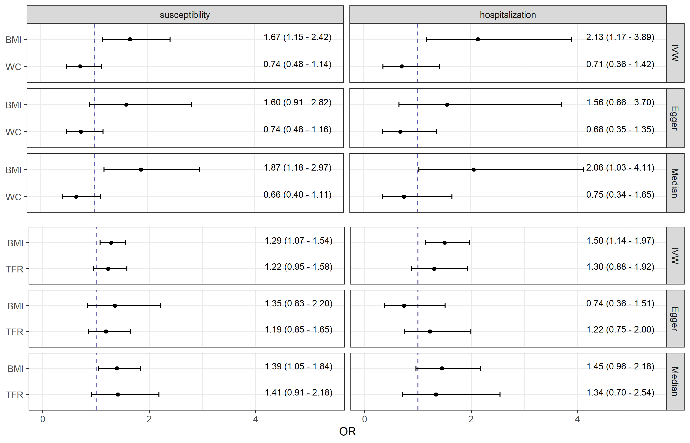

**Fig. A.12** Causal direct effect estimates (odds ratios and 95 % confidence intervals) from pairwise multivariable Mendelian randomization analyses of body mass index (BMI), waist circumference (WC), and trunk fat ratio (TFR) with COVID-19 susceptibility as well as hospitalization. In main analysis the robust inverse-variance weighted (IVW) method with multiplicative random effects was applied. In sensitivity analyses the MR-Egger with multiplicative random effects and the Median approach were performed.

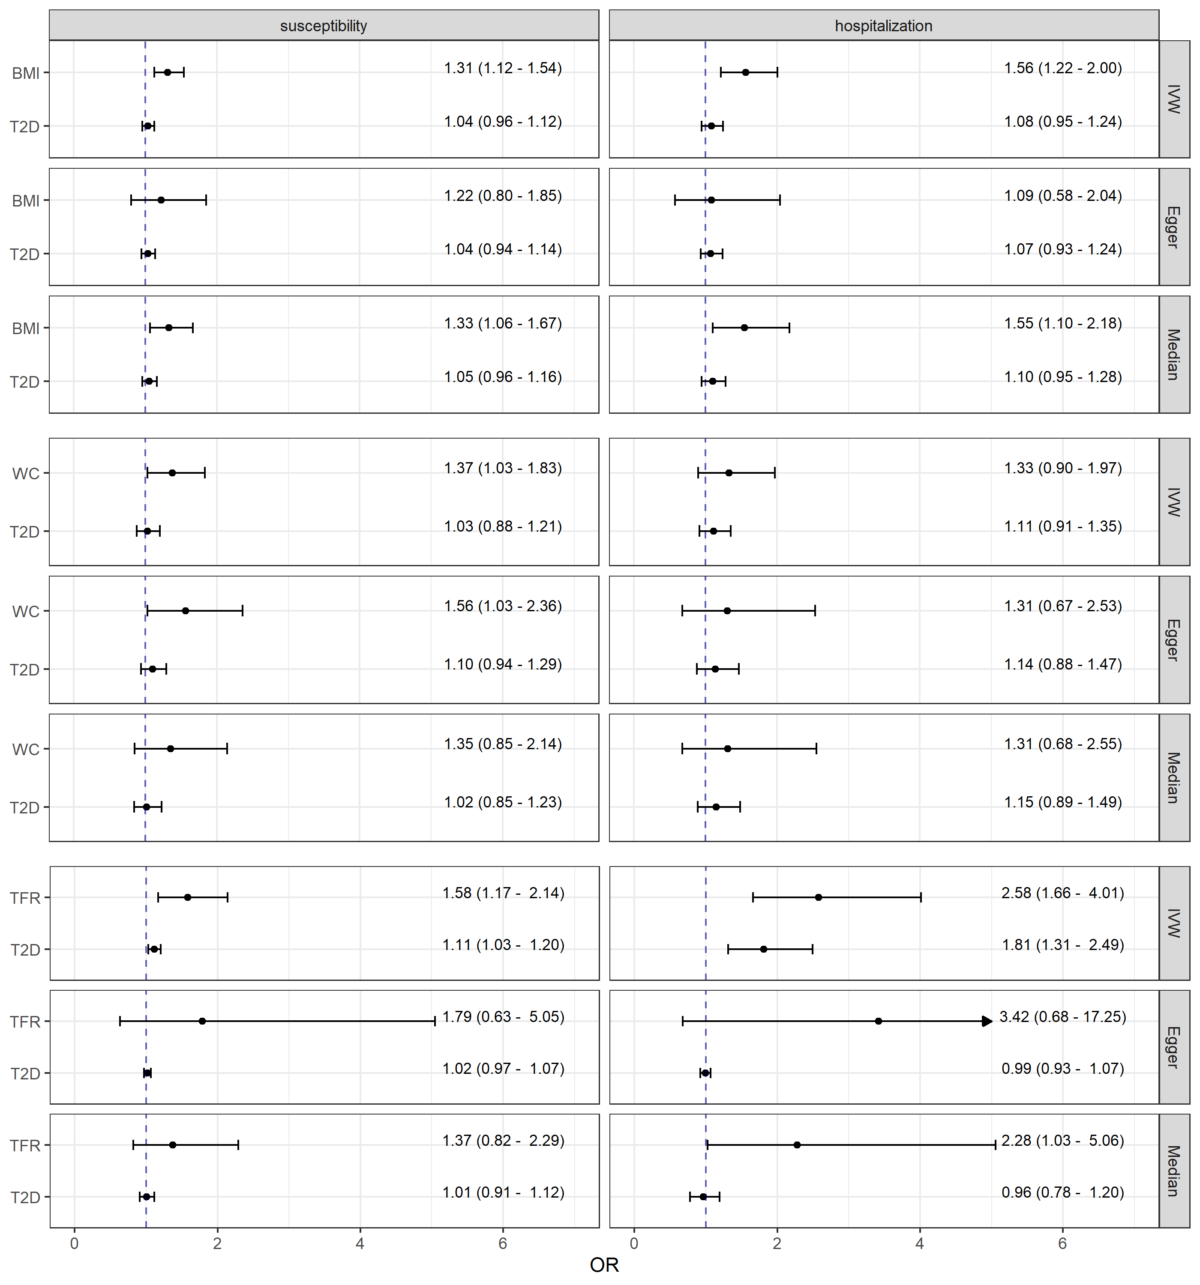

**Fig. A.13** Causal estimates (odds ratios and 95 % confidence intervals) from multivariable Mendelian randomization mediation analyses of body composition measures, body mass index (BMI), waist circumference (WC), and trunk fat ratio (TFR), adjusted for type 2 diabetes (T2D) on COVID-19 susceptibility as well as hospitalization. In main analysis the robust inverse-variance weighted (IVW) method with multiplicative random effects was applied. In sensitivity analyses the MR-Egger with multiplicative random effects and the Median approach were performed. The arrow represents a confidence interval exceeding the plot range (Upper CI = 17.25).

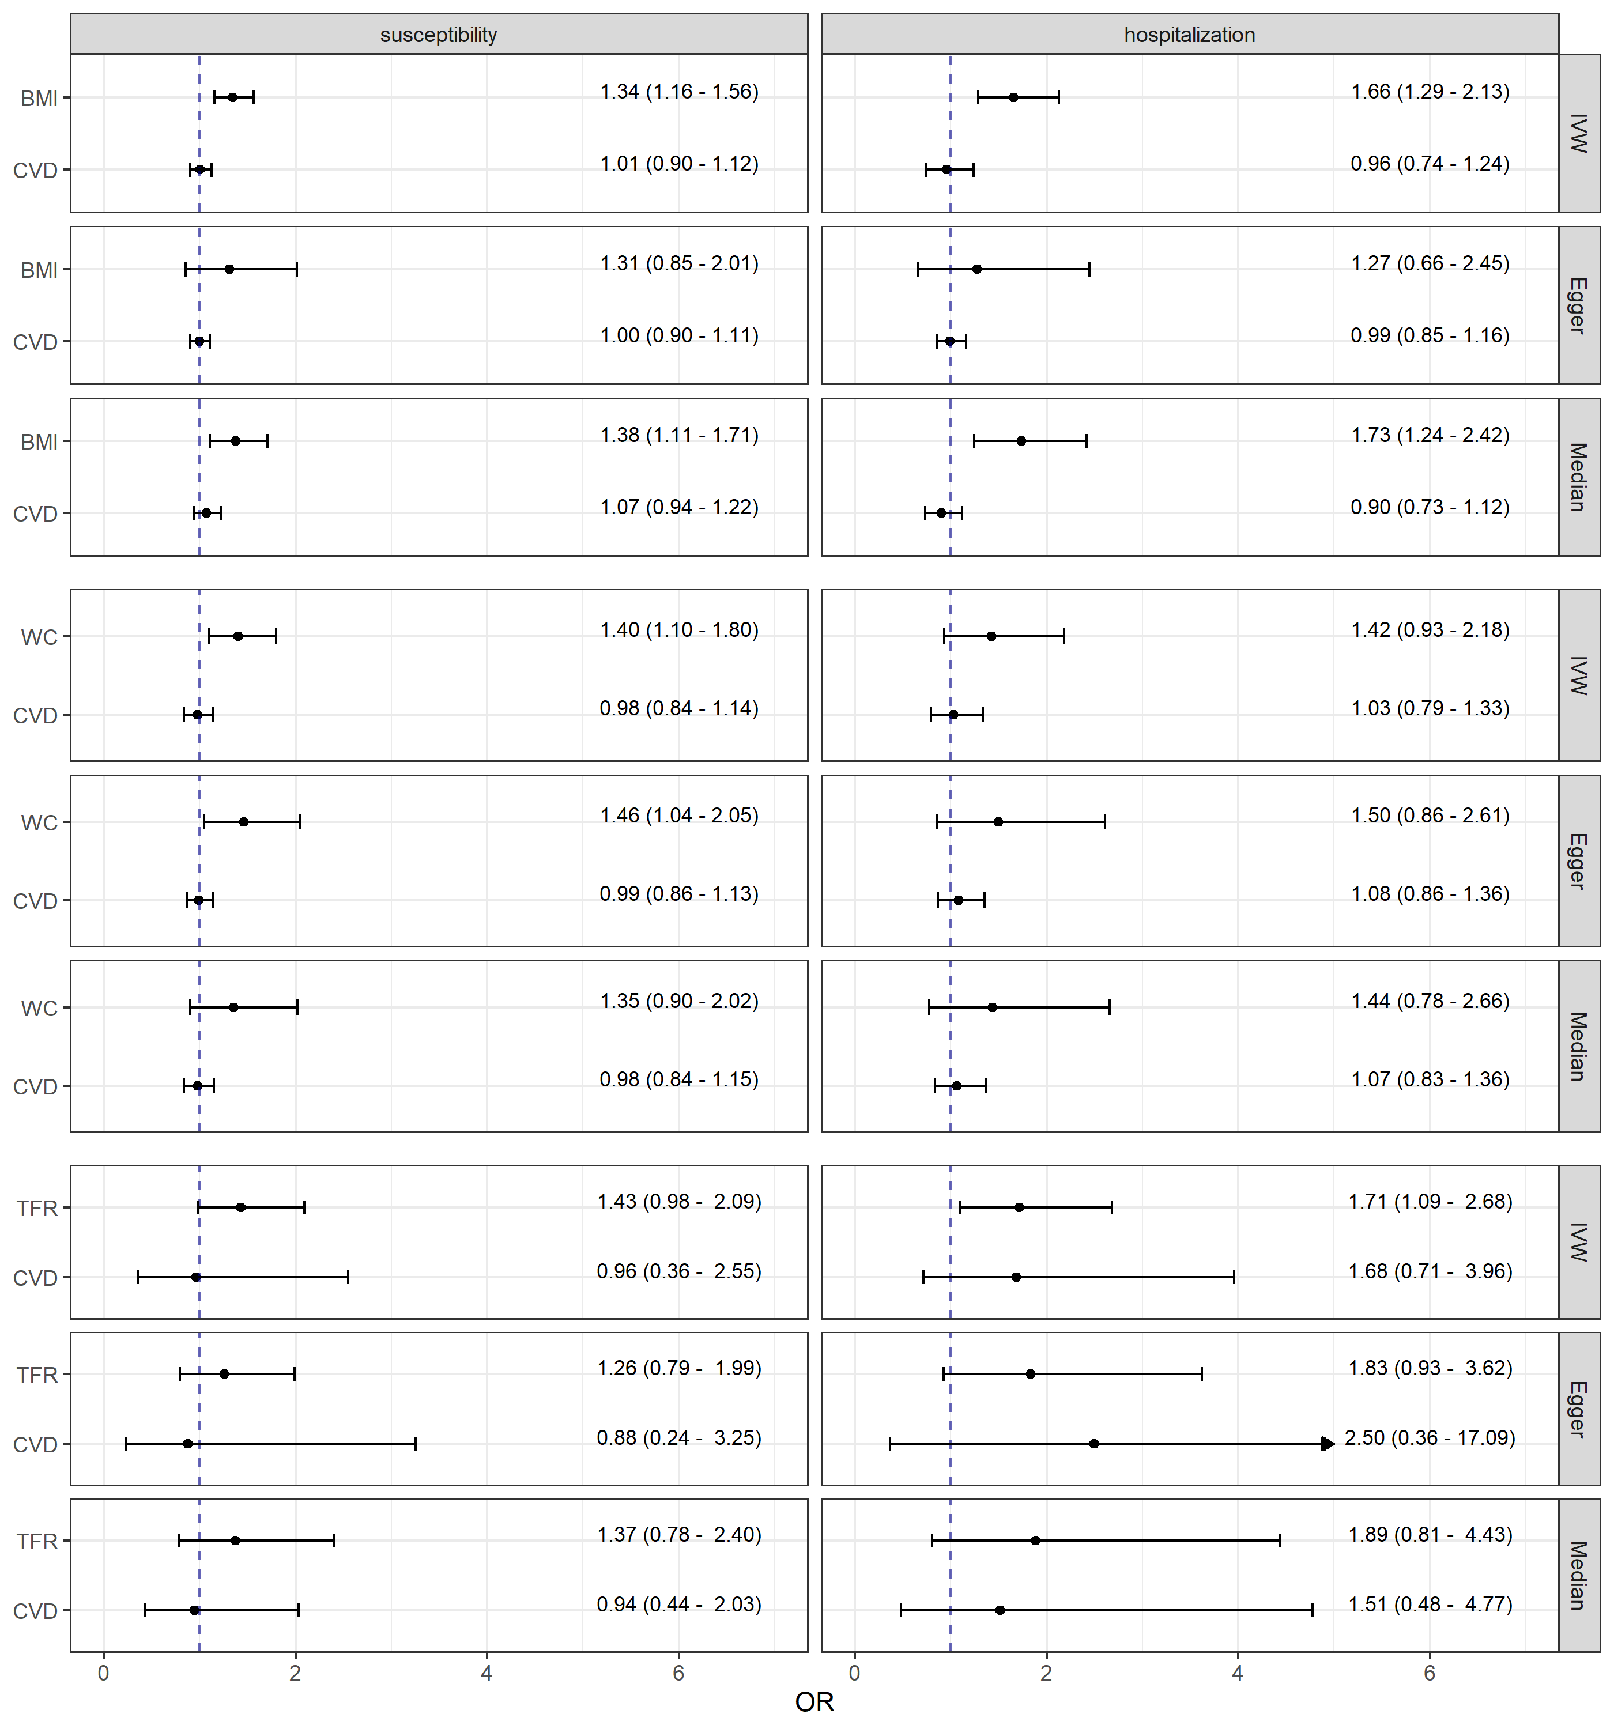

**Fig. A.14** Causal estimates (odds ratios and 95 % confidence intervals) from multivariable Mendelian randomization mediation analyses of body composition measures, body mass index (BMI), waist circumference (WC), and trunk fat ratio (TFR), adjusted for cardiovascular diseases (CVD) on COVID-19 susceptibility as well as hospitalization. In main analysis the robust inverse-variance weighted (IVW) method with multiplicative random effects was applied. In sensitivity analyses the MR-Egger with multiplicative random effects and the Median approach were performed. The arrow represents a confidence interval exceeding the plot range (Upper CI = 17.09).

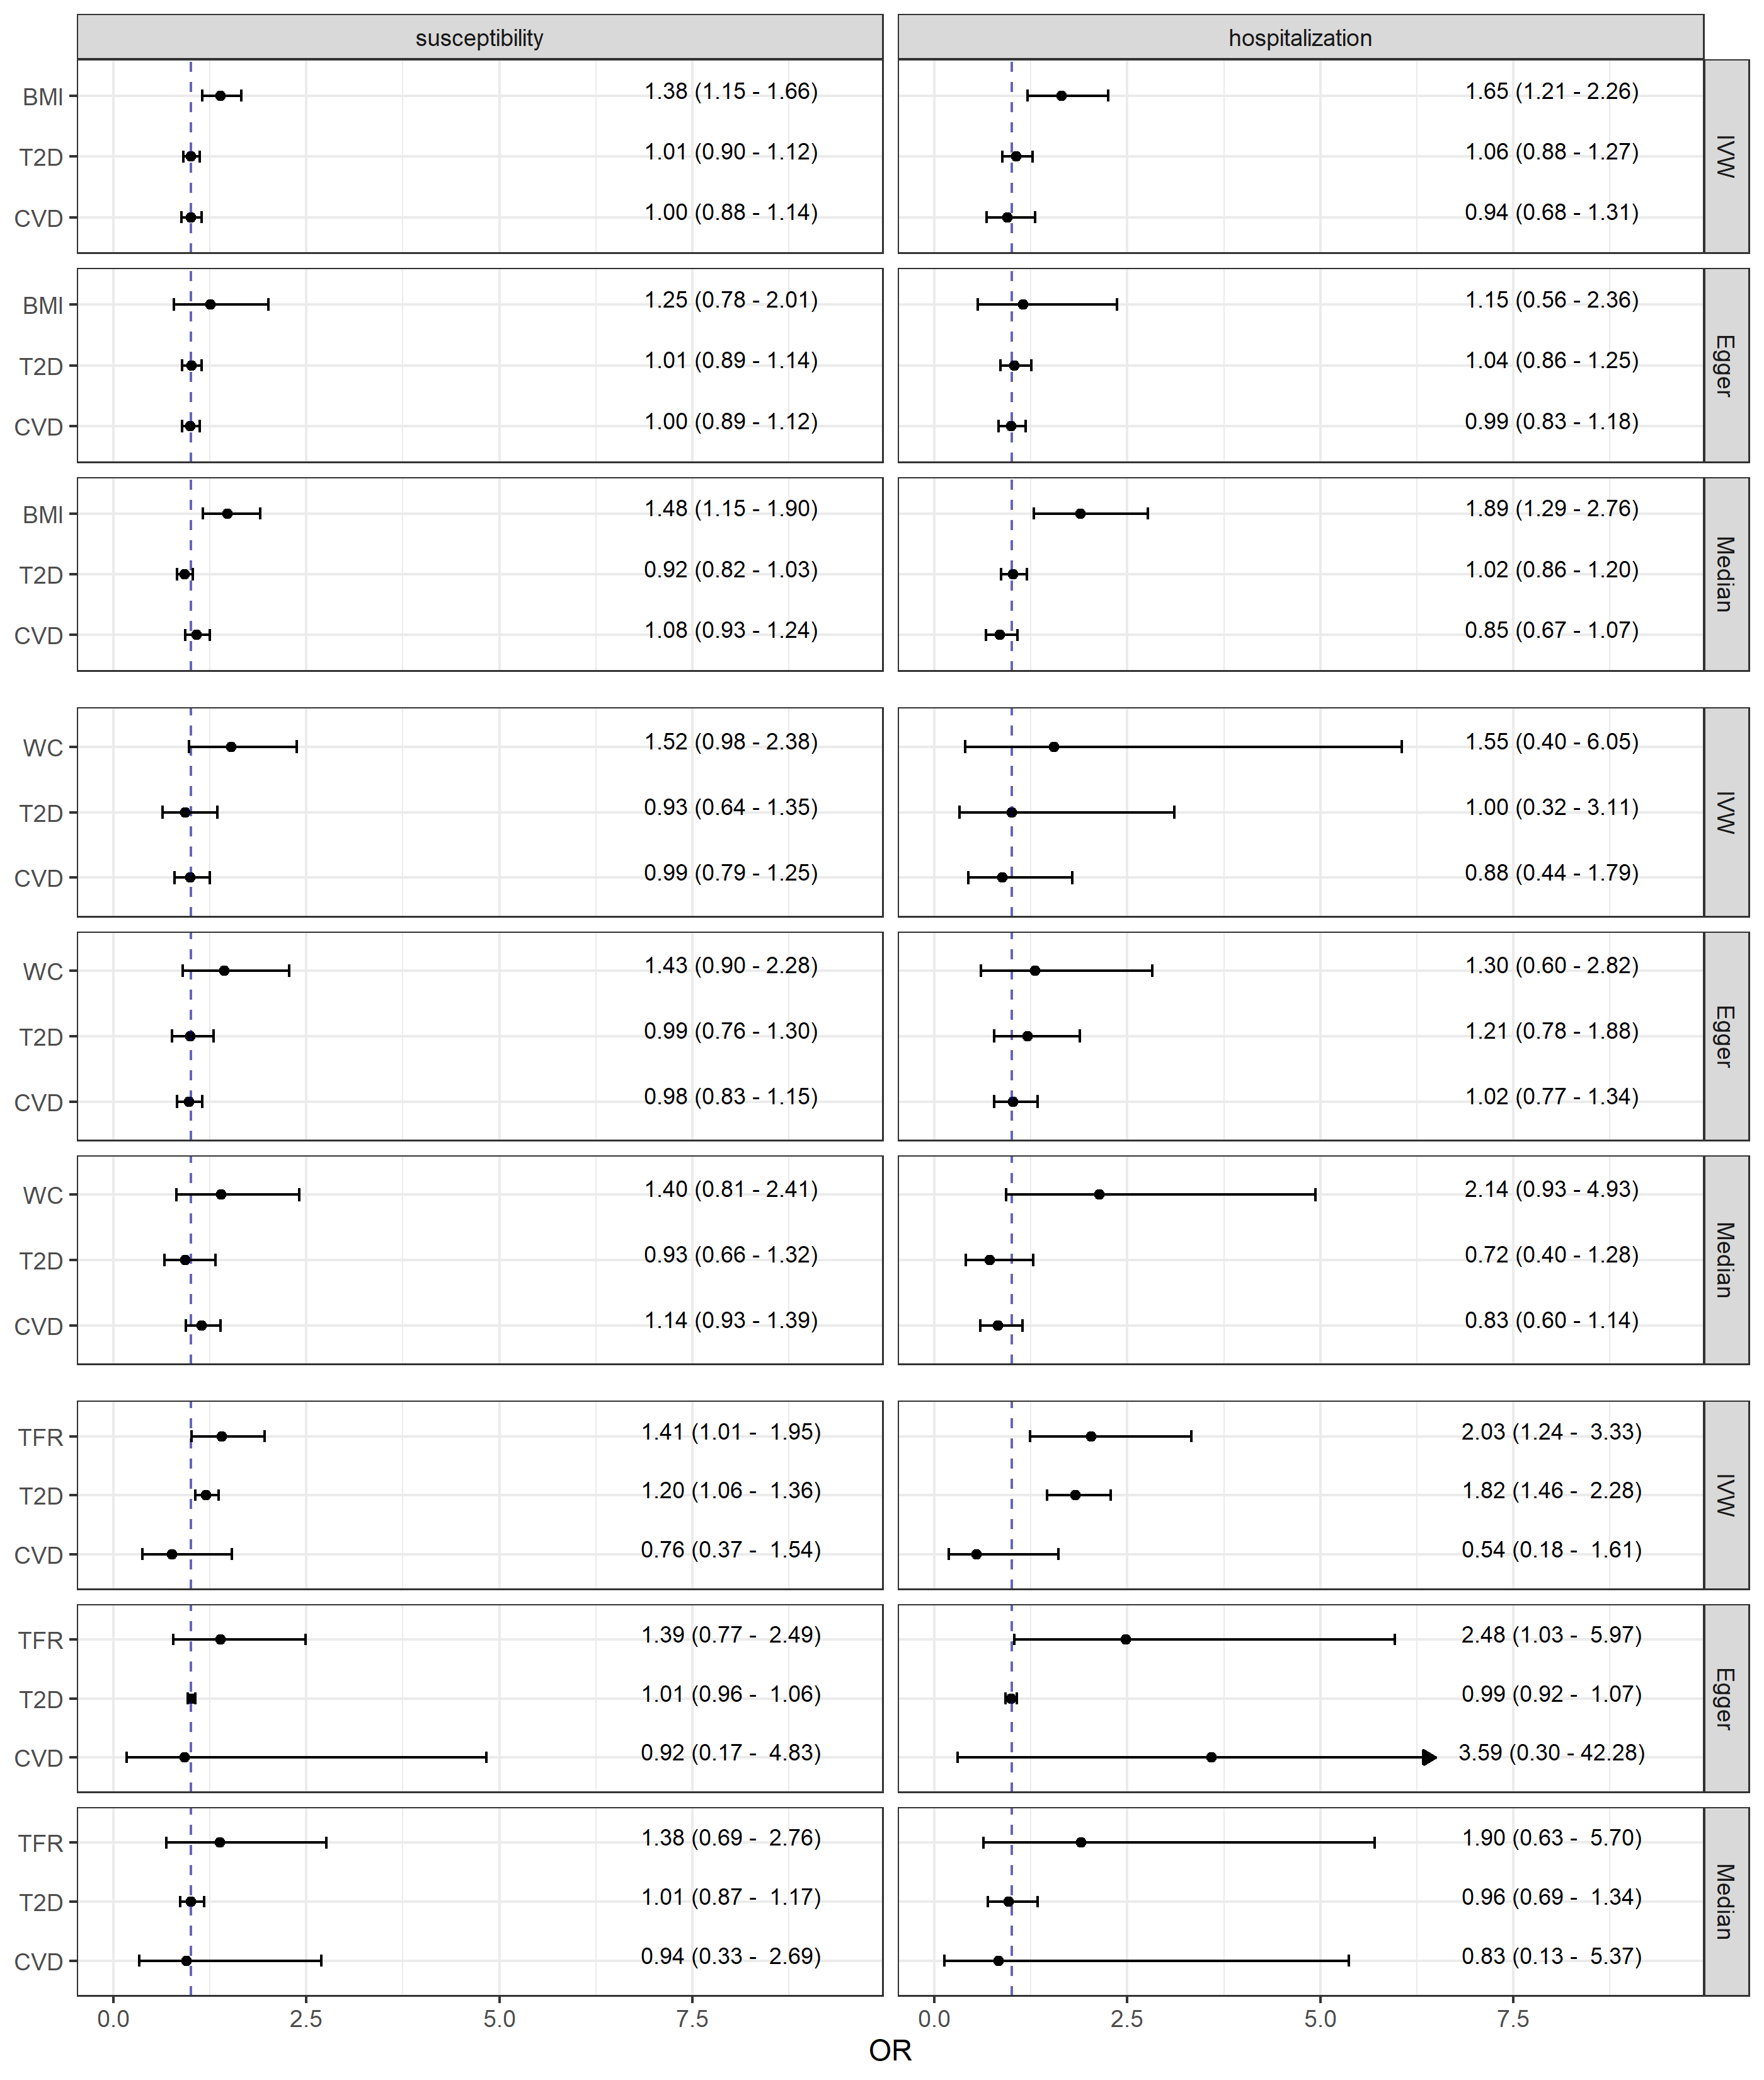

**Fig. A.15** Causal estimates (odds ratios and 95 % confidence intervals) from multivariable Mendelian randomization mediation analyses of body composition measures, body mass index (BMI), waist circumference (WC), and trunk fat ratio (TFR), adjusted for both, type 2 diabetes (T2D) and cardiovascular diseases (CVD) on COVID-19 susceptibility as well as hospitalization. In main analysis the robust inverse-variance weighted (IVW) method with multiplicative random effects was applied. In sensitivity analyses the MR-Egger with multiplicative random effects and the Median approach were performed. The arrow represents a confidence interval exceeding the plot range (Upper CI = 42.28).

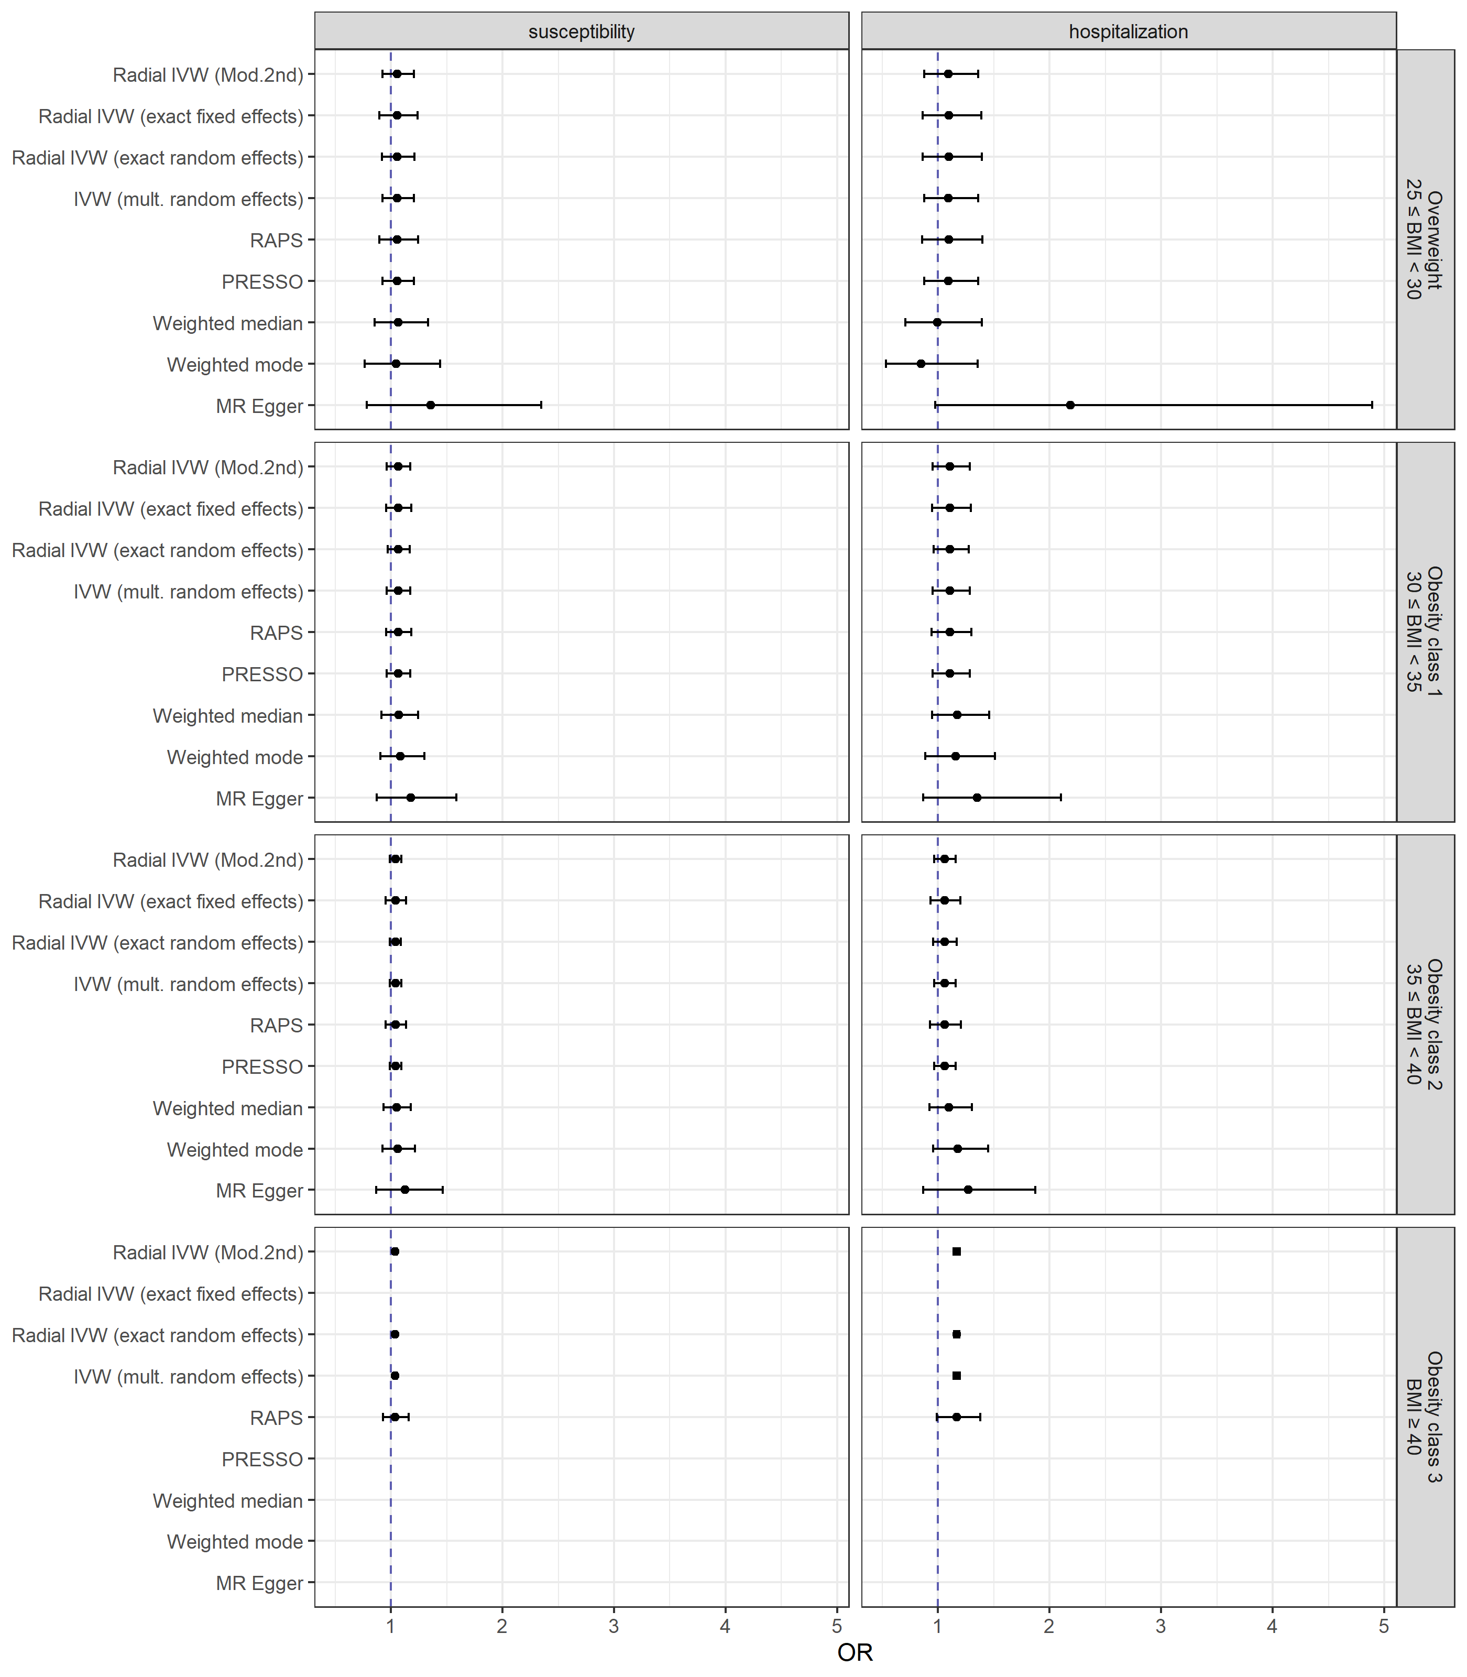

**Fig. A.16** Causal effect estimates (odds ratios and 95 % confidence intervals) from the univariable Mendelian randomization analyses of distinct BMI categories (compared to subjects with a BMI < 25 kg/m²) with COVID-19 susceptibility and hospitalization. Missing estimates are due to numerical issues.

Abbrevations: IVW (Mod.2nd) inverse-variance weighted model with modified 2nd order weights.