Supplementary Material



**Figure A1.** Quantification results of specific extracellular proteins (OCN, OPN, OPG, DKK-1, SOST, IL-6 and TNF-α). Results were shown as lines and scatters.

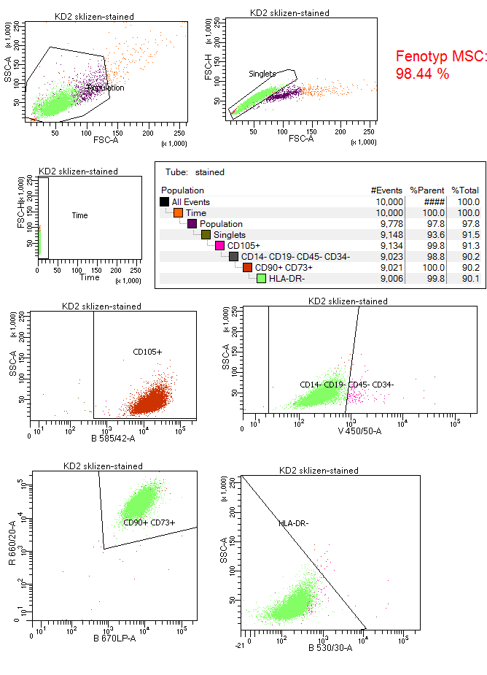

**Figure A2.** The percentage of stem cells is determined as a number of cells with positive expression of CD105, CD73, CD90 and with negative expression of CD45, CD34, CD14, CD19, HLA-DR. 98.44 % of cells in this passage preserved the stemness phenotype.