**Supporting** **Information** **For:**

**Resonance-Enhanced Multiphoton Ionization Spectroscopy of Mono- and Polycyclic Aromatic Hydrocarbons in the Gas Phase**

Carolin Schwarz1,2, Fabian Etscheidt1,3, Christian Gehm1,2, Johannes Passig1,4,5, Sven Ehlert3, Thorsten Streibel1,5*, Ralf Zimmermann1,4,5

1 – Joint Mass Spectrometry Centre / Chair of Analytical Chemistry, University of Rostock, 18059 Rostock, Germany

2 – Leibniz Institute for Baltic Sea Research Warnemünde, 18119 Rostock, Germany

3 – Photonion GmbH, 19061 Schwerin, Germany

4 – Department Life, Light & Matter (LLM), University of Rostock, 18059 Rostock, Germany

5 – Joint Mass Spectrometry Centre, Cooperation Group “Comprehensive Molecular Analytics” (CMA), Helmholtz Zentrum München, Neuherberg, 85764, Germany

* – corresponding author: thorsten.streibel@uni-rostock.de

**Keywords:** resonance-enhanced multiphoton ionization (REMPI), time-of-flight mass spectrometry (TOFMS), spectroscopy, (polycyclic) aromatic hydrocarbons ((P)AH), optical parametric oscillator (OPO)

Table of Contents:

|  |  |  |
| --- | --- | --- |
| Figure S1 | Investigation of the influence of the size of alkyl groups. | Page 2 |
| Figure S2 | Investigation of the influence of the position of alkyl groups. | Page 2 |
| Figure S3 | The dependence of the intensity on the laser energy at 248 nm. | Page 3 |
| Figure S4 | The dependence of the intensity on the laser energy at 266 nm. | Page 3 |
| Figure S5 | The dependence of the intensity on the laser energy at λmax. | Page 4 |

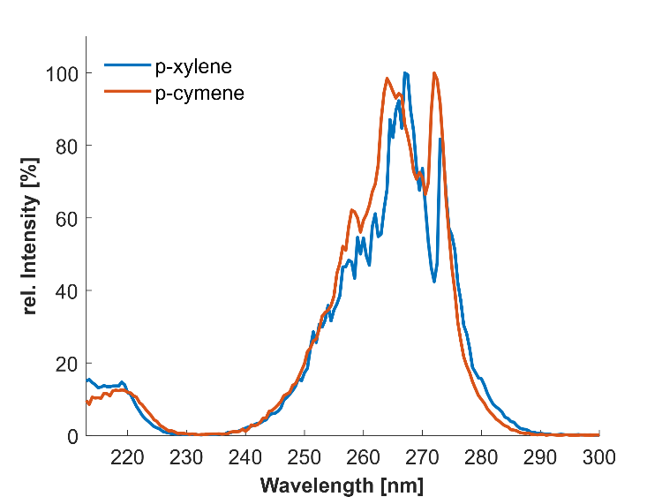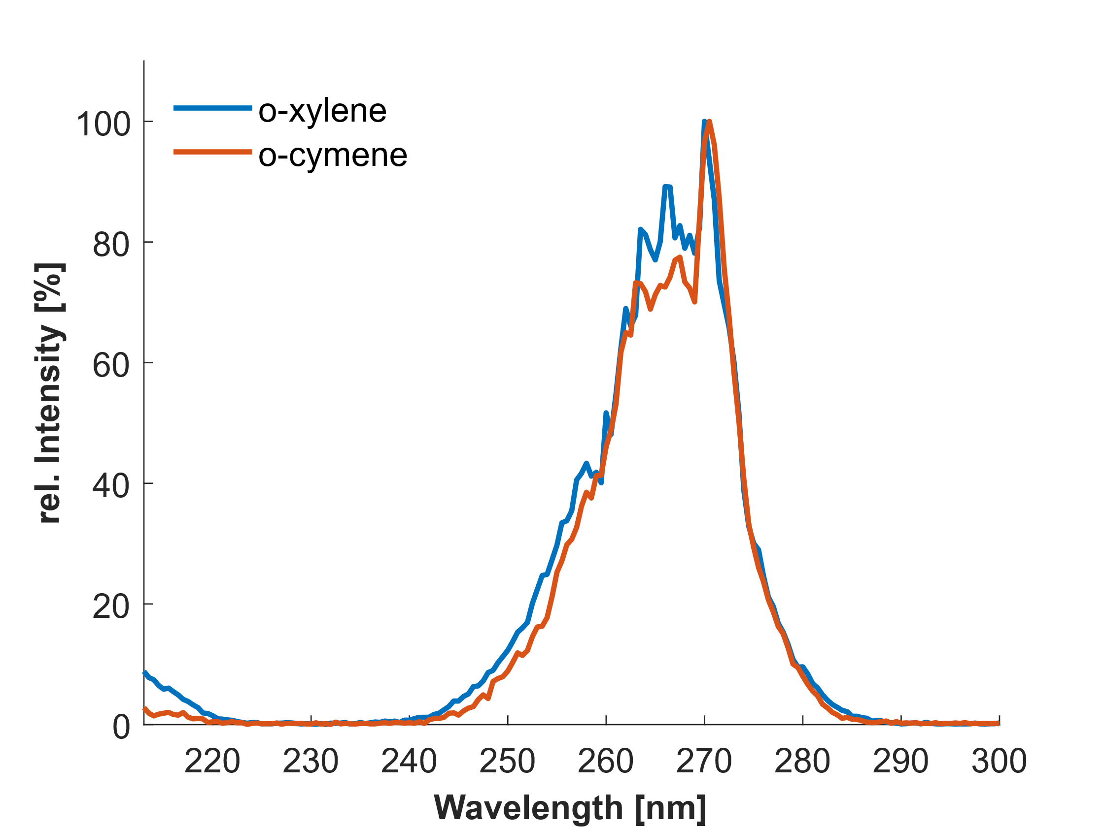

Figure S1 Investigation of the influence of the size of alkyl groups. (A) Ortho-xylene, containing two methyl groups, and ortho-cymene, containing one methyl and one isopropyl group. (B) Para-xylene, containing two methyl groups, and para-cymene, containing one methyl and one isopropyl group.

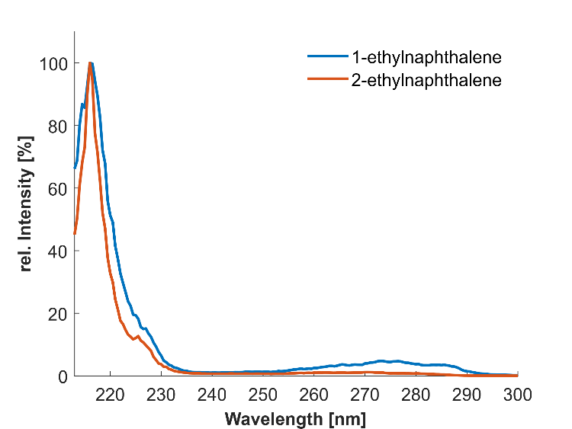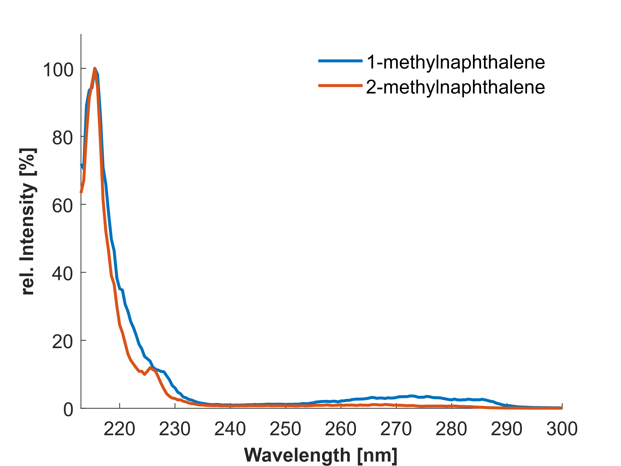

Figure S2 Investigation of the influence of the position of alkyl groups. (A) Methyl-substituted naphthalene on the α-position (1-MN) compared to the β-position (2-MN). (B) Ethyl-substituted naphthalene on the α-position (1-EN) compared to the β-position (2-EN).

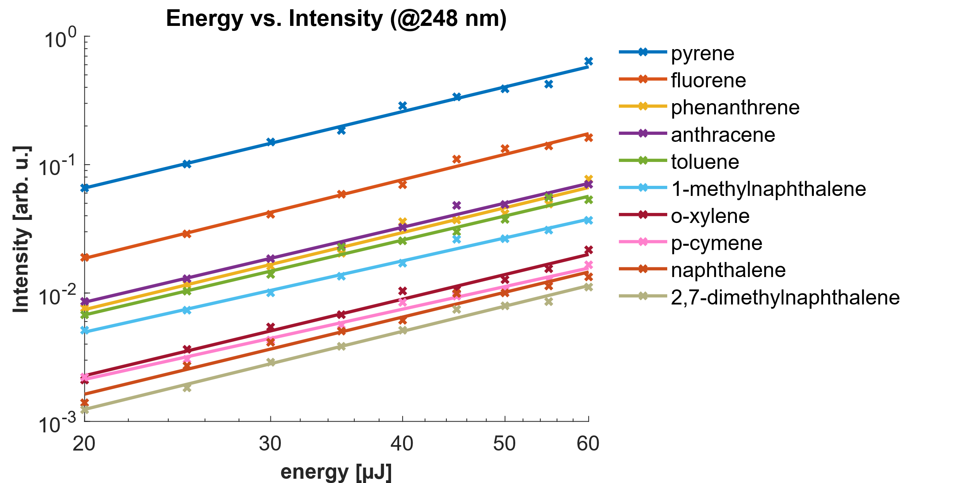

Figure S3 The dependence of the intensity on the laser energy for several compounds in the wavelength range from 20 to 60 µJ at a wavelength of 248 nm for the determination of the exponents for the calculation of the relPICS.

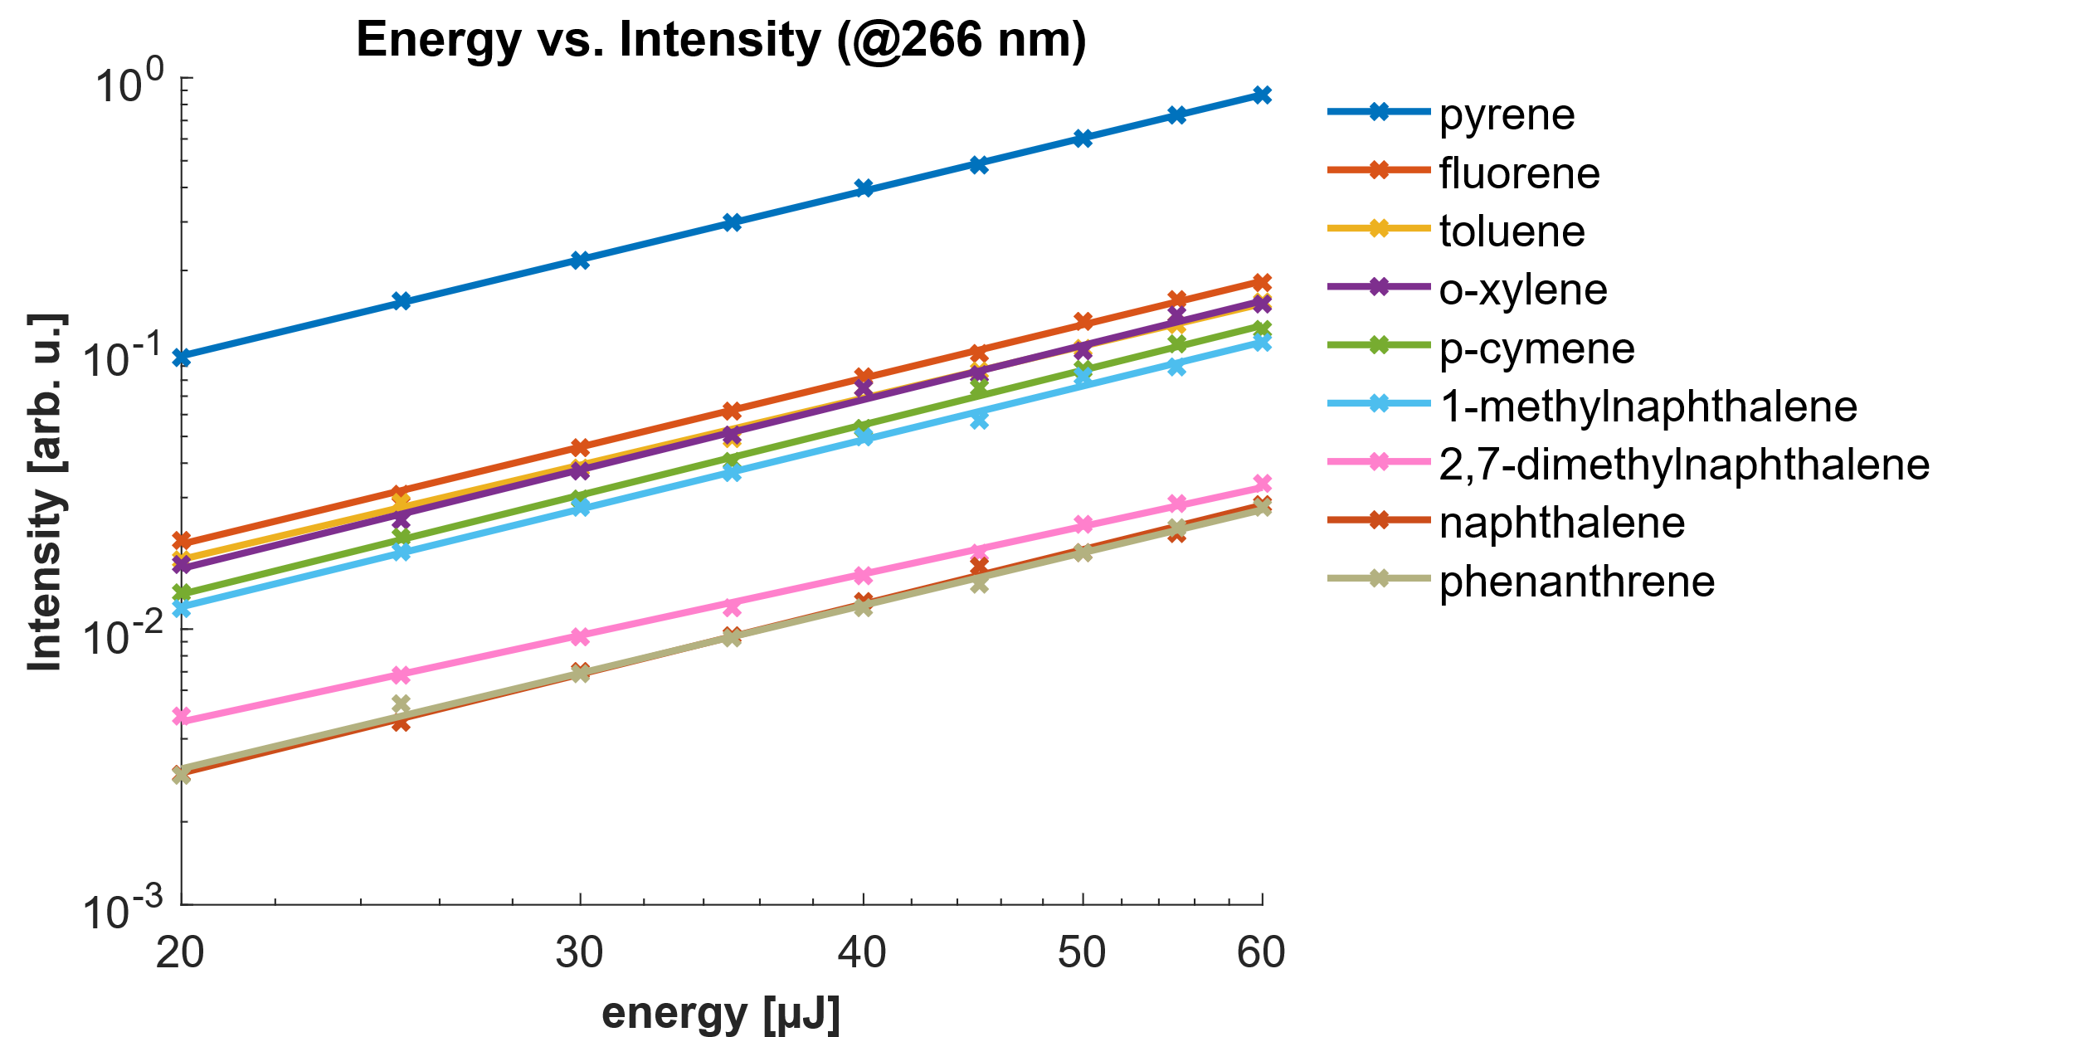

Figure S4 The dependence of the intensity on the laser energy for several compounds in the wavelength range from 20 to 60 µJ at a wavelength of 266 nm for the determination of the exponents for the calculation of the relPICS.

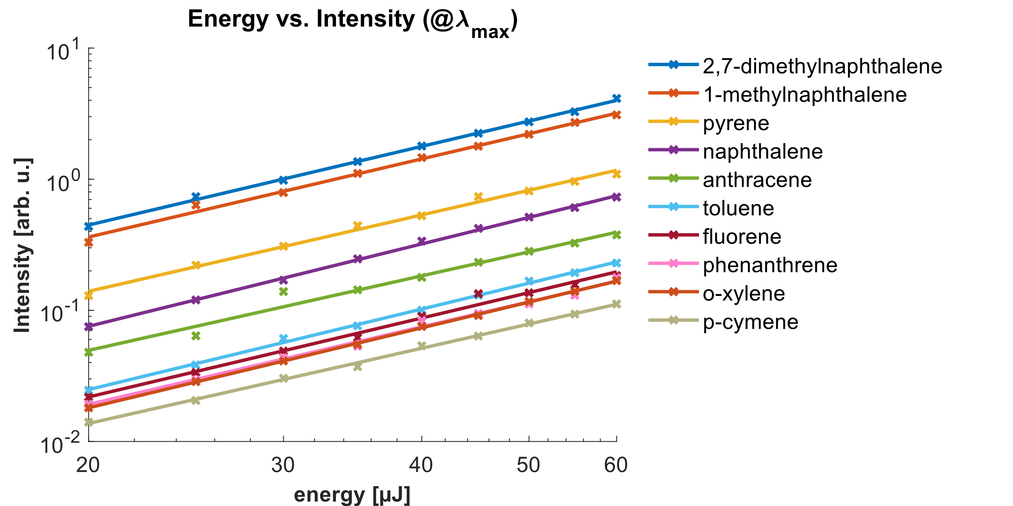

Figure S5 The dependence of the intensity on the laser energy for several compounds in the wavelength range from 20 to 60 µJ at λmax for the determination of the exponents for the calculation of the relPICS.