**Supplementary figures**

**Supplementary figure 1** Metabolic parameters (HOMA2-B, HOMA2-S, insulinogenic and disposition index) in IGT, naïve and treated groups at diagnosis



HOMA2-B, homeostatic model assessment of β-cell activity; HOMA2-S, homeostatic model assessment of insulin sensitivity; IGT, impaired glucose tolerance; T2DM, type 2 diabetes mellitus.

**Supplementary figure 2** HOMA2-B levels and T2DM duration in pooled population



The group with disease duration set at −4 represents IGT patients, while the remaining are T2DM patients, naïve and treated. HBA1c, glycated haemoglobin; HOMA2-B, homeostatic model assessment of β-cell function; T2DM, type 2 diabetes mellitus.

**Supplementary figure 3.** Lowess smoothing of HOMA2-B and duration of the disease in naïve and treated patients with T2DM



HOMA2-B, homeostatic model assessment of β-cell function; T2DM, type 2 diabetes mellitus.

**Supplementary figure 4.** Distribution density across the HOMA2-B tertiles for various metabolic parameters (The inset table compares the metabolic parameters in the three groups amongst the HOMA2-B tertiles)

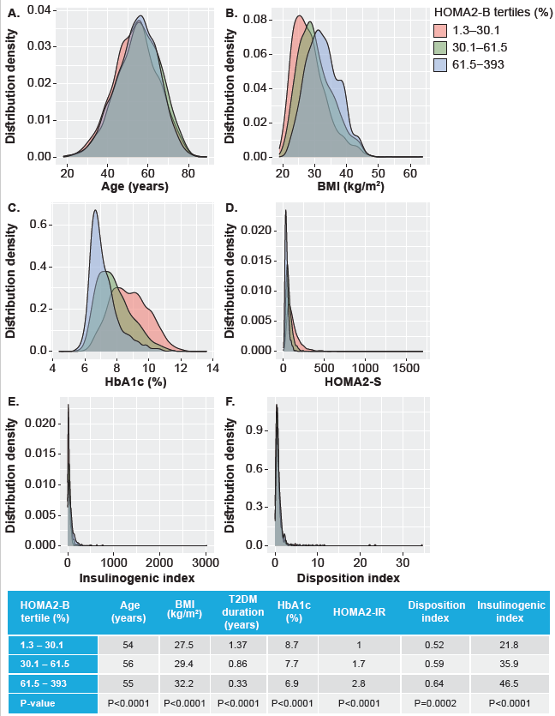

The data is expressed as median. BMI, body mass index; HBA1c, glycated haemoglobin; HOMA2-B, homeostatic model assessment of β-cell function; T2DM, type 2 diabetes mellitus.