**The effect of air pollution when modified by temperature on respiratory health outcomes: a systematic review and meta-analysis.**

Ashtyn Tracey Areal 1, Qi Zhao 1,2, Claudia Wigmann1, Alexandra Schneider3 and Tamara Schikowski1*,

1Department of Epidemiology, IUF-Leibniz Research Institute for Environmental Medicine, Düsseldorf, Germany;

2Department of Epidemiology, School of Public Health, Cheeloo College of Medicine, Shandong University, Jinan, China;

3 Institute of Epidemiology, Helmholtz Zentrum München – German Research Center for Environmental Health (GmbH), Neuherberg, Germany

**\*** Corresponding author: Dr. Tamara Schikowski, Department of Epidemiology, IUF-Leibniz Research Institute for Environmental Medicine, Auf'm Hennekamp 50, Düsseldorf 40225, Germany.

Email: [Tamara.Schikowski@IUF-Duesseldorf.de](mailto:Tamara.Schikowski@IUF-Duesseldorf.de); Tel: +49 211 3389 341

**Abstract**

**Background:** Respiratory diseases are a leading cause of mortality and morbidity, and are exacerbated by air pollution and temperature.

**Aim:** To assess published literature on the effect of air pollution modified by temperature on respiratory mortality and hospital admissions.

**Methods:** We identified 26,441 papers in PubMed and Web of Science, up to March 2020, and selected 34 for analysis; inclusion criteria included observational studies, short-term air pollution, and temperature exposure. Air pollutants considered were particulate matter with a diameter <10µm (PM10), ozone (O3), and nitrogen dioxide (NO2). A random-effects model was used for our meta-analysis.

**Results:** For respiratory mortality we found that when the PM10 effect is modified by high temperatures there is an increased pooled Odds Ratio (OR, 95% CI) of 1.019 (1.010-1.028), and for the effect of O3 during the warm season the pooled OR is 1.007 (1.002-1.011). For hospital admissions, when the effect of PM10 is adjusted for the warm season, there is a pooled OR of 1.013 (1.005-1.020), and for respiratory hospital admissions, the effect of O3 during the warm season the pooled OR is 1.011 (1.005-1.020). In our analysis for low temperatures, results were inconsistent.

**Conclusions:** Exposure to air pollution when modified by high temperature is likely to affect respiratory mortality and hospital admissions. This is most clear for O3  and PM10. The interaction analysis of air pollution and temperature is still a relatively new research field and results are largely inconsistent.

**Keywords:** Respiratory Health, Air Pollution, Temperature, Systematic Review, Global Health.

1. **Introduction**

Chronic respiratory diseases (CRD) are among the leading causes of disability and death globally.1 Asthma is one of the most common CRD in both adults and children; with approximately 339 million cases globally, asthma also presents an increasing financial burden.2 3 Chronic obstructive pulmonary disease (COPD) is an umbrella term that includes chronic bronchitis and emphysema.4 Diagnosed between the ages of 40 and 50, the exact number of cases of COPD is estimated to be between 65 and 215 million cases and is the third leading cause of death.1 2 4

Climate change has a negative impact on human health due to increased exposure to adverse climate-related stresses.5 6 Air pollution and suboptimal temperature represent two of the biggest risks to health, impacting all regions, socioeconomic groups, sexes, and age groups.7 Approximately seven million people die from air pollution exposure every year.8 Air pollution often exacerbates respiratory disease by permeating into the lung tissue and damaging the lungs.9

Temperature has been implicated in increased mortality and morbidity in those older than 65, pregnant women, people with pre-existing conditions, those with disabilities, people who work outdoors or in non-cooled environments, and those in regions at the limit for human habitation.10 11 Temperature often exacerbates respiratory conditions by increasing respiratory workload.12-14

As the numbers of CRD cases increase every year, investigating the potential association with climate change is of the utmost importance. This review aims to assess literature on the effect of air pollution when modified by air temperature on respiratory mortality and respiratory hospital admissions (RHA).

2. Materials and Methods

Literature search

Literature was sought through PubMed/Web of Science using keywords such as, “Air pollution”, “Air temperature”, “Respiratory disease”, “Mortality”, “Hospital admissions”, “Asthma”, and “COPD”, and using snowballing, which uses the reference list of a paper to find additional papers.15 A detailed list of search terms can be found in Appendix B.

Inclusion and exclusion criteria

Inclusion criteria included papers published after 1989 with no restriction on location of study. Only epidemiological observational studies were included; while qualitative research, literature reviews, simulation studies and case reports were excluded. We chose to exclude meta-analyses that only provided a pooled result. Study outcomes had to be defined according to the International Classification of Diseases (ICD) 9 [codes: 460-519] and/or 10 [codes: J00-J99]. Studies on respiratory disease caused by infectious agents (i.e. tuberculosis, influenza and pneumonia) were excluded. Only studies that investigated short-term air pollution exposure were included. All results had to be presented as quantitative data with increments. This process is shown in the Preferred Reporting items for Systematic reviews and Meta-Analyses (PRISMA) checklist in Appendix A16.

Data extraction

Data extracted included the reference (authors, and publication date), study location, study population, study design, outcome variables (RHA, respiratory mortality, or both), ICD code, exposure variables, type of statistical analysis, type of effect estimate, and main result (Appendix E).

Quality Assessment

Quality assessment was performed using, “Risk of Bias Assessment Instrument for Systematic reviews informing WHO Global Air quality guidelines” (Appendix D). These guidelines were developed by the WHO Global Air Quality Guidelines Working Group on Risk Bias Assessment to assess the quality of eligible air pollution studies included for systematic reviews.17 The instrument specifies six topics of interest: confounding, selection bias, exposure assessment, outcome measurement, missing data, and selective reporting. Each topic and subtopic were classified as low, medium, or high risk.

Statistical Analysis

Studies were grouped into three air pollution-temperature relationships: 1) air pollution modified by high or low temperatures. 2) the effect of air pollution during the warm or cool season. 3) Air pollution modified by temperature at specific temperatures. We decided to limit meta-analysis to studies in one of the above-mentioned groups (i.e. air pollution-temperature relationship) with five or more papers. Effect estimates were converted to odds ratio (OR) per 10µg/m3 increase in air pollutant; conversion equations can be found in Appendix F.

Due to different study designs, methods, exposures, populations, and settings, heterogeneity was expected, thus a random-effects model was selected to account for within- and between-study heterogeneity. We used the DerSimonian-Laird (DL) estimator, which is the most commonly used estimator in medical research.18 Heterogeneity was assessed using the I2 test, as well as an outlier analysis; an outlier was defined as a study with either a lower bound confidence interval (CI) greater than the pooled-upper CI, or an upper bound CI that is less than the pooled-lower bound CI. A sensitivity analysis was performed using the Hartung-Knapp-Sidik-Jonkman (HKSJ) method which uses the Sidik-Jonkman (SJ) estimator.19

All statistical analyses were performed using R software, version 3.6.1 using the “meta” “metafor” “dmetar” and “forestplot” packages.19 20 A P-value of less than 0.05 was considered statistically significant. This study has been registered on PROSPERO with the registration number CRD42020173203.

There was no funding source for this study.

3. Results

Our initial literature search found 26436 studies. After removal of duplicate studies, animal studies, and studies published prior to 1990, we assessed the titles, abstracts, and keywords of the papers that left us with 122 papers. Full text of these studies was assessed according to the inclusion and exclusion criteria, which left us with 34 studies; this is shown in the PRISMA flow chart (Appendix C, Figure 1). Our risk of bias assessment tool had six criteria (confounding, selection bias, exposure assessment, outcome measurement, missing data, and selective reporting) with each criteria scored as low, medium, or high risk. None of the studies included were classified as high risk in any of the criteria.

Of the 34 studies included, 15 studies had respiratory mortality as their outcome, 18 studies had RHA as their outcome, and one study had both respiratory mortality and RHA as their outcome. O3 was an exposure variable for 22 studies, 25 studies had PM10 as an exposure variable, and 20 studies had NO2 as an exposure variable.

Time series studies accounted for 25 studies, eight studies were case-crossover studies, and one study was a cohort study with a cross-sectional design component. Statistical methods varied; 14 studies used generalised additive models (GAM), eight studies used conditional logistic regression models, five studies used Poisson regression models, three studies used autoregressive log-linear models; cox proportional hazards models, distributed lag models, generalised estimating equations, and generalised linear models, were used in the remaining four studies.

Publication of studies ranged from 1996-2019. Five studies were published in the 1990s, 12 studies were published in the 2000s, and 17 studies were published in the 2010s. In terms of study location, 14 studies came from China, five studies from the United Kingdom (UK), four studies from the United States of America, five studies from Taiwan, three studies from Australia, and one study from Japan, Latin America ( e.g. Brazil, Mexico, and Chile), the Netherlands, and South Korea, respectively. A summary of these characteristics can be found in Appendix E.

We performed a meta-analysis for the effect of PM10 when modified by low and high temperature on respiratory mortality. The study by Meng, et al. 21 presented separate results for eight cities in China, therefore, each city result was included. We found an increased odds of respiratory mortality when PM10 was modified by low temperature [OR: 1.006 (95%CI: 1.000 to 1.011) per 10µg/m3 increase in PM10] (Figure 1a). Heterogeneity in this analysis was high with an I2 (95% CI) of 72.0% (49.8% to 84.3%). There was a statistically significant increased odds of respiratory mortality when PM10 was modified by high temperature [OR: 1.019 (95%CI: 1.010 to 1.028) per 10µg/m3 increase in PM10] (Figure 1b). Heterogeneity was high with an I2 (95% CI) of 82.3% (70.4% to 89.5%).

In the low temperature analysis, none of the studies were classified as outliers. In the high temperature analysis we found that the results for Wuhan, from the study by Meng, et al. 21, and the study by Cheng and Kan 22 were outliers; after exclusion, there was minimal change in the OR with the association showing significance (Figure 1b, Appendix G). In the sensitivity analysis there was no significant change in the effect of PM10 when modified by both high and low temperatures on respiratory mortality compared to the main analysis (results not shown).

**Figure 1a: PM10 modified by low temperatures.**

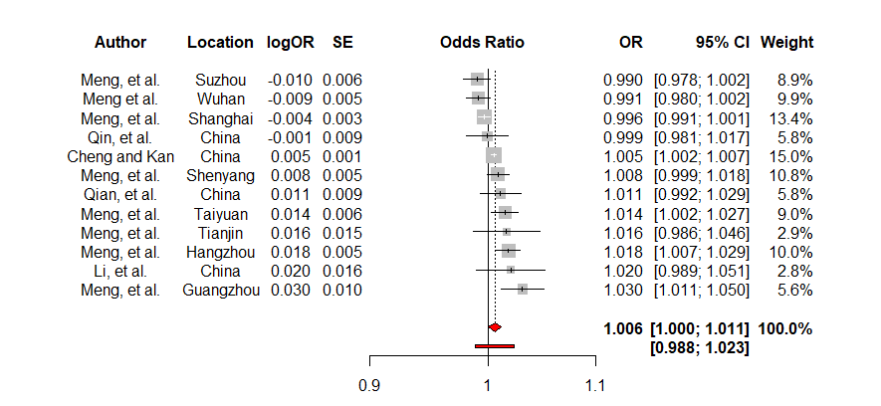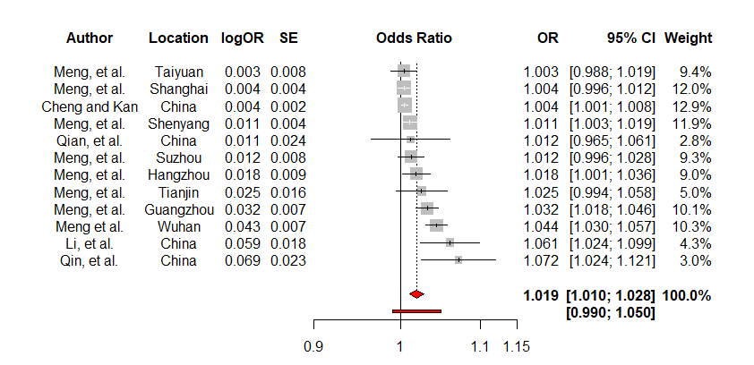

**Figure 1b: PM10 modified by high temperatures.**

**Figure 1. Forest plots showing the overall effect (per 10µg/m3) of PM10 when modified by temperature on respiratory mortality using the DL estimator.**

The majority of studies that investigated the effect of NO2, and O3 when modified by low and high temperature found an increased odds of respiratory mortality.22-24

The effect of O3 during the cold season on respiratory mortality was minimal [OR: 1.003 (95%CI: 1.000 to 1.006) per 10µg/m3 increase in O3] (Figure 2a). Heterogeneity was classified as low with an I2 (95% CI) of 61.4% (25.5% to 80.0%). The effect of O3 during the warm season on respiratory mortality was statistically significant with an increased odds of mortality [OR: 1.007 (95%CI: 1.002 to 1.011) per 10µg/m3 increase in O3] (Figure 2b). Heterogeneity was classified as high with an I2 (95% CI) of 81.5% (68.9% to 89.1%).

For the cold season analysis, the study by Anderson, et al. 25 was found to be an outlier; however, when excluded from the analysis there was a minimal change in the effect size (Figure 1c, Appendix C). For the warm season, the results for São Paulo, from the study by Romieu, et al. 26, and the study by Zanobetti and Schwartz 27 were outliers; the effect size decreased slightly, however there was still an increased odds of respiratory mortality (Figure 1d, Appendix G). Removal of the outlier studies saw the heterogeneity decrease to 19.5%. A sensitivity analysis found that during both the cold and warm season there was no substantialchange in the results when compared to the main analysis (results not shown).

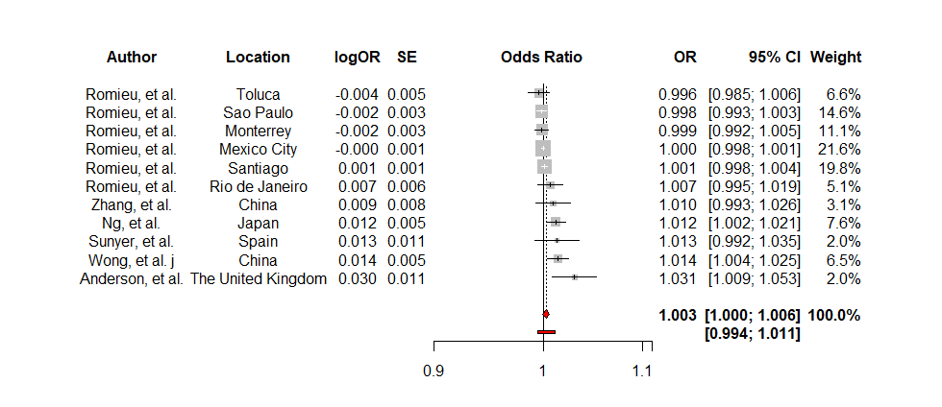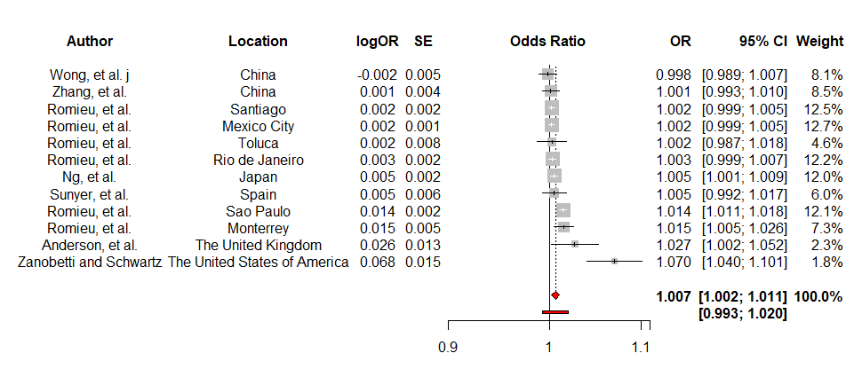

**Figure 2a: O3 effect in the cold season.**

**Figure 2b: O3 effect in the warm season.**

**Figure 2. Forest plots showing random effects models for the effect of O3 (per 10µg/m3) when modified by season on respiratory mortality using the DL estimator.**

The effect of NO2 modified by low and high temperatures showed an increased risk of RHA.28 29 For the effect of PM10 modified by high temperature, two studies28 30 found an increased risk and one study found a decreased risk.29 When PM10 was modified by low temperatures, two studies found an increased risk28 29 and one study found a decreased risk. 30

Exposure to PM10 during the cold season showed an increase in the odds of RHA31-35, however the study by Wong, et al. 34 found a decreased risk of RHA during the cold season in London, UK.

We were able to perform an analysis for the effect of PM10 during the warm season on RHA, this analysis found an increased odds of RHA [OR: 1.013; 95% CI: 1.005 to 1.020 per 10µg/m3 increase in PM10] (Figure 3). Heterogeneity was low with an I2 (95% CI) of 38.0% (0.0% to 76.9%). Our outlier analysis revealed that none of our included studies were outliers. Our sensitivity analysis revealed minimal change in the effect estimate (results not shown).

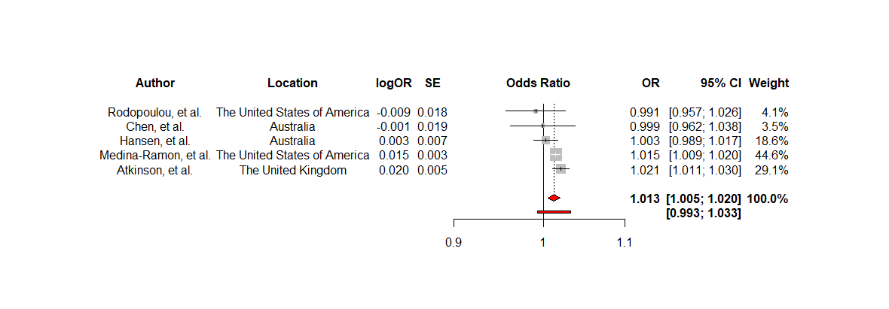

**Figure 3: Forest plot showing the random effects model for the effect of PM10 (per 10µg/m3) during the warm season on RHA using the DL estimator.**

For effect of O3 during the cold season, there is a decrease in the odds of RHA [OR: 0.997; 95% CI: 0.991 to 1.004 per 10µg/m3 increase in O3] (Figure 4a). Heterogeneity was low with a I2 (95% CI) of 62.2% (0.0% to 85.7%). For the effect of O3 during the warm season, there is an increase in the odds of RHA [OR: 1.011; 95% CI: 1.005 to 1.017 per 10µg/m3 increase in O3] (Figure 4b). Heterogeneity was moderate with a I2 (95% CI) of 73.5% (33.8% to 89.4%).

The outlier analysis found that for the effect of O3 during the cold season, none of the studies were classified as outliers. The outlier analysis for the effect of O3 during the warm season found that the study by Chen, et al. was an outlier; after exclusion there was minimal change in the effect estimate (Figure 1e, Appendix G). Heterogeneity decreased from an I2 (95% CI) of 73.55 (33.8% to 89.4%) to an I2 (95% CI) of 0.0% (0.0% to 84.7%). Our sensitivity analysis found minimal change in the effect estimates for the effect of O3 during both the cool and warm seasons (results not shown).

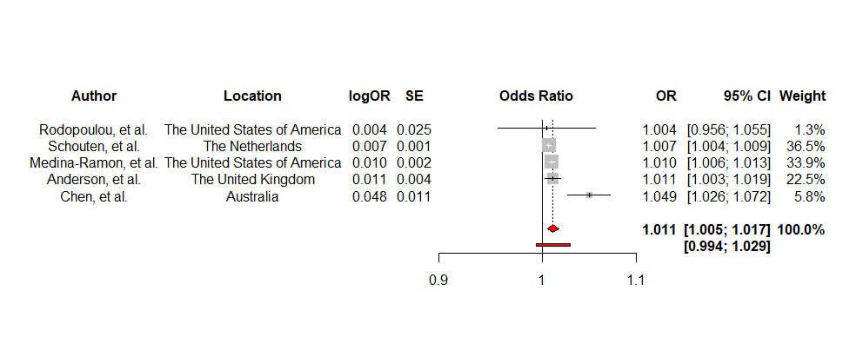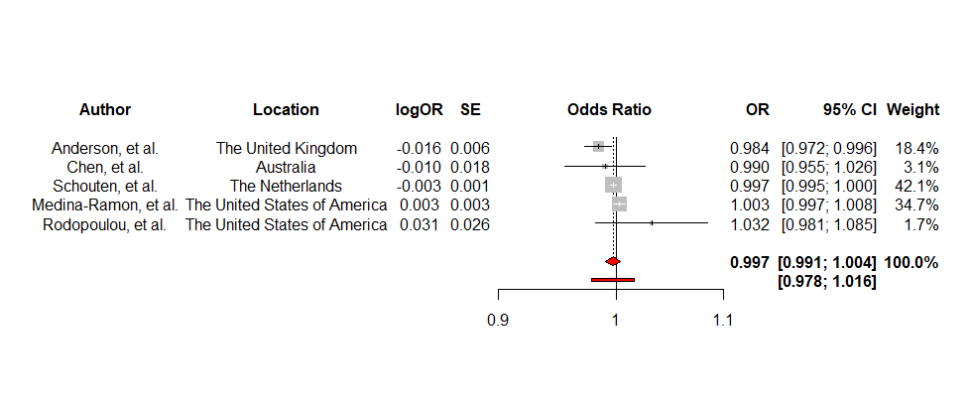

**Figure 4a: O3 effect in the cold season.**

**Figure 4b: O3 effect in the warm season.**

**Figure 4: Forest plots showing the random effects models for the effect of O3 when modified by season on RHA using the DL estimator.**

There was an increased odds of RHA when exposed to NO2 during the warm season.31 34 36-39 For the cold season, three studies reported an increased odds of RHA31 34 36, while two studies reported a decreased odds of RHA.34 39

Air pollution modified by temperature at specific temperatures found that there was an increased odds of RHA when exposed to PM10/NO2/O3 on warm (≥25°C) as well as cold days (<25°C).40-42

When looking at PM10 modified by temperature, there was an increased odds of RHA on warm (≥25°C) and cold (<20°C) days.40 43 44 Studies on NO2, and O3 modified by temperature found that there was an increased odds of RHA on warm days (≥20°C), and a decreased odds of RHA on cold days (<20°C).43 44

4. Discussion

In this systematic review and meta-analysis, we identified 34 studies that presented results on air pollution exposure, a temperature variable, and respiratory mortality and/or RHA. As far as we are aware, this is the first systematic review that aims to assess available literature on both air pollution and temperature exposures and their effect on respiratory health outcomes.

The majority of studies reported an increased odds of both respiratory mortality and RHA after exposure to air pollutants (PM10, NO2, and O3), and high temperatures. This was supported by our meta-analyses, which found statistically significant results for the effect of air pollutants and high temperatures on our respiratory outcomes. For low temperatures, results were largely inconsistent; overall, there appears to be an increased odds for respiratory mortality and RHA after exposure to selected air pollutants (PM10, NO2, and O3) and low temperatures.

The effect of O3 and temperature on respiratory outcomes was of interest. As expected, there was an increased risk of adverse health outcomes during high temperatures and the warm season, however, the effect of low temperature and the cold season was inconclusive. An effect of O3 during low temperatures/cool season was not expected due to low O3 concentrations, however more studies are reporting an increased risk of adverse respiratory health outcomes after exposure to O3 at low temperatures/cool season.22 25 34 41-43 45 46 Zhang, et al. 47 hypothesized that climate change is prolonging the O3 season, while also causing stagnant atmospheric conditions that promote the formation of O3; they conclude that it is difficult to determine a threshold value for the effect of O3 on health and that if a threshold exists it is probably lower than the current health-based standard.

Heterogeneity was expected due to the differences in study design, locations, populations, statistical methods, and variable characteristics. Differences in variable definition are common in air pollution-temperature studies. Studies use different air pollution concentrations, i.e. NO2 1-hour maximum and NO2 24-hour maximum, and temperature measures, i.e. mean temperature, median temperature, with some studies using 5% and 95% percentiles and others using 25% and 75% percentiles. Differences in measurement types makes it challenging to draw conclusions on the effect of air pollution when modified by temperature on respiratory health outcomes. Our review is in line with previous systematic reviews that investigated air pollution, temperature, and health outcomes as they also found that their analyses had varying (?) and high I2-values.48 However, Bunker, et al. 48 argued that I2-thresholds are more suited for controlled epidemiological studies rather than environment-health relationship studies that do not follow as stringent reporting guidelines.

We chose to exclude studies that only provided pooled results from a meta-analysis. However, two of these excluded studies were of interest. The first study by Analitis, et al. 49 showed the potential synergistic effect between air pollution and temperature on respiratory mortality in Europe; this study supports our own meta-analyses, in that it also found increased risk of mortality during the warm season when exposed to O3. The second study by Stafoggia, et al. 50 included an interaction term between PM10 and temperature. While this study failed to find any significant results, the use of an interaction term shows a shift towards investigating potential interactive effect between air pollution and temperature on health.

Biologically, air pollution and temperature affect the respiratory system differently. Air pollution accumulates and permeates through lung tissue. O3 causes non-visible structural lung modifications, while PM induces an increase in proinflammatory activity which leads to bronchial damage.9 The modifications and damage caused by air pollution on the lungs makes the body more susceptible to developing, and exacerbating, CRDs.9 During periods of high temperatures, e.g. heat waves, the body is unable to efficiently thermoregulate, which leads to excessive sweating and dehydration, exacerbating CRDs due to increased airway resistance.10 14 51 During low temperatures, the veins and arteries narrow, causing an increase in cardiac and respiratory workload.12 13

Climate change, air pollution, and temperature are in a continuous feedback loop.52 Air pollution is largely influenced by meteorological variables such as temperature, humidity and wind; as the concentration of greenhouse gases increases in the atmosphere, the excess greenhouse gases causes climate change and global warming.52 However, this feedback loop means that policies addressing one could influence and combat the other. The Paris Climate Agreement is an example of such a policy; signed in 2015, it is the first legally binding climate agreement between 196 countries which aims to ensure that temperatures do not rise by more than 2°C above pre-industrial levels by 2100.10 However, since 2015, the five hottest years on record have occurred.10 Rising temperatures are rapidly changing the climate, causing downstream effects on different environmental systems and exposing vulnerabilities in both developing and developed nations. Heatwave events are a contributing factor to the rise in wildfires, which compromise not only infrastructure but also human health through the excess release of air pollutants. Therefore, policymakers should aim to develop policies that combat many different facets of climate change.

Systematic reviews, such as this one, are important for policy development as it synthesises available research into a single document and allows us to identify trends that may not be as apparent in an individual study. Our review shows that policymakers should promote and develop polices using a global health perspective as by lowering the levels of air pollution and encouraging awareness of the impacts of temperature on health, we could potential decrease preventable deaths attributed to both air pollution and temperature.

The coronavirus disease (COVID-19) pandemic has shown that shifting our perspectives from a public health approach to a global health approach is vital for research purposes. While the majority of our studies came from China, which is classified as an upper-middle income country (UMIC), there is a lack of studies from other countries classified as lower- and middle-income countries (LMIC). We hypothesise through collaboration, and by improving the research capabilities of LMIC, we will encourage research that allows for more conclusive evidence on the nature and effect size of the combined effect between air pollution and temperature. This would allow researchers to investigate more effective statistical models, e.g. quantifying the effect modification of temperature more effectively by using a stratification method, whereby one model includes an interactive effect term between the air pollutant and temperature, and another model that does not include an interactive effect term.

A strength of this study was that the inclusion criteria allowed for a large number of studies to be included and assessed. Selection of studies were limited to papers published from 1990, which allowed for up to 30 years of research to be included in this analysis. The selection was done in duplicate, which limits selection bias. Using a random-effects model in our meta-analysis allowed for a better account of within- and between-study heterogeneity.

A limitation is the lack of homogeneity due to different study designs, statistical analysis techniques, selection of confounders, air pollution measurements, temperature definitions and measurements, and populations, in the included studies. Research was almost exclusively limited to developed countries or regions e.g. North America, Europe, and Australia, with the exception of the large number of studies from China, a UMIC, and one study from Latin America, of which two countries are UMIC.

5. Conclusions

We are living in an era where the effects of climate change are becoming more apparent. Therefore, investigating the effects of climate change, as well as its causes and consequences, on different health outcomes is imperative. The health effects of both air pollution and temperature are well studied, but the potential interactive effect of air pollution and temperature on health is still a relatively new field of study. With results on the potential interactive effect between air pollution and temperature being largely inconsistent, we should encourage future research in different regions and locations, which would allow for more conclusive evidence on this relationship. This systematic review and meta-analysis found that the effect of air pollution, specifically O3 and PM10, on respiratory mortality and hospital admissions is modified by temperature.

**Author Contributions:** Conceptualization, AT.A. and T.S.; methodology: study selection and data extraction, AT.A., T.S., C.W and Q.Z; software, AT.A.; validation, AT.A., Q.Z. and T.S.; formal analysis, AT.A.; investigation, AT.A.; resources, AT.A., Q.Z, T.S; writing—original draft preparation, AT.A.; writing—review and editing, AT.A., Q.Z, C.W, A.S, and T.S; visualization, AT.A.; supervision, Q.Z., C.W, and T.S. All authors have read and agreed to the published version of the manuscript.

**Funding:** This research received no outside funding.

**Conflicts of Interest:** The authors declare no conflict of interest

**Acknowledgements:** I would like to thank Dr. Ute Kraus for her advice and assistance.

**References**

1. Forum of International Respiratory Societies. The Global Impact of Respiratory Disease- Second Edition. Second Edition ed. Sheffield: European Respiratory Society, 2017:43.

2. Soriano JB, Abajobir AA, Abate KH, et al. Global, regional, and national deaths, prevalence, disability-adjusted life years, and years lived with disability for chronic obstructive pulmonary disease and asthma, 1990&#x2013;2015: a systematic analysis for the Global Burden of Disease Study 2015. *The Lancet Respiratory Medicine* 2017;5(9):691-706. doi: 10.1016/S2213-2600(17)30293-X

3. Soriano JB, Kendrick PJ, Paulson KR, et al. Prevalence and attributable health burden of chronic respiratory diseases, 1990&#x2013;2017: a systematic analysis for the Global Burden of Disease Study 2017. *The Lancet Respiratory Medicine* 2020;8(6):585-96. doi: 10.1016/S2213-2600(20)30105-3

4. World Health Organization. Chronic obstructive pulmonary disease (COPD) 2017 [Available from: <https://www.who.int/news-room/fact-sheets/detail/chronic-obstructive-pulmonary-disease-(copd>).

5. Lin H, Ma W, Liu Q. Ambient Temperature and Health in China: Springer 2019.

6. Pachauri RK, Allen MR, Barros VR, et al. Climate change 2014: synthesis report. Contribution of Working Groups I, II and III to the fifth assessment report of the Intergovernmental Panel on Climate Change: Ipcc 2014.

7. World Health Organization. Ambient air pollution: A global assessment of exposure and burden of disease. 2016

8. World Health Organisation. Noncommunicable diseases and air pollution. Copenhagen, Denmark: WHO, 2019:12.

9. De Sario M, Katsouyanni K, Michelozzi P. Climate change, extreme weather events, air pollution and respiratory health in Europe. *Eur Respir J* 2013;42(3):826-43. doi: 10.1183/09031936.00074712 [published Online First: 2013/01/15]

10. Watts N, Amann M, Arnell N, et al. The 2020 report of The Lancet Countdown on health and climate change: responding to converging crises. *The Lancet* 2020

11. Hughes L, Hanna E, Fenwick J. The silent killer: Climate change and the health impacts of extreme heat. 2016

12. D’Amato M, Molino A, Calabrese G, et al. The impact of cold on the respiratory tract and its consequences to respiratory health. *Clinical and Translational Allergy* 2018;8(1):20. doi: 10.1186/s13601-018-0208-9

13. Seltenrich N. Between Extremes: Health Effects of Heat and Cold. *Environmental health perspectives* 2015;123(11):A275-A80. doi: 10.1289/ehp.123-A275

14. Leon LR. Thermoregulatory responses to environmental toxicants: The interaction of thermal stress and toxicant exposure. *Toxicology and applied pharmacology* 2008;233(1):146-61.

15. Guidelines for snowballing in systematic literature studies and a replication in software engineering. Proceedings of the 18th international conference on evaluation and assessment in software engineering; 2014. Citeseer.

16. Moher D, Liberati A, Tetzlaff J, et al. Preferred Reporting Items for Systematic Reviews and Meta-Analyses: The PRISMA Statement. *PLOS Medicine* 2009;6(7):e1000097. doi: 10.1371/journal.pmed.1000097

17. World Health Organisation. Risk of Bias Assessment Instrument for Systematic Review informing WHO global air quality guidelines. Copenhagen, Denmark: World Health Organisation Regional Office for Europe; 2020 [Available from: <https://www.euro.who.int/en/health-topics/environment-and-health/air-quality/publications/2020/risk-of-bias-assessment-instrument-for-systematic-reviews-informing-who-global-air-quality-guidelines-2020>.

18. Veroniki AA, Jackson D, Viechtbauer W, et al. Methods to estimate the between-study variance and its uncertainty in meta-analysis. *Res Synth Methods* 2016;7(1):55-79. doi: 10.1002/jrsm.1164 [published Online First: 2015/09/02]

19. Harrer M, Cuijpers P, Furukawa TA, et al. Doing meta-analysis in R: A hands-on guide. *PROTECT Lab Erlangen* 2019

20. R: A language and environment for statistical computing [program]. Vienna, Austria: R Foundation for Statistical Computing, 2019.

21. Meng X, Zhang Y, Zhao Z, et al. Temperature modifies the acute effect of particulate air pollution on mortality in eight Chinese cities. *Sci Total Environ* 2012;435-436:215-21. doi: 10.1016/j.scitotenv.2012.07.008 [published Online First: 2012/08/03]

22. Cheng Y, Kan H. Effect of the interaction between outdoor air pollution and extreme temperature on daily mortality in Shanghai, China. *J Epidemiol* 2012;22(1):28-36. doi: 10.2188/jea.je20110049 [published Online First: 2011/11/02]

23. Qian Z, He Q, Lin HM, et al. High temperatures enhanced acute mortality effects of ambient particle pollution in the "oven" city of Wuhan, China. *Environ Health Perspect* 2008;116(9):1172-8. doi: 10.1289/ehp.10847 [published Online First: 2008/09/17]

24. Qin RX, Xiao C, Zhu Y, et al. The interactive effects between high temperature and air pollution on mortality: A time-series analysis in Hefei, China. *Sci Total Environ* 2017;575:1530-37. doi: 10.1016/j.scitotenv.2016.10.033 [published Online First: 2016/12/29]

25. Anderson HR, Ponce de Leon A, Bland JM, et al. Air pollution and daily mortality in London: 1987-92. *Bmj* 1996;312(7032):665-9. doi: 10.1136/bmj.312.7032.665 [published Online First: 1996/03/16]

26. Romieu I, Gouveia N, Cifuentes LA, et al. Multicity study of air pollution and mortality in Latin America (the ESCALA study). *Res Rep Health Eff Inst* 2012(171):5-86. [published Online First: 2013/01/15]

27. Zanobetti A, Schwartz J. Ozone and survival in four cohorts with potentially predisposing diseases. *Am J Respir Crit Care Med* 2011;184(7):836-41. doi: 10.1164/rccm.201102-0227OC [published Online First: 2011/06/28]

28. Qiu H, Tan K, Long F, et al. The Burden of COPD Morbidity Attributable to the Interaction between Ambient Air Pollution and Temperature in Chengdu, China. *Int J Environ Res Public Health* 2018;15(3) doi: 10.3390/ijerph15030492 [published Online First: 2018/03/15]

29. Wang MZ, Zheng S, Wang SG, et al. The weather temperature and air pollution interaction and its effect on hospital admissions due to respiratory system diseases in western China. *Biomed Environ Sci* 2013;26(5):403-7. doi: 10.3967/0895-3988.2013.05.011 [published Online First: 2013/04/25]

30. Ren C, Tong S. Temperature modifies the health effects of particulate matter in Brisbane, Australia. *Int J Biometeorol* 2006;51(2):87-96. doi: 10.1007/s00484-006-0054-7 [published Online First: 2006/09/13]

31. Chen K, Glonek G, Hansen A, et al. The effects of air pollution on asthma hospital admissions in Adelaide, South Australia, 2003-2013: time-series and case-crossover analyses. *Clin Exp Allergy* 2016;46(11):1416-30. doi: 10.1111/cea.12795 [published Online First: 2016/10/30]

32. Hansen A, Bi P, Nitschke M, et al. Particulate air pollution and cardiorespiratory hospital admissions in a temperate Australian city: A case-crossover analysis. *Sci Total Environ* 2012;416:48-52. doi: 10.1016/j.scitotenv.2011.09.027 [published Online First: 2012/01/10]

33. Medina-Ramon M, Zanobetti A, Schwartz J. The effect of ozone and PM10 on hospital admissions for pneumonia and chronic obstructive pulmonary disease: a national multicity study. *Am J Epidemiol* 2006;163(6):579-88. doi: 10.1093/aje/kwj078 [published Online First: 2006/01/31]

34. Wong CM, Atkinson RW, Anderson HR, et al. A tale of two cities: effects of air pollution on hospital admissions in Hong Kong and London compared. *Environ Health Perspect* 2002;110(1):67-77. doi: 10.1289/ehp.0211067 [published Online First: 2002/01/10]

35. Rodopoulou S, Chalbot MC, Samoli E, et al. Air pollution and hospital emergency room and admissions for cardiovascular and respiratory diseases in Dona Ana County, New Mexico. *Environ Res* 2014;129:39-46. doi: 10.1016/j.envres.2013.12.006 [published Online First: 2014/02/18]

36. Anderson HR, Ponce de Leon A, Bland JM, et al. Air pollution, pollens, and daily admissions for asthma in London 1987-92. *Thorax* 1998;53(10):842-8. doi: 10.1136/thx.53.10.842 [published Online First: 1999/04/08]

37. Atkinson RW, Bremner SA, Anderson HR, et al. Short-term associations between emergency hospital admissions for respiratory and cardiovascular disease and outdoor air pollution in London. *Arch Environ Health* 1999;54(6):398-411. doi: 10.1080/00039899909603371 [published Online First: 2000/01/14]

38. Schouten JP, Vonk JM, de Graaf A. Short term effects of air pollution on emergency hospital admissions for respiratory disease: results of the APHEA project in two major cities in The Netherlands, 1977-89. *J Epidemiol Community Health* 1996;50 Suppl 1:s22-9. doi: 10.1136/jech.50.suppl_1.s22 [published Online First: 1996/04/01]

39. Mohr LB, Luo S, Mathias E, et al. Influence of season and temperature on the relationship of elemental carbon air pollution to pediatric asthma emergency room visits. *J Asthma* 2008;45(10):936-43. doi: 10.1080/02770900802404082 [published Online First: 2008/12/17]

40. Cheng MH, Chiu HF, Yang CY. Coarse Particulate Air Pollution Associated with Increased Risk of Hospital Admissions for Respiratory Diseases in a Tropical City, Kaohsiung, Taiwan. *Int J Environ Res Public Health* 2015;12(10):13053-68. doi: 10.3390/ijerph121013053 [published Online First: 2015/10/27]

41. Tsai SS, Cheng MH, Chiu HF, et al. Air pollution and hospital admissions for asthma in a tropical city: Kaohsiung, Taiwan. *Inhal Toxicol* 2006;18(8):549-54. doi: 10.1080/08958370600686176 [published Online First: 2006/05/24]

42. Yang CY, Chen CC, Chen CY, et al. Air pollution and hospital admissions for asthma in a subtropical city: Taipei, Taiwan. *J Toxicol Environ Health A* 2007;70(2):111-7. doi: 10.1080/15287390600755059 [published Online First: 2007/03/17]

43. Lee IM, Tsai SS, Chang CC, et al. Air pollution and hospital admissions for chronic obstructive pulmonary disease in a tropical city: Kaohsiung, Taiwan. *Inhal Toxicol* 2007;19(5):393-8. doi: 10.1080/08958370601174818 [published Online First: 2007/03/17]

44. Yang CY, Chen CJ. Air pollution and hospital admissions for chronic obstructive pulmonary disease in a subtropical city: Taipei, Taiwan. *J Toxicol Environ Health A* 2007;70(14):1214-9. doi: 10.1080/15287390701380880 [published Online First: 2007/06/19]

45. Ng CF, Ueda K, Nitta H, et al. Seasonal variation in the acute effects of ozone on premature mortality among elderly Japanese. *Environ Monit Assess* 2013;185(10):8767-76. doi: 10.1007/s10661-013-3211-6 [published Online First: 2013/04/23]

46. Wong CM, Ma S, Hedley AJ, et al. Effect of air pollution on daily mortality in Hong Kong. *Environ Health Perspect* 2001;109(4):335-40. doi: 10.1289/ehp.01109335 [published Online First: 2001/05/04]

47. Zhang JJ, Wei Y, Fang Z. Ozone Pollution: A Major Health Hazard Worldwide. *Front Immunol* 2019;10:2518-18. doi: 10.3389/fimmu.2019.02518

48. Bunker A, Wildenhain J, Vandenbergh A, et al. Effects of Air Temperature on Climate-Sensitive Mortality and Morbidity Outcomes in the Elderly; a Systematic Review and Meta-analysis of Epidemiological Evidence. *EBioMedicine* 2016;6:258-68. doi: 10.1016/j.ebiom.2016.02.034 [published Online First: 2016/05/24]

49. Analitis A, De' Donato F, Scortichini M, et al. Synergistic Effects of Ambient Temperature and Air Pollution on Health in Europe: Results from the PHASE Project. *Int J Environ Res Public Health* 2018;15(9) doi: 10.3390/ijerph15091856 [published Online First: 2018/08/30]

50. Stafoggia M, Schwartz J, Forastiere F, et al. Does temperature modify the association between air pollution and mortality? A multicity case-crossover analysis in Italy. *Am J Epidemiol* 2008;167(12):1476-85. doi: 10.1093/aje/kwn074 [published Online First: 2008/04/15]

51. Bernstein AS, Rice MB. Lungs in a warming world: climate change and respiratory health. *Chest* 2013;143(5):1455-59. doi: 10.1378/chest.12-2384 [published Online First: 2013/05/08]

52. Orru H, Ebi KL, Forsberg B. The Interplay of Climate Change and Air Pollution on Health. *Current Environmental Health Reports* 2017;4(4):504-13. doi: 10.1007/s40572-017-0168-6

53. Anderson HR, Bremner SA, Atkinson RW, et al. Particulate matter and daily mortality and hospital admissions in the west midlands conurbation of the United Kingdom: associations with fine and coarse particles, black smoke and sulphate. *Occup Environ Med* 2001;58(8):504-10. doi: 10.1136/oem.58.8.504 [published Online First: 2001/07/14]

54. Feng W, Li H, Wang S, et al. Short-term PM10 and emergency department admissions for selective cardiovascular and respiratory diseases in Beijing, China. *Sci Total Environ* 2019;657:213-21. doi: 10.1016/j.scitotenv.2018.12.066 [published Online First: 2018/12/14]

55. Li G, Zhou M, Cai Y, et al. Does temperature enhance acute mortality effects of ambient particle pollution in Tianjin City, China. *Sci Total Environ* 2011;409(10):1811-7. doi: 10.1016/j.scitotenv.2011.02.005 [published Online First: 2011/03/08]

56. Li G, Jiang L, Zhang Y, et al. The impact of ambient particle pollution during extreme-temperature days in Guangzhou City, China. *Asia Pac J Public Health* 2014;26(6):614-21. doi: 10.1177/1010539514529811 [published Online First: 2014/04/16]

57. Sunyer J, Castellsague J, Saez M, et al. Air pollution and mortality in Barcelona. *J Epidemiol Community Health* 1996;50 Suppl 1:s76-80. doi: 10.1136/jech.50.suppl_1.s76 [published Online First: 1996/04/01]

58. Tian L, Liang F, Guo Q, et al. The effects of interaction between particulate matter and temperature on mortality in Beijing, China. *Environ Sci Process Impacts* 2018;20(2):395-405. doi: 10.1039/c7em00414a [published Online First: 2018/01/18]

59. Zhang Y, Huang W, London SJ, et al. Ozone and daily mortality in Shanghai, China. *Environmental health perspectives* 2006;114(8):1227-32. doi: 10.1289/ehp.9014

60. Zhang F, Li L, Krafft T, et al. Study on the association between ambient air pollution and daily cardiovascular and respiratory mortality in an urban district of Beijing. *Int J Environ Res Public Health* 2011;8(6):2109-23. doi: 10.3390/ijerph8062109 [published Online First: 2011/07/22]

Appendix

**Appendix A: PRISMA Checklist**

**Table 1a: PRISMA Checklist**

|  |  |  |  |
| --- | --- | --- | --- |
| **Section/topic** | **#** | **Checklist item** | **Reported on page #** |
| **TITLE** | | |  |
| Title | 1 | Identify the report as a systematic review, meta-analysis, or both. |  |
| **ABSTRACT** | | |  |
| Structured summary | 2 | Provide a structured summary including, as applicable: background; objectives; data sources; study eligibility criteria, participants, and interventions; study appraisal and synthesis methods; results; limitations; conclusions and implications of key findings; systematic review registration number. |  |
| **INTRODUCTION** | | |  |
| Rationale | 3 | Describe the rationale for the review in the context of what is already known. |  |
| Objectives | 4 | Provide an explicit statement of questions being addressed with reference to participants, interventions, comparisons, outcomes, and study design (PICOS). |  |
| **METHODS** | | |  |
| Protocol and registration | 5 | Indicate if a review protocol exists, if and where it can be accessed (e.g., Web address), and, if available, provide registration information including registration number. |  |
| Eligibility criteria | 6 | Specify study characteristics (e.g., PICOS, length of follow-up) and report characteristics (e.g., years considered, language, publication status) used as criteria for eligibility, giving rationale. |  |
| Information sources | 7 | Describe all information sources (e.g., databases with dates of coverage, contact with study authors to identify additional studies) in the search and date last searched. |  |
| Search | 8 | Present full electronic search strategy for at least one database, including any limits used, such that it could be repeated. |  |
| Study selection | 9 | State the process for selecting studies (i.e., screening, eligibility, included in systematic review, and, if applicable, included in the meta-analysis). |  |
| Data collection process | 10 | Describe method of data extraction from reports (e.g., piloted forms, independently, in duplicate) and any processes for obtaining and confirming data from investigators. |  |
| Data items | 11 | List and define all variables for which data were sought (e.g., PICOS, funding sources) and any assumptions and simplifications made. |  |
| Risk of bias in individual studies | 12 | Describe methods used for assessing risk of bias of individual studies (including specification of whether this was done at the study or outcome level), and how this information is to be used in any data synthesis. |  |
| Summary measures | 13 | State the principal summary measures (e.g., risk ratio, difference in means). |  |
| Synthesis of results | 14 | Describe the methods of handling data and combining results of studies, if done, including measures of consistency (e.g., I2) for each meta-analysis. |  |

|  |  |  |  |
| --- | --- | --- | --- |
| **Section/topic** | **#** | **Checklist item** | **Reported on page #** |
| Risk of bias across studies | 15 | Specify any assessment of risk of bias that may affect the cumulative evidence (e.g., publication bias, selective reporting within studies). |  |
| Additional analyses | 16 | Describe methods of additional analyses (e.g., sensitivity or subgroup analyses, meta-regression), if done, indicating which were pre-specified. |  |
| **RESULTS** | | |  |
| Study selection | 17 | Give numbers of studies screened, assessed for eligibility, and included in the review, with reasons for exclusions at each stage, ideally with a flow diagram. |  |
| Study characteristics | 18 | For each study, present characteristics for which data were extracted (e.g., study size, PICOS, follow-up period) and provide the citations. |  |
| Risk of bias within studies | 19 | Present data on risk of bias of each study and, if available, any outcome level assessment (see item 12). |  |
| Results of individual studies | 20 | For all outcomes considered (benefits or harms), present, for each study: (a) simple summary data for each intervention group (b) effect estimates and confidence intervals, ideally with a forest plot. |  |
| Synthesis of results | 21 | Present results of each meta-analysis done, including confidence intervals and measures of consistency. |  |
| Risk of bias across studies | 22 | Present results of any assessment of risk of bias across studies (see Item 15). |  |
| Additional analysis | 23 | Give results of additional analyses, if done (e.g., sensitivity or subgroup analyses, meta-regression [see Item 16]). |  |
| **DISCUSSION** | | |  |
| Summary of evidence | 24 | Summarize the main findings including the strength of evidence for each main outcome; consider their relevance to key groups (e.g., healthcare providers, users, and policy makers). |  |
| Limitations | 25 | Discuss limitations at study and outcome level (e.g., risk of bias), and at review-level (e.g., incomplete retrieval of identified research, reporting bias). |  |
| Conclusions | 26 | Provide a general interpretation of the results in the context of other evidence, and implications for future research. |  |
| **FUNDING** | | |  |
| Funding | 27 | Describe sources of funding for the systematic review and other support (e.g., supply of data); role of funders for the systematic review. |  |

*From:*  Moher D, Liberati A, Tetzlaff J, Altman DG, The PRISMA Group (2009). Preferred Reporting Items for Systematic Reviews and Meta-Analyses: The PRISMA Statement. PLoS Med 6(7): e1000097. doi:10.1371/journal.pmed1000097

Appendix B: Word List for Web of Science

“Air Pollution AND Temperature AND Respiratory disease” OR “Air Pollution AND Temperature AND Chronic Respiratory disease” OR “Air Pollution AND Temperature AND Chronic obstructive pulmonary disease” OR “Air Pollution AND Temperature AND COPD” OR “Air Pollution AND Temperature AND Asthma” OR “Air Pollution AND Temperature AND Mortality” OR “Air Pollution AND Temperature AND Hospital Admission” OR “Outdoor Air Pollution AND Temperature AND Respiratory disease” OR “Outdoor Air Pollution AND Temperature AND Chronic Respiratory disease” OR “Outdoor Air Pollution AND Temperature AND Chronic obstructive pulmonary disease” OR “Outdoor Air Pollution AND Temperature AND COPD” OR “Outdoor Air Pollution AND Temperature AND Asthma” OR “Outdoor Air Pollution AND Temperature AND Mortality” OR “Outdoor Air Pollution AND Temperature AND Hospital Admission”

“Air Pollution AND Extreme temperatures AND Respiratory disease” OR “Air Pollution AND Extreme temperatures AND Chronic Respiratory disease” OR “Air Pollution AND Extreme temperatures AND Chronic obstructive pulmonary disease” OR “Air Pollution AND Extreme temperatures AND COPD” OR “Air Pollution AND Extreme temperatures AND Asthma” OR “Air Pollution AND Extreme temperatures AND Mortality” OR “Air Pollution AND Extreme temperatures AND Hospital Admission” OR “Outdoor Air Pollution AND Extreme temperatures AND Respiratory disease” OR “Outdoor Air Pollution AND Extreme temperatures AND Chronic Respiratory disease” OR “Outdoor Air Pollution AND Extreme temperatures AND Chronic obstructive pulmonary disease” OR “Outdoor Air Pollution AND Extreme temperatures AND COPD” OR “Outdoor Air Pollution AND Extreme temperatures AND Asthma” OR “Outdoor Air Pollution AND Extreme temperatures AND Mortality” OR “Outdoor Air Pollution AND Extreme temperatures AND Hospital Admission”

“Air Pollution AND Hot Temperature AND Respiratory disease” OR “Air Pollution AND Hot Temperature AND Chronic Respiratory disease” OR “Air Pollution AND Hot Temperature AND Chronic obstructive pulmonary disease” OR “Air Pollution AND Hot Temperature AND COPD” OR “Air Pollution AND Hot Temperature AND Asthma” OR “Air Pollution AND Hot Temperature AND Mortality” OR “Air Pollution AND Hot Temperature AND Hospital Admission” OR “Outdoor Air Pollution AND Hot Temperature AND Respiratory disease” OR “Outdoor Air Pollution AND Hot Temperature AND Chronic Respiratory disease” OR “Outdoor Air Pollution AND Hot Temperature AND Chronic obstructive pulmonary disease” OR “Outdoor Air Pollution AND Hot Temperature AND COPD” OR “Outdoor Air Pollution AND Hot Temperature AND Asthma” OR “Outdoor Air Pollution AND Hot Temperature AND Mortality” OR “Outdoor Air Pollution AND Hot Temperature AND Hospital Admission”

“Air Pollution AND Cold Temperature AND Respiratory disease” OR “Air Pollution AND Cold Temperature AND Chronic Respiratory disease” OR “Air Pollution AND Cold Temperature AND Chronic obstructive pulmonary disease” OR “Air Pollution AND Cold Temperature AND COPD” OR “Air Pollution AND Cold Temperature AND Asthma” OR “Air Pollution AND Cold Temperature AND Mortality” OR “Air Pollution AND Cold Temperature AND Hospital Admission” OR “Outdoor Air Pollution AND Cold Temperature AND Respiratory disease” OR “Outdoor Air Pollution AND Cold Temperature AND Chronic Respiratory disease” OR “Outdoor Air Pollution AND Cold Temperature AND Chronic obstructive pulmonary disease” OR “Outdoor Air Pollution AND Cold Temperature AND COPD” OR “Outdoor Air Pollution AND Cold Temperature AND Asthma” OR “Outdoor Air Pollution AND Cold Temperature AND Mortality” OR “Outdoor Air Pollution AND Cold Temperature AND Hospital Admission”

“Air Pollution AND Respiratory disease” OR “Air Pollution AND Chronic Respiratory disease” OR “Air Pollution AND Chronic obstructive pulmonary disease” OR “Air Pollution AND COPD” OR “Air Pollution AND Asthma” OR “Air Pollution AND Mortality” OR “Air Pollution AND Hospital Admission” OR “Outdoor Air Pollution AND Respiratory disease” OR “Outdoor Air Pollution AND Chronic Respiratory disease” OR “Outdoor Air Pollution AND Chronic obstructive pulmonary disease” OR “Outdoor Air Pollution AND COPD” OR “Outdoor Air Pollution AND Asthma” OR “Outdoor Air Pollution AND Mortality” OR “Outdoor Air Pollution AND Hospital Admission”

“Temperature AND Respiratory disease” OR “Temperature AND Chronic Respiratory disease” OR “Temperature AND Chronic obstructive pulmonary disease” OR “Temperature AND COPD” OR “Temperature AND Asthma” OR “Temperature AND Mortality” OR “Temperature AND Hospital Admission” OR “Extreme temperatures AND Respiratory disease” OR “Extreme temperatures AND Chronic Respiratory disease” OR “Extreme temperatures AND Chronic obstructive pulmonary disease” OR “Extreme temperatures AND COPD” OR “Extreme temperatures AND Asthma” OR “Extreme temperatures AND Mortality” OR “Extreme temperatures AND Hospital Admission” OR “Hot Temperature AND Respiratory disease” OR “Hot Temperature AND Chronic Respiratory disease” OR “Hot Temperature AND Chronic obstructive pulmonary disease” OR “Hot Temperature AND COPD” OR “Hot Temperature AND Asthma” OR “Hot Temperature AND Mortality” OR “Hot Temperature AND Hospital Admission” OR “Cold Temperature AND Respiratory disease” OR “Cold Temperature AND Chronic Respiratory disease” OR “Cold Temperature AND Chronic obstructive pulmonary disease” OR “Cold Temperature AND COPD” OR “Cold Temperature AND Asthma” OR “Cold Temperature AND Mortality” OR “Cold Temperature AND Hospital Admission”

**Appendix C**

**Figure 1a: PRISMA flow chart**

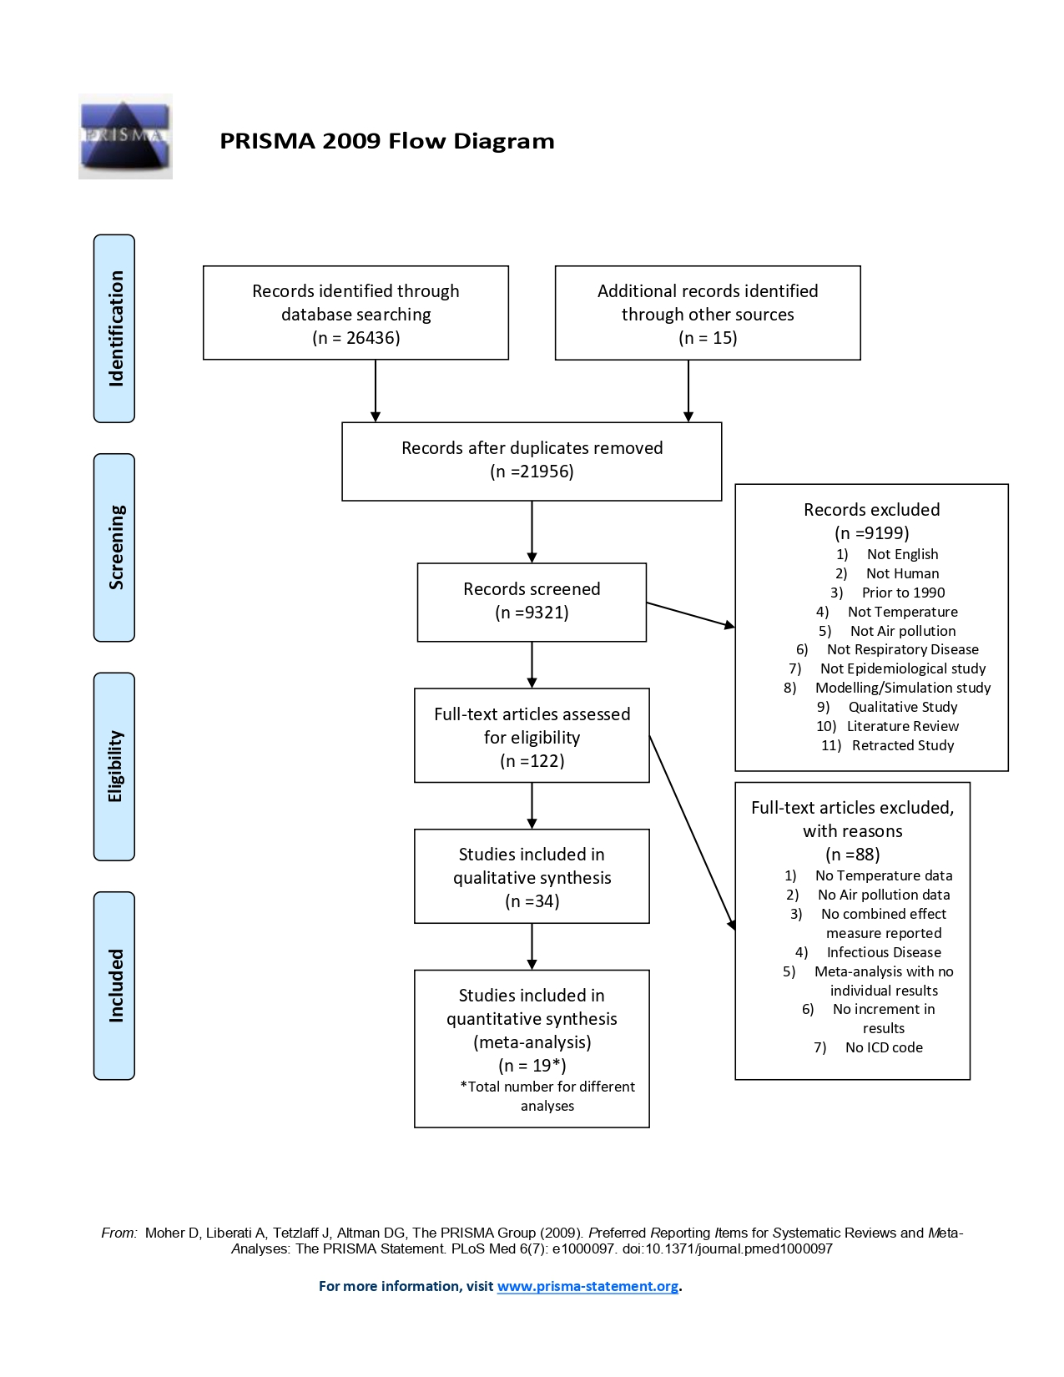

**Appendix D: Risk of bias checklist**

# **Table 1b: Risk of bias assessment instrument**

|  |  |  |  |  |  |  |
| --- | --- | --- | --- | --- | --- | --- |
| **Risk of bias instrument** | **Topic:** |  |  | **Reviewer ID:** |  |  |
|  | **Study ID:** | | |  |  |
|  | **Date:** | | |  |  |
| **For each**  **PECOS** |  | **Long-term studies** | **Short-term studies** |  |  | **Notes** |
| **Critical potential confounders** |  |  |  |  |  |
| **Other potential confounders** |  |  |  |  |  |
| **Domain** | **Subdomain** | **Low-risk (ideal study) criteria** | **Moderate-risk criteria** | **High-risk criteria** | **Overall judgement**  **for a domain: Low/**  **Moderate/**  **High** | **Rationale/**  **Notes (quotes from the study to justify the**  **judgement)** |
| **1.**  **Confounding** | Were all confounders considered adjusted for in the analysis? | All critical and other/additional potential confounders adjusted for or with support (e.g. exploratory analysis) of minimal risk due to residual confounding  (i.e. there is evidence that this confounder might not lead to severe confounding). | All critical potential confounders but not all other/ additional potential confounders adjusted for without support (e.g. exploratory analysis) of minimal risk due to residual confounding (i.e. there is evidence that this confounder might not lead to severe confounding). | Not all critical potential confounders adjusted for without support (e.g. exploratory analysis) of minimal risk due to residual confounding. |  |  |
| Validity of measuring of confounding factors | Confounders measured with documented valid methods. | Not all critical potential confounders were measured with documented valid methods; however, there is evidence that this does not lead to severe confounding. | Any critical or other/additional potential confounder not validly assessed and evidence of residual confounding. |  |  |
| Control in analysis (Did the authors use an appropriate analysis method or study design that controlled for confounding domains?) | Authors used appropriate analysis methods or study designs that controlled for confounding domains. | Authors used inappropriate methods or designs when adjusting for  critical potential confounders; however, there is evidence that this does not lead to severe confounding. | Authors used inappropriate methods or study designs when adjusting for critical and other/additional potential confounders. |  |  |
| ***Overall*** | | | |  |  |

|  |  |  |  |  |  |  |
| --- | --- | --- | --- | --- | --- | --- |
| **Domain** | **Subdomain** | **Low-risk (ideal study) criteria** | **Moderate-risk criteria** | **High-risk criteria** | **Overall judgement**  **for a domain: Low/**  **Moderate/**  **High** | **Rationale/**  **Notes (quotes from the study to justify the**  **judgement)** |
| **2.**  **Selection bias** | Selection of participants into the study (includes nonresponse) | Participants in all exposure levels and with all outcomes had equal opportunity to be in the study. | Participants in all exposure levels did not have equal opportunity to be in the study, but **not** to the extent that effect estimates were seriously biased  (rationale required). | Participants in all exposure levels did not have equal opportunity to be in the study, to the extent that effect estimates were seriously biased. |  |  |
|  |  |  | ***Overall*** |  |  |
| **3.**  **Exposure assessment** | Methods used for exposure assessment | Exposure levels assessed with appropriate methods. | Exposure levels assessed with less than appropriate methods but not to the extent that effect estimates were seriously biased. | Exposure levels not assessed with appropriate methods to the extent that effect estimates were seriously biased. |  |  |
| Exposure measurement methods comparable across the range of exposure | Measurement methods used are comparable across the range of exposure. | Measurement methods vary across the range of exposure; **however**, there is evidence supporting that the exposure measurement is  sufficiently similar that effect estimates are not seriously biased. | Measurement methods vary across the range of exposure and differences are not accounted for. |  |  |
| Change in exposure status (for long-term studies only) | Spatial exposure contrasts did not change throughout the study or time varying exposure was used to account for changes. | Spatial exposure contrasts did change throughout the study and were not accounted for **but** effect estimates were not seriously biased. | Spatial exposure contrasts did change throughout the study and were not accounted for, **and** effect estimates were seriously biased and were different in cases and non-cases. |  |  |
| Exposure contrast | Exposure contrast was large compared to the precision of exposure assessment (between-subject variance larger than withinsubject variance). | Exposure contrast was small relative to the withinsubject variance but not to the extent that the study is uninformative. | Exposure contrast was so small relative to the within-subject variance that the study is uninformative. |  |  |
|  |  |  | ***Overall*** | | |

|  |  |  |  |  |  |  |
| --- | --- | --- | --- | --- | --- | --- |
| **Domain** | **Subdomain** | **Low-risk (ideal study) criteria** | **Moderate-risk criteria** | **High-risk criteria** | **Overall judgement**  **for a domain: Low/**  **Moderate/**  **High** | **Rationale/**  **Notes (quotes from the study to justify the**  **judgement)** |
| **4.**  **Outcome measurement** | Blinding of outcome measurement | Outcome measurements were not influenced by knowledge of the exposure. | Outcome measures were influenced by knowledge of the exposure; however, evidence supports that effect estimates were unlikely biased. | Outcome  detection was related to exposure status and effect estimates are likely biased. |  |  |
| Validity of  outcome measurements | No systematic errors in the measurement of the outcome or systematic errors were unrelated to the exposure. | Minimum systematic errors suspected in the measurement were related to the exposure received. | Critical systematic errors in the  measurement  were related to the exposure received. |  |  |
| Outcome measurement | Methods of outcome assessment were comparable across exposure groups. | Methods of outcome assessment were not comparable across exposure groups; **however**, evidence supports that outcome detection would not have varied. | Methods of outcome assessment were not comparable across exposure groups. |  |  |
|  |  |  | ***Overall*** |  |  |
| **5.**  **Missing data** | Missing data of outcome measures | No missing outcome data or missing data infrequent (<10%) or missing data related to outcome or exposure data imputed using appropriate methods. | Missing data on outcomes not infrequent (≥10%) and rationale for attrition explained in the study; methods have possibly been used to properly account for it. | Evidence of substantial missing outcome data (≥10%), rationale for attrition not explained in the study and methods unlikely to properly account for it. |  |  |
| Missing data of exposures | No missing exposure data or missing data infrequent (<10%) or missing data related to exposure or outcome data imputed using appropriate methods. | Missing data on exposure not infrequent (≥10%) and rationale for attrition explained in the study; methods have possibly been used to properly account for it. | Evidence of substantial missing exposure data (≥10%), rationale for missing data not explained in the study, and/ or the portion of participants and reasons for missing data are dissimilar across exposures/ exposure groups. |  |  |
|  |  |  | ***Overall*** | | |

|  |  |  |  |  |  |  |
| --- | --- | --- | --- | --- | --- | --- |
| **Domain** | **Subdomain** | **Low-risk (ideal study) criteria** | **Moderate-risk criteria** | **High-risk criteria** | **Overall judgement**  **for a domain: Low/**  **Moderate/**  **High** | **Rationale/**  **Notes (quotes from the study to justify the**  **judgement)** |
| **6.**  **Selective reporting** | Authors reported a priori primary and secondary study aims | Effect estimates presented for all hypotheses tested as per aims; reference to published or unpublished study protocol. | Effect estimates presented for **some (not all)** hypotheses tested as per aims, **but** evidence suggests that effect estimates unlikely to be seriously biased. | Effect estimates selectively presented for **some (not all)** hypotheses tested as per aims **and** effect estimates likely to be seriously biased. |  |  |
|  |  |  | ***Overall*** |  |  |

Risk of bias assessment instrument for systematic reviews informing WHO global air quality guidelines

Appendix E

Table 1C: A table showing the data extracted from 34 included studies.

|  |  |  |  |  |  |  |  |  |  |  |  |
| --- | --- | --- | --- | --- | --- | --- | --- | --- | --- | --- | --- |
| **Author** | **Year** | **Country/ Region** | **Outcome Variable** | **Codes** | **Temperature-Air pollution relationship** | **Study Design** | **Statistical Model** | **Air pollutants (unit)** | **Temperature variable** | **Effect estimate** | **Results** |
| Anderson, et al. 25 | 1996 | The United Kingdom | Mortality | 460-519 (9th) | Seasonality | Time series | Auto-regressive log-linear regression models | 8-hour O3 (ppb); 24-hour NO2 (ppb) | Warm season  Cold season | % increase (95%CI)/ change in 10-90th percentile | **O3**: Cold= 6.20 (1.76 to 10.94); Warm= 5.41 (0.35 to 10.73).  **NO2**: Cold= -0.25(-2.54 to 2.10); Warm= -2.90 (-7.55 to 1.99) |
| Anderson, et al. 36 | 1998 | The United Kingdom | Hospital admissions | 493 (9th) | Seasonality | Time series | Auto-regressive log-linear regression models | 8-hour O3 (ppb); 24-hour NO2 (ppb) | Warm season  Cold season | %increase (95%CI)/10ppb | **O3:** Cold= -3.17(-5.44 to -0.84); Warm= 2.21(0.62 to 3.82).  **NO2:** Cold= 1.30(0.38 to 2.23); Warm= 1.15(-0.25 to 3.67) |
| Anderson, et al. 53 | 2001 | The United Kingdom | Mortality and Hospital admissions | 460-519 (9th) | Seasonality | Time series | Generalised Additive Models (GAM) | 24-hour PM10(µg/m3); 1-hour NO2(ppb); 8-hour O3 (ppb) | Season | Interaction with season P-value | Mortality: **PM10** p=0.2; **NO2** p=0.3; **O3** p= 0.1.  Hospital Admissions: **PM10** p=0.2; **NO2** p=0.02; **O3** p=0.1 |
| Atkinson, et al. 37 | 1999 | The United Kingdom | Hospital admissions | 460-519 (9th) | Seasonality | Time series | Auto-regressive log-linear regression models | 24-hour PM10 (µg/m3); 8-hour O3 (ppb); 1-hour NO2 (ppb) | Warm season | % change (95%CI)/ change in 10-90th percentile | **NO2**: 4.63 (1.87 to 7.46);  **PM10:** 6.45 (3.34 to 9.65). |
| Chen, et al. 31 | 2016 | Australia | Hospital admissions | J45 and J46 (10th) | Seasonality | Case-crossover | Conditional logistic regression | PM10 (µg/m3). NO2 (ppb). O3 (ppb) | Warm season  Cold season | OR (95%CI)/10-unit increase | **PM10:** Cold= 1.067 (1.023 to 1.112) Warm= 0.999 (0.961 to 1.037).  **NO2:** Cold= 1.091 (1.048 to 1.136) Warm= 1.056 (1.008 to 1.105).  **O3**: Cold= 0.980 (0.912 to 1.053) Warm= 1.100 (1.053 to 1.148) |
| Cheng and Kan 22 | 2012 | China | Mortality | 460-519 (9th); J00-J98 (10th) | Combined effect | Time series | GAM | PM10 (µg/m3); O3 (µg/m3); NO2 (µg/m3) | Extreme temperature (95% vs. 5%) | % change (95%CI)/10 µg/m3 | **PM10:** Low= 0.46 (0.21 to 0.72) High= 0.44 (0.21 to 0.82).  **NO2:** Low= 1.25 (0.71 to 1.79) High= 1.04 (0.33 to 1.75).  **O3:** Low= 1.78 (0.84 to 2.73) High= 0.54 (0.15 to 0.92) |
| Cheng, et al. 40 | 2015 | Taiwan | Hospital admissions | 490-494 and 496 (9th) | Adjusted for Temperature | Case-crossover | Conditional logistic regression | PM10 (µg/m3). | ≥25°C  <25°C | % increase (95%CI)/10µg/m3. | **PM10.** Asthma: ≥25°C=2 (0 to 4) <25°C=4 (3 to 6).  COPD: ≥25°C= 1 (0 to 2) <25°C=5 (3 to 6) |
| Feng, et al. 54 | 2019 | China | Hospital admissions | J44.103, J44.901, J45-46 (10th) | Seasonality | Time series | GAM | PM10 (µg/m3) | Season | p value for interaction | All respiratory outcomes: p=0.72. |
| Hansen, et al. 32 | 2012 | Australia | Hospital admissions | J00-J99 (10th) | Seasonality | Case-crossover | Conditional logistic regression | PM10 (µg/m3) | Warm season  Cold season | % increase in odds (95%CI)/ 10 µg/m3 | **PM10:** Cold= 1.10 (-0.22 to 2.43) Warm= 0.27 (-1.14 to 1.69) |
| Lee, et al. 43 | 2007 | Taiwan | Hospital admissions | 490-492, 494, 496 (9th) | Adjusted for Temperature | Case-crossover | Conditional logistic regression | PM10 (µg/m3); NO2 (ppb); O3 (ppb) | ≥25°C  <25°C | OR (95% CI)/change in 10-90th percentile | **PM10:** ≥ 25°C= 1.273 (1.153 to 1.406) <25°C= 1.503 (1.375 to 1.643).  **NO2**: ≥ 25°C= 1.241(1.117 to 1.379) <25°C= 1.975 (1.785 to 2.186).  **O3:** ≥ 25°C= 1.266 (1.196 to 1.344) <25°C= 1.222 (1.108 to 1.347) |
| Li, et al. 55 | 2011 | China | Mortality | J00-J99 (10th) | Combined effect | Time series | GAM | PM10 (µg/m3) | Mean temperature at 14.65°C and 20°C cut off (high vs. low) | % change (95%CI)/10 µg/m3 | Cut-off= 14.65°C: low= 0.45 (-0.17 to 1.07) high= 0.73 (-0.15 to 1.62).  Cut-off= 20°C: low= 0.46 (-0.12 to 1.04) high= 0.74 (-0.33 to 1.82) |
| Li, et al. 56 | 2014 | China | Mortality | J00-J99 (10th) | Combined effect | Time series | GAM | PM10 (µg/m3) | Low Temperature  High Temperature | Excess RR (%) (95%CI)/ 10 µg/m3 | Low= 1.97 (-1.10 to 5.12). High= 6.09 (2.42 to 9.89) |
| Medina-Ramon, et al. 33 | 2006 | The United States of America | Hospital admissions | 490-496 (exc.493). 9th | Seasonality | Case-crossover | Conditional logistic regression | PM10 (µg/m3); O3 (ppb) | Warm season  Cold season | % increase/ 5-ppb or 10-µg/m3 (95% CI) | **PM10:** warm= 1.47 (0.93 to 2.01); cold= 0.10 (-0.30 to 0.49)  **O3:** warm= 0.48 (0.30 to 0.66); cold= 0.14 (-0.13 to 0.42) |
| Meng, et al. 21 | 2012 | China | Mortality | J00-J98 (10th) | Combined effect | Time series | GAM | PM10 (µg/m3) | Low temperature  High temperature | % change (95%CI)/ 10 µg/m3 | **Guangzhou**: low= 3.05 (1.11 to 5.00); high= 3.21 (1.80 to 4.61).  **Hangzhou**: low= 1.77 (0.69 to 2.85); high= 1.84 (0.13 to 3.54).  **Shanghai**: low= -0.40 (-0.95 to 0.14); high= 0.37 (-0.42 to 1.16)  **Shenyang**: low= 0.84 (-0.11 o 1.78); high= 1.09 (0.29 to 1.89).  **Suzhou**: low= -1.04 (-2.38 to 0.03); high= 1.23 (-0.37 to 2.82).  **Taiyuan**: low= 1.45 (0.22 to 2.68); high= 0.34 (-1.21 to 1.89).  **Tianjin**: low= 1.59 (-1.41 to 4.60); high= 2.53 (-0.67 to 5.74)  **Wuhan:** low= -0.91 (-1.96 to 0.14); high= 4.35 (3.02 to 5.69) |
| Mohr, et al. 39 | 2008 | The United States of America | Hospital admissions | 493 (9th) | Seasonality | Time series | GEE analysis | NO2 (ppm); O3 (ppm) | Sumer  Winter | RR (95%CI)/ 10 ppb increase | **NO2:** summer= 1.05 (0.98 to 1.13)  winter= 0.98 (0.89 to 1.19).  **O3:** summer= 0.96 (0.90 to 1.03)  winter= 1.05 (0.97 to 1.14) |
| Ng, et al. 45 | 2013 | Japan | Mortality | J00-J99 (10th) | Seasonality | Time series | GLM | O3 (ppbv) | Warm season  Cold season | % change (95%CI)/ 10 ppbv increase | warm= 0.97 (0.16 to 1.79)  cold= 2.38 (0.50 to 4.30) |
| Qian, et al. 23 | 2008 | China | Mortality | 460-519 (9th) and J00-J98 (10th) | Combined effect | Time series | GAM | PM10 (µg/m3); O3 (µg/m3); NO2 (µg/m3) | Low temperature  High temperature | %change (95%CI)/ 10 µg/m3 | **PM10:** low= 1.07 (-0.76 to 2.95) high= 1.15 (-3.54 to 6.07).  **NO2:** low= 3.17 (-2.13 to 8.75) high= 7.68 (-12.36 to 32.30).  **O3:** low= 1.14 (-2.88 to 5.33) high= 2.98 (-0.79 to 6.90) |
| Qin, et al. 24 | 2017 | China | Mortality | J00-J99 (10th) | Combined effect | Time series | GAM | PM10 (µg/m3); NO2 (µg/m3) | Low temperature  High temperature | % increase (95%CI)/ 10 µg/m3 | **PM10**: low= -0.11 (-1.93 to 1.74) high= 7.18 (2.44 to 12.13).  **NO2:** low= -1.94 (-8.50 to 4.66) high= 25.58 (3.66 to 47.99) |
| Qiu, et al. 28 | 2018 | China | Hospital admissions | J41-44 (10th) | Combined effect | Time series | GAM | PM10 (µg/m3); NO2 (µg/m3) | Low temperature  High temperature | % change (95%CI)/ 10 µg/m3 | **PM10:** low= 1.73 (1.22 to 2.25) high= 1.04 (0.08 to 2.00).  **NO2:** low= 5.59 (3.65 to 7.56) high= 3.50 (1.42 to 5.62) |
| Ren and Tong 30 | 2006 | Australia | Hospital admissions | 460-519 (9th) and J00-J99 (10th) | Combined effect | Time series | GAM | PM10 (µg/m3) | Low temperature  High temperature | % change (95%CI)/10 µg/m3 | Low= -1.67 (-3.75 to 0.46)  High= 3.84 (1.47 to 6.26). |
| Rodopoulou, et al. 35 | 2014 | The United States of America | Hospital admissions | 460-466, 480-486, 490-493, 496 (9th) | Seasonality | Time series | Poisson regression models | 24-hour PM10 (µg/m3); 8-hour O3 (ppbv) | Warm season  Cold season | % increase (95%CI)/ 10 µg/m3 or 10ppbv | **PM10:** cold= 1.3 (-0.6 to 3.3) warm= -0.9 (-4.3 to 2.6).  **O3**: cold= 6.5 (-3.7 to 17.9) warm= 0.9 (-8.6 to 11.4) |
| Romieu, et al. 26 | 2012 | Latin America: Brazil, Chile, Mexico | Mortality | 460-519 (9th) and J00-98 (10th) | Seasonality | Time series | DLM | O3 (µg/m3) | Warm season  Cold season | % change (95%CI)/ 10 µg/m3 | **Sao Paulo:** cold= -0.18 (-0.67 to 0.32) warm= 1.45 (1.07 to 1.82).  **Rio de Janeiro:** cold= 0.68 (-0.55 to 1.93) warm= 0.30 (-0.06 to 0.67).  **Santiago**: cold= 0.10 (-0.16 to 0.37) warm= 0.22 (-0.1 to 0.54).  **Mexico City:** cold= -0.02 (-0.18 to 0.13) warm= 0.23 (-0.06 to 0.51).  **Monterrey:** cold= -0.15 (-0.82 to 0.52) warm= 1.51 (0.47 to 2.56).  **Toluca:** cold= -0.43 (-1.45 to 0.59) warm= 0.25 (-1.30 to 1.83). |
| Schouten, et al. 38 | 1996 | The Netherlands | Hospital admissions | 460-519 (9th) | Seasonality | Time series | Poisson regression models | 8-hour O3 (µg/m3); 24 hour and 1-hour NO2 (µg/m3) | Winter  Summer | RR (95%CI) /100 µg/m3 | **O3:** summer= 1.069 (1.043 to 1.096) winter= 0.974 (0.948 to 1.001).  **NO2:** summer= 1.017 (0.983 to 1.051) winter= 1.057 (1.027 to 1.088) |
| Sunyer, et al. 57 | 1996 | Spain | Mortality | 460-519 (9th) | Seasonality | Time series | Poisson regression models | 1-hour NO2 (µg/m3); 1-hour O3 (µg/m3) | Winter  Summer | RR (95%CI)/100 µg/m3 | **NO2:** summer= 1.047 (0.970 to 1.130) winter= 0.996 (0.908 to 1.094).  **O3**: summer= 1.050 (0.927 to 1.188) winter= 1.140 (0.924 to 1.406) |
| Tian, et al. 58 | 2018 | China | Mortality | J00-99 (10th) | Combined effect | Time series | GAM | PM10 (µg/m3) | Low temperature (<15.9°C)  High temperature (≥20°C) | % change (95%CI)/ 10 µg/m3 | low= 0.18 (0.00 to 0.36);  high= 0.38 (-0.02 to 0.77) |
| Tsai, et al. 41 | 2006 | Taiwan | Hospital admissions | 493 (9th) | Adjusted for Temperature | Case-crossover | Conditional logistic regression | PM10 (µg/m3); NO2 (ppb); O3 (ppb) | ≥25°C  <25°C | OR (95%CI)/ interquartile range increase | **PM10**: ≥25°C= 1.302 (1.155 to 1.467) <25°C= 1.556 (1.398 to 1.371);  **NO2**: ≥25°C= 1.259 (1.111 to 1.427) <25°C= 2.119 (1.875 to 2.394);  **O3**: ≥25°C= 1.290 (1.200 to 1.386) <25°C= 1.206 (1.075 to 1.353) |
| Wang, et al. 29 | 2013 | China | Hospital admissions | J00-99 (10th) | Combined effect | Time series | GAM | PM10 (µg/m3); NO2 (µg/m3) | Low temperature  High temperature | RR (95%CI)/ interquartile range increase | **PM10:** low= 1.303 (1.226 to 1.384) high= 0.996 (0.929 to 1.069).  **NO2:** low= 1.383 (1.280 to 1.494) high= 1.004 (0.904 to 1.114) |
| Wong, et al. 46 | 2001 | China | Mortality | 460-519 (9th) | Seasonality | Time series | Poisson regression models | 24-hour PM10 (µg/m3); 8-hour O3 (µg/m3); 24-hour NO2 (µg/m3) | Warm season  Cold season | RR (95%CI)/change in the 10-90th percentile | **PM10:** warm= 1.05 (0.98 to 1.12) cold= 1.06 (1.00 to 1.13).  **NO2**: warm= 1.05 (0.99 to 1.13) cold= 1.09 (1.02 to 1.16).  **O3**: warm= 0.99 (0.94 to 1.05) cold= 1.08 (1.02 to 1.15) |
| Wong, et al. 34 | 2002 | China and The United Kingdom | Hospital admissions | 460-519 (9th) | Seasonality | Time series | Poisson regression models | 24-hour PM10 (µg/m3); 8-hour O3 (µg/m3); 24-hour NO2 (µg/m3) | Warm season  Cold season | %change (95%CI)/ 10 µg/m3 | **China**: **PM10** warm= 0.8 (0.1 to 1.4) cold= 1.2 (0.6 to 1.9).  **NO2** warm= 0.8 (0.1 to 1.6); cold= 3.0 (2.1 to 3.9).  **O3** warm= 0.8 (0.2 to 1.4); cold= 1.0 (0.2 to 1.7).  **The UK: PM10** warm= 1.8 (0.5 to 31); cold= -0.5 (-1.5 to 0.5)  **NO2** warm= 0.6 (-0.2 to 1.4); cold= -0.7 (-1.4 to 0.0).  **O3** warm= 1.0 (0.3 to 1.7); cold= 0.2 (-0.7 to 1.2) |
| Yang, et al. 42 | 2007 | Taiwan | Hospital admissions | 493 (9th) | Adjusted for Temperature | Case-crossover | Conditional logistic regression | PM10 (µg/m3); NO2 (ppb); O3 (ppb) | ≥25°C  <25°C | OR (95%CI)/ interquartile range increase | **PM10**: ≥25°C= 1.046 (0.971 to 1.128) <25°C= 1.048 (1.011 to 1.087);  **NO2**: ≥25°C= 1.178 (1.113 to 1.247) <25°C= 1.128 (1.076 to 1.182);  **O3:** ≥25°C= 1.029 (0.967 to 1.094) <25°C= 1.179 (1.111 to 1.251) |
| Yang and Chen 44 | 2007 | Taiwan | Hospital admissions | 490-492, 494, 496 (9th) | Adjusted for Temperature | Case-crossover | Conditional logistic regression | PM10 (µg/m3); NO2 (ppb); O3 (ppb) | ≥20°C  <20°C | OR (95%CI)/ interquartile range increase | **PM10**: ≥20°C= 1.133 (1.098 to 1.168) <20°C= 1.035 (0.994 to 1.077);  **NO2:** ≥20°C= 1.193 (1.158 to 1.230) <20°C= 0.972 (0.922 to 1.024);  **O3**: ≥20°C= 1.157(1.118 to 1.197) <20°C=0.936 (0.974 to 1.003) |
| Zanobetti and Schwartz 27 | 2011 | The United States of America | Mortality | 490-492, 494-496 (9th) | Seasonality | Cross-sectional; Cohort studies | Cox Proportional Hazards Models | O3 (ppb) | Summer | HR (95%CI)/ 5ppb | 1.07 (1.04 to 1.09) |
| Zhang, et al. 59 | 2006 | China | Mortality | 460-519 (9th) and J00-98 (10th) | Seasonality | Time series | GAM | O3 (µg/m3) | Winter | % increase (95%CI)/ 10 µg/m3 | 0.95 (-0.71 to 2.60) |
| Zhang, et al. 60 | 2011 | China | Mortality | J00-98 (10th) | Seasonality | Time series | GAM | PM10 (µg/m3); NO2 (µg/m3) | Warm season  Cold season | RR (95%CI)/ 10 µg/m3 | **PM10:** cold= 1.003(1.002 to 1.0031) warm= 0.999 (0.997 to 1.001);  **NO2:** cold= 1.017 (1.016 to 1.018) warm= 0.995 (0.989 to 1.001) |

Appendix F: Conversion equations

| **estimate given (ESTstudy)** | **unit** | **increment** | **Conversion formula** |
| --- | --- | --- | --- |
| %-change | ppb | INCppb | beta=(ln(ESTstudy/100+1))/INCppb  sd=(beta-((ln(1+CIlow/100))/INCppb))/1.96  OR= EXP(beta/ CF*10)  CI= EXP((beta±1.96*sd)/CF*10  %-change=(EXP(beta/ CF*10)-1)*100  CI=(EXP((beta±1.96*sd)/CF*10)-1)*100 |
| %-change | μg/m³ | INCμg/m³ (≠10) | beta=(ln(ESTstudy /100+1))/INCμg/m³  sd=(beta-((ln(1+CIlow/100))/INCμg/m³))/1.96  OR= EXP(beta*10)  CI= EXP((beta±1.96*sd)*10  %-change=(EXP(beta*10)-1)*100  CI=(EXP((beta±1.96*sd)*10)-1)*100 |
| OR, HR, RR | ppb | INCppb | beta=ln(ESTstudy)/INCppb  sd=(beta-(ln(CIlow)/INCppb))/1.96  OR=EXP(beta/CF*10)  CI=EXP((beta±1.96*sd)/CF*10  %-change=(EXP(beta/CF*10)-1)*100  CI=(EXP((beta±1.96*sd)/CF*10)-1)*100 |
| OR, HR, RR | μg/m³ | INCμg/m³ | beta=ln(ESTstudy)/INCμg/m³  sd=(beta-(ln(CIlow)/INCμg/m³))/1.96  OR= EXP(beta*10)  CI= EXP((beta±1.96*sd)*10  %-change=(EXP(beta*10)-1)*100  CI=(EXP((beta±1.96*sd)*10)-1)*100 |

CF, conversion factor (1.91 for NO2, 2 for ozone); CI, confidence interval; CIlow, lower confidence interval given in study; ESTstudy, estimate given in study; HR, hazard ratio; INC, increment; OR, odds ratio; ppb, parts per billion; RR, relative risk; sd, standard deviation

Appendix G: Figures showing the results of outlier analysis

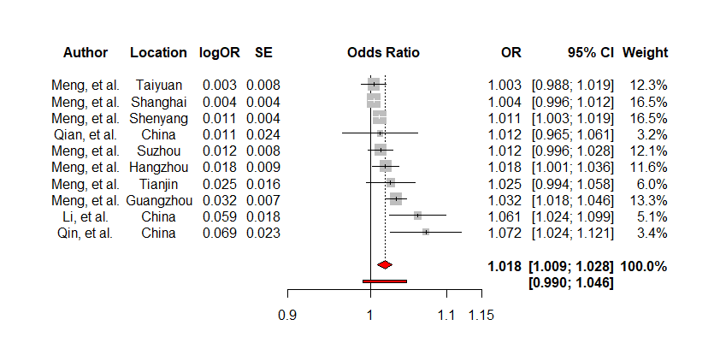

**Figure 1b: A forest plot showing the effect of PM10 (per 10µg/m3) when modified by high temperatures on respiratory mortality after the exclusion of outliers using the DL estimator.**

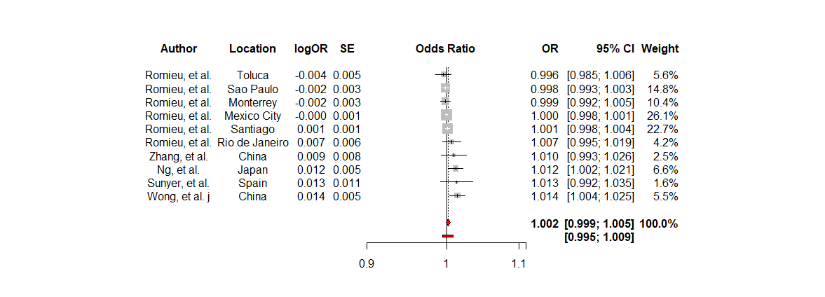

**Figure 1c: A forest plot showing the effect of O3 (per 10µg/m3) when modified by the cold season on respiratory mortality after the exclusion of outliers using the DL estimator.**

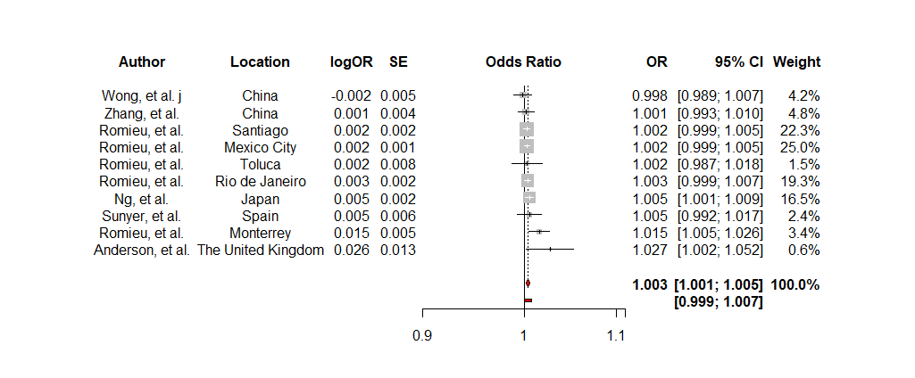

**Figure 1d: A forest plot showing the effect of O3 (per 10µg/m3) when modified by the warm season on respiratory mortality after the exclusion of outliers using the DL estimator.**

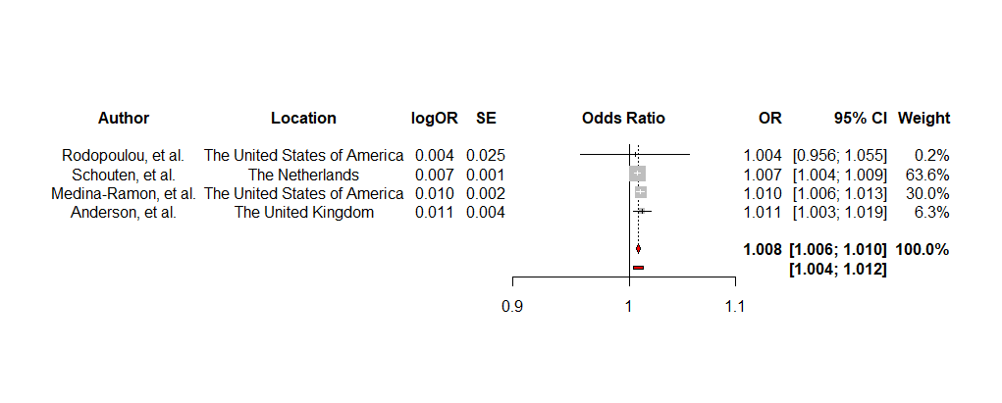

**Figure 1e: A forest plot showing the effect of O3 (per 10µg/m3) when modified by the warm season on RHA after the exclusion of outliers using the DL estimator**