# Single-cell profiling reveals dendritic cell signatures associated with autoimmune inflammation

Michelle P. Ashton1,2, Anne Eugster1, Sevina Dietz1, Doreen Loebel1, Annett Lindner1, Denise Kuehn1, Anna E. Taranko3, Babett Heschel4, Anita Gavrisan5, Anette-Gabriele Ziegler5,6,7, Martin Aringer4, Ezio Bonifacio1,2,5,7

1DFG-Center for Regenerative Therapies Dresden, Faculty of Medicine Carl Gustav Carus, TU Dresden, Germany

2Paul Langerhans Institute Dresden of the Helmholtz Centre Munich at the Faculty of Medicine Carl Gustav Carus, TU Dresden, Dresden, Germany

3Institute of Nutritional Science, University of Potsdam, Potsdam, Germany

4Department of Medicine III, Division of Rheumatology, University Medical Center and Faculty of Medicine Carl Gustav Carus, TU Dresden, Dresden, Germany

5Forschergruppe Diabetes e.V., Neuherberg, Germany

6Institute of Diabetes Research, Helmholtz Zentrum München, Neuherberg, Germany

7German Center for Diabetes Research (DZD), Neuherberg, Germany

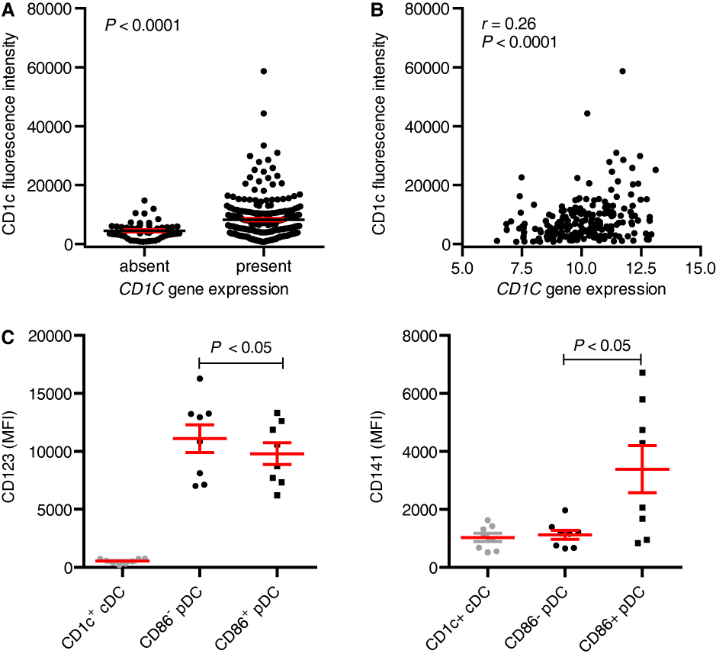

**Figure S1. Protein expression profiles of DC sub-populations.** CD1C protein expression was determined as the fluorescence intensity recorded during index sorting for 285 CD1c+ cDCs isolated from eight healthy adults where index sorting was available (Data not collected for one adult in HCAdult cohort). Each dot represents a single cell. (A) Stratification of data based on the presence/absence of *CD1C* transcripts. The bars and lines indicate the mean and SEM, respectively. Significance was determined using the Mann–Whitney *U* test. (B) Correlation between protein expression (fluorescence intensity) and gene expression in cells with detectable *CD1C* gene expression. Spearman’s *r* and the two-tailed *P* value are shown. (C) CD123 (left) and CD141 (right) protein expression levels of CD1c+ cDCs and pDCs from eight healthy adults recorded during index sorting (Data not collected from one adult in HCAdult cohort). pDCs are segregated based on the presence/absence of *CD86* transcripts. Each dot represents the MFI of single cells analyzed from one individual. The bars and lines indicate the mean and SEM, respectively. \**P* < 0.05 (two-tailed paired *t* test).

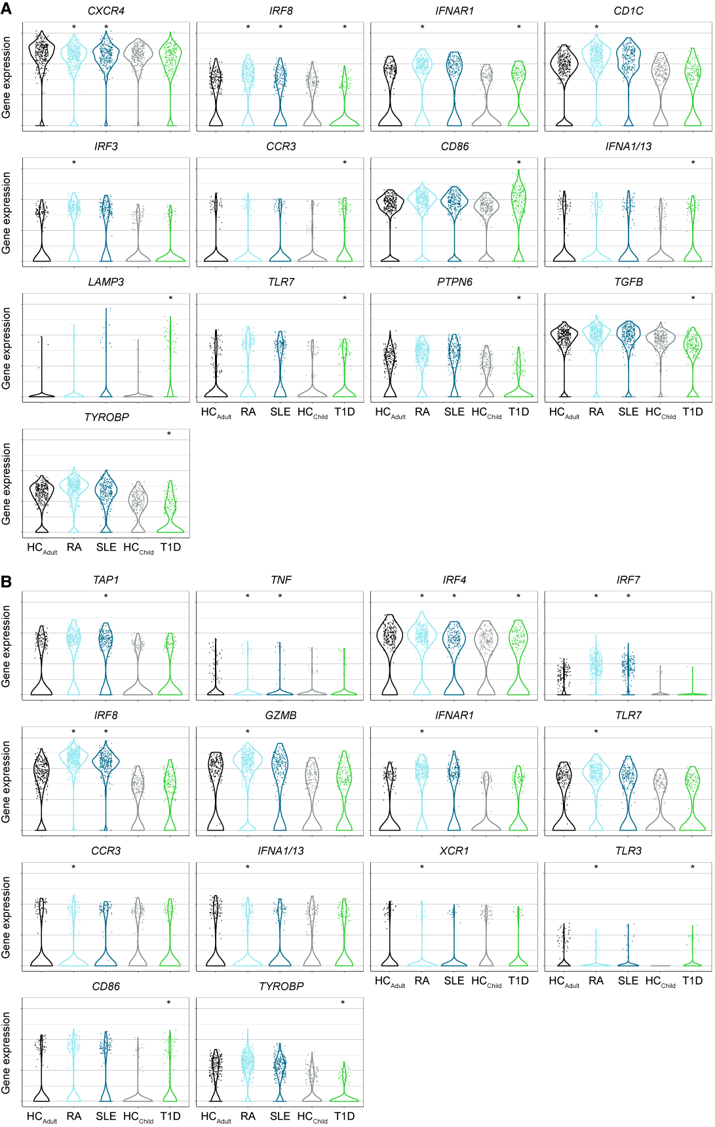

**Figure S2. Single-cell gene expression levels of DC subsets.** CD1c+ cDCs (A) and pDCs (B) were single-cell-sorted from freshly isolated PBMCs from healthy adults (HCAdult); patients with RA, SLE, or recent-onset T1D; and a second healthy cohort that was age-matched to the T1D cohort (HCChild). The cells were subjected to single-cell gene expression analysis. Each dot represents an individual cell. Only genes with a significant difference in expression between at least one disease cohort and the corresponding age-matched healthy cohort are shown based on Hurdle analysis with FDR correction and a significance threshold of 0.001 (indicated by an asterix).

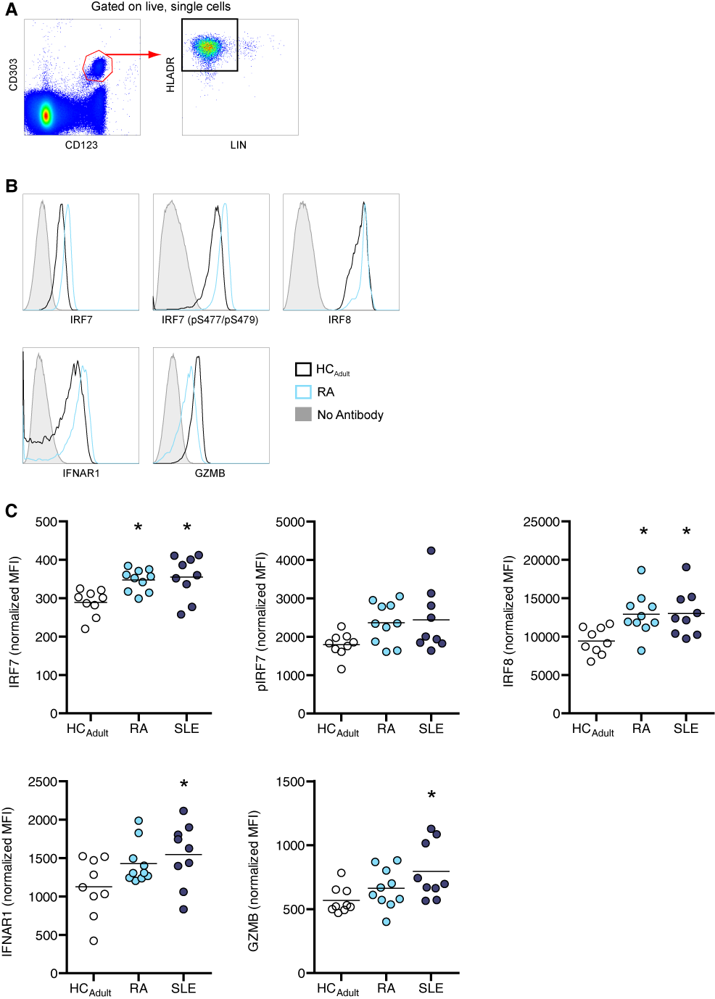

**Figure S3. Protein expression analysis of pDCs from patients with RA and SLE, and healthy adults.** The expression levels of IRF7, phosphorylated IRF7, IRF8, IFNAR1 and GZMB were determined by intracellular flow cytometric analysis. (A) pDCs were identified as CD123+CD303+HLADR+LIN−. (B) Representative histograms from a RA patient and a healthy adult. (C) Normalized MFI values for the panel of markers. Each dot represents an individual subject and the line represents the mean. \**P <* 0.05 (one-way ANOVA)

### Table S1. Genes and primers used for single-cell gene expression analyses

|  |  |  |
| --- | --- | --- |
| **Gene** | **5’ primer** | **3’ primer** |
| *CCR3* | TGTCTCGTTCTCCCTCTGCT | AGCCACATTGTAGGGTGTCC |
| *CD1C* | TTCTTCTCCCAGGTGGTGAC | AGTTGCCCTTGGACCAGTTA |
| *CD40* | GCTTGTCCAAGGGTGACATT | GTGAGAGCTGTGTCCTGCAC |
| *CD86* | TTCCCTGATGTTACGAGCAA | GAGGCCGCTTCTTCTTCTTC |
| *CXCR4* | GGTGGTCTATGTTGGCGTCT | TGCAATAGCAGGACAGGATG |
| *FCGR1* | ACAGCCACTCAGACCTCGAC | TTATCCTTCCACGCATGACA |
| *FCGR3* | CGGTGCAGCTAGAAGTCCAT | CAGAAGTAGGAGCCGCTGTC |
| *GNAS* | CTGCTCGCTGAGAAAGTCCT | AGCAGTAGTGACGCCCATCT |
| *GZMB* | GCTGCAGTAGCATGATGTCG | GGTGGCTTCCTGATACGAGA |
| *GZMB* | GCTGCAGTAGCATGATGTCG* | ACTGTTGGGGAAGCTCCATA* |
| *IDO1* | TCACAGACCACAAGTCACAGC | TCCAGTTTGCCAAGACACAG |
| *IFNA1/13* | TAGACAAATTCTGCACCGAAC | GGGATCTCATGATTTCTGCTCT |
| *IFNAR1* | TGAGTCTGTCGGGAATGTGA | TGCGAAATGGTGTAAATGAGTC |
| *IRF3* | GTTCTGTGTGGGGGAGTCAT | CCTTGTACTGGTCGGAGGTG |
| *IRF4* | GAGCCAAGCATAAGGTCTGC | TCTGGGTAGGGGAACAGGA |
| *IRF7* | AGGCAGAGCCGTACCTGTC | CTACCTGCTGGGGGTCTGT |
| *IRF8* | ACGAGGTTACGCTGTGCTTT | TGATCAGCTCGTCGATTTCA |
| *LAMP3* | TCAGCCATCGTCAGTCAAGA | ATTTTCGGGTGCCACAGTT |
| *Ly75* | TGAATGTGAACATGGTTTTGG | TCCTTGTGCATATCGAACTGA |
| *NRP1* | ACCAACCCCACAGATGTTGT | AGTTTCTGTCCCCTTGGTTG |
| *PTPN6* | GAACTGCTCCGATCCCACTA | CATGACCTTGATGTGGGTGA |
| *STAT3* | GCTTTTGTCAGCGATGGAGT | GCTGCAACTCCTCCAGTTTC |
| *TAP1* | CGCCTCACTGACTGGATTCT | TGGAAAAACTCCGTCTCCTG |
| *TGFB* | CACAACTCCGGTGACATCAAA | TACCTGAACCCGTGTTGCT |
| *TGFB* | CAACTCCGGTGACATCAAAA* | TACCTGAACCCGTGTTGCTT* |
| *TLR3* | AGGCGGGTGTTTTTGAACTA | CGCAAACAGAGTGCATGGT |
| *TLR7* | AACCATGTGATCGTGGACTG | TTGACCCCAGTGGAATAGGT |
| *TLR9* | AACTGCAGCACCCTCAACTT | TCGTGGTAGAGGTCCAGCTT |
| *TNF* | TGAGGTACAGGCCCTCTGAT | CCCCAGGGACCTCTCTCTAA |
| *TNF* | TGAGGTACAGGCCCTCTGAT* | CCCGAGTGACAAGCCTGTAG* |
| *TYROBP* | ATTGCAGTTGCTCTACGGTGA | CTGATAAGGCGACTCGGTCT |
| *XCR1* | CCATCTTCCACAAGGTGCTT | ATGGCGAAGATGAGCTTGAC |

*Alternative primer pairs used for qPCR.