**Title:** The supply of multiple ecosystem services requires biodiversity across spatial scales

**Current author list (not definitive):**

Gaëtane Le Provost1,*<https://orcid.org/0000-0002-1643-6023>, Noëlle V. Schenk2<https://orcid.org/0000-0003-3240-1135>, Caterina Penone2<https://orcid.org/0000-0002-8170-6659>, Jan Thiele3<https://orcid.org/0000-0002-5649-6397>, Catrin Westphal4<https://orcid.org/0000-0002-2615-1339>, Eric Allan2<https://orcid.org/0000-0001-9641-9436>, Manfred Ayasse5, Julia Binkenstein6, Nico Blüthgen7, Runa S. Boeddinghaus8,9<https://orcid.org/0000-0002-9946-23222>, Andrea Larissa Boesing1<https://orcid.org/0000-0002-7467-4281>, Ralph Bolliger2<https://orcid.org/0000-0001-5383-9713>, Verena Busch10, Markus Fischer1,4, Kevin Frank11, Martin Gossner12<https://orcid.org/0000-0003-1516-6364>, Norbert Hoelzel13<http://orcid.org/0000-0002-6367-3400>, Kirsten Jung5<https://orcid.org/0000-0002-9449-2215>, Ellen Kandeler14<https://orcid.org/0000-0002-2854-0012>, Valentin H. Klaus15<https://orcid.org/0000-0002-7469-6800>, Till Kleinebecker10<https://orcid.org/0000-0003-1121-2861>, Theresa Klötzing16, Sophia Leimer17<https://orcid.org/0000-0001-6272-204X>, Sven Marhan8<https://orcid.org/0000-0002-8954-5968>, Kathryn Morris18<https://orcid.org/0000-0003-3548-444X>, Sandra Müller19<https://orcid.org/0000-0003-4289-755X>, Felix Neff12, Margot Neyret1<https://orcid.org/0000-0001-9435-1634>, Yvonne Oelmann20<https://orcid.org/0000-0003-3513-6568>, David Perović21<https://orcid.org/0000-0002-7301-5591>, Daniel Prati2, Matthias C.Rillig22,23<https://orcid.org/0000-0003-3541-7853>, Hugo Saiz2,24, Deborah Schäfer2, Martin Schäfer19, Michael Scherer-Lorenzen19<https://orcid.org/0000-0001-9566-590X>, Michael Schloter25,26[https://orcid.org/ 0000-0003-1671-1125](https://orcid.org/%200000-0003-1671-1125), Ingo Schöning27[https://orcid.org/ 0000-0003-1671-1125](https://orcid.org/%200000-0003-1671-1125), Marion Schrumpf27, Juliane Steckel28, Ingolf Steffan-Dewenter29, Barbara Stempfhuber30, Susan Trumbore31, Marco Tschapka5, Juliane Vogt32, Christiane Weiner7, Wolfgang Weisser33, Konstans Wells34<https://orcid.org/0000-0003-0377-2463>, Michael Werner29, Wolfgang Wilcke35<https://orcid.org/0000-0002-6031-4613>, Peter Manning1<https://orcid.org/0000-0002-7940-2023>

1Senckenberg Biodiversity and Climate Research Centre (SBIK-F), Senckenberg Gesellschaft für Naturforschung, Senckenberganlage 25, 60325 Frankfurt, Germany.

2Institute of Plant Sciences, University of Bern, Altenbergrain 21, 3013 Bern, Switzerland.

3Thünen Institute of Biodiversity, Bundesallee 65, 38116 Braunschweig, Germany.

4Functional Agrobiodiversity, Department of Crop Sciences, University of Göttingen, Göttingen, Germany.

5Institute of Evolutionary Ecology and Conservations Genomics, University of Ulm, Albert-Einstein-Allee 11, 89081 Ulm, Germany.

6 XXX

7Ecological Networks, Biology, Technische Universität Darmstadt, Schnittspahnstr. 3, 64287 Darmstadt, Germany.

8Institute of Soil Science and Land Evalution, Department of Soil Biology, University of Hohenheim, Emil-Wolff-Str. 27, 70599 Stuttgart, Germany.

9Center for Agricultural Technology Augustenberg (LTZ), Section Agroecology, Neßlerstr. 25, 76227 Karlsruhe, Germany.

10Department of Landscape Ecology and Resources Management, Justus Liebig University Giessen, Heinrich-Buff-Ring 26-32, 35392 Gießen, Germany.

11 XXX

12Forest Entomology, WSL Swiss Federal Research Institute, Zürcherstrasse 111, CH-8903 Birmensdorf, Switzerland.

13Institute of Landscape Ecology, University of Münster, Heisenbergstr. 2, 48149 Münster, Germany.

14Institute of Soil Science and Land Evaluation, University of Hohenheim, Stuttgart, Germany.

15Institute of Agricultural Sciences, ETH Zürich, Universitätstr. 2, 8092 Zürich, Switzerland.

16 XXX

17Research Data Services, University Library, University of Duisburg-Essen, Lotharstr. 65, 47057 Duisburg, Germany.

18Department of Biology, Xavier University, 3800 Victory Parkway, Cincinnati, OH, 45207, USA.

19University of Freiburg, Faculty of Biology, Geobotany, Schaenzlestr. 1, D-79104 Freiburg, Germany.

20Geoecology, University of Tübingen, Rümelinstr. 19-23, 72070 Tübingen, Germany.

21DPI Agriculture, NSW Department of Primary Industries, Australian Cotton Research Institute, Narrabri, NSW 2390, Australia.

22Institut für Biologie, Plant Ecology, Freie Universität Berlin, Berlin, D-14195 Germany.

23Berlin-Brandenburg Institute of Advanced Biodiversity Research (BBIB), Berlin, D-14195 Germany.

24Department of Agricultural and Environmental Sciences, Technical School, University of Zaragoza, Ctra de Cuarte s/n, 22071, Huesca, Spain.

25Helmholtz Munich; Research Unit for Comparative Microbiome Analysis, Ingolstaedter Landstr. 1; 85758 Oberschleissheim, Germany.

26Technical University of Munich; Chair for Soil Science; Emil-Ramann-Straße 2, 85354 Freising, Germany.

27Max-Planck Institute for Biogeochemistry, Hans-Knoell-Str. 10, 07745 Jena, Germany.

28 XXX

29Department of Animal Ecology and Tropical Biology, Biocenter, University of Würzburg, Am Hubland, D-97074 Würzburg, Germany.

30 XXX

31 XXX

32Natura 2000-Station Unstrut-Hainich/Eichsfeld, Dorfstraße 77A, 99820 Hörselberg-Hainich, Germany.

33Terrestrial Ecology Research Group, Department of Ecology and Ecosystem Management, Technical University of Munich, Freising, Germany.

34Department of Biosciences, Swansea University, Swansea SA28PP, United Kingdom.

35Institute of Geography and Geoecology, Karlsruhe Institute of Technology (KIT), Reinhard-Baumeister-Platz 1, 76131 Karlsruhe, Germany.

**\*corresponding author**: [gaetane.le-provost@senckenberg.de](mailto:gaetane.le-provost@senckenberg.de)

ABSTRACT

The impact of local biodiversity loss on ecosystem functioning is well-established but the role of spatial biodiversity dynamics in the delivery of ecosystem services remains poorly understood. We address this gap using a comprehensive dataset describing the supply of 16 cultural, regulating and provisioning ecosystem services in 150 agricultural grasslands and detailed multi-scale data on land use and plant diversity. We showed that both the plot-level and the surrounding plant diversity played an important role in the local supply of cultural and aboveground regulating ecosystem services. In contrast, provisioning and belowground regulating ecosystem services were more strongly driven by field management and abiotic factors. Structural equation models revealed that the surrounding plant diversity promoted ecosystem services both directly, likely by fostering the spill-over of ecosystem service providers from surrounding areas, and indirectly, by maintaining plot-level diversity. These results provide a comprehensive picture of which ecosystem services rely most strongly on biodiversity, and the respective scales of biodiversity that drives these services. This key information is required for the upscaling of biodiversity-ecosystem service relationships, and the informed management of biodiversity within agricultural landscapes.

INTRODUCTION

Global threats to biodiversity have motivated much research into the relationship between biodiversity and ecosystem functioning1–3. This work has provided substantial evidence that plot-level (typically <1000m²) biodiversity can affect multiple ecosystem functions and services, in both experimental communities2,4 and in natural ecosystems5–12. However, most of these studies have mainly focused on the effects of biodiversity on ecosystem processes at these relatively small spatial scales, rather than on the impact of larger scale biodiversity on ecosystem services13–15. This gap is significant as biodiversity change occurs at all spatial scales, and sometimes in contrasting directions, e.g. local enrichment but homogenization and loss at larger spatial scales16,17. The lack of a mechanistic understanding of how biodiversity at larger spatial scales affects the delivery of multiple ecosystem services precludes the upscaling of biodiversity-ecosystem service relationships to the large spatial scales relevant to policy and management14,15.

Considering the multiscale nature of biodiversity is essential to understand how biodiversity underpins ecosystem services14,15. At the plot level, higher plant species richness (i.e. α-diversity) enhances ecosystem functioning due to complementarity between co-occurring species1,18 and because diverse plant communities are more likely to contain species that strongly affect ecosystem functioning (i.e. the selection effect19,20; Fig. 1, arrow 1).

However, in real-world ecosystems, plant diversity at larger scales could also influence local ecosystem functioning7,10,15, as can the associated diversity of other taxa21. Heterogeneity in species identities and abundances between local communities (i.e. β-diversity) can affect local ecosystem services directly, e.g. by fostering the spill-over of mobile ecosystem service providers such as birds and pollinators, which require heterogenous habitats22, and also indirectly as functionally distinct communities can maintain α-diversity in a changing environment20,23,24 and buffer local biodiversity loss against environmental changes25 (Fig. 1, arrows 2 and 3). Similarly, the diversity of the overall species pool (i.e. γ-diversity) can affect ecosystem services by encouraging a diverse pool of associated ecosystem service providers that spill over to provide services26,27, and indirectly by maintaining local plant diversity through dispersal processes. Based on these mechanisms we predict that ecosystem services provided by highly mobile animal species, such as birds or insects, will be most strongly influenced by the direct pathways described above28–30, while services provided by less mobile species (e.g. the regulating services of plants) are more affected by local biodiversity, which would be maintained by a diverse surrounding species pool (Fig. 1, arrows 1 & 3).

Within agricultural landscapes, which cover a large proportion of the Earth’s surface31, biodiversity effects on ecosystem services operate within the context of land-use factors, which influence ecosystem services directly and indirectly by affecting biodiversity15,32. Therefore, to understand the role of biodiversity in the supply of agroecosystem services, the relative importance of these many pathways and influences should be determined. At the field level, intensive land use typically promotes a small set of provisioning services directly (e.g. fertilization and pesticide use that promote biomass production; Fig. 1, arrow 4) but causes changes to biodiversity and functional composition that indirectly impact other ecosystem services2,5 (Fig. 1, arrows 5 and 6). Land-use effects at local scales can also operate via long time lags, such as lasting effects of tillage on soil biodiversity and structure33,34. At the landscape level, the conversion of natural or semi-natural habitats such as forests or grasslands into cropland can have both immediate and legacy effects on biodiversity33,35 and ecological processes36. For example, the presence and the permanency of semi-natural habitats in the surrounding landscape can significantly affect local ecosystem service provision directly, via cross-habitat exchanges of material and energy37,38 (Fig. 1, arrow 7), and indirectly, by influencing the dispersal and colonization of plant species within local patches22,33,39,40 (Fig. 1, arrows 8 and 9). In addition, the landscape context might determine local land-use decisions due to physical constraints (e.g. via farmer decisions to specialize or diversify in land use, Fig. 1, arrow 10) and therefore indirectly affect ecosystem services22,41. While there has been a substantial effort to identify how landscape-level factors in agroecosystems affect biodiversity and ecosystem services22,42, these studies tend to focus on a small number of regulating ecosystem services provided by aboveground species, such as pollination and pest control22,43,44. How spatial processes influence a broader set of ecosystem services, particularly cultural services and belowground regulating ecosystem services, is far less understood.

In this study, we addressed the gaps highlighted above by investigating how plant diversity and land-use factors at different spatial scales affect a wide range of ecosystem services, including understudied services such as cultural ecosystem services. We did this by using a comprehensive dataset from the German Biodiversity Exploratories project45 on ecosystem service indicators for the local supply of cultural, regulating, and provisioning ecosystem services in 150 agricultural grasslands, and detailed multi-scale data on land-use and plant diversity. Because plant species richness is known to be closely correlated with the whole ecosystem biodiversity in these grasslands26, it was considered as a proxy for the diversity of multiple taxa (hereafter defined as ‘plant diversity’). Similarly, plant β-diversity was considered as a proxy of habitat heterogeneity15. These measures were taken in agricultural grassland fields that vary strongly in their plot-level land-use intensity46,47, and which were situated in landscapes of varying complexity48 and management history (see Methods). We measured indicators of 16 ecosystem services classified into four types: (i) cultural ecosystem services: acoustic diversity, bird watching potential and total flower cover; (ii) aboveground regulating ecosystem services: pollination, natural enemy abundance, lack of pathogen infection, lack of herbivory, dung decomposition; (iii) aboveground provisioning ecosystem services: shoot biomass and forage quality; (iv) belowground regulating ecosystem services: soil aggregation, phosphorus retention index, nitrogen retention index, soil carbon stocks, potential nitrification, groundwater recharge (Table S1). The capacity of ecosystem to provide these bundles of services was captured using separate multifunctionality metrics49 calculated for cultural, aboveground regulating, aboveground provisioning and belowground regulating ecosystem services. We then used structural equation models (SEM) that specified the pathways of influence described above to test the direct and indirect effects of different factors on the local supply of grassland ecosystem services: environmental factors, plant diversity and land-use components encompassing plot-level (here defined as 50 m × 50 m) factors, field-level (here defined as a 75-m radius, a scale selected to coincide with the dispersal kernel of most plant species49) factors describing the plot surroundings, and landscape-level (here defined within a 1000-m radius) factors. We interpret these associations as evidence of biodiversity and land-use effects, and for simplicity we use terms such as ‘effects’ and ‘drivers’ hereafter. While we acknowledge the correlational and static nature of our study, we believe our interpretation is supported by existing knowledge and the nature of our study design, which minimizes confounding factors (Fig. 1).

RESULTS AND DISCUSSION

The supply of many ecosystem services was strongly affected by the surrounding plant diversity and landscape factors, and these effects were of equal importance to plot-level plant diversity and field-level land use (Fig. 2). This suggests that spatial biodiversity dynamics are a major driver of local ecosystem service supply. Although plant diversity showed many positive effects, the strength and direction of these effects varied between the four studied ecosystem service types (Fig. 3, see also Figs. S1 and S2). Both plot- and field-level plant diversity played a positive and important role in the supply of cultural and aboveground regulating ecosystem services. In contrast, provisioning and belowground regulating ecosystem services were more strongly driven by field-level land use and environmental factors (Fig. 3). Below, we detail which ecosystem services were most reliant on biodiversity, and the scale of biodiversity that drives these services.

*Cultural ecosystem services*

Cultural ecosystem services were promoted by independent effects of both plot-level and field-level plant diversity (Figs. 3 and S2), meaning that as hypothesized cultural ecosystem services, including acoustic diversity, aesthetic value (i.e. high flower cover) and birdwatching potential, were higher in diverse grasslands surrounded by diverse plant communities. Plot-level plant diversity accounted for 12.2% ± 4.6 s.e.m (average ± standard error of the mean total effect sizes across the associated ecosystem services) of the total effects for cultural ecosystem services (Fig. 2), with a total standardized effect of plant α-diversity = 0.06 on cultural ecosystem service multifunctionality index (Fig. 3, Table S2). Field-level plant diversity accounted for 30.3% ± 7.0 s.e.m of the total effects (Fig. 2), with a total standardized effect of plant γ-diversity = 0.33 (Fig. 3). Cultural ecosystem services were less strongly affected by field-level land use (25.9% ± 2.0 s.e.m, Fig. 2), where land-use intensity negatively affected cultural ecosystem services (total standardized effect of land-use intensity = -0.17, Fig. 3). For these ecosystem services, the effects of the surrounding biodiversity were as strong as the effect of field-level land use (Fig. 2). These results support our hypotheses and suggest that preserving a large heterogeneity of ecosystems that supports a large species pool in agricultural landscapes could offset the negative effects of land-use practices on cultural and aboveground regulating ecosystem services. In addition, field land-use history affected cultural ecosystem services, with a positive effect of field-level grassland permanency (i.e. the number of times the field was recorded as being grassland in ¾ survey dates over 200 years) on cultural ecosystem services (total standardized effect = 0.17). Habitat stability at the field level can enhance the abundance and the diversity of cultural ecosystem-service providers, such as birds33, at the local scales (Fig. S1). However, these organisms often need diverse habitats to meet their nesting and feeding requirements50–52, potentially explaining the negative relationship with a high cover of permanent grasslands at the landscape level (total standardized effect of historical grassland cover = -0.15, Fig. 3). This hypothesis is supported by the net positive effect of land-cover diversity within the landscape on cultural ecosystem services (total standardized effect of land-cover diversity = 0.09, Fig. 3) and particularly on the individual service of bird watching potential (total standardized effect of land-cover diversity = 0.18, Fig. S1).

*Aboveground regulating ecosystem services*

Similar to cultural ecosystem services, aboveground regulating ecosystem services were positively affected by plant diversity at both plot- and field-level, with positive effects of α- and γ-diversity (total standardized effects of plant α-diversity = 0.23, and of plant γ-diversity = 0.02, Fig. 3). This was particularly true for pollination and natural enemy abundance (Fig. S1). Considering multifunctionality indices calculated as the percentage of measured services that exceeded 75% of their maximum observed level across all study plots instead of 50%, the strength of positive effects of the plant γ-diversity increased (Fig. S3). High levels of regulating ecosystem services were therefore strongly associated with high levels of surrounding biodiversity. Alongside the effects of plant diversity, aboveground regulating ecosystem services were strongly influenced by both field-level (accounting for 20.1% ± 2.8 s.e.m of the total effects) and landscape-level land use (accounting for 26.4% ± 1.7 s.e.m of the total effects, Fig. 2). Field-level land-use intensity reduced the local supply of aboveground regulating ecosystem services (total standardized effect = -0.04, Fig. 3). The effect of landscape-level land use was largely due to a positive effect of historical grassland cover on aboveground regulating ecosystem services (total standardized effects = 0.10, Fig. 3). The stability of favorable and resource-rich habitats at the landscape level can thus strongly benefit the mobile organisms that provide aboveground regulating services33,53,54, such as pollinators (Fig. S1).

*Aboveground provisioning ecosystem services*

Unlike cultural and aboveground regulating ecosystem services, aboveground provisioning ecosystem services were primarily driven by field-level land use (accounting for 32.9% ± 1.0 s.e.m of the total effects, Fig. 2), in that land-use intensity strongly and positively increases aboveground provisioning services (total standardized effect = 0.49), including fodder production (Fig. S1). Landscape-level land use played little role in driving this class of services, and only accounted for 13.6% ± 3.0 s.e.m of the total effects (Fig. 2). We also found a negative effect of plot-level plant diversity (total standardized effect of the plant α-diversity = -0.29) and of the surrounding field-level plant diversity on these services (total standardized effects of plant β-diversity = -0.05, plant γ-diversity = -0.08, Fig. 3). These effects are likely related to high fodder production and quality in fertilized ecosystems55 and the shifts towards higher plant tissue quality that are associated with fertilization-induced plant functional composition changes and diversity loss32.

To explore the hypothesis that it was not diversity *per se* but associated functional composition changes that drive these effects, we substituted plant α-diversity with a community abundance-weighted measure (CWM) of plant specific leaf area (SLA) in the structural equation models, as these properties are strongly negatively correlated (*r* = -0.48) and SLA indicates plant tissue turnover and decomposability26,56–58. While models containing plot-level plant diversity were always selected as the best fitting ones this analysis partially confirmed that a shift towards fast-growing species (i.e. a higher plant community SLA) was positively related to aboveground provisioning ecosystem services: in the alternate model the effects of SLA were positive (total standardized effect = 0.17, Fig. S4), and land-use intensity indirectly increased provisioning ecosystem services via changes to SLA (effect of plot-level land-use intensity on CWM SLA = 0.33, Fig. S4 and Table S2).

*Belowground regulating ecosystem services*

Belowground regulating ecosystem services, such as those related to carbon storage and nutrient cycling, were most strongly driven by environmental factors (Fig. 2). Belowground regulating ecosystem services were positively related to topographic wetness (total standardized effect of topographic wetness index = 0.20) and soil pH (total standardized effect = 0.08, Fig. 3). This most likely relates to tighter cycling of nutrients and higher topsoil carbon stocks in moist and pH-neutral soils (Fig. S1). We also found a strong positive effect of field-level grassland permanency on belowground regulating ecosystem services (total standardized effect = 0.23, Fig. 3), reflecting that soil processes were faster, nutrient cycling tighter and carbon stocks higher in fields that have not been ploughed and stayed as grasslands for a long time (Fig. S1). This is likely due to the slow development of soil communities34, and accumulation of soil carbon, after local tillage has stopped59. These habitat stability measures may also include the positive effects of soil biodiversity on soil processes60,61 as more diverse soil communities develop following the cessation of agricultural practices such as tillage33. Such effects of soil biodiversity are unlikely to be captured by our plant diversity measures as belowground diversity is weakly associated with aboveground biodiversity in our system5.

*Direct and indirect effects of field-level plant diversity on ecosystem services*

We assessed whether the effects of the field-level plant diversity on ecosystem services operate directly, by fostering the spill-over effects of mobile organisms, or indirectly, by maintaining plot-level plant diversity. This was achieved by focusing a subset of our SEMs, specifically direct paths from plant γ-diversity and β-diversity to ecosystem services, and indirect paths of plant γ-diversity and β-diversity through changing plant α-diversity (Fig. 4, see also Fig. S5). These analyses revealed that plant γ-diversity had both direct and indirect positive effects on cultural ecosystem services and aboveground regulating ecosystem services (Fig. 4b). However, the mechanisms involved in these relationships varied between these ecosystem services. As hypothesized, cultural ecosystem services relying on highly mobile animal species were mainly affected by positive direct effects of both plant γ-diversity and β-diversity (Fig. 4b), indicating that a higher plant diversity in the surroundings and high habitat heterogeneity fosters the spill-over of cultural ecosystem providers. By contrast, aboveground regulating ecosystem services were mostly affected by an indirect positive effect of plant γ-diversity (Fig. 4b), which indicate that the surrounding field-plant diversity enhances these services by maintaining plot-level plant diversity. A larger species pool is therefore essential to maintain high levels of cultural and regulating ecosystem services over time20. In contrast, for aboveground provisioning ecosystem services the surrounding field-plant diversity had negative effects, operating via both direct and indirect pathways (Fig. 4b). These effects are likely due to land-use practices and associated changes in plant community composition that boost these ecosystem services. An exception to this trend was that plant γ-diversity had a strong direct and positive effect on aboveground provisioning services (Fig. 4b), mostly driven by its positive effect on forage quality (Fig. S1). While the underlying mechanism is difficult to discern in this case, higher biodiversity in the surroundings can secure a sustainable supply of provisioning ecosystem services such as forage quality, e.g. via dilution effects on pathogen spread62.

*Wider implications*

By decomposing the direct and indirect effects of the surrounding biodiversity on local ecosystem service supply, we revealed that a wider species pool (i.e. plant γ-diversity) promotes many ecosystem service, and via different mechanisms, i.e. likely by fostering the spill-over of ecosystem service providers, and by maintaining plot-level biodiversity (Fig. 4). This was particularly true for cultural and aboveground regulating ecosystem services (Fig. 2). Loss of diversity within the overall species pool may therefore damage cultural and aboveground regulating ecosystem services as strongly as, or even more strongly than, local species losses (i.e. loss in plant α-diversity)25.

Focusing on local diversity when investigating the relationships between biodiversity and ecosystem services is not sufficient to capture the consequences of the many scales of biodiversity change on ecosystem functioning15,20,63. Many theoretical studies have highlighted the potential importance of β- and γ-diversity for ecosystem service delivery (e.g. 15,25,64), but to date very little empirical evidence has been provided (but see 12). By showing that the supply of many ecosystem services relies on the surrounding plant diversity, our results support the idea that managing the surrounding biodiversity is essential to secure ecosystem service provision. More specifically, the finding that the surrounding biodiversity boosts services via the maintenance of plot-level biodiversity is also consistent with the spatial insurance hypothesis25. However, a full understanding of how spatial biodiversity dynamics drive ecosystem service delivery is lacking63. Many further studies are required before the functional and societal consequences of biodiversity changes at multiple spatial scales are fully understood.

While we observe generally positive effects of plant diversity on ecosystem services, the different types of ecosystem services were not affected by biodiversity the same way (Fig. 3). For example, cultural and aboveground regulating ecosystem services are strongly and positively impacted by plot- and field-level plant diversity, while aboveground provisioning ecosystem services tended to show a negative association (Fig. 3). Our analyses indicate that these negative plant diversity effects are driven by an associated shift in the functional composition of plant communities towards fast-growing species that can boost ecosystem productivity32,56.

Together, our results further emphasize the strong trade-offs between the different ecosystem services provided by agroecosystems65–67, and indicate that management strategies focusing on the delivery of few aboveground provisioning ecosystem services may be detrimental to regulating ecosystem services, as they are driven in opposing directions by the same drivers7. Despite further evidence for trade-offs between ecosystem services, our results also indicate that such trade-offs may be weakened by conserving both high and low intensity patches within agricultural landscapes, as low intensity areas promoted multiple services when present in the immediate landscape. This is not guaranteed, however, as the converse relationship is also observed: the nearby presence of intensely managed low diversity areas reduces biodiversity and associated ecosystem services within the low intensity parts of the landscape35. It therefore remains to be seen if a spatially interwoven mosaic of permanent and biodiverse habitats and intensive patches (i.e. ‘land-sparing’ strategy68) is the best means of preserving landscape multifunctionality, i.e. landscapes that simultaneously provide high levels of multiple ecosystem services69.

Alongside the effects of biodiversity, cultural and belowground regulating ecosystem services were higher in grassland fields that were not converted regularly (i.e. a high field-level grassland permanency). We also found that aboveground regulating ecosystem services were positively impacted by the presence and the permanency of grasslands at the landscape-level (Fig. 3). There is now substantial evidence that permanent grasslands are important in maintaining the biodiversity of ecosystem service providers in agricultural landscapes22,33,35,70. However, these studies focused almost exclusively on a small number of aboveground regulating services, such as pollination or pest control39,43,71. By considering multiple ecosystem services, our results indicate that reducing grassland field conversion, coupled with the strategic arrangement of permanent grasslands within agricultural landscapes can not only help to maintain a biodiverse species pool but can also enhance the supply of above- and belowground ecosystem services that are essential to sustainability.

To date, biodiversity-ecosystem functioning research has concentrated on the impact of biodiversity loss at small spatial scales on ecosystem functions, rather than on the impact of large-scale biodiversity change on ecosystem services13,14,63. However, it is at larger spatial scales that most management and policy decisions affecting biodiversity and ecosystem functioning are taken. In addition, at these scales, there are often multiple ecosystem stakeholders with competing demands, such as a priority for cultural or provisioning services72,73, and landscape multifunctionality is therefore often desired at the society level69. While studies have investigated the correlation between biodiversity and landscape multifunctionality74,75, a mechanistic understanding of how spatial biodiversity dynamics affect the landscape-level supply of ecosystem services is largely missing14,76,77. Our study goes beyond these correlative studies and suggests that using spatially explicit and mechanistic approaches is essential to understand the link between biodiversity and services, and the management of landscapes to ensure the needs of multiple stakeholder groups are met78,79.

*Conclusion*

By employing a comprehensive study setup and using structural equation models, our results revealed that the supply of multiple ecosystem services requires biodiversity across spatial scales, and that the surrounding biodiversity promotes local ecosystem services through a range of mechanisms. Future assessment of ecosystem service delivery must therefore consider spatial biodiversity dynamics, e.g. when mapping ecosystem services75, to accurately assess the status and drivers of ecosystem services, and to evaluate the consequences of biodiversity change on ecosystem services. Another key message of this work is that the local-level supply of many important ecosystem services is enhanced in landscapes containing biodiverse and permanent grasslands. Preserving large species pool within permanent habitats in agricultural landscapes can promote a wider range of the vital ecosystem benefits, especially the cultural and aboveground regulating ecosystem services, upon which many rural people ultimately depend80.

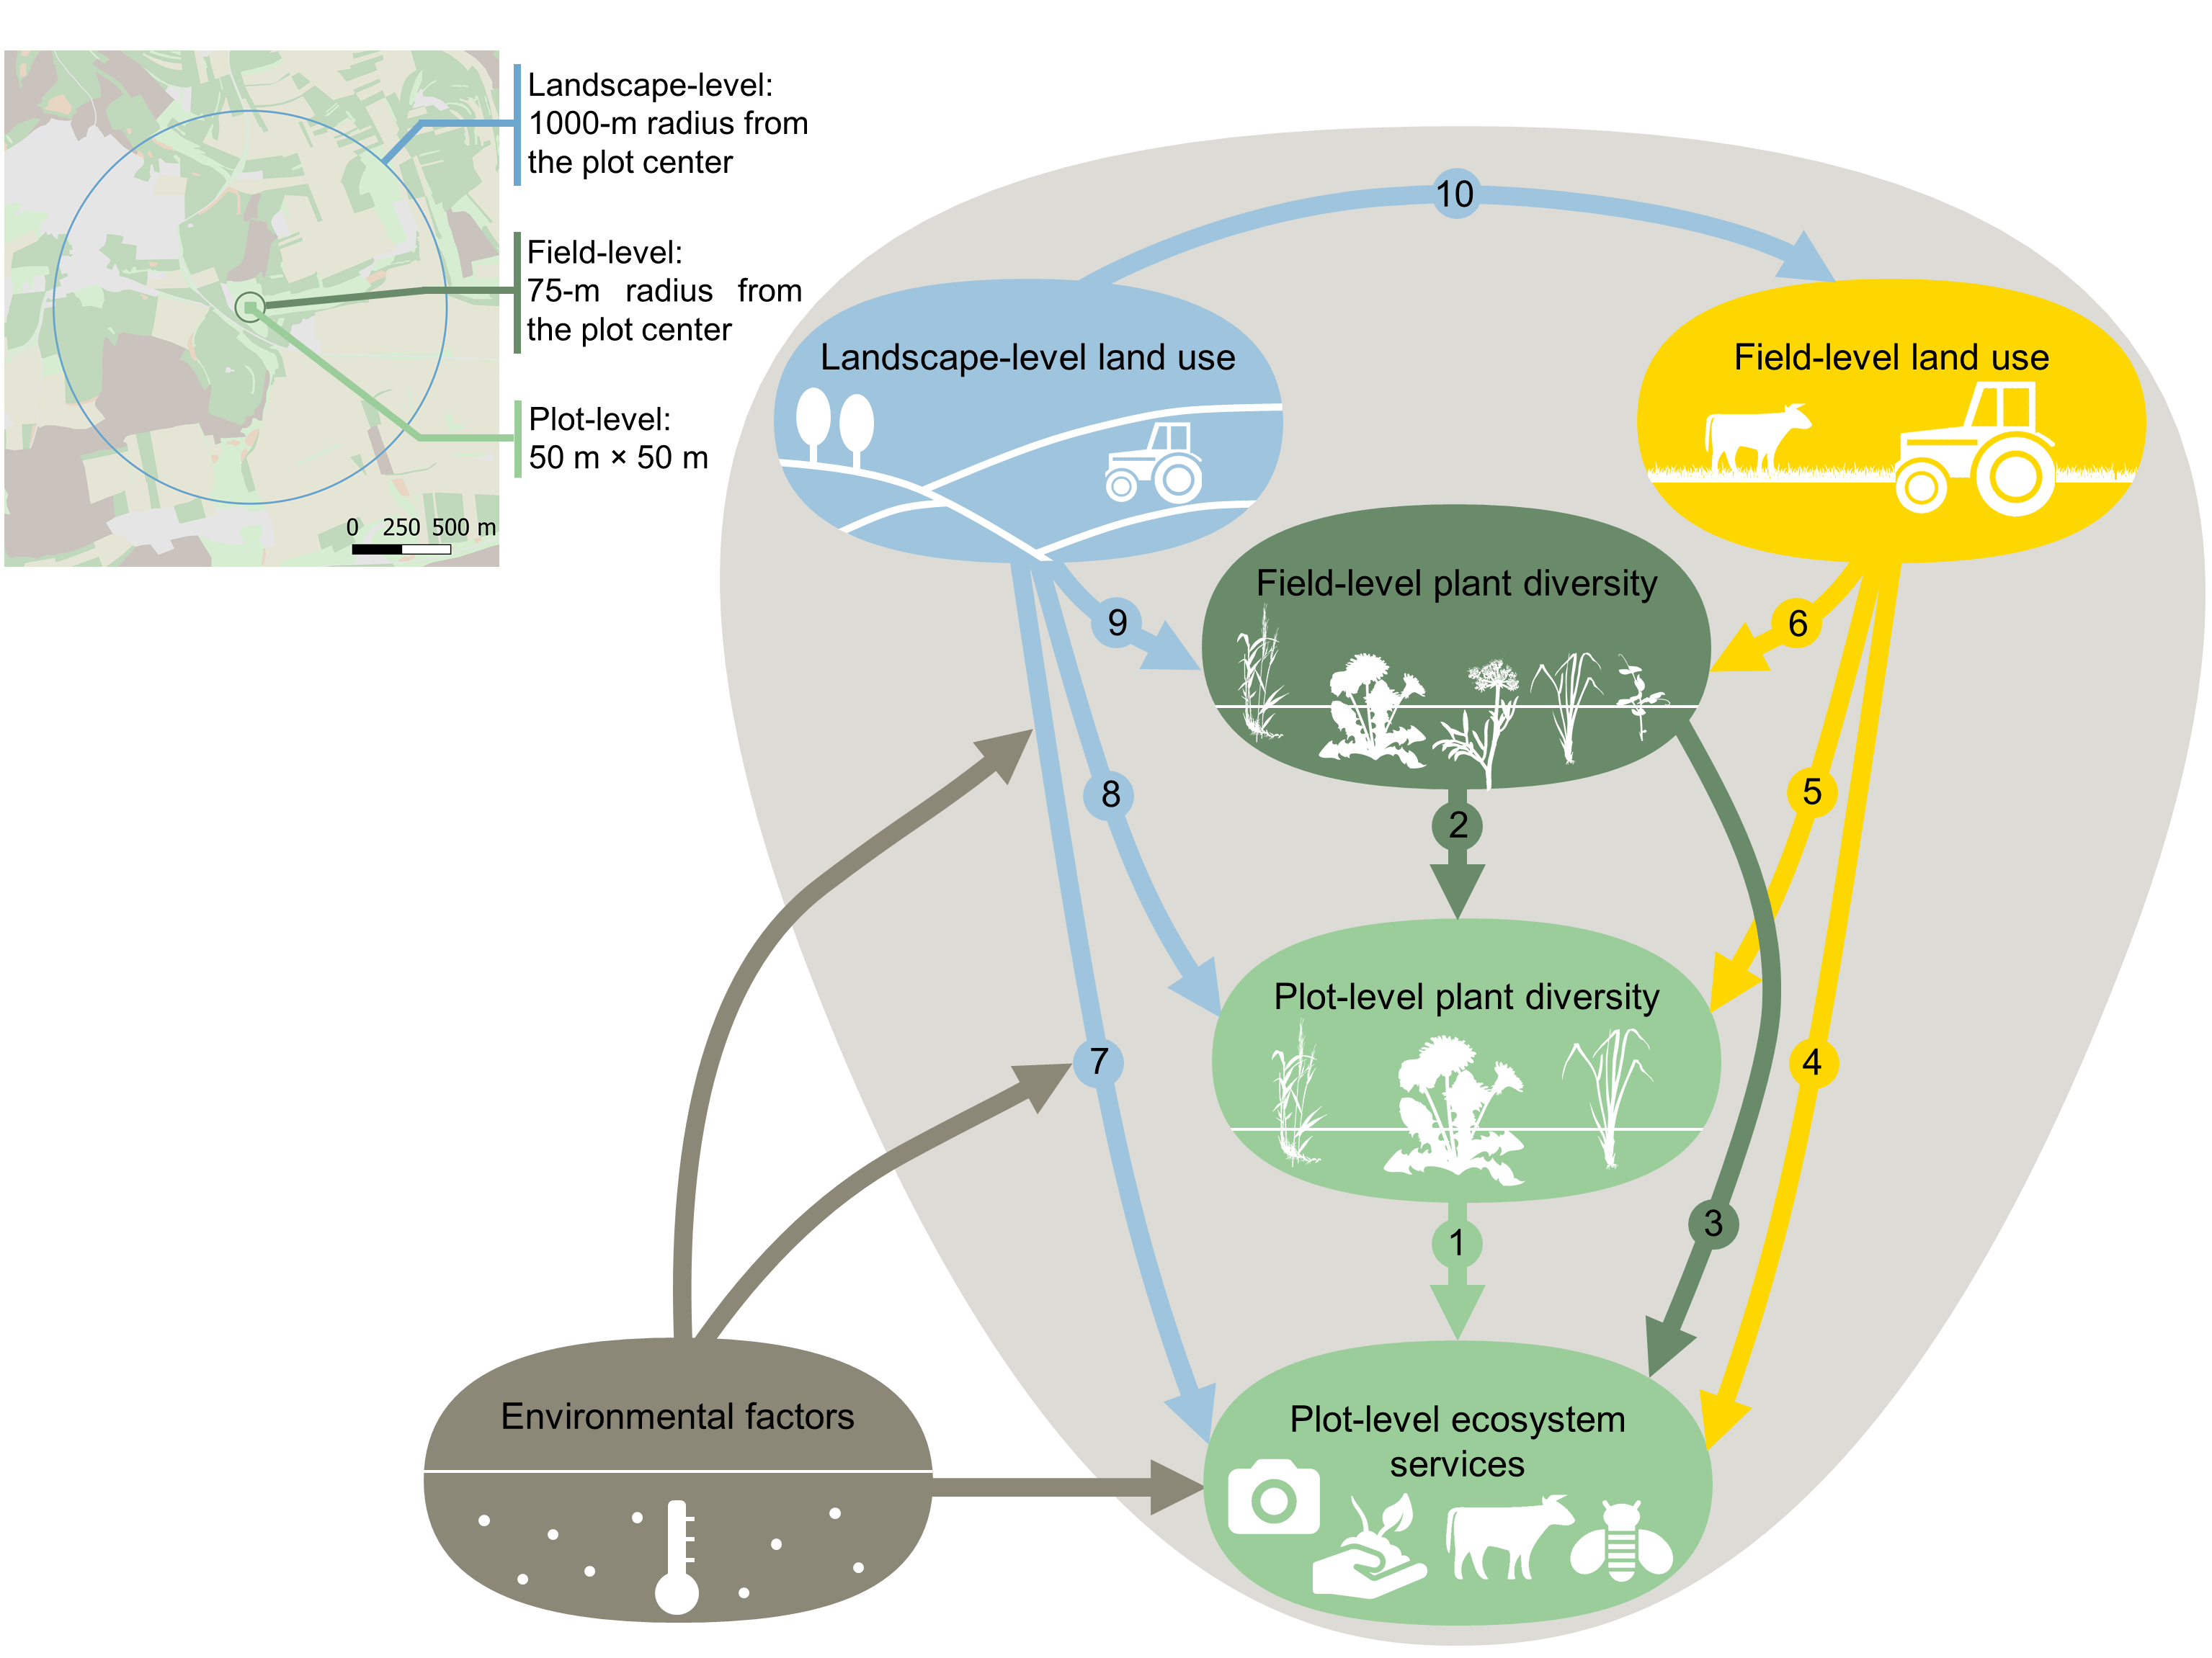FIGURES

**Figure 1. Conceptual framework of the relationship between landscape- and field-level land use, field- and plot-level plant diversity and plot-level ecosystem services.** Landscape-level (1000-m from the plot center) land use is represented in blue, field-level (75-m radius from the plot center) plant diversity and land use are represented in dark green and in yellow respectively, and plot-level (50 m × 50 m plot) factors are represented in light green. Note that this framework is a simplification of the full structural equation model used in this study, and that environmental factors are not presented in full here. All individual paths considered are presented in Table S2. Each plant icon represents a different species in the species pool. Arrows illustrate causal links between plot-level plant diversity and ecosystem services, field-level plant diversity and land use, and landscape-level land use. See introduction for a full explanation of these relationships and associated hypotheses.

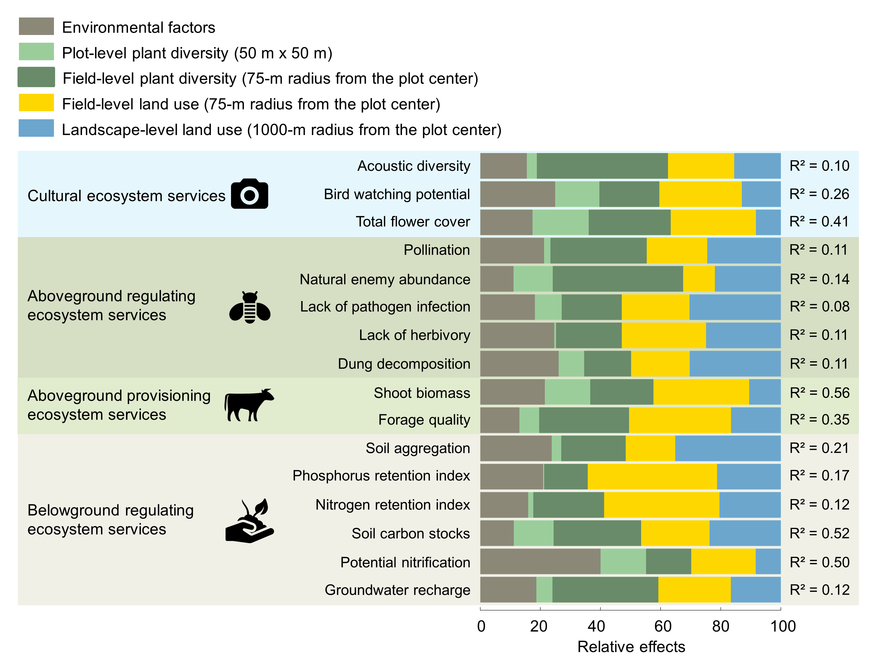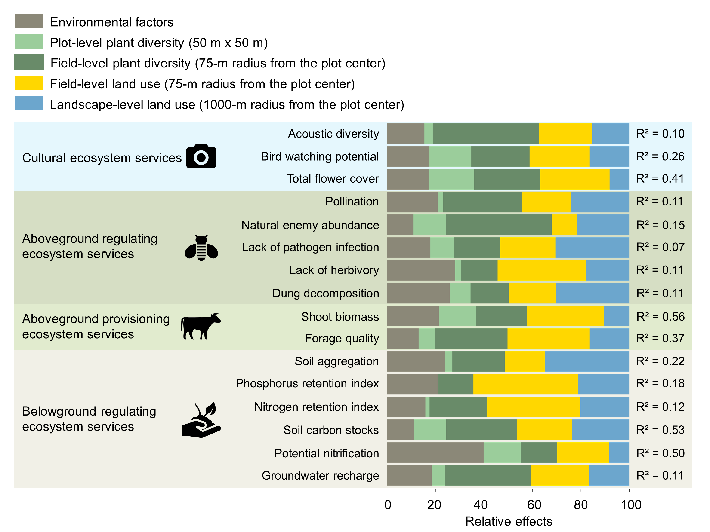**Figure 2. Relative importance of plant diversity and land-use predictors on cultural, aboveground regulating and provisioning, and belowground regulating ecosystem services.** The effects of the predictors were calculated considering both direct and indirect relationships (total effects) between the predictors and the response variables. We then expressed the importance of each group of predictors as the percentage of total effects they explained, based on the comparison between the absolute values of their standardized path coefficients and the sum of all standardized path coefficients from the SEM. Relative effects were calculated for each group of predictors: environmental factors, plot-level (50 m × 50 m) plant diversity, field-level (75-m radius from the plot center) plant diversity, field-level (75-m radius from the plot center) land use, and landscape-level (1000-m from the plot center) land use. R² for each ecosystem service is calculated based on the full structural equation model (see Table S2 for the individual path coefficients). All predictors and response variables were scaled to interpret parameter estimates on a comparable scale. See also Fig. S1 for the total standardized effects of each predictor.

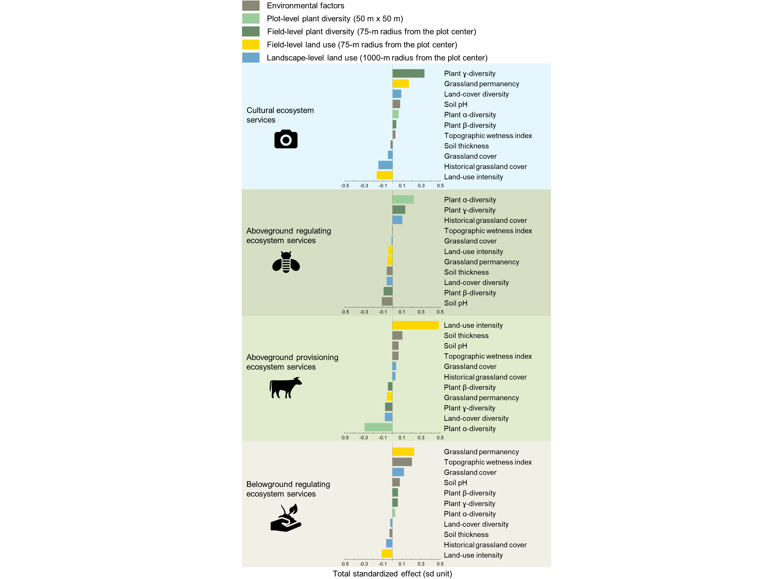**Figure 3. The multiple drivers of cultural, aboveground regulating and provisioning, and belowground regulating ecosystem services in grasslands.** Total standardized effects (sd unit) were calculated based on the results of structural equation models (considering both direct and indirect effects of the predictors) for each predictor: environmental factors, plot-level (50 m × 50 m) plant diversity, field-level (75-m radius from the plot center) plant diversity, field-level (75-m radius from the plot center) land use, and landscape-level (1000-m radius from the plot center) land use. Models were fitted to four multifunctionality measures: cultural, aboveground regulating and provisioning, and belowground regulating ecosystem service multifunctionality. The total standardized effects correspond to the sum of standardized direct effects (i.e. individual paths) and indirect effects (i.e. the multiplied paths). For each multifunctionality measure, total standardized effects of the different predictors are ordered from the highest positive effect to the lowest negative effect. All predictors were scaled to allow interpretation of parameter estimates on a comparable scale. Plot-level and landscape-level predictors were log-transformed. See Table S2 for the individual path coefficients and Fig. S1 for the effects of predictors on each individual ecosystem service.

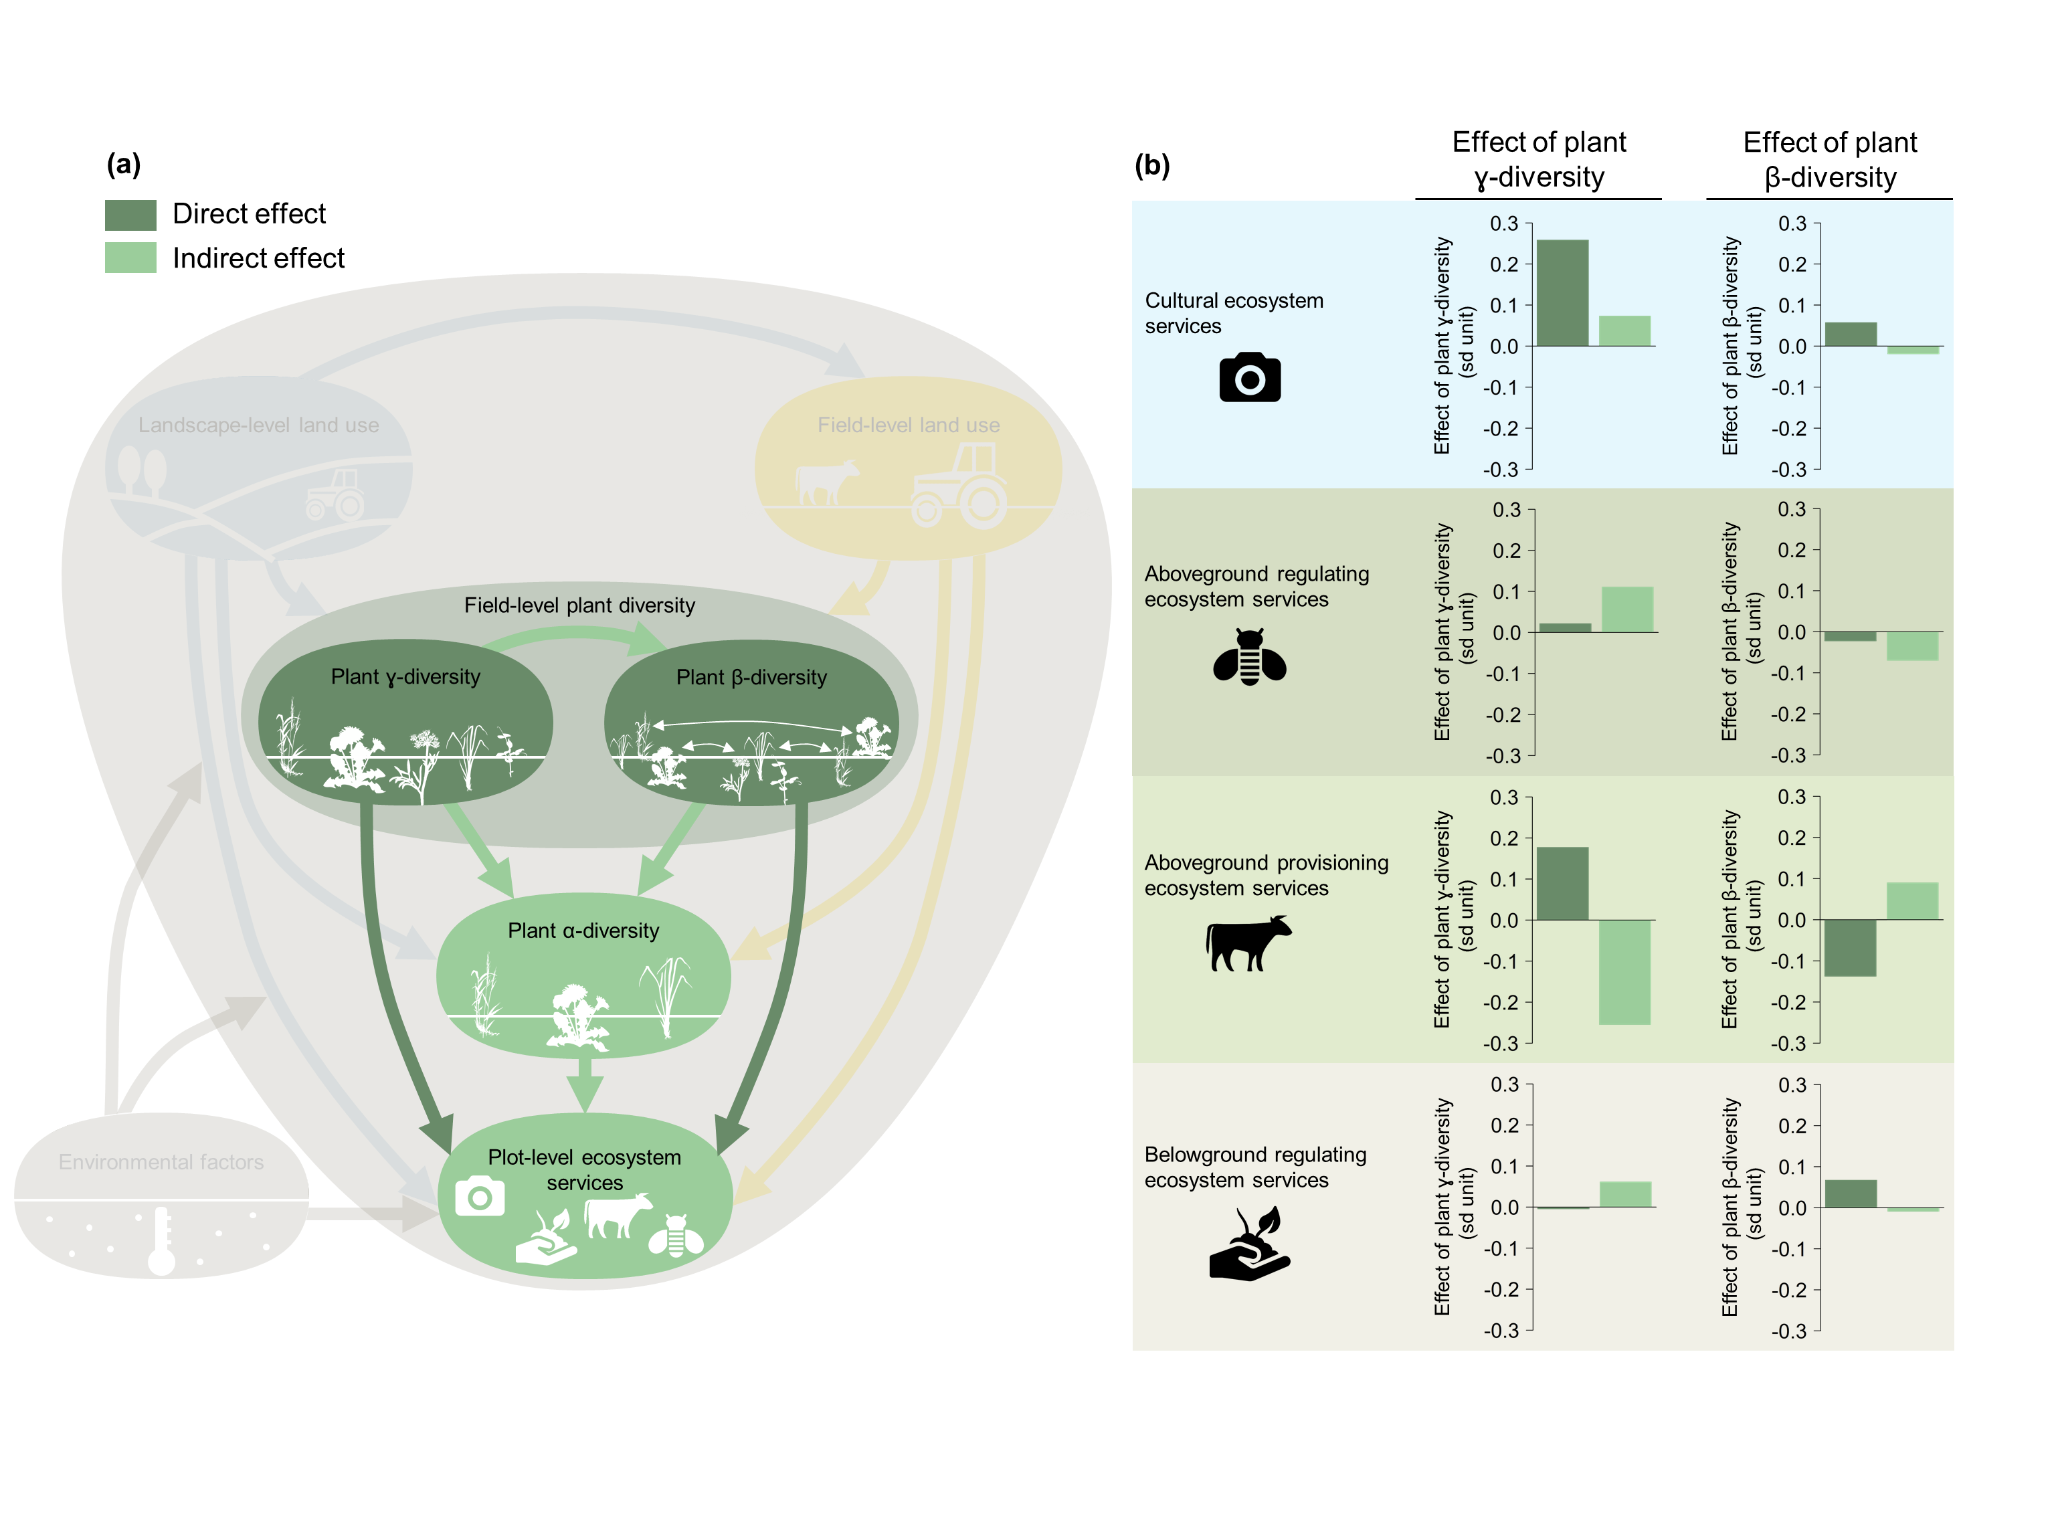**Figure 4. The strength of direct and indirect effects of field-level plant diversity on plot-level ecosystem services.** A subset of the full structural equation model (a) was used to calculate the indirect effects of field-level plant γ-diversity and plant β-diversity, through changing plot-level plant α-diversity. Direct and indirect effects of field-level plant γ-diversity and plant β-diversity (b) were calculated based on the full structural equation models, i.e. also including the faded components of (a), for cultural, aboveground regulating and provisioning, and belowground regulating ecosystem services separately. All individual paths considered are presented in Table S2.

METHODS

**Study design**

The studied grassland plots are part of the large-scale and long-term Biodiversity Exploratories project45 ([www.biodiversity-exploratories.de](http://www.biodiversity-exploratories.de)) and are located in three German regions: (i) the Schwäbische Alb region in the low mountain range of south-western Germany; (ii) the Hainich-Dün region in hilly central Germany; and (iii) the Schorfheide-Chorin region in the post-glacial lowlands of north-eastern Germany. The three regions differ in climate, geology and topography, but each is characterized by a gradient of grassland land-use intensity that is typical for large parts of temperate Europe45. In each region, fifty plots (50 m × 50 m) were chosen in mesic grasslands by stratified random sampling from a total of 500 candidate plots on which initial vegetation, soil and land-use surveys were conducted. This ensured that the plots covered the whole range of land-use intensities and management types, while minimizing confounding factors such as spatial position or soil type. All plots were grasslands for at least 10 years before the start of the project in 200647.

**Ecosystem service indicators**

In each of the 150 grassland plots, data on 16 indicators of ecosystem services were collected (most data available at <https://doi.org/10.17616/R32P9Q>). These services included (i) three cultural ecosystem services: acoustic diversity (the distribution of acoustic energy among frequency bands during diurnal recordings), bird watching potential (bird diversity), aesthetic value (total flower cover)81,82; (ii) five aboveground regulating ecosystem services: pollination (number of flower visitors), natural enemy abundance (number of attacked brood cells by parasitoid predating pest insects recorded in trap-nesting wasps), lack of pathogen infection (inverse of the total cover of foliar fungal pathogens), lack of herbivory (inverse of the total proportion of leaf area damaged by invertebrate herbivores), dung decomposition (proportion of dung dry mass removed); (iii) two aboveground provisioning ecosystem services: shoot biomass (peak standing biomass), forage quality (index based on crude protein concentration and relative forage value); (iv) six belowground regulating ecosystem services: soil aggregation (proportion of water stable soil aggregates), phosphorus retention index (calculated as a ratio between shoot and microbial phosphorus stocks and that of soil extractable phosphorus), nitrogen retention index (calculated as a ratio between shoot and microbial nitrogen stocks and that of soil extractable nitrogen), soil carbon stocks (soil organic carbon stocks in the top 10 cm), potential nitrification (ammonia oxidation under lab conditions), groundwater recharge (annual net downward water fluxes to below 0.15 m soil depth). To classify ecosystem services, we used the Common International Classification of Ecosystem Services (CICES83) and the Intergovernmental Platform for Biodiversity and Ecosystem Services (IPBES; which includes ecosystem services in the broader concept of nature’s contributions to people80) classifications. See also Table S1 for further details.

Measures of overall ecosystem service supply can be useful for addressing general trends (e.g. for management purposes) in addition to the study of responses of individual ecosystem services. We therefore calculated the overall ecosystem capacity to maintain ecosystem services simultaneously (i.e. multifunctionality6,69,84). To do so, we first scaled values of each ecosystem service because these values can vary widely. We then calculated multifunctionality measures for cultural, aboveground regulating, aboveground provisioning and belowground regulating ecosystem services separately. Multifunctionality was calculated as the percentage of measured services (measured services only, to correct for the fact that some services that had not been measured in all sites) that exceeded a given threshold of their maximum observed level across all study plots84. To reduce the influence of outliers, we calculated the maximum observed level as the average of the top five sites84. Given that any threshold is likely to be arbitrary, the use of multiple thresholds is recommended to better understand the role that biodiversity and land use play in affecting ecosystem multifunctionality and to account for tradeoffs between services84. Therefore, we used three different thresholds (25%, 50% and 75%) to represent a wide spectrum in the analyses performed. Our results focus on the 50% threshold, while results for the 25% and 75% threshold are presented in Fig. S3. As an alternative approach, we also calculated average-based indices by calculating the average across all services84. In these metrics, all ecosystem services are weighted equally, thus preventing the measure from being driven by specific services (Figs. S2). We further calculated overall multifunctionality measures, considering all ecosystem services simultaneously. Because the different types of ecosystem services considered in this study show contrasting responses, the use of an overall multifunctionality measure provides little insights (see results for overall ecosystem multifunctionality measures in Fig. S6).

**Plant diversity**

At the local level (i.e. 50 m × 50 m grassland plot), we annually sampled vascular plants in an area of 4 m × 4 m on each plot between mid-May and mid-June, and estimated the percentage cover of each occurring species. For our local plant α-diversity measure, we used mean plant species richness between 2009 and 2018. In addition, we calculated the Specific Leaf Area (SLA, ratio of leaf area to leaf dry mass), a measure related to plant tissue turnover and decomposability26,56–58. High SLA indicates fast-growing and acquisitive plant strategies58. We calculated the community weighted mean (CWM SLA) values by weighting the SLA value of each plant species by its abundance (relative cover) as a measure of local plant functional composition. CWMs were calculated for each year between 2009 and 2018, and then averaged across years to produce a single value per plot. SLA values were obtained from the TRY database85 but were unavailable for some rare species, so these were excluded from CWM estimation. However, an SLA value was attributed to most species (i.e. plant species representing at least 80% of the total cover averaged across all plots and years).

To assess the field-level plant diversity of each grassland plot, we surveyed the vegetation within the major surrounding homogeneous vegetation zones in a 75-m radius of each plot in 2017 and 2018. Each of these zones represented visually distinct habitats and were mostly situated within the same grassland-field as the focal plot, but we occasionally surveyed other habitat types (c. 20% were situated in hedgerows, margins or forests). In each of these zones, we selected a single, representative area of 2 m × 2 m in which the cover of all vascular plant species was estimated. We surveyed at least four zones for each grassland plot. If less than four different homogeneous zones were identified, we surveyed the vegetation twice or more within a large homogeneous zone. We characterized the overall changes in species composition between these surrounding plant communities (i.e. field-level plant β-diversity) by calculating the Sørensen dissimilarity index, which corresponds to an average of all pairwise dissimilarities between plant communities86. In addition, to characterize the overall surrounding species pool (i.e. plant γ-diversity), we calculated the total species richness recorded in these surrounding zones.

**Field-level land use**

Land-use intensity was assessed annually for the field within which each plot, and most associated field-level plant diversity plots, was located. This was done via questionnaires sent to land managers in which they reported the level of fertilization (kg total N ha-1 year-1), the number of mowing events per year (from one to three cuts), and the number and type of livestock and their duration of grazing (number of livestock units × grazing days ha-1 year-1). We used this information to calculate three indices for fertilization, mowing and grazing intensity respectively, standardized by their mean value across all three regions overall the years 2006-201846,47. We then quantified the land-use intensity (LUI) as the square-root of the sum of these three indices according to 46, using the LUI calculation tool87 implemented in BExIS (<http://doi.org/10.17616/R32P9Q>). We used this compound index as fertilization and mowing are positively correlated (r = 0.68), and grazing and mowing negatively correlated (r = -0.62). At the minimum LUI of 0.5–0.7, grasslands are typically unfertilized, and grazed by one cow (>2 year old) per hectare for 30 days (or one sheep per hectare for the whole year). At an intermediate LUI of 1.5, grasslands are usually unfertilized (or fertilized with less than 30 kg N ha-1 year-1), and are either mown twice a year or grazed by one cow per hectare for most of the year (300 days). At a high LUI of 3, grasslands are typically fertilized at a rate of 60–120 kg N ha-1 y-1, are mown 2–3 times a year or grazed by three cows per hectare for most of the year (300 days), or are managed by a combination of grazing and mowing.

Additionally, we used historical land-use maps to calculate the permanency of field-level land use. Historical maps from the Schwäbische Alb are digitized cadastral maps from 1820, topographic maps (map scale = 1:25000) from the German Empire from 1910, and topographic maps (map scale = 1:25000) from the Federal Republic of Germany from 1960. Historical maps from the Hainich are digitized old topographic maps (map scale = 1:25000) from 1850, topographic maps (map scale = 1:25000) from the German Republic from 1930, and topographic maps (map scale = 1:10000) from the German Democratic Republic from 1960. Historical maps from Schorfheide-Chorin are digitized old topographic maps (map scale = 1:25000) of 1850, topographic maps (map scale = 1:25000) from the German Republic of 1930, and topographic maps (map scale = 1:25000) from the German Democratic Republic from 1960. Field-level land use permanency was calculated as the number of times the field was recorded as a grassland, and varied between 4 (the field was always recorded as a grassland in all time points) and 1 (the land use recorded at the field level was different between all subsequent time points).

**Landscape-level land use**

At the landscape level (i.e. 1000-m radius of the center of the grassland plot), land use was recorded in 2008 within a 1000-m radius of each grassland plot88, and mapped in a Geographical Information System (GIS) database, running on QGIS v3.6. This scale has been chosen as it approximate the dispersal distance of different taxa. Land use was classified into six broad categories: croplands, grasslands, forests, water bodies, roads and urban areas (see Table S4). To describe the current landscape-level land use, we first calculated the proportion of the landscape covered by grasslands. Grasslands represent relatively undisturbed habitats in temperate agricultural landscapes and are likely to act as favorable habitats and dispersal corridors for some ecosystem service providers33,70,89. We also calculated the diversity of land-cover types in the landscape (i.e. the Shannon diversity of land-cover types), which has been shown to positively affect biodiversity and associated ecosystem services in agricultural landscapes43,48,90,91. Note that the Shannon diversity index contains an evenness component that means low abundance land-cover types have little weighting, and that within the 1000-radii water bodies, roads and urban areas covered a small proportion (0.55 - 6.39%) of the landscape in the three regions (Table S4). Therefore, the land-cover diversity metric was not sensitive to the presence of these rare land-cover types. A second landscape land-use survey was done in a 250-m radius of the plots in 2017 and we found that grassland cover (r = 0.81), forest cover (r = 0.80) and total land-cover diversity (r = 0.71) recorded in 2017 were highly correlated with data calculated in the same 250-m radius of each grassland plot in 2008, suggesting that over the last 10 years landscape composition was largely unchanged.

Additionally, we used the historical land-use maps to quantify the landscape-level historical grassland cover, between 1820/50 and 2008. To do so, we calculated the ratio of the mean to the standard deviation of grassland cover recorded in the landscape from 1820/50 to 2008. Historical grassland cover values were high when there was a higher grassland cover and this cover did not fluctuate over time.

**Environmental factors**

In each grassland plot, we measured important environmental covariates known to affect plant species richness92–97 and ecosystem processes32. Soil thickness was measured as the combined thickness of all topsoil and subsoil horizons. We determined soil thickness by sampling a soil core in the center of the study plots. We used a motor driven soil column cylinder with a diameter of 8.3 cm for the soil sampling (Eijkelkamp, Giesbeek, The Netherlands). To determine soil pH, a soil campaign was organized in 2011 and a composite sample representing the soil of the whole plot was prepared by mixing 14 mineral topsoil samples (0–10 cm, using a manual soil corer with 5.3 cm diameter) from the same plot. Soil samples were air dried and sieved (< 2 mm), and we then measured the soil pH in the supernatant of a 1:2.5 mixture of soil and 0.01 M CaCl2. Finally, for each plot we calculated the Topographic Wetness Index (TWI), defined as ln(a/tanB) where a is the specific catchment area (cumulative upslope area which drains through a Digital Elevation Model (DEM, [http://www.bkg.bund.de](http://www.bkg.bund.de/)) cell, divided by per unit contour length) and tanB is the slope gradient in radians calculated over a local region surrounding the cell of interest92,98. TWI therefore combines both upslope contributing area (determining the amount of water received from upslope areas) and slope (determining the loss of water from the site to downslope areas). TWI was calculated from raster DEM data with a cell size of 25 m for all plots, using ArcGIS tools (flow direction and flow accumulation tools of the hydrology toolset and raster calculator). The TWI measure used was the average value for a 4 × 4 window in the center of the plot, i.e. 16 DEM cells corresponding to an area of 100 m ×100 m. Initial analyses found that this was a stronger predictor than more local measures, thus indicating it is representative of the 50 m × 50 m plot area and its surroundings.

**Data analysis**

To assess the relative importance of plot-, field- and landscape-level factors in driving cultural, aboveground regulating, aboveground provisioning and belowground regulating ecosystem services, we used structural equation modelling (SEM)99. We defined five groups of predictors, spanning a range of spatial scales: (i) environmental factors that may drive plant species richness92–97 and also directly affect ecosystem services32: soil pH, soil thickness, and the TWI; (ii) the plot-level plant diversity, corresponding to plant α-diversity; (iii) the field-level plant diversity, which included plant β-diversity and plant γ-diversity; (iv) the field-level land-use attributes, which included land-use intensity and field-level grassland permanency; (v) the landscape-level land-use attributes, which included the land-cover diversity, the grassland cover, and the historical grassland cover. We formulated a hypothetical causal model (Fig. 1) based on *a priori* knowledge of grassland agroecosystem landscapes (see introduction for a full explanation of the paths included and associated hypotheses) and used this to test the fit of the model to the data. Covariances between variables were added to the initial model if they significantly improved model fit using modification indices (P < 0.05). We fitted separate SEMs for each ecosystem service measure individually, and for the different multifunctionality measures (i.e. cultural, aboveground regulating, aboveground provisioning and belowground regulating ecosystem services, and overall multifunctionality), using the lavaan package100. To account for inherent regional differences in environmental factors, plant diversity, land use and ecosystem services, we calculated the residuals for all our variables from linear models including region as a predictor, and then used these residual values in all SEM analyses. In order to allow comparison between the responses of the different ecosystem services, we always use the same SEM structure, without running any model simplification.

We estimated direct and indirect effects as standardized path coefficients, thus allowing for comparisons between ecosystem services. We calculated the fit of each SEM to the data using a Chi-squared test (Table S3). Response variables and predictors were log-transformed if necessary before analysis to meet linear model assumptions. To evaluate the relative importance of (i) environmental factors, (ii) the plot-level plant diversity, (iii) the field-level plant diversity, (iv) the field-level land use, and (v) the landscape-level land use as drivers of ecosystem services, we expressed the importance of each group of predictors as the percentage of total effects they explained, based on the comparison between the absolute values of their standardized path coefficients and the sum of all absolute values of standardized path coefficients from the SEM6,33,91,101. Before running our SEMs, we fitted separately linear models contained in the SEMs (Table S2) to test for residual spatial autocorrelation using Moran’s I tests. We did not find any evidence of residual spatial autocorrelation (P-values > 0.10).

In addition, we investigated whether changes in functional composition drove local ecosystem services. We substituted local plant α-diversity with the community weighted mean of SLA (CWM SLA) in our SEMs, and we used second-order Akaike’s Information Criterion (AICc) to compare the fit of SEMs containing local plant α-diversity with SEMs containing the CWM SLA (Table S3).

DATA AVAILABILITY

This work is based on data from several projects of the Biodiversity Exploratories programme (DFG Priority Program 1374). The data used for analyses are publicly available from the Biodiversity Exploratories Information System (https://doi.org/10.17616/R32P9Q), or will become publicly available after an embargo period of five years from the end of data assembly to give the owners and collectors of the data time to perform their analysis. Any other relevant data are available from the corresponding author upon reasonable request.

ACKNOWLEDGEMENTS

We thank the managers of the three Exploratories, Iris Steitz, Sandra Weithmann, Florian Staub, Sonja Gockel, Kerstin Wiesner, Katrin Lorenzen, Andreas Hemp, Martin Gorke, Miriam Teuscher and all former managers for their work in maintaining the plot and project infrastructure; Simone Pfeiffer, Maren Gleisberg, Christiane Fischer and Jule Mangels for giving support through the central office, Jens Nieschulze, Michael Owonibi and Andreas Ostrowski for managing the central data base, and Eduard Linsenmair, Dominik Hessenmöller, François Buscot, Ernst-Detlef Schulze and the late Elisabeth Kalko for their role in setting up the Biodiversity Exploratories project. We thank the administration of the Hainich national park, the UNESCO Biosphere Reserve Swabian Alb and the UNESCO Biosphere Reserve Schorfheide-Chorin as well as all land owners for the excellent collaboration. P.M. acknowledges support from the German Research Foundation (DFG; MA 7144/1-1). The work was partly funded by the DFG Priority Program 1374 “Biodiversity-Exploratories”. Field work permits were issued by the state environmental offices of Baden-Württemberg, Thüringen, and Brandenburg from 2008 to 2021.

REFERENCES

1. Hooper, D. U. *et al.* Effects of biodiversity on ecosystem functioning: a consensus of current knowledge. *Ecol. Monogr.* **75**, 3–35 (2005).

2. Cardinale, B. J. *et al.* Biodiversity loss and its impact on humanity. *Nature* **486**, 59–67 (2012).

3. Tilman, D., Isbell, F. & Cowles, J. M. Biodiversity and ecosystem functioning. *Annu. Rev. Ecol. Evol. Syst.* **45**, 471–493 (2014).

4. Hector, A. *et al.* Plant Diversity and Productivity Experiments in European Grasslands. *Science* **286**, 1123–1127 (1999).

5. Soliveres, S. *et al.* Biodiversity at multiple trophic levels is needed for ecosystem multifunctionality. *Nature* **536**, 456–459 (2016).

6. Gross, N. *et al.* Functional trait diversity maximizes ecosystem multifunctionality. *Nat. Ecol. Evol.* **1**, 0132 (2017).

7. van der Plas, F. *et al.* Towards the development of general rules describing landscape heterogeneity–multifunctionality relationships. *J. Appl. Ecol.* **56**, 168–179 (2019).

8. Jochum, M. *et al.* The results of biodiversity–ecosystem functioning experiments are realistic. *Nat. Ecol. Evol.* 1–10 (2020).

9. Duffy, J. E., Godwin, C. M. & Cardinale, B. J. Biodiversity effects in the wild are common and as strong as key drivers of productivity. *Nature* **549**, 261–264 (2017).

10. van der Plas, F. *et al.* Biotic homogenization can decrease landscape-scale forest multifunctionality (vol 113, pg 3557, 2016). *Proc. Natl. Acad. Sci. U. S. A.* **113**, E2549–E2549 (2016).

11. Isbell, F. *et al.* High plant diversity is needed to maintain ecosystem services. *Nature* **477**, 199–202 (2011).

12. Hautier, Y. *et al.* Local loss and spatial homogenization of plant diversity reduce ecosystem multifunctionality. *Nat. Ecol. Evol.* **2**, 50–56 (2018).

13. Srivastava, D. S. & Vellend, M. Biodiversity-ecosystem function research: is it relevant to conservation? *Annu. Rev. Ecol. Evol. Syst.* 267–294 (2005).

14. Isbell, F. *et al.* Linking the influence and dependence of people on biodiversity across scales. *Nature* **546**, 65–72 (2017).

15. Mori, A. S., Isbell, F. & Seidl, R. β-Diversity, Community Assembly, and Ecosystem Functioning. *Trends Ecol. Evol.* **33**, 549–564 (2018).

16. Chase, J. M. & Knight, T. M. Scale-dependent effect sizes of ecological drivers on biodiversity: why standardised sampling is not enough. *Ecol. Lett.* **16**, 17–26 (2013).

17. Chase, J. M. *et al.* Embracing scale-dependence to achieve a deeper understanding of biodiversity and its change across communities. *Ecol. Lett.* **21**, 1737–1751 (2018).

18. Barry, K. E. *et al.* The Future of Complementarity: Disentangling Causes from Consequences. *Trends Ecol. Evol.* **34**, 167–180 (2019).

19. Loreau, M. & Hector, A. Partitioning selection and complementarity in biodiversity experiments. *Nature* **412**, 72–76 (2001).

20. Hagan, J. G., Vanschoenwinkel, B. & Gamfeldt, L. We should not necessarily expect positive relationships between biodiversity and ecosystem functioning in observational field data. *Ecol. Lett.* **24**, 2537–2548 (2021).

21. Brose, U. & Hillebrand, H. Biodiversity and ecosystem functioning in dynamic landscapes. *Philos. Trans. R. Soc. B Biol. Sci.* **371**, 20150267 (2016).

22. Tscharntke, T. *et al.* Landscape moderation of biodiversity patterns and processes-eight hypotheses. *Biol. Rev.* **87**, 661–685 (2012).

23. Ricotta, C. On beta diversity decomposition: trouble shared is not trouble halved. *Ecology* **91**, 1981–1983 (2010).

24. Kraft, N. J. B. *et al.* Disentangling the Drivers of β Diversity Along Latitudinal and Elevational Gradients. *Science* **333**, 1755–1758 (2011).

25. Loreau, M., Mouquet, N. & Gonzalez, A. Biodiversity as spatial insurance in heterogeneous landscapes. *Proc. Natl. Acad. Sci.* **100**, 12765–12770 (2003).

26. Manning, P. *et al.* Grassland management intensification weakens the associations among the diversities of multiple plant and animal taxa. *Ecology* **96**, 1492–1501 (2015).

27. Isbell, F. *et al.* Benefits of increasing plant diversity in sustainable agroecosystems. *J. Ecol.* **105**, 871–879 (2017).

28. Gonthier, D. J. *et al.* Biodiversity conservation in agriculture requires a multi-scale approach. *Proc. R. Soc. Lond. B Biol. Sci.* **281**, 20141358 (2014).

29. Flynn, D. F. *et al.* Loss of functional diversity under land use intensification across multiple taxa. *Ecol. Lett.* **12**, 22–33 (2009).

30. Seibold, S. *et al.* Arthropod decline in grasslands and forests is associated with landscape-level drivers. *Nature* **574**, 671–674 (2019).

31. Foley, J. A. *et al.* Solutions for a cultivated planet. *Nature* **478**, 337–342 (2011).

32. Allan, E. *et al.* Land use intensification alters ecosystem multifunctionality via loss of biodiversity and changes to functional composition. *Ecol. Lett.* **18**, 834–843 (2015).

33. Le Provost, G. *et al.* Land-use history impacts functional diversity across multiple trophic groups. *Proc. Natl. Acad. Sci.* **117**, 1573–1579 (2020).

34. Adl, S. M., Coleman, D. C. & Read, F. Slow recovery of soil biodiversity in sandy loam soils of Georgia after 25 years of no-tillage management. *Agric. Ecosyst. Environ.* **114**, 323–334 (2006).

35. Le Provost, G. *et al.* Contrasting responses of above- and belowground diversity to multiple components of land-use intensity. *Nat. Commun.* **12**, 3918 (2021).

36. James, L. A. (2015). Legacy effects. Oxford Bibliographies in Environmental Science. https://doi.org/10.1093/OBO/97801 99363445-0019

37. Lamy, T., Liss, K. N., Gonzalez, A. & Bennett, E. M. Landscape structure affects the provision of multiple ecosystem services. *Environ. Res. Lett.* **11**, 124017 (2016).

38. Alsterberg, C. *et al.* Habitat diversity and ecosystem multifunctionality—The importance of direct and indirect effects. *Sci. Adv.* **3**, e1601475 (2017).

39. Tscharntke, T., Klein, A. M., Kruess, A., Steffan-Dewenter, I. & Thies, C. Landscape perspectives on agricultural intensification and biodiversity – ecosystem service management. *Ecol. Lett.* **8**, 857–874 (2005).

40. Gámez-Virués, S. *et al.* Landscape simplification filters species traits and drives biotic homogenization. *Nat. Commun.* **6**, 8568 (2015).

41. Benton, T. G., Vickery, J. A. & Wilson, J. D. Farmland biodiversity: is habitat heterogeneity the key? *Trends Ecol. Evol.* **18**, 182–188 (2003).

42. Bullock, J. M., Aronson, J., Newton, A. C., Pywell, R. F. & Rey-Benayas, J. M. Restoration of ecosystem services and biodiversity: conflicts and opportunities. *Trends Ecol. Evol.* **26**, 541–549 (2011).

43. Dainese, M. *et al.* A global synthesis reveals biodiversity-mediated benefits for crop production. *Sci. Adv.* **5**, eaax0121 (2019).

44. Mitchell, M. G. E., Bennett, E. M. & Gonzalez, A. Linking Landscape Connectivity and Ecosystem Service Provision: Current Knowledge and Research Gaps. *Ecosystems* **16**, 894–908 (2013).

45. Fischer, M. *et al.* Implementing large-scale and long-term functional biodiversity research: The Biodiversity Exploratories. *Basic Appl. Ecol.* **11**, 473–485 (2010).

46. Blüthgen, N. *et al.* A quantitative index of land-use intensity in grasslands: Integrating mowing, grazing and fertilization. *Basic Appl. Ecol.* **13**, 207–220 (2012).

47. Vogt, J. *et al.* Eleven years’ data of grassland management in Germany. *Biodivers. Data J.* **7**, e36387 (2019).

48. Gámez-Virués, S. *et al.* Landscape simplification filters species traits and drives biotic homogenization. *Nat. Commun.* **6**, (2015).

49. Nathan, R. Long-distance dispersal of plants. *Science* **313**, 786–788 (2006).

50. Vickery, J. A. *et al.* The management of lowland neutral grasslands in Britain: effects of agricultural practices on birds and their food resources. *J. Appl. Ecol.* **38**, 647–664 (2001).

51. López-Jamar, J., Casas, F., Díaz, M. & Morales, M. B. Local differences in habitat selection by Great Bustards Otis tarda in changing agricultural landscapes: implications for farmland bird conservation. *Bird Conserv. Int.* **21**, 328–341 (2011).

52. Wells, K., Böhm, S. M., Boch, S., Fischer, M. & Kalko, E. K. Local and landscape-scale forest attributes differ in their impact on bird assemblages across years in forest production landscapes. *Basic Appl. Ecol.* **12**, 97–106 (2011).

53. Bommarco, R., Lindborg, R., Marini, L. & Öckinger, E. Extinction debt for plants and flower-visiting insects in landscapes with contrasting land use history. *Divers. Distrib.* **20**, 591–599 (2014).

54. Kuussaari, M. *et al.* Extinction debt: a challenge for biodiversity conservation. *Trends Ecol. Evol.* **24**, 564–571 (2009).

55. Lee, M., Manning, P., Rist, J., Power, S. A. & Marsh, C. A global comparison of grassland biomass responses to CO2 and nitrogen enrichment. *Philos. Trans. R. Soc. B Biol. Sci.* **365**, 2047–2056 (2010).

56. Boeddinghaus, R. S. *et al.* Plant functional trait shifts explain concurrent changes in the structure and function of grassland soil microbial communities. *J. Ecol.* **107**, 2197–2210 (2019).

57. Reich, P. B. The world-wide ‘fast–slow’ plant economics spectrum: a traits manifesto. *J. Ecol.* **102**, 275–301 (2014).

58. Díaz, S. *et al.* The global spectrum of plant form and function. *Nature* **529**, 167–171 (2016).

59. Smith, P. Do grasslands act as a perpetual sink for carbon? *Glob. Change Biol.* **20**, 2708–2711 (2014).

60. Wagg, C., Bender, S. F., Widmer, F. & Heijden, M. G. A. van der. Soil biodiversity and soil community composition determine ecosystem multifunctionality. *Proc. Natl. Acad. Sci.* **111**, 5266–5270 (2014).

61. Bradford, M. A. *et al.* Discontinuity in the responses of ecosystem processes and multifunctionality to altered soil community composition. *Proc. Natl. Acad. Sci.* **111**, 14478–14483 (2014).

62. Schaub, S. *et al.* Plant diversity effects on forage quality, yield and revenues of semi-natural grasslands. *Nat. Commun.* **11**, 768 (2020).

63. Gonzalez, A. *et al.* Scaling-up biodiversity-ecosystem functioning research. *Ecol. Lett.* **23**, 757–776 (2020).

64. Pasari, J. R., Levi, T., Zavaleta, E. S. & Tilman, D. Several scales of biodiversity affect ecosystem multifunctionality. *Proc. Natl. Acad. Sci.* **110**, 10219–10222 (2013).

65. Qiu, J. *et al.* Land-use intensity mediates ecosystem service tradeoffs across regional social-ecological systems. *Ecosyst. People* **17**, 264–278 (2021).

66. Bennett, E. M., Peterson, G. D. & Gordon, L. J. Understanding relationships among multiple ecosystem services. *Ecol. Lett.* **12**, 1394–1404 (2009).

67. Cavender-Bares, J., Balvanera, P., King, E. & Polasky, S. Ecosystem service trade-offs across global contexts and scales. *Ecol. Soc.* **20**, (2015).

68. Green, R. E., Cornell, S. J., Scharlemann, J. P. W. & Balmford, A. Farming and the fate of wild nature. *Science* **307**, 550–555 (2005).

69. Manning, P. *et al.* Redefining ecosystem multifunctionality. *Nat. Ecol. Evol.* **2**, 427–436 (2018).

70. Clough, Y. *et al.* Density of insect-pollinated grassland plants decreases with increasing surrounding land-use intensity. *Ecol. Lett.* **17**, 1168–1177 (2014).

71. Emmerson, M. *et al.* Chapter Two - How Agricultural Intensification Affects Biodiversity and Ecosystem Services. in *Advances in Ecological Research* (eds. Dumbrell, A. J., Kordas, R. L. & Woodward, G.) vol. 55 43–97 (Academic Press, 2016).

72. Neyret, M. *et al.* Assessing the impact of grassland management on landscape multifunctionality. *Ecosyst. Serv.* **52**, 101366 (2021).

73. Peter, S., Le Provost, G., Mehring, M., Müller, T. & Manning, P. Cultural worldviews consistently explain bundles of ecosystem service prioritisation across rural Germany. *People Nat.* **4**, 218–230 (2022).

74. Anderson, B. J. *et al.* Spatial covariance between biodiversity and other ecosystem service priorities. *J. Appl. Ecol.* **46**, 888–896 (2009).

75. Maes, J. *et al.* Mapping ecosystem services for policy support and decision making in the European Union. *Ecosyst. Serv.* **1**, 31–39 (2012).

76. Mace, G. M., Norris, K. & Fitter, A. H. Biodiversity and ecosystem services: a multilayered relationship. *Trends Ecol. Evol.* **27**, 19–26 (2012).

77. Metzger, J. P. *et al.* Considering landscape-level processes in ecosystem service assessments. *Sci. Total Environ.* **796**, 149028 (2021).

78. Costanza, R. *et al.* Twenty years of ecosystem services: how far have we come and how far do we still need to go? *Ecosyst. Serv.* **28**, 1–16 (2017).

79. DeFries, R. & Nagendra, H. Ecosystem management as a wicked problem. *Science* **356**, 265–270 (2017).

80. Díaz, S. *et al.* Assessing nature’s contributions to people. *Science* **359**, 270–272 (2018).

81. Junge, X., Schüpbach, B., Walter, T., Schmid, B. & Lindemann-Matthies, P. Aesthetic quality of agricultural landscape elements in different seasonal stages in Switzerland. *Landsc. Urban Plan.* **133**, 67–77 (2015).

82. Lindemann-Matthies, P., Junge, X. & Matthies, D. The influence of plant diversity on people’s perception and aesthetic appreciation of grassland vegetation. *Biol. Conserv.* **143**, 195–202 (2010).

83. Haines-Young, R. & Potschin, M. *CICES-Towards a common classification of ecosystem services*. (2016).

84. Byrnes, J. E. *et al.* Investigating the relationship between biodiversity and ecosystem multifunctionality: challenges and solutions. *Methods Ecol. Evol.* **5**, 111–124 (2014).

85. Kattge, J. *et al.* TRY plant trait database – enhanced coverage and open access. *Glob. Change Biol.* **26**, 119–188 (2020).

86. Koleff, P., Gaston, K. J. & Lennon, J. J. Measuring beta diversity for presence–absence data. *J. Anim. Ecol.* **72**, 367–382 (2003).

87. Andreas Ostrowski, Katrin Lorenzen, Eleonora Petzold & Sirko Schindler. *Land use intensity index (LUI) calculation tool of the Biodiversity Exploratories project for grassland survey data from three different regions in Germany since 2006, BEXIS 2 module*. (Zenodo, 2020). doi:10.5281/zenodo.3865579.

88. Steckel, J. *et al.* Landscape composition and configuration differently affect trap-nesting bees, wasps and their antagonists. *Biol. Conserv.* **172**, 56–64 (2014).

89. Shoffner, A., Wilson, A. M., Tang, W. & Gagné, S. A. The relative effects of forest amount, forest configuration, and urban matrix quality on forest breeding birds. *Sci. Rep.* **8**, 1–12 (2018).

90. Fahrig, L. *et al.* Functional landscape heterogeneity and animal biodiversity in agricultural landscapes. *Ecol. Lett.* **14**, 101–112 (2011).

91. Sirami, C. *et al.* Increasing crop heterogeneity enhances multitrophic diversity across agricultural regions. *Proc. Natl. Acad. Sci.* **116**, 16442–16447 (2019).

92. Gessler, P. E., Moore, I. D., McKENZIE, N. J. & Ryan, P. J. Soil-landscape modelling and spatial prediction of soil attributes. *Int. J. Geogr. Inf. Syst.* **9**, 421–432.

93. Zinko, U., Seibert, J., Dynesius, M. & Nilsson, C. Plant species numbers predicted by a topography-based groundwater flow index. *Ecosystems* **8**, 430–441 (2005).

94. Moeslund, J. E. *et al.* Topographically controlled soil moisture drives plant diversity patterns within grasslands. *Biodivers. Conserv.* **22**, 2151–2166 (2013).

95. Keddy, P. A. Assembly and response rules: two goals for predictive community ecology. *J. Veg. Sci.* **3**, 157–164 (1992).

96. Myers, M. C., Mason, J. T., Hoksch, B. J., Cambardella, C. A. & Pfrimmer, J. D. Birds and butterflies respond to soil-induced habitat heterogeneity in experimental plantings of tallgrass prairie species managed as agroenergy crops in Iowa, USA. *J. Appl. Ecol.* **52**, 1176–1187 (2015).

97. Carvalheiro, L. G. *et al.* Soil eutrophication shaped the composition of pollinator assemblages during the past century. *Ecography* **43**, 209–221 (2020).

98. Sørensen, R., Zinko, U. & Seibert, J. On the calculation of the topographic wetness index: evaluation of different methods based on field observations. *Hydrol. Earth Syst. Sci.* **10**, 101–112 (2006).

99. Grace, J. B. Structural equation modeling for observational studies. *J. Wildl. Manag.* **72**, 14–22 (2008).

100. Rosseel, Y. Lavaan: An R package for structural equation modeling and more. Version 0.5–12 (BETA). *J. Stat. Softw.* **48**, 1–36 (2012).

101. Le Bagousse-Pinguet, Y. *et al.* Phylogenetic, functional, and taxonomic richness have both positive and negative effects on ecosystem multifunctionality. *Proc. Natl. Acad. Sci.* **116**, 8419–8424 (2019).