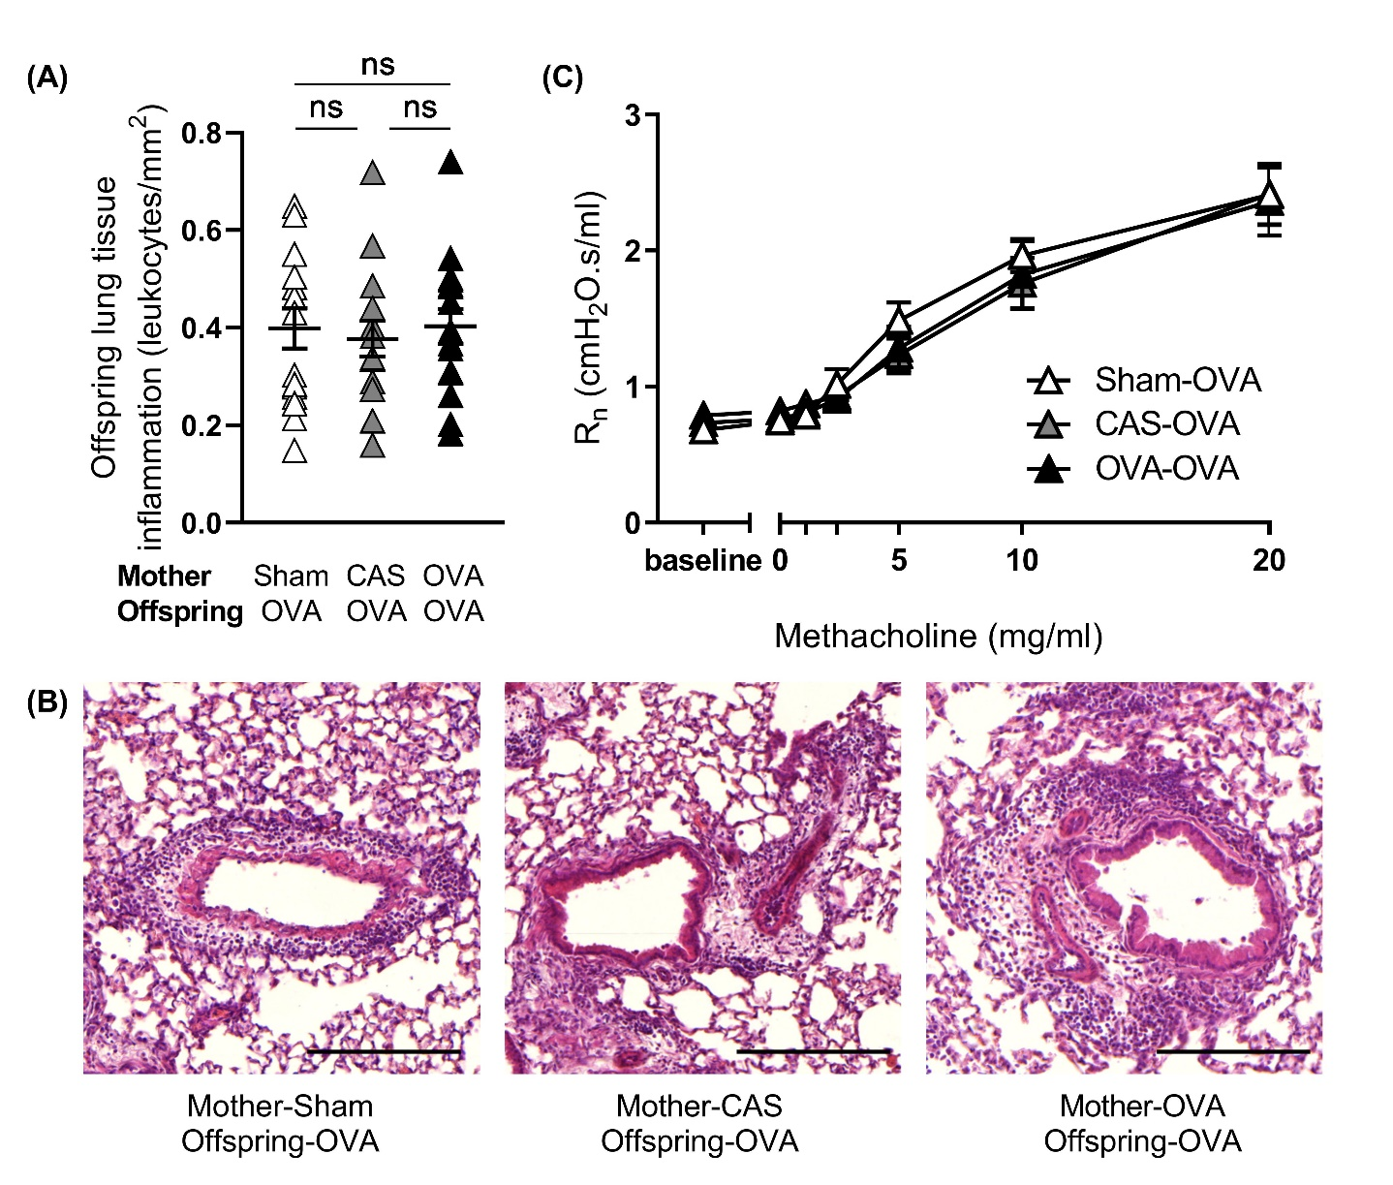

**Supplementary Figure 1: Maternal experimental asthma during pregnancy does not influence allergic offspring lung tissue inflammation or airway reactivity.**

Graphs show OVA allergic offspring from sham treated dams or dams with allergic airway inflammation to either CAS or OVA during pregnancy. (A) Allergic offspring lung tissue inflammation. Sham-OVA (*n*=16), CAS-OVA (*n*=17), OVA-OVA (*n*=15). (B) Representative images of allergic offspring lung histology. Scale bar = 100µm. (C) Allergic offspring airway reactivity data (*n*=10/group). Results represent two independently performed experiments. Means ± SEM are shown. ns = not significant, lung tissue inflammation: ANOVA or Kruskal-Wallis with Dunnett’s multiple comparisons test. Airway reactivity data were compared for each dose of methacholine using a two-way ANOVA.