**Supporting Information**

***Adapting current model with field data of related performance reference compounds in passive samplers to accurately monitor hydrophobic organic compounds in aqueous media***

**Cedrique Temoka12●, Gerd Pfister2, Bernhard Henkelmann2, Karl-Werner Schramm12\***

1 TUM, Wissenschaftszentrum Weihenstephan für Ernährung, Landnutzung und Umwelt, Department für Biowissenschaften, Weihenstephaner Steig 23, 85350 Freising, Germany*[schramm@wzw.tum.de](mailto:schramm@wzw.tum.de)

2 Helmholtz Zentrum München - German Research Center for Environmental Health (GmbH), Molecular EXposomics (MEX), Ingolstädter Landstr.1, D-85764 Neuherberg, Germany

Corresponding authors: Pokem Temoka; Karl-Werner Schramm; Helmholtz Zentrum München GmbH ●[pokem.temoka@helmholtz-muenchen.de](mailto:pokem.temoka@helmholtz-muenchen.de); Phone +49 (0) 89-3187-3748

To understand PRC behavior in water and to evaluate *In situ* sampling rates of sixteen 13C-PAH-PRC labeled compounds *Rs,PRC(N)* with moderate and high hydrophobicity, investigations were made in 3 different sampling sites:

1-The Yangtze River is the longest river in both China and Asia, and is also the third longest river in the world in terms of its length (6,300 km) and largest flux (9.6×1011 m3 year−1). More and more people in cities and towns along the river explore the river water as a source of drinking water. The Three Gorges Dam (TGD), which had been constructed on the Yangtze River, is the world’s largest hydroelectric power generator with a total generating capacity of 18,200 MW. Apart from producing electricity, the dam increases the Yangtze River's shipping capacity, and reduces the potential for floods downstream by providing flood storage space. The reservoir created by TGD has an area of 1080km2, 700km length with the backwater ending in Chongqing city. The maximum sluicing water level is 175m. Many toxic pollutants, especially persistent toxic substances (PTS), from the industries such as automobile, textile, chemical, and electronic production and shipping activity, or from domestic sewage, are not listed in the National Standard yet.

2-The Danjiangkou Reservoir (DJR) (32°36′–33°48′N; 110°59′–111°49′E) located in the juncture of Hubei and Henan provinces in China is the biggest tributary of the Yangtze River, to North China including Tianjin and Beijing for irrigation, industrial and domestic usages (Li et al., 2008).

3-Within more than 3000 years history, Istanbul has been the most crowded (15% of the total population) and industrialized city in Turkey (TCIB, 2007). Because of the increasing rate of industry and population, Istanbul has faced many pollution problems due organic pollutants reference.

1. **VO preparation**

VO is a semi permeable membrane device with measuring 2.5 cm wide by 23cm long and the membrane thickness is 0.00675 cm. In each VO, 700 µL of triolein (Sigma, Munich, Germany, 99%) was spiked with performance reference compounds (PRC), sixteen labeled 13C EPA-PAH compounds with *log Kow* values ranging from 3.38 to 6.63 to enable an estimation of ambient chemical levels at different optional periods of exposure due to different kinetics. The PRC used included: Naphthalene-13C6, Acenaphthylene-13C6 Acenaphthene-13C6, Fluorene 13C6, Phenanthrene-13C6, Anthracene-13C6 , Fluoranthene-13C6, Pyrene-13C3, Benzo(a)anthracene- 13C6, Chrysene-13C6, Benzo(b)fluoranthene-13C6, Benzo(k)fluoranthene-13C6, Benzo(a)pyrene-13C4, Indeno(1,2,3-cd)pyrene-13C6, Benzo(g,h,i)perylene-13C12, Dibenz(a,h)anthracene-13C6.

1. **Sampling sites**

The chemical VO-transfer depends on physicochemical properties of the target compound and the exposure conditions. In this present study, previous experimental values in four different environments under condition of low to high water flows were used:

1) The VO was deployed for 24 days in seven sites across 600 km in the Three Gorges Reservoir of China during May-June 2008 (Wang et al, 2009). The sampling places (Fig.S1) are: 1. Maoping (Great dam); 2.Guojiaba; 3.Longxikou; 4.Guandukou; 5.Wanzhou; 6.Changshou; 7.Chongqing.

2) The VO was deployed for 26 days in twelve sites along 600 km in the Three Gorges Reservoir of China during April-May 2011. The sampling places (Fig. S1) are: 1. Maoping (Great dam); 2. Guojiaba; 3. Xiangxi I; 4. Xiangxi II; 5. Daning I; 6.Daning II; 7. Fengxi; 8.Xiaojang I; 9. Xiaojang II; 10.Wanzhou; 11. Changshou; 12. Chongqing.

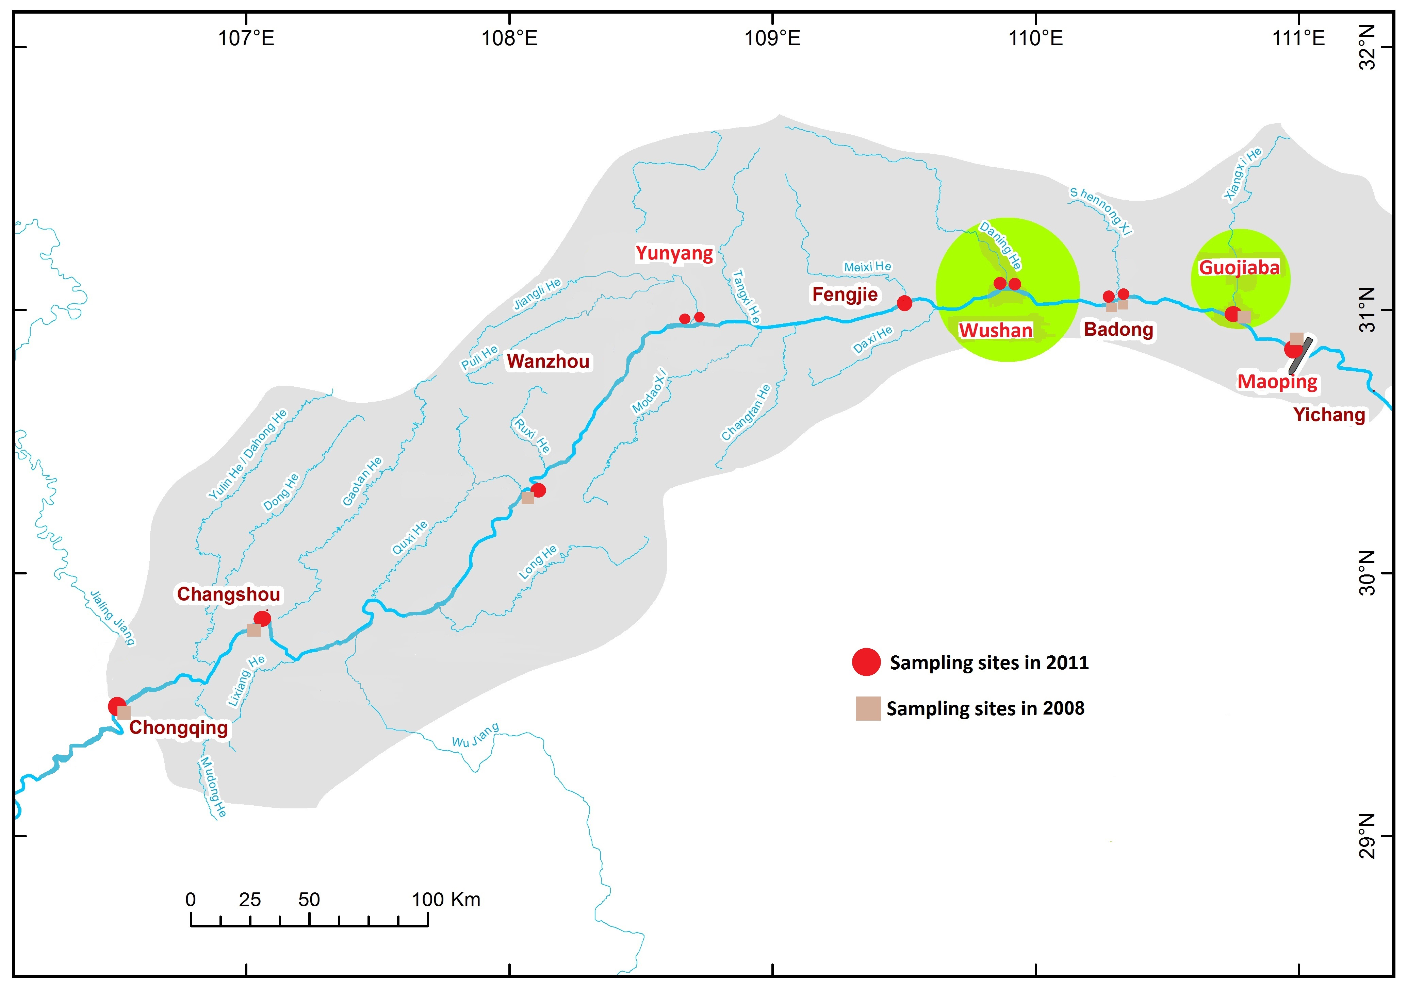

**Fig.S1** sampling sites along 600km of Three Gorge Reservoir in China during 2011

1. The VO was deployed for a minimum of 26 days and a maximum of 30 days in 5 sites in the Drinking water reservoir DJR of China in 2009. The sampling places are: 1. Baqian; 2. Hejiawah; 3. Lianhua; 4. Longkou; 5. Dam.

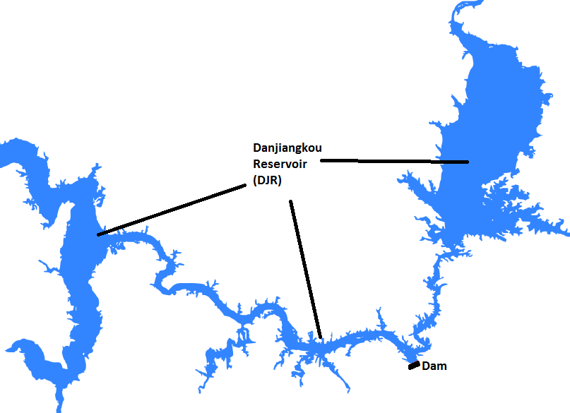

**Fig.S2** sampling sites in Danjiangkou Reservoir (DJR)

4) The VO was deployed for a minimum of 7 days and a maximum of 21 days in 5 sites in the Istanbul Strait of Turkey in 2008. The sampling places are: 1. Istinye dereici; 2. Istinye; 3. Tuzla; 4. Buyukada; 5. Anadolu Feneri.

To establish the new PRC selection approach, the recent experiment values in Three Gorges reservoir of China during April 2011 were used (cf. above and Fig.S1)

The VO was immerged as 7 replicates into water about 1 m depth in stainless steel cages to avoid mechanical damage to them and to minimize the influence of variations in flow/turbulence at membrane surface during the sampling. The samplers were mounted on boats or fastened to docks which were about 10–20 m from the river bank. VO for the determination of blanks was prepared together with the VO samples and was transported to the sampling sites also in the clean air tight jars, not deployed and kept in dark. At retrieval, the biofouling material and sediments on the VO were washed off by ambient water from the site carefully. Then VO was transported to the laboratory in the related glass jars in darkness and was kept in a freezer at -28oC until processing.

1. **Extraction, clean-up and analysis**

All organic solvents used were of picograde quality and were obtained from LGC standards (Wesel, Germany). VO was cut into small pieces prior to extraction. The sample was then extracted in a 250 mL Erlenmeyer flask overnight by soaking in 100 mL of cyclohexane at 200 rpm with a constant temperature shaker. Internal quantification standards for PAH (Naphthalene-D8, Acenaphthylene-D8, Acenaphthene- D10, Fluorene-D10, Phenanthene-D10, Anthracene-D10, Fluoranthene-D10, Pyrene-D10, Benzo(a)anthracene-D12, Chrysene-D12, Benzo(b)fluoranthene-D12, Benzo(k)fluoranthene-D12, Benzo(a)pyrene-D12, Indeno(1,2,3-c,d)pyrene-D12, Benzo(g,h,i)- perylene-D12, Dibenzo(a,h)anthracene-D14) in n-nonane were added to the cyclohexane prior to extraction. The organic phase was passed over anhydrous sodium sulfate to remove water. The volumes of the extracts were reduced to dryness using vacuum rotary evaporation and the mass of triolein residues was determined. The triolein was re-dissolved in approximately 1–2 mL mixture of n-hexane: dichloromethane (1:1, V:V) and the samples underwent cleanup using a mixed column (silica gel from Wesel Germany, grade 60; 3 cm diameter column containing, from the bottom upward, 10 g silica, 5 g alumina with 3% H2O, 5 g anhydrous sodium sulfate). The extracts were eluted with 100 mL mixture of n-hexane and dichloromethane (1:1) and reduced to 1 mL. The residues were further purified through a C18 SPE cartridge for which acetonitrile is used as eluting solvent. After adding a recovery standard (13C12-1,2,3,4-TCDD, Pentachlorotoluene, 13C12-1,2,3,7,8,9-HxCDD), the extracts were concentrated with a gentle flow of nitrogen to 20 µL to be ready for analytical determination. Instrumental analysis of PAH, PCB and OCP was performed by use of Agilent 5890 II plus MAT95, a gas chromatograph coupled to a high resolution mass spectrometer GC/MS. Helium was used as the carrier gas with a head pressure of 16 psi. The GC/MS operating conditions are 47-eV EI ionization with the MS ion source temperature at 260 °C. The temperature program of GC was first hold at 60 °C for 1.5 min, then increases to 225 °C at 10 °C min-1 and to 290°C at 5°C min-1, then hold for 20 min at 315°C. The temperature program of the injection port was increased to 120°C at 12°Cs-1 and the maintained at 280°C for 5 min. The temperature of transfer line was 300°C.The sample was injected in a splitless mode with the cooled injection system CIS3.

1. **Quality assurance/ Quality control**

The VO blanks were analyzed as a control to obtain the amounts of PRC prior to exposure, and to obtain the blank values of the other analytes. In the case of detected blank signals the method detection limits (MDLs) were calculated on the basis of 3 times standard deviation of mean blank value (X) when more than 2 blank values are available or 3 times of 0.25 X when only 1 or 2 blanks are available. A result R is valid when the margin between the sample value and the average blank value X is larger than the MDL and is reported as a result after subtraction of the average blank value X. Otherwise R is reported as less than MDL. When blank signals for a compound are not detected, the MDLs are calculated on the basis of a signal-to-noise of 3:1 of the mass traces of the unlabeled compound. Every signal below this limit is treated as not detectable. The recovery standard (PCT and 13C12-1,2,3,7,8,9-HxCDD ) are used for the calculation of the recoveries of deuterated internal standards. The recoveries of the internal standards are used to control the performance of the sample preparation step (extraction and cleanup). Low recoveries indicate an insufficient extraction and/or a failed fractionation on the clean-up columns. The average recoveries of all deuterated internal standards are between 40% and 120%.

**II New calculation procedure**

Twelve replicated VO-field blanks, produced during sampling campaigns in 2011 together with the samples deployed in twelves different sampling sites along Three Gorges Reservoir (TGR), were used in this study to determinate the uncertainty values of retained PRC into VO. The VO-field blanks consisted of loaded samplers taken to and from the field with other VOs but never removed from their airtight vials. These blanks were prepared and analyzed simultaneously in the same manner as the deployed samplers to determine whether contamination or losses occurred during the VO loading, transport or analysis. A normal distribution for the results can be assumed, because the PRC concentrations can be well determined in cases of minor or no losses.

For each PRC, the standard deviation was calculated from obtained retained PRC values of the blank samples. The obtained values *uo* of blank sample were first normalized in percentage *%u* according to the expected values *uw*, following this equation:

**% (1)

Then the standard deviation *Sn*(%)was obtained by following the equation:

**(2)

%ui, are the obtained values in percent for the blank sample *i, ū* is the sample mean of the obtained values and *n* is the amount of blank samples used for the measurements.

The coefficient of variation *CV* (%)is calculated as following:

****(3)

The standard error SCV of the coefficient of variation is calculated as:

 (4)

The uncertainty (y) of the VO-field blanks is described on the manuscript (Eq.9).

Under the null hypothesis suggesting that the blank sample values of biased estimate coefficient of variation was equal to zero, the calculation of T-criterion *tα,ν*was 4.9. This value is larger than the critical value of a student’s t distribution k= 2.201 for α=0.05, ν=11 degrees of freedom and 95% confidence interval. Thus, the null hypothesis is rejected and the biased estimate of blank samples coefficient of variation is concluded larger than zero.

**Table S1** *Rsmin* (L.d-1) was applied if a direct measurement of *RsPRC* (L.d-1) was not obtainable for the estimation of *RsPRC(N)* (L.d-1) during sampling campaign in 2011 in Three Gorges Reservoir in China**.** The campaign covered twelves sampling sites: Maoping (MP) Guojiaba(GJB), Xiangxi I/II (XX1/2), Daning I/II (DN1/2), Fendji (FJ), Xiaojiang I/II (XJ1/2), Wanzhou (WZ), Changshou (CS), Chongqing (CQ). *Rs,PRC(N)* were directly used as the native PAHs sampling rates *Rs,PAH(N)* (L.d-1) with similar physicochemical properties

|  |  |  |  |  |  |  |  |  |  |  |  |  |  |
| --- | --- | --- | --- | --- | --- | --- | --- | --- | --- | --- | --- | --- | --- |
|  |  | **MP** | | | | **GJB** | | | | **XX1** | | | |
| **PAH-PRC compounds** | **log *Kow*** | ***RsPRC*** | ***Rsmin*** | ***RsPRC(N)*** | ***RsPAH(N)*** | ***RsPRC*** | ***Rsmin*** | ***RsPRC(N)*** | ***RsPAH(N)*** | ***RsPRC*** | ***Rsmin*** | ***RsPRC(N)*** | ***RsPAH(N)*** |
| Naphthalin-13C6 | 3.38 | 0.674 | 0.004 | 0.674 | 0.674 |  | 0.005 |  |  | 0.735 | 0.004 | 0.735 | 0.735 |
| Acenaphthylen-13C6 | 4.07 | 1.715 | 0.026 | 1.715 | 1.715 | 3.037 | 0.036 | 3.037 | 3.037 | 2.448 | 0.026 | 2.448 | 2.448 |
| Acenaphthen-13C6 | 3.92 | 0.742 | 0.022 | 0.742 | 0.742 | 1.543 | 0.031 | 1.543 | 1.543 | 1.167 | 0.022 | 1.167 | 1.167 |
| Fluoren-13C6 | 4.1 | 1.085 | 0.030 | 1.085 | 1.085 | 2.032 | 0.043 | 2.032 | 2.032 | 2.104 | 0.031 | 2.104 | 2.104 |
| Phenanthren-13C6 | 4.46 | 1.464 | 0.066 | 1.464 | 1.464 | 2.148 | 0.092 | 2.148 | 2.148 | 2.421 | 0.067 | 2.421 | 2.421 |
| Anthracen-13C6 | 4.54 | 1.582 | 0.117 | 1.582 | 1.582 | 2.314 | 0.165 | 2.314 | 2.314 | 2.514 | 0.120 | 2.514 | 2.514 |
| Fluoranthen-13C6 | 4.84 | 1.119 | 0.070 | 1.119 | 1.119 | 2.040 | 0.098 | 2.040 | 2.040 | 1.399 | 0.072 | 1.399 | 1.399 |
| Pyren-13C3 | 5.18 | 1.765 | 0.194 | 1.765 | 1.765 | 2.450 | 0.270 | 2.450 | 2.450 | 4.141 | 0.198 | 4.141 | 4.141 |
| Benzo(a)anthracen- 13C6 | 5.6 | 4.574 | 0.911 | 4.574 | 4.574 | 3.020 | 1.264 | 3.020 | 3.020 | 3.253 | 0.931 | 3.253 | 3.253 |
| Chrysen-13C6 | 5.84 | 8.847 | 1.451 | 8.847 | 8.847 | 8.010 | 2.010 | 8.010 | 8.010 | 7.068 | 1.484 | 7.068 | 7.068 |
| Benzo(b)fluoranthen-13C6 | 6.44 | 33.753 | 6.129 | 33.753 | 33.753 | 12.235 | 8.441 | 12.235 | 12.235 | 27.003 | 6.267 | 27.003 | 27.003 |
| Benzo(k)fluoranthen-13C6 | 6.44 | 32.119 | 6.189 | 32.119 | 32.119 | 19.412 | 8.524 | 19.412 | 19.412 | 22.288 | 6.328 | 22.288 | 22.288 |
| Benzo(a)pyren-13C4 | 6.42 | 30.890 | 6.385 | 30.890 | 30.890 | 33.971 | 8.794 | 33.971 | 33.971 | 25.262 | 6.528 | 25.262 | 25.262 |
| Indeno(1,2,3-cd)pyren-13C6 | 6.42 | 21.245 | 6.015 | 21.245 | 21.245 | 17.907 | 8.285 | 17.907 | 17.907 | -1.470 | 6.150 | 6.150 | 6.150 |
| Benzo(g,h,i)perylen-13C12 | 6.63 | 57.909 | 14.310 | 57.909 | 57.909 | 127.072 | 19.669 | 127.072 | 127.072 | 69.526 | 14.631 | 69.526 | 69.526 |
| Dibenz(a,h)anthracen-13C6 | 6.5 | 29.833 | 8.418 | 29.833 | 29.833 | -1.183 | 11.587 | 11.587 | 11.587 | 22.263 | 8.608 | 22.263 | 22.263 |

|  |  |  |  |  |  |  |  |  |  |  |  |  |  |
| --- | --- | --- | --- | --- | --- | --- | --- | --- | --- | --- | --- | --- | --- |
|  |  | **XX2** | | | | **DN1** | | | | **DN2** | | | |
| **PAH-PRC compounds** | **log *Kow*** | ***RsPRC*** | ***Rsmin*** | ***RsPRC(N)*** | ***RsPAH(N)*** | ***RsPRC*** | ***Rsmin*** | ***RsPRC(N)*** | ***RsPAH(N)*** | ***RsPRC*** | ***Rsmin*** | ***RsPRC(N)*** | ***RsPAH(N)*** |
| Naphthalin-13C6 | 3.38 | 0.731 | 0.004 | 0.731 | 0.731 |  | 0.004 |  |  |  | 0.004 |  |  |
| Acenaphthylen-13C6 | 4.07 | 2.735 | 0.026 | 2.735 | 2.735 |  | 0.026 |  |  |  | 0.026 |  |  |
| Acenaphthen-13C6 | 3.92 | 1.150 | 0.022 | 1.150 | 1.150 |  | 0.022 |  |  | 1.431 | 0.022 | 1.431 | 1.431 |
| Fluoren-13C6 | 4.1 | 2.584 | 0.031 | 2.584 | 2.584 | 2.568 | 0.031 | 2.568 | 2.568 | 2.985 | 0.031 | 2.985 | 2.985 |
| Phenanthren-13C6 | 4.46 | 2.867 | 0.067 | 2.867 | 2.867 | 3.076 | 0.066 | 3.076 | 3.076 | 3.055 | 0.066 | 3.055 | 3.055 |
| Anthracen-13C6 | 4.54 | 2.965 | 0.119 | 2.965 | 2.965 | 3.267 | 0.118 | 3.267 | 3.267 | 3.181 | 0.118 | 3.181 | 3.181 |
| Fluoranthen-13C6 | 4.84 | 1.591 | 0.071 | 1.591 | 1.591 | 1.707 | 0.070 | 1.707 | 1.707 | 1.358 | 0.070 | 1.358 | 1.358 |
| Pyren-13C3 | 5.18 | 2.736 | 0.197 | 2.736 | 2.736 | 2.760 | 0.195 | 2.760 | 2.760 | 3.542 | 0.195 | 3.542 | 3.542 |
| Benzo(a)anthracen- 13C6 | 5.6 | 2.748 | 0.926 | 2.748 | 2.748 | 3.250 | 0.916 | 3.250 | 3.250 | 5.920 | 0.916 | 5.920 | 5.920 |
| Chrysen-13C6 | 5.84 | 4.821 | 1.476 | 4.821 | 4.821 | 9.590 | 1.461 | 9.590 | 9.590 | 10.460 | 1.461 | 10.460 | 10.460 |
| Benzo(b)fluoranthen-13C6 | 6.44 | 16.538 | 6.232 | 16.538 | 16.538 | 1.068 | 6.170 | 6.170 | 6.170 | 16.170 | 6.170 | 16.170 | 16.170 |
| Benzo(k)fluoranthen-13C6 | 6.44 | 17.750 | 6.294 | 17.750 | 17.750 | -2.425 | 6.231 | 6.231 | 6.231 | 16.230 | 6.231 | 16.230 | 16.230 |
| Benzo(a)pyren-13C4 | 6.42 | 8.232 | 6.492 | 8.232 | 8.232 | 9.434 | 6.428 | 9.434 | 9.434 | 18.208 | 6.428 | 18.208 | 18.208 |
| Indeno(1,2,3-cd)pyren-13C6 | 6.42 | 5.826 | 6.116 | 6.116 | 6.116 | -2.890 | 6.055 | 6.055 | 6.055 | -1.912 | 6.055 | 6.055 | 6.055 |
| Benzo(g,h,i)perylen-13C12 | 6.63 | 53.725 | 14.552 | 53.725 | 53.725 | 10.831 | 14.408 | 14.408 | 14.408 | 43.242 | 14.408 | 43.242 | 43.242 |
| Dibenz(a,h)anthracen-13C6 | 6.5 | 14.769 | 8.561 | 14.769 | 14.769 | 0.286 | 8.475 | 8.475 | 8.475 | 9.454 | 8.475 | 9.454 | 9.454 |

|  |  |  |  |  |  |  |  |  |  |  |  |  |  |
| --- | --- | --- | --- | --- | --- | --- | --- | --- | --- | --- | --- | --- | --- |
|  |  | **FJ** | | | | **XJ1** | | | | **XJ2** | | | |
| **PAH-PRC compounds** | **log *Kow*** | ***RsPRC*** | ***Rsmin*** | ***RsPRC(N)*** | ***RsPAH(N)*** | ***RsPRC*** | ***Rsmin*** | ***RsPRC(N)*** | ***RsPAH(N)*** | ***RsPRC*** | ***Rsmin*** | ***RsPRC(N)*** | ***RsPAH(N)*** |
| Naphthalin-13C6 | 3.38 |  | 0.004 |  |  |  | 0.004 |  |  |  | 0.004 |  |  |
| Acenaphthylen-13C6 | 4.07 | 3.044 | 0.026 | 3.044 | 3.044 | 3.065 | 0.026 | 3.065 | 3.065 | 2.959 | 0.026 | 2.959 | 2.959 |
| Acenaphthen-13C6 | 3.92 |  | 0.022 |  |  |  | 0.022 |  |  |  | 0.022 |  |  |
| Fluoren-13C6 | 4.1 | 2.375 | 0.031 | 2.375 | 2.375 | 2.406 | 0.030 | 2.406 | 2.406 | 2.371 | 0.031 | 2.371 | 2.371 |
| Phenanthren-13C6 | 4.46 | 2.889 | 0.066 | 2.889 | 2.889 | 2.934 | 0.066 | 2.934 | 2.934 | 2.940 | 0.066 | 2.940 | 2.940 |
| Anthracen-13C6 | 4.54 | 3.193 | 0.119 | 3.193 | 3.193 | 3.221 | 0.117 | 3.221 | 3.221 | 3.254 | 0.119 | 3.254 | 3.254 |
| Fluoranthen-13C6 | 4.84 | 1.632 | 0.071 | 1.632 | 1.632 | 1.470 | 0.070 | 1.470 | 1.470 | 1.463 | 0.071 | 1.463 | 1.463 |
| Pyren-13C3 | 5.18 | 2.930 | 0.196 | 2.930 | 2.930 | 2.920 | 0.194 | 2.920 | 2.920 | 2.760 | 0.196 | 2.760 | 2.760 |
| Benzo(a)anthracen- 13C6 | 5.6 | 4.060 | 0.922 | 4.060 | 4.060 | 4.910 | 0.910 | 4.910 | 4.910 | 4.920 | 0.920 | 4.920 | 4.920 |
| Chrysen-13C6 | 5.84 | 8.470 | 1.470 | 8.470 | 8.470 | 8.840 | 1.450 | 8.840 | 8.840 | 8.470 | 1.466 | 8.470 | 8.470 |
| Benzo(b)fluoranthen-13C6 | 6.44 | 16.210 | 6.210 | 16.210 | 16.210 | 16.130 | 6.126 | 16.130 | 16.130 | 16.190 | 6.193 | 16.190 | 16.190 |
| Benzo(k)fluoranthen-13C6 | 6.44 | 19.490 | 6.271 | 19.490 | 19.490 | 16.190 | 6.187 | 16.190 | 16.190 | 16.250 | 6.254 | 16.250 | 16.250 |
| Benzo(a)pyren-13C4 | 6.42 | 17.080 | 6.469 | 17.080 | 17.080 | 16.380 | 6.382 | 16.380 | 16.380 | 12.660 | 6.451 | 12.660 | 12.660 |
| Indeno(1,2,3-cd)pyren-13C6 | 6.42 | -5.284 | 6.094 | 6.094 | 6.094 | -7.815 | 6.012 | 6.012 | 6.012 | -2.274 | 6.078 | 6.078 | 6.078 |
| Benzo(g,h,i)perylen-13C12 | 6.63 | 28.773 | 14.500 | 28.773 | 28.773 | -19.759 | 14.306 | 14.306 | 14.306 | -14.413 | 14.461 | 14.461 | 14.461 |
| Dibenz(a,h)anthracen-13C6 | 6.5 | 3.037 | 8.530 | 8.530 | 8.530 | -16.919 | 8.415 | 8.415 | 8.415 | -12.279 | 8.507 | 8.507 | 8.507 |

|  |  |  |  |  |  |  |  |  |  |  |  |  |  |
| --- | --- | --- | --- | --- | --- | --- | --- | --- | --- | --- | --- | --- | --- |
|  |  | **WZ** | | | | **CS** | | | | **CQ** | | | |
| **PAH-PRC compounds** | **log *Kow*** | ***RsPRC*** | ***Rsmin*** | ***RsPRC(N)*** | ***RsPAH(N)*** | ***RsPRC*** | ***Rsmin*** | ***RsPRC(N)*** | ***RsPAH(N)*** | ***RsPRC*** | ***Rsmin*** | ***RsPRC(N)*** | ***RsPAH(N)*** |
| Naphthalin-13C6 | 3.38 |  | 0.004 |  |  |  | 0.004 |  |  | 0.733 | 0.004 | 0.733 | 0.733 |
| Acenaphthylen-13C6 | 4.07 | 2.028 | 0.027 | 2.028 | 2.028 | 1.651 | 0.027 | 1.651 | 1.651 | 3.110 | 0.027 | 3.110 | 3.110 |
| Acenaphthen-13C6 | 3.92 | 0.983 | 0.023 | 0.983 | 0.983 | 1.081 | 0.023 | 1.081 | 1.081 | 1.313 | 0.023 | 1.313 | 1.313 |
| Fluoren-13C6 | 4.1 | 1.515 | 0.032 | 1.515 | 1.515 | 1.986 | 0.032 | 1.986 | 1.986 | 3.029 | 0.031 | 3.029 | 3.029 |
| Phenanthren-13C6 | 4.46 | 1.832 | 0.068 | 1.832 | 1.832 | 2.236 | 0.068 | 2.236 | 2.236 | 6.201 | 0.068 | 6.201 | 6.201 |
| Anthracen-13C6 | 4.54 | 2.031 | 0.122 | 2.031 | 2.031 | 2.406 | 0.122 | 2.406 | 2.406 | 7.908 | 0.121 | 7.908 | 7.908 |
| Fluoranthen-13C6 | 4.84 | 1.660 | 0.073 | 1.660 | 1.660 | 1.091 | 0.073 | 1.091 | 1.091 | 6.635 | 0.072 | 6.635 | 6.635 |
| Pyren-13C3 | 5.18 | 2.430 | 0.201 | 2.430 | 2.430 | 2.200 | 0.201 | 2.200 | 2.200 | 2.233 | 0.200 | 2.233 | 2.233 |
| Benzo(a)anthracen- 13C6 | 5.6 | 4.950 | 0.945 | 4.950 | 4.950 | 4.950 | 0.945 | 4.950 | 4.950 | 11.304 | 0.941 | 11.304 | 11.304 |
| Chrysen-13C6 | 5.84 | 8.510 | 1.506 | 8.510 | 8.510 | 8.510 | 1.506 | 8.510 | 8.510 | 38.577 | 1.499 | 38.577 | 38.577 |
| Benzo(b)fluoranthen-13C6 | 6.44 | -13.269 | 6.358 | 6.358 | 6.358 | 7.842 | 6.358 | 7.842 | 7.842 | 109.619 | 6.329 | 109.619 | 109.619 |
| Benzo(k)fluoranthen-13C6 | 6.44 | -10.029 | 6.421 | 6.421 | 6.421 | 10.067 | 6.421 | 10.067 | 10.067 | 41.975 | 6.391 | 41.975 | 41.975 |
| Benzo(a)pyren-13C4 | 6.42 | 2.336 | 6.623 | 6.623 | 6.623 | 100.439 | 6.623 | 100.439 | 100.439 | 74.642 | 6.593 | 74.642 | 74.642 |
| Indeno(1,2,3-cd)pyren-13C6 | 6.42 | -4.227 | 6.240 | 6.240 | 6.240 | 22.676 | 6.240 | 22.676 | 22.676 | 18.653 | 6.211 | 18.653 | 18.653 |
| Benzo(g,h,i)perylen-13C12 | 6.63 | -11.970 | 14.843 | 14.843 | 14.843 | 63.282 | 14.843 | 63.282 | 63.282 | 116.983 | 14.775 | 116.983 | 116.983 |
| Dibenz(a,h)anthracen-13C6 | 6.5 | -3.896 | 8.733 | 8.733 | 8.733 | 28.528 | 8.733 | 28.528 | 28.528 | 151.517 | 8.693 | 151.517 | 151.517 |

.

**Fig. S3** Relationship between *RsPRC (N)* and log *Kow* of the twelves sample sites in TGR in 2011

**III- Comparison between *RsPAH (N)* and *RsPAH (H)***

The VO preparation, the sampling site, the analyte extraction, clean up and analyses and the quality control are found on previous studies1-3

**Fig. S4** Comparison of native PAH sampling rate from Huckins model *RsPAH(H)* and native PAH sampling rate direct from the sixteen PRCs *RsPAH(N)* in the twelve sites in TGR ( See Comparison of *RsPAH(H)* and *RsPAH(N)* in Maoping , on the main manuscript) at different temperature (from 17.3°C to 23.9°C) as a function of *log Kow* for sixteen 13C PRC-PAHs. Similar evolution of *RsPAH(H)* and *RsPAH(N)* is observed in each sampling site

**Table S2** Determination of the contribution of mSP, mDOC and mW to estimate the total mass distribution of PAHs concentration in 1L of water

|  |  |  |  |  |  |
| --- | --- | --- | --- | --- | --- |
| **Analytes** | **mW** | **mSP** | **mDOC** | **mT** | **CT** |
|  | **[ng]** | **[ng]** | **[ng]** | **[ng]** | **ng/L** |
| Nap | 9.03732 | 0.00211 | 0.02892 | 9.06835 | 9.06835 |
| Acy | 0.04089 | 0.00005 | 0.00066 | 0.04160 | 0.04160 |
| Ace | 0.20402 | 0.00017 | 0.00231 | 0.20650 | 0.20650 |
| Fle | 0.78831 | 0.00127 | 0.01741 | 0.80699 | 0.80699 |
| Phe | 3.36287 | 0.00951 | 0.13040 | 3.50278 | 2.50000 |
| An | 0.29527 | 0.00102 | 0.01394 | 0.31022 | 0.31022 |
| Flu | 1.32156 | 0.01650 | 0.22625 | 1.56431 | 1.56431 |
| Pyr | 1.43002 | 0.01752 | 0.24024 | 1.68779 | 1.68779 |
| BaA | 0.06517 | 0.00303 | 0.04150 | 0.10969 | 0.90969 |
| Chr | 0.09536 | 0.00443 | 0.06072 | 0.16051 | 0.16051 |
| BbF | 0.11436 | 0.00206 | 0.02825 | 0.04467 | 1.19000 |
| BkF | 0.20314 | 0.00045 | 0.00617 | 0.00976 | 0.22976 |
| BaP | 0.50420 | 0.00050 | 0.00686 | 0.01156 | 0.61156 |
| InD | 0.60300 | 0.00122 | 0.01667 | 0.02088 | 0.72088 |
| BghiP | 0.30126 | 0.00048 | 0.00663 | 0.00837 | 0.38373 |
| DahA | 0.07095 | 0.00042 | 0.00580 | 0.00718 | 0.08718 |

In 1L of water,mSP is the mass distribution of suspended particles, mDOC is the mass distribution of DOC and mW is the mass distribution of freely dissolved PAHs in VO determined with new method calculation presented in the present study, mT is the total mass distribution and CT is the total PAHs concentration.

**References**

1. J. Wang, Y. Bi, G. Pfister, B. Henkelmann, K. Zhu and K.-W. Schramm, *Chemosphere*, 2009, **75**, 1119-1127.

2. J. Wang, B. Henkelmann, Y. Bi, K. Zhu, G. Pfister, W. Hu, C. Temoka, B. Westrich and K.-W. Schramm, *Environmental Science and Pollution Research*, 2013, **20**, 7071-7079.

3. B. Karacık, O. Okay, B. Henkelmann, G. Pfister and K.-W. Schramm, *Marine Pollution Bulletin*, 2013, **70**, 258-265.