**Supplementary Material**

**Comparison of the Chemical Profile of Heavy-Duty Machinery Aerosol in an Occupational Exposure Scenario with a Focus on the Impact of Alternative Fuels**

Nadine Gawlitta, Jürgen Orasche, Genna-Leigh Geldenhuys, Gert Jakobi, Mark Wattrus, Maximilian Jennerwein, Bernhard Michalke, Thomas Gröger*, Patricia Forbes, Ralf Zimmermann

Corresponding author: thomas.groeger@helmholtz-muenchen.de

*Table S1: Fuel composition of B0, GTL and RME. Composition of B0 and GTL were measured and quantified by GC*×*GC-ToFMS. RME was characterized by following norm: EN 14103, EN15779, EN 14110, EN 14105, EN 14106.*

|  |  |  |  |  |  |
| --- | --- | --- | --- | --- | --- |
| B0 | | GTL | | RME | |
| Compound class | **% [m/m]** | **Compound class** | **% [m/m]** | **Compound class** | **% [m/m]** |
| n-paraffins | 16.0 | n-paraffins | 51.9 | Ester content | Min. 96.5 |
| iso-paraffins | 21.4 | iso-paraffins | 47.7 | Linolenic acid content | Max. 12 |
| Naphthenes/  olefins | 21.8 | Monocyclic paraffins | 0.2 | Polyunsaturated (n≥4 double bonds) methyl ester | Max. 1 |
| Dinaphthenes/  olefins | 22.1 | Bi-and polycyclic paraffins | 0.2 | Methanol content | Max. 0.2 |
| Polynaphthenes/  Olefins | 0.5 | Alkyl benzenes | 0 | Monoglyceride content | Max. 0.7 |
| Alkylbenzenes | 7.8 | Cyclic alkyl benzenes | 0 | Diglyceride content | Max. 0.2 |
| Indenes | 1.6 | Bi-and polycyclic aromatics | 0 | Triglyceride content | Max. 0.2 |
| Naphthenobenzenes | 6.1 |  |  | Free Glycerol | Max. 0.02 |
| Naphthalenes | 1.6 |  |  | Total Glycerol | Max. 0.25 |
| Biphenyls/  acenaphthenes | 0.7 |  |  |  |  |
| Fluorenes | 0.3 |  |  |  |  |
| Anthracenes/  phenanthrenes | 0.1 |  |  |  |  |
| SUM | 100 |  | 100 |  | - |

*Table S2: Fuel properties of RME.*

|  |  |  |
| --- | --- | --- |
| Property | Analysis Method | Requirements |
| Density at 15 °C [kg m-3] | EN ISO 3675 | 860-900 |
| Viscosity at 40 °C [mm2 s-1] | EN ISO 3104 | 3.5-5.0 |
| Flash point [°C] | EN ISO 2719/3679 | Min. 101 |
| Sulfur content [mg kg-1] | EN ISO 20846/20884/13032 | Max. 10 |
| Cetane-number | EN ISO 5165 | Min. 51 |
| Group II metals (Na+K) [mg kg-1] | EN 14108/14109/14538 | Max. 5.0 |
| Group II metals (Ca+Mg) [mg kg-1] | EN 14538 | Max. 5.0 |
| Phosphorus content [mg kg-1] | EN 14107/FprEN 16294 | Max. 4.0 |
| CFFP (cold filter plugging point) [°C] | EN 116 | -12 |

*Table S3: Fuel properties of B0 according to fuel company (Certification Mark 648/3694). *Sulfur content and water content analyzed according to DIN EN ISO 20884 and DIN EN ISO 12937, respectively.*

|  |  |
| --- | --- |
| Property | Requirements |
| Density [kg L-1] at 20 °C | 0.822 |
| Viscosity at 40 °C, mm2 s-1] | 2.2 / 5.3 |
| Flash point (PMCC) [°C] | Min. 55 |
| Sulfur content [mg kg-1] | 29.3* |
| Cetane-number | Min. 45 |
| CFFP (cold filter plugging point) [°C] | Max. -4 (winter grade) |
| Water content [mg kg-1] | < 30* |

*Table S4: Fuel properties of GTL.*

|  |  |  |
| --- | --- | --- |
| Property | Analysis Method | Requirements |
| Density [kg L-1] at 20 °C | ASTM D4052 | 0.765 |
| Viscosity [cSt] at 40 °C | ASTM D445/D7042 | 2.2 |
| Flash point | ASTM D93 | 57 |
| Sulfur content [mg kg-1] | ASTM D5453 | <1 |
| Cetane-number | ASTM D6890 | 80 |

*Table S5: GC*×*GC-ToFMS characterization of lubricating oil.*

|  |  |
| --- | --- |
| Compound Class | % [m/m] |
| Paraffins | 61.5 |
| Naphthenes/Olefins | 12.5 |
| Dinaphthenes/Olefins | 20.0 |
| Polynaphthenes/Olefins | 2.8 |
| Benzenes | 0.5 |
| 2,6-Di-tert-butylphenole | 1.9 |
| Unclassified | 0.9 |
| SUM | 100 |

*Table S6: Elemental composition of lubrication oil by ICP-AES.*

|  |  |
| --- | --- |
| Element | Concentration [mg kg-1] |
| Silver (Ag) | 11.6 |
| Copper (Cu) | 6.8 |
| Aluminum (Al) | 2.1 |
| Cadmium (Cd) | 1.8 |
| Sodium (Na) | 47.6 |
| Potassium (K) | 8.1 |
| Chromium (Cr) | <0.5 |
| Manganese (Mn) | <0.5 |
| Nickel (Ni) | <0.5 |
| Iron (Fe) | 1.1 |
| Molybdenum (Mo) | 1.4 |
| Barium (Ba) | <0.5 |
| Boron (B) | 310 |
| Calcium (Ca) | 1710 |
| Magnesium (Mg) | 8.9 |
| Lead (Pb) | 2.0 |
| Vanadium (V) | <0.5 |
| Tin (Sn) | <0.5 |
| Zinc (Zn) | 1300 |
| Silicon (Si) | 5.0 |
| Titanium (Ti) | <0.5 |
| Phosphorus (P) | 1230 |
| Cobalt (Co) | 0.6 |
| Lithium (Li) | <0.5 |

*Table S7: Flow parameters of GC*×*GC analysis. Helium was used as carrier gas.*

|  |  |  |  |
| --- | --- | --- | --- |
| Column flow [mL min-1] | Split flow [mL min-1] | t [s]  PM2.5 | t [s]  Sioutas |
| 1.0 | 100 | 90 | 90 |
| 2.6 | 0 | 650 | 650 |
| 1.0 | 100 | 4060 | 9940 |

*Table S8: Injection temperature profile of GC*×*GC analysis. Time of the temperature steps was adjusted to the length of analysis.*

|  |  |  |  |
| --- | --- | --- | --- |
| T rate [°C s-1] | T [°C] | t [s]  PM2.5 | t [s]  Sioutas |
| - | 50 | 100 | 100 |
| 2 | 300 | 1200 | 1200 |
| - | 280 | 3500 | 9380 |

*Table S9: GC oven temperature profile of GC*×*GC analysis of PM2.5 samples.* *The secondary oven was used with a temperature offset of 5 °C relative to the GC oven temperature. The modulator temperature offset was 20 °C relative to the secondary oven temperature. The modulation time was set to 2 s. Hot pulse time was 0.6 s. Cool time between stages 0.4 s.1*

|  |  |  |
| --- | --- | --- |
| T rate  [°C min-1] | T [°C] | Hold time [min] |
| - | 40 | 5 |
| 2 | 330 | - |
| - | 330 | 15 |

*1 The modulation time was set to 4 s with a hot pulse time of 0.6 s and a cool time of 0.4 s for size-segregated samples (Sioutas).*

*Table S10: Internal standards (ISTDs) used for the analysis of PM samples.*

|  |  |
| --- | --- |
| ISTD | Concentration [g L-1] |
| Acenaphthylene-D8 | 0.003 |
| Acenaphthene-D10 | 0.002 |
| Biphenyl-D10 | 0.001 |
| Fluorene-D10 | 0.001 |
| Anthracene-D10 | 0.001 |
| Phenanthrene-D10 | 0.001 |
| Fluoranthene-D10 | 0.001 |
| Pyrene-D10 | 0.002 |
| Benz[a]anthracene-D12 | 0.001 |
| Chrysene-D12 | 0.001 |
| Benz[b]fluoranthene-D12 | 0.001 |
| Benz[k]fluoranthene-D12 | 0.001 |
| Benz[e]pyrene-D12 | 0.001 |
| Benz[a]pyrene-D12 | 0.001 |
| Indeno[1,2,3-cd]pyrene-D12 | 0.001 |
| Dibenz[a,h]anthracene-D14 | 0.001 |
| Benz[ghi]perylene-D12 | 0.001 |
| Coronene-D12 | 0.001 |
| n-Hexadecane-D34 | 0.001 |
| n-Docosane-D46 | 0.001 |
| n-Tetracosane-D50 | 0.002 |
| n-Triacontane-D62 | 0.001 |
| Benz[a]anthracene-7,10-dione-D10 | 0.003 |
| 9,10-Anthraquinone 13C6 | 0.001 |

*Table S11: Data processing of PM0.25 samples with ChromaTOF Tile (Version 027.2.0, Leco, USA)*

|  |  |
| --- | --- |
| Processing Parameters |  |
| Tile size D1 (modulations) | 5 |
| Tile size D2 (spectra) | 12 |
| S/N threshold | 200 |
| Samples that must exceed S/N threshold | 3 |
| Mass F-ratios to average | 1 |
| Threshold type to apply | p-value |
| p-value threshold | 0.05 |
| Minimum masses per tile | 3 |
| Minimum mass | 29 |
| Maximum mass | 650 |

*Table S12: Sorbent material (Merck, Germany) of the thermal desorption glass tubes for gas phase sampling. Each glass tube consisted of three layers of sorbents, which were separated by glass wool. Thermal desorption of sorbent layers was done in reverse order.*

|  |  |  |
| --- | --- | --- |
| Sorbent sampling order in direction of airflow | Sorbent | Weight [mg] |
| 1 | Carbotrap® B (20-40 mesh) | 60 |
| 2 | Carbotrap® Y (20-40 mesh) | 60 |
| 3 | Carboxen® 569 (20-45 mesh) | 60 |

*Table S13: Overview of (isotope labelled) compounds used for the internal and calibration standard mixture for gas phase analysis. Calibration Standard Mixture is listed.*

|  |  |  |  |
| --- | --- | --- | --- |
| ISTD | Concentration  [g L-1] | Calibration Standard Mixture | Precision  [% RSD] |
| Benzene d6 | 0.2370 | Benzene | 19 |
| Toluene d8 | 0.2344 | Toluene | 3 |
| o-Xylene d10 | 0.0787 | m-Xylene | 8 |
| Naphthalene d8 | 0.0797 | o-Xylene | 7 |
| Biphenyl d10 | 0.0719 | Ethylbenzene | 11 |
| Acenaphthylene d8 | 0.0288 | Benzaldehyde | 15 |
| Acenaphthene d10 | 0.0149 | Styrene | 7 |
| Fluorene d10 | 0.0310 | Phenol | 17 |
| Phenanthrene d10 | 0.0217 | Indene | 12 |
| Anthracene d10 | 0.0241 | Indane | 15 |
| n-Heptane d16 | 0.0664 | Naphthalene | 15 |
| n-Dodecane d26 | 0.0693 | Fluorene | 14 |
| n-Hexadecane d34 | 0.0387 | Acenaphthene | 16 |
|  |  | Acenaphthylene | 12 |
|  |  | Phenanthrene | 9 |
|  |  | Anthracene | 7 |
|  |  | 1-Methylnaphthalene | 17 |
|  |  | 1,2-Dimethylnaphthalene | 16 |
|  |  | 2-Methylnaphthalene | 14 |
|  |  | n-Alkanes (C8-C20) |  |

*Table S14: GC oven temperature program for gas phase analysis.*

|  |  |  |
| --- | --- | --- |
| T rate [°C min-1] | T [°C] | Hold time [min] |
| - | 50 | 4 |
| 20 | 70 | - |
| 10 | 260 | 11 |

*Table S15: Data processing of gas phase samples with OpenChrom (Lablicate Edition 1.4.0.202110221400).*

|  |  |
| --- | --- |
| OpenChrom Settings |  |
| Baseline Detector | SNIP |
| Chromatogram Filter | Baseline |
| Peak Detection | MCR-AR |
| Peak Integrator | Trapezoid |
| Peak Identification | NIST Library (Match factor 70) |
| Data Conversion | .ocb-files |
| S/N | 50 |

*Table S16: Determination of the carbon content of the combustion aerosols of the three distinct fuel types (B0, GTL, RME) by a thermal-optical carbon analyzer. # Samples measured in duplicate. For these samples, the mean value is listed in the table. Other values reflect single measurements.*

|  |  |  |  |  |
| --- | --- | --- | --- | --- |
| **Sample** | **OC**  **[mg C m-3]** | **EC**  **[mg C m-3]** | **EC/OC** | **TC**  **[mg C m-3]** |
| **B0** PM2.5 | 2.9 | 1.3 | 0.45 | 4.2 |
| PM0.25# | 2.1 | 1.1 | 0.52 | 3.2 |
| **GTL** PM2.5 | 1.6 | 0.7 | 0.44 | 2.3 |
| PM0.25# | 1.2 | 0.7 | 0.58 | 1.9 |
| **RME** PM2.5 | 3.5 | 0.4 | 0.11 | 3.9 |
| PM0.25 | 2.7 | 0.3 | 0.11 | 3.0 |

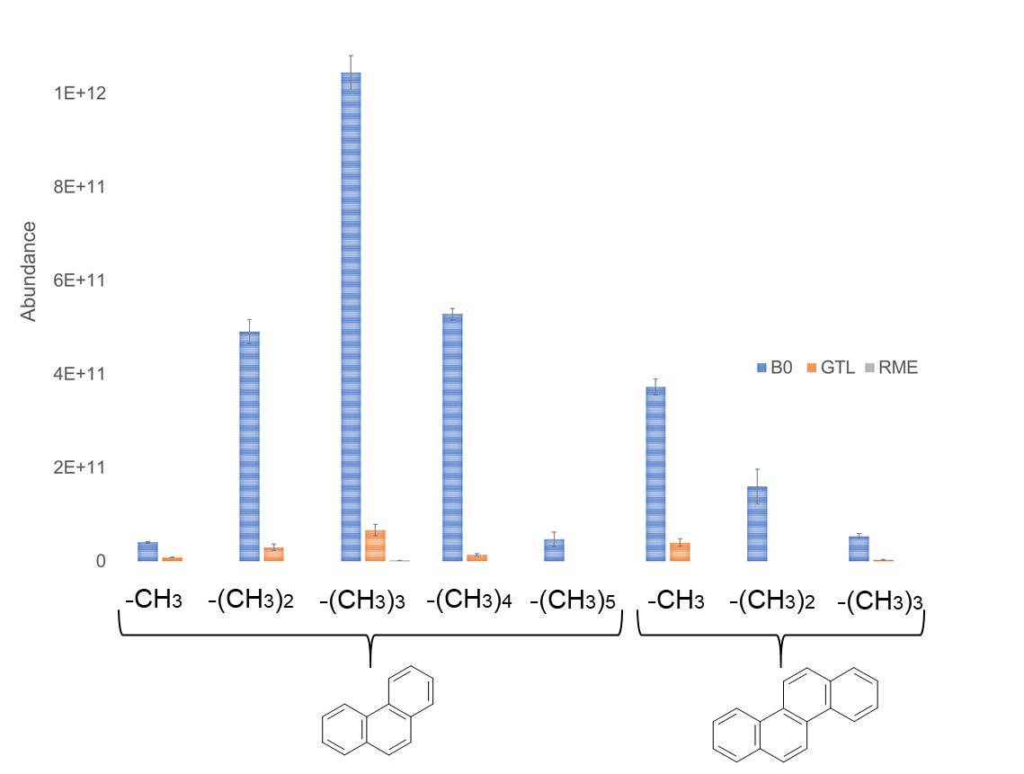

Figure S1: PAH distribution of PM2.5 samples of B0, GTL and RME combustion aerosol. Samples were measured in triplicate. Standard deviation is depicted as error bars.

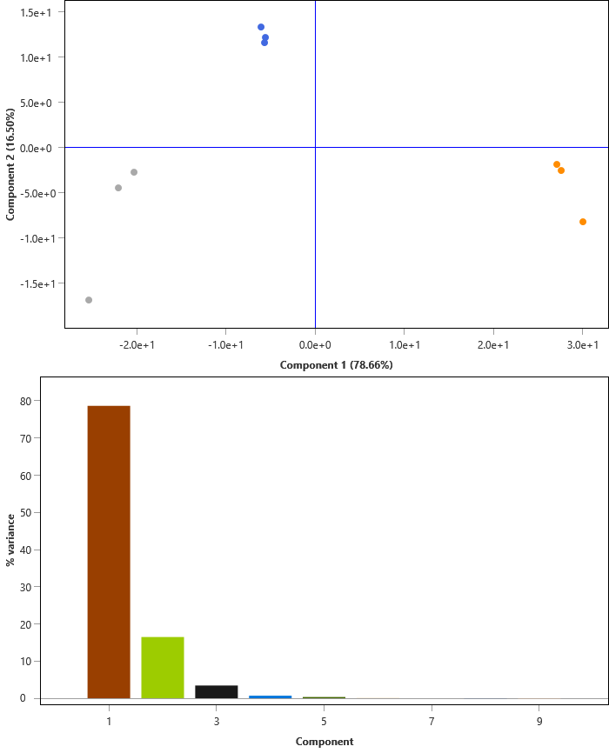Figure S2: Scores plot of the supervised PCA of the PM0.25 combustion aerosol of B0 (blue), GTL (orange) and RME (grey) after analysis via TD-GCxGC-ToFMS.

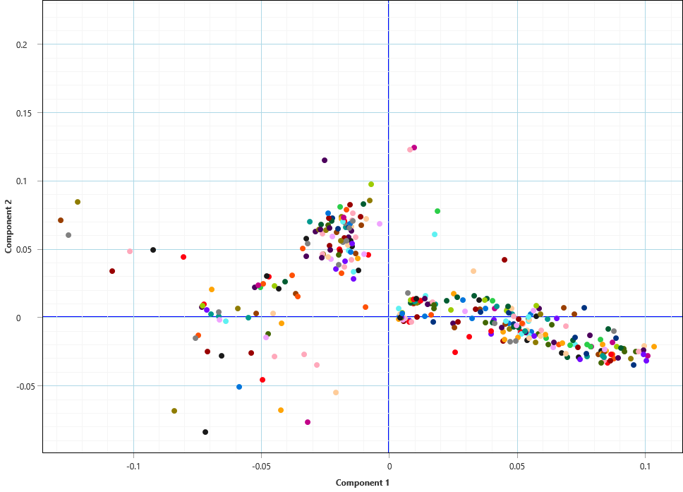

Figure S3: Loadings plot of the supervised PCA of the PM0.25 combustion aerosol of B0, GTL and RME after analysis via TD-GCxGC-ToFMS. Ellipse summarizes significant loadings for PM0.25 of RME.

|  |  |  |  |  |  |  |  |  |  |  |  |  |  |  |  |  |  |
| --- | --- | --- | --- | --- | --- | --- | --- | --- | --- | --- | --- | --- | --- | --- | --- | --- | --- |
| PM2.5 | Al  [ng m-3] | B  [ng m-3] | Ba  [ng m-3] | Ca  [µg m-3] | Cr  [ng m-3] | Cu  [ng m-3] | Fe  [ng m-3] | K  [µg m-3] | Mg  [ng m-3] | Na  [µg m-3] | Ni  [ng m-3] | P  [ng m-3] | S  [µg m-3] | Se  [ng m-3] | Sn  [ng m-3] | Ti  [ng m-3] | Zn  [ng m-3] |
| B01 | 4519 | 1313 | 1123 | 25 | 872 | 458* | 4482 | 45 | 2319 | 18 | 537 | 4772 | 20 | 442* | 145* | 664 | 5101 |
| GTL | 4367 | 782 | 893 | 18 | 846 | 448* | 2925 | 18* | 1792* | 11 | 671 | 2662* | 14 | 441 | 224 | 332 | 2329 |
| RME | 3969 | 976 | 1075 | 21 | 970 | 425* | 3392 | 39 | 2311 | 16 | 637 | 3043 | 17 | 471 | 264 | 257 | 5216 |
| PM0.25 | *Al*  *[ng m-3]* | *B*  *[ng m-3]* | *Ba*  *[ng m-3]* | *Ca*  *[µg m-3]* | *Cr*  *[ng m-3]* | *Cu*  *[ng m-3]* | *Fe*  *[ng m-3]* | *K*  *[µg m-3]* | *Mg*  *[ng m-3]* | *Na*  *[µg m-3]* | *Ni*  *[ng m-3]* | *P*  *[ng m-3]* | *S*  *[µg m-3]* | *Se*  *[ng m-3]* | *Sn*  *[ng m-3]* | *Ti*  *[ng m-3]* | *Zn*  *[ng m-3]* |
| B03 | 8585 | 752 | 794 | 14 | 1137* | 592 | 7146 | 41 | 1758* | 10 | 881 | 3507 | 14 | 746 | 221 | 253 | 4375 |
| GTL2 | 9570 | 422 | 820 | 11 | 1478* | 429* | 6963 | 57 | 1709* | 10 | 1047 | 2626* | 9 | 547 | 208 | 215* | 1588 |
| RME | 4413 | 473 | 914 | 18 | 735* | 441* | 5918 | 88 | 2206 | 14 | 666 | 3545 | 14 | 566 | 215 | 287 | 5631 |
|  |  |  |  |  |  |  |  |  |  |  |  |  |  |  |  |  |  |

*Table S17: Determination of the elemental composition of the combustion aerosols arising from the distinct fuel types using ICP-AES. The concentration of each element was normalized by m3. If not stated differently, the elemental composition was measured on a single sample. 1 n=2; 2 n=3; 3 n=5. Mean values are depicted for samples measured n > 1. *Calculated concentration is below the LOQ and should not be used for quantitative comparison of this element. These elements are only indicated to give a rough idea about the amount detected for the different fuel types. Elements that were not detected over the LOQ in any of the samples were excluded from further comparison. The different limits of quantification (LOQs) for the same element in the distinct PM of the fuels can be explained by the different filter sizes and, thus, the different overall concentrations on the filter used for ICP-AES analysis.*

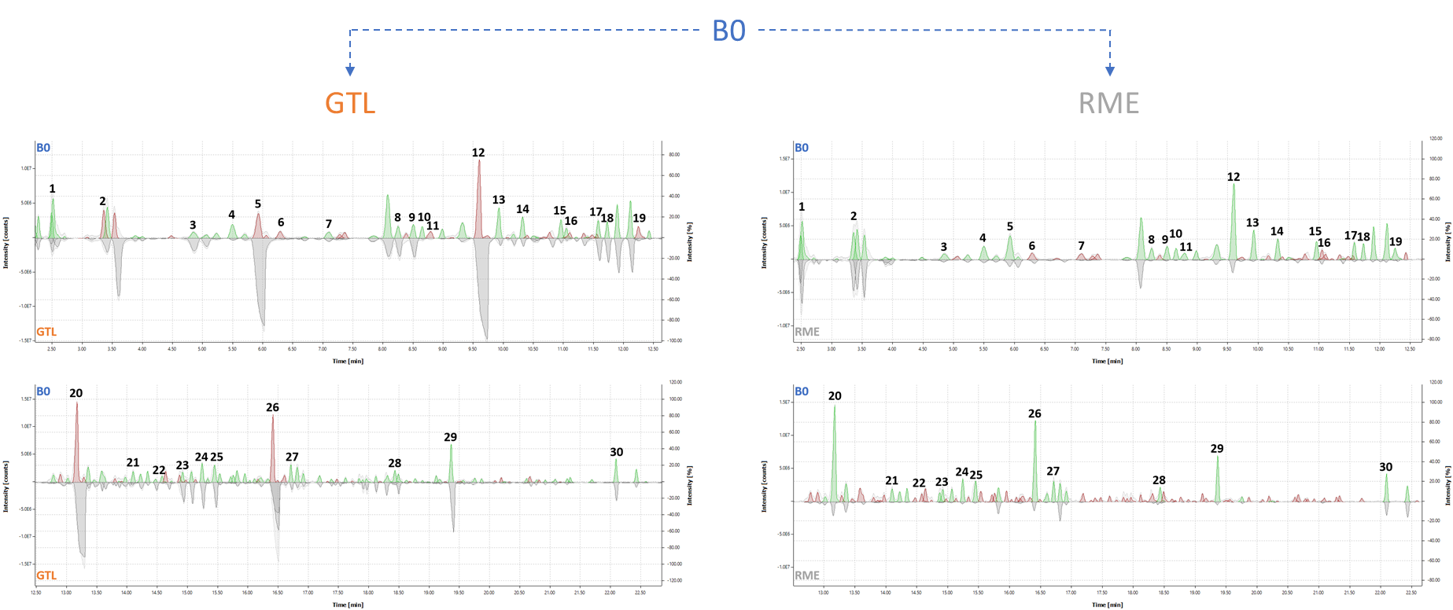

Figure S4: TD-GC-MS analysis of gas phase at the main sampling station during test cycle conditions. Left: Chromatogram of B0 gas phase compared to GTL gas phase. Right: Chromatogram of B0 gas phase compared to RME gas phase. Four different chromatograms can be observed. Upper ones: Retention time from 2 to 13 min. Lower ones: Retention time from 13 to 23 min. Upper part of a chromatogram displays the B0 gas phase components, lower part of the chromatogram displays GTL (left) or RME (right) gas phase components. The 30 most abundant peaks found in the gas phase of B0 are labelled numerically.

|  |  |  |  |
| --- | --- | --- | --- |
| **GTL – Compounds** | **Abundance** | **RME – Compounds** | **Abundance** |
| Decane | 4.47E+09 | *Benzene* | 2.48E+08 |
| Nonane | 3.81E+09 | *Toluene* | 1.89E+08 |
| Undecane | 3.67E+09 | *Decane* | 7.92E+07 |
| Octane | 1.57E+09 | *Undecane* | 6.67E+07 |
| Dodecane | 1.48E+09 | *Nonane* | 6.03E+07 |
| Tridecane | 1.19E+09 | *Tetradecane* | 5.76E+07 |
| Tridecane | 9.43E+08 | *Hexane, 2,4-dimethyl-* | 4.15E+07 |
| Decane, 2-methyl- | 6.31E+08 | *Dodecane* | 3.80E+07 |
| Decane, 3-methyl- | 5.71E+08 | *Hexadecane* | 2.97E+07 |
| Undecane, 2-methyl- | 4.56E+08 | *Styrene* | 2.84E+07 |
| Heptane, 2,4-dimethyl- | 4.22E+08 | *Bicyclo[2.1.1]hexan-2-ol, 2-ethenyl-* | 2.47E+07 |
| Nonane, 3-methyl- | 4.22E+08 | *D-Limonene* | 2.24E+07 |
| Undecane, 3-methyl- | 4.08E+08 | *Pentadecane* | 2.16E+07 |
| Decane, 4-methyl- | 4.04E+08 | *Methyl 3-butenoate* | 1.96E+07 |
| Decane, 5-methyl- | 3.85E+08 | *Ethylbenzene* | 1.85E+07 |
| Nonane, 2-methyl- | 3.74E+08 | *Oxirane, octyl-* | 1.78E+07 |
| Undecane, 5-methyl- | 3.74E+08 | *Undecane* | 1.76E+07 |
| Cyclobutene, 2-propenylidene- | 3.39E+08 | *Tetradecane, 2,6,10-trimethyl-* | 1.75E+07 |
| Undecane, 4-methyl- | 3.29E+08 | *1-Nonanol* | 1.73E+07 |
| Tetradecane | 2.74E+08 | *6-Heptenoic acid, methyl ester* | 1.73E+07 |
| Benzene | 2.2E+08 | *5-Hexenoic acid, methyl ester* | 1.46E+07 |
| Octane, 3-methyl- | 2.17E+08 | *Tridecane* | 1.19E+07 |
| Hexane, 3-methyl- | 1.95E+08 | *Benzaldehyde, 2-methyl-* | 1.16E+07 |
| Dodecane, 2-methyl- | 1.88E+08 | *Hexadecane* | 1.05E+07 |
| 10-Methylnonadecane | 1.69E+08 | *Naphthalene* | 1.04E+07 |
| Dodecane, 2,7,10-trimethyl- | 1.58E+08 | *1H-Indene, 1-chloro-2,3-dihydro-* | 1.02E+07 |
| 2,3-Dimethyldecane | 1.45E+08 | *Decane, 2-methyl-* | 1.01E+07 |
| 5-Ethyldecane | 1.28E+08 | *Undecane* | 9.57E+06 |
| 2,6-Dimethyldecane | 1.18E+08 | *Cyclopropane, 1-pentyl-2-propyl-* | 8.98E+06 |
| Undecane, 3-methyl- | 1.18E+08 | *Decane, 4-methyl-* | 8.40E+06 |

*Table S18: 30 most abundant compounds found in the gas phase of GTL and RME. Table compounds listed from the highest to the lowest peak abundance (TIC area). Identification based on NIST library hits (match factor > 700).*