Rescue of respiratory failure in pulmonary alveolar proteinosis due to pathogenic *MARS1* variants

Dominic Lenz, MD,1§ Mirjam Stahl, MD,2,3§ Elias Seidl, MD,4§ Dominik Schöndorf,5 Heiko Brennenstuhl, MD,1 Florian Gesenhues, MD,4 Tina Heinzmann, MD,6 Thomas Longerich, MD,7 Marisa I. Mendes, PhD,8 Holger Prokisch, PhD,9,10 Gajja S. Salomons, PhD,8 Carola Schön, MD,4 Desirée E. C. Smith, PhD,8 Olaf Sommerburg, MD,2,4 Matias Wagner, MD,9,10,11 Jens H. Westhoff, MD,12 Karl Reiter, MD,4 Christian Staufner, MD,1# Matthias Griese, MD4#,*

§ DL, MS and ES contributed equally to this study.

# CS and MG contributed equally to this study.

* Corresponding author.

**Online Data Supplement**

**Detailed description of the clinical course of both brothers with PAP**

Birth of the index patient was at term (38+4 weeks of gestational age) via Caesarean section with low body weight (2120g; z -2.97) and height (44cm; z -3.29) 1, hence presenting small for gestational age (SGA). Despite normal respiratory adaption (APGAR 9/10/10), he was admitted to the neonatology ward due to hypoglycemia (min. 2.17 mmol/L, Ref 2.5-6.7 mmol/L). Ultrasound of the brain revealed chambered, cystic lateral ventricles with slightly enlarged anterior horns. He was discharged in good clinical conditions after some days of intensive feeding. Aged four months, the boy was admitted to hospital with cough and fever. He was diagnosed with pneumonia (Fig. 2A), but no pathogen could be isolated. Further, suffering from diarrhea and failure to thrive, CMV colitis was diagnosed (CMV IgG 127.6 U/mL (Ref < 6 U/mL), CMV IgM 7.16 U/mL (Ref < 0.85 U/mL), CMV DNA positive intestinal biopsy) and treated with ganciclovir. The diagnostic work-up revealed no signs for immunodeficiency (normal immunoglobulins, normal T-/B-/NK-cell count, lymphocyte subpopulation, CD4-helper cells, T-suppressor cells, T-cell ratio), cystic fibrosis (normal sweat chloride), and coeliac disease (normal transglutaminase antibodies). Testing regarding metabolic disorders remained unremarkable (amino acids in blood plasma, acylcarnitines in dried blood spot, organic acids in urine). Increased alanine aminotransferase (ALAT) and total bilirubin were noticed for the first time. At five month of age, the boy experienced another respiratory tract infection with coughing and fever (Corona-Virus, Respiratory Syncytial-Virus, broncho-alveolar lavage (BAL) with Pneumocystis jirovecii positive PCR). As in other forms of PAP, we assume that respiratory infections, in particular when they affect the alveolar region, result in disturbance of alveolar macrophage surfactant clearance, leading to accumulation of alveolar surfactant, i.e. PAP, if there is a predisposition from genetic or other factors for PAP. Due to normocytic anemia (Hb 6.6 g/dL) the boy received one unit of erythrocyte concentrate; furthermore, iron supplementation was started. At seven months of age, psychomotor developmental delay and severe dystrophy (BMI 11.7 kg/m², z -5.1) were noticed. The MRI of the brain was normal (no more cystic structures), but work-up revealed hepatomegaly and elevated hepatic transaminases. Liver biopsy showed lobular disarray, a moderate mixed periportal steatosis, mild ballooning and scattered inflammatory foci; a pattern consistent with mild non-alcoholic steatohepatitis and overlapping chronic extra-acinar cholestasis. There was a mild ductular reaction, while the interlobular bile ducts revealed only subtle irregularities (Fig. 3 A-F). Progressive liver disease was indicated by initial development of liver cirrhosis with demonstrable perisinusoidal collagen deposition. There was neither an indication for α1-anti-trypsin deficiency, copper, or iron storage nor CMV infection. At this time, persistent tachypnea triggered chest CT showing ground glass opacities in combination with extensive interlobular septal thickening (crazy paving pattern) in all lobes (Fig. 2B), leading to the diagnosis of childhood interstitial lung disease (chILD) and treatment with hydroxychloroquine since the age of eleven months. A gastric tube was inserted, improving weight and height development in the following months (Supp. Fig. 1 A-C). At two years of age, the boy had experienced eight hospital admissions due to respiratory tract infections. Except for one episode, no prolonged oxygen supplementation was necessary (Fig. 2E). Aged two years and seven months, the index patient underwent fundoplication due to severe gastroesophageal reflux with an axial sliding hernia; the PEG was removed and a gastric and jejunal catheter inserted. Extubation was performed successfully few hours after surgery, whereas 16 hours after the surgery, the boy suffered from a severe and rapid hypoglycemia (min. 0.56 mmol/L, Ref 3.3-6.7 mmol/L). Blood glucose could be stabilized with intravenous glucose, but within the next 24 hours his clinical condition deteriorated and he developed multiorgan failure with respiratory insufficiency with pulmonary edema, anuria and liver failure with ascites (max. INR 2.21, ALAT max. 106 U/l, ASAT max. 66 U/l). High-flow nasal cannula (HFNC, max. 23 l/min FiO2 1.0) did not relieve the situation and invasive high-frequency oscillation ventilation was started including NO-therapy. Renal failure necessitated 20h of hemofiltration and showed tubulo-interstitial damage. Coagulopathy was treated by substitution of vitamin K and fresh-frozen plasma. Amino acids were supplemented (2 g/kg/d) and high glucose intake (8 g/kg/d) was assured. After five days of invasive ventilation, the boy was extubated and therapy was continued with supplemental oxygen by nasal cannula (6-8 l/min, FiO2 1.0). Chest-CT (Fig. 2C) revealed increasing crazy paving pattern in line with severe PAP with respiratory insufficiency. Oral methionine at increasing dosage was initiated, protein intake of 2-3 g/kg/d was assured and blood levels of amino acids were monitored (Supp. Fig. 2A). For immediate relief of symptoms six therapeutic WLL were performed under general anesthesia using a previously described technique 2,3. Increased amounts of protein could be removed (1.7 g – 3.2 g per WLL). Under this intensive treatment, the respiratory situation improved slowly. PCR of BAL fluid revealed varicella DNA and acyclovir treatment was started. To prevent frequent respiratory infections, treatment with intra-venous immunoglobulins (IVIG) was started. After six months of this therapeutic approach, no more ventilation or supplemental oxygen were needed. Oxygen saturations during day and night were normal (95-100%) and signs of dyspnea had disappeared with improved chest imaging (Fig. 2D). Therapy with hydroxychloroquine was stopped, whereas assured protein intake and oral methionine supplementation were continued. At last visit, the boy had learned to walk and run without dyspnea. Growth curves had normalized (Supp. Fig. 1A-C). There was still psychomotor delay with muscular hypotonia, and the patient had persistently elevated liver transaminases.

The older brother of the index patient (F1:II.1) carrying the same homozygous variant as the index patient was born at 35+1 weeks of gestation via Caesarean section due to a HELPP-syndrome of the mother (birthweight 2040g, z -1.39) 1. After adequate cardio-respiratory adaption, the boy developed apnea, tachypnea and hypoglycemia (min. 1.78 mmol/L, Ref 2.5-6.7 mmol/L) at the age of 7 minutes. He was treated by pharyngeal CPAP (PEEP 5 cmH2O) with mild oxygen supply (FiO2 max. 0.25). Hyperbilirubinemia (max. 270 µmol/L) was treated by phototherapy, anemia (Hb 9.1 g/dL) with iron supplementation. At the age of 2.5 months, the boy was re-admitted to the hospital due to gastroenteritis with recurrent vomiting and increasing unrest. Ultrasound of the brain revealed prepontine cystic structures. Cerebrospinal fluid showed no hints for infections or metabolic energy disorders (normal lactate). Despite iron supplementation, normocytic anemia (Hb 9.2 g/dL) was diagnosed. Metabolic work-up revealed elevated serum lactate (max. 6.62 mmol/L) without further hints of an underlying metabolic disorder. In the following two years the boy was admitted twice to hospital: the first time he was diagnosed with an influenza infection with concomitant otitis media, treated with oseltamivir. The second time he suffered from dehydration due to a febrile gastroenteritis caused by rotavirus and norovirus. The following years, the boy was in good health, except weight gain in the lower range for age (BMI 13-14 kg/m², z -1.8 to -1.3; Supp. Fig. 1 D-H). The parents reported that the boy had a clear preference for a high protein diet, including up to five eggs per day and typically preferring chicken meat and other protein rich nutritional products to other food. After the genetic diagnosis was made, reverse phenotyping was performed. Radiological examinations showed signs of an interstitial lung disease (Fig. 4A and B), milky BAL fluid was compatible with PAP, and an impaired lung function (FVC 74%, z-Score -2.14) was diagnosed. However, no signs of liver disease were detected, with normal liver enzymes and function, inconspicuous abdominal ultrasound and normal fibroscan. Neuropediatric assessment revealed a developmental delay with first steps at 20 months, free sitting at 1.5 years, first words at 3 years, and biking at 5 years. From the age of 3 years, he had a development spurt, and currently attends the 2nd class of a regular school with normal performance. He speaks 3 languages (Turkish, Zaza and German). Examination showed a slight gross and fine motor coordination disorder, but no remarkable neurological findings. Based on the positive experience in his younger brother, a protein rich diet was assured (2-3 g/kg/d) and methionine supplementation was initiated with 50 mg/kg/d (Supp. Fig. 2B).

**SUPPLEMENTAL TABLES**

Sup. Table 1:Genotypes and clinical phenotypes of patients with interstitial lung and liver disease (ILLD), including the study patients and all previously published individuals.

See Excel file: Supp. Table 1

Abbreviations: N, no; Y, yes; n.a., not available; SGA, small for gestational age; FTT, failure to thrive; SaO2, oxygen saturation; MRI, magnetic resonance imaging; CT, computed tomography. Descent according to international two letter country code.

**SUPP. FIGURE LEGENDS**

**Supplemental Figure S1.** Anthropometry in brothers affected by biallelic pathogenic variants in MARS1. (A - C) Growth charts (WHO based; z-score) for the index patient (F1:II.3). Red arrow indicates start of additional nutrition via naso-gastric tube, later replaced by PEG/PEJ in the index patient.(D – H) Growth charts (WHO based; z-score) of the older brother (F1:II.1) of the index patient.

**Supplemental Figure S2.** In-silico effect prediction of MARSmissense variants using five different prediction scores. General guidelines for interpretation: a CADD (Combined Annotation Dependent Depletion) score of > 20 identifies the top 1 % of most deleterious variants within a give gene; an M-CAP (Mendelian Clinically Applicable Pathogenicity) score of > 0.025 aims to misclassify no more than 5% of pathogenic variants and reduces the number of variants of uncertain significance; PolyPhen > 0.5 is classified as “possibly damaging”; the REVEL (Rare Exome Variant Ensemble Learner) score integrates 8 conservative and 8 functional scores, high values reflect higher probability to be “disease causing”; SIFT (Sorting intolerant from tolerant) < 0.05 can be interpreted as “deleterious”.

**Supp. Fig. 1A**

**F1:II.3**

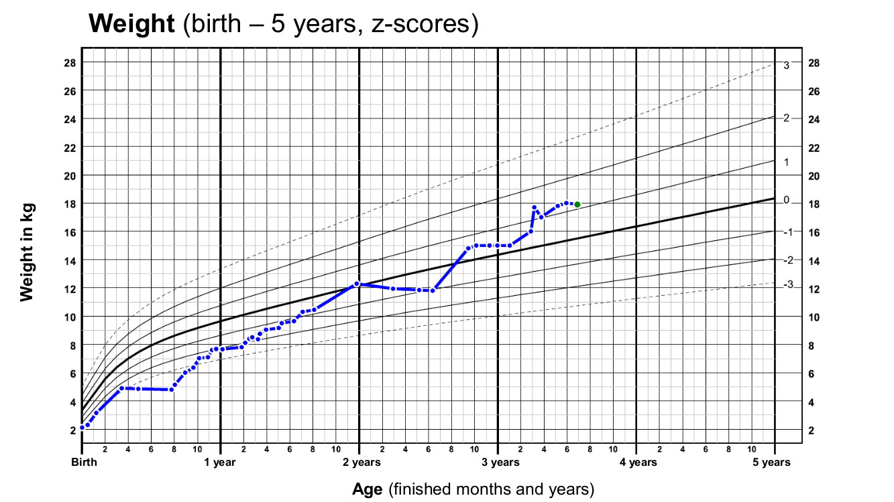

**Supp. Fig. 1B**

**F1:II.3**

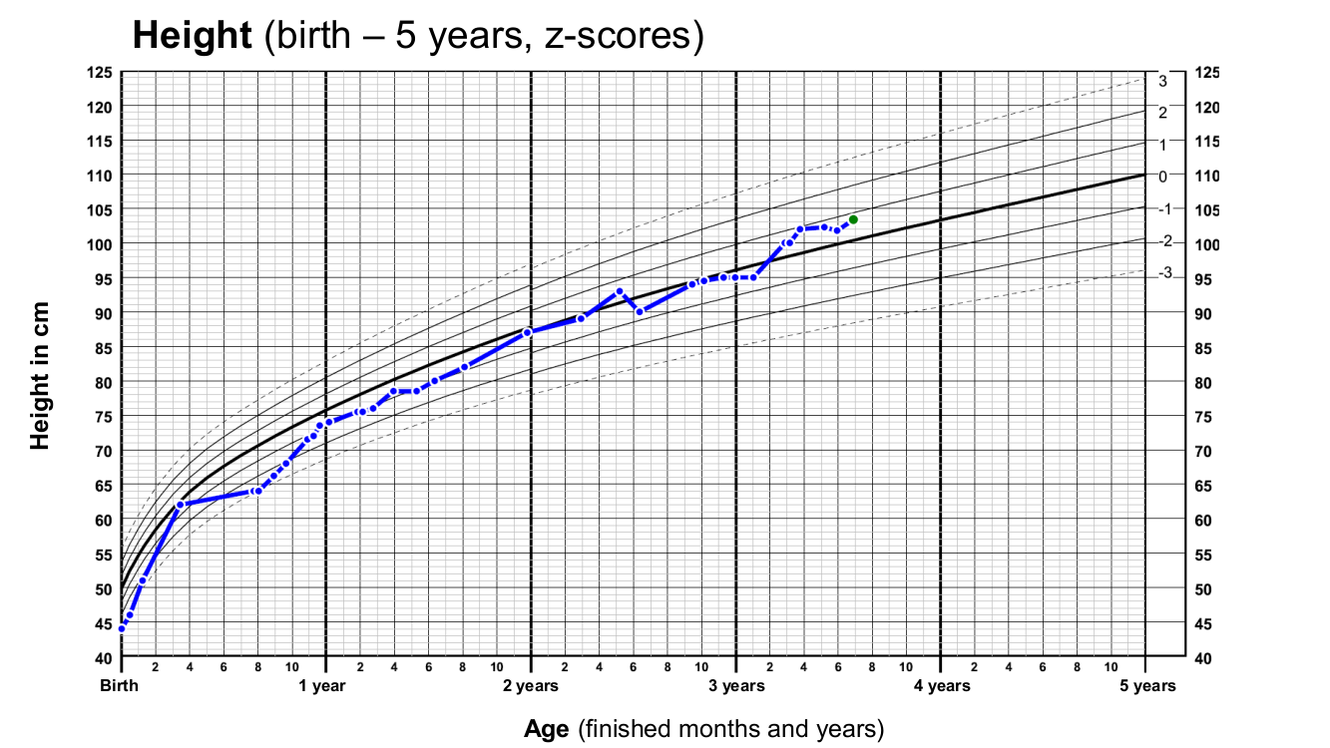

**Supp. Fig. 1C**

**F1:II.3**

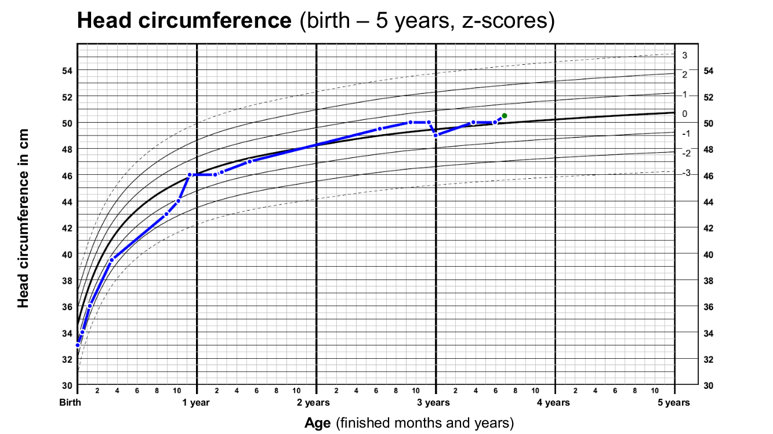

**Supp. Fig. 1D**

**F1:II.1**

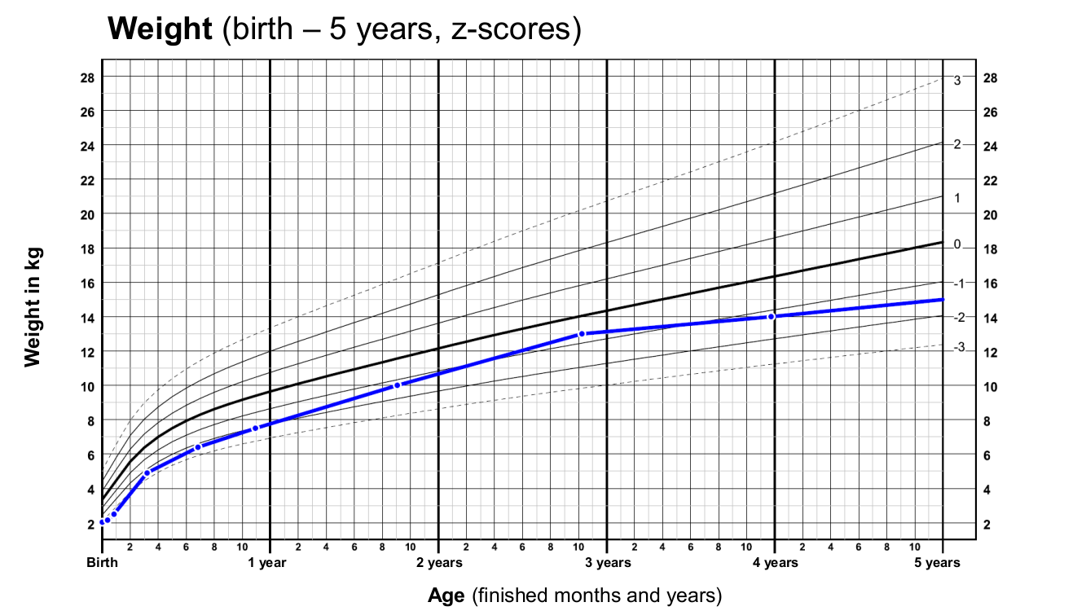

**Supp. Fig. 1E**

**F1:II.1**

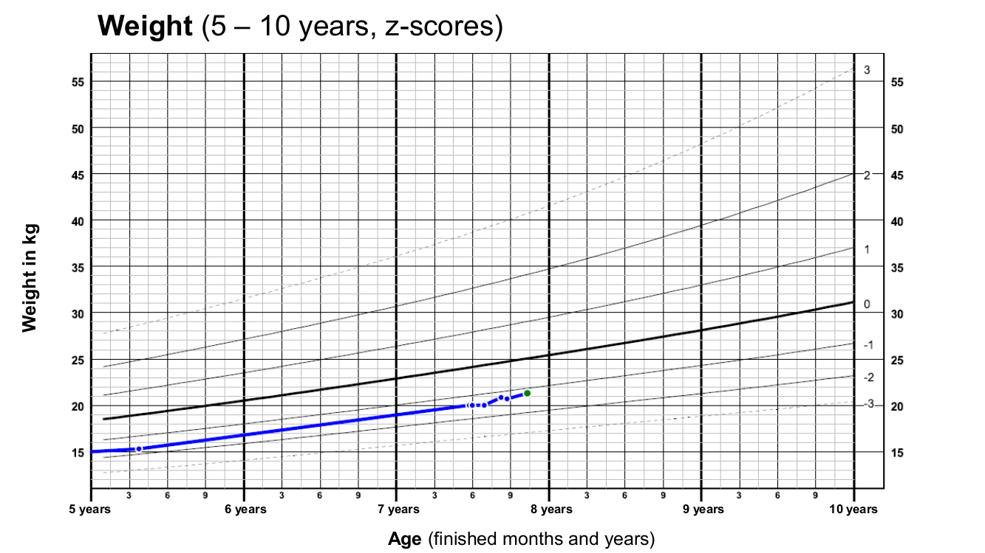

**Supp. Fig. 1F**

**F1:II.1**

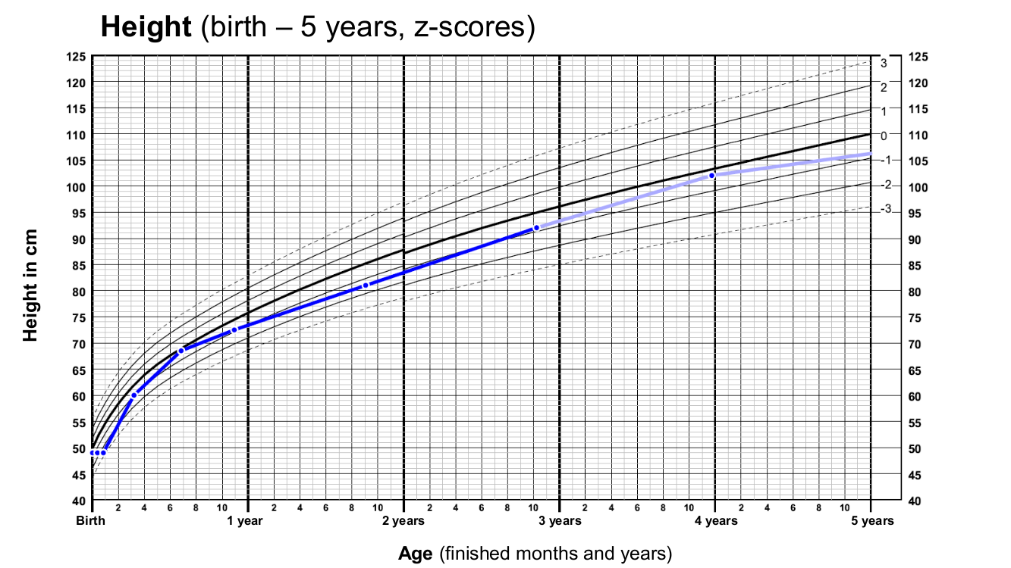

**Supp. Fig. 1G**

**F1:II.1**

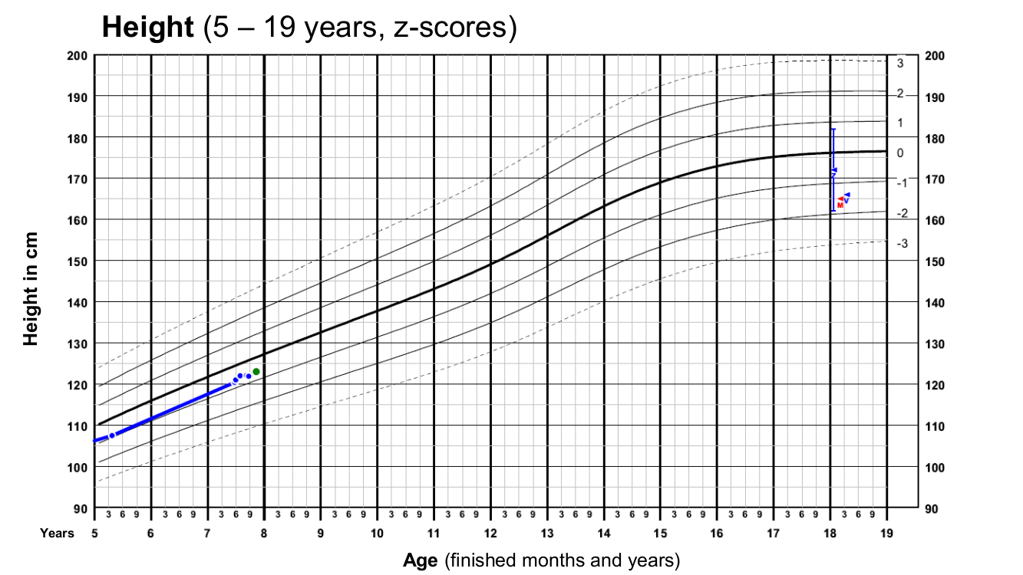

**Supp. Fig. 1H**

**F1:II.1**

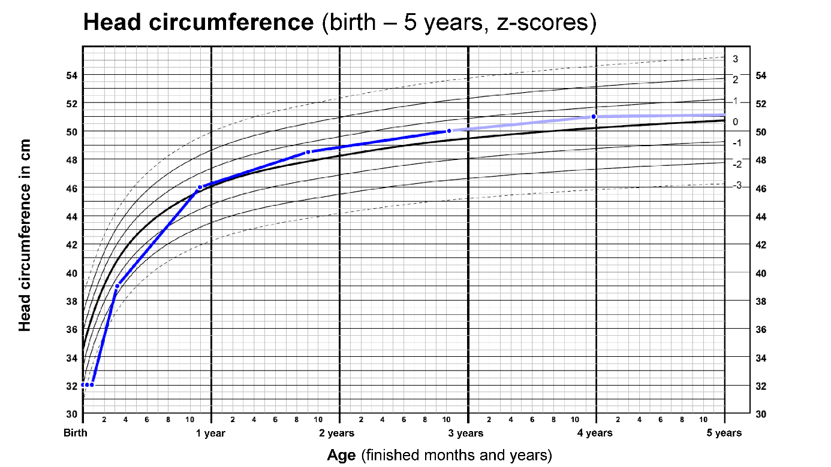

**Supp. Fig. 2**

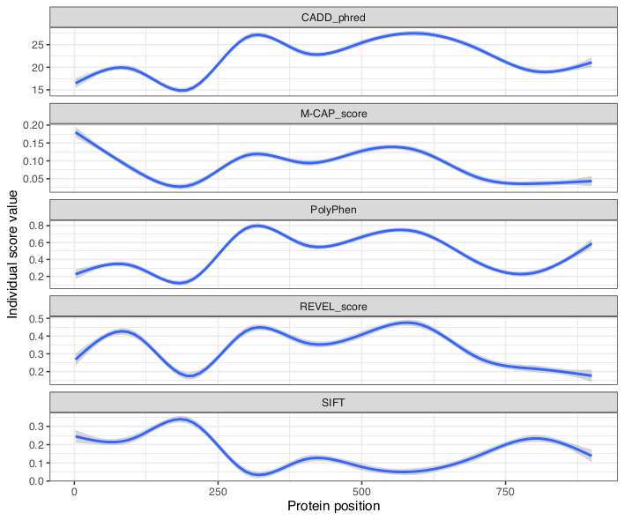

**References**

1 Voigt, M. *et al.* Analysis of the Neonatal Collective in the Federal Republic of Germany. *Geburtsh Frauenheilk* **66**, 956-970, doi:10.1055/s-2006-924458 (2006).

2 Griese, M. *et al.* Long-term follow-up and treatment of congenital alveolar proteinosis. *BMC pediatrics* **11**, 72, doi:10.1186/1471-2431-11-72 (2011).

3 Reiter, K., Schoen, C., Griese, M. & Nicolai, T. Whole-lung lavage in infants and children with pulmonary alveolar proteinosis. *Paediatric anaesthesia* **20**, 1118-1123, doi:10.1111/j.1460-9592.2010.03442.x (2010).