Additional Figure S1

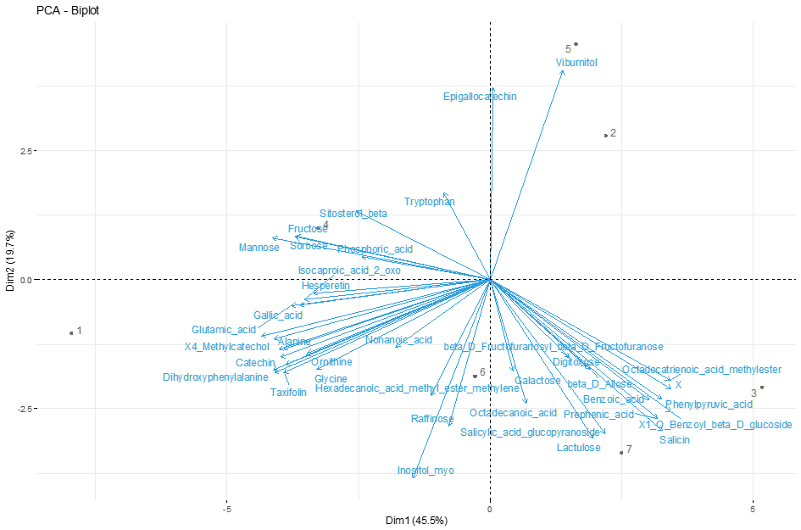

Fig S1 Biplot of rhizosphere soil metabolites of Riesling with oak or poplar in combination and as monoculture. Arrows indicate vectors; statistics according to Methods part.

Additional Figure S2

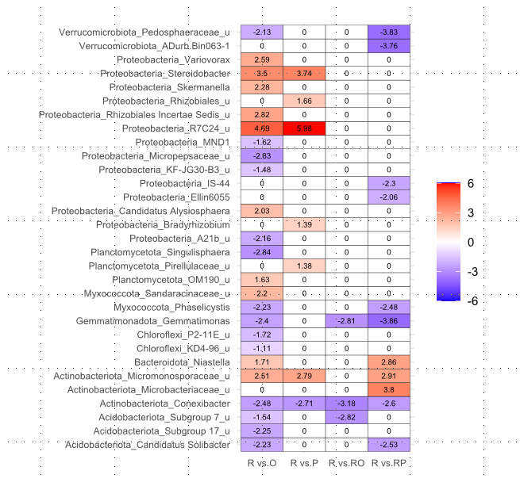

Fig. S2 Analysis of root microbiome of Riesling (R) with oak (O) and poplar (P) in combination and monoculture. Heatmap shows significant (p<0.05) log-fold changes of pairwise comparisons on genus level calculated in ANCOM-BC2, using Benjamini-Hochberg correction for multiple comparisons.