Supplementary Material

**Earthworm cast formation and development: a shift from plant litter to mineral associated organic matter**

**A. Vidal a,b*, F. Watteau c, L. Remusat d, C.W. Muellerb, T. T. Nguyen Tu a, Franz Buegger e, S. Derenne a, K. Quenea**

**\*CORRESPONDENCE:** Dr. Alix Vidal**,** alix.vidal@wzw.tum.de

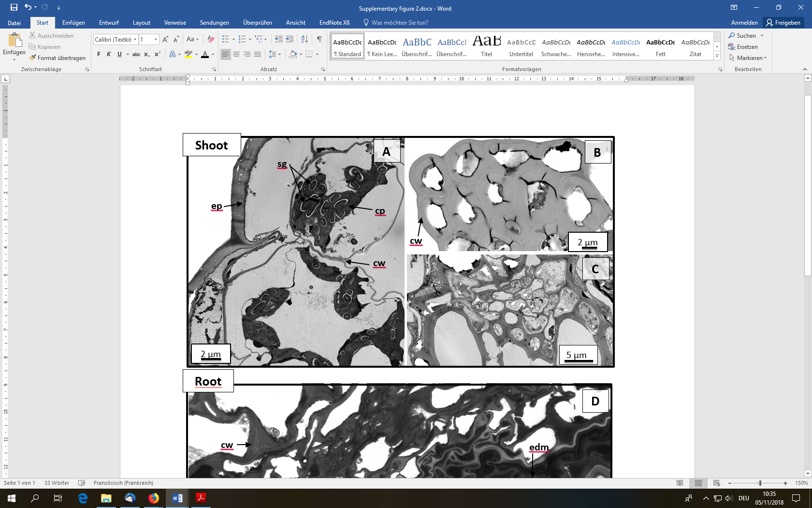

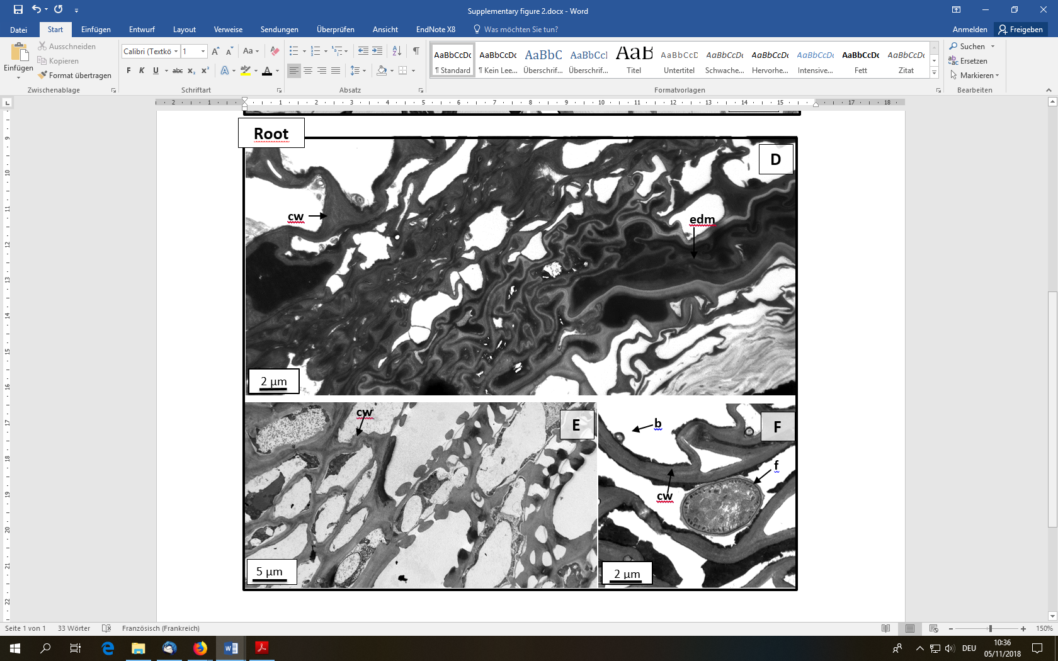

**Supplementary figure 1.** TEM micrographs of initial shoots (A-C) and roots (G-F). **(A)** chlorophyll parenchyma and epidermis cells; **(B)** and **(E)** woody tissue; **(C)** woody and parenchyma tissue; **(D)** parenchyma tissue and **(F)** microorganisms present in initial roots. b, bacteria; cp, chloroplast area; cw, cell wall; edm, electron dense matter; ep, epidermis; f, fungus; sg, starch grain.

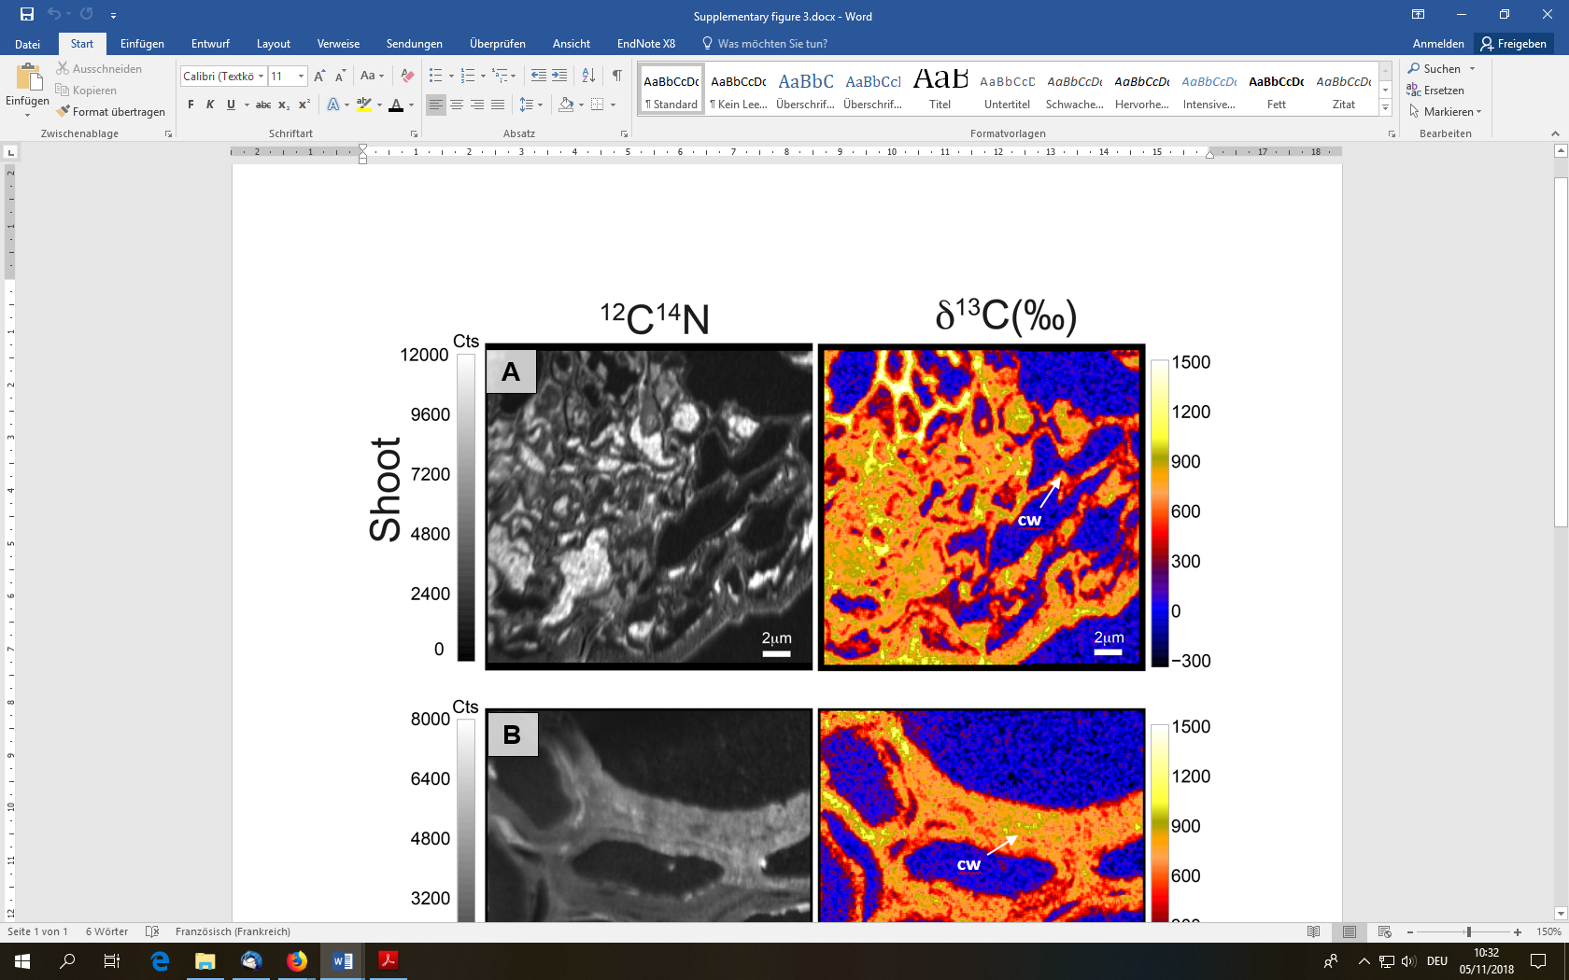

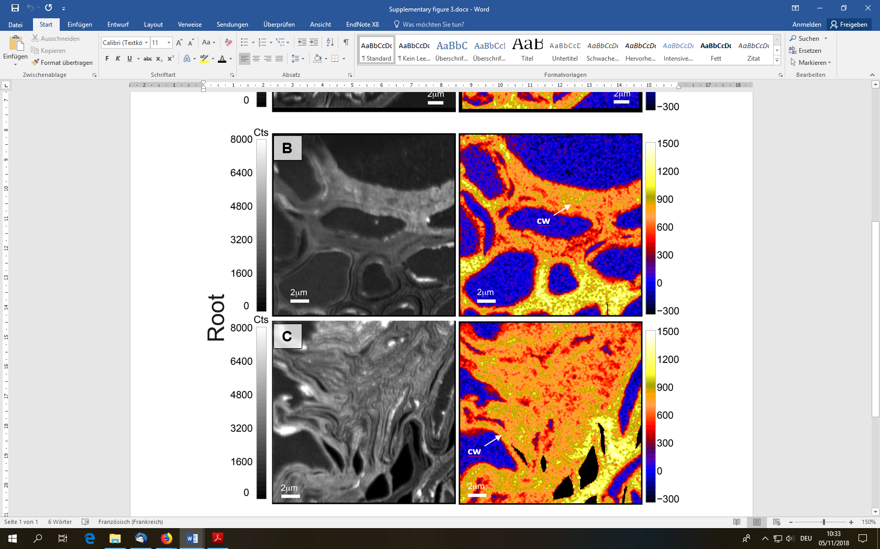

**Supplementary figure 2.**NanoSIMS images of the 12C14N- and δ13C in initial **(A)** shoots and **(B)**, **(C)** roots of *Lolium multiflorum*. cw, cell wall.

|  |  |  |
| --- | --- | --- |
|  | **Shoot** | **Root** |
| OC content (mg.g soil-1) | 408 | 402 |
| δ13C (‰) | 1632 | 1324 |
| alkyl-C | 14.9 | 4.42 |
| O-N-alkyl-C | 62.4 | 63.4 |
| aromatic-C | 10.5 | 17.6 |
| carboxyl-C | 11.7 | 14.0 |
| alkyl-C/O-N-alkyl-C | 0.24 | 0.07 |

**Supplementary table 1.** Chemical characterization of the initial roots and shoots applied on the soil surface at the beginning of the experiment.

**Supplementary table 2.** Intensity in the chemical shift regions integrated from 13C Cross polarization magic angle nuclear magnetic resonance (CPMAS NMR) spectra, in earthworm cast samples.

|  |  |  |  |  |  |  |  |  |  |  |
| --- | --- | --- | --- | --- | --- | --- | --- | --- | --- | --- |
|  |  | **Particulate Organic Matter (POM)** | | | | **Mineral associates Organic Matter (MOM)** | | | | |
|  |  | alkyl-C | O-N-alkyl-C | aromatic-C | carboxyl-C | alkyl-C | O-N-alkyl-C | aromatic-C | carboxyl-C |
| Cast-Control | 8 weeks | 16.2 | 37.5 | 28.5 | 16.8 | 16.3 | 38.9 | 24.2 | 19.8 |
| 54 weeks | 13.1 | 33.1 | 30.8 | 21.2 | 17.1 | 34.3 | 26.1 | 20.7 |
| Cast-Shoot | 8 weeks | 15.3 | 61.6 | 13.7 | 9.1 | 17.9 | 47.3 | 17.5 | 16.5 |
| 54 weeks | 18.9 | 41.1 | 24.2 | 15.4 | 20.6 | 42.1 | 19.7 | 16.3 |
| Cast-Root | 8 weeks | 7.4 | 68.4 | 15.7 | 8.2 | 11.1 | 64.6 | 14.7 | 9.2 |
| 54 weeks | 14.3 | 41.1 | 26.4 | 16.9 | 17.4 | 46.3 | 22.1 | 13.6 |