**SUPPLEMENTARY MATERIAL**

**Lipoprotein(a) and the Risk of Cardiovascular Disease in the European Population – Results from the BiomarCaRE Consortium.**

C. Waldeyer*1, N. Makarova*1,2, T. Zeller1, 2, R. B. Schnabel1, 2, F.J. Brunner1, T. Jørgensen3, 4, 5, A. Linneberg3, 4, 6, T. Niiranen7, V. Salomaa7, P. Jousilahti7, J.Yarnell8, M. M. Ferrario9, G. Veronesi9, P. Brambilla10, S. G. Signorini10, L. Iacoviello11, S. Costanzo11, S. Giampaoli12, L. Palmieri12, C. Meisinger13, B. Thorand13, F. Kee8, W. Koenig14, 15, 16, F. Ojeda1, J. Kontto7, U. Landmesser 17, 18, 19,K. Kuulasmaa7, S. Blankenberg1, 2

¹ University Heart Center Hamburg, Department for General and Interventional Cardiology, Hamburg, Germany

² German Center for Cardiovascular Research (DZHK e.V.), partner site Hamburg/Kiel/Lübeck, Germany

3 Faculty of Health and Medical Sciences, University of Copenhagen, Denmark

4 Research Centre for Prevention and Health, Capital Region, Denmark

5 Medical Faculty, Aalborg University

6 Rigshospitalet, Copenhagen University Hospital, Copenhagen, Denmark

7 National Institute for Health and Welfare, Helsinki, Finland

8 Centre for Public Health, Queens University of Belfast, Centre for Public Health Belfast, Northern Ireland

9 Research Centre in Epidemiology and Preventive Medicine, Department of Clinical and Experimental Medicine, University of Insubria, Varese, Italy

10 Università degli studi di Milano-Bicocca, Department of Medicina e Chirurgia, Italy

11 IRCCS Istituto Neurologico Mediterraneo Neuromed, Department of Epidemiology and Prevention, Laboratory of Molecular and Nutritional Epidemiology, Pozzilli, Isernia, Italy

12 Istituto Superiore di Sanità, Rome, Italy

13 Helmholtz Zentrum München, German Research Center for Environmental Health, Institute of Epidemiology II, Neuherberg, Germany

14 University of Ulm Medical Center, Department of Internal Medicine II - Cardiology, Ulm, Germany

15 German Heart Center Munich, Technical University of Munich, Munich, Germany

16 DZHK (German Centre for Cardiovascular Research), partner site Munich Heart Alliance, Munich, Germany

17 Department of Cardiology, Charité Universitätsmedizin Berlin, Campus Benjamin Franklin, Berlin, Germany

18 Berlin Institute of Health (BIH), Berlin, Germany

19 DZHK (German Centre for Cardiovascular Research), partner site Berlin, Berlin, Germany

* Authors contributed equally as first author of the manuscript

**Corresponding author**

Stefan Blankenberg, MD

University Heart Center Hamburg

Clinic for General and Interventional Cardiology, Hamburg, Germany

Email: s.blankenberg@uke.de

Phone: +49 407410-56800

Fax: +49 407410-53622

**Box S1**

Overview and description of contributing studies

**BiomarCaRE cohorts**

|  |  |  |
| --- | --- | --- |
| **Study/cohort (Reference)** | **Country** | **Study/cohort full name and short description** |
| MONICA Brianza Study (1) | Italy | The MONICA-Brianza Cohort Study is a prospective observational study of three cohorts of 25-64 years old residents in Brianza, a highly-industrialized area located between Milan and the Swiss border, Northern Italy. Gender- and ten-year age stratified samples were randomly drawn in 1986, 1990, and 1993, and cardiovascular risk factors were investigated at baseline following the procedures of the WHO MONICA Project. The overall participation rate was 69%. For all subjects whole blood and serum samples were stored in a biobank. The protocol was approved by the Monza Hospital Ethical Committee. Study participants were followed up for first coronary or stroke events, fatal and non-fatal, up to the end of 2008, for a median of 15 years. http://epimed.uninsubria.eu. |
| Caerphilly Prospective Study (2) | United Kingdom | The Caerphilly cohort is a prospective population based cohort from Wales. Men aged 56-70 years in 1989-93 were selected from the general population of Caerphilly in South Wales (population 40000) based on their date of birth from electronical registers and private census. Phase 3 (N=2171) was collected in 1989-93 and re-examined ten years later in 2002-2004 (Phase 5) taking repeated measurements of several risk factors and biomarkers. For current analysis only Phase 3 was used. Follow-up for deaths was performed by the Office of National Statistics and for non-fatal cardiovascular events using data linkage of hospital and GP records with validation by a study medical committee. Follow-up has been completed to February 2012. <http://www.thl.fi/publications/morgam/cohorts/full/uk/unk-caea.htm> |
| FINRISK 1997 (3) | Finland | The FINRISK study is a series of population-based cardiovascular risk factor surveys carried out every five years in five (or six in 2002) districts of Finland, including North Karelia, Northern Savo (former Kuopio), Southwestern Finland, Oulu Province, Lapland province (in 2002 only), and the region of Helsinki and Vantaa. A stratified random sample was drawn for each survey from the national population register; the age-range was 25-74 years. All individuals enrolled in the study received a physical examination, a self-administered questionnaire, and a blood sample was drawn. The cohort of the 1997 survey was used for the current analysis. Altogether 11500 individuals were invited and 8444 (73%) participated in the clinical examination. During follow-up the National Hospital Discharge Register, the National Causes of Death Register and the National Drug Reimbursement Register were used to identify endpoints. At the moment, the follow-up extends until Dec. 31st, 2010, i.e., 14 years from baseline. The Coordinating Ethics Committee of the Helsinki and Uusimaa Hospital District approved the study, which followed the declaration of Helsinki. All subjects gave written informed consent. <http://www.thl.fi/publications/morgam/cohorts/full/finland/fin-fina.htm> |
| DanMONICA Study, RCPH (4) | Denmark | The DanMONICA cohorts from the Research Center for Prevention and Health are three prospective population based cohorts from 11 municipalities from the western part of the suburbs of Copenhagen, Denmark. Random sampling was based on the national population register, stratified by sex and year of birth. Cohort 1 and 3 consists of men and women aged 30-70 years and cohort 2 consists of men and women aged 30-60. Cohort 1 was collected in 1982-1984 (N=4052). Cohort 2 (N=1504) was examined in 1986-1987 and cohort 3 (N=2026) was examined in 1991-1992. Follow up is achieved through linkage to the National Cause of Death Register and National Hospital Discharge Register (Lynge et al. (5)). The MORGAM diagnosis was derived from the routine diagnosis as described in http://www.thl.fi/publications/morgam/cohorts/full/denmark/den-gloa.htm Follow up for the cohorts 1, 2, and 3 is completed to December 31st 2010. <http://www.thl.fi/publications/morgam/cohorts/full/denmark/den-gloa.htm> |
| Kooperative Gesundheits-forschung in der Region Augsburg (KORA)(6) | Germany | The WHO Multinational Monitoring of Trends and Determinants in Cardiovascular Disease (MONICA)/ Cooperative Health Research in the Region of Augsburg (KORA) cohorts comprise all respondents from representative sample surveys from the city of Augsburg and the less urban Landkreis Augsburg and Landkreis Aichach-Friedberg regions in Bavaria, Southern Germany. List of municipalities and population registers were used as sampling frames for the first and the second stage of two-stage sampling, respectively. The second stage of sampling was stratified by sex and ten-year age group. The Survey 3 (S3) baseline examination (1994-1995) was carried out as part of the WHO MONICA project and consists of 4856 men and women aged 25-74 years with a response rate of 75%. The Survey 4 (S4) baseline examination was carried out in 1999-2001 and includes 4261 participants (response rate: 66%). The S4 study and morbidity and mortality follow-ups were conducted within the frame of KORA. (7)The BiomarCaRE project includes n=4692 and n=4221 participants from S3 and S4, respectively.  Within the framework of the KORA Studies, follow-up questionnaires were sent to each former participant in 1997-1998, in 2002-2003, and in 2008-2009 to obtain information on the occurrence of chronic diseases and risk factors. Mortality follow-up was performed as follows: If a person did not return the follow-up questionnaire, the person's vital status was ascertained through the population registries inside and outside the study area.  Coronary events were identified through the MONICA/KORA Augsburg coronary event registry. (8) Coronary deaths were validated by autopsy reports, death certificates, and chart review from the last treating physician. Self-reported cases of incident stroke were validated by medical records. Further details on the study procedures can be found under http://www.thl.fi/publications/morgam/cohorts/full/germany/ger-auga.htm |
| Moli-Sani Project(9) | Italy | The cohort of the Moli-Sani Project was recruited in the Molise region from city hall registries by a multistage sampling. First, townships were sampled in major areas by cluster sampling; then, within each township, participants aged 35 years or over were selected by simple random sampling. Exclusion criteria were pregnancy at the time of recruitment, lack of understanding, current multiple trauma or coma, or refusal to sign the informed consent. A total of 24325 men (47%) and women (53%) over the age of 35 were examined at baseline from 2005 to 2010. Participation was 70%. The cohort was followed up for a median of 4.2 years (maximum 6.5 years) at December 2011 and will be followed up every 5 years. (9) Follow-up is achieved through record linkage to national mortality registries and hospital discharge registers, validation of events was achieved through hospital record linkage and doctors medical records using the criteria desribed in http://www.thl.fi/publications/morgam/cohorts/full/italy/ita-mola.htm <http://www.moli-sani.org/> |
| **M**alattie **AT**erosclerotiche **I**stituto **S**uperiore di **S**anità (MATISS) (10) | Italy | The study started in 1983 as DiSCo - DIstretto Sezze controllo COmunitario - a demonstration project of non-communicable diseases conducted in Central Italy, in a rural area located 100 km southeast of Rome. In 1983-84 and in 1986-87 independent random samples of the general population, stratified by age and sex were drawn in 4 towns (Sezze, Roccagorga, Bassiano, and Priverno). Cardiovascular risk factors were measured in 1983-1984 (participation rate 67%) and in 1986-1987 (participation rate 41%). Since 1993 the project continued as prospective observational study with the name of MATISS. In 1993-96 a new cohort of 1 970 persons (participation rate 60%) was examined together with the old cohorts (1983-84 and 1986-87). BiomarCaRE includes all data and biological specimens collected in 1993-96 for a total of 4489 persons aged 20-79 years, i.e. 72% of the re-examined old cohorts (only those with serum/plasma specimens) and the new cohort.  Follow-up is available for all cohorts until December 2004. Vital status was checked at the municipalities of residence; mortality was performed by mortality registry and causes of deaths were collected from death certificates; suspected fatal and non-fatal coronary and stroke events, identified by the record linkage of mortality and hospital discharge diagnosis registries, were validated by the MONICA diagnostic criteria using the clinical records and other GPs information. The study is part of the CUORE Project of the Italian Public Health Institute and was approved by the Ethic Committee in 2008. http://www.cuore.iss.it/eng/assessment/procedures.asp |

**2. Definition of endpoints**

*Major coronary event* was defined as first fatal or non-fatal coronary event with any of the following diagnostic categories:

* definite acute myocardial infarction (AMI)
* possible AMI or coronary death
* definite or possible AMI, not specifiable
* unstable angina pectoris
* unclassifiable (see MORGAM Manual). (11)

*Cardiovascular disease event* as an endpoint was defined as the first fatal or non-fatal coronary event or likely cerebral infarction.

The coronary event included:

* acute definite or possible myocardial infarction or coronary death
* unstable angina pectoris
* cardiac revascularization
* unclassifiable death.

“Unclassifiable” death refers to death with insufficient evidence of coronary origin and no competing cause. For further details of the definition, see MORGAM Derived Variable CVD3. (12)

In the Caerphilly study this end-point included only definite myocardial infarction and no strokes. In the MONICA/KORA Augsburg study cardiac revascularization was not followed up. In the MONICA/KORA Augsburg and MONICA Brianza studies unstable angina pectoris was not assessed as an outcome but it is largely included in the category “possible myocardial infarction” of the WHO MONICA classification used in these studies.

*Total mortality* as an endpoint was defined as death due to any cause during the follow-up time. The follow-up starts at the date of baseline examinations.

Details of the follow-up and diagnostic procedures of each participating study have been published elsewhere. (12)

**3. Funding and acknowledgements of cohorts**

Caerphilly Prospective Study (CaPs). This study was supported by a Project Grant from the British Heart Foundation (PG/09/002/26056).

The FINRISK surveys were mainly funded by budgetary funds of THL. Additional funding has been obtained from numerous non-profit foundations. Dr. Salomaa (PI) has been supported by the Finnish Foundation for Cardiovascular Research and the Academy of Finland (grant number 139635).

The DanMONICA cohorts at the Research Centre for Prevention and Health were established over a period of ten years and have been funded by numerous sources which have been acknowledged, where appropriate, in the original articles.

The Moli-Sani Project was partially supported by research grants from Pfizer Foundation (Rome, Italy), the Italian Ministry of University and Research (MIUR, Rome, Italy)–Programma Triennale di Ricerca, Decreto n.1588 and Instrumentation Laboratory, Milan, Italy.

The follow-up activities for the MONICA Brianza Study were funded by the Regione Lombardia Health Administration (grants 31737/1997, 17155/2004 and 10800/2009) as part of the Osservatorio Epidemiologico Cardiovascolare Regionale Lombardo. Key personnel: Ferrario MM and Cesana G (study PIs); F Gianfagna; G Veronesi; P Brambilla and S. Signorini (bio-banking activities).

Baseline survey of the MATISS Study was funded by the National Research Council; follow-up of the cohort was supported by the Ministry of Health. Key personnel: L. Palmieri, F. Pannozzo, C. Donfrancesco, C. Lo Noce and S. Giampaoli.

The KORA research platform and the KORA Augsburg studies are financed by the Helmholtz Zentrum München, German Research Center for Environmental Health, which is funded by the German Federal Ministry of Science and Research (Berlin, Germany) and by the State of Bavaria. Furthermore, KORA research was supported within the Munich Center of Health Sciences (MC Health), Ludwig-Maximilians University München, as part of LMUinnovative.

**References**

1. Gianfagna, F., et al., Do apolipoproteins improve coronary risk prediction in subjects with metabolic syndrome? Insights from the North Italian Brianza cohort study. *Atherosclerosis*, 2014. **236**(1): p. 175-181.

2. Yarnell, J., et al., Fibrinogen, viscosity, and white blood cell count are major risk factors for ischemic heart disease. The Caerphilly and Speedwell collaborative heart disease studies. *Circulation*, 1991. **83**(3): p. 836-844.

3. Borodulin, K., et al., Forty-year trends in cardiovascular risk factors in Finland. The *European Journal of Public Health*, 2015. **25**(3): p. 539-546.

4. Osler, M., et al., The cohorts at the research centre for prevention and health, formerly ‘The glostrup population Studies’. *International journal of epidemiology*, 2011. **40**(3): p. 602-610.

5. Lynge, E., J.L. Sandegaard, and M. Rebolj, The Danish national patient register. *Scandinavian journal of public health*, 2011. **39**(7 suppl): p. 30-33.

6. Löwel, H., et al., The MONICA Augsburg surveys-basis for prospective cohort studies. *Das Gesundheitswesen*, 2005. **67**(S 01): p. 13-18.

7. Holle, R., et al., KORA-a research platform for population based health research. *Das Gesundheitswesen*, 2005. **67**(S 01): p. 19-25.

8. Löwel, H., et al., Case finding, data quality aspects and comparability of myocardial infarction registers: results of a south German register study. *Journal of clinical epidemiology,* 1991. **44**(3): p. 249-260.

9. Di Castelnuovo, A., et al., Association of D-dimer levels with all-cause mortality in a healthy adult population: findings from the MOLI-SANI study. *Haematologica*, 2013: p. haematol. 2012.083410.

10. Giampaoli, S., et al., Short term changes in cardiovascular risk factors in the DI. S. CO. intervention project. *European journal of epidemiology*, 1991. **7**(4): p. 372-379.

11. MORGAM Manual. MORGAM Project e-publications [Internet]. 2001-; (1). URN:NBN:fi-fe20041529. Available from URL:http://www.thl.fi/publications/morgam/manual/contents.htm

12. Kulathinal, S., et al., Contributors from Participating Centres, for the MORGAM Project. Description of MORGAM Cohorts. MORGAM Project. e-publications [Internet]. 2005-;(2). URN: NBN: fi-fe20051214. Available from URL:http://www.thl.fi/publications/morgam/cohorts/index.html

**Figures and tables**

|  |  |
| --- | --- |
| **Table S1** | Baseline characteristics of each participating cohort |
| **Table S2** | Baseline characteristics according to the predefined categories of Lp(a) |
| **Table S3** | Coefficients of variation and mean storage duration for each cohort |
| **Table S4** | C-Indices for all investigated endpoints |
| **Table S5** | Net reclassification improvement for all investigated endpoints |
| **Figure S1** | Geographical overview of the included BiomarCaRE cohorts and the according European regions with the corresponding Lp(a) medians in mg/dL |
| **Figure S2** | Density of Lp(a) levels for European regions and for each particular cohort |
| **Figure S3** | Kaplan-Meier curves according to the Lp(a) categoriy <50 mg/dL and ≥50 mg/dL for the endpoints major coronary events, CVD events, and total mortality |
| **Figure S4** | Cox regression analysis according to the Lp(a) categoriy <50 mg/dL and ≥50 mg/dL for the endpoints major coronary events, CVD events, and total mortality |
| **Figure S5** | Cox regression analysis for a continuous version of cube root transformed Lp(a) for all investigated endpoints |
| **Figure S6** | Cox regression analysis for a continuous version of cube root transformed Lp(a) for the endpoints major coronary events, CVD events, and total mortality stratified by cohort and sorted by European region |

**Table S1** Baseline characteristics of each participating cohort

|  |  |  |  |  |  |  |  |
| --- | --- | --- | --- | --- | --- | --- | --- |
| **Characteristics** |  | | | | | | |
|  | **Brianza** | **Caerphilly** | **FINRISK** | **DanMONICA** | **KORA** | **Moli-Sani** | **MATISS** |
| Number of individuals, No. | 4932 | 2171 | 8444 | 3530 | 8913 | 24325 | 4489 |
| Years of baseline examinations, range in years | 1986-1994 | 1990-1992 | 1997 | 1986-1991 | 1995-2000 | 2006-2008 | 1994-1995 |
| Men, No. (%) | 2432 (49.3) | 2171 (100) | 4253 (50.4) | 1758 (49.8) | 4427 (49.7) | 11702 (48.1) | 1755 (39.1) |
| Women, No. (%) | 2500 (50.7) | 0 (0) | 4191 (49.6) | 1772 (50.2) | 4486 (50.3) | 12623 (51.9) | 2734 (60.9) |
| Age at baseline examination, years | 46.7  (36.9, 56.0) | 62.4  (58.5, 66.1) | 48.7  (37.4, 59.6) | 50.0  (39.8, 60.0) | 50.5  (37.7, 61.9) | 54.6  (45.8, 64.4) | 50.3  (38.4, 61.7) |
| **Cardiovascular risk factors** |  |  |  |  |  |  |  |
| Daily smoker, No. (%) | 1479 (30.0) | 542 (34.1) | 1810 (21.9) | 1496 (42.4) | 2008 (22.5) | 4949 (20.6) | 1020 (22.7) |
| Diabetes, No. (%) | 129 (2.7) | 129 (5.9) | 488 (5.8) | 85 (2.4) | 459 (5.1) | 1576 (6.5) | 197 (4.4) |
| Hypertension, No. (%) | 1709 (34.9) | 1295 (63.4) | 3867 (45.8) | 835 (23.7) | 3566 (40.1) | 13666 (56.2) | 2295 (51.2) |
| Body-mass-index, kg/m² | 24.9  (22.5, 27.8) | 26.6  (24.4, 28.9) | 26.2  (23.6, 29.2) | 24.6  (22.3, 27.4) | 26.5  (23.9, 29.6) | 27.5  (24.7, 30.8) | 27.5  (24.6, 30.6) |
| Systolic blood pressure, mmHg | 128.0  (116.0, 141.0) | 144.0  (130.0, 158.0) | 134.0  (121.0, 149.0) | 121.0  (111.0, 134.0) | 130.0  (118.0, 144.0) | 138.5  (125.5, 153.5) | 136.0  (122.0, 153.0) |
| Total cholesterol, mg/dL | 212.0  (183.0, 241.0) | 239.8  (212.7, 266.8) | 208.8  (185.6, 239.8) | 224.3  (195.9, 255.2) | 224.3  (197.2, 255.2) | 211.0  (185.0, 239.0) | 216.0  (189.0, 246.0) |
| HDL cholesterol, mg/dL | 54.0  (46.0, 64.0) |  | 52.2  (43.7, 62.6) | 53.8  (44.5, 65.4) | 53.4  (43.7, 65.7) | 56.0  (47.0, 66.0) | 50.0  (42.0, 59.0) |
| LDL cholesterol, mg/dL | 115.0  (88.0, 146.0) |  | 102.0  (82.0, 125.0) | 144.0  (118.2, 172.7) | 126.0  (104.0, 151.0) | 125.0  (103.0, 148.0) | 126.0  (101.0, 153.1) |
| **Medication** |  |  |  |  |  |  |  |
| Antihypertensive, No. (%) | 527 (10.7) | 453 (22.3) | 1134 (13.9) | 240 (7.0) | 1295 (14.5) | 6894 (28.8) | 797 (17.8) |
| Cholesterol lowering, No. (%) | 42 (2.5) |  | 279 (4.7) | 11 (0.5) |  | 1853 (8.0) | 172 (3.8) |
| **Lipoprotein(a)** |  |  |  |  |  |  |  |
| Information on lipoprotein (a), No. (%) | 4549 (92.2) | 1880 (86.6) | 7790 (92.3) | 3488 (98.8) | 8048 (90.3) | 22999 (94.5) | 3377 (75.2) |
| Lipoprotein (a), mg/dL | 10.0 (4.3, 20.7) | 7.9 (3.4, 21.3) | 4.6 (2.4, 10.3) | 5.7 (2.6, 14.1) | 7.9 (4.3, 18.5) | 11.3 (5.2, 22.5) | 9.4 (4.6, 19.9) |
| **Endpoints during follow-up** |  |  |  |  |  |  |  |
| Major coronary event, No. (%) | 281 (6.0) | 492 (25.4) | 513 (6.5) | 405 (11.9) | 332 (3.9) | 331 (1.4) | 98 (2.2) |
| Cardiovascular disease, No. (%) | 355 (7.6) | 492 (25.4) | 705 (8.9) | 489 (14.3) | 423 (4.9) | 371 (1.6) | 131 (3.0) |
| Total mortality, No. (%) | 535 (11.5) | 1120 (57.9) | 814 (10.3) | 840 (24.6) | 789 (9.2) | 473 (2.0) | 306 (7.0) |

Baseline characteristics are presented as absolute and relative frequencies for categorical variables, and quartiles for continuous variables as well as ranges in years for years of baseline examinations. Lipoprotein (a) was measured using a fully automated, particle-enhanced turbidimetric immunoassay (Biokit Quantia Lp(a)-Test; Abbott Diagnostics, USA).

HDL stands for high density lipoprotein. LDL stands for low density lipoprotein. Numbers of endpoints during follow-up are reported for individuals without CVD at baseline.

**Table S2** Baseline characteristics according to the predefined categories of Lp(a)

|  |  |  |  |  |
| --- | --- | --- | --- | --- |
| **Predefined categories of Lp(a),**  **percentiles, (No.)** | **<33rd**  **(N=15754)** | **33 to <66th (N=17821)** | **66 to <90th (N=13016)** | **≥90th**  **(N=5540)** |
| **Characteristics** |
| Men, No. (%) | 8639 (54.8) | 8756 (49.1) | 6015 (46.2) | 2575 (46.5) |
| Women, No. (%) | 7115 (45.2) | 9065 (50.9) | 7001 (53.8) | 2965 (53.5) |
| Age at baseline examination, y | 50.5 (40.5, 60.6) | 51.7 (41.8, 61.6) | 54.1 (43.9, 63.2) | 53.6 (43.6, 63.2) |
| **Cardiovascular risk factors** |  |  |  |  |
| Daily smoker, No. (%) | 3883 (25.0) | 4302 (24.5) | 2848 (22.2) | 1191 (21.9) |
| Diabetes, No. (%) | 930 (5.9) | 930 (5.3) | 659 (5.1) | 266 (4.8) |
| Hypertension, No. (%) | 7350 (46.7) | 8248 (46.4) | 6537 (50.3) | 2789 (50.5) |
| Body-mass-index, kg/m² | 26.6 (23.9, 29.9) | 26.6 (23.9, 29.7) | 26.9 (24.1, 30.0) | 26.7 (24.1, 29.8) |
| Systolic blood pressure, mmHg | 133.5 (120.5, 149.0) | 133.5 (121.0, 148.5) | 135.5 (122.5, 150.5) | 135.5 (122.0, 151.0) |
| Total cholesterol, mg/dL | 208.8 (181.7, 239.8) | 212.7 (186.0, 242.0) | 220.0 (193.0, 248.0) | 227.0 (201.0, 255.2) |
| HDL cholesterol, mg/dL | 52.2 (43.0, 63.0) | 54.0 (45.0, 64.6) | 55.7 (47.0, 66.0) | 56.0 (48.0, 66.0) |
| LDL cholesterol, mg/dL | 125.3 (102.4, 149.4) | 128.8 (106.8, 153.6) | 135.5 (112.7, 160.5) | 140.0 (117.6, 164.8) |
| **Medication** |  |  |  |  |
| Antihypertensive, No. (%) | 2874 (18.5) | 3409 (19.4) | 2961 (23.1) | 1241 (22.7) |
| Cholesterol lowering, No. (%) | 491 (4.6) | 633 (5.0) | 677 (6.9) | 327 (8.1) |
| **Lipoprotein (a)** |  |  |  |  |
| Information on Lp(a), No. | 15754 | 17821 | 13016 | 5540 |
| Lp(a), mg/dL | 2.6 (1.8, 3.6) | 8.1 (6.3, 10.4) | 20.8 (16.1, 29.5) | 57.9 (49.1, 68.1) |
| **Endpoints during follow-up** |  |  |  |  |
| Major coronary event, No. (%) | 901 (5.7) | 819 (4.6) | 649 (5.0) | 314 (5.7) |
| Cardiovascular disease, No. (%) | 1107 (7.0) | 958 (5.4) | 759 (5.8) | 360 (6.5) |
| Total mortality, No. (%) | 1768 (11.2) | 1664 (9.3) | 1068 (8.2) | 497 (9.0) |

Baseline characteristics are presented as absolute and relative frequencies for categorical variables, and quartiles for continuous variables as well as ranges in years for years of baseline examinations. HDL stands for high density lipoprotein. LDL stands for low density lipoprotein. Numbers of endpoints during follow-up are reported for individuals without CVD at baseline.

**Table S3** Coefficients of variation and mean storage duration for each cohort

|  |  |  |  |
| --- | --- | --- | --- |
|  | **Coefficients of variation**  **(%)** | | **Mean storage duration, years** |
| **Cohort** | intra-assay | inter-assay |  |
| **DanMONICA** | 3.2 | 5.3 | 20.0 |
| **FINRISK** | 1.3 | 6.6 | 15.7 |
| **Caerphilly** | 2.7 | 6.8 | 19.4 |
| **KORA** | 1.1 | 6.9 | 19.8 |
| **Brianza** | 1.1 | 8.3 | 25.3 |
| **Moli Sani** | 2.1 | 6.5 | 7.1 |
| **MATISS** | 2.0 | 7.7 | 21.5 |

**Table S4** C-Indices for all investigated endpoints

Pattern A

|  |  |  |
| --- | --- | --- |
| **C-index (CVRFs)**  **(base model)** | **C-index (CVRFs) +**  **LP(a)** | **C-index difference to base model;**  **p-value** |
| 0.84 (0.82, 0.85) | 0.84 (0.82, 0.85) | 0.001  (0.000, 0.002);  0.043 |

Pattern B

|  |  |  |
| --- | --- | --- |
| **C-index (CVRFs)**  **(base model)** | **C-index (CVRFs) +**  **LP(a)** | **C-index difference to base model;**  **p-value** |
| 0.83 (0.81, 0.84) | 0.83 (0.82, 0.85) | 0.001  (0.000, 0.002);  0.034 |

Pattern C

|  |  |  |
| --- | --- | --- |
| **C-index (CVRFs)**  **(base model)** | **C-index (CVRFs) +**  **LP(a)** | **C-index difference to base model;**  **p-value** |
| 0.82 (0.81, 0.84) | 0.82 (0.81, 0.84) | 0.000  (0.000, 0.000);  0.77 |

C-Indices for **(A)** major coronary events, **(B)** cardiovascular disease events, and **(C)** total mortlity. For all endpoints the cardiovascular risk factor (CVRF) variables were used to adjust the models. If no Lp(a) was used in the model these variable define the ‘base model’. Age was used as the time scale of the Cox models (so they are implicitly adjusted for age). A Weibull baseline hazard was used to compute the event probabilities (from the Cox models). These (10 years) event probabilities were used to compute the C-indices.

**Table S5** Net reclassification improvement for all investigated endpoints

Pattern A

|  |  |  |  |  |  |  |  |
| --- | --- | --- | --- | --- | --- | --- | --- |
| **CASES** | <1% | 1 to <5% | 5 to <10% | ≥10% | Reclassified up, No. (%) | Reclassified down, No. (%) | NRI |
| **CVRFs and lipoprotein (a)** | | | | | (95% CI) |
| <1% | 47 | 5 | 0 | 0 | 93 (4.8) | 81 (4.2) | 0.006 (-0.011, 0.023) |
| 1 to <5% | 7 | 436 | 30 | 0 |  |  |  |
| 5 to <10% | 0 | 20 | 495 | 58 |  |  |  |
| ≥10% | 0 | 0 | 53 | 843 |  |  |  |
| **NONCASES** |  |  |  |  |  |  |  |
| <1% | 17 644 | 386 | 0 | 0 | 1 206 (2.6) | 1 398 (3.0) | 0.004 (0.002, 0.006) |
| 1 to <5% | 508 | 15 985 | 463 | 0 |  |  |  |
| 5 to <10% | 0 | 533 | 5 544 | 357 |  |  |  |
| ≥10% | 0 | 0 | 358 | 4 253 |  |  |  |
| **OVERALL** |  |  |  |  |  |  | **0**.**010 (-0**.**008, 0**.**028)** |

Pattern B

|  |  |  |  |  |  |  |  |
| --- | --- | --- | --- | --- | --- | --- | --- |
| **CASES** | <1% | 1 to <5% | 5 to <10% | ≥10% | Reclassified up, No. (%) | Reclassified down, No. (%) | NRI |
| **CVRFs and lipoprotein (a)** | | | | | (95% CI) |
| <1% | 31 | 9 | 0 | 0 | 107 (4.8) | 91 (3.9) | 0.008 (-0.008, 0.024) |
| 1 to <5% | 5 | 395 | 35 | 0 |  |  |  |
| 5 to <10% | 0 | 31 | 534 | 63 |  |  |  |
| ≥10% | 0 | 0 | 55 | 1 171 |  |  |  |
| **NONCASES** |  |  |  |  |  |  |  |
| <1% | 14 638 | 363 | 0 | 0 | 1 137 (2.5) | 1 263 (2.8) | 0.003 (0.001, 0.005) |
| 1 to <5% | 387 | 16 294 | 417 | 0 |  |  |  |
| 5 to <10% | 0 | 493 | 6 247 | 384 |  |  |  |
| ≥10% | 0 | 0 | 383 | 5 474 |  |  |  |
| **OVERALL** |  |  |  |  |  |  | **0**.**011 (-0**.**006, 0**.**028)** |

Pattern C

|  |  |  |  |  |  |  |  |
| --- | --- | --- | --- | --- | --- | --- | --- |
| **CASES** | <1% | 1 to <5% | 5 to <10% | ≥10% | Reclassified up, No. (%) | Reclassified down, No. (%) | NRI |
| **CVRFs and lipoprotein (a)** | | | | | (95% CI) |
| <1% | 118 | 1 | 0 | 0 | 5 (0.2) | 8 (0.3) | -0.001 (-0.004, 0.002) |
| 1 to <5% | 1 | 372 | 1 | 0 |  |  |  |
| 5 to <10% | 0 | 1 | 443 | 3 |  |  |  |
| ≥10% | 0 | 0 | 6 | 2 155 |  |  |  |
| **NONCASES** |  |  |  |  |  |  |  |
| <1% | 15 603 | 41 | 0 | 0 | 138 (0.3) | 167 (0.4) | 0.000 (0.000, 0.001) |
| 1 to <5% | 62 | 14 707 | 42 | 0 |  |  |  |
| 5 to <10% | 0 | 54 | 6 297 | 55 |  |  |  |
| ≥10% | 0 | 0 | 51 | 8 019 |  |  |  |
| **OVERALL** |  |  |  |  |  |  | **0**.**000 (-0**.**004, 0**.**003)** |

Net reclassification improvement by endpoint with estimates of the expected number of reclassifications per risk category for cases and noncases. **(A)** for major coronary events, **(B)** for cardiovascular disease events, and **(C)** for total mortality. NRI is presented as a number with a theoretical range between -2 and 2.

**Figure S1** Geographical overview of the included BiomarCaRE cohorts and the according European regions with the corresponding Lp(a) medians in mg/dL

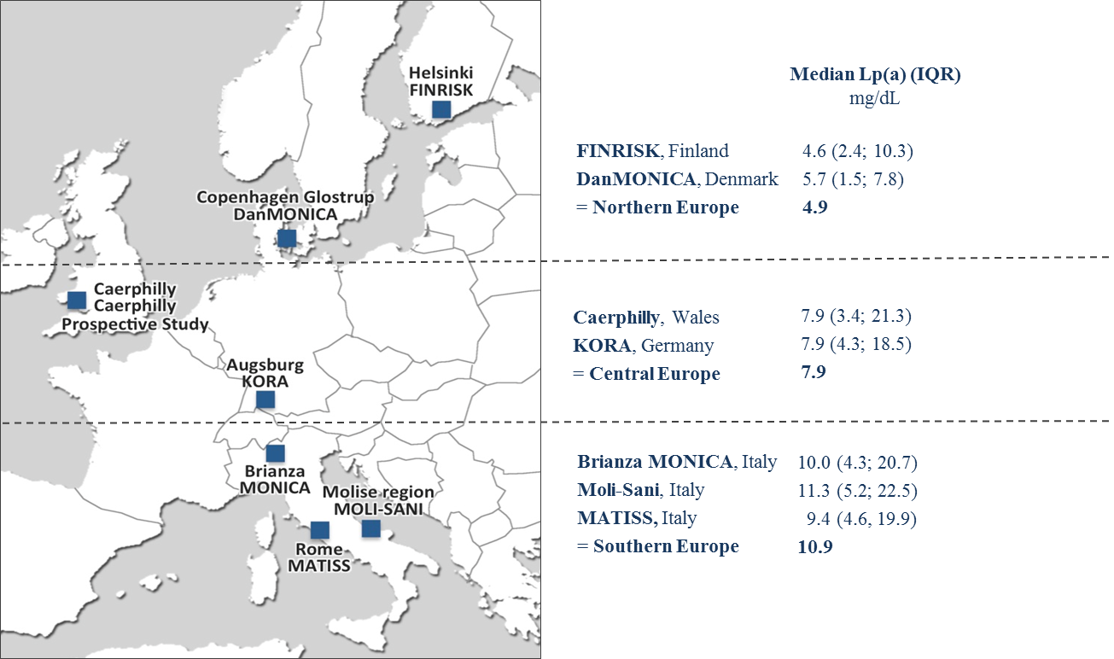

Jonckheere-Test, *P*-value <0.001. IQR stands for interquartile range.

**Figure S2** Density of Lp(a) levels for European regions and for each particular cohort

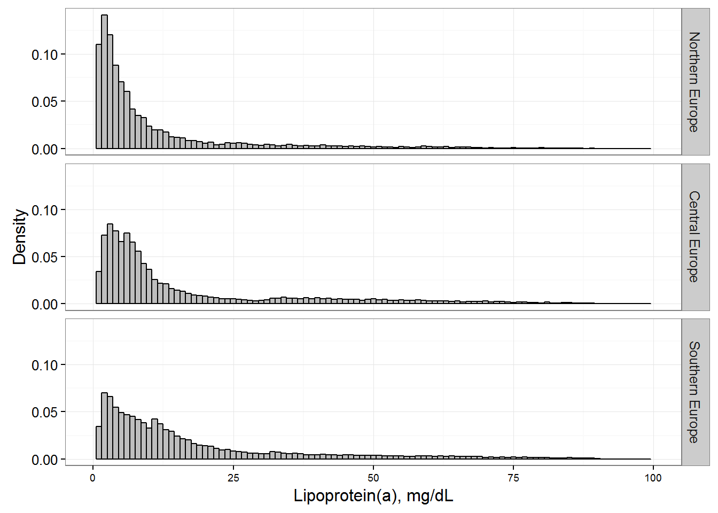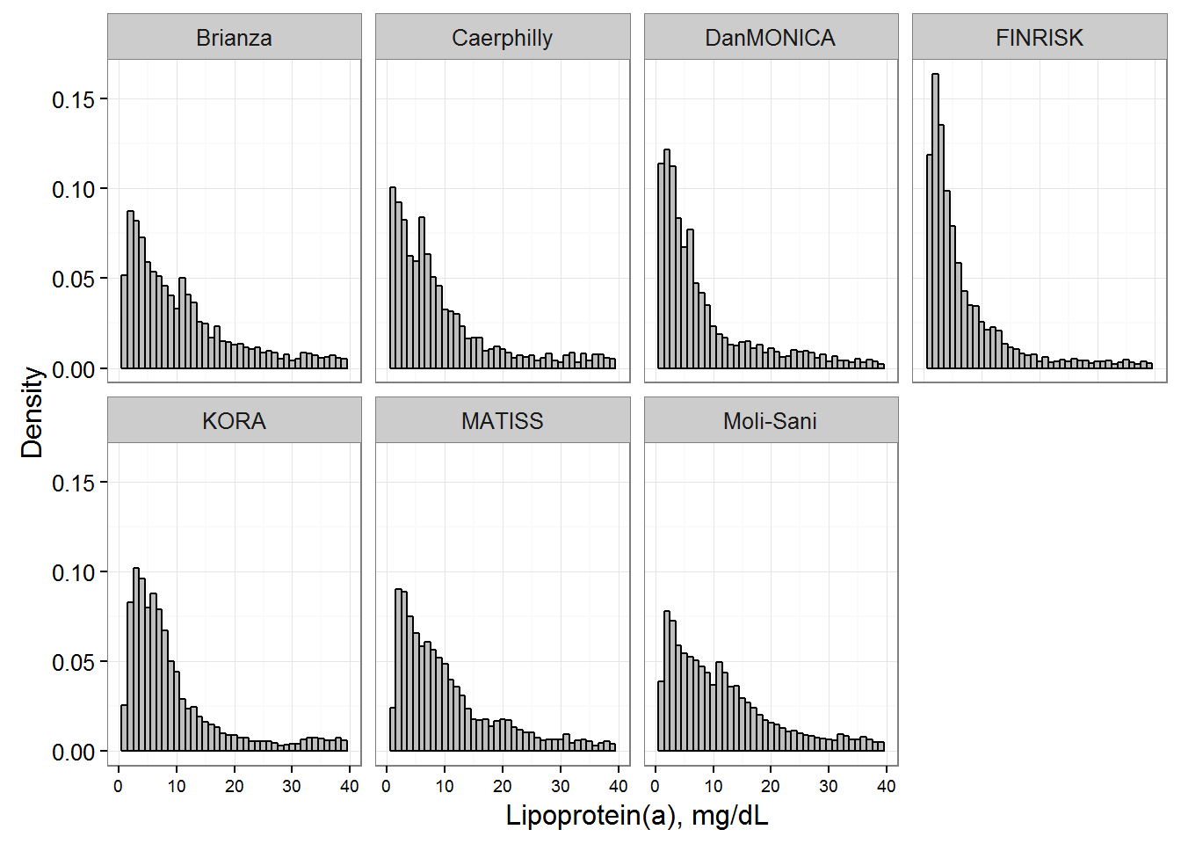

Density (y-axis) of Lp(a) levels (x-axis) **(A)** in the Northern European, Central European, and Southern European cohorts and **(B)** in each particular cohort.

**Figure S3:** Kaplan-Meier curves according to the Lp(a) categoriy <50 mg/dL and ≥50 mg/dL for the endpoints major coronary events, CVD events, and total mortality

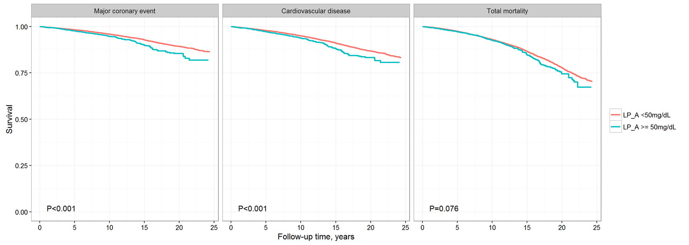

*P* stands for *P*-value of log-rank test.

**Figure S4:** Cox regression analysis according to the Lp(a) categoriy <50 mg/dL and ≥50 mg/dL for the endpoints major coronary events, CVD events, and total mortality

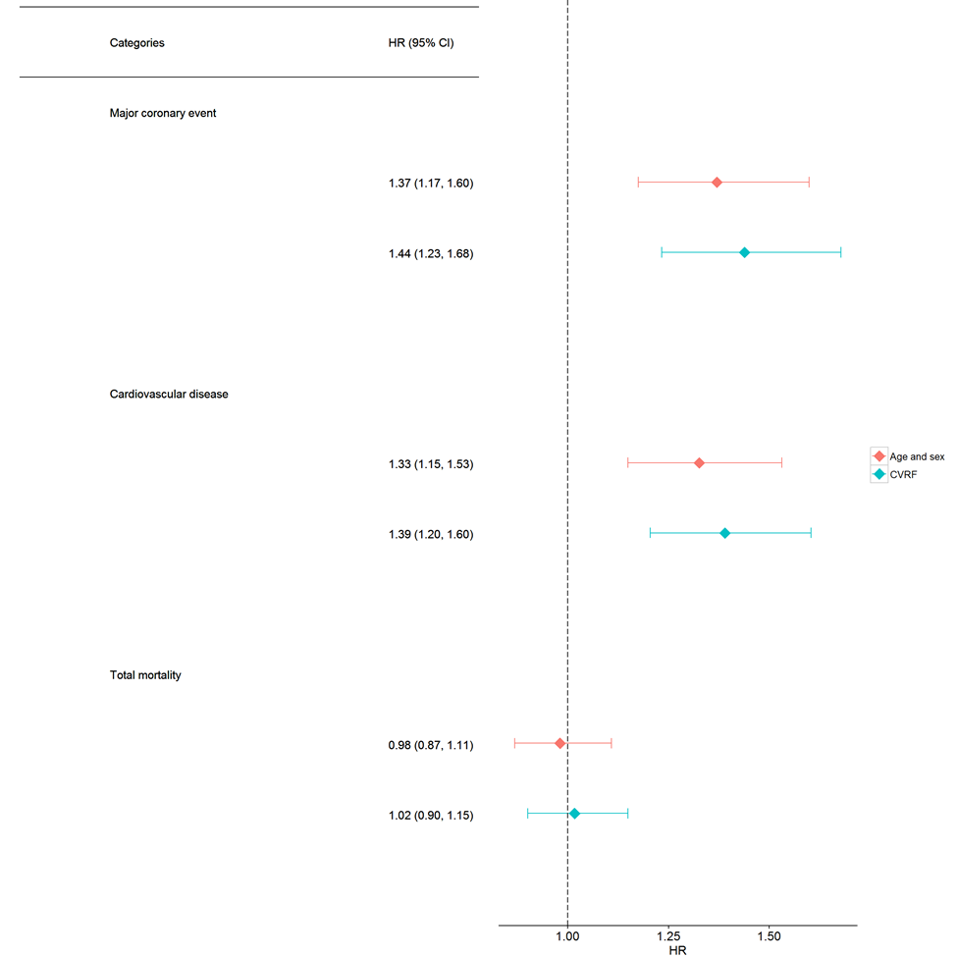

Adjusted for age and sex (model1 ♦) and for age, sex, smoking status, total cholesterol, diabetes, hypertension and BMI (model 2 ♦). N events for MCE = 2038, N events for CVD events = 2478 N events for total mortality = 3978. HR (95%CI) stands for hazard ratio (95% CI stands for confidence interval).

**Figure S5** Cox regression analysis for a continuous version of cube root transformed Lp(a) for all investigated endpoints

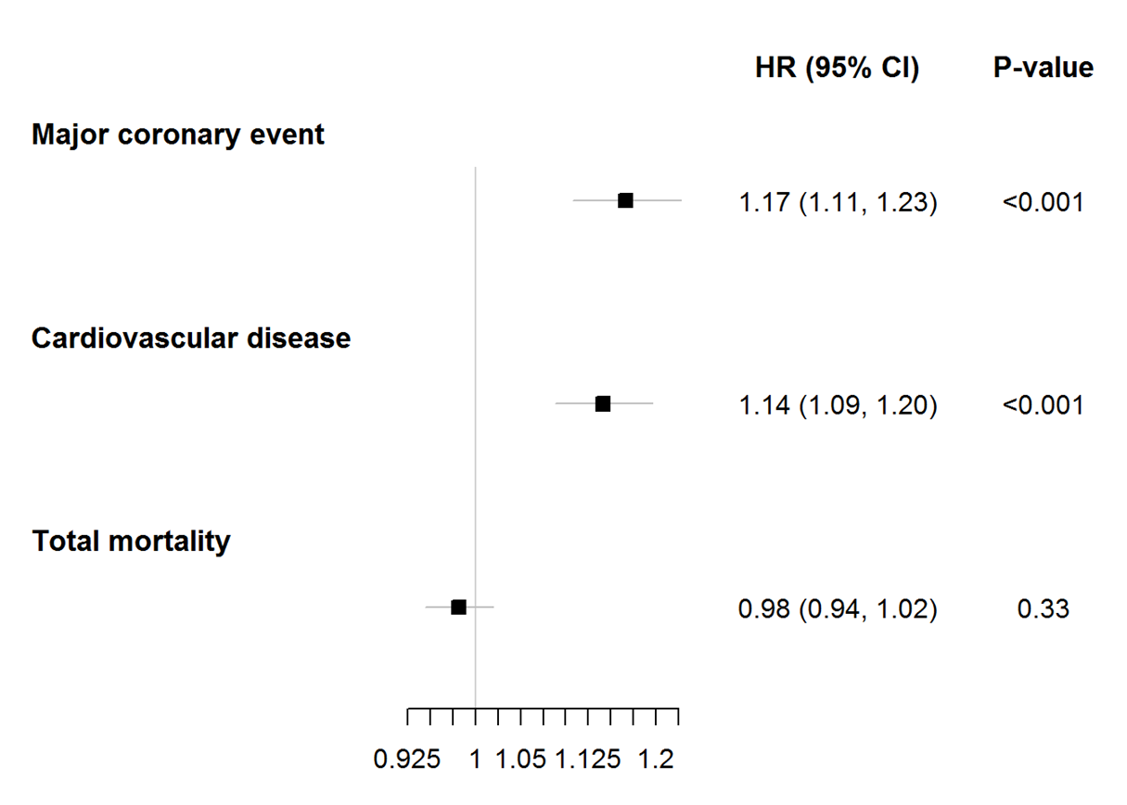

Cox regression analysis for a continuous version of cube root transformed Lp(a) for the endpoints major coronary event, CVD event, and total mortality adjusted for age, sex, smoking status, total cholesterol, diabetes, hypertension and BMI. HR (95%CI) stands for hazard ratio (95% confidence interval).

**Figure S6** Cox regression analysis for a continuous version of cube root transformed Lp(a) for the endpoints major coronary events, CVD events, and total mortality

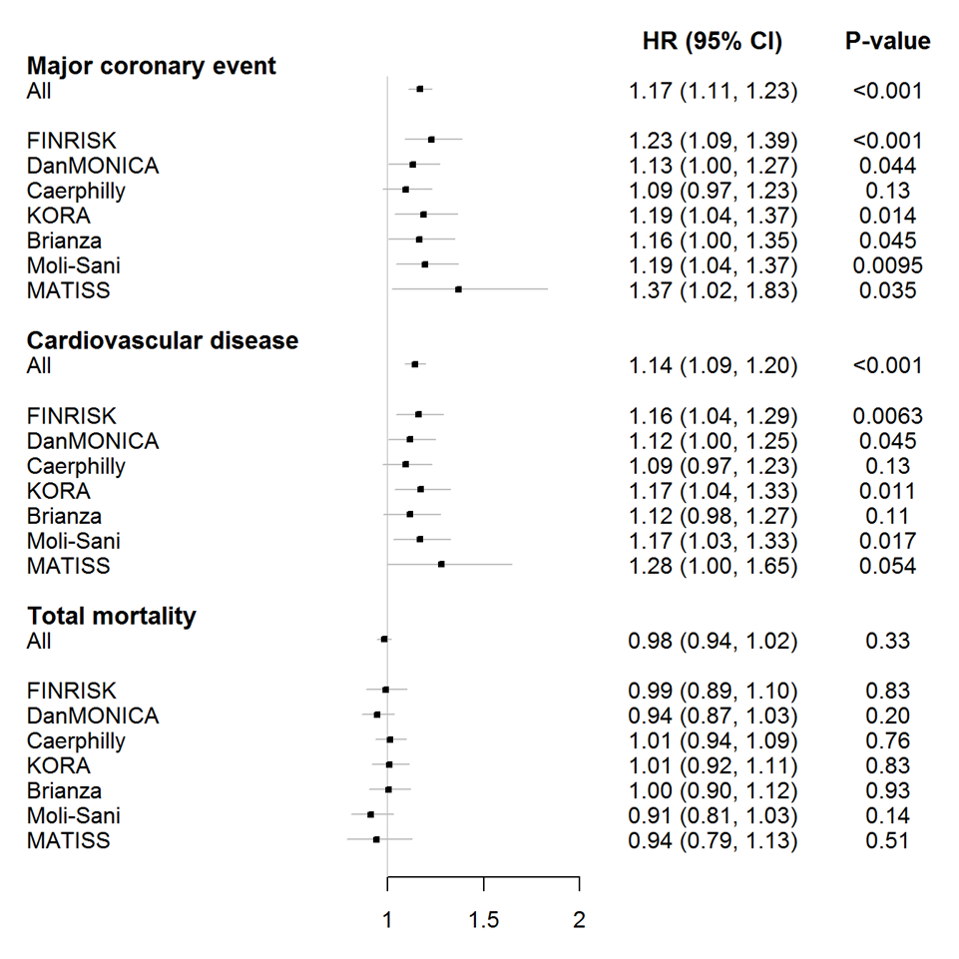

Stratified by cohort and sorted by European region (see Supplementary figure S1). Adjusted for age, sex, smoking status, total cholesterol, HDL cholesterol, diabetes, hypertension and BMI. HR (95%CI) stands for hazard ratio (95% confidence interval).