**Supplemental Materials**

**Association between residential greenness and metabolic syndrome in Chinese adults**

Bo-Yi Yang, Kang-Kang Liu, Iana Markevych, Luke D. Knibbs, Michael S. Bloom, Shaymali C. Dharmage, Shao Lin, Lidia Morawska, Joachim Heinrich, Bin Jalaludin, Meng Gao, Yuming Guo, Yang Zhou, Wen-Zhong Huang, Hong-Yao Yu, Xiao-Wen Zeng, Li-Wen Hu, Qiang Hu, Guang-Hui Dong

**Table of contents**

**Table S1.** Characteristics of the study participants and non-participants (without blood sampling)

**Table S2.** Distributions and inter-correlations (Spearman correlation coefficients) for NDVI, SAVI, and air pollutants

**Table S3.** Associations of per 0.1-unit increase in NDVI500-m and NDVI500-m with metabolic syndrome prevalence after excluding participants with cardiovascular diseases (n = 14,739)

**Table S4.** Associations of per 0.1-unit increase in NDVI500-m and NDVI500-m with metabolic syndrome after excluding participants with hypotension (n = 15,212)

**Table S5.** Associations of per 0.1-unit increase in NDVI500-m and NDVI500-m with metabolic syndrome after excluding participants with underweight (n = 14,950)

**Table S6.** Association between quartile greenness and metabolic syndrome (n = 15,477)

**Table S7.** Associations of per 0.1-unit increase in NDVI500-m and NDVI500-m with metabolic syndrome after additional adjustment for smoking, drinking, controlled diet of low calories, and sugar-sweetened soft drink (n = 15,477)

**Table S8.** Associations of per IQR increase in greenness metrics with metabolic syndrome severity score (n = 15,477)

**Table S9.** Associations of per IQR increase in greenness metrics with the number of metabolic syndrome components (n = 15,477)

**Figure S1.** Flowchart for the sampling process of the 33 Communities Chinese Health Study

**Figure S2**. Directed acyclic graph for the association between greenness and metabolic syndrome, showing potential confounders and mediators

**Table S1.** Characteristics of the study participants and non-participants (without blood sampling)

|  |  |  |  |
| --- | --- | --- | --- |
|  | **Analytic sample** | **Excluded sample** |  |
| **Characteristic** | **(n = 15,477)** | **(n = 9368)** | ***P* value** |
| Age (years, mean ± SD) | 45.0 ± 13.5 | 45.7 ± 13.0 | 0.999 |
| Sex |  |  | <0.001 |
| Men | 8156 (52.7%) | 4505 (48.1%) |  |
| Women | 7321 (47.3%) | 4863 (51.9%) |  |
| Ethnicity |  |  | <0.001 |
| Han | 14,554 (94.0%) | 8916 (95.2%) |  |
| Others | 923 (6.0%) | 452 (4.8%) |  |
| Household income per year |  |  | <0.001 |
| ≤10,000 Yuan | 3144 (20.3%) | 2617 (27.9%) |  |
| >10,000 Yuan | 12,333 (79.7%) | 6751 (72.1%) |  |
| Smoking status |  |  | 0.009 |
| Nonsmoker | 10,837 (70.0%) | 6706 (71.6%) |  |
| Smoker | 4640 (30.0%) | 2662 (28.4%) |  |
| Alcohol consumption |  |  | <0.001 |
| Nondrinker | 11,668 (75.4%) | 7414 (79.1%) |  |
| Drinking | 3809 (24.6%) | 1954 (20.9%) |  |
| Regular exercise |  |  | <0.001 |
| No | 10,545 (68.1%) | 6653 (71.0%) |  |
| Yes | 4932 (31.9%) | 2715 (29.0%) |  |

Abbreviations: SD, standard deviation.

**Table S2.** Distributions and inter-correlations (Spearman correlation coefficients) for NDVI, SAVI, VCF, and air pollutants

|  |  |  |  |  |  |  |  |  |  |  |  |  |  |  |  |
| --- | --- | --- | --- | --- | --- | --- | --- | --- | --- | --- | --- | --- | --- | --- | --- |
|  | **Median (IQR)** | **Min** | **Max** | **NDVI500-m** | **NDVI1000-m** | **SAVI500-m** | **SAVI1000-m** | **VCF500- m** | **VCF1000-m** | **PM1** | **PM2.5** | **PM10** | **NO2** | **SO2** | **O3** |
| NDVI500-m | 0.29 (0.17) | 0.18 | 0.80 | 1 | 0.90a | 0.98a | 0.89a | 0.56 a | 0.50 a | -0.36a | -0.32 | -0.05 | -0.05 | 0.07 | 0.07 |
| NDVI1000-m | 0.31 (0.15) | 0.20 | 0.75 |  | 1 | 0.89a | 0.97a | 0.45 a | 0.45 a | -0.42a | -0.39a | -0.09 | -0.08 | 0.002 | 0.02 |
| SAVI500- m | 0.16 (0.11) | 0.10 | 0.48 |  |  | 1 | 0.90a | 0.50 a | 0.42 a | -0.34 | -0.32 | -0.04 | -0.06 | 0.08 | 0.06 |
| SAVI1000-m | 0.17 (0.10) | 0.11 | 0.45 |  |  |  | 1 | 0.37 a | 0.37 a | -0.46a | -0.43a | -0.15 | -0.07 | -0.09 | -0.08 |
| VCF500- m | 5.75 (4.52) | 2.17 | 33.63 |  |  |  |  | 1 | 0.91 a | 0.25 | 0.30 | 0.35a | 0.24 | 0.33 | 0.37a |
| VCF1000-m | 5.71 (1.97) | 2.93 | 24.73 |  |  |  |  |  | 1 | 0.26 | 0.32 | 0.33 | 0.33 | 0.26 | 0.35a |
| PM1 | 62.0 (15.0) | 50.00 | 82.00 |  |  |  |  |  |  | 1 | 0.99a | 0.73a | 0.67a | 0.52 | 0.47 |
| PM2.5 | 73.00 (26.00) | 64.00 | 104.00 |  |  |  |  |  |  |  | 1 | 0.72a | 0.63a | 0.51 | 0.45 |
| PM10 | 123.0 (19.0) | 93.00 | 145.00 |  |  |  |  |  |  |  |  | 1 | 0.65a | 0.81a | 0.81a |
| NO2 | 33.00 (9.00) | 27.00 | 45.00 |  |  |  |  |  |  |  |  |  | 1 | 0.25 | 0.45 |
| SO2 | 48.0 (20.0) | 36.00 | 78.00 |  |  |  |  |  |  |  |  |  |  | 1 | 0.84a |
| O3 | 50.0 (22.0) | 27.00 | 71.00 |  |  |  |  |  |  |  |  |  |  |  | 1 |

Abbreviations: IQR, interquartile range (computed by subtracting the 1st quartile from the 3rd quartile); Max, maximum; min, minimum; NO2, nitrogen dioxide; NDVI, normalized difference vegetation index; O3, ozone; PM1, particle with aerodynamic diameter ≤1.0 µm; PM2.5, particle with aerodynamic diameter ≤2.5 µm; PM10, particle with aerodynamic diameter ≤10 µm; SAVI, soil adjusted vegetation index; SO2, sulfur dioxide; VCF, vegetation continuous field. Note: PM1 and PM2.5 values community-based, while the remaining four air pollutants were air monitoring station based.

aStatistically significant correlation (*P* < 0.05).

**Table S3.** Association between quartile greenness and metabolic syndrome (n = 15,477)

|  |  |
| --- | --- |
| **Greenness metrics** | **Adjusted OR (95% CI)a** |
| NDVI500-m |  |
| Q1 | 1 (Reference) |
| Q2 | 0.80 (0.73 to 0.89) |
| Q3 | 0.66 (0.60 to 0.73) |
| Q4 | 0.71 (0.63 to 0.79) |
| *P* value for trend | <0.0001 |
| SAVI500-m |  |
| Q1 | 1 (Reference) |
| Q2 | 0.90 (0.82 to 0.99) |
| Q3 | 0.69 (0.62 to 0.76) |
| Q4 | 0.67 (0.61 to 0.76) |
| *P* value for trend | <0.0001 |
| VCF500-m |  |
| Q1 | 1 (Reference) |
| Q2 | 1.02 (0.75 to 1.39) |
| Q3 | 0.73 (0.48 to 1.09) |
| Q4 | 0.71 (0.53 to 0.96) |
| *P* value for trend | 0.058 |

Abbreviations: CI, confidence interval; NDVI, normalized difference vegetation index; OR, odds ratio; SAVI, soil adjusted vegetation index; VCF, vegetation continuous field.

aAdjusted for age, sex, ethnicity, household income, education, and district-level of gross domestic product and population density.

**Table S4.** Associations of per IQR increase in greenness metrics with metabolic syndrome prevalence after excluding participants with cardiovascular diseases (n = 14,739)

|  |  |  |
| --- | --- | --- |
| **Greenness metrics** | **Adjusted OR (95% CI)a** | ***P* value** |
| NDVI500-m | 0.83 (0.72 to 0.95) | 0.008 |
| SAVI500-m | 0.82 (0.71 to 0.95) | 0.007 |
| VCF500-m | 0.92 (0.84 to 1.01) | 0.080 |

Abbreviations: CI, confidence interval; NDVI, normalized difference vegetation index; OR, odds ratio; SAVI, soil adjusted vegetation index; VCF, vegetation continuous field.

aAdjusted for age, sex, ethnicity, household income, education, and district-level of gross domestic product and population density.

**Table S5.** Associations of per IQR increase in greenness metrics with metabolic syndrome after excluding participants with hypotension (n = 15,212)

|  |  |  |
| --- | --- | --- |
| **Greenness metrics** | **Adjusted OR (95% CI)a** | ***P* value** |
| NDVI500-m | 0.81 (0.70 to 0.93) | 0.003 |
| SAVI500-m | 0.80 (0.69 to 0.93) | 0.003 |
| VCF500-m | 0.91 (0.83 to 0.99) | 0.037 |

Abbreviations: CI, confidence interval; NDVI, normalized difference vegetation index; OR, odds ratio; SAVI, soil adjusted vegetation index; VCF, vegetation continuous field.

aAdjusted for age, sex, ethnicity, household income, education, and district-level of gross domestic product and population density.

**Table S6.** Associations of per IQR increase in greenness metrics with metabolic syndrome after excluding participants with underweight (n = 14,950)**a**

|  |  |  |
| --- | --- | --- |
| **Greenness metrics** | **Adjusted OR (95% CI)** | ***P* value** |
| NDVI500-m | 0.83 (0.73 to 0.96) | 0.009 |
| SAVI500-m | 0.81 (0.70 to 0.93) | 0.004 |
| VCF500-m | 0.91 (0.84 to 1.00) | 0.052 |

Abbreviations: CI, confidence interval; NDVI, normalized difference vegetation index; OR, odds ratio; SAVI, soil adjusted vegetation index; VCF, vegetation continuous field

aAdjusted for age, sex, ethnicity, household income, education, and district-level of gross domestic product and population density.

**Table S7.** Associations of per IQR increase in greenness metrics with metabolic syndrome after additional adjustment for cigarette smoking, alcohol drinking, controlled diet of low calories, and sugar-sweetened soft drink (n = 15,477)

|  |  |
| --- | --- |
| **Greenness Metrics** | **Adjusted OR (95% CI)** |
| NDVI500-m |  |
| Main modela | 0.81 (0.70 to 0.93) |
| Main modela + cigarette smoking | 0.81 (0.70 to 0.93) |
| Main modela + alcohol drinking | 0.81 (0.70 to 0.93) |
| Main modela + controlled diet of low calories | 0.81 (0.70 to 0.93) |
| Main modela + sugar-sweetened soft drink | 0.81 (0.70 to 0.93) |
| SAVI500-m |  |
| Main modela | 0.80 (0.69 to 0.93) |
| Main modela + cigarette smoking | 0.80 (0.69 to 0.93) |
| Main modela + alcohol drinking | 0.80 (0.69 to 0.93) |
| Main modela + controlled diet of low calories | 0.80 (0.69 to 0.93) |
| Main modela + sugar-sweetened soft drink | 0.80 (0.69 to 0.93) |
| VCF500-m |  |
| Main modela | 0.91 (0.83 to 1.00) |
| Main modela + cigarette smoking | 0.91 (0.83 to 1.00) |
| Main modela + alcohol drinking | 0.91 (0.83 to 0.99) |
| Main modela + controlled diet of low calories | 0.91 (0.83 to 1.00) |
| Main modela + sugar-sweetened soft drink | 0.91 (0.83 to 1.00) |

Abbreviations: CI, confidence interval; NDVI, normalized difference vegetation index; OR, odds ratio; SAVI, soil adjusted vegetation index; VCF, vegetation continuous field.

aAdjusted for age, sex, ethnicity, household income, education, and district-level of gross domestic product and population density.

**Table S8.** Associations of per IQR increase in greenness metrics with metabolic syndrome severity score (n = 15,477)

|  |  |  |
| --- | --- | --- |
| **Greenness metrics** | **Adjusted β (95% CI)a** | ***P* value** |
| NDVI500-m | -0.090 (-0.178 to -0.001) | 0.048 |
| SAVI500-m | -0.097 (-0.188 to -0.005) | 0.038 |
| VCF500-m | -0.025 (-0.082 to 0.031) | 0.381 |

Abbreviations: CI, confidence interval; NDVI, normalized difference vegetation index; OR, odds ratio; SAVI, soil adjusted vegetation index; VCF, vegetation continuous field.

aAdjusted for age, sex, ethnicity, household income, education, and district-level of gross domestic product and population density.

**Table S9.** Associations of per IQR increase in greenness metrics with the number of metabolic syndrome components (n = 15,477)

|  |  |  |
| --- | --- | --- |
| Greenness metrics | **Adjusted OR (95% CI)a** | ***P* value** |
| NDVI500-m | 0.91 (0.86 to 0.96) | 0.001 |
| SAVI500-m | 0.91 (0.86 to 0.96) | 0.001 |
| VCF500-m | 0.96 (0.93 to 0.99) | 0.031 |

Abbreviations: CI, confidence interval; NDVI, normalized difference vegetation index; OR, odds ratio; SAVI, soil adjusted vegetation index; VCF, vegetation continuous field.

aAdjusted for age, sex, ethnicity, household income, education, and district-level of gross domestic product and population density.

**Three** cities (Shenyang, Anshan, and Jinzhou) were randomly selected out of the 14 cities in Liaoning province, Northeastern China

**Three** communities were randomly selected from each of 11 districts (five districts in Shenyang, three in Anshan, and three in Jinzhou), yielding 33 communities in total

**700-1000** households were selected from each of the 33 communities

**One** adult aged 18-74 years were randomly selected from each household

**9368** participants who refused to provide a blood sample were excluded

**15,477** participants were finally included in this analysis

**24,845** participants completed the questionnaire

**Figure S1.** Flowchart for the sampling process of the 33 Communities Chinese Health Study

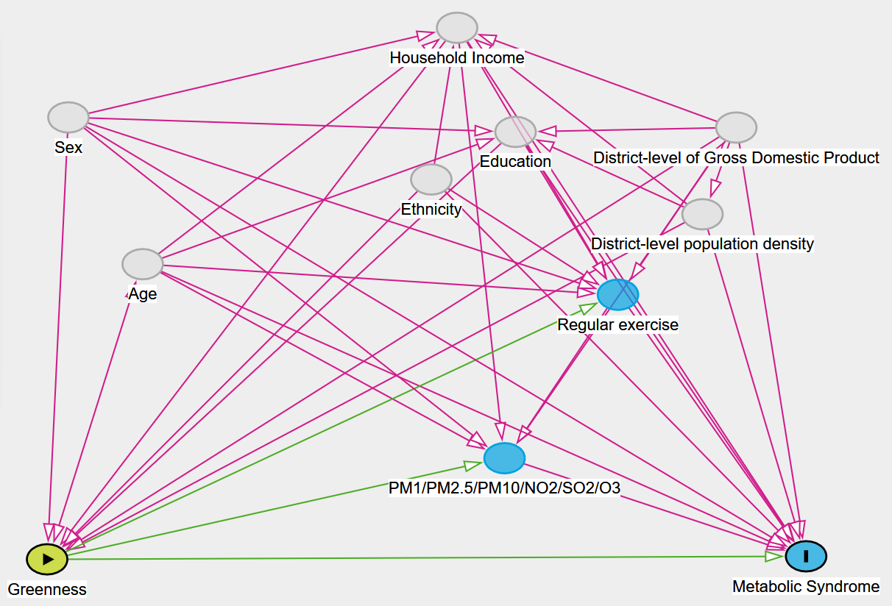

**Figure S2**. Directed acyclic graph for the association between greenness and metabolic syndrome, showing potential confounders and mediators. Pink lines indicate potential confounders, and green lines indicate potential mediators. NO2, nitrogen dioxide; O3, ozone; PM1, particle with aerodynamic diameter ≤1.0 µm; PM2.5, particle with aerodynamic diameter ≤2.5 µm; PM10, particle with aerodynamic diameter ≤10 µm; SO2, sulfur dioxide.