Air pollution, health and social deprivation: a fine-scale health impact assessment of mortality, lung cancer incidence and low birth weight

Morelli Xavier1, Rieux Camille2, Josef Cyrys4, Bertil Forsberg3, Slama Rémy1

1Inserm, U823, Institut Albert Bonniot, Team of Environmental Epidemiology Applied to Reproduction and Respiratory Health, Grenoble, France;  
2Air Rhône-Alpes, Grenoble, France;  
3Occupational and Environmental Medicine, Dept of Public Health and Clinical Medicine, Umea University, Umea, Sweden;  
4Helmholtz Zentrum München, German Research Center for Environmental Health, Institute of Epidemiology II, Neuherberg, Germany.

**Corresponding Author**Xavier Morelli  
CRI INSERM/UJF U823  
Rond-Point de la Chantourne  
38706 La Tronche Cedex  
Tel: +33 4 76 54 94 02  
Email: xavier.morelli@ujf-grenoble.fr

**Keywords**Atmospheric pollution; dispersion model; health impact assessment; particulate matter; attributable risk; social deprivation; burden of disease

**Acknowledgments**Isère Cancer Registry is kindly acknowledged for providing cancer data incidence. We thank CépiDC (Inserm) for providing mortality data and the ERISC platform for providing the social deprivation data (EDI). We also thank Air Rhône-Alpes for granting access to air pollution data as well as population density data.

**Funding**The study is part of the ACCEPTED project, funded by ANSES (the French Agency for Environmental and Occupational Health Safety) in the context of ERA-Envhealth call.

# Abstract (n=250 words)

Context: Health impact assessment studies often ignore within-city spatial variations of air pollutants.

Objective: Our objective was to quantify the health impact of fine particulate matter (PM2.5) in 2 urban areas using fine-scale air pollution modeling, and the variations of this impact according to social deprivation.

Methods: In Grenoble and Lyon areas (0.4 and 1.2 million inhabitants, respectively) in 2012, PM2.5 exposure was estimated on a 10x10 m grid by coupling a dispersion model to population density. Outcomes were mortality, lung cancer and term low birth weight incidences. The numbers of cases attributable to air pollution were estimated overall and stratifying areas according to the European Deprivation Index (EDI). We repeated the estimations assuming a spatial homogeneity of air pollutants.

Results: Median PM2.5 levels were 18.1 and 19.6 μg/m3 in Grenoble and Lyon urban areas, respectively, entailing respectively 114 (5.1% of total, 95% confidence interval, CI, 3.2–7.0%) and 491 non-accidental deaths (6.0% of total, 95% CI 3.7–8.3%) attributable to long-term exposure to PM2.5. Attributable term low birth weight cases represented 23.6% of total (9.0–37.1%) in Grenoble and 27.6% of total cases (10.7–42.6%) in Lyon. In Grenoble, 6.8% of incident lung cancer cases were attributable to air pollution (95% CI 3.1–10.1%). Estimated impact was lower by 8 to 20% when estimating exposure through background stations. Health impact was highest in neighborhoods with intermediate to higher social deprivation.

Discussion: Health impact studies relying on background stations to estimate air pollution levels tend to underestimate their health impact.

# 1 Introduction

Air pollution increases mortality rate and leads to anticipated deaths from cardiovascular or respiratory causes. Air pollution has also negative effects on lung cancer incidence (Raaschou-Nielsen et al., 2013) as well as asthma (Jacquemin et al., 2015). An effect of low birth weight risk is also plausible (Wilhelm et al., 2012; Pedersen et al., 2013).

The dose-response functions from epidemiological studies can be translated into a number of attributable cases at the population level through health impact assessment studies. These studies are usually based on the air quality monitoring networks, which have a (very) limited spatial resolution and does not fully take into account local sources, since the stations considered generally exclude those close to traffic sources. This approach makes the strong hypothesis that the people living in the study area are exposed to the same pollutants concentrations, which has been proved not to be the case in urban areas (Jerrett et al., 2005). Few health impact assessment studies have relied on fine-scale air pollution levels such as Land-Use Regressions (LUR) or dispersion models (Forastiere et al., 2011, Rojas-Rueda et al., 2012).

Within the 12 urban areas corresponding to the cohorts of ESCAPE European project, the proportion of term low birth weight cases attributable to PM2.5 pregnancy exposure was estimated to be 22% (95% confidence interval, CI, 8-33%). To our knowledge, no (other) health impact assessment study considered term low birth weight as an outcome.

The issue of environmental justice, or socio-economic status facing air pollution, has become a public health priority. Within Europe, relationships between air pollution exposure and socio-economic status vary according to city (Deguen and Zmirou-Navier, 2010). Some studies reported a higher exposure to air pollution for the population with intermediate social deprivation (Havard et al., 2009), or with higher social deprivation like in most American studies (Kruize et al., 2007, Namdeo and Stringer, 2008), while others found an inverse relationship between air pollution exposure and socio-economic status (to be checked and possibly corrected) (Forastiere et al., 2007). A recent study conducted in four large French cities emphasized these contrasted associations: in Paris, the population most exposed to air pollution was the one with the lowest social deprivation, while the opposite was found in Marseille and Lille. In Lyon urban area, the most exposed neighborhoods were those with an intermediate social deprivation status (Padilla et al., 2014). Differences in air pollution levels according to social deprivation are likely to entail differences in the health burden associated to air pollution between neighborhoods with different deprivation levels –however only health impact assessment studies relying on fine-scale information on air pollution, social deprivation (and possibly population density) can assess the resulting contrasts in health impact between neighborhoods.

The main aim of this work was to quantify the long-term effects of air pollution on health in two cities in the French Alps, relying on a fine-scale dispersion model. Our second objective was to evaluate the possible social gradients in air pollution exposure and health impact of PM2.5. The adverse health events considered were non-accidental mortality, lung cancer incidence and term low birth weight.

# 2 Materials and Methods

## 2.1 Study areas

This study was conducted in part of the Grenoble (670,000 inhabitants) and Lyon (2,120,000 inhabitants) urban areas in the south-East of France, which are respectively the 11th and 2nd largest in France in term of population (INSEE, National Institute of the Statistic and the Economic Studies, 2011). The study area was defined according to the air pollution dispersion model coverage (Figure 1). The area corresponded to Grenoble and Lyon cities and to the major surrounding cities which had a homogeneous urban structure and topography.

## 2.2 Assessment of air pollution levels

We relied on Sirane PM2.5 dispersion model (Soulhac et al., 2011, 2012). The input data of the model are road traffic, the neighborhood description (in particular buildings characteristics, street widths), heating systems and punctual emission sources such as industries. The pollutants dispersion modeling takes into account urban structures as well as several meteorology variables on a hourly-basis like wind speed, wind direction and fluctuation, or ground temperature. The model output is provided on a 10x10 m grid. Data from a background air quality monitoring station (AQMS) were collected to perform the sensitivity analyses on non-accidental mortality, lung cancer incidence and term low birth weight cases.

Information on population density was available at the same spatial resolution than the dispersion model, and was provided by Air Rhône-Alpes based on data from INSEE and the National Institute of Geographic and Forestry Information (IGN, 2007; INSEE, 2010).

## 2.3 Health events considered

We considered the long-term effects of air pollution on all-cause, non-accidental mortality (ICD10: A00-R99), on lung cancer incidence (ICD10: C33-34) and on term low birth weight risk. Data on death cases were obtained from the death registry dedicated unit of the French Institute of Health and Medical Research (INSERM). The local cancer registry (Registre du cancer de l’Isère) provided the lung cancer incident cases in Grenoble. Presence of cancer registries in each region of France is at the instigation of local authorities, and such registry did not exist for the Lyon urban area, hence restricting the health impact assessment for lung cancer incidence only in the Grenoble urban area. Data on term low birth weight cases were estimated from the number of total births available at the city scale in 2007 (INSEE, 2013) and the national perinatal survey (INSERM, 2011), which allowed us to calculate the nation-wide part of term low birth weights based on the total live births.

Both data of mortality and term low birth weight were available at the city scale, while cancer incident cases were available at the IRIS (housing Blocks Regrouped for Statistical Information) scale, which is the most accurate geographical census unit available. The IRIS are homogeneous neighborhoods containing on average 2,000 inhabitants, and are similar to the US census block group (INSEE, 2008).

## 2.4 Exposure-risk functions

We aimed to rely on exposure-risk (or dose-response) functions relying on a fine-scale exposure model and limited potential for confounding as well as on robust studies such as meta-analyses. For low birth weight, given the differences in prevalence and possibly risk factors distributions between Europe and America, we aimed to rely on a European study.

For non-accidental mortality we selected the meta-risk available from the latest WHO expert meeting (WHO, 2014); the function for lung cancer incidence was also issued from a meta-analysis (Hamra et al., 2014), while the function for term low birth weight was based on the study by Pedersen et al. (2013). The relative risks are listed in the Table 1.

## 2.5 Risk characterization

The long-term health impact of air pollution was evaluated as the number of adverse health events attributable to over-exposure to air pollution, compared to a reference level. The reference level corresponded to a yearly PM2.5 average of 10 µg/m3, the World Health Organization (WHO) air quality guideline threshold (WHO, 2005).

The number NACi,j of cases attributable to air pollution at each geographical coordinate (i,j) was estimated as

E1: 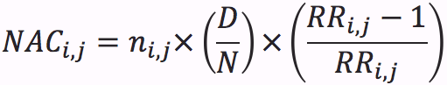

Where ni,j is population density, D the total number of disease cases in the smallest geographical area available, N the population in the same scale as for the disease cases, and RRi,j the customized relative risk at location (i,j) depending on the PM2.5 concentration Ci,j observed at this location:



All attributable cases NACi,j were then summed over the study area.

## 2.6 Sensitivity analyses

The impact of air pollution was also assessed under alternative hypotheses assuming a homogeneous spatial distribution of the population density (E2) or of the PM2.5 concentrations (E3):

E2: 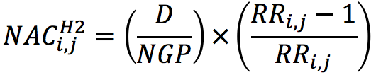

E3: 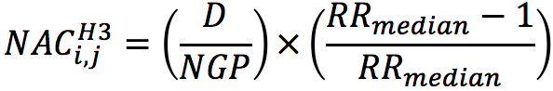

Where NGP is the total number of grid points in the area. In E3, RRmedian represents the median of the PM2.5 in the study area.

Finally we estimated the number of attributable cases under the classical approach relying on the air quality monitoring network. One central station was available in Grenoble with PM2.5 monitoring data, while three stations were used in Lyon. Compared to H3, the model-based relative risk with the median PM2.5 levels was replaced by RRAQMS_avg, the relative risk corresponding to the yearly average of PM2.5 levels recorded by the station(s):

E4: 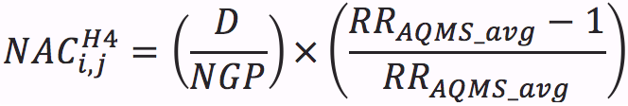

Finally, all estimations of the number of lung cancer cases were repeated with a degradation of the spatial resolution of the incident lung cancer cases, the only health event for which data at the census block, or IRIS were available (Figure 2). This analysis was done in order to investigate the influence of the spatial resolution of information on health events.

## 2.7 Socio-economic inequalities

Area-level socio-economic status was estimated through the European Deprivation Index (EDI) (Pornet et al., 2012). The EDI quantifies the deprivation status and relies on ten characteristics available at the IRIS –or neighborhood– level. The variables cover various socio-economic characteristics such as an overcrowded housing, the occupational class, employment status or basic amenities presence and are described by Pornet et al. (2012).

To evaluate the relationship between the exposure to air pollution and the EDI, we described the population-weighted air pollution exposure categorized into deciles depending on the EDI decile of the IRIS, as well as the health impact by EDI decile, at the same neighborhood scale. In addition, we ranked the IRIS in each urban area by their median exposure level to PM2.5, and compared the ordered result with the EDI score by means of Spearman’s rank correlation coefficients.

Data management and analyses were performed with Stata software (StataCorp LP, TX USA); QGIS software was used for the spatial operations and cartography (QGIS 2.4, OSGeo Foundation, Beaverton, OR, USA).

# 3 Results

## 3.1 Study population, air pollution exposure and health events

The part of the Grenoble urban area considered in our study included 385,000 inhabitants, out of which 157,000 inhabitants (41% of the total) lived inside the main city. Each of the 169 IRIS –or neighborhoods– included an average population of 2,280 (interquartile range: 1,940–2,760) for a total area of 245 km2. In Lyon, 470,000 out of 1.2 millions inhabitants, or 39% of the total, lived in the main city. The number of IRIS in the urban area was 495, with an average population of 2,470 (interquartile range: 1,970–2,990) for a total area of 480 km2. The two study areas are represented in Figure 1.

The 5th, 50th and 95th percentiles of the population density-weighted exposures to PM2.5 for year 2012 were 17.4, 18.1, 19.0 and 18.5, 19.6, 21.3 μg/m3 in Grenoble and Lyon urban areas, respectively. The average PM2.5 levels recorded in 2012 by the background air quality monitoring stations were 17.51 µg/m3 in Grenoble and 18.08 µg/m3 in Lyon.

Regarding the occurrence of adverse health events, the number of non-accidental deaths was 2,254 and 8,148 in Grenoble and Lyon urban areas, respectively, which represents death rates of 5.9‰ and 6.7‰, respectively. The part of term low birth weight cases among total live births was estimated at 2.54% nation-wide, which represents 133 and 474 term low birth weight cases in Grenoble and Lyon urban areas, respectively. The total of incident lung cancer cases in Grenoble urban area was 195, which corresponded to a rate of 50.6 cases/100,000 inhabitants. The rate per 100,000 inhabitants varied depending on the IRIS, and was 26.1 and 78.9 for the first and last deciles, respectively (Figure 2).

## 3.2 Health impact of PM2.5 exposure

The estimated health impact of air pollution on all-cause, non-accidental mortality corresponded to 114 cases in Grenoble (95% CI 71–157), or 5.1% of the total (95% CI 3.2–7.0%); the corresponding figures for Lyon were 491 cases (95% CI 305–675) or 6.0% of the total (95% CI 3.7–8.3%). The number of lung cancer new cases that could be attributed to PM2.5 levels was 13.2 in Grenoble (95% CI 6.1–19.7), or 6.8% of the total (95% CI 3.1–10.1%). The number of term low birth weight cases was estimated to be 31.4 (23.6% of the total, 95% CI 9.0–37.1%). In Lyon, 131 term low birth weight cases were assumed attributable to PM2.5, which represents 27.6% of the total (95% CI 10.7–42.6%, Table 2).

The sensitivity analyses show that the estimated health impact of exposure to PM2.5 was lower when assessing the exposure with a single estimate, should it be the median of the dispersion grid estimates (*H3* hypothesis) or the yearly average recorded by one or several air quality monitoring stations (*H4* hypothesis). Compared to the fine-scale approach (*H1* hypothesis), the health impact estimated with *H3* was lower by 7.5 to 8.6% in Grenoble, depending on the health event, and lower by 8.3 to 9.4% in Lyon. For *H4*, the difference with *H1* was comparable to the difference with *H3* for Grenoble, while in Lyon the difference in term of health impact proved to be more important than with *H3*, with a number of attributable cases lower by 18.0 to 19.8%, depending on the health event (Table 3). Regarding *H2* hypothesis, the health impact was lower by 4.7 to 5.6% than with *H1* depending on the city and health event, except for the lung cancer cases in Grenoble, for which the health impact was 1.5% higher with *H2* than with *H1*. However, restricting the study area to the city center resulted in a health impact always higher when not considering population-weighting, with differences between *H1* and *H2* varying from 1.1 to 2.4% depending on the city, and health event (Table S1).

For lung cancer incidence, ignoring the spatial distribution of cases in Grenoble urban area did not result in a visible difference in term of health impact (Table 4, Figure 2).

## 

## 3.3 Stratification of estimates on social deprivation

Air pollution was moderately associated with the neighborhood social deprivation index, exposure being lowest in the neighborhoods in the decile of the social deprivation index corresponding to the lowest deprivation, and highest in the fifth to seventh deciles (Table 5, Figure 3). The Spearman’s rank coefficient of correlation between PM2.5 median exposure and EDI score, by IRIS, was 0.40 in Grenoble (n=169 IRIS) and 0.23 in Lyon (n=495) (Figure 4, Figure S1).

Stratification of the health impact of PM2.5 on the social deprivation (EDI) index showed similar contrasts. For mortality and term low birth weight and depending on the social deprivation decile, the maximum difference observed in term of health impact was in the 11.8%–12.0% and 9.8%–10.9% ranges in Grenoble and Lyon urban areas, respectively. For lung cancer incidence, the maximum difference in term of health impact was 12.1% when considering the spatial distribution of the lung cancer cases at the urban area scale. The differences were higher for a spatial distribution of cases at the IRIS and city scales, being 33.0% and 32.1%, respectively (Table 5, Figure S2).

# 4 Discussion

## 4.1 Summary

This study is among the first to perform a health impact assessment of fine particulate matter relying on a spatially resolved exposure model, taking into account PM2.5 concentrations from a fine-scale dispersion model with a 10-meter resolution, coupled to knowledge of the population density at the same scale. In addition, we provided an estimated of the number of term low birth weight cases attributable to air pollution, which had to our knowledge very little been done (Pedersen et al. 2013). Exposure assessment based on background air quality monitoring stations tended to underestimate population exposure, and hence also the health impact. In contrast, including fine-scale information on the spatial resolution of disease cases (lung cancer) did not entail a difference in term of health impact compared to aggregating information on cases at the city or urban area level as is usually done. The impact of PM2.5 on mortality, lung cancer and term low birth weight tended to be highest in areas with a moderate to higher deprivation index, and lowest in areas with lowest deprivation.

## 4.2 Strengths and limitations

The main originality of our study was the reliance on a fine scale air pollution model coupled to fine-scale data on population density, lung cancer incidence and social deprivation; the estimation of the air pollution impact in terms of term low birth weight cases and the sensitivity analysis allowing providing an estimate of the difference in terms of health impact between our methodology and the more classical approach relying on background air quality monitoring stations in two contrasted areas. Limitations include exposure misclassification due to lack of consideration of indoor exposures and time-space activity, and possible residual confounding in the dose-response functions used.

## 4.3 Underlying assumptions and data

We have chosen to restrict our study to fine particulate matter (PM2.5). Associations with the outcomes considered have been reported for other atmospheric pollutants, including PM10, nitrogen (di)oxide (Pedersen et al., 2013, Nafstad et al., 2003, Hystad et al., 2013), and ozone. PM10 include the smaller PM2.5 fraction that we considered, and, at least for low birth weight, there is evidence that any effect additional to that of PM2.5, if any, is likely to be low (Pedersen, 2013)(verify for mortality/lung cancer). For NO2, the literature is less clear, so that one cannot exclude an effect on some of the outcomes we considered in addition to that of PM2.5; we have taken the cautious option not to estimate an effect of NO2, which may have led to an underestimation of the effect of atmospheric pollutants considered as a whole. Results of health impact assessment studies (HIA) are generally highly sensitive to case ascertainment and the dose-response function chosen. Hence, our study has limitations inherent to current HIA studies. We did not restrict our study population to the corresponding age classes of the dose-response function, and we supposed that the people living inside the study areas were the only exposed, and that the exposure at the home addresses was the only part of the space-time activity.

Data on mortality are exhaustive in France; for data privacy reasons, it was not possible to obtain mortality data at a scale finer than the city. If we assume that the conclusions of the sensitivity analysis done with lung cancer also apply to other health outcomes, there is no reason to believe that having data at a finer scale for mortality would have strongly changed the impact of air pollution estimated globally. However such information may have modified the distribution of attributable cases according to social deprivation. The impact of particulate matter on all-cause non-accidental mortality in the general population has been quantified in several studies (Künzli et al., 2000, Pascal et al., 2013). Residual confounding cannot be excluded, e.g. because of lack of consideration of noise, a possible risk factor for cardiovascular deaths correlated to air pollution levels (Foraster et al., 2011). We have used the meta-risk estimated for the world, which was very close to that estimated from European studies only (RR of 1.06 per 10 µg/m3, 95% CI 1.02–1.11).

For lung cancer incidence, the presence of a local cancer registry, which is not systematic in France, allowed us to obtain data at the smallest geographical unit available, instead of the city level. Regarding the data quality, 3 cases could not be geocoded by the registry, which represents 1.5% of missing health event data. To our knowledge, the study by Hamra et al. (2014) was the first meta-analysis providing an estimate for the association between outdoor PM2.5 concentrations and lung cancer. This meta-risk is partly based on studies corrected for active smoking, the main risk factor associated with lung cancer risk; the authors reported consistent meta-estimates when restricting the analysis to studies adjusting for smoking status and other individual characteristics. In a more recent study, Cui et al. (2015) conducted a meta-analysis of ambient PM2.5 concentrations and lung cancer with 10 out of 12 selected studies matching the studies used by Hamra et al. who relied on 14 studies. Both exposure-risk relationships were close, Cui et al. (2015) reporting a relative risk of 1.09 (95% CI: 1.06–1.11).

Data on term low birth weight case incidence are not available centrally so that we estimated their number by applying the ratio of term low birth weights among total live births, or 2.524%, from a recent national perinatal survey, to the total number of births at the city level (INSERM, 2011). The estimated effect of PM2.5 on term low birth weight incidence was based on a recent European study of about 50,000 births with harmonized fine scale air pollution modeling relying on land use regression and adjusted for a large number of potential confounders (Pedersen, 2013). It was much higher than that from previous meta-analyses; for example, Dadvand et al (2013) reported an OR term low birth weight of 1.10 (95% CI, 1.03-1.18) for each increase by 10 µg/m3 in PM2.5 concentrations, compared to 1.39 (95% CI, 1.12-1.77) for the Pedersen et al. study. Applying the dose-response function from Dadvand et al. yielded an estimated proportion of term low birth weight cases attributable to PM2.5 concentrations of 8.9% (95% CI 2.8–14.9%) in Lyon area, compared to 27.6% (95% CI, 10.7-42.6%) with the dose-response function we chose. For both of these studies, the exposure-risk relationship corresponded to an exposure to PM2.5 during maternal gestation, while our health impact of term low birth weight relied on yearly exposures. Again, confounding (in any direction) cannot be excluded, as these studies did not adjust the PM2.5 effect for any influence of noise or meteorological factors, which have been recently reported to impact low birth weight risk (Gehring et al., 2014, Strand et al., 2011).

## 4.4 Which approach should be used to assess air pollution in future HIA studies?

To our knowledge, most former health impact assessment studies did not use exposure models such as dispersion models or land-use regressions with a spatial resolution capable of catching street-scale contrasts of exposure (Pascal et al., 2013, Sousa et al., 2012), although a previous health impact assessment study conducted in Estonia relied on a fine scale dispersion model with a 200 m spatial resolution (Orru et al., 2009). Regarding the population-density weighting for air pollution exposure assessment, we could not identify another study applying a weighting at a fine, street level scale. A previous study considered such weighting for station-based CO and benzene exposure assessment (Marshall et al., 2003).

The typical approach used in former HIA studies consists in estimating the exposure to air pollution with data from the air quality monitoring network. In France, and probably in other countries, the background monitoring stations used in such studies are located so as to provide an estimate of the background air pollution levels. As documented in our study, in a typical urban area setting, such an approach tends to underestimate air pollution levels, and hence the health impact of atmospheric pollution. In Grenoble, the mean exposure level was underestimated by 3.3% while in the larger Lyon area, the average of background monitoring stations yielded an estimate 8.1% lower than the density weighted average provided by our approach. The situation might differ in other countries where monitoring stations are located also closed to major streets (at traffic sites) and not only in urban background.

The reliance on air quality monitoring stations in HIA may at first sight seem appealing since many of the dose-response functions derive from epidemiological studies in which exposure was also assessed from air quality monitoring station. We believe that this should not be used as an argument not to move towards reliance on finer scale models in HIA studies. First, more and more epidemiological studies now provide dose-response functions based on fine-scale air pollution modeling (Raaschou-Nielsen et al., 2013, Pedersen et al., 2013…). Second, it is generally assumed that the reliance on background air quality monitoring stations in etiological studies will mainly lead to Berkson-type error, which is not assumed to bias strongly dose-response function, meaning that dose-response functions are in theory close to those observed with models entailing less exposure misclassification (Thomas et al., 1993). If this holds, there is no reason to combine an unbiased dose-response function to an estimate the distribution of air pollution levels that tends to underestimate exposure.

## 4.5 Air pollution and social deprivation in urban areas

Different patterns have been reported between and within Europe and the USA in terms of associations between air pollution exposure and social deprivation. Most American studies found that the more deprived population was exposed to higher concentrations of air pollutants. The literature in Europe is less abundant and does not converge on a common trend. Two studies conducted in the Netherlands and the United Kingdom found higher exposures to air pollution for the most deprived population. However, in a review, Deguen and Zmirou-Navier (2010) found opposite associations depending on the study. The study by Havard et al. (2009) in Strasbourg resulted in an exposure higher for the middle-classes. Our findings in Lyon urban area were similar to those from Padilla et al. (2014), who compared yearly averages of ambient NO2 concentrations with 3 quintiles of social deprivation. The authors also used the Sirane dispersion model for exposure assessment, while social deprivation was estimated with another method based on principal component analyses resulting in nine socio-economic characteristics, some of which being close or identical to our method (i.e. unemployment, single-parent household), and also available at the census block level. To our knowledge, no previous study had described associations between social deprivation and air pollution in Grenoble area. The amplitude of the spatial variations in PM2.5 levels were relatively modest within each city (the 95th percentile of exposure was 1.6 µg/m3 higher than the 5th percentile, an increase by 9% in Grenoble, and 2.8 µg/m3, or 15%, in Lyon), which is typical of fine particulate matter, a pollutant which often has more limited spatial variations at the urban level than other pollutants such as NO2 (but larger than ozone). This puts an upper bound to contrasts in air pollution levels associated with neighborhood-level deprivation; if NO2 has additional effects on some of the outcomes we considered, the amplitude in health burden differences between neighborhoods with different social deprivation index could be actually higher than estimated here. Moreover, our study only took into account the between-neighborhood contrasts in PM2.5 levels; other differences exist between subjects with contrasted deprivation level, such as behavioral or environmental exposure to other factors influencing the occurrence to the health outcomes we considered (e.g., smoking prevalence, which is in France more than twice as high among the unemployed, compared to the employed; INPES 2014). The effect of these differences is to some extent taken care of in our estimate related to lung cancer, which is based on lung cancer incidence data at the neighborhood scale, but not in our estimates of mortality and low birth weight incidence, which are based on cases aggregated at the city scale.

All in all, these studies suggest that there is no universal pattern in the association between air pollution exposure and social deprivation, and that associations differ even within a single region. In the two cities, still, it appeared that air pollution exposure was more strongly an issue of middle-class and lower-class neighborhoods, compared to upper-class (least deprived) neighborhoods.

## 4.6 Conclusion

We estimated that about 3-8% of deaths, 9-43% of term low birth weight cases and 3-10% of lung cancer cases (Grenoble only) could be attributable to chronic exposure to PM2.5 and correlated air pollutants. Our uncertainty estimates may be underestimated in the case of term low birth weight, for which there is heterogeneity between studies in dose-response functions, with the existence of a meta-analysis reporting weaker associations than in the European meta-analysis we relied on. Health impact assessment studies relying on background monitoring stations tend to underestimate the health burden of particulate matter air pollution. Use of exposure models with a fine, street level spatial resolution coupled with knowledge of the population density at the same scale, is a feasible and relevant approach. While the more deprived population of our study did not bear the largest part of the health burden, the question remains as to how reducing population exposures in order to comply with modern air quality regulations and guidelines.

# 5 References

Cui P, Huang Y, Han J, Song F, Chen K. Ambient particulate matter and lung cancer incidence and mortality: a meta-analysis of prospective studies. Eur J Public Health. 2015 Apr;25(2):324–9.

Dadvand P, Parker J, Bell ML, Bonzini M, Brauer M, Darrow LA, et al. Maternal exposure to particulate air pollution and term birth weight: a multi-country evaluation of effect and heterogeneity. Environ Health Perspect. 2013 Mar;121(3):267–373.

Deguen S, Zmirou-Navier D. Social inequalities resulting from health risks related to ambient air quality—A European review. The European Journal of Public Health. 2010 Feb 1;20(1):27–35.

Foraster M, Deltell A, Basagaña X, Medina-Ramón M, Aguilera I, Bouso L, et al. Local determinants of road traffic noise levels versus determinants of air pollution levels in a Mediterranean city. Environ Res. 2011 Jan;111(1):177–83.

Forastiere F, Stafoggia M, Tasco C, Picciotto S, Agabiti N, Cesaroni G, et al. Socioeconomic status, particulate air pollution, and daily mortality: differential exposure or differential susceptibility. Am J Ind Med. 2007 Mar;50(3):208–16.

Forastiere F, Badaloni C, de Hoogh K, von Kraus MK, Martuzzi M, Mitis F, et al. Health impact assessment of waste management facilities in three European countries. Environ Health. 2011;10:53.

Gehring U, Tamburic L, Sbihi H, Davies HW, Brauer M. Impact of noise and air pollution on pregnancy outcomes. Epidemiology. 2014 May;25(3):351–8.

Hamra GB, Guha N, Cohen A, Laden F, Raaschou-Nielsen O, Samet JM, et al. Outdoor particulate matter exposure and lung cancer: a systematic review and meta-analysis. Environ Health Perspect. 2014 Sep;122(9):906–11.

Havard S, Deguen S, Zmirou-Navier D, Schillinger C, Bard D. Traffic-related air pollution and socioeconomic status: a spatial autocorrelation study to assess environmental equity on a small-area scale. Epidemiology. 2009 Mar;20(2):223–30.

Hystad P, Demers PA, Johnson KC, Carpiano RM, Brauer M. Long-term residential exposure to air pollution and lung cancer risk. Epidemiology. 2013 Sep;24(5):762–72.

IGN. BD TOPO® [Internet]. 2007 [cited 2015 Mar 24]. Available from: http://pro.ign.fr/bdtopo

INPES (Guignard et al.). Le tabagisme en France : analyse de l’enquête Baromètre santé 2010 [Internet]. 2014 [cited 2015 Mar 24]. Available from: http://www.inpes.sante.fr/Barometres/barometre-sante-2010/index.asp#tabac

INSEE. IRIS - Définition [Internet]. 2008 [cited 2015 Mar 24]. Available from: http://www.insee.fr/fr/methodes/default.asp?page=definitions/iris.htm

INSEE. Populations légales 2007 [Internet]. 2010 [cited 2015 Mar 24]. Available from: http://www.insee.fr/fr/ppp/bases-de-donnees/recensement/populations-legales/default.asp?annee=2007

INSEE. Naissances par commune, département et région de 2003 à 2013 [Internet]. 2013 [cited 2015 Mar 24]. Available from: http://www.insee.fr/fr/themes/detail.asp?reg_id=99&ref_id=etat-civil-naissances

INSEE. Populations légales 2011 des départements et des collectivités d’outre-mer [Internet]. 2013 [cited 2015 Mar 24]. Available from: http://www.insee.fr/fr/ppp/bases-de-donnees/recensement/populations-legales/france-departements.asp?annee=2011

INSERM. Enquête nationale périnatale 2012 [Internet]. 2011 [cited 2015 Mar 24]. Available from: http://www.sante.gouv.fr/enquete-nationale-perinatale-2010.html

Jacquemin B, Siroux V, Sanchez M, Carsin A-E, Schikowski T, Adam M, et al. Ambient Air Pollution and Adult Asthma Incidence in Six European Cohorts (ESCAPE). Environ Health Perspect. 2015 Feb 24;

Jerrett M, Arain A, Kanaroglou P, Beckerman B, Potoglou D, Sahsuvaroglu T, et al. A review and evaluation of intraurban air pollution exposure models. J Expo Anal Environ Epidemiol. 2005 Mar;15(2):185–204.

Kruize H, Driessen PPJ, Glasbergen P, van Egmond KND. Environmental equity and the role of public policy: experiences in the Rijnmond region. Environ Manage. 2007 Oct;40(4):578–95.

Künzli N, Kaiser R, Medina S, Studnicka M, Chanel O, Filliger P, et al. Public-health impact of outdoor and traffic-related air pollution: a European assessment. Lancet. 2000 Sep 2;356(9232):795–801.

Marshall JD, Riley WJ, McKone TE, Nazaroff WW. Intake fraction of primary pollutants: motor vehicle emissions in the South Coast Air Basin. Atmospheric Environment. 2003 Aug;37(24):3455–68.

Nafstad P, Håheim LL, Oftedal B, Gram F, Holme I, Hjermann I, et al. Lung cancer and air pollution: a 27 year follow up of 16 209 Norwegian men. Thorax. 2003 Dec;58(12):1071–6.

Namdeo A, Stringer C. Investigating the relationship between air pollution, health and social deprivation in Leeds, UK. Environ Int. 2008 Jul;34(5):585–91.

Orru H, Teinemaa E, Lai T, Tamm T, Kaasik M, Kimmel V, et al. Health impact assessment of particulate pollution in Tallinn using fine spatial resolution and modeling techniques. Environ Health. 2009;8:7.

Padilla CM, Kihal-Talantikite W, Vieira VM, Rossello P, Nir GL, Zmirou-Navier D, et al. Air quality and social deprivation in four French metropolitan areas—A localized spatio-temporal environmental inequality analysis. Environmental Research. 2014 Oct;134:315–24.

Pascal M, Corso M, Chanel O, Declercq C, Badaloni C, Cesaroni G, et al. Assessing the public health impacts of urban air pollution in 25 European cities: results of the Aphekom project. Sci Total Environ. 2013 Apr 1;449:390–400.

Pedersen M, Giorgis-Allemand L, Bernard C, Aguilera I, Andersen A-MN, Ballester F, et al. Ambient air pollution and low birthweight: a European cohort study (ESCAPE). Lancet Respir Med. 2013 Nov;1(9):695–704.

Pornet C, Delpierre C, Dejardin O, Grosclaude P, Launay L, Guittet L, et al. Construction of an adaptable European transnational ecological deprivation index: the French version. J Epidemiol Community Health. 2012 Nov;66(11):982–9.

Raaschou-Nielsen O, Andersen ZJ, Beelen R, Samoli E, Stafoggia M, Weinmayr G, et al. Air pollution and lung cancer incidence in 17 European cohorts: prospective analyses from the European Study of Cohorts for Air Pollution Effects (ESCAPE). Lancet Oncol. 2013 Aug;14(9):813–22.

Rojas-Rueda D, de Nazelle A, Teixidó O, Nieuwenhuijsen MJ. Replacing car trips by increasing bike and public transport in the greater Barcelona metropolitan area: a health impact assessment study. Environ Int. 2012 Nov 15;49:100–9.

Soulhac L, Salizzoni P, Cierco F-X, Perkins R. The model SIRANE for atmospheric urban pollutant dispersion; part I, presentation of the model. Atmospheric Environment. 2011 Dec;45(39):7379–95.

Soulhac L, Salizzoni P, Mejean P, Didier D, Rios I. The model SIRANE for atmospheric urban pollutant dispersion; PART II, validation of the model on a real case study. Atmospheric Environment. 2012 Mar;49:320–37.

Sousa SIV, Pires JCM, Martins EM, Fortes JDN, Alvim-Ferraz MCM, Martins FG. Short-term effects of air pollution on respiratory morbidity at Rio de Janeiro--Part II: health assessment. Environ Int. 2012 Aug;43:1–5.

Strand LB, Barnett AG, Tong S. The influence of season and ambient temperature on birth outcomes: a review of the epidemiological literature. Environ Res. 2011 Apr;111(3):451–62.

Thomas D, Stram D, Dwyer J. Exposure measurement error: influence on exposure-disease. Relationships and methods of correction. Annu Rev Public Health. 1993;14:69–93.

Wilhelm M, Ghosh JK, Su J, Cockburn M, Jerrett M, Ritz B. Traffic-related air toxics and term low birth weight in Los Angeles County, California. Environ Health Perspect. 2012 Jan;120(1):132–8.

World Health Organization. WHO Air quality guidelines for particulate matter, ozone, nitrogen dioxide and sulfur dioxide [Internet]. 2005 [cited 2015 Mar 24]. Available from: http://www.who.int/phe/health_topics/outdoorair/outdoorair_aqg/en/

World Health Organization. WHO Expert Meeting: Methods and tools for assessing the health risks of air pollution local, national and international level (meeting report) [Internet]. 2014 [cited 2015 Mar 24]. Available from: http://www.euro.who.int/en/health-topics/environment-and-health/air-quality/publications/2014/who-expert-meeting-methods-and-tools-for-assessing-the-health-risks-of-air-pollution-at-local,-national-and-international-level

# 6 Tables and Figures

Table 1: Exposure–risk functions used for long-term effects of air pollution exposure to fine particulate matter (PM2.5).

|  |  |  |  |
| --- | --- | --- | --- |
| **Health event** | **Study** | **Pollutant** | **Relative risk (95% CI) for a 10 µg/m3 increase in exposure** |
| Non-accidental mortality | WHO 2014 a | PM2.5 | 1.066 (1.040 – 1.093) |
| Lung cancer incidence | Hamra et al. 2014 a | PM2.5 | 1.09 (1.04 – 1.14) |
| Term low birth weightc | Pedersen et al. 2013 | PM2.5 | 1.392 (1.124 – 1.769) b |

a Meta-analysis based relative risks.

b The original odds-ratio was reported for a 5 µg/m3 increase in exposure: 1.18 (1.06–1.33).

c Occurrence of low birth weight (<2500 g) births among term births (those occurring before the end of the 37th gestational week).

Table 2: Estimation of the number of cases attributable to PM2.5 exposure in 2012 in Grenoble and Lyon urban areas (non-accidental mortality, lung cancer incidence and term low birth weight incidence).

|  |  |  |  |
| --- | --- | --- | --- |
| **Health event** | **Observed number of health events** | **Number of attributable cases** (% of total) | **95% CI** (% of total) |
| **Non-accidental mortality** | |  |  |
| Grenoble | 2,250 | 114 (5.1%) | 71–157 (3.2–7.0%) |
| Lyon | 8,150 | 491 (6.0%) | 305–675 (3.7–8.3%) |
| **Lung cancer incidence** | |  |  |
| Grenoble | 195 | 13.2 (6.8%) | 6.1–19.7 (3.1–10.1%) |
| **Term low birth weight cases** | |  |  |
| Grenoble | 133 **a** | 31.4 (23.6%) | 12.0–49.4 (9.0–37.1%) |
| Lyon | 474 **a** | 131 (27.6%) | 50.8–202 (10.7–42.6%) |

a Estimated number of birth weights <2500g among term births (≥37 gestational weeks).

Table 3: Sensitivity analyses of the health impact assessment under three alternative hypotheses related to the spatial resolution.

|  |  |  |  |  |  |
| --- | --- | --- | --- | --- | --- |
| **Health event and hypothesis a** | **PM2.5 exposure**:  5th–50th–95th percentile (µg/m3) | **Number of attributable cases (NAC)** | | | |
| **NAC** | (% of total) | **95% CI** | (% of total) |
| **Non-accidental mortality** | |  | |  | |
| Grenoble area (n=385,000) | |  | |  | |
| H1 (reference) | 17.4–18.1–19.0 | 114 (5.1%) | | 71–157 (3.2–7.0%) | |
| H2 | 17.1–17.5–18.9 | 108 (4.8%) | | 67–149 (3.0–6.6%) | |
| H3 | 17.5–17.5–17.5 | 105 (4.7%) | | 65–145 (2.9–6.4%) | |
| H4 | 17.5–17.5–17.5 | 106 (4.7%) | | 65–146 (2.9–6.4%) | |
| Lyon area (n=1,220,000) | |  | |  | |
| H1 (reference) | 18.5–19.6–21.3 | 491 (6.0%) | | 305–675 (3.7–8.3%) | |
| H2 | 18.3–18.9–21.0 | 465 (5.7%) | | 289–639 (3.5–7.8%) | |
| H3 | 18.9–18.9–18.9 | 449 (5.5%) | | 278–617 (3.4–7.6%) | |
| H4 | 18.1–18.1–18.1 | 410 (5.0%) | | 254–565 (3.1–6.9%) | |
| **Lung cancer incidence** | |  | |  | |
| Grenoble area (n=385,000) | |  | |  | |
| H1 (reference) | 17.4–18.1–19.0 | 13.2 (6.8%) | | 6.1–19.7 (3.1–10.1%) | |
| H2 | 17.1–17.5–18.9 | 13.4 (6.9%) | | 6.2–20.0 (3.2–10.3%) | |
| H3 | 17.5–17.5–17.5 | 12.2 (6.3%) | | 5.6–18.2 (2.9–9.3%) | |
| H4 | 17.5–17.5–17.5 | 12.2 (6.3%) | | 5.7–18.3 (2.9–9.4%) | |
| **Term low birth weight cases** | |  | |  | |
| Grenoble area (n=385,000) | |  | |  | |
| H1 (reference) | 17.4–18.1–19.0 | 31.4 (23.6%) | | 12.0–49.4 (9.0–37.1%) | |
| H2 | 17.1–17.5–18.9 | 30.0 (22.6%) | | 11.5–47.4 (8.6–35.6%) | |
| H3 | 17.5–17.5–17.5 | 29.2 (22.0%) | | 11.1–46.3 (8.3–34.8%) | |
| H4 | 17.5–17.5–17.5 | 29.4 (22.1%) | | 11.2–46.5 (8.4–35.0%) | |
| Lyon area (n=1,220,000) | |  | |  | |
| H1 (reference) | 18.5–19.6–21.3 | 131 (27.6%) | | 50.8–202 (10.7–42.6%) | |
| H2 | 18.3–18.9–21.0 | 124 (26.1%) | | 48.2–193 (10.2–40.7%) | |
| H3 | 18.9–18.9–18.9 | 121 (25.5%) | | 46.5–188 (9.8–39.6%) | |
| H4 | 18.1–18.1–18.1 | 111 (23.4%) | | 42.6–175 (9.0–36.9%) | |

a H1 (fine-scale approach): taking into account spatial variations of both population density and pollution; H2: H1 assuming spatial homogeneity of population density; H3: H2 assuming spatially homogeneous air pollution levels (area-specific median level of dispersion model estimate used); H4: H2 assuming spatially homogeneous air pollution levels, as estimated by the area-specific background air quality monitoring stations (1 station in Grenoble: *Villeneuve Les Frênes*, and 3 stations in Lyon: *Vaulx en Velin*, *Lyon Centre* and *Villefranche Village*; see Figure 1).

Table 4: Estimation of PM2.5 impact on lung cancer incidence with varying assumptions on the spatial resolution of the information on lung cancer incidence (Grenoble urban area only).

|  |  |  |  |
| --- | --- | --- | --- |
| **Spatial resolution of the  lung cancer cases** | **PM2.5 exposure**:  5th–50th–95th percentile (µg/m3) | **Number of**  **attributable cases**  (% of total) | **95% CI** (% of total) |
| **Census block (IRIS) a** |  |  |  |
| H1 (reference) | 17.4–18.1–19.0 | 13.2 (6.7%) | 6.1–19.7 (3.1–9.9%) |
| H2 | 17.1–17.5–18.9 | 13.4 (6.8%) | 6.2–20.0 (3.1–10.1%) |
| H3 | 17.5–17.5–17.5 | 12.2 (6.2%) | 5.6–18.2 (2.8–9.2%) |
| H4 | 17.5–17.5–17.5 | 12.2 (6.2%) | 5.7–18.3 (2.9–9.2%) |
| **City b** |  |  |  |
| H1 (reference) | 17.4–18.1–19.0 | 13.2 (6.7%) | 6.1–19.7 (3.1–9.9%) |
| H2 | 17.1–17.5–18.9 | 13.0 (6.6%) | 6.0–19.4 (3.0–9.8%) |
| H3 | 17.5–17.5–17.5 | 11.8 (6.0%) | 5.5–17.7 (2.8–8.9%) |
| H4 | 17.5–17.5–17.5 | 11.9 (6.0%) | 5.5–17.8 (2.8–9.0%) |
| **Whole urban area** |  |  |  |
| H1 (reference) | 17.4–18.1–19.0 | 13.1 (6.6%) | 6.1–19.6 (3.1–9.9%) |
| H2 | 17.1–17.5–18.9 | 12.5 (6.3%) | 5.8–18.7 (2.9–9.4%) |
| H3 | 17.5–17.5–17.5 | 12.1 (6.1%) | 5.6–18.1 (2.8–9.1%) |
| H4 | 17.5–17.5–17.5 | 12.2 (6.2%) | 5.7–18.2 (2.9–9.2%) |

a The census block (IRIS) is the finest scale for which lung cancer cases were available; IRIS included on average 2,280 inhabitants (interquartile range: 1,940–2,760) and Grenoble area included a total of 169 IRIS.

b For the city-scale setup, lung cancer cases were aggregated at the city scale (total of 25 cities in Grenoble urban area).

Table 5: Stratification of the population-weighted median exposure to PM2.5 and health impact of PM2.5 on the social deprivation status (part of the number of attributable cases (NAC) on the total, by EDIa decile).

|  |  |  |  |  |  |  |  |  |  |  |  |
| --- | --- | --- | --- | --- | --- | --- | --- | --- | --- | --- | --- |
|  | **Social deprivation decile** | | | | | | | | | | **NAC**  (Part of total) |
|  | **1** (less deprived) | **2** | **3** | **4** | **5** | **6** | **7** | **8** | **9** | **10** (more deprived) |
| **Grenoble** |  |  |  |  |  |  |  |  |  |  |  |
| Population (thousands) | | | | | | | | | | | |
|  | 40.0 | 38.9 | 37.1 | 38.2 | 39.4 | 39.8 | 38.5 | 36.2 | 38.7 | 38.2 |  |
| 10.4% | 10.1% | 9.6% | 9.9% | 10.2% | 10.3% | 10% | 9.4% | 10% | 9.9% |  |
| PM2.5 exposure | | | | | | | | | | | |
|  | 17.54 | 17.66 | 17.84 | 18.06 | 18.23 | 18.29 | 18.31 | 18.08 | 18.01 | 18.14 |  |
| Non-accidental mortality | | | | | | | | | | | |
|  | 11.2 | 11.0 | 10.8 | 11.4 | 11.9 | 12.1 | 11.8 | 10.8 | 11.4 | 11.5 | 114 |
| 5.0% | 4.9% | 4.8% | 5.1% | 5.3% | 5.4% | 5.2% | 4.8% | 5.1% | 5.1% | 5.1% |
| Lung cancer incidence | | | | | | | | | | | |
| * IRIS | 1.17 | 1.18 | 1.24 | 1.35 | 1.12 | 1.42 | 1.46 | 1.44 | 1.35 | 1.48 | 13.2 |
|  | 6.0% | 6.1% | 6.4% | 6.9% | 5.7% | 7.3% | 7.5% | 7.4% | 6.9% | 7.6% | 6.8% |
| * City scale | 1.14 | 1.09 | 1.26 | 1.34 | 1.38 | 1.43 | 1.45 | 1.3 | 1.4 | 1.39 | 13.2 |
|  | 5,9% | 5,6% | 6,5% | 6,9% | 7,1% | 7,3% | 7,4% | 6,7% | 7,2% | 7,1% | 6.8% |
| * Urb. area | 1.3 | 1.27 | 1.25 | 1.31 | 1.37 | 1.39 | 1.36 | 1.24 | 1.32 | 1.33 | 13.2 |
| scale | 6,7% | 6,5% | 6,4% | 6,7% | 7,0% | 7,1% | 7,0% | 6,4% | 6,8% | 6,8% | 6.8% |
| Term low birth weight cases | | | | | | | | | | | |
|  | 3.11 | 3.05 | 2.99 | 3.13 | 3.28 | 3.32 | 3.23 | 2.97 | 3.15 | 3.17 | 31.4 |
| 23.4% | 22.9% | 22.5% | 23.5% | 24.7% | 25.0% | 24.3% | 22.3% | 23.7% | 23.8% | 23.6% |
| **Lyon** |  |  |  |  |  |  |  |  |  |  |  |
| Population (thousands) | | | | | | | | | | | |
|  | 124.1 | 120.7 | 123 | 120.7 | 122.9 | 122.9 | 123.9 | 121.6 | 122.5 | 119 |  |
| 10.2% | 9.9% | 10.1% | 9.9% | 10.1% | 10.1% | 10.1% | 10% | 10% | 9.7% |  |
| PM2.5 exposure | | | | | | | | | | | |
|  | 18.77 | 19.15 | 19.58 | 19.74 | 19.9 | 20.02 | 19.92 | 19.93 | 19.56 | 19.26 |  |
| Non-accidental mortality | | | | | | | | | | | |
|  | 46 | 47 | 49.7 | 48.7 | 50.8 | 51 | 51.4 | 51 | 49.1 | 46.7 | 491 |
| 5.6% | 5.8% | 6.1% | 6.0% | 6.2% | 6.3% | 6.3% | 6.3% | 6.0% | 5,7% | 6.0% |
| Term low birth weight cases | | | | | | | | | | | |
|  | 12.3 | 12.5 | 13.2 | 12.9 | 13.5 | 13.5 | 13.6 | 13.5 | 13.0 | 12.4 | 131 |
| 25.9% | 26.4% | 27.8% | 27.2% | 28.5% | 28.5% | 28.7% | 28.5% | 27.4% | 26,2% | 27.6% |

* “IRIS”, “City scale” and “Urban area scale” represent the spatial distribution of the cases used for assessing the Lung cancer NAC by EDI decile. Ultimately, only the IRIS line should be kept because it represents the method with the finest spatial resolution available.

Figure 1: Study areas (A) and air pollution models for PM2.5 concentrations in Grenoble (B) and Lyon (C) urban areas (PM2.5 yearly averages for the year 2012).

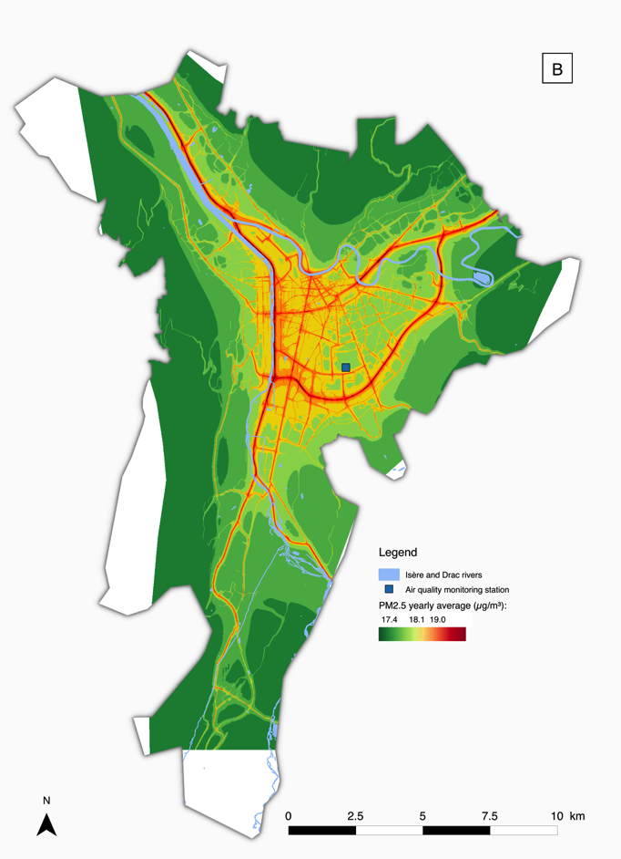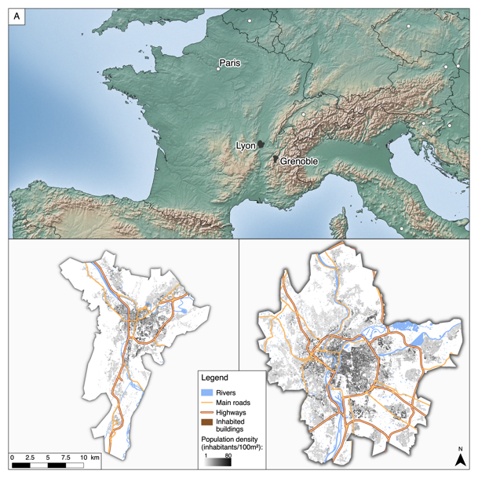

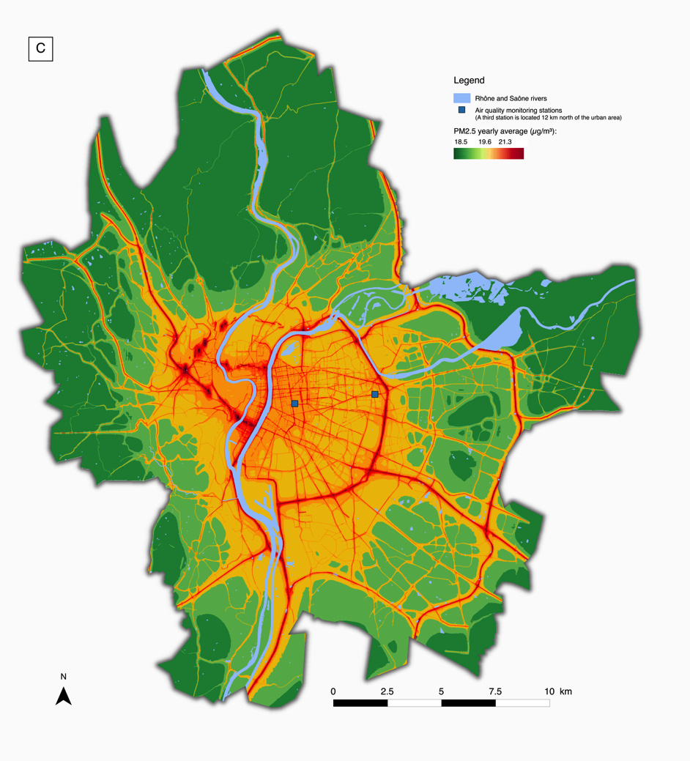

Figure 2: Spatial distribution of lung cancer incidence rates, taking into account the neighborhood-specific information on the distribution of cases (A) and assuming spatial homogeneity in the distribution of cases between neighborhoods from the same city (B).

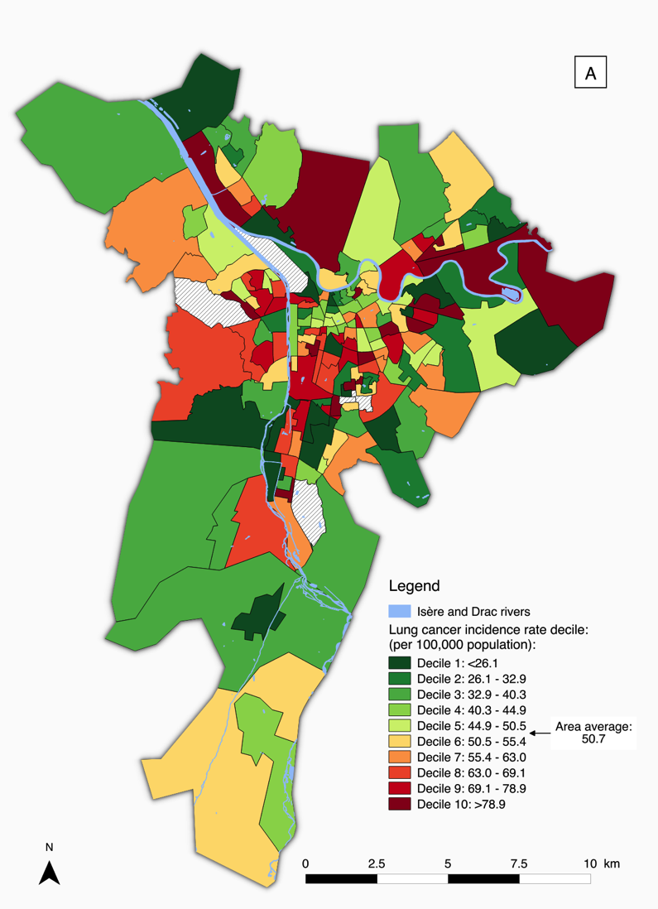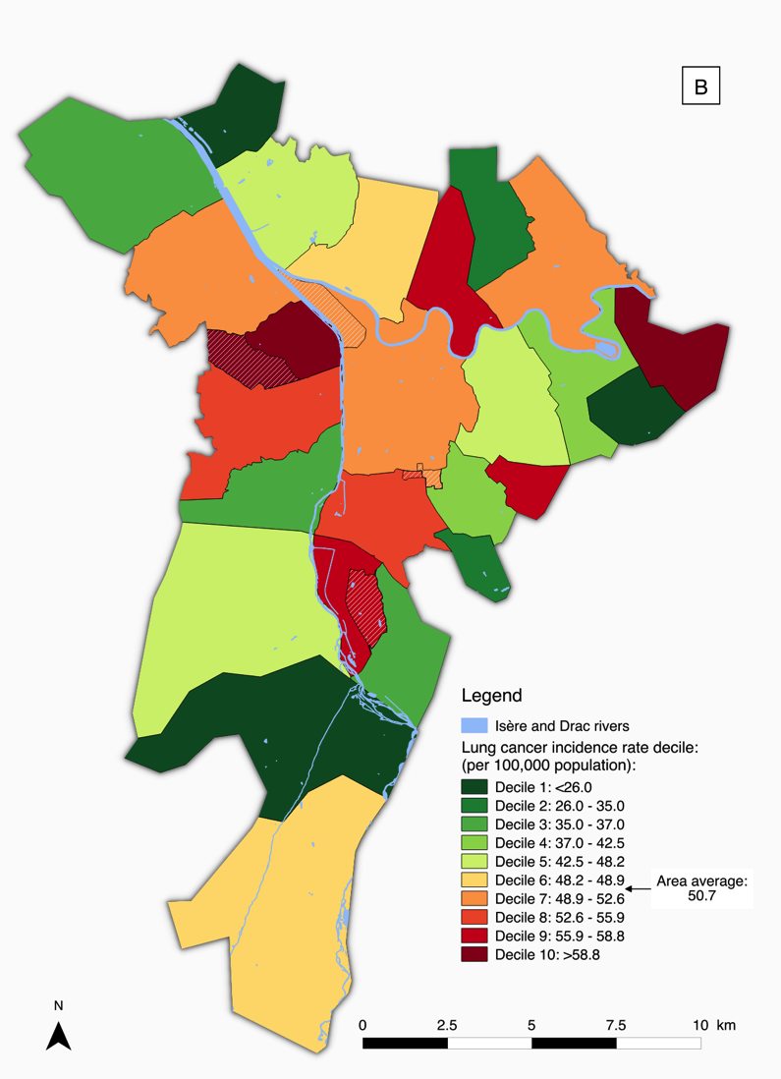

Figure 3: Median PM2.5 exposures by neighborhoods grouped in social deprivation (EDI index) decile, in Grenoble and Lyon (exact values: see Table 5).



Figure 4: Social deprivation status (European Deprivation Index, EDI) at the IRIS scale in Grenoble (A) and Lyon (B) urban areas.

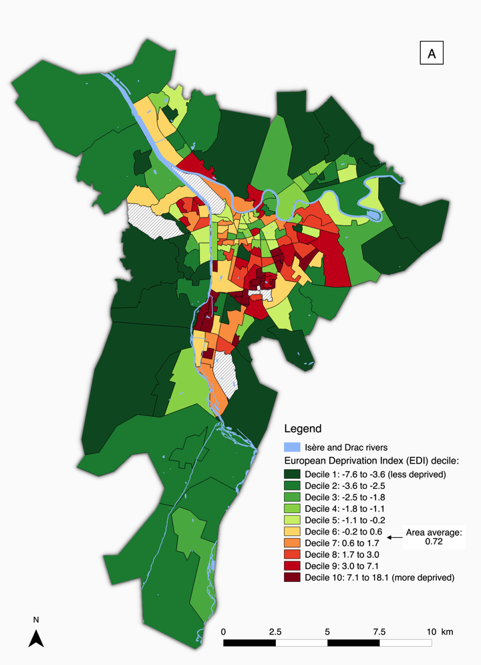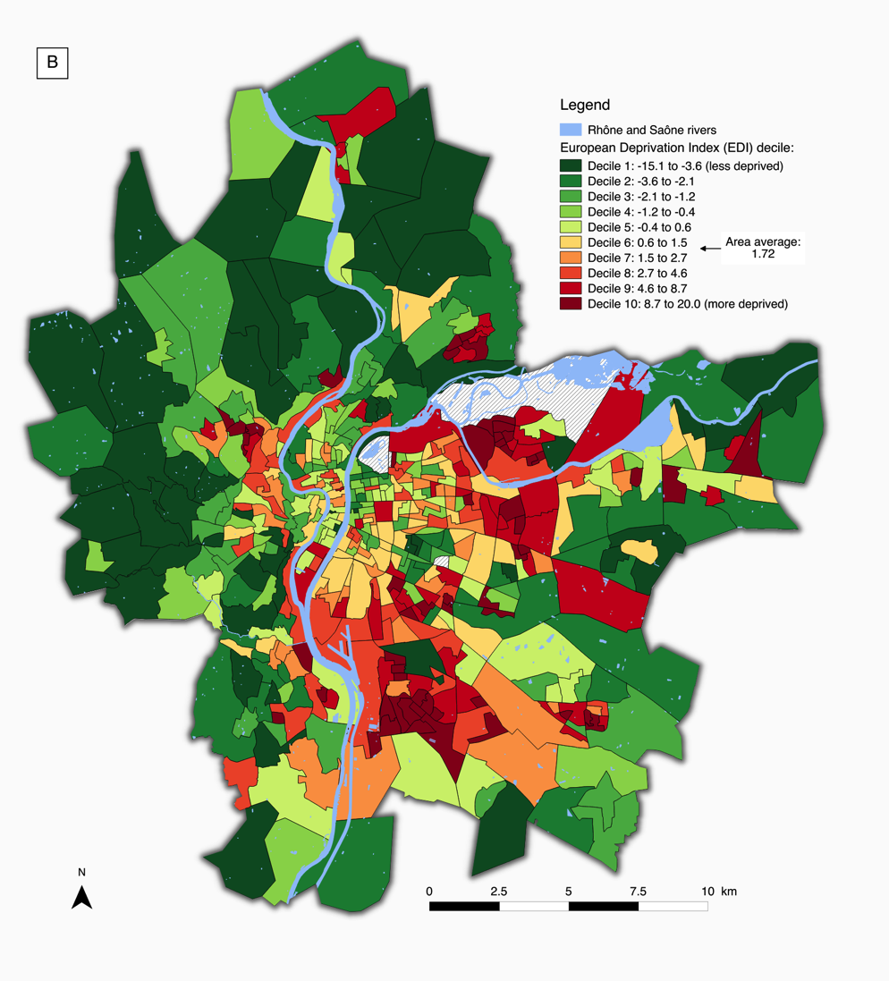

# 6 Supplemental material

Table S1: Sensitivity analyses of the health impact assessment under three different alternative hypotheses, restricted to the main city in each of the two areas.

|  |  |  |  |  |  |
| --- | --- | --- | --- | --- | --- |
| **Health event and hypothesis** | **Difference of the health impact compared to the  whole study areaa** | **Number of attributable cases (NAC)** | | | |
| **NAC** | (% of total) | **95% CI** | (% of total) |
| **Non-accidental mortality** | |  | |  | |
| Grenoble city (n=157,000) | |  | |  | |
| H1 (reference) | 2.0% | 53.8 (5.2%) | | 33.4–74.1 (3.2–7.2%) | |
| H2 | 12.5% | 55.1 (5.4%) | | 34.2–75.9 (3.3–7.4%) | |
| H3 | 10.6% | 53.2 (5.2%) | | 33.0–73.3 (3.2–7.1%) | |
| H4 | N.A.b | 48.2 (4.7%)b | | 29.8–66.4 (2.9–6.4%)b | |
| Lyon city (n=470,000) | |  | |  | |
| H1 (reference) | 6.7% | 206 (6.4%) | | 128–283 (4.0–8.8%) | |
| H2 | 14.0% | 209 (6.5%) | | 130–287 (4.1–9.0%) | |
| H3 | 12.7% | 200 (6.2%) | | 125–275 (3.9–8.6%) | |
| H4 | N.A.b | 161 (5.0%)b | | 100–222 (3.1–6.9%)b | |
| **Lung cancer incidence** | |  | |  | |
| Grenoble city (n=157,000) | |  | |  | |
| H1 (reference) | 2.9% | 5.8 (7.0%) | | 2.7–8.6 (3.3–10.4%) | |
| H2 | 4.3% | 5.9 (7.2%) | | 2.7–8.8 (3.3–10.7%) | |
| H3 | 9.5% | 5.7 (6.9%) | | 2.6–8.5 (3.2–10.3%) | |
| H4 | N.A.b | 5.2 (6.3%)b | | 2.4–7.7 (2.9–9.4%)b | |
| **Term low birth weight cases** | |  | |  | |
| Grenoble city (n=157,000) | |  | |  | |
| H1 (reference) | 3.4% | 14.3 (24.4%) | | 5.5–22.4 (9.4–38.2%) | |
| H2 | 10.2% | 14.6 (24.9%) | | 5.6–22.7 (9.5–38.7%) | |
| H3 | 9.1% | 14.1 (24.0%) | | 5.4–22.2 (9.2–37.8%) | |
| H4 | N.A.b | 12.9 (22.1%)b | | 4.9–20.5 (8.4–35.0%)b | |
| Lyon city (n=470,000) | |  | |  | |
| H1 (reference) | 5.1% | 53.8 (29.0%) | | 21.1–82.7 (11.4–44.6%) | |
| H2 | 12.3% | 54.4 (29.3%) | | 21.4–83.3 (11.5–44.9%) | |
| H3 | 11.4% | 52.7 (28.4%) | | 20.6–81.2 (11.1–43.8%) | |
| H4 | N.A.b | 43.5 (23.4%)b | | 16.7–68.4 (9.0–36.9%)b | |

H1 (fine-scale approach): taking into account spatial variations of both population density and pollution; H2: H1 assuming spatial homogeneity of population density; H3: H2 assuming spatially homogeneous air pollution levels (area-specific median level of dispersion model estimate used); H4: H2 assuming spatially homogeneous air pollution levels, as estimated by the area-specific background air quality monitoring stations (1 station in Grenoble: *Villeneuve Les Frênes*, and 3 stations in Lyon: *Vaulx en Velin*, *Lyon Centre* and *Villefranche Village*; see Figure 1).

a Difference of number of attributable cases between the main city restricted analysis and the whole urban area setup. Higher values indicate a stronger health impact, depending on the study area setup and the calculation hypothesis.

b H4 relies on the monitoring station(s), which provide identical exposure estimates regardless of the study area.

Figure S1: Scatter plots of the ranked median PM2.5 levels and the EDI score at the IRIS scale in the Grenoble (A) and Lyon (B) urban areas (higher EDI values represent more deprived neighborhoods).





Figure to be removed?

Figure S2: Stratification of the number of cases attributable to the exposure to PM2.5 on the EDI decile, for non-accidental mortality and term low birth weight in Grenoble and Lyon (A) and lung cancer incidence with different levels of spatial distribution of cases (B) (exact values: see Table 5).

**A**





**B**

Note: in the figure above (B), the upper-left and upper-right curves correspond to the spatial distribution of cases represented in Figure 2A and 2B, respectively.