**Supplementary Material for IV**

**Quantitative biokinetics of titanium dioxide nanoparticles after intravenous injection in rats (Part 1)**

# Wolfgang G. Kreyling*#§, Uwe Holzwarth+, Nadine Haberl*, Ján Kozempel+1, Stephanie Hirn*, Alexander Wenk*2, Carsten Schleh*3, Martin Schäffler*, Jens Lipka*, M. Semmler-Behnke*4 and Neil Gibson+

# * Helmholtz Center Munich – German Research Center for Environmental Health, Comprehensive Pneumology Center, Institute of Lung Biology and Disease, Helmholtz Centre Munich, Ingolstaedter Landstrasse 1, D-85764 Neuherberg / Munich, Germany,

#  Helmholtz Center Munich – German Research Center for Environmental Health, Institute of Epidemiology 2, Ingolstaedter Landstrasse 1,D-85764 Neuherberg / Munich, Germany

# 2 European Commission, Joint Research Centre, Directorate F – Health, Consumers and Reference Materials, Via E. Fermi 2749, I-21027 Ispra (VA), Italy

§Corresponding author

Wolfgang G. Kreyling

Institute of Epidemiology 2

Helmholtz Centre Munich,

Ingolstaedter Landstrasse 1

D-85764 Neuherberg / Munich

Germany

phone: +49 89 2351 4817

E-mail address: [Kreyling@helmholtz-muenchen.de](mailto:Kreyling@helmholtz-muenchen.de)

1 Current address: Czech Technical University in Prague, Faculty of Nuclear Sciences and Physical Engineering, Břehová 7, CZ-11519 Prague 1, Czech Republic

2 Current address: Dept. Infrastructure, Safety, Occupational Protection, German Research Center for Environmental Health, D-85764 Neuherberg / Munich, Germany

3 Current address: Abteilung Gesundheitsschutz, Berufsgenossenschaft Holz und Metall, D-81241 München, Germany

4 Current address: Bavarian Health and Food Safety Authority, D-85764 Oberschleissheim, Germany

**Content**

* Radiolabeling of titanium dioxide (TiO2) nanoparticles
* Nanoparticle preparation for application and characterization
* Animals and animal housing
* Nanoparticle application and animal maintenance in metabolic cages
* Sample preparation for radiometric analysis
* Radiometric and statistical analysis
* Blood correction and total blood volume
* 48V-activity determination of skeleton and soft tissue
* Biokinetics of soluble 48V in ionic form after IV-injection
* Correction of the biokinetics assigned to [48V]TiO2NP for the effect of free 48V-ions
* Evaluation of the auxiliary and main study by pharmacokinetic modeling

**Radiolabeling of titanium dioxide (TiO2) nanoparticles**

Pure titanium dioxide (TiO2, type ST-01 from Ishihara Sangyo Kaisha, Ltd, Osaka, Japan) with spherically-shaped primary anatase particles of 7-10 nm crystal size, was proton irradiated using the MC40 Cyclotron at the Joint Research Centre (Ispra, Italy) in a specially designed thin target capsule that allows efficient cooling of the sample from both sides as described earlier (Abbas, 2010, Hildebrand, 2015, Holzwarth, 2012, Kreyling, 2011).

The ion-beam energy was set so that, after passage through the beamline, capsule windows and the cooling water, the ion energy incident on the nanoparticles was about 13.5 MeV (1 eV ≈ 1,602 × 10-19 J), suitable for efficient creation of 48V *via* the (p,n) nuclear reaction from Ti. Two batches of 20 mg ST-01 TiO2NP were irradiated with a proton beam current of 5 μA; one with a 48V-activity concentration of 1.0 MBq/mg (48V-activity per TiO2 mass) was used for the 1h, 4h and 24h retention experiments. The second one was irradiated on five consecutive days yielding an activity concentration of 2.35 MBq/mg and was used for the 7d and 28d retention experiments in order to preserve sufficient sensitivity in spite of longer radioactive decay and to detect any minor redistribution and clearing processes. At these radioactivity concentrations the atomic ratio of 48V:Ti in the nanoparticles is about 2.6 × 10-7 and 6.2 × 10-7, respectively. Hence, statistically, from 1000 primary TiO2 particles only a few will contain a 48V-radiolabel.

The radioactive 48V decays back to 48Ti *via* electron capture or positron emission, with a half-life of 15.97 days, emitting γ-rays with an energy of 0.99 MeV and 1.3 MeV in the process, as well as γ-rays of 511 keV that result from electron-positron annihilation.

During the activation process, each 48V-radiolabel created will recoil due to conservation of momentum and be implanted into another nanoparticle several hundred nm from its original position. Since this process, together with the chemical difference, may result in some cases in non-perfect integration of the 48V within the nanoparticles with the risk of subsequent radiolabel leaching, the TiO2NP were carefully washed, as described below, and free 48V was removed. Due to diffusion processes in the tiny particles bringing 48V-ions to the nanoparticle surface and possibly due to a very slow dissolution of the nanoparticles themselves in aqueous media (Vogelsberger, 2003, Vogelsberger, 2008) this leaching is likely to be a continuous process. Thus, washed suspensions of radiolabelled [48V]TiO2NP may develop new 48V-ion impurities, which may amount to 2% of the total activity within 28 days at low pH-values (Hildebrand, 2015).

The temperature at the centre of the nanoparticle sample during irradiation was raised by approximately 150°C but this is below the threshold temperature for the onset of structural changes (Holzwarth, 2012, Inagaki, 2009). Radiation damage due to collision processes was calculated, indicating that only a small fraction of the atoms of the nanoparticles would be displaced from their lattice positions. An XRD scan of a sample of TiO2NP treated to a similar irradiation treatment showed that neither the crystalline structure (anatase) nor the average crystallite size had measurably changed during the activation process (Gibson, 2011, Holzwarth, 2012).

**Nanoparticle preparation for application and characterization**

After proton irradiation, the nanoparticles were recovered from the irradiation capsule and subjected to a procedure to disperse them, remove free 48V and size-select a ‘nano-fraction’ of the material for the subsequent experiments by removing larger aggregates/agglomerates. Thus, a size selected ‘nano-fraction’ of radiolabeled [48V]TiO2NP of aggregated/agglomerated ST-01 TiO2NP was used for the experiments.

The [48V]TiO2NP were recovered from the irradiation capsule, suspended in 150 μL sodium pyrophosphate solution (0.5 M), used as a surfactant, and filled up with double-distilled water (dd H2O) to 3 mL. This suspension was ultrsasonicated for 1 min and filtered through a 0.22 μm disposable membrane syringe filter to remove large agglomerates and then sonicated again in a water-bath for 1 min (Branson 15010 Bath Sonicator, 42 kHz, 70W). It was then maintained for 24 hours at 70°C. Afterwards, soluble 48V was separated from the nanoparticles by centrifugation (1 min; 4000 × *g*). The nanoparticle pellet was resuspended in 2 mL of 0.1 mM sodium pyrophosphate solution and sonicated in a water-bath (30 min). Afterwards, the nanoparticle sodium pyrophosphate suspension was incubated for another 30 min at 70°C, the suspension was centrifuged again (1 min; 4000 × *g*), the pellet recovered and resuspended in 2 mL dd H2O, sonicated (1 min) and filtered through a 0.22 μm syringe filter. The filter was discarded and the suspension was washed using a 3 kDa Amicon centrifugation filter (50 min, 4000 × *g*). The nanoparticles were recovered from the Amicon filter cup using 250 µL dd H2O and then topped up to a volume of 2 mL with dd H2O. The suspension was incubated for 12 hours at 70 °C and afterwards sonicated in a water bath (60 min). The resulting suspension was centrifuged (6 min, 4000 × *g*) and the supernatant containing the smallest particle fraction was taken for the experiments.

While this procedure contains only one washing step by centrifugal ultrafiltration, keeping track of the various resuspension steps of the recovered pellet, the sodium pyrophosphate that might still be present in a single dose of [48V]TiO2NP, once injected into a rat, cannot increase the pyrophosphate concentration in the circulation of the rat beyond 0.1 μM, which is below the normal physiological level of (3 – 5)μM (Villa-Bellosta, 2011).

For each of the five individual biodistribution studies at different retention time points we prepared new [48V]TiO2NP suspensions using the protocol given above. A simultaneous start of [48V]TiO2NP application to all rats (four rats per group, five time points, three application routes) was not possible due to the rather short half-life of 48V (15.97 d) and the large number of samples (typically more than 20 for each rat, resulting in more than 1200 for the whole experimental series) to be sequentially quantified by -ray spectrometry with sufficient counting statistics over measuring times of up to four hours. As a result, the experiments investigating the five different periods of retention time had to be staggered. However, each [48V]TiO2NP suspension was used for all three biodistribution studies reported in the three relevant articles of this volume of Nanotoxicology – either after intravenous injection (IV) (Kreyling et al., 2017 Part 1), after intra-esophageal instillation (gavage) (Kreyling et al., 2017 Part 2) or after intratracheal instillation (IT) (Kreyling et al., 2017 Part 3) for a given retention time point. Thus each retention time point was analyzed for all three exposure routes starting from the same [48V]TiO2NP suspension batch with the same nanoparticle properties.



**Figure S1:** Hydrodynamic diameter of the five separately prepared [48V]TiO2NP suspensions measured directly before application in biodistribution studies at five different retention times (1h, 4h, 24h, 7d and 28d).

The hydrodynamic diameter of the nanoparticles and the zeta potential were measured in triplicates several times during preparation for control purposes using Dynamic Light Scattering (DLS) by a Malvern Zetasizer (Malvern, Herrenberg, Germany). Finally prior to each *in vivo* application the size distribution was measured again by DLS. Figure S1 shows the hydrodynamic size distributions of the separately prepared [48V]TiO2NP suspensions measured by DLS immediately prior to *in vivo* application. The size distributions are plotted as intensity frequencies. While there was some variability in the size distributions after the dispersion and size selection procedure they overlap very well. Only the suspension for the 4h time point appeared to have a particle size somewhat smaller than the others. Mean data of the numeric evaluation are compiled in Table S1.

**Table S1:** Physicochemical characteristics of the [48V]TiO2NP suspensions used for 5 different retention times. For each retention time the same suspension was applied in three different exposure routes *via* intravenous injection (IV), intra-esophageal instillation (GAV) and intratracheal instillation (IT)

|  |  |  |  |  |  |  |
| --- | --- | --- | --- | --- | --- | --- |
| Retention time |  | 1h | 4h | 24h | 7d | 28d |
| Zeta Potential* | [mV] | -38.9 + 4.2 | -33.2 ± 2.4 | -29.9 + 8.1 | -42.7 + 9.2 | -35.2 + 7.6 |
| Z-average* | [nm] | 93 | 72 | 93 | 82 | 101 |
| PDI* |  | 0.157 | 0.228 | 0.160 | 0.197 | 0.135 |
| Crystal structure§ |  | anatase | anatase | anatase | anatase | anatase |
| Primary part. diameter§ | [nm] | 7 - 10 | 7 - 10 | 7 - 10 | 7 - 10 | 7 - 10 |
| Specific surface area (BET) & | m2/g | 316 | 316 | 316 | 316 | 316 |

* measured with a Malvern Zetasizer;

PDI – polydispersity index;

§ manufacturer data confirmed by own XRD measurements;

&BET – [Brunauer](http://de.wikipedia.org/wiki/Stephen_Brunauer), [Emmett](http://de.wikipedia.org/wiki/Paul_Hugh_Emmett), [Teller](http://de.wikipedia.org/wiki/Edward_Teller) method to determine the specific surface area (own measurements; Autosorb-1, Quantachrome Instruments, Florida, USA).

The mean ± STD of Z-averages and PDI of all five distributions (given in Table S1) are 88 ± 11 nm and 0.18 ± 0.04, respectively. The PDI indicates that the size distributions are polydisperse but with a rather narrow size distribution. Whether the sizes were plotted as intensity or volume or number frequency distributions only one single peak was detected. Therefore, the volume and number distributions may be considered as reliable. The mean ± STD of the volume and number distribution maxima of all five spectra are 65 ± 12 nm and 48 ± 11 nm, respectively. We conclude therefore that we successfully selected a reasonably narrow distributed ‘nano-fraction’ of the original ST-01 TiO2 particle aggregates/agglomerates by applying the multiple step size selection procedure described above. This was supported by TEM investigations – presented in Figure S2 – which revealed approximately spherical aggregates/agglomerates of roughly 50 nm in diameter after the size selection and dispersion process. Samples for transmission electron microscopy were prepared from the aqueous suspensions on glow discharged 300 mesh Formvar®-coated copper grids and investigated with a Philips 300 TEM at 60 kV acceleration voltage.

E:\Eigene Dateien\AA-WINWORD\PUBLTEXT\PAPERS\2014\TiO2 NP Triologie\TiO2-NP TEM Barbara Rothen\Figure 2 TiO2-NP TEM.tif

**Figure S2:** Transmission electron micrograph of size-selected TiO2NP sampled immediately after the preparation procedure described above. TEM sample preparation leads to ‘clumping’ together of aggregates/agglomerates on the support grid.

From the known activity conecentration of the proton irradiated batches of TiO2 nanoparticles (1.0 MBq/mg and 2.35 MBq/mg) and the 48V-radioactivity of the applied [48V]TiO2NP, the applied nanoparticle mass was calculated for each application route at each of the five retention times as reported in Table S2. While the numbers of aggregates/agglomerates applied to each rat were not possible to calculate, since it was impossible to determine the apparent specific density of the [48V]TiO2NP due to their porous, chain-like structure shown in Figure S2 the number of applied primary nanoparticles can be estimated if necessary.

**Animals and animal housing**

Healthy, female Wistar-Kyoto rats (WKY/Kyo@Rj rats, Janvier, Le Genest Saint Isle, France), 8–10 weeks of age (263 ± 10 g mean (± STD) body weight) were housed in pairs in relative-humidity and temperature controlled ventilated cages (VentiRack Bioscreen TM, Biozone, Margate, UK) on a 12-hr day/night cycle. Rodent diet and water were provided *ad libitum*. After purchase the rats were adapted for at least two weeks and then randomly attributed to the experimental groups. All experiments were conducted under German federal guidelines for the use and care of laboratory animals and were approved by the Regierung von Oberbayern (Government of District of Upper Bavaria, Approval No. 211-2531-94/04) and by the Institutional Animal Care and Use Committee of Helmholtz Centre Munich.

**Nanoparticle application and animal maintenance in metabolic cages**

Although we aimed to obtain the same [48V]TiO2NP concentration in each of the five suspension preparations, in fact the [48V]TiO2NP concentrations varied by a factor of two due to the multiple step preparation process.

In addition, we found very significant differences in [48V]TiO2NP retention in the syringes used for each IV-injection even though we had minimized the times between finalizing the preparation of the [48V]TiO2NP suspensions, filling the minimal-dead-space, 1-mL-insulin-syringe (Omnican® 100, Braun, Melsungen, Germany, specified dead space 0.4 µL) and the intravenous injection to each rat to less than two minutes. These material losses in the syringe can be determined for each rat by measuring the residual radioactivity of the [48V]TiO2NP left in the syringe and cannula after application of the [48V]TiO2NP suspension. Actually, the losses in the syringe were not caused by the dead space because of the special design of the plunger minimizing the syringe dead space to 0.4µL. This volume cannot explain the large variations of activity retained in the syringes that varied from 15% up to 90% of the loaded activity.

Such significant losses may result from electrostatic [48V]TiO2NP adhesion to the plastic walls of the syringe and may occur not only with the nanoparticle suspensions we were using but as well with those used by other investigators using the same or similar application methods. Since the use of radiolabeled nanoparticles requires much less cumbersome specimen preparation as required for other analytical techniques when striving for a complete, balanced biodistribution of nanoparticles in laboratory animals, such detailed measurements are usually not performed with non-radioactively labeled nanoparticles. Consequently such losses will usually remain undiscovered and may have contributed substantially to unresolved variability and errors of the nanoparticle doses applied to experimental animals in other similar experimental studies reported in scientific literature.

Similar observations were not made in the auxiliary studies where radioactivity was applied in ionic form where syringes and cannulas exhibited nothing more than the slight contamination expected for equipment that was in touch with open radioactive substances.

**Table S2:** The effectively injected activity of the [48V]TiO2NP suspensions into the rats (first row) was determined from the balance over all tissue samples (including the carcass), organs, urine and feces collected from each rat. It was frequently much smaller than the 48V-activity loaded into the 1mL insulin-syringes (Omnican® 100, Braun, Melsungen, Germany; specified dead volume < 0.4µL) due to retention of nanoparticles in the syringe and cannula. The last row presents the percentage of 48V-activity retained in the syringes and cannulas. The applied nanoparticle mass refers to the mass effectively received by the rats.

|  |  |  |  |  |  |  |
| --- | --- | --- | --- | --- | --- | --- |
| Retention time | Unit | 1h | 4h | 24h | 7d | 28d |
| Effective 48V radioactivity received by rats | [kBq] | 18.15 ± 3.37 | 11.29 ± 3.69 | 16.53 ± 3.69 | 253.99 ± 54.23 | 110.27 ± 5.76 |
| applied [48V]TiO2NP mass | [µg] | 18.15 ± 3.37 | 11.29 ± 3.69 | 16.53 ± 3.69 | 108.08 ± 54.23 | 46.92± 2.54 |
| Percentage of [48V]TiO2NP retained in the syringe after application | % | 62.8±6.2 | 71.3±1.7 | 32.6±4.5 | n.d. | n.d. |

#Mean ± SD of integrally measured 48V-radioactivity of each rat, n = 4 for each group

&Mean ± SD of [48V]TiO2NP mass calculated from the radioactivity concentration (1.0 kBq/µg for 1h, 4, 24, and 2.35 kBq/µg for 7d and 28d) and the integrally measured 48V-radioactivity of each rat, n = 4 for each group

n.d. = not determined

Nanoparticle suspensions were applied to non-fasted animals as described earlier (Kreyling, 2014, Schleh, 2012, Hirn, 2011, Semmler, 2004, Kreyling, 2002). Firstly, the rats were anesthetized by inhalation of 5% isoflurane in oxygen until muscular tonus relaxed. The isoflurane-pre-anesthetized rat was kept under isoflurane anesthesia and a flexible IV-catheter (24 G, ¾ in) was placed into the tail vein. Subsequently, an effective volume of 60μl of the [48V]TiO2NP suspension was slowly injected using a 1-mL-insulin-syringe (Omnican® 100, Braun, Melsungen, Germany; specified dead volume < 0.5µL). The syringe and cannula used for the injection were collected for measurements of the residual [48V]TiO2NP.

The effectively applied [48V]TiO2NP doses exhibited an undesired variation due to nanoparticle retention in the application equipment, which was not observed for the injection of ionic titanium and vanadium in the auxiliary study using the same equipment, and whose size exceeds by far dead volume effects in syringes and cannulas. Another issue, which could have complicated the biokinetics studies is the retention of nanoparticles at the injection site. This issue was addressed by measuring the 48V-activity in the tail including the injection point. A maximum fraction of about (1.5±2.3)% of the injected activity was found 1h after injection. But already after 4h only (0.13±0.05)% were determined, a value that remained constantly low over the whole investigated retention period (24h; (0.13±0.1)%). Therefore, a slow release of applied [48V]TiO2NP that might have been retained at the injection point, could be excluded. 98.5% of the applied dose was applied as a single bolus and only a small part of 1.37% was delivered delayed within 4 hours after injection, unlikely to interfere with the IV investigation.

After application of the nanoparticle suspensions, rats were kept individually in metabolism cages (Tecniplast, Hohenpreissenberg, Germany) for quantitative but separate collection of urine and faeces. For ethical reasons the 28-day groups of rats were maintained individually on cotton cloths in normal cages starting immediately after [48V]TiO2NP application. The cloth was replaced by a new cloth every 3-4 days (two cloths per week), and from the collected cloth fecal droppings were separated quantitatively. After separation, the cloth contained only 48V originating from urine which had soaked and dried.

**Sample preparation for radiometric analysis**

At the chosen time periods of 1h, 4h, 24h, 7d or 28d after [48V]TiO2NP application by IV-injection rats were anesthetized (by 5 % isoflurane inhalation) and euthanized by exsanguination *via* the abdominal aorta as described earlier (Kreyling, 2014, Schleh, 2012, Hirn, 2011, Semmler, 2004, Kreyling, 2002). In this way approximately 60 % to 70% of the total blood volume could be recovered. Organs, tissues, remaining carcass and excretions as specified in Table S3 were collected for radiometric analysis. During dissection, none of the organs were cut and all fluids were cannulated (where necessary) in order to avoid any cross contamination.

**Table S3:** Organ, tissue and other samples prepared for radiometric analysis.

|  |  |  |
| --- | --- | --- |
| lungs | liver | spleen |
| kidneys | brain | heart |
| uterus | | |
| GIT: gastro-intestinal tract, comprising oesophagus, stomach, small and large intestine | | |
| total skin | muscle sample (hind legs) | exsanguinated blood |
| head: skinned head without brain | | |
| bone sample (humerus or femur carefully cleaned from muscles and fat) | | |
| skeleton: estimated from measured bone sample activity times 10% BW (derived in Eqn. (S8)) | | |
| carcass: total remaining carcass beyond the above listed organs and tissues, consists of skeleton and soft tissue | | |
| soft tissue: non-osseous tissues of the carcass; it includes muscles, fat, skin, connective tissue, paws: 48V-activity calculated to be the difference between carcass and skeleton activities; | | |
| Secondary organs: sum of all organs listed | | |
| after IV-injection the tail with the IV-injection point | | |
| excretion: total daily urine and faeces, collected separately | | |
| hepato-biliary clearance (hbc): after IV-injection any 48V found in the lower part of the GIT and fecal excretion represent clearance from the liver *via* the hepato-biliary pathway into the intestine | | |

**Radiometric and statistical analysis**

The 48V-radioactivity of all samples was measured by γ-ray spectrometry without any further physico-chemical preparation in either a lead-shielded 10-mL or a lead-shielded 1-L well type NaI(Tl) scintillation detector as previously described (Kreyling, 2014, Schleh, 2012, Hirn, 2011, Semmler, 2004). For radiometric analysis the 511 keV γ-ray emission – resulting from electron-positron annihilation - was used. The count rates were corrected for physical decay and background radiation. Additionally, count rates were calibrated to a 48V reference source in order to correlate 48V-radioactivity to the mass of the TiO2NP. Samples yielding net counts (*i.e.*, background-corrected counts) in the 511 keV region-of-interest of the 48V γ-ray spectrum were defined to be below the detection limit (< 0.2 Bq) when they were less than three standard deviations of the background count rate in this region-of-interest.

For a complete balance of the applied 48V-radioactivity within each rat, the 48V-activities of all individual samples were summed up for each rat and used as a denominator for the calculation of 48V-activity fraction in each sample. These fractions were averaged over the four rats of each group and are reported with the standard error of the mean (SEM) as described earlier (Kreyling, 2014, Schleh, 2012, Hirn, 2011, Semmler, 2004, Kreyling, 2002).

All calculated significances are based on a One-Way-ANOVA test and a *post hoc* Tukey Test. In case of an individual two group comparison, the unpaired t-test was used. p ≤ 0.05 was considered significant.

**Blood correction and total blood volume**

In order to obtain the true value of 48V-activity in the organs and tissues of interest the radioactivity contributed by the residual blood retained after exsanguination had to be subtracted. In the case of the carcass, the difference between the estimated total blood volume of the animal and the sum of all organ blood contents and the collected blood sample was calculated to be the blood volume of the carcass.

**Table S4:** Organ specific weight factors  for the residual blood in the organ tissue after exsanguination given as residual blood weight per organ weight according to (Oeff, 1955).

|  |  |  |  |  |
| --- | --- | --- | --- | --- |
| Lung (g•g-1) | liver (g•g-1) | spleen (g•g-1) | kidney (g•g-1) | brain (g•g-1) |
| 0.28 ± 0.10) | 0.14 ± 0.03 | 0.16 ± 0.04 | 0.22 ± 0.04 | 0.018 ± 0.001 |
| heart (g•g-1) | GIT§  (g•g-1) | muscle (g•g-1) | fat (g•g-1) | thyroid* g/organ |
| 0.15 ± 0.02 | 0.020 ± 0.006 | 0.016 ± 0.002 | 0.012 ± 0.002 | 0.008 ± 0.001 |

* thyroid given for complete organ; § intestine and stomach

The blood contents of organs and tissues were calculated according to the findings of Oeff and Konig (Oeff, 1955) and the 48V-radioactivities of the organs were corrected for these values as follows:

|  |  |  |
| --- | --- | --- |
|  |  | (S1) |

where denotes the 48V-activity measured in the organ "i" at the time point in Bq which is corrected for the residual blood content by subtracting calculated according to

|  |  |  |
| --- | --- | --- |
|  |  | (S2) |

making use of the mass and the 48V-activity measured for the blood recovered from exsanguination at the time point , the mass of the organ  and the organ specific weight factor  compiled in Table S4. The total blood volume *BV* in mL was estimated to be

|  |  |  |
| --- | --- | --- |
|  |  | (S3) |

according to the work of Lee and Blaufox (Lee, 1985), where *BW* denotes the body weight in g.

To determine the 48V-activity in the residual blood of the remaining carcass or skeleton for each rat the following procedure was applied. Firstly, the mass of the residual blood volume in the carcass or skeleton (tissue = carcass or skeleton) was calculated by subtracting from the mass of the total blood volume  the mass of the sampled blood volume  and the sum of the masses of the residual blood volumes of all organs  which had been calculated according from Eqn (S2) according to the findings of Oeff and Konig (Oeff, 1955)

|  |  |  |
| --- | --- | --- |
|  |  | (S4) |

For each rat the 48V-activity in the residual blood of the remaining carcass or skeleton (tissue = carcass or skeleton) is then given by

|  |  |  |
| --- | --- | --- |
|  |  | (S5) |

as the 48V-activity concentration determined from the blood sample taken times the mass of the residual blood in carcass or skeleton times the mass fraction of carcass or skeleton with respect to the rat’s body weight. This estimate assumes that the residual blood volume is proportional to the mass of either the carcass or skeleton. Since the remaining carcass consists of the skeleton and soft tissue, the 48V-activity in the residual blood of the soft tissue is the difference between 48V-activities of carcass minus skeleton:

|  |  |  |
| --- | --- | --- |
|  | . | (S6) |

To determine the contribution of the 48V-activity in the residual blood to the total 48V-activity retained in all organs and tissues, the ratio

|  |  |  |
| --- | --- | --- |
|  |  | (S7) |

is defined, where the 48V-activity of the residual blood retained in each organ,, is calculated according to Eqn (S5). As the retention of 48V-activity in blood, organs and tissues depends on time and follows different patterns the ratio  itself depends on time. This is shown in Figure S3 for all organs, remaining carcass, skeleton and soft tissue.



**Figure S3:** Ratio  of the 48V-activity in the residual blood over the measured organ or tissue activity. Panel A: liver, spleen, lungs; panel B: kidneys, heart, uterus; panel C: carcass, skeleton, soft tissue. Mean ± SEM, n = 4.

Ratios are lowest in liver and spleen and decline gradually over time. The low ratios confirm the expected high phagocytosis activity in these two organs. Additionally, it indicates that 48V-ions released from [48V]TiO2NP are not retained in these two organs but cleared by blood. Interestingly, the ratio in the skeleton is also rather low indicating also high [48V]TiO2NP retention and low 48V-ion retention. The high ratios in lungs, heart and soft tissue indicate high retention of 48V-ions which are likely been metabolized. The surprisingly low ratios in kidneys after 24h are unexpected and indicate low [48V]TiO2NP retention; this needs further investigation.

**48V-activity determination of skeleton and soft tissue**

The 48V-activity in the whole skeleton of each rat was extrapolated from the activity of a bone sample  and its mass,, assuming the estimated weight of the skeleton to be 10% of the total body weight  (Charkes, 1979)

|  |  |  |
| --- | --- | --- |
|  | . | (S8) |

For this purpose the bone sample was carefully cleaned from other tissue. The 48V-activity to be assigned to the soft tissue  of each rat was calculated from the difference of the 48V-radioactivity content of the total remaining carcass  (including soft tissue, muscle sample, skeleton, bone sample) and the activity in the skeleton as determined in Eqn (S1):

|  |  |  |
| --- | --- | --- |
|  |  | (S9) |

**Biokinetics of soluble 48V in ionic form after IV injection**

We performed auxiliary experiments to investigate the biodistribution of soluble, ionic 48V at 24 hours and seven days after IV injection as described earlier (Kreyling, 2014, Kreyling, 2002). These data were used for correction of 48V-leaching from the [48V]TiO2NP in secondary organs and tissues. In order to mimic 48V-leaching from the TiO2NP we also added to the carrier-free ionic 48V 0.33 µg/µL ionic Ti(NO3)4 in 60 µL of distilled water in order to obtain a nitrate solution of sufficient ionic strength to stably maintain the ions, and adjusted the pH value to 5 at which no spontaneous precipitation occurred. Thus, 60 µL of 27 kBq ionic 48V and 20 µg of ionic Ti were injected into the tail vein of each rat.



**Figure S4:** Biodistribution of soluble ionic 48V-radionuclide at 24 hours and 7 days after IV-injection of carrier free 48V in 0.33 µg/µL ionic Ti(NO3)4 aqueous solution. Mean ± SEM, n = 4. Levels of significances: * p<0.05; ** p<0.01; *** p<0.001.

After IV injection of soluble 48V in ionic form the urinary excretion dominated and increased significantly from 35% to 53% from day 1 to day 7 (see Figure S4). In addition, a large and significantly decreasing amount (33% and 27% on day 1 and day 7, respectively) had been accumulated in the remaining carcass consisting of the skeleton and soft tissue. Hepatobiliary clearance of the soluble 48V into the small intestine and fecal excretion amounted to 18% at 24h and decreased to 12% at day 7. After 24h the 48V amount in the blood declined significantly from to 3.5% to 0.6% at day 7. Of the secondary organs, liver and kidneys retention were highest at about 5% and 2.5%, respectively. In all other organs the retention was below 1%. As with the liver and kidneys the retained amount of 48V decreased between 24h and day 7, except in the spleen where it increased significantly while the uterus and brain showed non-significant changes.

**Correction of the biokinetics assigned to [48V]TiO2NP for the effect of released 48V-ions**

The mass of the nanoparticles is quantified by the measurement of the γ-ray emissions of the radiolabel 48V knowing the activity concentration of 48V (1.0 MBq/mg (1h, 4h, 24h) and 2.35 MBq/mg (7days and 28 days)) in the [48V]TiO2NP.

Since the [48V]TiO2NP may be prone to release of radiolabels from the surface, and because there are indications in literature for a very slow but presumably not negligible nanoparticle dissolution (Vogelsberger, 2003, Vogelsberger, 2008) a small fraction of the radiolabels may be released into the suspension and later inside the body of the animals as ions. Since the ionic 48V and the radiolabeled [48V]TiO2NP exhibit a distinctly different excretion behavior and biokinetics, the auxiliary study described above could be used to correct the nanoparticle biokinetics for the presence of 48V in ionic form.



**Figure S5:** Urinary excretion per day as a percent of the totally applied 48V-activity in the main study and the auxiliary study after IV-injection either of a bolus of radiolabeled [48V]TiO2NP (in the main study) or of a bolus of 48V-ions (in the auxiliary study). Data obtained from the various groups of rats of both studies are indicated in the legend. Urinary samples of the 28-d group were integrally collected over 3-4 days: the integral measurement was divided by the number of sample days and the result was plotted for each day as the daily urinary excretion.

Figure S5 shows that urinary excretion in the main study is much lower than in the auxiliary study, which indicates a very low presence of ions in the main study. It is also obvious that after day 10 the urinary excretion rate can be considered constant at a rate of 0.09% d-1 of the total applied activity. Up to day 6 both data sets show an exponentially decreasing excretion rate, which indicates that also the injected nanoparticle suspension contained a small bolus of already released 48V-ions. The initially rapid exponential decay of the excretion rate can be fitted in both cases with a decay constant *λ* ≈ (0.25 – 0.5) d-1. This corroborates the assumption that in both cases urinary excretion is only due to renal clearance of 48V-ions which implies that it has to follow the same excretion kinetics.

The distribution of 48V-ions has been followed up to seven days after injection. The biodistribution pattern of the [48V]TiO2NP in the main manuscript and the biodistribution pattern of 48V-ions presented in Figure S4 exhibit distinct differences. Therefore it is necessary to correct the biodistribution assigned to [48V]TiO2NP for effects due to the distribution of 48V-ions either injected with the [48V]TiO2NP or subsequently released from the [48V]TiO2NP.

In order to determine the amount of ions in the animal bodies we may assume that the whole urinary excretion of 48V-activity in the main study is due to ion excretion since the amount of [48V]TiO2NP that may be eliminated by renal clearance will be extremely small in view of their size distribution, the vast majority being too large to pass the kidneys (e.g. (Choi, 2007)).

The total amount of activity ** applied by IV-injection of a nanoparticle suspension in the main study can be considered being distributed in three groups: (i) the activities  of the nanoparticles distributed in the body over all organs and compartments "i" (ii) the activities of the ionic fraction in the same compartments and (iii) the accumulated urinary excreted activity up to time  . Assuming that only ions contribute to urinary excretion, there is no nanoparticulate fraction of activity in the urine. We can therefore write

|  |  |  |
| --- | --- | --- |
|  | . | (S10) |

Normalizing all activities in this equation to the totally applied activity ** we get the balance equation for the fractions of activities

|  |  |  |
| --- | --- | --- |
|  | . | (S11) |

In the auxiliary study where a total activity **in purely ionic form is injected we get analogously

|  |  |  |
| --- | --- | --- |
|  | . | (S12) |

In order to be able to correct the biodistribution of [48V]TiO2NP for the effect of 48V present in ionic form we have to determine at each time point ** the content of ions in the body. In order to accomplish this task we have to compare the urinary excretion accumulated up to time  determined in the main study with the one in the auxiliary study. By assuming that at any time ** the ratio of the fractions of urinary excreted ions to the fraction of ions in the body is the same we can estimate the total 48V-ion activity fraction in the body in the main study. Thus,

|  |  |  |
| --- | --- | --- |
|  |  | (S13) |

holds and the activity fraction of 48V-ions in the main study using radiolabeled [48V]TiO2NP,  can be calculated. Since the data of the auxiliary study are obtained from different rats the mean values of  and  are used. Accordingly, in the main study the activity fraction of ions in the body that can be assigned to a certain organ or tissue follows the relation

|  |  |  |
| --- | --- | --- |
|  | , | (S14) |

also here the mean values of  and  obtained from four rats per retention time point in the auxiliary study are used. The activity fraction determined in the main study then consists of two additive components

|  |  |  |
| --- | --- | --- |
|  |  | (S15) |

given by the accumulated fractions of the total applied activity which is present in the organs or compartments due to radiolabeled [48V]TiO2NP and another one in form of 48V-ions. In order to obtain the biodistribution of the [48V]TiO2NP the raw data need to be corrected for the ion distribution, which has been obtained in the auxiliary study. This correction is accomplished making use of Eqns (S13) to (S15)

|  |  |  |
| --- | --- | --- |
|  |  | (S16) |

which distributes the activity fraction of 48V-ions present in the main study according to their biodistribution in the auxiliary study.

Within the first seven days the corrections can be performed using the corresponding biodistribution patterns for ions known after 24h and day 7. For the biodistributions of the [48V]TiO2NP after 1h and 4h the 48V-ion effects can approximately be corrected using the biodistribution of ions for 24h. The analysis of the excretion data in the [48V]TiO2NP study up to day 28 shows that the 48V-activity fraction that can be attributed to free 48V-ions is constant from about day 6 up to day 28. Therefore, also the biodistribution of the ions can be considered constant and the correction can be based on the known ion distribution at day 7.

**Evaluation of the auxiliary and main study by pharmacokinetic modeling**

The auxiliary study can be modeled according to the pharmacokinetics of a single bolus of 48V-ions injected in a single compartment with exclusively urinary excretion. In this case we can determine the ions in the body from the difference of the applied bolus and the urinary excretion which gives for the activity fractions:

|  |  |  |
| --- | --- | --- |
|  |  | (S17) |

where  denotes the urinary excreted 48V-activity fraction accumulated up to time point ** - see Figure S6*.* With a first order excretion kinetics the differential equation

|  |  |  |
| --- | --- | --- |
|  |  | (S18) |

holds, which has the solution

|  |  |  |
| --- | --- | --- |
|  |  | (S19) |

where λ denotes the excretion rate constant for 48V-ions and  the injected 48V-ion activity fraction at time .

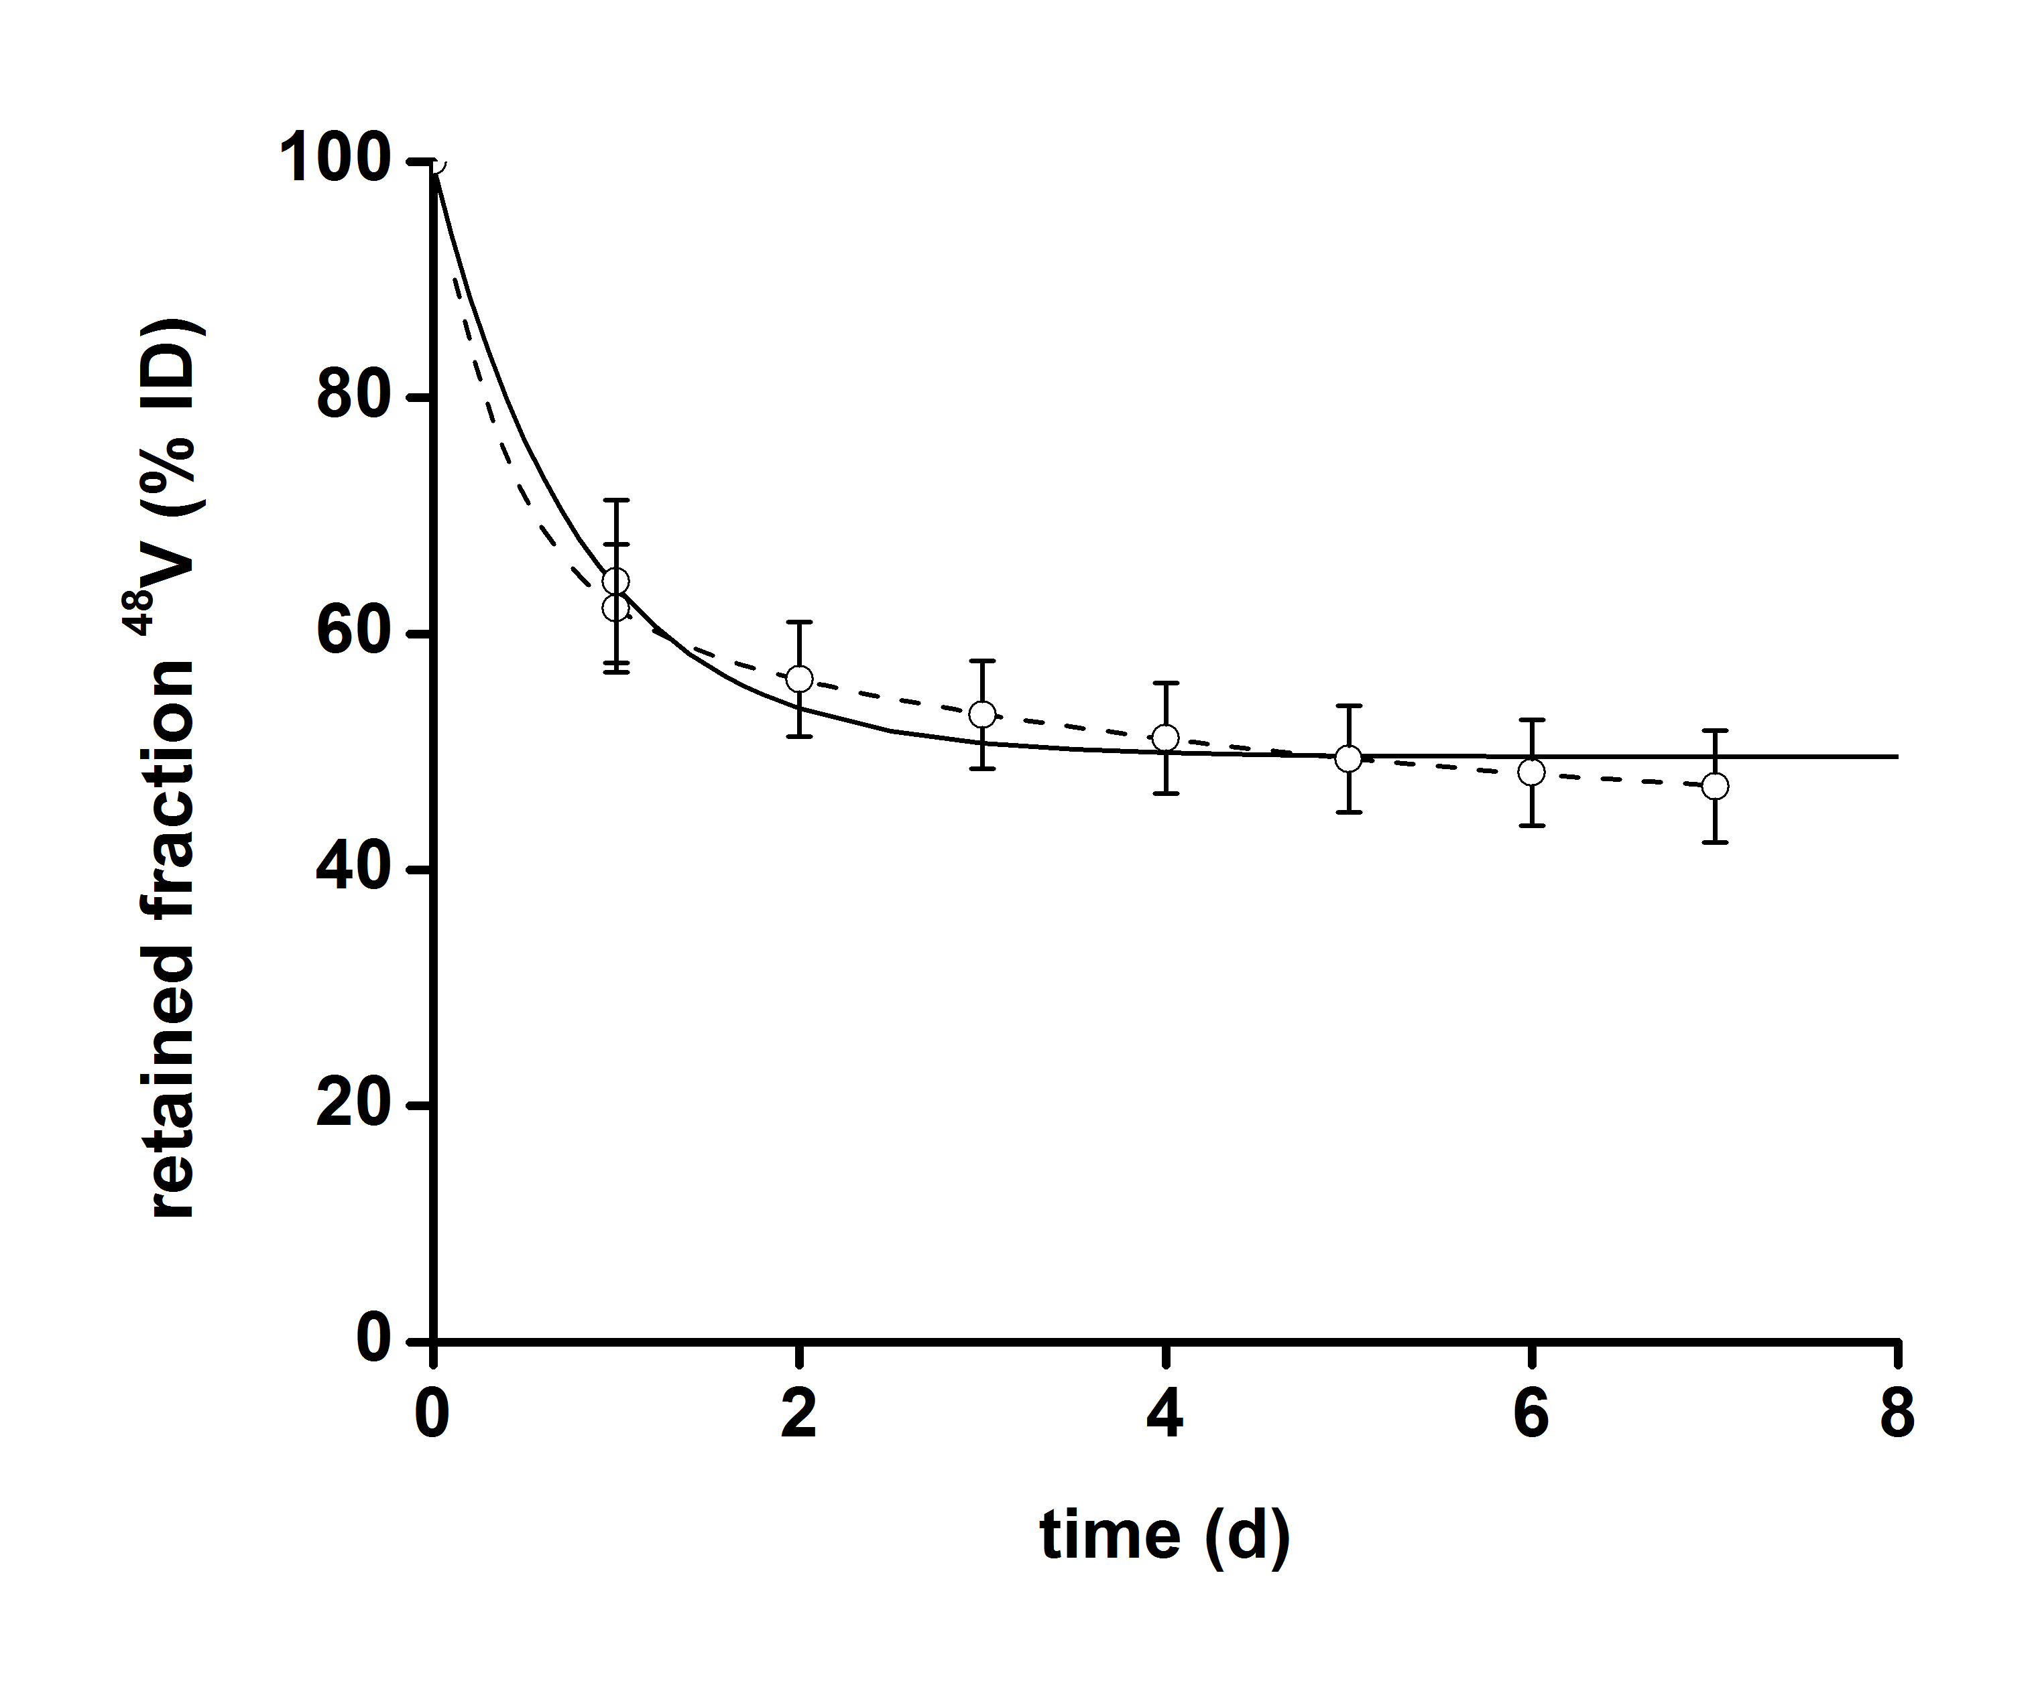

**Figure S6:** 48V-ion activity in the body *versus* time derived according to Eqn (S17) from the accumulated excreted activity fractions up to time *t* in the auxiliary study. The solid fitted curve represents a single exponential decay with λ = 1.24 d-1. The dashed curve presents a double exponential decay with decay constants λ1 = 46.55 d-1 and λ2 = 0.25 d-1.

In the main study the situation can be described equivalently to the application of a single bolus dose of 48V-ions, together with slow release of 48V-ions from [48V]TiO2NP, and exclusively48V-ion urinary excretion in a single compartment model. An analytical mathematical treatment of this problem is (Gibaldi, 2007). In the present case the 48V-ions are slowly released from the [48V]TiO2NP with a release constant *k* and for the activity fraction bound in [48V]TiO2NP the differential equation

|  |  |  |
| --- | --- | --- |
|  |  | (S20) |

holds. The differential equation for the activity fraction of free ions in the body now comprises two terms describing the excretion of ions from the body with an excretion constant *λ* and their release from the [48V]TiO2NP with a release constant *k*,

|  |  |  |
| --- | --- | --- |
|  | . | (S21) |

For the 48V-activity fraction in the urinary excretion up to time, which has been determined experimentally, the equation

|  |  |  |
| --- | --- | --- |
|  |  | (S22) |

holds. At any time the 48V-activity fractions, which are normalized to the total applied activity  and corrected for radioactive decay, must fulfill the balance equation

|  |  |  |
| --- | --- | --- |
|  | . | (S23) |

Assuming that at time *t* = 0 the total injected 48V-activity may already contain a small fraction  in ionic form that has been released from the [48V]TiO2NP already during the preparation of the injectable suspension, at *t* = 0 the condition

|  |  |  |
| --- | --- | --- |
|  |  | (S24) |

must be fulfilled.

The solutions of the differential Eqn (S20) is given by

|  |  |  |
| --- | --- | --- |
|  | . | (S25) |

The inhomogeneous, linear differential Eqn (S21) has the solution

|  |  |  |
| --- | --- | --- |
|  |  | (S26) |

in which the constant *c* has to be determined from the condition, which yields

|  |  |  |
| --- | --- | --- |
|  |  | (S27) |

and gives a double exponential expression for the complete solution of the differential Eqn (S21)

|  |  |  |
| --- | --- | --- |
|  | . | (S28) |

In Figure S7 the experimentally determined 48V-activity fraction in the body ** is presented as a function of  (corrected for decay), which corresponds to

|  |  |  |
| --- | --- | --- |
|  | . | (S29) |

With Eqns (S25) and (S28) it should now be possible to describe the experimental observation by

|  |  |  |
| --- | --- | --- |
|  | . | (S30) |

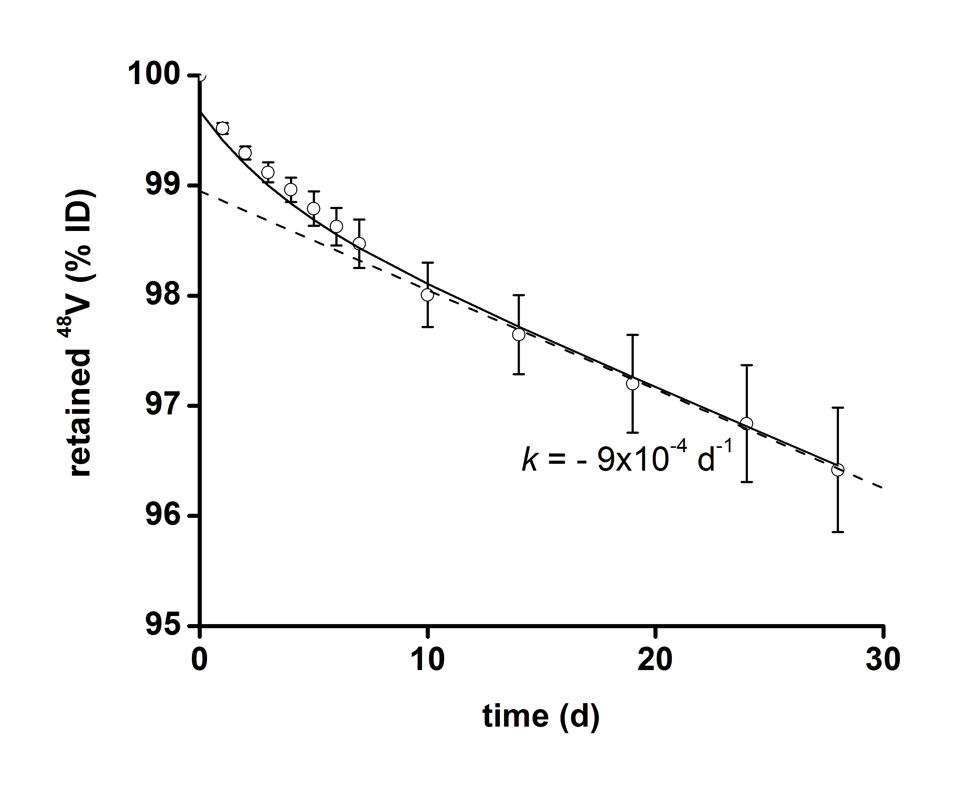

**Figure S7:** Total 48V-activity percentage retained in the rat bodies *versus* time in the main study. The values are obtained by subtracting the urinary excreted activity fractions accumulated up to time *t* from the total applied 48V-activity. In the [48V]TiO2NP main study the activity is retained in the body for a much longer time than in the auxiliary study after 48V-ion injection. The decrease of the 48V-activity in the body – corrected for the radioactive decay of the 48V – can be explained by a slow release of 48V-ions from the [48V]TiO2NP at a rate k = -9 × 10-4 d-1 (fitted to the dashed line according to Eqn (S34) for  days when the exponential term in Eqn (S34) becomes negligible) and a much faster excretion of the ions with λ = 0.25 d-1 as outlined by the model presented in this section. The solid line is a fit of the experimental data to Eqn (S34) which additionally yields  as the activity fraction due to 48V-ions present at *t* = 0 (time of injection of the [48V]TiO2NP suspension).

However, a look at the data in Figure S7 shows a rather linear decrease of the 48V-activity in the body at least for the data obtained after day 6. From the auxiliary study we know that the exponential decrease of the 48V-activity fraction of free 48V-ions follows an exponential decrease. Therefore, we conclude that the term in Eqn (S30), and also the argument of the exponential function, must both be small. An exponential function can be expanded in a row according to

|  |  |  |
| --- | --- | --- |
|  |  | (S31) |

For small arguments (**<<1) we can ignore the quadratic and higher order terms, which gives us the approximation

|  |  |  |
| --- | --- | --- |
|  |  | (S32) |

and allows us to rewrite Eqn (S30) as

|  |  |  |
| --- | --- | --- |
|  |  | (S33) |
|  | , |

which now contains a second term which is linear in time. Fitting the data in Figure S7 to a straight line in the time period 7 d ≤ *t* ≤ 28 d gives us a slope  ≈ 9⋅10-4/d. From the auxiliary experiment we get for the 48V-ion excretion a constant *λ* ≈ (0.25 – 0.5) d-1. With the slope *m* << *λ* we obtain *k* ≈ *m*, which allows us to deduce that the ions are released from the [48V]TiO2NP with a release constant of *k* ≈ 9⋅10-4/d. This means that *k*/(*λ*-*k*) ≈ *k*/*λ* and (*k*/(*λ*-*k*) +1) ≈ 1, which simplifies Eqn (S33) further and we get

|  |  |  |
| --- | --- | --- |
|  |  | (S34) |

for the description of the data in Figure S7. Hence, for the 48V-ion activity fraction in the body

|  |  |  |
| --- | --- | --- |
|  |  | (S35) |

holds, which matches the experimental data rather well (see Figure S8). At day 28 the second term in Eqn (S35) is of the order of 10-6 and can therefore be neglected in Eqns (S34) and (S35) which means that the ratio is given by *k/λ* ≈ 9⋅10-4. Therefore, the correction of the biodistribution of the 48V-activity, assigned to the [48V]TiO2NP, for effects of free 48V-ions in the group of rats that were sacrificed on day 28 will be very small.

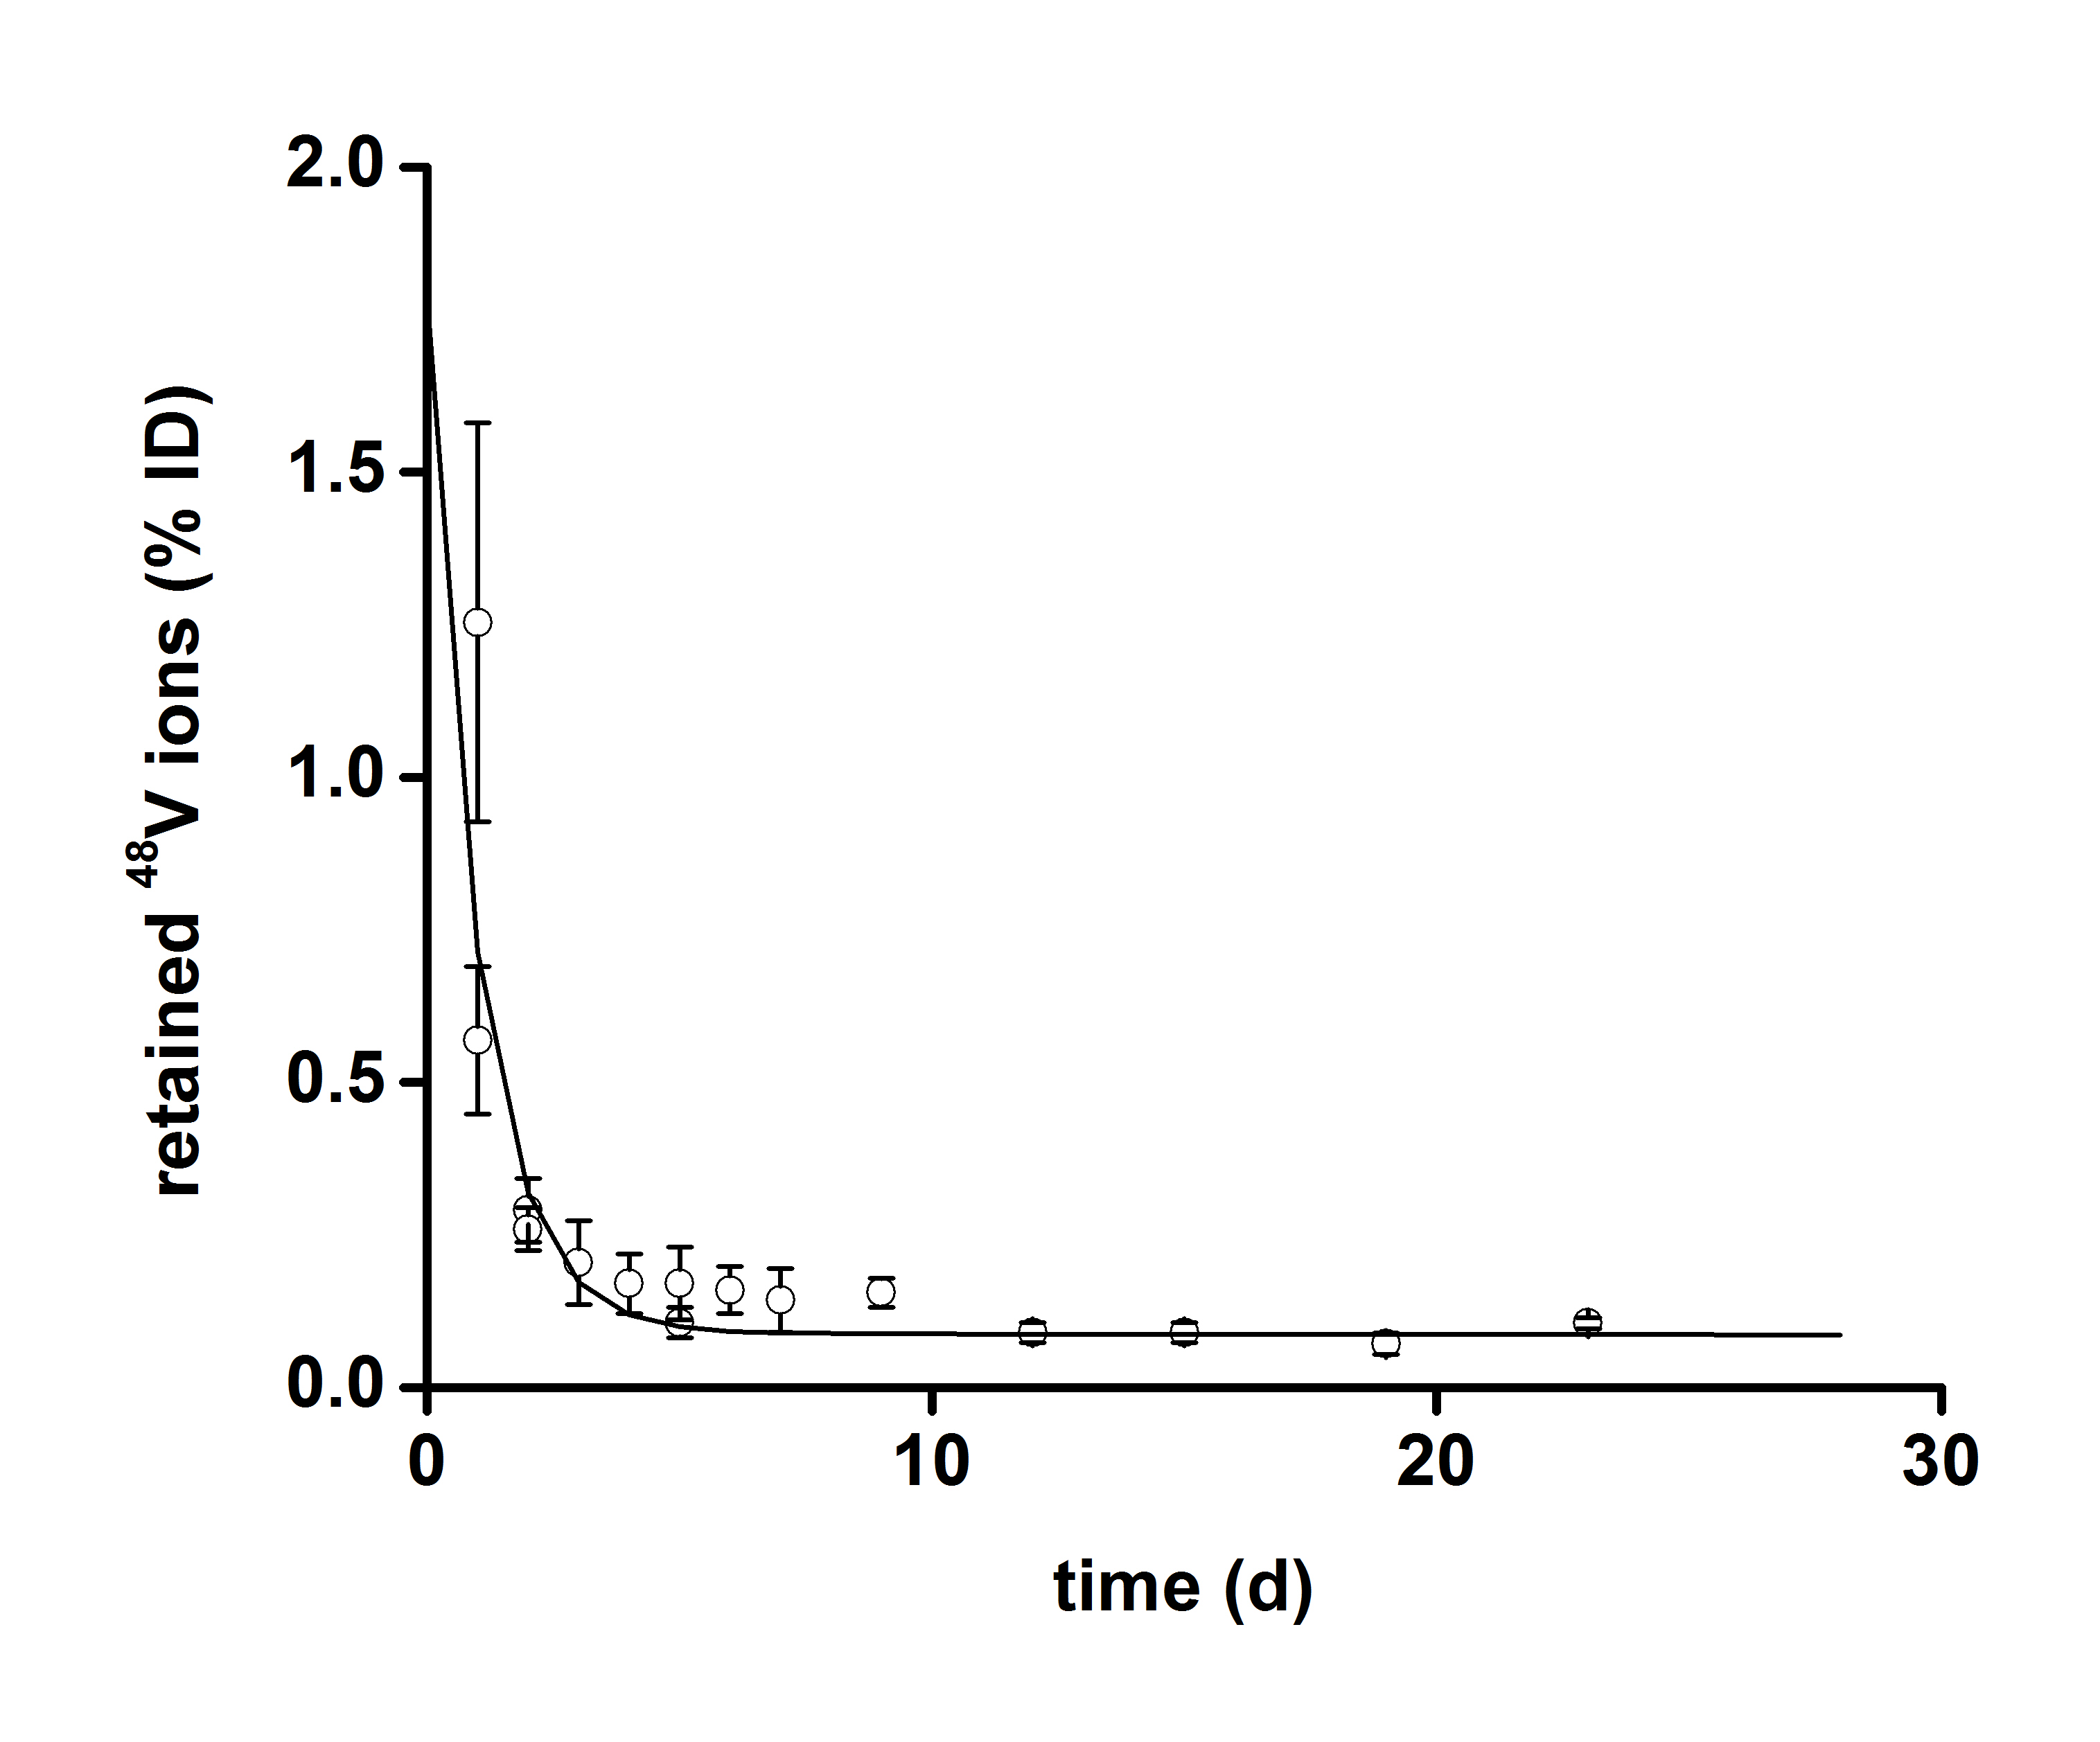

**Figure S8:** The 48V-activity fraction due to free 48V-ions in the body of the rats of the main study *versus* time calculated according to Eqn (S13) from experimental data matches the theoretical expectation of Eqn (S35) fitted with =9×10-4d-1, = 0.25 d-1and .

The pharmacokinetic modeling applied to the experimental data shows that the fraction of free 48V-ions rapidly decreases after application. Therefore the corrections applied to the biodistribution of the [48V]TiO2NP after day 7 are only meaningful for organs that exhibit low (uncorrected) [48V]TiO2NP burden in the main study while exhibiting a high 48V-ion load in the auxiliary study.

From Figure S9 it is also obvious that the results are only slightly affected by a possible variation of the excretion rate  which has been forced to meet a first order excretion kinetics for the 48V-ions. The double exponential fit in Figure S6 indeed matches the experimental data much better, which may indicate that more than one excretion process is involved or that the ions are available in different chemical states and/or species with possibly different excretion rates. Such adjustments have however no important effect on the conclusions derived from the modeling presented above, where variations of λ in the range between 0.25 and 2 have little effect. The release rate *k* from the [48V]TiO2NP can be determined accurately from the slope in the linear part in Figure S7 and *λ* >> *k* . Variations of the ratio *k*/*λ* that lead to substantial changes in the behavior of the system are depicted in Figure S9.

Additionally the experimentally determined excretion rates in the main study as shown in Figure S5, show an approximately constant value for *t* > 7 d given by as expected from the mathematical treatment that gives the daily excretion as the first derivative of (the latter given by Eqn (S34)). Thus the whole picture is consistent.

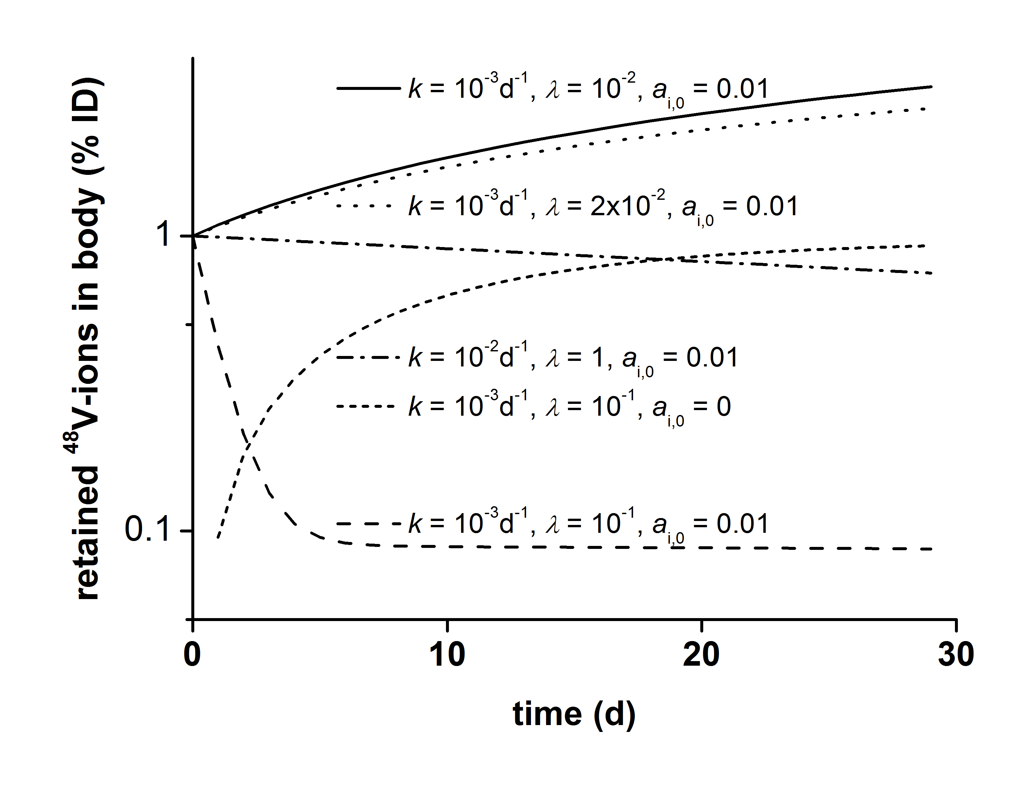

**Figure S9:** Making use of Eqn (S30) before introducing any approximations shows that the pronounced decrease of the free 48V-ion activity fraction in the present study is due the favorable combination of low ion release rate from the [48V]TiO2NP and sufficiently high excretion rate. Setting the 48V-activity fraction of ions at *t* = 0 to zero shows the expected built up of ions in the body. The same holds if the excretion rate is reduced (much smaller *λ*). By increasing both the release rate from the [48V]TiO2NP and excretion rate of ions from the body a state can be found that keeps the initial ion fraction (nearly) constant.

**References**

Abbas, K, Cydzik, I, Del Torchio, R, Farina, M, Forti, E, Gibson, N, Holzwarth, U, Simonelli, F & Kreyling, W 2010. Radiolabelling of TiO2 nanoparticles for radiotracer studies. *Journal of Nanoparticle Research,* 12**,** 2435-2443.

Charkes, ND, Brookes, M & Makler, PT, Jr. 1979. Studies of skeletal tracer kinetics: II. evaluation of a five-compartment model of [18F]fluoride kinetics in rats. *J Nucl Med,* 20**,** 1150-7.

Choi, HS, Liu, W, Misra, P, Tanaka, E, Zimmer, JP, Ipe, BI, Bawendi, MG & Frangioni, JV 2007. Renal clearance of quantum dots. *Nature Biotechnology,* 25**,** 1165-1170.

Gibaldi, M & Perrier, D 2007. *Chapter 1: One Compartment Model; In: Gibaldi M, Perrier D,(eds). Pharmacokinetics,* New York:, Informa Healthcare, 1-45.

Gibson, N, Holzwarth, U, Abbas, K, Simonelli, F, Kozempel, J, Cydzik, I, Cotogno, G, Bulgheroni, A, Gilliland, D, Ponti, J, Franchini, F, Marmorato, P, Stamm, H, Kreyling, W, Wenk, A, Semmler-Behnke, M, Buono, S, Maciocco, L & Burgio, N 2011. Radiolabelling of engineered nanoparticles for in vitro and in vivo tracing applications using cyclotron accelerators. *Archives of Toxicology,* 85**,** 751-73.

Hildebrand, H, Schymura, S, Holzwarth, U, Gibson, N, Dalmiglio, M & Franke, K 2015. Strategies for radiolabeling of commercial TiO2 nanopowder as a tool for sensitive nanoparticle detection in complex matrices. *Journal of Nanoparticle Research,* 17**,** 1-12.

Hirn, S, Semmler-Behnke, M, Schleh, C, Wenk, A, Lipka, J, Schaffler, M, Takenaka, S, Moller, W, Schmid, G, Simon, U & Kreyling, WG 2011. Particle size-dependent and surface charge-dependent biodistribution of gold nanoparticles after intravenous administration. *European Journal of Pharmaceutics and Biopharmaceutics,* 77**,** 407-16.

Holzwarth, U, Bulgheroni, A, Gibson, N, Kozempel, J, Cotogno, G, Abbas, K, Simonelli, F & Cydzik, I 2012. Radiolabelling of nanoparticles by proton irradiation: temperature control in nanoparticulate powder targets. *Journal of Nanoparticle Research,* 14.

Inagaki, M, Kondo, N, Nonaka, R, Ito, E, Toyoda, M, Sogabe, K & Tsumura, T 2009. Structure and photoactivity of titania derived from nanotubes and nanofibers. *Journal of Hazardous Materials,* 161**,** 1514-1521.

Kreyling, WG, Biswas, P, Messing, ME, Gibson, N, Geiser, M, Wenk, A, Sahu, M, Deppert, K, Cydzik, I, Wigge, C, Schmid, O & Semmler-Behnke, M 2011. Generation and characterization of stable, highly concentrated titanium dioxide nanoparticle aerosols for rodent inhalation studies. *Journal of Nanoparticle Research,* 13**,** 511–524.

Kreyling, WG, Hirn, S, Moller, W, Schleh, C, Wenk, A, Celik, G, Lipka, J, Schaffler, M, Haberl, N, Johnston, BD, Sperling, R, Schmid, G, Simon, U, Parak, WJ & Semmler-Behnke, M 2014. Air-blood barrier translocation of tracheally instilled gold nanoparticles inversely depends on particle size. *ACS Nano,* 8**,** 222-33.

Kreyling, WG, Holzwarth, U, Haberl, N, Kozempel, J, Wenk, A, Hirn, S, Schleh, C, Schäffler, M, Lipka, J, Semmler-Behnke, M & Gibson, N. Part 1: Quantitative biokinetics of titanium dioxide nanoparticles after intravenous injection in rats *Nanotoxicology***,** [Epub ahead of print]. doi: 10.1080/ 17435390.2017.1306892.

Kreyling, WG, Holzwarth, U, Schleh, C, Kozempel, J, Wenk, A, Haberl, N, Hirn, S, Schäffler, M, Lipka, J, Semmler-Behnke, M & Gibson, N. Part 2: Quantitative biokinetics of titanium dioxide nanoparticles after oral application in rats *Nanotoxicology***,** [Epub ahead of print]. doi: 10.1080/ 17435390.2017.1306893.

Kreyling, WG, Holzwarth, U, Haberl, N, Kozempel, J, Wenk, A, Hirn, S, Schleh, C, Schäffler, M, Lipka, J, Semmler-Behnke, M & Gibson, N. Part 3: Quantitative biokinetics of titanium dioxide nanoparticles after intratracheal instillation in rats. *Nanotoxicology***,** [Epub ahead of print]. doi: 10.1080/ 17435390.2017.1306894.

Kreyling, WG, Semmler, M, Erbe, F, Mayer, P, Takenaka, S, Schulz, H, Oberdörster, G & Ziesenis, A 2002. Translocation of ultrafine insoluble iridium particles from lung epithelium to extrapulmonary organs is size dependent but very low. *Journal of Toxicology and Environmental Health-Part A,* 65**,** 1513-1530.

Lee, HB & Blaufox, MD 1985. Blood volume in the rat. *J Nucl Med,* 26**,** 72-6.

Oeff, K & Konig, A 1955. [Blood volume of rat organs and residual amount of blood after blood letting or irrigation; determination with radiophosphorus-labeled erythrocytes.]. *Naunyn Schmiedebergs Arch Exp Pathol Pharmakol,* 226**,** 98-102.

Schleh, C, Semmler-Behnke, M, Lipka, J, Wenk, A, Hirn, S, Schaffler, M, Schmid, G, Simon, U & Kreyling, WG 2012. Size and surface charge of gold nanoparticles determine absorption across intestinal barriers and accumulation in secondary target organs after oral administration. *Nanotoxicology,* 6**,** 36-46.

Semmler, M, Seitz, J, Erbe, F, Mayer, P, Heyder, J, Oberdorster, G & Kreyling, WG 2004. Long-term clearance kinetics of inhaled ultrafine insoluble iridium particles from the rat lung, including transient translocation into secondary organs. *Inhalation Toxicology,* 16**,** 453-9.

Villa-Bellosta, R & Sorribas, V 2011. Calcium phosphate deposition with normal phosphate concentration. -Role of pyrophosphate. *Circ J,* 75**,** 2705-10.

Vogelsberger, W 2003. Thermodynamic and kinetic consioderations of the formation and dissolution of nanoparticles of substances having low solubility. *Journal of Physical Chemistry B,* 107**,** 9669-9676.

Vogelsberger, W, Schmidt, J., Roelfs, F. 2008. Dissolution kinetics of oxide nanoparticles: The observation of an unusual behaviour. . *Colloids and Surfaces A,* 324**,** 51-57.