Supporting Information
Tuning the Photophysical Properties of Cyanine by Barbiturate Functionalization and Nanoformulation for Efficient Optoacoustics- Guided Phototherapy

Nian Liu, Patrick O'Connor, Vipul Gujrati,* Divyesh Shelar, Xiaopeng Ma, Pia Anzenhofer, Uwe Klemm, Xinhui Su, Yuanhui Huang, Karin Kleigrewe, Annette Feuchtinger, Axel Walch, Michael Sattler, Oliver Plettenburg, Vasilis Ntziachristos*
*Correspondence: Vipul Gujrati (vipul.gujrati@tum.de), Vasilis Ntziachristos (bioimaging.translatum@tum.de)

Fig. S1 Synthesis of enamine XX.

Fig. S2. The synthetic procedure to produce BC810, BC885, and BC1010.

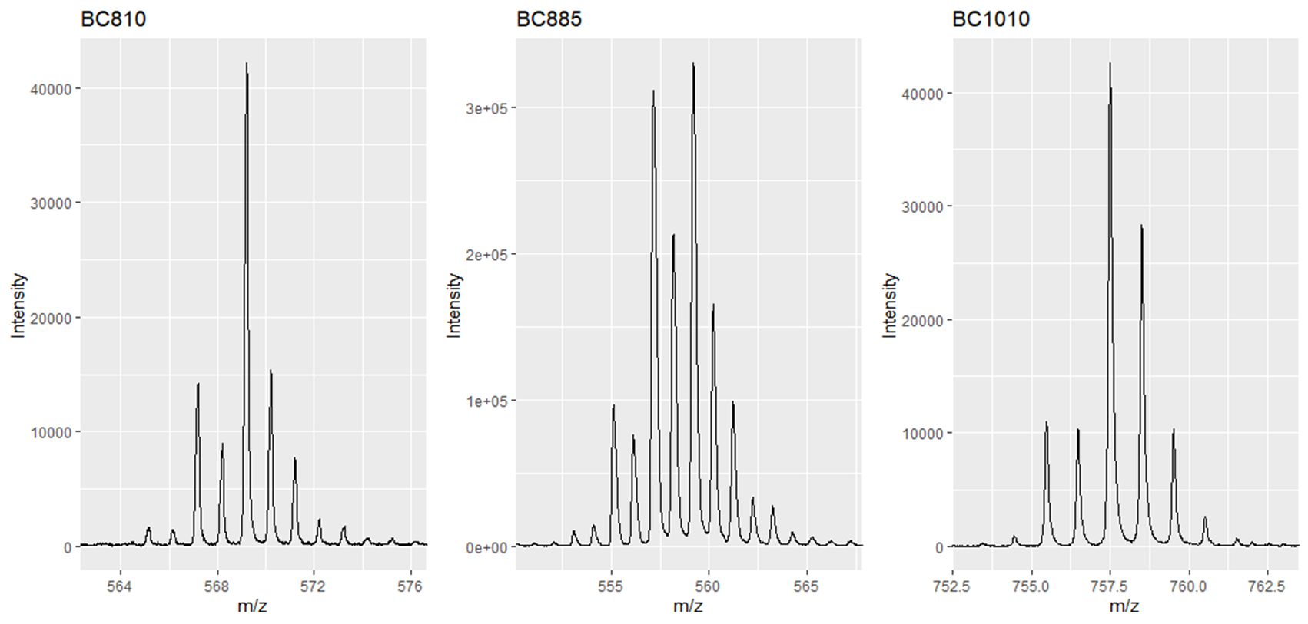
Fig. S3. Matrix assisted laser desorption ionization-time of flight (MALDI-TOF) mass spectrum of BC810, BC885, and BC1010.

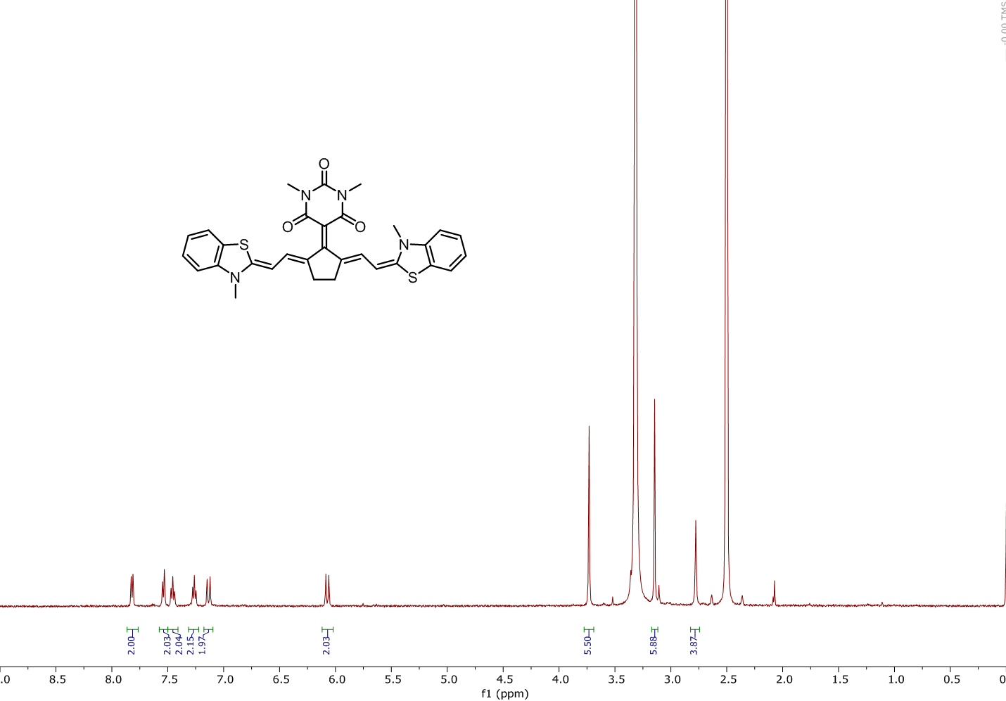
Fig. S4. ¹H nuclear magnetic resonance (NMR) spectrum of BC810.

Table S1. Optical properties of BC810, BC885, and BC1010 in dichloromethane (DCM). The relative fluorescent quantum yield of BC810 and BC885 was determined by using indocyanine green as a reference solution, and BC1010’s was determined by using IR1048 as a reference (ΦF = 0.004).
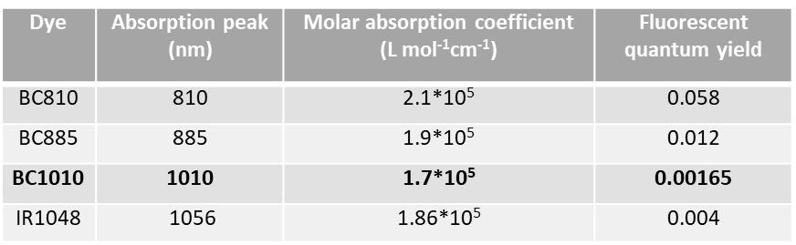

Fig. S5. Absorption spectra of BC810, BC885, BC1010 and IR1048 in water.
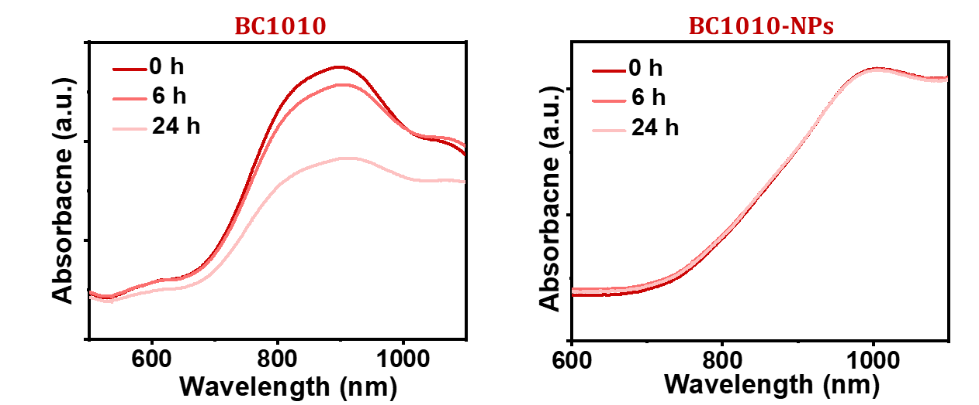
Fig. S6. Absorption spectra of BC1010 and BC1010-NPs in water during 24 h’s observation.

Fig. S7. Absorption spectra of 1,3-Diphenylisobenzofuran (DPBF) incubated with BC1010-NPs before and after laser irradiation. The absorption intensity shows no decrease after the treatment, signifying no ¹O₂ generation.
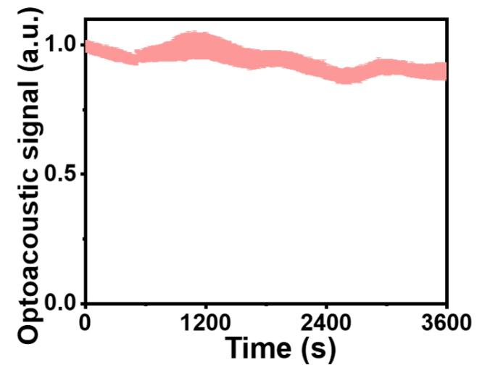
Fig. S8. Optoacoustic (OptA) signal stability of BC1010 after 60 min of pulsed laser irradiation (fluence 10 mJ/cm²).

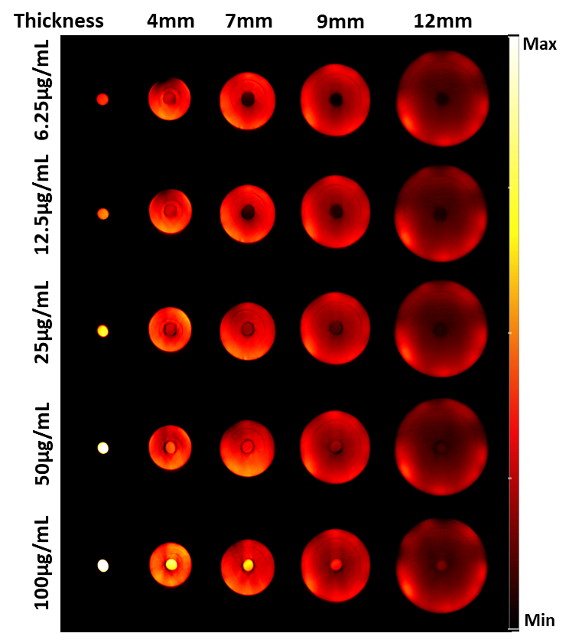
Fig. S9. Optoacoustic (OptA) images of the BC1010-NPs samples with various concentrations in the tissue-mimicking cylindrical phantoms with different radii.

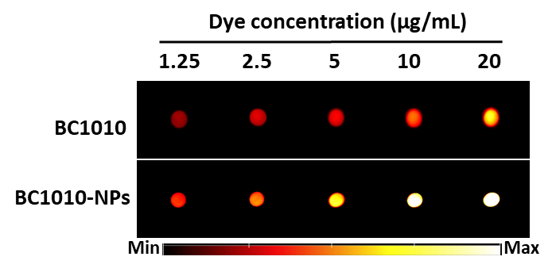
Fig. S10. Optoacoustic (OptA) images of BC1010 and BC1010-NPs samples with various concentrations.

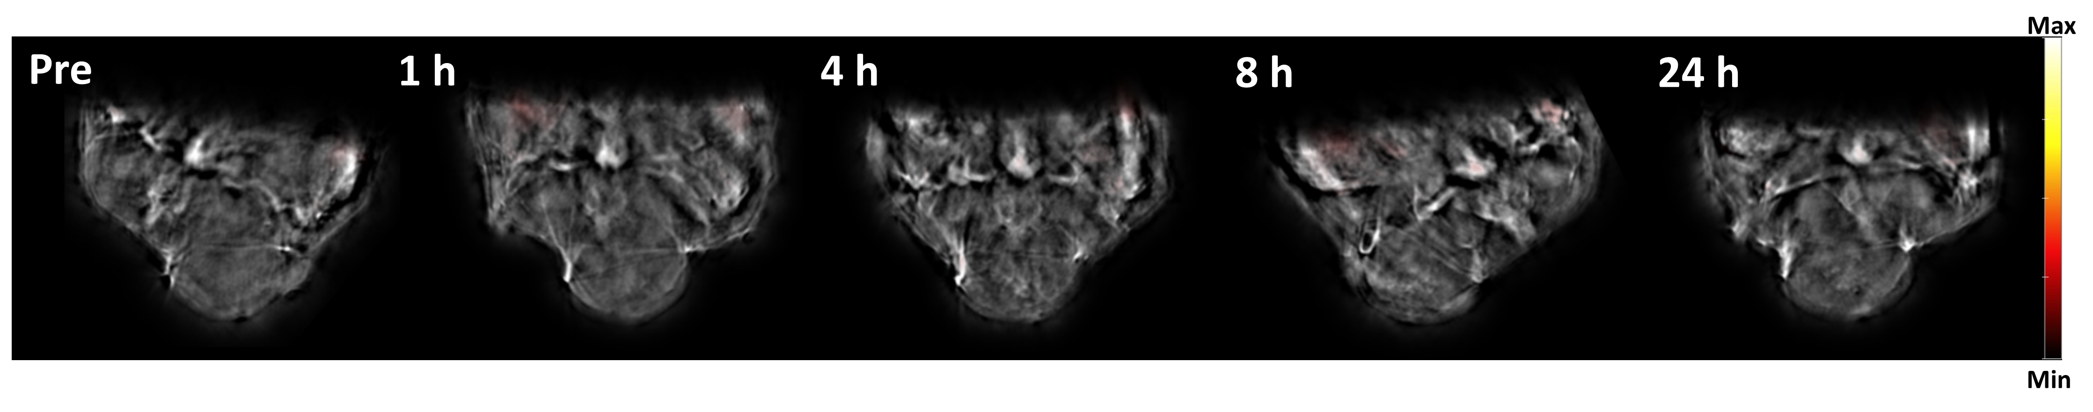
Fig. S11. Representative unmixed multispectral optoacoustic tomography (MSOT) images of a 4T1 subcutaneous tumor mouse after intravenous injection of BC1010 (n=3).
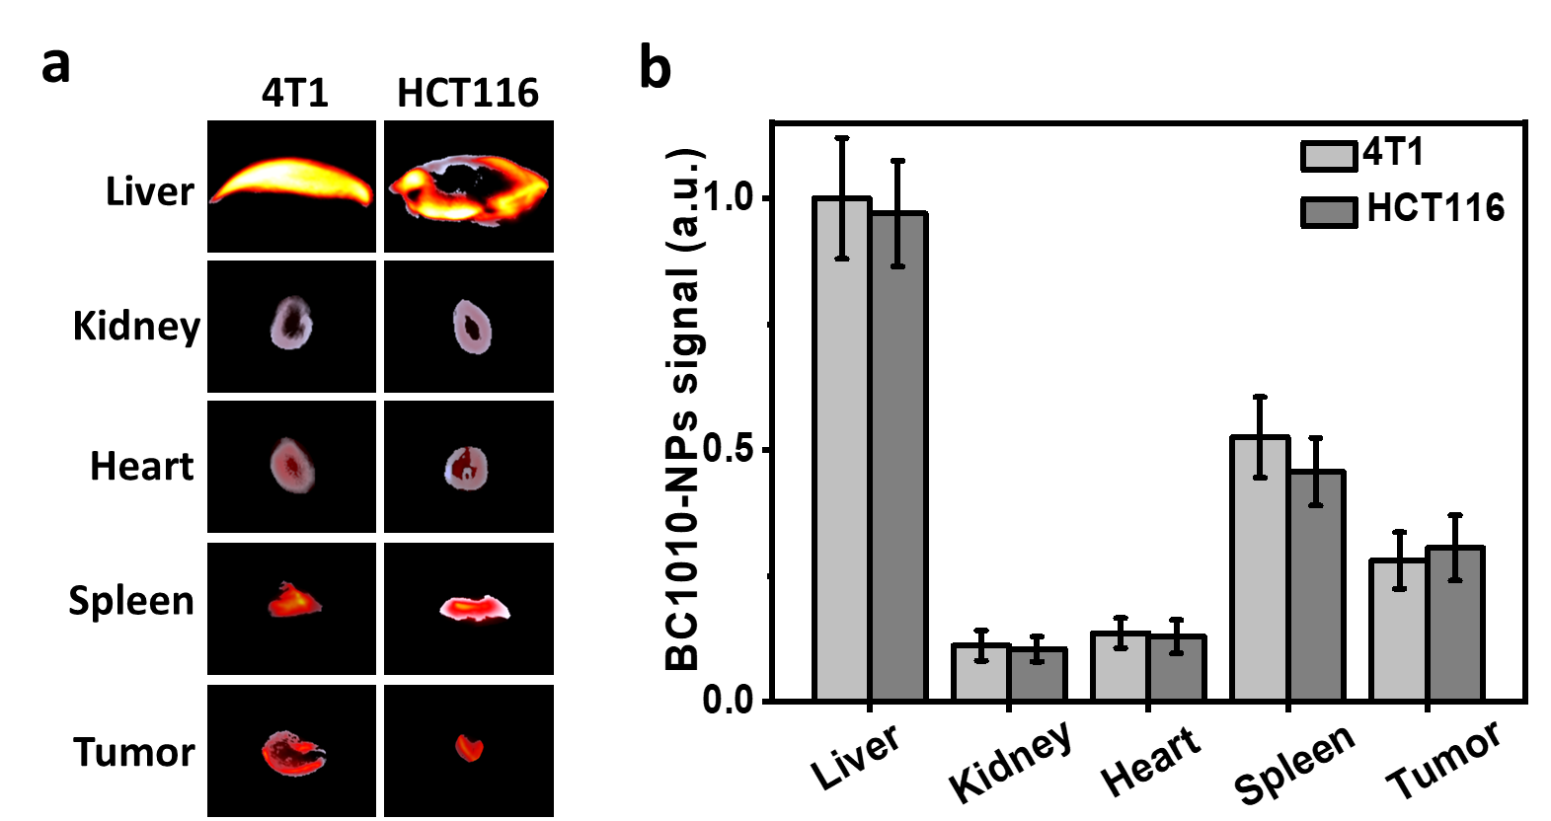
Fig. S12. (a) Optoacoustic (OptA) coronal plane images and (b) corresponding signal intensities of major organs 24 h post-injection of BC1010-NPs (3 mg/mL, 100 μL) in two different tumor models (n=3).

Fig. S13. Average concentration of BC1010-NPs over time in mouse serum. The mice were intravenously injected with 100 μL BC1010-NPs (3 mg/mL). Subsequently, blood was collected at various time points and centrifuged for 10 min to obtain serum for further absorption measurements (n=3). The half-life of BC1010-NPs in blood was calculated using WinNonlin 4.1 software.

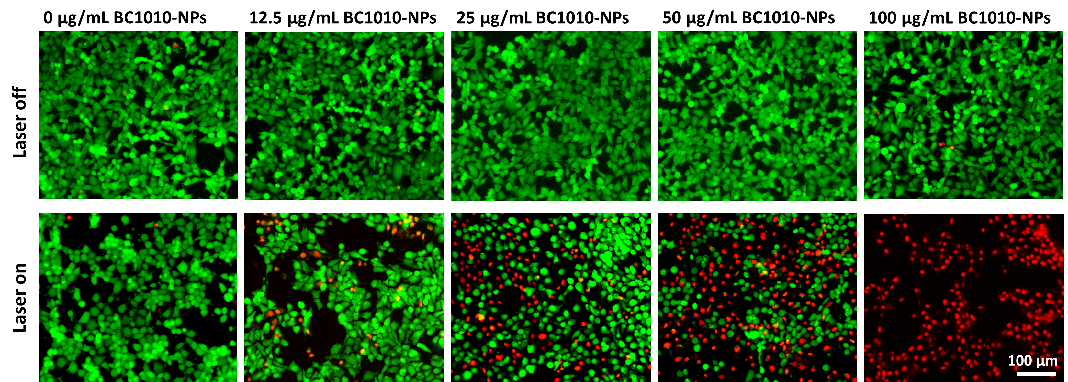
Fig. S14. Fluorescence images of live/dead staining of 4T1 cells after different treatments (green color, live cells; red color, dead cells).

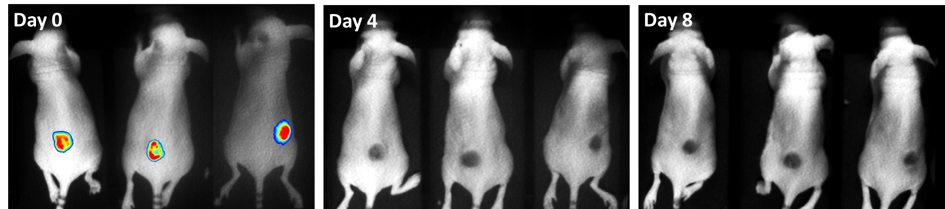
Fig. S15. Bioluminescence images of 4T1-Luc tumor bearing mice over eight days after treatment with BC1010-NPs + Laser.

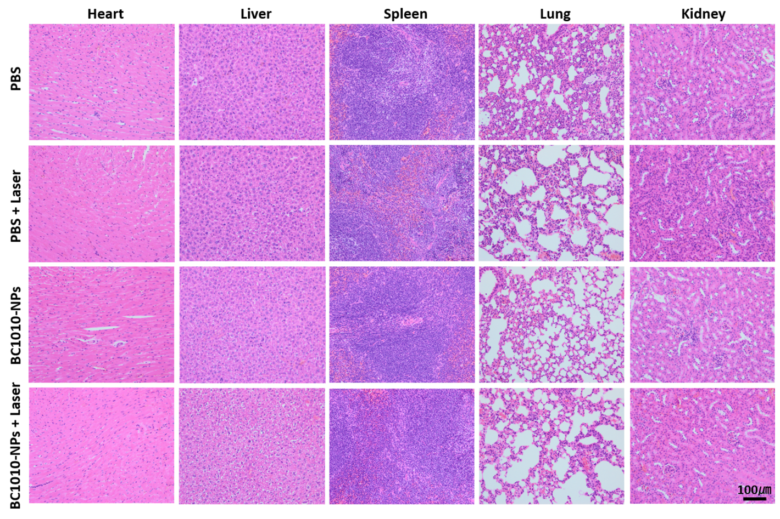
Fig. S16. Representative images showing hematoxylin and eosin (H&E)-stained cryosections of major organs from the four treated groups.
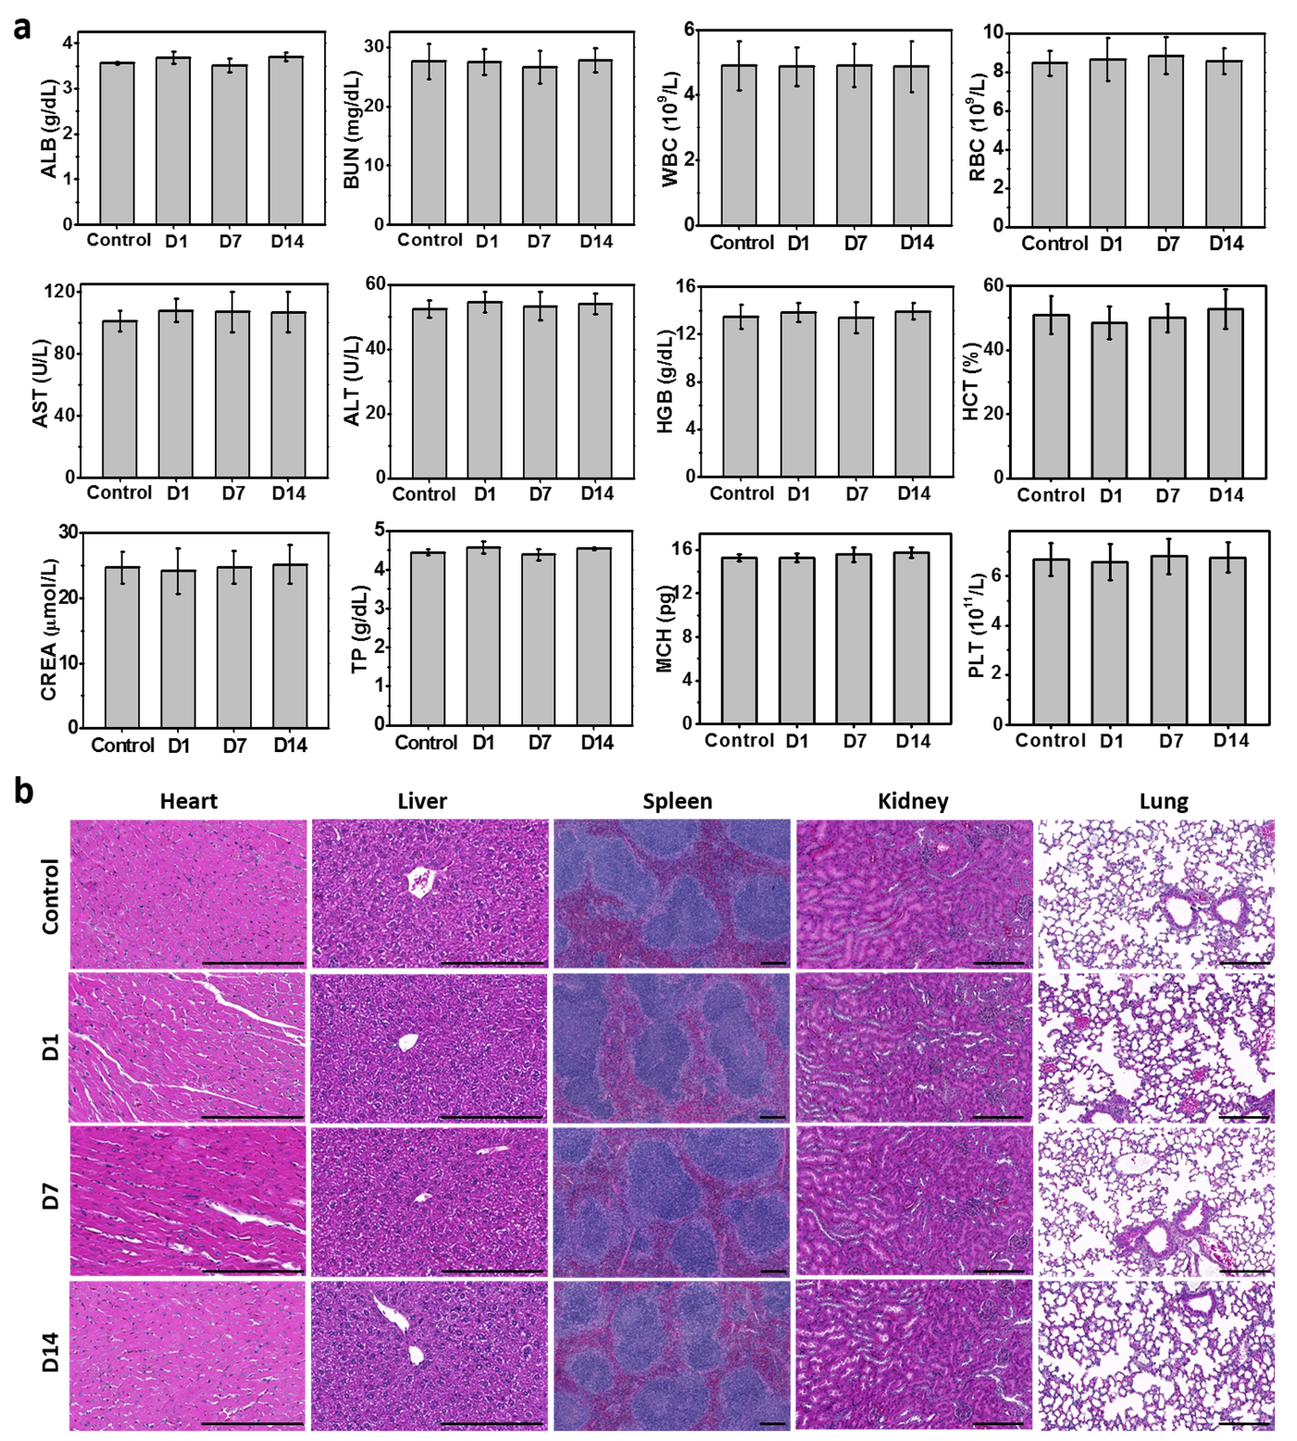
Fig. S17. (a) Results of blood biochemistry and hematology measurements of healthy C57BL/6 mice treated with 100 μL BC1010-NPs (3 mg/mL) or PBS (control) (n=5 per group). ALB, albumin; BUN, blood urea nitrogen; AST, aspartate transferase; ALT, alanine transferase; CREA, creatinine; TP, total protein; WBC, white blood cells; RBC, red blood cells; HGB, hemoglobin; HCT, hematocrit; MCH, mean corpuscular hemoglobin; PLT, platelet. (b) Representative images of hematoxylin and eosin (H&E)-stained sections of vital organs from treated C57BL/6 mice (20× magnification).

