Table S1: Pollen taxa summed to obtain total pollen for the Hirst devices.

|  |  |
| --- | --- |
| **Common English Name** | **Latin Name** |
| Alder | *Alnus* |
| Amarant family | Amaranthaceae |
| Ash | *Fraxinus* |
| Beech | *Fagus* |
| Birch | *Betula* |
| Buttercup family | Ranunculaceae |
| Cedar | *Cedrus* |
| Common box | *Buxus* |
| Crucifers | Brassicaceae |
| Cypress family | Cupressaceae |
| Daisy family (other) | Asteraceae |
| Elder | *Sambucus* |
| Elm | *Ulmus* |
| Ginkgo | *Ginkgo* |
| Grasses | Poaceae |
| Hazel | *Corylus* |
| Hophornbeam | *Ostrya* |
| Hornbeam | *Carpinus* |
| Larch | *Larix* |
| Lime-tree, linden | *Tilia* |
| Maize | *Zea* |
| Mercury | *Mercurialis* |
| Miscellaneous | *-* |
| Mugwort | *Artemisia* |
| Mulberry family | Moraceae |
| Nettle family and Hemp family | Urticaceae & Cannabaceae |
| Oak | *Quercus* |
| Olive family (other) | Oleaceae |
| Palm family | Arecaceae |
| Pine | *Pinus* |
| Plane | *Platanus* |
| Plantain | *Plantago* |
| Poplar | *Populus* |
| Ragweed | *Ambrosia* |
| Rose family | Rosaceae |
| Rye | *Secale* |
| Sedge family | Cyperaceae |
| Sorrel, dock | *Rumex* |
| Spruce | *Picea* |
| Sweet chestnut | *Castanea* |
| Sweetgum | *Liquidambar* |
| Umbellifers | Apiaceae |
| Walnut | *Juglans* |
| Willow | *Salix* |
| Yew | *Taxus* |

Table S2: Pollen taxa summed to obtain total pollen for the Hund-Wetzlar BAA500.

|  |  |
| --- | --- |
| **Common English Name** | **Latin Name** |
| Alder | *Alder* |
| Ash | *Fraxinus* |
| Bedstraw | *Galium* |
| Beech | *Fagus* |
| Birch | *Betula* |
| Chestnut | *Castanea* |
| Cruciferous family | Brassicaceae |
| Daisy family | Asteraceae |
| Elderflower | *Sambucus* |
| Grasses | Poaceae |
| Hazelnut | *Corylus* |
| Hornbeam | *Carpinus* |
| Horse Chestnut | *Aesculus* |
| Nettle family | Urticaceae |
| Sorrel | *Rumex* |
| Oak | *Quercus* |
| Pine | *Pinus* |
| Plane | *Platanus* |
| Plantain | *Plantago* |
| Poplar | *Populus* |
| Rye | *Secale* |
| Sedge family | Cyperaceae |
| Spruce | *Picea* |
| Unknown | - |
| Walnut | *Juglans* |
| Willow | *Salix* |
| Yew | *Taxus* |

Table S3: Sampling rates of all instruments used.

|  |  |  |
| --- | --- | --- |
| **Instrument** | **Flow rate** | **Sampling/hour** |
| *Hirst* | 10 l/min | 30 l/hr (5% of 600l) |
| *BAA500* | 100 l/min (1 minute every 10) | 150 l/hr (25% of 600l) |
| *WIBS* | 0.3 l/min | 18 l/hr |
| *Rapid-E* | 2.8 l/min | 168 l/hr |
| *Poleno* | 40 l/min | 2400 l/hr |
| *KH-3000* | 4.1 l/min | 246 l/hr |

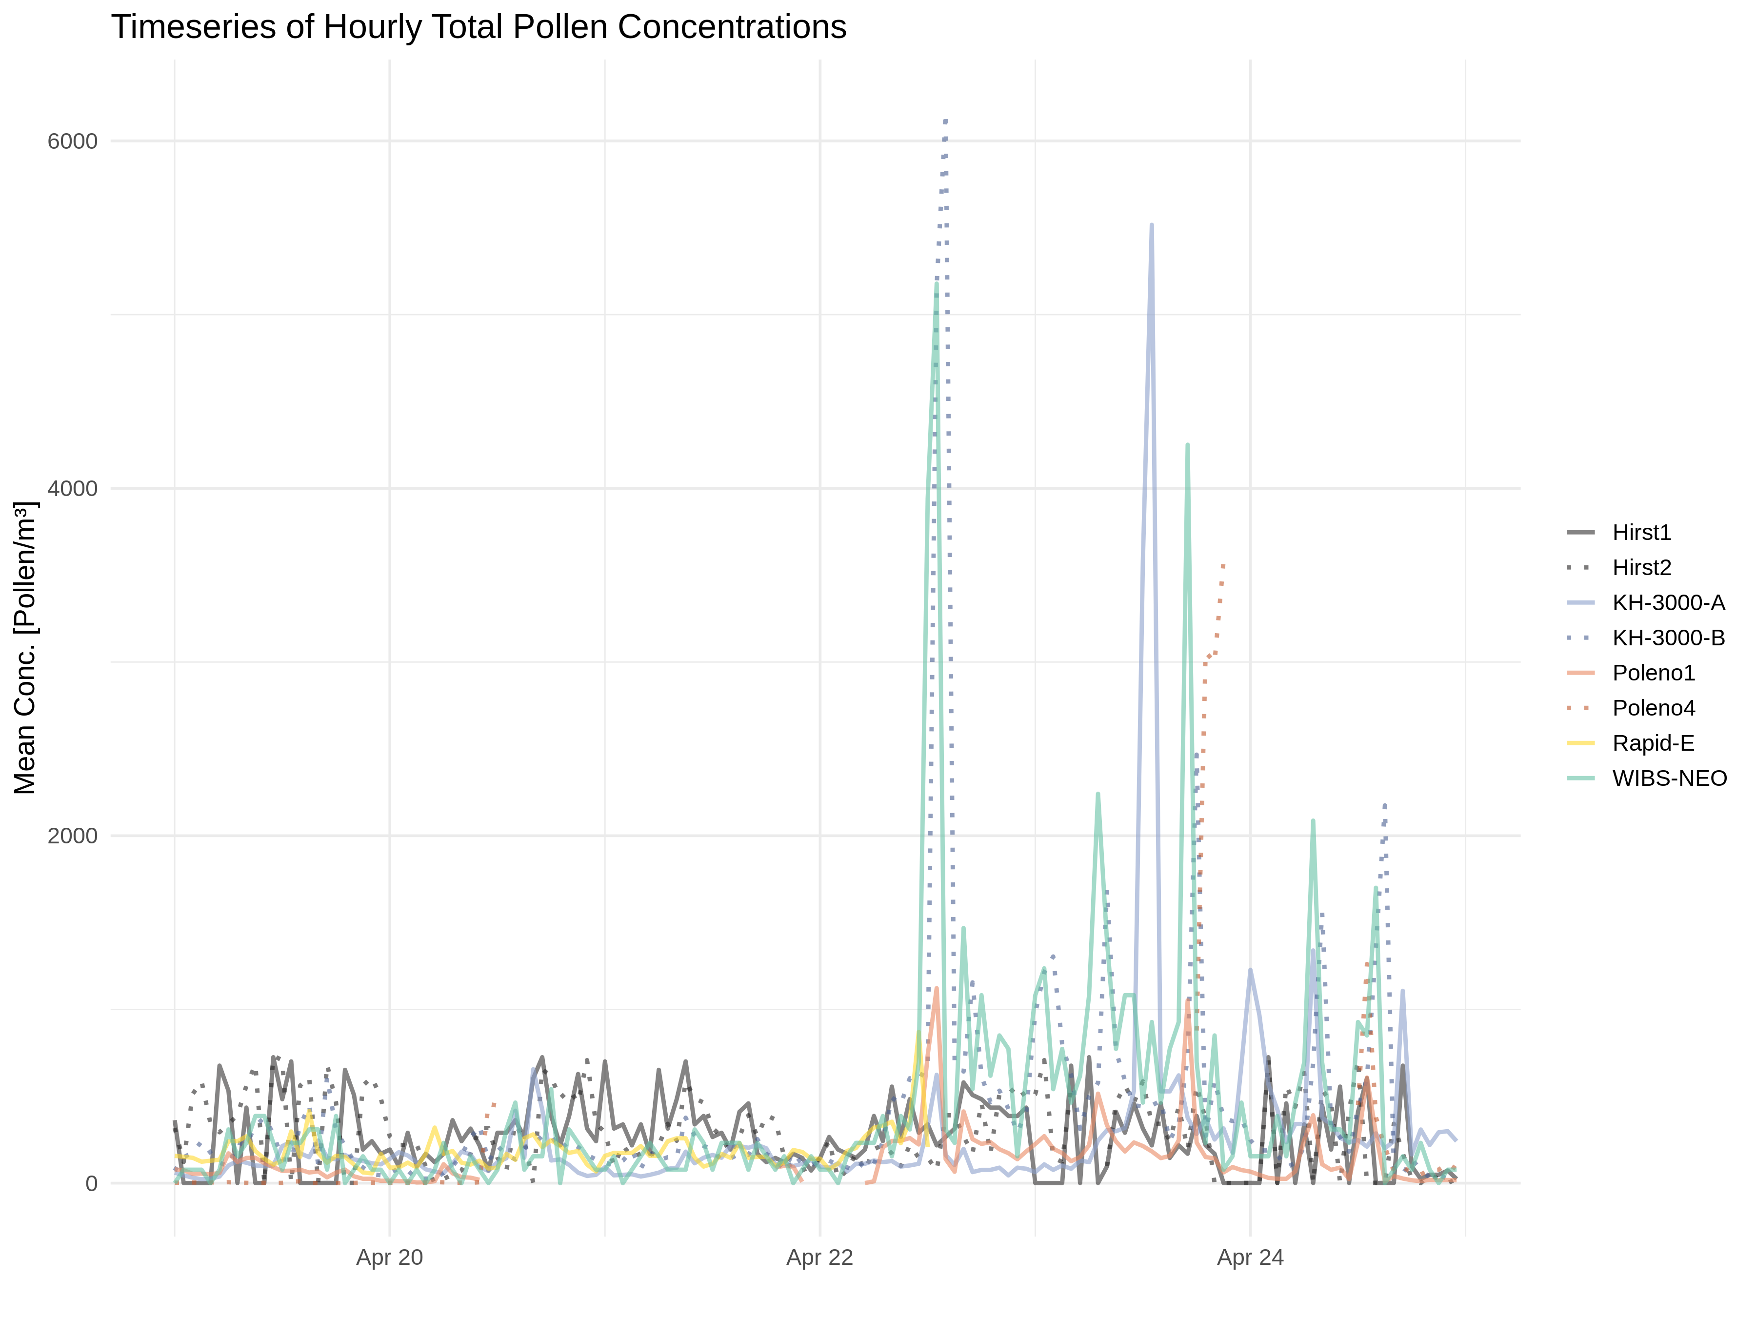

Figure S1: Hourly average total pollen counts for the selected period of study: 19-25 April 2019.

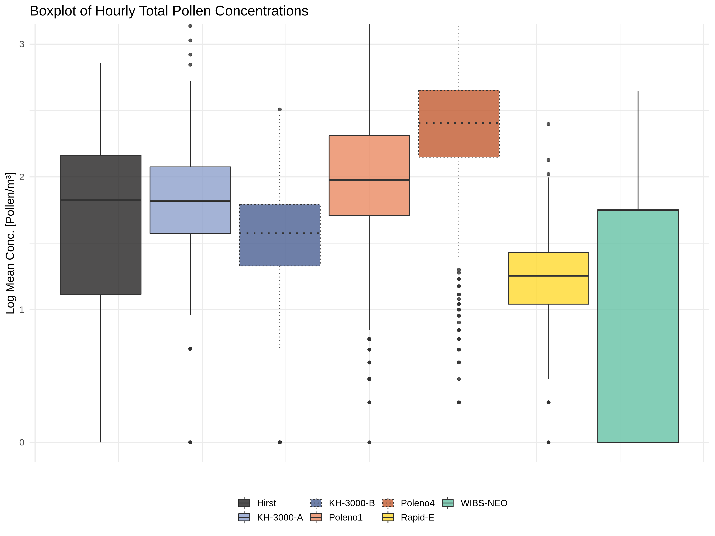

Figure S2: Box plot of logarithmic hourly average total pollen counts for the study period from 19 April - 31 May 2019.

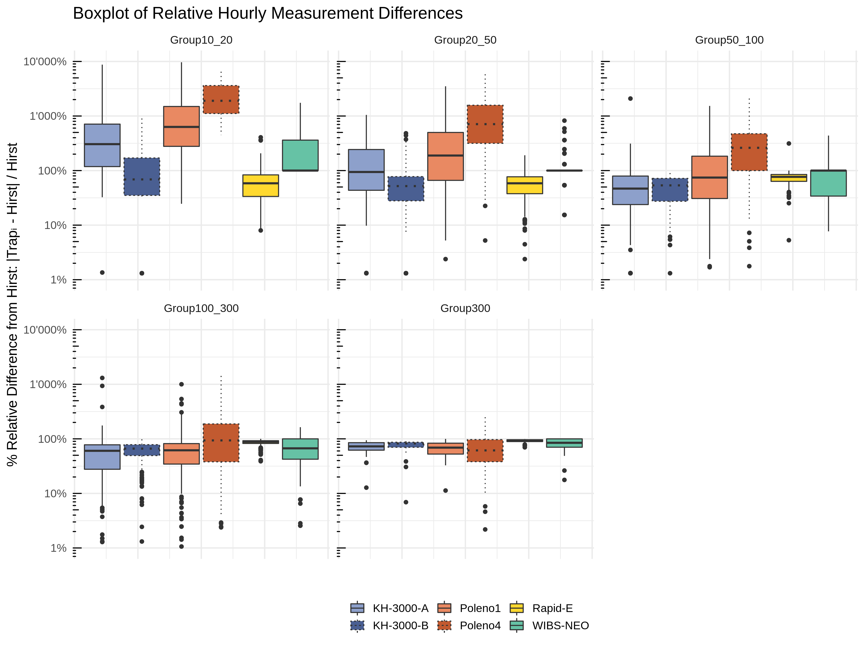

Figure S3: Box plots of hourly average percentage differences from the Hirst mean. The total pollen counts are separated into concentration groups based on the Hirst-trap data (from top left to bottom right: 20-49, 50-99, 100-300, and >300 pollen grains/m3, respectively). Note that the y-axis is on a log-scale, with a value of 1 indicating a 10x larger value compared to the Hirst average.

|  |  |  |  |  |
| --- | --- | --- | --- | --- |
| **Instruments** | **Lower** | **Estimator** | **Upper** | **p-value** |
| *Hirst-KH3000-A* | 0.50 | 0.54 | 0.57 | 0.06 |
| *Hirst-KH3000-B* | 0.37 | 0.40 | 0.44 | 0.00 |
| *Hirst-Poleno-1* | 0.59 | 0.63 | 0.66 | 0.00 |
| *Hirst-Poleno-4* | 0.81 | 0.84 | 0.86 | 0.00 |
| *Hirst-Rapid-E* | 0.24 | 0.27 | 0.31 | 0.00 |
| *Hirst-WIBS* | 0.31 | 0.34 | 0.38 | 0.00 |

Table S1: Non-parametric robust contrast test results with confidence intervals for hourly average observations. Each instrument is compared to the average of the two Hirst traps for the entire study period. If the estimator is greater (smaller) than 0.5, then the instrument tends to have higher (lower) values than the Hirst average. If the confidence interval (lower and upper bounds) encompasses the 0.5 value there is no significant difference between the two datasets (also indicated by a p-value greater than 0.05). Significant p-values are highlighted in red.