Supplementary material
A multi-scale analysis of airborne Alternaria spore dispersal: influence of meteorology, land cover and air pollution
Table S1. Geographical and demographic characteristics of the study sites in alphabetical order. This table presents the site name, geographic coordinates (latitude and longitude), altitude (meters above sea level), and green space area recorded by the municipality (km²). Additionally, it includes the total municipal area at each sampling site (km²) and the population size of the corresponding city, except for site Schneefernerhaus.
Location | Latitude (° N) | Longitude (° E) | Altitude (m a.s.l.) | Green space area (km²) 2015 | Total area of the municipality (km²) 2015 | Population size
Altoetting | 48.23 | 12.68 | 398.00 | 0.03 | 23.07 | 12,750
Augsburg | 48.33 | 10.90 | 497.00 | 4.99 | 146.87 | 245,600
Bamberg | 49.90 | 10.89 | 238.00 | 2.05 | 54.62 | 73,331
Bayreuth | 49.94 | 11.53 | 419.00 | 2.19 | 66.89 | 72,148
Berchtesgaden | 47.64 | 13.01 | 573.00 | 0.04 | 35.62 | 103,907
Freising | 48.16 | 11.59 | 510.00 | 0.59 | 88.59 | 173,225
Donaustauf | 49.04 | 12.21 | 425.00 | 0.07 | 9.72 | 3,999
Feucht | 49.38 | 11.20 | 365.00 | 0.21 | 9.81 | 13,491
Gaissach | 47.75 | 11.58 | 717.00 | 0.00 | 38.55 | 3,131
Garmisch | 47.49 | 11.10 | 821.00 | 0.15 | 205.67 | 87,385
Hof | 50.32 | 11.90 | 531.00 | 1.88 | 58.02 | 44,660
Koesching | 48.82 | 11.51 | 391.00 | 0.14 | 55.69 | 9,428
Landshut | 48.54 | 12.14 | 397.00 | 1.00 | 65.83 | 69,211
Marktheidenfeld | 49.85 | 9.63 | 216.00 | 0.17 | 35.70 | 10,967
Mindelheim | 48.04 | 10.50 | 610.00 | 0.26 | 56.42 | 14,569
Munich | 48.13 | 11.56 | 538.00 | 25.09 | 310.71 | 1,450,381
Oettingen | 48.96 | 10.60 | 431.00 | 0.29 | 34.22 | 5,166
Passau | 48.56 | 13.44 | 318.00 | 0.35 | 69.56 | 50,566
Trostberg | 48.03 | 12.56 | 483.00 | 0.07 | 51.55 | 11,073
Schneefernerhaus | 47.42 | 10.99 | 2650.00 | -- | -- | --
Viechtach | 49.08 | 12.87 | 459.00 | 0.04 | 62.47 | 8,060
Weiden | 49.68 | 12.17 | 403.00 | 1.07 | 70.57 | 42,055
Zusmarshausen | 48.40 | 10.61 | 483.00 | 0.05 | 68.60 | 6,255

Alternaria Station | Nearest Weather Station | Weather Lat | Weather Lon | Weather Dist km
Altoetting | Muehldorf | 48.28 | 12.50 | 14.27
Augsburg | Augsburg | 48.43 | 10.94 | 11.04
Bamberg | Bamberg (Sternwarte) | 49.88 | 10.88 | 2.34
Bayreuth | Heinersreuth-Vollhof | 49.97 | 11.52 | 3.05
Berchtesgaden | Berchtesgaden (KKst) | 47.63 | 13.01 | 0.63
Freising | Muenchen-Bogenhausen | 48.14 | 11.60 | 1.92
Donaustauf | Regensburg | 49.04 | 12.10 | 7.91
Feucht | Nuernberg-Netzstall | 49.43 | 11.25 | 6.42
Gaissach | Kreuth | 47.64 | 11.74 | 16.97
Garmisch | Garmisch-Partenkirchen | 47.48 | 11.06 | 2.96
Hof | Hof | 50.31 | 11.88 | 1.91
Koesching | Koesching | 48.83 | 11.49 | 2.02
Landshut | Landshut-Reithof | 48.57 | 12.26 | 9.44
Marktheidenfeld | Breitsol | 49.90 | 9.43 | 15.61
Mindelheim | Kaufbeuren-Oberbeuren | 47.88 | 10.58 | 19.30
Munich | Muenchen-Bogenhausen | 48.14 | 11.60 | 3.36
Oettingen | Reimlingen | 48.83 | 10.51 | 16.47
Passau | Passau-Oberhaus | 48.58 | 13.47 | 2.94
Trostberg | Trostberg | 48.03 | 12.54 | 1.53
Schneefernerhaus | Zugspitze | 47.42 | 10.98 | 0.41
Viechtach | Prackenbach-NeuhÃ¤usl | 49.11 | 12.82 | 4.69
Weiden | Weiden | 49.67 | 12.18 | 1.85
Zusmarshausen | Dillingen/Donau-Fristingen | 48.56 | 10.56 | 17.76
Table S2. Spatial relationship between sampling sites and environmental monitoring stations in Bavaria. Alternaria spore sampling sites in alphabetical order and their nearest meteorological stations in Bavaria, Germany. The table includes the names and locations (latitude – Weather Lat and longitude – Weather Lon) of weather stations, along with the geodesic distance (in kilometers – Weather Dist km) between them. These distances were used to evaluate the spatial representativeness of local meteorological data. Where distances exceeded 10 km, Copernicus ERA5 reanalysis data were used to supplement observational gaps.

Table S3. Main parameters of the Alternaria season across 23 locations in alphabetical order during 2015 (1st May to 30th September). The table presents the start, peak, and end dates of the spore season, total season duration (days), seasonal fungal index (SFI), peak daily concentration (spores/m³), the number of days exceeding key concentration thresholds (100 spores/m³) and the number of days including the 90% (90th percentile) and 75% (75th percentile) of the SFI in this location).
Location | Start day | Peak concentration date | End day | Season duration in days | SFI | Peak daily concentration | Days with more than 100 spores/m³ | days percentile 90 | days quantile 75
Altoetting | 19. Jul. | 23. Aug. | 7. Sep. | 51 | 1971.13 | 245.36 | 5 | 3 | 22
Augsburg | 16. Jun. | 8. Aug. | 30. Sep. | 107 | 3406.18 | 123.71 | 5 | 1 | 30
Bamberg | 26. Jun. | 23. Jul. | 31. Aug. | 67 | 16646.39 | 690.72 | 57 | 52 | 70
Bayreuth | 1. Jul. | 23. Jul. | 1. Sep. | 63 | 9901.03 | 400.00 | 33 | 32 | 66
Berchtesgaden | 13. Jun. | 14. Aug. | 10. Sep. | 90 | 1645.55 | 76.48 | 0 | 0 | 11
Donaustauf | 21. Jun. | 17. Jul. | 9. Sep. | 81 | 8735.05 | 325.77 | 39 | 29 | 68
Feucht | 19. Jun. | 25. Jul. | 26. Aug. | 69 | 6918.56 | 220.62 | 30 | 24 | 60
Freising | 29. Jun. | 1. Aug. | 29. Sep. | 93 | 10870.10 | 364.95 | 45 | 37 | 79
Gaissach | 30. Jun. | 14. Aug. | 8. Sep. | 71 | 1682.47 | 76.29 | 0 | 0 | 11
Garmisch | 10. Jun. | 13. Aug. | 28. Aug. | 80 | 663.92 | 37.11 | 0 | 0 | 1
Hof | 29. Jun. | 8. Aug. | 1. Sep. | 65 | 13578.35 | 744.33 | 41 | 33 | 59
Koesching | 26. Jun. | 17. Jul. | 5. Sep. | 72 | 10938.14 | 560.82 | 51 | 40 | 73
Landshut | 19. Jun. | 31. Jul. | 14. Aug. | 57 | 8560.82 | 445.36 | 36 | 28 | 53
Marktheidenfeld | 28. Jun. | 1. Aug. | 4. Sep. | 69 | 16171.13 | 865.98 | 47 | 40 | 72
Mindelheim | 28. Jun. | 31. Jul. | 13. Sep. | 78 | 4062.37 | 173.20 | 7 | 3 | 47
Munich | 20. Jun. | 31. Jul. | 12. Sep. | 85 | 7748.45 | 298.97 | 31 | 20 | 65
Oettingen | 25. Jun. | 24. Jul. | 6. Sep. | 74 | 13546.39 | 698.97 | 51 | 45 | 79
Passau | 24. Jun. | 1. Aug. | 14. Sep. | 83 | 6740.72 | 336.08 | 23 | 15 | 62
Schneefernerhaus | 11. Jun. | 14. Aug. | 18. Sep. | 100 | 880.41 | 74.23 | 0 | 0 | 4
Trostberg | 27. Jun. | 31. Jul. | 8. Sep. | 74 | 10373.14 | 348.45 | 36 | 32 | 68
Viechtach | 10. Mai. | 4. Jun. | 7. Aug. | 90 | 278.87 | 24.74 | 0 | 0 | 0
Weiden | 22. Jun. | 23. Aug. | 11. Sep. | 82 | 3887.63 | 286.60 | 8 | 6 | 35
Zusmarshausen | 22. Jun. | 4. Aug. | 16. Sep. | 87 | 6168.04 | 313.40 | 19 | 17 | 63

Table S4. Monthly integral of Alternaria spore concentrations at each sampling site during the 2015 season (1st May to 30th September). Sites are listed in alphabetical order.
Site | May | June | July | August | September
Altoetting | 0.00 | 53.61 | 156.70 | 1418.56 | 342.27
Augsburg | 71.13 | 318.56 | 1041.24 | 1443.29 | 364.95
Bamberg | 111.34 | 1352.58 | 7443.30 | 6940.21 | 798.97
Bayreuth | 51.55 | 400.00 | 3714.43 | 5139.18 | 595.88
Berchtesgaden | 18.56 | 148.45 | 709.28 | 604.31 | 164.95
Donaustauf | 75.26 | 684.54 | 3623.71 | 3453.61 | 897.94
Feucht | 55.67 | 720.62 | 2564.95 | 3503.09 | 74.23
Freising | 82.47 | 527.84 | 3424.74 | 4701.03 | 1649.48
Gaissach | 0.00 | 103.09 | 647.42 | 816.49 | 115.46
Garmisch | 12.37 | 98.97 | 319.59 | 200.00 | 32.99
Hof | 61.86 | 769.07 | 4632.99 | 7383.51 | 730.93
Koesching | 79.38 | 857.73 | 4725.77 | 4410.31 | 864.95
Landshut | 70.10 | 692.78 | 4925.77 | 2863.92 | 8.25
Marktheidenfeld | 77.32 | 923.71 | 7439.18 | 6624.74 | 1106.19
Mindelheim | 32.47 | 227.84 | 1523.71 | 1736.08 | 542.27
Munich | 52.58 | 629.90 | 2274.23 | 3723.71 | 1068.04
Oettingen | 115.46 | 1125.77 | 6391.75 | 4975.26 | 938.14
Passau | 21.65 | 507.22 | 2471.65 | 2879.38 | 860.82
Schneefernerhaus | 18.56 | 125.77 | 175.26 | 426.80 | 131.96
Trostberg | 43.30 | 660.82 | 5068.79 | 3699.79 | 900.44
Viechtach | 68.56 | 162.89 | 30.93 | 16.49 | 0.00
Weiden | 62.89 | 280.41 | 1490.72 | 1719.59 | 334.02
Zusmarshausen | 43.30 | 474.23 | 1903.09 | 2707.22 | 1040.21

Table S5. Averages values of the Alternaria spore concentrations, meteorological variables and air pollutants recorded at each station during the study period (1st May to 30th September 2015) in alphabetical order. Temperature (minimum [Tmin], maximum [Tmax] and average [Tmean], °C), relative air humidity (RH, %) and precipitation (PP, mm) were primarily obtained from the German Meteorological Service (DWD). For stations lacking ground-based observations within 15 km, these variables were supplemented using Copernicus ERA5 reanalysis data (gray background). Additional variables, including solar radiation (SR, J/m²) and wind speed (WS, m/s) were derived from ERA5 for all sites. Daily air pollution data (NO₂, O₃, CO₂, PM_{2.5}, PM₁₀ in µg m⁻³) were provided by Copernicus Atmosphere Monitoring Service (CAMS), European Environment Agency (EEA, 2016).
Location | Spore concentrations  (spores/m³) | Tmean  (°C) | Tmax  (°C) | Tmin  (°C) | PP  (mm) | RH  (%) | WS  (m/s) | CO₂  (µg m⁻³) | NO₂  (µg m⁻³) | O₃  (µg m⁻³) | PM₁₀  (µg m⁻³) | PM_{2.5}  (µg m⁻³) | SR  (Wh m⁻²)
Altoetting | 14.93 | 17.77 | 24.16 | 11.38 | 2.38 | 74.76 | 2.01 | 0.00 | 11.40 | 70.94 | 14.31 | 11.40 | 203.10
Augsburg | 18.51 | 15.38 | 21.03 | 9.36 | 1.90 | 76.24 | 2.57 | 0.00 | 12.39 | 68.59 | 14.45 | 11.19 | 209.32
Bamberg | 120.63 | 17.72 | 24.32 | 10.48 | 1.34 | 69.24 | 2.43 | 0.00 | 9.04 | 73.54 | 12.87 | 9.99 | 211.88
Bayreuth | 73.89 | 17.27 | 23.88 | 10.09 | 1.05 | 69.40 | 2.15 | 0.00 | 7.55 | 71.08 | 12.93 | 10.09 | 213.31
Berchtesgaden | 11.27 | 17.29 | 23.71 | 10.83 | 3.47 | 76.03 | 1.89 | 0.00 | 8.11 | 79.83 | 13.04 | 10.23 | 186.66
Donaustauf | 63.30 | 18.32 | 25.40 | 12.02 | 1.70 | 69.79 | 2.24 | 0.00 | 11.94 | 67.72 | 13.56 | 10.44 | 210.49
Feucht | 54.91 | 17.46 | 24.53 | 9.93 | 1.60 | 69.49 | 2.83 | 0.00 | 15.10 | 67.73 | 14.13 | 11.01 | 221.25
Freising | 64.32 | 16.46 | 22.32 | 10.05 | 2.37 | 73.60 | 2.55 | 0.00 | 16.90 | 66.13 | 14.99 | 11.50 | 207.25
Gaissach | 11.60 | 16.66 | 22.61 | 11.22 | 4.22 | 73.22 | 1.52 | 0.00 | 5.55 | 76.40 | 12.48 | 9.72 | 200.88
Garmisch | 4.34 | 15.61 | 21.99 | 9.74 | 5.36 | 77.39 | 1.74 | 0.00 | 5.02 | 65.53 | 11.91 | 9.50 | 196.35
Hof | 93.64 | 15.74 | 20.98 | 10.34 | 1.66 | 70.25 | 2.64 | 0.00 | 9.93 | 68.57 | 12.97 | 10.15 | 202.30
Koesching | 78.69 | 18.02 | 24.19 | 12.40 | 1.53 | 68.65 | 2.72 | 0.00 | 10.90 | 67.41 | 14.12 | 10.94 | 214.39
Landshut | 61.15 | 18.17 | 23.60 | 13.07 | 2.32 | 67.61 | 2.32 | 0.00 | 8.22 | 69.88 | 14.10 | 10.90 | 210.01
Marktheidenfeld | 111.53 | 18.26 | 24.33 | 12.50 | 1.25 | 63.94 | 2.57 | 0.00 | 10.19 | 69.24 | 13.42 | 9.82 | 206.67
Mindelheim | 28.02 | 16.00 | 22.02 | 9.98 | 3.76 | 75.23 | 2.57 | 0.00 | 6.18 | 72.65 | 13.91 | 11.06 | 206.30
Munich | 52.71 | 17.47 | 23.48 | 10.86 | 2.38 | 72.37 | 2.55 | 0.00 | 17.18 | 67.16 | 14.57 | 11.26 | 207.25
Oettingen | 93.42 | 17.43 | 23.55 | 11.14 | 1.45 | 69.81 | 2.94 | 0.00 | 10.86 | 68.61 | 13.47 | 10.60 | 210.45
Passau | 46.17 | 17.80 | 23.24 | 12.50 | 2.20 | 71.49 | 1.78 | 0.00 | 12.55 | 78.86 | 13.34 | 10.53 | 203.06
Schneefernerhaus | 5.72 | 2.39 | 5.29 | -0.30 | 5.65 | 84.71 | 3.01 | 0.00 | 6.49 | 65.50 | 11.52 | 9.18 | 194.23
Trostberg | 74.63 | 17.45 | 22.91 | 12.25 | 2.97 | 74.15 | 2.27 | 0.00 | 9.71 | 67.72 | 13.86 | 11.12 | 196.50
Viechtach | 2.02 | 16.64 | 22.08 | 11.38 | 1.79 | 70.25 | 2.80 | 0.00 | 5.07 | 75.92 | 12.90 | 10.27 | 205.91
Weiden | 26.81 | 17.19 | 23.10 | 11.22 | 1.66 | 67.55 | 2.17 | 0.00 | 10.33 | 71.28 | 12.71 | 10.15 | 207.32
Zusmarshausen | 43.74 | 17.52 | 24.05 | 11.28 | 2.14 | 75.62 | 2.62 | 0.00 | 11.41 | 67.55 | 14.86 | 11.74 | 212.53

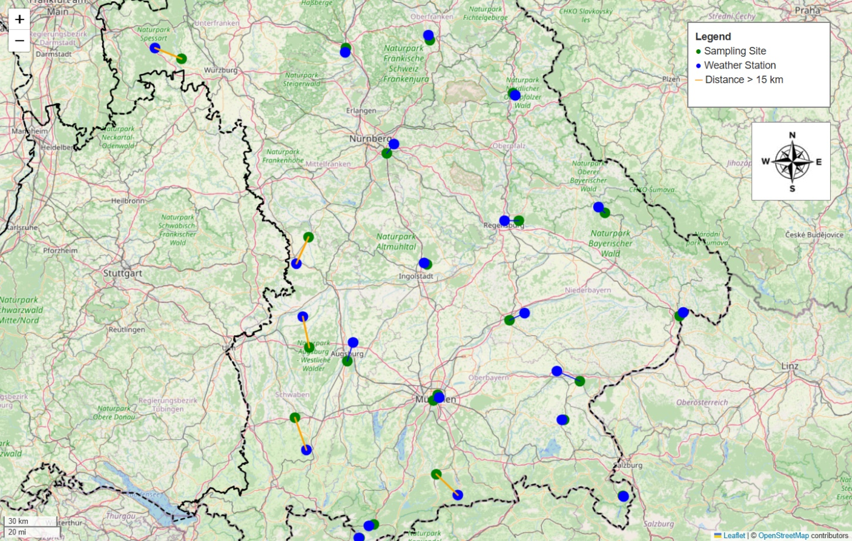
Figure S1. Spatial relationship between sampling sites and environmental monitoring stations in Bavaria. Map showing the spatial distribution of Alternaria spore sampling stations (green markers) in Bavaria, Germany, and their nearest meteorological monitoring stations (blue markers). Connecting lines represent the shortest geodesic distance between each sampling site and its corresponding weather station. Distances exceeding 15 km are highlighted in orange, indicating locations where observational gaps were supplemented with modeled data from the Copernicus ERA5 reanalysis. The administrative boundary of Bavaria is outlined with a dashed black line to contextualize the regional coverage.
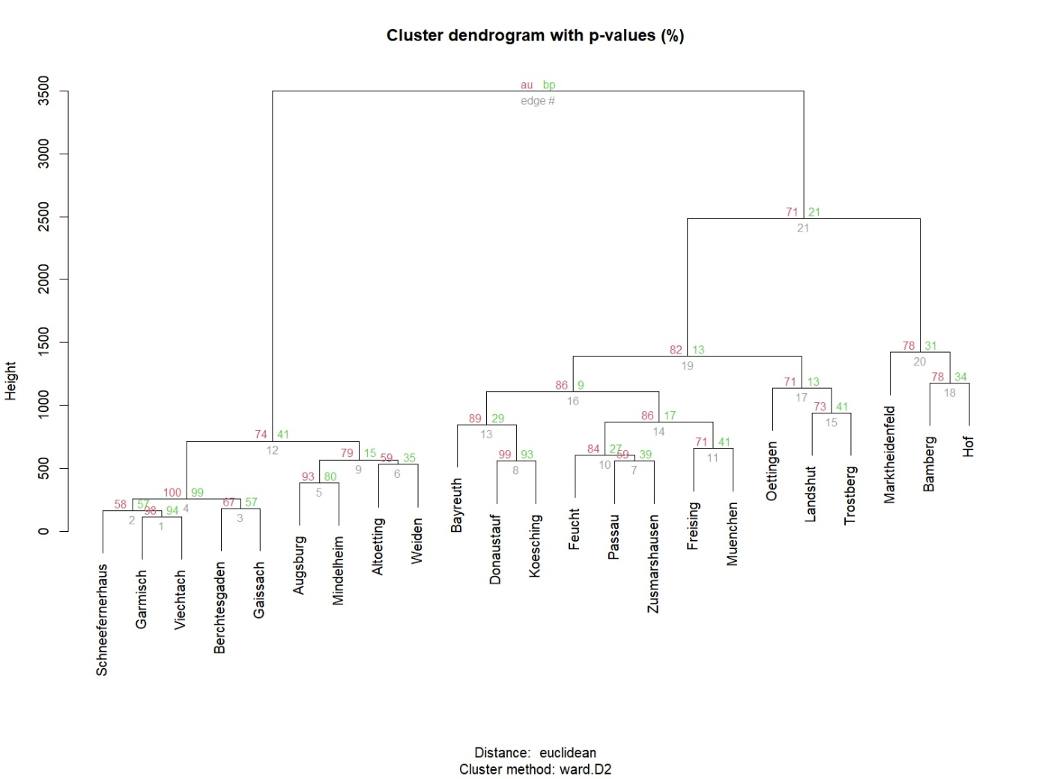
Figure S2. Cluster dendrogram showing p-values (%) for Alternaria Seasonal Fungal Index (SFI) at each sampling site, generated using agglomerative hierarchical clustering with Ward's linkage method.
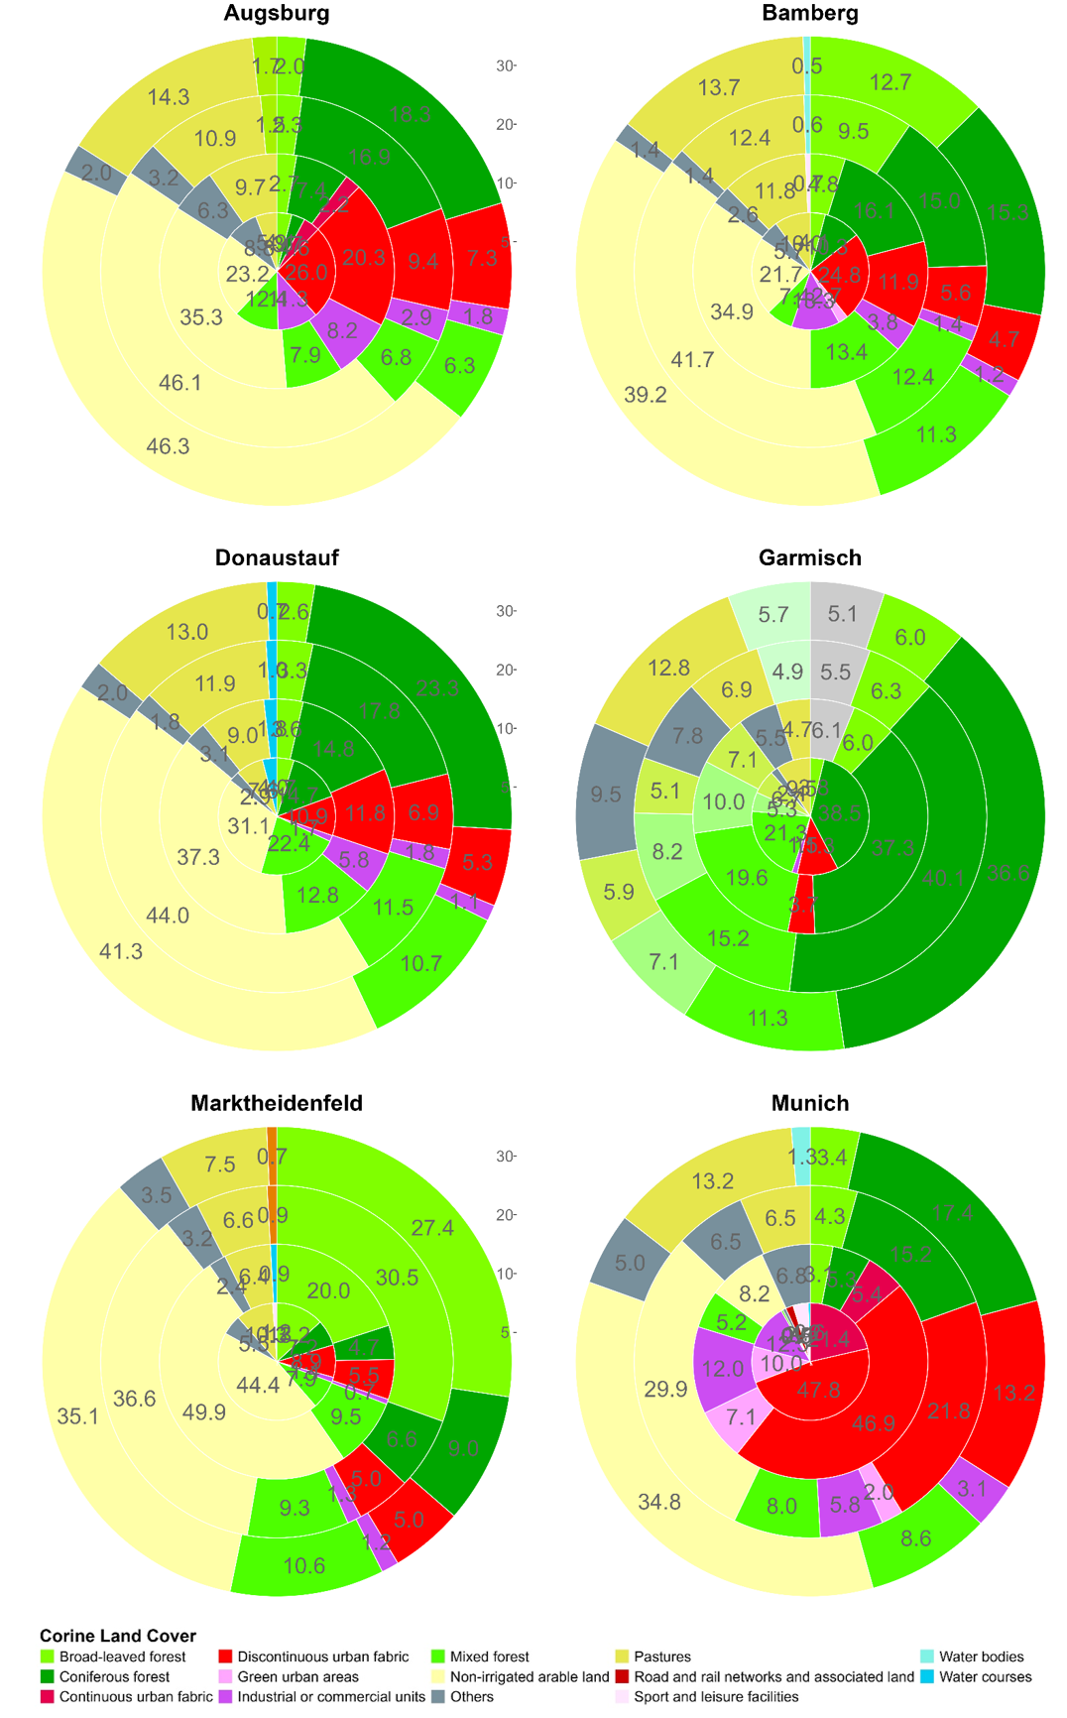
Figure S3. Relative abundance (%) of the pollen sources according to the CORINE land cover habitats, considering several rings at different distances around the pollen traps (5, 10, 20, 30 km). Concentric ring graphs represented the abundance of the main land uses surrounding the stations. The urban land density was calculated by dividing the urban area in each ring by the total land area in the corresponding ring.
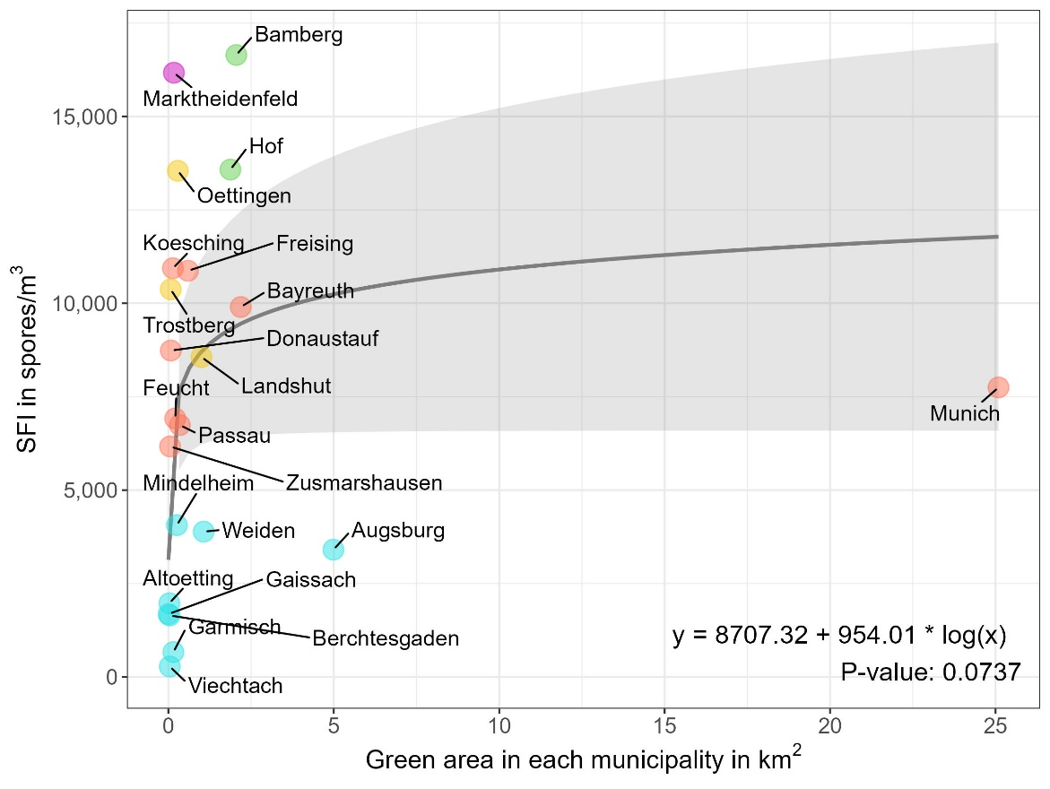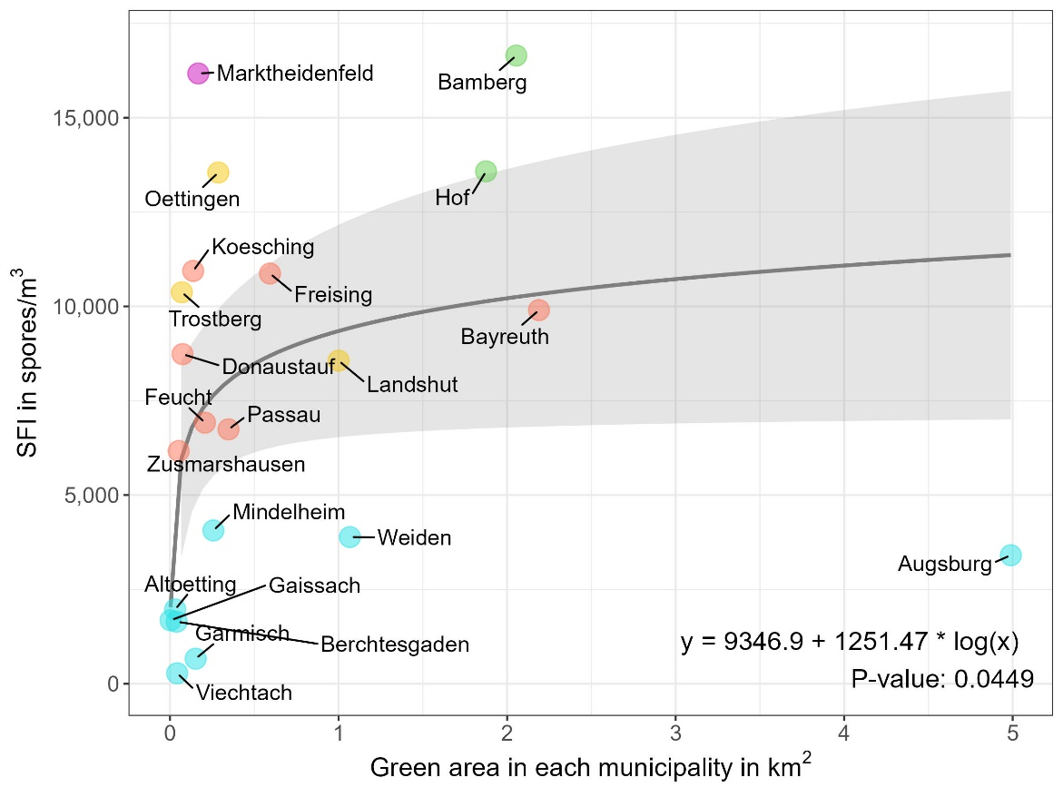
a)
b)
Figure S4. Association between city green spaces and airborne Alternaria spores. a) Relationship between green urban areas (km²) and Seasonal Fungal Index (SFI) at each location for 22 sites. Schneeferneraus is excluded since is not a municipality. Each color represents a different cluster group identified through clustering analysis. b) Relationship between green urban areas (km²) and SFI at each location for 21 sites. The city of Munich has been excluded due to its significantly larger green area compared to the other locations, which could distort the results. Similarly, Schneeferneraus has been excluded as it is not classified as a municipality. Each location is color-coded based on the cluster group to which it belongs, as identified through clustering analysis.
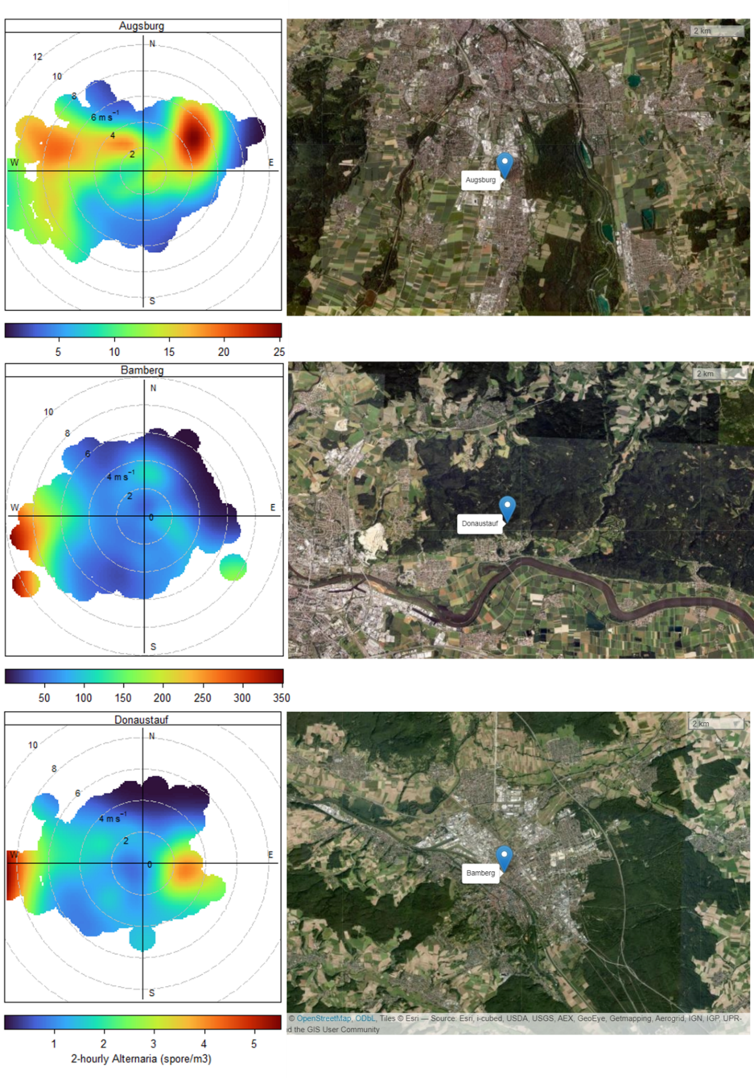
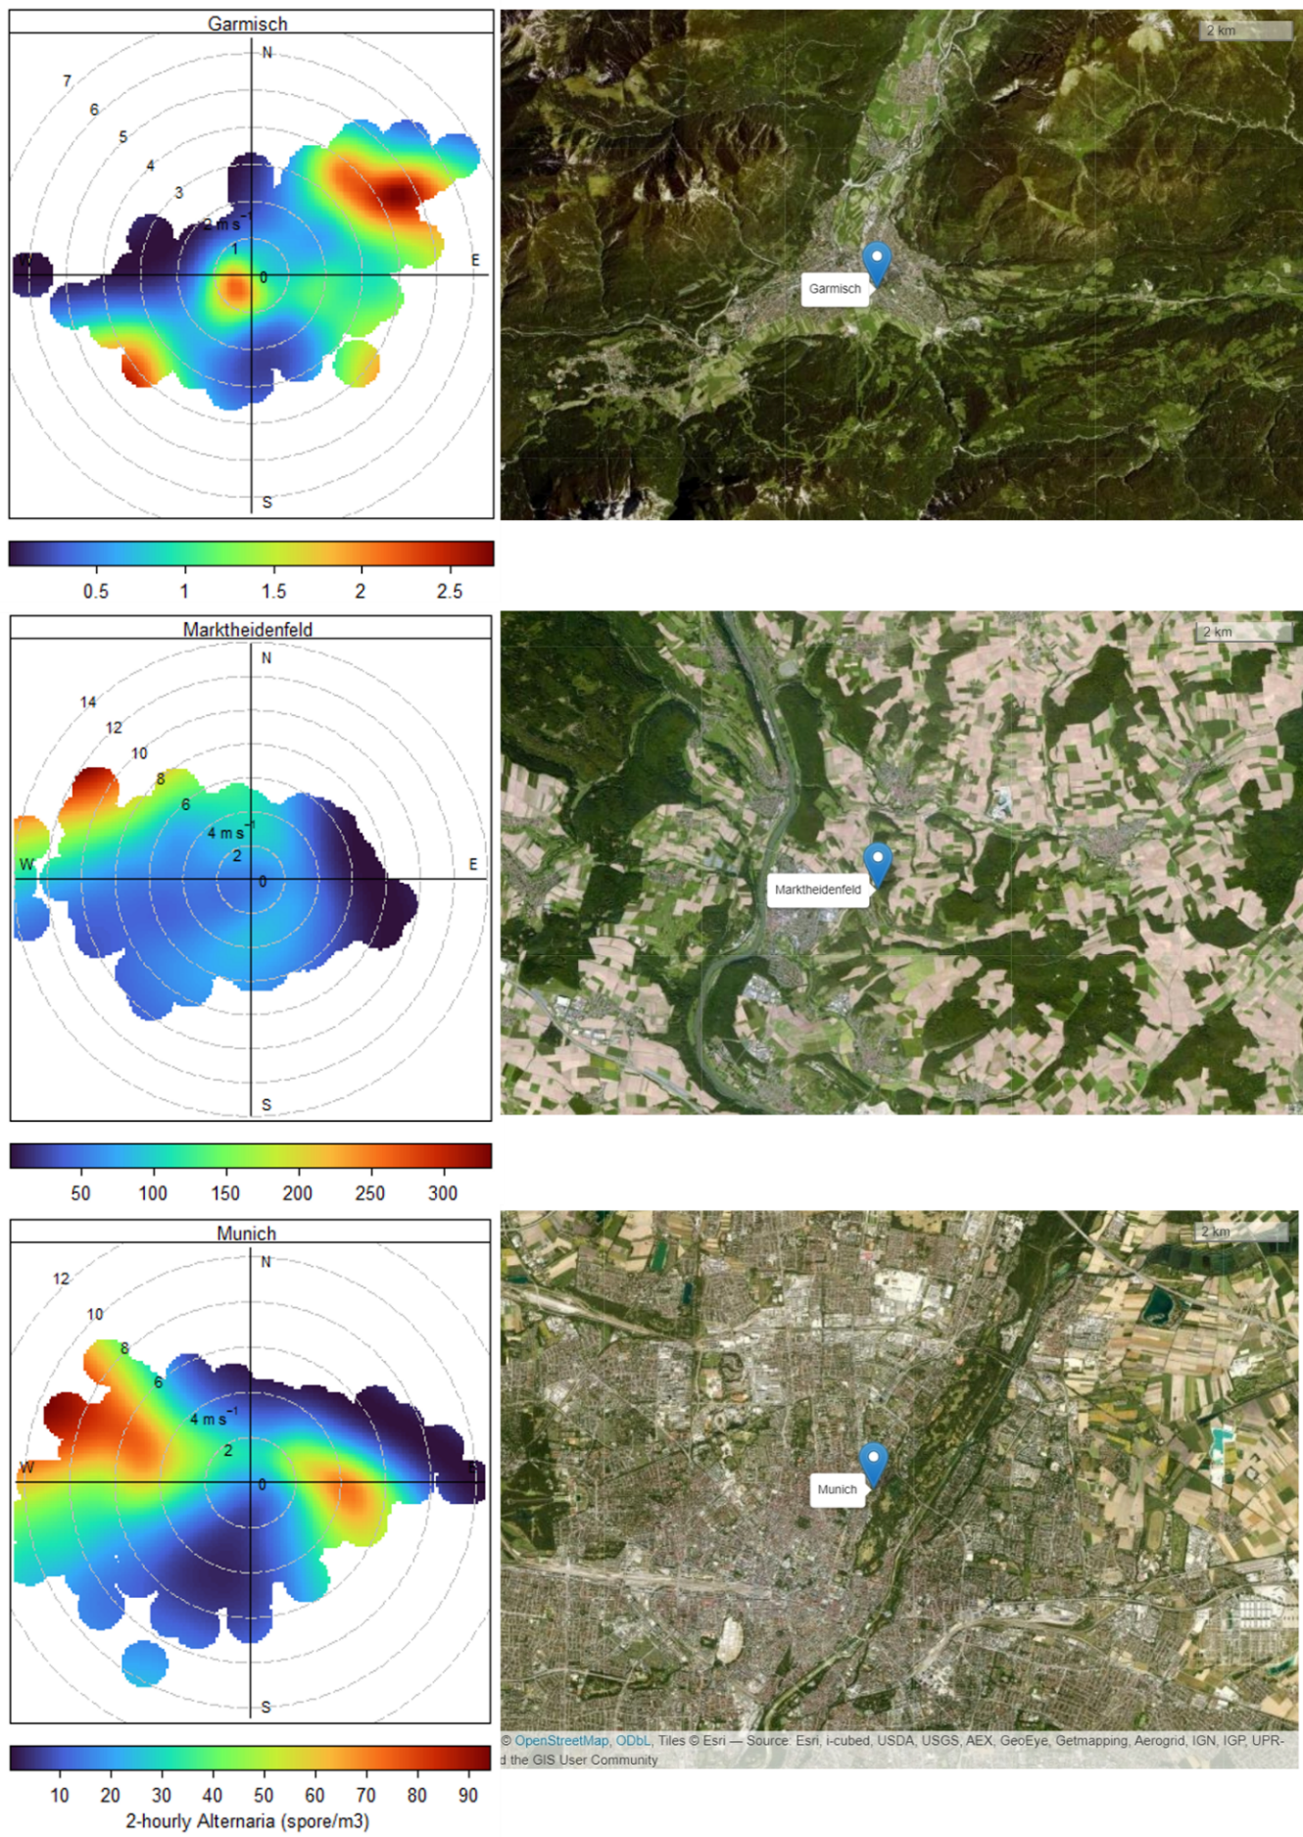
Figure S5. Alternaria hourly concentration in polar coordinates (left) showing concentration by wind speed and direction in one of the sites of each cluster and one form the Alps (Garmisch). Mean concentrations are calculated for wind speed-direction ‘bins’ (e.g. 0-1, 1-2 m/s and 0-10, 10-20 degrees etc.). Lower concentrations of spores are in blue and higher ones in red color. On the right, there are satellite maps over the study area of the each considered site.

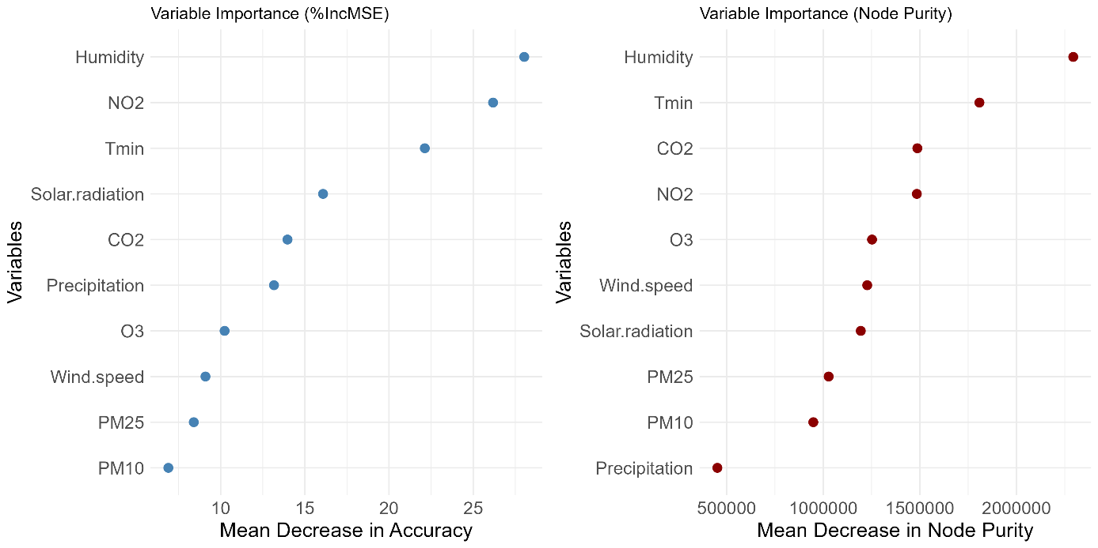
Figure S6. Variable importance plot for the random forest model. The plot illustrates the relative importance of each predictor variable in predicting the target variable, with higher values indicating greater influence. %IncMSE (Percentage Increase in Mean Squared Error): represents how much the Mean Squared Error (MSE) increases when the variable is excluded from the model, a low %IncMSE suggests that the variable has less impact on the model’s accuracy. IncNodePurity (Increase in Node Purity) refers to how homogenous the target variable is within a node after splitting and measures how much the variable improves the homogeneity of the nodes in the trees. Higher values indicate that the variable is effective in creating more homogeneous groups
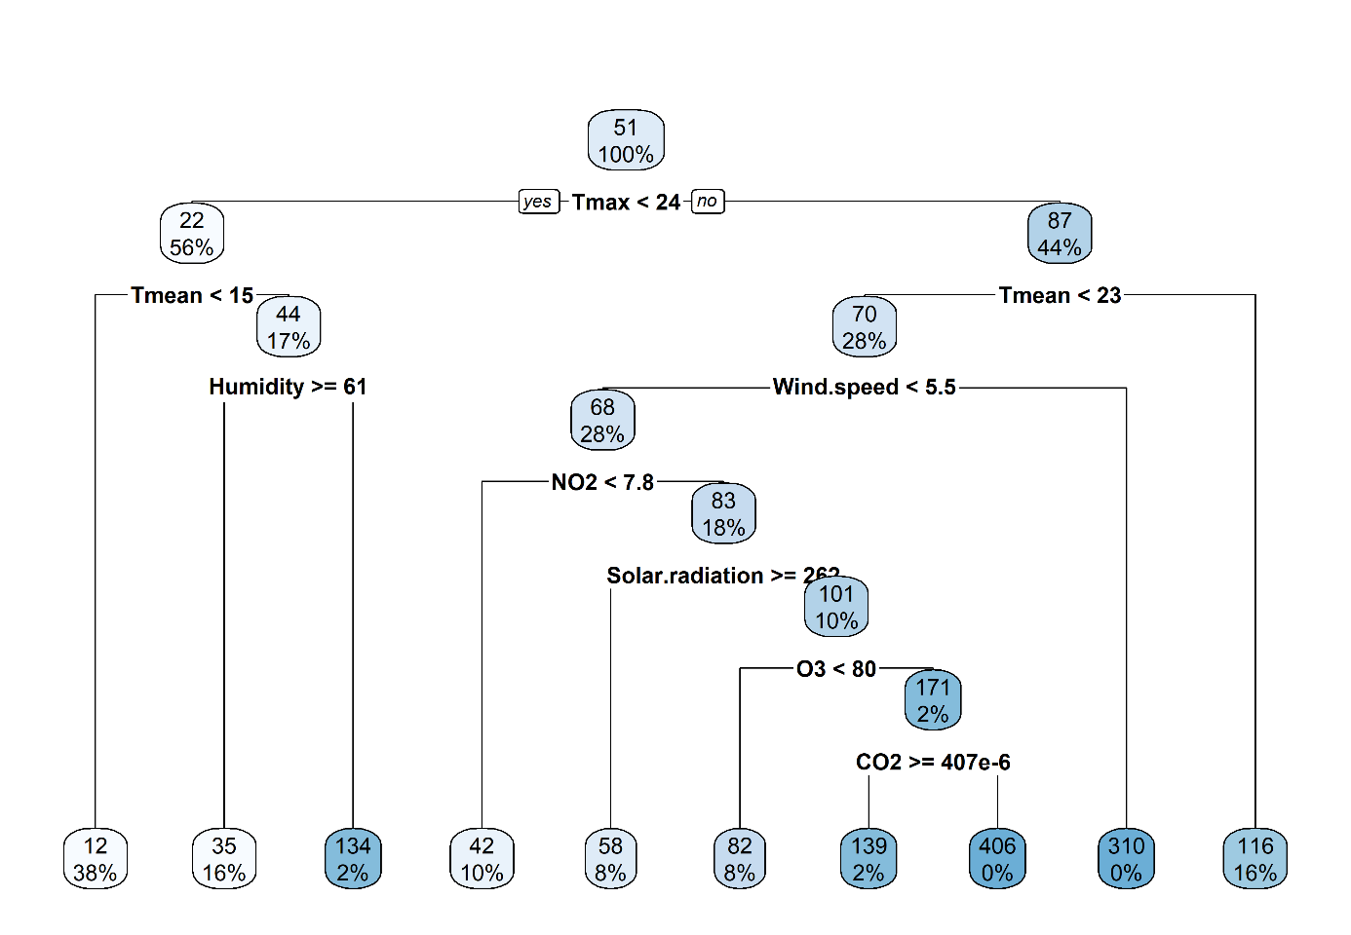
Figure S7. Pruned regression tree model for predicting Alternaria concentration in the study area with the 23 locations considering weather and pollution variables. The tree was pruned based on cross-validation error to avoid overfitting and highlight the most significant predictors, with complexity parameter (CP) used to optimize tree size. The tree represents the relationship between predictor variables and the predicted outcomes. Each split represents the most important variable in reducing the variance of the target variable (Alternaria), with the terminal nodes showing predicted values for the response.
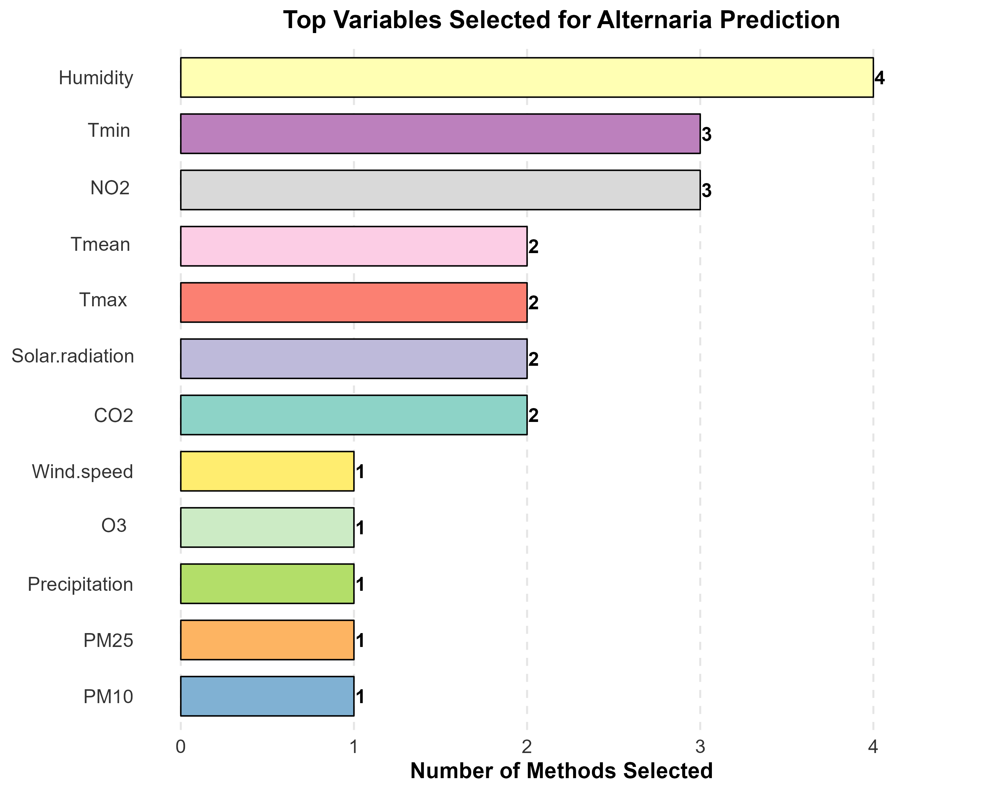
Figure S8. Bar chart showing the number of methods (random forest, regression tree, xgboost and stepwise regression method) that selected each variable in the prediction of Alternaria spore concentration. Variables are ranked by their selection frequency across methods.

