**Supplementary materials**

**Mirabegron-induced brown fat activation does not exacerbate atherosclerosis in mice with a functional hepatic ApoE-LDLR pathway**

Zhixiong Ying*1,2, Robin van Eenige*1,2, Rosa Beerepoot1,2, Mariëtte R. Boon1,2, Niels J. Kloosterhuis3, Bart van de Sluis3, Alexander Bartelt4,5,6, Patrick C.N. Rensen1,2, Sander Kooijman1,2

*Authors contributed equally.

1Division of Endocrinology, Department of Medicine, Leiden University Medical Center, Leiden, The Netherlands

2Einthoven Laboratory for Experimental Vascular Medicine, Leiden University Medical Center, Leiden, The Netherlands

3Department of Pediatrics, University of Groningen, University Medical Center Groningen, Groningen, The Netherlands

4Institute for Cardiovascular Prevention (IPEK), Ludwig-Maximilians-University, Munich, Germany

5Institute for Diabetes and Cancer (IDC), Helmholtz Center Munich, Neuherberg, Germany

6German Center for Cardiovascular Research (DZHK), Partner Site Munich Heart Alliance, Technische Universität München, Munich, Germany

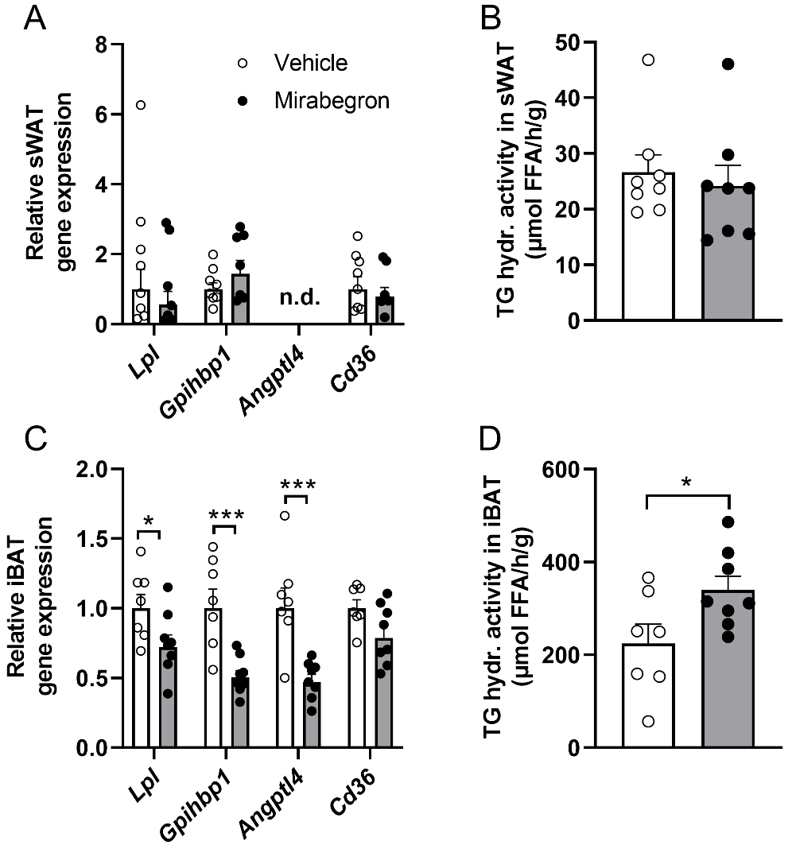

**Supplementary Fig. S1. Mirabegron stimulates lipoprotein lipase activity in brown adipose tissue.**Female APOE*3-Leiden.CETP mice were fed a Western-type diet and injected with mirabegron or vehicle for 15 weeks. In **(A, B)** subcutaneous white adipose tissue (sWAT) and **(C, D)** interscapular brown adipose tissue (iBAT) samples collected 4 hours after the last injection, relative gene expression levels of lipoprotein lipase (*Lpl*), glycosylphosphatidylinositol anchored high density lipoprotein binding protein 1 (*Gpihbp1*), angiopoietin-like 4 (*Angptl4*) and cluster of differentiation 36 (*Cd36*) was determined, and the LPL activity was determined and expressed as triglyceride (TG) hydrolase (hydr.) activity in μmol free fatty acids (FFA) per hour (h) per gram (g) tissue. Data are presented as mean ± SEM and individual data points (**A**, **C**-**D**, *n*=7-8 per group; **B**, n=8 per group). \**P* < 0.05, \*\*\**P* < 0.001. n.d. not detectable (*i.e.*, CT value > 33).