# Anatomical Considerations for Inhaled Aerosol Deposition Modeling: Methods, Applications, Challenges and Opportunities

Robert F. Phalena*, Mark D. Hooverb,

Michael J. Oldhamc, and Laleh Golshahid , Otmar Schmide,f

1. *University of California, 100 Theory Ste. 100, Irvine, California, 92617-1830, USA*

*\* Corresponding author. Tel.: 1-949-824-4758 Email address:* [*rfphalen@uci.edu*](mailto:rfphalen@uci.edu)

1. *Mark D Hoover LLC, Morgantown, WV, 26505-3628, USA*
2. *Oldham Associates, LLC, Goochland, VA, 23103, USA*
3. *Virginia Commonwealth University, College of Engineering, Richmond VA 23284-8068, USA*
4. *Institute of Lung Biology and Disease, Helmholtz Zentrum Muenchen, 85764 Neuherberg,*

*German*

1. Comprehensive Pneumology Center - Member of the German Center for Lung Research (DZL), 81377 Munich, Germany

# Abstract

This paper, one of several in a special issue of the *Journal of Aerosol Science* on “Inhaled Aerosol Dosimetry”, covers selected methods for defining the respiratory tract anatomy required as input to inhaled aerosol deposition models, along with some applications and challenges. “Anatomy” refers to the study of biological structures and to the structures themselves.

Quantitative anatomical data obtained by morphometric measurements are used in inhaled aerosol deposition dose models. The equations used in modeling calculations define the needed specific quantitative anatomy input, whether the model is deterministic, stochastic, semi- empirical, or computational fluid dynamics based. Replica airway casts are widely used for defining airway morphology, and for making hollow models to validate deposition calculations. The parameters measured on casts, e.g., airway lengths, diameters, branching and gravity angles, alveolar shapes, and generational linkages do not capture some important airway details, such as bifurcation shapes, airway motion, deviations from airway smoothness, and non-uniform airway tube diameters. These details can affect inhaled aerosol fates. Advances in methods for scanning airways in living bodies or in non-dissected excised lungs have overcome many of the problems associated with replica cast morphometry, but limitations remain with respect to providing linked airway regions, capturing airway motion, and resolving fine structural detail. There are also needs for cast measurements and scans that represent additional animal species and normal variations within species and individuals. Other methods for defining airway anatomy, such as serial sectioning of fixed or frozen tissue, planar x-ray imaging, and bolus aerosol inhalation, also provide useful airway anatomical data. Along with advances in aerosol dynamics, the current state of understanding airway anatomy is adequate for modeling many medical and environmental exposure cases.

However, it appears that advances in understanding respiratory tract anatomy and physiology have lagged behind advances in the quality of aerosol science used in current inhaled aerosol deposition models, with the exception of dynamic and/or multi-component aerosol systems (e.g., cigarette smoke). Accordingly, both challenges and opportunities for anatomists and aerosol scientists working on inhaled aerosol dose models lie ahead.

# Highlights

* Airway anatomy is required as input in inhaled aerosol models.
* Anatomical information for dose models comes from a variety of methods.
* Scanning methods are used to discover living or non-dissected airway anatomy.
* New exposure scenarios may require new knowledge of airway structures.

**Key words**: Inhaled aerosol models; Respiratory airway anatomy; Lung casts; Respiratory tract scanning: Tracheobronchial morphometry; Computational fluid dynamics; MPPD model.

# Introduction and Some Early History

* 1. *Overview*

Anatomy is both the science of describing biological and other structures, and the structures themselves. A branch of anatomy, “physiological anatomy”, studies structures, primarily organs, in relation to their functions. “Morphology” is a synonym of “anatomy”, and “morphometry” as used herein is the quantitative measurement of biological structures (Weibel, 1963). Aerosol scientists use quantitative anatomical measurements, a form of physiological anatomy, along with breathing air flow patterns and aerosol dynamics to calculate inhaled aerosol deposition patterns. In addition, the disciplines of anatomy and aerosol science have both contributed to understanding the internal doses received from inhaling airborne materials such as aerosol medications, infectious microorganisms, occupational dusts and ambient air pollutants. As a result, some aspects of aerosol science and respiratory tract anatomy research have an entwined history; each has advanced in response to developments in the other.

A living mammalian respiratory tract defies a complete description of its structures and its functions. Depictions, descriptions and replicas, no matter how detailed and accurate, are incomplete abstractions. Yet, such representations are essential for many applications including modeling the deposition of inhaled aerosols and their components (particles, vapors and gases). The mammalian respiratory tract airways, starting at the entrances to the nose and mouth and terminating in hundreds of millions of alveoli, are accompanied by blood vessels, muscles, collagen, nerves, glands and lymphatics. All of these components are important for determining the fates of inhaled substances, and they challenge anatomists to describe their sizes, shapes, numbers, linkages, variations, and changes over time. Detailed accurate anatomical and physiological data are essential to understanding, describing, and predicting deposition patterns and other fates of inhaled materials. This paper reviews several methods used for obtaining respiratory-tract anatomical data and their applications for understanding, modeling and predicting inhaled aerosol deposition patterns. Many of the anatomical methods are still in a period of development. The applications of inhaled aerosol models to current environmental and laboratory exposures, especially those involving dynamic complex aerosol systems, pose new challenges to aerosol scientists and airway anatomists.

* 1. *Historical developments*

The importance of aerosol treatments was noted in the mid-18th century by William Davidson who wrote, “Inhalation is the only mean [sic] we have of local treatment (of lung diseases), but which when properly regulated may be of considerable service.” (Davidson, 1765). The sentiment, “properly regulated,” also applies to other issues including risk assessments and modern medical applications related to inhaled materials. William Snow Miller published a history of the scientific understanding of respiratory tract anatomy in his monograph, *The Lung* (Miller, 1947). He pointed out that by the mid-1830s mammalian anatomical knowledge was recognized as essential for performing successful surgeries and for understanding respiratory diseases and treatments. Also recognized by that time was the relevance of animal studies, because all mammals share the problem of delivering oxygen to tissues and removing carbon dioxide. Animals were widely available and thus made major contributions to knowledge, along with some early human cadaver dissections. Long standing barriers to human cadaver dissections during early periods included harsh punishments for conducting such dissections and the often prevailing view that medical treatments should be based on eliminating evil spirits by using supernatural interventions and treating symptoms, all without any need for a detailed understanding of human anatomy (Garrison, 1929; Standring, 2016; von Staden, 1992).

Prior to the availability of medical microscopes, anatomists gathered gross and sub-gross information on structures such as lung lobes, airway linkages, blood vessels, pleural membranes, and lymph nodes, and they developed qualitative terminologies to describe their observations.

The focus of such studies was often narrow, being directed at understanding the primary functions of each organ, such as gas exchange for the lungs. As methods of study and knowledge advanced, many non-respiratory functions of the respiratory tract were appreciated (Fishman, 1977; Crystal, et al., 1997). Among these were metabolic, immunologic, secretory, excretory, blood clot removal, and other functions including conditioning inhaled air and the deposition, and clearance of inhaled particles and gases (e.g., Drinker and Hatch, 1936; Casarett, 1975).

In the mid-1900s, sophisticated methods for structural quantitation of the airways were introduced by the renowned anatomist, Ewald R. Weibel (1929-2019) (Weibel, 1963). The airways in the lung were described as including the trachea, major bronchi, small bronchioles, respiratory bronchioles, terminal bronchioles, alveolar ducts, and alveoli. Methods for quantitatively describing respiratory tract anatomy have proliferated since they were introduced by Weibel (e.g. see Carson, et al., 2010; Hsia, et al., 2010; Yang, et al., 2019).

* 1. *Modeling considerations*

Inhaled aerosol deposition models are used for calculating health related risks, predicting the beneficial effects of inhaled medicinals, and advancing basic respiratory tract physiology.

Werner Hofmann (2020) described five basic types of inhaled aerosol deposition models: 1) the single dimension “trumpet” model; 2) the single airway “single path” deterministic model; 3) the asymmetric “multiple path” deterministic model; 4) the “stochastic asymmetric” multiple-path” model; and 5) the computational fluid and particle dynamics (CFPD) model. He concluded that all of the models made predictions that were consistent with experimental data on the deposition of simple inhaled particles in humans. Such models depend on biological factors such as airway anatomy, airflows during breathing, and physical aerosol particle factors such as sedimentation, impaction, interception, and diffusion that lead to deposition in the respiratory tract. Other

mechanisms for the deposition of inhaled particles that are not generally modeled include electrostatic and turbulent forces (Darquenne, 2020).

The specific anatomical data sets required for aerosol deposition modeling include those that determine air flow and boundary conditions. The problem of acquiring anatomical input data for modeling is complicated by several factors, including the complexity of airways, individual differences, the effects of exertional states, growth and aging, species differences, disease states, airway motion, and biological adjustments to the acute effects of inhaled materials. In addition, validation of aerosol deposition calculations is required. Hollow airway models, along with aerosol deposition studies in living humans and laboratory animals are used for validation.

Modern scanning methods for acquiring airway anatomy are largely replacing older morphometric methods because they capture more accurate detail (Yang, et al., 2019). Also, validation of inhaled aerosol deposition models can be achieved by performing controlled aerosol inhalation studies in the same subjects that were scanned for input to the models. Details on scanning methods and measurements are found in Section 6.

# Modeling Approaches

As previously described, a variety of modeling approaches have been used to predict the deposition of inhaled particles. Most of these approaches require morphometric respiratory tract anatomical information. Table 1. summarizes some common aerosol deposition models along with their anatomy-related requirements. The types and levels of anatomical detail required to produce valid deposition data are not completely understood. For the tracheobronchial region, tube lengths, and diameters, along with branch angles and inclination angles to gravity are required for mechanistic model inputs. But bifurcation shapes, orientations, surface roughness, tube curvatures, and variable diameters within individual airways are likely to be important as well. To cover the entire respiratory tract, model types must be linked. Empirical models are required for determining total deposition via oral and nasal breathing modes. Semi empirical models are used for upper airways (nose, mouth pharynxes and larynx), because the anatomies of these structures are difficult to quantify. Mechanistic models are applied to the tracheobronchial airways and alveoli. Computational fluid dynamics models can use morphometry data, or scans of actual airways.

In the seminal model of Findeisen (1935), aerosol dynamics (diffusion, impaction, sedimentation, and interception) and anatomical descriptions of respiratory tract regions were used to calculate the probabilities of particle deposition in airways. Using Hofmann’s (2020) model type definitions, Findeisen’s model is a deterministic single path model. The results were strongly dependent on the inhaled particle sizes, shapes and densities, as well as the shapes, sizes, and configurations of each airway region. Findeisen described the bronchial tree and alveolar region as cylindrical tubes and spherical sacs respectively. His model had nine respiratory tract regions based on existing data from a dog, a calf and a sheep, but the nasal and oral regions were not considered. The model produced a U-shape total deposition curve vs. particle size. Findeisen’s approach is still relevant today. However, this approach is largely limited by the assumption that the tracheobronchial tree consists of smooth right circular cylindrical tubes that branch without consideration of the shape of the bifurcation (or sometimes

trifurcation). There are also other assumptions in the model that involve simplification of the complex anatomical reality (Table 2).

There have been several refinements of the Findeisen (1935) mechanistic particle deposition approach (Morrow et al., 1966; ICRP, 1994; NCRP, 1997, ARA, 2018 (MPPD model)). The Multiple-Path Particle Dosimetry (MPPD) Model (Table 1) follows the mechanistic approach of Findeisen (1935) along with the incorporation of airway model selections and some basic lung physiology. For example, the MPPD model typically uses uniform lung expansion and contraction during a breath, which means airflow through an airway is proportional to the airway’s distal airway volume. A recent addition includes the assumption that lung ventilation is proportional to lung compliance, airway resistance and airflow inertance. The MPPD Model has incorporated lung anatomy for several species (human, monkey, pig, rabbit, rat) and several strains of mice. The initial strains of mice were the Balb/c and B6C3F (Miller, et al., 2016). The anatomy and particle deposition for the C57BL/6 mouse were recently added (Asgharian, et al., (2019). One can expect this model to continue to incorporate additional species as well as more complex aerosol dynamics for multi component aerosol systems. Such additions were discussed at an ad hoc meeting at U.C. Irvine following the October 2019 Inhaled Aerosol Dosimetry Conference. Adding deposited particle dissolution rates in lung fluids was discussed at the ad hoc meeting as well.

Computational fluid dynamics (CFD models are a recent, and in many ways an improved method for predicting inhaled aerosol deposition (Kimbell, et al., 1993; Finlay and Martin, 2008; Rostami, 2009; Hofmann, 2011, 2020). In these models air flows in airway structures are numerically solved by finite element analysis, and then particles are introduced and tracked.

When a particle intercepts an airway boundary it is recorded as having deposited on the airway. Thus, exact locations of particle depositions are found, as opposed to the total deposition in an airway (Hofmann and Balashazy, 1991; Balshazy and Hofmann, 1993). Reviews on the models along with applications have been published by Rostami (2009), Kleinstreuer and Feng (2013), and Hofmann (2020).

# Replica Casts

Replica casts continue to be used as a source of airway morphometry data for deterministic computations of the deposition efficiencies and location of deposits of inhaled aerosols, (Timbrell, et al., 1970; Oldham, et al., 1997; Jacob, et al., 2013; Hofmann, 2020).

It is likely that the use of solidifying material injections into organs followed by removal of the tissue (corrosion casting), proceeded reports in the scientific literature. Joseph Narat and colleagues in the Department of Anatomy at the University of Illinois stated that “Swammerdam (1670) is usually regarded as the inventor of solidifying injection masses into organs” (Narat, et al., 1936). Jan Swammerdam and Frederik Ruysch used wax injections to study blood vessels (Olry, 1998). However, Cornille, et al. (2019) credits Leonardo da Vinci with using wax to cast bovine brain cavities circa 1505-1507. The casting work on airways that followed explored various injected materials. Metal alloys, waxes, celluloid, and acetone-dissolved x-ray film, were used. However, the resulting casts tended to be fragile, and either required lengthy solidifying

times or tedious cast recovery procedures. Such problems discourage detailed morphometric measurements. Improvements in casting materials and casting methods were needed in order to advance respiratory tract morphometry.

The advantages and artifacts associated with several injection methods for the preparation of solid bronchopulmonary corrosion casts have been discussed by Tompsett, (1952) and the following considerations were suggested: 1) the material should be unaffected by the reagent used to destroy the lung tissues, 2) complete filling of the alveolar region should be avoided, since complete filling makes it difficult to remove the alveolar tissue afterwards, 3) lungs should be expanded to some extent, and 4) special techniques are needed to remove the residual air in the lungs that blocks complete casting (Tompsett, 1952). In order to overcome some of the aforementioned difficulties with production of corrosion based casts and to obtain more realistic geometrical relationships, improved casting methods were needed.

Narat, et al., (1936) used a vinyl resin with acetone thinner to make replica casts of blood vessels, producing casts that solidified during water immersion for 24 hours. The tissue was then dissolved in fuming hydrochloric acid for 3-4 days, followed by washing in running water before dry mounting. After Narat and colleagues’ publication, casting material advancements followed that allowed for accurate, flexible respiratory tract casts that could be used for detailed morphometric measurements (Rahn & Ross, 1957; Weibel and Gomez, 1962; Liebow, 1947; Horsfield, et al., 1966; Tompsett, 1956; Pump, 1969; Timbrell, et al., 1970; and Eisman, 1970). Room-temperature vulcanizing rubber (RTV) casts were made by Wolfe, (1962); Frank and Yoder (1966); and Kilpper and Stidd, (1973). In these corrosion cast studies, either inflated dried lungs, or fresh lungs usually suspended in water, were injected with RTV, followed by RTV curing and then dissolving of the tissue. Several types of silicone rubber industrial molding compounds including Silastic E (Dow Corning, Midland, Michigan) and RTV-700 (General Electric, Waterford, New York), were found suitable for production of in situ lung casts with good representation of anatomical detail of structures as small as a few micrometers while resulting in very small shrinkages during curing at room temperature (Phalen, et al., 1973).

Cornillie et al. (2019) critically reviewed corrosion casting materials and methods for a variety of applications including RTV airways casts. They recommended removing the tissue by boiling in water, using a pressure wash with water, soaking in 10% hydroxide, and performing a final water rinse. De Sordi, et al. (2014) reported use of polyurethane foam for lung casts of several species. The bronchial tree was filled, but the casts were “somewhat brittle,” which could hamper detailed measurements including airway linkages.

A challenge for accurate representational lung casting is that the respiratory tract is collapsible so confinement in the thorax determines its shape, and the shape of lung casts. A method for RTV casting in-situ based on Kilpper and Stidd’s (1973) isolated-lung preparation method, but performed in situ at autopsy was published by Phalen, et al. (1973). The method involved opening the upper thorax, inserting a cannula in the trachea, ventilating with CO2 (which is soluble in water), filling the organ with degassed physiological saline, injecting silicone rubber to make the lungs fill the space available in the thorax, and curing for up to 24 hours in the body. After curing, the organ was removed as shown in Figure 1 and the tissue was dissolved in a sodium hydroxide solution, then neutralized in dilute acid (e.g. dilute household vinegar), and washed with water. The casts were flexible, replicated fine (micrometer-level) detail, and held

their shape indefinitely. Two partially trimmed casts are shown in Figure 2. Investigators have used the in-situ casting method for rodent airway morphometry (Jacob, et al., 2013), for examining species differences in tracheobronchial anatomy (Figures 2 & 3), for distal (acinus) morphometry (Haffeli-Bleuer & Weibel (1988), fractal analysis (Weibel, 1991) and to examine the effects of age on human airways (Figure 4). Future challenges include adding more species, and defining the variations within species.

In response to the importance of quantitative measurement of lung parameters (e.g., lung volume, alveolar number, volume and surface area, etc.), the unique challenges in anatomical quantification that are size dependent (i.e., human vs. mouse), and the material influence of the various techniques on the anatomical values being reported, the American Thoracic Society and European Respiratory Society jointly published standards for quantitative assessment of lung structure (Hsia, et al., 2010). Key to their published standards for total lung fixation (via airway instillation or vascular perfusion), was the incorporation of controlled infusion pressures (≤ 20- 25 cm H2O above the highest point of the lung) with an iso-osmolar material.

# Hollow Models

* 1. *Simplistic models, applications and limitations*

Hollow models of the respiratory tract are used for bench-top particle deposition experiments that provide data for validation of modeling predictions. Hollow models have been developed using various techniques and materials. Simplistic models using straight circular cross-sectional tubes have been made from plastic, glass or metal to study air flow patterns, particle motion and deposition patterns in airway segments or bifurcations (Clinkenbeard, et al., 2002; Ferron, 1977; Guichard, et al., 1988; Myojo, 1987, 1990). Particularly, physical models of a tracheobronchial tree, made from glass or metal, with the dimensions of Weibel’s idealized airway geometry (Weibel, 1963), have been used for observations of flow patterns (Schroeter and Sudlow, 1969) and aerosol deposition patterns (Ferron, 1977; Myojo, 1987, 1990; Kim and Garcia, 1991; Kim & Iglesias, 1989; Kim & Fisher, 1999). Figure 5 depicts a hollow cast in which airflows can be controlled and particle deposition efficiencies measured. The cast can be opened to view local deposition patterns. However, simple idealized models lack anatomical details and only represent portions of the total lung structure. Comparisons of simple idealized models with anatomically accurate realistic models have shown that even subtle differences in airway morphology, including the effects of preceding and following airway generations, and the lack of a larynx can cause differences in the flow patterns of nearby airway bifurcations (Chan, et al., 1980). The differences are mainly due to airflow disturbances, including excessive axial velocity in the ideal models in the absence of larynx, which leads to artificial enhancement of deposition at the bifurcations (Chan, et al., 1980). The setup in Figure 5 using a hollow airway model is based on Weibel’s (1963) symmetric model without a larynx. Timbrell, et al. (1970) used the lost wax method by coating a solid wax cast of a pig lung with silver. Adult hollow airway models have been scaled downward based on the available morphometry data for children (Oldham, et al., 1997).

* 1. *Hollow models based on replica casts*

Hollow airway models created from cadaver lungs have also been used in particle deposition studies (Cheng Y-S, et al., 1999; Corcoran & Chigier, 2002; Schlesinger & Lippmann, 1972; Schlesinger, et al., 1977; Smith et al., 2001; Sussman et al., 1991; Gurman, et al., 1984; Cohen, et al., 1990). To include anatomical details in the production of hollow respiratory tract airway models, numerous materials and techniques including improved casting techniques have been used (Schlesinger & Lippmann, 1972; West & Hugh-Jones, 1959; Briant & Lippmann,1992; and Frank & Yoder, 1966). Solid casts have been used to make hollow replicas of airways (Clinkenbeard, et al., 2002). To do this the lost wax process has typically been used, where the solid lung casts are coated with layers of wax and a rubber material, and the wax is melted away to allow removal of the hollow replica. For other studies and replicate experiments, the fabricated hollow model can be used to make multiple solid wax models.

* 1. *Hollow models made from airway scanning data*

Recently, high-resolution computed tomography and anatomical imaging data, obtained using different imaging modalities, have been used to develop hollow airway models. There are numerous rapid prototyping techniques available (Karapatis, et al, 1998; Lantada & Morgado, 2012; Ahanger et al., 2019), and a few of these have been evaluated for production of anatomically-correct hollow airway models (Clinkenbeard, et al., 2002). In one study, selective laser sintering (SLS) was chosen among the rapid prototyping options, because in the view of the authors SLS did not require additional supporting structures unlike other rapid prototyping techniques such as stereolithography (SLA). The accuracy of the three-dimensional anatomic computer model in comparison with the image data set and the precision of the SLS process in producing an anatomical physical model from the three-dimensional computer model have been evaluated (Clinkenbeard et al., 2002) and results were found to be in agreement. The largest dimensional difference between the image data set and the three-dimensional computer model was 0.1 mm, and the average difference between the physical model and computer model was

±0.03% (Clinkenbeard, et al., 2002). A 0.1mm difference can be large for the human terminal bronchiole (0.4 mm diameter, by 0.5 mm length), so it could produce errors in modeling. But the errors should be acceptable down to airways larger than terminal bronchioles, reported to be 0.6 mm in diameter and 1.7 mm in length (Hofmann, 2020).

* 1. *Measuring particle deposits*

A challenge for the use of hollow models is that sampling deposited particles for chemical analysis can generate artifacts if the rapid prototyping or other casting material leaches out and interferes with the analysis of the tracer or the deposited study material of interest. Depending on the type of tracer, it is sometimes unavoidable to prevent the overlap of the ultraviolet or fluorescent peak of the tracer with the peak of the material getting washed off the surface of airway models. In such cases, deposited particle counting has been implemented to quantify the particle deposition based on the relative difference in the number concentration across the region of interest in the airway models (Storey-Bishoff, et al., 2008; Golshahi, et al., 2011).

* 1. *Combining airway regions*

Since complete image sets of extrathoracic and intrathoracic airways are not always available merging different data sets has been considered (Lizal, et al., 2011). For example, models of the laryngopharynx to trachea were merged with the digital reference bronchial model of Schmidt, et al. (2004). Alternatively, an approach to predict the thoracic lung dose is to measure deposition efficiency of inhaled aerosols in hollow anatomical airway models of extrathoracic airways and infer the thoracic lung dose by subtracting deposition in the extrathoracic airways from the total inhaled dose. A more detailed review of anatomical extrathoracic airway models can be found in Golshahi, et al., (2015). The ICRP (1994), NCRP (1997), and MPPD (ARA, 2018) inhaled aerosol deposition software models combine empirical, semi empirical, and deterministic models to provide total and regional deposition doses.

# Morphometric Measurements on Casts

The quantitative measurements that are required for inhaled aerosol mathematical modeling involve the anatomical features that influence the deposition of inhaled particles and gases. Such features are found in equations that describe inhaled particle deposition mechanisms including diffusion, impaction, sedimentation and interception. For tubular airways, tube lengths, diameters and inclinations to the force of gravity, along with branching angles are important (Yeh, et al., 1976; Finlay & Martin, 2008; Darquenne et al., 2016; Hofmann, 2020). When the tracheobronchial (TB) tree is considered, the sequence (generation number) of airways and the number of airways at each generation are needed because upstream and downstream generations modify airflow patterns. The required precision of dimensions and angles can be estimated by performing a sensitivity analysis on the mechanistic deposition equations (Phalen, et al., 1990). Using particle diameters ranging from 0.1 to 10 micrometers, the authors concluded that variation in airway angles and airway dimensions of + 10% led to errors in particle deposition calculations of 10%. Therefore measurements of + 5% were recommended for airway dimensions and branching and gravity angles. But practical considerations, such as the resolution of cast measuring instruments, estimating dimensions of cast airways, and the accuracy of the replica cast will limit the morphometric precision and accuracy.

Simple morphometric measurements have been made by referring to an idealized template (Figure 6) for bifurcations on casts of humans, dogs, rats and hamsters (Raabe, et al., 1976). The measurements provided anatomical input data for inhaled aerosol deposition software to calculate diffusion, impaction, sedimentation and interception probabilities. Data from Raabe’s studies have been used in several computational dosimetry models (e.g. ICRP, 1994; NCRP, 1997; Asgharian, et al., 2001; Miller et al., 2016; ARA, 2018; Hofmann, 2020). Note that radii of curvature associated with a branch are not usually measured because simple curvatures as shown on the template are seldom seen in the casts.

Ideally, all of the tubes and branches of the tracheobronchial (TB) tree would be measured, a currently impractical task. Therefore simplifications, such as “typical” (or average) paths from the trachea to the most distal bronchioles, and randomly generated airway tree structures are used (Hofmann, 2011). Typical path models have been used to represent the entire human TB tree or individual lobes of the lung (Yeh & Schum, 1980; Hofmann, 2020).

The foregoing is based on several assumptions including: 1) that TB tubes are right-circular cylinders; 2) that airways branch angles can be treated as equivalent to the angles formed by two intersecting straight tubular center lines; 3) that each generation of an airway has a single inclination to the force of gravity, and 4) that the TB tree is a static structure that does not change during breathing. None of these assumptions are true (Figures 2, 3 and 4), so modeling results should be validated if possible before they are trusted. Other limitations of morphometry include anomalous features, such as surface roughness; variations in mucus thickness; impressions of ribs, blood vessels cartilage rings, and plates; growths (such as tumors); occlusions; collapsed airway tubes; the presence of alveoli on bronchioles; collateral ventilation shunts that allow air to flow laterally between typical paths; and the actions of the beating heart, the diaphragm and the intercostal muscles. Clearly, respiratory tract morphometrists face many challenges and opportunities as they work to improve inhaled aerosol dose models.

# Respiratory Tract Scanning Methods and Data

* 1. *Overview*

Scanning methods can overcome many of the limitations of casting techniques. Prior to acquisition of respiratory tract anatomy using non-invasive scanning methods including magnetic resonance imaging (MRI) and computed tomography (CT), a variety of manual digitization techniques using cadaver tissue or casts derived from cadaver tissue were used for both laboratory animals and humans (Kimbell, et al., 1993; Harrison, 1995; Kepler, et al., 1995).

Development and refinement of MRI and various CT based high-resolution computed tomography; low-resolution computed tomography; multi-detector computed tomography, positron emission tomography–computed tomography (PET-CT); and single photon emission computed tomography (SPECT) scanning methods have revolutionized the acquisition of anatomical data. Both MRI and CT have also been used to obtain quantitative respiratory tract anatomy from in situ prepared respiratory tract casts in humans and laboratory animals. These respiratory tract data have been used for predictions of aerosol deposition using CFD techniques, as well as the creation of hollow airway models in which particle deposition experiments have been conducted (Lizal et al., 2011, 2017). Lizal et al. (2017) critically reviewed developments in computational methods for simulating and measuring deposited aerosols in humans. They evaluated the suitable methods for various applications, including medical, and model validation studies.

* 1. *Magnetic resonance imaging (MRI)*

Initially, the use of MRI to study the respiratory tract in humans focused on extrathoracic airways (e.g., nose, mouth, pharynxes, and larynx) because the tracheobronchial airways were difficult to image (Swift, 1991; Lewis, et al., 2005). To increase resolution and minimize motion artifacts, fast pulsed scans and respiratory gating techniques were developed (McRobbie, et al., 2003). Use of hyperpolarized gases (e.g., 1H, 3He) significantly increased the resolution of MRI techniques enabling studies of the tracheobronchial and alveolar airways in humans and animals (Johnson et al., 2001; Minard, et al., 2006). For example, Flors, et al., (2017) used hyperpolarized 3He to determine the alveolar size in children with bronchopulmonary dysplasia.

MRI techniques have also been used to obtain airway anatomy from in-situ prepared silicone rubber lung casts of humans and research animals. Martonen, et al., (2002) used an MRI scan of an adult human replica cast of extrathoracic airways through main bronchi to describe particle transport within these airways using CFD techniques. Carson, et al., (2010) used an MRI scan of a replica young Rhesus monkey lung cast to predict airflow and particle deposition using CFD techniques.

* 1. *Computerized Tomography, CT*

A computerized tomography (CT) scan is a series of x-ray images around a body that can be processed to yield three-dimensional images of hard and soft tissues including bones, blood vessels, airways, glands and other structures. CT techniques have been used to obtain airway geometries for CFD studies and create hollow airway models for particle deposition studies of human extrathoracic, tracheobronchial, and alveolar airway anatomy (Tawhai, et al., 2004; Xi and Longest 2007; Corley, et al., 2012). A recent review (Darquenne, et al., (2016), explained that the ability to segment high resolution CT images into tracheobronchial airways varies among human subjects and even within lung lobes and depends on several factors including the lung volume when the CT images were acquired. As summarized in the same review, use of PET or SPECT techniques are limited by their spatial resolutions of approximately 6 and 15 mm, respectively, and also by motion artifacts due to breathing (Darquenne, et al., 2016). Since x-rays are used in creating CT images, the total radiation dose is a concern when humans are scanned and is the rationale why dimensions from only the first 6-9 airway generations are available and longitudinal and pediatric studies are limited (Conway, et al., 2013). Two publications by Kuo, et al., (2017a,b) used CT scans to develop an airway-artery measurement technique and used them to diagnose bronchiectasis (pathologic enlargement) and airway wall thickening in children with cystic fibrosis. In one of the most extensive uses of CT scans for airway morphometry (N=3,169), Smith et al., (2018) correlated differences in upper tracheobronchial bronchial anatomy with differences in distal airway anatomy and gene expression that were identified as susceptibility factors for chronic obstructive pulmonary disease.

CT and micro-CT scans have also been used to obtain respiratory tract anatomy from laboratory animals and from in-situ prepared lung casts of dogs, rats, and various strains of mice (Perzl, et al., 1996; Thiesse, et al., 2005; Islam, et al., 2017). Asgharian, et al., (2019) used micro-CT images of replica in-situ lung casts to develop tracheobronchial airway particle deposition predictions for C57BL/6 mice.

# Other Anatomical Data Methods

* 1. *Overview*

Anatomical data can also be obtained by a variety of techniques other than those discussed above. Hsia et al. (2010) provide an excellent review including standardization of quantitative lung structure assessments. Many methods have not been prominent in producing input data for

inhaled aerosol dose software but they can be used to validate human airway morphometry and generate new insights (Cookson, et al., 1993; Sanderson, 2011; Scott et al., 2014).

* 1. *Serial sectioning*

A histologic technique involving the measurement of airways on serial sections of fixed, gel filled, or frozen tissues can be used to reconstruct three dimensional airways. Artifacts of fixation (shrinkage and distortion) and sectioning (stretching and compression) must be known and corrected for. For lungs, the state of inflation upon fixing or freezing must be determined, and obtaining representative tissue blocks is a difficulty due to lobar and other variations in anatomy (Dungworth, et al., 1976; Hsia et al., 2010). Nondestructive virtual tissue “sectioning” can also be performed using intact tissue and optical imaging techniques such as confocal microscopy (Cookson, et al., 1993; Scott et al., 2014). More information on confocal sectioning is found in subsection 7.4.

X-ray images of inhaled or infused contrast agents can depict the coated or filled airways, but single plane images do not allow for correcting out-of-plane (parallax) artifacts. Airway lengths and branch angels can appear to be diminished on ordinary x-ray images. A solution to this problem is to take three-dimensional x-ray images, by using two adjacent x-ray sources that “fire” simultaneously producing a double image on the film (Yeh, et al., 1975). Software and recording x-y coordinates of corresponding features on the double image will allow true lengths, branch angles, and gravity angles to be determined. This technique was used to validate the accuracy of in-situ lung casts made after tantalum powder inhalation with pre and post x-ray imaging (Yeh et al., 1975) but it is difficult to set-up the x-ray machines, to write the software and measure the relative position of the selected points within the images. One should also note that powdered airway contrast media can burn rapidly in enriched oxygen atmospheres, limiting their use in human patients. A similar steroradiography method for rapidly producing three- dimensional images of stationary objects for qualitative viewing was reported by Akaranate et al. (2013). Advances in steroradiography techniques using two separated x-ray views are widely used in medicine and can replace CT scans in some cases. An additional benefit is that such steroradiography delivers lower x-ray doses than CT.

* 1. *Exhaled particle analysis*

Other methods, such as counting exhaled particles in successively exhaled air volumes provide information on airway dimensions, but they require sophistication and validation in order to provide accurate generation-by-generation data on airway lengths and diameters. Branch angles and airway inclinations to gravity are not measurable currently using these methods. Some studies have shown aerosol methods such as aerosol bolus dispersion (ABD) and aerosol-derived airway morphometry (ADAM) (Blanchard, 1996b; Brand, et al., 1995) can serve as non-invasive diagnostic tools for emphysematous lung injury (Beinert, et al., 1995; Kohlhaufl, et al., 1998).

Convective gas mixing is measured with ABD, and assessment of airway changes in ADAM is based on a parameter known as the effective airway diameter (EAD) (Blanchard, 1996a, b; Brand, et al., 1995; Brand, et al., 1997). In brief, the ADAM technique was developed based on the analysis of changes in concentration of exhaled monodisperse aerosol (diameter ≥ 0.8 m and <1 m) in known exhaled volumes due to gravitational settling during a few seconds of

breath holds. In ABD, a small volume (bolus) of monodisperse aerosol (0.4-1 m diameter) is inhaled by the subject into a specified volumetric lung depth and then immediately exhaled in a broadened (dispersed) shape (Kohlhaufl, et al., 1999). These aerosol methods were compared with high resolution computed tomography (HRCT), which showed a strong correlation between effective airway diameter (EAD) and the HRCT visual score, but the correlation between CT lung density and the visual score was weak with aerosol bolus dispersion (ABD) (Kohlhaufl, et al., 1999). Aerosol bolus dispersion is relatively simple to administer, but due to its weak correlation with HRCT, conventional lung function tests are suggested to supplement this method (Brand, et al., 1998).

Recently Darquenne and Prisk (2020) performed aerosol bolus deposition studies in four subjects over 19 years (at age 0, 9, 15 and 19) and found that peripheral deposition of monodisperse 1 micrometer polystyrene latex particles increases with age. The authors discussed the results in relation to corresponding pulmonary function data. With care, these methods, can be used to validate computational models with respect to their accuracy for predicting ventilation and calculating aerosol deposition in distal pulmonary regions. This would be valuable for exploring small airways, since radiographic methods currently cannot provide detailed information on the shape and dimensions of these distal regions (also called the “silent zone”) due to their small size, large total volume, low resistance to airflow and motion artifacts.

* 1. *Fluorescence imaging*

With the development of novel fluorescence imaging technologies and analytical software, qualitative and quantitative assessment of airway structure along with measurement of inhaled aerosol deposition patterns in the lung can be achieved. Previously, fluorescence imaging in the lung relied on physically cutting the tissue into thin slices (ca. 10 to 100 µm), imaging each slice and reconstructing the three-dimensional architecture. If fluorescent particles had been previously deposited, they could also be imaged in the slices, thus, correlating particle deposition patterns with airway structure and potentially providing validation of computational fluid dynamical modeling (Barapatre, et al., 2015). Barapatre et al., (2015) and Bauer, et al. (2020) performed such imaging studies in mice using cryosliced frozen tissue after instilled (Barapatre) and inhaled (Bauer) fluorescent micro particles.

Alternatively, chemically induced optical clearing, making the tissue transparent, allows ex vivo imaging of intact (non-dissected) tissue, organs and even whole organisms up to the size of a mouse with light sheet fluorescence microscopy (LSFM). LSFM provides virtual slicing by sequential illumination with 4-10 µm thick light sheets followed by image analysis methods (Olarte, et al, 2018). This technology allows for three dimensional visualization of the lung architecture (e.g. innervation, and airway morphology) and quantitative morphological analysis using laser scanning confocal microscopy (Scott, et al., 2014). More recently, tissue-cleared LSFM was introduced for co-mapping of pulmonary architecture and nanoparticle distribution with cellular-level resolution in whole mouse lungs (Figure 7) yielding lung morphology such as airway diameter, branching angle and mean (alveolar) chord length overlaid with deposited (instilled) nanoparticle distribution throughout the entire lung without the need for immunostaining (Yang et. al., 2019). This method also reveals that liquid instillation provides a patchy central distribution of substances as compared to a more uniform deposition of inhaled aerosol (Yang et. al., 2019, Ehrmann, et al., 2020). These sophisticated methods represent an opportunity to advance regionally resolved dosimetry of inhaled aerosols with up to cellular resolution throughout the entire, non-dissected lung. While this technology is currently limited to whole mice (Pan et al., 2019), efforts are under way to extend this to larger organs/animals and to intact segments of the human lung

# Discussion

Inhaled aerosol deposition software and the included particle physics deposition mechanisms have defined much of the required morphometric anatomy input data requirements. The primary mechanisms that deposit inhaled particles were described by Findeisen (1935) as being diffusion, impaction, sedimentation, and interception. Other, secondary deposition mechanisms, such as electrostatic, and thermophoretic are yet to be added to current inhaled aerosol deposition software. Modeling approaches for concentrated complex aerosols (i.e., mainstream cigarette smoke) that are temporally dynamic have been pursued for decades (Porstendorfer, 1971; Ingebrethsen, 1986; Martonen, 1992; Phalen, et al., 1994; Broday & Robinson, 2003; Kane, et al., 2010). Recent modeling progress for the semi-volatile constituents of aerosols, which are applicable to components of cigarette smoke and e-cigarette aerosols have been developed (Pichelstorfer, et al., 2016; Asgharian, et al., 2013). The rate limiting aspect appears to be determination of activity coefficients to account for deviations from ideal behavior in a mixture of chemical substances, which are used with Raoult's law to calculate the gas/vapor phases. For these phenomena, new anatomical and other data may be needed in the deposition models; mucus composition and thickness, surface temperatures and partition coefficients, etc. are examples.

The issue of cloud behavior, also called “bulk”, “colligative”, “ensemble”, or “hydrodynamic interaction” behavior has implications for anatomical research. In free (unconfined) space concentrated aerosol clouds exhibit behaviors that differ from those of individual aerosol particles. Enhanced settling rates due to hydrodynamic capture of nearby particles act to reduce the drag of the cloud (Fuchs, 1964). During settling the air can flow around the cloud as opposed to flowing through it. For concentrated clouds in a confined space, such as a tracheobronchial airway, wall effects that hinder settling can occur, along with other phenomena. Such effects are difficult to model, but airway cross-sectional, diameter, and bifurcation shapes and orientations should be considered along with particle aerodynamic sizes, size distributions, entraining gas density and number concentration. The cloud effect has been modeled for inhaled cigarette smoke by Martonen (1992), Broday & Robinson (2003), and Asgharian et al., (2014). These models imply that the anatomies of the mouth, glottis, and upper airways influence the cloud structure and deposition.

In addition to improving the understanding of the deposition of inhaled particles in the respiratory tract, improved anatomical modeling can assist with understanding exhaled aerosol particles and droplets from the respiratory system, either as a source for transfer of particulate materials to other individuals or as a source of aerosols for evaluation of the past exposure history and the state of health of individuals emitting those aerosols. A variety of methods for collecting exhaled breath for analysis currently exist (Lawal, et al., 2017). In addition to coughing, the rupture of bubbles or liquid films in deep lung airways are likely sources (Johnson & Morawska, 2009; Oldham & Moss, 2019). Scheuch (2020) reviewed exhaled aerosol particles and their potential role in spreading virus infections, he reported that “mucus/surfactant aerosols”

in the diameter range of 0.2 to 0.6 µm can contain viruses and persist in indoor air for several hours.

The topic, “anatomical considerations for inhaled aerosol deposition modeling” is in a period of continuing advancement. New developments in understanding aerosol behavior in the air, during inhalation and in the body are, in-part defining the specific respiratory tract anatomy of interest. For example, inhalability (the sampling efficiency of the nasal and oral entrances) indicates the need for improved anatomical knowledge of the face, the exterior and anterior nostrils and mouth including the teeth and tongue. This topic was not included in this review, Similarly, as mentioned above the deposition mechanisms of non-ideal aerosol systems (e.g. dynamic multi- component aerosols) are being investigated for emerging nicotine delivery methods, and inhalable medications. These developments also indicate a need for new information on upper airway anatomical features, such as those that provide surface areas and transit times predicting inhaled aerosol alterations. In this regard, the complexity and dynamics of nasal and oral compartments also require additional anatomical research.

New exposure scenarios, such as those related to the human exploration of space, and those arising from the applications of nanoaerosols, define needed anatomical data on macro- and mirco-scales. At the macro level, changes in airway structure, ventilation and blood flow that occur during prolonged space travel and occupancy on extraterrestrial bodies, require additional research. At the micro level, inhaled nanoparticles and their association with other environmental aerosols, and with the respiratory tract (e.g., nose to brain transport) indicate a need for additional anatomical data. After inhalational deposition, engineered nanoparticles may have unique and poorly-understood immediate and long term fates, including their persistence, transformation, and entry into tissues throughout the body. These fates require a better understanding of interactions with body fluids (e.g., mucus), cells and cellular organelles including mitochondria and phagosomes. Targeted medicinal nano aerosols have fates in the body that depend on physical and biochemical properties that are poorly understood. In this regard, advances in understanding will be needed.

Our appreciation of variations in respiratory tract anatomy, in humans and laboratory animals is expanding. The human nose is not as complex as it is in other animals that rely heavily on olfaction for survival. Sniffing alters airflows in the nose and directs the inhaled air to olfactory tissue, and into the sinus cavities. Models of local tissue exposures should be better explored in this regard. In the extreme, consider the nasal and tracheal airways of elephants, giraffes, humans, dogs and mice. It is apparent, that quantitative comparative anatomy to-date has only been done on a very few species. The problem is compounded by differences within species (e.g., German shepherds, beagles, and chihuahuas), and differences in varieties and strains.

Similarly, the effects of disease states on inhaled aerosol fates are under a period of development. Genetic differences in human races, along with gender and age-related anatomical changes are being explored, but these topics require additional research. Variation of airway dimensions in a single healthy subject can be expected to change with age, posture, activity, medication usage, environmental air quality, internal secretions and even emotional state. How much airways change in these circumstances is poorly understood, and additional quantitation that could be used as input in inhaled aerosol dose models is needed. Early inhaled radioactive aerosol dose models focused on the typical (“reference”) human lung (Morrow, et al., 1966;

ICRP, 1994; NCRP, 1997). The ICRP (1994) and NCRP (1997) models had equations for scaling to age, and levels of activity. Body size parameters may be better metrics than age or gender for scaling respiratory tract anatomy and airflows. Additional variations can be expected due to changes in muscle tone and mucus thickness. The anatomical variations in upper airways of an individual (nose, mouth, pharynxes and larynx) can be significant during the normal breathing cycle, nasal cycling, exercise, sniffing, speaking, and other conditions. Nasal cycling involves normal airflow alternation of the right and left nasal passages, as each side opens and closes rhythmically (Garcia, et al., 2015). Similarly, rodents can be expected to have large changes in the shapes of their nares during breathing (Deschenes, et al., 2015).

The above paragraphs demonstrate how the advances in basic aerosol science, emergence of new exposure scenarios, and new questions about the effects of inhaled aerosols all pose new challenges for anatomists. Anatomical techniques must continue to advance to aid in meeting the challenges.

This limited review represents an update on the current methods and applications for airway anatomy, along with their history, application and opportunities for research. The opportunities are great and the related research should have a high priority.

# Acknowledgments

The authors thank Leslie Owens for management, administrative, and information technology support. Dr. Phalen’s support includes the UC Irvine Center for Occupational and Environmental Health, The Charles S. Stocking Fund, and The UC Irvine Advancement Fund (#3500).

**Table 1** Examples of modeling approaches for inhaled aerosols and their respiratory-tract anatomy requirements.

|  |  |  |
| --- | --- | --- |
| **Approach** | **Description** | **Anatomy Requirements** |
| Empirical | Based on inhalation experiments  in animals or models | Minimal, except for hollow model studies |
| Semi-empirical | Aerosol physics considerations are used to develop equations that can be extrapolated to unstudied  problems | General descriptions of anatomical structures are used to define physical deposition mechanisms |
| Findeisen type (mechanistic) including stochastic  models | Mechanisms, such as diffusion, impaction, sedimentation and interception, are applied to airway  regions | Simplified anatomy of each modeled region is required. |
| Multiple-Path Particle Dosimetry (MPPD) model; (ARA, 2018) | Mechanistic as above, but incorporates basic pulmonary physiology for airway  expansion/contraction during a breath and for airflow calculations | Simplified anatomy of each modeled region plus, lobar lung volumes, number and size of alveoli |
| CFD,  Computational Fluid Dynamics | Airway boundary conditions are used to numerically solve airflows, and particles are inserted  to define interactions with boundaries | Accurate anatomical data are required, e.g., using morphometry or scans of airways. |

**Table 2** Anatomical characteristics that deviate from idealized airways, and thus are not commonly modeled in traditional aerosol deposition computer programs.

|  |  |  |
| --- | --- | --- |
| **Structure** | **Ideal** | **Deviations** |
| Airway tubes | Smooth, right circular cylinders | Surface roughness; mucus plugs; variable diameter along tubes length; taper or curvature of tubes; and non-circular cross-  sections are commonly seen. |
| Branching | Regular, in that cross-connections  are absent | Collateral ventilation varies across species  and individuals, e.g., canals of Lambert. |
| Bifurcations | Represented by two bent tubes | The bifurcation apex can be sharp, blunt, or blunt with a sharp central spike.  Trifurcations are usually split into two  bifurcations for modeling purposes. |
| Alveoli | Opened spheres that do not connect | Collateral ventilation, called pores of Kohn are seen between alveoli, as are variable  alveolar shapes. |

Note: Canals of Lambert are airway tubes that laterally connect bronchi and bronchioles, providing collateral ventilation. Numbers, diameters, lengths, and effects on airflow are not currently known, as are the implications related to disease.

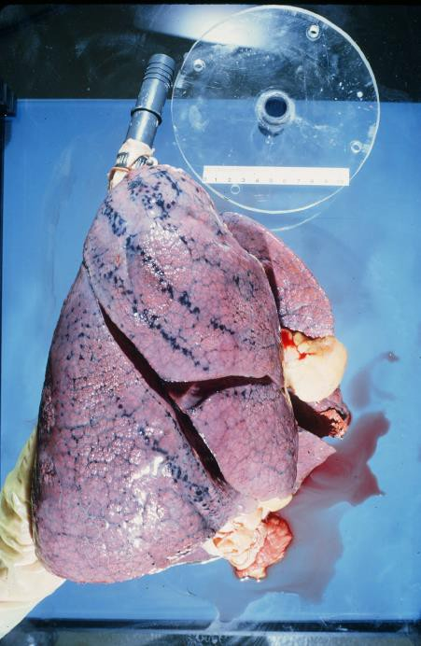

**Figure 1**. A human lung as removed from the thoracic cavity 24 hours after injection with room temperature vulcanizing silicone rubber. The donor was a non smoker but black deposits showing the rib pattern may be carbonaceous or ferrous material stored in the lymphatics. The cast was made at the Inhalation Toxicology Research Institute in Albuquerque. Source: The Air Pollution Health Effects Laboratory at the University of California, Irvine, with kind permission.

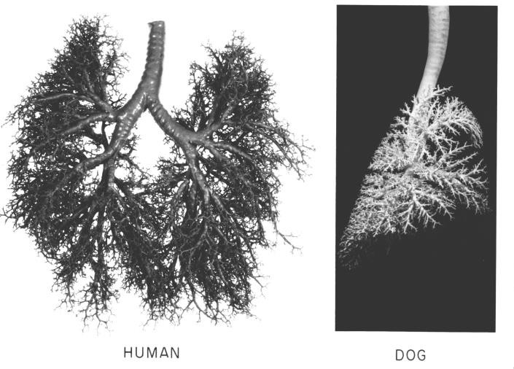

**Figure 2**. In-situ silicone rubber tracheobronchial casts from a human and a beagle dog. Note that the daughter branches are more symmetrical in the human, and those of the dog are more monopodial. Differences in species branching may be due to the shapes of the thorax, more spherical (human) and elongated (dog). Also the dog lung may allow for panting (for cooling)

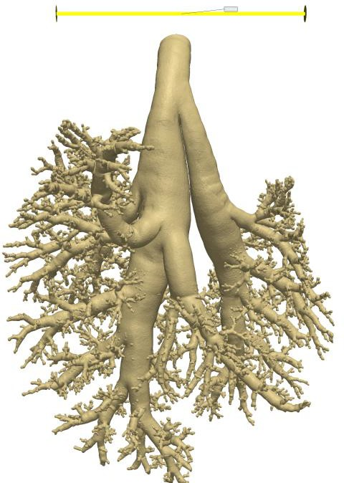without producing hyperventilation syndrome. Source: The Air Pollution Health Effects Laboratory at the University of California, with kind permission.

**Figure 3**. Visualization of a micro CT scan of an in-situ prepared ApoE-/- mouse cast that demonstrates the non-idealized airway structures (airway curvature, surface roughness or texture, changing diameter along airway length, etc.) that are not captured in most morphometric measurements. Figure supplied by Philip Morris International, Inc.

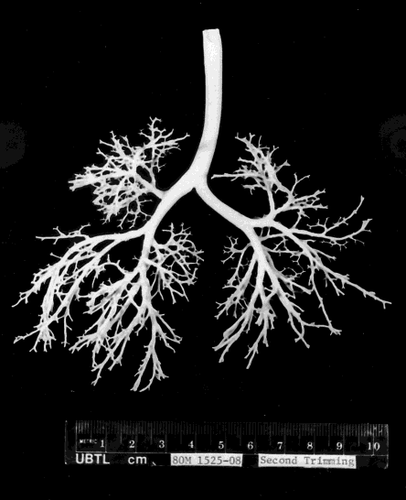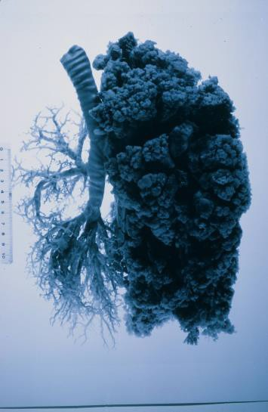

**Figure 4**. In-situ silicone rubber human lung casts from a 4 month old (left) and 80 year old (right) subject. The child cast was made by the late Dr. JB Mortensen, University of Utah. The adult cast was made at the Inhalation Toxicology Research Institute in Albuquerque, NM.

Source: Air Pollution Health Effects Laboratory, University of California, Irvine, with kind permission.

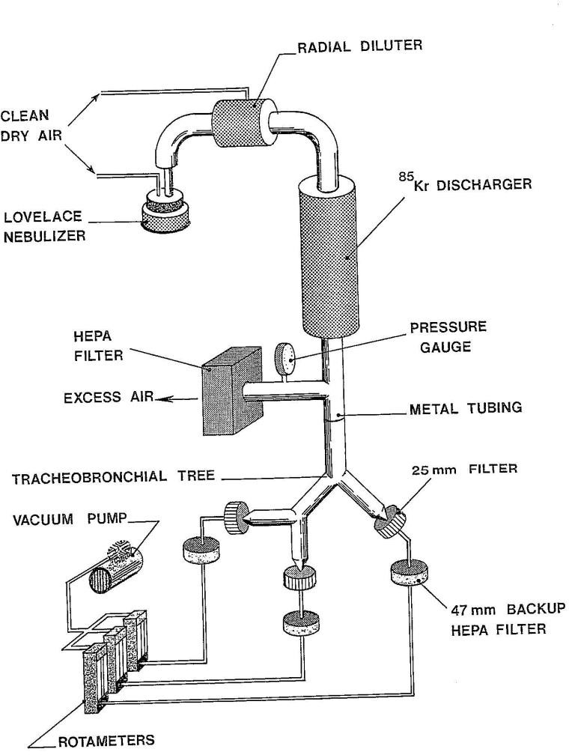

**Figure 5**. A simplified hollow model of human, trachea and large bronchi set up for particle deposition studies under controlled outlet airflows. The model can be used to validate mechanistic inhaled aerosol deposition calculations. Oldham et al. (1997) used this setup to examine aerosol deposition in idealized adult and scaled child airways. Supplied by the Air Pollution Health Effects Laboratory, University of California, Irvine with kind permission.

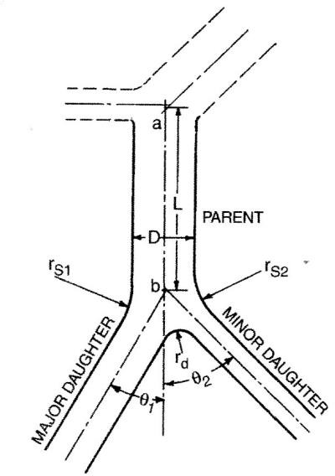

**Figure 6.** Idealized model of the airway branch, the basic unit of structure in the tracheobronchial airway. Diameters (D), lengths (a-b, L), radii (r), and branch angles (Ɵ) are defined by this model. The radii on this diagram are not usually measured on tracheobronchial casts because they are not perfect arcs.

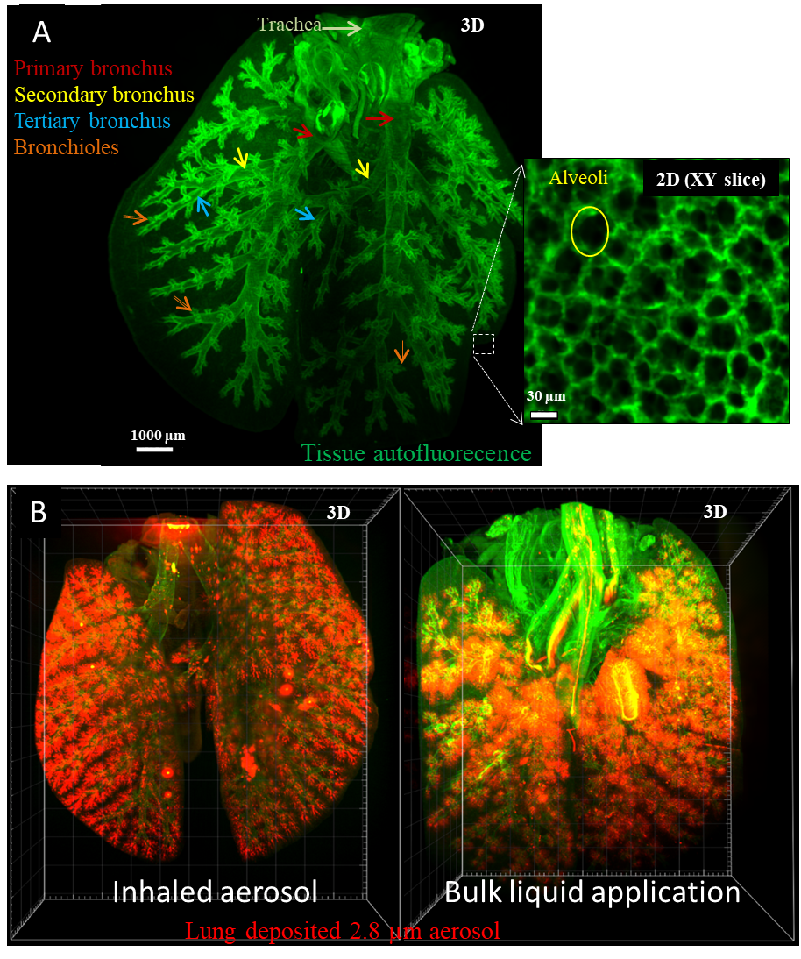

**Figure 7**. Leveraging light sheet fluorescence microscopy (LSFM) on a tissue-cleared murine lungs for A) depicting the entire lung architecture of a virtually sliced murine lung with cellular resolution (from trachea to alveoli – see insert). ~~The insert depicts a magnified section of the alveolar structure~~ (adapted with permission from Yang et al., 2019; Copyright 2019 American Chemical Society). B) Co-mapping of inhaled fluorescently labeled 2.8 µm aerosol (red) and ~~the~~ murine lung architecture (green) reveals uniform aerosol deposition throughout the entire lung as compared to the more central and patchy deposition of a bulk liquid via intratracheal instillation (adapted with permission from Yang et al., 2019; Copyright 2019 American Chemical Society).

# References

Ahangar, P., Cooke, M. E., Weber, M. H. & Rosenzweig, D. H. (2019). Current biomedical applications of 3D Printing and additive manufacturing. *Applied Sciences*, 9, 1713; doi:10.3390/app9081713.

Akaranate, A., Chankow, N. & Pattarasumunt, A. (2013). Fast and low cost x-ray stereoradiography displayed on a 3D monitor. *Open Journal of Applied Sciences*, 3: 308-311, doi: 10.4236/ojapps.2013.34039.

ARA. (2018). Multiple-Path Particle Dosimetry Model (MPPD V3.04). (https://[www.ara.com/products/multiple-path-particle-dosimetry-model-mppd-v-304).](http://www.ara.com/products/multiple-path-particle-dosimetry-model-mppd-v-304)) Accessed 6/28/2020.

Asgharian, B., Hofman, W., & Bergmann, R. (2001). Particle deposition in a multiple-path model of the human lung, *Aerosol Science and Technology*, 34(4), 332-339.

Asgharian, B., Rostami, A. A., Price, O. T., & Pithawalla, Y. B. (2018). Regional deposition of inhaled aerosol constituents from Electronic Nicotine Delivery Systems (ENDS) in the respiratory tract. *Journal of Aerosol Science*, 126:7-20.

Asgharian, B., Oldham, M. J., Price, O. T., Lucci, F., Hoeng J., & Kuczaj, A. K. (2019). Development of an inhalation dosimetry model for C57BL/6 mice in Multiple-Path Particle Dosimetry (MPPD) model. Inhaled Aerosol Dosimetry Conference, October 2019, Irvine California.

Asgharian, B., Price, O. T., Yuteri, C. U., Dickens, C. & McAughey, J. (2014). Component- specific, cigarette particle deposition modeling in the human respiratory tract. *Inhalation Toxicology*, 26(1): 36-47.

Balashazy, I. & Hofmann, W. (1993). Particle deposition in airway bifurcations I. Inspiratory flow. *Journal of Aerosol Science*, 24, 745-772.

Barapatre, N., Symvoulidis, P., Moller, W., Prade, F., Deliolanis, N. C., Hertel, S., Winter, G., Yildirim, A. O., Stoeger, T., Eickelberg, O., Ntziachristos, V. & Schmid, O. (2015).

Quantitative detection of drug dose and spatial distribution in the lung revealed by cryoslicing imaging. *Journal of Pharmaceutical and Biomedical Analysis*, 102(5): 129-136. doi.org/10.1016/j.jpba.2014. 09.001.

Bauer, C., Krueger, M., Lamm, W. J. E., Glenny, R. W. & Beichel, R. R. (2020). lapdMouse: associating lung anatomy with local particle deposition in mice. *Journal of Applied Physiology*, 128: 309-323. doi:10.1152/japplphysiol.00615.2019.

Beinert, T., Brand, P., Behr, J., Vogelmeier, C., & Heyder, J. (1995). Peripheral airspace dimensions in patients with COPD. *Chest*, 108(4):998-1003.

Blanchard, J. D. (1996a). Aerosol bolus dispersion and aerosol-derived airway morphometry: assessment of lung pathology and response to therapy, Part 1. *Journal of Aerosol Medicine,* 9(2):183-205.

Blanchard, J. D. (1996b). Aerosol bolus dispersion and aerosol-derived airway morphometry: assessment of lung pathology and response to therapy, Part 2. *Journal of Aerosol Medicine,* 9(4):453-476.

Brand, P., Rieger, C., Beinert, T., & Heyder, J. (1995). Aerosol derived airway morphometry in healthy subjects. *The European Respiratory Journal*, 8(10):1639-1646.

Brand, P., Rieger, C., Schulz, H., Beinert, T., & Heyder, J. (1997). Aerosol bolus dispersion in healthy subjects. *The European Respiratory Journal,* 10(2):460-467.

Brand, P., App, E. M., Meyer, T., Kur, F., Muller, C., Kur, F., Dienemann, H., Reichart, B., Fruhmann, G., & Heyder J. (1998). Aerosol bolus dispersion in patients with bronchiolitis obliterans after heart-lung and double-lung transplantation. *Journal of Aerosol Medicine*, 11(1): 41-53.

Briant, J. K., & Lippmann, M. (1992). Particle transport through a hollow canine airway cast by high-frequency oscillatory ventilation. *Experimental Lung Research*. Taylor & Francis; 18:385–407. https://doi.org/10.3109/01902149209031692.

Broday, D. M., & Robinson, R. (2003). Application of cloud dynamics to dosimetry of cigarette smoke particles in the lungs. *Aerosol Science and Technology*, 37: 510-527.

Carson, J. P., Einstein, D. R ., Minard, K. R., Fanucchi, M. V., Wallis, C. D., & Corley, R. A., (2010). High resolution lung airway cast segmentation with proper topology suitable for computational fluid dynamic simulations. *Computerized Medical Imaging and Graphics*, 34(7): 572-578.

Casarett, L. T. (1975). Toxicology of the respiratory system, chap. 9. in *Toxicology: The basic science of poisons*, Casarett, L. J. & Doull, J., eds., Macmillian Publishing Company, New York, Toronto and London, p. 201-244.

Chan, T. L., Schreck, R. M., & Lippmann, M. (1980). Effect of the laryngeal jet on particle deposition in the human trachea and upper bronchial airways, *Journal of Aerosol Science*, [11:447–59. http://www.sciencedirect.com/science/article/pii/0021850280901172.](http://www.sciencedirect.com/science/article/pii/0021850280901172)

Cheng, Y-S., Zhou, Y., & Chen B. T. (1999). Particle deposition in a cast of human oral airways,

*Aerosol Science and Technology.* [31:286–300. http://dx.doi.org/10.1080/027868299304165.](http://dx.doi.org/10.1080/027868299304165) Clinkenbeard, R. E., Johnson, D. L., Parthasarathy, R., Cengiz, A. M., Tan, K. H., & Park, S. M., et al. (2002). Replication of human tracheobronchial hollow airway models using a selective laser sintering rapid prototyping technique. *American Industrial. Hygiene Association Journal*,

63(2): 141-150.

Cohen, B. S., Sussman, R. G., & Lippmann, M. (1990). Ultrafine particle deposition in a human tracheobronchial cast. *Aerosol Science and Technology*. Taylor & Francis; 12:1082–91. https://doi.org/10.1080/02786829008959418.

Conway, J., Fleming, J., Bennett, M., & Havelock, T. (2013). The co-imaging of gamma camera measurements of aerosol deposition and respiratory anatomy. *Journal of Aerosol Medicine and Pulmonary Drug Delivery*, 26:123-130.

Cookson, M. J., Davies, C. J., Entwistle, A., & Whimster, W. F. (1993). The microanatomy of the alveolar duct of the human lung imaged by confocal microscopy and visualised with computer-based 3D reconstruction. *Computerized Medical Imaging and Graphics*, 17(3): 201- 210.

Corcoran, T. E., & Chigier, N. (2002). Inertial deposition effects: a study of aerosol mechanics in the trachea using laser Doppler velocimetry and fluorescent dye. *Journal of Biomechanical Engineering*, 124:629–37.

Corley, R. A., Kabilan, S., Kuprat, A. P., Carson, J. P., Minard, K. R., Jacob, R. E., Timchalk,

C., Glenny, R., Pipavath, S., Cox, T., Wallis, C. D., Larson, R. F., Fanucchi, M. V., Postlethwait, E. M., & Einstein, D. R. (2012). Comparative computational modeling of airflows and vapor dosimetry in the respiratory tracts of rat, monkey, and human, *Toxicological Sciences*, 128:500-516, doi:10.1093/toxsci/kfs168.

Cornillie, P., Casteleyn, C., von Horst, C., & Henry, R. (2019). Corrosion casting in anatomy: Visualizing the architecture of hollow structures and surface details. *Anatomia Histologia, Embryologia*, 48(6): 1-34. https://doi.org/10.1111/ahe.12450.

Crystal, R.G., West, J.B., Weibel, E.R. & Barnes, P.J., eds. (1997). *The lung; scientific foundations*, 2 volumes, (2nd edn.), Lippincoltt-Raven Publishers, Philadelphi. 2879 pp.

Darquenne, C., Fleming, J. S., Katz, I., Martin, A. R., Schroeter, J., Usmani, O. S., Venegas, J., & Schmid, O. (2016). Bridging the gap between science and clinical efficacy: physiology, imaging, and modeling of aerosols in the lung. *Journal of Aerosol Medicine and Pulmonary Drug Delivery*, 29(2):107-126, doi:10.1089/jamp.2015.1270.

Darquenne, C. (2020). Deposition mechanisms. *Journal of Aerosol Medicie and Pulmonary Drug Delivery*, 33(4): 181-185, DOI:10.1089/jamp.2020.29029.cd.

Darquenne, C., & Prisk, G. K. (2020). The effect of aging on bolus deposition in the healthy adult lung: A 19-year longitudinal study. *Journal of Aerosol Medicine and Pulmonary Drug Delivery*, 33(3): 133-139.

Davidson, W. B. (1795). Observations, Anatomical, Physiological, and Pathological, on the Pulmonary System; With Remarks on Some of the Diseases of the Lungs, viz, on Haemorrhage, Wounds, Asthma, Catarrh, Croup, and Consumption; Tending to Establish a New Pathology of the Lungs Founded on the Anatomy and Physiology of the Parts. Printed by S. Low for T.Egerton, London, pg. 11.

DeSordi, N., Bombardi, C., Chiocchetti, R., Clavenzani, P., Trere, C., Canova, M., & Grandis, A. (2014). A new method for producing casts for anatomical studies. *Anatomical Science International,* 89: 255-265.

Deschenes, M., Haidarliu, S., Demers, M., Moore, J., Kleinfeld, D., & Ahissar, E. (2015). Muscles involved in naris dilation and nose motion in rat. *The Anatomical Record*, 298:546- 553.

Drinker, P., & Hatch, T. (1936). *Industrial dust: Hygenic significance, measurement and control*. McGraw-Hill Book Company, New York and London, 316 pgs.

Dungworth, D. L., Schwartz, L. W., Tyler, W. S., & Phalen, R. F., (1976). Morphological methods for evaluation of pulmonary toxicity in animals. *Annual Review of Pharmacology and Toxicology*, 16: 381-399.

Ehrmann, S., Schmid, O., Darquenne, C., Rothen-Rutishauser, B., Sznitman, J., Yang, L., Barsova, H., Vecellio, L., Mitchell, J., & Heuze-Vourc’h, N. (2020). Innovative preclinical models for pulmonary drug delivery research. *Expert Opinion on Drug Delivery*, 17(4): 463- 478. Doi.org/10.1080/17425247.2020.1730807.

Eisman, M. M. (1970). Lung models: Hollow, flexible reproductions. *Journal of Applied Physiology*, 29: 531-533.

Ferron, G. A. (1977). Deposition of polydisperse aerosols in two glass models representing the upper human airways. *Journal of Aerosol Science*, 8(6): 409-421.

Findeisen, W. (1935). Uber das Absetzen kleiner in der Luft suspendierter Teilchen in der mensehlichen Lunge bei der Atmung. (Translation: Concerning the precipitation of small air- suspended particles in human lungs during respiration). Pflugers Archiv fur die Gesamte Physiologie des Menschen und der Tiere, 236: 367-379.

Finlay, W. H., & Martin, A. R. (2008). Recent advances in predictive understanding of respiratory tract deposition. *Journal of Aerosol Medicine and Pulmonary Drug Delivery*, 21(2): 189-205.

Fishman, A. P. (1977). Non-respiratory functions of lungs. *Chest*. 72(1): 84-89.

Flors, L., Mugler, J. P. III, Paget-Brown, A., Froh, D. K., DeLange, E. E., Patrie, J. T., & Altes,

T. A. (2017). Hyperpolarized helium-3 diffusion-weighted magnetic resonance imaging detects

abnormalities of lung structure in children with bronchopulmonary dysplasia. *Journal of Thoracic Imaging*, 32:323-332.

Frank, N. R., & Yoder, R. E., (1966). A method of making a flexible cast of the lung. *Journal of Applied Physiology,* 21:1925-1926.

Fuchs, N. A. (1964). *The Mechanics of Aerosols*, translated from the Russian by R. E. Daisley and Marina Fuchs, and edited by C. N. Davies. Pergamon Press Ltd., Toronto, Canada, pp. 46- 51.

Garcia, G. J. M., Patel, R. G., Frank-Ito, D. O., Kimbell, J. S., & Rhee, J. S., (2015). Response to Dr. Chung’s question on simulating the nasal cycle with computational fluid dynamics. *Oto laryngology Head and Neck Surgery*, 153(2): 308-309.

Garrison, F. H., (1929). *An Introduction to the history of medicine: with medical chronology, suggestions for study and bibliographic data, 4th edition*. W. B. Saunders Company, Philadelphia and London, 996 pgs.

Golshahi, L., Noga, M. L., Thompson, R. B., & Finlay, W. H., (2011). In vitro deposition measurement of inhaled micrometer-sized particles in extrathoracic airways of children and adolescents during nose breathing. *Journal of Aerosol Science,* 42:474–88.

Golshahi, L., Finlay, W. H., & Wachtel, H. (2015). Use of Airway Replicas in Lung Delivery Applications. In: Dhand R, editor. *ISAM Textbook. Aerosol Medicine*, p. 221–52.

Guichard, J. C., Zerrari, A., & Jaffrin, M. Y. (1988). Etude experimentale du depot de particules fibreuses dans un modele bronchique rigide. *Journal of Aerosol Science,* 19:73-85.

Gurman, J. L., Lioy, P. J., Lippmann, M., & Schlesinger, R. B. (1984). Particle deposition in replicate casts of the human upper tracheobronchial tree under constant and cyclic inspiratory flow. II. Experimental model. *Aerosol Science and Technology*. Taylor & Francis; 3:253-257. https://doi.org/10.1080/02786828408959013 .

Haefeli-Bleuer, B. & Weibel, E. R. (1988). Morphometry of the human pulmonary acinus. *The Anatomical Record*, 220: 401-414.

Harrison, D. F. N. (1995). *The Anatomy and Physiology of the Mammalian Larynx.* Cambridge, Cambridge University Press, (Chapter 2).

Hofmann, W. (2020). Regional deposition: Deposition models. *Journal of Aerosol Medicine and Pulmonary Drug Delivery*, 33(5): 239-248. doi:10.1089/jamp.2020.29031.wh.

Hofmann, W., & Balashazy, I. (1991). Particle deposition patterns within airway bifurcations – solution of the 3D Navier Stokes equation. *Radiation Protection Dosimetry*, 38(1-3), 57-63.

Hofmann, W. (2011). Modeling inhaled particle deposition in the human lung: A review. *Journal of Aerosol Science*, 42: 693-724.

Horsfield, K., Cumming, G., & Hicken, P. (1966). A morphologic study of airway disease using bronchial casts. *American Review of Respiratory Disease*, 93: 900-906.

Hsia, C. C. W., Hyde, D. M., Ochs, M., & Weibel, E. R. (2010). An official research policy statement of the American Thoracic Society/European Respiratory Society: Standards for Quantitative Assessment of lung structure. *American Journal of Respiratory and Critical Care Medicine*, 181:394-418. doi:10.1164/rccm.200809-1522ST.

ICRP (International Commission on Radiological Protection). (1994). *Human Respiratory Tract Model for Radiological Protection*. Publication 66. Pergamon Press, New York, NY.

Ingebrethsen, B. J. (1986). Evolution of the particle size distribution of mainstream cigarette smoke during a puff. *Aerosol Science and Technology*, 5:423-433.

Islam, A., Oldham, M. J., & Wexler, A. S. (2017). Comparison of manual and automated measurements of tracheobronchial airway geometry in three Balb/c mice, *The Anatomical Record*, 300:2046-2057. doi: 10.1002/ar.23624.

Jacob, R. E., Colby, S. M., Kabilian, S., Einstein, D. R., & Carson, J. P. (2013). In situ casting and imaging of the rat airway tree for accurate 3D reconstruction, *Experimental Lung Research*, 39: 249-257.

Johnson, G., Cofer, G. P., Hedlund, LI. W., Maronpot, R. R., & Suddarth, S. A. (2001). Registered 1 H and 3 He magnetic resonance microscopy of the lung. *Magnetic Resonance in Medicine*, 45:365-370.

Johnson, G. R., & Morawaska, L. (2009). The mechanism of breath aerosol formation. *Journal of Aerosol Medicine and Pulmonary Drug Delivery*, 22(3): 229-237.

Kane D. B., Asgharian, B., Price, O. T., Rostami, A., & Oldham, M. J. (2010). Effect of smoking parameters on the particle size distribution and predicted airway deposition of mainstream cigarette smoke. *Inhalation Toxicology*, 22:199-209.

Karapatis, N. P., van Griethuysen, J. P. S., & Glardon R. (1998). Direct rapid tooling: a review of current research. *Rapid Prototyping Journal*. 4:77–89.

Kepler, G. M., Joyner, D. R., Fleishman, A., Richardson R., Gross, E. A., Morgan, K. T., & Kimbell, J. S. (1995). Method for obtaining accurate geometrical coordinates of nasal airways for computer dosimetry modeling and lesion mapping. *Inhalation Toxicology*, 7:207-1224.

Kilpper, R. W., & Stidd, P. J. (1973). A wet-lung technique for obtaining Silastic rubber casts of the respiratory airways. *Anatomical Record*, 176(3), 279-287.

Kim, C. S., & Iglesias, A. J. (1989). Deposition of Inhaled Particles in Bifurcating Airway Models: I. Inspiratory Deposition. *Journal of Aerosol Medicine*, 2:1–14.

Kim, C. S., & Garcia L. (1991). Particle deposition in cyclic converging tube flow. *Aerosol Science and Technology,* 14(3):323-330.

Kim, C. S., & Fisher, D. M. (1999). Deposition Characteristics of Aerosol Particles in Sequentially Bifurcating Airway Models*. Aerosol Science and Technology,* 31(2-3):198-220.

Kimbell, J. S., Gross, E. A., Joyner, D. R., Godo, M. N., & Morgan, K. T. (1993). Application of computational fluid dynamics to regional dosimetry of inhaled chemicals in the upper respiratory tract of the rat. *Toxicology and Applied Pharmacology*, 121:253-263.

Kleinstreuer, C. & Feng, Y. (2013). Computational analysis of non-spherical particle transport and deposition in shear flow with application to lung aerosol dynamics – A review, *Journal of Biomechanical Engineering*. Vol.135(2) doi: 10.1115/1.4023236., 19 pgs.

Kohlhaufl, M., Brand, P., Selzer, T., Scheuch, G., Meyer, T., Weber, N., Schulz, H., Haussinger, K., Heyder, J. (1998). Diagnosis of emphysema in patients with chronic bronchitis: a new approach. *The European Respiratory Journal*, 12(4):793-798.

Kohlhaufl, M., Brand, P., Rock, C., Radons, T., Scheuch, G., Meyer, T., Schulz, H., Pfeifer, K. J., Haussinger, K., & Heyder, J. (1999). Noninvasive diagnosis of emphysema. Aerosol morphometry and aerosol bolus dispersion in comparison to HRCT. *American Journal of Respiratory and Critical Care Medicine*, 160(3):913-918.

Kuo, W., de Bruijne, M., Petersen, J., Nasserinejad, K., Ozturk, H., Chen, Y., Perez-Rovira, A., & Tiddens, H. A. W. M. (2017a). Diagnosis of bronchiectasis and airway wall thickening in children with cystic fibrosis: objective airway-artery quantification. *European Radiology*, 27:4680-4689.

Kuo, W., Soffers, T., Andrinopoulou, E. R., Rosenow, R., Ranganathan, S., Turkovic, L., Stock,

S. M., Tiddens, H.A.W.M. (2017b). Quantitative assessment of airway dimensions in young

children with cystic fibrosis lung disease using chest computed tomography. *Pediatric Pulmonology*, 52:1414-1423.

Lantada, A. D. & Morgado, P. L. (2012). Rapid prototyping for biomedical enginerring: Current capabilities and challenges. *Annual Review of Biomedical Engineering*, 14: 73-96.

Lawal, O., Ahmed, W. M., Nijsen, T. M. E., et al. (2017) Exhaled breath analysis: a review of ‘breath-taking’ methods for off-line analysis. *Metabolomics,* 13, 110. <https://doi.org/10.1007/s11306-017-1241-8>)

Lewis, T. A., Tzeng, Y-S., McKinstry, E. L., Tooker, A. C., Hong, K., Sun Y., Mansour, J., Handler, Z., & Albert, M. S. (2005). Quantification of airway diameters and 3D airway tree rendering from dynamic hyperpolarized 3He magnetic resonance imaging. *Magnetic Resonance in Medicine*, 53:474-478.

Liebow, A. A., Hales, G. E., Lindskog, G. E. & Bloomer, W. E., (1947). Plastic demonstrations of pulmonary pathology. *International Academy of Pathology*, 27: 116-129.

Lizal, F., Elcner, J., Hopke, P. K., Jedelsky, J., & Jicha, M. (2011). Development of a realistic human airway model. *Journal of Enginerring in Medicine*, 22: 197–207.

Lizal, F., Jedelsky, J., Morgan, K., Bauer, K., Llop, J., Cossio, U., Kassinos, S., Verbanck, S., Ruiz-Cabello, J., Santos, A., Koch, E., & Schnabel, C. (2017). Experimental methods for flow and aerosol measurements in human airways and their replicas. *European Journal of Pharmaceutical Sciences*, 113: 95-131, Special Issue, DOI: 10.1016/j.ejps.2017.08.021.

Martonen, T. B., (1992). Deposition patterns of cigarette smoke in human airways. *American Industrial Hygiene Association Journal*, 53: 6-18.

Martonen, T. B., Zhang, Z., Yue, G., & Musante, C. J. (2002). 3-D particle transport with the human upper respiratory tract. *Journal of Aerosol Science*, 33:1095-1110.

McRobbie, D. W., Pritchard, S. E., & Quest, R. A. (2003). Studies of the human oropharyngeal airspaces using magnetic resonance imaging (MRI)-1. Validation of a three-dimensional MRI method for producing ex vivo virtual and physical casts of the oropharyngeal airways during inspiration. *Journal of Aerosol Medicine*, 16:401-415.

Miller, F. J., Asgharian, B., Schroeter, J. D., & Price, O. T. (2016). Improvements and additions to the Multiple Path Particle Dosimetry model. *Journal of Aerosol Science*, 99: 14-26.

Miller, W. S. (1947). *The Lung 2nd edn*., Charles C. Thomas, Springfield Il, pp. 162-202. Minard, K. R., Einstein, D. R., Jacob, R. E., Kabilan, S., Duprat A. P., Timchalk, C. A., Trease,

L. l., & Corely, R. A. (2006). Application of magnetic resonance (MR) imaging for the development and validation of computational fluid dynamic (CFD) models of the rat respiratory system. *Inhalation Toxicology*, 18:787-794.

Morrow, P. E., Bates, D. V., Fish, B. R., Hatch, T. F., & Mercer, T. T. (1966). Deposition and retention models for internal dosimetry of the human respiratory tract. *Health Physics*, 12, 173- 207.

Myojo, T. (1987). Deposition of fibrous aerosol in model bifurcating tubes. *Journal of Aerosol Science*, 18(3):337-347.

Myojo, T. (1990). The effect of length and diameter on the deposition of fibrous aerosol in a model lung bifurcation. *Journal of Aerosol Science*, 21(5):651-659.

Narat, J. K., Loef, J. A., & Narat, M. (1936). On the preparation of multicolored corrosion specimens. *Anatomical Record*, 64(2), 155-160.

NCRP (National Council on Radiation Protection and Measurements) (1997). *Deposition, Retention, and Dosimetry of Inhaled Radioactive Substances*. NCRP SC 57-2, NCRP, Bethesda, MD.

Olarte, O. E., Andilla, J., Gaulda, E. J. & Loza-Alverez, P. (2018). Light-sheet microscopy: a tutorial. *Advances in Optics and Photonics*, 10(1): 111-179. doi.org/10.1364/AOP.10.000111.

Oldham, M. J., Mannix, R. C., & Phalen, R. F. (1997). Deposition of monodisperse particles in hollow models representing adult and child-size tracheobronchial airways. *Health Physics*, 72:827–34.

Oldham, M. J., & Moss, O. R. (2019). Pores of Kohn: Forgotten alveolar structures and potential source of aerosols in exhaled breath. *Journal of Breath Research*.

13:021003.https://doi.org/10.1088.1752-7163/ab0524.

Olry, R. (1998). Short history of vascular injections, with special reference to the heart vessels.

*Journal of the International Society for Plastination*, 13(1): 7-11.

Perzl, M. A., Schulz, H., Paretzke, H. G., Englmeier, K. H., & Heyder, J. (1996). Reconstruction of the lung geometry for the simulation of aerosol transport. *Journal of Aerosol Medicine*, 9:409-418.

Phalen, R. F., Schum, G. M., & Oldham, M. J. (1990). The sensitivity of an inhaled aerosol tracheobronchial deposition model to input parameters. *Journal of Aerosol Medicine*, 3(4): 271-282.

Phalen, R. F., Yeh, H. C., Raabe, O. G., & Velasquez, D. J. (1973) Casting the lungs in-situ.

*Anatomical Record*, 177: 255-263.

Phalen, R. F. & Oldham, M. J. (1983). Tracheobronchial airway structure as revealed by casting techniques. *American Review of Respiratory Diseases*, 128:S1-S4.

Phalen, R. F., Oldham, M. J., Mannix, R. C., & Schum, G. M. (1994). Cigarette smoke deposition in the tracheobronchial tree: Evidence for colligative effects, *Aerosol Science and Technology*, 20:215-226.

Pichelstorfer, L., Hofmann, W., Winkler-Heil, R., Yurteri, C. U., & McAughey, J. (2016). Simulation of aerosol dynamics and deposition of combustible and electronic cigarette aerosols in the human respiratory tract. *Journal of Aerosol Science*, 99:125-132.

Porstendorfer, J. (1971). Investigations into the question of the growth of inhaled aerosol particles in the respiratory tract. *Journal of Aerosol Science*, 2:73.

Pump, K. K. (1969). Morphology of the acinus of the human lung. *Diseases of the Chest*, 56: 126-134.

Raabe, O. G., Yeh, H. C., Schum, G. M., & Phalen, R. F. (1976). *Tracheobronchial Geometry: Human, Dog, Rat, Hamster*. Report 110.LF-53. Albuquerque NM: Lovelace Foundation.

Rahn, H., & Ross, B. B. (1957). Bronchial tree casts, lobe weights, and anatomical dead space measurements in the dog’s lung. *Journal of Applied Physiology*, 10: 154-157.

Rostami, A. A. (2009). Computational modeling of aerosol deposition in respiratory tract: A review. *Inhalation Toxicology*, 21, 262-290.

Sanderson, M. J., (2011). Exploring lung physiology in health and disease with lung slices.

*Pulmonary Pharmacology and Thearapeutics*, 24(5): 452-465.

Scheuch, G. (2020). Breathing is enough: For the spread of influenza virus and SARS-Cov-2 by breathing only. *Journal of Aerosol Medicine and Pulmonary Drug Delivery*, 33(4):730-234, DOI:10.1089/jamp.2020.1616.

Schlesinger, R. B., Bohning, D. E., Chan, T. L., & Lippmann, M. (1977). Particle deposition in a hollow cast of the human tracheobronchial tree. *Journal of Aerosol Science*. 8:429–45.

Available f[rom: http://www.sciencedirect.com/science/article/pii/0021850277900362](http://www.sciencedirect.com/science/article/pii/0021850277900362)

Schlesinger, R. B., & Lippmann, M. (1972). Particle Deposition in Casts of the Human Upper Tracheobronchial Tree. *American Industrial Hygene Association Journal*.

33(4):237-251.

Schmidt, A., Zidowitz, S., Kriete, A., Denhard, T., Krass, S., & Peitgen, H-O (2004). A digital reference model of the human bronchial tree. *Computational Medical Imaging Graphics*, 28:203–11.

Schroter, R. C., & Sudlow, M. F. (1969). Flow patterns in models of the human bronchial airways. *Respiration Physiology*. 7:341–55. <http://www.sciencedirect.com/science/article/pii/0034568769900188>.

Scott, G. D., Blum, E. D., Fryer, A. D. & Jacoby, D. B. (2014). Tissue optical clearing, three- dimentional imaging, and computer morphometry in whole mouse lungs and human airways. *American Journal of Respiratory Cell and Molecular Biology*, 51(1): 43-55.

Smith, S., Cheng, Y. S., & Yeh, H. C. (2001). Deposition of ultrafine particles in human tracheobronchial airways of adults and children. *Aerosol Science and Technology*, 35:697–709.

Smith, B. M., Traboulsi, H., Austin, J. H. M., Manichaikul, A., Hoffman, E. A., Bleecker, E. R., Cardoso, W. V., Cooper, C., Couper, D. J., Dashnaw, S. M., Guo, J., Han, M. K., Hansel, N.

N., Hughes, E. W., Jacobs, D. R. Jr, Kanner, R. E., Kaufman, J. D., Kleerup, E., Lin, C. L.,

Liu, K., Lo Cascio, C. M., Martinez, F. J., Nguyen, J. N., Prince, M. R., Rennard, S., Rich, S.

S., Simon, L., Sun, Y., Watson, K. E., Woodruff, P. G., Baglole, C. J., Barr, R. G. (2018). MESA, Lung and SPIROMICS investigators. Human airway branch variation and chronic obstructive pulmonary disease. *Proceedings of the National Academy of Sciences of the USA*. 30;115(5):E974-E981. doi: 10.1073/pnas.1715564115.

Standring, S. (2016). A brief history of topographical anatomy. *Journal of Anatomy*; 229(1): 32- 62. doi:10111/joa.12473.

Storey-Bishoff, J., Noga, M., & Finlay, W. H. (2008). Deposition of micrometer-sized aerosol particles in infant nasal airway replicas. *Journal of Aerosol Science*, 39:1055–65.

Sussman, R. G., Cohen, B. S., & Lippmann, M. (1991). Asbestos Fiber Deposition in a Human Tracheobronchial Cast. I. Experimental. *Inhalation Toxicology*, 3:145–60. https://doi.org/10.3109/08958379109145281.

Swift, D. L. (1991). Inspiratory inertial deposition of aerosol in human nasal replica casts: implication for the proposed NCRP lung model. *Radiation Protection Dosimetry*, 38:29-34.

Tawhai, M. H., Hunter, P., Tschirren, J., Reinhardt, J., McLennan, G., & Hoffmann, E. A. (2004). CT-based geometry analysis and finite element models of the human and ovine bronchial tree. *Journal of Applied Physiology*, 97:2310-2321, doi:10.1152/japplphysiol.00520.

Thiesse, J., Reinhardt, J. M., de Ryk, J., Namati, E., Leinen, J., Recheis, W. A., Hoffman, E. A., & McLennan, G. (2005). Three-dimensional visual truth of the normal airway tree for use as a quantitative comparison to micro-CT reconstructions. *Proceedings SPIE 5746, Medical Imaging: Physiology, Function, and Structure from Medical Images*, 50, https://doi.org/10.1117/12596806.

Timbrell, V., Bevan, N. E., Davies, A. S., & Munday, D.E. (1970). Hollow casts of lungs for experimental purposes. *Nature,* 225: 97-98.

Tompsett, D. H. (1952). A New Method for the Preparation of Bronchopulmonary Casts.

*Thorax*[, 7:78–88, http://www.ncbi.nlm.nih.gov/pmc/articles/PMC1019142/.](http://www.ncbi.nlm.nih.gov/pmc/articles/PMC1019142/) Tompsett, D. H. (1956). *Anatomical Techniques*, Livingstone, Edinburg and London.

von Standen, H. (1992). The discovery of the body: Human dissection and its cultural context in ancient Greece. *The Yale Journal of Biology and Medicine*; 65:223-241.

Weibel, E. R. & Gomez, D. M. (1962). Architecture of the human lung. *Science*, 137: 577-585. Weibel, E. R. (1963). *Morphometry of the Human Lung*. Springer-Verlag, Berlin.

Weibel, E. R. (1991). Fractal geometry – a design principle for living organisms. *American Journal of Physiology*, 261(6): L361-L369.

West, J. B., & Hugh-Jones, P. (1959). Patterns of gas flow in the upper bronchial tree. *Journal of Applied Physiology,*14:753-759. https://doi.org/10.1152/jappl. 14.5.753. Accessed 7/18/2020. Wolfe, K. B. (1962). A method for preparing mammalian lungs for anatomical study. *Laboratory*

*Digest*, 9-12.

Xi, J. & Longest, P. W. (2007). Transport and deposition of micro-aerosols in realistic and simplified models of the oral airway. *Annals of Biomedical Engineering*, 35: 560-581.

Yang, L., Feuchtinger, A., Möller W., Ding, Y., Kutschke, D., Moller, G., Schittny, J.C., Burgstaller, G., Hofmann, W., Stoeger, T., Razansky, D., Walch, A., & Schmid, O. (2019). Three-dimensional quantitative co-mapping of pulmonary morphology and nanoparticle distribution with cellular resolution in nondissected murine lungs. *ACS Nano*, 13(2): 1029-1041.

Yeh, H. C., Phalen, R. F. and Raabe, O. G. (1976). Factors influencing the deposition on inhaled particles. *Environmental Health Perspective*, 15:147-156.

Yeh, H. C., Hulbert, A., Phalen, R. F., Velasquez, D. J., & Harris, T. D . (1975). A stereoradiographic technique and its application to lung casts. *Investigative Radiology*, 10: 351- 357.

Yeh, H. C., & Schum, G. M. (1980). Models of human lung airways and their application to inhaled particle deposition. *Bulletin of Mathematical Biology*, 42: 461-480.