*Cell Death and Disease*

Manuscript CDDIS-20-3567RR

Supplementary Materials

**Neuroinflammation induces synaptic scaling through IL-1β-mediated activation of the transcriptional repressor REST/NRSF**

F. Buffolo1,2*, V. Petrosino3,4*, M. Albini1,2*, M. Moschetta1,4, F. Carlini3,4, T. Floss5, N. Kerlero de Rosbo3, F. Cesca1,6, A. Rocchi1,4§, A. Uccelli3,4*§, F. Benfenati1,4*§

1 Center for Synaptic Neuroscience and Technology, Istituto Italiano di Tecnologia, Largo Rosanna Benzi 10, 16132 Genova, Italy; 2 Department of Experimental Medicine, University of Genova, Viale Benedetto XV, 3, 16132 Genova, Italy; 3 Department of Neurosciences, Rehabilitation, Ophthalmology, Genetics, Maternal and Child Health, University of Genova, Largo P. Daneo, 3, 16132 Genova, Italy; 4 IRCCS, Ospedale Policlinico San Martino, Largo Rosanna Benzi 10, 16132 Genova, Italy; 5 Helmholtz Zentrum München, Deutsches Forschungszentrum für Gesundheit und Umwelt (GmbH), Ingolstädter Landstr. 1, 85764 Neuherberg, Germany; 6 Department of Life Sciences, University of Trieste, Trieste, Italy.

* These authors contributed equally to this work

§ Corresponding authors

**SUPPLEMENTARY MATERIALS**



**Supplementary Figure 1. IL-1β treatment increases REST and REST 4 mRNAs in N2a cells.** The mRNA levels of REST **(a)** and REST4 **(b)** were quantified by qRT-PCR in IL-1β- treated-cells as compared to control cells (NS). Gapdh, Actin and Hprt1 were used as housekeeping genes in qRT-PCR analyses Graphs show means ± sem with superimposed individual points from distinct culture dishes prepared from at least n=3 independent preparations. ***p<0.001; Mann-Whitney *U*-test.

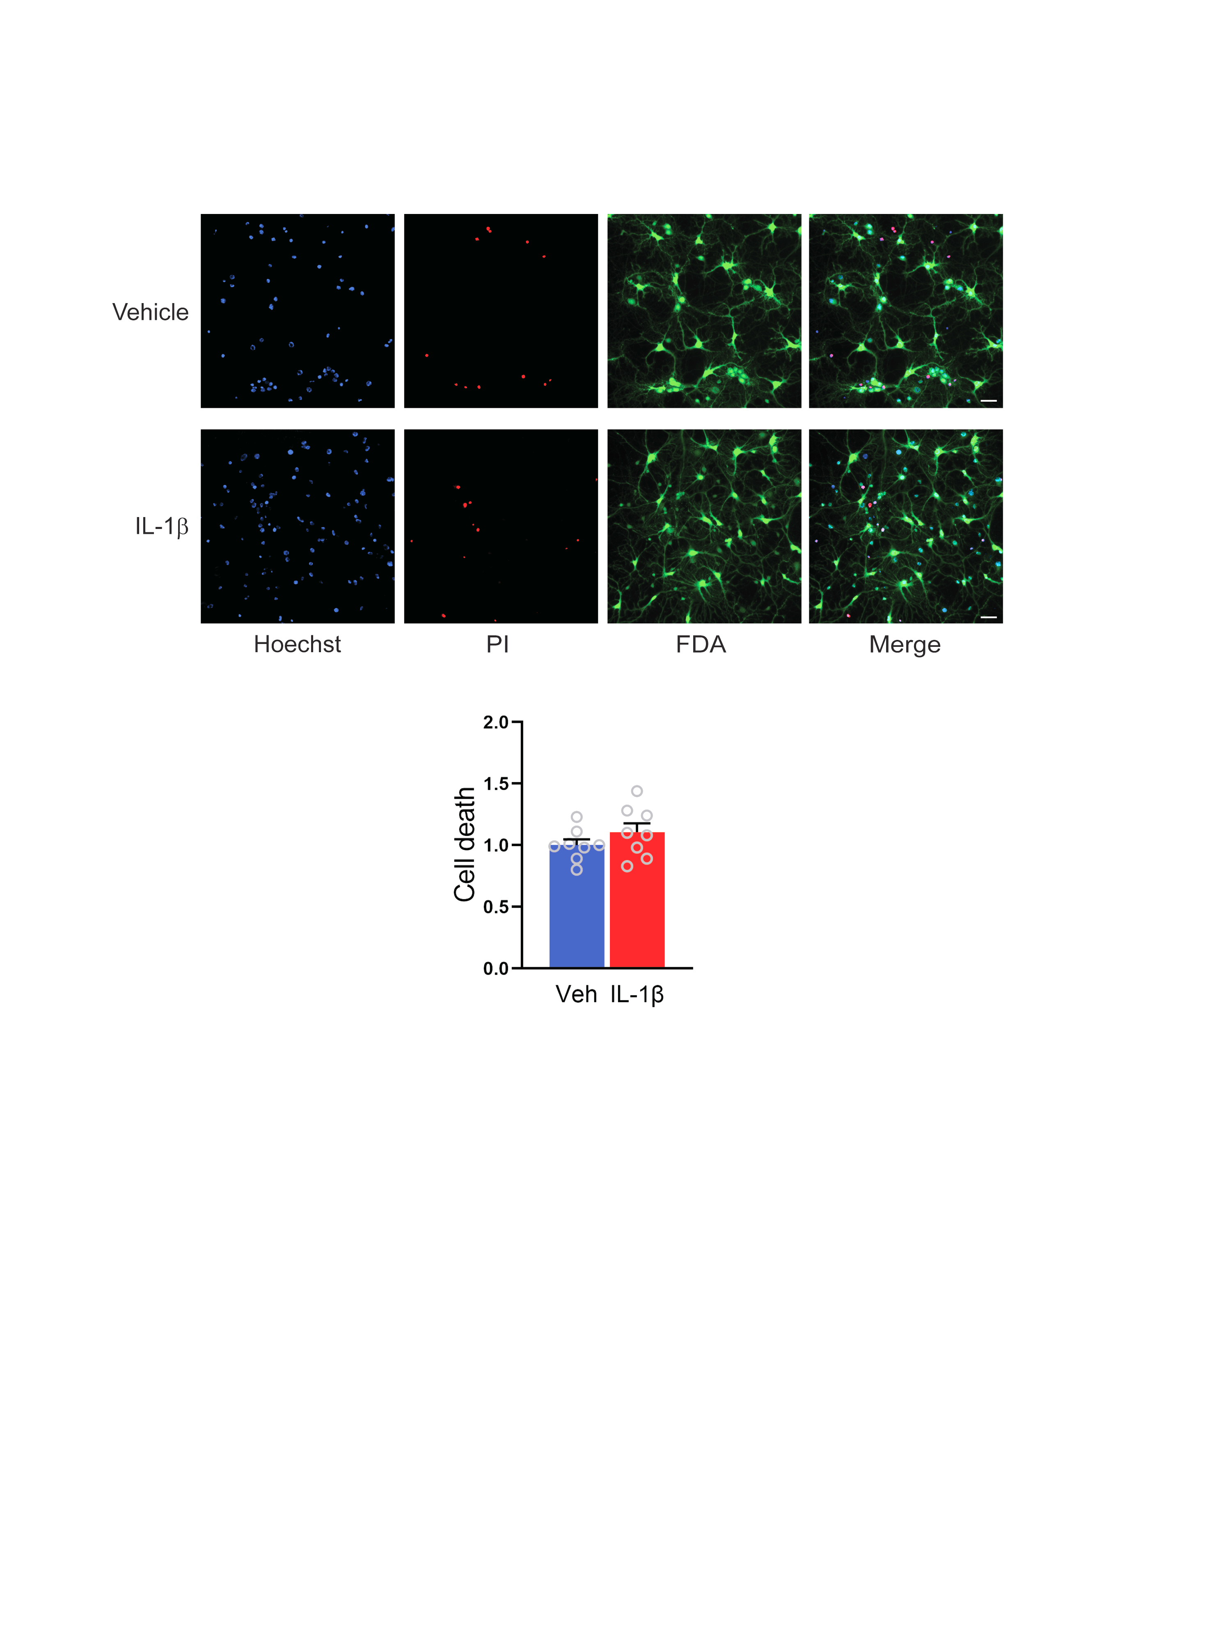

**Supplementary Figure 2. Neuronal cell viability after 7 days upon exposure to IL-1β.** Primary mouse cortical neurons were exposed to IL-1β (20 ng/ml) or vehicle (veh; 0.1% BSA) for 20 min at 7 DIV and analyzed at 14 DIV. Cell viability was evaluated by fluorescence microscopy. Representative images of neuronal cultures stained with Hoechst 33342 for nuclear visualization (blue), propidium iodide (PI; red) for cell death quantification and fluorescein diacetate (FDA; green) for cell viability detection. Scale bars, 100 μm. The percentages of PI-positive cells with respect to the total number of Hoechst-positive cells, were calculated for each experimental group and normalized to the values of vehicle-treated samples. The bar plot shows the means ± sem with superimposed individual points from distinct culture dishes prepared from at least n=3 independent preparations. p>0.05; unpaired two-tailed Student’s *t*-test.

**Supplementary Figure 3. Characterization of REST silencing in RESTGTi cortical neurons. (a)** Schematic representation of REST GTinv cassette, modified from (52). **(b,c)** Primary cortical neurons from RESTGTi mice were transduced with lentiviral vectors encoding defective (ΔCre) and active (Cre) Cre-recombinase and the expression of full-length REST was assessed by qRT-PCR (b) and western blotting (c) analysis. In (c), a representative experiment and the respective quantification are shown. The residual levels of REST mRNA/protein reflect the near complete transduction of primary neurons.In qRT-PCR analysis Actin, Gusb and Gapdh were used as reference genes; in Western blotting analysis, Calnexin was used as a loading control. Graphs show means ± sem with superimposed experimental points (n=5-9). *p<0.05, ***p<0.001; unpaired two-tailed Student’s *t*-test.