# SUPPLEMENTAL MATERIAL

**Association of proton pump inhibitor use with endothelial function and metabolites of the nitric oxide pathway: a cross-sectional study**

Michael Nolde1,2*, Martin Bahls3,4*, Nele Friedrich4,5, Marcus Dörr3,4, Tobias Dreischulte6, Stefan B. Felix3,4, Ina-Maria Rückert-Eheberg1,7, Nayeon Ahn1,2, Ute Amann2, Edzard Schwedhelm8,9, Henry Völzke4,10, Markus M. Lerch11, Jakob Linseisen1,2, Christa Meisinger1,2*, Sebastian E. Baumeister1,2*

1 Chair of Epidemiology, Ludwig-Maximilians-Universität München, UNIKA-T Augsburg, Augsburg, Germany;

2 Independent Research Group Clinical Epidemiology, Helmholtz Zentrum München, German Research Center for Environmental Health, Neuherberg, Germany;

3 Department of Internal Medicine B, University Medicine Greifswald, Greifswald, Germany;

4 German Centre for Cardiovascular Research (DZHK) partner site Greifswald, Greifswald, Germany;

5 Institute of Clinical Chemistry and Laboratory Medicine, University Medicine Greifswald, Greifswald, Germany;

6 Department of General Practice and Family Medicine, Ludwig-Maximilians-Universität München, Munich, Germany;

7 Institute of Epidemiology, Helmholtz Zentrum München, German Research Center for Environmental Health, Munich, Germany;

8 Institute of Clinical Pharmacology and Toxicology, University Medical Center Hamburg-Eppendorf, Hamburg, Germany;

9 German Centre for Cardiovascular Research (DZHK) partner site Hamburg/Kiel/Lübeck, Hamburg, Germany;

10 Institute of Community Medicine, University Medicine Greifswald, Greifswald, Germany;

11 Department of Medicine A, University Medicine Greifswald, Greifswald, Germany;

*contributed equally

# Supplemental Figure

Figure I - Flow Chart

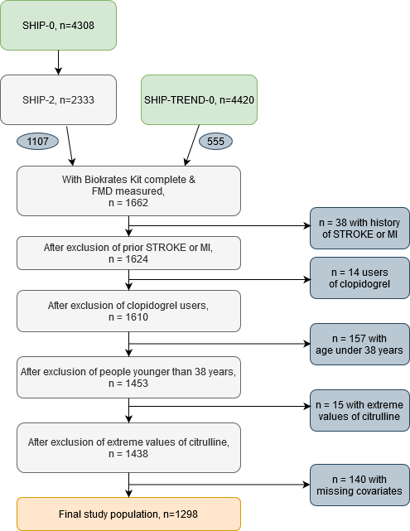

|  |  |  |  |
| --- | --- | --- | --- |
| **Table I. Estimates for the association between the regular daily intake of PPIs and FMD, as well as plasma concentrations of citrulline, arginine, ADMA and SDMA adjusted for censoring** | | | |
| Outcome | Regression coefficient | (95% CI) | *P* |
| FMD in [%] | -1.04 | (-2.07; -0.01) | 0.047 |
| Citrulline [µmol/l] | -2.50 | (-4.96; -0.04) | 0.047 |
| Arginine [µmol/l] | -0.46 | (-5.59; 4.67) | 0.861 |
| ADMA [µmol/l] | -0.01 | (-0.05; 0.04) | 0.784 |
| SDMA [µmol/l] | 0.00 | (-0.08; 0.08) | 0.990 |
| PPIs Proton pump inhibitors (Anatomical Therapeutic Chemical (ATC) code A02BC); FMD flow-mediated dilation, ADMA asymmetric dimethylarginine, SDMA symmetric dimethylarginine;  Method: Inverse Probability Weighted Linear Regression with stabilized weights adjusting for censoring and measured confounding | | | |

# Supplemental Table

|  |  |  |  |
| --- | --- | --- | --- |
| **Table I. Estimates for the association between the regular daily intake of PPIs and FMD, as well as plasma concentrations of citrulline, arginine, ADMA and SDMA adjusted for censoring** | | | |
| Outcome | Regression coefficient | (95% CI) | *P* |
| FMD in [%] | -1.04 | (-2.07; -0.01) | 0.047 |
| Citrulline [µmol/l] | -2.50 | (-4.96; -0.04) | 0.047 |
| Arginine [µmol/l] | -0.46 | (-5.59; 4.67) | 0.861 |
| ADMA [µmol/l] | -0.01 | (-0.05; 0.04) | 0.784 |
| SDMA [µmol/l] | 0.00 | (-0.08; 0.08) | 0.990 |
| PPIs Proton pump inhibitors (Anatomical Therapeutic Chemical (ATC) code A02BC); FMD flow-mediated dilation, ADMA asymmetric dimethylarginine, SDMA symmetric dimethylarginine;  Method: Inverse Probability Weighted Linear Regression with stabilized weights adjusting for censoring and measured confounding | | | |